WATER-use zonation under projected land-cover change in Bolon Watershed, Indonesia

Abstract
Land-cover change can weaken watershed hydrological regulation and intensify flood–drought risk, particularly under increasing climate variability. This study evaluates how observed and projected land-cover dynamics influence water-use zonation in the Bolon River Watershed (North Sumatra, Indonesia) to support sustainable spatial planning. A GIS-based approach was applied using QGIS and the MOLUSCE plugin with a Cellular Automata–Artificial Neural Network (CA–ANN) model to simulate land-cover change from mapped Sentinel-2 land cover (2017, 2021, 2024) and forecast patterns for 2029 and 2033. Water-use zones were delineated by integrating recharge potential, catchment function, and water availability, then overlaid with the regional spatial plan (RTRW) to assess consistency. Results indicate continuing conversion from forest and wet agriculture toward plantations and built-up land: forest decreases from 800 km² (2017) to 700 km² (2024) and is projected to reach 600 km² (2033), while plantations increase from 300 km² (2017) to 350 km² (2024) and 450 km² (2033). Although rainfall increases from 2,500 mm/year (2024) to 2,600 mm/year (2033), infiltration capacity declines from 1,200 to 1,150 mm/year, indicating reduced recharge potential and higher runoff propensity. RTRW consistency is lowest in plantation-designated areas (50%), suggesting a governance mismatch that may accelerate hydrological degradation. We recommend integrating hydrological zonation as a constraint layer in RTRW revision and permitting to protect high-capacity zones and reduce future water-security risks.
Keywords: Bolon watershed; land-cover change prediction; CA–ANN; MOLUSCE; GIS; recharge potential; RTRW consistency; climate adaptation
1. Introduction
Rapid land-cover transformation within watersheds can disrupt hydrological processes and degrade both water quantity and quality. Land conversion—such as deforestation and the replacement of agricultural land with plantations or built-up areas—often increases surface runoff, reduces infiltration, and heightens vulnerability to floods and droughts (Nasrullah et al., 2010). These impacts occur because vegetation removal and soil compaction weaken the soil’s capacity to absorb and store rainfall, accelerating flow routing toward channels. Over time, this can reduce groundwater recharge and dry-season baseflow, while also increasing peak discharge during heavy rainfall events. Accordingly, understanding the hydrological implications of land-cover change is essential for designing sustainable watershed management strategies (Salaudeen et al., 2023).
In parallel, climate variability and climate change can amplify watershed risk, making land-cover transitions more consequential for water security. Shifts in rainfall intensity, seasonality, and extremes may increase the probability that degraded catchments experience both short-term flooding and longer dry-season shortages. When land conversion coincides with more intense rainfall events, runoff responses can become sharper, sediment transport can increase, and river systems can be stressed beyond their historical regimes. This highlights the need for planning approaches that anticipate future conditions rather than relying only on current land-cover states. Therefore, land-cover forecasting and hydrological zoning are increasingly important to support climate-adaptive watershed governance (Admas et al., 2024).
Effective water-use zonation requires a sound understanding of the physical and ecological attributes of a landscape. Different zones deliver distinct hydrological functions and should be managed according to environmental priorities and socio-economic needs (Loucks & van Beek, 2017). For example, recharge-sensitive areas need protection to sustain groundwater storage, while upstream catchment areas require management to reduce erosion and moderate flow regimes. Without zoning that reflects these functions, land allocation can unintentionally shift development into hydrologically strategic zones. This calls for systematic spatial assessment of the factors shaping water distribution, storage, and utilization.
Advances in Geographic Information Systems (GIS) enable predictive land-cover modelling using spatial datasets and robust algorithms. The MOLUSCE plugin in QGIS has been widely used to forecast land-use/land-cover change with relatively high performance, supporting evidence-based conservation and natural resource planning (Muhammad et al., 2022). Such modelling is useful because it represents both neighborhood effects (through cellular automata) and transition potential (through machine-learning models such as artificial neural networks). When validated, model outputs provide plausible spatial trajectories that can be linked to hydrological indicators and zoning decisions. Consequently, GIS-based modelling offers a practical decision-support tool in watersheds where land conversion pressures are accelerating.
In the Bolon watershed, ongoing urban expansion and plantation development are likely to reduce recharge and catchment functions. These changes may not be evenly distributed across the landscape, meaning that the most serious hydrological impacts can occur when conversion concentrates in strategic recharge zones or upstream regulating areas. The need is therefore not only to map change but to anticipate where change will occur and what hydrological functions will be affected. This study employs QGIS–MOLUSCE to predict land-cover change through 2033 and assess its implications for water-use zonation, providing a forward-looking basis for water-resource planning.
Recharge areas play a critical role in replenishing groundwater and sustaining river baseflow, especially during dry seasons. Infiltration and recharge capacity are shaped by slope, soil texture, and rainfall, which together determine how much precipitation becomes subsurface storage rather than rapid runoff (Prahasta, 2014). Landscapes with gentle slopes and coarse-textured soils typically exhibit higher infiltration potential, while steep slopes or fine-textured and compacted soils tend to promote overland flow. If land-cover conversion increases bare surfaces or impervious cover in recharge-sensitive areas, groundwater replenishment can decline even if annual rainfall remains stable. Therefore, identifying and protecting recharge zones is essential for long-term water security.
In addition to recharge areas, catchment areas regulate how rainfall is collected and routed toward the main river network. Rainfall intensity and land cover strongly influence runoff generation and streamflow responses, affecting flood peaks, erosion, and sedimentation dynamics (Santoso et al., 2025). When vegetation is reduced or replaced by simplified land covers, the catchment’s ability to dampen hydrological extremes decreases, and water availability becomes more variable. Mapping catchment functionality is therefore fundamental for anticipating future water stress and prioritizing upstream management actions. This is particularly relevant where land-cover change interacts with climatic variability to intensify hydrological instability.
Water-use zonation should integrate land cover, recharge potential, and water availability to guide sustainable utilization while preventing ecological degradation (Muhammad et al., 2022). Such zonation provides a spatial “rule set” for allocating uses based on hydrological capacity rather than administrative or short-term economic drivers alone. By translating hydrological indicators into practical zone classes, planners can identify where development should be limited, where conservation must be prioritized, and where mitigation measures are needed. Zonation becomes especially valuable when it is derived from both current conditions and plausible future land-cover trajectories. In this way, zoning can function as a preventive tool rather than a reactive response to degradation.
Integrating water-use zonation with regional spatial plans (RTRW) is crucial to ensure that development priorities do not compromise hydrological sustainability. Spatial planning documents that differentiate protected and cultivation zones must reflect hydrological capacity and watershed constraints, otherwise legal land allocations may unintentionally facilitate degradation (Bappeda Prov. Sumatera Utara, 2017). Overlay analysis between hydrological zones and RTRW can identify mismatches where high-recharge or high-catchment-function areas are designated for intensive cultivation or settlement expansion. These mismatches are important because they can become governance “hotspots” for future land–water conflict and declining ecosystem services. Therefore, zoning–RTRW alignment is a key step for implementing hydrologically informed land governance.
This study aims to (i) evaluate the impacts of land-cover change on water-use zonation in the Bolon watershed, and (ii) predict land-cover change through 2033 using spatial modelling, thereby supporting policy recommendations for sustainable local water-resource governance (Loucks & van Beek, 2017). The research integrates observed land-cover mapping, CA–ANN-based forecasting, and hydrological zonation indicators into a single GIS workflow. It further assesses planning relevance by comparing zonation outputs with RTRW allocations to identify areas requiring protection, mitigation, or planning revision. By linking predictive modelling with actionable zoning and governance checks, the study provides a transferable framework for watershed planning under ongoing land conversion pressures.

2. Methods
2.1 Study Area
The study was conducted in the Bolon River Watershed, North Sumatra, Indonesia. The watershed delineation covers approximately 1,956 km²; however, after raster alignment, masking, and consistent class coverage across multi-temporal datasets, the effective analysis extent used in land-cover tabulation is 1,950 km². The Bolon watershed is a major water source for agriculture, settlements, and industry across areas including Simalungun and Batu Bara.
Figure 1. Location map of the Bolon River Watershed (DAS Bolon).
Map layout revised to international standards: basin boundary, inset map, coordinate grid, north arrow, and scale bar; labels in Arial, minimum size 12
.
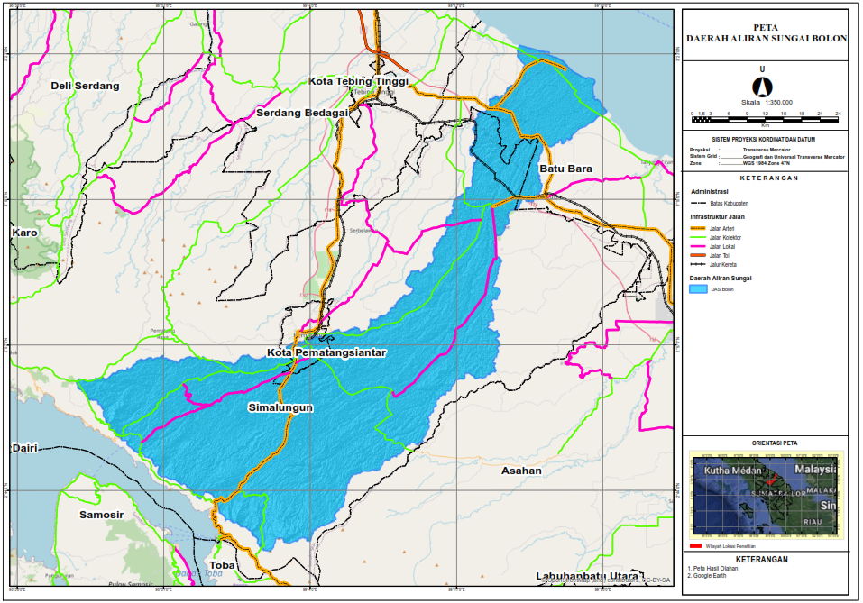
2.2 Data and Data Sources
This study uses both primary and secondary spatial datasets:
- Sentinel-2 imagery for land-cover mapping (2017, 2021, 2024).
- Digital Elevation Model (DEM) for slope derivation.
- Rainfall data from local hydrological stations.
- Supporting soil and hydrological datasets where available (e.g., soil texture).
2.3 Land-Cover Change Prediction (MOLUSCE: CA–ANN)
Land-cover change prediction was performed using QGIS with the MOLUSCE plugin. The model integrates Cellular Automata (CA) and Artificial Neural Networks (ANN) (including MLP in MOLUSCE workflows) to simulate land-cover dynamics and project future patterns for 2024, 2029, and 2033.
A conceptual CA transition formulation can be expressed as:
$$P_{t+1}=f(P_{t},N_{t})$$
where:
- $P_{t}$is the cell state at time $t$,
- $P_{t+1}$is the cell state at time $t+1$,
- $N_{t}$represents neighborhood influence,
- $f$is the transition function/rules governing change (Sugiarto, 2018).
Model performance was assessed using the Kappa Index:
$$κ=\frac{P_{o}-P_{e}}{1-P_{e}}$$
where:
- $P_{o}$is observed agreement,
- $P_{e}$is expected agreement due to chance.
2.4 Water-Use Zonation Analysis
After generating land-cover predictions, water-use zones were delineated by integrating three components: recharge areas, catchment function, and water availability.
(1) Recharge potential was derived from slope, rainfall, and soil texture:
$$I=f(S,T,C)$$
where:
- $I$is recharge/infiltration potential,
- $S$is slope,
- $T$is soil texture,
- $C$is rainfall (Prahasta, 2014).
(2) Catchment function was assessed using rainfall and land-cover characteristics affecting runoff:
$$A=\int_{0}^{T}{R(t)⋅C(t) dt}$$
where:
- $A$denotes catchment contribution (conceptual),
- $R(t)$is rainfall at time $t$,
- $C(t)$is the land-cover coefficient at time $t$.
2.5 Spatial-Plan Consistency (RTRW Overlay)
Zonation outputs were compared against RTRW spatial allocations through overlay analysis to identify mismatches and potential land–water conflicts. A weighted suitability score can be expressed as:
$$S_{t}=\sum_{i=1}^{n}{W_{i}}⋅A_{i}$$
where:
- $S_{t}$is the suitability score at time $t$,
- $W_{i}$is the weight of parameter $i$,
- $A_{i}$is the area meeting parameter $i$.
2.6 Data Analysis
Outputs were evaluated using descriptive statistics and spatial analysis (map-based interpretation, tabulation of class changes, and overlay-based consistency evaluation). The results were synthesized into policy-relevant recommendations for watershed management.

3. Results and Discussion
3.1 Land-Cover Dynamics (2017–2024)
Land-cover mapping using Sentinel-2 imagery indicates significant conversion from forest and wet agricultural land toward plantations, built-up land, and bare/unused land. This pattern reflects intensifying land-use pressure within the watershed and suggests declining hydrological buffering capacity.
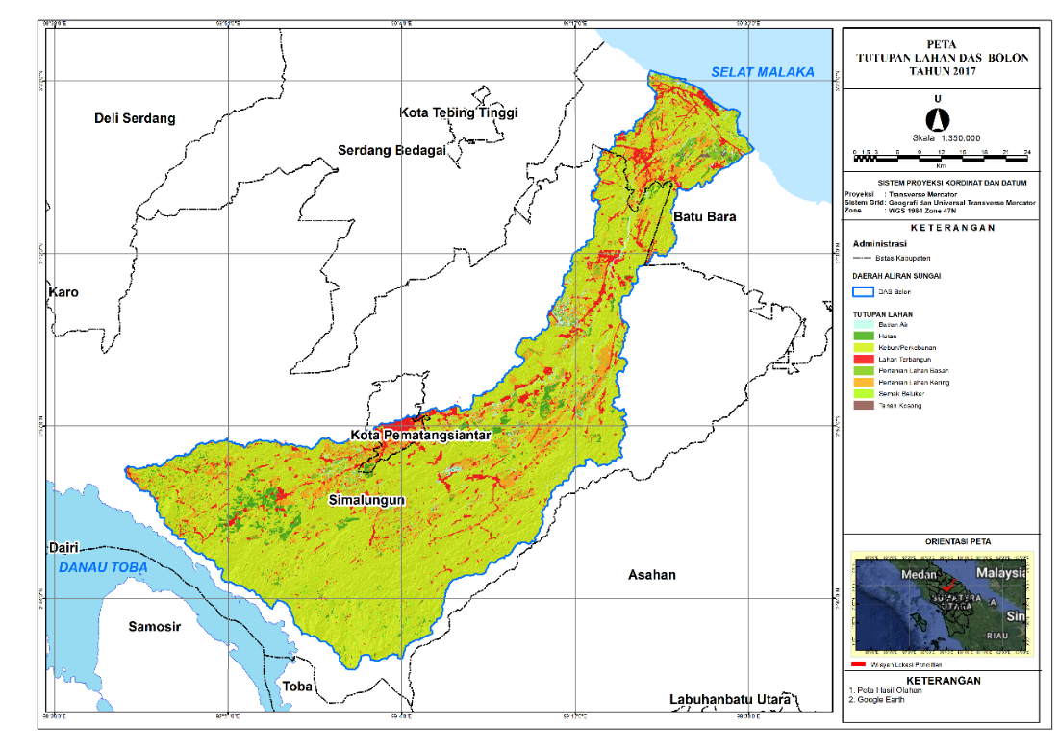
Figure 2. Land cover map (2017)
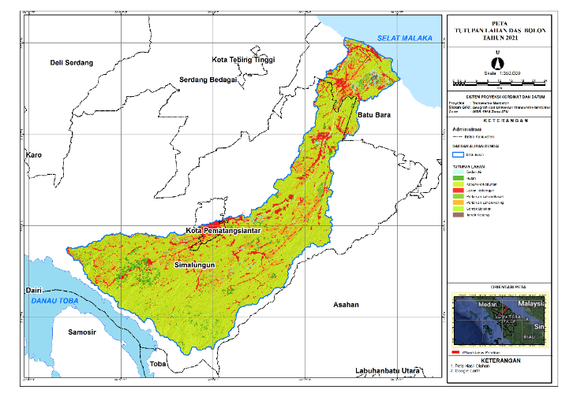
Figure 3. Land cover map (2021)
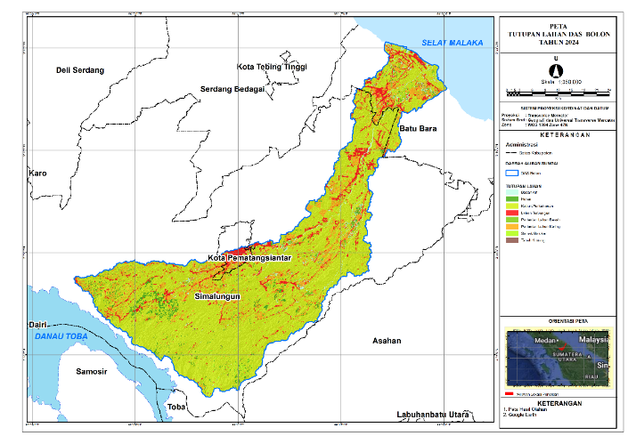
Figure 4. Land cover map (2024)

Table 1. Land-cover distribution in the Bolon watershed (2017, 2021, 2024)
Year | Forest | Wet Agriculture | Dry Agriculture | Plantation | Built-up | Bare Land | Total (km²)
2017 | 800 | 250 | 100 | 300 | 50 | 100 | 1,950
2021 | 750 | 240 | 120 | 330 | 60 | 150 | 1,950
2024 | 700 | 220 | 130 | 350 | 80 | 180 | 1,950
Table 1 indicates a clear land-cover transition in the Bolon watershed during 2017–2024, dominated by the reduction of natural and moisture-retaining land covers and the expansion of more disturbance-prone classes. Forest cover declines from 800 km² (2017) to 700 km² (2024), representing a net loss of 100 km² (≈12.5%), while wet agriculture decreases from 250 to 220 km² (−30 km²; ≈12.0%). In contrast, plantations expand from 300 to 350 km² (+50 km²; ≈16.7%), built-up land increases from 50 to 80 km² (+30 km²; ≈60.0%), and bare/unused land rises from 100 to 180 km² (+80 km²; ≈80.0%). These shifts collectively imply a progressive decline in hydrological buffering capacity because forests and wet agricultural systems typically support higher infiltration and water retention, whereas plantations (especially when associated with soil compaction and simplified vegetation structure), built-up surfaces, and bare land tend to increase surface runoff and reduce groundwater recharge. Importantly, the total watershed area is 1,950 km², while the table reports the main land-cover classes; the remaining portion corresponds to other minor or mixed classes captured in the classification but not displayed here, which should be clarified in the final table note for transparency. Overall, the observed trajectory suggests increasing watershed “flashiness” (higher peak flows after rainfall) and weaker dry-season baseflow support, particularly if conversion occurs in recharge-sensitive zones.
3.2 Predicted Land-Cover Change (2029–2033)
Future land-cover simulations suggest continued expansion of plantations and built-up areas through 2033, while forests and wet agriculture are projected to shrink further.
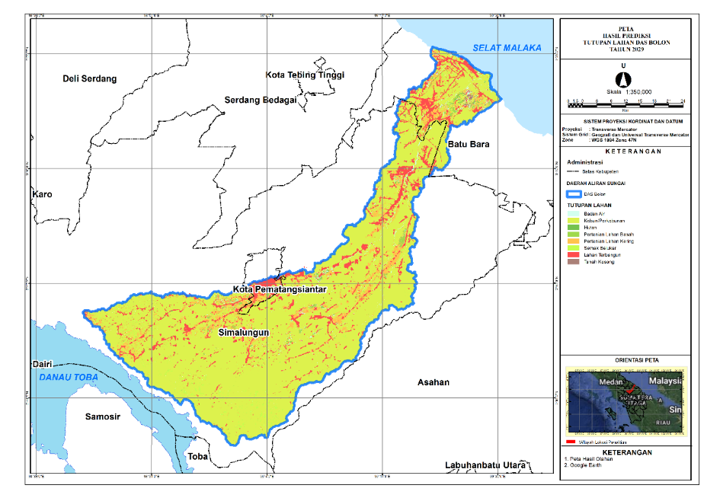
Figure 5. Predicted land cover (2029)
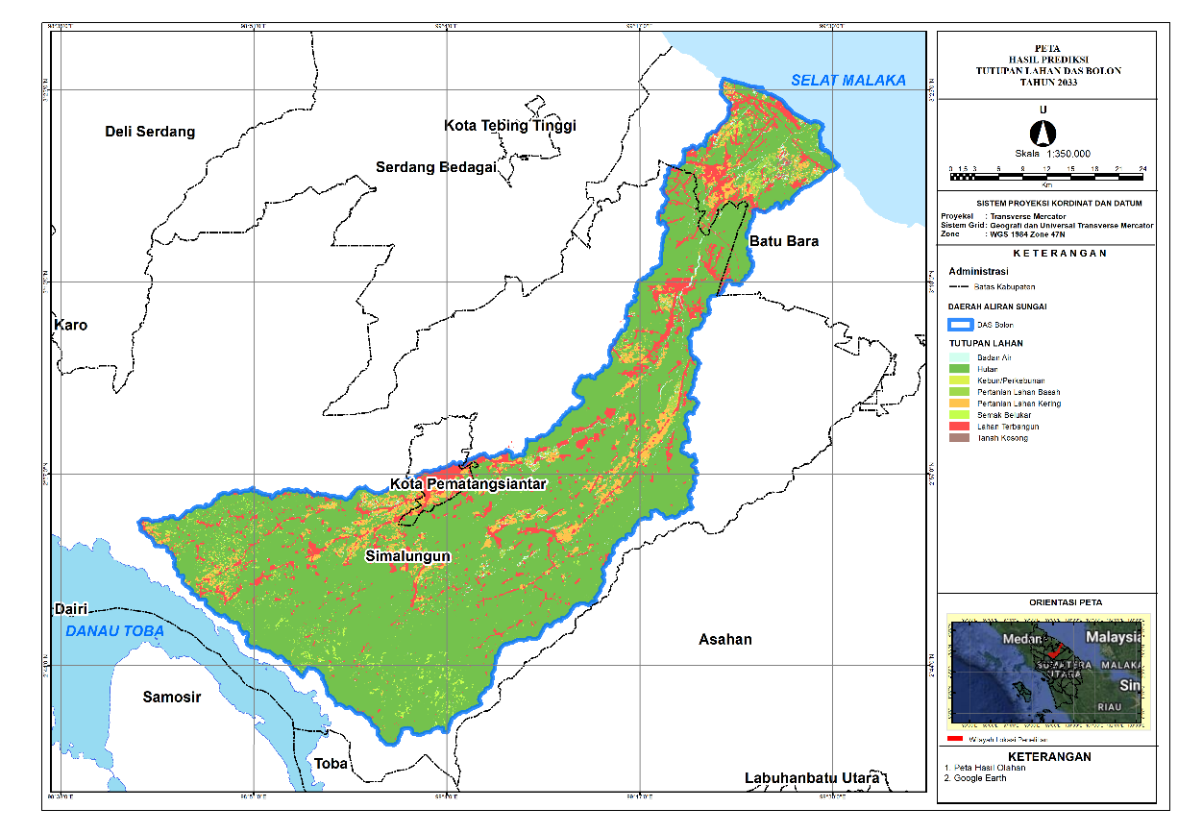
Figure 6. Predicted land cover (2033)
Table 2. Predicted land-cover distribution in the Bolon watershed (2029 and 2033)
Year | Forest | Wet Agriculture | Dry Agriculture | Plantation | Built-up | Bare Land | Total (km²)
2029 | 650 | 200 | 140 | 400 | 100 | 150 | 1,950
2033 | 600 | 180 | 150 | 450 | 130 | 180 | 1,950
Table 2 extends the observed trajectory into the future and indicates that the land-cover transition is expected to continue through 2033. Forest cover is projected to decline from 650 km² (2029) to 600 km² (2033), a further reduction of 50 km² (≈7.7%), while wet agriculture decreases from 200 to 180 km² (−20 km²; ≈10.0%). At the same time, plantations expand from 400 to 450 km² (+50 km²; ≈12.5%), built-up land increases from 100 to 130 km² (+30 km²; ≈30.0%), and bare land rises from 150 to 180 km² (+30 km²; ≈20.0%). This predicted pattern is hydrologically significant because it suggests the watershed is moving toward a land-cover composition that generally favors runoff generation over infiltration. In practical terms, continued plantation and settlement expansion can increase soil compaction and imperviousness, thereby reducing effective recharge and accelerating stormflow routing to the river network. If these conversions overlap with high-recharge and high-catchment-function areas, the consequences can include higher flood peaks during wet periods and diminished groundwater replenishment during the dry season. As with Table 1, if the listed classes do not fully sum to the watershed total, the remaining area should be explicitly reported as “other land cover” (or the missing classes should be listed) to ensure the accounting of 1,950 km² is complete and reproducible.
3.3 Impacts on Recharge Areas
Recharge zones are essential for maintaining groundwater storage and baseflow. The results indicate that conversion of forest to plantations and built-up land reduces recharge capacity, especially in areas characterized by exposed land cover and steeper slopes. Spatial outputs for 2024, 2029, and 2033 suggest an increasing share of low-recharge zones as land conversion progresses, implying heightened drought susceptibility during dry seasons.
3.4 Catchment Function and Water Availability
Catchment areas collect rainfall and route it toward the river system. The simulations indicate a contraction of effective catchment area despite a projected increase in rainfall, highlighting the structural role of land cover in shaping water availability.
Table 3. Catchment conditions and infiltration capacity (2024, 2029, 2033)
Year | Catchment Area (km²) | Rainfall (mm/year) | Infiltration Capacity (mm/year)
2024 | 1,200 | 2,500 | 1,200
2029 | 1,150 | 2,550 | 1,180
2033 | 1,100 | 2,600 | 1,150
Table 3 demonstrates that changes in land cover are associated with a structural weakening of hydrological function, even under slightly increasing rainfall. The effective catchment area decreases from 1,200 km² (2024) to 1,100 km² (2033), a net contraction of 100 km² (≈8.3%), while rainfall increases from 2,500 to 2,600 mm/year (+100 mm/year; ≈4.0%). However, infiltration capacity declines from 1,200 to 1,150 mm/year (−50 mm/year; ≈4.2%), indicating that additional rainfall does not translate into improved recharge. This divergence is consistent with land-cover conversion toward plantations, built-up land, and bare surfaces that promote faster overland flow, reduce soil permeability, and shorten residence time for water to infiltrate. Hydrologically, this pattern implies increasing flood sensitivity (greater and faster peak flows during high rainfall events) alongside reduced dry-season groundwater contribution and potentially lower baseflow sustainability. Therefore, the combined evidence suggests a growing risk of hydro-climatic stress: rainfall may intensify short-term runoff hazards, while long-term water availability becomes more uncertain due to declining infiltration and recharge performance.
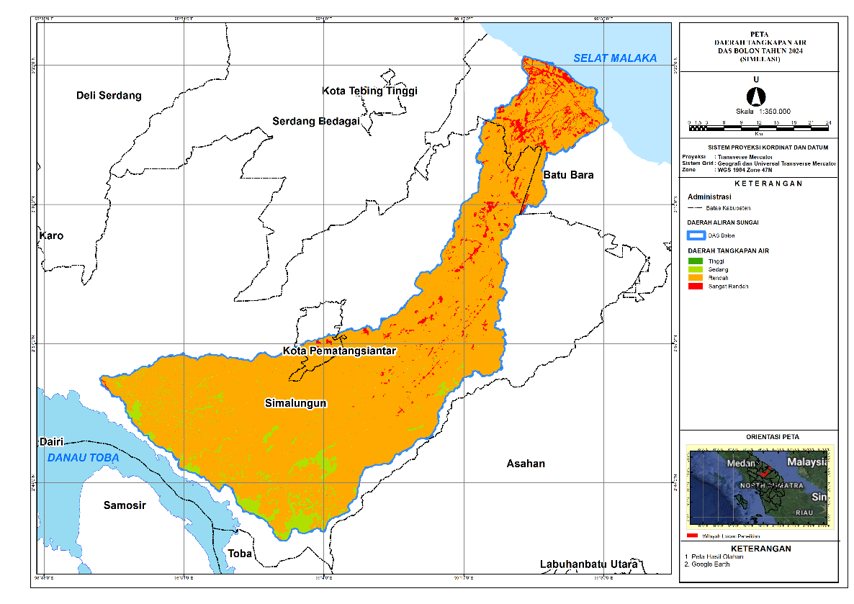
Figure 7. Catchment function map (2024)
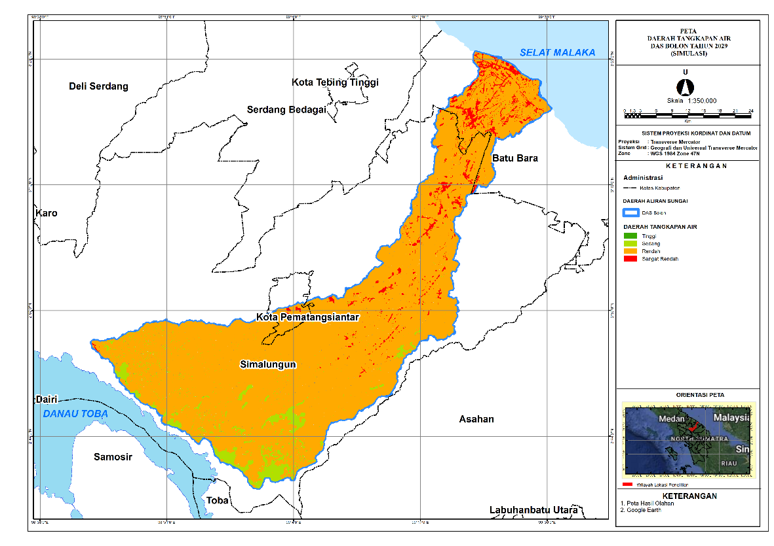
Figure 8. Catchment function map (2029)
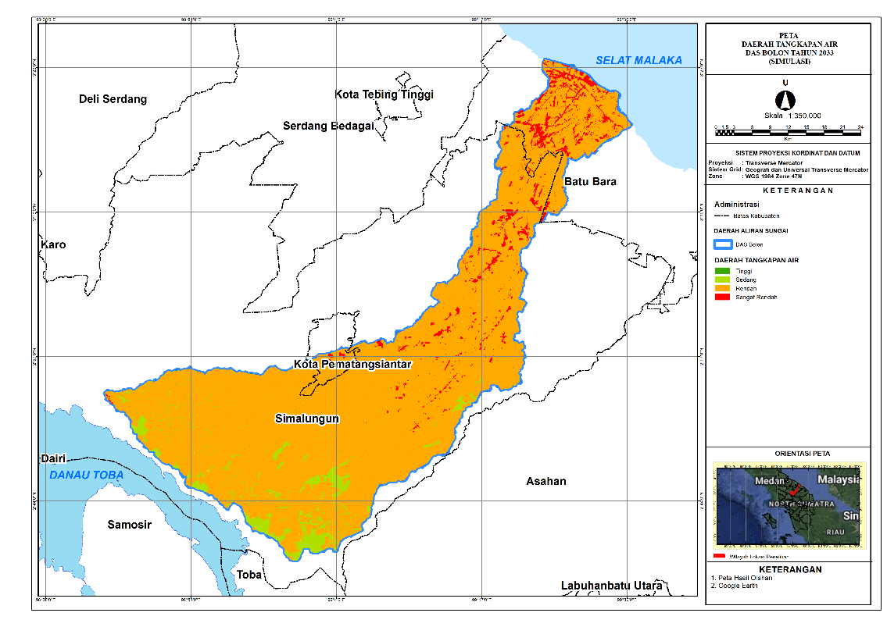
Figure 9. Catchment function map (2033)
3.5 Consistency of Water-Use Zones with RTRW
Overlay analysis shows that several water-use zones are not fully aligned with RTRW allocations, suggesting potential land–water governance conflicts.
Table 4. Overlay results: water-use zones vs. RTRW (2024)
Zone | Area (km²) | Consistency with RTRW (%)
Recharge Zone | 400 | 85%
Catchment Zone | 350 | 75%
Plantation Zone | 500 | 50%
Table 4 provides direct evidence of spatial-planning misalignment between hydrologically important zones and the RTRW allocation. Recharge zones show relatively high consistency (85%), yet the remaining 15% represents approximately 60 km² (of 400 km²) that is potentially allocated to uses not fully supportive of recharge protection. Catchment zones exhibit 75% consistency, leaving about 87.5 km² (of 350 km²) at risk of incompatible land allocation. The most critical issue is the plantation zone, where consistency is only 50%, implying that roughly 250 km² (of 500 km²) may involve land-use allocations that conflict with hydrological priorities. This pattern suggests that plantation expansion and/or plantation-designated planning areas may overlap hydrologically strategic locations that should function as recharge and catchment protection areas. From a governance perspective, such mismatches increase the likelihood of cumulative degradation because land conversion becomes legally facilitated through the spatial plan, weakening enforcement leverage for watershed protection. The overlay results therefore provide a clear basis for planning intervention: hydrological zonation should be adopted as a constraint layer in RTRW revision and permitting, with priority attention to zones showing low consistency (especially plantation-related allocations) to prevent further decline in recharge and catchment function.
3.6 Discussion
The overlay between water-use zones and the RTRW land-use structure provides a spatial diagnostic of alignment and potential conflict between watershed hydrological capacity and planned development directions. By integrating these layers, the analysis identifies where current and future land allocations are likely to support hydrological functions (e.g., recharge and flow regulation) versus where they may erode them through intensification of built-up, industrial, or high-input cultivation uses.
Across 2024, 2029, and 2033, the overlay reveals a consistent pattern. The very-low water-use zone is fully allocated to industrial cultivation areas (≈2.97 km² in 2024 and ≈2.93 km² in 2029–2033), indicating a hydrologically coherent match: areas with minimal capacity to provide/retain surface water are indeed planned for intensive economic use. In contrast, the low and medium zones dominate the watershed and are largely embedded within cultivation space, particularly agriculture (≈824.81 km² in 2024; ≈822.83 km² in 2029; ≈821.39 km² in 2033) and production forest (≈228 km² consistently). While portions of these zones fall within protected designations (e.g., water bodies, mangroves, conservation and local protection), the prevailing allocation to cultivation implies that large areas with limited-to-moderate hydrological function remain exposed to continued land-use pressure, potentially reinforcing low infiltration and elevated runoff if conservation practices are not mainstreamed.
Most critically, the high water-use zone—representing the best hydrological capacity—remains predominantly located within cultivation allocations, especially settlements and agriculture. The settlement footprint in the high zone increases from ≈59.05 km² (2024) to ≈61.46 km² (2029) and ≈62.70 km² (2033), while high-zone agriculture expands from ≈35.59 km² (2024) to ≈38.92 km² (2029) and ≈41.69 km² (2033). This persistent configuration signals a structural planning risk: hydrologically strategic areas are not sufficiently protected within the spatial plan and may experience functional degradation unless development controls, green infrastructure, and water-sensitive land management are strengthened. Consequently, the overlay indicates that the RTRW framework, while partially aligned with hydrological protection in designated protected sub-areas, may still permit cumulative impacts that reduce watershed resilience to flood–drought extremes.
Planning implications (compact)
- Priority protection: High-capacity water-use zones currently assigned to settlement and agriculture should be treated as hydrological priority areas, with stricter controls on impervious expansion and stronger requirements for green open space and drainage performance.
- Prevent “medium → low” degradation: Medium zones heavily used for agriculture and settlements should adopt conservation-oriented practices (e.g., infiltration enhancement, riparian buffers, erosion control) to avoid downward shifts in hydrological function.
- Targeted restoration: Where low-capacity zones intersect protected designations, restoration (vegetation recovery and hydrological rehabilitation) is needed to realign actual function with the protection intent.
- RTRW refinement: The recurring mismatch in high zones suggests the need to update or operationalize RTRW provisions using hydrological zonation as a constraint layer for permitting and zoning enforcement.

4. Conclusions
This study demonstrates that land-cover change has significant implications for water-use zonation in the Bolon River Watershed. GIS-based modelling using QGIS–MOLUSCE indicates that conversion from forests and wet agricultural land to plantations and built-up areas has reduced recharge potential and weakened catchment function. If these trajectories persist through 2033, the watershed will face increasing exposure to hydrological hazards, including flood and drought risks, with potential consequences for water availability and ecosystem stability.
Overlay analysis further reveals notable mismatches between water-use zones and the RTRW spatial plan, particularly within plantation zones. This suggests the need for more adaptive and proactive spatial planning that recognizes hydrological priorities and prevents development patterns from undermining watershed resilience.
Overall, the study offers spatially explicit evidence to support sustainable watershed management in the Bolon basin and provides a transferable modelling approach for other Indonesian watersheds experiencing similar land-conversion pressures.
Disclaimer (Artificial intelligence)
Option 1:
Author(s) hereby declare that NO generative AI technologies such as Large Language Models (ChatGPT, COPILOT, etc.) and text-to-image generators have been used during the writing or editing of this manuscript.
Option 2:
Author(s) hereby declare that generative AI technologies such as Large Language Models, etc. have been used during the writing or editing of manuscripts. This explanation will include the name, version, model, and source of the generative AI technology and as well as all input prompts provided to the generative AI technology
Details of the AI usage are given below:
1.
2.
3.

References
Bappeda Prov. Sumatera Utara. (2017). Rencana Tata Ruang Wilayah Provinsi Sumatera Utara 2017–2037. Badan Perencanaan Pembangunan Daerah Provinsi Sumatera Utara.
DeMers, M. N. (2005). Fundamentals of Geographic Information Systems (3rd ed.). John Wiley & Sons.
Fardani, I., Mohmed, F. A. J., & Chofyan, I. (2020). Pemanfaatan Prediksi Tutupan Lahan Berbasis Cellular Automata-Markov dalam Evaluasi Rencana Tata Ruang (Studi Kasus Kota Cirebon). Majalah Kajian Geografi, 21(2), 157–169. https://doi.org/10.23887/mkg.v21i2.28121
Gao, C., Cheng, D., Iqbal, J., & Yao, S. (2023). Yellow River Region land cover and relationship analysis with mountain hazards. Land, 12(340), 1–24. https://doi.org/10.3390/land12020340
Gregorio, A., & Jansen, L. J. M. (2000). Land Cover Classification System (LCCS): Classification concepts and user manual for software version 1.0. FAO.
Iskandar, B., Saidah, Kurnia, A. A., Jauhari, A., & Zannah, F. (2023). Modeling land cover change using MOLUSCE in Kahayan Tengah Forest Management Unit, Central Kalimantan. Jurnal Sylva Lestari, 11(1), 79–97. https://doi.org/10.23960/jsl.v12i2.734
Kumari, S., & Roy, A. (2025). Simulation of land use and land cover using the MOLUSCE plugin integrated with QGIS for the Western Himalayan Region of India. ISPRS Archives, 48(5), 81–85. https://doi.org/10.5194/isprs-archives-XLVIII-M-5-2024-81-2025
Loucks, D. P., & van Beek, E. (2017). Water resources planning and management: An overview. In Water Resource Systems Planning and Management. Springer. https://doi.org/10.1007/978-3-319-44234-1_1
Muhammad, R., Zhang, W., Abbas, Z., Guo, F., & Gwiazdzinski, L. (2022). Spatiotemporal change analysis and prediction of future land use/land cover changes using QGIS MOLUSCE and remote sensing big data: A case study of Linyi, China. Land, 11(3). https://doi.org/10.3390/land11030419
Nasrullah, & Kartiwa, B. (2010). Landuse change analysis in relation to hydrological characteristic of Krueng Aceh watershed. Indonesian Soil and Climate Journal, (31). https://doi.org/10.2017/jti.v0i31.223
Prahasta, M. (2014). Introduction to GIS and Spatial Data Analysis. PT Elex Media Komputindo.
Ramadan, G. F., & Hidayati, I. N. (2022). Prediction and simulation of land use and land cover changes using open source QGIS: A case study of Purwokerto, Central Java, Indonesia. Indonesian Journal of Geography, 54(3), 344–351. https://doi.org/10.22146/IJG.68702
Santoso, D. H., Algary, T. A., & Hilmi, I. K. (2025). Land use change analysis using plugin MOLUSCE in Yogyakarta Urban Agglomeration Area. INSOLOGI: Jurnal Sains dan Teknologi, 4(2), 160–169. https://doi.org/10.55123/insologi.v4i2.5032
Speich, M. J., Zappa, M., Scherstjanoi, M., & Lischke, H. (2020). FORests and HYdrology under climate change in Switzerland v1.0. Geoscientific Model Development, 13(2), 537–564. https://doi.org/10.5194/gmd-13-537-2020
Sugiarto, I. D. (2018). Pemetaan Tata Guna Lahan Kota Batu dengan Data Penginderaan Jauh (Undergraduate thesis). Universitas Airlangga.
Admas, M., Melesse, A. M., & Tegegne, G. (2024). Predicting the impacts of land use/cover and climate changes on water and sediment flows in the megech watershed, upper blue nile basin. Remote Sensing, 16(13), 2385. https://doi.org/10.3390/rs16132385
Salaudeen, A., Shahid, S., Ismail, A., Adeogun, B. K., Ajibike, M. A., Bello, A. A. D., & Salau, O. B. (2023). Adaptation measures under the impacts of climate and land-use/land-cover changes using HSPF model simulation: Application to Gongola river basin, Nigeria. Science of the Total Environment, 858, 159874. https://doi.org/10.1016/j.scitotenv.2022.159874

