Molecular Characterization of Campylobcter Isolates from Slaughter Slabs in Jos, Plateau State, Nigeria

ABSTRACT
OBJECTIVES: Characterization of 195 Campylobacter isolates from chicken meat and environment samples from slaughter slabs in Jos, Plateau state, Nigeria was performed to detect resistance and virulence genes and genetic relatedness of the Campylobacter species.
METHODS: Isolates identified using culture methods were confirmed for genus and specie level by multiplex PCR. Antimicrobial resistance and virulence genes were detected molecularly, and phylogenetic analysis was conducted using MEGA X to assess the genetic relatedness of the isolates.
RESULTS: Campylobacter jejuni =10.7% and Campylobacter coli =3.6% were identified by multiplex PCR. Among the 12 molecularly characterized isolates, 10 carried the tetO gene (tetracycline resistance), 9 carried the 23S rRNA gene (macrolide resistance), and 7 carried the gyrA gene (fluoroquinolone resistance). The cdtC virulence gene was detected in 8 of the 12 isolates. Phylogenetic analysis showed five major clusters, indicating genetic diversity and wide geographical distribution of the isolates.
CONCLUSIONS: The findings of this study highlights the presence of multidrug-resistant and potentially virulent Campylobacter species in chicken and environmental samples from slaughter slabs in Jos. The detection of resistance genes such as tetO, 23S rRNA, and gyrA underscores the threat posed by antimicrobial-resistant Campylobacter in poultry meat These findings underscore the need for improved hygiene practices, rational antibiotic use in poultry production, and enhanced surveillance systems to prevent the spread of resistant and pathogenic Campylobacter strains to humans.
Keywords: Campylobacter spp, polymerase chain reaction, resistance genes, bacterial illness, genetic similarity

INTRODUCTION
Campylobacteriosis is a zoonotic disease transmitted to humans from animals or animal products. Most often, carcasses or meat contaminated by Campylobacter from faeces during slaughtering serves as reservoirs (WHO,2020).Campylobacter is recognized as one of the major causes of foodborne bacterial diseases, worldwide (Tang et al., 2020). The main species responsible for acute gastroenteritis in humans. are Campylobacter jejuni and Campylobacter coli Akbar Shahid et al., 2024).These species are responsible for most of all human Campylobacter gastroenteritis cases worldwide (Akbar Shahid et al., 2024). Though, other species such as Campylobacter lari and Campylobacter upsaliensis have also been involved in sporadic cases of gastroenteritis (Kaakoush et al., 2015). These pathogens are capable of causing health infections such as urinary tract infections, sepsis, or certain neuropathies and in particular, reactive arthritis, Guillain-Barre´ syndrome (GBS), irritable bowel, and Miller Fisher syndrome (MFS)( Scallan et al., 2015). The poultry birds serves as reservoir for a lot of human cases. Livestock, particularly chickens and poultry, are significant carriers of Campylobacter species (Amjad and Zia, 2023). These are commonly found in their fecal samples and exhibit resistance to various antibiotics like quinolones, macrolides, tetracyclines, aminoglycosides, and chloramphenicol (Gloanec et al., 2022).
The multidrug resistance of Campylobacter species has become a worldwide issue, with particular concerns regarding resistance to important medications such as fluoroquinolones and macrolides (Lekshmi et al., 2023; Qin et al., 2023). The resistance to fluoroquinolones and macrolides has substantially increased due to chromosomal mutations that lead to the development of drug resistance (Conesa et al., 2022; Milton et al., 2020).While campylobacteriosis is often self-limiting, the growing problem of antimicrobial resistance poses a significant challenge in managing this illness (Lekshmi et al., 2023; Qin et al., 2023). Although, infections caused by Campylobacter are usually self-limiting and may not require antibiotic treatment, but therapy becomes necessary in some cases of prolonged enteritis and septicemia. Macrolides (erythromycin and azithromycin), fluoroquinolones (ciprofloxacin), and tetracyclines are commonly used drugs for treating human campylobacteriosis.treatment of human campylobacteriosis ( Gharbi et al., 2023). The overuse of antibiotics in human infections and the misuse of antimicrobial drugs in animal husbandry are the main reasons for the increased resistance rates in Campylobacter species (Liu et al., 2022). Studies have been carried out on the epidemiology of campylobacteriosis, indicating its prevalence worldwide (Wanja et al., 2021;Gharbi et al., 2023). Although the illness is frequently self-limiting, the rising incidence of AMR presents a significant challenge. Antimicrobial Resistance poses major challenges to treatment and disease management. Many studies investigates the AMR in Campylobacter as a global public health problem, with resistance rates increasing worldwide(Ngulukun et al., 2017;Suman Kumar et al.,2021).Therefore, emergence of resistant Campylobacter strains has serious implications for food safety and public health. Subsequently, fluoroquinolone and macrolide resistance have doubled in the past 20 years, highlighting the urgency of addressing (Mohan et al., 2025).
Antibiotic resistance in Campylobacter species involves various molecular mechanisms such as point mutations in specific genes like gyrA, tet(O), and 23S rRNA, as well as the activation of multidrug efflux pumps like CmeABC. Fluoroquinolone resistance in Campylobacter is primarily caused by mutations in the quinolone resistance-determining region (QRDR) of the DNA gyrase gene, gyrA. High resistance to tetracycline in Campylobacter is often linked to the tet (O) gene, which encodes a protective ribosomal protein (Poudel et al., 2022). Resistance to macrolides in Campylobacter is commonly associated with point mutations in the V domain of the 23S rRNA gene and the activation of the CmeABC multidrug efflux pump (Gharbi et al.,2023). Various genes such as erm(B), aadE, sat4, blaOXA-61, and aphA-3 are also been responsible for antimicrobial resistance in Campylobacter strains, leading to multidrug resistance (Paravisi et al., 2020). Campylobacter strains exhibit resistance to different types of antibiotics including erythromycin, streptomycin/streptothricin, β-lactams, and aminoglycosides due to the presence of specific resistance genes (Ramatla et al., 2022).
Molecular studies have shown the main virulence factors involved in the pathogenesis of Campylobacter causing various health issues like urinary tract infections, sepsis, reactive arthritis, Guillain-Barre´ syndrome, irritable bowel, and Miller Fisher syndrome. These includes adherence, invasion of intestinal epithelial cells, toxin production, and survival in host cells (Gharbi et al., 2022).
Several studies have revealed a significant association between virulence genes and antimicrobial resistance (AMR) in bacterial pathogens, suggesting a link between antibiotic resistance and potential colonization or invasion capacities of these bacteria. Such association has been studied and some reports have shown that infection in humans with antimicrobial resistant strains of Campylobacter is associated with a longer period of diarrhea (Liu et al., 2022).
Molecular techniques have been used from previous studies to accurately identify Campylobacter species, including C. jejuni and C. coli, which are the most common culprits in human infections (Audu et al.,2022;) Understanding the genetic diversity of Campylobacter in slaughter slabs and evolutionary relationships within geographical locations and the various hosts can aid researchers to track the pathogen movements and understand their origins and how environmental drivers of disease spread play a role (Du et al.,2019).Understanding the molecular mechanisms of antibiotic resistance, virulence potential and genetic diversity of Campylobacter in slaughter slabs is crucial for developing effective strategies to combat the growing issue of multidrug resistance and reducing contamination and preventing human infections. The knowledge of molecular epidemiology of Campylobacter from chicken in slaughter slabs in Jos, plateau state is limited, therefore, investigating the species dominant in chicken, determine the antimicrobial resistance genes and cdtC virulence gene in Campylobacter isolates from chicken and slaughter slabs environments can provide valuable insights into the mechanisms of resistance and the potential for their spread. By understanding the genetic diversity of Campylobacter in slaughterhouses and slabs, this study can inform strategies for reducing contamination and preventing human infections. From our previous study, we have reported the occurrence and the geographic distribution of Campylobacter infection from various slaughter slabs from processed chickens and environmental samples and have reported the antibiotic susceptibility profile in the isolated strains (Olabode et al.,2025). Thus, the objectives of this study are to identify the specific Campylobacter species present, investigating the presence and prevalence of antimicrobial resistance genes and cdtC virulence gene in Campylobacter isolates from slaughter slabs and assess the diversity of Campylobacter strains using molecular techniques.

MATERIALS AND METHODS
Determination of multidrug resistance (MDR)
The total number of 195 Campylobacter isolates were previously recovered from processed chicken and environmental samples and tested against erythromycin (Ery), ciprofloxacin (Cip), nalidixic acid (Nal), tetracycline (Tet), ampicillin (Amp), azithromycin (Azi), gentamicin (Gen), and chloramphenicol (Chl). Their antimicrobial resistant pattern were shown in our previous study (Olabode et al., 2025).
DNA Extraction
Presumed Campylobacter culture on (mCCDA) selective media plate was suspended in200ul sterile distilled water in 15ml Eppendorf tube. The suspension was further vortexed briefly for 10 seconds and immediately boiled at 100°C for 15minutes. To extract the DNA, the samples were cooled immediately on ice for 5 minutes and centrifuged at 13,000xg for 10 minutes (Raja et al., 2017). The supernatant was further used as the DNA templates for PCR.
PCR assay was carried out to confirm the isolates (Fermentas, Germany). PCR was carried out in a 2X master mix composition of Taq 2X Master Mix (New England Biolabs™) containing 10 mM Tris-HCl, 50 mM KCl, 1.5 mM MgCl_{2,}0.2 mM of each dNTPs. The mix was carried out in a 25µl total volume of enzyme mix per sample.
Amplification of Target DNA
Primers (InqabaBiotech South Africa) was used to amplify a 439-bp 16S fragment from the genus Campylobacter (Moreno et al., 2003). The isolates were confirmed using multiplex PCR as described by Wang et al. (2008). The primers used targets the 16S rRNA and the lpxA genes.
To differentiate the organism at the specie level, lpxA gene which codes for the enzyme lpxA were used (Klena et al., 2004) These set of primers are robust and stable, possess a high level of discrimination and have been used by many authors to differentiate Campylobacter species (Klena et al., 2004; Lv et al., 2020). Campylobacter genus and species-specific identification were performed by PCR on a Gene AMP PCR system 2700 (Applied Biosystems, USA) thermocycler.
Genus specific
The 25ul reaction mix comprised of 12.5ul Bioline Mytaq Red MixR, (0.11 units/ul Taq DNA polymerase,82.5mM Tris-HCL pH8.5, 22mM (NH4)2SO4, 1.65mM MgCl2, 0.22mM dNTPs), 1.0ul each of Cam 220 forward primer and Cam659 reverse primer gene, sterile distilled water to volume and 2ul of the genomic DNA. The cycle conditions used were as follows: an initial incubation at 94°C for 60 seconds, followed by 35 cycles of denaturation at 94°C for 60 seconds, annealing at 64°C for 30 seconds, and elongation at 72°C for 30 seconds, and finally 7 minutes of extension at 72°C(NCBI,2014). The primer product(amplicon) was separated by electrophoresis (Bio-Rad, USA) in 15% agarose gel at100 volts for 45minutes in Tris Boric EDTA(TBE). Then the gel was visualized by ethidium bromide staining, illuminated by ultraviolet transilluminator and documented by a gel documentation system Chemi Genius-SYNGENE). A 100bp DNA ladder was used as size reference for the PCR assay.
Species Specific
After genus confirmation, a multiplex PCR was performed for species identification using primers target the lipid A lpxA gene in two Campylobacter species namely C.jejuni and C. Coli (Klena et al., 2004). The 25ul reaction mix had 12.5ul of Bioline My Taq MixR, 1.0ul of forward primers complementary to the lpxA gene for C.jejuni and C.coli with the 3.0ul reverse primer ARKK2m, 25 sterile distilled water to volume and 3.0ul of the genomic DNA. The cycle conditions used were as follows: an initial incubation at 94°C for 60 seconds, followed by 35 cycles of denaturation at 94°C for 60 seconds, annealing at 64°C for 30 seconds, and elongation at 72°C for 30 seconds, and finally 7 minutes of extension at 72°C (NCBI, 2014). The primer product (amplicon) was separated by electrophoresis (Bio-Rad, USA) in 15% agarose gel at100 volts for 45minutes in Tris Boric EDTA (TBE). Then the gel was visualized by ethidium bromide staining, illuminated by ultraviolet transilluminator and documented by a gel documentation system Chemi Genius-SYNGENE). A 100bp DNA ladder was used as size reference for the PCR assay. Positive and negative control were used in all the PCR reactions.
Table 1: Sequence of the oligonucleotides (primers) used in the multiplex PCR and their expected amplicon sizes (bp)
Target | Primers | Sequence (5' to3') | Amplicon size (bp)
16SrRNAª | Cam220F  Cam659R | GGTGTAGGATGAGACTATATA  TTCCATCTGCCTCTCCCY | 439  439
lpxA^{b} | lpxA C. jejuni  lpxA C. coli  lpxA C. Lari  lpxAC.upsaliensi  lpxA ARKK2m | ACAACTTGGTGACGATGTTGTA  AGACAAATAAGAGAGAATCAG  TRCCAAATGTTAAAATAGGCGA  AAGTCGTATATTTTCYTACGCTTG  CAATCATGDGCDATATGASAATAHGCCAT | 331  391  233  206

a. Primers adapted from Moreno et al., (2003)
b. Primers adapted from Klena et al., (2004)

Detection of antimicrobial resistance genes in the Campylobacter isolates
Detection of the antimicrobial resistance genes in the Campylobacter isolates were done using specific primers. Following identification, 75% of chicken isolates and 25% of slaughter slab environment isolates were subjected to detection of three antimicrobial resistance genes as follows: gyrA (1083 bp), 23RRNA (852 bp) and tetO (559bp). PCR primers were synthesized and sourced from Inqaba Biotechnologies (Pretoria, South Africa). PCRs were carried out in the BIO-RAD, T100™ Thermal Cycler (Singapore) for a 25μL reaction. The amplification conditions for gyrA (1083 bp), and23RRNA (852 bp) consisted of an initial denaturalisation at 95°C for 5 min, 35 cycles at 95°C for 50s, specific Tm for each primer for 30 s and 72°C for 1 min, followed by a final extension at 72°C for 7 min. PCR conditions for the tetO gene, a 559 bp product, were as follows: an initial denaturalization of 95°C for 1 min, and then 95°C for 1 min, 49°C for 1 min and 72°C for 1 min, repeated for 35 cycles. PCR products were then electrophoresed on a 1.5% agarose gel run at 60 V for 60 min, stained with ethidium bromide and then visualized using the ChemiDoc™ MP Imaging System (BIO-RAD).
Detection of CdtC gene in the Campylobacter isolates
CdtC as one of the regulatory subunit gene responsible for expression of toxin production in campylobacter was screened in this study. The primer and PCR cycling condition was obtained from Inqaba Biotechnical industries (Pty) Ltd, Pretoria, south Africa. PCRs were carried out in the BIO-RAD, T100™ Thermal Cycler (Singapore) for a 25μl reaction using ThermoScientific DreamTaq Green PCR Master Mix (2X), A total of 12.5μl DreamTaq Green PCR Master Mix was used, with 1.5μl of each primer, 5μl template DNA and 4.5μl nuclease-free water making a total volume of 25μl. The cdtC gene was run using amplification conditions according to Rizal et al., (2010), the conditions consisted of an initial denaturalization at 94°C for 15 minutes, 45 cycles at 94°C for 1 minute, specific Tm for each cdt primer for 1 minute, and 72°C for 1 minute, followed by a final extension at 72°C for 7 minutes. PCR products were then electrophoresed on a 1.5% agarose gel run at 60V for 60 minutes, stained with ethidium bromide and then visualized using the BIO-RAD, ChemiDoc™ MP Imaging System.

Table 2: Details of Antibiotic resistance genes and cdtC Virulence gene primers and their Expected Amplicon Sizes of Target Genes Used
Target gene | Primer sequence (5'-3') | Amplicon size (bp) | Reference
GYRA F:  GYRA R: | CAACTGGTTCTAGCCTTTTG  AATTTCACTCATAGCCTCACG | 1083 | Sahin et al., 2017
TET (O) F:  TET (O) R: | GCGTTTTGTTTATGTGCG  ATGGACAACCCGACAGAAG | 559 | Pratt and Korolik, 2005
23rRNA F:  23rRNA R: | GCTCGAAGGTTAATTGATG  GCTCTTGGCAGAACAAC | 852 | Perez-Boto et al., 2014
cdtC F:  cdtC R: | CGATGAGTTAAAACAAAAAGATA  TTGGCATTATAGAAAATACAGTT | 182 | Ngobese et al., 2020

Sequencing of 16S rRNA Gene
The positive PCR products were subsequently sequenced through standard Sanger’s sequencing method with the BigDye terminator v3.1 sequencing kit and a 3730xl automated sequencer (Applied Biosystems, Foster City, CA, USA). A sequencing analysis was performed on six(6)of C. jejuni strains isolated. Primers and methods used for PCR amplification, purification of the PCR products, and sequencing were performed according to the method described by Kim et al. (2011). The amplified PCR products were sequenced by the Inqaba biotec Africa Genomics company. The nucleotide sequences acquired in this examination were analysed using the BIO-WEB online tool and Muscle (EMBL’s European Bioinformatics Institute, 2020) programs.
Identification of the isolates from their sequences:
The sequences for each of the isolates were first retrieved from Finch TV version 1.4 as reported previously (Sevindik et al., 2024). The sequences were then cleaned using the BIO-WEB online tool to remove non-nucleotides (non-AGTCs) from all the sequences. The cleaned sequences were then identified at NCBI using the BLAST (Basic Local Alignment Search Tool), which were the BLASTn (nucleotide) and BLASTx (protein) options, respectively. The sequences (n = 6) were identified to be the complete genome of Campylobacter jejuni with 99% similarity.
Phylogenetic tree:
Following BLAST, a similar complete genome of C. jejuni was retrieved from the NCBI nucleotide database in FASTA format for the construction of a neighbour-joining tree. The phylogenetic tree was constructed using the Molecular Evolutionary Genetics Analysis (MEGA) version x (Kumar et al., 2018). Previously deposited sequences (n=32) of the C. jejuni complete genome with a coverage of 800 to 1200 bases in length were retrieved and utilised in the construction of the neighbour-joining tree. In MEGA, alignment is done using MUSCLE (Edgar, 2004). Following alignment, a neighbour-joining tree was constructed as previously reported (Kaur et al., 2018) with bootstraps set at 1000.
Data Analysis
Data management and analysis were done using Statistical Package for social Sciences (SPSS) version 27, program excel (Microsoft office Excel 2010, Professional Edition) and SAS software (version 9.0). Descriptive statistics were used to describe the result of prevalence. Prevalence was estimated as the number of samples detected positive to Campylobacter from the total sample analyzed.. The sequenced 16S rRNA gene of the 6 isolates was compared to nucleotide sequences available in GenBank. Phylogenetic tree was constructed using the Molecular Evolutionary Genetics Analysis (MEGA) version X.

RESULTS
Table 3 presents percentages of Campylobacter species from different slaughter slabs. Jos main abattoir slaughter slab has the highest number of Campylobacter species
Table 3: Percentages of Campylobacter species from slaughter slabs
 | Slaughter Slabs Location n (%)
Campylobacter species | Jos Main Abattoir | Terminus | Chobe | Kugiya | Trade Center
Campylobacter jejuni | 11(91.7) | 5 (83.3) | 3 (100.0) | 2 (40.0) | 0 (0.00)
Campylobacter coli | 1 (8.3) | 1 (16.7) | 0 (0.00) | 3 (60.0) | 2 (100.0)
Total | 12 (100.0) | 6 (100.0) | 3 (100.0) | 5(100.0) | 2 (100.0)

Table 4 presents the distribution of multidrug Resistant Campylobacter Species in Chicken and Environmental Samples from Slaughter Slabs in Jos Metropolis by Multiplex PCR Reaction. Campylobacter jejuni occurred more than Campylobacter coli. The overall isolation rate of multidrug Campylobacter species is 14.4%, Campylobacter jejuni (10.8%) while Campylobacter coli (3.6%) respectively. Chi-square tests indicate that occurrence of multiple drug-resistant Campylobacter is significantly associated with the species (χ² = 10.714, df = 1, p = 0.0001).
Table 4: Distribution of Confirmed Campylobacter Species in Chicken and Environmental Samples from Slaughter Slabs in Jos Metropolis by Multiplex PCR Reaction
Chicken Sources | Number Tested | Number (%) positive | Number (%) Positive |  | Df | X² | P value
 |  |  | C. jejuni | C. coli | 1 | 10.714 | 0.001
Broiler caeca | 165 | 18(10.9) | 18(10.9) | - | 1 | 10.714 | 0.001
Layer caeca | 15 | 0(0.0) | - | - | 1 | 10.714 | 0.001
Chicken swab | 6 | 3(50) | 3(50) | - | 1 | 10.714 | 0.001
Environmental samples |  |  |  |  | 1 | 10.714 | 0.001
Hand swab | 3 | 3(100) |  | 3(100) | 1 | 10.714 | 0.001
Knives swab | 4 | 2(50) |  | 2(50) | 1 | 10.714 | 0.001
Cutting board swab | 2 | 2(100) |  | 2(100) | 1 | 10.714 | 0.001
Total | 195 | 28(14.4) | 21(10.8) | 7(3.6)

Table 5 Shows antimicrobial resistance genes detection in Campylobacter species from processed chicken samples and environmental samples of slaughter slabs. All the three (n=3 ) genes investigated 100% were positively amplified 75% (n=9) chicken and 25%(n=3) environmental samples.
The gyrA gene 1083bp was detected at 66% and 33% chicken and environment isolates respectively. Tet (o) gene which confers tetracycline resistance was the most prevalent among the other resistance genes investigated with prevalence of 100% and 33% from processed chicken and environment isolates respectively. 23SrRNA which confers resistance to macrolide (erythromycin and Azithromycin) was the second most prevalent present at 77% and 66% from the isolates. From the isolates, tet (o) gene was observed to be higher in the isolates obtained from chicken samples than from the ones from environmental samples.
Table 5: Detection of antimicrobial Resistance genes (ARGs) in Campylobacter isolates
Antimicrobial Resistance Genes | Resistance detected | Processed Chicken samples  C. jejuni (75%) n=9 (%) | Environmental samples  C. coli (25%)  n=3(%) | Total %  N=12
Tet(o) | Tetracycline | 9(100) | 1(33) | 10(83)
23SrRNA | Mycrolide | 7(77) | 2(66) | 9(75)
GyrA | Fluoroquinolones | 6(66) | 1(33) | 7(58)

Table 6 is detection of cdtC Virulence Gene in Camptlobacter isolates many of the isolates 8/12(67%) harbored the cdtC gene based on PCR detection of 182bp. Campylobacter cytotoxin factor(cdtC) was detected in77.7%(n=9) of Campylobacter jejuni from chicken samples and 33.3%(n=3) of Campylobacter coli from environment samples.
Table 6: Frequency table showing distribution of cdtC Virulence Gene in Campylobacter species
Campylobacter species | Number Tested | Number positive % (N=12)
Campylobacter jejuni | 9 | 7 (77.7)
Campylobacter coli | 3 | 1 (33.3)
Total | 12 | 8 (66.7)

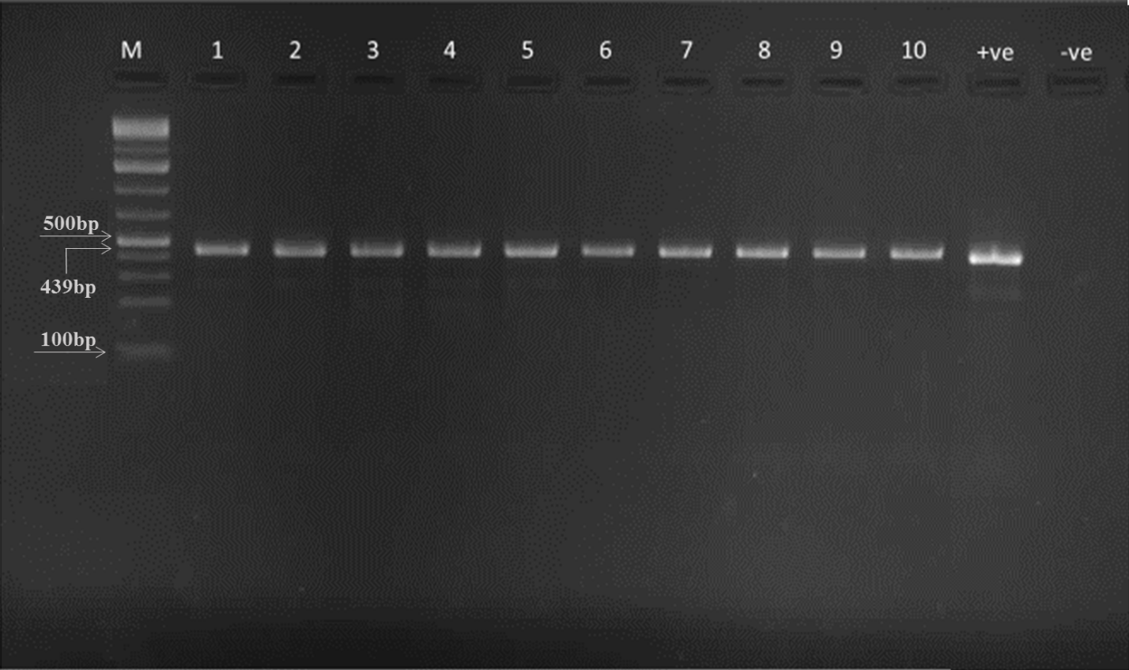
Plate 1: Representative gel image for multiplex PCR agarose Gel Electrophoresis of 16SrRNA Gene of the Isolates. Lanes 1 – 10 are 16SrRNA Gene bands at 439bp.
Line 1-10 positive for Campylobacter isolates
Key:
ML: Molecular Ladder(100bp)
439bp: Campylobacter isolates expected band size
+VE: Positive control
-VE: Negative control
Plate 2: shows representative gel image for multiplex PCR agarose gel electrophoresis analysis for Campylobacter species. On 331 base pair ladder and 391 base pair ladder (Lanes 3,4,5 and 8) showed molecular relatedness with the primers for Campylobacter jejuni and Campylobacter coli respectively. All the samples ran equal distance with the positive control at the positive(+VE) lane.

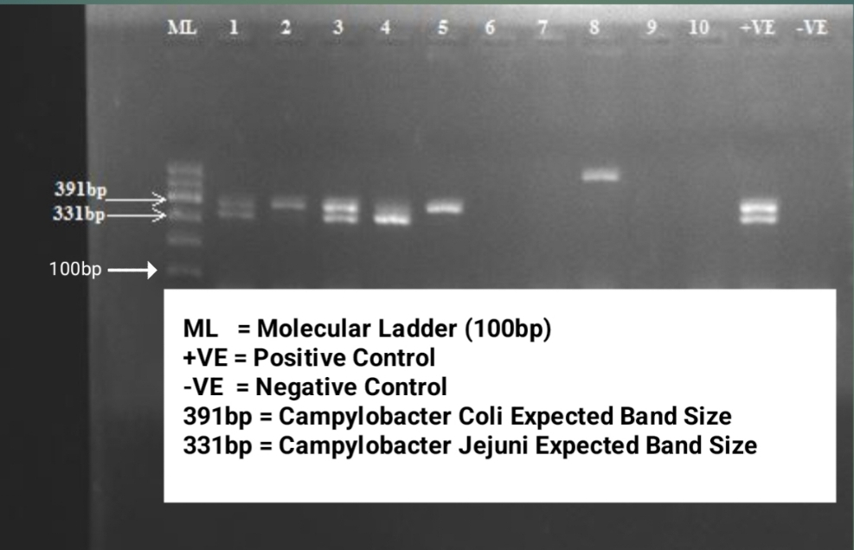
Plate 2: Representative gel picture of Campylobacter species Multiplex PCR agarose gel electrophoresis analysis
Line 3, 4, 5, 8 positive for Campylobacter species
Key:
ML: Molecular Ladder(100bp)
391bp: Campylobacter coli expected band size
331: Campylobacter jejuni expected band size
+VE: Positive control
-VE: Negative control

Plate 3 is representative gel image for multiplex PCR agarose gel electrophoresis analysis for campylobacter resistance genes. On 559 bas pair ladder, lane1 and lane2 shows positivity for tet(o) gene. Also 852 base pair ladder, lane5 and lane6 shows positivity for 23rRNAgene. Equally, on 1083 base pair ladder, lanes (9 and 10) show positivity for gyrA gene. Positive and negative controls were used and all the samples ran equal distance with the positive control at the positive(ve) lanes.

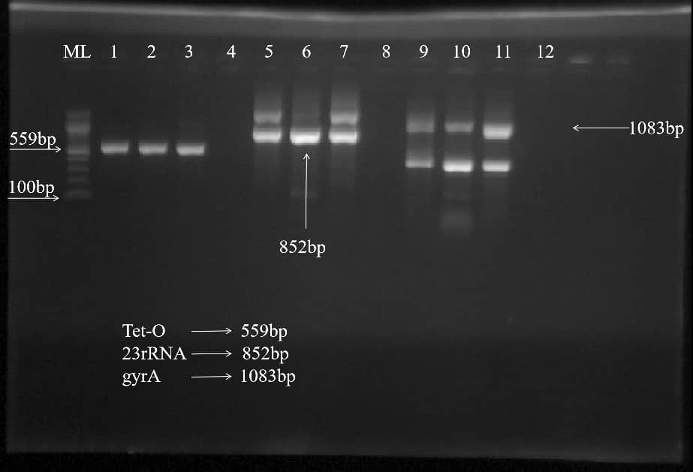
Plate 3: Representative gel image of resistance genes investigated from Campylobacter spp.
Lanes 1&2: positive for Tet (0) gene; Lane 3: positive control for tet(O) gene; Lane 4: negative control for tet(O) gene; lanes 5&6: positive for Ery23rRNA gene; lane 7:positive control for Ery23rRNA gene; Lane 8:negative control for Ery23rRNA gene; Lanes 9&10: positive for GYRA gene; Lane 11: positive control for GYRA gene; Lane 12: negative control for GYRA gene
Key:
ML: Molecular Ladder(100bp); Tet(O): 559bp; ERY23rRNA: 852bp; GYRA: 1083bp

Plate 4 is representative gel image for multiplex PCR agarose gel electrophoresis analysis for campylobacter cdtC virulence gene. On 182 base pair ladder, lanes (1, 2 and 3) shows positivity for cdtC gene. Both positive and negative control were used and all the samples ran equal distance with the positive control at the positive(+ve) lanes.
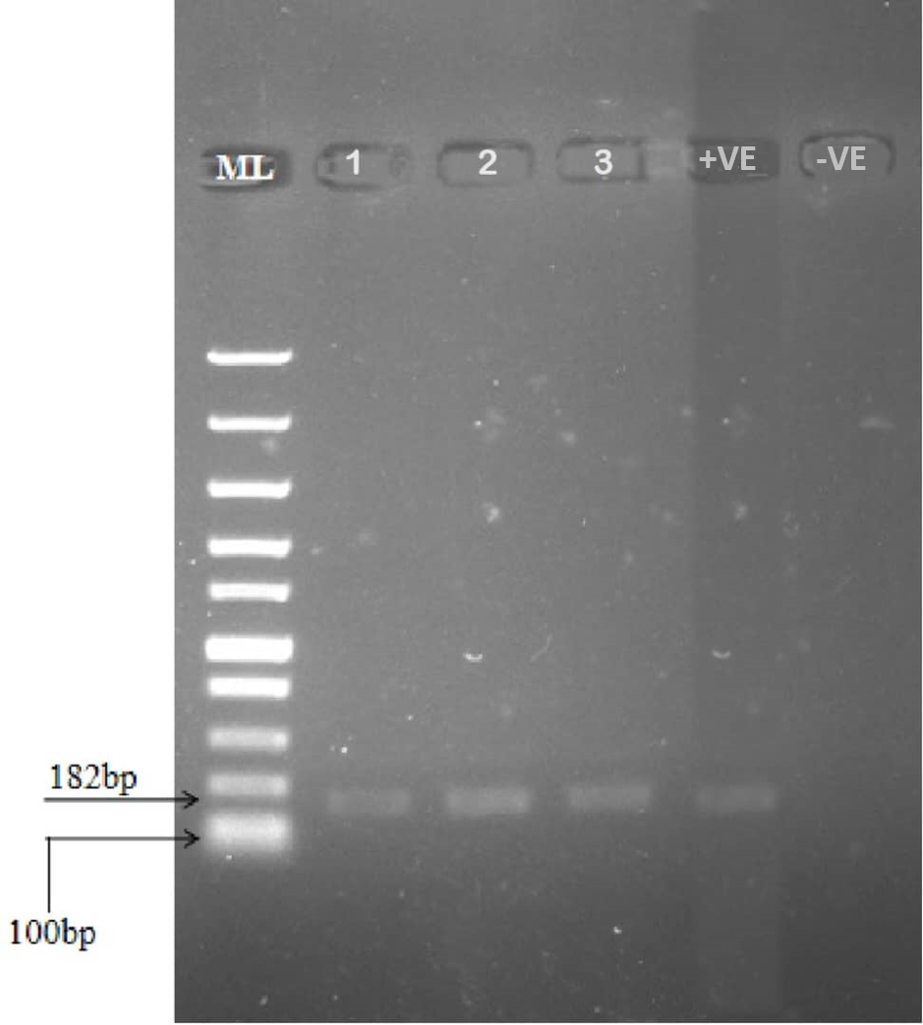
Plate 4: Representative gel image of CDTc virulence gene from Campylobacter species.
Lanes 1,2 &3= positive for CDTc virulence gene at 182bp; Lane 4= positive control; Lane 5= negative control

Figure 1 presents the Phylogenetic tree showing genetic relatedness of the Campylobacter isolates.
This revealed five major clusters comprising sequences from diverse geographic locations and sources. The first cluster contained 12 sequences, including those from Canada (human), the USA (n = 1 from bovine), Finland (n = 1 from feces), India (n = 2 from human), China (n = 3 from human), the USA (unspecified source), China (n = 2 from Macaca), and Brazil (n = 1 from chicken). The second cluster included 5 sequences from the USA (n = 2 from chicken and human), Lithuania (n = 1 from Corvus), Finland (n = 1 from Corvus monedula), and one from an unspecified source.
The third cluster consisted of 5 sequences from the UK (n = 1 from human feces), China (n = 1 from chicken), and our samples from Nigeria (n = 3, with two from chicken and one from the environment). The fourth cluster contained 6 sequences, including two from the UK (environment), one from Finland (feces), and three from our samples from Nigeria (n = 3 from chicken). The final cluster had 10 sequences from Brazil (n = 2 from chicken), the Czech Republic (n =1 from human), China (n = 1 from Macaca), Slovakia (n =1 from an unspecified source), Thailand ( n =1 from chicken), Finland (n = 2 from Corvus monedula), the USA (n = 1 from chicken), and Canada (n =1 from feces). This clustering pattern highlights global diversity and sources contributing to the phylogenetic structure.
Sequences of Campylobacter 16rRNA gene and interpretation of the phylogenetic tree
The phylogenetic tree revealed five major clusters comprising sequences from diverse geographic locations and sources. The first cluster contained 12 sequences, including those from Canada (human), the USA (n = 1 from bovine), Finland (n = 1 from feces), India (n = 2 from human), China (n = 3 from human), the USA (unspecified source), China (n = 2 from Macaca), and Brazil (n = 1 from chicken). The second cluster included 5 sequences from the USA (n = 2 from chicken and human), Lithuania (n = 1 from Corvus), Finland (n = 1 from Corvus monedula), and one from an unspecified source. The third cluster consisted of 5 sequences from the UK (n = 1 from human feces), China (n = 1 from chicken), and our samples from Nigeria (n = 3, with two from chickens and one from the environment). The fourth cluster contained 6 sequences, including two from the UK (environment), one from Finland (feces), and three from our samples from Nigeria (n = 3 from chicken). The final cluster had 10 sequences from Brazil (n = 2 from chicken), the Czech Republic (n =1 from human), China (n = 1 from Macaca), Slovakia (n =1 from an unspecified source), Thailand ( n =1 from chicken), Finland (n = 2 from Corvus monedula), the USA (n = 1 from chicken), and Canada (n =1 from feces). This clustering pattern highlights global diversity and sources contributing to the phylogenetic structure.

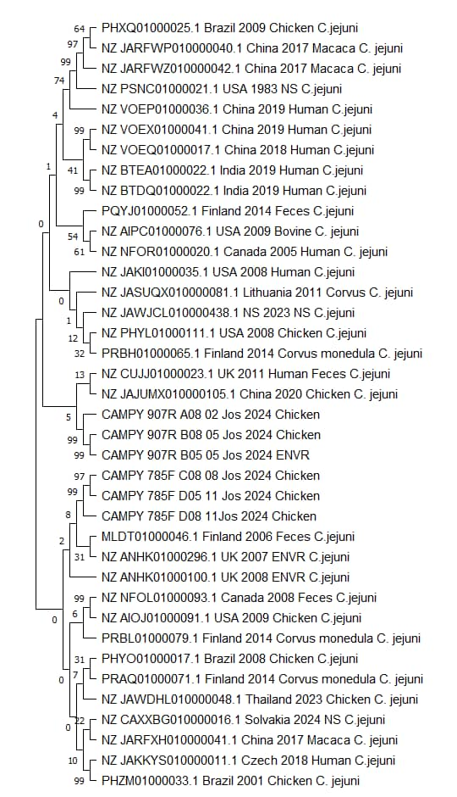
Figure 1: Sequences of Campylobacter 16rRNA gene and constructed Phylogenetic tree using the Molecular Evolutionary Genetic Analysis (MEGA) version X

DISCUSSION
Distribution of Campylobacter species confirmed by PCR in this present study showed that Campylobacter jejuni was the most prevalent species followed by Campylobacter coli. This result is consistent with the studies by Varga et al. (2019) and Kouglenou et al. (2020) who reported the predominance of Campylobacter jejuni and Campylobacter coli respectively. Other studies, such as those by Neogi et al. (2020) and Berhanu et al. (2021) also confirmed the predominance of C. jejuni in poultry meat. The variation in the distribution of Campylobacter species as reported by the studies of Agbankpe et al. (2022) may be attributed to differences in animal species, geographical locations, and sampling sources. Also, isolates that were positive by culture/conventional method of identification Olabode et al.(2025) and found negative by PCR in this present study may be due to presence of species of close genera such as Acrobacter and Helicobacter that colonize animal intestinal tract. Other campylobacter species other than C.Jejuni, C. coli and C. lari may have also contaminated and affected the integrity( Ngulukun et al.,2011). Isolates were stored at-20ºC in 15% glycerol and brain heart infusion broth before DNA extraction pending when material/ reagent were available. This delay may have contributed to loss of quality and integrity of DNA extracts resulting to lower PCR sensitivity as revealed by Nwankwo et al. (2017).
Also, from our present study, PCR detection showed mixed infection with C. jejuni and C. coli in samples examined. This corroborates with El- wadawe et al. (2019) study who detected mixed infection of their isolates. The attribute and ability of PCR to detect mixed infection of Campylobacter species is an added advantage over conventional method as observed by Kulkami et al.(2002).
High occurrence rate of resistance to tetracycline in the phenotypic analysis and the detection of tet (o) gene conferring resistance to tetracycline from all the chicken samples was present in all isolates tested. This may account for the extremely high resistance to tetracycline. Our result agrees to the reports by Poudel et al. (2022). While lower prevalence as observed by Reddy and Tashiri (2017) is not consistent with our findings.
There is a correlation between the phenotypic resistant profile and the genotypic result. From our study, majority of the Campylobacter strains that showed resistance to tetracycline carried the tet (o) resistant gene. This study showed higher prevalence rate of the tet (o) resistant gene from Campylobacter. jejuni from chicken samples than Campylobacter. coli from environmental samples. This finding agrees with the reports of Wozniak- Biel et al. (2018) which revealed all C. jejuni tetracycline-resistant strains obtained from broilers, possessed the tet(o) gene. In contrast, Gomes et al. (2022) reported both low prevalence of tetracycline-resistant strains in phenotypic and tet(o) gene resistance genotypic study of Campylobacter strains from healthy monkeys and their environmental samples. The difference in results obtained may be that the samples collected were probably not indiscriminately exposed to this antimicrobial class. This result correlates with other studies which revealed tet(o) gene associated with tetracycline resistance being specific for detection of tetracycline resistant campylobacter (Pratt and Korolik, 2005; Papadopoulos, 2021). It therefore suggests that tetracycline may not be a good choice for Campylobacter treatment (Gharbi et al., 2022).
The 23SrRNA gene that confers resistance to macrolides was found in high prevalence from our study. This result is consistent with the reports of Bolinger et al. (2017) who reported high prevalence of 23SrRNA resistant gene in Campylobacter isolates. Interestedly, 23S rRNA gene mutation was more prevalent in C. jejuni from chicken samples than C. coli. From previous studies, Gharbi et al., (2022) reported that point mutations A2075G and/or A2074C in the 23S rRNA gene are associated with the resistance to erythromycin, these were found in all erythromycin-resistant Campylobacter isolates. Cantero et al. (2018) also found C. coli isolates having a mutation at position A2075G on the 23S rRNA, which are associated with high level erythromycin resistance. In addition to the 23S rRNA mutations, recent studies have shown that multidrug efflux pump system (CmeABC) plays an important role for resistance to macrolides (Cantero et al., 2018; Obeng et al., 2012).
Two mechanisms are shown to be involved in ciprofloxacin resistance. The first is the presence of the operon cmeABC, which is the most common multidrug efflux pump in Campylobacter as one leading to resistance to fluoroquinolones by mechanism of decreasing the amount of the drug in the cell (Yan et al., 2006). The second resistance mechanism that relate to point mutation in the quinolone- resistance determining region (QRDR) or gyrA gene is the Thr-86-ILe mutation. These are commonly found in fluoroquinolone- Campylobacter resistant isolates (Liu et al., 2019). Our study revealed a moderate prevalence of gyrA gene mutation. This corroborate with other studies where moderate to high level prevalence of gyrA gene mutation was observed (Reddy and Tishiri (2017); Poudel et al., 2022). In this study, GyrA mutation associated with ciprofloxacin resistance was found in C. jejuni from chicken carcasses than in C. coli from environmental samples. This result agrees with the study of Can (2023) that revealed more GyrA mutation associated with ciprofloxacin resistance in C. jejuni than in C. coli from Campylobacter isolates from poultry meat in Turkey.
The presence of genes conferring resistance to tetracycline, macrolides and fluoroquinolone in this study suggests these antibiotics may have been abused either by overuse or under used in poultry farms where these poultry products are sourced. These are then spread to the environments thereby hampering treatment of infections caused by these pathogens.
In our study, cdtC gene, one of the regulatory subunit gene (binding protein) responsible for movement of cdtB gene into cells by endocytosis leading to toxin production was detected from the Campylobacter species examined.Campylobacter toxin factor (cdtC) was detected in Campylobacter jejuni from chicken samples. Our result confirm higher prevalence of cdtC gene in C.jejuni as compared to C.coli. This is not consistent with the finding of Barakat et al. (2020) who reported high prevalence rate of cdtB gene from C.jejuni in their study. Our finding corroborates with other studies where detection of cdtC among other genes in Campylobacter isolates were examined (Gargiulo et al., 2010; Ramatla et al., 2022). Prevalence of CDT complex varies from places and sources of samples from previous studies( Rozynek et al.,2005; Carvalho et al.,2010) Although from our study, only cdtC gene which is one of the CDT complex was examined, it is of public health importance. This agrees with the study of Ramatla et al. (2022) who reported cdtC gene as the most prevalent gene among other genes detected. The difference in the prevalence reported might be due to the type and sources of samples examined. The presence of CDT complex in food can lead to the severity of human campylobacteriosis. The gene complex encoded by three liked genes (cdtA, cdtA and cdtC) causing cytotoxin production is one of the most studied virulence factors in Campylobacter species (Bissong and Ateba, 2019). Cytotoxin production raises concerns about food safety. Detection of this gene in our study indicates pathogenic potential of the campylobacter species.
Our neighbour joining tree revealed five major clusters, underscoring the genetic diversity and geographic spread of the sequences analyzed. Each cluster represents a mix of sequences from different countries, species, and environmental sources, suggesting a complex web of transmission and evolutionary relationships. This clustering pattern may reflect the interconnectedness of microbial strains globally, potentially driven by factors such as human travel, animal trade, environmental contamination, and zoonotic transmission (Woolhouse et al., 2001; Karesh et al., 2012; Rahman et al., 2020). A closer examination of each cluster reveals key insights that can enhance our understanding of pathogen dynamics and evolutionary divergence.
The first cluster, containing sequences from Canada, the USA, Finland, India, China, and Brazil, highlights the wide geographic distribution of genetically related sequences. The second cluster, with sequences from the USA, Lithuania, and Finland, is notable for including Corvus species, which are birds known to inhabit diverse environments and interact with both human and animal populations. The third and fourth clusters, which include sequences from Nigeria, the UK, China, and Finland, emphasize the role of environmental samples and poultry in pathogen dynamics. The final cluster, containing sequences from Brazil, the Czech Republic, China, Slovakia, Thailand, Finland, the USA, and Canada, further highlights the global distribution of related sequences. The presence of sequences from diverse sources, including humans, chicken, Macaca (Monkey), and bovines, suggests potential cross-species transmission and environmental spillover (Daszak et al., 2000). This aligns with earlier reports where human isolates clustered with chicken more than pigeons in their study in Egypt (2019), and clustering of human with cattle and chicken isolates in the USA (Kelley et al., 2020).
Furthermore, the diversity of sources, ranging from chicken and Macaca (Monkey) to human feces, reflects the multifaceted nature of pathogen evolution and transmission. Notably, the presence of sequences from different continents may indicate long-distance dissemination of pathogens, possibly facilitated by human travel, migratory birds, or global trade networks (Krauss and Webster, 2010). This underscores the importance of a “One Health” approach that integrates human, animal, and environmental health to better understand and mitigate the risks of emerging infectious diseases (Destoumieux-Garzón et al., 2018). The composition of the clusters hints as the potential role of birds as reservoirs or vectors for pathogen dissemination across regions (Abd El-Hamid et al., 2019). This raises concerns about zoonotic risks, particularly in regions where humans and animals interact closely. Moreover, the presence of human sequences alongside those from animal and environmental sources may indicate anthropogenic influences on microbial evolution, such as antimicrobial resistance driven by agricultural practices or environmental pollution (Robinson et al., 2016). The deposition of unspecified sequences highlights gaps in metadata that can limit the ability to draw firm conclusions about transmission pathways. Improved metadata reporting, such as detailed sample origins and collection conditions, is crucial for future studies aiming to trace pathogen evolution and movement (Dugan et al., 2014).
The presence of multiple sequences from Nigeria, particularly from chicken and the environment, suggests that local factors such as farming practices, sanitation, and wildlife interactions may contribute to the observed clustering (Rachman et al., 2024). The close genetic relationship between Nigerian sequences and those from other countries may reflect the impact of global poultry trade or shared ecological niches, underscoring the need for biosecurity measures and enhanced surveillance in agricultural settings (Jones et al., 2013). Overall, the phylogenetic clustering pattern points to a complex interplay of local and global factors influencing pathogen diversity and distribution.
CONCLUSION
This study highlights the presence of multidrug-resistant and potentially virulent Campylobacter strains in chicken and environmental samples from slaughter slabs in Jos. The detection of resistance genes such as tetO, 23S rRNA, and gyrA underscores the threat posed by antimicrobial-resistant Campylobacter in poultry meat. These findings underscore the need for improved hygiene practices, rational antibiotic use in poultry production, and enhanced surveillance systems to prevent the spread of resistant and pathogenic Campylobacter strains to humans.
Ethical Approval
Ethical Clearance was obtained from the National Veterinary Research Institute, Vom, Animal Use and Care Ethical Committee REF.NO:AEC/02/182/25 and the Health Research Ethics Committee, Plateau State Specialist Hospital. Jos, Plateau state, Reg. No:NHREC/09/23/2010b.
Disclaimer (Artificial intelligence)
Author(s) hereby declare that NO generative AI technologies such as Large Language Models (ChatGPT, COPILOT, etc.) and text-to-image generators have been used during the writing or editing of this manuscript.
References
Akbar Shahid, M., Saeed, A., Ur Rahman, S., Muhammad Salman, M., Ahmed Bhatti, S., Mudasser Nazir, M.and Nauman Zahid, M. (2024). Pathobiology, public health significance, and control of Campylobacter infections. Recent advances in bacterial biofilm studies - Formation, regulation, and eradication in human infections. IntechOpen.
Audu, B.J., Norva, S., Bruno, L., Meenakshi, R., Macrae Marion, .M and Forbes, K. J. (2022). Genomic diversity and antimicrobial resistance of Campylobacter spp. from humans and livestock in Nigeria Journal of Biomedical Science, 29:7

Amjad, M. and Zia, U.-U.-R. (2023). Poultry as A source and reservoir for campylobacteriosis. European Journal of Veterinary Medicine, 3(1), 11–17.
Kaakoush, N.O., Castan˜o-Rodrı´guez, N., Mitchel,l H.M.and Man, S.M (2015).Global epidemiology of Campylobacter infection. Clinical Microbiology. Review 2015;28:687.
Barakat, A.M.A., Abd El-Razik, K.A., Elfadaly, H.A., Rabie, N.S,, Sadek, S.A.S.and Almuzaini, A.M (2020) Prevalence, molecular detection, and virulence gene profiles of Campylobacter species in humans and foods of animal origin, Veterinary World, 13(7): 1430-1438
Conesa, A., Garofolo, G., Di Pasquale, A.and Camma, ` C. (2022). Monitoring AMR in Campylobacter jejuni from Italy in the last 10 years (2011–2021): microbiologicaland WGS data risk assessment. European Food Safety Authority Journal, 20.
Du, J., Luo, J., Huang, J., Wang, C., Li, M., Wang, B., Wang, B., Chang, H., Ji, J., Sen, K and He, H (2019) Emergence of Genetic Diversity and Multi-Drug Resistant Campylobacter jejuni From Wild Birds in Beijing, China. Front. Microbiol. 10:2433.

Elmer, W.K., Stephen, D.A., Janda, P.h.D., William, M., Paul, C.S. and Winn, M.D.W.C Jr.(1998). Color Atlas and Textbook of Diagnosis Microbiology.5th Edition. pp.322-326
El-Wadawe, N.R., Omran, E.A., Hazzah, W.A. and Bakr, W. M. (2019) Detection of campylobacter in chicken parts by conventional methods and polymerase chain reaction with identification of antibiotic resistance profile. Journal of High Institute of Public Health. 2019;49(2):73-81.

Gharbi, M., Béjaoui, A., Hamda, C.B., Ghedira, K., Ghram, A. and Maaroufi, A. (2022) Distribution of Virulence and Antibiotic Resistance Genes in Campylobacter Jejuni and Campylobacter Coli Isolated from Broiler Chickens in Tunisia. Journal of. Microbiology. Immunology. Infection., 55, 1273–1282.
Gharbi, M., Béjaoui, A., Hamrouni, S., Arfaoui, A. and Maaroufi, A. (2023). Persistence of Campylobacter spp in Poultry Flocks after Disinfection, Virulence, and Antimicrobial Resistance Traits of Recovered Isolates. Antibiotics 12, 890.
Gharst, G., Oyarzabal, O.A. and Hussain, S.K. (2013) Review of Current Methodologies to Isolate and Identify Campylobacter spp. from Foods. Journal of Microbiological Methods, 95, 84-92.
Gloanec, N., Dory, D., Quesne, S., B´even, V., Poezevara, T., Keita, A., Chemaly, M. and Guyard-Nicod`eme, M. (2022). Impact of DNA prime/protein boost vaccination against Campylobacter jejuni on immune responses and gut microbiota in chickens. Vaccines, 10(6), 981.
International Organization for Standardization (ISO) (2015). 17604: Microbiology of the food chain – Carcass sampling for microbiological analysis. International Organization for Standardization,pp1-20.
International Organization for Standardization (ISO) (2017). Microbiology of the food chain – Horizontal method for detection and enumeration of Campylobacter spp. – Part 1: detection method (ISO 10272-1:2017. Geneva
Kaur, A., Sharma, A. S. and Singh, J. (2018). Construction of Phylogenetic Tree using MEGA. In 2018 International Conference on Computing, Power and Communication Technologies (GUCON) pp. 531-534.
Kim, J., Miller, C.M., Shepherd, M.W Jr., Liu, X and Jiang, X. (2011). Impact of indigenous microorganisms on Escherichia coli O157:H7 growth in cured compost. Bioresource Technology. 102:9619–9625
Klena,J.D.,Parker,C.T.,Knibb,K.J.,Ibbitt,Devane,P.M.L.,Horn,S.T.,Miller,W.G.and Konkel,M.E.(2004).DifferentiationofCampylobactercoli,Campylobacterjejuni,Campylobacterlari, andCampylobacter upsaliensis by a MultiplexPCRDevelopedfromtheNucleotideSequenceoftheLipidAGenelpxA. J.Clin.Microbiol.42:5549
Kumar, S., Stecher, G., Li, M., Knyaz, C. and Tamura, K. (2018). MEGA X: molecular evolutionary genetics analysis across computing platforms. Molecular biology and evolution, 35(6), 1547-1549.
Kulkarni, S.P., Lever, S., Logan, J.M., Lawson, A.J., Stanley, J. and Shafi, M. S. (2002) Detection of Campylobacter species: a comparison of culture and polymerase chain reaction based methods. Journal of Clinical Pathology ;55(10):749-53.

Lekshmi, M., Kumar, S. H., Nayak, B. B.and Varela, M. F. (2023). Antimicrobial resistance in food-borne Campylobacter spp. Handbook on antimicrobial resistance (pp. 1–19). Singapore: Springer Nature.
Liu, F., Lee, S. A., Xue, J., Riordan, S. M.and Zhang, L. (2022). Global epidemiology of campylobacteriosis and the impact of COVID-19. Frontiers in Cellular and Infection Microbiology, 12.
Lv, R., Wang, K., Feng, J., Heeney, D. D., Liu, D. and Lu, X (2020). Detection and Quantification of Viable but Non-culturable Campylobacter jejuni. Frontiers in Microbiology, 10, 2920
Milton, A. A. P., Priya, G. B., Angappan, M., Momin, K. M., Ghatak, S.and Kannan, P. (2020). Campylobacteriosis: emerging foodborne zoonosis. Food product optimization for quality and safety control (pp. 165–187). Apple Academic Press.
Mohan, V., Strepis, N., Mitsakakis, K., Becker, K., Chindelevitch, L., Shivaperumal, N., Swe-Han, K. S and Hays, J. P. (2025). Antimicrobial resistance in Campylobacter spp. Focussing on C. Jejuni and C. Coli – A Narrative Review. Journal of Global Antimicrobial Resistance.
MorenoY, Botella S, Luis Alonso J, Ferru´s MA, Herna´ndez M & Herna´ndez J (2003). Specific Detection of Arcobacter and Campylobacter Strains in Water and Sewage by PCR and Fluorescent In Situ Hybridization. Applied Environmental Microbiology, 69 (2): 1181–1186.
Nachamkin I. (1999). Campylobacter and Arcobacter. In: Murray P.R. and Baron E.G.O., Manual of Clinical Microbiology 7th Eds. ASM press; Washington DC. America. Society of Microbiology.1999, pp. 716– 26.
Naing , L .T., Winn, B.N., Rusli, O. (2022). Practical Issues in Calculating the Sample Size for Prevalence Studies. MEDICAL STATISTIC Archives of Orofacial Sciences ,1: 9-14.
National Center for Biotechnology information (2014): Primer based approach PCR amplification of high GC content Gene: mycobacterium gene as a model. Molecular Biology International.
Ngulukun, S. S., Oboegbulem, S. I., Fagbamila, I. O., Bertu, W. and Odugbo, M. O. (2011) Prevalence and Molecular Characterization of Thermophilic Campylobacter Species Isolated from Cattle in Plateau State, Nigeria. Nigerian Veterinary Journal Volume:32 (4) 349-356

Ngulukun, S.S. (2017). Taxonomy and physiological characteristics of Campylobacter spp. Campylobacter, 41-60
Nwankwo, I.O., Faleke, O. O., salihu, M.D., Musa, U., gaji, A. A., Audu,. B. and Ngulukun, S. (2017) Prevalence and molecular identification of Campylobacter species isolates from poultry and humans in Sokoto, Nigeria. Sokoto Journal of Veterinary Sciences 15: 1-8.

Olabode, V.B., Umeh,E.U., Sar,T.T., Aernan,P.T and Innocent, I.G ( 2025). Isolation, Identification and Antibiotic Resistance Pattern of Campylobacter Species Isolated from Chickens and Environmental Samples from Slaughter Slabs in Jos, Plateau State, Nigeria”. International Journal of Pathogen Research 14 (5):9-17.
Olabode, V. B., Gberikon, G.M. and Barde, I. J. (2019) Prevalence of Salmonella Species in raw Chicken and Quail eggs isolated from Selected Farms in Jos Plateau State, International Journal of Current Research Vol. 11, Issue, 01, pp.76-79
Paravisi, M., Laviniki, V., Bassani, J., Kunert, H., Carvalho, D. and Wilsmann, D.E. (2020) Antimicrobial Resistance in Campylobacter jejuni Isolated from Brazilian Poultry Slaughterhouses. Brazilian Journal of Poultry Science; vol.22.
Poudel, S., Li, T., Chen,S., Zhang,X., Cheng,W., Sukumaran, A.T., Kiess, A.S. and Zhanga, F.L (2022). Prevalence, Antimicrobial Resistance, and Molecular Characterization of Campylobacter Isolated from Broilers and Broiler Meat Raised without Antibiotics. Microbiology Spectrum. Volume 10 Issue 3, pp00251-2522
Pe´rez-Boto, D., Lo´pez-Portole, .J.A., Simo´n, C., Valdezate, S and Echeita, M. A. (2014). Study of the molecular mechanisms involved in high-level macrolide resistance of Spanish Campylobacter jejuni and Campylobacter coli strains. Journal of Antimicrobial Chemotherapy 65(10):2083–2088.

Qin, X., Wang, X. and Shen, Z. (2023). The rise of antibiotic resistance in Campylobacter Current Opinion in Gastroenterology, 39(1): 9–15.
Ramatla, T., Mileng, K., Ndou,.R., Tawana,.M., Mofokeng,.L., Syakalima,.M., Lekota,.K.E. and Thekisoe ,O (2022) Campylobacter jejuni from Slaughter Age Broiler Chickens: Genetic Characterization, Virulence, and Antimicrobial Resistance Genes International Journal of Microbiology Volume 2022, pp120-133.
Reddy, S. and Zishiri, O.T. (2018) Genetic characterisation of virulence genes associated with adherence, invasion and cytotoxicity in Campylobacter spp. isolated from commercial chickens and human clinical cases Onderstepoort Journal of Veterinary Research 85(1)

Sandhu, R., Dahiya, S. and Sayal, P. (2016) Evaluation of multiple antibiotic resistance (MAR) index and Doxycline susceptibility of Acinetobacter species among inpatients. Indian Journal of Microbiology. Research.3(3):299–304
Scallan, E., Hoekstra, R.M., Mahon, B.E., Jone,s T.F.and Griffin, P.M(2015). An assessment of the human health impact of seven leadingfoodborne pathogens in the United States using disability adjusted life years. Journal of Epidemiology Infection.143:2795.
Sevindik, E., Can, A. E., Özkara, Z., Duşgun, Y., Toksöz, Ş. and Özdemir, H. İ. (2024). Phylogenetic relationships among Lamiaceae species from Aydin (Türkiye), based on rbcL sequences. Biologica Nyssana, 15(2): 455-458
Suman Kumar, M., Ramees, T.P., Dhanze, H., Gupta, S., Dubal, Z.B. and Kumar, A. (2021) Occurrence and antimicrobial resistance of Campylobacter isolates from broiler chicken and slaughter house environment in India, Animal Biotechnology,12(3)103-107

Tang, M., Zhou, Q., Zhang, X., Zhou, S., Zhang, J., Tang, X., Lu, J.and Gao, Y. (2020) Antibiotic resistance profiles and molecular mechanisms of Campylobacter from chicken and pig in China. Frontiers in Microbiology, 11(October), 1–11.
Wang, Y., Kong, F., Gilbert, G., Brown, M., Gao, W., Yu, S and Yang, Y. (2008). Use of a multiplex PCR-based reverse line blot (mPCR/RLB) hybridisation assay for the rapid identification of bacterial pathogens. Clinical Microbiology and Infection, 14(2): 155-160

Wanja, D. W., Mbuthia, P. G., Aboge, G. O., & Bebora, L. C. (2021). Seasonal Prevalence and Molecular Identification of Thermophilic Campylobacter from Chicken, Cattle, and Respective Drinking Water in Kajiado County, Kenya. International Journal of Microbiology, 2022(1), 1526641.
World Health Organization(WHO,2020).Campylobacter.http://w.w.w/who.int/new-room/fact-sheets/details.Geneva.Switzerland

