MOLECULAR CHARACTERIZATION OF FASCIOLA SPP. AMONG SLAUGHTERED CATTLE IN GOMBE CENTRAL ABATTOIR, GOMBE STATE

ABSTRACT
Fascioliasis, caused by Fasciola hepatica and Fasciola gigantica, is a zoonotic parasitic disease with profound economic and public health impacts. Traditional morphological identification of Fasciola spp. is limited in distinguishing closely related species and hybrids, necessitating molecular approaches. This study investigates the molecular diversity of Fasciola spp. from slaughtered cattle in Gombe. Adult flukes were collected from infected cattle livers and genomic DNA was extracted and subjected to PCR amplification targeting internal transcribe spacer (ITS-2) and mitochondrial COI gene regions. Amplicons were sequenced, aligned, and analyzed phylogenetically. Results revealed the presence of both F. hepatica and F. gigantica in the study areas. Analysis of the overall genetic sequence data showed that 93.3% of the sequences of Fasciola isolates were F. gigantica, while 6.6.7% were F. hepatica. Blast searches within the NCBI database revealed similarity of 99.60% similarity with F. hepatica and between 94-100 with F. gigantica with deposited sequences in the GenBank database from African countries of Egypt, Kenya, Libya, Uganda, Algeria and from Turkey. The phylogenetic tree constructed based upon the ITS-2 and COX 1 sequences revealed a close relationship with isolates of F. gigantica from Niger, Egypt and Nigeria, while F. hepatica isolate with Iran. These findings highlight the molecular complexity of fascioliasis in Gombe and underscore the need for molecular surveillance to support control programs.

Keywords
Cattle, Fascioliasis, Fasciola gigantica, Fasciola hepatica, Gombe, Molecular characterization, ITS-2,
COX-1
” [1]. “
INTRODUCTION
In human nutrition and socioeconomic development, cattle are considered highly important. Milk is known to have high nutrition value and is the best source of proteins, calories, calcium, and some other minor components. In the world scene, the supply of meat is barely meeting the food demands and contributes 28% and 13% to the diet in protein and calories, respectively [1]. At the top of the list, the cattle, by their beef products, primarily provide a steady supply of protein and at the same time serve as the main economic factor, creating the opportunity for job and income for rural butchers in less developing regions like Nigeria [2]. Its increasingly becoming a challenge to meet these growing needs over time, and thus more and more attention is now being given to improvements in fields such as production systems, pasture management, and disease control strategies [3]. Fasciola infection is a major hazard for livestock in cattle, particularly in places where humidity and temperature are favorable (El-Tahawy et al., 2017) [4]. Economic loss incurred because of bovine fasciolosis cannot be accurately calculated, but it is a well-recognized leading cause of poor performance in many areas [5].

Fascioliasis is a neglected tropical disease caused by digenean trematodes of the genus Fasciola. The disease affects cattle, sheep, and goats, resulting in significant livestock losses through liver condemnation, decreased productivity, and mortality. Humans are accidental hosts and become infected through ingestion of metacercariae-contaminated vegetation or water [6]. Globally, F. hepatica predominates in temperate regions, while F. gigantica is widespread in tropical and subtropical zones, including Africa. Both species overlap in some regions, where intermediate or hybrid forms have been reported.
The growing popularity of the disease is driven by the high prevalence among rural herding communities in resource-poor countries and their constant close association with livestock. Studies in some African countries including Uganda, Cameroon, Zambia, and Nigeria, have revealed considerable losses incurred due to liver condemnation during meat inspection [7]. Although the disease fascioliasis begins as a subclinical disease similar to some bacterial infections, causing poor milk yield and quality, left unattended it may lead to more devastating outcomes such as severe weight loss, diarrhoea, swelling under the jaw, and sudden death if allowed to progress [8].
The liver flukes, Fasciola hepatica and Fasciola gigantica, are positioned in the Phylum Platyhelminthes, under the Order Plagiorchiida, FamilyFasciolidae, and Genus Fasciola [9]. “These two dominant species are the main etiological agents of fascioliasis in both livestock and human, which is categorized as a neglected disease in the past few decades (Mas-Coma et al., 2022). [10]. The morphologically-similar eggs of the two species vary in their size, egg size being the main differentiating factor: the eggs of F.gigantica (160−190×70−90 μm) are usually a bit bigger than those of F.hepatica (130−150×6). The adult worms of F. hepatica can be distinguished morphologically by having a smaller shoulder, a shorter cephalic cone, bigger ventral suckers, and anteriorly placed testes. Moreover, the two species manifest different branching patterns of their caeca, testes, and ovaries. [11]. In spite of these morphological differences regarding reproductive traits, reports exist of the hybridization of these two species-the two species have a common geographical distribution in India and Pakistan [12, 13].

Morphological discrimination between Fasciola species is challenging due to phenotypic plasticity and overlapping features [14].
.The molecular techniques, including PCR and the sequencing of nuclear ribosomal markers such as ITS-1, ITS-2 and mitochondrial genes (COI and NADH dehydrogenase), aid species discrimination and hybridization detection[15]. It is believed that the High-copy-number ITS2 regions are very common genetic markers for diversity studies because they have a very high variety in their sequences, which is caused by the fact that they are surrounded by the more stable regions [16, 17]. At the same time mitochondrial DNA (mtDNA) sequences are also widely used molecular tools. The faster evolutionary rate of mitochondrial genomes in most eukaryotes, compared to nuclear genomes, makes them especially useful for differentiating closely related species and subspecies” [13]. DNA separation technique, or more precisely the PCR method, is the main process of comparison of the conserved region among the samples from different organisms. They have also been used to identify the group of the isolates of the Fasciola species which were taken from various geographical regions, by studying the inter-species as well as genetic differences within a species.
Despite the economic and zoonotic importance of fascioliasis in Gombe, there is still a big lack of our knowledge in the field of the molecular characterization of adult forms of Fasciola. This shortcoming has been a reason of adult fluke species obtained from slaughterhouses in local areas to be poorly identified until now and has resulted in the absence of solid molecular epidemiological data as far as the pretty ongoing situation is concerned. This study therefore seeks to characterize Fasciola spp. from slaughtered cattle at molecular level, to provide insight into species distribution and genetic diversity.

MATERIALS AND METHODS

Ethical Approval
The protocol for the study encompassed ethical approval of the Animal Ethical committee (AEC) of the National Veterinary Research Institute (NVRI), Vom, (ACE/20/83/20), and also with the full approval of authorities in the abattoir.

Study Design and Cattle Selection
The study of occurrence of Fascioliasis in slaughtered cattle was carried between February 2023 to January 2024. 384 cattle were chosen and label from the lots prepared for daily slaughter. The samples ranged in age, consisting of both sexes and different breeds, including while Fulani, Sokoto Gadali, and red Bororo.
Study Population.
The Study was conducted on naturally suspected infected and healthy cattle meant for slaughter in the abattoir. Most of the cattle Slaughtered in this abattoir were from Ngalda, Leggal, Gombe, Dukku and Bayo, however some were often supplemented from the rural cattle market within the State.
Age Estimate
The age of the cattle was calculated by the presence and the condition of the front teeth, that were examined either before or after slaughter. The eruption sequence of these incisors is closely related to the age of the animal: the first pair stands out between 1.5 and 2 years; the second pair follows between 2.5 and 3 years; the third pair is present between 3 and 3.5 years; and the fourth pair (the completion of the full set) is only present after 4 years. Another point can be made: the state of wear on the permanent incisors is a hint that the cattle is over 4 years old [18].

Sample Collection and Transportation
Prior to sampling, the abattoir was visited to make preliminary arrangements toward collection of samples. A total of three hundred and eighty-four (384) of live fasciola spp samples were collected at the abattoir. Liver flukes in adult age were received from cows with natural diseases at a nearby butchery. When taking out, the livers were incised along the bile ducts and all care was taken to keep the parasites in their original state. Under the microscope, the tissue of the contaminated organs was first chopped through (moshed). Then parasites were retrieved and directly put into 10% formalin kept in sterile sample containers. These were then taken to the laboratory for the analysis that followed.
Molecular Characterization of Fasciola species
DNA extraction
To avoid contamination by sexual material, a piece of the body wall tissue was removed from the posterolateral part of the fluke by cutting it with a disposable blade. The tissue was then placed in a 1.5 mL Eppendorf tube, mixed with 50 μL of deionized water, and homogenized by a micro-electric tissue grinder. The DNA of Fasciola was finally extracted from this tissue homogenate by using the Gel Extraction Kit (Omega Bio-tek, Norcross, Georgia, USA) following the manufacturer's instructions [19].

Detection of Fasciola species ITS 2 and COX1 gene using polymerase chain reaction (PCR)
The PCR reaction setup was done in 50 μl. The ingredients added to this volume Were as follows: 5 μL of genomic DNA, 3 μL of each primer, 4 μL of dNTPs, 5 μL of 10×Ex Taq buffer, 0.25 μL of Ex Taq polymerase, and 29.75 μL of DDW. Amplifications were carried out using the TaKaRa PCR Thermal Cycler (Takara Bio Inc., Otus, Japan) and the following cycling program: a 30-second hold at 94∘C followed by 30 cycles of 98 ∘C for 10 seconds (denaturation), 60∘C for 30 seconds (annealing), and 72∘C for 30 seconds (extension); with a final extension at 72∘C for 10 minutes; and then a termination step at 4∘C. The amplified ITS-2 products were checked on a 1.5% agarose gel stained with ethidium bromide using the electrophoresis technique, as stated by [20].

Table 1: Characteristics of Primers for the Detection of COX1 and ITS-2genes in Fasciola Hepatica and F. gigantica

Target gene/ Organism | Oligonucleotide sequence (5’-3’) | Amplicon size (bp) | GenBank accession No. | Reference
F. hepatica COX1 | F: TTTGCCTGGGTTTGGAGTTA  R: CCACACAACAGGATCCCATA | 283 | GU112476.1 | [20]
F. hepatica ITS-2 | F: GTTATAAACTATCACGACGCCCAAA  R: GAAGACAGACCACGAAGGGTA | 364 | AJ272053.1 | [20]
F. giganticaCOX1 | F: GGTCTTTGGGGTGGATTTTT  R: GTCCAACCAACACCCATACC | 308 | AB983838.1 | [20]
F. gigantica ITS-2 | F: TATCACGACGCCCAAAAAGT  R: CCAAGTTCAGCATCAAACCA | 300 | EU260059.1 | [20]

Key: COX1= mitochondrial cytochrome c oxidase subunit 1; ITS-2 = nuclear ribosomal internal transcribed spacer 2
Sequencing analysis of cox1 and ITS-2 genes
The amplified DNA fragments' sequence from the Fasciola species was determined by carrying out a number of steps. First, the PCR products were isolated through purification procedure. The cox1 and ITS-2 products were next separated by means of electrophoresis and were visualised, and then, they were sent for direct sequencing to SolGent (Daejeon, Korea). The sequences that were obtained were then checked through the Clone Manager software (Sci-Ed Software, Cary, North Carolina, USA). For our analysis, the cox1 and ITS-2 sequences were compared with the full sequences of Fasciola hepatica (GenBank Accession Nos. GU112476.1 and AJ272053.1, respectively) and Fasciola gigantica (GenBank Accession Nos. AB983838.1 and EU260059.1, respectively) and this was done by following the procedures described in” [20]. “.
Phylogenetic Analysis of Fasciola species
Phylogenetic trees have been setup for the estimation of the evolutionary relations of F. hepatica, F. gigantica, and other available Trematoda species. The 36 complete Trematoda nucleotide sequences and an outgroup sequence, all of which were taken from the GenBank database. Nucleotide sequences were singled out for gene membership followed by alignments in each gene and their corresponding amino acid sequences were determined separately using Novopro Labs and the MEGA 11.0 software package (19). Subsequently to the trees, ML, and MEGA 11.0, the final resultant was done via the Maximum-Likelihood (ML) method as described earlier by [21].

RESULTS AND DISCUSSIONS
PCR Amplification of the ITS 2 Gene of Fasciola Isolates from Abattoir Slaughtered Cattle in Gombe
Plan of DNA analysis is a way to understand the different species of Fasciola and carry out some kinds of control in an endemic area or region. The PCR amplification of ITS 2 gene of isolated Fasciola species was done using the primers as mentioned above and presented in figure 1 and 2. Based on the PCR amplification, no detectable variations in terms of amplicon size was observed in the current study, while the negative control produced no bands as expected. A 364bp fragment was obtained following PCR amplification of Fasciola hepatica isolates from cattle in Gombe (Figure 1) While ITS 2 fragments of Fasciola gigantica also produced 300bp fragment by PCR amplification in samples collected from cattle in Gombe (Figure 2)
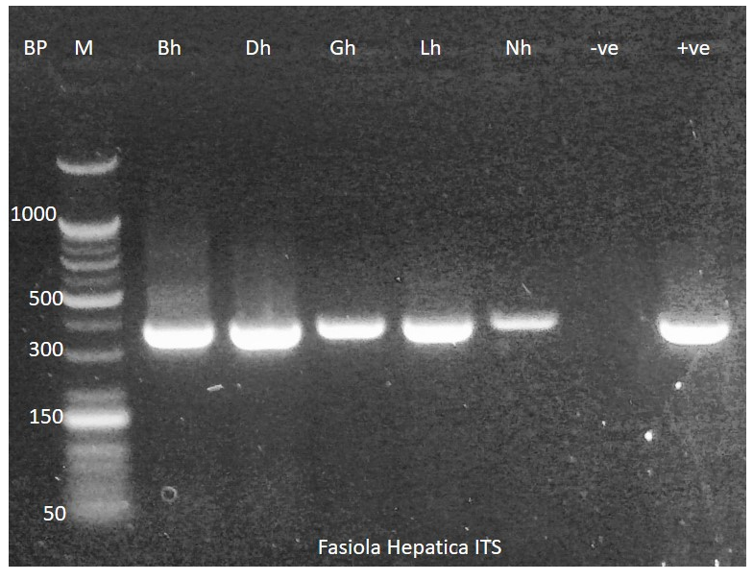

Figure 1: Polymerase chain reaction product of 364 bp of partial nucleotide sequences of the ribosomal DNA of ITS2 gene. Lane M: DNA ladder (1000 bp). Lane: 1-5 represent F. hepatica isolates in slaughtered cattle from Gombe abattoir, positive (+ve) and a neg (-ve) Control
The results of amplification of ITS 2 in Fasciola isolates appeared similar to the previous observation of [20]. However, longer fragment for the same ITS 2 was reported by [22] among Fasciola hepatica isolates from cattle in Egypt while similar fragment was obtained by [23] in Columbia of Fasciola hepatica isolated from cattle. In addition, positive samples, for which ITS 2 of Fasciola gigantica amplified showed a fragment similar to the previous observation of [24] in Egypt but the result deviate from 1100 bp fragment in F. gigantica isolate observed by [25] among cattle in Nigeria. Furthermore, the mitochondrial gene; Cytochrome c oxidase sub unit 1(COX 1) was successfully amplified. The result of this study is in agreement with the findings of [26] in Iran who reported similar COX 1 fragment of Fasciola hepatica, while it differs with 500 bp fragment obtained by [27] among Fasciola gigantica isolates from cattle in Nigeria.
Apart from the genes employed in this study, others such as the nuclear marker, Phosphoenolpyruvate carboxykinase (pepck), mitochondrial gene; subunit 1 (NAD1) and internal transcribed spacer 1(ITS1) had been applied in the detection of Fasciola gigantica in the first report of molecular characterizations of Fasciola species from Nigeria [28, 29, 30]. The employment of two genes for the detection of Fasciola DNA in this study agrees with the suggestion of [31]. for researches on evolutionary genetics and molecular epidemiology of fascioliasis in Africa and Asia, where the two species of Fasciola have been known to overlap. Besides,[15] also suggested that a combination of nuclear gene markers (ITS1 or ITS2) and mitochondrial gene markers (cox1 or nad1) are essential for correct diagnosis in case both F. hepatica and F. gigantica are suspected.

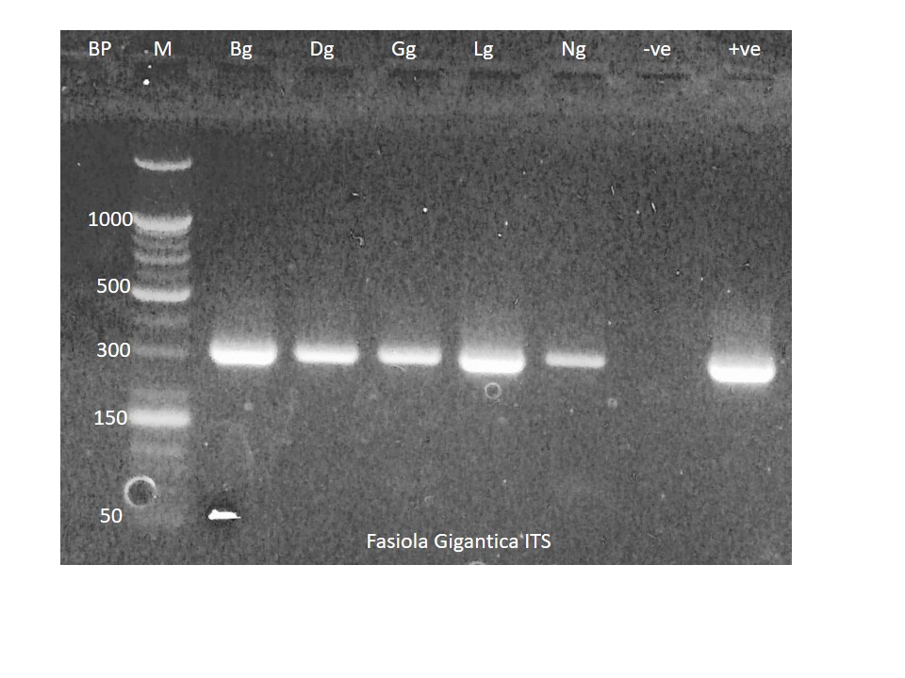

Figure 2: Polymerase chain reaction product of 300 bp of partial nucleotide sequences of the ribosomal DNA of ITS2 gene. Lane M: DNA ladder (1000 bp). Lane: 1-5 represent F. gigantica isolates in slaughtered cattle from Gombe abattoir, positive (+ve) and a negative control (–ve)

PCR Amplification of the Mitochondrial Cytochrome c Oxidase sub unit 1 (COX1) Gene of Fasciola Isolates from Abattoir Slaughtered Cattle in Gombe
Mitochondrial COX1 marker of Fasciola species in Gombe slaughtered cattle isolates was amplified following DNA extraction and presented in figure 3-4. A 304bp fragment of Fasciola hepatica and 308bp of Fasciola gigantica were produced.
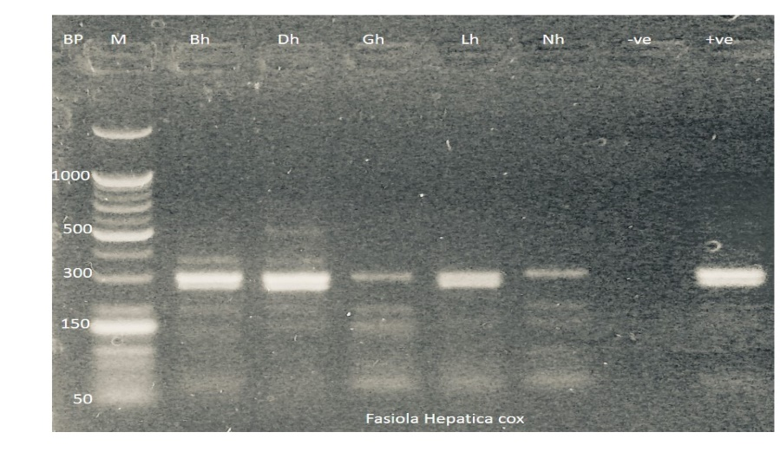

Figure 3: Polymerase chain reaction product of 283 bp of partial nucleotide sequences of the Mitochondrial DNA of COX 1 gene. Lane M: DNA ladder (1000 bp). Lane: 1-5 represent F. hepatica isolates in slaughtered cattle from Gombe abattoir, positive (+ve) and a negative control (–ve)
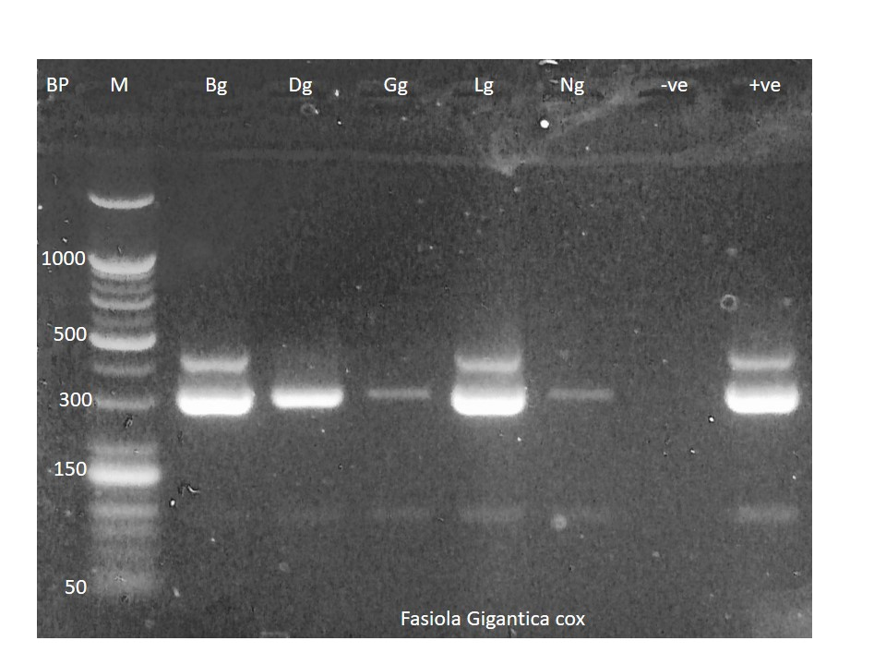

Figure 4: Polymerase chain reaction product of 308 bp of partial nucleotide sequences of the Mitochondrial DNA of COX 1 gene. Lane M: DNA ladder (1000 bp). Lane: 1-5 represent F. gigantica isolates in slaughtered cattle from Gombe abattoir, positive (+ve) and a negative control (–ve)
DNA Sequencing of Fasciola Amplicons
Fifteen PCR products were sent for sequencing to the Macrogen Company using forward and reverse primers. For all the Fasciola isolates selected, the ITS2 and COX 1 PCR products were successfully sequenced into forward and reverse sequences. The alignment of sequences obtained from the present study (Table 2) demonstrated that the isolated worms were F. hepatica and Fasciola gigantica. The sequence similarity showed 99.60% similarity with sequences recorded for F. hepatica and 94-100% for Fasciola gigantica in the GenBank database using the NCBI BLAST tool. The blast search demonstrated that these sequences shared similarity to F. hepatica isolated from cattle in Libya (MT025519) and Fasciola gigantica from cattle in Nigeria (MN608173, KU376411 and KU376412), Kenya (MZ396930, KP760871, MZ39692 and MZ3969111), Uganda (OQ548385), Algeria (MT094387), Libya (MT025356), Egypt (MT423006) and Turkey (KY613944and KY613945).

Table 2: ITS 2 and Cox 1 Genes Sequence Producing Significant Alignment for Specie Identification
55 | Identified strain | Gene | Type of genome | Sequence ID | %D
Bg ITS2 | Fasciola hepatica | ITS 2 | Partial sequence | MT025519 | 99.60
Dg ITS2 | Fasciola gigantica | ITS 2 | Partial sequence | MT423006 | 99.57
Gg ITS2 | Fasciola gigantica | ITS 2 | Partial sequence | MT025356 | 99.56
Lg ITS2 | Fasciola gigantica | ITS 2 | Partial sequence | MN608173 | 99.21
Ng ITS2 | Fasciola gigantica | ITS 2 | Partial sequence | MZ396930 | 100.00
Bh ITS2 | Fasciola gigantica | ITS 2 | Partial sequence | KY613944 | 99.18
Dh ITS2 | Fasciola gigantica | ITS 2 | complete sequence | KP760871 | 99.37
Gh ITS2 | Fasciola gigantica | ITS 2 | Partial sequence | OQ548385 | 100.00
Lh ITS2 | Fasciola gigantica | ITS 2 | Partial sequence | MZ396921 | 99.69
Nh ITS2 | Fasciola gigantica | ITS 2 | Partial sequence | MZ396911 | 100.00
Bg COX | Fasciola gigantica | COX | Partial sequence | LC142795 | 95.44
Dg COX | Fasciola gigantica | COX | Partial sequence | KY613945 | 95.44
Gg COX | Fasciola gigantica | COX | Partial sequence | KU376412 | 99.97
Ng COX | Fasciola gigantica | COX | Partial sequence | KU376411 | 94.60
Bh COX | Fasciola gigantica | COX | Partial sequence | MT094387 | 97.12

In this study, obtained sequences revealed the existence of Fasciola gigantica and Fasciola hepatica. This observation is similar to the result obtained by [27] in Nigeria and [32] in the first genetic characterizations of Fasciola species from Niger Republic. However, it is not supported by the studies done by [33] in Saudi Arabia and [34] in Columbia, which only reported Fasciola hepatica while some researchers such as [29] in Sokoto [27] in Oyo and [35] reported the presence of only F. gigantica in Egypt.
The sequencing indicated that most of them are those of Fasciola gigantica. Likewise [36] recording 83% and 17% of Kenya isolates, identified them as F. gigantica and F. hepatica, respectively.[31] also reported F. gigantica as the most predominant specie of cattle in Ilori, Nigeria. However, this is not in support with the findings of [27] that identified F. hepatica as the most prevalent specie among cattle in Nigeria. Previously, it was taught that F. hepatica was distributed mostly in the temperate regions, while F. gigantica is distributed in the tropical regions of some countries ” [28]. “ It has been proven not to be so, as recent studies attest the presence of F. hepatica in Africa and Asia” [37,38,16] including this present research which confirms the presence of both F. hepatica and F. gigantica in some regions of Nigeria. The present study also represents the first record of Fasciola hepatica from cattle in the study area. This could be attributed to environmental and host-related factors that may influence the distribution of Fasciola flukes” [39]. “
Blast searches within the NCBI database revealed similarity of 99.60% similarity with F. hepatica and between 94-100 with Fasciola gigantica with deposited sequences in the GenBank database from African countries of Egypt, Kenya, Libya, Uganda, Algeria and Turkey. The relative similarities observed is a reflection of the genes investigated. The ITS 2 is a highly variable gene while the mitochondrial genes do not possess the needed properties for comparison because of their relatively short length [10]. “

Phylogenetic Analysis
The evolutionary relationship of Fasciola spp. sequences with other sequences is depicted in the Phylogenetic tree (Figure 5). The tree shows that the regions sequenced for samples Bh cox, Gg cox, Ng cox, Bh Its, Lg Its, Dg ITS, Ng Its, Dh ITS, Lh Its, Nh ITS, Gh ITS, and Bg ITS are all descended from the same ancestral lineage (accessed from the gene bank), with 76% similarity to the most common parent. While Bg Cox and Dg Cox areas diverged within the first generation of the ancestral tree, they are more preserved than the other regions in the samples.
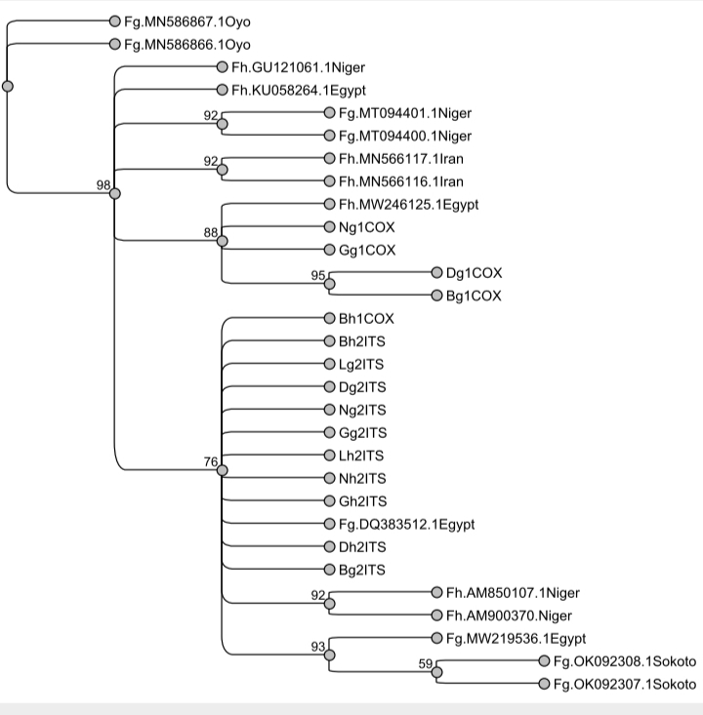

Figure 5: Phylogenetic relationship of ITS1 and COX 1 sequences of Fasciola spp isolates from Gombe state, Nigeria using the Maximum Likelihood method.
Phylogenetic analysis has had various applications and is, to an extent, a key tool when studying the differentiation of populations, the process of species formation, and even adaptation to particular ecological conditions [40]. In our specific case, a phylogenetic study found a similarity between the isolates of Fasciola gigantica parasite detected in Gombe State and the ones reported earlier in Oyo State and Sokoto State, within Nigeria ” [27, 8]. “ The same study reported that there were also similarities in the genetic composition of these isolates of parasite with that of some from the neighboring countries such as Niger Republic, Burkina Faso, and Zambia. It is thus concluded by researchers that the parasite's spreading and transmission in the local population might go hand in hand with the migration patterns of the traditional nomads across the borders of the neighboring countries ” [8]. “ In the same way, sequence relationships of the phylogenetic results confirmed that the sequence in this study has been found in other countries, e.g., Niger and Egypt. Also, the clustering of Fasciola gigantica from Nigeria with those from other African countries like Egypt agrees with the findings of ” [28]. “ using cox1 and NAD 1 genes. This may indicate the ancestral origin of the species, which has been traced to probably warm, eastern Africa” [41]. “ Furthermore, the similarity formed by the Fasciola hepatica sequence with other from Iran, probably indicate the Eurasian near-East origin of Fasciola hepatica. Results of the phylogenetic relationship study and of infection pattern by these two species reflects this origin elucidated ” [41]. “

CONCLUSION
The molecular identification using ITS-2 and COX 1 and the sequencing revealed the presence of F. hepatica and F. gigantica. Overall genetic sequence data showed that 93.3% of the sequences of Fasciola isolates were F. gigantica, while 6.67% were F. hepatica. Blast searches within the NCBI database revealed 99.60% similarity with F. hepatica and between 94-100 with Fasciola gigantica with deposited sequences in the GenBank database from African countries of Egypt, Kenya, Libya, Uganda, Algeria and Turkey. The phylogenetic tree based on ITS-2 and COX I sequences shows close relatedness with F. gigantica isolates from Niger, Egypt and Nigeria while a closer association with F. hepatica isolates was shown with Iran.

ETHICAL APPROVAL
An introductory letter was collected from the Biological Science department, ATBU Bauchi and taken to the abattoir before sample collection

Disclaimer (Artificial intelligence)
Option 1:
Author(s) hereby declare that NO generative AI technologies such as Large Language Models (ChatGPT, COPILOT, etc.) and text-to-image generators have been used during the writing or editing of this manuscript.

REFERENCES

1. Varijakshapanicker, P., Mckune, S., Miller, L., Hendrickx, S., Balehegn, M., Dahl, G. E., & Adesogan, A. T. (2019). Sustainable livestock systems to improve human health, nutrition, and economic status. Animal Frontiers, 9(4), 39–50. https://doi.org/10.1093/af/vfz041

2. Mapiye, O., Makombe, G., Molotsi, A., Dzama, K., & Mapiye, C. (2021). Towards a Revolutionized Agricultural Extension System for the Sustainability of Smallholder Livestock Production in Developing Countries: The Potential Role of ICTs. Sustainability, 13(11), 5868. https://doi.org/10.3390/su13115868

3. Gheorghe-Irimia, R. A., et al. (2023). Innovations in Dairy Cattle Management: Enhancing Productivity and Environmental Sustainability. Annals of “Valahia” University of Târgovişte. Agriculture, 15(2), 18–25. https://doi.org/10.2478/agr-2023-0013

4. El-Tahawy, A. S., Bazh, E. K., & Khalafalla, R. E. (2017). Epidemiology of bovine fascioliasis in the Nile Delta region of Egypt: Its prevalence, evaluation of risk factors, and its economic significance. Veterinary World, 10(10), 1241–1249. https://doi.org/10.14202/vetworld.2017.1241-1249

5. Odeniran, P. O., Omolabi, K. F., & Ademola, I. O. (2020). Economic model of bovine fasciolosis in Nigeria: an update. Tropical Animal Health and Production, 52(6), 3359–3363. https://doi.org/10.1007/s11250-020-02367-7

6. Caravedo, M. A., & Cabada, M. M. (2020). Human Fascioliasis: Current Epidemiological Status and Strategies for Diagnosis, Treatment, and Control. Research and Reports in Tropical Medicine, 11, 149–158. https://doi.org/10.2147/RRTM.S237461

7. Mohamed, D. K. A. (2021). A study on causes of cattle liver condemnation at an abattoir in Omdurman area, Khartoum State, Sudan. BMC Veterinary Research, 17(1), 58. https://doi.org/10.1186/s12917-021-02766-4

8. Shoulah, S. A., Gaballa, M. M. S., Al-Assas, M. M., Saqr, S. A., Gattan, H. S., & Selim, A. (2024). Histopathological changes and oxidative stress associated with Fascioliasis in bovines. Tropical Animal Health and Production, 56(2), 48. https://doi.org/10.1007/s11250-024-03896-1

9 Haridwal, S., Malatji, M.P., & Mukaratirwa, S. (2021). Morphological and molecular characterization of Fasciola hepatica and Fasciola gigantica phenotypes from co-endemic localities in Mpumalanga and KwaZulu-Natal provinces of South Africa. Food and Waterborne Parasitology. https://doi.org/10.1016/j.fawpar.2021.e00114

10. Mas-Coma, S., Valero, M. A., & Bargues, M. D. (2022). Human and Animal Fascioliasis: Origins and Worldwide Evolving Scenario. Clinical Microbiology Reviews, 35(4), e00088-19. https://doi.org/10.1128/cmr.00088-19
11. Gedefaw, T., Mebratu, A. S., Dagnachew, S., & Fenta, M. D. (2025). Comparative analysis of anthelmintic treatments: impact on liver biomarkers and clinical recovery in sheep with fasciolosis. Frontiers in Veterinary Science, 12, 1485568. https://doi.org/10.3389/fvets.2025.1485568

12. Rehman, Z. U., Tashibu, A., Tashiro, M., Rashid, I., Ali, Q., Zahid, O., Ashraf, K., Shehzad, W., Chaudhry, U., & Ichikawa-Seki, M. (2021). Molecular characterization and phylogenetic analyses of Fasciola gigantica of buffaloes and goats in Punjab, Pakistan. Parasitology International, 82, 102288. https://doi.org/10.1016/j.parint.2021.102288

13. Hasan, M. M., Ahmed, N., Roy, B. C., Rabbi, M. R. R., Sajib, M. M. R., Biswas, H., Biswas, P. G., Anisuzzaman, Alam, M. Z., & Talukder, M. H. (2025). Molecular detection and phylogenetic characterization of hybrid Fasciola in black Bengal goats from Bangladesh: β-tubulin isotype 3 polymorphisms and genetic diversity. medRxiv. https://doi.org/10.1101/2025.06.12.25329487

14. Sy, I., Dambeck, M., Ngufor, C., Eneanya, C. J., Nwafor, S. V., Nweze, N. E., Nweze, C. C., Nweze, E. I., Al-Qaoud, K. M., Al-Jawabreh, A., Al-Jawabreh, H., & Al-Jawabreh, A. (2020). Identification of Adult Fasciola spp. Using Matrix-Assisted Laser/Desorption Ionization Time-of-Flight (MALDI-TOF) Mass Spectrometry. Microorganisms, 9(1), 82. https://doi.org/10.3390/microorganisms9010082

15. Ai, L., Chen, M. X., Alasaad, S., Elsheikha, H. M., Li, J., Li, H. L., Lin, R. Q., Zou, F. C., Zhu, X. Q., & Chen, J. X. (2011a). Genetic characterization, species differentiation and detection of Fasciola spp. by molecular approaches. Parasites & Vectors, 4(1), 101. https://doi.org/10.1186/1756-3305-4-101

16. Sarkari, B., Parhoode, M., Abdolahi Khabisi, S., Motevalli Haghi, F., Mowlavi, G. R., Sharif, M., Daryani, A., & Gholami, S. (2017). Genetic diversity of Fasciola spp. isolates from northern part of Iran: comparison with southwestern isolates. Journal of Parasitic Diseases, 41(3), 768–772. https://doi.org/10.1007/s12639-017-0886-6

18. Duguma, A. (2016). Practical Manual on Veterinary Clinical Diagnostic Approach. Journal of Veterinary Science & Technology https://doi.org/10.4172/2157-7579.1000337

19. Doyle, S. R., Sankaranarayanan, G., Allan, F., Berger, D., Jimenez Castro, P. D., Collins, J. B., Crellen, T., Duque-Correa, M. A., Ellis, P., Jaleta, T. G., Laing, R., Maitland, K., McCarthy, C., Moundai, T., Softley, B., Thiele, E., Ouakou, P. T., Tushabe, J. V., Webster, J. P., Weiss, A. J., Lok, J., Devaney, E., Kaplan, R. M., Cotton, J. A., Berriman, M., & Holroyd, N. (2019). Evaluation of DNA Extraction Methods on Individual Helminth Egg and Larval Stages for Whole-Genome Sequencing. Frontiers in Genetics, 10, 826. https://doi.org/10.3389/fgene.2019.00826

20. Elliott, T., Muller, A., Brockwell, Y., Spithill, T. W., & Anderson, G. A. (2014). Evidence for high genetic diversity of NAD1 and COX1 mitochondrial haplotypes among triclabendazole resistant and susceptible populations and field isolates of Fasciola hepatica (liver fluke) in Australia. Veterinary Parasitology, 200(1-2), 90-96. https://doi.org/10.1016/j.vetpar.2013.11.019

21. Abuzeid, A. M. I., Hefni, M. M., Huang, Y., Zhuang, T., & Li, G. (2024). Phylogenetic relationship of Prohemistomum vivax to other trematodes based on the internal transcribed spacer region and mitochondrial genes. Parasitology Research. https://doi.org/10.1007/s00436-024-08126-z

22. Mehmood, N., et al. (2024). Molecular Characterization and Phylogenetic Analysis of Fasciola gigantica Based on ITS-1 Genetic Marker and copro-epidemiological Survey from Ruminants of Pakistan. Acta Parasitologica, 69(4), 1866–1875. https://doi.org/10.1007/s11686-024-00911-1
23. Khalifa, R. M., Hassanin, A. S., Monib, M. E.-S. M., Yones, D. A., El-Ossily, N. A., & Abdel-Rahman, A. S. (2016). Molecular and phylogenic characterization of Fasciola hepatica from Assiut, Egypt based on nuclear ribosomal DNA sequences. Journal of Medical Science And Clinical Research, 4(1), 9007–9016. https://doi.org/10.18535/jmscr/v4i1.38

24. Ai, L., Weng, Y. B., Elsheikha, H. M., Zhao, G. H., Alasaad, S., Chen, J. X., Li, J., Li, H. L., Wang, C. R., Chen, M. X., Lin, R. Q., & Zhu, X. Q. (2011b). Genetic diversity and relatedness of Fasciola spp. isolates from different hosts and geographic regions revealed by analysis of mitochondrial DNA sequences. Veterinary Parasitology. https://doi.org/10.1016/j.vetpar.2011.03.057

25. Omar, M.A., Elmajdoub, L.O., Ali, A.O., Ibrahim, D.A., Sorour, S.S., Al-Wabel, M.A., Ahmed, A.I., Suresh, M., & Metwally, A.M. (2021). Genetic characterization and phylogenetic analysis of Fasciola species based on ITS2 gene sequence, with first molecular evidence of intermediate Fasciola from water buffaloes in Aswan, Egypt. Annals of Parasitology, 67(1), 55–65. https://doi.org/10.17420/ap6701.312

25. Mogha, L., Kainga, H., Kamanga, N., Kapalamula, T. F., Wood, C., Thomas, L. F., Mutua, F., Sargison, N., Hayashida, K., Tsutsumi, T., Hayashi, N., Nonaka, N., Nakao, R., & Chatanga, E. (2025). Genetic diversity and population structure of Fasciola gigantica isolated from cattle in Malawi. Veterinary Research Communications, 49(3), 157. https://doi.org/10.1007/s11259-025-10717-9

26. Hasanpour, H., Falak, R., Naddaf, S. R., Mas-Coma, S., Rokni, M. B., Badirzadeh, A., Mokhtarian, K., Mohebali, M., Jafarpour Azami, S., Fadavi, A., Gharagozlou, M. J., Mohammad, K., & Mowlavi, G. (2020). Molecular Characterization of Fasciola spp. from Some Parts of Iran. Iranian Journal of Public Health, 49(1), 157–166. https://doi.org/10.18502/ijph.v49i1.3062

27 Alaba, A.E., et al. (2024). DNA barcode identification of a tropical liver fluke (Fasciola gigantica) in cattle from Oyo, southwestern Nigeria. The Journal of Basic and Applied Zoology. https://doi.org/10.1186/s41936-024-00403-8

28. Ichikawa-Seki, M., Tokashiki, M., Opara, M. N., Iroh, G., Hayashi, K., Kumar, U., & Itagaki, T. (2017). Molecular characterization and phylogenetic analysis of Fasciola gigantica from Nigeria. Parasitology International, 66(1), 893–897. https://doi.org/10.1016/j.parint.2016.10.010

29.Salem, L. M. A., Khalifa, N. O., & Abd El-Halim, M. O. (2022). Prevalence, Molecular Characterization and Phylogenetic Analysis of Fasciola spp. Based on ITS2 Gene Sequence from Slaughtered Animals in Abattoirs and its public Health in Qualyobia Province, Egypt. Advances in Animal and Veterinary Sciences, 10(11). https://doi.org/10.17582/journal.aavs/2022/10.11.2396.2406

29. Salihu, M. D., Musawa, A. I., Garba, B., Yakubu, Y., Bello, M. B., Magaji, A. A., Junaidu, A. U., Jibril, A. H., Ballah, F. M., & Achi, C. R. (2022). Molecular characterization and species differentiation of Fasciola parasite isolated from cattle slaughtered at Sokoto modern abattoir, Nigeria. Nigerian Journal of Parasitology, 43(1), 102–108. https://doi.org/10.4314/njpar.v43i1.14

30. Ola-Fadunsin, S. D., Uwabujo, P. I., Halleed, I. N., & Richards, B. (2020). Prevalence and financial loss estimation of parasitic diseases detected in slaughtered cattle in Kwara State, North-central Nigeria. Journal of Parasitic Diseases, 44(1), 1-9.

31. Mas-Coma, S., Bargues, M. D., & Valero, M. A. (2018). Human fascioliasis infection sources, their diversity, incidence factors, analytical methods and prevention measures. Parasitology, 145(13), 1665–1699. https://doi.org/10.1017/S0031182018000914

32. Ali, H., Alasaad, S., Li, Q., Lin, R. Q., Martín-Atance, P., Granados, J., Díez-Baños, P., Pérez, J., & Zhu, X. Q. (2008). Genetic characterisation of Fasciola samples from different host species and geographical localities revealed the existence of F. hepatica and F. gigantica in Niger. Parasitology Research, 102(5), 1021–1024. https://doi.org/10.1007/s00436-007-0870-7

33. Garcia-Corredor, D. et al. (2023) “Molecular characterization of Fasciola hepatica in endemic regions of Colombia,” Frontiers in Veterinary Science, 10, p. 1171147. Available at: https://doi.org/10.3389/fvets.2023.1171147.

34. Dar, Y., Amer, S., Mercier, A., Courtioux, B., & Dreyfuss, G. (2012). Molecular identification of Fasciola spp. (Digenea: Fasciolidae) in Egypt. Parasite (Paris, France), 19(2), 177–182. https://doi.org/10.1051/parasite/2012192177

35. Mucheka, V. T., Lamb, J. M., Pfukenyi, D. M., & Mukaratirwa, S. (2015). DNA sequence analyses reveal co-occurrence of novel haplotypes of Fasciola gigantica with F. hepatica in South Africa and Zimbabwe. Veterinary Parasitology, 214(1–2), 144–151. https://doi.org/10.1016/j.vetpar.2015.09.024

36. French, A. S., Zadoks, R. N., Skuce, P. J., Gunn, G. J., McClean, C. P., Macrae, A. J., & Gilbert, L. A. (2019). Habitat and host factors associated with liver fluke (Fasciola hepatica) diagnoses in wild red deer (Cervus elaphus) in the Scottish Highlands. Parasites & Vectors, 12(1), 535. https://doi.org/10.1186/s13071-019-3782-3

37. Choi, Y.-J., Fontenla, S., Fischer, P. U., Le, T. H., Costábile, A., Blair, D., Brindley, P. J., Tort, J. F., Cabada, M. M., & Mitreva, M. (2020). Adaptive Radiation of the Flukes of the Family Fasciolidae Inferred from Genome-Wide Comparisons of Key Species. Molecular Biology and Evolution, 37(1), 84–99. https://doi.org/10.1093/molbev/msz204

38. Alvi, M. A., Khalid, A., Ali, R. M. A., Saqib, M., Qamar, W., Li, L., Ahmad, B., Fu, B.-Q., Yan, H.-B., & Jia, W.-Z. (2023). Genetic variation and population structure of Fasciola hepatica: an in silico analysis. Parasitology Research, 122(9), 2155–2173. https://doi.org/10.1007/s00436-023-07917-0

