Structural and Spectroscopic Analysis of Treated Water with a Crystal Instrument

Abstract
The water investigated in this study, – generated via crystal-mediated activation and designed as Alpha Omega Water, – exhibits measurable modifications in its hydrogen-bond network and in parameters associated with hydrogen-bond and related interaction. A multidisciplinary analytical framework was employed, integrating eight complementary methodologies: Non-equilibrium Energy Spectrum (NES), Differential Non-equilibrium Energy Spectrum (DNES), Fourier Transform Infrared spectroscopy (FT–IR), color corona imaging, black-white histogram analysis, color and heat mapping. NES and DNES analyses revealed a statistically significant increase in hydrogen-bond energy in Alpha Omega Water (p < 0.05), indicating a reorganization of the the hydrogen-bond network. Gaussian fitting combined with bootstrap analysis (10,000 iterations) demonstrated a shift in the energy distribution toward stronger hydrogen bonding, consistent with a model-based interpretation suggesting the predominance of energetically favorable clusters of 5–6, 7–8, and 14–15 water molecules. FT–IR spectra showed enhanced resolution of O–H stretching and H–O–H bending modes, reflecting altered intermolecular interactions. Corona discharge analyses,including color imaging, brightness evaluation, and heat/color mapping revealed elevated photon emission., In addition, increased energy density (a difference of 1.03 eV/cm²), expanded discharge area, and greater edge complexity were observed.These findings indicate modified electrical and optical discharge behavior and enhanced energetic responsiviness. Collectivelly, these converging results provide evidence that Alpha Omega water exhibits a more ordered and energetically enhanced molecular structure comared to control water, with potential implications for biological and technological applications.

Keywords: water, filtration, spectral analysis, water clusters, color corona images

1. Introduction
Water is a fundamentally dynamic molecular system whose structural organization emerges from nonlinear interactions within its hydrogen-bond network [1,2]. The collective behavior of the hydrogen bonds governs key physiological properties, including cluster formation, proton transfer, and energy redistribution [3,4]. Recent interdisciplinary studies demonstrate that water does not exist solely as isolated molecules but forms transient, energetically differentiated clusters with distinct geometries and lifetimes [5]. Density functional theory (DFT) models, supported by NMR studies, have provided insight into the hydrogen-bond structure of water clusters [6]. Advanced spectroscopic and computational research, including FT–IR, DFT modeling, and electrochemical impedance spectroscopy, has shown that external influences can shift the equilibrium between small and medium-sized clusters, alter hydrogen bond strength, and modulate network symmetry [4,7]. These findings expand the conventional understanding of water, revealing a sensitive, responsible system capable of reorganizing in responsive to physical, electromagnetic, and catalytic stimuli.
Within this scientific context, structured waters such as Alpha Omega Water represent an important area of investigation. Analyses in this study employing the Non-equilibrium Energy Spectrum (NES), Differential Non-equilibrium Energy Spectrum (DNES), Fourier Transform Infrared spectroscopy (FT–IR), and corona discharge imaging have indicated that the activation process underlying Alpha Omega Water induced measurable modifications in hydrogen bond energies, cluster distribution and energetics, and the spectral signature of water’s molecular network.
The development of histogram analysis for black-and-white corona discharge images of water drops has been reported by Pesotskaya, Glukhova, and co-authors [8,9].
They are credited with developing the histogram method, which enables quantitative assessment of physical and chemical processes.
Before histogram analysis, liquid drops are subjected to external fields or chemical substances. The drops are activated by a corona electrical discharge at the air-liquid interface. The histogram method evaluates the brightness and pixel distribution of the resulting images, providing a detailed quantitative characterization. The analysis consists of two components. First, the image's brightness range is divided into predefined intervals (e.g., from black to white). Second, the number of pixels within each brightness interval is counted to generate the corresponding histogram [10]. This approach enables an in-depth investigation of interactions and transformations occurring in water and aqueous systems, underscoring its relevance to studies in physics, chemistry, and biology.
Color mapping is a widely used image analysis technique that assigns colors to
intensity or spatial features in an image to enhance visual patterns and support quantitative comparisons [11]. In studies of the corona discharge effect, color mapping has been applied to visualize morphological differences and to compute metrics such as mean intensity, total area, and edge density, enabling objective assessment of structural differences between samples (e.g., discharge of water drops) beyond simple visual inspection.
The present study aims to advance the characterization of Alpha Omega Water by integrating
complementary analytical methodologies that probe its molecular, spectroscopic, and structural properties. By combining NES/DNES analysis, cluster modeling, FT–IR spectroscopy, and corona discharge imaging. The study seeks to elucidate the structural mechanisms responsible for the observed enhancements of hydrogen-bond interactions and the formation of complex cluster geometries. This multi-modal approach provides a comprehensive framework for understanding water restructuring processes and their potential implications for biological and technological applications.

2. Materials and methods
2.1. Alpha Omega Water® 220011 Crystal Instrument
For water treatment, an Alpha Omega Water® 220011 Crystal Instrument, manufactured by SIA JL Ventures, AO Water Technologies (Kekavas Novads, LV-2111, Latvia), was used.
The Alpha Omega Water 220011® Crystal Instrument is certified in accordance with 'Technischer Überwachungsverein (TÜV)' and 'Deutscher Verein des Gas- und Wasserfaches (DVGW)' drinking-water standards. Water treatment was performed by installing the Instrument within the municipal water supply network, using drinking water compliant with Directive (EU) 2020/2184 of 16 December 2020. The instrument contains water-conducted elements coated with gold and silver, and the standard acrylic housing is replaced with a synthetic quartz crystal housing of 99.99% purity.
The Alpha Omega Water 220011 Crystal Instrument has technical specifications for installation. The housing consists of a purely crystalline cylinder. The parameters are 65 cm in length, 8 cm in diameter, and 6.5 kg in weight. The instrument contains certified copper pipes and brass.
Tap water was used as the control group. Both the experimental samples is referented as “AO treated water” and the control samples were stored at room temperature in the laboratory for analysis. Each method using “AO-treated water” samples and control samples was conducted five times.

2.2. Non-equilibrium energy spectrum (NES) and Differential non-equilibrium energy spectrum (DNES)
The NES and DNES methods are applied to study the structure of water by analyzing the optical effect connected with the wetting angle of evaporation. The process of changes in the wetting angle of water drops is non-equilibrium and discrete [12].
Evaporation is carried out in a hermetically sealed chamber, and the setup’s principle has been published in previous studies [13–15]. During this process, changes occur in the water drops’ surface tension and in the distribution of hydrogen bonds. In the NES method, the distribution of effective hydrogen-bond energy-related parameters, f(E), expressed in eV⁻¹, is measured. This distribution reflects how the structural organization of water molecules changes during evaporation.
The DNES method determines the difference between the NES spectrum of the investigated sample and that of a control sample, thereby isolating the effects of the specific factor being studied. It is assumed that all other external factors influence both samples equally [13–15].
The method operates in the infrared range of 8–14 μm (714–1250 cm⁻¹).

2.3. Clustering water molecules regarding the function of the distribution of energies of hydrogen bonds
Based on the spectral data obtained using the NES and DNES methods, a mathematical model is applied to relate the energy of the hydrogen bonds to the size of the water clusters. The model calculates the number of water molecules (H₂O)_{n} participating in clusters at different energy levels. Each energy step is 0.0025 eV within the range of hydrogen bond energies (–E)=0.0912–0.1387 eV. All values within the interval are normalized to 100. For each value at a 0.0025 eV step, the percentage of water molecules corresponding to that specific hydrogen bond energy is obtained.
For both the sample and control groups, five measurements were performed, followed by statistical analysis.
The resulting data are presented as tables and graphical figures that illustrate the dependence of f(E), a function of the number of molecules, on the distribution of hydrogen-bond energies.

2.4. Fourier Transform Infrared (FT–IR) Spectroscopy
Fourier Transform Infrared (FT–IR) spectroscopy was employed to analyze the water samples. Spectra were acquired using a Thermo Nicolet Avatar 360 FTIR spectrometer (Waltham, MA, USA) equipped with a DTGS detector. Measurements were performed over the wavenumber range 400–4000 cm⁻¹, with 64 accumulated scans and a spectral resolution of 2 cm⁻¹. All experiments were carried out at a controlled temperature of 298.15 K [18,19]. The FT–IR analyses were conducted at the Institute of General and Inorganic Chemistry, Bulgarian Academy of Sciences (BAS), Sofia, Bulgaria.

2.5. Color Corona Images of the Alpha Omega Water and Control Sample The color-coronal spectral analysis method using gas-discharge emission on a sample of Alpha Omega Water will reveal distinct characteristics that reflect the specific molecular and energetic organization of the water following the activation process [20]. The method is connected with the structuring of water molecules, and water is more transparent to the electric field due to the ordering of water molecules and hydrogen bonds. If the water molecules are chaotic, the effects decrease. The experiment will use a transparent electrode made of Hostaphan (87 mm in diameter) filled with a conductive liquid (a 1% solution of CaCO₃ in deionized H₂O). The Alpha Omega Water sample will be placed on a photosensitive material, and a voltage of 12 kV with a carrier frequency of 15 kHz will be applied between the sample and the electrode [21].

2.6. Black-white histogram analysis of the corona discharge of water drops
The black-white histogram analysis of the corona discharge of water drops methodology is based on the calculation of median values. It involves determining the medians of medians of 12 histogram columns and computing the differences between medians across brightness intervals. The brightness distribution in the discharge radiation image of water samples does not conform to the standard Gaussian distribution model. Therefore, median-based estimation determines the average pixel brightness within specified interval divisions [12,13].

2.7. Color mapping
Color mapping is a technique that transforms pixel values in an image into color codes, enhancing the visualization of details and contrast. The method was applied for levitating water drops. Color mapping is particularly effective for highlighting the intensity of specific phenomena, such as corona discharge, by clearly representing the distribution of electrical activity.

3. Results & Discussion

3.1. Application of NES and DNES for Alpha Omega Water
In the study, measurements are conducted on samples of Alpha Omega Water and control samples. The control samples contain water before treatment to produce Alpha Omega water. These analyses of Alpha Omega Water can be performed using the NES and DNES methods.
Table 1 illustrates the results of the NES and DNES spectra of Alpha Omega Water
Table 1. Results of the NES and DNES spectra of Alpha Omega Water
Type of water | NES Е (eV)  Samples* | NES E (eV)  Control samples** | DNES E (eV)
Alpha Omega Water | −0.1213;−0.1209; −0.1215; −0.1214; −0.1210 | −0.1126; −0.1124; −0.1127; −0.1128; −0.1125 | −0.0087; −0.0085; −0.0088;−0.0086; −0.0085

Note: *Samples of Alpha Omega Water
** Control samples of water before preparing of Alpha Omega Water
The average result of the Differential non-equilibrium energy spectrum (DNES) is
∆E = E_{sampes} – E_{control samples} = (−0.1212) eV − (−0.1126) eV =− 0.0086 eV

Each sample and the control sample were measured five times. The results are statistically significant according to Student’s t-test at the p < 0.001 level, with a correlation coefficient r = 0.8741. The coefficient of correlation is strongly positive, indicating that Alpha Omega Water has a significant effect on the modification of hydrogen bonds between water molecules as energy increases.
The average result of the DNES confirms the Student t-test analysis.

  - Clustering water molecules regarding the function of the distribution of energies of hydrogen bonds
In the Gaussian fitting of the hydrogen bond energy distribution function (eV⁻¹), the control samples exhibited a maximum at (−0.1066) eV, while the samples of Alpha Omega Waterpeaked at (−0.1117) eV (Fig. 1).

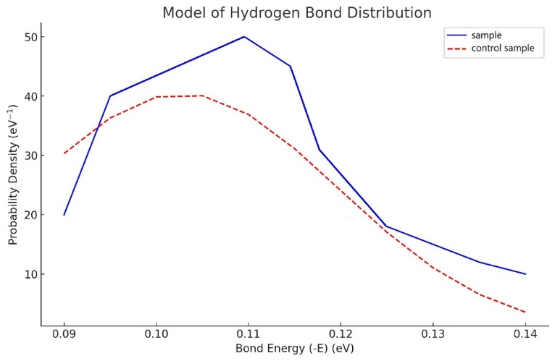
Fig. 1. Graph showing the Gaussian fitting of the hydrogen bond energy distribution function (eV⁻¹) for Alpha Omega Water and the control samples.

A bootstrap analysis with 10,000 iterations revealed a mean differences of Alpha Omega Water and the control samples are demonstrated in Fig. 2.

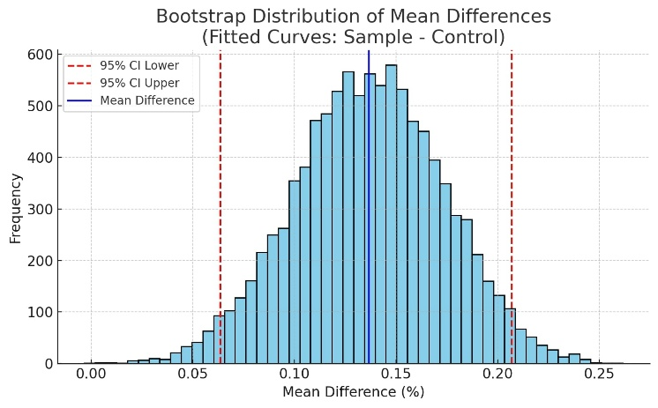
Fig. 2. A bootstrap analysis with 10,000 iterations revealed a mean difference between Alpha Omega Water and the control samples

At the energy level of (−0.1117) eV, a bootstrap analysis with 10,000 iterations was performed for Alpha Omega Water, revealing a statistically significant shift in the distribution peak and an increased frequency of occurrence in this energy range compared to the control samples. The value for control samples is (−0.1066) eV. The difference is essential and indicates a shift of +0.0051 eV toward stronger hydrogen bonding.
Based on established theoretical models of hydrogen bonding and cluster formation in water, this energy value is interpreted as corresponding to predominant water clusters comprising 5–6, 7–8, or 14–15 H₂O molecules. These cluster sizes are considered energetically favorable and structurally stable under the given conditions, suggesting that Alpha Omega Water promotes the formation of such optimized hydrogen-bonded assemblies.

3.3. Fourier Transform Infrared (FT–IR) Spectroscopy
Fourier Transform Infrared (FT–IR) is a precise analytical spectroscopy for examining the molecular interactions of water, particularly hydrogen bonding and cluster formation. Upon exposure to infrared radiation, water molecules absorb energy at characteristic frequencies corresponding to the vibrations of hydrogen bonds. The resulting FT–IR spectra provide insights into the energy, type, and structural organization of water clusters, which play a key role in its physicochemical and biological properties.
Frequencies around 3200–3400 cm⁻¹ are typically associated with O–H stretching vibrations in hydrogen-bonded water – these indicate the strength and number of hydrogen bonds. Peaks at 2130 cm⁻¹ demonstrate combination bands. Peaks around 1640 cm⁻¹ correspond to the bending (deformation) vibrations of H₂O molecules – useful for analyzing the content and structure of water clusters. The appearance of more distinct peaks in the spectrum may indicate the stabilization of certain cluster forms – for example, hexagonal water structures, which are hypothesized to be associated with higher energy efficiency.
Fig. 3 illustrates the FT–IR spectrum of Alpha Omega Water
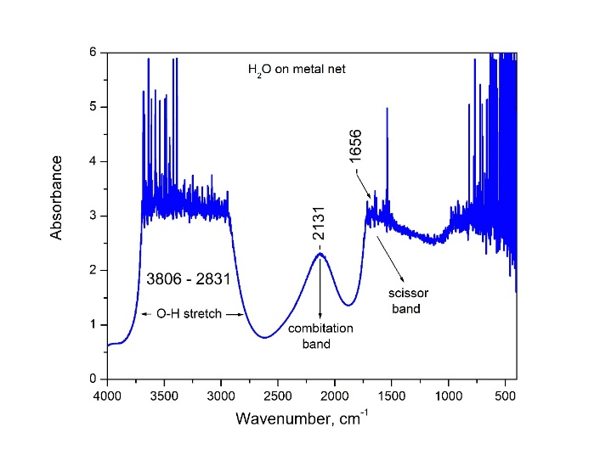
Fig. 3. FT–IR spectrum of Alpha Omega Water
The FT–IR spectrum of Alpha Omega Water exhibits well-defined absorption peaks and characteristic spectral ranges, reflecting complex intermolecular interactions. The broad band observed in the 2831–3806 cm⁻¹ region corresponds to O–H stretching vibrations, indicating extensive hydrogen-bonding networks. The distinct peak at 2131 cm⁻¹ is associated with a combination band, while the signal at 1656 cm⁻¹ corresponds to the H–O–H bending mode (scissoring vibration) of water molecules. These spectral features suggest enhanced structural dynamics and reorganization of hydrogen bonds. The observed changes are consistent with the results from NES and DNES spectroscopy, which demonstrate an increase in the energetic states and the presence of organized water clusters in Alpha Omega Water.
3.4. Color corona spectral analysis

Fig. 4 shows the color coronal images of water drops of the sample of Alpha Omega Water (a) and the control sample (b)

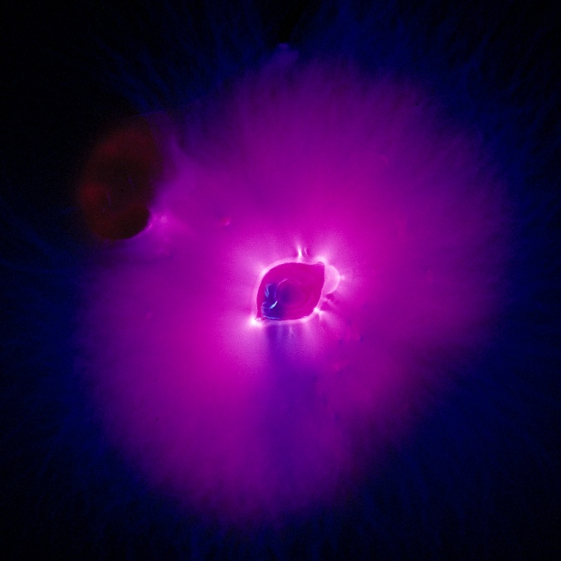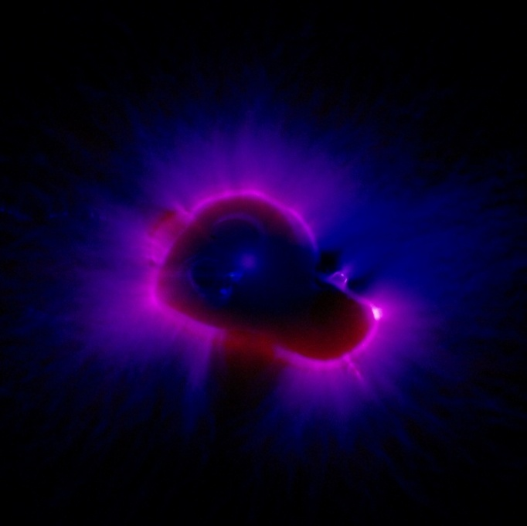

Fig. 4. Color Coronal images of drops of the sample of Alpha Omega Water (a) and the control sample (b)

The results in Figure 4b illustrate that the photon emission for the control sample was E = 2.49 eV, whereas for the experimental sample shown in Figure 4a, E = 3.03 eV. The difference is E = 0.54 eV. The radius of the water drop is 0.41 cm, or S = πr² = 3.14 x 0.412 = 0.528 cm². For the experimental sample, the result is 3.03 eV/0.528 cm² = 5.74 eV/cm². For the control sample, the result is 2.49 eV/0.528 cm² = 4.71 eV/cm².
The difference between the sample and the control sample is 5.74-4.71=1.03 eV/cm²
Based on the results, Alpha Omega Water will exhibit more intense electrical activity and a more structured coronal emission than a control (non-activated) water sample. This would indicate a significant change in the molecular and energetic configuration of the water, with a possible correlation to biological activity and antioxidant properties.
3.5. Black-white histogram analysis of the corona discharge of water drops
The black-and-white histogram analysis method for corona discharge from water drops is based on calculating median values. The analysis includes the medians of 12 histogram columns and the differences between them across brightness intervals. Since the brightness distribution does not follow a Gaussian model, the median-based approach yields a more accurate estimate of the average pixel brightness within defined brightness intervals.

Fig. 5 shows the black-white corona of water drops from Alpha Omega Water (a) and of the control sample (b). The images were captured using the method from the patent [9].

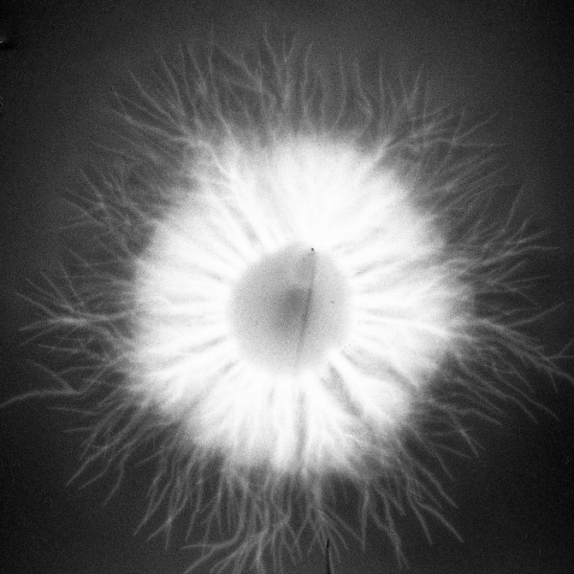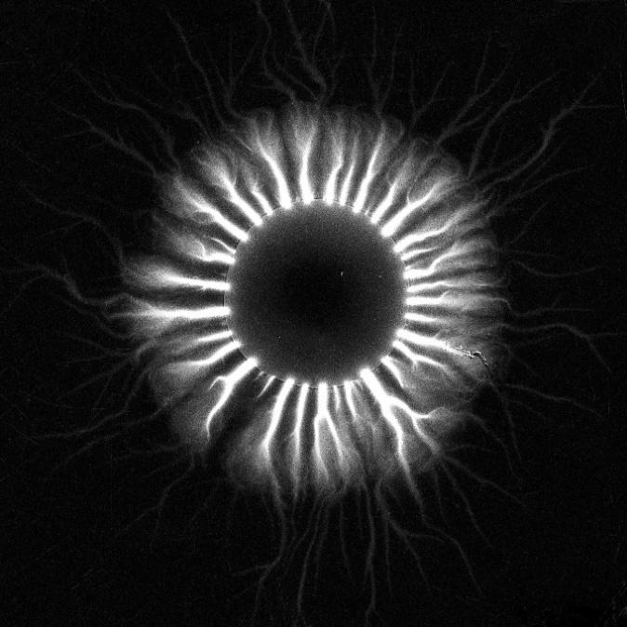
a. b.

Fig. 5. Black-white corona from the drop of Alpha Omega Water (a) and of the control sample (b).

Fig. 6 presents the normalized brightness histograms of Alpha Omega Water and the control sample, along with their difference, revealing a broader and more evenly distributed intensity profile in the treated water, indicative of enhanced structural organization and energetic activity in the corona discharge.

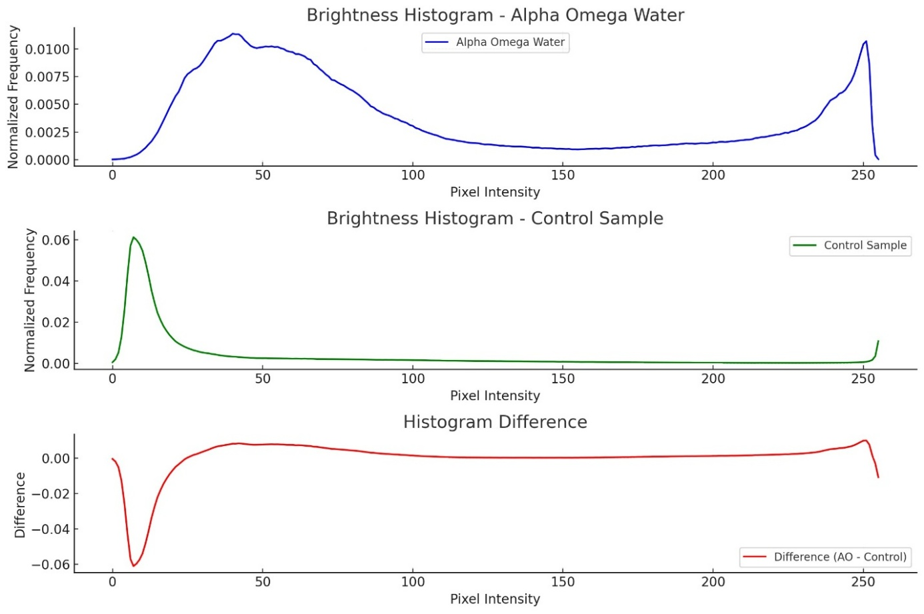

Fig. 6. Normalized brightness histograms of Alpha Omega Water and the control sample
Two statistical tests were applied to the pixel intensity distributions of Alpha Omega Water and the control sample (simulated based on the histograms):
Kolmogorov–Smirnov test (KS test):
Statistic: 0.842
p-value: < 0.001
This indicates a difference in distribution shapes between the two samples.
Mann–Whitney U test (non-parametric test for median shift):
U-statistic: 33,900,796.0
p-value: < 0.001
This confirms a statistically significant shift in brightness values between Alpha Omega Water and the control sample.
Fig. 7 demonstrates a comparative analysis of median brightness between Alpha Omega Water and the control sample
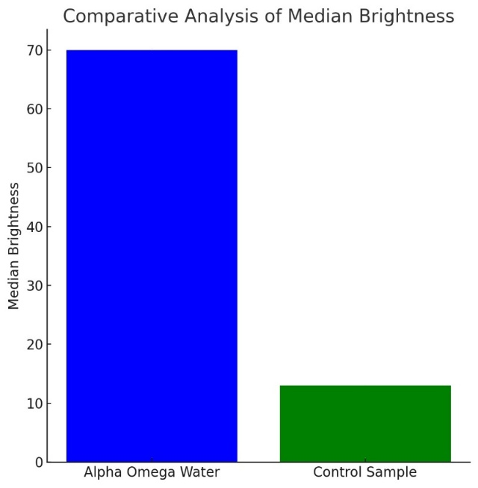
Fig. 7. Comparative analysis of median brightness between Alpha Omega Water and the control sample

The Fig. 7 presents a comparative analysis of median brightness of corona discharge for Alpha Omega Water and a control sample. The median brightness of Alpha Omega Water is approximately 70 arbitrary units, whereas the control sample exhibits a median brightness of about 13 arbitrary units.

7. Color mapping – Quantitative Analysis

Color mapping was applied to visualize the morphology of electric corona discharge on water drops.
The results are shown in Fig. 8 and Table 2.

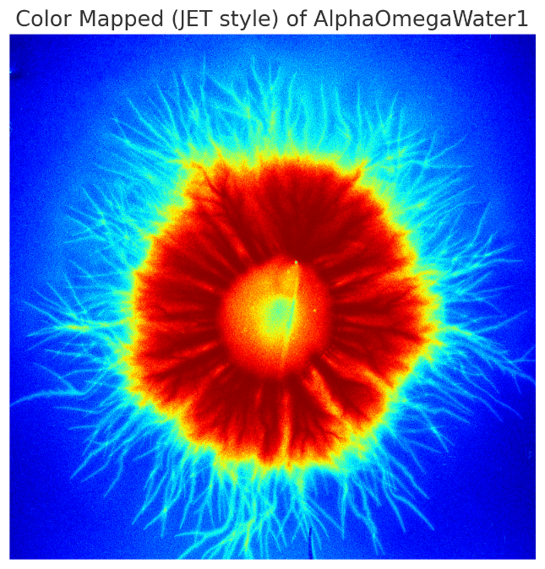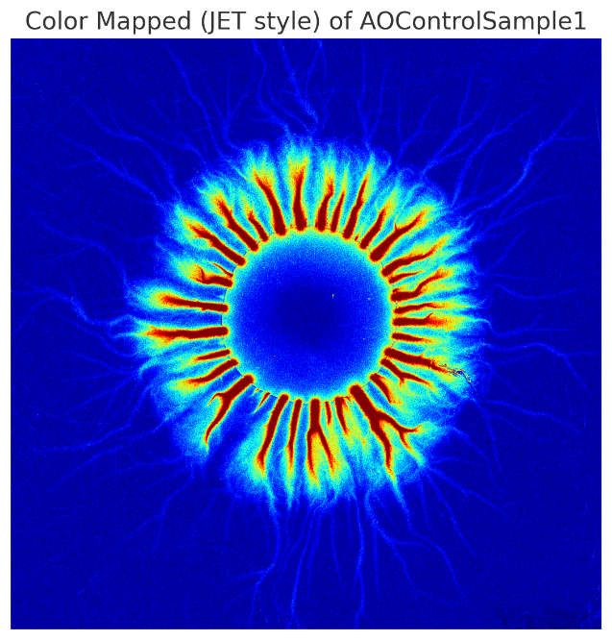
a. Alpha Omega Water drop b. Control sample drop

Fig. 8. Color mapping of electric corona discharge on water drops of Alpha Omega Water (a) and control sample (b)

Table 2. Total discharge area, mean, and edge density of water drops of Alpha Omega Water and control sample

Indicators | Alpha Omega Water | Control Sample | Difference
Total discharge area | 100 (ref. unit) | 61.85 | 38.15
Mean intensity | 102.84 | 71.93 | 30.91
Edge density (complexity) | 0.097 | 0.079 | 0.018

Mean intensity – pixel values in the range 0 to 255.
Edge density=Number of Edge pixels/total area (pixels) is in the range (0–1)
These results suggest a more organized, intense, and spatially coherent corona discharge in Alpha Omega Water, indicating higher internal order and electrical responsiveness of the sample.
Figure 8 demonstrated color-mapped images images of the electric corona discharge from Alpha Omega Water and the control sample, revealing clear differences in discharge morphology. Alpha Omega Water exhibits a larger and more intense discharge region, while the control sample displays a weaker and more fragmented pattern.
The quantitative data in Table 2 confirm these observations. The total discharge area of Alpha Omega Water (100 relative units) is markedly higher than that of the control sample (61.85). The mean discharge intensity is also greater for Alpha Omega Water (102.84) compared to the control (71.93). In addition, the edge density is higher for Alpha Omega Water (0.097 vs. 0.079), indicating increased discharge complexity and structural organization.

4. Conclusions
The following results and analyses were obtained from the investigation of the NES spectra of Alpha Omega Water and the control sample.
The differential difference is analyzed using the DNES method. The greater this difference, the more pronounced the structural changes in the hydrogen bonds between water molecules. The magnitude of this difference reflects the extent of physicochemical modifications in the hydrogen bond network.
Mathematical model of water clusters – the mathematical model of Alpha Omega Water. Water clusters are analyzed by the number of water molecules, with hydrogen-bond energies used to distinguish between them. The results provide a model-based interpretation of differences in cluster organization and hydrogen-bond energetics. Water clusters characterized by higher-hydrogen-bond energy parameters are associated with altered energetic states of the system. Larger clusters of 10–12 water molecules optimally reorganize into smaller clusters of 4–5 water molecules. The model suggest a dynamic redistribution between larger and smaller water clusters under the applied activation conditions.
The black-white histogram analysis, supported by color and heat mapping methods, reveals statistically and visually significant differences between Alpha Omega Water and the control sample:
- Increased intensity and structural organization of the corona discharge in Alpha Omega Water;
- Higher energy density per unit area in the sample, indicating differences in discharge characteristics;
- Wider spatial coverage of the discharge zone in the experimental sample;
- Greater edge complexity, pointing to a more structured and coherent discharge pattern;
- These results reflect better differences in physicochemical and discharge-related properties, with more stable and energetically enhanced water clusters;
Altogether, the findings support the hypothesis that Alpha Omega Water exhibits a restructured, energetically activated form of water relative to the control sample.

Disclaimer (Artificial intelligence)
Author(s) hereby declare that NO generative AI technologies such as Large Language Models (ChatGPT, COPILOT, etc.) and text-to-image generators have been used during the writing or editing of this manuscript.
References
- Kontogeorgis, G. M., Holster, A., Kottaki, N., Tsochantaris, E., Topsøe, F., Poulsen, J. M., Bache, M., Liang, X., Blom, N. S., & Kronholm, J. (2022). Water structure, properties and some applications – A review. Chemical Thermodynamics and Thermal Analysis, 6, 100053. https://doi.org/10.1016/j.ctta.2022.100053
- Tyrovolas, I. J. (2020). New explanation for the Mpemba effect. Proceedings, 46(2). https://doi.org/10.3390/ecea-5-06658
- Seijas, L. E., Zambrano, C. H., Almeida, R., Alí-Torres, J., Rincón, L., & Torres, F. J. (2023). Exploring the non-covalent bonding in water clusters. International Journal of Molecular Sciences, 24(6), 5271. https://doi.org/10.3390/ijms24065271
- Ignatov, I., Marinov, Y. G., Vassileva, P., Gluhchev, G., Pesotskaya, L. A., Jordanov, I. P., & Iliev, M. T. (2025). Nonlinear hydrogen bond network in small water clusters: Combining NMR, DFT, FT-IR, and EIS research. Symmetry, 17, 1062. https://doi.org/10.3390/sym171062
- Maheshwary, S., Patel, N., Sathyamurthy, N., Kulkarni, A. D., & Gadre, S. R. (2001). Structure and stability of water clusters (H2O)n, n=8–20: An ab initio investigation. Journal of Physical Chemistry A, 105(46), 10525–10537. https://doi.org/10.1021/jp013141b
- Nawar, F. A., Saeed, B. A., & Hansen, P. E. (2025). Structural studies of intramolecularly hydrogen-bonded vinylogous thiocarboxamides. NMR and isotope experiments and a DFT theoretical study. Journal of Molecular Structure, 1338, 142321. https://doi.org/10.1016/j.molstruc.2025.142321
- Huang, L., Lambrakos, S. G., Shabaev, A., Bernstein, N., & Massa, L. (2015). Molecular analysis of water clusters: Calculation of the cluster structures and vibrational spectrum using density functional theory. Comptes Rendus Chimie, 18(5), 516–524. https://doi.org/10.1016/j.crci.2014.12.009
- Pesotskaya, L. A., Glukhova, N. V., & Lapitskiy, V. N. (2013). Analysis of the images of the water drops Kirlian glow. Naukovyi Visnyk Natsionalnoho Hirnychoho Universytetu, 1, 91–96. https://nv.nmu.org.ua/index.php/nv/article/view/103
- Pesotskaya, L. A., Churilov, V. V., Glukhova, N. V., Gulevskaya, G. I., & Ignatov, I. I. (2023). Device for registration of gas discharge glow of various objects “RGS-1”. Patent Ukraine No. 37. Ukrainian National Office for Intellectual Property and Innovations. https://base.uipv.org/searchINV/
- Ignatov, I., Pesotskaya, L., Glukhova, N., Yevdokimenko, N., Popova, T. P., Ignatov, A. I., & Stoyanov, Ch. (2025). Registration of different types of water with corona gas discharge effects and parameters of brightness. Portugaliae Electrochimica Acta, 43(4), 217–224. https://doi.org/10.4152/pea.2025430401
- Zhou, L., & Hansen, C. D. (2016). A survey of colormaps in visualization. IEEE Transactions on Visualization and Computer Graphics, 22(8), 2051–2069. https://doi.org/10.1109/TVCG.2015.2489649
- Antonov, A. (1984) An optical method version for determination of the wetting angle of liquids. Comptes Rendus de l'Académie Bulg. des Sci., 37, 1199.
- Antonov, A. (1995) Research of the non-equilibrium processes in the area in allocated systems, Dissertation thesis for degree “Doctor of physical sciences”, Blagoevgrad, Sofia, 1–255.
- Gramatikov, P., Antonov, A., & Gramatikova, M. (1992). A study of the properties and structure variations of water systems under the stimulus of outside influences. Fresenius Journal of Analytical Chemistry, 343(1), 134–135. https://doi.org/10.1007/BF00332070.
- 15. Todorova, L.& Antonov, A. (2000) Note on the drop evaporation method for study of water bond distribution. Comptes Rendus de l'Académie Bulg. des Sci. 53.
- Ignatov, I., & Valcheva, N. (2023). Physicochemical, isotopic, spectral, and microbiological analyses of water from glacier Mappa, Chilean Andes. Journal of the Chilean Chemical Society, 68(1), 5802–5906. https://dialnet.unirioja.es/servlet/articulo?codigo=8800000
- Ignatov, I., Iliev, M. T., & Gramatikov, P. S. (2023). Education program on Physics and Chemistry for Non-equilibrium processes at the interfaces between solid-liquid-gaseous media. European Journal of Contemporary Education, 12(3), 862–873. https://doi.org/10.13187/ejced.2023.3.862
- Slavov, D., Tomaszewska, E., Grobelny, J., Drenchev, N., Karashanova, D., Peshev, Z., & Bliznakova, I. (2024). FTIR spectroscopy revealed nonplanar conformers, chain order, and packaging density in diOctadecylamine- and octadecylamine-passivated gold nanoparticles. Journal of Molecular Structure, 1314, 138827. https://doi.org/10.1016/j.molstruc.2024.138827
- Ignatov, I., Marinov, Y. G., Vassileva, P., Gluhchev, G., Pesotskaya, L. A., Jordanov, I. P., & Iliev, M. T. (2025). Nonlinear Hydrogen Bond Network in Small Water Clusters: Combining NMR, DFT, FT-IR, and EIS Research. Symmetry, 17(7), 1062. https://doi.org/10.3390/sym17071062
- Ignatov, I. (2007) Energy Biomedicine, 3^{d} Chapter: Color coronal spectral analysis. IKH, Munich. 52–76.
- Ignatov, I., Drossinakis, Ch., & Ignatov, A. I. (2025). Color coronal spectral analysis: Results with water solution of Calcium Carbonate. Portugaliae Electrochimica Acta, 43(2), 113–126. https://doi.org/10.4152/pea.2025430203

