Diagnosis and Treatment of Probable VKH Disease:A Case Series Highlighting Multimodal Imaging and Combined Immunosuppression.

.
ABSTRACT

Vogt-Koyanagi-Harada disease(VKH) is an idiopathic multisystem autoimmune disease affecting the melanocyte-containing tissues such as Uvea,inner ear,meninges and skin.Cases of Probable vogt-koyanagi-harada disease are rarely encountered in clinical practice.Here we report case series of Probable VKH disease diagnosed with use of multimodal imaging techniques and treated with combination of Systemic corticosteroids and Immunosuppressives .

Keywords: Probable VKH, Posterior Uveitis,Immunosuppressives, Autoimmune disease

1. INTRODUCTION

“Vogt-Koyanagi-Harada (VKH) disease is a bilateral granulomatous panuveitis associated with central nervous system, auditory, and dermatological manifestations.It initially manifests with prodromal symptoms similar to aseptic meningitis, followed by posterior uveitis with exudative retinal detachments and disc hyperemia” ⁽¹⁾.”The first international workshop defined VKH as bilateral uveitis without a history of trauma or ocular surgery and classified VKH disease as (a) complete VKH with ocular, neurological,auditory and integumentary involvement; (b) incomplete VKH with ocular and either neurological/auditory or integumentary involvement; and (c) probable VKH without extraocular manifestation”⁽²⁾.Presentation of probable VKH is uncommon and poses diagnostic challenge.Use of Multimodal imaging-Fundus fluorescein angiography(FFA),Optical coherence tomography (OCT) findings has led to diagnosis of VKH, monitor response to treatment.Initial treatment with high dose Intravenous methylprednisolone for 3days followed by oral steroids and addition of immunosuppresives early in the course of disease improves final vision and prevents recurrence.Because of rare occurance and few reports in the literature,we want to report case series of probable VKH disease.

Case History:
Case-1 A 26-year-old-male patient presented with sudden diminution of vision in both eye since 1 week(LE>RE).Best corrected visual acuity(BCVA) of 6/36 in OD and Counting fingers 3meters in OS.Intraocular pressure(IOP) was 14mmhg in OD,16mmhg in OS,with normal anterior segment.Fundus examination of both eye showed vitritis,normal optic disc with multifocal serous retinal detachment in the posterior pole (Fig 1a 1b).Fundus fluorescein angiography(FFA)-multiple pinpoint hyperfluorescence in the early arteriovenous phase with pooling of dye in subretinal space in the late arteriovenous phase(Fig 1c 1d).Optical coherence tomography(OCT) shows multiple neurosensory detachment with subretinal fluid and subretinal septae, (Fig 1e 1f).Complete blood workup and radiological investigations done to rule out tuberculosis,sarcoidosis and posterior scleritis.Audiometry results were normal and there is no skin manifestation,no history of previous ocular surgery or ocular trauma.The patient was diagnosed with probable VKH disease.Patient was administered intravenous methylprednisolone(IVMP)1mg daily for three consecutive days.After rheumatologist consultation oral prednisolone was given according to bodyweight(BW) 1mg/kg BW, which was tapered over a period of 6months.After 2month of initiation of oral steroids,patient was prescribed immunosuppressive agent oral Azathioprine 50mg thrice daily for 3months,50mg twice daily for 3months and 50mg once daily maintained over the period of 2years. No recurrence in 2year period the BCVA in both eye( BE )was 6/6,N6. IOP was normal bilaterally.

Case 2-67-year-old female presented with diminution of vision in BE since 2 days.BCVA was Counting finger 3meters in OD,6/36 in OS. IOP was 16mmhg in OD,15mmhg in OS with quiet anterior segment. Fundus examination of both eye shows normal optic disc,multifocal serous retinal detachment in the posterior pole(Fig 2a 2b). OCT–shows large serous retinal detachments with subretinal fluid,subretinal septae ,RPE undulation.(Fig 2c 2d).Patient does not has any skin manifestations and Audiometry was normal.Patient was diagnosed probable VKH disease and administered intravenous methylprednisolone(IVMP)1mg daily for three consecutive days.After rheumatologist consultation oral prednisolone was given according to bodyweight(BW) 1mg/kg BW, which was tapered over a period of 6months.After 2month of initiation of oral steroids,patient was prescribed immunosuppressive agent oral Azathioprine 50mg thrice daily for 3months,50mg twice daily for 3months and 50mg once daily maintained over the period of 2years.At follow up visit BCVA improved to 6/6 N6 with normal IOP.

Case 3-58 year old female presented with diminution of vision in both eyes since 3 months. She also gave history of redness in both eyes in the past.Her BCVA was 6/60 in OD and counting fingers 3meters in OS. Anterior segment examination revealed bilateral conjunctival congestion, old mutton fat KP’s, AC cells 2+ with Koeppe’s nodules. Pupil reaction was sluggish. Fundus had a hazy media due to vitritis, hyperemic blurred disc, dilated tortuous veins with multiple fluid pockets around arcade in both eyes(Fig 3a,3b). FFA showed a hot disc, multiple hyper & hypoflourescent dots, multilobular pooling (Fig 3c,3d).On OCT-RPE undulations,multifocal neurosensory detachment with subretinal fluid, subretinal septae was seen(Fig 3e,3f).Laboratory tests for tuberculosis,sarcoidosis and toxoplasmosis were negative. Audiometry results were normal and there is no skin manifestation.For anterior uveitis patient was treated with Topical Prednisolone acetate 1% eye drops 8 times a day and Topical Homatropine eye drops twice a day.Patient was known case of hypertensive,BP was 160/100mmhg after physician and rheumatologist consultation patient was started on oral Prednisolone 1mg/kg body weight, At her first follow up after 1 week, vision had improved to 6/60 in both eyes with no ocular complaints. During her follow up visit at one month oral Prednisolone was tapered over period of 6months and oral Azathioprine 50mg was started thrice daily for 3months,50mg twice daily for 3months and 50mg once daily maintained over the period of 2years.On follow-up BE BCVA improved to 6/9.

Fig 1a,1b (Fundus photography of BE) - normal optic disc,multifocal serous retinal detachment in the posterior pole.

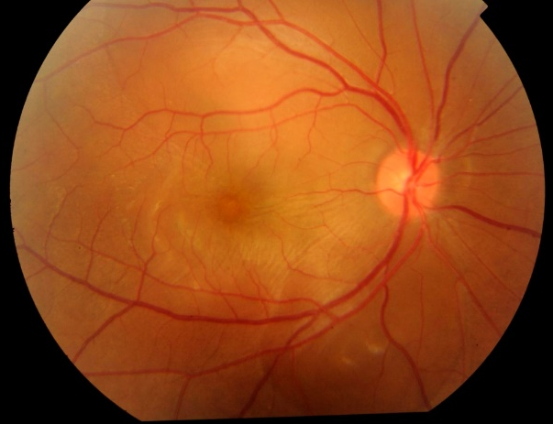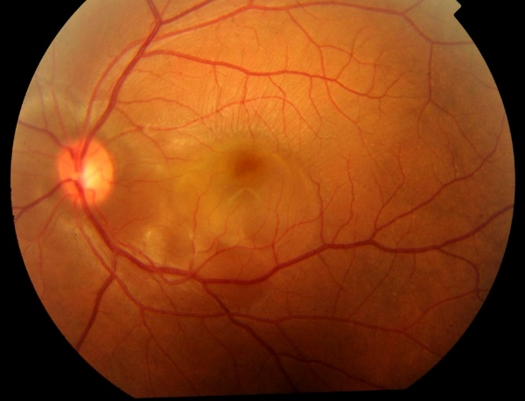
Fig 1c,1d (Fundus fluorescein angiography of BE)- pooling and leakage of dye in the subretinal space in the late stage of angiogram.

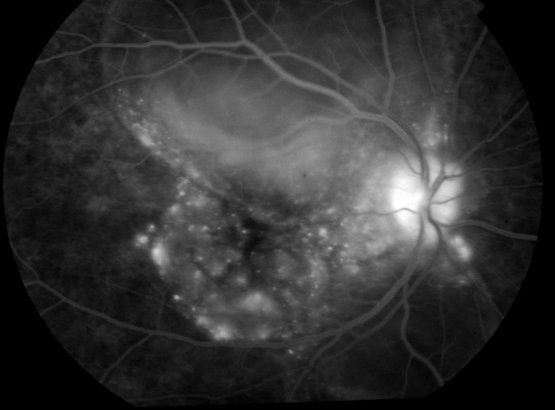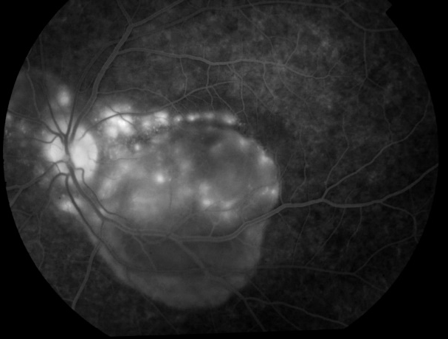
Fig 1e,1f (optical coherence tomography of BE) - multiple neurosensory detachment with subretinal fluid and subretinal septae.

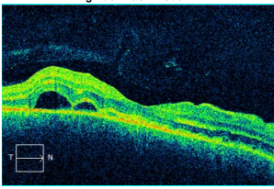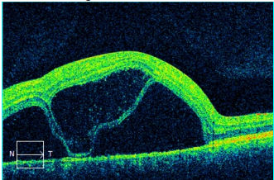
Fig 1g,1h(optical coherence tomography of BE)- shows complete resolution of subretinal fluid.

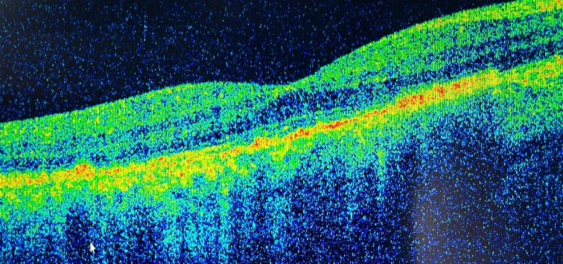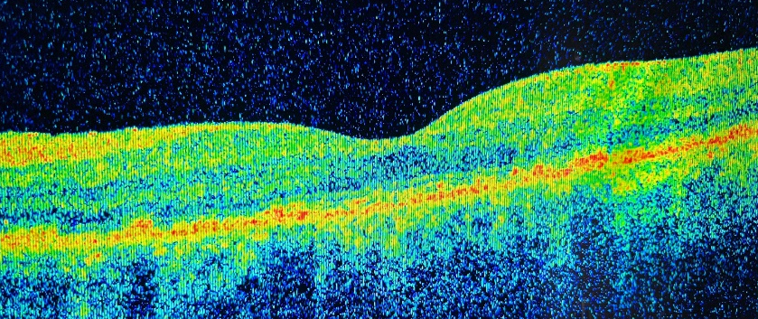

Fig 2a,2b (Fundus photography of BE) - shows normal optic disc,multifocal serous retinal detachment in the posterior pole.

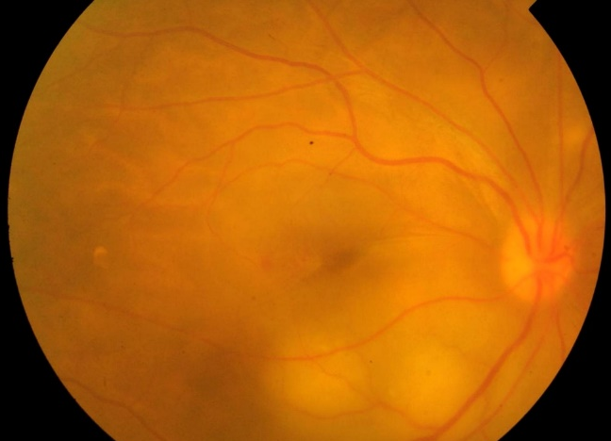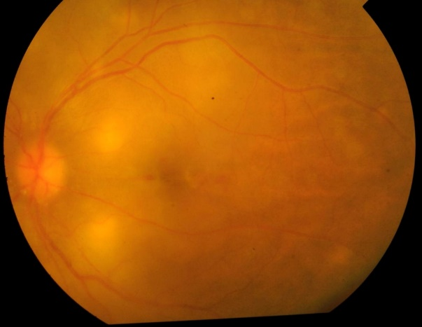

Fig 2c,2d (optical coherence tomography of BE) - large serous retinal detachments with subretinal septae and RPE undulation.

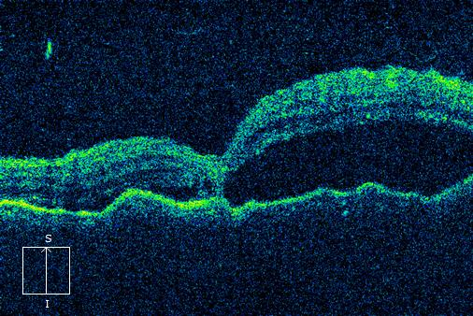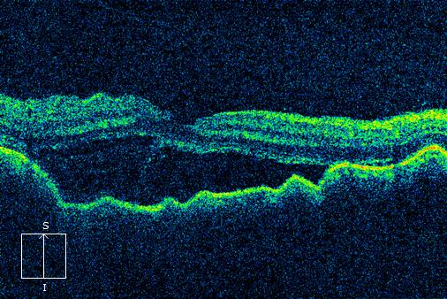

Fig 2e,2f(optical coherence tomography of BE)- shows complete resolution of subretinal fluid after treatment

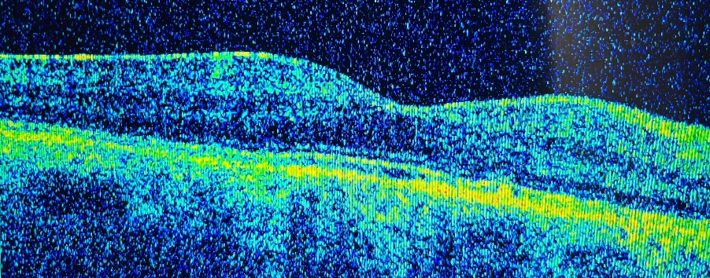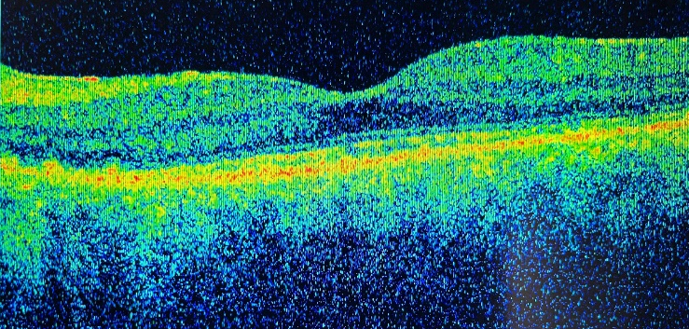

Fig 3a,3b (Fundus photography of BE)- vitritis, hyperemic blurred disc, dilated tortuous veins with multiple fluid pockets around arcade

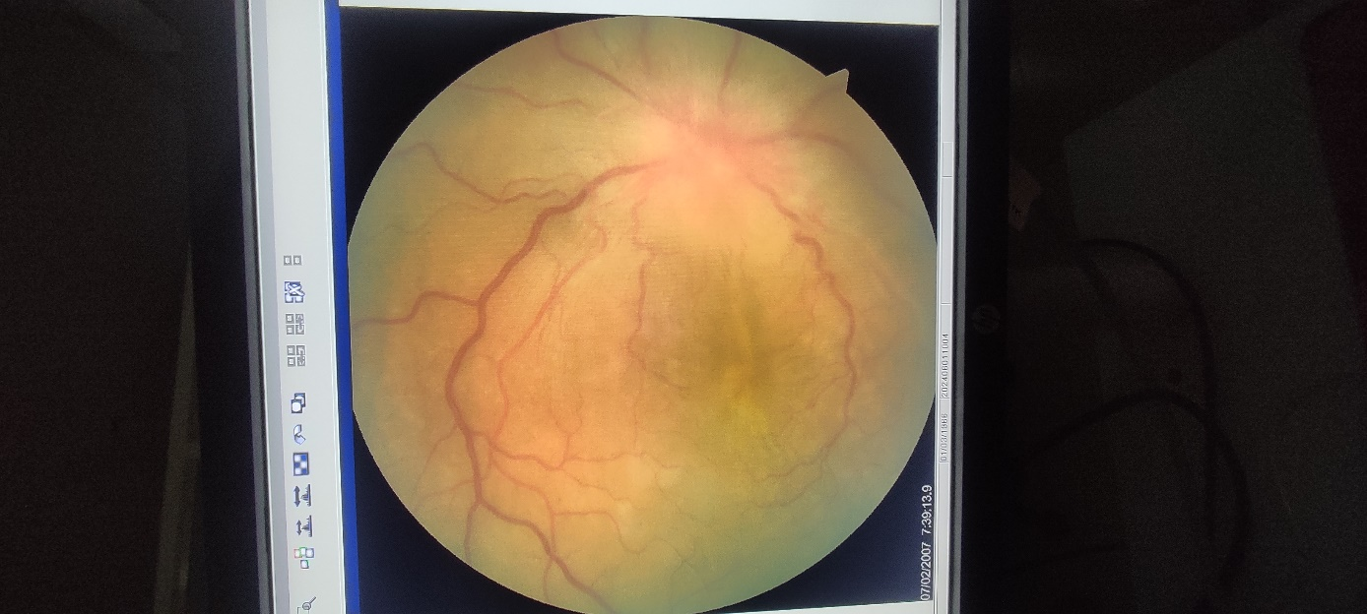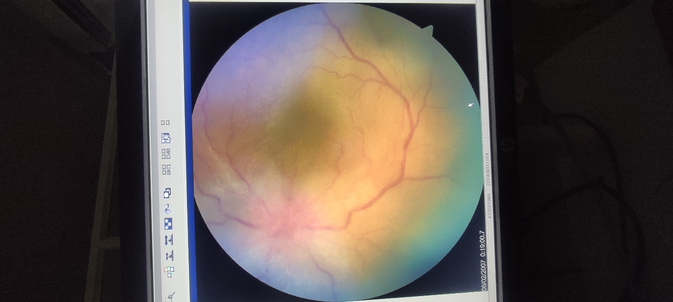

Fig3c,3d (Fundus fluorescein angiography of BE)- -hot disc, multiple hyper & hypoflourescent dots, multilobular pooling.

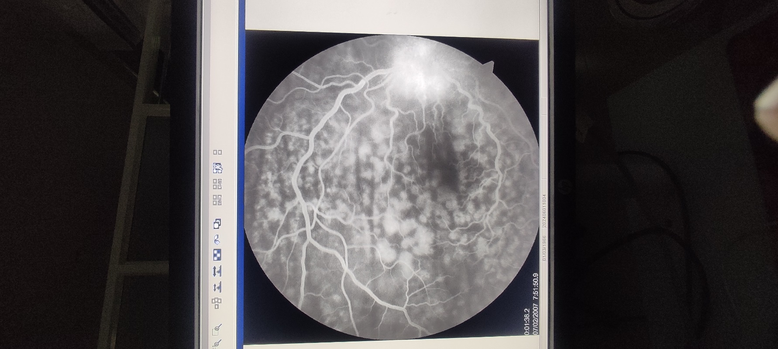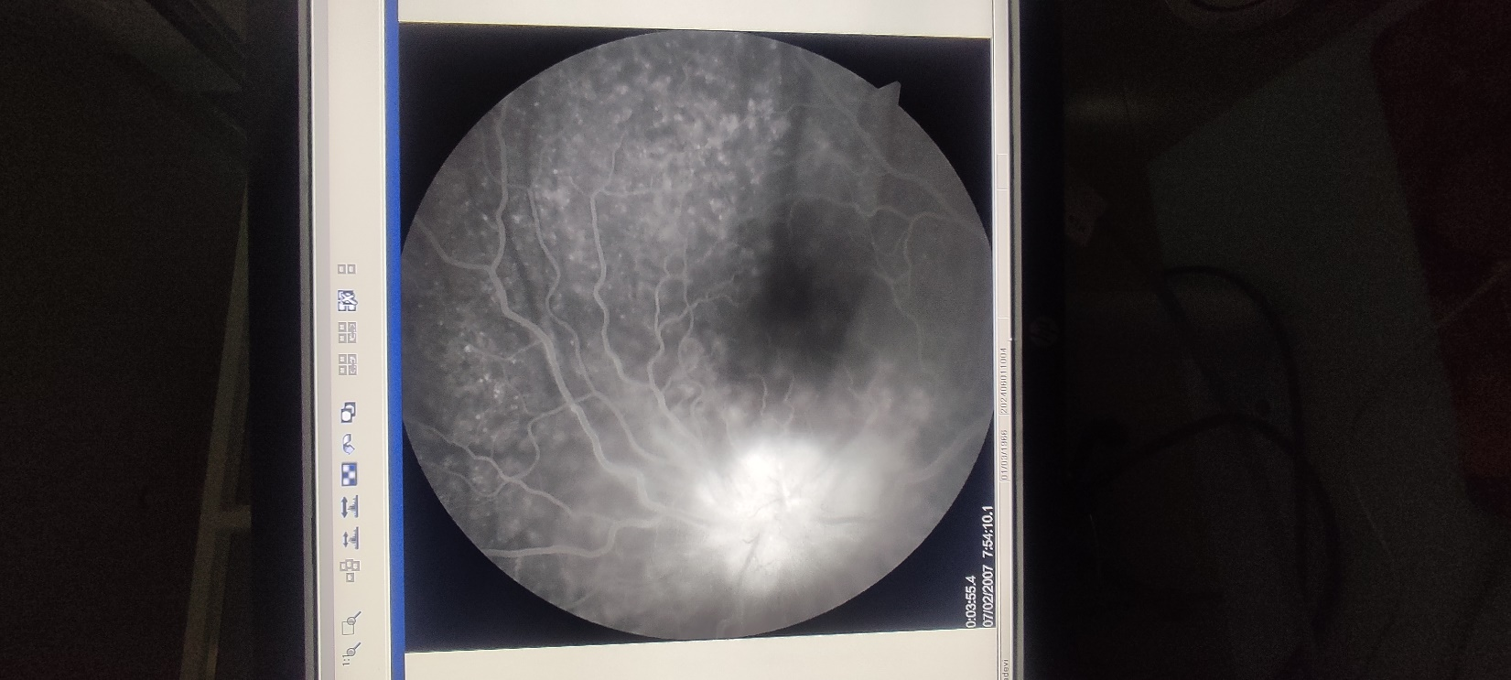

Fig 3e,3f (optical coherence tomography of BE)- RPE undulations,multifocal neurosensory detachment with subretinal fluid, subretinal septae.

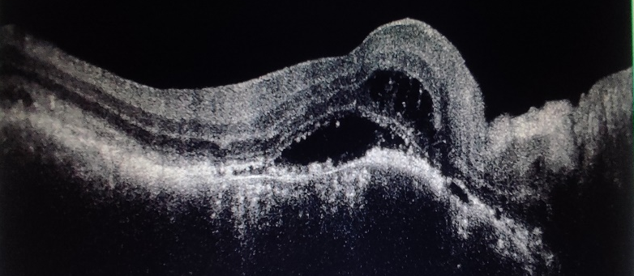
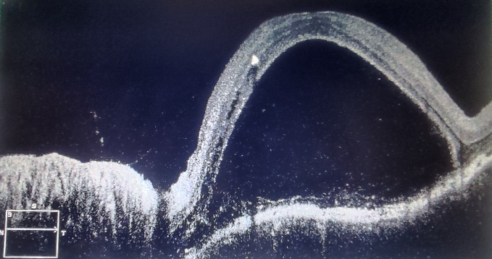

Fig 3g,3h(optical coherence tomography of BE)- shows complete resolution of subretinal fluid.

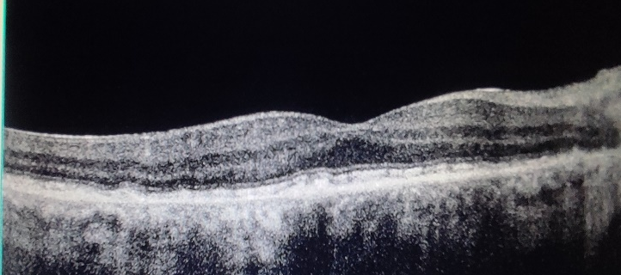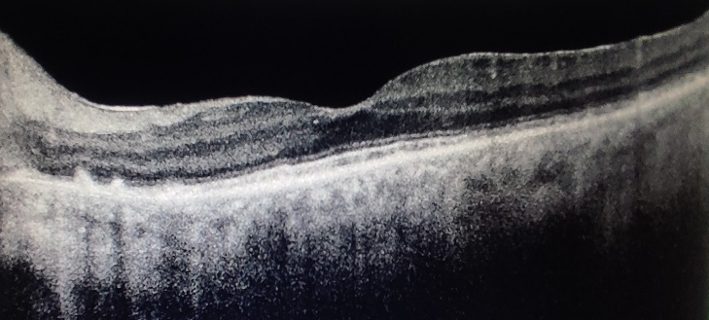

Discussion:
VKH disease is rare granulomatous inflammatory disease that affects the pigmented structures such as eye meninges, inner ear and skin⁽³⁾. Its prevalence in developing countries like India is 1.4%–3.5%⁽⁴⁾.Clinically disease is characterized into four phases:prodromal,uveitic,chronic and recurrent.Prodromal phase-patients present with fever,headache and nausea.within 1-2 days of onset of prodromal phase,patient complain of blurred vision,photophobia,redness and ocular pain.Uveitic phase-cells are present in anterior chamber ,vitreous or both.Disc edema,thickening of posterior choroid,multiple serous reinal detachments.Chronic phase-small,discrete and scattered depigmented lesions seen in the fundus giving in sunset glow fundus.depigmentation in the corneal limbus is known as Sugiura’s sign.Recurrent phase-anterior uveitis is more predominant than posterior uveitis.Mutton-fat keratic precipitates,Koeppe iris nodules,posterior synechiae and iris becomes atrophic.choroidal neovascularization may occur in the peripapillary region and macula.Retinal pigment epithelial proliferation result in subretinal fibrosis⁽⁵⁾.Treatment regimens include corticosteroids (intravenous, oral,and regional),immunosuppressive agents and Biologics.Our report showed case series of Probable VKH diagnosed and treated successfully leading to good visual outcome.Age of presentation 2nd-6th decade with female preponderance.most common visual complaint was diminuation of vision.All cases presented in uveitis phase,two cases presented as posterior uveitis and one case as panuveitis. Fundus fluorescein angiography of first case - multiple pinpoint hyperfluorescence in the early arteriovenous phase with pooling of dye in the late arteriovenous phase,third case- hot disc, multiple hyper & hypoflourescent dots, multilobular pooling and window defect,similar findings are reported by Fardeau C et al in his study on FFA in VKH ⁽⁶⁾. Optical coherence tomography of all case showed vitritis,multifocal neurosensory detachment with subretinal fluid and subretinal septae,in addition to above findings second and third case showed RPE undulations.Ganesh, et al. reported in his study the findings of Acute VKH-subretinal septae,SRF,subretinal hyperreflective dots,RPE undulations⁽⁷⁾.For all cases laboratory and radiological test were done to rule out ocular tuberculosis,sarcoidosis and posterior scleritis.With multimodal imaging findings diagnosis of Probable VKH was made.First case and second case IVMP for 3days followed by oral steroids 1mg/kg bodyweight,tapered over 6months,after 2 months of starting oral steroids Azathioprine 50mg was given for period of 2years and third case was treated with oral steroids and azathioprine.Sasamoto Y et al reported pulse and high dose corticosteroids resulted in good final visual acuity⁽⁸⁾. Enzo A et al reported early introduction of Azathioprine in treatment of VKH resulted in complete control of inflammation and normal vision⁽⁹⁾.

4. Conclusion

This case series contributes to limited literature on Probable VKH disease and highlights the role of Multimodal imaging modalities-Fundus fluorescein angiography and OCT can not only used to diagnose but also to monitor therapy and to predict recurrences. In VKH disease, inflammation arises from the choroidal stroma, and the choroidal space is readily available for systemic treatment. Prompt and ongoing treatment at the disease's onset with a combination of corticosteroids and non-steroidal immunosuppressive agents can lead to visual improvement in many instances, preventing the sunset glow fundus resulting from depigmentation due to prolonged uncontrolled inflammation

Competing interests
No competing interest exist

Consent
Written and informed consent is taken from the patient for publication of case report and accomapanying images.

Ethical approval
“All authors hereby declare that all experiments have been examined and approved by the appropriate ethics committee and have therefore been performed in accordance with the ethical standards laid down in the 1964 Declaration of Helsinki.”

Disclaimer (Artificial intelligence)
Option 1:
Author(s) hereby declare that NO generative AI technologies such as Large Language Models (ChatGPT, COPILOT, etc.) and text-to-image generators have been used during the writing or editing of this manuscript.
Option 2:
Author(s) hereby declare that generative AI technologies such as Large Language Models, etc. have been used during the writing or editing of manuscripts. This explanation will include the name, version, model, and source of the generative AI technology and as well as all input prompts provided to the generative AI technology
Details of the AI usage are given below:
1.NO AI generated information is used.
2.
3.

References

- Read, Russell W. MD*; Rao, Narsing A. MD†; Cunningham, Emmett T. Jr MD, PhD, MPH‡. Vogt-Koyanagi-Harada disease. Current Opinion in Opthalmology 11(6):p 437-442, December 2000.
- Read RW, Holland GN, Rao NA, et al. Revised diagnostic criteria for Vogt–Koyanagi–Harada disease: report of an international committee on nomenclature. Am J Ophthalmol. 2001;131(5):647–652. doi: 10.1016/s0002-9394(01)00925-4.
- Lavezzo, M. M., Sakata, V. M., Morita, C., Rodriguez, E. E. C., Abdallah, S. F., da Silva, F. T. G., Hirata, C. E., & Yamamoto, J. H. (2016). Vogt-Koyanagi-Harada disease: review of a rare autoimmune disease targeting antigens of melanocytes. Orphanet Journal of Rare Diseases, 11(1), 29. https://doi.org/10.1186/s13023-016-0412-4
- Patil, Y. B., Garg, R., Rajguru, J. P., Sirsalmath, M., Bevinakatti, V. A., Kumar, M., & Sharma, S. (2020). Vogt-Koyanagi-Harada (VKH) syndrome: A new perspective for healthcare professionals. Journal of Family Medicine and Primary Care, 9(1), 31-35. https://doi.org/10.4103/jfmpc.jfmpc_787_19.
- Vogt-Koyanagi-Harada disease. Sigiura S. https://ndlsearch.ndl.go.jp/books/R000000004-I1921286 Jpn J Ophthalmol. 1978;22:229–242.).
- Fardeau C, Tran TH, Gharbi B, Cassoux N, Bodaghi B, LeHoang P. Retinal fluorescein and indocyanine green angiography and optical coherence tomography in successive stages of Vogt–Koyanagi–Harada disease. Int Ophthalmol. 2007;27(2–3):163–172. doi: 10.1007/s10792-006-9024-7).
- Ganesh SK, Mistry S, Nair N. Role of Swept source optical coherence tomography in management of acute Vogt-Koyanagi-Harada’s disease. Indian J Ophthalmol 2022;70:2458-63.).
- Sasamoto Y, Ohno S, Matsuda H. Studies on corticosteroid therapy in Vogt-Koyanagi-Harada disease. Ophthalmologica. 1990 Mar 31;201(3):162-7).
- Enzo A. Castiglione, Eugenia I. Abusleme, Claudio Perez, Jaime Tapia, Raul Escalona Parga; Early Introduction of Immunosuppressives in Vogt-Koyanagi-Harada Disease. Invest. Ophthalmol. Vis. Sci. 2012;53(14):5484).

