Distinct Airway Microbiome States in Mycoplasma pneumoniae: Positive and Negative COPD Exacerbations in Elderly Patients

Abstract
Background: Chronic obstructive pulmonary disease (COPD) is frequently complicated by infection-associated exacerbations, but how Mycoplasma pneumoniae (MP) shapes airway microbial ecology in this setting is unclear.

Methods: In a single-center cross-sectional study, we enrolled 58 elderly participants from southwestern China: healthy controls (HealthyControl), stable COPD with negative MP (COPD_Stable_MPneg), acute exacerbation without MP (COPD_AE_MPneg), and acute exacerbation with MP (COPD_AE_MPpos). Sputum underwent 16S rRNA (V3–V4) sequencing with DADA2-based amplicon sequence variant inference. Using phyloseq, microeco and DESeq2, we assessed alpha/beta diversity, taxonomic composition, differentially abundant genera and FAPROTAX-predicted functions.

Results: Compared with HealthyControl, all COPD groups showed reduced Chao1 richness and Shannon diversity, with the lowest diversity and greatest within-group Bray–Curtis dissimilarity in COPD_AE_MPneg, indicating progressive “microbial simplification” and destabilization. HealthyControl sputum was dominated by oral commensals (Streptococcus, Veillonella, Neisseria, Prevotella, Haemophilus, Rothia). COPD_Stable_MPneg retained this oral-like architecture but with enrichment of Corynebacterium and depletion of Moraxella. COPD_AE_MPneg exhibited the most pronounced dysbiosis, with broad depletion of health-associated genera and enrichment of Limosilactobacillus, consistent with collapse of a commensal network rather than overgrowth of a single pathogen. COPD_AE_MPpos showed a narrower pattern, mainly decreased Moraxella and Pseudarcobacter. FAPROTAX predictions revealed higher contributions of chemoheterotrophy, fermentation and “gut-like” functions (human_gut, mammal_gut, human_pathogens_gastroenteritis), particularly in COPD_AE_MPneg.

Conclusions: In elderly COPD patients, airway dysbiosis is characterized by loss of diversity, disruption of an oral-like community and emergence of gut-like, pathogen-enriched profiles. MP-negative exacerbations display the most extensive commensal loss and functional reprogramming, whereas MP-positive episodes show a distinct but more restricted perturbation, underscoring the ecological heterogeneity of COPD exacerbations.

Keywords: Chronic obstructive pulmonary disease, Destabilization, Airway dysbiosis, ecological heterogeneity
Introduction
Chronic obstructive pulmonary disease (COPD) is a major cause of morbidity and mortality worldwide and is characterized by persistent airflow limitation, chronic airway inflammation and frequent acute exacerbations(Agustí et al., 2023b, 2023a; Singh et al., 2019). In clinical practice, a substantial proportion of COPD patients experience acute exacerbations triggered by respiratory infections, which markedly accelerate lung function decline, impair quality of life and increase the risk of hospitalization and death(Abi Abdallah et al., 2024; F et al., 2024; Lippi et al., 2022; van der Bie et al., 2024). Among the infectious triggers, Mycoplasma pneumoniae (MP) has attracted increasing attention, especially in older adults and patients with pre-existing chronic lung diseases, but its impact on airway microbial ecology in COPD remains poorly understood(Georgakopoulou et al., 2024; Guo et al., 2024a).

With the rapid development of high-throughput sequencing, accumulating evidence indicates that the lower respiratory tract is not sterile, and that perturbations of the airway microbiome are closely linked to COPD onset, progression and exacerbation(Faner et al., 2017; Luo et al., 2024a; Wang et al., 2024). Prior studies have mainly compared healthy controls with stable COPD, or contrasted stable versus exacerbation states, showing a shift towards Proteobacteria-enriched, dysbiotic communities during exacerbations(Dicker et al., 2021a; Huang et al., 2014a; Wang et al., 2016). However, few studies have simultaneously considered (i) the baseline difference between healthy individuals and COPD patients, (ii) the transition from stable COPD to acute exacerbation, and (iii) the additional effect of specific pathogens such as MP on top of COPD-related dysbiosis. In particular, it is largely unknown whether MP-positive acute exacerbations represent a distinct airway microbial pattern compared with MP-negative episodes(Guo et al., 2024b; Lv and Xiong, 2024; Wang et al., 2023).

Mycoplasma pneumoniae lacks a cell wall and exhibits unique biological features, including close adherence to airway epithelium and immune-modulatory properties(He et al., 2016; Hu et al., 2022; Sharplin and Goyal, 2025). In COPD patients, MP infection may further disturb the fragile ecological balance of the airway microbiome, favoring enrichment of potentially pathogenic genera and loss of beneficial commensals, thereby amplifying airway inflammation and tissue damage(Ar et al., 2018; Guo et al., 2024c; Yang et al., 2024). Clarifying how MP-positive and MP-negative COPD patients differ in their airway microbial structure and predicted functions may help to refine clinical phenotypes of exacerbations and provide a microbiome-based rationale for prevention and treatment strategies(Bastani and Jalilian, 2024; Li et al., 2025).

In this study, we performed 16S rRNA gene sequencing of lower respiratory tract samples from four well-defined groups: healthy controls (HC), patients with stable COPD and negative MP detection (stable COPD, MP−; SC-COPD_MP−), patients with acute exacerbation of COPD but negative for MP (acute exacerbation, MP−; AE-COPD_MP−), and patients with acute exacerbation of COPD who were MP-positive (acute exacerbation, MP+; AE-COPD_MP+). By integrating alpha and beta diversity analyses, genus-level taxonomic profiling, differential abundance testing and FAPROTAX-based functional prediction, we aimed to: (i) delineate the stepwise changes of airway microbiota from health to stable COPD and further to acute exacerbation; (ii) distinguish the microbial signatures of MP-positive versus MP-negative exacerbations; and (iii) explore potential functional shifts associated with MP infection on the COPD background. These data are expected to provide a preliminary microbial framework for understanding MP-related COPD exacerbations and to generate hypotheses for future mechanistic and interventional studies.

Method
Study design and participants
This was a single-center, cross-sectional study conducted at Pu’er Municipal Traditional Chinese Medicine Hospital from January 2025 to September 2025. Patients with a clinical diagnosis of chronic obstructive pulmonary disease (COPD) and healthy volunteers undergoing routine health check-ups were consecutively enrolled. According to acute exacerbation status and Mycoplasma pneumoniae (MP) infection, subjects were categorized into four groups along a disease continuum:

(1) HealthyControl: individuals without a history of COPD and without any symptoms or signs of acute respiratory infection at the time of health check-up (enrollment).
(2) COPD_Stable_MPneg: patients with a confirmed diagnosis of COPD according to GOLD criteria who were in a stable condition at the time of enrollment (no acute exacerbation during the preceding 4 weeks), and who tested negative for Mycoplasma pneumoniae (MP) by serology and/or PCR.
(3) COPD_AE_MPneg: patients admitted with an acute exacerbation of COPD at the time of hospital admission (enrollment), who tested negative for MP by serology and/or PCR.
(4) COPD_AE_MPpos: patients admitted with an acute exacerbation of COPD at the time of hospital admission (enrollment), with concomitant MP infection confirmed by serology and/or PCR.

Inclusion criteria were: age ≥ 18 years; ability to provide informed consent (or consent from a legal guardian); and willingness to undergo clinical and laboratory assessments. Exclusion criteria included: active pulmonary tuberculosis, lung cancer or overt bronchiectasis; known primary or secondary immunodeficiency or use of systemic immunosuppressive therapy within the previous 3 months; receipt of systemic antibiotics within the previous 4 weeks that could markedly alter the respiratory microbiota; and any other condition judged by the investigators to interfere with study participation.
Clinical data and laboratory measurements
Demographic and clinical data, including age, sex, smoking history, comorbidities and details related to COPD acute exacerbation, were collected at enrollment using a standardized case report form. Within 24 hours of inclusion, peripheral venous blood samples were drawn and processed in the hospital central laboratory according to routine procedures.

Serum immunoglobulin levels (IgM, IgG and IgA) and complement components (C3, C4) were measured by immunoturbidimetry on an automated biochemistry platform (Roche cobas 702 system, Roche Diagnostics). C-reactive protein (CRP) was quantified by immunoturbidimetric assay on the same analyzer. Complete blood counts, including absolute and relative eosinophil counts, were obtained using a fully automated hematology analyzer, and eosinophil (Eosinophil) indices were extracted for analysis.

Circulating infection and cardiac injury biomarkers, including procalcitonin (PCT), B-type natriuretic peptide or its N-terminal pro-peptide (BNP/NT-proBNP), and high-sensitivity cardiac troponin I (hs-cTnI), were determined by chemiluminescent immunoassay using the MAGICL 6000 automated analyzer (New Industries Biomedical, or equivalent platform), following the manufacturer’s instructions and internal quality-control procedures.

Inflammatory cytokines, including interferon-γ (IFN-γ), tumor necrosis factor-α (TNF-α) and interleukin-6 (IL-6), were also measured in serum using an electrochemiluminescence or chemiluminescent immunoassay on the Roche cobas 702 system, and reported in pg/mL. All assays were performed in the same laboratory, with regular internal and external quality assessment to ensure result reliability.

Radiological evaluation and clinical manifestations
At baseline, all patients with COPD underwent chest X-ray examination. Two board-certified radiologists, blinded to group allocation, independently reviewed the images and categorized findings as unilateral pneumonia, bilateral pneumonia, or predominantly increased pulmonary markings/reticular changes. In the event of discrepant readings, a senior radiologist provided the final adjudication.
Clinical symptoms and signs were assessed on the day of enrollment by trained physicians using a structured checklist. Recorded manifestations included the presence or absence of fever (body temperature ≥ 38 °C), cough and sputum production, wheezing or dyspnea, chest pain, sore throat, and lung crackles or other abnormal auscultatory findings. These variables were encoded as binary indicators (present/absent) for subsequent analysis and correlation with laboratory and microbiota data.

Respiratory sample collection and 16S rRNA sequencing
Before initiation of antibiotic treatment whenever possible, respiratory specimens (expectorated sputum or airway secretions, according to departmental standard operating procedures) were collected into sterile tubes. Samples were promptly transported at 4 °C to the laboratory, aliquoted, and stored at –80 °C until DNA extraction.

Total bacterial DNA was extracted using a commercial kit (e.g. Qiagen or equivalent), and DNA concentration and purity were assessed by spectrophotometry. The V3–V4 hypervariable regions of the bacterial 16S rRNA gene were amplified using universal primers. After PCR amplification and purification, sequencing libraries were constructed following the manufacturer’s protocol and sequenced on an Illumina platform (e.g. MiSeq, 2 × 250 bp paired-end runs, or an equivalent configuration). Raw sequence data were generated in FASTQ format for downstream bioinformatic processing.

16S rRNA gene sequencing and microbiome data processing
Genomic DNA was extracted from sputum samples using a commercial bacterial genomic DNA extraction kit (Qiagen, Hilden, Germany) according to the manufacturer’s instructions. The bacterial 16S rRNA gene was amplified targeting the V3–V4 hypervariable region using barcoded primers 341F (5'-CCTACGGGNGGCWGCAG-3') and 806R (5'-GACTACHVGGGTATCTAATCC-3'). Amplicons were purified, quantified, pooled at equimolar concentrations, and sequenced on an Illumina MiSeq platform (Illumina, San Diego, CA, USA) with paired-end reads (2 × 250 bp). Demultiplexed raw reads in FASTQ format were used for downstream analysis.

Raw sequences were processed in R using the DADA2 pipeline to obtain high-resolution amplicon sequence variants (ASVs). Low-quality tails were truncated (truncLen ≈ 400, maxEE = 2, and no ambiguous bases allowed), error rates were learned from the data, and dereplication, denoising, merging of paired reads, and chimera removal were performed to construct a non-chimeric ASV table. Taxonomic assignment was carried out against the SILVA 138.1 reference database to obtain hierarchical classification from kingdom to genus. Sequences not classified as bacteria or archaea, as well as putative contaminants annotated as mitochondria or chloroplast, were removed.

The resulting ASV count table, taxonomy table, and sample metadata were integrated into a phyloseq object and further converted into a microeco::microtable for standardized ecological analyses. To mitigate the impact of uneven sequencing depth, all samples were rarefied to a uniform depth of 36,000 high-quality reads before alpha- and beta-diversity calculations. Relative abundances were computed at different taxonomic levels, and genus-level profiles were used to characterize dominant taxa and to support subsequent functional prediction analyses based on FAPROTAX.

Statistical analysis
Clinical and laboratory data were analyzed using R software (version 4.3.x, R Foundation for Statistical Computing). Continuous variables were examined for normality using the Shapiro–Wilk test. Normally distributed data are presented as mean ± standard deviation and were compared using Student’s t-test (two groups) or one-way ANOVA (more than two groups). Non-normally distributed data are reported as median (interquartile range) and were compared using the Mann–Whitney U test or Kruskal–Wallis test, as appropriate. Categorical variables are summarized as counts and percentages and were compared using the χ² test or Fisher’s exact test.

Microbiome analyses were performed in R (version 4.3.3) using dada2, phyloseq, microeco, vegan, DESeq2, and ggplot2. Alpha diversity indices (Chao1 richness and Shannon diversity) were calculated from the rarefied ASV table, and differences among the four clinical groups (HealthyControl, COPD_Stable_MPneg, COPD_AE_MPneg, COPD_AE_MPpos) were assessed using the Kruskal–Wallis test followed by Dunn’s post hoc test with multiple-comparison adjustment. Beta diversity was quantified using Bray–Curtis dissimilarity, visualized by principal coordinate analysis (PCoA), and group differences in community structure were tested by permutational multivariate analysis of variance (PERMANOVA) and analysis of similarities (ANOSIM).

At the genus level, relative abundance data were summarized with stacked bar plots and heatmaps for descriptive visualization. For differential abundance analysis, DESeq2 was applied to non-rarefied genus-level count data aggregated from ASVs, using HealthyControl as the reference group. Three pairwise contrasts were examined: COPD_Stable_MPneg vs HealthyControl, COPD_AE_MPneg vs HealthyControl, and COPD_AE_MPpos vs HealthyControl. P values were adjusted for multiple testing using the Benjamini–Hochberg false discovery rate (FDR) procedure, and genera with adjusted P (padj) < 0.05 and |log₂ fold change| > 1 were considered significantly different. Volcano plots and log₂ fold-change heatmaps were used to visualize differential genera across groups. For all analyses, a two-sided P value < 0.05 was considered statistically significant unless otherwise specified.

Result
3.1 Baseline clinical and laboratory characteristics
Baseline characteristics of the four groups are summarized in Table 1. Age was comparable across groups (Healthy control 69.1 ± 7.8 vs. Stable COPD, MP− 70.5 ± 8.2 vs. AECOPD, MP− 71.3 ± 6.5 vs. AECOPD, MP+ 70.7 ± 7.9 years; p = 0.64), whereas COPD patients—particularly those with AECOPD—were more often male (40% in Healthy control vs. 87% in Stable COPD, MP−, 93% in AECOPD, MP− and 71% in AECOPD, MP+; p = 0.006).

Markers of cardiac stress and systemic inflammation were markedly elevated in all COPD subgroups compared with Healthy controls. NT-proBNP increased from 20.0 ± 0.0 pg/mL in Healthy controls to 2,984.2 ± 6,864.1 pg/mL in Stable COPD, MP−, 1,080.3 ± 1,450.3 pg/mL in AECOPD, MP− and 1,280.1 ± 1,374.7 pg/mL in AECOPD, MP+ (p < 0.001). Procalcitonin was nearly undetectable in Healthy controls (0.0 ± 0.0 ng/mL) but increased in all COPD groups, with particularly high levels in AECOPD, MP+ (0.4 ± 1.1, 0.8 ± 1.7 and 49.1 ± 175.6 ng/mL in Stable COPD, MP−, AECOPD, MP− and AECOPD, MP+, respectively; p < 0.001). CRP showed a similar pattern, rising from 1.3 ± 0.6 mg/L in Healthy controls to 56.5 ± 101.4 mg/L in Stable COPD, MP−, 23.0 ± 60.1 mg/L in AECOPD, MP− and 45.2 ± 65.2 mg/L in AECOPD, MP+ (p < 0.001), indicating a substantially higher inflammatory burden in COPD, especially in the exacerbation groups.

Nutritional and biochemical indices also differed between groups. Total protein was lower in COPD patients than in Healthy controls (82.5 ± 3.9 g/L vs. 68.5 ± 8.5, 63.5 ± 19.0 and 73.7 ± 5.5 g/L in Stable COPD, MP−, AECOPD, MP− and AECOPD, MP+, respectively; p < 0.001), whereas albumin levels were similar across groups (p = 0.40). Indices of hepatic and renal function showed modest but significant group differences: TBIL and DBIL were higher in COPD—particularly in the AECOPD subgroups (TBIL 4.5 ± 1.3 vs. 8.6 ± 4.1, 9.7 ± 5.2 and 14.2 ± 8.3 μmol/L; p < 0.001; DBIL p = 0.024)—and urea was increased (3.5 ± 1.1 vs. 6.5 ± 4.5, 6.6 ± 3.1 and 8.4 ± 7.5 mmol/L; p = 0.007), while creatinine did not differ significantly (p = 0.50). Muscle and myocardial enzymes (CK, CK-MB, HBDH) also varied among groups, with CK and CK-MB peaking in the AECOPD, MP− group (p ≤ 0.015), suggesting greater systemic and cardiometabolic stress in COPD, particularly during acute exacerbations.

3.2 Sequencing output and alpha/beta diversity
High-throughput 16S rRNA sequencing followed by DADA2 denoising yielded an amplicon sequence variant (ASV) table with 5,718 unique sequences across 59 sputum samples. Chimera removal identified 405 bimeric ASVs (7.1% of sequences) and reduced the table to 5,313 non-chimeric ASVs while retaining 98.9% of total reads. Sequencing depth per sample after quality filtering and chimera removal ranged from 72,771 to 97,825 reads (median 88,971, IQR 86,861–91,404), and rarefaction curves for all samples reached clear plateaus (Figure 1). All samples had >80,000 reads and were rarefied to 36,000 reads for downstream ecological analyses.

Alpha diversity showed a stepwise decline from HealthyControl to COPD, with the lowest diversity observed in AECOPD(Figure 2, Table Sx). For Chao1 richness, HealthyControl had the highest values (median 215, IQR 190–245), followed by COPD_Stable_MPneg (median 195), COPD_AE_MPneg (median 172) and COPD_AE_MPpos (median 160; Kruskal–Wallis P = 0.003). Post-hoc Dunn tests indicated significantly lower richness in all three COPD groups compared with HealthyControl (all P < 0.05), whereas differences among COPD subgroups were not statistically significant. Shannon diversity showed a similar gradient (HealthyControl median 3.45 vs COPD_Stable_MPneg 3.21, COPD_AE_MPneg 2.87 and COPD_AE_MPpos 2.61; global P = 0.004), with HealthyControl exhibiting the highest evenness, both AECOPD groups showing significantly reduced diversity compared with HealthyControl (P < 0.05), and the Stable COPD group displaying intermediate values overlapping with both HealthyControl and AECOPD.

Bray–Curtis beta diversity further demonstrated a marked restructuring of the sputum microbiome (Figure 3, Table SX). PCoA based on Bray–Curtis distances showed that HealthyControl samples clustered separately from COPD samples along the first two axes (PCoA1 12.8%, PCoA2 10.5%, together explaining 23% of total variance), whereas the three COPD subgroups (COPD_Stable_MPneg, COPD_AE_MPneg and COPD_AE_MPpos) partially overlapped with each other but were all shifted away from HealthyControl in ordination space. Global PERMANOVA confirmed significant overall community differences among the four groups (R² = 0.10, F = 2.05, P = 0.001). Pairwise PERMANOVA analyses showed that each COPD subgroup differed significantly from HealthyControl (COPD_AE_MPneg vs HealthyControl: R² = 0.12, adjusted P = 0.002; COPD_AE_MPpos vs HealthyControl: R² = 0.08, adjusted P = 0.002; COPD_Stable_MPneg vs HealthyControl: R² = 0.10, adjusted P = 0.002), whereas comparisons among COPD subgroups themselves were not significant after correction (P > 0.05). Consistently, ANOSIM yielded an R statistic of 0.19 (P = 0.001), indicating moderate between-group separation.

Within-group Bray–Curtis distances were lowest in HealthyControl (median 0.42) and significantly higher in COPD groups, particularly in the two AECOPD subgroups (median 0.58 in COPD_AE_MPneg and 0.62 in COPD_AE_MPpos; both P < 0.05 vs HealthyControl), indicating greater inter-individual heterogeneity during exacerbations. Between-group distances were largest between HealthyControl and each COPD subgroup and comparatively smaller among COPD subgroups themselves, consistent with a shared dysbiotic state in COPD with progressive divergence from the healthy airway microbiome.

3.3 Phylum-level community structure
At the phylum level, the sputum microbiome was dominated by six major phyla—Firmicutes, Bacteroidota, Proteobacteria, Actinobacteriota, Fusobacteriota and Patescibacteria—with the remainder assigned to a composite “Others” category (Figure 4). Together, these six phyla accounted for the majority of sequences across all four groups.

In HealthyControl samples, Bacteroidota and Proteobacteria were the leading phyla (32.0% and 19.8% of total reads, respectively), accompanied by smaller proportions of Firmicutes (4.6%), Actinobacteriota (5.0%), Fusobacteriota (3.7%) and Patescibacteria (2.6%), while the “Others” category contributed 32.2%. In COPD patients, the community shifted toward a more Proteobacteria-enriched configuration, particularly in COPD_Stable_MPneg and COPD_AE_MPneg, where Proteobacteria rose to 42.2% and 44.3%, respectively, with concomitant reductions in Bacteroidota (21.2% and 24.1%) and in the “Others” fraction (21.3% and 13.1%). COPD_AE_MPpos displayed an intermediate pattern, with Proteobacteria and Bacteroidota co-dominating (31.7% and 31.6%, respectively) and modest contributions from the other phyla. Overall, these phylum-level shifts indicate a transition from a more phylogenetically diverse, Bacteroidota-rich community in HealthyControl to a Proteobacteria-skewed airway microbiome in COPD, especially during acute exacerbations.

3.4 Genus-level composition, core OTUs and group-specific taxa
At the genus level, the sputum microbiome showed clear shifts from HealthyControl to COPD (Figure 5). HealthyControl samples were dominated by typical oral commensals such as Streptococcus (mean 23.4%), Veillonella (14.8%), Neisseria, Prevotella, Haemophilus and Rothia, with additional contributions from Alloprevotella, Porphyromonas, Actinomyces, Leptotrichia, Fusobacterium, Capnocytophaga and Gemella (Genus_Top40_heatmap_by_Group4.pdf). COPD_Stable_MPneg retained a broadly similar commensal-dominated profile but exhibited subtle shifts, including increased Corynebacterium and reduced Moraxella, suggesting an early perturbation of the community structure without complete loss of the oral-type background.

In contrast, both AECOPD groups—especially COPD_AE_MPneg—showed marked reductions in many health-associated genera (e.g. Neisseria, Prevotella, Veillonella, Haemophilus and Rothia) and relative enrichment of a limited set of stress- or disease-associated taxa such as Corynebacterium, Mycoplasma, Acinetobacter, Pseudomonas and Staphylococcus. This resulted in a less even genus distribution and a more pronounced dominance of a few genera in AECOPD compared with HealthyControl and Stable COPD, consistent with a dysbiotic shift toward pathogen-enriched communities during exacerbations.

Venn and UpSet analyses further illustrated the distribution of shared and group-specific OTUs/ASVs (Venn_OTU_seqratio_Group4.pdf; UpSet_OTU_Group4.pdf). A “core” airway microbiome comprising 245 OTUs was shared by all four groups, accounting for approximately 82% of total reads. Each clinical group also harbored unique OTUs: HealthyControl 58, COPD_Stable_MPneg 79, COPD_AE_MPneg 112 and COPD_AE_MPpos 96. The fraction and absolute number of group-specific OTUs were larger in COPD groups, particularly in AECOPD, indicating that disease and exacerbation are associated not only with loss of common commensals but also with the acquisition or selective expansion of less ubiquitous taxa.
3.5 Differentially abundant genera associated with COPD status and MP infection
DESeq2 analyses at the genus level, using non-rarefied counts and HealthyControl as the reference, identified key taxa associated with COPD status and MP infection(Figure 6, Table SX). Comparisons yielded 27 significantly different genera for COPD_AE_MPneg vs HealthyControl, 2 for COPD_Stable_MPneg vs HealthyControl, and 2 for COPD_AE_MPpos vs HealthyControl (padj < 0.05, |log₂FC| > 1).
In COPD_AE_MPneg, Limosilactobacillus was significantly enriched (log2FC > 1, padj < 0.05), whereas a broad panel of genera—including Streptococcus, Rothia, Treponema, Corynebacterium, RC9_gut_group, Romboutsia and members of Absconditabacteriales—were markedly depleted (log2FC < −1, padj < 0.05). This pattern suggests that AECOPD without MP infection is characterized predominantly by the loss of health-associated commensals and community thinning, rather than the expansion of a single dominant pathogen.

In COPD_Stable_MPneg, only two genera were significantly altered relative to HealthyControl, with Corynebacterium enriched and Moraxella depleted (both |log₂FC| > 1, padj < 0.05), pointing to a subtle but specific reshaping of the airway microbiota even during clinical stability. In COPD_AE_MPpos, Moraxella and Pseudarcobacter were significantly decreased compared with HealthyControl (padj < 0.05), and the consistent depletion of Moraxella in both COPD_Stable_MPneg and COPD_AE_MPpos suggests particular sensitivity of this genus to COPD-related inflammation and/or treatment exposure. Volcano plots and the log₂ fold-change heatmap (Genus_DESeq2_log2FC_heatmap.pdf) summarize these patterns, highlighting that COPD_AE_MPneg exhibits the most extensive depletion of commensal genera, whereas COPD_Stable_MPneg and COPD_AE_MPpos display more limited but distinct alterations in specific taxa.

3.6 Predicted functional profiles of the airway microbiome
FAPROTAX-based functional prediction showed that these taxonomic shifts were accompanied by systematic changes in ecological functions (Figure 7, Table Sx). Functions related to chemoheterotrophy and fermentation (e.g., chemoheterotrophy, aerobic_chemoheterotrophy, fermentation) displayed altered relative abundances, with COPD groups often exhibiting higher contributions than HealthyControl (ANOVA P < 0.05).

Notably, functions annotated as human_gut, mammal_gut and human_pathogens_gastroenteritis were significantly enriched in COPD, especially in COPD_AE_MPneg (mean 3.2% vs 0.8% in HealthyControl; P < 0.05), in line with the observed loss of classical oral commensals and the relative enrichment of gut-like or pathogen-associated genera. Nitrogen- and sulfur-related pathways such as nitrate_reduction, respiration_of_sulfur_compounds and sulfate_respiration also showed group-dependent differences (P < 0.05), indicating that COPD and MP infection reshape not only taxonomic composition but also the predicted metabolic capabilities of the sputum microbiome. Together, these functional predictions support a shift toward a more gut-like, pathogen-enriched and metabolically altered airway ecosystem in COPD, particularly in AECOPD without MP co-infection.

4. Discussion
In this cross-sectional study of 58 elderly participants from Pu’er, we characterized how the sputum microbiome shifts from health to stable COPD and acute exacerbations, and how these patterns are modulated by concomitant Mycoplasma pneumoniae infection. By combining high-resolution 16S rRNA sequencing with an integrated ecological and functional pipeline, we observed that COPD is not defined by the emergence of a single dominant pathogen, but rather by progressive simplification and destabilization of an oral-like airway community, superimposed on which distinct ecological “states” emerge in exacerbations with and without MP(Huang and Boushey, 2015; Yang et al., 2021; Zhang et al., 2022). These findings extend current concepts of airway dysbiosis in COPD and highlight that host–microbe imbalance in the lower airways is multidimensional, involving changes in diversity, composition and predicted functional capacity(Kou et al., 2024a; Mammen and Sethi, 2016a).

A consistent signal in our cohort was the gradual loss of microbial richness and evenness from healthy controls to stable COPD and AECOPD. This “microbial simplification” has been described in other chronic airway diseases and is increasingly interpreted as a marker of reduced ecological resilience(Choi et al., 2024; Mammen and Sethi, 2016b). In an elderly population where age was comparable across groups, the observed decrease in Chao1 and Shannon indices and the increase in within-group dissimilarity suggest that disease-related factors—rather than aging per se—erode the redundancy and stability of the airway ecosystem. Once diversity is lost, communities may become more vulnerable to perturbations such as viral infections, antibiotic exposure or environmental insults, and less able to return to a pre-exacerbation configuration(Bouquet et al., 2020). The larger between-patient heterogeneity we observed in COPD groups is compatible with a scenario where individual treatment histories, comorbidities and prior colonization events push each airway microbiome into a different local “attractor state” rather than a uniform “COPD microbiome”. Clinically, this instability may help explain why some patients enter a frequent exacerbator phenotype despite similar spirometric severity(Dicker et al., 2021b; Huang et al., 2014b).

At the taxonomic level, our data support the notion that the healthy sputum microbiome in older adults largely reflects an oral commensal community, with Streptococcus, Veillonella, Neisseria, Prevotella, Haemophilus and Rothia as key members(Gupta et al., 2021). Stable COPD in our cohort still retained much of this architecture, but already showed subtle rearrangements, including enrichment of Corynebacterium and depletion of Moraxella compared with healthy controls. This pattern suggests that even in the absence of overt exacerbation, the airway microbiota in COPD is displaced from the healthy equilibrium and occupies an intermediate dysbiotic state. The most profound shifts appeared in AECOPD without MP infection, where multiple health-associated or commensal genera—such as Streptococcus, Rothia, Treponema, RC9_gut_group, Romboutsia and members of Absconditabacteriales—were significantly depleted, while Limosilactobacillus was enriched. Rather than a simple “pathogen overgrowth” model, these changes are more consistent with a collapse of a complex commensal network and a transition toward a less even, more fragile community dominated by fewer taxa, potentially reducing colonization resistance and mucosal immune homeostasis.

Exacerbations with concomitant MP infection showed a different, more restricted pattern of alterations. In our cohort, COPD patients with AECOPD_MPpos exhibited significant depletion of Moraxella and Pseudarcobacter, but did not show the same breadth of commensal loss as the MP-negative exacerbation group. The consistent depletion of Moraxella in both stable COPD and MP-positive exacerbations contrasts with reports that highlight Moraxella catarrhalis as a frequent pathogen in COPD. Several explanations are plausible, including regional epidemiology in southwestern China, high background use of antibiotics that selectively suppress Moraxella, or underpowering for specific pathogens due to modest sample size. Regardless of the exact drivers, the divergence between AECOPD_MPneg and AECOPD_MPpos in our data supports the idea that COPD exacerbations are microbiologically heterogeneous: some are characterized by broad community collapse without a single identified pathogen, whereas others reflect a more focused disturbance superimposed on pre-existing COPD-related dysbiosis.

Analyses of core and group-specific OTUs and inferred functional profiles add another layer to this ecological picture. The presence of a shared core set of OTUs across all four groups—accounting for the majority of total sequences—indicates that a baseline oral–airway microbiome persists even in advanced disease. However, the higher number of group-specific OTUs in COPD, particularly in AECOPD, suggests that disease and exacerbations are accompanied by the acquisition or expansion of niche-adapted taxa, possibly linked to repeated antibiotic exposure, hospitalization or microaspiration of oropharyngeal and gastrointestinal contents(Dima et al., 2019; Kou et al., 2024b). FAPROTAX-based functional predictions further support the notion that these compositional shifts reshape the metabolic capacities of the airway community. COPD groups displayed increased contributions of chemoheterotrophy and fermentation, consistent with enrichment of fermentative, inflammation-adapted bacteria in a hypoxic, mucus-rich microenvironment. Enrichment of functions annotated as human_gut, mammal_gut and human_pathogens_gastroenteritis was particularly prominent in AECOPD without MP, suggesting that “gut-like” or enteric-associated traits are more common in diseased airways(Kou et al., 2024b, 2024c). Although predictive tools such as FAPROTAX are inherently indirect and limited by 16S resolution, the convergence of taxonomic and functional signals is compatible with the emerging gut–lung axis paradigm and raises the possibility that chronic microaspiration or translocation of intestinal bacteria contributes to airway dysbiosis in COPD(Bowerman et al., 2020; Wang et al., 2017).

These ecological findings have several potential clinical implications. First, the profound loss of commensal genera and enrichment of gut-like functions in AECOPD without MP infection suggest that microbiome disruption in these patients may be more severe and diffuse than in those with MP-positive exacerbations, where a specific pathogen can be identified. This raises the hypothesis that AECOPD_MPneg might represent a phenotype in which the precipitating triggers (e.g. viruses, pollutants or non-MP bacteria) are less easily captured by routine diagnostics, but exert a stronger impact on the resident community(Berenji et al., 2025; Luo et al., 2024b). Such patients might be more prone to recurrent exacerbations, impaired mucus clearance or secondary infections, and may require closer follow-up, more cautious use of broad-spectrum antibiotics and consideration of strategies that aim to preserve or restore commensal diversity. Second, the relatively limited but distinct changes observed in AECOPD_MPpos suggest that targeted management of MP infection, superimposed on optimized COPD therapy, may be sufficient to reverse microbiome perturbations in some cases, although this needs to be tested in longitudinal cohorts. Third, the overall pattern of Proteobacteria and Actinobacteriota enrichment, reduction of health-associated oral commensals and functional shifts toward fermentative and gut-like profiles points to microbiome signatures that might be developed into risk markers for exacerbation-prone patients, once validated in larger and independent populations(Dicker et al., 2021c; Leitao Filho et al., 2019; Luo et al., 2024c).

Our study also has methodological strengths that lend weight to these conclusions. We focused on a relatively homogeneous elderly cohort from a single center, with comparable age across groups, thereby reducing confounding by age-related microbiome changes. We applied a rigorous 16S rRNA pipeline based on ASV inference (DADA2) and used established ecological frameworks (phyloseq, microeco) to integrate alpha and beta diversity, compositional analyses, OTU sharing patterns and functional predictions within a unified workflow. Importantly, we analyzed stable COPD, exacerbations without MP and exacerbations with MP as separate strata rather than pooling all COPD patients together, which allowed us to detect potential ecological differences between these clinically relevant subgroups.

Nevertheless, several limitations must be acknowledged. The overall sample size, and especially the per-group numbers, are modest, which reduces power to detect small effect sizes and may contribute to some unexpected findings such as consistent Moraxella depletion. The cross-sectional design precludes causal inference and does not capture temporal dynamics of microbiome changes before, during and after exacerbations; as such, we cannot distinguish whether observed dysbiosis is a cause, consequence or bystander of exacerbation events. Sputum samples are prone to contamination from upper airway microbiota and may not fully reflect lower airway or alveolar communities, although they are clinically accessible and relevant to routine practice. Our reliance on 16S rRNA sequencing limits taxonomic resolution to the genus level in many cases and necessitates the use of predictive tools such as FAPROTAX for functional inference, which cannot substitute for shotgun metagenomics or metabolomic profiling. Finally, we did not systematically control for all potential confounders, including detailed antibiotic histories, inhaled corticosteroid use, environmental exposures and comorbidities, which may influence both microbiome composition and clinical outcomes and should be more comprehensively captured in future work.

In summary, this study provides an integrated view of how the sputum microbiome in elderly individuals from southwestern China is reshaped along the axis from health to stable COPD and acute exacerbations, and how MP infection status modulates this ecological landscape. COPD is associated with reduced diversity, destabilization of a commensal oral-like community, compositional shifts toward Proteobacteria- and Actinobacteriota-enriched profiles and functional signatures suggestive of fermentative and gut-like traits. Among COPD subgroups, acute exacerbations without MP infection show the most pronounced loss of health-associated genera and the strongest enrichment of gut-like functions, whereas MP-positive exacerbations exhibit a more focused but distinct pattern of perturbation. Future longitudinal, multi-omics studies with larger sample sizes and detailed treatment histories are needed to validate these patterns, clarify the mechanistic links between specific taxa or functional modules and airway inflammation, and explore whether microbiome-based markers can refine risk stratification and guide personalized prevention and management strategies for COPD exacerbations in clinical practice.

Conclusions:
In elderly individuals, COPD is associated with reduced diversity, destabilization of an oral-like commensal sputum microbiome, enrichment of Proteobacteria- and Actinobacteriota-dominated profiles, and predicted functional shifts toward fermentative and gut-like traits. Acute exacerbations without MP infection display the most extensive commensal loss and gut-like functional enrichment, whereas MP-positive exacerbations show a more focused but distinct pattern of perturbation superimposed on COPD-related dysbiosis. These findings support the ecological heterogeneity of COPD exacerbations and provide a microbial framework for future longitudinal, multi-omics studies aimed at refining exacerbation phenotypes and developing microbiome-informed prevention and management strategies.

Ethical approval and consent:

The study protocol was approved by the Ethics Committee of Pu’er Municipal Traditional Chinese Medicine Hospital (Approval number: 202509), and written informed consent was obtained from all participants.

Funding:
This work was supported by the Scientific Research Project of Puer Hospital of Traditional Chinese Medicine (Grant No. PESZYYY-2023007).

Disclaimer (Artificial intelligence)
Author(s) hereby declare that NO generative AI technologies such as Large Language Models (e.g., ChatGPT, Copilot, etc.) and text-to-image generators have been used during the writing or editing of this manuscript.

Reference:

- Abi Abdallah, G., Diop, S., Jamme, M., Legriel, S., Ferré, A., 2024. Respiratory Infection Triggering Severe Acute Exacerbations of Chronic Obstructive Pulmonary Disease. Int. J. Chron. Obstruct. Pulmon. Dis. 19, 555–565. https://doi.org/10.2147/COPD.S447162
- Agustí, A., Celli, B.R., Criner, G.J., Halpin, D., Anzueto, A., Barnes, P., Bourbeau, J., Han, M.K., Martinez, F.J., de Oca, M.M., Mortimer, K., Papi, A., Pavord, I., Roche, N., Salvi, S., Sin, D.D., Singh, D., Stockley, R., Varela, M.V.L., Wedzicha, J.A., Vogelmeier, C.F., 2023a. Global Initiative for Chronic Obstructive Lung Disease 2023 Report: GOLD Executive Summary. Respirol. Carlton Vic 28, 316–338. https://doi.org/10.1111/resp.14486
- Agustí, A., Celli, B.R., Criner, G.J., Halpin, D., Anzueto, A., Barnes, P., Bourbeau, J., Han, M.K., Martinez, F.J., Montes de Oca, M., Mortimer, K., Papi, A., Pavord, I., Roche, N., Salvi, S., Sin, D.D., Singh, D., Stockley, R., López Varela, M.V., Wedzicha, J.A., Vogelmeier, C.F., 2023b. Global Initiative for Chronic Obstructive Lung Disease 2023 Report: GOLD Executive Summary. Eur. Respir. J. 61, 2300239. https://doi.org/10.1183/13993003.00239-2023
- Ar, A., K, G., H, Z.M., 2018. Prevalence of Mycoplasma Pneumoniae Infection in Patients with COPD Exacerbation; a Letter to the Editor. Emerg. Tehran Iran 6.
- Bastani, M.N., Jalilian, S., 2024. Unraveling the enigma: The emerging significance of pulmonary surfactant proteins in predicting, diagnosing, and managing COVID-19. Immun. Inflamm. Dis. 12, e1302. https://doi.org/10.1002/iid3.1302
- Berenji, F., Zarrinfar, H., Gholizadeh, A., Sargazi, F., Jamali, J., Parian Noghabi, M., Salehi Sangani, G., Hosseini Farash, B.R., 2025. Co-Infection of Lophomonas blattarum and Pneumocystis jirovecii in Patients with Respiratory Disorders in Northeastern Iran. Iran. J. Parasitol. 20, 299–306. https://doi.org/10.18502/ijpa.v20i2.19049
- Bouquet, J., Tabor, D.E., Silver, J.S., Nair, V., Tovchigrechko, A., Griffin, M.P., Esser, M.T., Sellman, B.R., Jin, H., 2020. Microbial burden and viral exacerbations in a longitudinal multicenter COPD cohort. Respir. Res. 21, 77. https://doi.org/10.1186/s12931-020-01340-0
- Bowerman, K.L., Rehman, S.F., Vaughan, A., Lachner, N., Budden, K.F., Kim, R.Y., Wood, D.L.A., Gellatly, S.L., Shukla, S.D., Wood, L.G., Yang, I.A., Wark, P.A., Hugenholtz, P., Hansbro, P.M., 2020. Disease-associated gut microbiome and metabolome changes in patients with chronic obstructive pulmonary disease. Nat. Commun. 11, 5886. https://doi.org/10.1038/s41467-020-19701-0
- Choi, Y.J., Park, H.J., Kim, C.Y., Choi, A., Cho, J.H., Byun, M.K., 2024. Dynamic microbial changes in exacerbation of chronic obstructive pulmonary disease. Front. Microbiol. 15, 1507090. https://doi.org/10.3389/fmicb.2024.1507090
- Dicker, A.J., Huang, J.T.J., Lonergan, M., Keir, H.R., Fong, C.J., Tan, B., Cassidy, A.J., Finch, S., Mullerova, H., Miller, B.E., Tal-Singer, R., Chalmers, J.D., 2021a. The sputum microbiome, airway inflammation, and mortality in chronic obstructive pulmonary disease. J. Allergy Clin. Immunol. 147, 158–167. https://doi.org/10.1016/j.jaci.2020.02.040
- Dicker, A.J., Huang, J.T.J., Lonergan, M., Keir, H.R., Fong, C.J., Tan, B., Cassidy, A.J., Finch, S., Mullerova, H., Miller, B.E., Tal-Singer, R., Chalmers, J.D., 2021b. The sputum microbiome, airway inflammation, and mortality in chronic obstructive pulmonary disease. J. Allergy Clin. Immunol. 147, 158–167. https://doi.org/10.1016/j.jaci.2020.02.040
- Dicker, A.J., Huang, J.T.J., Lonergan, M., Keir, H.R., Fong, C.J., Tan, B., Cassidy, A.J., Finch, S., Mullerova, H., Miller, B.E., Tal-Singer, R., Chalmers, J.D., 2021c. The sputum microbiome, airway inflammation, and mortality in chronic obstructive pulmonary disease. J. Allergy Clin. Immunol. 147, 158–167. https://doi.org/10.1016/j.jaci.2020.02.040
- Dima, E., Kyriakoudi, A., Kaponi, M., Vasileiadis, I., Stamou, P., Koutsoukou, A., Koulouris, N.G., Rovina, N., 2019. The lung microbiome dynamics between stability and exacerbation in chronic obstructive pulmonary disease (COPD): Current perspectives. Respir. Med. 157, 1–6. https://doi.org/10.1016/j.rmed.2019.08.012
- F, Z., Y, C., T, Z., W, Y., 2024. Epigenetic regulation of macrophage activation in chronic obstructive pulmonary disease. Front. Immunol. 15. https://doi.org/10.3389/fimmu.2024.1445372
- Faner, R., Sibila, O., Agustí, A., Bernasconi, E., Chalmers, J.D., Huffnagle, G.B., Manichanh, C., Molyneaux, P.L., Paredes, R., Pérez Brocal, V., Ponomarenko, J., Sethi, S., Dorca, J., Monsó, E., 2017. The microbiome in respiratory medicine: current challenges and future perspectives. Eur. Respir. J. 49, 1602086. https://doi.org/10.1183/13993003.02086-2016
- Georgakopoulou, V.E., Lempesis, I.G., Tarantinos, K., Sklapani, P., Trakas, N., Spandidos, D.A., 2024. Atypical pneumonia (Review). Exp. Ther. Med. 28, 424. https://doi.org/10.3892/etm.2024.12713
- Guo, Z.-Q., Gu, S.-Y., Tian, Z.-H., Du, B.-Y., 2024a. A comprehensive review of Mycoplasma pneumoniae infection in chronic lung diseases: recent advances in understanding asthma, COPD, and bronchiectasis. Front. Med. 11, 1437731. https://doi.org/10.3389/fmed.2024.1437731
- Guo, Z.-Q., Gu, S.-Y., Tian, Z.-H., Du, B.-Y., 2024b. A comprehensive review of Mycoplasma pneumoniae infection in chronic lung diseases: recent advances in understanding asthma, COPD, and bronchiectasis. Front. Med. 11, 1437731. https://doi.org/10.3389/fmed.2024.1437731
- Guo, Z.-Q., Gu, S.-Y., Tian, Z.-H., Du, B.-Y., 2024c. A comprehensive review of Mycoplasma pneumoniae infection in chronic lung diseases: recent advances in understanding asthma, COPD, and bronchiectasis. Front. Med. 11, 1437731. https://doi.org/10.3389/fmed.2024.1437731
- Gupta, S., Shariff, M., Chaturvedi, G., Sharma, A., Goel, N., Yadav, M., Mortensen, M.S., Sørensen, S.J., Mukerji, M., Chauhan, N.S., 2021. Comparative analysis of the alveolar microbiome in COPD, ECOPD, Sarcoidosis, and ILD patients to identify respiratory illnesses specific microbial signatures. Sci. Rep. 11, 3963. https://doi.org/10.1038/s41598-021-83524-2
- He, J., Liu, M., Ye, Z., Tan, T., Liu, X., You, X., Zeng, Y., Wu, Y., 2016. Insights into the pathogenesis of Mycoplasma pneumoniae (Review). Mol. Med. Rep. 14, 4030–4036. https://doi.org/10.3892/mmr.2016.5765
- Hu, J., Ye, Y., Chen, X., Xiong, L., Xie, W., Liu, P., 2022. Insight into the Pathogenic Mechanism of Mycoplasma pneumoniae. Curr. Microbiol. 80, 14. https://doi.org/10.1007/s00284-022-03103-0
- Huang, Y.J., Boushey, H.A., 2015. The Sputum Microbiome in Chronic Obstructive Pulmonary Disease Exacerbations. Ann. Am. Thorac. Soc. 12 Suppl 2, S176-180. https://doi.org/10.1513/AnnalsATS.201506-319AW
- Huang, Y.J., Sethi, S., Murphy, T., Nariya, S., Boushey, H.A., Lynch, S.V., 2014a. Airway microbiome dynamics in exacerbations of chronic obstructive pulmonary disease. J. Clin. Microbiol. 52, 2813–2823. https://doi.org/10.1128/JCM.00035-14
- Huang, Y.J., Sethi, S., Murphy, T., Nariya, S., Boushey, H.A., Lynch, S.V., 2014b. Airway microbiome dynamics in exacerbations of chronic obstructive pulmonary disease. J. Clin. Microbiol. 52, 2813–2823. https://doi.org/10.1128/JCM.00035-14
- Kou, Z., Liu, K., Qiao, Z., Wang, Y., Li, Yanmiao, Li, Yinan, Yu, X., Han, W., 2024a. The alterations of oral, airway and intestine microbiota in chronic obstructive pulmonary disease: a systematic review and meta-analysis. Front. Immunol. 15, 1407439. https://doi.org/10.3389/fimmu.2024.1407439
- Kou, Z., Liu, K., Qiao, Z., Wang, Y., Li, Yanmiao, Li, Yinan, Yu, X., Han, W., 2024b. The alterations of oral, airway and intestine microbiota in chronic obstructive pulmonary disease: a systematic review and meta-analysis. Front. Immunol. 15, 1407439. https://doi.org/10.3389/fimmu.2024.1407439
- Kou, Z., Liu, K., Qiao, Z., Wang, Y., Li, Yanmiao, Li, Yinan, Yu, X., Han, W., 2024c. The alterations of oral, airway and intestine microbiota in chronic obstructive pulmonary disease: a systematic review and meta-analysis. Front. Immunol. 15, 1407439. https://doi.org/10.3389/fimmu.2024.1407439
- Leitao Filho, F.S., Alotaibi, N.M., Ngan, D., Tam, S., Yang, J., Hollander, Z., Chen, V., FitzGerald, J.M., Nislow, C., Leung, J.M., Man, S.F.P., Sin, D.D., 2019. Sputum Microbiome Is Associated with 1-Year Mortality after Chronic Obstructive Pulmonary Disease Hospitalizations. Am. J. Respir. Crit. Care Med. 199, 1205–1213. https://doi.org/10.1164/rccm.201806-1135OC
- Li, X., Zeng, Q., Liu, C., Yi, X., Luo, H., Tong, Q., Chen, H., You, X., 2025. The Immune Modulatory Role of Surfactants in Mycoplasma pneumoniae Infection. J. Inflamm. Res. 18, 2909–2922. https://doi.org/10.2147/JIR.S507526
- Lippi, L., Folli, A., Curci, C., D’Abrosca, F., Moalli, S., Mezian, K., de Sire, A., Invernizzi, M., 2022. Osteosarcopenia in Patients with Chronic Obstructive Pulmonary Diseases: Which Pathophysiologic Implications for Rehabilitation? Int. J. Environ. Res. Public. Health 19, 14314. https://doi.org/10.3390/ijerph192114314
- Luo, L., Tang, J., Du, X., Li, N., 2024a. Chronic obstructive pulmonary disease and the airway microbiome: A review for clinicians. Respir. Med. 225, 107586. https://doi.org/10.1016/j.rmed.2024.107586
- Luo, L., Tang, J., Du, X., Li, N., 2024b. Chronic obstructive pulmonary disease and the airway microbiome: A review for clinicians. Respir. Med. 225, 107586. https://doi.org/10.1016/j.rmed.2024.107586
- Luo, L., Tang, J., Du, X., Li, N., 2024c. Chronic obstructive pulmonary disease and the airway microbiome: A review for clinicians. Respir. Med. 225, 107586. https://doi.org/10.1016/j.rmed.2024.107586
- Lv, J., Xiong, X., 2024. Extracellular Vesicle microRNA: A Promising Biomarker and Therapeutic Target for Respiratory Diseases. Int. J. Mol. Sci. 25, 9147. https://doi.org/10.3390/ijms25179147
- Mammen, M.J., Sethi, S., 2016a. COPD and the microbiome. Respirol. Carlton Vic 21, 590–599. https://doi.org/10.1111/resp.12732
- Mammen, M.J., Sethi, S., 2016b. COPD and the microbiome. Respirol. Carlton Vic 21, 590–599. https://doi.org/10.1111/resp.12732
- Sharplin, L., Goyal, V., 2025. Mycoplasma pneumoniae respiratory tract infections in children: when and how to diagnose and treat. Breathe Sheff. Engl. 21, 250046. https://doi.org/10.1183/20734735.0046-2025
- Singh, D., Agusti, A., Anzueto, A., Barnes, P.J., Bourbeau, J., Celli, B.R., Criner, G.J., Frith, P., Halpin, D.M.G., Han, M., López Varela, M.V., Martinez, F., Montes de Oca, M., Papi, A., Pavord, I.D., Roche, N., Sin, D.D., Stockley, R., Vestbo, J., Wedzicha, J.A., Vogelmeier, C., 2019. Global Strategy for the Diagnosis, Management, and Prevention of Chronic Obstructive Lung Disease: the GOLD science committee report 2019. Eur. Respir. J. 53, 1900164. https://doi.org/10.1183/13993003.00164-2019
- van der Bie, S., Haaksma, M.E., Vermin, B., van Assema, H., van Gorp, E.C.M., Langerak, T., Endeman, H., Snijders, D., van den Akker, J.P.C., van Houten, M.A., van Lelyveld, S.F.L., Goeijenbier, M., 2024. A Systematic Review of the Pulmonary Microbiome in Patients with Acute Exacerbation COPD Requiring ICU Admission. J. Clin. Med. 13, 472. https://doi.org/10.3390/jcm13020472
- Wang, B., Tan, M., Li, W., Xu, Q., Jin, L., Xie, S., Wang, C., 2024. Exploring the microbiota difference of bronchoalveolar lavage fluid between community-acquired pneumonia with or without COPD based on metagenomic sequencing: a retrospective study. BMC Pulm. Med. 24, 278. https://doi.org/10.1186/s12890-024-03087-6
- Wang, L., Hao, K., Yang, T., Wang, C., 2017. Role of the Lung Microbiome in the Pathogenesis of Chronic Obstructive Pulmonary Disease. Chin. Med. J. (Engl.) 130, 2107–2111. https://doi.org/10.4103/0366-6999.211452
- Wang, Y., Zou, M., Zhao, Y., Kabir, M.A., Peng, X., 2023. Exosomal microRNA/miRNA Dysregulation in Respiratory Diseases: From Mycoplasma-Induced Respiratory Disease to COVID-19 and Beyond. Cells 12, 2421. https://doi.org/10.3390/cells12192421
- Wang, Z., Bafadhel, M., Haldar, K., Spivak, A., Mayhew, D., Miller, B.E., Tal-Singer, R., Johnston, S.L., Ramsheh, M.Y., Barer, M.R., Brightling, C.E., Brown, J.R., 2016. Lung microbiome dynamics in COPD exacerbations. Eur. Respir. J. 47, 1082–1092. https://doi.org/10.1183/13993003.01406-2015
- Yang, C.-Y., Li, S.-W., Chin, C.-Y., Hsu, C.-W., Lee, C.-C., Yeh, Y.-M., Wu, K.-A., 2021. Association of exacerbation phenotype with the sputum microbiome in chronic obstructive pulmonary disease patients during the clinically stable state. J. Transl. Med. 19, 121. https://doi.org/10.1186/s12967-021-02788-4
- Yang, Z., Zhou, J., Su, N., Zhang, Z., Chen, J., Liu, P., Ling, P., 2024. Insights into the defensive roles of lncRNAs during Mycoplasma pneumoniae infection. Front. Microbiol. 15, 1330660. https://doi.org/10.3389/fmicb.2024.1330660
- Zhang, Y., Ning, H., Zheng, W., Liu, J., Li, F., Chen, J., 2022. Lung microbiome in children with hematological malignancies and lower respiratory tract infections. Front. Oncol. 12, 932709. https://doi.org/10.3389/fonc.2022.932709

Table legends

Table 1. Baseline clinical characteristics by group

Variable | Healthy control  N = 15¹ | Stable COPD, MP−  N = 15¹ | AECOPD, MP−  N = 14¹ | AECOPD, MP+  N = 14¹ | Overall  N = 58¹ | p-value²
Gender |  |  |  |  |  | 0.006
male | 6 (40%) | 13 (87%) | 13 (93%) | 10 (71%) | 42 (72%)
female | 9 (60%) | 2 (13%) | 1 (7.1%) | 4 (29%) | 16 (28%)
Age(years) | 69.1 ± 7.8 | 70.5 ± 8.2 | 71.3 ± 6.5 | 70.7 ± 7.9 | 70.5 ± 7.9 | 0.64
nt_pro_bnp_pg_m_l | 20.0 ± 0.0 | 2,984.2 ± 6,864.1 | 1,080.3 ± 1,450.3 | 1,280.1 ± 1,374.7 | 1,226.1 ± 3,386.2 | <0.001
pct_ng_m_l | 0.0 ± 0.0 | 0.4 ± 1.1 | 0.8 ± 1.7 | 49.1 ± 175.6 | 11.9 ± 85.4 | <0.001
TP | 82.5 ± 3.9 | 68.5 ± 8.5 | 63.5 ± 19.0 | 73.7 ± 5.5 | 72.2 ± 12.8 | <0.001
ALB | 40.5 ± 2.5 | 38.9 ± 5.1 | 36.6 ± 8.9 | 39.6 ± 2.9 | 39.0 ± 5.5 | 0.4
ALT | 38.9 ± 1.7 | 17.6 ± 14.5 | 18.4 ± 16.3 | 23.9 ± 27.7 | 25.0 ± 18.5 | <0.001
AST | 38.0 ± 2.0 | 28.3 ± 10.8 | 24.3 ± 14.9 | 28.0 ± 13.4 | 30.0 ± 12.0 | 0.005
TBIL | 4.5 ± 1.3 | 8.6 ± 4.1 | 9.7 ± 5.2 | 14.2 ± 8.3 | 8.9 ± 6.0 | <0.001
DBIL | 2.1 ± 1.1 | 3.0 ± 3.1 | 11.8 ± 30.3 | 5.2 ± 3.5 | 5.2 ± 14.9 | 0.024
UREA | 3.5 ± 1.1 | 6.5 ± 4.5 | 6.6 ± 3.1 | 8.4 ± 7.5 | 6.0 ± 4.7 | 0.007
CR | 90.1 ± 11.8 | 89.8 ± 50.9 | 96.0 ± 23.2 | 122.8 ± 113.0 | 98.5 ± 59.2 | 0.5
CK | 71.7 ± 17.0 | 84.5 ± 51.7 | 139.6 ± 76.7 | 72.3 ± 49.0 | 86.3 ± 51.8 | 0.015
CKMB-9 | 3.0 ± 1.3 | 1.3 ± 1.7 | 5.8 ± 7.7 | 1.3 ± 1.5 | 2.7 ± 3.7 | 0.005
LDH | 205.7 ± 26.8 | 178.0 ± 43.1 | 218.7 ± 52.6 | 198.1 ± 38.3 | 200.6 ± 39.1 | 0.2
HBDH | 197.0 ± 41.2 | 129.4 ± 42.2 | 173.7 ± 42.6 | 149.1 ± 34.5 | 167.4 ± 47.0 | 0.013
CRP | 1.3 ± 0.6 | 56.5 ± 101.4 | 23.0 ± 60.1 | 45.2 ± 65.2 | 30.6 ± 67.7 | <0.001
¹n (%); Mean ± SD
²Pearson's Chi-squared test; Kruskal-Wallis rank sum test

Figure legends

Figure 1. Rarefaction curves indicate sequencing depth sufficiency across study groups

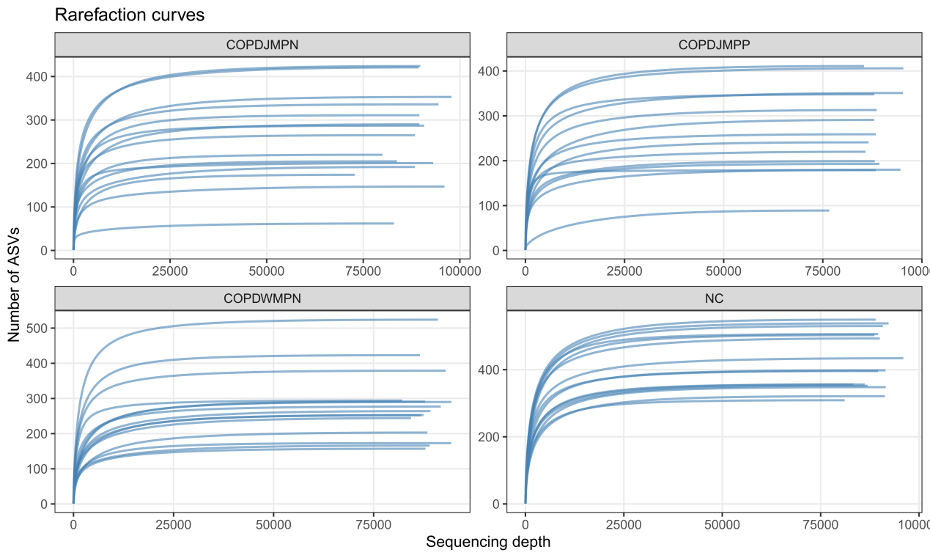
Rarefaction curves for individual samples in each group (NC, COPDJMPN, COPDJMPP, and COPDWMPN). The x-axis denotes sequencing depth, and the y-axis shows the number of observed ASVs. Each line represents one sample. Curves approaching a plateau with increasing reads suggest adequate sampling coverage for capturing within-sample richness.

Figure 2 Reduced alpha diversity in COPD groups compared with healthy controls
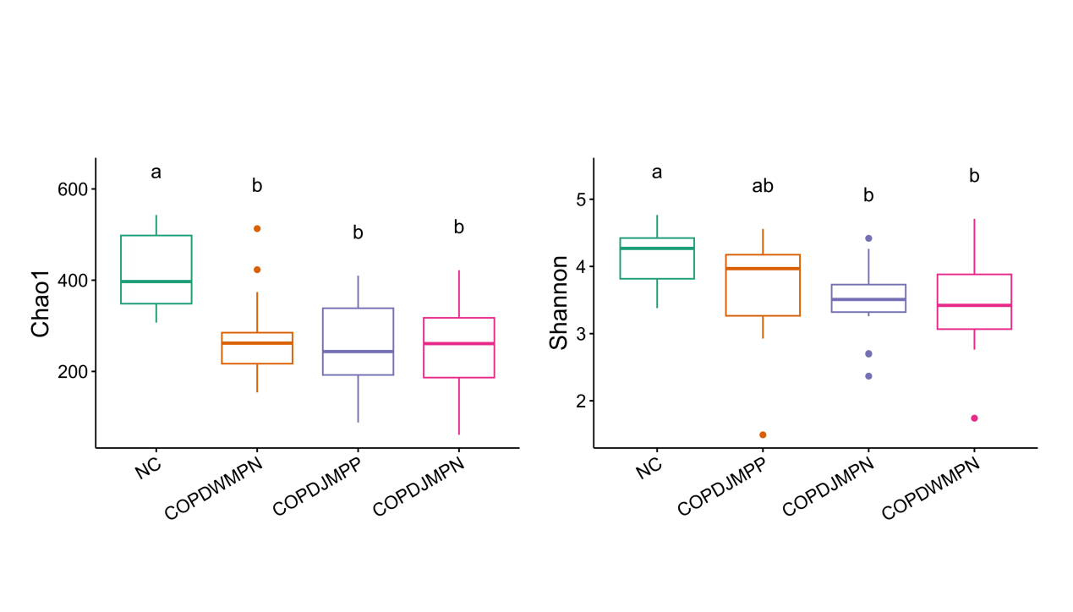
Boxplots of within-sample (alpha) diversity across groups (NC, COPD-WMPN, COPD-JMPP, COPD-JMPN). Left: Chao1 richness; right: Shannon diversity. Boxes show the interquartile range with median lines; whiskers indicate variability and points denote outliers. Different letters above boxes indicate statistically significant differences between groups (P < 0.05), whereas shared letters indicate no significant difference.

Figure 3. Beta diversity analysis reveals group-specific shifts in sputum microbial community structure

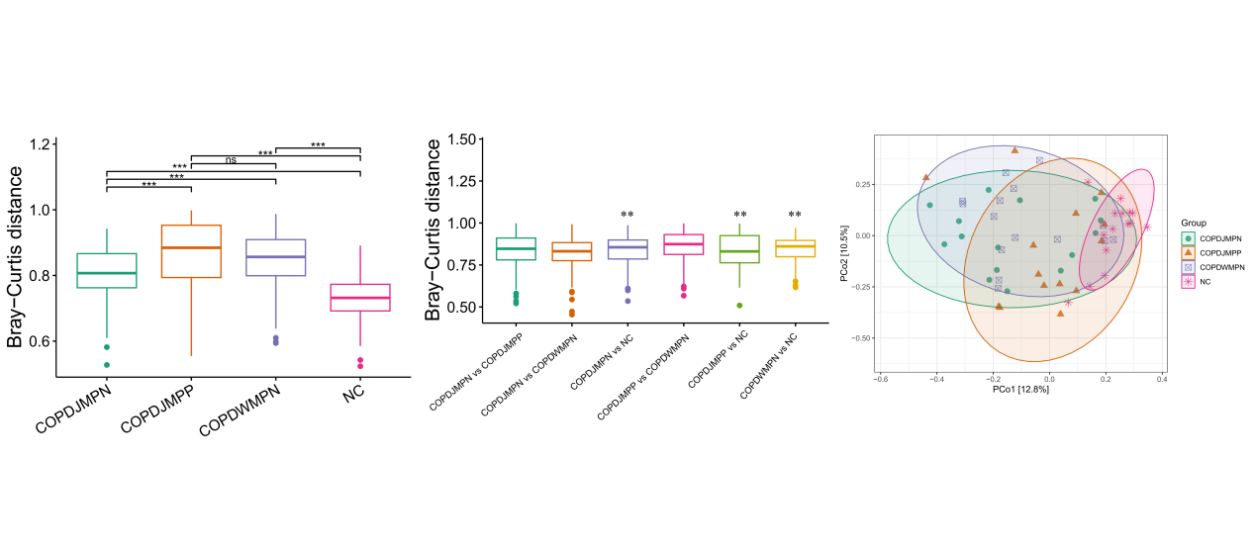Bray–Curtis beta diversity comparisons among groups (COPDJMPN, COPDJMPP, COPDWMPN, and NC). Left, within-group Bray–Curtis distances, with pairwise group comparisons indicated (ns, not significant; **P < 0.01; ***P < 0.001). Middle, between-group Bray–Curtis distances for selected pairwise contrasts. Right, principal coordinates analysis (PCoA) based on Bray–Curtis dissimilarities; each point represents one sample and ellipses indicate group clustering. Axis labels show the percentage of variance explained by each coordinate.

Figure 4.Phylum-level microbiome composition differs across COPD subgroups and healthy controls

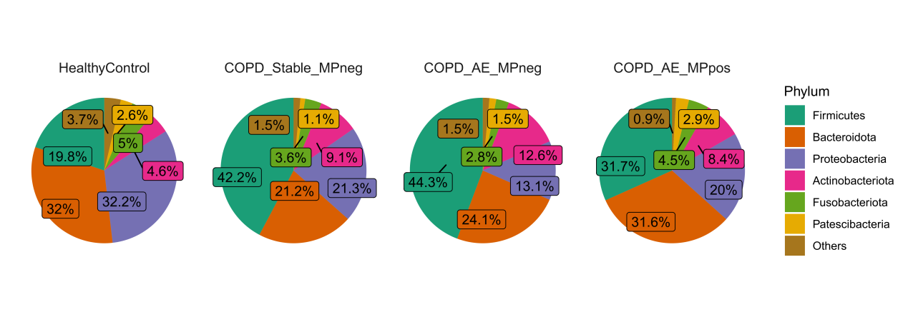Pie charts showing the mean relative abundance of dominant bacterial phyla in sputum samples from HealthyControl, COPD_Stable_MPneg, COPD_AE_MPneg, and COPD_AE_MPpos groups. Percent labels indicate the average proportion of each phylum within a group. “Others” represents the combined relative abundance of all remaining low-abundance phyla not shown individually.
Figure 5. Genus-level heatmap of relative abundance reveals distinct microbial profiles across groups

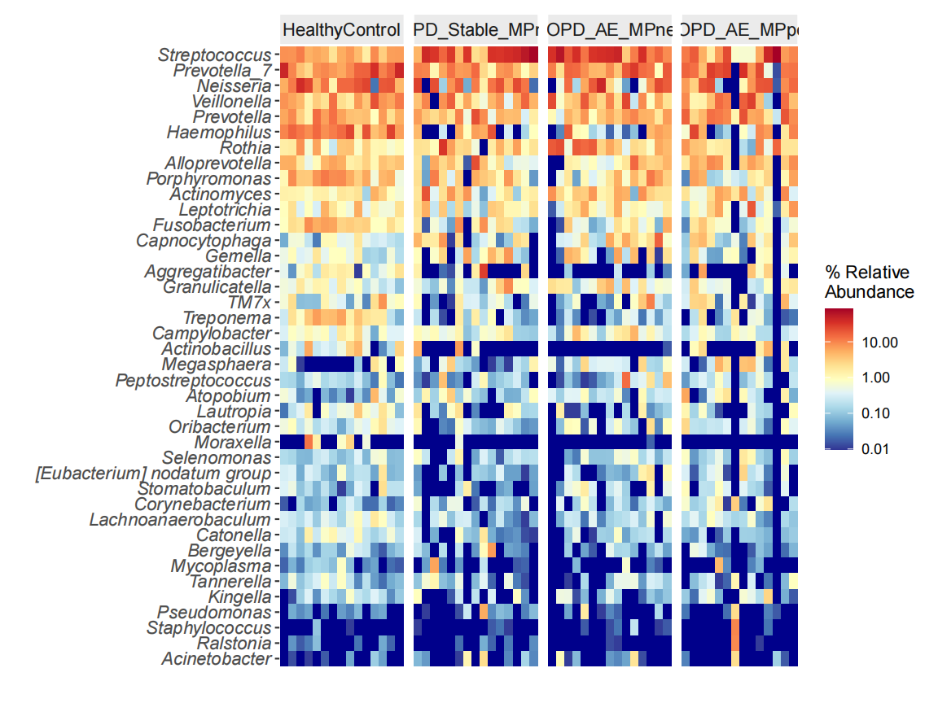
Heatmap showing genus-level community composition across individual sputum samples from HealthyControl, COPD_Stable_MPneg, COPD_AE_MPneg, and COPD_AE_MPpos. Rows represent bacterial genera and columns represent samples, grouped by clinical category. Colors indicate relative abundance (%) on a log10 scale (legend), with warmer colors denoting higher abundance and cooler colors denoting lower abundance, highlighting inter-individual variability and group-specific shifts in dominant genera.

Figure 6. Differentially abundant genera in COPD subgroups compared with healthy controls

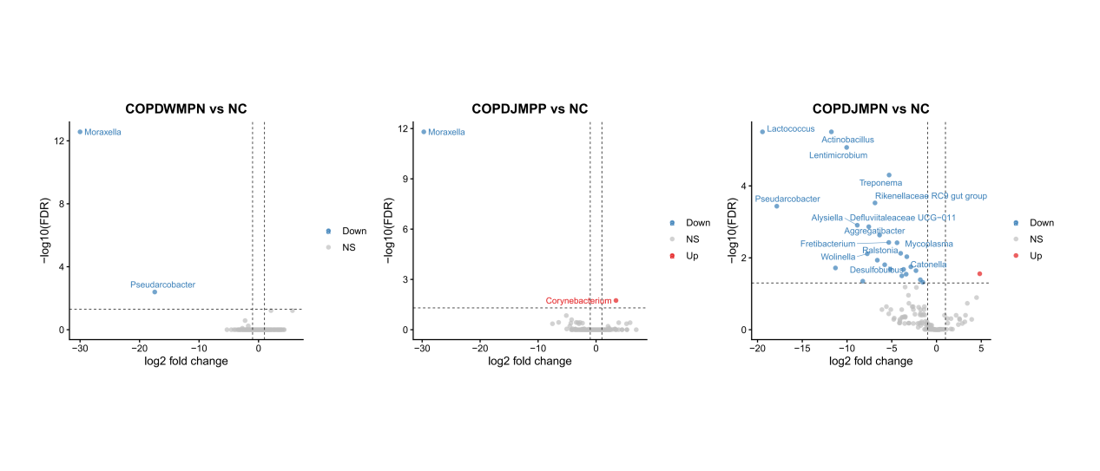
Volcano plots showing genus-level differential abundance between each COPD subgroup and NC (COPDWMPN vs NC, COPDJMPP vs NC, and COPDJMPN vs NC). The x-axis indicates log2 fold change and the y-axis shows −log10(FDR). Dashed vertical lines mark the fold-change threshold and the dashed horizontal line denotes the significance cutoff. Points are colored by direction of change (Up/Down) or not significant (NS), and selected significant genera are annotated.

Figure 7. Differential abundance of FAPROTAX-predicted functions across groups

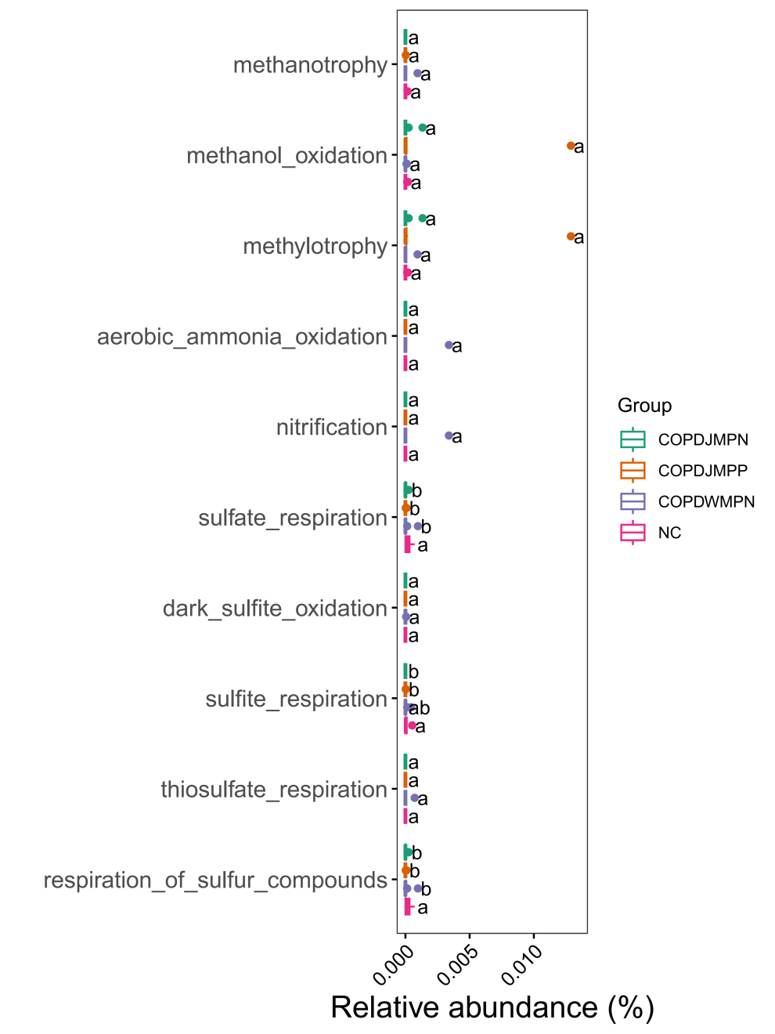
Dot/box plots showing the relative abundance (%) of selected FAPROTAX-predicted microbial functional categories across NC, COPDJMPN, COPDJMPP, and COPDWMPN groups. Each point represents an individual sample, and group distributions are summarized for each function. Different letters indicate statistically significant differences between groups for the same function (P < 0.05); groups sharing the same letter are not significantly different.

