Biosynthesis of Cu-doped Zinc Oxidenanoparticles using leaf extract of Azadirachta Indica: Antibacterial properties and application in photocatalytic degradation

ABSTRACT
The green synthesised Zinc Oxide and Copper-doped Zinc Oxides are oxide-based photocatalysts possessing nanostructures and show efficient photocatalytic degradation of organic pollutant i.e.Methylene Blue(MB) dye and effective antimicrobial activities against Staphylococcus aureus and Bacillus subtilis gram positive bacteria. The photocatalytic degradation has been studied under a constant source of visible light and the antimicrobial activity has been studied using agar dilution or the disk diffusion method. The doped oxides of general formula Zn_{1-x}Cu_{x}O( x= 0.005, 0.01 and 0.02) were synthesised by calcination process in a muffle furnace and were obtained in powder form. The sample powder was characterised by Fourier Transform Infrared Spectroscopy (FTIR), Field Emission Scanning Electron Microscopy (FESEM),Energy Dispersive X-ray Spectroscopy(EDAX), X-ray Diffraction(XRD), Dynamic Light Scattering (DLS) and Atomic Absorption Spectroscopy (AAS).The formation of phase-pure materials with a wurzite structure was indicated by XRD. FESEM images reveal that prepared sample exhibit nanoscale structure . The elemental composition of the sample was confirmed by the EDAX spectroscopy which verified the correct stoichiometry of the oxides. The photocatalytic activity of the sample was evaluated by studying its performance in degrading methylene blue, an organic water pollutant under specific pH conditions and a constant dose of irradiation over duration of several hours. The results demonstrated significant visible light photocatalytic activity that was dependant on the duration of irradiation. With the goal of determining the optimal doping level for enhanced degradation performance, Zn_{0.99}Cu_{0.01}O with the ideal doping amount, demonstrated the highest degrading efficiency of 72% after approximately 90 minutes. The Cu-doped ZnO nanoparticles synthesized via a green method also exhibited enhanced antimicrobial activity against Gram-positive bacteria which can be attributed to the synergistic effect of Cu and ZnO. These findings suggest potential applications in medical and environmental fields.

Key words: Photocatalyst, Methylene blue, Calcination, Nanoparticles, Antimicrobial activity

Introduction
“Dyes and their effluents from textiles, foods and printing industries are the major pollutants released in water bodies. Generally dyes are highly toxic and nonbiodegradable because of its complex nature, causing serious threat to the ecosystem. Methylene blue (MB) is a widely used dye in textile industries, which is extremely carcinogenic and toxic” [1]. “To eliminate dye pollution from the wastewater various methods such as adsorption, oxidation, filtration, and sedimentation etc. are used.Photocatalytic degradation is one of the alternative ways that have been demonstrated to effectively degrade and remove the organic pollutants in the presence of a photocatalyst” [2,3] because of their non toxic effect and low cost. Semiconductor materials such as TiO₂, ZnO, Fe₂O₃, CdS, and ZnS have been used as photocatalysts. They provide photo-generated holes with high oxidizing power due to their wide band gap energies.

“ZnO has been extensively studied to act as an efficient photocatalyst owing to its high photosensitivity, high stability, nontoxicity, wide availability, and low cost” [4,5]. “ZnO has a band gap energy of 3.37 eV as well as a large excitonbinding energy of 60 meV at room temperature” [6,7] and “it has been suggested as an alternative to TiO₂ photocatalyst due to its ability to absorb a larger fraction of solar spectrum due to higher photon efficiency and also have a larger quantum efficiency compared to TiO₂” [8,9].

Recently, “ZnO has found use as an antimicrobial agent and has seen application in the lining of food packaging to reduce spoilage” [10]. “Zn²⁺ is an essential ion for many microorganisms due to its involvement in various cellular reactions, but at concentrations above 10⁻⁷ mol L⁻¹ it becomes cytotoxic” [11−14]. “Another process is that it induces the formation of powerful oxidizing agents (such as hydrogen peroxide) within bacteria cells that can cause cell damage. New approaches are needed for biomedical applications of ZnO-NPs to actively perform in antimicrobial and antibacterial activities” [15]. For this to happen, “the properties and functionality of ZnO-NPs were needed to be improved by incorporating other materials as dopants that were sought to be the transition metals (Fe, Mn, Cu, Cr) or biomolecules at the nanoscale” [16,17]. “After doping with transition metals and biomolecules, the surfaces of these nanoparticles are modified to have excellent biocompatibility to effectively perform in antimicrobials, antioxidants, drug delivery systems, bio-imaging, and biosensors, etc”. [18].

“Among all other dopants, Cu²⁺ is found to significantly change the morphological, structural, optical, electrical, magnetic, and biological properties of the ZnO-NPs. Because of biomedical applications, Cu²⁺ is considered to be the best option” [19], because it has a comparable size of ionic radii to that of Zn²⁺ (0.73 A, and 0.74 A) and non-toxic to biological species. “The combined antibacterial properties of CuO and ZnO can be investigated by doping Cu into a ZnO matrix or Zn into a CuO matrix” [20]. Besides, “doping acquires the dopant to have excellent electrical conductivity. Moreover, it can easily modify or change the chemical and physical properties of ZnO” [21, 22]. “Because of the significant improvement in the properties of ZnO-NPs with Cu-doping, several techniques have been reported in the past” [23]. Likewise, “ZnO and Cu-doped ZnO nanorods were reported by the mechanically assisted thermal decomposition process. Cu-doped ZnO nanorods were found to exhibit better photocatalytic and antibacterial characteristics enhancing their (biomedical) properties than pure ZnO nanorods” [24,25]. “Several more techniques have been reported for the synthesis of Cu-doped ZnO-NPs including sol-gel, co-precipitation, sonochemical synthesis, vapor transport technique, hydrothermal, combustion method etc” [26,27]. “These conventional methods fail to address theproblems related to toxicity, cost, waste production and environmental contamination. Regardless of innovative fabrication techniques for use of ZnO for degradation of MB under solar light with good results” [28]. “In order to overcome them, today'sresearchers have been immensely focusing on the green chemistry route for synthesizing metal oxides. Green approach towards the synthesis of metal oxide NPs is more eco-friendly, economically viable, socially accepted, safer, sustainable to the environment etc and account for increase in the yields of production” [29, 30]. The synthesis of Zinc oxide nanoparticles using leaf extract has been reported along with study of their antibacterial activities [38].

The present work is undertaken to fabricate copper doped zinc oxide nanoparticles via green approach and identify the effect of dopant concentration in the properties and characterization of ZnO nanoparticles. “Among the available greener methods, the use of leaf extracts is the best way as it involves simplest, less investment, shorter time period, highly efficient, non-pathogenic and feasible process to prepare metal oxide at larger scale relative to bacteria, fungi and algae mediated synthesis. Therefore, in this regard, we have focused on synthesis of ZnO NPs from the Azadirachta Indica (AI) leaf extract, which act as a stabilizer for nanoparticles and is a highly effective green approach of degrading the MB dye using visible light driven photocatalytic process. Metal dopants possess a unique ability to elevate the properties of ZnO nanoparticles, however, copper-doped (Cu-doped) ZnO nanoparticles are fabricated in the present work as it shows promising exclusive physicochemical properties for biological benefits , along with photocatalytic applications. The doping of Cu and Ag in ZnO is expected to modify optical absorption and other physical or chemical properties of ZnO” [31,32].

Materials and Methods
Preparation of Neem Leaf Extract
The leaves of the Azadirachtaindica(neem) plant were washed and sterilised. The aqueous extract of the sample was obtained by heating 25 g of fresh leaves in a 250 ml glass beaker with 100 ml of double distilled water at a temperature of 60°C for duration of 30minutes. The mixture was continuously stirred using a magnetic stirrer until the colour of the solution turned brown. The extract was cooled to ambient temperature and filtered using Whatman 40 filter paper. The extract was refrigerated for subsequent synthesis processes.
Synthesis of pure Zinc oxide
To synthesize undoped zinc oxide 25 mL of neem leaf extract was added to 25 mL of 1M Zinc Acetate Dihydrate. The mixture was agitated constantly using a magnetic stirrer, while maintaining the solution at a pH of 7.0 by gradually adding 0.5 M sodium hydroxide at room temperature. The precipitate was filtered and washed multiple times with water followed by ethanol. After that it was dried in an oven at 60 degrees Celsius for overnight, crushed into a fine powder, and then calcined at 400⁰C for one hour in a muffle furnace.
Synthesis of Copper doped zinc oxide.
For the preparation of Cu doped ZnO i.e.Zn_{0.995}Cu_{0.005}O , Zn_{0.99}Cu_{0.01}O and Zn_{0.98}Cu_{0.02}O required volumes of Zn(CH₃COO)₂.2H₂O, Cu(NO₃)₂.3H₂O and leaf extract mixture was agitated constantly using a magnetic stirrer, while maintaining the solution at a pH of 7.0 by gradually adding 0.5 M sodium hydroxide at room temperature. This led to the production of a precipitate. In order to remove contaminants, the precipitate was filtered and washed multiple times with water, followed by ethanol. After that, it was dried in an oven at 60 degrees Celsius overnight, crushed into a fine powder, and then calcined at 400 degrees Celsius for one hour in a muffle furnace.
Photocatalytic study
The process of degradation of a 5 ppm solution of methylene blue in water was carried out at neutral pH. The zinc oxide and Cu-doped zinc oxide nanoparticles, synthesized beforehand, were used as the catalyst at a concentration of 0.007 g/L. The reaction mixture was ultrasonicated for about 35 minutes. The solution was kept at a neutral pH and the temperature was fixed at 300 ⁰C. The reaction mixture was agitated in the absence of light for the duration of 1 hour in order to establish a state of equilibrium between the adsorption and desorption of methylene blue on the surface of the catalyst. The reaction mixture was taken and was once again subjected to magnetic agitation and exposed to sources of visible light. At 30-minute intervals, 3 ml portions of the dye solution were withdrawn and filtered to remove any particles present and centrifuged. The absorbance of the sample solution was measured using a UV-Vis spectrophotometer, specifically within the wavelength range of 450-680 nm. The level of photo degradation was assessed by monitoring the variations in absorbance.

Results and Discussions
SEM Analysis
The morphology of the synthesized samples was analysed using a scanning electron microscope FESEM, model ZEISS Gemini 300 . Pure Zinc Oxide and Cu doped zinc oxide were shown in Figure 1a& 1b, indicating that the ZnO particles are mostly spherical in shape, with an average diameter ranging from 40 to 60 nm. The Cu-doped ZnO particles have a somewhat irregular spherical shape with an average size ranging from 30 to 50 nanometers. The pictures demonstrate that green production methods yield ZnO and Cu-ZnO nanoparticles with clearly distinguishable morphological features.The addition of Cu to ZnO alters its structure and decreases the size of the particles, which could improve its usefulness for applications that need specific surface characteristics and homogeneity of particles.

(a) (b)
Figure-1: SEM picture of (a) pureZnO and (b) Cu-doped ZnO

EDAX analysis
The purpose of the EDAX analysis is to confirm the elemental composition and dispersion of ZnO and Cu-doped ZnO nanoparticles that were created utilising environment friendly procedures. This investigation is essential for verifying the successful integration of Cu into the ZnO matrix and comprehending the material's potential for diverse applications. The EDAX spectrum of Pure Zinc Oxide and Cu-Doped Zinc oxide (Figure 2a) exhibits supplementary peaks due to copper (Cu) in addition to zinc (Zn) and oxygen (O). This verifies the effective incorporation of Cu into the ZnO matrix through doping [ Table-2].The lack of notable impurity peaks suggests that the synthesised ZnO has a high level of purity.

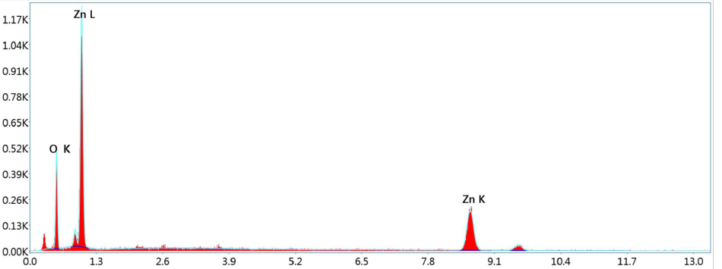
(a)

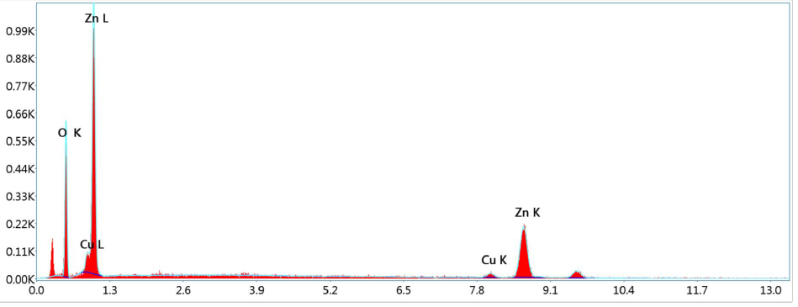
(b)
Figure.2 EDAX spectrum of (a) pureZnO and (b) Cu-doped ZnO

[Table-1: EDAX elemental composition of synthesized sample]
Elements | Atomic%
Elements | ZnO | Cu doped ZnO
O K | 61.8 | 65.2
Zn K | 38.2 | 33.0
Cu K |  | 1.8

DLS Analysis
The DLS measurement was taken in a Litesizer 500 instrument in a quartz measurement cell. The purpose of the DLS analysis is to ascertain the particle size distribution and stability of ZnO and Cu-doped ZnO nanoparticles that have been synthesised utilising green methods. The size distribution profile in the case of pure Zinc Oxide obtained from dynamic light scattering (DLS) analysis (Figure 3) exhibits a prominent peak with an average hydrodynamic diameter of 55 nm and a polydispersity index (PDI) of 0.7, suggesting a rather homogeneous size distribution. Cu-doped Zinc Oxide reveals an average hydrodynamic diameter of 50 nm, slightly lower than that of undoped ZnO. The PDI of 0.15 suggests a more uniform size distribution
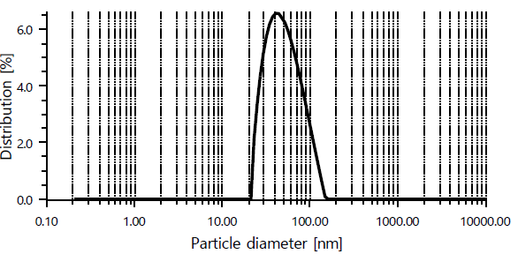
Figure 3: DLS spectra of Cu-doped ZnO

FT-IR Analysis
FTIR spectroscopy is a valuable technique for obtaining vital information on the chemical bonds and functional groups that are present in a material. The FTIR spectrum of ZnO (Figure 4a) exhibits distinct peaks at 403 cm⁻¹ (representing Zn-O stretching), 3310 cm⁻¹ (indicating O-H stretching), and 1697 cm⁻¹ (corresponding to C=O stretching caused by organic residues). In case of Cu doped sample the observed shift to 406 cm⁻¹ indicates alterations in the Zn-O bond surroundings as a result of Cu doping. The presence of additional peaks at around 687 cm⁻¹ can be attributed to the formation of Cu-O bonds, which confirms the inclusion of copper (Cu) into the ZnO matrix

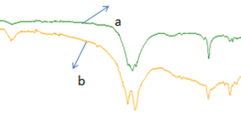
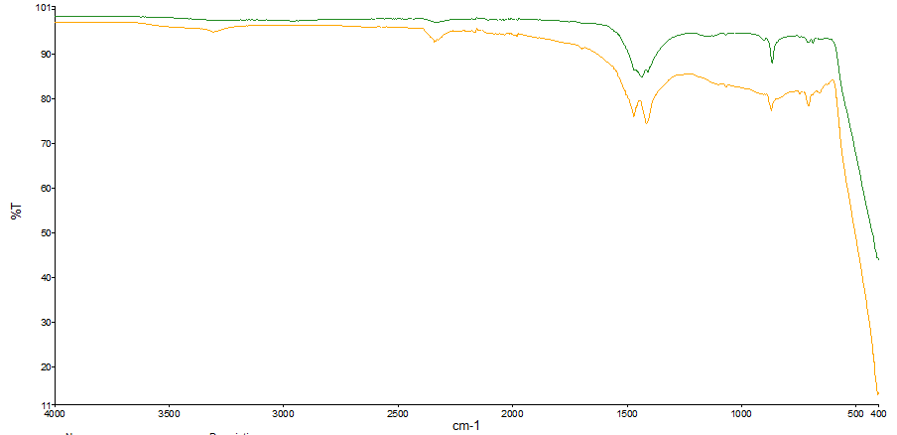

Figure 4. FTIR spectra of pure ZnO and Cu doped ZnO

Atomic Absorption Spectroscopy
The analysis is essential to verify the concentration of zinc and copper in the samples, hence confirming the efficacy of the doping and synthesis process. The AAS analysis (Table 2) indicates that the zinc content in the ZnO sample is 56.51% of as determined by the synthesis conditions. The AAS analysis (Table2) reveals that the zinc concentration in the Cu-doped ZnO sample corresponds to 50.8%, while the copper content aligns with the targeted doping level, accounting for 6.54%.

Table 2. AAS data of Pure and Cu-doped ZnO

Sample | Zn% | Cu%
Pure ZnO | 56.51 | -------
Cu-doped ZnO | 50.8 | 6.54

Thermal analysis TGA/DTG
The thermogravimetric analysis (TGA) curve of Cu-ZnO (Figure 5) exhibits a comparable initial weight reduction of 4% till reaching a temperature of 150°C due to loss of water. However, the second stage of weight loss is slightly altered, with a 4% reduction in weight taking place between temperatures of 250-450°C when compared with pure ZnO , which is most likely attributed to the breakdown of organic wastes resulting from the green synthesis procedure. The residual weight remains constant up to a temperature of 800°C, showing a high level of thermal stability.

“DTG, which expresses the first-order mass derivative (dm/dt) over the heating temperature, was important to evaluate mass loss more easily. The maximum point in the DTG (peak temperature) curve is obtained when the TGA curve shows a change at a stage in which the variation of sample mass occurs more rapidly” [33]

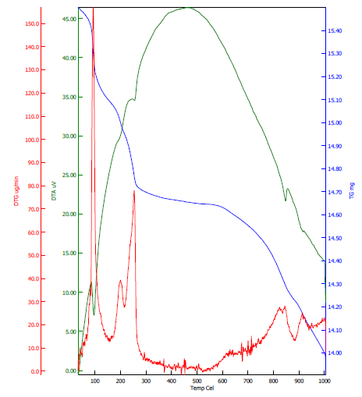
Fig. 5: TG-DTA analysis of Cu doped ZnO

X-ray Diffraction Analysis
Fig-6 shows the observed X-ray diffraction pattern of ZnO and Cu-doped ZnO. The crystallite size, phase, and structure of the material are determined with the help of positions and intensities of the peaks. The peaks in the XRD pattern appear at 31.9°, 34.4°, 36.5°, 47.5°, 56.7°, 62.8°, 66.5°, 67.8°, and 69.1° corresponds to (100), (002), (101), (102), (110), (103), (200), (112), (201), (004), and (202)

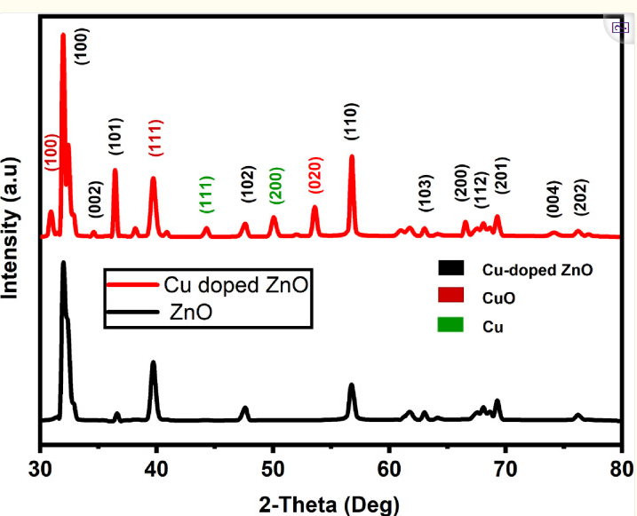
Figure-6: X-ray diffraction images of ZnO and Cu-doped ZnO
planes in hexagonal wurtzite ZnO and Cu-doped ZnO respectively (JCPDS card No. 89–7102) [34, 35]. The XRD pattern also has several more peaks located at 30.9°, 38.8°, 44.5°, 50.2°, and 53.5°. The peaks at 30.9°, 38.8°, and 53.5° correspond to (100), (111), and (020) in Cu (II) oxide, whereas, the peaks at 44.5°, and 50.2° are assigned to the FCC phase of Copper [36]. The existence of Cu and CuO indicates the Cu-doping of the as-synthesized ZnO.
Photocatalytic measurement
Methylene blue (MB) solution was photocatalytically degraded by making use of synthesized Cu-ZnO nanoparticles under a 100W incandescent light source, positioned 15cm above the MB solution. The presented graph illustrates the degradation of a 5ppm MB solution over varying time durations (0-200 min) under visible light sources. The spectra of the Methylene blue solution in an aqueous medium demonstrated a gradual deterioration of the dye as time progressed (Fig-7). Consequently, the initial deep blue colour of the solution faded to a lighter blue shade. The percentage degradation of Methylene blue can be evaluated as:
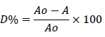-
where Ao is the initial absorbance and A is the absorbance of the dye at a particular time.
By using above formulae can get percentage degradation of samples collected at various time intervals as given in Table 3 and the result is shown graphically (Fig-8).

Table 3. Degradation % at different time intervals of MB dye

Time | ZnO | Zn_{0.995}Cu_{0.005}O | Zn_{0.99}Cu_{0.01}O | Zn_{0.98}Cu_{0.02}O
30 | 42 | 54.9 | 55.7 | 60
60 | 50 | 59.5 | 57.5 | 62.6
90 | 57.7 | 63 | 72 | 65.6
120 | 60.3 | 64.7 | 73.5 | 66.7
150 | 60.8 | 64.9 | 73.8 | 66.9
180 | 61.2 | 65.1 | 74.2 | 67.3
200 | 62 | 65.7 | 74.5 | 67.5

Figure-7 Absorbance Graph of ZnO and Cu doped ZnO
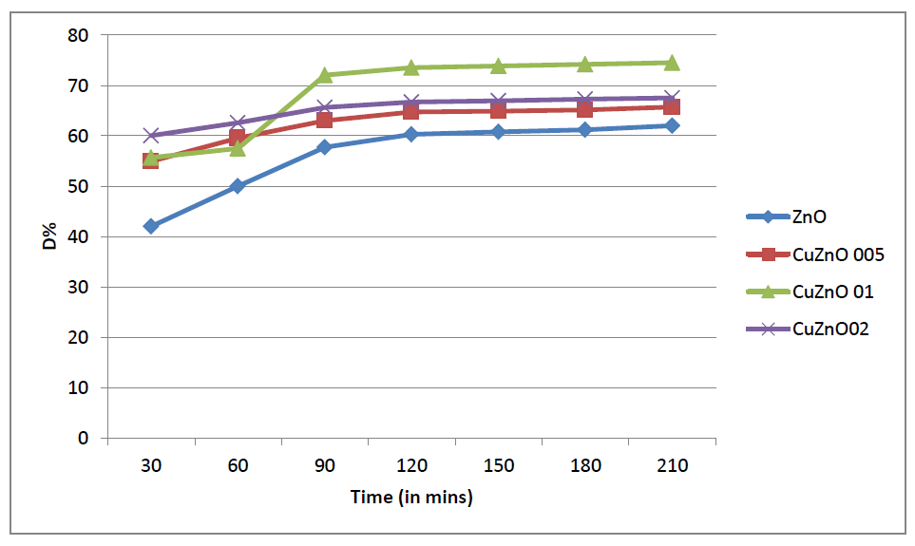

Figure 8. Degradation graph of MB dye by ZnO and Cu-doped ZnO

Antimicrobial Activity
Our findings are supported by several studies indicating that Cu-doped ZnO-NPs reported in the current work exhibit better antibacterial activity (than pure ZnO) towards Staphylococcus aureus and Bacillus subtilis Gram-positive bacteria. Zinc oxide (ZnO) nanoparticles are well-known for their antimicrobial properties. However, the doping of ZnO with other metals such as copper (Cu) can enhance these properties. Gram-positive bacterial strains Staphylococcus aureus and Bacillus subtilis were used. The disk diffusion method was employed to evaluate antimicrobial activity. Sterile disks impregnated with nanoparticle suspensions were placed on agar plates inoculated with bacterial cultures. Zones of inhibition were measured after incubation at 37°C for 24 hours (Fig-9). The enhanced antimicrobial activity of Cu-doped ZnO nanoparticles can be attributed to the synergistic effect of Cu and ZnO. The generation of reactive oxygen species and the disruption of bacterial cell membranes arelikely mechanisms. These results are consistent with previous studies, highlighting the potential of Cu-doped ZnO nanoparticles as effective antimicrobial agents. Cu-doped ZnO nanoparticles synthesized via a green method exhibited enhanced antimicrobial activity against Gram-positive bacteria. These findings suggest potential applications in medical and environmental fields. Future studies should explore differentdoping concentrations and in vivo applications.This has been supported by the findings that “the Cu-doped ZnO-NPs or powders in an aqueous solution can produce various reactive oxygen species (ROS) such as hydroxyl radicals (OH), singlet oxygen, or superoxide anion (O²⁻). Hydroxyl radicals and singlet oxygen species are negatively charged species that cannot penetrate the cell membrane. Zn²⁺, Cu, Cu¹⁺, and Cu²⁺ ions released from Cu-doped ZnO-NPs are cytotoxic to microbes. It is well known that zinc ions in high concentrations can negatively influence multiple activities in bacteria, such as glycolysis, transmembrane proton translocation, and acid tolerance which can prolong the lag phase of bacteria. Copper ions may bind with DNA molecules and disrupt the helical structure, resulting in cell death. ROS induces oxidative stress which can impair bacterial membranes, lipids, proteins, and DNA” [37].

Figure 9. Zone of inhibition formed by Cu-doped ZnO against Gram-positive bacteria

Mechanism of photocatalysis
In the presence of air or oxygen, when a photocatalytic solution containing Methylene blue is exposed to visible radiation or UV, electron-hole pairs are generated. These photo-induced electron-hole pairs possess both reducing and oxidizing capabilities. The valence band of the photocatalyst interacts with adsorbed -OH or H₂O molecules on its outer surface, leading to the formation of OH radicals. The OH radicals then react with Methylene blue, resulting in the production of CO₂, sulphate, nitrate, H₂O, and a small amount of HCl acid. Simultaneously, the electrons, excited, in the conduction band engage with oxygen molecules adsorbed on the outer layer of the photocatalyst, giving rise to the generation of super-oxide radicals. The overall photocatalytic mechanism can be described as follows-
hν + Catalyst→ e⁻ + h⁺ [1]
The electron removed, reacts with oxygen present in water. As a result of which super-oxide radical (O₂.-) is produced.
O₂ + e⁻→ O₂• ‾[2]
Then the holes produced in VB of the catalyst now can directly oxidize MB, react with super-oxides radicals, generating OH radicals.
O₂• ‾+ H⁺ → HOO• [3]
HOO• + e⁻ → HO₂ ‾ [4]
HO₂ ‾ + H⁺ → 2H₂O₂ (H₂O₂ = 2OH ‾) [5]
The debasement of the methylene blue dye from its aqueous solution depends on the OH- that is produced. In the process of photodegradation, holes created by light sources travel along a single electron oxidation pathway to form Hydroxyl radicals (OH•). For the most part, these OH• are in charge of the chromophoric dye's disintegration.
Conclusion
The degradation performance of the nanoparticles was assessed, and the Zn_{0.99}Cu_{0.01}O exhibited the maximum degradation rate of 72% after approximately 90 minutes. This suggests that the ideal level of doping greatly improves the ability of ZnO nanoparticles to degrade substances. The green synthesis method successfully generated ZnO and Cu-doped ZnO nanoparticles with favourable characteristics. The characterization procedures verified the effective doping, excellent purity, consistent shape, favourable colloidal stability, and exceptional thermal stability of the nanoparticles. The Zn_{0.99}Cu_{0.01}O with the ideal doping amount, demonstrated the highest degrading efficiency of 72% after approximately 90 minutes. This underscores the significance of optimising the doping concentration in order to get exceptional catalytic activity.Cu-doped ZnO nanoparticles synthesized via a green method also exhibited enhanced antimicrobial activity against Gram-positive bacteriawhich can be attributed to the synergistic effect of Cu and ZnO. These findings suggest potential applications in medical and environmental fields.The inhibitory effect was enhanced in a dose-dependent manner. It has been observed that Gram-positive microbes are more susceptible to Cu-doped ZnO-NPs as compared to Gram-negative microbes. Cu-doped ZnO-NPs can further be investigated for antifungal, drug delivery, tissue engineering, and other biomedical applications.

Disclaimer (Artificial intelligence)
Option 1:
Author(s) hereby declare that NO generative AI technologies such as Large Language Models (ChatGPT, COPILOT, etc.) and text-to-image generators have been used during the writing or editing of this manuscript.
Option 2:
Author(s) hereby declare that generative AI technologies such as Large Language Models, etc. have been used during the writing or editing of manuscripts. This explanation will include the name, version, model, and source of the generative AI technology and as well as all input prompts provided to the generative AI technology
Details of the AI usage are given below:
1.
2.
3.

REFERENCES
[1] Z. Z. Vasiljevic, M. P. Dojcinovic, J. D. Vujancevic, I. Jankovic- Castvan, M. Ognjanovic, N. B. Tadic, S. Stojadinovic, G. O. Brankovicand and M. V. Nikolic, R. Soc. Open Sci. 7, (2020),200708.

[2] Al-Hamdi, A. M., Rinner, U., &Sillanpää, M. (2017). Tin dioxide as a photocatalyst for water treatment: A review. Process Safety and Environmental Protection, 107, 190-205. https://doi.org/10.1016/j.psep.2017.01.022.
[3] Akin, M. B., &Oner, M. (2013). Photodegradation of methylene blue with sphere-like ZnO particles prepared via aqueous solution. Ceramics International, 39(8), 9759–9762. https://doi.org/10.1016/j.ceramint.2013.05.024
[4] Wu, H. Y., Jian, W. J., Dang, H. F., Zhao, X. F., Zhang, L. Z., & Li, J. H. (2017). Hierarchical Ag-ZnO Microspheres with Enhanced Photocatalytic Degradation Activities. Polish Journal of Environmental Studies, 26(2), 871-880. https://doi.org/10.15244/pjoes/65363
[5] Tian, C., Zhang, Q., Wu, A., Jiang, M., Liang, Z., Jiang, B., & Fu, H. (2012). Cost-effective large-scale synthesis of ZnO photocatalyst with excellent performance for dye photodegradation. Chemical Communications, 48(23), 2858-2860. https://doi.org/10.1039/C2CC16434E
[6] Liu, H., Zhong, L., Govindaraju, S., & Yun, K. (2019). ZnO rod decorated with Ag nanoparticles for enhanced photocatalytic degradation of methylene blue. Journal of Physics and Chemistry of Solids. https://doi.org/10.1016/j.jpcs.2018.12.040
[7] Mao, Y., Li, Y., Zou, Y., Shen, X., Zhu, L., & Liao, G. (2019). Solvothermal synthesis and photocatalytic properties of ZnO micro/nanostructures. Ceramics International, 45(2), 1724-1729. https://doi.org/10.1016/j.ceramint.2018.10.054
[8] Hung, S. T., Chang, C. J., & Hsu, M. H. (2011). Improved photocatalytic performance of ZnOnanograss decorated pore-array films by surface texture modification and silver nanoparticle deposition. Journal of Hazardous Materials, 198, 307-316. https://doi.org/10.1016/j.jhazmat.2011.10.043
[9] Khayyat, S. A., Akhtar, M. S., & Umar, A. (2012). ZnOnanocapsules for photocatalytic degradation of thionine. Materials Letters, 81, 239-241. https://doi.org/10.1016/j.matlet.2012.04.039

[10]Xie, Y., He, Y., Irwin, P. L., Jin, T., & Shi, X. (2011). Antibacterial Activity and Mechanism of Action of Zinc Oxide Nanoparticles against Campylobacter jejuni. Applied and Environmental Microbiology, 77(7), 2325–2331. https://doi.org/10.1128/AEM.02149-10
[11]Ripa, S., &Ripa, R. (1994). Zinc and immune function. Minerva Medica, 86(7-8), 315-318. http://www.minervamedica.it/en/journals/minerva-medica/archive.php
[12]Sirelkhatim, A., Mahmud, S., Seeni, A., Kaus, N. H. M., Ann, L. C., Bakhori, S. K. M., Hasan, H., & Mohamad, D. (2015). Review on Zinc Oxide Nanoparticles: Antibacterial Activity and Toxicity Mechanism. Nano-Micro Letters, 7(3), 219-242. https://doi.org/10.1007/s40820-015-0040-x.
[13]Jiang, W., Mashayekhi, H., & Xing, B. (2009). Bacterial toxicity comparison between nano- and micro-scaled oxide particles. Environmental Pollution, 157(5), 1619–1625. https://doi.org/10.1016/j.envpol.2008.12.025
[14]Brayner, R., Ferrari-Iliou, R., Brivois, N., Djediat, S., Benedetti, M. F., &Fiévet, F. (2006). Toxicological Impact Studies Based on Escherichia coli Bacteria in Ultrafine ZnO Nanoparticles Colloidal Medium. Nano Letters, 6(4), 866-870. https://doi.org/10.1021/nl052326h
[15].Brayner, R., Ferrari-Iliou, R., Brivois, N., Djediat, S., Benedetti, M. F., &Fiévet, F. (2006). Toxicological Impact Studies Based on Escherichia coli Bacteria in Ultrafine ZnO Nanoparticles Colloidal Medium. Nano Letters, 6(4), 866-870. https://doi.org/10.1021/nl052326h
[16]. Khan S., et al., Comparative synthesis, characterization of Cu-doped ZnO nanoparticles and their antioxidant,antibacterial, antifungal and photocatalytic dye degradation activities. Dig J NanomaterBiostruct,12(3): (2017). 877–89.
[17]. Wahab, R., Khan, F., Yang, Y. B., Hwang, I. H., Shin, H. S., Ahmad, J., Dwivedi, S., Khan, S. T., Siddiqui, M. A., Saquib, Q., Musarrat, J., Al-Khedhairy, A. A., Mishra, Y. K., & Ali, B. A. (2019). Fabrication of Engineered TiO2 Nanoparticles Their Cytotoxic, Genetic and Bioanalytical Study for Myoblast Cancer Cells. Nanoscience and Nanotechnology Letters, 11(6), 784–794. https://doi.org/10.1166/nnl.2019.2952
[18]. Kalantar, E., Kabir, K., Gharibi, F., Hatami, S., &Maleki, A. (2013). Effect and properties of surface-modified copper doped ZnO nanoparticles (Cu:ZnO NPs) on killing curves of bacterial pathogens. Journal of Medical Bacteriology, 2(1-2), 20–26. https://jmb.tums.ac.ir/index.php/jmb/article/view/36
[19]. Wahab, R., Dwivedi, S., Singh, S., Mishra, Y. K., Musarrat, J., Al-Khedhairy, A. A., & Kaushik, N. K. (2013). Effective inhibition of bacterial respiration and growth by CuO microspheres composed of thin nanosheets. Colloids and Surfaces B: Biointerfaces, 111, 211–217. https://doi.org/10.1016/j.colsurfb.2013.06.003
[20]. Khalid, A., Ahmad, P., Alharthi, A. I., Muhammad, S., Khandaker, M. U., Rehman, M., Faruque, M. R. I., Din, I. U., Alotaibi, M. A., Alzimami, K., & Bradley, D. A. (2021). Structural, Optical, and Antibacterial Efficacy of Pure and Zinc-Doped Copper Oxide Against Pathogenic Bacteria. Nanomaterials, 11(2), 451. https://doi.org/10.3390/nano11020451
[21]. Sajjad, M., Iqbal, M. Z., Khan, M. A., Khan, M. S., & Khan, M. A. (2018). Structural and optical properties of pure and copper doped zinc oxide nanoparticles. Results in Physics, 9, 1301–1309. https://doi.org/10.1016/j.rinp.2018.04.010
[22]. Papadaki, D., Mhlongo, G. H., Motaung, D. E., Nkosi, S. S., Panagiotaki, K., Christaki, E., Assimakopoulos, M. N., Papadimitriou, V. C., Rosei, F., Kiriakidis, G., & Ray, S. S. (2019). Hierarchically porous Cu-, Co-, and Mn-doped platelet-like ZnO nanostructures and their photocatalytic performance for indoor air quality control. ACS Omega, 4(15), 16429–16440. https://doi.org/10.1021/acsomega.9b02016
[23]. Charde, S. J., Sonawane, S. S., Rathod, A. P., Sonawane, S. H., Shimpi, N. G., &Parate, V. R. (2018). Copper-Doped Zinc Oxide Nanoparticles: Influence on Thermal, Thermo Mechanical, and Tribological Properties of Polycarbonate. *Polymer Composites*, *39*(S3), E1398–E1406. https://doi.org/10.1002/pc.24315
[24]. Bhuyan, T., Khanuja, M., Sharma, R., Patel, S., Reddy, M. R., Anand, S., & Varma, A. P. (2015). A comparative study of pure and copper (Cu)-doped ZnO nanorods for antibacterial and photocatalytic applications with their mechanism of action. Journal of Nanoparticle Research, 17(7), 1-11. https://doi.org/10.1007/s11051-015-3093-3
[25]. Narayanan, P. M., Wilson, W. S., Abraham, A. T., &Sevanan, M. (2012). Synthesis, Characterization, and Antimicrobial Activity of Zinc Oxide Nanoparticles Against Human Pathogens. BioNanoScience, 2(4), 329–335. https://doi.org/10.1007/s12668-012-0061-6
[26]. Wang, M., Ren, F., Cai, G., Liu, Y., Shen, S., & Guo, L. (2014). Activating ZnO nanorod photoanodes in visible light by Cu ion implantation. *Nano Research*, *7*(3), 353–364. https://doi.org/10.1007/s12274-013-0401-7
[27]. Alhadhrami, A., Almalki, A. S. A., Adam, A. M. A., &Refat, M. S. (2018). Preparation of Semiconductor Zinc Oxide Nanoparticles as a Photocatalyst to Get Rid of Organic Dyes Existing Factories in Exchange for Reuse in Suitable Purpose. International Journal of Electrochemical Science, 13(7), 6503–6521. https://doi.org/10.20964/2018.07.04
[28]. El Golli, A., Fendrich, M., Bazzanella, N., Dridi, C., Miotello, A., &Orlandi, M. (2021). Wastewater remediation with ZnO photocatalysts: Green synthesis and solar concentration as an economically and environmentally viable route to application. Journal of Environmental Management, 286, 112226. https://doi.org/10.1016/j.jenvman.2021.112226
[29]. Vidya, C., Manjunatha, C., Sudeep, M., Ashoka, S., & Raj, M. A. L. A. (2020). Photo-assisted mineralisation of titan yellow dye using ZnO nanorods synthesised via environmental benign route. SN Applied Sciences, 2(4), 1–15. https://doi.org/10.1007/s42452-020-2537-2
[30]. Devatha, C. P., &Thalla, A. K. (2018). Green Synthesis of Nanomaterials. In *Synthesis of Inorganic Nanomaterials* (pp. 169–184). https://doi.org/10.1016/B978-0-08-101975-7.00007-5
[31]. Kuriakose, S., Satpati, B., & Mohapatra, S. (2015). Highly efficient photocatalytic degradation of organic dyes by Cu doped ZnO nanostructures. Physical Chemistry Chemical Physics, 17(38), 25172–25181. https://doi.org/10.1039/C5CP01681A
[32]. Heiba, Z. K., Mohamed, M. B., El-naggar, A. M., &Albassam, A. A. (2020). Effect of Mg and Cu doping on structural, optical, electronic, and thermal properties of ZnS quantum dots. Journal of Materials Science: Materials in Electronics, 31, 21342–21354. https://doi.org/10.1007/s10854-020-04900-x
[33]. Cahino, A. M., Loureiro, R. G., Dantas, J., Madeira, V. S., & Fernandes, P. C. R. (2019). Characterization and evaluation of ZnO/CuO catalyst in the degradation of methylene blue using solar radiation. Ceramics International, 45, 13628–13636. https://doi.org/10.1016/J.CERAMINT.2019.03.239
[34].Ganesh, R. S., Durgadevi, E., Navaneethan, M., Patil, V. L., Ponnusamy, S., Muthamizhchelvan, C., Kawasaki, S., Patil, P. S., & Hayakawa, Y. (2018). Tuning the selectivity of NH3 gas sensing response using Cu-doped ZnO nanostructures. Sensors and Actuators A: Physical, 269, 331–341. https://doi.org/10.1016/j.sna.2017.11.042
[35].Kanmani, S. S., & Ramachandran, K. (2013). Role of aqueous ammonia on the growth of ZnO nanostructures and its influence on solid-state dye sensitized solar cells. Journal of Materials Science, 48(5), 2076–2091. https://doi.org/10.1007/s10853-012-6981-2
[36].Kumar, A., Saxena, A., De, A., Shankar, R., &Mozumdar, S. (2013). Facile synthesis of size-tunable copper and copper oxide nanoparticles using reverse microemulsions. RSC Advances, 3(15), 5015–5021. https://doi.org/10.1039/c3ra22997a
[37]. Khalid, A., Ahmad, P., Alharthi, A. I., Muhammad, S., Khandaker, M. U., Faruque, M. R. I., et al. (2021). Synergistic effects of Cu-doped ZnOnanoantibiotic against Gram-positive bacterial strains. PLoS One, 16(5), e0251082. https://doi.org/10.1371/journal.pone.0251082
[38]. Alyamani AA, Albukhaty S, Aloufi S, AlMalki FA, Al-Karagoly H, Sulaiman GM. (2021). Green fabrication of zinc oxide nanoparticles using phlomis leaf extract: characterization and in vitro evaluation of cytotoxicity and antibacterial properties. Molecules. 26(20):6140. https://doi.org/10.3390/molecules26206140

