Development of Chocolate-Coated Grape Pomace Extrudates with Enhanced Antioxidant Activity and Sensory Acceptability
ABSTRACT
Transforming agro-industrial waste into gourmet functional foods offers a dual solution to environmental sustainability and consumer nutrition. This study valorizes grape pomace and okara, nutrient-dense by-products of the wine and soy-milk industries into a high-fiber, protein-rich extruded snack. To bridge the gap between “healthy” and “highly acceptable,” we evaluated the impact of a milk chocolate coating on the snack’s physicochemical and sensory profile compared to uncoated samples. Using a completely randomized design (CRD) and paired t-tests for analysis, results revealed that, moisture and ash remained stable, the chocolate coating significantly balanced the product’s profile by increasing pH from 4.69 to 5.33 and reducing titratable acidity from 0.74% to 0.40%. While fat content increased due to the cocoa butter and milk fat, the structural integrity of the extrudates remained intact. Most notably, the coating triggered a synergistic boost in antioxidant activity, despite non-significant changes in total phenolic content, the significant rise in antioxidant activity suggests a powerful interaction between grape and cocoa polyphenols. Sensory results confirmed a marked improvement in overall acceptability, proving that chocolate coating is not just an additive, but a strategic tool to transform industrial by-products into value-added, market-ready functional delicacies.

Keywords: soy-milk, pH, polyphenols, CRD, milk chocolate
- INTRODUCTION
Valorization of the agro-industrial by-products has gained significant attention in the recent years, due to its potential to reduce food waste and promote sustainable food production. Building upon the development of grape pomace and okara enriched product in our previous report (Sindhu et al., 2026). We used extrusion technology, a versatile, high-temperature short-time (HTST) process to transform these fibrous residues into expanded, crispy snacks. Although extrusion yields products with an acceptable expansion ratio, the inherent bitterness and mouthfeel of the by-products necessitate further refinement. Chocolate coating is known to improve sensory acceptability, flavour, and visual appeal, while providing a protective barrier against moisture uptake and oxidative deterioration. Using grape pomace and okara in an extruded product help in valorizing the agro-industrial byproduct, although it produces the good extrudates with acceptable expansion ratio and crispness, fiber content in grape made it little difficult for the consumers to accept the product, to overcome this problem we have tried coating the optimized product with commercially available milk chocolate in order to enhance the sensory properties and other physico-chemical properties of the extruded snacks. Edible and lipid-based chocolate coating is a widely recognized strategy to improve product acceptability, shelf life, and consumer appeal, by acting as semi-permeable barriers that reduce moisture and gas transfer (Gounga et al., 2017; Matloob et al., 2023). While such coatings have been applied in a range of food products to improve quality and longevity, there is limited research on their application to extruded snacks enriched with agro-industrial by-products.
The present study focuses on the development and evaluation of chocolate-coated extrudates formulated from an optimized okara–grape pomace blend, investigating the effects of chocolate coating on physicochemical properties, functional characteristics, and storage stability. The chocolate coated extrudates found to have better sensory acceptability than the uncoated extrudate along possessing higher polyphenols and antioxidant activity. Our study supports the sustainable development goal (SDG) 12 – Responsible consumption and production. This work aims to bridge the gap between valorization of underutilized residues and practical product enhancement strategies for commercialization and sustainable snack development.
- MATERIALS AND METHODS
  - Materials
Grape pomace was prepared from ‘Pusa Navrang’ grapes and okara is prepared from the soyabeans, the detailed procedure for the preparation is given in our previous study (Sindhu et al., 2025). Maize flour, sugar, cocoa powder, and milk chocolate were procured from a local market. All the chemicals used in the study were of analytical grade.
  - Extrudate preparation
Grape pomace was used to partially replace maize flour in the formulation, keeping the ingredient ratio unchanged, to create extrudates enhanced with grape pomace. An optimized formulation comprising 7.5% grape pomace, 71.5% maize flour, 10% okara, 10% sugar, and 1% cocoa powder was prepared. The ingredients were mixed and conditioned to a moisture content of 11% before extrusion at a screw speed of 300 rpm and a barrel temperature of 117–121 °C. This optimized process yielded a desirability value of 0.76. After experimental validation, the improved extrudates were uniformly coated with milk chocolate at 5% (w/w) on a weight basis to evaluate changes in physico-chemical characteristics and sensory quality.
2.3 Bio-chemical properties.
2.3.1 pH
pH was measured using a digital pH meter (AOAC, 2016).
2.3.2 Titratable acidity
Titratable acidity of the extrudates was determined and expressed as percentage of tartaric acid, following the procedure described by Ranganna (2010). 2.3.3 Moisture content
Moisture content of the extrudates was determined using the oven-drying method by drying a 5 g sample at 105 ± 2 °C to constant weight, as per AOAC (2000). 2.3.4 Ash content
Ash content of the extrudates was determined by dry ashing in a muffle furnace at 600 °C, following the standard AOAC (2000) method. 2.3.5 Fat content
Crude fat content of the extrudates was determined using a Soxhlet extraction system (DET-GRAS N, P SELECTA, Spain) with petroleum ether as the solvent, following the method described by Ojure and Quadri (2012).
2.3.6 Total phenolic content
Total phenolic content of the extrudates was estimated following the method described by Sulaimankhil et al. (2021) with slight modifications. The extrudates were first ground into a fine powder using a laboratory grinder. Approximately 1 g of the powdered sample was mixed with 10 mL of methanol (80%) and extracted by shaking at room temperature for 2–3 h. The mixture was then centrifuged at 5000 rpm for 10 min, and the supernatant was collected for analysis. For TPC determination, 0.5 mL of the extract was mixed with 2.5 mL of 10% Folin–Ciocalteu reagent and allowed to react for 5 min. Subsequently, 2.0 mL of 7.5% sodium carbonate solution was added, and the mixture was incubated in the dark at room temperature for 30 min. The absorbance was measured at 765 nm using a UV–Visible spectrophotometer. Total phenolic content was calculated from a gallic acid standard curve and expressed as mg gallic acid equivalents (GAE) per 100 g of sample.
2.3.7 Total antioxidant activity (FRAP)
Total antioxidant activity (TAA) was determined using the ferric reducing antioxidant power (FRAP) assay as described by Sethi et al. (2020). The assay was performed using the same extract prepared for total phenolic content analysis. Briefly, the FRAP reagent was freshly prepared by mixing 300 mM acetate buffer (pH 3.6), 10 mM TPTZ solution in 40 mM HCl, and 20 mM ferric chloride (FeCl₃·6H₂O) in a ratio of 10:1:1 (v/v/v). An aliquot of 0.1 mL of the sample extract was added to 3.0 mL of FRAP reagent and incubated at 37 °C for 30 min in the dark. The increase in absorbance was measured at 593 nm using a UV–Visible spectrophotometer. The antioxidant activity was calculated using a Trolox standard curve and expressed as µmol Trolox equivalents (TE) per g of sample.
2.3.8 Sensory evaluation
A descriptive sensory analysis was carried out with a semi-trained panel consisting of 25 individuals aged between 25 and 35 from the Division of Food Science and Postharvest Technology, ICAR-Indian Agricultural Research Institute. Sensory descriptors such as Appearance, taste, texture, aroma were recorded using a 9-point hedonic scale, where 0 indicated not acceptable and 9 denoted most acceptable (Ranganna, 2010).
2.4 Statistical analysis.
The experiment followed a completely randomized design (CRD), and all analyses were carried out in triplicate (n = 3). Results are presented as mean ± standard deviation (SD). One-way ANOVA was used to analyze differences among formulations using IBM SPSS Statistics 19 (SPSS Inc., USA). Paired t-tests were employed to evaluate the effect of chocolate coating by comparing samples before and after coating. Statistical significance was accepted at p < 0.05.
3. RESULTS AND DISCUSSION
3.1 pH and titratable acidity (TA)
The pH of the grape pomace extrudate was 4.69 ± 0.14, whereas the chocolate-coated extrudate showed a higher pH of 5.33 ± 0.09. There is a statistically significant change in the pH (p = 0.009 < 0.05). The milk chocolate used for coating, which contains buffering components like milk solids, sugar, and fats that would lessen the overall acidity of the underlying grape pomace extrudate, could be a plausible explanation for the rise in pH seen in the chocolate-coated extrudate (Atalar et al., 2025). The TA of the chocolate-coated extrudate (0.40 ± 0.10%) was much lower than that of the grape pomace extrudate (0.74 ± 0.07%), with a significant decrease after coating (p = 0.04 < 0.05). This implies that the product’s measured acid content was neutralized by the chocolate. A lower measured TA in the coated product can result from the chocolate’s contents diluting or masking the acidity found in the grape pomace extrudate matrix (Kumar et al., 2021). Figure 1 displays the chocolate-coated and uncoated extrudates.
3.2 Moisture content
The grape pomace extrudate had a moisture content of 4.05 ± 1.00%, whereas the chocolate-coated extrudate had a somewhat lower value of 2.85 ± 0.27%. Nevertheless, the change was not statistically significant (p = 0.07). The chocolate coating's barrier effect, which may lessen moisture retention or evaporation during handling and storage, is responsible for the somewhat reduced moisture content in the chocolate-coated extrudate. The trend is consistent with the finding that fat-rich coatings frequently lower the water activity at the surface, so modestly lowering the overall moisture content measured in coated items, even if the difference was not statistically significant (Joardder et al., 2019). Additionally, the extrudate and chocolate-coated extrudate's low moisture content (<5%) indicates that they are low-moisture foods, which are preferred for improved microbiological stability and shelf life. The chocolate coating is appropriate for preserving the physicochemical stability of the extrudate (Syamaladevi et al., 2016) (Table 1).
3.3 Fat content and ash content
The grape pomace extrudate had a fat content of 1.59 ± 0.20%, while the chocolate-coated extrudate had a fat level of 2.63 ± 0.20% (p = 0.0007) (Table 1). Since milk chocolate contains considerable amounts of fats, such as milk fat and cocoa butter, which directly contribute to the coated product’s overall fat content, this notable increase is anticipated. The incorporation of chocolate not only enhances the energy content but also influences the texture, mouthfeel, and overall sensory acceptance of the extrudate (Lenin et al., 2021). On the other hand, the ash content, which is a measure of the total mineral matter, was 2.65 ± 3.23% for the grape pomace extrudate and 3.23 ± 0.20% for the chocolate-coated extrudate. Nevertheless, this rise did not reach statistical significance (p = 0.1). The mineral contributions from the chocolate ingredients such as milk solids and cocoa, which contain calcium, potassium, magnesium, and trace elements may be responsible for the modest rise. The absence of significance suggests that the extrudate’s mineral composition was not significantly changed by the chocolate coating (Singh et al., 2024).
3.4 Sensory evaluation
The grape pomace extrudate's sensory score was 6.54 ± 0.05, whereas the chocolate-coated extrudate scored much higher at 7.69 ± 0.12 (p = 0.009) (Table 1), suggesting that the chocolate coating greatly improved overall acceptability. A more pleasing flavor profile results from the milk chocolate coating’s extra sweetness, which counteracts the grape pomace's moderate acidity and bitterness (Harwood & Hayes, 2017). Chocolate coating added a creamy texture and a pleasant snap or crunch to the extrudate depending on its crystallization, which enhances the tactile feel of the extrudate, making it more acceptable by the consumers (Kumar et al., 2021). Additionally, the chocolate coating enhances aesthetic appeal by providing a consistent, glossy surface that is typically favored by customers. Visual characteristics have a significant impact on extrudate’s perceived flavor and general acceptability (Doğan & Yılmaz, 2023). In order to improve general acceptance, the chocolate coating might partially cover up unfavorable flavors from the grape pomace, such as astringency or off-notes from polyphenols.
3.5 Total phenolic content and total antioxidant activity
The grape pomace extrudate had a total phenolic content (TPC) of 773.76 ± 8.57 mg GAE/100 g, whereas the chocolate-coated extrudate had a slightly higher TPC of 814.69 ± 9.57 mg GAE/100 g. But according to Table 1, this increase was not statistically significant (p = 0.08 > 0.05). On the other hand, the extrudate's total antioxidant activity as determined by FRAP rose from 185.52 ± 2.21 µmol TE/g to 202.33 ± 2.89 µmol TE/g in the chocolate-coated extrudate (p = 0.005 < 0.05). Grape pomace, which is known to be a rich source of polyphenols such flavonoids, phenolic acids, and anthocyanins, is responsible for the high phenolic content seen in both samples (Sindhu et al., 2025). Chocolate and cocoa are known to include flavanols and other antioxidant chemicals, the small, non-significant rise in TPC following chocolate coating may be the result of cocoa-derived polyphenols (Di Mattia et al., 2017). But given the already high phenolic load of the grape pomace matrix, the absence of statistical significance indicates that the phenolic contribution from chocolate was somewhat small.
It is interesting to note that after chocolate coating, the FRAP values dramatically rose despite the non-significant change in TPC. This increase in antioxidant capacity of the coated extrudates may be attributed to the synergistic interaction between polyphenolic compounds from grape pomace (such as flavonoids, phenolic acids, anthocyanins, and resveratrol) and cocoa-derived antioxidants, particularly flavan-3-ols and procyanidins. (Subroto et al., 2022). According to reports, the strong reducing power of cocoa polyphenols can improve ferric reducing antioxidant potential without necessarily increasing total phenolic content proportionately. This effect has been documented in composite food systems, where the type, structure, and bioactivity of individual phenolic compounds influence antioxidant activity in addition to the overall phenolic concentration (Skroza et al., 2022). Higher antioxidant activity may also have resulted from the chocolate coating's protective matrix, which lessened the oxidative destruction of phenolic components during processing and analysis. Similar findings have been documented in coated or composite functional meals, where coatings improve the efficacy and stability of antioxidants (Hu et al., 2016).
Table 1. Physicochemical, functional, and sensory properties of uncoated and chocolate-coated grape pomace extrudates.
Attributes | Extrudate | Chocolate coated extrudate | p value
pH | 4.69±0.14 | 5.33±0.09 | 0.009*
Titratable acidity | 0.74±0.07 | 0.40±0.10 | 0.04*
Moisture content | 4.05±1.00 | 2.85±0.27 | 0.07
Fat content | 1.59±0.20 | 2.63±0.20 | 0.0007*
Ash content | 2.65±3.23 | 3.23±0.20 | 0.1
Sensory score | 6.54±0.05 | 7.69±0.12 | 0.009*
Total phenolic content (mg GAE/100 g) | 773.76±8.57 | 814.69±9.57 | 0.08
Total antioxidant activity (FRAP) (µmol TE/g) | 185.52±2.21 | 202.33±2.89 | 0.005*
Values are expressed as mean ± standard deviation (SD) (n = 3). Different parameters were analyzed using paired t-test and one-way ANOVA. Values marked with an asterisk (*) are significantly different at p < 0.05.

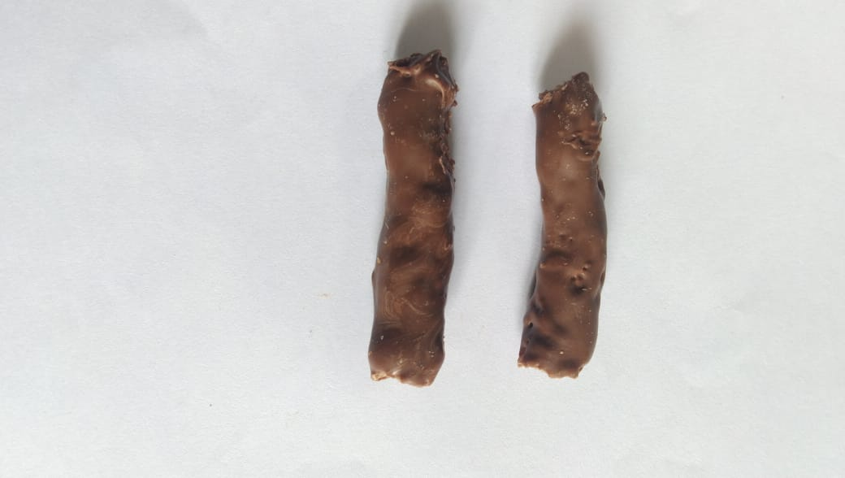
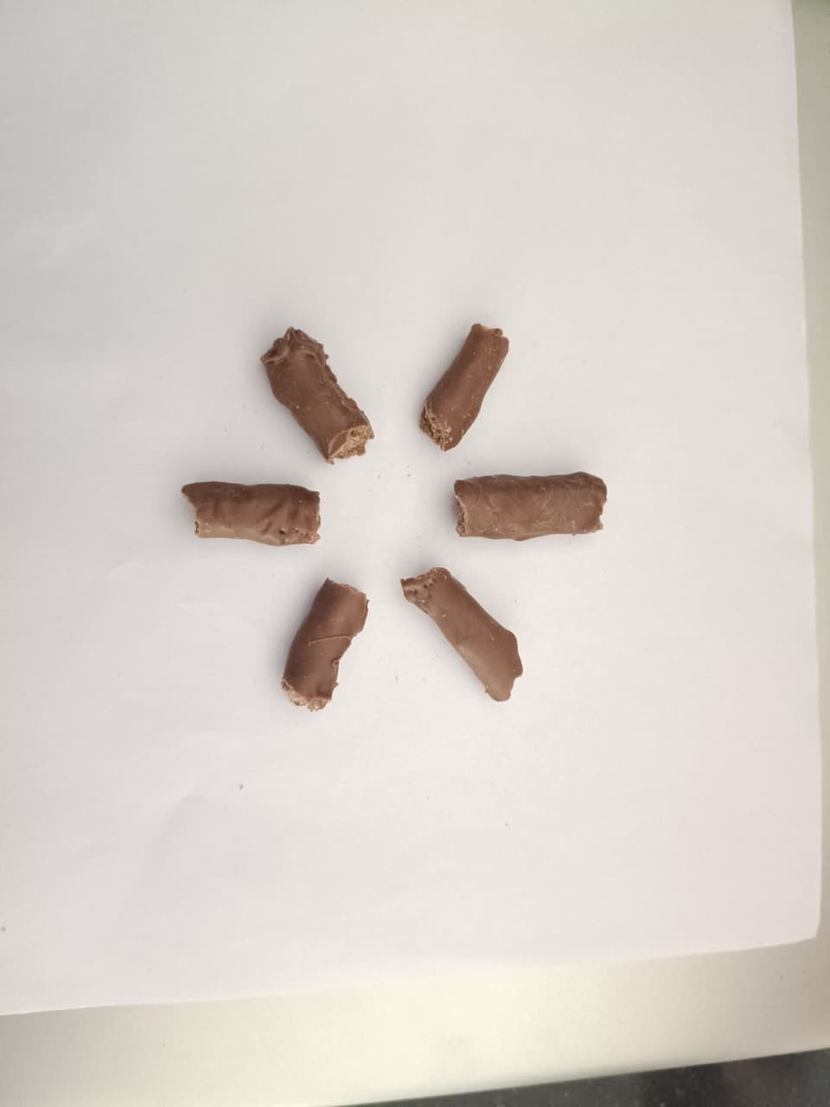
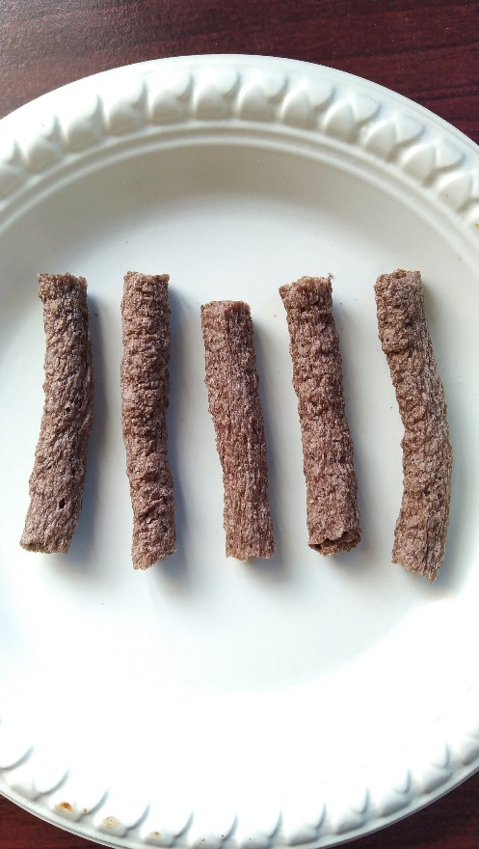
Fig. 1. Visual appearance of grape pomace extrudates before and after chocolate coating.

- CONCLUSION
The current work assessed the effects of chocolate coating on the physicochemical, functional, and sensory properties of grape pomace-based extrudates and proved their effective development. Grape pomace’s potential as a useful functional ingredient was confirmed by the extrudates it produced, which had a noticeable phenolic content and antioxidant activity. Chocolate coating has reduced the acidity of the extrudates, while moisture and ash content did not show any significant change. Total phenolic content did not show a significant change, the chocolate-coated extrudates exhibited a significantly higher antioxidant activity, suggesting synergistic interactions between grape pomace polyphenols and cocoa-derived antioxidants. Additionally, a sensory assessment showed that the chocolate-coated extrudates' overall acceptability had significantly improved, underscoring the contribution of chocolate coating to improving consumer appeal. The results show that chocolate coating is a viable method for grape pomace valorization and the creation of nutritionally enhanced, value-added functional snack products by enhancing the sensory quality and antioxidant potential of grape pomace extrudates without sacrificing their stability.
DISCLAIMER (ARTIFICIAL INTELLIGENCE)
Author(s) hereby declares that NO generative AI technologies such as Large Language Models (ChatGPT, COPILOT, etc.) and text-to-image generators have been used during the writing or editing of this manuscript.
ACKNOWLEDGEMENT
The authors thank Indian Council of Agricultural Research Indian Agricultural Research Institute (IARI) for financial support.
COMPETING INTERESTS
Authors have declared that no competing interests exist.
REFERENCES

- AOAC (2000) Official methods of analysis of AOAC international, 17thedn. AOAC International, Gaithersburg, MD, USA.
- AOAC (2016). Official Methods of Analysis of AOAC International, 20th Edition.
- Atalar, İ., Apaydın, A., Elmacı, C., ElObeid, T., & Konar, N. (2025). Effect of different alkaline solutions in cocoa powder alkalization: Effects on pasteurized chocolate milk. Applied Food Research, 5(1), 100692. https://doi.org/10.1016/j.afres.2025.100692
- Di Mattia, C. D., Sacchetti, G., Mastrocola, D., & Serafini, M. (2017). From cocoa to chocolate: The impact of processing on in vitro antioxidant activity and the effects of chocolate on antioxidant markers in vivo. Frontiers in Immunology, 8, 1207.
- Doğan, G., & Yılmaz, İ. (2023). Product Development and Sensory Evaluation of Dark Chocolate Filled with Chestnut Honey. Black Sea Journal of Agriculture, 6(5), 452-458. https://doi.org/10.47115/bsagriculture.1293710
- Gounga, M. E., Omar, K. A., Amadou, I., & Xu, S. Y. (2017). Chocolate coating effect on whey protein isolate—pullulan‐coated freeze‐dried chestnut. American Journal of Food Science and Technology, 5(3), 70-77.
- Harwood, M. L., & Hayes, J. E. (2017). Sensory evaluation of chocolate and cocoa products. Beckett's industrial chocolate manufacture and use, 509-520. https://doi.org/10.1002/9781118923597.ch21
- Hu, Y., Pan, Z. J., Liao, W., Li, J., Gruget, P., Kitts, D. D., & Lu, X. (2016). Determination of antioxidant capacity and phenolic content of chocolate by attenuated total reflectance-Fourier transformed-infrared spectroscopy. Food chemistryChemistry, 202, 254-261. https://doi.org/10.1016/j.foodchem.2016.01.130
- Joardder, M. U., Mourshed, M., & Masud, M. H. (2019). State of bound water: measurement and significance in food processing. Berlin/Heidelberg, Germany: Springer. https://doi.org/10.1007/978-3-319-99888-6
- Kumar, S., Baniwal, P., Nayik, G. A., Prasad, K., Khan, K. A., Ghramh, H. A., & Karabagias, I. K. (2021). Optimization and development of ready to eat chocolate coated roasted flaked rice as instant breakfast food. Foods, 10(7), 1658. https://doi.org/10.3390/foods10071658
- Lenin, S., Sujatha, R., & Sundaram, S. (2021). Nutritional Composition, Mineral analysis and Sensory Evaluation of Cake and Chocolate with Moringa oleifera Leaf Powder. Journal of Pharmaceutical Research International, 33(60B), 2367-2373. https://doi.org/10.9734/jpri/2021/v33i60B34886
- Matloob, A., Ayub, H., Mohsin, M., Ambreen, S., Khan, F. A., Oranab, S., & Ercisli, S. (2023). A review on edible coatings and films: Advances, composition, production methods, and safety concerns. ACS omega, 8(32), 28932-28944.
- Ojure, M. A., & Quadri, J. A. (2012). Quality evaluation of noodles produced from unripe plantain flour using xanthan gum. International Journal of Research and Reviews in Applied Sciences, 13(3), 740–752. Retrieved from https://www.arpapress.com/Volumes/Vol13Issue3/IJRRAS_13_3_09.
- Ranganna, S. (2010). Handbook of Analysis and Quality Control for Fruit and Vegetable Products. 2nd Edition. Tata McGraw-Hill, New Delhi.
- Sethi, S., Joshi, A., Arora, B., Bhowmik, A., Sharma, R.R., & Kumar, P. (2020). Significance of FRAP, DPPH and CUPRAC assays for antioxidant activity determination in apple fruit extracts. European Food Research and Technology, 246(3), 591-598. https://doi.org/10.1007/s00217-020-03432-z.
- Sindhu, P. M., Sethi, S., Arora, B., Joshi, A., Kumar, C., & Lekshmi, S. G. (2025). Valorization of grape pomace and okara for the development of nutritionally and functionally enriched extrudates: A circular economy approach in snack production. Indian Journal of Agricultural Sciences, 95(9), 1028-1035.
- Singh, P. K., Khedkar, R. D., & Chandra, S. (2024). Chocolate: An overview of functional potential and recent trends in fortification. Brazilian Journal of Food Technology, 27, e2023118.Shin, J. M., Hwang, Y. O., Tu, O. J., Jo, H. B., Kim, J. H., Chae, Y. Z., & Park, S. K. (2013). Comparison of different methods to quantify fat classes in bakery products. Food chemistry, 136(2), 703-709. https://doi.org/10.1016/j.foodchem.2012.08.033
- Skroza, D., Šimat, V., Vrdoljak, L., Jolić, N., Skelin, A., Čagalj, M., & Generalić Mekinić, I. (2022). Investigation of antioxidant synergisms and antagonisms among phenolic acids in the model matrices using FRAP and ORAC methods. Antioxidants, 11(9), 1784.Ibrić, A., & Ćavar, S. (2014). Phenolic compounds and antioxidant activity of cocoa and chocolate products. Bulletin of the Chemists and Technologists of Bosnia and Herzegovina, 42, 37-40.
- Subroto, E., Andoyo, R., Indiarto, R., Lembong, E., & Rahmani, F. (2022). Physicochemical properties, sensory acceptability, and antioxidant activity of chocolate bar fortified by solid lipid nanoparticles of gallic acid. International Journal of Food Properties, 25(1), 1907-1919. https://doi.org/10.1080/10942912.2022.2115066
- Sulaimankhil, Z., Sethi, S., Sharma, R. R., Verma, M. K., Dahuja, A., & Bhowmik, A. (2021). Influence of aqueous hexanal on quality of ‘Royal Delicious’ apple during cold storage. Acta Physiologiae Plantarum, 43(9), 134. https://doi.org/10.1007/s11738-021 03301-6
- Syamaladevi, R. M., Tang, J., Villa‐Rojas, R., Sablani, S., Carter, B., & Campbell, G. (2016). Influence of water activity on thermal resistance of microorganisms in low‐moisture foods: a review. Comprehensive Reviews in Food Science and Food Safety, 15(2), 353-370. https://doi.org/10.1111/1541-4337.12190

