Original Research Article
Structural and Optical characteristics of PVA films doped with MgO nanocrystalline

Abstract
The integration of Magnesium oxide nanoparticles (MgO NPs) into polyvinyl alcohol (PVA) matrix creates nanocomposite films that are considered one of the most capable materials for cost-effective, reliable, and solar-saving energy in daily desired applications. The structural and optical properties of MgO NPs were studied using X-ray diffraction (XRD), and Ultraviolet–visible spectroscopy (UV–vis) at different weight percentages (2, 4, 6, and 8 wt%) of MgO NPs that were incorporated into PVA by the solution casting method. The results showed that all samples have a cubic crystal structure with an observed increase in crystal size as the MgO concentration increases. FTIR analysis indicated that there is an interaction between MgO and the PVA through hydrogen bonding. The energy band gap and tail of localized state of PVA/MgO nanocomposites have been calculated by using Tauc and Urbach relations, respectively. The band gap of the nanocomposite samples decreases as MgO wt% increases. The loading of 2 to 8 wt% of MgO NPs in the PVA matrix caused a significant reduction in direct bandgap, indirect bandgap, and Urbach energy. These results showed that the spectroscopic properties of PVA-MgO NP films were modified considerably with small loadings of MgO NPs in the PVA matrix due to cross-linking formation between the nanoparticles and the polymer. In addition, this increase in percentages has affected the optical parameters by enhancing the optical proficiency for the prepared samples with a noticeable slight shift to the visible region to improve their efficiency to be used as photocatalytic and energy-saving applications in more reliable and effective methods. This study has yielded significant insights that may aid in the advancement of optoelectronic applications in industries by reducing costs. These results could be instrumental in enhancing production processes and making the use of more viable and cost-effective options for industrial operations.

Key Words
Sol–gel _ MgO nanoparticles _ Optical band gap _ Urbach energy _ Dispersion energy

Introduction
Over the last decade, researchers have proved that when materials are made at the nanoscale, it exhibits novel and considerably enhanced physical characteristics [1–3]. Therefore, scientists have focused on the development of nanoparticles, aiming to form easier and cost-effective methods for producing nanostructures [4-6]. Nonetheless, metal oxide (MO) semiconductors are cost-effective, chemically stable, and environmentally suitable for photoelectric devices with the benefit of effects of different ambient conditions. Particularly, MgO nanomaterials have been widely investigated due to their broad and possible uses in innovative applications in addition to their wide bandgap [5-8]. MgO is an inorganic material that crystallizes in a rock-salt crystal structure and has thermodynamically stable (100) crystal planes [9]. MgO NP has various unique and extraordinary properties, such as excellent thermal and chemical stability, non-toxicity, high melting point, wear resistance, low erosion rate, non-toxicity and good biocompatibility [10–13]. MgO NP is regarded as a viable contender in domains such as catalysis and wastewater treatment, among others, due to its essential properties like large surface area, strong surface reactivity, and buffer capacity [14–17]. Additionally, MgO NP is widely used as a protective layer in ceramics, aircraft, metallurgical photonic materials, antimicrobial agents, re retardants, and biosensors [18]. Different techniques have been employed to synthesize MgO nanoparticles, including solution combustion [19], solvent mixed spray pyrolysis [10], hydrothermal precipitation [20], and numerous other advanced and straightforward techniques. methods processes [21,22]. Managing synthesis factors such as temperature, pH, and gelling agent serves as a crucial aspect for managing the size, shape, and morphology of the nanoparticles[23].
On the other hand, polymers reinforced with nanoparticles have garnered considerable interest over the last few decades due to their affordability, ease of processing, and the integration of the appealing features of inorganic nanoparticles and organic polymers that have been anticipated to exhibit properties that are synergistically improved [24]. The possible uses of polymer nanocomposites are in optoelectronics, automotive, aerospace, and various other applications [16–18]. The characteristics of polymer nanocomposites rely on the chemistry, shape, and size of the nanoparticles [25]. Polyvinyl alcohol (PVA) is a well-known water-soluble, biocompatible, biodegradable material with great optical transparency and dielectric strength. Their properties are determined by the type and percentage of the doping substance. These qualities are mostly owing to the alkyl groups (OH) in PVA that create hydrogen bonding semicrystalline polymer utilized in optoelectronic devices that have strong interfacial contact, improved film-forming, is non-toxic, ecologically friendly, and is cost-effective [26]. When metal oxides are doped with PVA, interaction may take the form of hydrogen bonding with the metal oxide [27]. This improvement is mostly due to the nanomaterial's tiny size, increased surface area, quantum confinement effects, and strong interfacial interactions. This work concerns the preparation and fabrication of MgO/PVA by the casting technique to obtain cast films with good physical properties. Furthermore, the effect of adding the MgO was studied with varying concentrations. Also, the study investigated the changes in the crystal structure and morphology of MgO/PVA nanocomposite. The analysis revealed that changes in crystallinity are related to structural changes, as observed using X-ray diffraction. Additionally, the optical properties of the nanocomposite were examined to better understand how MgO interactions affect important properties of PVA. The results of this study provide valuable insights that can help advance the industrial application of these composites as materials with reduced cost.

METHODOLOGY

4.1 Materials
Magnesium (II) Chloride and PVA (IV) were purchased from Sigma Aldrich. Deionized water was used as a solvent. Ethanol and ammonium solution (NHOH) were purchased from Sigma Aldrich. All chemical reagents were of analytical grade and used without further purification. Double-distilled water was used throughout the experiments.

4.2 Preparation of pure MgO Nanoparticles
First, MgO was synthesized, then the PVA was incorporated into the MgO to form the final nanocomposite. To synthesize pristine MgO particles, MgCl₂ was dissolved in deionized water (100 mL) under constant stirring on a magnetic stirrer for 30 min, and then maintaining a pH of 7-8 by slowly adding NH₄OH solution, and the system was left for homogenization under constant stirring for 30 min. The yellowish gel formed after the reaction was dried at 100 ºC for 1 day until it turned into a yellow block crystal. Calcination of the synthesized materials was carried out in air at 450 ºC for 2 hours, resulting in white-colored MgO.

4.3 Preparation of PVA and PVA/MgO Nanoparticles
For the Synthesis of PVA/MgO Nanoparticles, the solution casting technique was used for the preparation of PVA and PVA/MgO composite films with various loadings of MgO nanoparticles (2,4,6, and 8 wt.%). A pure and homogeneous solution of PVA was obtained by dissolving 1 g of PVA into 10mL deionized water and stirring vigorously at 80°C until a transparent solution. For example, at the same time, MgO particles (2 wt.%) were dispersed in 10 mL of deionized water separately at ambient temperature for 3 h and then added to the PVA solution. The solution was again stirred for 1h with the magnetic stirrer for 2hours. The resulting PVA-MgO solution was poured on a clean, dried Petri dish and left to dry for 2 days at room temperature. The dried PVA/MgO (2wt.%) composite films were peeled off the Petri dish and cut into the required size for further analysis. The same process was also repeated for the preparation of PVA/MgO (2 wt.%), PVA/MgO (4 wt.%), PVA/MgO (6wt.%), and PVA/MgO (8 wt.%) composite films. To remove any residual solvents, the composite films are placed on a hot plate at 35°C for three hours. Finally, the composite was encapsulated into circular pieces measuring 6 mm with a thickness of 0.5 mm for characterization and testing.

Table 1: Prepared nanocomposites at different ratios of (MgO) concentrations

Samples | (MgO) concentrations | (PVA) concentrations
PVA | 0wt.% MgO | 100wt.% PVA
MgO | 100wt.% MgO | 0wt.% PVA
MgO /PVA | 2wt.% MgO | 98 wt.% PVA
MgO /PVA | 4 wt.% MgO | 96 wt.% PVA
MgO /PVA | 6 wt.% MgO | 94 wt.% PVA
MgO /PVA | 8 wt.% MgO | 92 wt.% PVA

Characterization techniques
X-ray diffraction measurements were conducted using a Shimadzu 6000 X-ray diffractometer with Cu-kα radiation of wavelength at λ = 1.5406 Å. Optical absorption spectra were recorded at room temperature using a UV–VIS–NIR spectrophotometer (type JASCO V670, double-beam spectrophotometer), which covered a wavelength range of 190–2700 nm. The reflectance spectrum was measured at a 6-degree angle from the normal direction of the sample surface. Characterization techniques Fourier transform infrared (FTIR) spectra measurements of these films were recorded using (Shimadzu UV-2600) IR spectrometer with a resolution of 4 cm⁻¹. The measurements were taken over the wave number range 500–4000 cm⁻¹. From these data, the optical constants such as band edge, optical band gap (both direct and indirect), and refractive index were determined.

Results and Discussions

X-Ray Diffraction
In order to understand the properties of the nanocomposite material, it is essential to know more about the details of its structure. The X-ray diffraction (XRD) technique was used for phase analysis. The XRD of PVA, MgO, and PVA/MgO composites was recorded using Philips X’PERT PRO diffractometer with Cu Kα (λ= 1.54060 Å) incident radiation. The XRD peaks were recorded in the 2θ range of 10°–80°.
To each X-ray diffraction line gained is broadened due to instrumental and physical factors (crystallite size and micro strains). Thus, the first step is the calculation of crystallite size and lattice strain from the Pattern of XRD. In the present work, the instrumental broadening is corrected by comparing the experimental data with reference to the parabolic approximation correction:
$β2=(1-\frac{b^{2}}{B^{2}})$ (1)
where B and b are the breadths (in radians) of the same Bragg-peak from the XRD scans of the experimental and reference powder, respectively.
Figure 1 shows the X-ray diffraction patterns for the pure MgO, pure PVA, and MgO/PVA NPs at different MgO concentrations (2wt%, 4 wt%, 6 wt%, and 8wt%), respectively. The variation of the MgO content in composite samples results in a change in the optical behavior, which may be associated with the induced structural changes. All samples showed a very defined, sharp, and narrow peak, indicating the production of a highly crystalline sample.
It can be observed from the X-ray diffraction pattern in Figure 1(a) for the pure MgO that diffraction lines have a cubic phase corresponding to crystal planes of (111),(200), (220), (311( at 2𝜃 values of 37.18⁰, 43.15⁰,62.68⁰, 75.16⁰, and match index data of (JCPDS No. 87-0653). The XRD pattern for the pure PVA in Figure 1(b) shows a broad peak position at 2𝜃 values of 19.26⁰ corresponding to the PVA semicrystalline phase [28]. This may be due to the presence of strong intra-molecular hydrogen bonding between different monomer units of PVA. The intensity of the characteristic peak of PVA decreased after embedding MgO nanoparticles in a polymer matrix, due to breaking the H-bond of the -OH group of the PVA chains, and the molecular chains are free to rotate[29]. In Figures (c) and (d), the composite film prepared with ratios 2wt% and 4wt% MgO shows only the diffraction line of MgO at 2 θ=43 .15, 62.68°, and a little disappearance of other peaks due to the small amount of MgO. This result suggests that the MgO nanoparticles lose their crystallinity when reinforced into the polymer matrix. Additionally, this implies that when MgO is integrated into PVA, it may fill the interstitial space between the polymer chains, causing the MgO NP to lose its intrinsic crystallinity [30].

The presence of characteristic diffraction peaks of MgO nanoparticles 2θ= 43 .15, 62.68° with the PVA polymer, revealing that the MgO nanoparticles have started to be incorporated in the PVA matrix host. As can be seen, a notable decrease in broadening in the PVA diffraction peak intensity was detected, which can be related to the H–bond and –OH group of the PVA chains breaking, and the molecular chains are free to rotate. In addition, this may be related to the intermolecular interaction between the PVA chains and MgO particles, affecting the composite crystallinity. At pattern (E), (f) with ratios 6 and 8wt.%, MgO diffraction peaks get narrower and sharper with a slightly higher intensity. This indicates that their combination of the PVA/MgO interface reduces the intermolecular stress in the amorphous portions, consequently increasing the mobility of the PVA chain, allowing the reordering of particular molecules, thus improving the composite crystallinity. Moreover, it was observed that the intensity of all the (101) peaks of PVA is reduced, suggesting that the addition of MgO nanoparticles deteriorates the crystallinity of the PVA matrix [5]. Also, it depicts that the H-bond of the -OH group in the PVA chains has been broken, and the molecular chains are all now free to revolve.
The Debye Scherer equation is used to calculate the average crystalline size of all samples using the reflection of the 2θ value of the XRD data.
$D=\frac{Kλ}{β COSθ}$ (2)
where D is the average crystallite size, the value of Scherer constant ‘k’ is 0.9, λ = 0.15406 nm is the wavelength of the X-ray beam, and 𝛽 is the full-width half maximum [22]. The crystallite size depended on the lattice micro-strain and the intensity of the peak. It has been observed that generally, the average crystallite size increases with the increasing Concentration of the MgO. The crystal size of Pure MgO is calculated to be around 147 nm. As shown in Table 2, there was a slight increase in crystal size when adding the MgO to the PVA matrix, starting from 54 nm at 2wt% to 57 nm at 8 wt%, accompanied by a decrease in dislocation density and the macrostrain. The slight broadening of the XRD peaks of MgO and the increase of crystal size, as shown in Figure 1 and Table 2, may also be attributed to the micro-strain of the crystal structure arising from defects like dislocation due to the formation of weak bonds with the PVA polymer.
Figure 2 demonstrates that the integrated intensity increased gradually as the MgO ratio increased. The observed increase in integrated intensity provides evidence of the ordering character of the nanocomposite samples. This enhanced orderliness is attributed to the atom arrangement caused by MgO doping, which results in a reduction of entanglements per atom and a consequential increase in atom mobility. Conversely, the increase in integral intensity signals an enhancement in the number of phases present within the samples. This decrease is indicative of improved crystallinity. On the other hand, the data also indicate that an increase in MgO ratios leads to a decrease in full width at half maximum (FWHM), suggesting an increase in crystal size from 53 nm at 2% to 56.8 nm at 8%, as depicted in Figure 2.
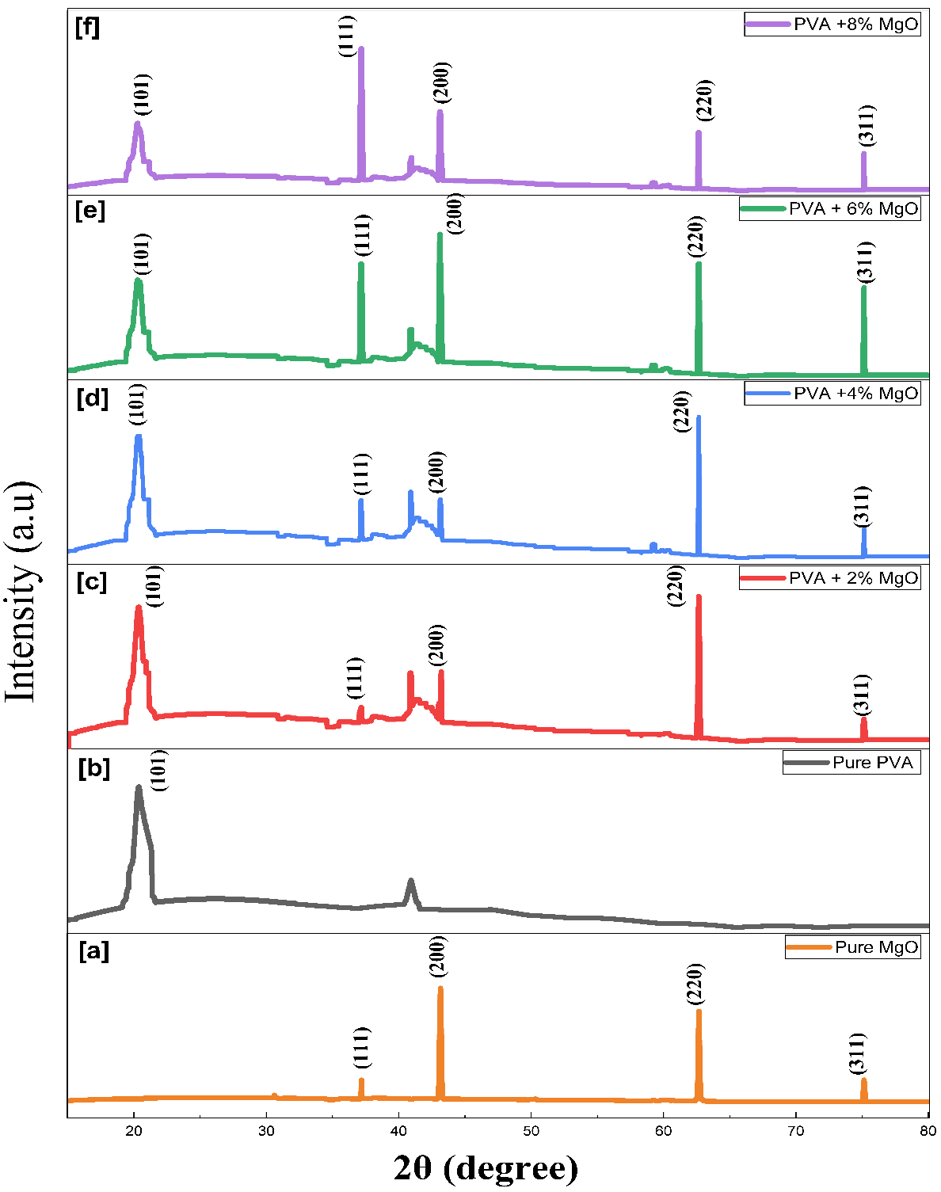

Figure 1: XRD pattern of MgO/PVA NPs with a Concentration of: a) pure MgO, b) pure PVA, c) 2wt.% MgO, d) 4wt.% MgO, e) 6wt.% MgO, f) 8wt.% MgO.

Table 2: Structural parameters derived from the XRD (111) peak for PVA/MgO nanocomposite films with different MgO loadings (2–8 wt.%).
MgO wt% | 2θ (degree) | FWHM β (rad) | Crystallite size D (nm) | Integrated Area | ε (Micro-strain)
PVA + 2% MgO | 37.145 | 2.760×${10}^{-3}$ | 53.0 | 3.39189 | 2.054×${10}^{-3}$
PVA + 4% MgO | 37.1679 | 2.710 × 10⁻³ | 54.0 | 8.49883 | 2.015× 10⁻³
PVA + 6% MgO | 37.16783 | 2.651×${10}^{-3}$ | 55.2 | 30.03371 | 1.971×${10}^{-3}$
PVA + 8% MgO | 37.17453 | 2.574×${10}^{-3}$ | 56.8 | 51.77884 | 1.914×${10}^{-3}$

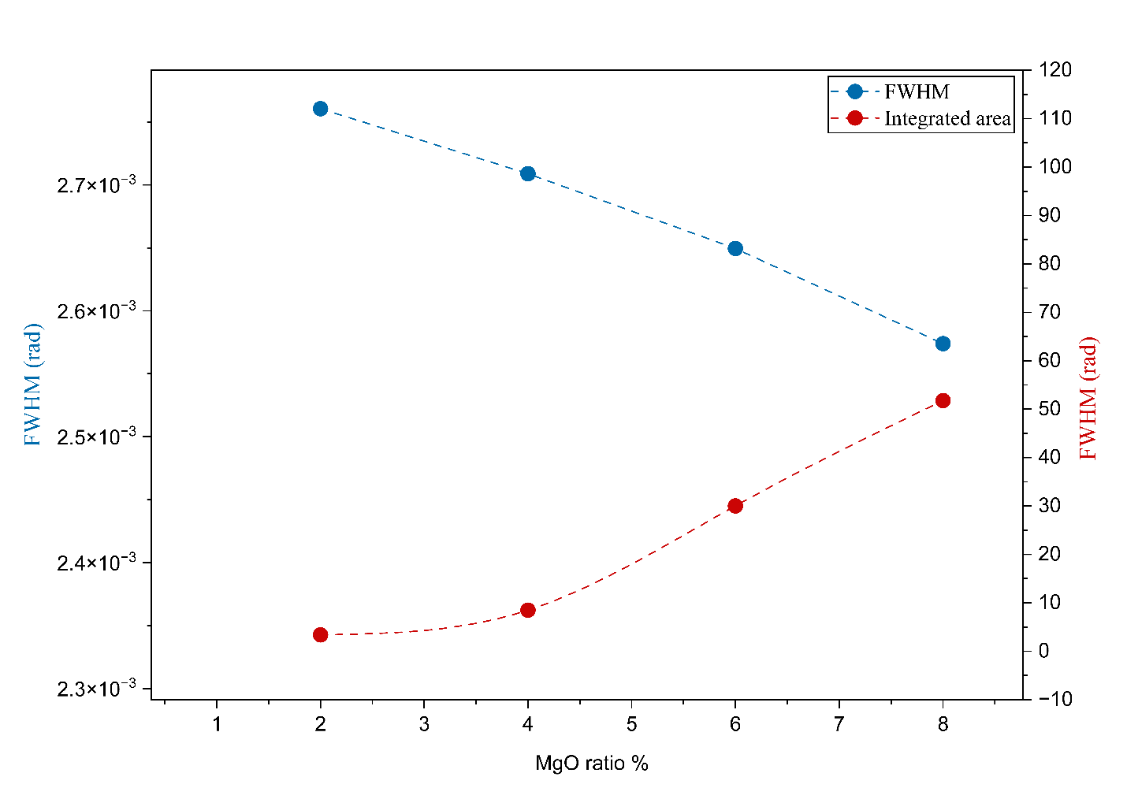
Figure 2: The effect of MgO ratio on the a) FWHM and b) the Integrated intensity.

FTIR Analysis
Figure 3 shows the FTIR characterization of MgO/PVA nanocomposites at ratios ranging from 2 to 8 wt% that focuses on identifying the interfacial interactions between the metal oxide and the polymer matrix. As the MgO loading increases, the broad O-H stretching peak shifts toward lower wavenumbers (from 3320 cm⁻¹ to 3280 cm⁻¹). This redshift is the primary evidence of physical interaction; the MgO surface oxygen atoms compete with the PVA's own hydroxyl groups for hydrogen bonding, creating a denser interfacial network [1, 2]. The peak at 1640 cm⁻¹ is standard to identify it as adsorbed water (H-O-H bending). Since MgO is highly hygroscopic, the intensity of this peak grows significantly as the concentration moves toward 8%, reflecting the composite's increased affinity for atmospheric moisture [2, 3]. The peak at 1141 cm⁻¹ is a well-known indicator of the crystalline phase of PVA. At 2% loading, this peak remains sharp. However, as the ratio reaches 6% and 8%, the peak intensity weakens. This demonstrates that the high density of MgO nanoparticles acts as a physical barrier, preventing the polymer chains from packing into regular crystalline lattices [4, 5]. In the low-frequency region (400–700 cm⁻¹), the characteristic vibrations of the Mg-O bond become increasingly distinct, confirming the presence of MgO in the composite films. At 2%, the signal may be noisy or buried in the baseline, but at 8%, it appears as a clear, sharp absorption band, confirming the high-density presence of the inorganic phase [1, 3]. The progressive change of these bands with increasing MgO wt.% suggests stronger interfacial interaction and increased incorporation of MgO within the PVA matrix. Table 3 shows the main function groups observed at the FTIR spectra of pure PVA and PVA/MgO nanocomposite films.

Table 3 Assignment of FTIR absorption bands (cm⁻¹) for PVA/MgO nanocomposite films.
Wave number cm⁻¹ | Function group | Effect of MgO doping
~3300 cm⁻¹ | O-H stretching | Shift and boarding
~2920 cm⁻¹ | C-H stretching | Minor Decrease
~1705 cm⁻¹ | C=O stretching | Intensity Increase
~1650 cm⁻¹ | H-O-H bending | Intensity Increase
~1141 cm⁻¹ | C-O stretching | Decreased Intensity
~450-700cm⁻¹ | Mg–O Stretching | Emergence / Sharpness

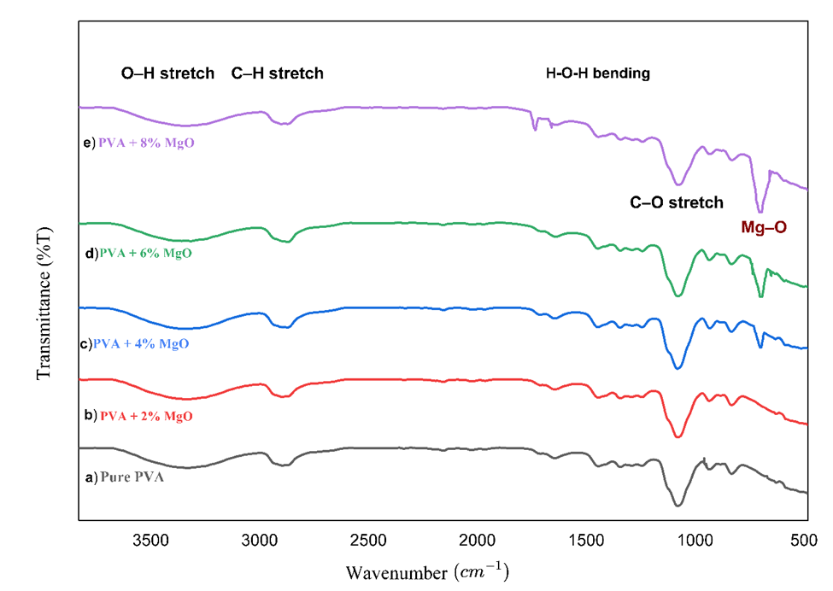

Figure 3. FTIR spectra (transmittance vs. wavenumber) of pure PVA and PVA/MgO nanocomposite films: a) pure PVA, b) 2 wt.% MgO, c) 4 wt.% MgO, d) 6 wt.% MgO, e) 8 wt.% MgO.

Optical Properties
The analysis of optical absorption spectra offers valuable insights into the composition and energy gap of nanocomposite materials. To investigate the impact of different MgO ratios in MgO/PVA nanocomposites, optical absorption was studied in the UV-vis range (190-900 nm). Figure 4 displays the spectra of pristine PVA and that of PVA substituted at different MgO concentrations (2 ,4,6, and 8 wt.%). The absorption of PVA film increases with increasing MgO content in both regions (UV and visible regions). The cubic MgO is a wide-bandgap ionic oxide of approximately (𝐸𝑔≈7.8 eV). Fundamental electronic transitions for MgO occurs typically at wavelengths shorter than 200 nm. An absorption band at 278 nm corresponds to an energy of approximately 4.46 eV, which is far below the required energy to bridge the MgO bandgap. In the context of PVA/MgO composites, the band at ~278 nm is almost exclusively attributed to the PVA matrix. It originates from $n→π^{*}$or $π→π^{*}$ transitions of residual carbonyl groups (𝐶=𝑂) or unsaturated carbon-carbon double bonds (𝐶=𝐶). These are present in PVA as impurities from the manufacturing process (residual acetate groups from the hydrolysis of polyvinyl acetate). While the intensity of this peak increases upon adding MgO, this is not due to MgO absorbing at that wavelength. Instead, it is caused by interfacial physical interactions (hydrogen bonding) between the MgO nanoparticles and the polymer chains, which can increase structural disorder or modify the local electronic environment of the polymer’s existing chromophores.

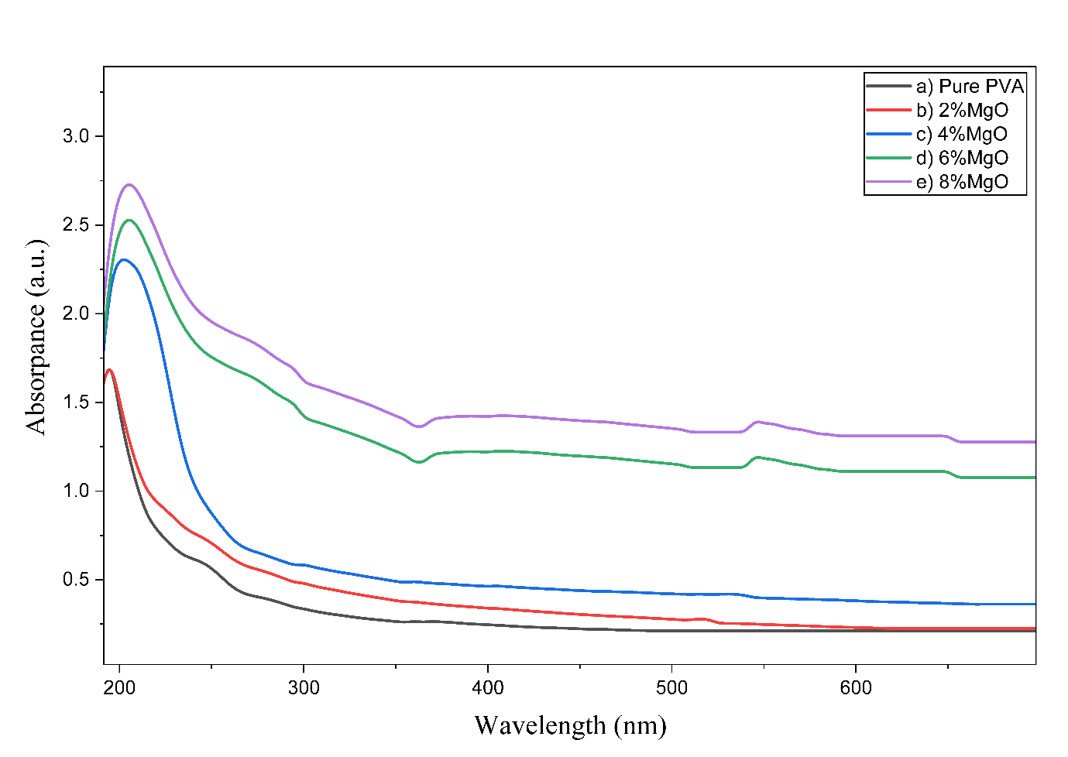

Figure 4: UV–VIS absorption spectra of the MgO/PVA NPs with a Concentration of: a) pure PVA, b) 2wt.% MgO, c) 4wt.% MgO, d) 6wt.% MgO, e) 8wt.% MgO.

Absorption Coefficient

Equation 3 determines the absorption coefficient (α) as a function of wavelength, were A is the absorbance at a specific wavelength and d (0.03 cm) is the sample thickness.
α = (2.303*A)/0.03 (3)
The optical absorption coefficient was determined as a function of the incident photon energy by extrapolating the linear portion of the curves to zero absorption α = 0 for pure PVA and substituted PVA/MgO NPs, as depicted in Figure 5. From the Figure, the absorption edge of pure PVA has been shifted to the lower energy region with the increase of the MgO ratio. It also shows that as photon energy increases, the absorption coefficient for all samples increases gradually. As the MgO loading increases (from 2wt% to 8wt%), the value of 𝛼 significantly increases. This is due to the higher density of MgO nanoparticles providing more absorption centres and increasing the probability of photon-matter interactions. In addition, with increasing MgO content, the absorption edge typically shifts toward longer wavelengths (lower energies) as a result of interfacial physical interactions and the creation of localized states (tails) in the forbidden gap, rather than direct chemical bond formation. The redshift of the absorption edge observed in all samples refers to the bandgap energy decrease [39]. The values obtained for the edge of absorption are tabulated in Table 4, where the absorption edge for PVA is 5.8 eV and decreased to 4.58 eV for an 8 wt.% MgO/PVA film. Figure 5 also reveals that the absorption edge of natural PVA and composite PVA/MgO films have significant change due to complete incorporation between the PVA matrix and MgO nanoparticles, and this is confirmed by XRD results. Further research exploring these properties is guaranteed to fully elucidate the underlying mechanisms and optimize their utility.

Optical Energy Gap
Tauc's relation was utilized to determine the optical energy gap of both PVA and the nanocomposite MgO/PVA NP samples, which can be expressed as follows:
𝛼 = 𝛽 ℎ𝜈 (ℎ𝜈 − 𝐸𝑔𝑥) (4)
where β is the constant associated with electronic transition probabilities, hυ is the photon energy, Eg is the optical forbidden gap, and x is an exponent factor where the exponent values determine the type of electronic transitions that could occur during the process of photon absorption. For forbidden and allowed direct transition, x = 3/2 and ½, while for indirect x = 2 and 3, respectively. transitions can occur both directly and indirectly near the basic band edge. This is indicated by plotting (αhυ)^{1/2} and (αhυ)² as a function of photon energy (hυ) [40]. The point of crossing the linear regions in Figure 5 with the photon energy axis is associated with the values of bandgap values. The variations in the electrical features of materials are known to arise from band structure. Knowledge of the band gaps is therefore extremely important [41]. The bandgap values for the permitted indirect and direct transitions are presented in Table 4. The bandgap values are shown to decline with the rising concentration of MgO. The optical energy gap decreases from 5.8 eV for pure PVA to 4.58 eV for PVA/MgO 8wt%, and from 4.83 eV for pure PVA to 2.74 eV for PVA/MgO 8wt%. for direct and indirect bandgap, respectively. This reduction may be interpreted as the band gap narrowing as a result of the increased density of localized states and the formation of defect levels within the forbidden gap. This is quantitatively supported by the calculated increase in Urbach energy (𝐸𝑢), which confirms that the incorporation of MgO increases structural disorder within the PVA matrix. Therefore, the MgO molecules bridge the gap between the two localized states with an increase in MgO concentration, thus reducing the potential barrier between them. The bandgap reduction detected is influenced by all the above factors [42]. Moreover, the MgO does not act as a traditional bulk dopant; rather, its high surface-to-volume ratio creates significant interfacial physical interactions (hydrogen bonding) with PVA chains. These interactions perturb the electronic environment of the polymer, leading to the observed redshift in the absorption edge and the subsequent narrowing of the optical gap [43-45].

Table 4: Optical parameters (direct and indirect band gaps and Urbach energy) of PVA/MgO nanocomposite films at different MgO concentrations.
Samples | Direct band gap Eg (eV) | Indirect band gap Eg (eV) | Urbach Energy Eu (eV)
2% MgO | 5.64 | 4.62 | 2.621575567
4% MgO | 4.99 | 4.47 | 3.43265138
6% MgO | 4.74 | 3.04 | 3.853713053
8% MgO | 4.58 | 2.74 | 4.446618347

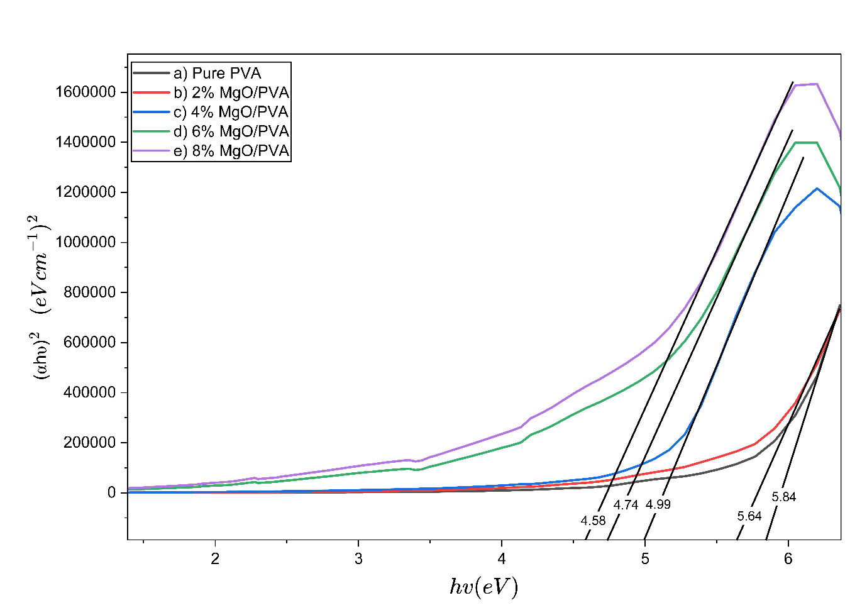
Figure 5: The variation of (αhv)² against the energy of the photon (hv) of the MgO/PVA NPs with a Concentration of: a) pure PVA, b) 2wt.% MgO, c) 4wt.% MgO, d) 6wt.% MgO, e) 8wt.% MgO.

Conclusion

There is significant attention on the development of optoelectronic and solar cells with novel structures as substitute commercial applications in production. The integration of Magnesium oxide nanoparticles (MgO NPs) into a polyvinyl alcohol (PVA) matrix yields high-performance nanocomposite films suitable for cost-effective, reliable, and energy-efficient applications. In this study, MgO/PVA films were fabricated using the solution casting method with filler loadings of 2, 4, 6, and 8 wt%. The structural and optical characteristics were systematically investigated using X-ray diffraction (XRD), Fourier-transform infrared spectroscopy (FTIR), and Ultraviolet–visible (UV–Vis) spectroscopy. XRD analysis confirmed the successful incorporation of the cubic MgO crystalline phase within the semi-crystalline PVA matrix. FTIR spectra revealed significant interfacial physical interactions, primarily through hydrogen bonding between the MgO surface hydroxyl groups and the PVA chains. UV–Vis analysis demonstrated that increasing MgO content leads to a progressive increase in optical absorbance and a subsequent reduction in both direct and indirect optical bandgaps (determined via Tauc plots). Furthermore, an increase in Urbach energy was observed with higher MgO loadings, indicating an enhancement in structural disorder and the density of localized states within the forbidden gap. These modifications in the spectroscopic parameters suggest that small loadings of MgO effectively tune the optical proficiency of the PVA matrix. The observed absorption characteristics and bandgap engineering make these MgO/PVA nanocomposites promising candidates for UV-shielding, photocatalysis, and sustainable optoelectronic devices, offering a viable and cost-effective route for industrial advancement.
COMPETING INTERESTS DISCLAIMER:
Authors have declared that they have no known competing financial interests OR non-financial interests OR personal relationships that could have appeared to influence the work reported in this paper.

Disclaimer (Artificial intelligence)
Author(s) hereby declare that NO generative AI technologies such as Large Language Models (ChatGPT, COPILOT, etc.) and text-to-image generators have been used during the writing or editing of this manuscript.

References
[1] Z. Dilli, A. Akturk, N. Goldsman, M. A. Holloway, and J. C. Rodgers, “Nonlinear behavior of electrostatic discharge protection structures under high-power microwave excitation: Modeling and simulation,” in 2011 IEEE International Symposium of Circuits and Systems (ISCAS), IEEE, 2011, pp. 1840–1843.
[2] M. C. MORARO, “OPTICAL AND ELECTRICAL CHARACTERIZATION OF Cd _{x} Se _{1-x} S AND Cu ₂ STHIN FILMS FOR SOLAR CELL APPLICATION MOGUNDE CHARLES MORARO (B. EdSc),” 2016.
[3] A. L. Linsebigler, G. Lu, and J. T. Yates Jr, “Photocatalysis on TiO₂ surfaces: principles, mechanisms, and selected results,” Chem Rev, vol. 95, no. 3, pp. 735–758, 1995.
[4] A. Pradel and M. Ribes, “Ionic conductivity of chalcogenide glasses,” in Chalcogenide Glasses, Elsevier, 2014, pp. 169–208.
[5] M. Dey et al., “Deposition of CdS thin film by thermal evaporation,” in 2019 International Conference on Electrical, Computer and Communication Engineering (ECCE), IEEE, 2019, pp. 1–5.
[6] I. F. Chetverikova, M. v Chukichev, and L. N. Rastorguev, “X-ray phase analysis and elastic properties of gallium nitride,” Izvestiya Akademii Nauk SSSR, Neorganicheskie Materialy, vol. 22, no. 1, pp. 63–66, 1986.
[7] B. K. Meyer et al., “Binary copper oxide semiconductors: From materials towards devices,” physica status solidi (b), vol. 249, no. 8, pp. 1487–1509, 2012.
[8] A. L. Linsebigler, G. Lu, and J. T. Yates Jr, “Photocatalysis on TiO₂ surfaces: principles, mechanisms, and selected results,” Chem Rev, vol. 95, no. 3, pp. 735–758, 1995.
[9] S. C. Abrahams and J. L. Bernstein, “Rutile: normal probability plot analysis and accurate measurement of crystal structure,” J Chem Phys, vol. 55, no. 7, pp. 3206–3211, 1971.
[10] M. Horn, C. F. Schwebdtfeger, and E. P. Meagher, “Refinement of the structure of anatase at several temperatures,” Zeitschrift für Kristallographie-Crystalline Materials, vol. 136, no. 1–6, pp. 273–281, 1972.
[11] P. Sawicka-Chudy et al., “TiO₂ Grown by Pulsed Laser Deposition and Reactive DC Direct Current Sputtering as an Intermediate Buffer Layer in Photovoltaic Structures,” Journal of Nanoelectronics and Optoelectronics, vol. 13, no. 7, pp. 995–1000, Jun. 2018, doi: 10.1166/jno.2018.2348.
[12] M. A. Green, Y. Hishikawa, E. D. Dunlop, D. H. Levi, J. Hohl‐Ebinger, and A. W. Y. Ho‐Baillie, “Solar cell efficiency tables (version 52),” Progress in Photovoltaics: Research and Applications, vol. 26, no. 7, pp. 427–436, 2018.
[13] R. Jose, V. Thavasi, and S. Ramakrishna, “Metal oxides for dye‐sensitized solar cells,” Journal of the American Ceramic Society, vol. 92, no. 2, pp. 289–301, 2009.
[14] S. Ruhle et al., “All-oxide photovoltaics,” J Phys Chem Lett, vol. 3, no. 24, pp. 3755–3764, 2012.
[15] S. Goto, Y. Adachi, K. Matsuda, and M. Nose, “Crystal structure and optical properties of TiO₂ thin films prepared by reactive RF magnetron sputtering,” Archives of Metallurgy and Materials, vol. 60, no. 2A, pp. 965–967, 2015, doi: 10.1515/amm-2015-0240.
[16] J. Zheng, S. Bao, and P. Jin, “TiO₂ (R)/VO₂ (M)/TiO₂ (A) multilayer film as smart window: Combination of energy-saving, antifogging and self-cleaning functions,” Nano Energy, vol. 11, pp. 136–145, 2015.
[17] M. J. Powell et al., “Intelligent multifunctional VO₂/SiO₂/TiO₂ coatings for self-cleaning, energy-saving window panels,” Chemistry of Materials, vol. 28, no. 5, pp. 1369–1376, 2016.
[18] M. C. Rao, K. Ravindranadh, and M. S. Shekhawat, “Structural and electrical properties of TiO₂ thin films,” in AIP Conference Proceedings, AIP Publishing LLC, 2016, p. 020077.
[19] G. K. Dalapati et al., “Color tunable low-cost transparent heat reflector using copper and titanium oxide for energy saving application,” Sci Rep, vol. 6, no. 1, pp. 1–14, 2016.
[20] M. I. Khan, K. A. Bhatti, R. Qindeel, H. S. Althobaiti, and N. Alonizan, “Structural, electrical and optical properties of multilayer TiO₂ thin films deposited by sol–gel spin coating,” Results Phys, vol. 7, pp. 1437–1439, 2017.
[21] M. Kang, S. W. Kim, and H. Y. Park, “Optical properties of TiO₂ thin films with crystal structure,” Journal of Physics and Chemistry of Solids, vol. 123, pp. 266–270, 2018.
[22] D. S. C. Halin, M. M. A. Abdullah, M. A. A. Mohd Salleh, N. Mahmed, A. N. Mohd Sakeri, and K. Abdul Razak, “Synthesis and characterization of Ag/Tio₂ thin film via sol-gel method,” in Solid State Phenomena, Trans Tech Publications Ltd, 2018, pp. 140–145. doi: 10.4028/www.scientific.net/SSP.273.140.
[23] S. Kumari et al., “A comprehensive review on various techniques used for synthesizing nanoparticles,” Journal of Materials Research and Technology, vol. 27, pp. 1739–1763, Nov. 2023, doi: 10.1016/J.JMRT.2023.09.291.
[24] D. R. Paul and L. M. Robeson, “Polymer nanotechnology: Nanocomposites,” Polymer (Guildf), vol. 49, no. 15, pp. 3187–3204, Jul. 2008, doi: 10.1016/J.POLYMER.2008.04.017.
[25] T. Hanemann and D. V. Szabó, “Polymer-Nanoparticle Composites: From Synthesis to Modern Applications,” Materials 2010, Vol. 3, Pages 3468-3517, vol. 3, no. 6, pp. 3468–3517, May 2010, doi: 10.3390/MA3063468.
[26] B. ; Liu, J. ; Zhang, H. Guo, B. Liu, J. Zhang, and H. Guo, “Research Progress of Polyvinyl Alcohol Water-Resistant Film Materials,” Membranes 2022, Vol. 12, Page 347, vol. 12, no. 3, p. 347, Mar. 2022, doi: 10.3390/MEMBRANES12030347.
[27] M. Bulinski, L. Pascu, and M. Dimitrievska, “Metal Doped PVA Films for Opto-Electronics-Optical and Electronic Properties, an Overview,” Molecules 2021, Vol. 26, Page 2886, vol. 26, no. 10, p. 2886, May 2021, doi: 10.3390/MOLECULES26102886.
[28] G. Kovtun, D. Casas, and T. Cuberes, “Influence of Glycerol on the Surface Morphology and Crystallinity of Polyvinyl Alcohol Films,” Polymers (Basel), vol. 16, no. 17, Sep. 2024, doi: 10.3390/polym16172421.
[29] G. Mohammed, A. M. El Sayed, and W. M. Morsi, “Spectroscopic, thermal, and electrical properties of MgO/ polyvinyl pyrrolidone/ polyvinyl alcohol nanocomposites,” Journal of Physics and Chemistry of Solids, vol. 115, pp. 238–247, Apr. 2018, doi: 10.1016/J.JPCS.2017.12.050.
[30] S. K. N, M. KUMAR, R. V. V, S. R, and G. SANJEEV, “Dielectric Properties of PVA/MgO Polymer Nanocomposite Films,” Mar. 2024, doi: 10.21203/RS.3.RS-4083885/V1.
[31] K. Y. Hsiao, R. J. Chung, P. P. Chang, and T. H. Tsai, “Identification of Hydroxyl and Polysiloxane Compounds via Infrared Absorption Spectroscopy with Targeted Noise Analysis,” Polymers (Basel), vol. 17, no. 11, Jun. 2025, doi: 10.3390/polym17111533.
[32] S. Elashry, H. El Saeed, and N. M. El-Siragy, “ATR-FTIR and UV-vis spectroscopy studies of microwave oven-generated oxygen plasma modification for PVA films,” 2022.
[33] H. M. Zidan, E. M. Abdelrazek, A. M. Abdelghany, and A. E. Tarabiah, “Characterization and some physical studies of PVA/PVP filled with MWCNTs,” Journal of Materials Research and Technology, vol. 8, no. 1, pp. 904–913, Jan. 2019, doi: 10.1016/J.JMRT.2018.04.023.
[34] S. F. Bdewi, O. G. Abdullah, B. K. Aziz, and A. A. R. Mutar, “Synthesis, Structural and Optical Characterization of MgO Nanocrystalline Embedded in PVA Matrix,” J Inorg Organomet Polym Mater, vol. 26, no. 2, pp. 326–334, Mar. 2016, doi: 10.1007/S10904-015-0321-3/TABLES/2.
[35] Z. D. A. Ali, A. A. Ahmed, and O. A. A. Dakhil, “Optical and electrical properties of nano magnesium oxide doped with polyvinyl alcohols (PVA) thin films,” in INTERNATIONAL WORKSHOP ON MACHINE LEARNING AND QUANTUM COMPUTING APPLICATIONS IN MEDICINE AND PHYSICS: WMLQ2022, AIP Publishing, Mar. 2024, p. 050010. doi: 10.1063/5.0197272.
[36] T. S. Soliman, “Effects of SiO2Nanoparticles on Polyvinyl Alcohol/Carboxymethyl Cellulose Polymer Blend Films’ Structural, Wettability, Surface Roughness, and Optical Characteristics,” Advances in Polymer Technology, vol. 2024, 2024, doi: 10.1155/2024/3623198.
[37] B. Azhdar, “Influence of fuel-to-oxidizer ratio, potential of hydrogen and annealing temperature on the structural and optical properties of nanocrystalline MgO powders synthesized by the hydrothermal method,” J Exp Nanosci, vol. 18, no. 1, Dec. 2023, doi: 10.1080/17458080.2023.2276278;WGROUP:STRING:PUBLICATION.
[38] A. H. A. Darwesh et al., “Investigation of Structural and Optical Characteristics of Biopolymer Composites Based on Polyvinyl Alcohol Inserted with PbS Nanoparticles,” Coatings, vol. 13, no. 3, Mar. 2023, doi: 10.3390/coatings13030578.
[39] S. B. Aziz et al., “Synthesis of PVA/CeO2 Based Nanocomposites with Tuned Refractive Index and Reduced Absorption Edge: Structural and Optical Studies,” Materials 2021, Vol. 14, Page 1570, vol. 14, no. 6, p. 1570, Mar. 2021, doi: 10.3390/MA14061570.
[40] R. López and R. Gómez, “Band-gap energy estimation from diffuse reflectance measurements on sol–gel and commercial TiO2: a comparative study,” Journal of Sol-Gel Science and Technology 2011 61:1, vol. 61, no. 1, pp. 1–7, Sep. 2011, doi: 10.1007/S10971-011-2582-9.
[41] P. R. Jubu et al., “Comment about the use of unconventional Tauc plots for bandgap energy determination of semiconductors using UV–Vis spectroscopy,” Results in Optics, vol. 14, p. 100606, Feb. 2024, doi: 10.1016/J.RIO.2024.100606.
[42] Al-Dahash, G. A., Bdewi, S. A., & Al-Zubaydi, A. S. (2024). Enhancing the optical and structural properties of PVA/MgO nanocomposites: A study on concentration-dependent effects. Optical Materials, 150, 114965. https://doi.org/10.1016/j.optmat.2024.114965.
[43] Bilgrami, A. L., Dangi, S. B., Hasan, P. M. Z., Quraishi, A. M., Melaibari, A. A., Sarwat, M., … Alvi, P. A. (2025). Reinforcement of various characteristics of biocompatible PVA/PMMA/N-GO polymer nanocomposite by functionalization of GO. Composite Interfaces, 32(6), 907–930. https://doi.org/10.1080/09276440.2024.2446045.
[44] Sharma, N., Aakansha, Kumar, S., Dalela, S., Hashmi, S. Z., Ahmad, M. A., … Alvi, P. A. (2025). Tailoring the optical, Raman and structural characteristics of PCCCe polymer nanocomposite by 1.3 MeV gamma irradiation. Composite Interfaces, 1–24. https://doi.org/10.1080/09276440.2025.2521161.
[45] Arya, J., Leel, N. S., Quraishi, A. M., Hashmi, S. Z., Kumar, S., Dalela, S., … Alvi, P. A. (2025). Tailoring the structural and optical properties of PVA/Sm@CeO₂ polymer nanocomposite with optimized molecular structure. Composite Interfaces, 1–20. https://doi.org/10.1080/09276440.2025.2537988.

