Original Research Article
Development of a novel method for disease severity driven variable rate chemical application based on plant morphological indicators

Abstract
Early blight, caused by Alternaria alternata, poses a critical challenge to tomato (Solanum lycopersicum L.) production, causing significant yield losses worldwide. Accurate quantification of plant disease severity is essential for the development of intelligent, site-specific crop protection systems. This study investigates the morphological responses of tomato plants following incidence of early blight disease across different stages of disease progression, with the objective of establishing biologically meaningful indicators for imaging-based disease severity classification. Key plant morphological parameters, including plant height, total leaf area, and diseased leaf area, were monitored over time and compared with healthy plants. Analysis of variance revealed a statistically significant difference in plant height between healthy and diseased plants after inoculation of disease, with average plant height after 90 days of growth were 94.86 and 81.81 cm respectively, indicating the impact of disease on overall plant growth. Temporal analysis of leaf area and diseased area exhibited distinct disease progression patterns, comprising an initial latent phase, a rapid symptom expansion phase, and a terminal phase characterized by tissue degradation. Disease severity was quantified using an area-based severity percentage derived from the ratio of diseased area to total leaf area, providing a normalized and scalable metric of infection intensity. The observed morphological and spatial disease characteristics closely correspond to features that can be extracted using machine vision techniques, such as changes in canopy geometry and lesion extent. The findings highlight the potential and the importance of severity based assessment of disease for variable-rate site-specific spraying systems, demonstrating clear advantages over conventional target-specific approaches in reducing chemical application, improving disease control efficiency, and supporting sustainable crop protection practices.
Keywords
Disease Severity; Early Blight; Machine Vision; Variable Rate Spraying
1. Introduction
Pests and diseases are among the most critical biotic stresses affecting vegetable crops in both open-field and protected cultivation. Their incidence not only reduces crop yield and quality but also disrupts market supply chains, resulting in substantial economic losses for growers (Ojiambo et al., 2025). Tomato is particularly vulnerable to a wide range of pests and diseases, including those caused by fungal, bacterial, and viral pathogens. Fungal infections are a major limitation in its cultivation and can cause substantial losses, with common diseases include damping off, early and late blight, wilt, anthracnose and powdery mildew (Khaire et al., 2021). Early blight alone has been reported to cause up to 100% yield loss in severe cases (Prabhakar et al., 2020; Dhar et al., 2025).
The incidence of harmful pathogens in plants leads to undergo a series of physiological and morphological changes that intensify as the disease progresses (Nazarov et al., 2020). These changes are not uniform, rather, vary with the severity of infection and the developmental stage of the host plant. Morphological responses in plant height, alterations in leaf size and shape, canopy thinning, chlorotic or necrotic lesion formation, and changes in overall biomass distribution provide visible and quantifiable indicators of disease impact (Kumari et al., 2024). Systematic investigation of these traits offers valuable insight into the interaction between host growth dynamics and disease progression.
Disease development is a temporally dynamic process influenced by host phenology, environmental conditions, and pathogen aggressiveness. Early-stage infections may cause subtle morphological deviations that are difficult to detect visually, whereas advanced severity levels often result in pronounced structural damage and growth suppression (Tack et al., 2012). Furthermore, plants at different growth stages may respond differently to identical levels of disease pressure, leading to variability in symptom expression and morphological degradation. Despite this complexity, most existing disease management practices continue to overlook within-field heterogeneity in disease severity and plant growth status.
Spraying applications, wherein, conventional pesticide application not only leads to inefficient chemical usage but also increases production costs, accelerates the development of pathogen resistance, and poses risks to environmental and human health due to higher exposure to chemicals, often leading to respiratory and skin-related health issues (Páez et al., 2017). These challenges underline the pressing need for sustainable alternatives that combine plant protection with resource efficiency. In the recent past, spraying technologies such as electrostatic sprayers and UAV based sprayers have been developed to improve pesticide use efficiency and reduce chemical consumption (Lin et al., 2023; Guo et al., 2024; Talaeizadeh et al., 2025). However, precision agriculture approaches advocate for site-specific crop protection measures, where inputs are applied in accordance with actual crop need (Anand et al., 2024; Dhar et al., 2025). A prerequisite for such approaches is the reliable identification of disease severity levels and their associated plant responses (Shi et al., 2023). Convolutional Neural Networks (CNN) have proven to be highly effective in diagnosing disease severity stages of plant diseases across different crops (Nigam et al., 2021; Sibiya et al., 2021; Haque et al., 2022). Existing studies, such as Prabhakar et al. (2020) and Verma et al. (2020), have demonstrated the potential of architectures like VGG16, AlexNet, and ResNet, in classifying disease severity in tomato crop. While significant research has focused on visual disease detection using imaging and machine learning techniques, comparatively limited attention has been given to linking disease severity with quantitative morphological characteristics across growth stages.
The present study addresses this gap by systematically analyzing plant morphological characteristics following disease inoculation across multiple severity stages and phenological phases. By correlating these parameters with defined severity levels, the study seeks to identify robust morphological indicators that can serve as proxies for disease intensity under varying growth conditions. Morphological indicators derived from this study can be integrated with sensor-based or vision-based detection platforms to enable real-time, severity-specific spraying decisions. Such a system would allow reduced chemical application based upon any severity conditions, ensuring adequate or variable rate application in areas exhibiting disease symptoms. Ultimately, this severity-driven management strategy has the potential to enhance disease control efficiency, reduce environmental impact, and contribute to sustainable crop protection practices.
2. Materials and methods
2.1. Proposed approach
Tomato was chosen as the experimental crop due to its widespread cultivation and significant economic value in vegetable production systems. Early blight, caused by Alternaria alternata, was selected as the target disease because it is one of the most prevalent and destructive foliar diseases affecting tomato plants, often resulting in substantial yield losses, up to 100% if not managed effectively (Prabhakar et al., 2020). The disease progresses rapidly under both greenhouse and open field conditions, especially in warm and humid environments, making timely detection and localized intervention essential.
The methodology began with the extraction of early blight-affected leaves from the field. These samples were then validated using microscopic observation to confirm the presence of the pathogen. Following this, the disease was artificially inoculated into healthy tomato plants. The plants were kept at observation providing favorable growth environment for the pathogen and morphological characteristics at various stages of the disease were acquired. The disease severity was categorized based on the percentage of diseased leaf area which was calculated using ImageJ software, and corelated with other plant morphological parameters.
2.2. Extraction and isolation of the fungal pathogen
The leaves showing characteristic symptoms of early blight were collected from tomato plants at the Center for Protected Cultivation, ICAR-Indian Agricultural Research Institute, New Delhi, for extraction of the fungal pathogen. The infected leaves were cut into small pieces using a sterile scalpel and surface sterilized with 1% sodium hypochlorite solution for one minute, followed by three rinses with sterile distilled water. The sterilized leaf pieces were dried using sterile blotting paper. Isolation of the blight causing fungal pathogen was carried out using the standard agar plate technique (APT). The surface sterilized leaf sections were placed on potato dextrose agar (PDA) plates inside a laminar air flow chamber and incubated at 26ºC. Fungi growth was observed after four days of incubation and emerging fungal colonies were sub-cultured onto PDA slants using a sterile inoculation needle to obtain pure cultures. The extraction and isolation process of fungal pathogen are shown in Fig. 1.
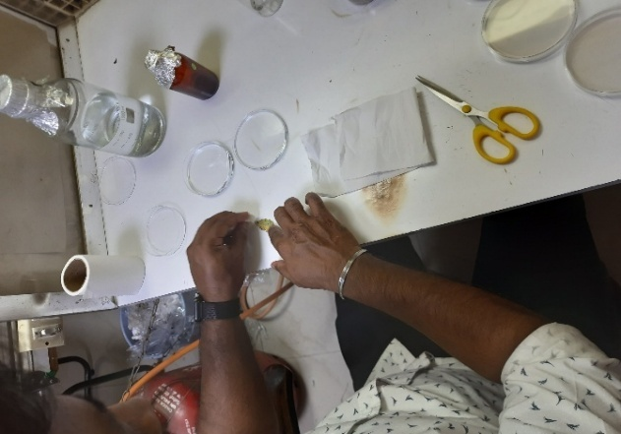 | 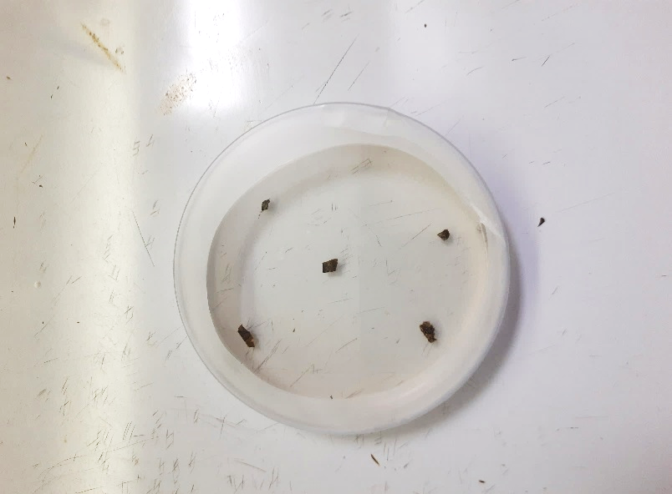 | 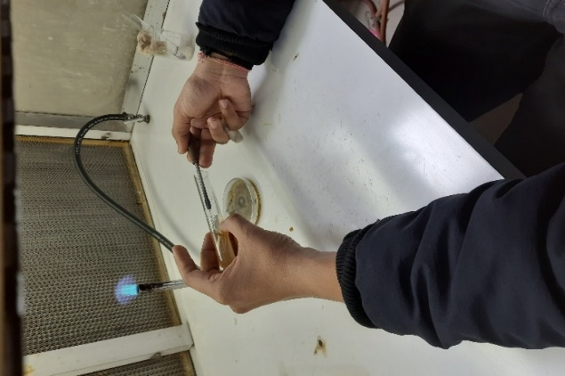
(a) | (b) | (c)
Fig. 1. Extraction and isolation of fungal pathogen, (a) Preparation of leaf samples, (b) PDA plates with diseased leaf sections, (c) Subculturing onto PDA slants
2.3. Microscopic observation of the pathogen
Microscopic observation was undertaken to confirm the presence of the desired pathogen. A single-spore culture was obtained by isolating a single conidium under a microscope. The isolated conidia were transferred onto PDA medium to ensure culture purity, and the resulting growth was examined for morphological characteristics. Detailed microscopic observation was carried out under a compound microscope (Make: Nikon; Model: Eclipse Ts2R), to assess key diagnostic features such as conidial shape, size, beak formation, pigmentation, branching patterns, and the presence of horizontal and vertical septa. The morphological analysis was conducted by following protocols described by Frazer et al., (2002), Simmons et al., (2007), and Woudenberg et al., (2014), ensuring accurate identification of the pathogen.
2.4. Cultivation of tomato plants
A highly indeterminate variety of tomato (NS-4266) commonly cultivated in greenhouses and known to be susceptible to early blight disease, was selected for the study. The seeds were selected from a single certified seed lot obtained from the same commercial supplier to ensure genetic uniformity. Seeds were sown in pro-trays containing a soilless media composed of coco-peat, perlite and vermiculite, in a 3:1:1 ratio (on volume basis), during the month of July. A total of fifty, twenty-day- old seedlings were transplanted on to 20 cm × 20 cm (diameter × height) pots filled with a sand-soil mixture in a 3:1 ratio.
2.5. Preparation of fungal suspension and inoculation in tomato plants
The main objective of preparation of fungal suspension was to generate a mass culture of Alternaria alternata for inoculating tomato plants and inducing disease symptoms. The preparation started with soaking of sorghum grains in distilled water overnight for about 12 hours. The soaked sorghum grains were transferred to conical flasks and carefully sealed using cotton plugs and sterilized in an autoclave at a temperature of 121°C for 30 minutes, maintaining the pressure of 1.05 kg.cm⁻² (15 psi) to eliminate any contaminants. After sterilization, the grains were cooled and mycelial bits of Alternaria alternata pathogen was inoculated into the sterilized grains in flasks using inoculation needle inside a laminar airflow chamber. The inoculated flasks were incubated at 25-28°C for 21 days in a BOD incubator, providing favorable environment for multiplication of fungal pathogen. After incubation, the colonized grains were macerated and suspended in sterile distilled water to prepare a conidial suspension with spore concentration of 1×10⁶ spores ml⁻¹.
Disease inoculation was carried out in the net houses of Division of Plant Pathology, ICAR-Indian Agricultural Research Institute, New Delhi. A total of 40 plants were randomly selected of which 20 plants were selected randomly and inoculated with disease, while 20 plants were kept healthy. For inoculation, leaves of one month old tomato plants were gently pricked with a sterile needle to facilitate inoculum entry and the fungal spore suspension was applied using a hand-held sprayer. The inoculated plants were placed inside a plastic chamber for 5 days as shown in Fig. 2, maintaining >90 % relative humidity using a humidifier to support fungal infection and disease development.
2.6. Study of morphological characteristics of tomato plants
Morphological characteristics provide essential information about physiological status of individual plant and reveal the underlying environmental factors responsible for changes in plants growth and development. In this study, key crop morphological characteristics such as plant height, leaf area and disease severity were monitored at different growth stages at 5-day intervals. Two crop conditions i.e., healthy plants and disease inoculated plants were evaluated to determine variations in morphological traits at different days post inoculation (DPI). The experimental plan for studying the plant morphological characteristics is presented in Table 1. The measurement of the morphological characteristics are illustrated in the following sub-sections.
Table 1 Plan of experiment for the study of plant morphological characteristics
Independent Parameters | Levels | Observable Parameters
Crop type | 1 (Tomato) | Crop morphological characteristics:  - Plant height (cm)  - Leaf area (cm²)  - Disease severity (%)
Crop condition | 2 (Healthy and disease inoculated)
Growth stages | At intervals of 5 days till  maturity
Replications | 3 | Environmental parameters:  - Temperature (°C)  - Relative humidity (%)  - Luminous intensity (lux)

2.6.1. Plant height
The height of healthy and disease inoculated tomato plants was measured at different growth stages by using a measuring scale (least count:1 mm). Plant height was recorded from the soil surface to the tip of the plant as shown in Fig. 2. Measurements were taken at 5-day intervals, and the average height of plants in each stage was computed accordingly.
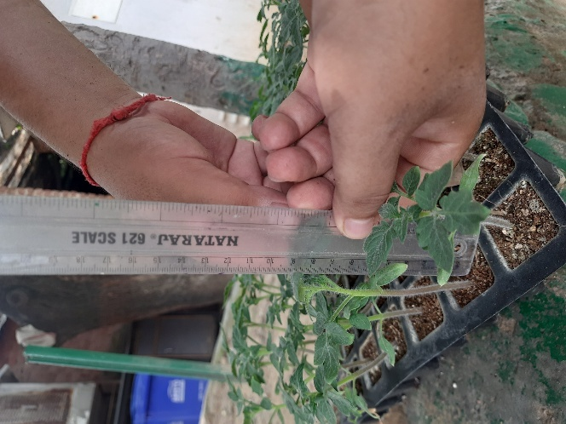
Fig. 2 Plant height measurement
2.6.2. Leaf area and disease severity
Leaf area and disease severity were measured to quantify the canopy development and assess the physiological response of the crop under experimental conditions. A total of 10 diseased leaves were selected randomly from different sections of plant canopy for measuring the total leaf area and the area affected by lesions, which was later used to calculate disease severity. A non-destructive imaging method was employed using ImageJ software (version 1.54f). ImageJ computes the area of an object based on pixel differentiation between the object and its background. For measurement of leaf area, images of the leaves were captured at an interval of 5 days on a flat board with white background, with a scale placed adjacent to the leaf. The acquired images were uploaded to the ImageJ software, where the scale was first set to actual dimensions. Subsequently, the image processing steps (Fig. 3) were performed to compute the total leaf area and area of diseased lesions. Disease severity was calculated using the formula (Bedi et al., 2024):
Disease severity (%) = $\frac{Total area of diseased pixels in leaf ({cm}^{2})}{Total area of pixels of entire leaf ({cm}^{2})}×100$

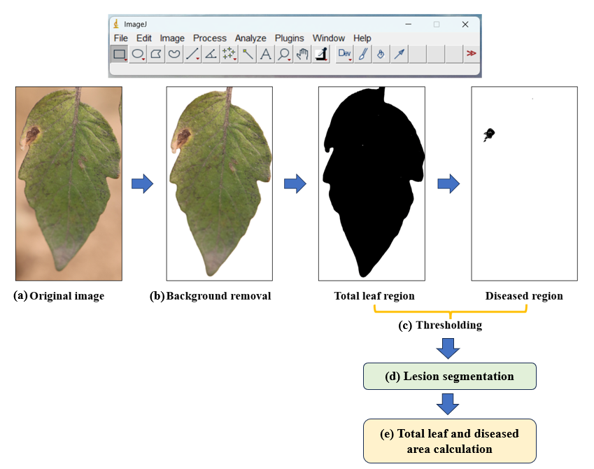
Fig. 3. Image processing in ImageJ for measurement of total leaf area and diseased regions
2.7. Environmental parameters
The environmental parameters -temperature, relative humidity and luminous intensity were recorded three times a day: morning (8-10 am IST), afternoon (12-2 pm IST), and evening (4-6 pm IST) at an interval of 5 days. Measurements were taken using a Professional 5-in-1 Environment Meter (Make: Brannan; Model: 13/464/0; Temperature range: -40 to 70°C; Relative humidity: 10 to 95%; Luminous intensity: 0 to 200 kLux), as shown in Fig. 4.
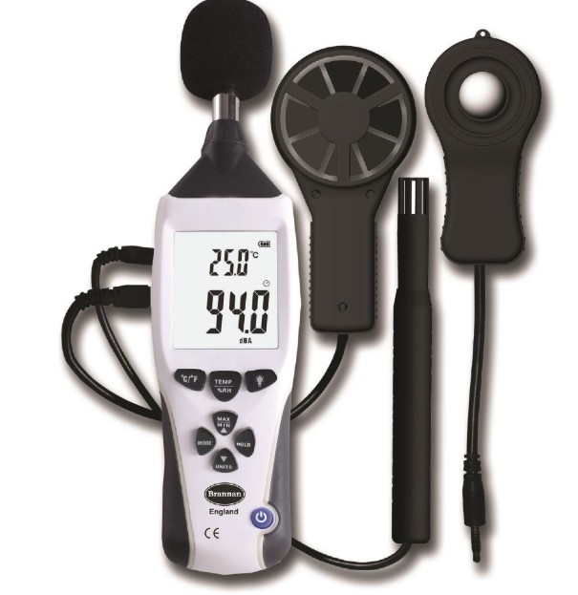
Fig. 4. 5 in 1 environment meter

3. Results
The results relating to morphological traits of healthy and disease affected plants are presented in the following section.
3.1. Morphological characteristics of inoculated and healthy tomato plants
Plant morphological traits reflect the influence of biotic and abiotic factors on crop growth and development and provide valuable insights into the physiological status of plants. These characteristics also help in understanding crop response to stress conditions and predicting future growth trends. In the present study, key morphological characteristics such as plant height (cm), leaf area (cm²) and severity of disease (%) were recorded for both early blight inoculated and healthy tomato plants at different growth stages at 5-day intervals. The environmental parameters (luminous intensity, temperature and relative humidity) during the growth of plants were recorded as shown in Table 2.
Table 2. Environmental conditions during growth of plants
Parameters | Morning  (8-10 am) | Afternoon  (12-2 pm) | Evening  (4-6 pm)
Luminous intensity (kLux) | 16-19.5 | 18-22 | 12.5-16.5
Temperature (°C) | 21-27 | 28-33 | 27-35
Relative humidity (%) | 80-91 | 58-70 | 60-75

3.2. Variations in plant height of healthy and inoculated tomato plants
Measurement of plant height commenced after emergence of seedlings and was recorded as the vertical distance from the soil surface to the uppermost tip of the youngest fully expanded leaf. The plant height of healthy tomato plants ranged from 1.45 cm at 5 days after planting (DAP) to 94.86 cm at 90 DAP, whereas, disease inoculated tomato plants exhibited a plant height of 1.41 to 82.08 cm over the same period, (Table 3). The growth trends of healthy and diseased plants over time is illustrated in Fig. 5. Disease inoculation was performed at 30 DAP, after which both healthy and inoculated plants exhibited a comparable and steady growth rate up to 40 DAP. The maximum growth rate for both treatments was observed between 40 and 70 DAP. However, beyond 40 DAP, the growth rate of disease-inoculated plants was consistently lower than that of healthy plants, indicating the adverse impact of early blight infection on vegetative growth. A significant difference in plant height was observed at 90 DAP, with healthy plants attaining an average height of 94.86 cm compared to 81.81 cm in disease-inoculated plants. Furthermore, after 75 DAP, disease-inoculated plants showed a marginal decline in plant height from 82.08 cm to 81.81 cm by 90 DAP, likely due to disease-induced physiological stress and tissue damage. Statistical analysis revealed that the variation in plant height of healthy and disease inoculated plants was significant at 5 percent level of significance with respect to days post inoculation (Table 4).
Table 3 Mean plant height of healthy and diseased plants at different days post inoculation
Days after planting | Plant height (cm)
Days after planting | Healthy | Disease inoculated
0 | 0 | 0
5 | 1.45 ± 0.41^{s} | 1.41 ± 0.47^{s}
10 | 4.09 ± 0.59^{r} | 4.07 ± 0.52^{r}
15 | 5.58 ± 0.47^{q} | 5.58 ± 0.38^{q}
20 | 6.99 ± 0.63^{p} | 6.97 ± 0.58^{p}
25 | 11.61 ± 0.54º | 11.57 ± 0.54º
30 | 17.64 ± 0.43^{n} | 17.64 ± 0.43^{n}
35 | 24.01 ± 0.41^{m} | 23.51 ± 0.37^{m}
40 | 30.70 ± 0.44^{l} | 29.70 ± 0.46^{l}
45 | 44.48 ± 0.90^{k} | 41.48 ± 0.90^{k}
50 | 57.11 ± 0.56^{i} | 52.12 ± 0.61^{j}
55 | 67.66 ± 0.90^{g} | 60.97 ± 0.52^{h}
60 | 75.70 ± 0.68e | 66.85 ± 0.46^{g}
65 | 82.02 ± 0.77^{d} | 72.34 ± 0.54^{f}
70 | 87.63 ± 2.27^{c} | 77.24 ± 1.65e
75 | 91.46 ± 2.63^{b} | 82.08 ± 2.87^{d}
80 | 94.58 ± 3.21^{a, b} | 82.07 ± 2.90^{d}
85 | 94.81 ± 3.39ª | 81.98 ± 2.95^{d}
90 | 94.86 ± 3.47ª | 81.81 ± 2.97^{d}
*Means sharing the same letter are statistically non -significant

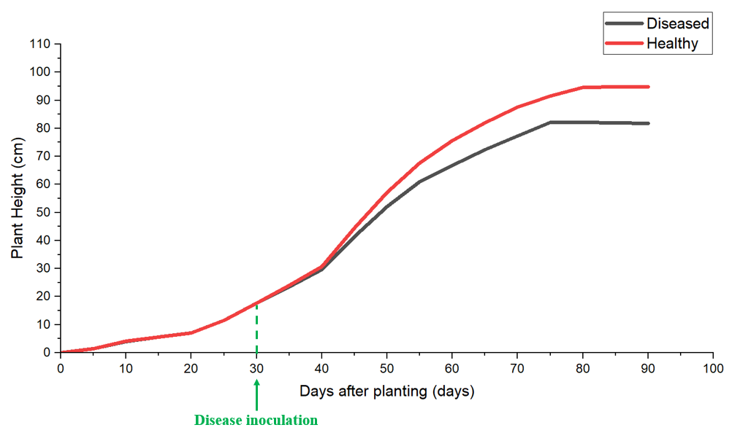
Fig. 5. Variation in plant height of healthy and disease inoculated tomato plants over time
Table 4 ANOVA table for effect on plant height after inoculation of disease
Source | DF | Sum of Squares | Mean Square | F Value | P Value
Days after inoculation | 11 | 121529.05 | 11048.09545 | 2998.05098 | <0.0001^{S}
Plant condition | 1 | 3591.36067 | 3591.36067 | 974.56457 | <0.0001^{S}
Interaction | 11 | 1104.88933 | 100.44448 | 27.25698 | <0.0001^{S}
Model | 23 | 126225.3 | 5488.05652 | 1489.25879 | <0.0001^{S}
Error | 216 | 795.98 | 3.68509 | - | -
Corrected Total | 239 | 127021.28 | - | - | -
*Level of significance = 5%
** S = Significant; NS = Non-significant

3.3. Variation of leaf area in disease inoculated tomato plants
The variation in leaf area of ten randomly selected disease inoculated tomato leaves was measured post inoculation of disease, as illustrated in Fig. 6. The total leaf area of most leaves remained steady for about 15 days post inoculation, after which a gradual decline was observed due to the progressive effect of disease leading to eventual leaf senescence. The variation in the area of diseased regions of all the ten leaves is presented in Fig. 7. Visible disease symptoms appeared approximately 5 days after inoculation. Subsequently, the symptomatic regions increased rapidly between 10th to 25th day post inoculation due to the increasing severity of disease. However, beyond 25 days after inoculation, the diseased area of all leaves showed a declining trend. This reduction was mainly attributed to the drying and shrinkage of necrotic tissues, which reduced the visibly measurable infected surface.
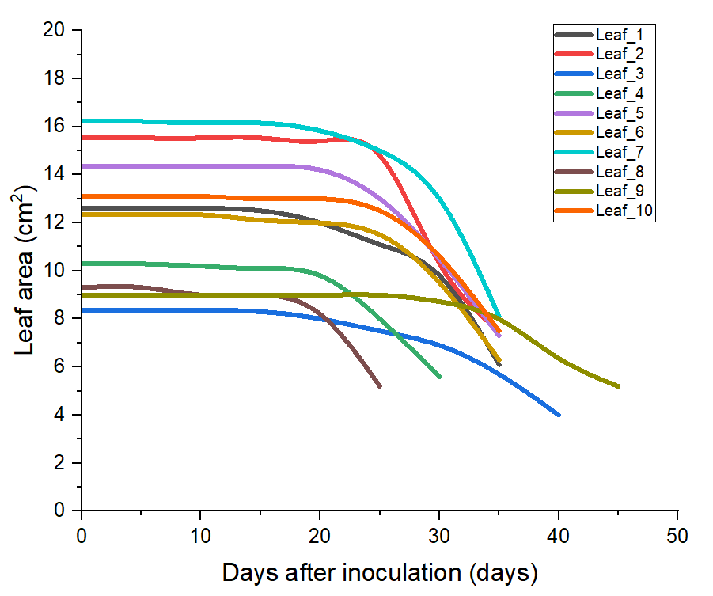
Fig. 6. Variation in leaf area of disease inoculated tomato leaves after inoculation
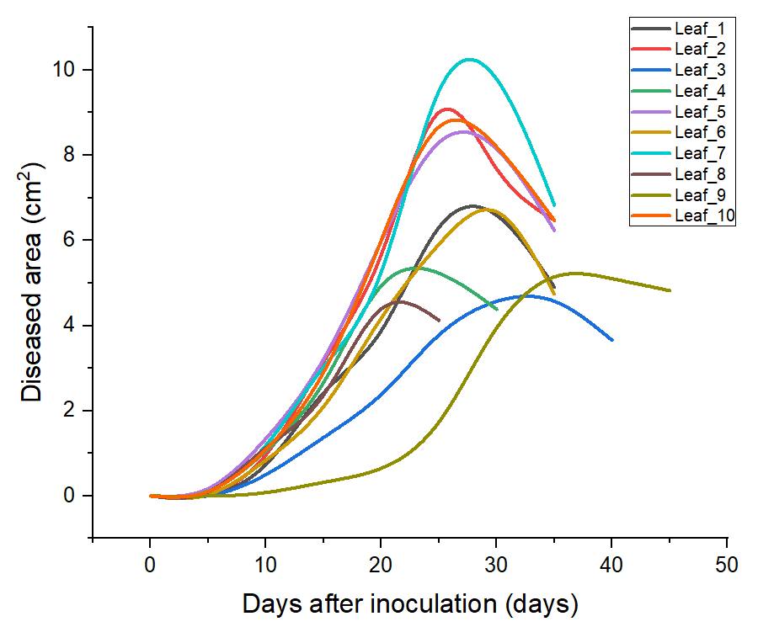
Fig. 7. Variation in diseased leaf area of tomato leaves after inoculation
3.4. Disease severity in inoculated tomato plants
The severity of disease was estimated as per the procedure described in section 2.6.2. The progression of disease severity in disease affected tomato leaves is depicted in Fig. 8. The observations revealed that the inoculated plants initially remained asymptomatic; however, after a period of latency of about 4 to 5 days, characteristic symptoms of early blight began to appear. Within five days after inoculation, the early blight affected leaves of tomato plants began to develop small, irregular brown to dark-brown lesions. These lesions gradually enlarged from 10th day to 45th day with disease severity increasing from 7.37% to 92.67%. The lesions exhibited atypical concentric ring pattern, imparting a “target-spot” appearance, a characteristic of early blight disease. As the infection progressed, the affected leaves turned yellow, dried out, and prematurely defoliated.
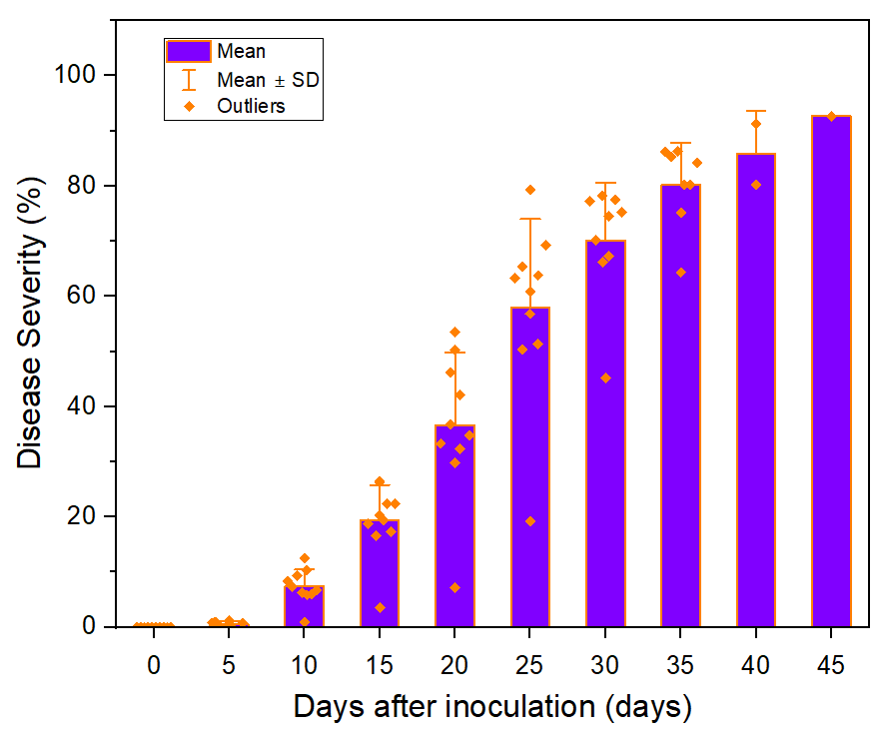
Fig. 8. Progression of disease severity in tomato plants after inoculation
4. Discussion
The present study provides important insights into the relationship between disease progression and plant morphological responses, with direct relevance to machine vision–based disease severity classification. Disease inoculation resulted in clear and progressive alterations in plant height, leaf area, and the spatial extent of diseased tissue when compared with healthy plants. Notably, plant height exhibited statistically significant variation between healthy and diseased plants after inoculation of disease (p < 0.05), confirming that disease impact is not limited to localized symptoms but extends to whole-plant growth suppression. Such growth-related parameters offer valuable contextual information that can complement image-based severity estimation in automated disease detection systems.
Temporal analysis of leaf area dynamics revealed an initial phase of minimal change followed by a sharp decline as disease severity increased. From a machine vision perspective, this reduction in leaf area translates to measurable changes in canopy geometry, leaf shape, and projected leaf surface, all of which can be captured through RGB or multispectral imaging (Zhang et al., 2024). The variability observed among individual leaves highlights the importance of pixel-level or instance-level analysis, as uniform canopy-level assessment may fail to capture localized severity variations. These findings support the need for fine-grained image segmentation approaches in vision-based disease detection frameworks.
The progression of diseased area demonstrated a well-defined temporal pattern, characterized by an incubation phase, a rapid expansion phase, and a terminal phase associated with tissue collapse (Anderegg et al., 2023). This pattern is particularly relevant for imaging-based severity classification, as the expansion of diseased regions directly corresponds to changes in color, texture, and lesion morphology, which are key features exploited by machine learning and deep learning models (Elliot et al. 2022). The observed peak and subsequent decline in diseased area further indicate that severity classification models must account for late-stage tissue degradation, where visible diseased area may decrease despite increased physiological damage.
The combined interpretation of total leaf area and diseased area establishes a strong biological basis for area-based disease severity percentage, which closely aligns with outputs derived from image segmentation models. By expressing severity as a ratio of diseased area to total leaf area, the study provides a normalized severity metric that adheres to variations in leaf size, plant age, and imaging scale. This normalization is particularly important for training and validating vision-based models intended for deployment under variable field conditions.
Furthermore, the significant differences observed between healthy and diseased plants in terms of plant height, canopy structure, and lesion development reinforce the importance of incorporating morphological context into machine vision pipelines. While lesion detection alone provides localized severity information, integrating structural cues such as leaf area reduction and canopy shrinkage can enhance model robustness and improve severity discrimination across growth stages (Bock et al., 2020; Liu et al., 2022). The findings of this study therefore support a hybrid vision-based approach, combining lesion-level segmentation with plant-level morphological assessment.
Overall, this study establishes a basis, generating a critical link between biological disease progression and imaging-observable features, providing a strong experimental foundation for the potential development of machine vision based disease severity classification systems and crop protection systems. Unlike conventional target-specific site-specific spraying approaches, which typically operate on a binary decision of disease presence or absence, the severity-aware framework supported by this study enables quantitative, continuous, and biologically meaningful assessment of disease intensity. By leveraging image derived metrics such as diseased area, total leaf area, and rate of disease severity, variable-rate spraying systems can dynamically adjust chemical dosage according to actual disease severity and plant growth status. Studies on variable-rate spraying systems based on disease severity (Tewari et al., 2020) has shown potential pesticide savings of up to 33.88 percent. This capability allows reduced chemical application in low-severity regions, precise intervention at moderate infection levels, and intensified treatment only where severe infection is present. Further, acquisition of high-quality images of diseased leaves could ensure better extraction of lesion features, which could be helpful in training machine learning models. The models could also be featured in UAVs for detection of disease, although, high resolution cameras should be a necessity for operating at higher altitudes. The outcomes of this study therefore provide a crucial experimental and biological foundation for advanced intelligent spraying systems, where machine vision driven severity classification directly governs dosage decisions, enabling economically viable, environmentally sustainable, and agronomically effective crop protection.
The study was particularly conducted to develop an approach for integrating plant morphological characteristics with disease severity, establishing a framework for precise disease detection and its potential deployment ability. Although, the study was restricted to only one pathogen-crop condition grown in protected cultivation environments, future studies should incorporate larger datasets, multiple crop–pathogen systems, environmental variability (open fields and protected cultivations environments at different agro-climatic zones), and real-world deployment of vision-guided variable rate spraying systems to fully validate and extend the proposed framework.
5. Conclusion
This study demonstrated that incidence of early blight disease induces clear and progressive morphological changes in tomato plants, as reflected by significant variation in plant height, reduction in leaf area, and expansion of diseased regions over time. The area-based disease severity percentage, derived from the ratio of diseased area to total leaf area, provided a biologically meaningful and scalable measure of infection intensity. The observed morphological and spatial disease patterns closely correspond to features extractable through machine vision techniques, thereby establishing a strong foundation for imaging-based disease severity classification beyond binary detection. By linking quantified disease severity with plant growth responses, the study underscores the critical advantage of disease severity based variable-rate site-specific spraying systems over conventional target-specific approaches, enabling dynamic, dose-optimized chemical application based on actual disease intensity. Overall, the findings support the potential development of intelligent, machine vision–driven precision spraying systems that can enhance disease control efficiency while reducing chemical usage and environmental impact. Future studies should incorporate larger datasets, multiple crop–pathogen systems, environmental variability and real-world deployment of vision-guided variable rate spraying systems to fully validate and extend the proposed framework.

COMPETING INTERESTS DISCLAIMER:
Authors have declared that they have no known competing financial interests OR non-financial interests OR personal relationships that could have appeared to influence the work reported in this paper.
Disclaimer (Artificial intelligence)
Author(s) hereby declare that NO generative AI technologies such as Large Language Models (ChatGPT, COPILOT, etc.) and text-to-image generators have been used during the writing or editing of this manuscript.

References
- Anand, R., Parray, R.A., Mani, I., Khura, T.K., Kushwaha, H., Sharma, B.B., Sarkar, S., Godara, S., Mojerlou, S., Mirzakhaninafchi, H. (2024). A multimodal approach for enhanced disease management in cauliflower crops: integration of spectral sensors, machine learning models and targeted spraying technology. Frontiers of Agricultural Science and Engineering, 1-13.
- Anderegg, J., Zenkl, R., Walter, A., Hund, A., & McDonald, B. A. (2023). Combining high-resolution imaging, deep learning, and dynamic modelling to separate disease and senescence in wheat canopies. Plant Phenomics, 5, 0053.
- Bock, C. H., Barbedo, J. G., Del Ponte, E. M., Bohnenkamp, D., & Mahlein, A. K. (2020). From visual estimates to fully automated sensor-based measurements of plant disease severity: status and challenges for improving accuracy. Phytopathology Research, 2(1), 9.
- Dhar, T., Parray, R. A., Bashyal, B. M., Nigam, S., Sharma, S., Prajwal, R., Dhanger, P., Singh, A. K., Khura, T. K., & Yeasin, M. (2025). Molecular Validation Integrated Reliable Deep Learning Approach for Early Blight Severity Detection in Tomato Crops under Protected Cultivation Environments. Results in Engineering, 107739.
- Dhar, T., Parray, R. A., Bashyal, B. M., Singh, A. K., Dhanger, P., Khura, T. K., Kumar, R., Hasan, M., & Yeasin, M. (2025). Optimized convolutional neural networks for real-time detection and severity assessment of early blight in tomato (Solanum lycopersicum L.). Fungal Genetics and Biology, 103984.
- Elliott, K., Berry, J. C., Kim, H., & Bart, R. S. (2022). A comparison of ImageJ and machine learning based image analysis methods to measure cassava bacterial blight disease severity. Plant Methods, 18(1), 86.
- Frazer, J. T. (2002). Two species of Alternaria cause early blight of potato (Solanum tuberosum) and tomato (Lycopersicon esculentum). Cornell University.
- Guo, Z., Zhang, J., Chen, L., Wang, Z., Wang, H., & Wang, X. (2024). Study on Deposition Characteristics of the Electrostatic Sprayer for Pesticide Application in Greenhouse Tomato Crops. Agriculture, 14(11), 1981.
- Haque, M. A., Marwaha, S., Arora, A., Deb, C. K., Misra, T., Nigam, S., & Hooda, K. S. (2022). A lightweight convolutional neural network for recognition of severity stages of maydis leaf blight disease of maize. Frontiers in plant science, 13, 1077568.
- Khaire, P. B., Phule, M., Vidyapeeth, K., Mane, S., Phule, M., & Vidyapeeth, K. (2021). Identification and management of fungal diseases of tomato. Agri-Meet Multidisciplinary e-Magazine, 1(1), 1-18.
- Kumari, K., Parray, R., Basavaraj, Y. B., Godara, S., Mani, I., Kumar, R., Khura, T., Sarkar, S., Ranjan, R., & Mirzakhaninafchi, H. (2024). Spectral sensor‐based device for real‐time detection and severity estimation of groundnut bud necrosis virus in tomato. Journal of Field Robotics, 42(1), 5-19.
- Lin, Z., Xie, J., Tian, S., Wang, X., Sun, W., & Mo, X. (2023). Research and experiment of electrostatic spraying system for agricultural plant protection unmanned vehicle. Frontiers in Ecology and Evolution, 11, 1138180.
- Liu, E., Gold, K. M., Combs, D., Cadle-Davidson, L., & Jiang, Y. (2022). Deep semantic segmentation for the quantification of grape foliar diseases in the vineyard. Frontiers in Plant Science, 13, 978761.
- Nazarov, P. A., Baleev, D. N., Ivanova, M. I., Sokolova, L. M., & Karakozova, M. V. (2020). Infectious plant diseases: etiology, current status, problems and prospects in plant protection. Acta Naturae, 12(3), 46.
- Nigam, S., Jain, R., Prakash, S., Marwaha, S., Arora, A., Singh, V. K., Singh, A. K., & Prakasha, T. L. (2021). Wheat disease severity estimation: a deep learning approach. In International conference on Internet of things and connected technologies (pp. 185-193). Cham: Springer International Publishing.
- Ojiambo, P. (2025). Insect pest and plant disease management in horticultural crop production: recent insights provide opportunities for improved control. Frontiers in Horticulture, 4, 1605035.
- Páez, F. C., Rincón, V. J., Sánchez-Hermosilla, J., & Fernández, M. (2017). Implementation of a low-cost crop detection prototype for selective spraying in greenhouses. Precision Agriculture, 18, 1011-1023.
- Prabhakar, M., Purushothaman, R., & Awasthi, D. P. (2020). Deep learning based assessment of disease severity for early blight in tomato crop. Multimedia Tools and Applications, 79(39), 28773-28784.
- Shi, T., Liu, Y., Zheng, X., Hu, K., Huang, H., Liu, H., & Huang, H. (2023). Recent advances in plant disease severity assessment using convolutional neural networks. Scientific Reports, 13(1), 2336.
- Sibiya, M., & Sumbwanyambe, M. (2021). Automatic fuzzy logic-based maize common rust disease severity predictions with thresholding and deep learning. Pathogens, 10(2), 131.
- Simmons, E. (2007). An Identification Manual, CBS Fungal Biodiversity Centre. Utrecht, Netherlands.
- Tack, A. J. M., Thrall, P. H., Barrett, L. G., Burdon, J. J., & Laine, A. L. (2012). Variation in infectivity and aggressiveness in space and time in wild host–pathogen systems: causes and consequences. Journal of Evolutionary Biology, 25(10), 1918-1936.
- Talaeizadeh, A., Sharifi, I., Alasty, A., & Ghatrehsamani, S. (2025). Agricultural Spraying Drones: A Comprehensive Review. Smart Agricultural Technology, 101519.
- Tewari, V. K., Pareek, C. M., Lal, G., Dhruw, L. K., & Singh, N. (2020). Image processing based real-time variable-rate chemical spraying system for disease control in paddy crop. Artificial Intelligence in Agriculture, 4, 21-30.
- Verma, S., Chug, A., & Singh, A. P. (2020). Application of convolutional neural networks for evaluation of disease severity in tomato plant. Journal of Discrete Mathematical Sciences and Cryptography, 23(1), 273-282.
- Woudenberg, J. H. C., Truter, M., Groenewald, J. Z., & Crous, P. W. (2014). Large-spored Alternaria pathogens in section Porri disentangled. Studies in Mycology, 79, 1-47.
- Zhang, X., Vinatzer, B. A., & Li, S. (2024). Hyperspectral imaging analysis for early detection of tomato bacterial leaf spot disease. Scientific Reports, 14(1), 27666.

