Morpho-cultural and pathogenic characterization of Microdochium sorghi isolates Causing Zonate Leaf Spot of Sorghum

ABSTRACT
Zonate leaf spot caused by Microdochium sorghi is an emerging and economically important foliar disease of sorghum in several humid and sub-humid regions. The present investigation was undertaken to study the pathogenicity, cultural behavior, morphological variability, and phenotypic diversity among M. sorghi isolates collected from different sorghum-growing regions of India. A total of forty-two isolates were recovered from naturally infected sorghum foliage and identified based on characteristic cultural and morphological features. Pathogenicity tests conducted under greenhouse conditions using the susceptible sorghum cultivar ‘Pant Chari-4’ confirmed the virulence of all isolates, with disease severity ranging from 33.45 to 88.24%, indicating significant variation in aggressiveness. Morpho-cultural characterization on oat meal agar medium revealed considerable diversity among isolates with respect to colony growth rate, pigmentation, texture, elevation, margin type, zonation, conidial morphology, and sclerotial formation. Although all isolates attained full plate growth, the time required varied markedly, reflecting inherent growth differences. Colony coloration ranged from salmon pink and grey to black and brown, while textures varied from felty and woolly to cottony. Conidial length and breadth showed wide variation, with conidia being falcate, hyaline, and pluriseptate. Most isolates produced microsclerotia, although a few failed to do so. Cluster analysis using the Unweighted Pair Group Method with Arithmetic Mean (UPGMA) based on Jaccard similarity coefficients grouped the isolates into two major clusters, with further subdivision into several subclusters, demonstrating substantial phenotypic diversity within the pathogen population. Notably, clustering did not correspond to geographical origin, suggesting that phenotypic variability is influenced more by host–pathogen interactions, environmental conditions, and adaptive evolution rather than location alone. The study highlights the extensive morphological and cultural variability present among M. sorghi isolates in India. Such variability has important implications for disease epidemiology, pathogen identification, and the development of effective disease management and resistance breeding strategies. Understanding the diversity and adaptive potential of M. sorghi is essential for designing sustainable approaches to manage zonate leaf spot in sorghum.
KEYWORDS: Microdochium sorghi, Morpho-cultural variability, Pathogenicity, Phenotypic diversity, UPGMA analysis, Sorghum, Zonate leaf spot.
1. INTRODUCTION
Sorghum [Sorghum bicolor (L.) Moench] is a diploid, photosynthetically efficient C₄ cereal crop widely cultivated across diverse agro-ecological regions of the world. Owing to its comparatively large grain size among millets, sorghum is often referred to as the “king of millets” or “great millet.” The crop is believed to have originated in Africa and subsequently spread to Asia, the Americas, and Australia. Sorghum is valued as a multipurpose crop, serving as a staple food for millions of people, an important source of livestock feed, fodder, and forage, and an emerging raw material for biofuel and cellulosic ethanol production. Globally, sorghum ranks as the fifth most important cereal crop. Sorghum is globally recognized as the fifth most important cereal crop. India is a leading sorghum-producing country, ranking second in terms of cultivated area (39.95 lakh hectares) and fourth in total production (49.55 lakh tonnes), with a mean productivity of 1,240 kg ha⁻¹. Despite its adaptability to marginal environments and tolerance to drought and high temperatures, sorghum productivity remains constrained by several biotic and abiotic stresses. Among biotic stresses, diseases caused by fungal pathogens pose a major threat to sorghum cultivation, frequently resulting in substantial yield and quality losses. Important diseases limiting sorghum production worldwide include stalk rot, downy mildew, grain mould, rust, head smut, leaf blight, anthracnose, and zonate leaf spot (Wang et al., 2006; Das and Rajendrakumar, 2016; Mengistu et al., 2018). The severity of these diseases is often aggravated under warm, humid, and cloudy conditions that favor pathogen survival, sporulation, and dissemination. Zonate leaf spot, caused by Microdochium sorghi (Bain and Edgerton ex Deighton) U. Braun, 1995 (syn. Gloeocercospora sorghi), is one of the economically important foliar diseases of sorghum. The disease is polycyclic in nature and widely distributed in humid and sub-humid sorghum-growing regions of the world. It was first reported as a pathogen of sweet sorghum in Louisiana and has since been recorded in several sorghum-producing countries (Sharma, 1983). The pathogen infects sorghum and other members of the family Poaceae, including maize, millet, and several grasses (Frederiksen and Odvody, 2000), highlighting its wide host range and epidemiological significance. The fungus survives between cropping seasons primarily as sclerotia on infected plant debris in the soil. Under favorable environmental conditions, these soil-borne sclerotia germinate to produce conidia, which are dispersed mainly by rain splash, initiating primary infections in the crop (Odvody and Madden, 1984). Symptoms of zonate leaf spot may appear on seedlings, leaves, leaf sheaths, and peduncles. The disease initially manifests as small, indistinct lesions on the lower leaves, which later enlarge into circular or target-shaped spots characterized by prominent concentric rings. As the disease progresses, lesions become purple-red to dark brown or blackish and frequently coalesce, resulting in extensive leaf blighting. Semi-oval lesions are commonly observed along leaf margins or near the midrib. Under prolonged humid and cloudy conditions, up to 85% of the photosynthetically active leaf area may be destroyed, leading to severe yield losses and reduced fodder quality, particularly in forage and sweet sorghum (Anahosur, 1986; Prom and Isakeit, 2022). Sporulation of M. sorghi is observed as slimy, salmon-colored sporodochia on the upper surface of lesions, accompanied by greyish-tan necrotic tissue embedded with black, spherical sclerotia arranged linearly. In severe infections, black oval spots may also develop on the seed surface, affecting seed quality and market value. Conidia of M. sorghi exhibit considerable variability in shape and size, ranging from fusiform and obclavate to narrowly acicular forms, measuring 20–90 × 1.5–4.5 µm, and generally containing 1–7 septa. Conidiophores are hyaline, simple to branched, or densely clustered, measuring 5–11 µm in length. Pink to salmon-colored gelatinous spore masses are commonly produced on infected tissues (Jiang et al., 2018).
On infected plant tissues, abundant conidia emerge through stomata as gelatinous masses, and black microsclerotia ranging from 0.1 to 0.2 mm in diameter are commonly observed on senescent tissues and artificial media (Stewart et al., 2019). Environmental factors such as temperature, pH, and water activity play a critical role in fungal growth, development, and sporulation (Yadav et al., 2014). In addition, variations in carbon and nitrogen sources, incubation period, agitation, and inoculum density significantly influence pathogen physiology and pathogenic potential (Tyagi and Paudel, 2014; Dubey, 2016). In M. sorghi, substantial variation has been reported in colony morphology, conidial dimensions, septation, and sclerotial formation (Braun, 1995; Von Arx, 1987). This phenotypic diversity is believed to result from host–pathogen co-evolution, where continuous host diversification and resistance breeding impose selective pressures that drive pathogen adaptation, genetic differentiation, and the emergence of diverse pathogenic variants (Were et al., 2012).
Understanding the cultural, morphological, and environmental requirements of Microdochium sorghi is therefore essential for elucidating its ecological adaptability and developing effective disease management strategies. The present study aims to investigate the culture characterization like growth and sporulation, sclerotia of M. sorghi, thereby providing a scientific basis for its efficient isolation, characterization, and management under field conditions. Accurate identification and characterization of the pathogen based on morphological and cultural traits are therefore essential for understanding disease epidemiology and developing effective management strategies.
2. MATERIALS AND METHODS
2.1 Collection and Preservation of Samples
Sorghum plants exhibiting characteristic symptoms of zonate leaf spot were collected from different sorghum-growing regions of India. Diseased plant samples from each location were wrapped in blotter paper and placed separately in labeled envelopes containing relevant location details. The samples were transported to the laboratory and stored at 4°C in a refrigerator for further studies.
2.2 Isolation and Identification of Zonate Leaf Spot Pathogen
Leaves showing typical zonate leaf spot symptoms were used for pathogen isolation. The diseased leaves were washed thoroughly under running tap water to remove surface contaminants and allowed to air-dry. Small tissue segments containing a single lesion were excised and surface-sterilized using 1% sodium hypochlorite (NaOCl) for 1 min, followed by three rinses with sterile distilled water (Barimani et al., 2013). The sterilized tissues were blot-dried on sterile tissue paper under aseptic conditions. The tissue pieces were placed on Oatmeal Agar (OMA) medium amended with streptomycin (100 μg ml⁻¹) in sterile Petri dishes and incubated in a B.O.D incubator at 26 ± 2°C (Ogbe et al., 2023). Emerging fungal mycelia were sub-cultured onto fresh OMA plates and examined for colony characteristics typical of Microdochium sorghi as described by Pande et al. (1991) and Browning et al. (1999). After 10 days of incubation, pure cultures were transferred to OMA slants and maintained at 4°C for subsequent studies.
2.3 Pathogenicity Test
Pathogenicity of the isolates was evaluated under greenhouse conditions. Surface-sterilized seeds of sorghum cultivar Pant Chari (PC-4) were sown in plastic pots, maintaining five plants per pot. Thirty-day-old plants were spray-inoculated using a hand-held atomizer with a conidial suspension adjusted to 1 × 10⁵ conidia ml⁻¹, prepared separately for each isolate (Thakur et al., 2007). Following inoculation, plants were maintained under optimum conditions (28°C temperature and relative humidity >90%) in the glasshouse and regularly monitored for the development of typical zonate leaf spot symptoms. The pathogen was re-isolated from symptomatic leaves, and the morphological characteristics of the re-isolated cultures were compared with the original parent isolates to confirm pathogenicity.
$$Disease incidence=\frac{Number of plants showing disease symptoms}{Total number of plant observed}×100$$
Table 1. Zonate leaf spot of sorghum disease severity standard rating scale (Thakur et al., 2007)
Disease severity rating scale
Score | Description | Reaction
1 | No symptoms or presence of chlorotic flasks | Immune
2 | 1-5% leaf area covered with lesion | Highly Resistant
3 | 6-10% leaf area covered with lesion | Resistant
4 | 11-20% leaf area covered with lesion | Moderately Resistant
5 | 21-30%leaf area covered with lesion | Moderately Susceptible
6 | 31-40% leaf area covered with lesion | Susceptible
7 | 31-50% leaf area covered with lesion | Susceptible
8 | 51-75% leaf area covered with lesion | Highly Susceptible
9 | >75 % leaf area covered with lesion | Highly Susceptible

2.4 Morphological Characterization
Morpho-cultural characteristics of the fungal isolates were studied on OMA following the procedures described by Cai et al. (2009). A 5-mm-diameter mycelial disc was aseptically cut from the actively growing margin of a 5-day-old culture and transferred to fresh OMA plates. The cultures were incubated at 26 ± 2°C (Linggi, 2021). Each isolate was maintained in three replications, and the experiment was arranged in a completely randomized design.
2.4.1 Colony Morphology
Colony color, growth pattern, and pigmentation on the reverse side of the plates were recorded on the seventh day after inoculation.
2.4.2 Colony Growth
Colony diameter was measured daily for seven days using a ruler. The growth rate was calculated as the mean daily radial growth (mm day⁻¹) over the seven-day incubation period.
2.4.3 Conidial Morphology and Size
Slide cultures were prepared by transferring a small amount of 15-day-old pure culture onto clean glass slides using a sterile needle. The slides were stained with 0.1% lactophenol cotton blue. The shape and size of 30 randomly selected conidia were examined using a fluorescence microscope equipped with an Olympus live image analyzer (DIC microscope) at 40× magnification.
2.4.4 Sclerotia
The presence or absence of sclerotia on culture plates was recorded during the incubation period.

2.5 UPGMA Analysis of Cultural and Morphological Characteristics of Microdochium sorghi Isolates
Forty-two Microdochium sorghi isolates were characterized based on their cultural and morphological traits. The parameters recorded included colony growth (diameter), colony colour, texture, elevation, margin characteristics, presence or absence of concentric rings, conidial shape and size, and sclerotia formation. The recorded qualitative and quantitative data were converted into a binary matrix and subjected to cluster analysis using the Unweighted Pair Group Method with Arithmetic Mean (UPGMA). Similarity coefficients were computed using the Jaccard similarity index, which is appropriate for binary morphological data (Jaccard, 1908). A dendrogram was constructed to depict phenotypic relationships among the isolates. All analyses were performed using NTSYS-pc software (version 2.1) (Rohlf, 2000). The resulting dendrogram illustrates the degree of phenotypic similarity among M. sorghi isolates based on combined cultural and morphological characteristics.

2.6 Molecular Identification and GenBank Accessioning
Genomic DNA was extracted from representative Microdochium sorghi isolates, and the internal transcribed spacer (ITS) region of rDNA was amplified using universal primers ITS1 and ITS4 (White et al., 1990). The amplified products were sequenced, and the resulting sequences were edited and assembled prior to analysis. Species identity was confirmed through BLASTn similarity searches against the nucleotide database of the National Center for Biotechnology Information (NCBI). The validated ITS sequences were submitted to the NCBI GenBank database, and accession numbers were assigned to each isolate.
3. RESULTS AND DISCUSSION
3.1 Collection of Foliage Samples and Isolation of Microdochium sorghi Isolates
Symptomatic foliage samples showing characteristic zonate leaf spot symptoms were collected from Uttarakhand and other major sorghum-growing regions of India. Isolations were carried out from naturally infected sorghum leaves, resulting in the recovery of forty-two fungal isolates. Based on cultural and morphological features typical of Microdochium sorghi, as described by Braun (1995), all isolates were identified as M. sorghi. Initial colony growth was characterized by white to salmon-pink mycelium, which gradually turned greyish with advancing incubation. Among the forty-two isolates, twenty-two originated from Uttarakhand, followed by Uttar Pradesh (seven), Maharashtra (four), Andhra Pradesh and Gujarat (two), and one isolate each from Karnataka, Chhattisgarh, Haryana, Punjab, and Jharkhand (Table 2). All isolates were maintained on oatmeal agar slants at 4°C and utilized throughout the study.
3.2 Pathogenicity Test
All forty-two M. sorghi isolates were tested for pathogenicity on the highly susceptible sorghum variety ‘PC-4’ under greenhouse conditions. Symptoms appeared within 2–5 days after inoculation in all treatments, confirming the pathogenic nature of the isolates. Zonation and salmon-pink sporulation became visible by the fifth day, while sclerotial bodies developed approximately 14 days after inoculation.
Disease severity varied significantly among isolates, ranging from 33.45 to 88.24%. The isolate Ms-Khtm exhibited the highest disease severity (88.24%), followed by Ms-Ptngr (86.15%) and Ms-Kch (80.35%). In contrast, Ms-Blspr and Ms-Pplkt recorded the lowest severity levels (33.45% and 35.12%, respectively). Notably, 29 isolates exhibited disease severity greater than 50%, indicating a high level of aggressiveness among most isolates. Re-isolation of the pathogen from artificially infected plants yielded cultures identical to the original inoculated isolates, thereby fulfilling Koch’s postulates. Microscopic examination confirmed the presence of pathogen conidia in infected tissues. No symptoms were observed in control plants sprayed with sterile distilled water. These results demonstrate substantial variation in virulence among M. sorghi isolates and underscore the importance of understanding pathogen diversity for effective disease management.
Table 2: Location wise sampling and Designations of Microdochium sorghi isolates, isolated from different locations of India and their pathogenicity
S. no | State | District | Location | Isolate code | Accession numbers | Disease incidence (%) | Disease severity range (%) | Incubation period (Hours) | Virulence
1 | Uttarakhand | Udham Singh Nagar | Pantnagar | Ms-Ptngr | OR164431 | 100 | 86.15 | 24 hrs | ++
2 | Uttarakhand | Udham Singh Nagar | Kichha | Ms-Kch | OR165792 | 100 | 80.35 | 24 hrs | ++
3 | Uttarakhand | Udham Singh Nagar | Bara | Ms-Bra | OR161409 | 100 | 77.33 | 24 hrs | ++
4 | Uttarakhand | Udham Singh Nagar | Sisaiya | Ms-Ssya | OR165793 | 100 | 63.14 | 24 hrs | +
5 | Uttarakhand | Udham Singh Nagar | Nanakmatta | Ms-Nnkmt | OR165804 | 100 | 71.25 | 24 hrs | ++
6 | Uttarakhand | Udham Singh Nagar | Khatima | Ms-Khtm | OR187246 | 100 | 88.24 | 24 hrs | ++
7 | Uttarakhand | Udham Singh Nagar | Khatima | Ms-Ktma-2 | OR180024 | 100 | 74.14 | 24 hrs | ++
8 | Uttarakhand | Udham Singh Nagar | Rudrapur | Ms-Rdpr | OR157960 | 100 | 63.12 | 24 hrs | +
9 | Uttarakhand | Udham Singh Nagar | Bazpur | Ms-Bzpr | OR178930 | 100 | 53.33 | 48 hrs | +
10 | Uttarakhand | Udham Singh Nagar | Kashipur | Ms-Khpr | OR185563 | 100 | 84.26 | 24 hrs | ++
11 | Uttarakhand | Nainital | Nainital | Ms-Nntl | OR187003 | 100 | 46.25 | 48 hrs | -
12 | Uttarakhand | Nainital | Ramnagar | Ms-Rmngr | OR157963 | 100 | 44.25 | 72 hrs | -
13 | Uttarakhand | Nainital | Haldwani | Ms-Hldwni | OR157965 | 100 | 70.24 | 24 hrs | ++
14 | Uttarakhand | Almora | Chaukhutia | Ms-Chktiy | OR157966 | 100 | 46.25 | 48 hrs | -
15 | Uttarakhand | Chamoli | Joshimath | Ms-Jshmt | OR157975 | 100 | 59.25 | 48 hrs | +
16 | Uttarakhand | Chamoli | Pipalkot | Ms-Pplkt | OR157976 | 100 | 35.12 | 72 hrs | -
17 | Uttarakhand | Chamoli | Gairsain | Ms-Girsn | OR157978 | 100 | 74.23 | 24 hrs | ++
18 | Uttarakhand | Dehradun | Herbertpur | Ms-Hrbtpr | OR157983 | 100 | 42.14 | 48 hrs | -
19 | Uttarakhand | Dehradun | Sahaspur | Ms-Dkshspr | OR161829 | 100 | 43.21 | 72 hrs | -
20 | Uttarakhand | Dehradun | Doiwala | Ms-Diwl | OR161880 | 100 | 55.24 | 48 hrs | +
21 | Uttarakhand | Haridwar | Haridwar | Ms-Hrdr | OR161881 | 100 | 71.54 | 48 hrs | ++
22 | Uttarakhand | Haridwar | Bahadarabad | Ms-Bhbrbd | OR178990 | 100 | 41.25 | 48 hrs | -
23 | Uttar Pradesh | Rampur | Rampur | Ms-Rmpr | OR179642 | 100 | 63.24 | 48 hrs | +
24 | Uttar Pradesh | Moradabad | Moradabad | Ms-Mrdbd | OR161882 | 100 | 57.89 | 24 hrs | +
25 | Uttar Pradesh | Bareilly | Bareilly | Ms-Brly | OR164448 | 100 | 46.35 | 48 hrs | -
26 | Uttar Pradesh | Meerat | Meerat | Ms-Mert | OR164449 | 100 | 76.21 | 24 hrs | ++
27 | Uttar Pradesh | Mirzapur | Mirzapur | Ms-Mrzpr | OR164443 | 100 | 67.45 | 24 hrs | +
28 | Uttar Pradesh | Bijnor  Bijnor | Dhampur | Ms-Dmpr | OR150490 | 100 | 44.62 | 72 hrs | -
29 | Uttar Pradesh | Bijnor  Bijnor | Nagina | Ms-Nagn | OR164444 | 100 | 70.14 | 24 hrs | ++
30 | Telangana | Warangal | Warangal | Ms-Wrngl | OR164439 | 100 | 55.45 | 48 hrs | +
31 | Telangana | Suryapet | Suryapet | Ms-Srpt | OR164427 | 100 | 61.25 | 24 hrs | +
32 | Chhattisgarh | Bilaspur | Bilaspur | Ms-Blspr | OR179649 | 100 | 33.45 | 72 hrs | -
33 | Haryana | Hisar | Hisar | Ms-Hsr | OR179013 | 100 | 71.26 | 24 hrs | ++
34 | Punjab | Ludhiana | Ludhiana | Ms-Ldyn | OR180025 | 100 | 63.14 | 48 hrs | +
35 | Gujarat | Surat | Surat | Ms-Drwd | OR164447 | 100 | 51.64 | 48 hrs | +
36 | Gujarat | Mangrol | Mangrol | Ms-Mngl | OR179925 | 100 | 71.24 | 24 hrs | ++
37 | Maharashtra | Akhola | Akhola | Ms-Akhl | OR164429 | 100 | 61.24 | 24 hrs | +
38 | Maharashtra | Parali | Satara | . Ms-Prli | OR179893 | 100 | 43.17 | 48 hrs | -
39 | Maharashtra | Wadi | Satara | Ms-Wdi-Prl | OR164455 | 100 | 50.74 | 48 hrs | +
40 | Maharashtra | Latur | Amhadpur | Ms-Amhdpr | OR164456 | 100 | 43.14 | 48 hrs | -
41 | Jharkhand | Birsa | Ranchi | Ms-Brs | OR179894 | 100 | 47.56 | 48 hrs | -
42 | Karnataka | Dharwad | Dharwad | Ms-Drwd | OR180114 | 100 | 53.47 | 24 hrs | +
 |  |  |  | C.D at 5% |  | N/A | 4.00
 |  |  |  | C.V |  | 8.29 | 4.13
 |  |  |  | SE(m) |  | 4.78 | 1.42
Note: (++) High Virulence, (+) Virulence, (-) Low Virulence

3.3 Morpho-Cultural Characterization of M. sorghi Isolates
Considerable variability was observed among the isolates with respect to cultural and morphological traits, including colony diameter, time required for full plate coverage, colony color (surface and reverse), texture, elevation, margin type, zonation, conidial size and shape, and presence of sclerotia (Table 3; Plate 1). Such variability highlights the morphological diversity of M. sorghi populations across different agro-ecological regions.
All isolates exhibited differential growth on OMA medium. Although all isolates attained full plate growth (90 mm diameter) within 12 days, the rate of growth varied significantly. Five isolates, including Ms-Hsr, Ms-Ptngr, and Ms-Rdpr, achieved full growth within 8 days after incubation (DAI). Twenty-one isolates reached maximum growth by 10 DAI, while the remaining sixteen isolates required 12 days to completely cover the plate (Table 3). These differences indicate inherent variability in growth potential among isolates.
Based on surface colony coloration, isolates were grouped into ten distinct categories, including salmon pink, grey, black, brown, ivory, and combinations involving contrasting center and margin pigmentation. Salmon-pink colonies were observed in isolates such as Ms-Kch, Ms-Bra, Ms-Khpr, and Ms-Mrzpr, whereas grey colonies predominated among several isolates including Ms-Srt, Ms-Mngl, and Ms-Ptngr. Unique pigmentation patterns such as grey center with black or white margins were also recorded, emphasizing phenotypic diversity.
Reverse pigmentation further differentiated the isolates and allowed their classification into five groups: black center with creamy margin, creamy, yellow-creamy, creamy center with black margin, and entirely black pigmentation. The majority of isolates exhibited creamy pigmentation on the reverse side, suggesting this as a common trait within the population.
Colony texture varied markedly among isolates and was categorized as felty, felty to woolly, fluffy, woolly, or cottony. Most isolates exhibited felty to woolly or fluffy textures, while a few showed distinct cottony growth. Variations were also evident in colony elevation, which ranged from flat and sub-raised to raised and umbonate forms. Raised colony elevation was predominant, though umbonate growth was restricted to a few isolates.
Colony margins were predominantly entire, followed by undulated and irregular types. Concentric zonation on the colony surface was observed in most isolates, whereas three isolates lacked surface zonation. Reverse zonation was present in almost all isolates, with a few notable exceptions.
Significant variation was also recorded in conidial dimensions. The mean conidial length ranged from 98.24 to 168.65 µm, while breadth varied from 1.95 to 3.01 µm. The longest conidia were produced by isolate Ms-Girsn, whereas the shortest were observed in Ms-Khpr. All isolates produced falcate conidia; however, the presence of microsclerotia varied, with two isolates (Ms-Blspr and Ms-Jshmt) failing to produce sclerotia. These morphological variations are indicative of adaptive responses to diverse environmental conditions prevailing across sorghum-growing regions.

Table 3: Cultural variability among different isolates of M. sorghi incubated at 28± 1°C
S. no | Isolates | Days to Cover Full Plate (90 mm) | Culture colour |  | Culture |  |  |  |  | Conidia |  | Conidia Shape | Sclerotia
S. no | Isolates | Days to Cover Full Plate (90 mm) | Surface | Reverse | Texture | Elevation | Margin | Zonation on Surface | Zonation on Reverse | Length (µm) | Breadth (µm) | Conidia Shape | Sclerotia
1 | Ms-Kch | 10 | Salman pink | Black centre and creamy margin | Felty to Woolly | Sub-Raised | Entire | Present | Present | 111.25 | 2.23 | Falcate | Present
2 | Ms-Hsr | 8 | Black centre and white margin | Black centre and creamy margin | Fluffy | Raised | Undulated | Present | Present | 168.65 | 3.01 | Falcate | Present
3 | Ms-Srt | 12 | Grey | Creamy | Felty to Woolly | Flat | Undulated | Present | Present | 114.15 | 2.33 | Falcate | Present
4 | Ms-Mngl | 12 | Grey | Creamy | Woolly | Raised | Entire | Present | Present | 109.66 | 1.95 | Falcate | Present
5 | Ms-Drwd | 10 | Grey centre and black margin | Black centre and creamy margin | Fluffy | Umbonate | Entire | Present | Present | 123.88 | 2.15 | Falcate | Present
6 | Ms-Diwl | 10 | Grey | Creamy | Fluffy | Raised | Entire | Absent | Absent | 139.77 | 2.45 | Falcate | Present
7 | Ms-Srpt | 10 | Black centre and white margin | Creamy centre and black margin | Felty to Woolly | Sub-Raised | Entire | Present | Present | 147.36 | 2.67 | Falcate | Present
8 | Ms-Girsn | 12 | Black centre and white margin | Black centre and creamy margin | Felty to Woolly | Flat | Undulated | Present | Present | 178.24 | 2.31 | Falcate | Present
9 | Ms-Nagn | 12 | Grey Centre and black margin | Creamy centre and black margin | Felty to Woolly | Flat | Entire | Present | Present | 102.48 | 2.14 | Falcate | Present
10 | Ms-Dmpr | 10 | Grey | Black centre and creamy margin | Felty | Raised | Entire | Present | Present | 141.55 | 2.66 | Falcate | Present
11 | Ms-Mrdbd | 10 | Grey | Black centre and creamy margin | Felty to Woolly | Sub-Raised | Entire | Present | Present | 142.33 | 2.44 | Falcate | Present
12 | Ms-Rmpr | 10 | Black | Black | Felty | Flat | Undulated | Present | Present | 152.32 | 2.51 | Falcate | Present
13 | Ms-Prli | 10 | Ivory | Yellow cream | Felty | Raised | Entire | Present | Present | 122.45 | 2.39 | Falcate | Present
14 | Ms-Hrdr | 10 | Grey centre and white margin | Black centre and creamy margin | Felty | Raised | Entire | Present | Present | 136.98 | 2.41 | Falcate | Present
15 | Ms-Bhbrbd | 12 | Ivory | Yellow Creamy | Fluffy | Raised | Entire | Present | Present | 124.25 | 2.19 | Falcate | Absent
16 | Ms-Khtm | 12 | Grey | Black centre and creamy margin | Felty to Woolly | Flat | Undulated | Present | Present | 177.25 | 2.84 | Falcate | Present
17 | Ms-Nnkmt | 10 | Grey | Black | Felty | Raised | Entire | Present | Present | 166.35 | 2.74 | Falcate | Present
18 | Ms-Bra | 12 | Salman pink | Black | Fluffy | Raised | Entire | Present | Absent | 144.78 | 2.65 | Falcate | Present
19 | Ms-Dkshspr | 12 | Grey | Black centre and creamy margin | Woolly | Umbonate | Irregular | Present | Present | 150.14 | 2.49 | Falcate | Present
20 | Ms-Ktma-2 | 12 | Ivory | Black centre and creamy margin | Fluffy | Raised | Entire | Absent | Present | 136.14 | 2.46 | Falcate | Present
21 | Ms-Ssya | 10 | White centre and grey margin | Black centre and creamy margin | Felty to Woolly | Sub-Raised | Undulated | Present | Present | 138.45 | 2.47 | Falcate | Present
22 | Ms-Khpr | 10 | Salman pink | Black centre and creamy margin | Fluffy | Raised | Entire | Present | Absent | 98.24 | 2.45 | Falcate | Present
23 | Ms-Bzpr | 10 | Brown | Yellow Creamy | Cottony | Raised | Regular | Present | Present | 108.25 | 2.31 | Falcate | Present
24 | Ms-Brs | 10 | Grey | Black centre and creamy margin | Fluffy | Raised | Entire | Present | Absent | 144.15 | 2.16 | Falcate | Present
25 | Ms-Mrzpr | 10 | Salman pink | Black centre and creamy margin | Fluffy | Raised | Entire | Present | Present | 122.22 | 2.11 | Falcate | Present
26 | Ms-Mert | 10 | Salman pink | Black centre and creamy margin | Fluffy | Raised | Entire | Present | Present | 147.25 | 2.49 | Falcate | Present
27 | Ms-Ptngr | 8 | Grey | Black centre and creamy margin | Cottony | Raised | Entire | Present | Present | 169.25 | 2.87 | Falcate | Present
28 | Ms-Hrbtpr | 8 | Grey centre and black margin | Black centre and creamy margin | Felty to Woolly | Sub-Raised | Entire | Present | Present | 128.25 | 2.22 | Falcate | Present
29 | Ms-Wdi-Prl | 12 | Black centre and white margin | Black centre and creamy margin | Fluffy | Raised | Entire | Present | Present | 169.58 | 2.46 | Falcate | Present
30 | Ms-Chktiy | 12 | Salman pink | Black centre and creamy margin | Cottony | Raised | Entire | Present | Present | 155.26 | 2.46 | Falcate | Present
31 | Ms-Amhdpr | 8 | Grey | Black centre and creamy margin | Felty to Woolly | Sub-Raised | Irregular | Present | Present | 123.54 | 2.44 | Falcate | Present
32 | Ms-Akhl | 12 | Brown | Black centre and creamy margin | Cottony | Sub-Raised | Entire | Absent | Present | 146.25 | 2.61 | Falcate | Present
33 | Ms-Rmngr | 10 | Salman pink | Black centre and creamy margin | Cottony | Flat | Entire | Present | Present | 163.40 | 2.51 | Falcate | Present
34 | Ms-Rdpr | 8 | Brown | Black centre and creamy margin | Cottony | Raised | Entire | Present | Absent | 179.25 | 2.13 | Falcate | Present
35 | Ms-Brly | 12 | Grey | Yellow Creamy | Fluffy | Raised | Entire | Present | Absent | 155.26 | 2.44 | Falcate | Absent
36 | Ms-Wrngl | 12 | White centre and black margin | Creamy centre and black margin | Felty to Woolly | Umbonate | Entire | Present | Present | 149.26 | 2.61 | Falcate | Present
37 | Ms-Ldyn | 10 | Salman pink | Yellow Creamy | Felty to Woolly | Raised | Entire | Present | Absent | 163.25 | 2.41 | Falcate | Present
38 | Ms-Hldwni | 12 | Brown | Black centre and creamy margin | Felty to Woolly | Raised | Entire | Present | Present | 144.25 | 2.65 | Falcate | Present
39 | Ms-Blspr | 10 | Brown | Yellow Creamy | Felty | Sub- Raised | Entire | Present | Present | 133.25 | 2.49 | Falcate | Absent
40 | Ms-Nntl | 10 | Brown | Black centre and creamy margin | Felty To Woolly | Sub- Raised | Irregular | Present | Present | 133.25 | 2.64 | Falcate | Present
41 | Ms-Pplkt | 10 | Black centre and white margin | Black centre and creamy margin | Woolly | Sub- Raised | Irregular | Present | Present | 135.25 | 2.43 | Falcate | Present
42 | Ms-Jshmt | 12 | Brown | Yellow Creamy | Cottony | Sub- Raised | Irregular | Present | Present | 105.54 | 2.31 | Falcate | Absent
Plate 1: Cultural and morphological characterization of M. sorghi isolates associated with sorghum zonate leaf spot in India
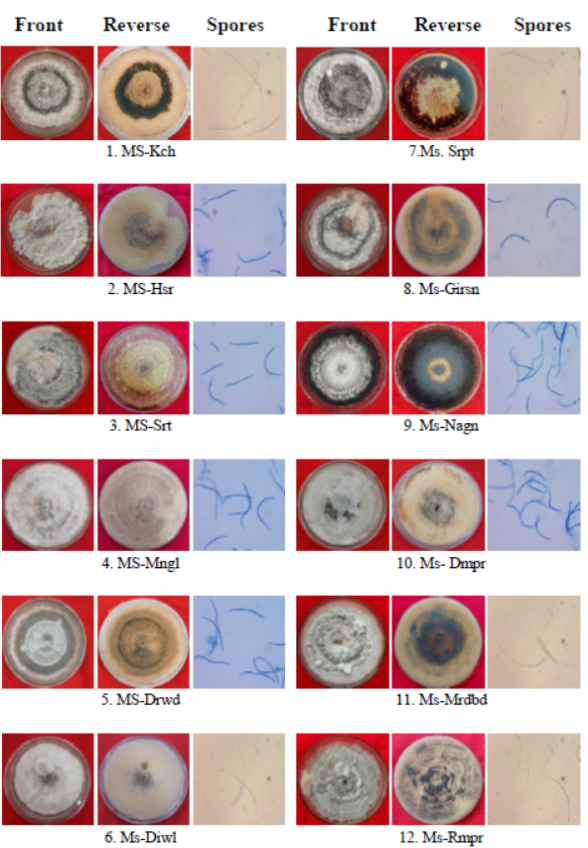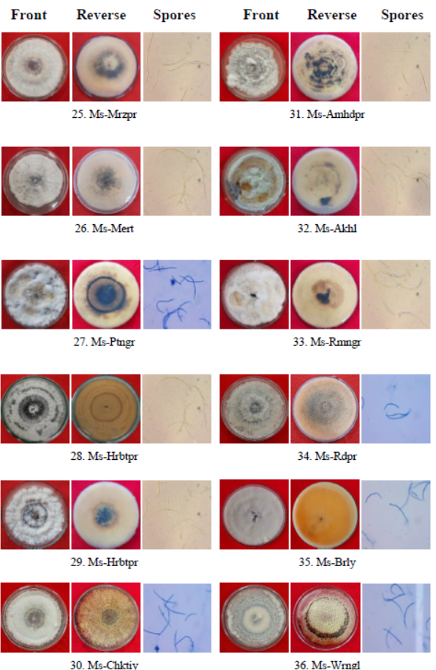
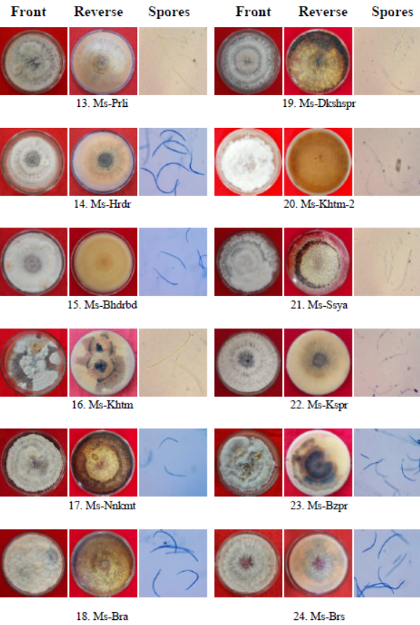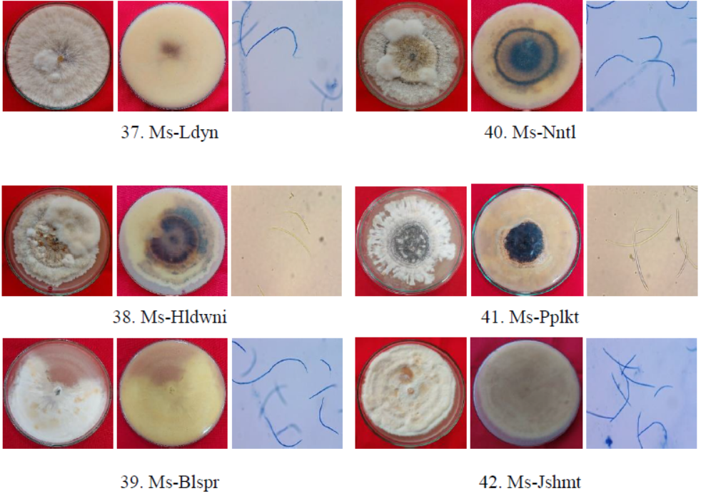

3.4 UPGMA Analysis of Cultural and Morphological Characteristics of M. sorghi Isolates
The cultural and morphological characteristics of the forty-two Microdochium sorghi isolates were subjected to cluster analysis using the Unweighted Pair Group Method with Arithmetic Mean (UPGMA) based on the Jaccard similarity coefficient. The analysis included multiple phenotypic traits, namely colony growth (diameter), colony colour, texture, elevation, margin type, presence of concentric rings, conidial shape and size, and the presence or absence of sclerotia. The resulting dendrogram illustrates the degree of relatedness and phenotypic similarity among the isolates based on these combined characteristics
The dendrogram grouped the forty-two isolates into two major clusters, designated as Cluster I and Cluster II. Cluster I comprised four isolates, namely Ms-Mrdbd, Ms-Brly, Ms-Blspr, and Ms-Jshmt, showing a relatively high similarity range of 81.5–89.0%. In contrast, Cluster II was more heterogeneous and included the remaining thirty-eight isolates, indicating greater diversity within this group.
Cluster II was further subdivided into two subclusters, IIa and IIb, with inter-subcluster similarity ranging from 71.5% to 74.5%. Subcluster IIa consisted of fifteen isolates and was further separated into two groups, IIa1 and IIa2. Among these, IIa2 contained a single isolate, Ms-Akhl, which behaved as an outlier within the cluster. Subcluster IIb comprised twenty-two isolates and exhibited additional internal structuring. Within this group, subcluster IIb1 included five isolates (Ms-Hsr, Ms-Rmpr, Ms-Nnkmt, Ms-Ptngr, and Ms-Rmngr) with similarity values ranging from 79.0% to 88.0%. Subcluster IIb2 was further divided into IIb2a and IIb2b and encompassed a total of twenty-seven isolates, displaying similarity levels between 74.7% and 94.6% (Fig. 1). These results clearly demonstrate considerable phenotypic diversity among the M. sorghi isolates.
Interestingly, the UPGMA clustering pattern did not show a strong association between isolate grouping and geographical origin. Isolates collected from different regions were distributed across multiple clusters and subclusters, indicating that phenotypic variability among M. sorghi isolates is not strictly governed by geographic location. This lack of geographical correlation suggests that factors such as host genotype, microclimatic conditions, cultural practices, and adaptive evolutionary processes may play a more prominent role in shaping the cultural and morphological diversity of M. sorghi. Such findings highlight the complex nature of pathogen variability and emphasize the importance of considering phenotypic diversity when developing disease management and resistance breeding strategies.
Fig 1: UPGMA dendrogram depicting phenotypic clustering of Microdochium sorghi isolates derived from cultural and morphological characteristics
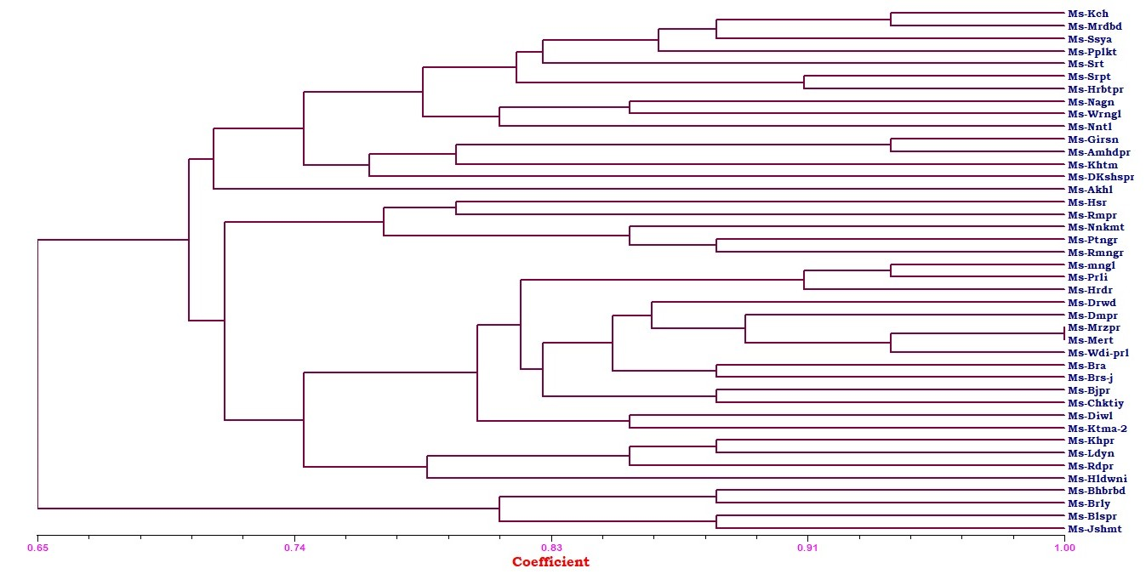
CONCLUSION
The present study clearly demonstrates that Microdochium sorghi, the causal agent of zonate leaf spot of sorghum, exhibits substantial variability in pathogenicity, cultural behavior, and morphological characteristics across different sorghum-growing regions of India. All forty-two isolates were pathogenic, but they differed significantly in disease severity, indicating wide variation in virulence potential. Morpho-cultural characterization revealed marked diversity in colony growth rate, pigmentation, texture, zonation, conidial dimensions, and sclerotial production, reflecting the adaptive nature of the pathogen.
UPGMA-based cluster analysis further confirmed pronounced phenotypic diversity among the isolates, with no clear association between clustering pattern and geographical origin. This suggests that factors such as host genotype, environmental conditions, and evolutionary adaptation play a more decisive role than location in shaping pathogen variability. The absence of geographic structuring emphasizes the potential risk of rapid pathogen adaptation and spread across regions. These findings underline the importance of comprehensive characterization of M. sorghi populations for accurate diagnosis, epidemiological understanding, and formulation of effective disease management strategies. The observed variability should be taken into account in resistance breeding programs and in developing integrated disease management approaches for zonate leaf spot of sorghum. Overall, the study provides valuable insights into the ecological adaptability and phenotypic complexity of M. sorghi, contributing to improved understanding and sustainable management of this economically important disease.

Disclaimer (Artificial intelligence)

Author(s) hereby declare that NO generative AI technologies such as Large Language Models (ChatGPT, COPILOT, etc.) and text-to-image generators have been used during the writing or editing of this manuscript.

REFERENCES
- Anahosur, K. H. 1986. Chemical control of foliar diseases of sorghum. Indian Phytopathol., 39: 526–528.
- Barimani, M., Pethybridge, S. J., Vaghefi, N., Hay, F. S., & Taylor, P. W. J. (2013). A new anthracnose disease of pyrethrum caused by C olletotrichum tanaceti sp. nov. Plant Pathology, 62(6), 1248-1257.
- Braun, U. 1995. A monograph of Cercosporella, Ramularia and allied genera (Phytopathogenic hyphomycetes) Eching: Ihw-Verlag, 1: p. 271.
- Cai, L., Hyde, K. D., Taylor, P. W. J., Weir, B., Waller, J., Abang, M. M. and Shivas, R. G. 2009. A polyphasic approach for studying Colletotrichum. Fungal Diversity, 39(1): 183-204.
- Chium Browning, M., Rowley, L. V., Zeng, P., Chandlee, J. M. and Jackson, N. 1999. Morphological, pathogenic and genetic comparisons of Colletotrichum graminicola isolates from Poaceae. Plant Dis., 83(3): 286-292.
- Das, I. K. and Rajendrakumar, P. 2016. Disease resistance in sorghum. In Biotic stress resistance in millets: pp. 23-67
- Dubey, S. C. 2016. Race profiling, genetic diversity, diagnostics and management of Fusarium oxysporum f.sp. ciceris causing will of chickpea. Indian Phytopathol., 69(3): 210-217.
- Frederiksen, R. A. and Odvody, G. N. 2000. Compendium of Sorghum Diseases, Phytopathology Press., p. 78.
- Jaccard, P. (1908). Nouvelles recherches sur la distribution florale. Bull. Soc. Vaud. Sci. Nat., 44, 223-270.
- Jiang, Y., Xu, J., Hu, L., Liu, K. J., Xu, X. D., Liu, Z. and Meng, W. L. 2018. First report of sorghum zonate leaf spot caused by Gloeocercospora sorghi in China. Plant Dis., 102(5): 1033-1033.
- Linggi, A. (2021). Management of leaf blight of citronella caused by Curvularia andropogonis (Zimm.) Boedijn in Meghalaya (Doctoral dissertation, Central Agricultural University).
- Mengistu, G., Shimelis, H., Laing, M. and Lule, D. 2018. Breeding for anthracnose (Colletotrichum sublineolum Henn.) resistance in sorghum: challenges and opportunities. Aust. J. Crop. Sci., 12: 1911–1920.
- Odvody, G. N. and Madden, D. B. 1984. Leaf sheath blights of Sorghum bicolor caused by Sclerotium rolfsii and Gloeocercospora sorghi in South Texas. Phytopathol., 74:264-268.
- Ogbe, A. A., Gupta, S., Stirk, W. A., Finnie, J. F., & Van Staden, J. (2023). Growth-promoting characteristics of fungal and bacterial endophytes isolated from a drought-tolerant mint species Endostemon obtusifolius (E. Mey. ex Benth.) NE Br. Plants, 12(3), 638.
- Pande, S., Mughogho, L. K., Bandyopadhyay, R. and Karunakar, R. I. 1991. Variation in pathogenicity and cultural characteristics of sorghum isolates of Colletotrichum graminicola in India. Plant Dis., 75(8): 778-783.
- Prom, L. K. and Isakeit, T. 2022. Incidence of Zonate Leaf Spot on Sorghum Accessions Under Disease-Conducive Growing Conditions Burleson County, Texas. Journal of Agriculture and Crops, 8(1): 35-38.
- Rohlf, F. J. (2000). NTSYS-pc: Numerical taxonomy and multivariate analysis system (Version 2.1). Exeter Software, Setauket, NY.
- Sharma, H. L. A. 1983. Technique for identifying and rating resistance to foliar diseases of sorghum under field conditions. Proce. Ind. Acad. Science., 42(2): 278-283.
- Stewart, S., Rodríguez, M., Mattos, N. and Abreo, E. 2019. First Report of Zonate Leaf Spot in Sorghum Caused by Microdochium sorghi in Uruguay. Agrociencia (Uruguay), 23(2): 94-98.
- Thakur, R. P. 2007. Anthracnose in Thakur R., P., Reddy. and B, Mathur K (Eds) Screening Techniques for Sorghum Diseases, ICRISAT. Pantacheru, India, pp53-57.
- Tyagi, S. and Paudel, R. 2014. Effect of different pH on the growth and sporulation of Fusarium oxysporum: the causal organism of wilt disease of tomato. Int. J. Basic and Appl Biology., 2(1): 103-106.
- Von Arx JA. 1987. Plant pathogenic fungi. Nova Hedwigia 87: 1–288.
- Wang, M. L., Dean, R., Erpelding, J. and Pederson, G. 2006. Molecular genetic evaluation of sorghum germplasm differing in response to fungal diseases: rust (Puccinia purpurea) and anthracnose (Collectotrichum graminicola). Euphytica., 148: 319-330.
- White, T. J., Bruns, T., Lee, S., & Taylor, J. (1990). Amplification and direct sequencing of fungal ribosomal RNA genes for phylogenetics. In M. A. Innis, D. H. Gelfand, J. J. Sninsky, & T. J. White (Eds.), PCR protocols: A guide to methods and applications (pp. 315–322). Academic Press.
- Yadav, R. S., Tyagi, S., Javeria, S. and Gangwar, R. K. 2014. Effect of different cultural condition on the growth of Fusarium moniliforme causing bakanae disease. Europ. J. Molecular Biotech., 4(2): 95-100.

