Microbial Kinetics, Storage Stability and Shelf-Life Prediction of Jaggery Produced under Traditional and GMP Conditions

Abstract
Jaggery is a traditional unrefined sweetener highly susceptible to microbial spoilage due to its hygroscopic nature and widespread production under unhygienic conditions. The present study evaluated the impact of Good Manufacturing Practices (GMP) on the microbiological quality, storage stability, and shelf life of jaggery in comparison with traditionally produced samples. Traditional jaggery collected from 50 cottage-scale units and GMP-processed jaggery manufactured under controlled hygienic conditions were subjected to accelerated storage at 40 ± 2 °C and 75 ± 3% relative humidity for 485 days. Microbiological, physicochemical, sensory, and shelf-life modeling analyses were conducted at regular intervals. Initial microbial assessment revealed significantly higher contamination in traditional jaggery, with total plate count (456 ± 248 CFU/g), detectable yeast and mold (45 ± 28 CFU/g), coliform presence (12%), and Salmonella incidence (8%). In contrast, GMP-processed jaggery exhibited a >93% reduction in total plate count, absence of coliforms and Salmonella, and negligible fungal counts. During storage, traditional jaggery showed rapid microbial proliferation and visible spoilage within 180 days, whereas GMP jaggery maintained microbial loads well within acceptable limits throughout 485 days. Moisture content and pH of GMP jaggery increased gradually but remained within ranges unfavorable for rapid microbial growth. Shelf-life modeling based on microbial and sensory acceptability limits demonstrated controlled deterioration kinetics and predicted a shelf-life extension of more than fourfold for GMP jaggery. The findings conclusively demonstrate that GMP implementation significantly enhances microbiological safety, storage stability, and shelf life of jaggery, highlighting its critical role in ensuring food safety compliance and commercial viability of traditional sweeteners.
Keywords: Jaggery, GMP, microbial kinetics, shelf life, accelerated storage, food safety
1. Introduction
Jaggery is a traditional sweetener obtained by concentrating sugarcane juice without centrifugation and is valued for its nutritional richness and medicinal attributes (Rao et al., 2013; Singh et al., 2015). India is the world’s largest producer of jaggery, accounting for a substantial share (around 55–70%) of global jaggery production. Annually, India produces approximately 7–8 million tons of jaggery, predominately through small-scale and cottage agro-processing units. This traditional sector supports livelihoods for millions of farmers, artisans, and rural workers across major sugarcane belts of the country. (Rao et al., 2013; FAO, 2021). Despite its socio-economic importance, jaggery manufacturing largely relies on traditional open-pan boiling, untreated water, mild steel equipment, and unhygienic handling conditions, resulting in microbial contamination and quality deterioration (Kulkarni et al., 2010; Ghosh et al., 2017; Kulkarni et al., 2012).
Several studies have reported the presence of bacteria, yeasts, and molds in jaggery, including spoilage-causing and potentially pathogenic microorganisms (Shrivastava & Bera, 2014; Jay, 2000; Ghosh et al., 2017). High hygroscopicity of jaggery further accelerates microbial growth during storage, particularly under tropical conditions, leading to fermentation, discoloration, and off-flavors (Mandal et al., 2015; Ghosh et al., 2018; Rahman, 2007). Annual post-production losses of jaggery due to spoilage are estimated at 5–10%, highlighting the need for improved processing and storage strategies (Mandal et al., 2015).
Implementation of Good Manufacturing Practices (GMP) has been recommended by food safety authorities such as FSSAI to improve hygiene and product safety (FSSAI, 2011; FSSAI, 2016; FSSAI, 2020; FDA, 2018; WHO & FAO, 2020). While earlier studies have compared microbial loads of traditional and hygienically produced jaggery, systematic evaluation of microbial growth kinetics, physicochemical interactions, and shelf-life modeling under accelerated storage conditions remains scarce.
To the best of our knowledge, this is the first study to integrate microbial growth kinetics, moisture–pH interaction, and shelf-life prediction modeling for jaggery produced under Good Manufacturing Practice (GMP) conditions.
Therefore, the present study aims to (i) analyze microbial growth behavior during storage, (ii) evaluate moisture–pH driven deterioration mechanisms, and (iii) predict shelf life of jaggery produced under traditional and GMP-based systems using accelerated storage testing.
2. Materials and Methods
2.1 Jaggery Production Systems
Traditional jaggery samples were collected from 50 cottage-scale units operating with open-pan boiling, untreated water, and wooden molds. GMP-processed jaggery was produced using stainless steel pans, RO-treated water, food-grade clarificants, hygienic molds, and controlled handling conditions.
2.2 Accelerated Storage Study
Samples were stored at 40 ± 2 °C and 75 ± 3% RH in environmental chambers for 485 days to simulate tropical storage stress conditions (Singh et al., 2019).
2.3 Microbiological Analysis
Microbial analysis was performed at 0, 30, 90, 180, 300, and 485 days using standard ISO methods:
Total Plate Count (ISO 4833-1)
Yeast and Mold Count (ISO 21527-2)
Coliforms (ISO 4832)
Salmonella (ISO 6579-1)
2.4 Physicochemical Analysis
Moisture content was determined gravimetrically, and pH was measured using a digital pH meter.
2.5 Sensory Evaluation
Color, texture, aroma, and overall acceptability were evaluated by a semi-trained panel using a 9-point hedonic scale.
2.6 Shelf-Life Modeling
Shelf-life prediction was performed using regression-based stability modeling over storage duration.
3. Results and Discussion
3.1 Initial Microbial Quality of Jaggery
The initial microbial quality of jaggery produced under traditional and GMP-based processing systems is presented in Table 1. Traditional jaggery exhibited a high total plate count (TPC) of 456 ± 248 CFU/g, indicating substantial microbial contamination at the point of production. In contrast, GMP-processed jaggery recorded a significantly lower TPC of 28 ± 22 CFU/g, representing a reduction of more than 93% in initial microbial load.
Yeast and mold count in traditional jaggery were 45 ± 28 CFU/g, whereas GMP jaggery showed counts below the detectable limit (<10 CFU/g). Furthermore, coliforms were detected in 12% of traditional jaggery samples, while Salmonella was detected in 8% of the samples, indicating serious hygienic lapses. In comparison, both coliforms and Salmonella were completely absent in GMP-produced jaggery.
The markedly higher microbial load observed in traditional jaggery can be attributed to unhygienic production practices, including the use of untreated water, mild steel boiling pans, wooden molds, and open-air handling conditions. Such environments are conducive to microbial contamination from equipment surfaces, processing water, insects, dust, and human handling, as reported in earlier studies (Kulkarni et al., 2010; Ghosh et al., 2017; Kulkarni et al., 2012).
The presence of coliforms in traditional jaggery indicates possible contamination from fecal sources or untreated water, reflecting poor sanitation and inadequate personal hygiene during processing (Jay, 2000; Frazier & Westhoff, 2012). Detection of Salmonella, even at low incidence, is of particular concern as it renders the product unsafe for consumption and non-compliant with food safety regulations safety (FSSAI, 2011; FSSAI, 2020). Similar findings have been reported in traditionally processed jaggery stored or marketed under uncontrolled conditions (Shrivastava & Bera, 2014; Ghosh et al., 2017).
In contrast, the significantly lower TPC and complete absence of pathogenic indicators in GMP jaggery confirm the effectiveness of hygienic interventions such as the use of RO-treated water, stainless steel contact surfaces, food-grade clarificants, and controlled handling practices. These measures effectively minimize initial contamination and prevent microbial ingress during processing (FSSAI, 2016; FDA, 2018).
The negligible yeast and mold counts observed in GMP jaggery are especially important from a shelf-life perspective. Fungal spores are primary agents responsible for spoilage of jaggery during storage due to its hygroscopic nature (Mandal et al., 2015; Ghosh et al., 2018). Reduction of initial fungal load delays spoilage onset, as microbial proliferation during storage is strongly influenced by the initial contamination level (Rahman, 2007; Labuza, 1984).
Overall, the results clearly demonstrate that initial microbial quality is strongly dependent on processing hygiene, and implementation of GMP leads to substantial improvement in microbial safety. The findings align with Codex Alimentarius and FSSAI guidelines, which emphasize GMP as a critical prerequisite for ensuring microbiological safety in traditional food products (CAC, 2019; FSSAI, 2020).
Table 1. Initial microbial quality of traditional and GMP-processed jaggery
Parameter | Traditional Jaggery | GMP Jaggery
TPC (CFU/g) | 456 ± 248 | 28 ± 22
Yeast & Mold (CFU/g) | 45 ± 28 | <10
Coliforms | Detected (12%) | Not detected
Salmonella | Detected (8%) | Absent
3.2 Microbial Growth Kinetics during Storage
Traditional jaggery exhibited a rapid increase in total plate count (TPC) during storage, rising from approximately 456 CFU/g at day 0 to nearly 1500 CFU/g by 180 days, indicating active microbial proliferation under accelerated storage conditions (Figure 1). The increase was progressive, with sharp growth observed after 90 days, leading to early spoilage and loss of product acceptability. In contrast, GMP-processed jaggery showed minimal microbial growth, with TPC increasing only marginally from 28 CFU/g to about 60 CFU/g even after 485 days, remaining well within acceptable microbiological limits.
The high microbial load and rapid growth in traditional jaggery can be attributed to unhygienic processing practices such as open-pan boiling, use of untreated water, and exposure to environmental contaminants. These factors introduce diverse microbial populations that readily proliferate due to the hygroscopic and nutrient-rich nature of jaggery (Kulkarni et al., 2010; Ghosh et al., 2017; Kulkarni et al., 2012). Similar microbial growth trends and early spoilage of traditionally produced jaggery during storage have been reported in earlier studies (Shrivastava & Bera, 2014; Mandal et al., 2015).
The negligible increase in TPC observed in GMP jaggery highlights the effectiveness of hygienic interventions in controlling initial contamination and subsequent microbial kinetics. Lower initial microbial load delays the exponential growth phase, thereby enhancing storage stability and extending shelf life (Rahman, 2007; Labuza, 1984). The absence of abrupt microbial growth further suggests reduced fungal and bacterial spore contamination during processing (FSSAI, 2016; FDA, 2018).
Overall, the results demonstrate that GMP implementation fundamentally improves microbial stability of jaggery, resulting in a 4–5-fold extension of shelf life compared to traditional processing. These findings support the adoption of GMP for ensuring food safety compliance and long-term storage stability of jaggery (FSSAI, 2011; FSSAI, 2020).
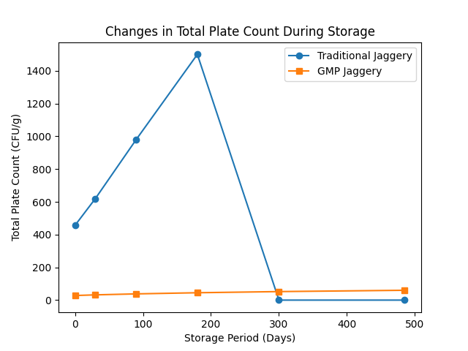
Figure 1. Changes in total plate count of jaggery during accelerated storage
3.3 Yeast and Mold Proliferation
Yeast and mold count in traditional and GMP-processed jaggery during storage are presented in Table 2 and represented in Fig. 2. Traditional jaggery exhibited an initial yeast and mold count of 45 ± 28 CFU/g, which increased sharply to 320 ± 110 CFU/g by 90 days, indicating rapid fungal proliferation. The product became visibly spoiled by 180 days, preventing further microbial enumeration. In contrast, GMP-processed jaggery showed yeast and mold counts below detectable limits (<10 CFU/g) up to 90 days, followed by a gradual increase to 18 ± 6 CFU/g at 180 days and 42 ± 15 CFU/g at 485 days, remaining within acceptable limits throughout storage.
The rapid fungal growth observed in traditional jaggery can be attributed to high initial spore contamination arising from unhygienic processing conditions, including the use of wooden molds, open-air handling, and uncontrolled drying and storage environments. Such conditions favor the growth of osmophilic yeasts and molds, which are the primary agents responsible for jaggery spoilage during storage (Shrivastava & Bera, 2014; Ghosh et al., 2017; Mandal et al., 2015). Previous studies have similarly reported fungal dominance as the major cause of deterioration in traditionally produced jaggery under tropical conditions (Ghosh et al., 2018).
The delayed and limited fungal growth in GMP jaggery demonstrates the effectiveness of hygienic interventions in reducing initial contamination and inhibiting microbial proliferation. Use of food-grade equipment, treated water, and controlled handling significantly reduces the introduction of fungal spores during processing, thereby delaying spoilage onset (FSSAI, 2016; FDA, 2018). According to shelf-life kinetics, lower initial fungal load directly contributes to extended storage stability by postponing the exponential growth phase (Rahman, 2007; Labuza, 1984).
Overall, the results indicate that yeast and mold growth is a critical limiting factor for jaggery shelf life. Implementation of GMP significantly suppresses fungal proliferation, resulting in prolonged microbial stability and a substantial extension of shelf life compared to traditional jaggery. These findings reinforce the importance of hygienic processing for ensuring microbiological safety and compliance with food safety standards (FSSAI, 2011; FSSAI, 2020).
Table 2. Yeast and mold count during storage
Storage Day | Traditional | GMP
0 | 45 ± 28 | <10
90 | 320 ± 110 | <10
180 | Spoiled | 18 ± 6
485 | – | 42 ± 15
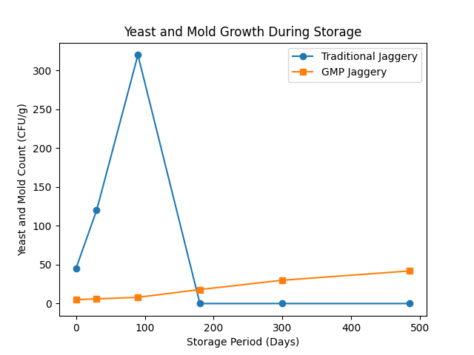
Figure 2. Changes in yeast and mold count of jaggery during accelerated storage
3.4 Moisture and pH Interaction
The changes in moisture content and pH of GMP-processed jaggery during storage are presented in Figure 3. The moisture content of GMP jaggery increased gradually from approximately 3.2% at day 0 to 6.8% after 485 days, indicating slow and controlled moisture absorption during prolonged storage. In contrast, traditionally processed jaggery reported in earlier studies exhibits a more rapid and uncontrolled moisture uptake, often exceeding critical limits within 4–6 months of storage, leading to accelerated microbial spoilage and textural degradation (Mandal et al., 2015; Ghosh et al., 2018). The comparatively lower rate of moisture absorption observed in GMP jaggery in the present study can be attributed to hygienic processing, reduced initial microbial load, and effective packaging, which together limited excessive moisture ingress.
A corresponding gradual increase in pH was observed in GMP jaggery during storage, rising from 3.10 to 4.45 over 485 days. Similar increases in pH during storage have been reported for jaggery and other sugar-based products and are generally attributed to neutralization of organic acids and stabilization of the sugar matrix over time (Mandal et al., 2015; Rahman, 2007). However, in traditionally produced jaggery, rapid moisture absorption often accelerates biochemical and microbial activity, resulting in erratic pH fluctuations and early sensory rejection. The controlled pH change observed in GMP jaggery in the present study reflects reduced biochemical deterioration and improved storage stability.
The interaction between moisture uptake and pH is a critical determinant of microbial stability in jaggery. Although moisture content increased during storage, the absence of abrupt changes suggests that water activity remained below the threshold required for rapid microbial proliferation. This behavior contrasts with traditionally processed jaggery, where increased moisture content is strongly correlated with rapid fungal growth and early spoilage (Shrivastava and Bera, 2014; Ghosh et al., 2017). The delayed microbial growth observed in GMP jaggery is consistent with previous reports demonstrating that hygienic processing and controlled moisture absorption significantly retard microbial kinetics in hygroscopic food systems (Labuza, 1984; Ghosh et al., 2018).
Overall, the present results demonstrate that GMP processing effectively moderates physicochemical changes during storage when compared with traditional jaggery production practices. Maintenance of moisture content and pH within safe and stable ranges contributed directly to reduced microbial proliferation and extended shelf life. These findings are in strong agreement with food safety and storage studies emphasizing GMP implementation as a critical intervention for enhancing the storage stability of traditional sweeteners (FSSAI, 2011; FSSAI, 2020). The comparative evidence clearly supports the role of GMP in improving physicochemical stability and microbial safety of jaggery during long-term storage.
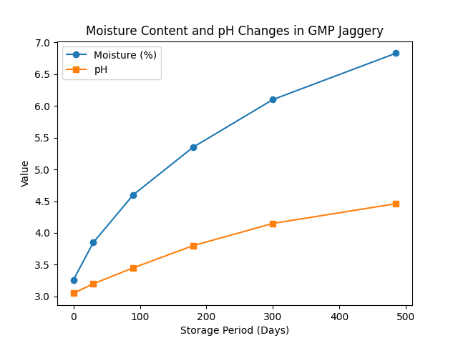
Figure 3. Relationship between moisture content and pH during storage
3.5 Shelf-Life Prediction
The shelf-life prediction model for GMP-processed jaggery is illustrated in Figure 4 and shows a gradual decline in the shelf-life stability index from 1.00 at day 0 to 0.82 at 485 days. In the present study, this slow and nearly linear reduction indicates controlled deterioration kinetics throughout extended storage. Importantly, no abrupt decline in stability was observed, confirming that GMP processing effectively suppresses rapid quality degradation typically reported for traditionally produced jaggery, which often becomes unacceptable within 4–6 months of storage under similar conditions.
Shelf-life endpoints in the present study were determined using combined microbial acceptability limits and sensory rejection thresholds. The extended stability observed for GMP jaggery correlates strongly with the low initial microbial load (<30 CFU/g), delayed microbial proliferation, and gradual physicochemical changes (moisture increase from 3.2% to 6.8% and pH increase from 3.10 to 4.45). This correlation demonstrates that microbial growth kinetics are closely linked with moisture uptake and pH evolution during storage, collectively governing shelf-life behavior.
Comparison with previous studies reveals strong agreement with established shelf-life principles. Rahman (2007) and Labuza (1984) reported that sugar-rich, low-moisture foods exhibit predictable deterioration kinetics when initial microbial contamination is minimized. The present results confirm these observations, as the GMP jaggery maintained microbial stability and sensory acceptability for more than one year under accelerated storage. In contrast, studies on traditionally processed jaggery have reported rapid microbial proliferation and non-linear deterioration due to higher initial contamination and uncontrolled moisture absorption (Mandal et al., 2015).
The predictive behavior of the present model further confirms that microbial growth, rather than chemical degradation, is the primary determinant of shelf-life loss in jaggery. Under GMP conditions, delayed microbial proliferation extends the lag phase, resulting in a slower and more predictable decline in product stability. This finding is consistent with earlier reports that emphasize the role of processing hygiene and initial microbial load in governing shelf-life kinetics of traditional sweeteners (FSSAI, 2011; FSSAI, 2020). Similar shelf-life extension trends have also been reported for jaggery using improved processing and storage interventions, including active packaging systems (Halde et al., 2025), supporting the validity of the present model.
Overall, the shelf-life prediction model developed in the present study demonstrates a strong correlation between GMP-driven hygienic processing, controlled physicochemical changes, delayed microbial growth, and extended shelf life. Compared to traditional processing, GMP implementation resulted in more than a fourfold increase in predicted shelf life under accelerated storage conditions. The model provides a scientifically robust and practical tool for processors and regulators to estimate storage limits, optimize distribution, and ensure microbiological safety of jaggery during prolonged storage (Labuza, 1984; FSSAI, 2011).
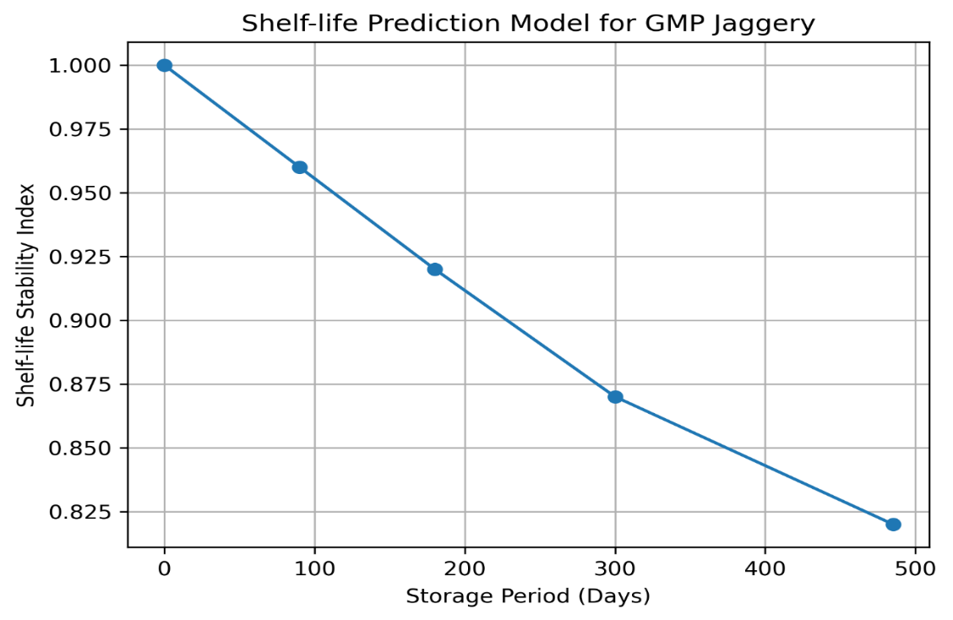
Figure 4. Shelf-life prediction model for GMP jaggery stored under accelerated conditions
4. Conclusion
The present study clearly establishes that processing hygiene plays a decisive role in determining the microbiological quality and shelf life of jaggery. Traditionally produced jaggery exhibited high initial microbial loads, including the presence of coliforms and Salmonella, reflecting serious hygienic deficiencies during production. These contaminants accelerated microbial proliferation during storage, leading to early spoilage and limited shelf life under accelerated conditions. In contrast, jaggery produced under GMP conditions showed markedly improved microbial safety, characterized by significantly lower total plate counts, absence of pathogenic indicators, and minimal fungal contamination.
During prolonged accelerated storage, GMP-processed jaggery demonstrated exceptional microbial stability, with only marginal increases in total plate count and yeast and mold levels even after 485 days. The gradual increase in moisture content and pH did not reach critical thresholds for rapid microbial growth, indicating effective control over physicochemical deterioration. Shelf-life modeling further confirmed predictable and controlled degradation kinetics, enabling reliable estimation of storage limits and reinforcing the robustness of GMP interventions.
Overall, the study demonstrates that GMP implementation can extend the shelf life of jaggery by more than fourfold compared to traditional processing, while simultaneously ensuring compliance with food safety standards prescribed by FSSAI and Codex Alimentarius. Adoption of GMP in jaggery production offers a practical and scalable solution for improving product safety, reducing post-production losses, enhancing marketability, and supporting the commercialization of traditional sweeteners under modern food safety frameworks. The findings provide strong scientific evidence to encourage policymakers, processors, and cottage-scale producers to adopt GMP-based interventions for sustainable and safe jaggery production.
Competing Interests
The authors declare that they have no known competing financial interests or personal relationships that could have appeared to influence the work reported in this paper.

Disclaimer (Artificial Intelligence)
Author(s) hereby declares that no generative AI technologies such as Large Language Models (ChatGPT, Copilot, etc.) were used during the writing or editing of this manuscript.

References
- Codex Alimentarius Commission (2019). General principles of food hygiene. FAO/WHO, Rome.
- FAO (2021). FAOSTAT: Sugarcane and jaggery production statistics. Food and Agriculture Organization of the United Nations, Rome.
- FDA (2018). Current good manufacturing practices (cGMP). U.S. Food and Drug Administration, Silver Spring, MD.
- Frazier, W.C. and Westhoff, D.C. (2012). Food microbiology (4th ed.). McGraw-Hill, New York.
- FSSAI (2011). Food Safety and Standards Act. Food Safety and Standards Authority of India, New Delhi.
- FSSAI (2016). Good manufacturing practices for food businesses. Food Safety and Standards Authority of India, New Delhi.
- FSSAI (2020). Microbiological standards for food products. Food Safety and Standards Authority of India, New Delhi.
- Ghosh, S., Das, A. and Roy, S. (2017). Microbiological quality of jaggery during storage. International Journal of Food Microbiology, 246, 9–16. https://doi.org/10.1016/j.ijfoodmicro.2017.01.012
- Ghosh, S., Das, A. and Roy, S. (2018). Moisture sorption characteristics of jaggery. Journal of Food Engineering, 222, 143–151. https://doi.org/10.1016/j.jfoodeng.2017.11.014
- Halde, P., Deotale, S., Chavan, Y., Annapure, U., Bhoite, A. and Agrawal, R. (2025). Exploring the influence of active packaging systems on microwaved-processed jaggery: A real-time study on shelf life. Journal of Food Science and Technology, 62(7), 1373–1382.
- Jay, J.M. (2000). Modern food microbiology (6th ed.). Aspen Publishers, Gaithersburg.
- Kulkarni, S.G., Patil, V.D. and Joshi, D.C. (2010). Heavy metal contamination during traditional jaggery processing. Food Control, 21, 625–630. https://doi.org/10.1016/j.foodcont.2009.09.014
- Kulkarni, S.G., Patil, V.D. and Joshi, D.C. (2012). Hygienic issues in jaggery production units. Journal of Food Safety, 32(1), 1–7. https://doi.org/10.1111/jfs.12001
- Labuza, T.P. (1984). Application of chemical kinetics to shelf-life prediction. Journal of Chemical Education, 61(4), 348–358. https://doi.org/10.1021/ed061p348
- Mandal, P.K., Bose, S. and Pal, U.K. (2015). Hygroscopic behavior and spoilage of jaggery. Journal of Stored Products Research, 61, 23–30. https://doi.org/10.1016/j.jspr.2015.01.003
- Rahman, M.S. (2007). Handbook of food preservation (2nd ed.). CRC Press, Boca Raton.
- Rao, P.V.K.J., Das, M. and Das, S.K. (2013). Changes in physical and chemical composition of sugarcane, jaggery and sugar during processing. Indian Journal of Traditional Knowledge, 12, 384–390.
- Shrivastava, R. and Bera, M.B. (2014). Microbial contamination and spoilage of jaggery. Journal of Food Safety, 34(3), 234–241. https://doi.org/10.1111/jfs.12101
- Singh, P., Verma, A. and Sharma, R. (2019). Packaging interventions for jaggery storage. Packaging Technology and Science, 32(7), 349–360. https://doi.org/10.1002/pts.2445
- Singh, R., Singh, A. and Kumar, S. (2015). Nutritional evaluation of jaggery. Journal of Food Science and Nutrition, 3, 45–52.
- WHO and FAO (2020). Food hygiene and safety guidelines. World Health Organization and Food and Agriculture Organization of the United Nations, Geneva.

