AI-Enabled Wi-Fi Operated Robotic Weeder for Precision Weed Management

.
ABSTRACT

This study aimed to design, develop, and evaluate a dual-operated AI-based Wi-Fi weeder for precision weed management in small and medium-scale farms. The weeder was equipped with a Raspberry Pi microcontroller and a camera module to detect crops and weeds in real-time, enabling autonomous operation. Laboratory tests evaluated Wi-Fi connectivity, which was effective up to 50 m, and battery/motor performance, while field trials assessed weeding efficiency, field efficiency, useful work coefficient, time/energy ratio, and economic performance. The weeder achieved a weeding efficiency of 98.07% and a field efficiency of 59.68%, with a useful work coefficient of 84.5% and a time/energy ratio of 72.1%, indicating high productivity and efficient energy use. Economic analysis showed an average profit gain of ₹68.5 per hour, demonstrating cost-effectiveness for small and medium-scale farmers. The results indicate that the AI-based Wi-Fi weeder is an effective, energy-efficient, and economically viable solution for automated weed control, reducing labor dependency and minimizing crop damage. Its performance highlights the potential for precision agriculture applications, and future improvements in navigation and AI detection are expected to further enhance efficiency and adaptability.

Keywords: Artificial Intelligence, AI-Based Weeder, Precision Weed Management, Agricultural Robotics, Raspberry Pi, Field Efficiency, Smart Agriculture

1. INTRODUCTION

Weeds are among the most persistent challenges in agricultural systems because they compete with crops for essential resources such as water, nutrients, sunlight, and space, often leading to substantial yield losses and reduced crop quality (Naruhn & Butz, 2021). Traditional weed control methods, such as broadcast herbicide application and manual removal, are often inefficient, costly, and environmentally harmful (Oerke, 2006). Precision weed management has emerged as a promising solution by applying treatments only where needed, improving control efficiency and reducing chemical use (Sangaraju, 2025).
Recent advances in machine vision and deep learning have accelerated the development of smart weeding systems capable of detecting and classifying weeds under real field conditions (Vijayakumar et al., 2025). Convolutional neural network (CNN) models and vision transformer approaches have achieved high accuracy in distinguishing crops from weeds and can be deployed on embedded platforms for real-time operation (Islam et al., 2025; Mamatha & Santhosh Reddy, 2025). Hybrid deep learning frameworks combining CNNs, vision transformers, and augmentation techniques have also demonstrated superior performance in weed detection with accuracy exceeding 99% on benchmark datasets, indicating their potential for automated edge deployment in precision agriculture (Pandiyaraju et al., 2025; Amer et al., 2015).
Field-level robotic spot spraying and autonomous weed control systems further illustrate the practical benefits of integrating deep learning with robotic actuation. Robot-based spot spraying has shown significant reductions in herbicide use while maintaining weed control efficacy comparable to conventional methods (Azghadi et al., 2024; (Yaseen & Long, 2024)). Transfer learning and optimization-based weed recognition models have also been proposed to improve detection and classification performance in varied agricultural environments (Gopalakrishnan et al., 2025).
Climate change has intensified challenges in weed management by altering temperature, rainfall patterns, and CO₂ concentrations, which in turn affect weed growth, emergence, and competitiveness (Jaikumar et al., 2024). Rising temperatures and irregular precipitation increase weed proliferation, shift weed species composition, and extend growing seasons, often giving weeds a competitive advantage over crops (Ziska & Dukes, 2014; Chauhan et al., 2023). These environmental changes make conventional weed control strategies less effective and increase the need for adaptive, precision-based approaches such as AI-powered robotic weeders that can operate under varying climate conditions (Sharma et al., 2023). Incorporating climate resilience into weeding technology is therefore essential for sustaining crop yields and ensuring efficient weed management in changing agricultural landscapes.
Despite these advances, many existing systems remain cost-intensive or lack adaptability across diverse crop types and field conditions. Small-scale farmers often cannot afford commercial robotic weeders, and challenges such as false positives in weed identification, sensitivity to lighting changes, and limited field coverage hinder widespread adoption.
To address these limitations, this study presents the design, development, and performance evaluation of a dual-operated AI-based Wi-Fi controlled robotic weeder equipped with a Raspberry Pi microcontroller for precision weed management. The goal is to provide an economical, robust automated weeding solution that achieves high accuracy and field efficiency while reducing labour dependency in small and medium-scale farming.

2. material and methods

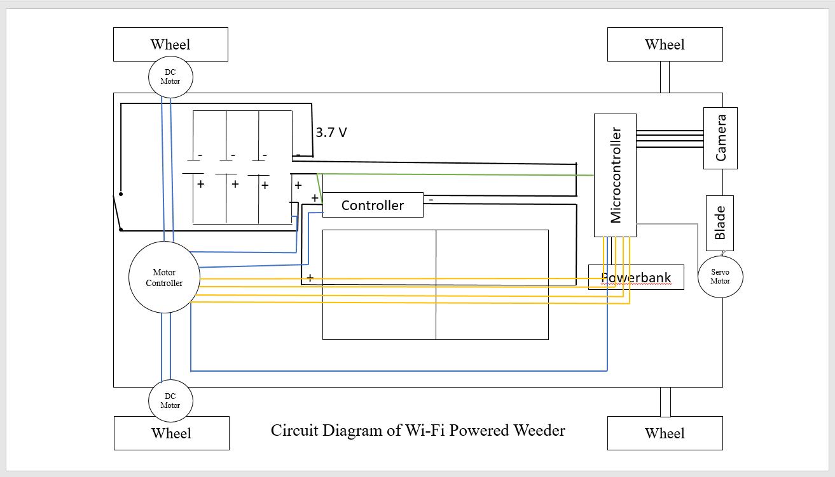
The project began with a hard board, which was already according to our requirements. The components were connected in two main systems: the power system, for charging and distribution, and the control system for movement and operation. Then, we connected 4 wheels of diameter of 7 cm and weight 70 grams. These wheels were picked as they‘ll give the machine the necessary traction while not bearing too much load onto the soil. We then connected a DC Motor to the wheels to provide the required speed of 0.22m/s. Then, we installed the Raspberry Pi and DC Motor Driver onto the chassis. We powered the Raspberry Pi microcontroller through the power bank. We connected the Raspberry Pi s GPIO (General Purpose Input/Output) pins to the input pins of the DC motor driver using wires. The Raspberry Pi will send control signals (such as speed and digital signals) to the motor driver through these wires. Then, we connected the terminals of the motor driver directly to the DC metal gear motors which were already attached to the wheels, using wires. The motor driver provides 5V power from the battery to run the motors according to Pi’s commands. The Pi camera module was placed at an angle of to the ground, at the front of the machine. This angle was used to provide a better visual access to the camera. Then, we connected the Pi camera module to the Raspberry Pi's CSI (Camera Serial Interface) port via its ribbon cable. We used a 12V DC battery as the primary power source to power the DC motor driver and the DC motors. A main switch was wired in series with the battery output to turn the entire weeder’s power on or off. Then, we connected the solar panels to be used as an alternative, sustainable source of power. Lastly, we connected the blade like an arm at the foremost part of the weeder, beside the camera.

Fig. 1 Circuit Diagram of AI Powered Weeder
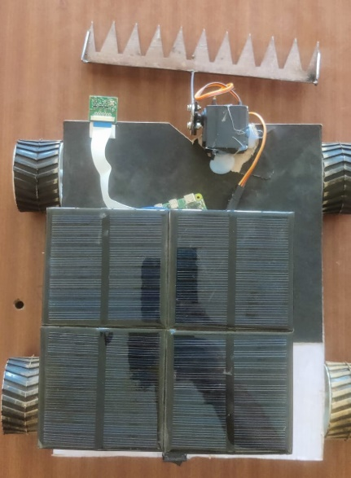
The weeder can be used to weed both row crops, and open fields. The data set used for the row crop is that of a tomato plant (Solanum lycopersicum). Python was the programming language chosen to write the code. As the weeder moves forward, the Raspberry Pi microcontroller sends signals to the connected camera module to continuously scan the surroundings for weeds and crop. Once it detects a weed, the blade is lowered and pushed into the ground right below the weed, and the weed is lifted, along with its roots, and discarded. When a crop is detected, the blade is raised to avoid damage to the crops, and the machine moves backward till it detects another weed. In case of an open field, no initial data needs to be fed. The weeder weeds though all the weeds present in the field.
Wheel
Raspberry Pi Camera Module
Hardboard
Solar Panel
Servo Motor
Blade
Fig. (a)

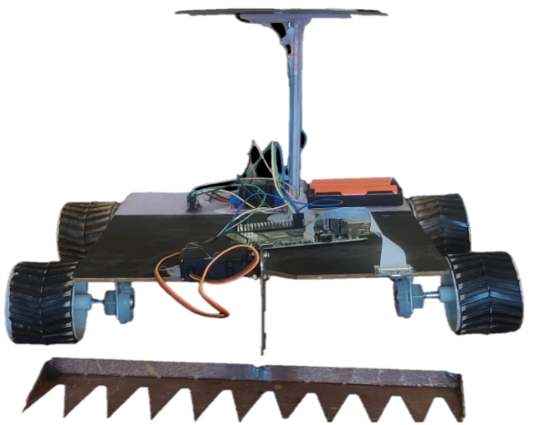
Connecting wires
Battery
Raspberry Pi Microcontroller
DC Gear Motor
Blade Arm
Fig. (b)

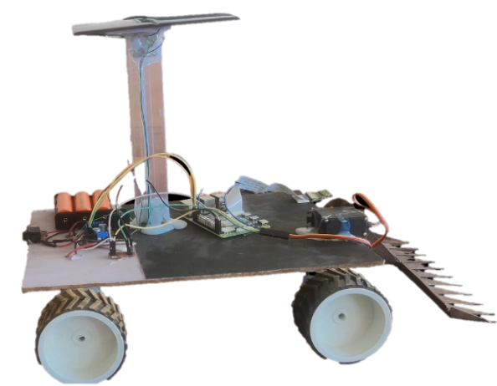
Switch
Motor Driver

Fig. (c)

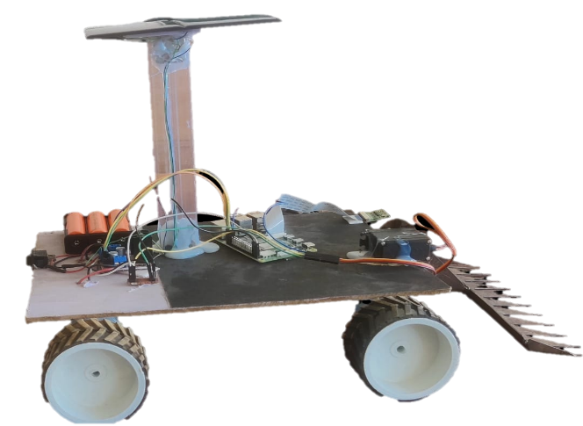
Fig. 2 Developed Wi-Fi Operated Weeder ((a). Top View (b). Front View and
Fig. (c)
Switch
Motor Driver
(c). Side View)

3. results and discussion

The developed AI-based Wi-Fi operated weeder was evaluated through a series of laboratory and field tests to assess its performance in weed management. Table 1 summarizes the key parameters obtained from three independent trials (T1, T2, and T3).
Laboratory Tests
- Wi-Fi Range Test:
The Wi-Fi module maintained a stable connection up to a maximum range of 50 meters under open field conditions. Tests conducted in environments with obstacles showed slight signal degradation but maintained functional connectivity, confirming reliable remote operation within typical field sizes.
- Battery and Motor Test:
The power system consisted of three 3.7 V lead acid rechargeable batteries connected in parallel, fully charged prior to testing. Continuous operation for one hour showed consistent voltage levels with minor reductions indicating stable battery performance. Motor functions, including lifting and lowering the blade arm, synchronized accurately with image recognition by the Pi camera. The blade actuation was powered by a 3.89 Ah lithium-ion battery, ensuring smooth operation during weeding cycles.
Field Tests
Performance evaluation was based on the following parameters:
a. Weeding efficiency:
The weeding efficiency was calculated as a percentage representing the ratio of weeds removed to the initial number of weeds.
W.E (%) = (W₁-W₂) / W₁×100

Where;
W₁ is the number of weeds per unit area before weeding
W₂ is the number of weeds per unit area after weeding.
b. Field efficiency:
Field Efficiency is the ratio of effective field capacity by theoretical field capacity expressed in percent.
$$Field efficiency \left(\%\right):\frac{Avg. Effective field capacity }{ Avg. Theoritical field capacity}×100$$
a. Effective field capacity (C):
Effective Field Capacity is defined as the actual area covered by the implement, based on its total time consumed and its width.
$$Effective Field Capacity (C):\frac{Area Covered }{ Actual Time Taken}$$
b. Theoretical field capacity:

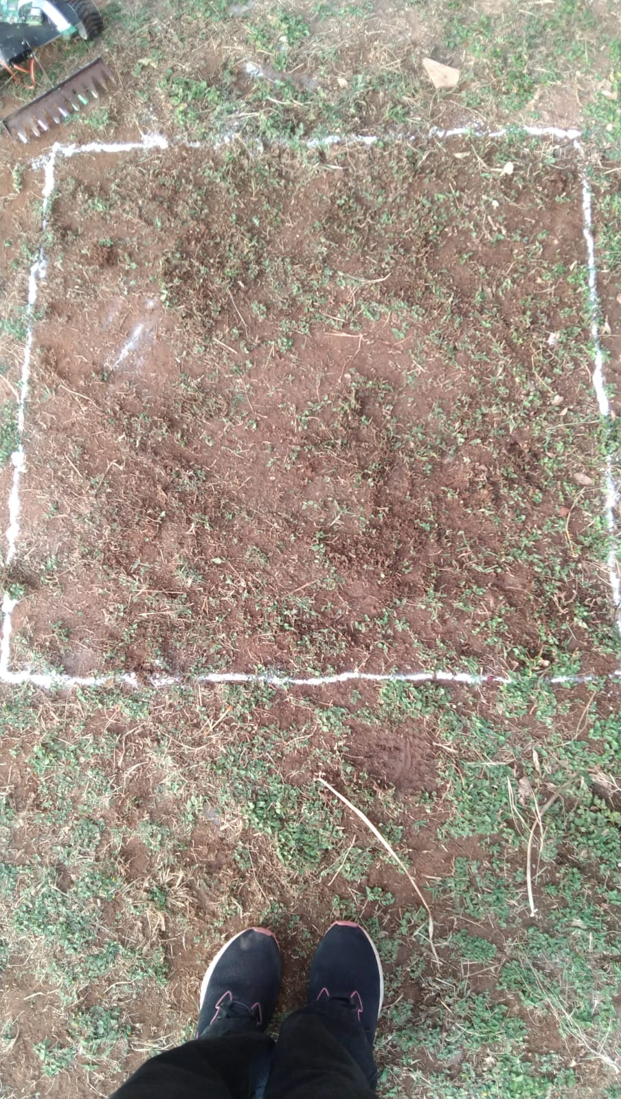
Theoretical Field Capacity is the rate of field coverage of the implement, based on 100 percent of time at the rated speed and covering 100 percent pf its rated width.
$$Theoretical Field Capacity \left(C\right)= \frac{Width x Speed}{ 10}$$

Fig.3 Before Weeding Fig.4 After Weeding
Table.1 Results of developed Solar Wi-Fi Based Weeder
Sl. No. | Parameter | T1 | T2 | T3 | Average
01. | Theoretical Field Capacity (m²/s) | 0.0484 | 0.0487 | 0.0485 | 0.0485
02. | Effective Field Capacity (m²/s) | 0.0243 | 0.0256 | 0.0370 | 0.0289
03. | Fielding Efficiency (%) | 50.20 | 52.57 | 76.29 | 59.68
04. | Weeding Efficiency (%) | 97.25 | 98.73 | 98.22 | 98.07
05 | Useful Work Coefficient (%) | 84.5 | 84.5 | 84.5 | 84.5
06 | Time/Energy Ratio (%) | 72.1 | 72.1 | 72.1 | 72.1
07 | Profit Gained (₹/hour) | 68.5 | 68.5 | 68.5 | 68.5

Fig. 5 Performance Metrics of the AI-Based Weeder
Discussion
The AI-based weeder showed an average theoretical field capacity of 0.0485 m²/s and an effective field capacity of 0.0289 m²/s, resulting in a field efficiency of 59.68%. This efficiency indicates moderate operational losses due to machine turning, repositioning, and blade engagement times. The system’s weeding efficiency of 98.07% confirms its high accuracy in detecting and removing weeds while preserving crops.
The useful work coefficient (84.5%) indicates that a significant majority of the machine’s operational time was actively spent on productive weeding rather than idle or transition phases. The time/energy ratio of 72.1% reflects effective energy utilization, with most power consumed in meaningful field work instead of overhead processes.
Economically, the weeder generated a consistent profit of ₹68.5 per hour, factoring in labor savings and improved crop health through effective weed control. The low fabrication cost (₹17,677) and moderate operating cost (₹71.04/hour) enhance the system's feasibility for small and medium-scale farmers.
Integration of AI and Wi-Fi control enables remote operation and monitoring, providing flexibility and scalability. This is particularly beneficial in areas facing labor shortages or high labor costs.
Future work should focus on increasing field efficiency by optimizing path planning to minimize non-productive movements. Enhancing energy management through solar power integration and advanced battery systems could further improve operational duration and sustainability. Expanding AI detection capabilities to handle diverse weed species and challenging terrains will broaden the application scope.
Overall, the developed weeder holds strong potential for advancing precision agriculture through efficient, cost-effective, and environmentally sustainable weed management.
4. Conclusion
The AI-assisted, Wi-Fi-operated weeder demonstrated high accuracy and efficiency in automatic weed removal, achieving a weeding efficiency of 98.07% and a field efficiency of 59.68%. The Raspberry Pi-based AI system, combined with remote operation, effectively identified and removed weeds, minimizing crop damage and labor. The useful work coefficient (84.5%) and time-energy ratio (72.1%) indicate optimal field performance. Designed cost-effectively, the system benefits small and medium-scale farmers, yielding an average gain of ₹68.5 per hour. Future enhancements in navigation, energy management, and AI algorithms can further improve adaptability and efficiency, supporting precision agriculture and smart farming practices.

Disclaimer (Artificial intelligence)
Author(s) hereby declare that NO generative AI technologies such as Large Language Models (ChatGPT, COPILOT, etc.) and text-to-image generators have been used during the writing or editing of this manuscript.

References

- Azghadi, M.R., Olsen, A., Wood, J., Saleh, A., Calvert, B., Fillols, E., 2024. Precise robotic weed spot-spraying for reduced herbicide usage and improved environmental outcomes. arXiv preprint.
- Chauhan, B.S., Mahajan, G., Sardana, V., 2023. Climate change impacts on weed dynamics and management strategies in agriculture. Crop Protection, 165, 106155.
- Gopalakrishnan, K., Sivaraj, R., Vijayakumar, M., 2025. Automated weed and crop recognition and classification model using deep transfer learning with optimization algorithm. Scientific Reports.
- Islam, T., Sarker, T.T., Ahmed, K.R., Rankrape, C.B., Gage, K., 2025. WeedVision: Multi-stage growth and classification of weeds using DETR and RetinaNet for precision agriculture. arXiv preprint.
- Mamatha, A., Santhosh Reddy, G., 2025. Advanced weed detection in agricultural fields using vision transformers. International Journal of Intelligent Systems and Applications in Engineering.
- Naruhn, G.-P., Butz, A.F., 2021. Weed impact on crop yield losses in winter cereals and broad acre crops. Journal of Agricultural Science.
- Oerke, E.-C., 2006. Crop losses to pests. Journal of Agricultural Science, 144(1), 31–43.
- Pandiyaraju, V., Karthik, A., Mynampati, S., Poovarasan, L., Saraswathi, D., 2025. A hybrid CNN-ViT-GNN framework with GAN-based augmentation for intelligent weed detection. arXiv preprint.
- Sangaraju, S., 2025. AI-powered precision agriculture: A technical review. Journal of Information Systems Engineering and Management.
- Sharma, R., Gupta, S., Singh, P., 2023. Precision weed management using machine vision: A review. Precision Agriculture Journal.
- Ziska, L.H., Dukes, J.S., 2014. Weed biology and climate change. John Wiley & Sons.
- Vijayakumar, S., Shanmugapriya, P., Saravanane, P., Ramesh, T., Murugaiyan, V., & Ilakkiya, S. (2025). Precision Weed Control Using Unmanned Aerial Vehicles and Robots: Assessing Feasibility, Bottlenecks, and Recommendations for Scaling. NDT, 3(2), 10.
- Amer, G., Mudassir, S. M. M., & Malik, M. A. (2015, May). Design and operation of Wi-Fi agribot integrated system. In 2015 International Conference on Industrial Instrumentation and Control (ICIC) (pp. 207-212). IEEE.
- Yaseen, M. U., & Long, J. M. (2024). Laser weeding technology in cropping systems: a comprehensive review. Agronomy, 14(10), 2253.
- Jaikumar, R., Sanjai, S. A., Sanjay, C., Kalam, S. S. A., & Kumar, P. N. (2024). AI-powered weed bot for sustainable precision farming. In Challenges in Information, Communication and Computing Technology (pp. 464-469). CRC Press.

