UNRAVELING PEST-WEATHER DYNAMICS: A STEPWISE REGRESSION APPROACH ON MAJOR PESTS IN RICE

ABSTRACT
Rice (Oryza sativa L.) is a major staple crop of the Godavari delta region of Andhra Pradesh, where its productivity is severely constrained by key insect pests, namely Yellow Stem Borer (YSB), Brown Planthopper (BPH), Gall Midge, and Leaf Folder (LF). Understanding long-term pest–weather relationships is essential for improving pest forecasting and developing climate-responsive management strategies. This study analyzed long-term weekly pest and weather data spanning over two decades (2002–2023 for kharif and 2003–2023 for Rabi) recorded at the Regional Agricultural Research Station, Maruteru, using stepwise regression analysis to identify critical climatic drivers influencing pest dynamics.
The results revealed strong season-specific pest responses to weather variables. During kharif, YSB incidence was primarily driven by minimum temperature (TMIN), evening relative humidity (RHE) and sunshine hours (SSH), while during Rabi, TMIN and RHE were dominant. Gall Midge outbreaks were mainly associated with SSH in kharif and TMIN and morning relative humidity (RHM) in Rabi. Leaf Folder infestation was significantly influenced by RHE and maximum temperature (TMAX) in kharif, whereas RHE, RHM and TMIN governed its occurrence in Rabi. BPH population during kharif responded to RHM, SSH and TMAX, while during Rabi, RHE emerged as the principal driver. The peak pest pressure was consistently observed during the kharif season, indicating it as the major risk period for yield loss in the region.
Although the developed models exhibited relatively low R² values, reflecting non-linear behaviour and high ecological heterogeneity in pest populations (a major limitation of the study), they provide critical insights into the climatic triggers of pest outbreaks. Based on these findings, the study recommends weather-based pest surveillance, timely advisories, and the adoption of climate-responsive integrated pest management (IPM) practices, particularly during the vulnerable kharif season, to effectively mitigate pest damage and enhance rice productivity in coastal Andhra Pradesh.

Keywords: Rice, Pest forecasting, Weather parameters, Multicollinearity and Stepwise Regression.
1. INTRODUCTION
Rice (Oryza sativa) is a staple food for more than half of the global population, particularly in tropical and subtropical regions, where it thrives in warm, humid, and water-rich environments, mainly in flooded fields. In Asia, it is central to food security. During 2023–24, India ranked first in rice area (7.8 million ha) and second in production (137.9 million tonnes; productivity 2,882 kg/ha). Andhra Pradesh alone accounted for 1.9 million ha and 7.3 million tonnes, with higher productivity (3,822 kg/ha) (https://www.indiastat.com, Indiastat, 2023–24). However, major insect pests such as Yellow Stem Borer (YSB), Gall Midge (GM), Leaf Folder (LF), and Brown Plant hopper (BPH) continue to threaten rice yields.
Among them, Yellow Stem Borer (YSB), Scirpophaga incertulas (Lepidoptera: Pyralidae), is a serious pest post-Green Revolution, causing yield losses of 20% in early crops and up to 70% in late planted crops (Reddy et al., 2022). Krishnaiah and Varma (2011) reported losses of 11.2–40.1% from dead hearts and 27.6–71.7% from white ears. The economic threshold is 2 egg masses/m² or 10% dead hearts (Prakash et al., 2014). For Cnaphalocrocis medinalis (leaf folder), insecticidal control is advised when two infested leaves per hill are found (Prakash et al., 2014, Arumugam et al. 2024). The Brown Plant hopper (BPH), Nilaparvata lugens (Hemiptera: Delphacidae), can cause up to 60% yield loss in susceptible varieties. Asian Gall Midge (GM) Orseolia oryzae (Diptera: Cecidomyiidae), causes major economic damage, especially in southern India, with yield losses of 0.8% (~US$80 million). The Rice Leaf folder (RLF), Cnaphalocrocis medinalis (Guenee) (Lepidoptera:Pyralidae) it is a predominant foliage feeder and one of the most destructive pests, affecting in all the rice ecosystems in Asia (Luo, S. J., 2010, Chakraborty et al. 2004).once it considered to a minor pest, emerged as a major threat since the late 1980s, causing 30–80% yield loss under epidemic conditions (Nanda & Bisoi, 1990; Shah et al., 2008, Reddy et al. 2025).
Several studies report that weather strongly influences pest population dynamics. Ali et al. (2022) used stepwise regression to relate six epidemiological weather variables to leaf rust severity in wheat, finding positive associations with all except minimum RH. They also developed a predictive model for lentil wilt, explaining 94.39% of variation and successfully validating it. Gholap et al. (2022) identified rainy days as positively, and wind speed, SSH, and minimum temperature as negatively, affecting Bt cotton yield by using stepwise regression analysis. Khan et al. (2006) applied stepwise regression to whitefly and mung bean yellow mosaic virus, with environmental factors (minimum and maximum air temperature, rainfall, and relative humidity) models explaining 81–92% variation across years. Kadam et al. (2022) applied stepwise regression and found that the weather factors significantly influencing cotton pests, with R² values ranging from 0.41 (aphids) to 0.66 (thrips, whiteflies); maximum and minimum temperatures and SSH were key predictors. Manikandan et al. (2024) reported that weather explained 50–61% variation in moringa pest infestations, with maximum temperature positively affecting budworm and ants, while rainfall and RH had opposite effects depending on pest species. For rice pests, Reddy et al. (2022) showed minimum temperature, SSH, and evening RH significantly influenced YSB populations, while Baswaraj et al. (2023) created statistical models to analyze the connection between weather conditions and the populations of lepidopteran pests in Kalyan Karnataka. In the study conducted by Rathod et al. (2021), Stepwise regression analysis was used to identify climatological factors affecting gall midge population buildup. Significant variables included TMIN, RHE, SSH at Warangal; RHM at Maruteru; TMAX, RHM, and SSH at Pattambi; and TMIN, RHM, RHE, and SSH at Jagdalpur. However, the low R² values across all centers suggest that the model is not a strong fit, potentially due to non-linearity and high variability in the dependent variables. Udayababu et al. (2021), Paul et al. (2020) linked weather to several rice pests, noting negligible gall midge incidence in 2017–18 but a sharp peak in 2019. Minruhi et al. (2023) identified TMAX, TMIN, RHM, and RF as significant factors affecting EW populations in the Kharif season. TMAX and RHM had negative effects, while TMIN and RF had positive effects. The model's low R² suggests a weak fit due to non-linearity and high heterogeneity in catches at RARS, Tirupati.
2. OBJECTIVES
1. To study the season wise pest scenario in Rice.
2. To identify the key weather parameters for incidence of season wise and pest wise in Maruteru, Andhra Pradesh.
3. MATERIALS AND METHODOLOGY
3.1 Data collection
Standard meteorological weeks (SMWs) were used to record long-term weekly data on rice from the Regional Agricultural Research station (RARS) in Maruteru, Andhra Pradesh. Typically, weekly data on the main pests of rice are gathered from 2002 to 2023 during the kharif season and from 2003 to 2023 during the Rabi season. These pests include Yellow Stem Borer (YSB), Brown Plant Hopper (BPH), Rice Leaf Folder (RLF), and Gall Midge (GM). Likewise, gather meteorological information on sunlight hours (SSH), relative humidity morning (RHM), relative humidity evening (RHE), maximum temperature (TMAX), and minimum temperature (TMIN) for the relevant crop period. For this study, weekly averages of weather factors and weekly pest data broken down by standard meteorological weeks (SMWs) were taken into account.
3.2 Statistical Models
Descriptive statistical parameters, which are crucial for illustrating the characteristics of the data under study, such as mean, standard error (SE), skewness, kurtosis, minimum, maximum, and coefficient of variation (CV), were the first to be used in statistical modeling. Essential information about the dataset's properties is provided by these measurements. Time series plots were also used to visually depict the trends in the data across time. The degree of interdependence between the variables was measured using Pearson's correlation coefficient analysis, which was used to investigate the correlations between the variables employed in the study. In order to examine the causal association between exogenous meteorological variables and rice pest populations, stepwise multiple regression models were utilized.
The regression equation in matrix notation is expressed as:
Y=Xβ+e…(1.1)
Where Y is the dependent variable representing the Rice pest population, X is the matrix of independent variables comprising the exogenous weather variables, β is the vector of regression coefficients and e is the residuals term assumed to be normally distributed with e ~N (0, $σ^{2}$). Correlation analysis and stepwise regression analysis were carried out in SPSS Ver.28 (Licensed).
4. RESULTS AND DISCUSSIONS
4.1. YSB PEST - KHARIF
4.1.1. Descriptive Statistics
Table 1 summarizes the descriptive statistics for YSB population and related weather variables. A coefficient of variation (CV) of 229.37% indicates high variability in pest incidence, with skewness and kurtosis values suggesting a non-normal distribution. The weather variables also show considerable variability, confirming diverse characteristics within the dataset.
Table 1. Summary statistics of Yellow Stem Borer (YSB) during Kharif Season at RARS, Maruteru
 | YSB | TMAX | TMIN | RHM | RHE | RF | SSH
Count | 616.0 | 616.0 | 616.0 | 616.0 | 616.0 | 616.0 | 616.0
Mean | 532.2 | 30.4 | 24.0 | 87.1 | 70.6 | 30.3 | 4.9
Std. Deviation | 1220.7 | 2.3 | 2.9 | 4.4 | 9.9 | 48.0 | 2.0
Variance | 1490087.2 | 5.2 | 8.2 | 19.4 | 97.3 | 2299.6 | 4.1
Skewness | 7.0 | 0.5 | -0.7 | -0.6 | -0.4 | 3.3 | 0.0
Kurtosis | 74.3 | 1.3 | -0.1 | 0.6 | 0.1 | 17.4 | -0.5
Minimum | 0.0 | 22.9 | 16.2 | 69.9 | 40.4 | 0.0 | 0.0
Maximum | 17428.0 | 39.6 | 30.7 | 96.9 | 95.1 | 428.6 | 9.6
CV% | 229.4 | 7.5 | 11.9 | 5.1 | 14.0 | 158.2 | 41.3

4.1.2. Correlation Analysis
The Pearson correlation coefficients between Yellow Stem Borer (YSB) populations and the weather variables analyzed are shown in Table 2. A minimal negative and non-significant correlation was found between the YSB population and TMAX (-0.028) and RHM (-0.02). Additionally, a minimal negative and significant correlation was observed between the YSB population and TMIN (-0.236), RHE (-0.225), and RF (-0.147). Conversely, a minimal positive and significant correlation between the YSB population and SSH (0.19) was noted.
Table 2. Pearson correlation coefficients between Yellow Stem Borer (YSB) populations and weather variables during Kharif Season
Correlations
 | YSB | TMAX | TMIN | RHM | RHE | RF
TMAX | -0.028
TMAX | -0.494
TMIN | -.236** | .527**
TMIN | (<0.0001) | (<0.0001)
RHM | -0.02 | -.334** | -.196**
RHM | -0.614 | (<0.0001) | (<0.0001)
RHE | -.225** | -.370** | .150** | .401**
RHE | (<0.0001) | (<0.0001) | (<0.0001) | (<0.0001)
RF | -.147** | -.124** | .143** | .203** | .233**
RF | (<0.0001) | -0.002 | (<0.0001) | (<0.0001) | (<0.0001)
SSH | .190** | .212** | -.242** | -.147** | -.357** | -.342**
SSH | (<0.0001) | (<0.0001) | (<0.0001) | (<0.0001) | (<0.0001) | (<0.0001)

4.1.3. Step Wise Regression Analysis
A stepwise regression analysis was performed to identify the most influential predictors of the weather parameters affecting the YSB pest. The criteria for variable entry and removal were set with an F-to-enter ≤ 0.050 and a probability of F-to-remove ≥ 0.100. In the first step, minimum temperature (TMIN) was entered into the model, resulting in a significant improvement (F(1,614) = 36.252, p < 0.001). In the second step, relative humidity (RHE) was added, leading to another significant enhancement (F (2,613) = 31.276, p < 0.001). In the third step, soil moisture (SSH) was included, which further enhanced the model (F(3,612) = 22.305, p < 0.001). In the final model, which included TMIN, RHE, and SSH, there was a strong fit, accounting for a substantial proportion of the variance (R² = 0.099; adjusted R² = 0.094). In the first step, the regression equation is
YSB (Kharif) = 2956.485-100.868(TMIN)
This highlights the significant positive impact of minimum temperature on YSB pest growth (t = 7.291, p < 0.001, β = -0.236). In the second step, with the addition of RHE, the regression equation is
YSB (Kharif) = 4352.566-88.394(TMIN) -24.028 (RHE)
Both TMIN (t = -5.317, p = 0.001, β = -0.207) and RHE (t = -4.989, p = 0.001, β = -0.194) showed positive standardized coefficients, indicating their contribution to the growth of YSB. In the third step, with the addition of SSH, the regression equation becomes
YSB (Kharif) = 3693.918 -81.45(TMIN) -20.599(RHE) +51.170(SSH)
In this final model, TMIN (t = -4.808, p = 0.0001, β = -0.191), RHE (t = -4.808, p = 0.0001, β = -0.166), and SSH (t = 2.012, p = 0.045, β = 0.084) all demonstrate positive standardized coefficients, suggesting their contributions to the growth of the yellow stem borer (YSB). In conclusion, minimum temperature (TMIN), relative humidity (RHE), and Sun Shine Hours (SSH) are the three major weather factors influencing the growth of the YSB pest in paddy fields.
Table 3. Stepwise regression model for population Yellow Stem Borer (YSB) during kharif and weather variables
ANOVA
Model |  | Sum of Squares | df | Mean Square | F | Sig.
1 | Regression | 51090747 | 1 | 51090747 | 36.252 | .000^{b}
1 | Residual | 865312896 | 614 | 1409304.4
1 | Total | 916403642 | 615
2 | Regression | 84854472 | 2 | 42427236 | 31.276 | .000^{c}
2 | Residual | 831549171 | 613 | 1356523.9
2 | Total | 916403642 | 615
3 | Regression | 90321380 | 3 | 30107127 | 22.305 | .000^{d}
3 | Residual | 826082262 | 612 | 1349807.6
3 | Total | 916403642 | 615
Model Summary
Model |  | R |  | R Square |  | Adjusted R Square |  | Std. Error of the Estimate
1 |  | .236ª |  | .056 |  | .054 |  | 1187.141
2 |  | .304^{b} |  | .093 |  | .090 |  | 1164.699
3 |  | .314^{c} |  | .099 |  | .094 |  | 1161.812
Coefficientsª
Model |  |  | Unstandardized Coefficients |  |  |  | Standardized Coefficients |  | t | Sig.
 |  |  | B |  | Std. Error |  | Beta |  | t | Sig.
1 | (Constant) |  | 2956.485 |  | 405.474 |  |  |  | 7.291 | .000
1 | TMIN |  | -100.868 |  | 16.753 |  | -.236 |  | -6.021 | .000
2 | (Constant) |  | 4352.566 |  | 486.372 |  |  |  | 8.949 | .000
2 | TMIN |  | -88.394 |  | 16.625 |  | -.207 |  | -5.317 | .000
2 | RHE |  | -24.028 |  | 4.816 |  | -.194 |  | -4.989 | .000
3 | (Constant) |  | 3693.918 |  | 585.234 |  |  |  | 6.312 | .000
3 | TMIN |  | -81.451 |  | 16.939 |  | -.191 |  | -4.808 | .000
3 | RHE |  | -20.599 |  | 5.097 |  | -.166 |  | -4.041 | .000
3 | SSH |  | 51.170 |  | 25.426 |  | .084 |  | 2.012 | .045

4.1.4. Discussion:
In this study, the stepwise regression model showed a weak fit, with a low R² value of 9%. This poor fit is likely due to non-linear relationships and high variability in the dependent variable, which makes it challenging to establish a strong association between yellow stem borer populations and external weather variables during the kharif season (Fig. 1). The analysis identified TMIN, RHE, and SSH as the key weather parameters significantly influencing YSB population growth in paddy fields. However, it should be noted that several other potential factors affecting YSB incidence were not considered in this study. Similarly, A related study by Sagar et al. (2017) reported that stepwise regression highlighted TMIN, RH1 (RHM), and SSH as important predictors of Helicoverpa armigera trap catches.
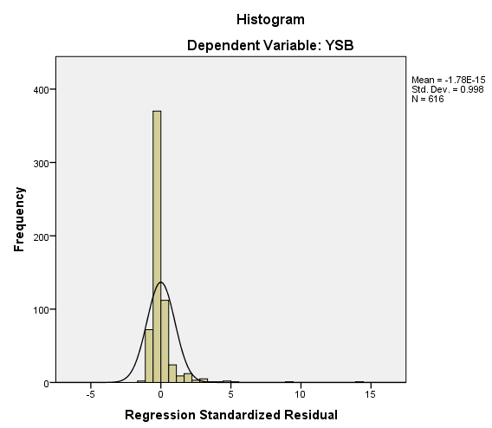 | 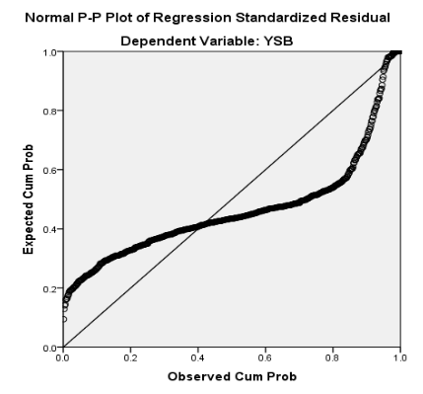 | 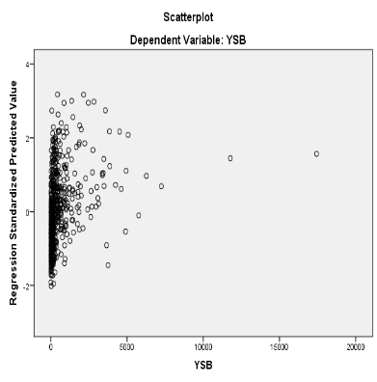
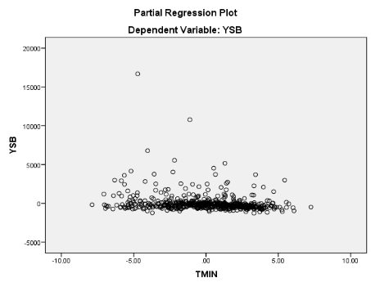 | 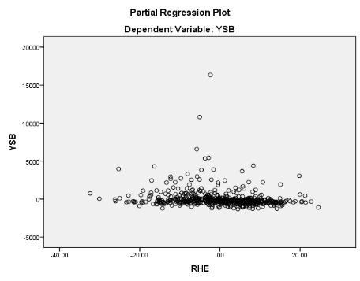 | 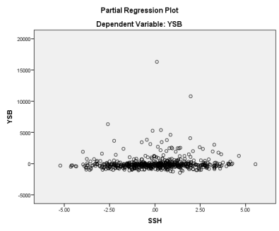
Fig 1: Regression diagnosis of Kharif YSB population with weather parameters
4.2. YSB-RABI
4.2.1. Descriptive Statistics:
Table 4 summarizes the descriptive statistics for YSB population and related weather variables for Rabi season. Skewness and kurtosis values indicated non-normal distribution patterns. Weather parameters also showed substantial variability, confirming the unique traits of the examined factors.
Table4. Summary statistics of Yellow Stem Borer (YSB) during Rabi Season at RARS, Maruteru
 | YSB | TMAX | TMIN | RHM | RHE | RF | SSH
Count | 420.0 | 420.0 | 420.0 | 420.0 | 420.0 | 420.0 | 420.0
Mean | 1216.6 | 31.3 | 22.5 | 87.8 | 61.5 | 3.9 | 7.6
Std. Deviation | 2376.8 | 2.9 | 2.9 | 4.8 | 12.0 | 17.1 | 1.3
Variance | 5649387.8 | 8.6 | 8.4 | 23.3 | 144.0 | 292.9 | 1.7
Skewness | 4.1 | 0.2 | 0.0 | -2.0 | -0.7 | 6.1 | -1.1
Kurtosis | 22.0 | 1.0 | -0.2 | 7.8 | -0.1 | 42.3 | 1.9
Minimum | 0.0 | 19.3 | 12.0 | 57.4 | 24.7 | 0.0 | 1.4
Maximum | 20648.0 | 42.8 | 29.7 | 97.6 | 87.6 | 152.0 | 9.9
CV% | 195.4 | 9.3 | 12.8 | 5.5 | 19.5 | 439.2 | 17.2

4.2.2. Correlation Analysis
The Pearson correlation coefficients between Yellow Stem Borer (YSB) populations and the weather variables analysed are shown in Table 5. A minimal negative and significant correlation was found between the YSB population and RHE (-0.339) and RHM (-0.18). Additionally, a minimal positive and significant correlation was observed between the YSB population and TMAX (0.331), TMIN (0.343) and SSH (0.147) conversely, a minimal positive and non-significant correlation between the YSB population and RF (0.06) was noted.
Table 5. Pearson correlation coefficients between Yellow Stem Borer (YSB) populations and weather variables during Rabi Season
 | YSB | TMAX | TMIN | RHM | RHE | RF
TMAX | .331**
TMAX | (<0.0001)
TMIN | .343** | .811**
TMIN | (<0.0001) | (<0.0001)
RHM | -.180** | -.138** | -.215**
RHM | (<0.0001) | (0.005) | (<0.0001)
RHE | -.339** | -.358** | -.156** | .152**
RHE | (<0.0001) | (<0.0001) | (<0.001) | -0.002
RF | 0.06 | .111* | .162** | -0.026 | 0.046
RF | (0.216) | (0.024) | (<0.001) | (0.589) | (0.351)
SSH | .147** | .261** | .131** | 0.021 | -.130** | -.147**
SSH | (0.002) | (<0.0001) | (0.007) | (0.667) | (0.007) | (0.003)

4.2.3. Step Wise Regression Analysis
A step wise regression analysis was performed to identify the most influential weather parameter of YSB Pest. The criteria, for variable entry & removal were set at a probability of F-to enter ≤0.050 and a probability of F-to remove ≥0.100. In the first Step min temp is entered into the model; resulting in a significant Improvement F (1, 418) = 55.823, P<0.001. In the second step Relative humidity entering was added, leading to another significant enhancement. F (2, 417) =52.492, P<0.001. The final model Including both TMIN, RHE demonstrated the most Influential Weather parameter for YSB growth with $(R^{2}=$0. 201, adjusted $R^{2}$ = 0. 197) in the first step, the regression equation is
YSB (Rabi) = -5129+281.965(TMIN)
Highlighting the significant Positive Impact of minimum temperature on YSB growth (t = 7. 471 P<0.001, beta = 0. 343) in second step, with the addition of RHE the regression equation became
YSB (Rabi) = - 725. 651 + 244. 395 (TMIN) -57.882 (RHE).
Both TMIN (T =6.713, P = 0.001, β= 0.299) and RHE (t=-6.594, P = 0.0001, beta =0.292) showed positive standardized co-efficient, suggesting their contribution to the growth of YSB. It was concluded that the two weather factors TMIN and RHE were the majorly influence on growth of YSB pest in paddy.
Table 6. Stepwise regression model for population Yellow Stem Borer (YSB) during Rabi and weather variables
ANOVAª
Model |  |  |  |  | Sum of Squares |  |  |  | df |  | Mean Square |  | F |  | Sig.
1 |  | Regression |  |  | 278875428.892 |  |  |  | 1 |  | 278875428.892 |  | 55.823 |  | .000^{b}
 |  | Residual |  |  | 2088218068.642 |  |  |  | 418 |  | 4995737.006
 |  | Total |  |  | 2367093497.533 |  |  |  | 419
2 |  | Regression |  |  | 476080373.368 |  |  |  | 2 |  | 238040186.684 |  | 52.492 |  | .000^{c}
 |  | Residual |  |  | 1891013124.165 |  |  |  | 417 |  | 4534803.655
 |  | Total |  |  | 2367093497.533 |  |  |  | 419
Model Summary
Model |  |  | R |  |  | R Square |  | Adjusted R Square |  |  |  | Std. Error of the Estimate
1 |  |  | .343ª |  |  | .118 |  | .116 |  |  |  | 2235.115
2 |  |  | .448^{b} |  |  | .201 |  | .197 |  |  |  | 2129.508
Coefficientsª
Model |  |  |  | Unstandardized Coefficients |  |  |  |  |  | Standardized Coefficients |  |  |  | t |  | Sig.
 |  |  |  | B |  |  | Std. Error |  |  | Beta |  |  |  |  |  | Sig.
1 | (Constant) |  |  | -5129.801 |  |  | 856.397 |  |  |  |  |  |  | -5.990 |  | .000
1 | TMIN |  |  | 281.965 |  |  | 37.739 |  |  | .343 |  |  |  | 7.471 |  | .000
2 | (Constant) |  |  | -725.651 |  |  | 1054.409 |  |  |  |  |  |  | -.688 |  | .492
2 | TMIN |  |  | 244.395 |  |  | 36.404 |  |  | .298 |  |  |  | 6.713 |  | .000
2 | RHE |  |  | -57.882 |  |  | 8.777 |  |  | -.292 |  |  |  | -6.594 |  | .000

4.2.4. Discussion
In this study, the stepwise regression model demonstrated a weak fit, indicated by a low $R^{2}$ value (20%). This weakness is likely due to non-linearity and considerable variation in the dependent variable (High Heterogeneity), making it difficult to establish a strong link between yellow stem borer populations and exogenous weather variables during the Rabi season. This trend is also evident in Fig. 2. Stepwise regression results identified TMIN, RHE, as the two main weather factors significantly influencing the growth of the YSB pest in paddy fields. It is also important to acknowledge that other potential factors affecting yellow stem borer incidence were not included in this analysis. A related study by Rana et al. (2017) found that the occurrence of YSB depended solely on minimum temperature in both 2014 and 2015, with variability ranging from 34 to 42 per cent. Notably, stepwise regression using pooled data from both years indicated that rainfall was the most influential factor for YSB incidence.
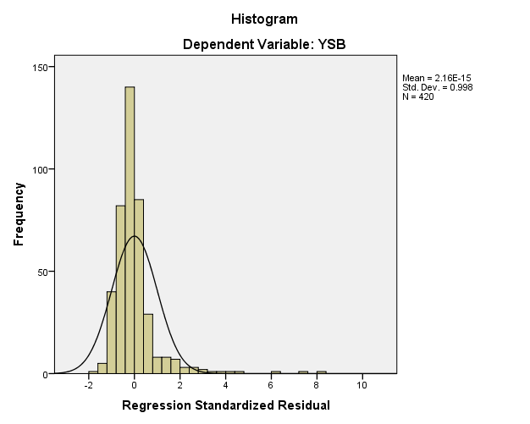 | 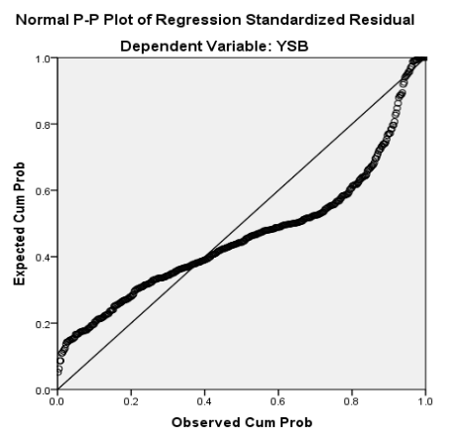 | 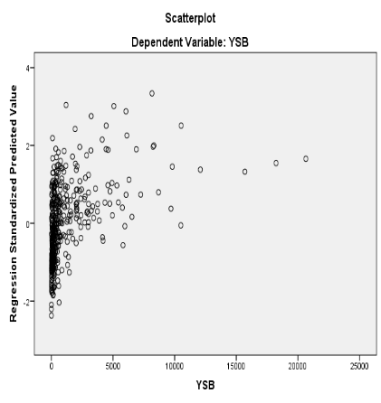
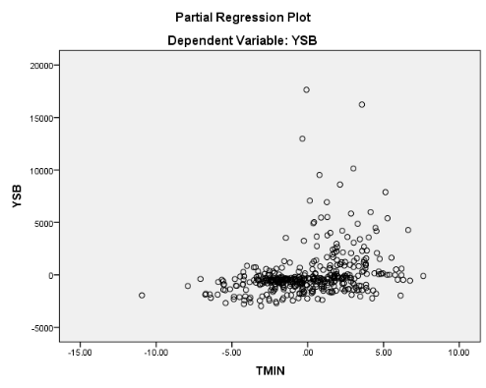 | 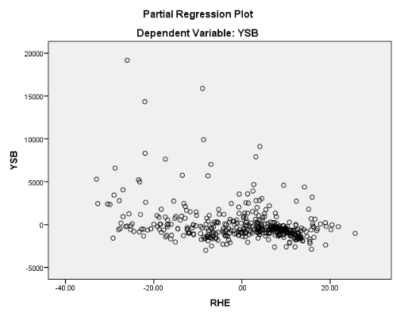
Fig 2. Regression diagnosis of Rabi YSB population with weather parameters
4.3. Gall Midge-Kharif
4.3.1. Descriptive Statistics
Table 7 summarizes GM population statistics alongside weather variables of Kharif season. The high coefficient of variation (CV) of 295.7% reflects data heterogeneity, while skewness and kurtosis indicate a deviation from normal distribution, emphasizing irregularity.
Table 7. Summary statistics of Gall Midge (GM) during Kharif Season at RARS, Maruteru
 | GM | TMAX | TMIN | RHM | RHE | RF | SSH
Count | 616.0 | 616.0 | 616.0 | 616.0 | 616.0 | 616.0 | 616.0
Mean | 157.5 | 30.4 | 24.0 | 87.1 | 70.6 | 30.3 | 4.9
Std. Deviation | 465.7 | 2.3 | 2.9 | 4.4 | 9.9 | 48.0 | 2.0
Skewness | 6.3 | 0.5 | -0.7 | -0.6 | -0.4 | 3.3 | 0.0
Kurtosis | 51.2 | 1.3 | -0.1 | 0.6 | 0.1 | 17.4 | -0.5
Minimum | 0.0 | 22.9 | 16.2 | 69.9 | 40.4 | 0.0 | 0.0
Maximum | 5187.0 | 39.6 | 30.7 | 96.9 | 95.1 | 428.6 | 9.6
CV% | 295.7 | 7.5 | 11.9 | 5.1 | 13.9 | 158.2 | 41.3

4.3.2. Correlation Analysis
The Pearson correlation coefficients between Gall Midge (GM) populations and the weather variables analysed are shown in Table 8. A minimal negative and non-significant correlation was found between the GM population and RF (-0.069) and RHE (-0.017). Additionally, a minimal negative and significant correlation was observed between the GM population and, RHM (-0.083). Additionally, a minimal positive and non-significant correlation between the GM population and TMAX (0.03) and TMIN (0.005). Conversely a minimal positive and significant correlation between the GM population and SSH (0.108) was noted.
Table 8. Pearson correlation coefficients between Gall Midge (GM) populations and weather variables during Kharif Season
 | GM | TMAX | TMIN | RHM | RHE | RF
TMAX | 0.03
TMAX | 0.464
TMIN | 0.005 | .527**
TMIN | 0.904 | (<0.0001)
RHM | -.083* | -.334** | -.196**
RHM | 0.039 | (<0.0001) | (<0.0001)
RHE | -0.017 | -.370** | .150** | .401**
RHE | 0.666 | (<0.0001) | (<0.0001) | (<0.0001)
RF | -0.069 | -.124** | .143** | .203** | .233**
RF | 0.088 | 0.002 | (<0.0001) | (<0.0001) | (<0.0001)
SSH | .108** | .212** | -.242** | -.147** | -.357** | -.342**
SSH | 0.008 | (<0.0001) | (<0.0001) | (<0.0001) | (<0.0001) | (<0.0001)

4.3.3. Step Wise Regression Analysis
A step wise regression analysis was performed to identify the most Influential predictors of weather parameter of gall midge in kharif season. The criteria for variable entry & removal were set at a of F-to enter ≤ 0.050 and a probability of f-to-remove ≥ 0.100 In this only SSH is entered into the model: resulting in a significant Improvement, F (1,614) = 7.186, P<.001. in the final model only SSH is the most influential weather parameter for gall midge growth with (R²=0.012; Adj R² = 0.010). the final regression equation is
Gall Midge (Kharif) = 36.138+24.862 (SSH)
Highlighting the significant positive impact of SSH for gall midge growth (t =2.681, p =0.008, beta=0.108). Finally, we conclude that SSH is the major influential weather parameter for growth of gall midge in kharif season in paddy crop.
Table 9. Stepwise regression model for population Gall Midge (GM) during Kharif and weather variables
ANOVAª
Model |  |  |  |  |  | Sum of Squares |  |  | df |  | Mean Square |  | F |  | Sig.
1 |  | Regression |  |  |  | 1543173.217 |  |  | 1 |  | 1543173.217 |  | 7.186 |  | .008^{b}
 |  | Residual |  |  |  | 131846428.465 |  |  | 614 |  | 214733.597
 |  | Total |  |  |  | 133389601.682 |  |  | 615
Model Summary
Model |  |  | R |  | R Square |  |  | Adjusted R Square |  |  |  | Std. Error of the Estimate
1 |  |  | .108ª |  | .012 |  |  | .010 |  |  |  | 463.394
Coefficientsª
Model |  |  |  | Unstandardized Coefficients |  |  |  |  |  | Standardized Coefficients |  |  |  | t |  | Sig.
 |  |  |  | B |  |  | Std. Error |  |  | Beta |  |  |  |  |  | Sig.
1 | (Constant) |  |  | 36.138 |  |  | 48.963 |  |  |  |  |  |  | .738 |  | .461
1 | SSH |  |  | 24.862 |  |  | 9.274 |  |  | .108 |  |  |  | 2.681 |  | .008
4.3.4. Discussion:
In this study, the stepwise regression model showed a weak fit, as indicated by a low value (1.2%). This likely results from non-linearity and significant variation in the dependent variable (high heterogeneity), making it challenging to establish a strong relationship between Gall Midge populations and external weather variables during the kharif season. This pattern is also visible in Fig. 3. Stepwise regression analysis identified SSH as the primary weather factor significantly affecting Gall Midge pest growth in paddy fields. It is important to note that other possible factors influencing Gall Midge incidence were not considered in this analysis. Similarly, a recent study by Reddy et al. (2022) conducted a stepwise regression analysis (SAS 9.3, ICAR-IIRR Hyderabad) throughout the year and found that SSH significantly and positively influences YSB populations. However, the low R² value at Rajendra Nagar indicates a poor model fit, likely due to non-linearity and high heterogeneity in the dependent variable.
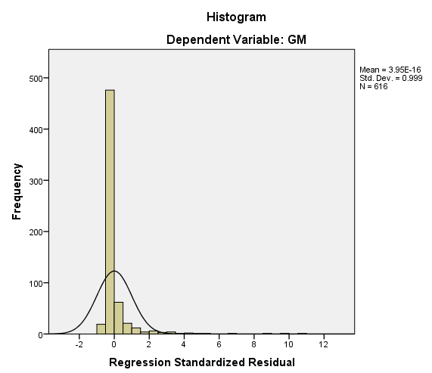 | 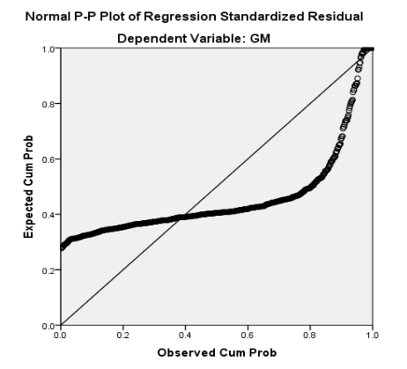  Partial Regression Plot  Dependent Variable: GM | 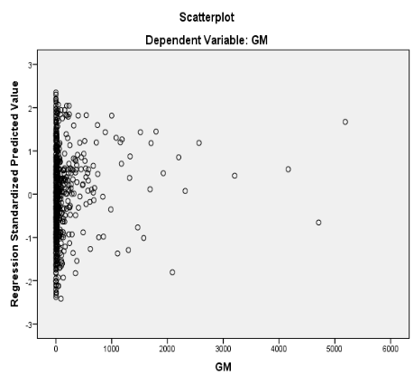
 | 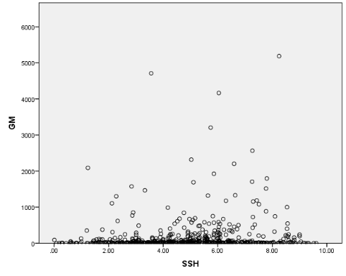
Fig 3. Regression diagnosis of Kharif Gall Midge population with weather parameters

4.4. Gall Midge- Rabi
4.4.1. Descriptive Statistics
Table 10 summarizes GM population alongside weather variables in Rabi season, with a high coefficient of variation (CV) at 206.4%, indicating data heterogeneity. Skewness and kurtosis values show significant deviation from normal distribution, highlighting data irregularities. Overall, the statistics illustrate considerable variability in the weather factors studied.
Table 10. Summary statistics of Gall Midge (GM) during Rabi Season at RARS, Maruteru
 | GM | TMAX | TMIN | RHM | RHE | RF | SSH
Count | 420.0 | 420.0 | 420.0 | 420.0 | 420.0 | 420.0 | 420.0
Mean | 204.9 | 31.3 | 22.5 | 87.8 | 61.5 | 3.9 | 7.6
Std. Deviation | 422.9 | 2.9 | 2.9 | 4.8 | 12.0 | 17.1 | 1.3
Variance | 178831.7 | 8.6 | 8.4 | 23.3 | 144.0 | 292.9 | 1.7
Skewness | 3.6 | 0.2 | 0.0 | -2.0 | -0.7 | 6.1 | -1.1
Kurtosis | 14.4 | 1.0 | -0.2 | 7.8 | -0.1 | 42.3 | 1.9
Minimum | 0.0 | 19.3 | 12.0 | 57.4 | 24.7 | 0.0 | 1.4
Maximum | 3000.0 | 42.8 | 29.7 | 97.6 | 87.6 | 152.0 | 9.9
CV% | 206.4 | 9.4 | 12.8 | 5.5 | 19.5 | 439.2 | 17.2

4.4.2. Correlation Analysis
The Pearson correlation coefficients between populations Gall Midge (GF) and the weather variables analysed are shown in Table 11. A minimal negative and non-significant correlation was found between the GM population and RF (-0.031) and RHE (-0.013). Additionally, a minimal negative and significant correlation was found between the GM population and RHM (-0.168). Additionally, minimal positive and significant correlation was observed between the GM population and TMAX (0.128) and TMIN (0.190). Conversely, a minimal positive and non-significant correlation between the GM population and SSH (0.037) was noted.
Table 11. Pearson correlation coefficients between populations Gall Midge (GM) and weather variables during Rabi Season
 | GM | TMAX | TMIN | RHM | RHE | RF
TMAX | .128**  .009
TMIN | .190**  (<0.0001) | .811**  (<0.0001)
RHM | -.168**  (0.001) | -.138**  (0.005) | -.215**  (<0.0001)
RHE | -.013  (0.79) | -.358**  (<0.0001) | -.156**  (0.001) | .152**  (0.002)
RF | -.031  (0.529) | .111*  (0.024) | .162**  (<0.001) | -.026  (0.589) | .046  (0.351)
SSH | .037  (0.447) | .261**  (<0.0001) | .131**  (0.007) | .021  (0.667) | -.130**  (0.007) | -.147**  (0.003)

4.4.3. Step Wise Regression Analysis
A step wise regression analysis was performed to identify the most influential weather parameter of gall midge Pest. The criteria, for variable entry & removal were set at a probability of F-to enter ≤0.050 and a probability of F-to remove ≥0.100. In the first Step min temp is entered into the model; resulting in a significant Improvement F (1, 418) = 15.645, P<0.001. In the second step Relative humidity entering was added, leading to another significant enhancement. F (2, 417) =11.670, P<0.001. The final model Including both TMIN, RHM demonstrated the most Influential Weather parameter for gall midge growth with ( $R^{2}=$0. 053, Adjusted $R^{2}$ = 0. 048) in the first step, the regression equation is
Gall Midge (Rabi) = -419.992+27.761(TMIN),

Highlighting the significant Positive Impact of minimum temperature on gall midge growth (t = 3.955, P<0.001, beta = 0. 190) in second step, with the addition of RHM. The regression equation became
Gall Midge (Rabi) = 698.527 + 23.565 (TMIN) -11.661 (RHM).
Both TMIN (t =3.304, P = 0.001, β= 0.161) and RHM (t=-2.730, P = 0.007, beta = -0.133) showed positive standardized co-efficient, suggesting their contribution to the growth of gall midge. Finally, conclusion is that two weather factors TMIN and RHM are the majorly influence the growth of gall midge pest in paddy.
Table 12. Stepwise regression model for population Gall Midge (GM) during Rabi and weather variables
ANOVAª
Model |  |  |  |  |  | Sum of Squares |  |  | df |  | Mean Square |  | F |  | Sig.
1 |  | Regression |  |  |  | 2703361.540 |  |  | 1 |  | 2703361.540 |  | 15.645 |  | .000^{b}
 |  | Residual |  |  |  | 72227137.172 |  |  | 418 |  | 172792.194
 |  | Total |  |  |  | 74930498.712 |  |  | 419
2 |  | Regression |  |  |  | 3971680.406 |  |  | 2 |  | 1985840.203 |  | 11.670 |  | .000^{c}
 |  | Residual |  |  |  | 70958818.306 |  |  | 417 |  | 170165.032
 |  | Total |  |  |  | 74930498.712 |  |  | 419
Model Summary
Model |  |  | R |  | R Square |  |  | Adjusted R Square |  |  |  | Std. Error of the Estimate
1 |  |  | .190ª |  | .036 |  |  | .034 |  |  |  | 415.683
2 |  |  | .230^{b} |  | .053 |  |  | .048 |  |  |  | 412.511
Coefficientsª
Model |  |  |  | Unstandardized Coefficients |  |  |  |  |  | Standardized Coefficients |  |  |  | t |  | Sig.
 |  |  |  | B |  |  | Std. Error |  |  | Beta |  |  |  |  |  | Sig.
1 | (Constant) |  |  | -419.992 |  |  | 159.271 |  |  |  |  |  |  | -2.637 |  | .009
1 | TMIN |  |  | 27.761 |  |  | 7.019 |  |  | .190 |  |  |  | 3.955 |  | .000
2 | (Constant) |  |  | 698.527 |  |  | 439.129 |  |  |  |  |  |  | 1.591 |  | .112
2 | TMIN |  |  | 23.565 |  |  | 7.133 |  |  | .161 |  |  |  | 3.304 |  | .001
2 | RHM |  |  | -11.661 |  |  | 4.271 |  |  | -.133 |  |  |  | -2.730 |  | .007

4.4.4. Discussion
In this study, the stepwise regression model demonstrated a weak fit, as reflected by the low R² value (5.3%). This weak explanatory power is likely due to non-linearity and the considerable variation in the dependent variable (high heterogeneity), which makes it difficult to establish a strong relationship between Gall Midge populations and exogenous weather variables during the Rabi season (Fig. 4). The analysis identified minimum temperature (TMIN) and morning relative humidity (RHM) as the two main weather factors significantly influencing Gall Midge incidence in paddy fields. It is also important to note that other potential factors influencing pest buildup were not included in this study. Similar findings were reported by Rathod et al. (2022), who conducted stepwise regression analyses across multiple centres and identified different sets of significant variables, including TMIN, RHE, and SSH at Warangal; RHM at Maruteru; TMAX, RHM, and SSH at Pattambi; and TMIN, RHM, RHE, and SSH at Jagdalpur. However, they also observed low R² values across all centres, suggesting that the models provided only a weak fit, most likely due to non-linearity and the high variability in Gall Midge populations.
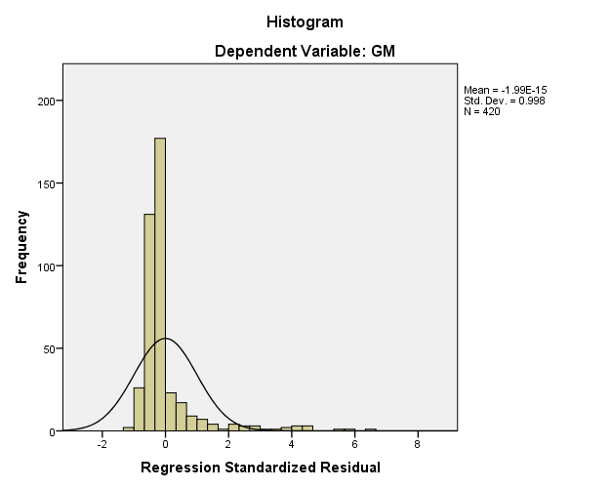 | 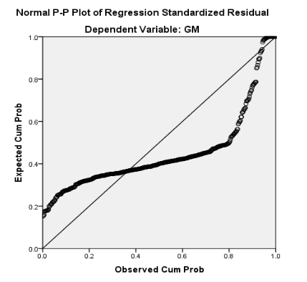 | 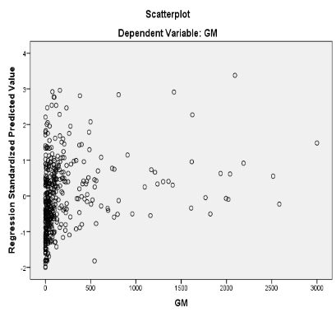
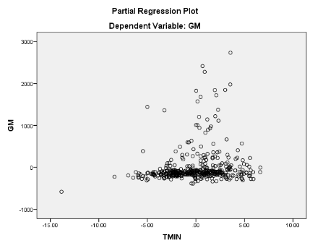 | 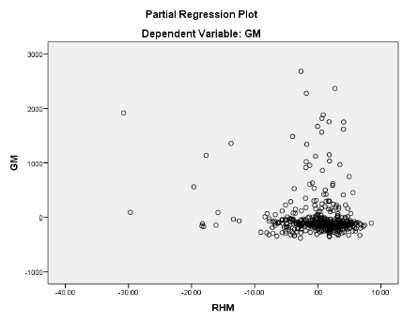
Fig 4. Regression diagnosis of Rabi Gall Midge population with weather parameters
4.5. BPH Pest- Kharif
4.5.1. Descriptive Statistics
Table 13 summarizes BPH population statistics and external weather variables in Kharif season, revealing a high coefficient of variation (CV) of 182.1%, indicating data heterogeneity. Skewness and kurtosis values suggest departures from normal distribution, further emphasizing data irregularity. The weather variables also show significant variability, offering insights into their characteristics.
Table 13. Summary statistics of Brown Plant Hopper (BPH) during Kharif Season at RARS, Maruteru
 | BPH | TMAX | TMIN | RHM | RHE | RF | SSH
Count | 616 | 616 | 616 | 616 | 616 | 616 | 616
Mean | 2228.7 | 30.4 | 24.0 | 87.1 | 70.6 | 30.3 | 4.9
Std. Deviation | 4059.2 | 2.3 | 2.9 | 4.4 | 9.9 | 48.0 | 2.0
Variance | 16477132.9 | 5.2 | 8.2 | 19.4 | 97.3 | 2299.6 | 4.1
Skewness | 3.2 | 0.5 | -0.7 | -0.6 | -0.4 | 3.3 | 0.0
Kurtosis | 12.7 | 1.3 | -0.1 | 0.6 | 0.1 | 17.4 | -0.5
Minimum | 0.0 | 22.9 | 16.2 | 69.9 | 40.4 | 0.0 | 0.0
Maximum | 28820.0 | 39.6 | 30.7 | 96.9 | 95.1 | 428.6 | 9.6
CV% | 182.1 | 7.5 | 11.9 | 5.1 | 14.0 | 158.2 | 41.3

4.5.2. Correlation Analysis
The Pearson correlation coefficients between Brown Plant Hopper (BPH) populations and the weather variables analysed are shown in Table 14. A minimal negative and non-significant correlation was found between the BPH population and RF (-0.051) and TMIN (-0.075). Additionally, a minimal negative and significant correlation was observed between the BPH population and, TMAX (-0.12). Additionally, a minimal positive and non-significant correlation between the BPH population and RHE (0.046). Conversely a minimal positive and significant correlation between the BPH population and SSH (0.108) and RHM (0.129) was noted.
Table 14. Pearson correlation coefficients between Brown Plant Hopper (BPH) populations and weather variables during Kharif Season
Correlations
 | BPH | TMAX | TMIN | RHM | RHE | RF
TMAX | -.120**  (0.003)
TMIN | -.075  (0.064) | .527**  (<0.0001)
RHM | .129**  (<0.0001) | -.334**  (<0.0001) | -.196**  (<0.0001)
RHE | .046  (0.252) | -.370**  (<0.0001) | .150**  (<0.0001) | .401**  (<0.0001)
RF | -.051  (0.211) | -.124**  (0.002) | .143**  (<0.0001) | .203**  (<0.0001) | .233**  (<0.0001)
SSH | .102*  (0.011) | .212**  (<0.0001) | -.242**  (<0.0001) | -.147**  (<0.0001) | -.357**  (<0.0001) | -.342**  (<0.0001)

4.5.3. Step Wise Regression Analysis
A step wise regression analysis was performed to identify the most Influential predictors of weather parameter of BPH pest. The criteria for variable entry & removal were set at a of F-to enter ≤ 0.050 and a probability of F to remove ≥ 0.100. In the 1st step RHM was entered into the Model: resulting in a significant Improvement, F (1,614) = 10.411) P<0.001. In second step, SSH was added, Leading to and significant enhancement, F (2,613) = 10.044, P< 0.0001. In third step TMAX was added, Leading to another significant enhancement F (3,612 = 9.076, P<0.001). In the final model Including RHM, SSH TMAX are demonstrated a strong fit, accounting for demonstrated the most influential weather parameters for BPH pest growth (R²=0.043; adj R² = 0.038) in the first step, the regression equation is
BPH (Kharif) = -8148.784+119.153(RHM)
highlighting the significant Positive Impact of RHM in BPH (t = 3.227, p<0.001, β= 0.129). In second step, with the addition of SSH the regression equation became
BPH (Kharif) = -10833.519+135.974(RHM) +249.922(SSH)
RHM (t = 3.667, p=0.001, beta = 0.147) and SSH (t=3.087, P= 0.002, beta = 0.124) showed positive Standardized co-efficient, suggesting their contribution to the growth of BPH. In third step with the addition of MAX TEMP the regression equation becomes
BPH (Kharif) = -2172.098+103.937(RHM)+287.522(SSH)-199.256(MAX T)
In RHM (t =2.675, p =0.008, beta= 0.113), SSH (t = 3.514, p =0.001, beta = 0.143) and MAX TEMP (t =-2.635, p = 0.009, beta =-0.112) these three weather factors are showing positive standardized coefficients, suggesting their contribution to the growth of BPH. Finally, we conclude that RHM, SSH, and TMAX are the 3 major weather factors influence the growth of BPH in kharif season in paddy.
Table 15. Stepwise regression model for population Brown Plant Hopper (BPH) during Kharif and weather variables
ANOVAª
Model |  |  |  |  | Sum of Squares |  |  | df |  | Mean Square |  | F |  | Sig.
1 |  | Regression |  |  | 168953204.389 |  |  | 1 |  | 168953204.389 |  | 10.411 |  | .001^{b}
 |  | Residual |  |  | 9964483585.449 |  |  | 614 |  | 16228800.628
 |  | Total |  |  | 10133436789.838 |  |  | 615
2 |  | Regression |  |  | 321521605.259 |  |  | 2 |  | 160760802.629 |  | 10.044 |  | .000^{c}
 |  | Residual |  |  | 9811915184.579 |  |  | 613 |  | 16006386.924
 |  | Total |  |  | 10133436789.838 |  |  | 615
3 |  | Regression |  |  | 431617515.936 |  |  | 3 |  | 143872505.312 |  | 9.076 |  | .000^{d}
 |  | Residual |  |  | 9701819273.902 |  |  | 612 |  | 15852645.872
 |  | Total |  |  | 10133436789.838 |  |  | 615
Model Summary
Model |  |  | R |  | R Square |  | Adjusted R Square |  |  |  | Std. Error of the Estimate
1 |  |  | .129ª |  | .017 |  | .015 |  |  |  | 4028.499
2 |  |  | .178^{b} |  | .032 |  | .029 |  |  |  | 4000.798
3 |  |  | .206^{c} |  | .043 |  | .038 |  |  |  | 3981.538
Coefficientsª
Model |  |  |  | Unstandardized Coefficients |  |  |  |  | Standardized Coefficients |  |  |  | t |  | Sig.
 |  |  |  | B |  | Std. Error |  |  | Beta |  |  |  |  |  | Sig.
1 | (Constant) |  |  | -8148.784 |  | 3220.359 |  |  |  |  |  |  | -2.530 |  | .012
1 | RHM |  |  | 119.153 |  | 36.929 |  |  | .129 |  |  |  | 3.227 |  | .001
2 | (Constant) |  |  | -10833.519 |  | 3314.329 |  |  |  |  |  |  | -3.269 |  | .001
2 | RHM |  |  | 135.974 |  | 37.077 |  |  | .147 |  |  |  | 3.667 |  | .000
2 | SSH |  |  | 249.922 |  | 80.950 |  |  | .124 |  |  |  | 3.087 |  | .002
3 | (Constant) |  |  | -2172.098 |  | 4656.327 |  |  |  |  |  |  | -.466 |  | .641
3 | RHM |  |  | 103.937 |  | 38.850 |  |  | .113 |  |  |  | 2.675 |  | .008
3 | SSH |  |  | 287.522 |  | 81.814 |  |  | .143 |  |  |  | 3.514 |  | .000
3 | TMAX |  |  | -199.256 |  | 75.610 |  |  | -.112 |  |  |  | -2.635 |  | .009

4.5.4. Discussion
In this study, the stepwise regression model showed a poor fit, as indicated by a low $R^{2}$ value (4.3%). This likely results from non-linearity and significant variation in the dependent variable (high heterogeneity), making it challenging to establish a strong relationship between Gall Midge populations and external weather variables during the Rabi season. This pattern is also visible in Fig. 5. The stepwise regression identified RHM, SSH, and TMAX as the three main weather factors significantly affecting the growth of the BPH pest in paddy fields. It is important to note that other possible factors influencing BPH incidence were not considered in this analysis. Similarly, a related study by Minruhi et al. (2023) found that stepwise regression identified TMAX, TMIN, RHM, and RF as important factors influencing EW populations in the Kharif season; TMAX and RHM had negative effects, while TMIN and RF had positive effects. The model was constructed sequentially, beginning with WS (R² = 0.0291) and gradually adding TMAX, TMIN, RHM, SSH, and RF, which increased the final R² to 0.1287. Although these variables explained some variation in EW populations, the low R² indicates a weak model fit due to non-linearity and high heterogeneity in catches at RARS, Tirupati.
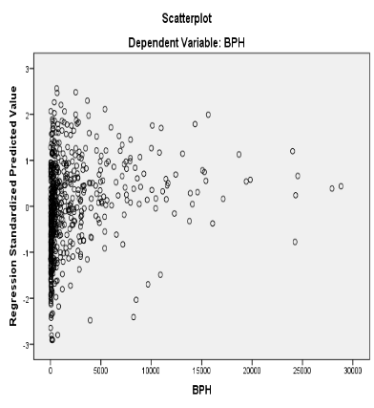 | 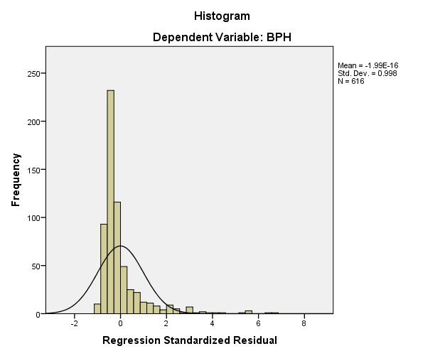 | 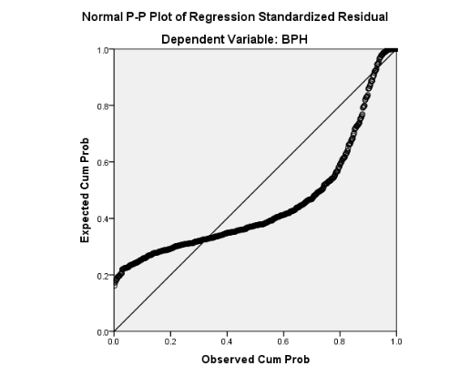
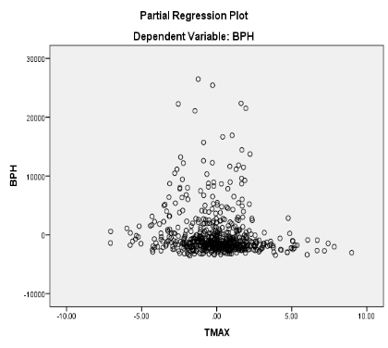 | 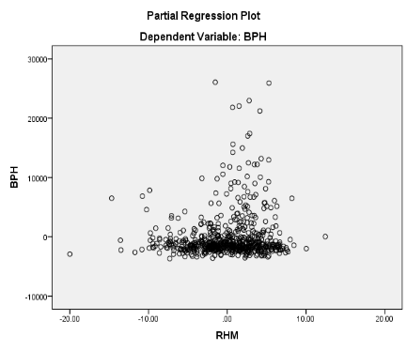 | 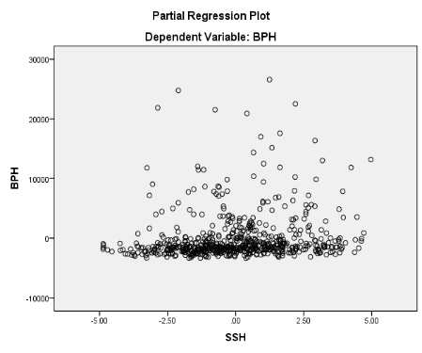
Fig 5: Regression diagnosis of Kharif BPH population with weather parameters
4.6. BPH Pest- Rabi
4.6.1. Descriptive Statistics
Table 16 summarizes BPH population statistics and external weather variables in BPH, showing a high coefficient of variation (CV) at 212.3% that indicates data heterogeneity. Additionally, skewness and kurtosis values suggest deviations from normal distribution. The weather variables also exhibit considerable variability, underscoring the diverse characteristics of the data.
Table 16. Summary statistics of Brown Plant Hopper (BPH) during Rabi Season at RARS, Maruteru
 | BPH | TMAX | TMIN | RHM | RHE | RF | SSH
Count | 420.0 | 420.0 | 420.0 | 420.0 | 420.0 | 420.0 | 420.0
Mean | 4454.3 | 31.3 | 22.5 | 87.8 | 61.5 | 3.9 | 7.6
Std. Deviation | 9455.2 | 2.9 | 2.9 | 4.8 | 12.0 | 17.1 | 1.3
Variance | 89400600.4 | 8.6 | 8.4 | 23.3 | 144.0 | 292.9 | 1.7
Skewness | 3.8 | 0.2 | 0.0 | -2.0 | -0.7 | 6.1 | -1.1
Kurtosis | 17.6 | 1.0 | -0.2 | 7.8 | -0.1 | 42.3 | 1.9
Minimum | 0.0 | 19.3 | 12.0 | 57.4 | 24.7 | 0.0 | 1.4
Maximum | 77725.0 | 42.8 | 29.7 | 97.6 | 87.6 | 152.0 | 9.9
CV% | 212.3 | 9.4 | 12.9 | 5.5 | 19.5 | 439.2 | 17.2
4.6.2. Correlation Analysis
The Pearson correlation coefficients between populations Brown Plant Hopper (BPH) and the weather variables analysed are shown in Table 17. Minimal positive and significant correlation was observed between the BPH population and TMAX (0.209), TMIN (0.204), RF (0.107) and SSH (0.144). Conversely, a minimal positive and non-significant correlation between the BPH population and RHM (0.043) and RHE (0.038) was noted.
Table 17. Pearson correlation coefficients between populations Brown Plant Hopper (BPH) and weather variables during Rabi Season
 | BPH | TMAX | TMIN | RHM | RHE | RF
TMAX | .209**  (<0.0001)
TMIN | .204**  (<0.0001) | .811**  (<0.0001)
RHM | .043  (0.373) | -.138**  (0.005) | -.215**  (<0.0001)
RHE | .038  (0.437) | -.358**  (<0.0001) | -.156**  (<0.001) | .152**  (0.002)
RF | .107*  (0.029) | .111*  (0.024) | .162**  (0.001) | -.026  (0.589) | .046  (0.351)
SSH | .144**  (0.003) | .261**  (<0.0001) | .131**  (0.007) | .021  (0.667) | -.130**  (0.007) | -.147**  (0.003)

4.6.3. Step Wise Regression Analysis
A step wise regression analysis was performed to identify the most Influential predictors of weather parameter of BPH pest. The criteria for variable entry & removal were set at of F-to enter ≤ 0.050 and a probability of F-to-remove ≥ 0.100. In the 1st step MAX TEMP was entered into the Model: resulting in a significant Improvement, F (1,418) = 19.102) P<0.001. In second step, RHE was added, Leading to and significant enhancement, F (2,417) = 12.918, P 0.0001. In third step SSH was added, Leading to another significant enhancement F (3,416) = 10.096, P<0.0001. In the final model Including TMAX, RHE, SSH are demonstrated a strong fit, accounting for demonstrated the most influential weather parameters for BPH growth (R²=0.068; adj R² = 0.061) in the first step, the regression equation is
BPH (Rabi) = -16605.672+672.88(TMAX)
highlighting the significant Positive Impact of T MAX in BPH growth (t = 4.371, p<0.001, β= -0.209). In second step, with the addition of RHE the regression equation became
BPH (Rabi) = -27561.907+822.364(TMAX)+40.104(RHE)
Both TMAX (t = 5.019, p=0.0001, beta = 0.255) and RHE (t=2.546, P= 0.011, beta = 0.130) showed positive Standardized co-efficient, suggesting their contribution to the growth of BPH. In third step with the addition of SSH the regression equation becomes
BPH (Rabi) = -30840.824+742.382(TMAX)+39.982(RHE)+354.922(SSH)
In TMAX (t =4.426, p =0.0001, beta= 0.231), RHE (t= 2.638, p =0.009, beta = 0.134) and SSH (t =2.062, p = 0.040, beta =0.101) these three weather factors are showing positive standardized coefficients, suggesting their contribution to the growth of BPH. Finally, we conclude that TMAX, RHE and SSH are the 3 major weather factors influence the growth of BPH of Rabi season in paddy.
Table 18. Stepwise regression model for population Brown Plant Hopper (BPH) during Rabi and weather variables
ANOVAª
Model |  |  |  |  | Sum of Squares |  |  |  | df |  | Mean Square |  | F |  | Sig.
1 |  | Regression |  |  | 1636999063.544 |  |  |  | 1 |  | 1636999063.544 |  | 19.102 |  | .000^{b}
 |  | Residual |  |  | 35821852516.971 |  |  |  | 418 |  | 85698211.763
 |  | Total |  |  | 37458851580.514 |  |  |  | 419
2 |  | Regression |  |  | 2185404920.884 |  |  |  | 2 |  | 1092702460.442 |  | 12.918 |  | .000^{c}
 |  | Residual |  |  | 35273446659.630 |  |  |  | 417 |  | 84588601.102
 |  | Total |  |  | 37458851580.514 |  |  |  | 419
3 |  | Regression |  |  | 2542270627.847 |  |  |  | 3 |  | 847423542.616 |  | 10.096 |  | .000^{d}
 |  | Residual |  |  | 34916580952.668 |  |  |  | 416 |  | 83934088.829
 |  | Total |  |  | 37458851580.514 |  |  |  | 419
Model Summary
Model |  |  | R |  |  | R Square |  | Adjusted R Square |  |  |  | Std. Error of the Estimate
1 |  |  | .209ª |  |  | .044 |  | .041 |  |  |  | 9257.333
2 |  |  | .242^{b} |  |  | .058 |  | .054 |  |  |  | 9197.206
3 |  |  | .261^{c} |  |  | .068 |  | .061 |  |  |  | 9161.555
Coefficientsª
Model |  |  |  | Unstandardized Coefficients |  |  |  |  |  | Standardized Coefficients |  |  |  | t |  | Sig.
 |  |  |  | B |  |  | Std. Error |  |  | Beta |  |  |  |  |  | Sig.
1 | (Constant) |  |  | -16605.672 |  |  | 4839.714 |  |  |  |  |  |  | -3.431 |  | .001
1 | TMAX |  |  | 672.888 |  |  | 153.959 |  |  | .209 |  |  |  | 4.371 |  | .000
2 | (Constant) |  |  | -27561.907 |  |  | 6452.513 |  |  |  |  |  |  | -4.271 |  | .000
2 | TMAX |  |  | 822.364 |  |  | 163.837 |  |  | .255 |  |  |  | 5.019 |  | .000
2 | RHE |  |  | 102.115 |  |  | 40.104 |  |  | .130 |  |  |  | 2.546 |  | .011
3 | (Constant) |  |  | -30840.824 |  |  | 6621.288 |  |  |  |  |  |  | -4.658 |  | .000
3 | TMAX |  |  | 742.382 |  |  | 167.748 |  |  | .231 |  |  |  | 4.426 |  | .000
3 | RHE |  |  | 105.488 |  |  | 39.982 |  |  | .134 |  |  |  | 2.638 |  | .009
3 | SSH |  |  | 731.840 |  |  | 354.922 |  |  | .101 |  |  |  | 2.062 |  | .040

4.6.4. Discussion
In this study, the stepwise regression model demonstrated a weak fit, indicated by a low $R^{2}$ value (6.8%). This weakness is likely due to non-linearity and considerable variation in the dependent variable (High Heterogeneity), making it difficult to establish a strong link between BPH populations and exogenous weather variables during the Rabi season. This trend is also evident in Fig.6. Stepwise regression results identified that TMAX, RHE and SSH are the three main weather factors significantly influencing the growth of the BPH pest in paddy fields. It is also important to acknowledge that other potential factors affecting BPH incidence were not included in this analysis. A related study by Prasannakumar et al (2014) a stepwise regression revealed that RH2 (RHE), RF, and TMAX were significant factors influencing BPH light trap captures. By using stepwise regression, it was discovered that RF and TMAX were significant factors influencing BPH light trap captures. Their absence from the analysis led to lower R² values of 0.80 (P=0.010), 0.46 (P=0.16), and 0.26 (P=0.4), respectively.
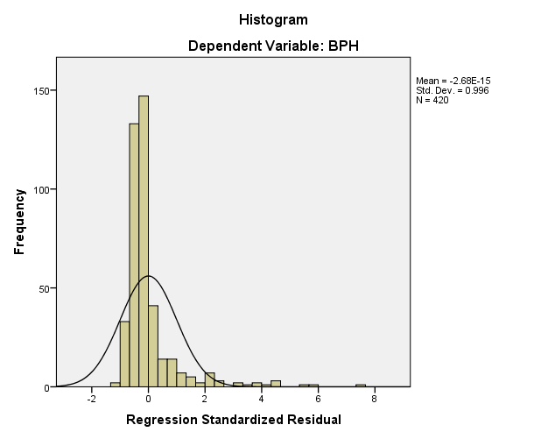 | 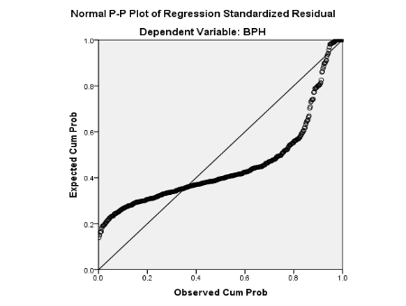 | 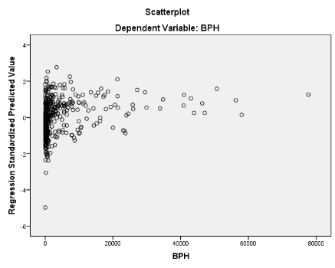
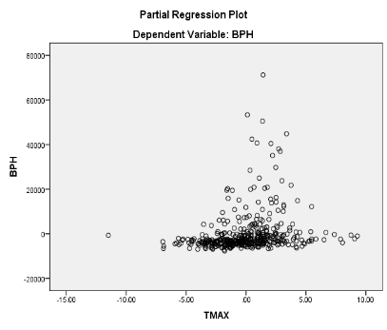 | 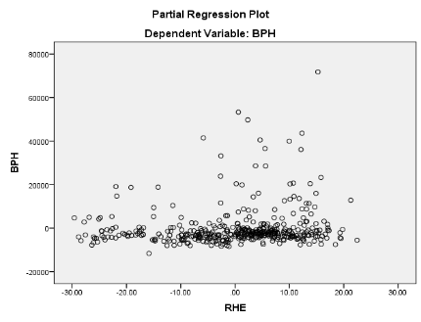 | 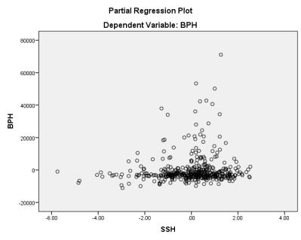
Fig 6. Regression diagnosis of Rabi BPH population with weather parameters
4.7. Leaf Folder Pest- Kharif
4.7.1. Descriptive Statistics
Table 19 summarizes the RLF population and weather variables of kharif season, indicating a high coefficient of variation (CV) at 323.8%, reflecting data heterogeneity. Skewness and kurtosis values suggest deviations from normal distribution, highlighting data irregularity. Overall, the weather variables exhibit considerable variation and distinct characteristics.
Table 19. Summary statistics of Rice Leaf Folder (RLF) during Kharif Season at RARS, Maruteru
 | LF | TMAX | TMIN | RHM | RHE | RF | SSH
Count | 616 | 616 | 616 | 616 | 616 | 616 | 616
Mean | 57.4 | 30.4 | 24.0 | 87.1 | 70.6 | 30.3 | 4.9
Std. Deviation | 185.9 | 2.3 | 2.9 | 4.4 | 9.9 | 48.0 | 2.0
Variance | 34560.4 | 5.2 | 8.2 | 19.4 | 97.3 | 2299.6 | 4.1
Skewness | 10.2 | 0.5 | -0.7 | -0.6 | -0.4 | 3.3 | 0.0
Kurtosis | 149.2 | 1.3 | -0.1 | 0.6 | 0.1 | 17.4 | -0.5
Minimum | 0.0 | 22.9 | 16.2 | 69.9 | 40.4 | 0.0 | 0.0
Maximum | 3247.0 | 39.6 | 30.7 | 96.9 | 95.1 | 428.6 | 9.6
CV% | 323.8 | 7.5 | 11.9 | 5.1 | 14.0 | 158.2 | 41.3

4.7.2. Correlation Analysis
The Pearson correlation coefficients between Rice Leaf Folder (RLF) populations and the weather variables analysed are shown in Table 20. A minimal negative and non-significant correlation was found between the RLF population and RHM (-0.048) and RF (-0.023). Additionally, a minimal negative and significant correlation was observed between the RLF population and, TMAX (-0.096), TMIN (-0.096) and RHE (-0.102). Conversely a minimal positive and significant correlation between the RLF population and SSH (0.089) was noted.
Table 20. Pearson correlation coefficients between populations Rice Leaf Folder (RLF) and weather variables during Kharif Season
 | LF | TMAX | TMIN | RHM | RHE | RF
TMAX | -.096*  (0.017)
TMIN | -.096*  (0.017) | .527**  (<0.0001)
RHM | -.048  (0.237) | -.334**  (<0.0001) | -.196**  (<0.0001)
RHE | -.102*  (0.011) | -.370**  (<0.0001) | .150**  (<0.0001) | .401**  (<0.0001)
RF | -.023  (0.575) | -.124**  (0.002) | .143**  (<0.0001) | .203**  (<0.0001) | .233**  (<0.0001)
SSH | .089*  (0.027) | .212**  (<0.0001) | -.242**  (<0.0001) | -.147**  (<0.0001) | -.357**  (<0.0001) | -.342**  (<0.0001)

4.7.3. Step Wise Regression Analysis
A step wise regression analysis was performed to identify the most Influential predictors of weather parameter of leaf folder pest. The criteria for variable entry & removal were set at of F-to enter ≤ 0.050 and a probability of F-to-remove ≥ 0.100 In the 1st step RHE was entered into the model: resulting in a significant Improvement, F (1,614) = 6.444) P<.011. In second step, TMAX was added, leading to another significant enhancement, F (2,613) = 9.822, P = 0.001. In the final model Including both RHE and TMAX are demonstrated a strong fit, demonstrated the most influential weather parameters for leaf folder growth (R²=0.176; adj R² = 0.031). In the first step, the regression equation is
RLF (Kharif) =192.994 -1.921(RHE)
High lighting the significant Positive Impact of RHE on leaf folder pest growth (t = -2.5391, p<0.001, β= -0.102). In second step, with the addition of TMAX the regression equation became
RLF (Kharif) = 651.124-2.999(RHE)-12.573(MAX T)
Both RHE (t=-3.718, p=0.0001, beta=-0.159) and MAX TEMP (t=-3.616, p=0.0001, beta=-0.155). These two weather parameters are showing positive standard coefficients, suggesting their contribution to the growth of leaf folder. Finally, we conclude that RHE and MAX TEMP are the two major weather parameters influence the growth of leaf folder in kharif season in paddy crop.
Table 18. Stepwise regression model for population Rice Leaf Folder (RLF) during Kharif and weather variables
ANOVAª
Model |  |  |  |  |  | Sum of Squares |  |  | df |  | Mean Square |  | F |  | Sig.
1 |  | Regression |  |  |  | 220763.127 |  |  | 1 |  | 220763.127 |  | 6.444 |  | .011^{b}
 |  | Residual |  |  |  | 21033857.287 |  |  | 614 |  | 34257.097
 |  | Total |  |  |  | 21254620.414 |  |  | 615
2 |  | Regression |  |  |  | 659977.539 |  |  | 2 |  | 329988.770 |  | 9.822 |  | .000^{c}
 |  | Residual |  |  |  | 20594642.875 |  |  | 613 |  | 33596.481
 |  | Total |  |  |  | 21254620.414 |  |  | 615
Model Summary
Model |  |  | R |  | R Square |  |  | Adjusted R Square |  |  |  | Std. Error of the Estimate
1 |  |  | .102ª |  | .010 |  |  | .009 |  |  |  | 185.087
2 |  |  | .176^{b} |  | .031 |  |  | .028 |  |  |  | 183.293
Coefficientsª
Model |  |  |  | Unstandardized Coefficients |  |  |  |  |  | Standardized Coefficients |  |  |  | t |  | Sig.
 |  |  |  | B |  |  | Std. Error |  |  | Beta |  |  |  |  |  | Sig.
1 | (Constant) |  |  | 192.994 |  |  | 53.923 |  |  |  |  |  |  | 3.579 |  | .000
1 | RHE |  |  | -1.921 |  |  | .757 |  |  | -.102 |  |  |  | -2.539 |  | .011
2 | (Constant) |  |  | 651.124 |  |  | 137.499 |  |  |  |  |  |  | 4.735 |  | .000
2 | RHE |  |  | -2.999 |  |  | .806 |  |  | -.159 |  |  |  | -3.718 |  | .000
2 | TMAX |  |  | -12.573 |  |  | 3.477 |  |  | -.155 |  |  |  | -3.616 |  | .000

4.7.4. Discussion
In this study, the stepwise regression model demonstrated a weak fit, indicated by a low R² value (17.6%). This weakness is likely due to non-linearity and the considerable variation in the dependent variable (high heterogeneity), which makes it difficult to establish a strong relationship between Rice Leaf Folder (RLF) populations and exogenous weather variables during the Kharif season (Fig. 7). The analysis identified maximum temperature (TMAX), evening relative humidity (RHE), and sunshine hours (SSH) as the three main weather factors significantly influencing RLF incidence in paddy fields. It is also important to note that other potential factors affecting RLF populations were not included in this analysis.
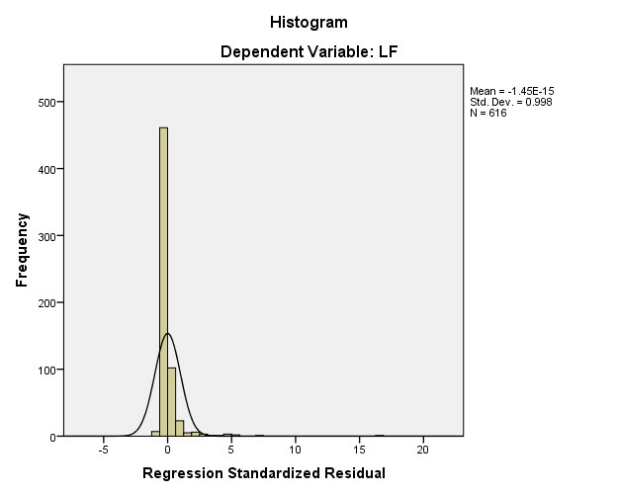 | 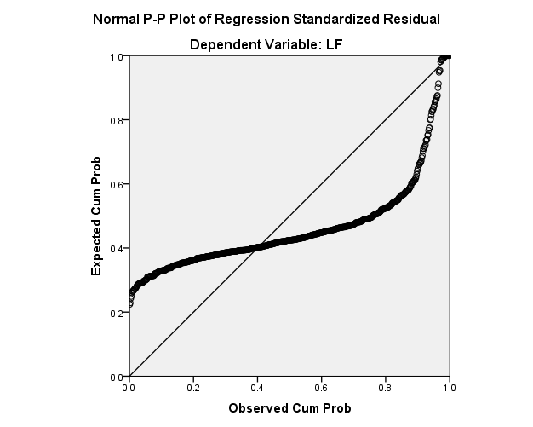 | 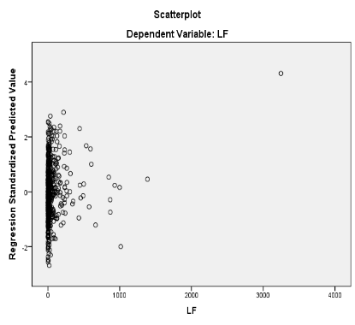
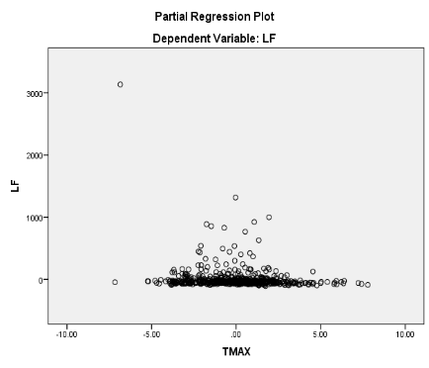 | 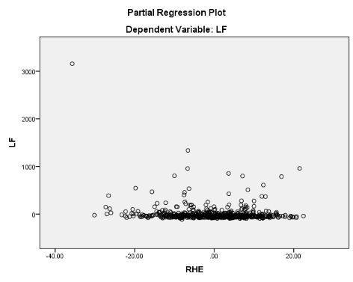
Fig 7: Regression diagnosis of Kharif RLF population with weather parameters
A related study by Manikandan et al. (2024) reported that different weather parameters have varying relationships with the populations of budworms, ants, and pod flies. Their analysis showed that maximum temperature, evening relative humidity, and rainfall significantly influenced these insect pest populations, while other factors such as minimum temperature, morning relative humidity, and wind speed exhibited weaker associations.
4.8. Rice Leaf Folder Pest-Rabi
4.8.1. Descriptive statistics
Table 22 summarizes RLF population statistics and weather variables of Rabi season, revealing a high coefficient of variation (CV) of 187%, indicating data heterogeneity. Skewness and kurtosis values suggest a departure from normal distribution. Overall, the statistics demonstrate significant variability in the weather variables studied.
Table 22. Summary statistics of Rice Leaf Folder (RLF) during Rabi Season at RARS, Maruteru
 | LF | TMAX | TMIN | RHM | RHE | RF | SSH
Count | 420.0 | 420.0 | 420.0 | 420.0 | 420.0 | 420.0 | 420.0
Mean | 16.6 | 31.3 | 22.5 | 87.8 | 61.5 | 3.9 | 7.6
Std. Deviation | 31.0 | 2.9 | 2.9 | 4.8 | 12.0 | 17.1 | 1.3
Variance | 962.2 | 8.6 | 8.4 | 23.3 | 144.0 | 292.9 | 1.7
Skewness | 3.5 | 0.2 | 0.0 | -2.0 | -0.7 | 6.1 | -1.1
Kurtosis | 17.0 | 1.0 | -0.2 | 7.8 | -0.1 | 42.3 | 1.9
Minimum | 0.0 | 19.3 | 12.0 | 57.4 | 24.7 | 0.0 | 1.4
Maximum | 279.0 | 42.8 | 29.7 | 97.6 | 87.6 | 152.0 | 9.9
CV% | 187.0 | 9.4 | 12.8 | 5.5 | 19.5 | 439.2 | 17.2

4.8.2. Correlation Analysis
The Pearson correlation coefficients between Rice Leaf Folder (RLF) populations and the weather variables analysed are shown in Table 23. A minimal negative and significant correlation was found between the RLF population and RHE (-0.29). Additionally, a minimal positive and non-significant correlation was observed between the RLF population and RHM (0.074), RF (0.046) and SSH (0.089).Conversely a minimal positive and significant correlation between the RLF population and TMAX (0.174) and TMIN (0.163) was noted.
Table 23. Pearson correlation coefficients between populations Rice Leaf Folder (RLF) and weather variables during Rabi Season
 | LF | TMAX | TMIN | RHM | RHE | RF
TMAX | .174**  (<0.0001)
TMIN | .163**  (<0.001) | .811**  (<0.0001)
RHM | .074  (<0.129) | -.138**  (<0.005) | -.215**  (<0.0001)
RHE | -.290**  (<0.0001) | -.358**  (<0.0001) | -.156**  (<0.001) | .152**  (<0.002)
RF | .046  (<0.344) | .111*  (<0.024) | .162**  (<0.001) | -.026  (<0.589) | .046  (<0.351)
SSH | .089  (<0.068) | .261**  (<0.0001) | .131**  (<0.007) | .021  (<0.667) | -.130**  (<0.007) | -.147**  (<0.003)

4.8.3. Step Wise Regression Analysis
A step wise regression analysis was performed to identify the most Influential predictors of weather parameter of leaf folder pest. The criteria for variable entry & removal were set at of F-to enter ≤ 0.050 and a probability of F-to-remove ≥ 0.100. In the 1st step RHE was entered into the Model: resulting in a significant Improvement, F (1,418) = 38.509) P<0.001. In second step, RHM was added, Leading to and significant enhancement, F (2,417) = 22.823, P 0.0001. In third step MIN TEMP was added, Leading to another significant enhancement F (3,416=18.853, P<0.001. In the final model Including RHE, RHM, TMIN are demonstrated a strong fit, accounting for demonstrated the most influential weather parameters for leaf folder growth (R²=0.120; Adj R² = 0.113 in the first step, the regression equation is
RLF (Rabi) = 62.748-0.751(RHE)
High lighting the significant Positive Impact of RHE in leaf folder growth (t=-6.206, p<0.001, β= -0.290). In second step, with the addition of RHM the regression equation became
RLF (Rabi) = -2.565-0.798(RHE)+0.777(RHM)
Both RHE (t = -6.565, p=0.001, beta = -0.309) and RHM (t=2.573, P= 0.001, beta = -0.121) showed positive Standardized co-efficient, suggesting their contribution to the growth of leaf folder. In third step with the addition of min temp the regression equation becomes
RLF (Rabi) = -58.277-0.749(RHE)+0.966(RHM)+1.605(MIN T)
In RHE (t =-6.176, p =0.0001, beta= -0.290), RHM (t = 3.169, p =0.002, beta = 0.150) and MIN TEMP (t =3.152, p = 0.002, beta =0.150) these three weather factors are showing positive standardized coefficients, suggesting their contribution to the growth of leaf folder. Finally, we conclude that RHE, RHM, TMIN are 3 major weather factors influence the growth of leaf folder in Rabi season in paddy.
Table 24. Stepwise regression model for population Rice Leaf Folder (RLF) during Rabi and weather variables
ANOVA
Model |  |  |  |  |  | Sum of Squares |  |  | df |  | Mean Square |  | F |  | Sig.
1 |  | Regression |  |  |  | 34008.043 |  |  | 1 |  | 34008.043 |  | 38.509 |  | .000^{b}
 |  | Residual |  |  |  | 369143.336 |  |  | 418 |  | 883.118
 |  | Total |  |  |  | 403151.379 |  |  | 419
2 |  | Regression |  |  |  | 39776.590 |  |  | 2 |  | 19888.295 |  | 22.823 |  | .000^{c}
 |  | Residual |  |  |  | 363374.789 |  |  | 417 |  | 871.402
 |  | Total |  |  |  | 403151.379 |  |  | 419
3 |  | Regression |  |  |  | 48252.888 |  |  | 3 |  | 16084.296 |  | 18.853 |  | .000^{d}
 |  | Residual |  |  |  | 354898.491 |  |  | 416 |  | 853.121
 |  | Total |  |  |  | 403151.379 |  |  | 419
Model Summary^{d}
Model |  |  | R |  | R Square |  | Adjusted R Square |  |  |  |  | Std. Error of the Estimate
1 |  |  | .290ª |  | .084 |  | .082 |  |  |  |  | 29.717
2 |  |  | .314^{b} |  | .099 |  | .094 |  |  |  |  | 29.520
3 |  |  | .346^{c} |  | .120 |  | .113 |  |  |  |  | 29.208
Coefficientsª
Model |  |  |  | Unstandardized Coefficients |  |  |  |  |  | Standardized Coefficients |  |  |  | t |  | Sig.
 |  |  |  | B |  |  |  | Std. Error |  | Beta |  |  |  |  |  | Sig.
1 | (Constant) |  |  | 62.748 |  |  |  | 7.578 |  |  |  |  |  | 8.281 |  | .000
1 | RHE |  |  | -.751 |  |  |  | .121 |  | -.290 |  |  |  | -6.206 |  | .000
2 | (Constant) |  |  | -2.565 |  |  |  | 26.478 |  |  |  |  |  | -.097 |  | .923
2 | RHE |  |  | -.798 |  |  |  | .122 |  | -.309 |  |  |  | -6.565 |  | .000
2 | RHM |  |  | .777 |  |  |  | .302 |  | .121 |  |  |  | 2.573 |  | .010
3 | (Constant) |  |  | -58.277 |  |  |  | 31.603 |  |  |  |  |  | -1.844 |  | .066
3 | RHE |  |  | -.749 |  |  |  | .121 |  | -.290 |  |  |  | -6.176 |  | .000
3 | RHM |  |  | .966 |  |  |  | .305 |  | .150 |  |  |  | 3.169 |  | .002
3 | TMIN |  |  | 1.605 |  |  |  | .509 |  | .150 |  |  |  | 3.152 |  | .002
4.8.4. Discussion
In this study, the stepwise regression model demonstrated a weak fit, indicated by a low $R^{2}$ value (12%). This weakness is likely due to non-linearity and considerable variation in the dependent variable (High Heterogeneity), making it difficult to establish a strong link between BPH populations and exogenous weather variables during the Rabi season.
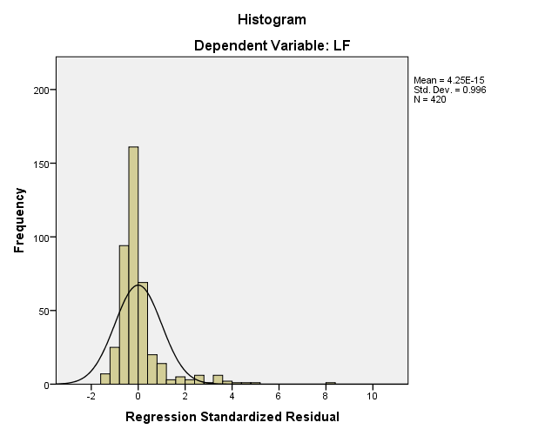 | 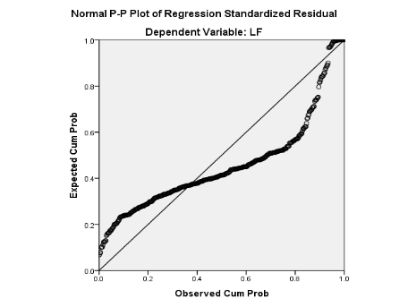 | 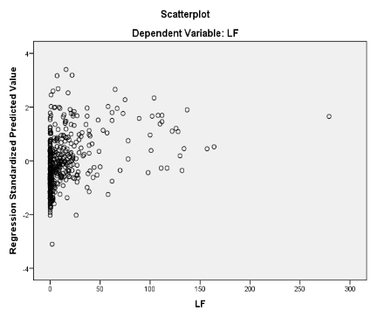
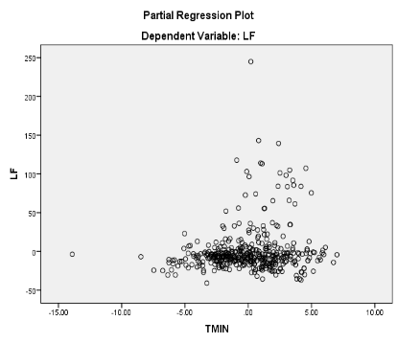 | 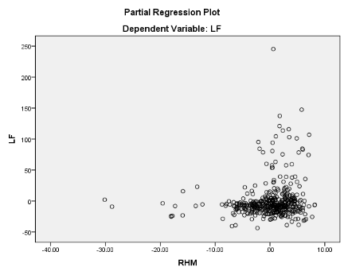 | 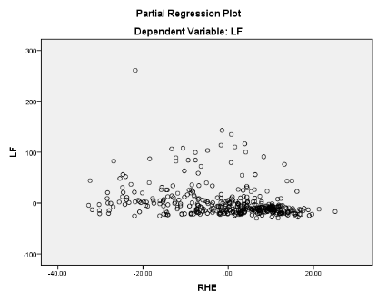
Fig 8. Regression diagnosis of Rabi RLF population with weather parameters
This trend is also evident in Fig.8. Stepwise regression results identified that RHE, RHM and TMIN are the three main weather factors significantly influencing the growth of the RLF pest in paddy fields. It is also important to acknowledge that other potential factors affecting RLF incidence were not included in this analysis. Similarly, a related study by Venkataviswateja et al. (2023), the minimum temperature had a significant negative relationship with the leaf folder, but the maximum temperature, rainfall, relative humidity in the morning, and relative humidity in the evening did not have a significant relationship. Rainfall and the highest temperature were found to be significant negative effects using stepwise regression. However, the low R² at Bapatla indicates weak model fit due to non-linearity and high heterogeneity.
5. CONCLUSION
In the present study, different regression models were developed to examine the relationship between weather variables, namely maximum temperature (TMAX), minimum temperature (TMIN), total rainfall (RF), morning relative humidity (RHM), evening relative humidity (RHE), and sunshine hours (SSH). These models, based on more than two decades of data, showed a lower range of R² values, indicating that they were not a strong fit for a linear model due to non-linearity and high heterogeneity in insect pest occurrence. The results revealed that the stepwise linear regression model was unable to capture the patterns in the heterogeneous count data, as it yielded high RMSE values, whereas the count regression model performed better identifying the relationship between weather variables and Rice pest population
Anyhow, these models offer valuable insights into the climatic triggers of pest outbreaks, enabling reliable pest forecasting and aiding climate-responsive integrated pest management practices in rice cultivation across coastal Andhra Pradesh. As per the recent studies weather pest relations can be unrevealed with Machine Learning models.
Disclaimer (Artificial intelligence)
Author(s) hereby declare that NO generative AI technologies such as Large Language Models (ChatGPT, COPILOT, etc.) and text-to-image generators have been used during the writing or editing of this manuscript.
6. ACKNOWLEDGEMENTS
The author would like to thank the Regional Agricultural Research Station, (RARS) Maruteru, Andhra Pradesh, for providing the necessary facilities to carry out this Research work.
7. COMPETING INTERESTS
Authors have declared that no competing interests exist.
8. REFERENCES
- Ali, Y., Raza, A., Iqbal, S., Khan, A.A., Aatif, H.M., Hassan, Z., Hanif, C.M.S., Ali, H.M., Mosa, W.F., Mubeen, I. and Sas-Paszt, L. 2022. Stepwise regression models-based prediction for leaf rust severity and yield loss in wheat. Sustainability, 14(21): 13893.
- Ali, Y., Qin, A., Aatif, H.M., Ijaz, M., Khan, A.A., Ahmad, S., Shahzad, U., Yasin, M. and Rahman, S.U. 2022. A stepwise multiple regression model to predict Fusarium wilt in lentil. Meteorological Applications, 29(4): e2088.
- Arumugam Gopalakrishnan, M., Chellappan, G., Patil, S.G., Rathod, S., Ayyanar, K., Ramasamy, J., Nagaranai Karuppasamy, S. and Swaminathan, M. 2024. Climate-Based Prediction of Rice Blast Disease Using Count Time Series and Machine Learning Approaches. AgriEngineering. 6(4):4353-4371.
- Biradar B, Kulkarni SA, Shobharani M, Sidramappa GB, Rathod S, Naveena K, et al. 2023. Enhancing legume crop protection: Machine learning approach for accurate prediction of lepidopteran pest populations in Kalyan Karnataka. The Pharma Innovation. 12(4):2319 2326.
- Chakraborty, S., Ghosh, R., Ghosh, M., Fernandes, C.D., Charchar, M.J. and Kelemu, S. 2004. Weather‐based prediction of anthracnose severity using artificial neural network models. Plant Pathology. 53(4): 375-386.
- Gholap, S.V., Asewar, B.V. and Kale, A.S. 2022. Development of regression model to predict BT cotton (Gossypium spp.) yield using meteorological variables for Parbhani and Nanded locations.
- Kadam, D.R., Timke, S.H., Dakhore, K.K. and Kadam, Y.E. 2022. Seasonal abundance of major insect pest on Bt cotton vis-à-vis weather parameters in Marathwada region, Maharashtra. Journal of Agrometeorology, 24(4):430-433.
- Khan, M.A., Rasheed, S. and Ali, S. 2006. Evaluation of multiple regression models based on epidemiological factors to forecast Bemisia tabaci and mungbean yellow mosaic virus. Pak. J. Phytopathol, 18(2): 107-110.
- Krishnaiah, K and Varma, N.R.G. 2011. Changing insect pest scenario in the rice ecosystem—A national perspective. Rice Knowledge Management Portal. 1: 1-28.
- Luo, S.J. 2010. Occurrence of rice leaf roller in China and its identification and prevention. Plant Diseases and Pests 1: 13–18.
- Manikandan, P. and Rengalakshmi, R. 2024. Influence of weather factors on population dynamics of major insect pests in Moringa (Moringa oleifera Lam.) in south Tamil Nadu. Journal of Agrometeorology, 26(2): 238-242.
- Minruhi, P., Kumari, P.L., Rathod, S., Murthy, B., Ramana and Devaki, K. 2023. Statistical evaluation of stepwise regression method for earwig population in groundnut (Arachis hypogaea L.). The Pharma Innovation. 12(12): 397-403.
- Nanda, V.K. and R. C. Bisoi. 1990. Bionomics of rice L7 C.M. Orissa J. Agrl. 3(2): 130-135.
- P. Lavanya Kumari, I. Paramasiva, U. Vineetha, A. Veeraiah, Sk. Shameem, P.N. Harathi, A.D.V.S.L.P Anand Kumar, M. Siva Rama Krishna, N. Sambasiva Rao, P. Udayababu, J. Manjunath, N. Kamakshi, and V. Visalakshmi. 2025. “Modeling and Predicting Rice Gall Midge Populations Using Climate Data and Machine Learning Techniques in Andhra Pradesh”. International Journal of Environment and Climate Change. 15 (10):467–484.
- P. Lavanya Kumari, I. Paramasiva, U. Vineetha, A. Veeraiah, SK. Shameem, P.N. Harathi, A.D.V.S.L.P Anand Kumar, M. Siva Rama Krishna, N. Sambasiva Rao, P. Udayababu, J. Manjunath, N. Kamakshi, V. Visalakshmi, and P. Siva. 2025. “Climate-Driven Forecasting of Brown Planthopper in Rice Fields Using Hybrid Machine Learning and Time Series Models”. International Journal of Environment and Climate Change. 15 (6):494–514.
- Prakash, A., David, B and OM, B. 2014. Plant protection in India: Challenges and research priorities. Applied Zoologists Research Association (AZRA). 170.
- Prasannakumar, N.R. and Chander, S. 2014. Weather-based brown planthopper prediction model at Mandya, Karnataka. Journal of Agrometeorology. 16(1): 126-129.
- Rana, R., Singh, G., Tanwar, A.K. and Kumar, R. 2017. Effect of weather parameters on the infestation of yellow stem borer, Scirpophaga incertulas Walker in basmati rice. Journal of Entomology and Zoology Studies. (3): 24-27.
- Rathod, S., Yerram, S., Arya, P., Katti, G., Rani, J., Padmakumari, A.P., Somasekhar, N., Padmavathi, C., Ondrasek, G., Amudan, S and Malathi, S. 2021. Climate-based modeling and prediction of rice gall midge populations using count time series and machine learning approaches. Agronomy. 12(1): 22.
- Razzaque, Q.M.A., Heinrichs, E.A and Rapusas, H.R. 1985. Mass rearing technique for the rice green leafhopper Nephotettix nigropictus (Stal). Philippine Entomologist. 6(4): 398-404.
- Reddy, B.N.K., Rathod, S., Kallakuri, S., Sridhar, Y., Admala, M., Malathi, S., Pandit, P and Jyostna, B. 2022. Modelling the Relationship between Weather Variables and Rice Yellow Stem Borer Population: A Count Data Modelling Approach. International Journal of Environment and Climate Change. 12(11): 3623-3632.
- Reddy, B.N.K. 2023. Development of Zero-Inflated Count Time Series Models For Forecasting Yellow Stem Borer (Scirpophaga Incertulas) Populations Of Rice. Doctoral dissertation. Proffessor Jayashankar Telangana State Agricultural University.
- Reddy, B.N.K., Rathod, S., Sridhar, Y., Kallakuri, S., Pandit, P., Jyostna, B., Malathi, S., Kumar, R.S., Sharma, S., Karthikeyan, K. and Varma, N.R.G. 2025. An innovative two-stage, zero-inflated, hybrid count time series model for predicting rice yellow stem borer using weather parameters in hotspot locations of India. Smart Agricultural Technology, 12: 101381.
- Sagar, D., Nebapure, S.M. and Chander, S. 2017. Development and validation of weather based prediction model for Helicoverpa armigera in chickpea. Journal of Agrometeorology. 19(4): 328-333.
- Shah, S., Ali, M., Rehman, U. H., Rehman, A., Abbasi, F. M., Khalil, I. H., and Ali, A. 2008. Characterization of wild rice species in response to leaf folder (Cnaphalocrocis medinalis). Sarh. J. Agri. 24(1): 69-74.
- Paul, R.K., Vennila, S., Yadav, S.K., Bhat, M.N., Kumar, M., Chandra, P., Paul, A.K. and Prabhakar, M. 2020. Weather based forecasting of sterility mosaic disease in pigeonpea (Cajanus cajan) using machina learning techniques and hybrid models. Indian J. Agric. Sci, 90(10): 1952-8.
- Udayababu, P., Sowjanya, P. and Jogarao, P. 2021. Population dynamics of rice Insect pests through light trap catches and its relation to abiotic factors in high altitude tribal zone of Seethampeta in Andhra Pradesh, India. International Journal of Environment and Climate Change. 11(12): 187-194.
- Venkataviswateja, B., Rao, V.S., Dhandapani, A., Reddy, G.R., Ramesh, D. and Kumar, A.A. 2023. Modelling of leaf folder populations (Cnaphalocrocis medinalis) in Paddy: A count time series approach. International Journal of Statistics and Applied Mathematics. 8: 257-261.

