Shifts in Drought and Wetness Patterns: An SPI-Based Taluka Level Analysis for Selected Districts of Saurashtra

Abstract
This study investigates long-term hydro-climatic variability in the Saurashtra region of western India by analysing taluka-level rainfall patterns using the Standardized Precipitation Index (SPI) for the period 1981–2023. Drawing on high-resolution ERA5-Land reanalysis data, drought and wetness characteristics were assessed for three major districts—Amreli, Junagadh, and Rajkot—across two contrasting climatic phases: 1981–2000, marked by recurrent droughts, and 2001–2023, characterized by strengthened monsoon rainfall. Results reveal pronounced shifts in drought–wetness regimes across all talukas. The pre-2000 period exhibited frequent moderate to severe droughts, with several talukas experiencing extreme drought conditions, particularly during 1984, 1986, and 1987. In contrast, the post-2000 period shows a substantial decline in drought frequency and complete disappearance of severe and extreme drought across all districts. Near-normal conditions now dominate 70–88% of the years, accompanied by increased occurrences of moderately, severely, and extremely wet years, especially during events such as 2007 and 2020. District-wise analysis highlights significant spatial differences, with Rajkot showing the strongest improvement, followed by Junagadh and Amreli. The findings demonstrate a clear regional transition from a drought-dominated regime toward a more stable and wetter monsoon climate. This taluka-level hydro-climatic assessment provides a robust scientific basis for strengthening regional climate adaptation strategies, enhancing drought monitoring systems, and supporting sustainable agricultural and water resource management in semi-arid regions such as Saurashtra.
Keywords: Standardized Precipitation Index (SPI); drought analysis; wetness patterns; ERA5-Land; taluka-level, climate variability
Introduction
Drought is an environmental problem that can have devastating effects on the humans, plants, animals, and the environment situations in all climatic zones, including low and high rainfall areas (Sajeev & Kundapura, 2023). The occurrence of drought first triggers as metrological drought in terms of insufficient rainfall and excessive evapotranspiration rates. Long-term meteorological drought can result in hydrological drought because of insufficient surface and subsurface water supplies, and agricultural drought because of insufficient soil moisture to enable good crop development. The meteorological drought cannot be prevented, its effects on agriculture, water resources, and society can be reduced with appropriate risk assessment, monitoring, and mitigation strategies. However, it is anticipated that the frequency and severity of droughts will increase due to ongoing climate change, especially in arid and semi-arid regions (Ramirez et al., 2022; Patil et al., 2023). The detection of drought onset, severity, duration, frequency, and geographical extent are all part of meteorological drought characterisation. As drought is a relative phenomenon, it is challenging to define it in a way that is widely recognized. As a result, the criteria used to assess drought are varied and change depending on local climate circumstances. As a result, accurate assessment of meteorological drought is extremely challenging due to intricate interactions among its properties. For nations like India, where 70–90% of the country's annual rainfall occurs during the southwest monsoon, which runs from June to September (Pandya & Gontia, 2023), the effective characterization of droughts and their proneness among the various regions is more important (Guhan et al., 2020; Hirapara et al., 2025). Any failure in the southwest monsoon puts the nation at high risk of socioeconomic distress because a sizable portion of the population depends on agriculture. In recent decades, rising temperatures and increasing climate variability have intensified the complexity and frequency of drought events, highlighting the need for long-term climatic assessments to support risk-informed planning (Hirapara et al., 2023).
The Saurashtra region of Gujarat exemplifies a landscape where climatic fluctuations exert profound influence on environmental and livelihood systems. Situated in a semi-arid to dry sub-humid climatic zone, the region depends predominantly on the southwest monsoon. The monsoon, however, is marked by substantial spatial and temporal variability. Rainfed agriculture dominates the region, and groundwater remains the principal source of irrigation due to the scarcity of surface water bodies. Consequently, regional water security and agricultural outcomes are tightly coupled with monsoon behavior, making continuous monitoring of rainfall conditions a critical requirement for sustainable development (Vigneshwari et al., 2024).
Historically, Saurashtra has experienced a long sequence of droughts, particularly during the 1980s and 1990s, when several consecutive monsoon failures caused severe crop losses, groundwater depletion, and widespread rural distress (Pandya & Gontia, 2023). Major drought episodes in 1985–1987, 1991, and the prolonged period of 1999–2002 left enduring impacts on agriculture and water resources. Although drought hazards dominate the region’s climatic profile, excessive rainfall also poses considerable challenges (Ratna et al., 2024). Short-duration, high-intensity wet spells often lead to localized flooding, soil erosion, waterlogging, and crop damage, underscoring the importance of assessing not only drought but also wetness anomalies. Together, these conditions highlight the need for a comprehensive characterization of the full spectrum of hydro-climatic extremes (Bharghavi et al., 2025).
Drought indices are the best tool for quantitative trend of the drought (Pandya & Gontia, 2025). Among various drought indicators, the Standardized Precipitation Index (SPI) has emerged as one of the most robust and widely used metrics for quantifying precipitation anomalies. Introduced by Mc Kee et al., (1993) and recommended by the World Meteorological Organization (WMO), SPI provides a probabilistic framework for evaluating short- and long-term moisture conditions across diverse climatic settings (Hirapara et al., 2023). In India, SPI has been extensively applied by the India Meteorological Department (IMD) and numerous researchers to examine drought characteristics across Gujarat, Maharashtra, Rajasthan, Karnataka, and other states (Bhukya et al., 2023; Agarwal et al., 2025; Waghmare et al., 2025). Prior studies consistently document the severity of droughts in Gujarat during the 1980s and 1990s. However, the majority of these analyses were undertaken at district or broader regional scales, limiting the understanding of finer spatial variability. Furthermore, earlier research has rarely integrated both drought and wetness categories, despite their combined significance for agricultural sustainability and hydrological balance.
Despite substantial progress in drought research, important gaps remain in the climatic understanding of Saurashtra. How rainfall patterns have evolved at a fine spatial resolution over the past four decades, particularly across taluka-level administrative units that experience distinct micro-climatic conditions. Moreover, few studies have performed comparative analyses between the historically drought-prone period before 2000, and the relatively wetter conditions observed in the decades that followed (Guria et al., 2025). The lack of such multi-decadal, high-resolution assessments limits the ability to detect localized climatic shifts, emerging patterns of wetness, and evolving vulnerabilities, thereby constraining regional-level planning and climate adaptation strategies (Vigneshwari et al., 2024).
To address these research gaps, the present study undertakes a detailed examination of long-term hydro-climatic variability in Saurashtra by analysing taluka-level SPI patterns from 1981 to 2023. The analysis focuses on characterizing the frequency, intensity, and spatial distribution of drought and wetness conditions while comparing two dominant climatic regimes—1981–2000, marked by recurrent droughts, and 2001–2023, characterized by relatively enhanced rainfall. By evaluating spatial differences across the talukas of Amreli, Junagadh, and Rajkot districts, the study aims to provide a scientifically robust understanding of how drought–wetness patterns have shifted over time. This work contributes critical insights for drought monitoring, agricultural planning, groundwater management, and long-term climate-resilience strategies in one of India’s most climate-sensitive regions.
Materials and Method
Study Area
This study was conducted in the selected districts (Junagadh, Amreli and Rajkot) of Saurashtra region of Gujarat State, India (Figure 1). Saurashtra is situated on the western coast of India, between 20°30' to 23°N latitude and 69° to 72°E longitude covering 11 districts. The monsoon commences usually in June and continues until September. The majority of the region falls within semi-arid and arid categories. Rainfall distribution is variable because the region is on the southwest monsoon's periphery. The region's rainy days range from 20 to 37. During the summer season, the maximum temperature reaches up to 42 °C and the minimum temperature falls below 25 °C. In the winter season, the minimum temperature occasionally dips below 8 °C and the maximum temperature up to 34 °C.
Data Collection
This research work utilized rainfall datasets (ERA5-Land Daily Aggregated - ECMWF Climate Reanalysis) for the period of 1981 to 2023, as detailed in Table 1. ERA5-Land is a reanalysis dataset offering a consistent view of the evolution of land characteristics over multiple decades at a higher resolution compared to ERA5. ERA5-Land has been produced by replaying the land component of the ECMWF ERA5 climate reanalysis. Reanalysis combines model data with observations from across the world into a globally complete and consistent dataset using the laws of physics. This reanalysis spans from 1950 to the present, offering comprehensive global climate and weather information at finer resolutions.
Table 1: Technical details of the data used in the study
Sr. No. | Product Name | Data taken from | Data used | Spatial resolution
1 | Rainfall | ERA5-Land | 1981 - 2023 | 0.1° × 0.1°
 | Website | https://developers.google.com/earth-engine/datasets/catalog/ECMWF_ERA5_LAND_DAILY_AGGR
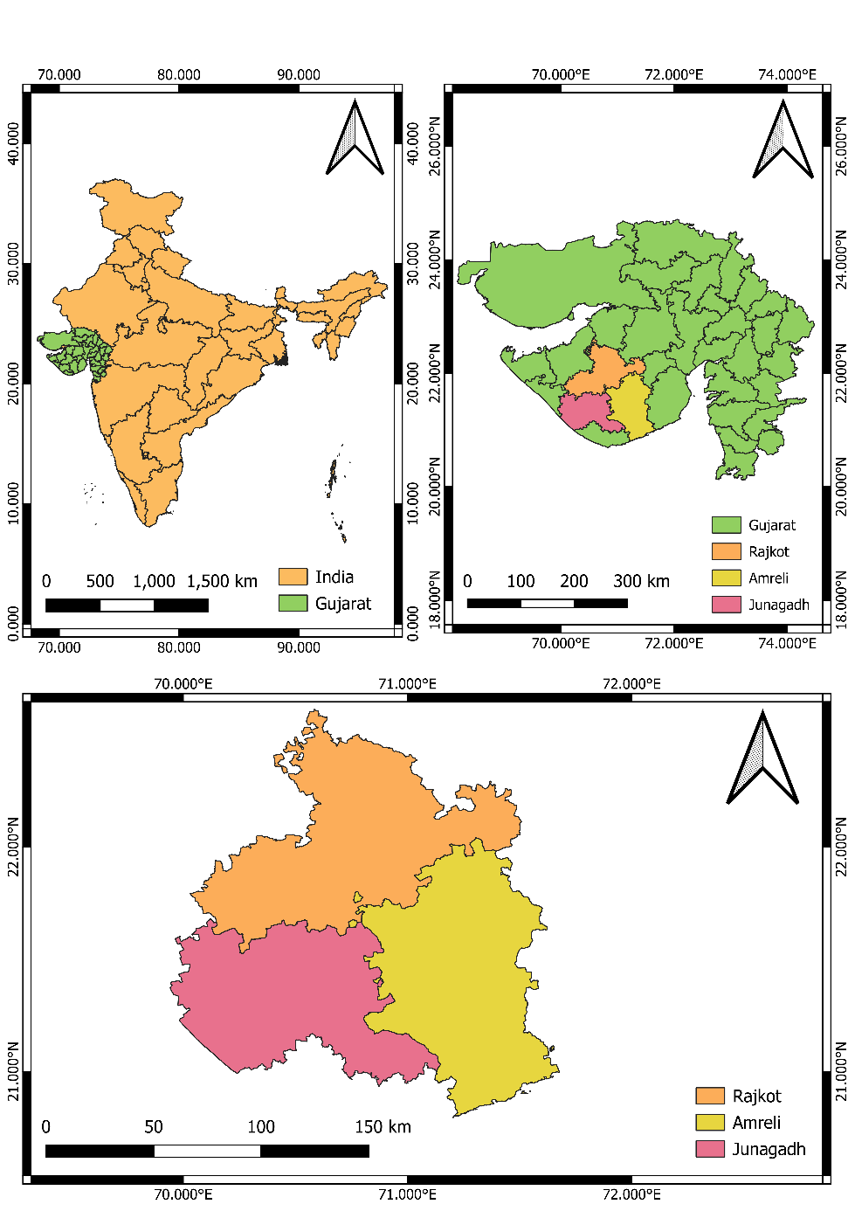
Fig. 1: Location map of the study area
Meteorological drought indices
Standardized Precipitation Index (SPI) (McKee et al. 1993)
The SPI is calculated by fitting a probability distribution of accumulated precipitation of specific periods like 1, 3, 6, 9, and 12 months and transformed to a normal distribution. Researchers used gamma probability distribution fitted to the long-term precipitation at various time scales to calculate SPI (Guttman, 1999).
The gamma distribution is defined by its frequency or probability density function:
$$g\left(x\right)= \frac{1}{β^{α }Г(α)}x^{α-1}e^{-x/β}$$ | (1)
Where, α, β and x>0, α is a shape parameter, β is the scale parameter and x is precipitation.
$$Г\left(α\right)=\int_{0}^{∞}{y^{α-1 }}e^{-y}$$ | (2)
Where Г(α) is the gamma function.
The maximum likelihood solutions are used to optimally estimate α and β (Thom, 1958)
$α=\frac{1}{4A}(1+\sqrt{1+\frac{4A}{3}}$, $=\frac{\overline{x}}{\hat{α}}$ , | (3)
where, A is ln$\left(\overline{x}\right)- \frac{\sum{ln⁡(x)}}{n}$ , where, n is the number of precipitation observations.
The cumulative probability is calculated using the resulting parameters of a precipitation event for a given time scale by the following equation.
$$G\left(x\right)=\int_{0}^{x}{g\left(x\right)dx}=\int_{0}^{x}{\frac{1}{β^{α }Г(α)}x^{α-1}e^{-x/β}dx}$$ | (4)
The gamma function is undefined for x=0 and a precipitation distribution may contain zeros, the cumulative probability becomes,
$$H \left(x\right)=q+\left(1-q\right) G(x)$$ | (5)
Where, q is the probability of zero, q can be estimated by m/n. The cumulative probability, H(x), is then transformed to the standard normal random variable Z with a mean zero and variance of one.
$$Z=SPI=-\left(t-\frac{C_{0}+C_{1}t+C_{2}t^{2}}{1+d_{1}t+d_{2}t^{2}+d_{3}t^{3}}\right)0<H\left(x\right)≤0.5$$ | (6)
$$Z=SPI=+\left(t-\frac{C_{0}+C_{1}t+C_{2}t^{2}}{1+d_{1}t+d_{2}t^{2}+d_{3}t^{3}}\right)0.5<H(x)≤1$$ | (7)
$t=\sqrt{ln\left(\frac{1}{{H\left(x\right))}^{2}}\right)}0<H(x)≤0.5$ | (8)
$t=\sqrt{ln\left(\frac{1}{{(1-H\left(x\right))}^{2}}\right)}0.5<H(x)≤1$ | (9)
c₀ ₌2.515517, c₁₌0.802583, c₂₌0.010328, d₁₌1.432788, d₂₌0.189269, d₃₌0.001308
The values of c₀, c₁, c₂, d₁, d₂, and d₃ are constants widely employed for SPI computation (Abramowitz and Stegun, 1965). Positive SPI values indicate the wet condition and negative SPI values indicate the dry condition. The threshold value categories based on ranges of index values are presented in Table 2. The drought indices SPI were calculated using R-Studio programming with the SPI package. The researchers utilized the same drought classification analysis that has been applied in Gujarat, Iran, and Maharashtra (Shah et al., 2015; Mishra & Chauhan, 2019; Pandya & Gontia, 2025).
Table 2: Drought severity classifications by meteorological drought indices
Category | SPI
Extremely wet | ≥ 2.0
Severely wet | 1.5 to 1.99
Moderately wet | 1.0 to 1.49
Mild wet | 0.5 to 0.99
Near normal | -0.49 to 0.49
Mild drought | -0.5 to -0.99
Moderate drought | -1.0 to -1.49
Severe drought | -1.5 to -1.99
Extreme drought | ≤ -2.0
Results and Discussion
The year 1984 shows widespread moderate drought conditions across all three districts of Saurashtra, although with varying intensity. In Amreli district, nine talukas experienced moderate drought, while two talukas remained in the near-normal category and no taluka recorded severe or extreme drought. Junagadh district recorded seven talukas under moderate drought and three talukas under severe drought, indicating a more intense drought situation compared to Amreli (Table 3). Rajkot district exhibited a mixed pattern, with six talukas in moderate drought and five talukas remaining near normal. No severe or extreme drought was recorded in Rajkot during 1984. Overall, the year 1984 can be considered a region-wide moderate drought year, with Junagadh experiencing relatively higher severity (Figure 2).
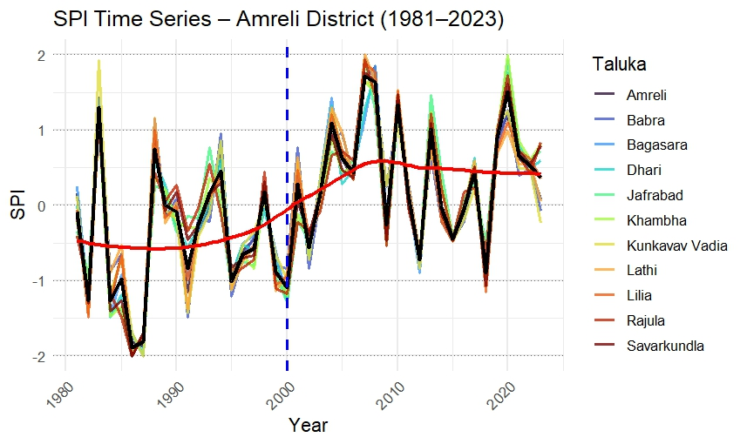
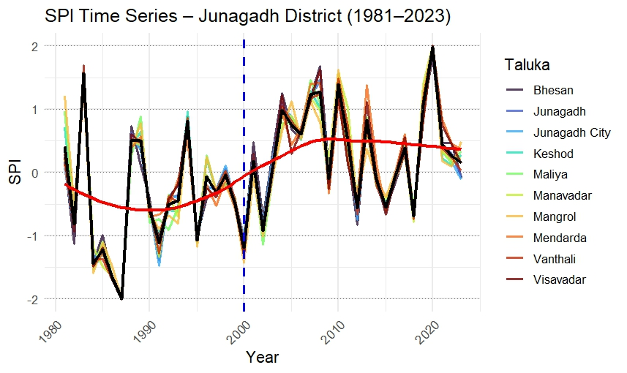
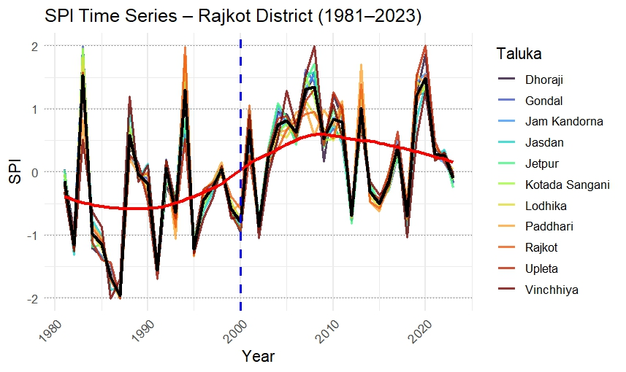
Fig. 2: District wise drought severities analysis for the period of 1981 to 2023
1986 year was considerably more intense and spatially widespread. Amreli district recorded a shift from moderate condition in earlier years to more intense classifications, with seven talukas under severe condition and four talukas under extreme condition: no taluka fell in the moderate drought condition or near-normal category (Table 3). This indicates one of the most severe drought impacts for Amreli during the period of analysis. Junagadh district recorded nine talukas under severe drought and one taluka under moderate drought, again showing severe rainfall deficits across almost the entire district. Rajkot district also displayed intense drought conditions, with eight talukas in severe drought and one taluka in extreme drought. The distribution in 1986 reveals that all three districts were severely affected, making it one of the strongest and most uniformly distributed drought years across Saurashtra (Figure 2).

Table 3: Number of Taluka under various severity categories based on SPI in three districts of Saurashtra
Year | District | Moderate drought | Severe drought | Extreme drought | Near normal | Moderate/  Severe/  Extreme Wet
1984 | Amreli | 9 | 0 | 0 | 2 | 0
1984 | Junagadh | 7 | 3 | 0 | 0 | 0
1984 | Rajkot | 6 | 0 | 0 | 5 | 0
1986 | Amreli | 0 | 7 | 4 | 0 | 0
1986 | Junagadh | 1 | 9 | 0 | 0 | 0
1986 | Rajkot | 2 | 8 | 1 | 0 | 0
1987 | Amreli | 0 | 9 | 2 | 0 | 0
1987 | Junagadh | 0 | 1 | 9 | 0 | 0
1987 | Rajkot | 0 | 3 | 8 | 0 | 0
1991 | Amreli | 4 | 0 | 0 | 7 | 0
1991 | Junagadh | 6 | 0 | 0 | 4 | 0
1991 | Rajkot | 4 | 7 | 0 | 0 | 0
The year 1987 was also a major drought year, but its spatial pattern differed from 1986. Amreli district experienced predominantly severe condition, with nine talukas classified under this category and two talukas falling under extreme condition. Junagadh district showed a more polarized pattern (Figure 2), with one taluka under severe condition and nine talukas under extreme condition, indicating an exceptionally intense and spatially concentrated drought event. Rajkot district exhibited three talukas under severe drought and eight talukas under extreme condition, marking widespread rainfall failure. Compared to 1986, the 1987 drought was more extreme in Junagadh and Rajkot, where extreme conditions dominated most talukas. This year is among the most severe condition years in the historical record, with extreme drought categories covering large portions of the region (Table 3).
In contrast to the intense drought years of 1986 and 1987, the drought characteristics of 1991 were milder and more spatially variable. Amreli district recorded four talukas under moderate drought and seven talukas remaining near normal, suggesting partial drought impact rather than widespread stress. Junagadh district exhibited six talukas in moderate drought and four under near-normal conditions, signifying a moderate drought year with less spatial intensity compared to the mid-1980s droughts. Rajkot district displayed a relatively mixed pattern, with four talukas under moderate drought and seven talukas experiencing severe drought, indicating localized but significant rainfall deficit in several talukas (Table 3).
Overall, the drought years between 1984 and 1991 show distinct variations in intensity and spatial distribution across Saurashtra. The years 1986 and 1987 represent the most severe and widespread droughts, with nearly all talukas in severe or extreme categories across all districts. The year 1984 shows moderate drought conditions dominating, while 1991 reflects a milder but still regionally significant drought event. These patterns highlight the high climatic variability during the 1980s and early 1990s and confirm that the region experienced strong drought cycles before the improvement observed after 2000 (Figure 2).
The year 1983 represents an early instance of strong wetness across Saurashtra, but its impact varied among the districts. In Amreli district, wetness was widespread, with ten talukas falling under the moderately wet category and one taluka under the severely wet category. No taluka experienced near normal or drought conditions, suggesting a consistently surplus rainfall pattern across the entire district. Junagadh district displayed a more intense distribution of wetness: although only three talukas were moderately wet, seven talukas fell under the severely wet category, indicating spatially concentrated but strong excess rainfall. Rajkot district experienced a similar pattern, but slightly more mixed, with two talukas classified as near normal, two under moderately wet, and seven under severely wet conditions. Overall, the year 1983 can be classified as a strongly wet year across all three districts, with Junagadh and Rajkot experiencing more severe wetness compared to Amreli.
The year 2007 marks another major wet episode, but with a distinctly uneven spatial distribution. Amreli district experienced intense wet conditions, with eight talukas in the severely wet category, two in the moderately wet category, and one taluka reaching the extremely wet category (Figure 2). This indicates a widespread and high-intensity wetness regime affecting almost the entire district. Junagadh district, in contrast, showed a very different pattern: all ten talukas were near normal, suggesting that while neighbouring districts experienced strong rainfall surpluses, Junagadh did not show abnormal wetness in that year. Rajkot district recorded one taluka as near normal, six talukas as moderately wet, and four as severely wet, reflecting a mix of normal and surplus rainfall (Table 3). This divergence shows that the 2007 wet year had localized impacts, with Amreli and Rajkot experiencing strong rainfall excess while Junagadh remained largely unaffected.
The year 2020 stands out as one of the most significant wet episodes in the recent climatic record, especially due to the dominance of severe and extreme wetness categories. In Amreli district, six talukas experienced severely wet conditions, and four talukas were moderately wet, with only one taluka remaining near normal. This pattern demonstrates widespread and uniform wetness across the district. Junagadh district experienced the most intense wetness of all districts: nine talukas fell under the extremely wet category, while one taluka was severely wet. This clearly shows that 2020 was an exceptionally wet year for Junagadh, with unprecedented rainfall surpluses affecting almost every taluka. Rajkot district recorded a combination of moderate, severe, and extreme wetness, with seven talukas moderately wet, three severely wet, and one taluka extremely wet. This indicates a very wet year across the district, though not as extreme as Junagadh.
Overall, the wet years 1983, 2007, and 2020 reveal distinct climatic signatures. The year 1983 featured strong but relatively balanced wetness across all districts, with Junagadh and Rajkot experiencing more severe conditions (Figure 2). The year 2007 showed highly uneven impacts, with Amreli experiencing intense wetness, Rajkot showing moderate to severe wetness, and Junagadh remaining near normal. The year 2020 exhibited the strongest wet signal of the dataset, with Junagadh experiencing extreme wetness across nearly all talukas and Amreli and Rajkot also showing widespread wet conditions. These patterns highlight the spatial variability of wet episodes in Saurashtra and emphasize how different districts respond differently to large-scale rainfall surpluses (Figure 2).
Percentage changes in drought categories of Amreli district talukas
The comparison of SPI category percentages between the periods 1981–1999 and 2000–2023 for Amreli district shows a clear and consistent reduction in drought frequency and a simultaneous increase in near-normal and moderately wet years across all talukas. During 1981–1999, moderate drought years contributed around 10 to 21 percent of the seasonal classifications across talukas such as Amreli, Babra, Dhari, Khambha, Lathi, Rajula, and Kunkavav Vadia. Severe droughts contributed an additional 5 to 11 percent in most talukas. Certain talukas like Bagasara, Jafrabad, Kunkavav Vadia, and Lilia also experienced extreme drought years at around 5 percent. Near-normal years dominated the pre-2000 period (around 58 to 74 percent), but their distribution suggested moderate climatic variability. Moderately wet years remained very low, typically between 0 and 10 percent, and severely wet or extremely wet years were extremely rare or absent entirely in this period (Figure 3).
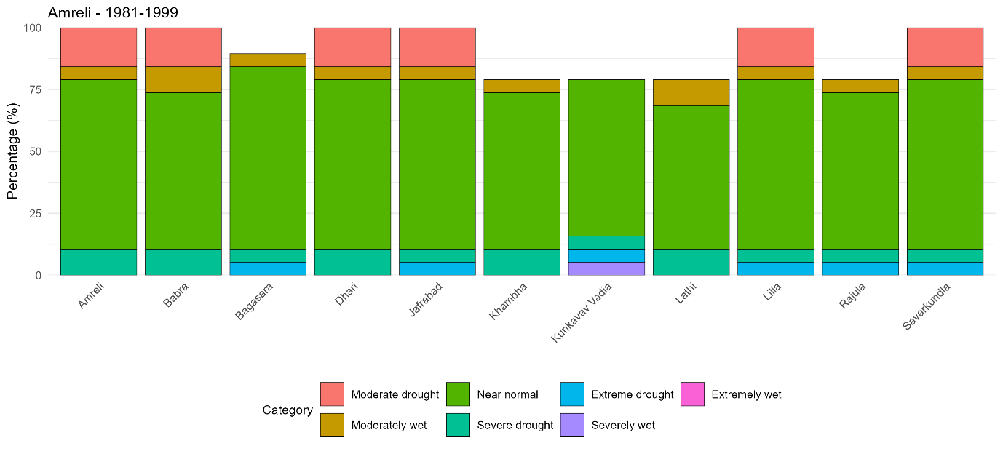
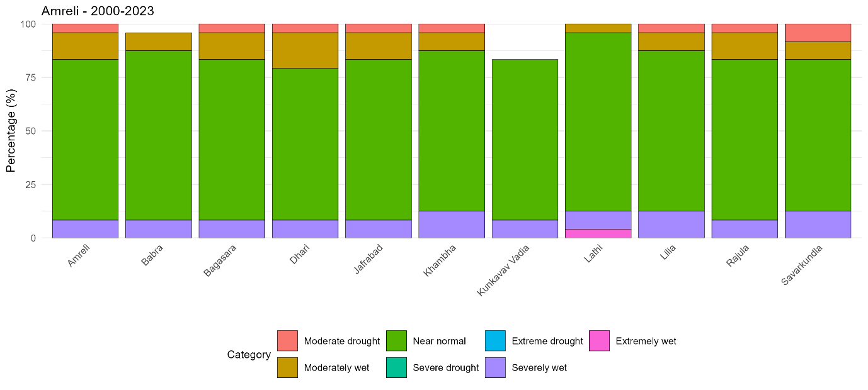
Fig. 3: Percentage changes in drought categories for various talukas of Amreli district
In the post-2000 period (2000–2023), the transformation is clearly visible. Moderate drought drops to a very low 0 to 8 percent range, with several talukas such as Lathi, Kunkavav Vadia, and parts of Bagasara showing no moderate drought at all. Severe drought and extreme drought completely disappear from the entire district after 2000. Near-normal years increase substantially to values ranging from 70 to 83 percent, with particularly high values in Lathi, Babra, and Bagasara. Moderately wet years increase to 8 to 17 percent, and severely wet years also appear at 8 to 12 percent in several talukas such as Khambha, Lilia, Savarkundla, and Lathi (Figure 3). Lathi is notable for showing a small percentage of extremely wet years (around 4 percent), indicating an occasional strong rainfall surplus.
The patterns observed in Amreli district show a strong shift from a drought-prone climatic regime before 2000 to a significantly more stable and wetter climate thereafter. The near elimination of severe and extreme drought categories in the post-2000 period indicates a profound improvement in monsoon reliability (Figure 3). The increase in near-normal years reinforces that rainfall deviations have decreased, and the climate system has become more stable. The increase in moderately wet and severely wet years highlights that rainfall surpluses have become more common. These changes likely contribute to improved groundwater recharge and better agricultural prospects. While occasional wet extremes appear, the absence of severe drought events represents a major advantage for the district’s agricultural systems. The changes shown by Amreli district align with broader hydrometeorological shifts seen in parts of Gujarat over the last two decades, resulting in reduced agricultural drought risk and greater climatic stability.
Percentage changes in drought categories of Junagadh district talukas
Junagadh district shows a similar but slightly more varied shift when comparing 1981–1999 with 2000–2023. In the pre-2000 period, moderate drought years ranged from 10 to 21 percent across talukas such as Junagadh, Manavadar, Vanthali, and Keshod. Severe drought years were present at 5 to 11 percent levels in almost every taluka. Extreme drought years also appeared in many locations, including Bhesan, Junagadh, Junagadh City, Keshod, Maliya, and Visavadar (Figure 4). These drought frequencies indicate that Junagadh district experienced significant water stress and rainfall deficit episodes during the 1980s and 1990s. Near-normal years accounted for around 63 to 68 percent across most talukas. Moderately wet years appeared infrequently, typically between 0 and 10 percent. Severely wet and extremely wet years were also rare, with small percentages observed in some talukas such as Bhesan, Junagadh, Junagadh City, and Vanthali (Figure 4).
In the post-2000 period, Junagadh district demonstrates a dramatic decline in drought frequencies. Moderate drought reduces to around 4 to 8 percent across most talukas, with several locations at exactly 4 percent. Severe drought and extreme drought completely disappear, mirroring the pattern found in Amreli district. Near-normal years increase to 70 to 75 percent in almost all talukas, with slightly lower values (around 70 percent) where wet events dominate. Moderately wet years rise significantly to 12 to 21 percent in several talukas, especially Junagadh, Junagadh City, Vanthali, Jetpur, and Maliya. Severely wet years show values of 4 to 12 percent. Extremely wet years appear between 4 to 8 percent in several talukas including Junagadh, Junagadh City, Keshod, Upleta, and Maliya (Figure 4).
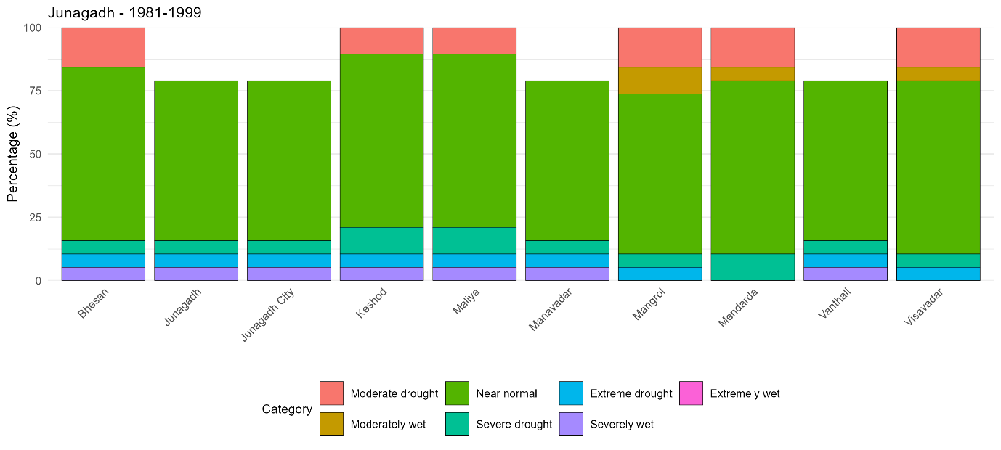
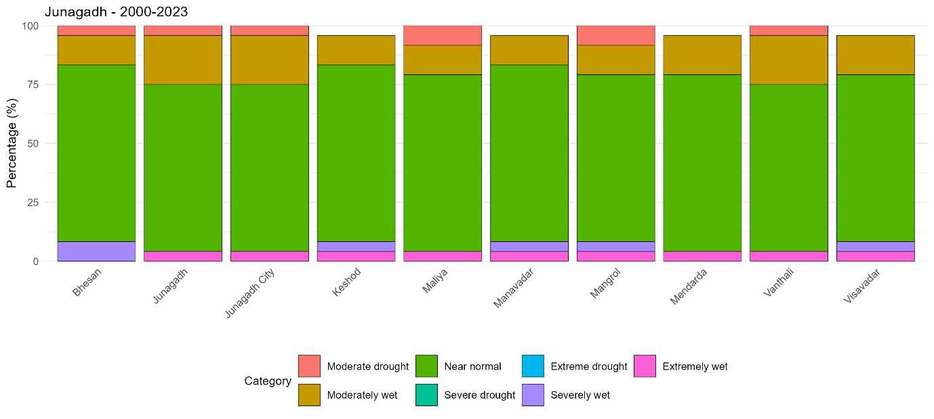
Fig. 4: Percentage changes in drought categories for various talukas of Junagadh district
Junagadh district exhibits a robust climatic shift toward reduced drought severity and increased wetness after 2000. The complete disappearance of severe and extreme drought categories indicates a significant improvement in monsoon strength and consistency. This district, located closer to the Arabian Sea and influenced by orographic effects of the Girnar hills, appears to have benefited significantly from enhanced moisture inflow and monsoon stabilization in the post-2000 period (Figure 4).
The increase in moderately wet, severely wet, and even extremely wet events suggests enhanced rainfall variability on the wetter side. While beneficial for agriculture, this shift also indicates the potential for flashier hydrological responses, requiring improved drainage and soil conservation efforts. Nevertheless, the overwhelming increase in near-normal years provides a foundation of climatic stability. Junagadh district’s shift reflects a transition toward a more favourable agricultural climate, with reduced drought stress and improved rainfall distribution.
Percentage changes in drought categories of Rajkot district talukas
Rajkot district shows the most striking improvement among the three districts. During the 1981–1999 period, the district experienced high drought frequencies. Moderate drought years contributed between 15 and 21 percent across almost all talukas. Severe drought years were recorded between 5 and 11 percent, and extreme drought appeared in many talukas such as Gondal, Jam Kandorna, Lodhika, Paddhari, and Rajkot. Near-normal years ranged from 52 to 63 percent, indicating a climate heavily influenced by rainfall fluctuations. Moderately wet years were rare (0 to 10 percent), while severely wet and extremely wet years appeared occasionally but at very low frequencies (Figure 5).
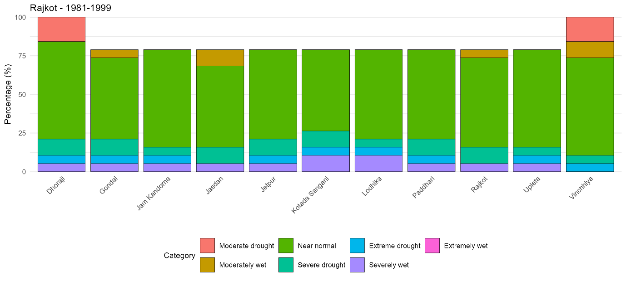
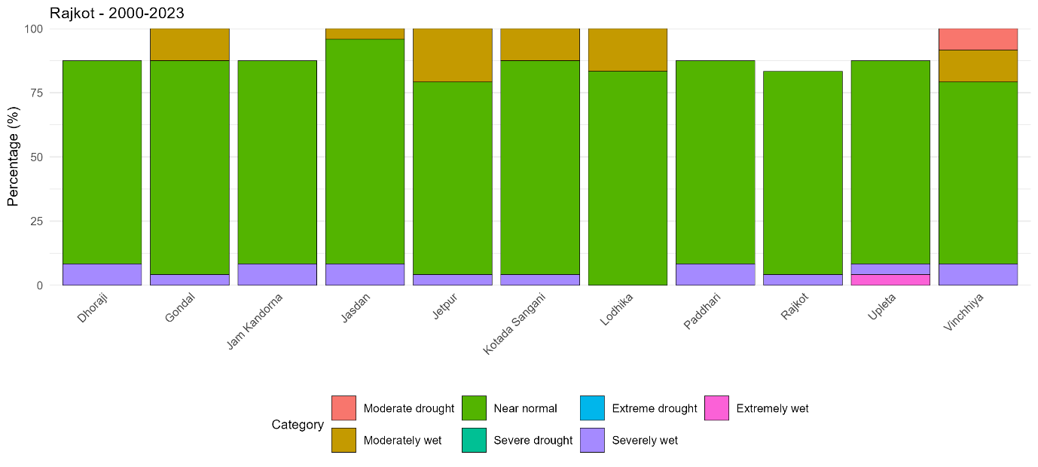
Fig. 5: Percentage changes in drought categories for various talukas of Rajkot district
After 2000, the drought situation in Rajkot district changes drastically. Moderate drought becomes zero in almost all talukas, with only a very few showing 4 to 8 percent. Severe drought and extreme drought disappear completely from the district. Near-normal years become dominant, reaching exceptionally high values of 79 to 87 percent in talukas such as Gondal, Jasdan, Kotada Sangani, Lodhika, Rajkot, Paddhari, Upleta, and Jetpur. Moderately wet years show substantial increases, ranging from 12 to 21 percent. Severely wet years show around 4 to 8 percent. Extremely wet years appear in talukas such as Upleta, indicating intense but infrequent rainfall events (Figure 5).
Rajkot district demonstrates the strongest climatic improvement among the three districts analysed. The complete elimination of moderate, severe, and extreme drought (in almost all talukas) signifies a remarkable shift in the region’s hydroclimatic character. This improvement could be influenced by broader changes in the monsoon system, regional moisture flows, as well as increased land surface wetness from irrigation and watershed interventions.
The substantial increase in near-normal years indicates that rainfall deficits have become rare. The climate appears far more reliable than in the preceding decades. The rise in moderately wet and severely wet events points to greater incidence of favourable rainfall. Although extremely wet events remain limited, their presence suggests the need for flood preparedness and improved drainage systems. Overall, Rajkot district’s climate has transitioned from one of the most drought-prone regions in Saurashtra to one of the most stable and rainfall-secure areas in the post-2000 period (Figure 5).
Across Amreli, Junagadh, and Rajkot districts, a region-wide transition is evident when comparing the periods 1981–1999 and 2000–2023. The pre-2000 climate was characterized by frequent moderate and severe drought years, occasional extreme drought, and substantial rainfall variability. Moderate drought occurred in 15 to 21 percent of years across many talukas, and severe drought added another 5 to 11 percent. These conditions reflect a historically drought-vulnerable Saurashtra region.
In contrast, the post-2000 climate shows a clear reduction in drought severity and frequency. Severe and extreme drought categories disappear entirely from all three districts. Moderate drought falls to almost zero across Rajkot and remains extremely low across Amreli and Junagadh. Near-normal years become the defining feature of the post-2000 climate, rising to 70 to 88 percent of the time. Wet categories, including moderately wet, severely wet, and extremely wet years, become more frequent, indicating greater monsoon strength and occasional high-intensity rainfall events.
Together, these patterns indicate that Saurashtra has undergone a significant shift from a drought-dominated regime to a more stable and wetter monsoon climate after 2000. This transformation has significant implications for agriculture, water resources, hydrological planning, and drought risk reduction across the region.
Conclusion
The analysis clearly shows that Saurashtra has undergone a major hydro-climatic shift from a drought-prone regime during 1981–2000 to a more stable and wetter climate after 2000. Severe and extreme droughts that were common earlier have virtually disappeared, while near-normal and wet years now dominate across all talukas of Amreli, Junagadh, and Rajkot. This transition indicates improved monsoon reliability, enhanced rainfall distribution, and reduced drought risk, providing favourable conditions for agriculture, groundwater recharge, and long-term climate resilience in the region.
Disclaimer (Artificial intelligence)
Author(s) hereby declare that NO generative AI technologies such as Large Language Models (ChatGPT, COPILOT, etc.) and text-to-image generators have been used during the writing or editing of this manuscript.
References
- Abramowitz, M., & Stegun, I. A. (1965). Handbook of mathematical functions: With formulas, graphs, and mathematical tables. Dover Publications. https://store.doverpublications.com/0486612724.html
- Agarwal, V., Vishvendra Raj Singh, B., Marsh, S., Qin, Z., Sen, A., & Kulhari, K. (2025). Integrated Remote Sensing for Enhanced Drought Assessment: A Multi‐Index Approach in Rajasthan, India. Earth and Space Science, 12(2), e2024EA003639.
- Bharghavi, K., Reddy, T. L., Kapa, H., Rajesh, P., Sushmitha, H., & Reddy, K. K. (2025). Decadal analysis of monsoon climate variability and drought indicators in Rayalaseema: long-term analysis using satellite data and drought indices. Stochastic Environmental Research and Risk Assessment, 39(11), 4985-5009. https://doi.org/10.1007/s00477-025-03059-0 .
- Bhukya, S., Tiwari, M. K., & Patel, G. R. (2023). Assessment of spatiotemporal variation of agricultural and meteorological drought in Gujarat (India) using remote sensing and GIS. Journal of the Indian Society of Remote Sensing, 51(7), 1493-1510. https://doi.org/10.1007/s12524-023-01715-y
- Guhan V., Geethalakshmi V., Panneerselvam S., Raviraj A., Lakshmanan A., Ramanathan S. P. & Bhuvaneswari K. (2020). Assessment of Drought Over Parambikulam Aliyar Basin of Tamil Nadu. International Journal of Environment and Climate Change, 10(10), 35–42. https://doi.org/10.9734/ijecc/2020/v10i1030245
- Guria, R., Dwivedi, S., Nayak, P., Goswami, S., da Silva, R. M., Santos, C. A. G., Dash, P. C., Mishra, M., Dogar, M. M., Meraj, G., & Almazroui, M. (2025). A comprehensive 120-year assessment of drought dynamics and climate teleconnections in Odisha, India (1901–2020): insights from SPI and trend evaluation. Natural Hazards. https://doi.org/10.1007/s11069-025-07336-7
- Guttman, N. B. (1999). Accepting the standardized precipitation index: a calculation algorithm. JAWRA Journal of the American Water Resources Association, 35(2), 311-322. https://doi.org/10.1111/j.1752-1688.1999.tb03592.x
- Hirapara, P., Brahmbhatt, M., & Tiwari, M. K. (2023). Investigation of Trends and Variability Associated with the SPI and SPEI as a Drought Prediction Tools in Gujarat Regions, India. In Surface and Groundwater Resources Development and Management in Semi-arid Region: Strategies and Solutions for Sustainable Water Management (pp. 79-95). Cham: Springer International Publishing. https://doi.org/10.1007/978-3-031-29393-1_7
- Hirapara, P., Rank, H. D., Patel, D. V., Tiwari, M. K., & Parma, H. V. (2023). The competing impacts of climate change on reductions of water quality parameters. Journal of Soil and Water Conservation, 22(3), 260-268. https://doi.org/10.5958/2455-7145.2023.00033.4
- Hirapara, P., Tiwari, M. K., Patel, G. R., Prajapati, G. V., Pandya, P. A., Sonawane, A., ... & Dutta, S. (2025). A GIS based approach for identifying potential sites for harvesting rain water in the Hathamati River Basin, India. ISH Journal of Hydraulic Engineering, 31(2), 316-327. https://doi.org/10.1080/09715010.2025.2456799
- McKee, T. B., Doesken, N. J., & Kleist, J. (1993). The relationship of drought frequency and duration to time scales. In Proceedings of the 8th Conference on Applied Climatology (Vol. 17, No. 22, pp. 179-183).
- Mishra, S. & Chauhan, M. (2019). Performance evaluation of two meteorological indices for drought assessment in Jalna. International Journal of Current Research, 11(01), 521-525.
- Pandya, P., & Gontia, N. K. (2023). Development of drought severity–duration–frequency curves for identifying drought proneness in semi-arid regions. Journal of Water and Climate Change, 14(3), 824-842. https://doi.org/10.2166/wcc.2023.438 .
- Pandya, P. A., & Gontia, N. K. (2025). Correlation vs. Kappa statistic: a new perspective on comparing meteorological drought indices. Theoretical and Applied Climatology, 156(1), 19.
- Patil, R., Polisgowdar, B. S., Rathod, S., Bandumula, N., Mustac, I., Srinivasa Reddy, G. V., Wali, V., Satishkumar, U., Rao, S., Kumar, A., & Ondrasek, G. (2023). Spatiotemporal characterization of drought magnitude, severity, and return period at various time scales in the Hyderabad Karnataka Region of India. Water, 15(13), 2483. https://doi.org/10.3390/w15132483
- Ramirez Sanchez Hermes Ulises, Fajardo Montiel Aida Lucia, Ortiz Bañuelos Alma Delia & De la Torre Villaseñor Odila. (2022). Impacts of Climate Change on the Water Sector in Mexico. Asian Journal of Environment & Ecology, 17(2), 37–57. https://doi.org/10.9734/ajee/2022/v17i230289
- Ratna, S. B., Sabeerali, C. T., Sharma, T., Pai, D. S., & Mohapatra, M. (2024). Combined influence of El Niño, IOD and MJO on the Indian Summer Monsoon Rainfall: Case Study for the years 1997 and 2015. Atmospheric Research. https://doi.org/10.1016/j.atmosres.2023.107214
- Sajeev, A., & Kundapura, S. (2023). Temporal assessment of meteorological drought events using stationary and nonstationary drought indices for two climate regions in India. Journal of Hydrologic Engineering, 28(11), 05023018. https://doi.org/10.1061/JHENG9.HEENG-5770
- Shah, R., Bharadiya, N., & Manekar, V. (2015). Drought index computation using standardized precipitation index (SPI) method for Surat District, Gujarat. Aquatic Procedia, 4, 1243-1249. https://doi.org/10.1016/j.aqpro.2015.02.162
- Thom, E. C. (1959). The discomfort index. Weatherwise, 12(2), 57-61. https://doi.org/10.1080/00431672.1959.9926960
- Vigneshwari, R., Patel, K. C., & Pandya, P. A. (2024). Analysis of Meteorological Drought for Selected Districts of Saurashtra Region of Gujarat. International Journal of Environment and Climate Change. https://doi.org/10.9734/ijecc/2024/v14i84364
- Waghmare, P. T., Panhalkar, S. S., & Pawar, S. D. (2025). Comparison of SPI and SPEI indices for drought assessment in eastern part of Satara district of Maharashtra, India. Mausam, 76(2), 607-618. https://doi.org/10.54302/mausam.v76i2.6079

