Synergistic Effects of Halophytic Compost, Cow dung manure and Azospirillum on Soil Microbial Dynamics and Enzymatic Activities

ABSTRACT
Rhizospheric enzyme activity and soil microbial biomass are known to be reliable markers of soil biological health. The decomposition and mineralization of organic matter in soil are mediated by diverse microbial communities through complex metabolic pathways. This study was aimed to evaluate the optimal use of halophytic composts on the microbial population and enzymes activity of Vigna unguiculata (L.) Walp. cultivated soil in east coastal agricultural soil of Tamil Nadu, India. The study was carried out in a saline agricultural soil during July-October 2024 at Thandavarayan Sozhaganpettai village adjacent to Pichavaram mangrove forest. This study was designed with six treatments viz, T₁-Sesuvium portulacastrum compost alone (6.25 ton / ha). T₂-Suaeda maritima compost alone (6.25 ton / ha), T₃-Sesuvium portulacastrum compost (3.13 ton / ha) + Cow dung manure (3.13 ton / ha), T₄-Suaeda maritima compost (3.13 ton / ha) + Cow dung manure (3.13 ton / ha), T₅-Sesuvium portulacastrum compost (3.13 ton / ha) + Cow dung manure (3.13 ton / ha) + Azospirillum (2kg / ha) , T₆-Suaeda maritima compost (3.13 ton / ha) + Cow dung manure (3.13 ton / ha) + Azospirillum (2kg / ha) and T₀–control and laid out in a randomized block design in three replications. The experimental results showed that application of Suaeda maritima compost (3.13 ton / ha) + Cow dung manure (3.13 ton / ha) + Azospirillum (2kg / ha) significantly enhanced the soil microbial population and enzymes activity such as, bacteria (68.33 %), fungi (66.70 %), actinomycetes (67.50 %) and dehydrogenase activity (74.44 %) and cellulase activity (62.04 %) compared to other halophytic compost and control. Soil pH, electrical conductivity, and bulk density declined, soil porosity and organic carbon content increased concurrently, suggesting an improved soil fertility and structure. Overall, the combined use of halophytic compost along with cow dung manure, and Azospirillum proved to be an effective and sustainable strategy for improving coastal salt affected agricultural soil.

Keywords: Halophytic Compost, Soil Microbial Dynamics, Cow dung manure and Azospirillum
1-INTRODUCTION
Microorganisms are largely responsible for the cycles of the elements within a soil and are involved in the decomposition of the organic matter at the ecosystem level via a variety of enzymes (Ganesh et al., 2025). In this sense, the addition of different organic amendments, such as solid organic wastes, sewage sludge, agricultural wastes, and animal manures, is a method of replenishing degraded soil quality through improvement of the biological status of the soil, which usually implies an increase in both microbial and enzyme activity (Kumari et al., 2016). Soil quality is a key factor for the growth of crop plants and the deciding factor for the availability of plant nutrients (Singh et al., 2016). Overuse of chemical fertilizers reduces soil aggregate structure, inhibits soil microbial and enzyme activity, and reduces the soil's ability to retain water and nutrients (Kashyap et al., 2025). Organic farming is one of the way to address this problem that assures the safety of food production, maintains the soil biodiversity and maintains the ecological equilibrium (Megali et al., 2013). Numerous studies have shown that using organic fertilizers is the greatest way to improve crop yield and soil fertility (Liu et al., 2021). Dinesh et al. (2010) state that applying organic manures and biofertilizers increased soil microbial and enzyme activity, and these metrics are sensitive enough to detect changes in soil quality. Rhizospheric enzyme activity and soil microbial biomass are known to be reliable markers of soil biological health. The decomposition and mineralization of organic matter in soil are mediated by diverse microbial communities through complex metabolic pathways. Soil enzyme activity and nutrient mineralization processes in agricultural soils have been shown to be significantly positively correlated in earlier research (Shi, 2010). Soil carbon mineralization is a crucial process in the carbon cycle of terrestrial ecosystems and a significant component of CO₂ exchange between soil and the atmosphere. Global warming accelerates soil organic carbon mineralization, with its mineralized products returning to the atmosphere primarily as CO₂, which in turn further contributes to global warming (Wu et al., 2024; Gupta et al., 2024).
After cereals, pulses are the second most important agricultural group. The cowpea is the most cosmopolite of the pulse crops and is planted in most parts of India. It has shown very promising results and holds great potential for a breakthrough in pulse production (Joshi et al., 2016). It is used as a vegetable, grain legume, fodder and as a green manure crop. Cowpea seeds rich in protein (24%), carbohydrates (60%), fat (1.26%), dietary fiber (11%), total sugar (6.90%), ash (3.24%), potassium (1112 mg/100 g) and sodium (16 mg/100 g) (U.S. Department of Agriculture [USDA], 2021). Cowpea has important beneficial effects in increasing soil fertility status because of its ability to fix atmospheric nitrogen (Sharma et al., 2024). Cowpea cultivation and production are practiced globally, with a total land area of approximately 15 million hectares annually, with total production averaging 6 million metric tonnes (Kirarei et al., 2024). In India cow pea occupies in an area of 3.24 lakh ha with an annual production of 1.98 lakh tonnes and an average productivity of 822 kg /ha (Harshitha and Prema, 2024).
Cuevas (1997) and Ravindran et al. (2007) documented the nutrient values of halophytes were higher than green manures (glycophytes), which were derived from Vigna catjang, Crotalaria juncea, Sesbania aculeate, and Cyamopsis tetrgonoloba. In addition, Balakrishnan et al. (2010) and Shaw et al. (2020) found that Ipomoea pescaprae, Sesuvium portulacastrum, and Suaeda maritima, had higher micro and macro nutrients than green manures from glycophytes. On the other hand, naturally occurring halophytes have accumulated NaCl in their tissues will breakdown during the composting process. In NaCl, the Na⁺ could chelation with the organic acids in the process of decomposition and leaving out the Cl⁻ in the decline of NaCl. Decomposition nullifies the presence of NaCl content in the plant tissues (Ravindran et al., 2007).
In this study field experiments were carried out to examine the changes in microbial population, enzymes activity and physio-chemical properties of halophytic compost combined with cow dung manure and Azospirillum amended coastal saline agricultural soil on east coast of Tamil Nadu, India.
2-MATERIALS AND METHODS
2.1.-Experimental site
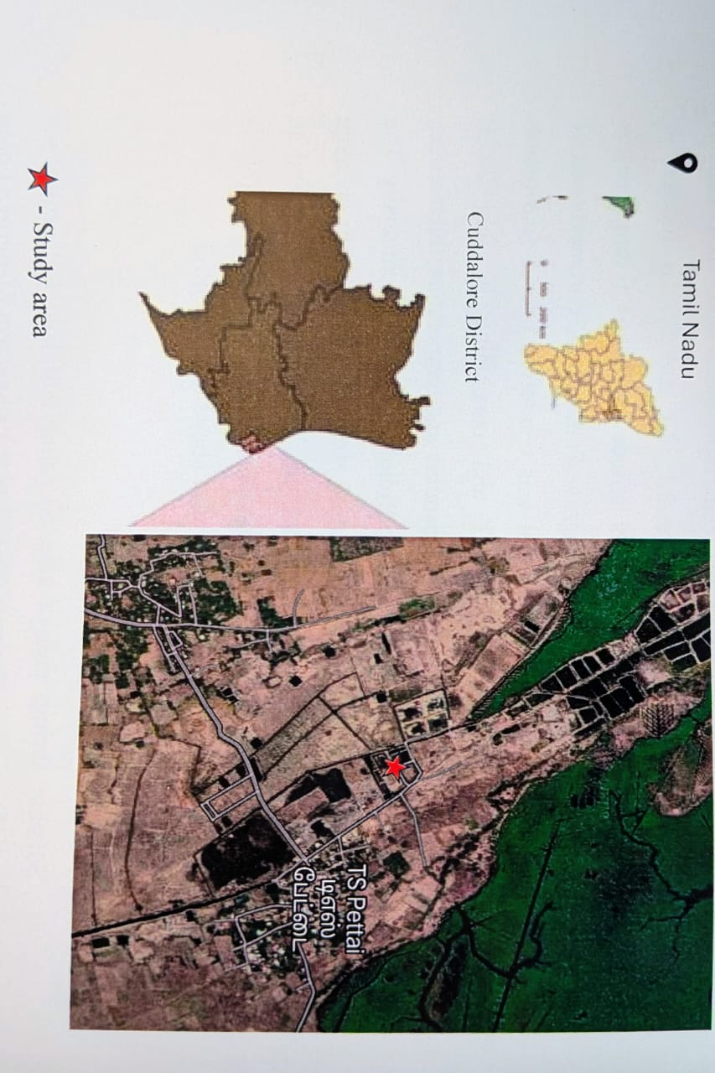
Field experiments were conducted at Thandavarayan Sozhaganpettai village (11º 21' N Latitude and 79º 50' E Longitude), which is 12 km from Annamalai University campus (+5.25 m above mean sea level), during July to October 2024. The physico-chemical characteristics of the experiment soil showed in Table 1.

Graph:1. Location of the Thandavarayan Sozhaganpettai village, 12 km from Annamalai University campus, TamilNadu. India.
2.2.-Compost preparation
Based on the reports from previous studies, two commonly growing halophytic herbs such as, Sesuvium portulacastrum L. and Suaeda maritima (L.) Dumort. from east coastal region of Tamil Nadu were selected for preparation of organic compost. Cow dung manure was procured from the Animal Husbandry Department, Annamalai University, was combined with halophytic compost and Azospirillum and applied to the experimental site as per the methodology. Three months old well developed healthy halophytic seedlings were harvested from nursery was used for preparation of halophytic compost based on the protocol outlined by Ravindran et al. (2007). After 90 days the compost was ready for use. It was dark brown and had a soily smell. The well decomposed halophytic compost is shown in (Plates. 1 and 2).
The plant materials (Halophytes) as well as rice straw were chopped well. The substrates were piled loosely in a compost pit and bulky in nature which provide better aeration within the heap. Aeration was provided by placing perforated bamboo trunks horizontally and vertically at regular intervals, to carry air through the compost heap. The compost activator, Trichoderma harzianum was added the substrates during pilling. The amount of activator used was usually1% of the total weight of the substrate (i.e. about 1 kg compost activator is mixed thoroughly with the substrates (Cuevas, 1997). The heap was covered completely with white plastic sheets. Heat was maintained at 50º C or higher and the heap was turned over every 5-7 days for the first two weeks and thereafter once every two weeks. Turning over the pile provided adequate aeration and evened up the rate of decomposition throughout pile. After 90 days the compost was ready for use. It was dark brown and had an earthy aroma. The well decomposed halophytic compost is shown in (Plates. 1 and 2).

2.3-Treatment
This study was designed with six treatments viz, T₁-Sesuvium portulacastrum compost alone (6.25 ton / ha). T₂-Suaeda maritima compost alone (6.25 ton / ha), T₃-Sesuvium portulacastrum compost (3.13 ton / ha) + Cow dung manure (3.13 ton / ha), T₄-Suaeda maritima compost (3.13 ton / ha) + Cow dung manure (3.13 ton / ha), T₅-Sesuvium portulacastrum compost (3.13 ton / ha) + Cow dung manure (3.13 ton / ha) + Azospirillum (2kg / ha) , T₆-Suaeda maritima compost (3.13 ton / ha) + Cow dung manure (3.13 ton / ha) + Azospirillum (2kg / ha) and T₀–control and the experiment was laid out in a randomized block design with three replications.
2.4-Determination of the soil microbial population
Soil microbial population in halophytic compost treated soils were counted by the serial dilution plate method. Bacteria, fungus, and actinomycetes were isolated and counted using soil extract agar, Martin's Rose Bengal agar, and Kenknight's agar media, respectively, in accordance with the protocol described by Pramer and Schmidt (1965).
2.5-Determination of the soil enzymes activity
Twenty grams of air dried soil and 0.2g of CaCO₃ were mixed and six grams of this mixture was placed in each of three test tubers. One ml of 3% aqueous solution of TTC (2, 3, 5-triphenyltetrazolium chloride) and 2.5 ml of distilled water were added to each tube and the contents were mixed well with a glass rod. The tube was sealed tightly and incubated at 37 °C for 24 h. Ten milliliters of methanol was added and shaken for 1 min. The suspension was filtered through a glass funnel plugged with absorbent cotton into 100 ml volumetric flask. The soil transferred to the funnel was washed with methanol until the reddish color disappeared from the cotton plug. Dehydrogenase activity was determined by using a spectrophotometer at 485 nm.
The soil Dehydrogenases activity was estimated using Tabatabai (1982) method, while Cellulase activity was measured using Tabatabai's (1982) method. The enumerations of population in the halophytic compost amended soil samples were analysed by soil serial dilution technique using appropriate dilution and media. Ten grams of soil samples were collected from rhizosphere of black gram. They were transferred to a 250 ml Erlenmeyer flask with 100ml of sterile distilled water and thoroughly shaked in a rotary shaker for ten minutes. Using pipette, 10 ml of the suspension was withdrawn and transferred; likewise serial dilution was continued using sterile distilled water till, 10⁻³, 10⁻⁴, 10⁻⁵ and 10⁻⁶ were obtained. Appropriate dilutions viz. 10⁻⁴ for fungi, 10⁻⁵ for actinomycetes and 10⁻⁶ for bacteria were employed. The colonies were counted and expressed per gram of moisture free soil.
Preparation of reagents (pH: 4.8)
One g soil was placed in 50 ml of Erlenmeyer flask and 1 ml of sodium acetate-acetic acid buffer, 0.3 ml of toluene, 1 ml of 1 per cent carboxymethyl cellulase and 3 ml of distilled water were added. The flasks were stoppered, shaken and incubated at room temperature (28 ± 2 °C). At the end of 24 h, 1ml of the supernatant from each flask was withdrawn and reducing sugars were estimated by employing Nelson’ reagent described by Nelson (1944).
Copper reagent ‘A’
To 80 ml distilled water, 2.5 g sodium carbonate (anhydrous), 2.5 g Rochelle salt (sodium potassium tartarate), 2 g sodium bicarbonate and 20 g sodium sulphate (anhydrous) were dissolved and the volume was raised to 100 ml. The mixture was filtered through filter paper and stored in amber coloured bottle.
Copper reagent ‘B’
Fifteen grams of copper sulphate was dissolved in 100 ml of distilled water and 2 drops of concentrated sulphuric acid was added. The solution was stored in an amber coloured bottle.
Arsenomolybdate reagent
To 45 ml of distilled water, 2.5 g of ammonium molybdate was dissolved and 2.5 ml concentrated sulphuric acid was added and stirred. 30 g of sodium arsenate dissolved to the solution and thoroughly mixed. The mixture was incubated at 37 °C for 24 to 48 hr. and stored in a glass stoppered brown bottle.
Procedure
To one ml of aliquot in a boiling test tube and 1 ml of the reagent mixture, which was prepared on the day of use and 25 parts of reagent ‘A’ with 1 part of reagent ‘B’. The solutions were mixed and placed in a boiling water bath for exactly 20 minutes and cooled in a running tap water. One ml of the arsenomolybdate colour reagent was added and the volume was raised to 25 ml with distilled water. The blue colour was read in spectronic-20 colorimeter at 495 nm. Standards prepared from glucose were employed to get a standard curve from which cellulase activity was calculated.
2.6-Determination of physico-chemical properties of experiment soil
In the experimental field, soil samples were taken at random from the rhizosphere at a depth of 0–20 cm. To calculate bulk density, a 5 cm-diameter soil core was taken from each trench. On undisturbed soil samples that were dried at 105 °C for 48 hours, bulk density was determined using the core method (Meng et al., 2013), and soil porosity was determined using the water saturation method (Klute, 1986). Before examination, the remaining soil samples were air-dried, sieved through a 2 mm mesh screen, and free of plant residues and coarse particles. Soil physico-chemical characteristics were measured as outlined by Dewis and Freitas (1970) prior to the start of the study. The pH and electrical conductivity of the soil samples were measured from a 1:5 soil to water solution using an Elico pH and electrical conductivity meter using the Jackson (1973) method. The modified Walkley and Black method was used to determine the amount of organic carbon (Nelson and Sommers 1982).
2.7-Statistical analysis
The experiment was carried out with three duplicates, and the findings are shown as mean ± standard error (S.E.). Statistical analysis was performed using GraphPad Prism version 8. One-way ANOVA analysis was performed followed by Tukey’s HSD (Honestly Significant Difference) test at 5% level of significance (P<0.05).
Table 1. Physico-chemical characteristics of the experimental field soil
Soil characteristics of the experimental field
Properties | Value
Mechanical Composition
Coarse sand (%) | 46.54
Silt (%) | 36.68
Clay (%) | 9.81
Texture class | Sandy loam
Physical properties
Bulk density (g cm⁻²) | 1.29
Porosity (%) | 44.21
Chemical properties
pH | 8.1
Electrical conductivity (dsm⁻¹) | 1.28
Organic carbon (%) | 0.38
Available Nitrogen (Kg ha⁻¹) | 123.2
Available Phosphorus (Kg ha⁻¹) | 63
Available Phosphorus (Kg ha⁻¹) | 317.6

Plate 1. Sesuvium portulacastrum L. compost (after 90 days)

Plate 2. Suaeda maritima L. compost (after 90 days)

3-RESULT
The study was carried out to investigate whether the organic matter breakdown of halophytes declined the NaCl amounts in compost. The findings indicated that after 90 days of composting, the NaCl content decreased significantly, with Sesuvium portulacastrum compost showing reductions to 35.9% Na⁺ and 44.13% Cl⁻, while Suaeda maritima compost exhibited reductions to 41.58% Na⁺ and 50.33% Cl⁻. Furthermore, the study revealed that Suaeda maritima compost, when combined with cow dung manure and Azospirillum, contained higher nutrient levels compared to other halophytic composts. Specifically, this combination showed increased concentrations of macronutrients (N, P, K, Ca, and Mg) and micronutrients (Zn, Fe, Mn, and Cu). Additionally, a decline in pH, C: N ratio and organic carbon was observed in Suaeda maritima compost integrated with cow dung manure and Azospirillum. (Table 2).
Table 2: Nutrient contents of different halophytic compost at maturity period (90 days)

Treatments | pH | C  (%) | N  (%) | C: N  Ratio | P  (%) | K  (%) | Ca  (ppm) | Mg  (ppm) | Zn  (%) | Fe  (%) | Mn  (%) | Cu  (%) | mg/g fr. wt
 |  |  |  |  |  |  |  |  |  |  |  |  | Before composting |  | After composting |  | Percentage of reduction
 |  |  |  |  |  |  |  |  |  |  |  |  | Na | Cl | Na | Cl | Na | Cl
T₁ | 7.12 | 49.88 | 1.85 | 26.96 | 0.73 | 1.51 | 1829 | 1432 | 8.39 | 10178 | 31.22 | 175 | 18.9 | 14.5 | 6.8 | 6.4 | 35.9 | 44.13
T₂ | 6.89 | 48.23 | 1.96 | 24.60 | 0.79 | 1.59 | 1864 | 1451 | 8.51 | 10202 | 31.98 | 189 | 21.4 | 14.9 | 8.9 | 7.5 | 41.58 | 50.33
T₃ | 6.81 | 45.27 | 2.73 | 14.98 | 1.35 | 1.96 | 3345 | 2595 | 10.75 | 10615 | 34.88 | 415 | --- | --- | --- | --- | --- | ---
T₄ | 6.73 | 44.77 | 2.81 | 13.53 | 1.43 | 2.12 | 3369 | 2647 | 10.81 | 10643 | 35.17 | 498 | --- | --- | --- | --- | --- | --
T₅ | 6.61 | 40.29 | 2.82 | 11.35 | 1.49 | 2.21 | 3374 | 2669 | 10.87 | 10669 | 36.04 | 526 | --- | --- | --- | --- | --- | ---
T₆ | 6.53 | 39.94 | 2.85 | 11.07 | 1.58 | 2.38 | 3381 | 2685 | 10.98 | 10694 | 36.21 | 569 | --- | --- | --- | --- | --- | ---

The results further revealed that the soil microflora exhibited a marked increase in bacterial, fungal, and actinomycete populations in plots treated with halophytic compost compared to the unmanured control during the first 45 days of cultivation. Likewise, soil enzyme activities, particularly dehydrogenase and cellulase, were substantially enhanced under halophytic compost treatments. Among the treatments, the combination of Suaeda maritima compost along with cow dung manure and Azospirillum (T₆) recorded the highest microbial counts and enzyme activities in soil. Overall, all halophytic compost treatments showed superior performance over unmanured soil in improving soil biological properties.
Nearly 68.33 % in bacteria, 66.70 % in fungi and 67.50 % in actinomycetes populations (Figures 1 to 3) were increased in Suaeda maritima compost combined with cow dung manure and Azospirillum treated soil (T₆). However, reduction in microbial population was noticed in the experimental plots after 45 day to harvest stage. Nearly 18.40 % in bacteria, 19.68 % in fungi and 19.44 % in actinomycetes populations were observed in Suaeda maritima compost in incorporation with cow dung manure and Azospirillum (T₆) when compared to the other compost treatments and control. (Figures 1 to 3).
Figure 1. Impact of halophytic compost application on soil Bacteria population. (n=3) p<0.05. Values shown are mean ± S.E.
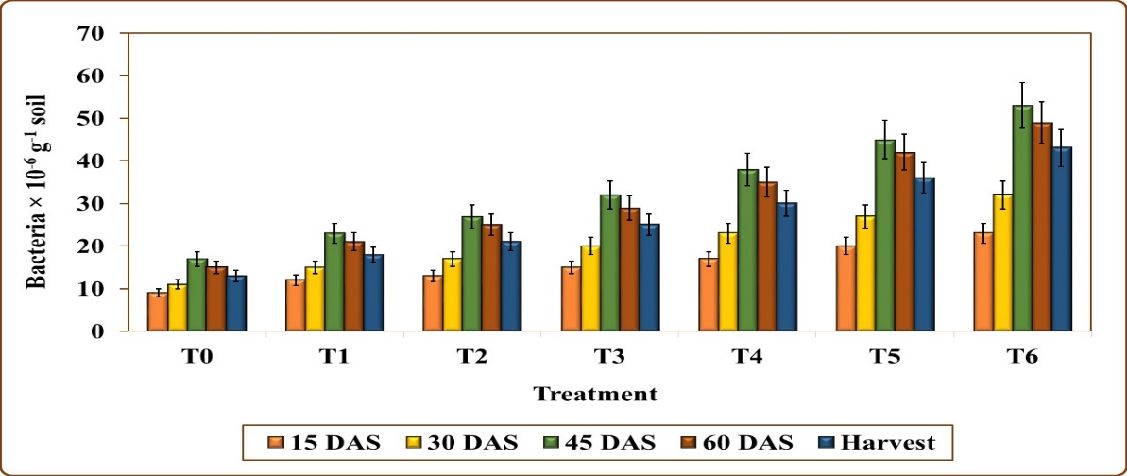

Figure 2. Impact of halophytic compost application on soil fungi population. (n=3) p<0.05. Values shown are mean ± S.E.

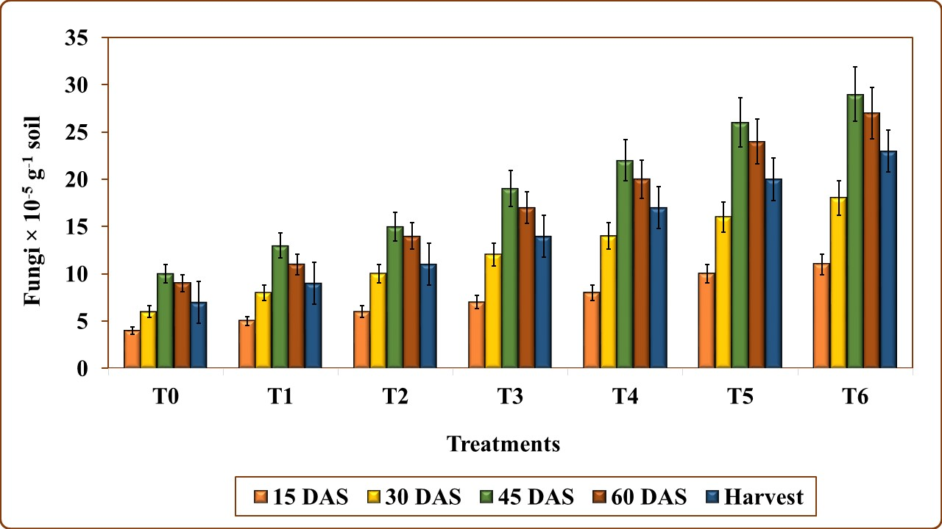

Figure 3. Impact of halophytic compost application on soil Actinomycetes population. (n=3) p<0.05. Values shown are mean ± S.E.
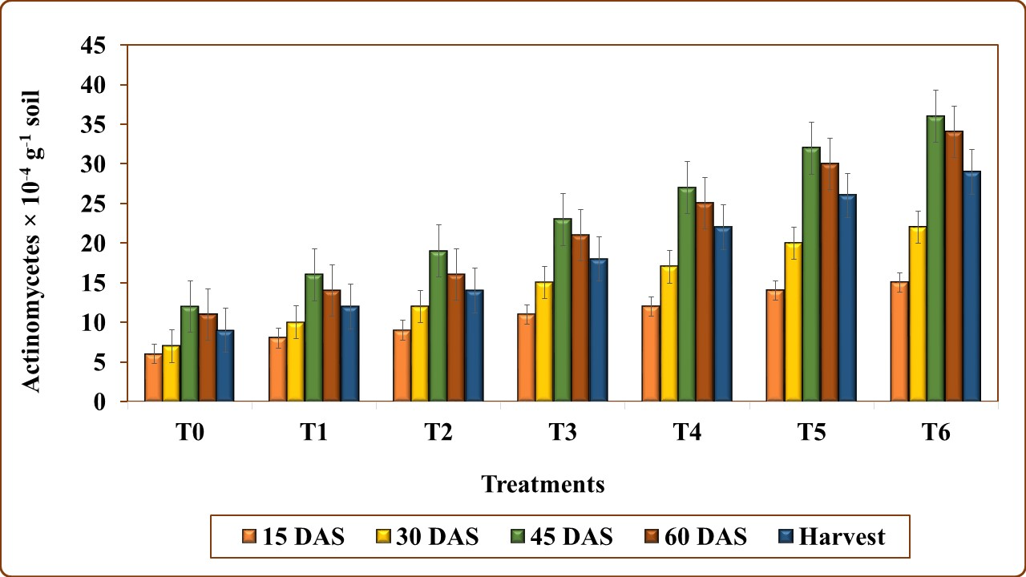

Similar to soil microbial populations, Suaeda maritima compost combined with cow dung manure and Azospirillum (T₆) was found to have a significant impact on enzyme activities, with a 74.44 % increase in dehydrogenases and 62.04 % increase in cellulase activity (Figures 4 and 5). Similar to microbial populations, a reverse trend in enzymes activities was observed from 45th day to harvest stage in all the compost treatments.
Figure 4. Impact of halophytic compost application on soil dehydrogenase activity. (n=3) p<0.05. Values shown are mean ± S.E.
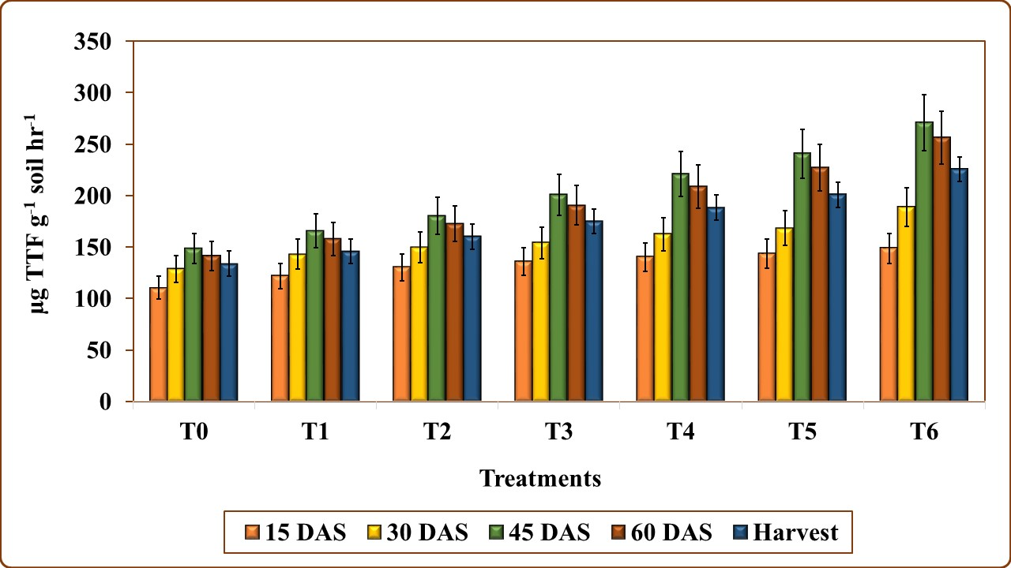

Figure 5. Impact of halophytic compost application on soil cellulase activity. (n=3) p<0.05. Values shown are mean ± S.E.

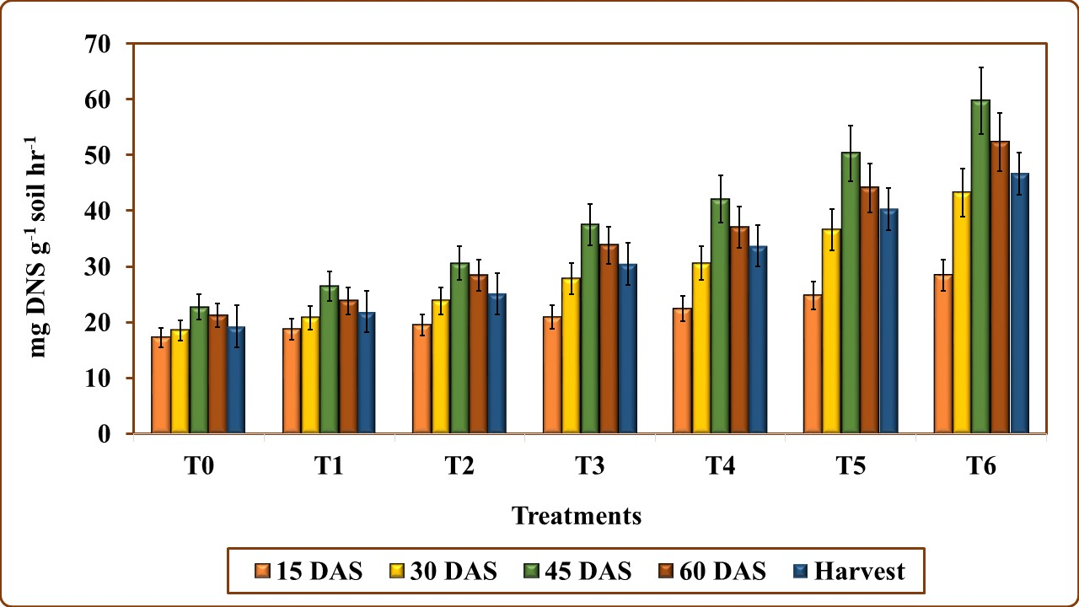

The application of halophytic compost notably reduced the pH and electrical conductivity of the soil at the end of harvest stage (Figures 6 and 7). Soil amended with Suaeda maritima compost mixed with cow dung manure and Azospirillum (T₆) showed the greatest pH reduction (7.37 %) when compared with other compost amended soils (T₁ to T₅) and unmanured control (T₀). Similar to pH, soils treated with halophytic compost showed a significant decrease in electrical conductivity. The greatest reduction (27.41 %) was seen in Suaeda maritima compost mixed with cow dung manure and Azospirillum (T₆) treatment. Similarly, soil bulk density (Fig. 8) showed a marked reduction (18.88 %) under halophytic compost treatments, indicating an improved soil structure.
Figure 6. Impact of halophytic compost application on soil pH. (n=3) p<0.05. Values shown are mean ± S.E.
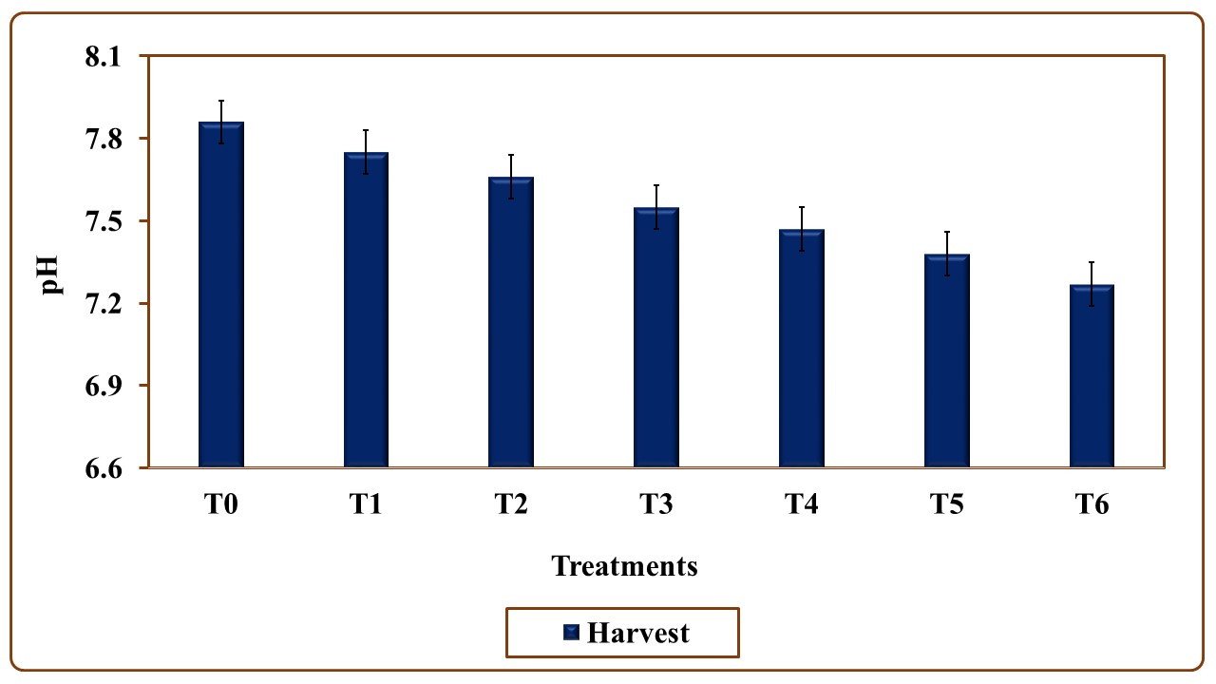

Figure 7. Impact of halophytic compost application on soil electrical conductivity. (n=3) p<0.05. Values shown are mean ± S.E.
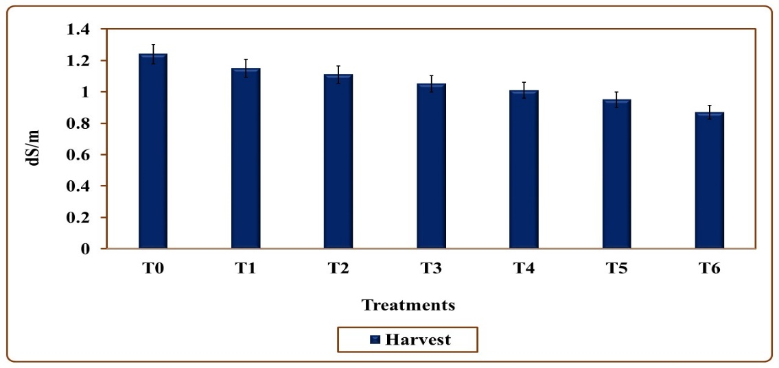

Figure 8. Impact of halophytic compost application on soil bulk density. (n=3) p<0.05. Values shown are mean ± S.E.
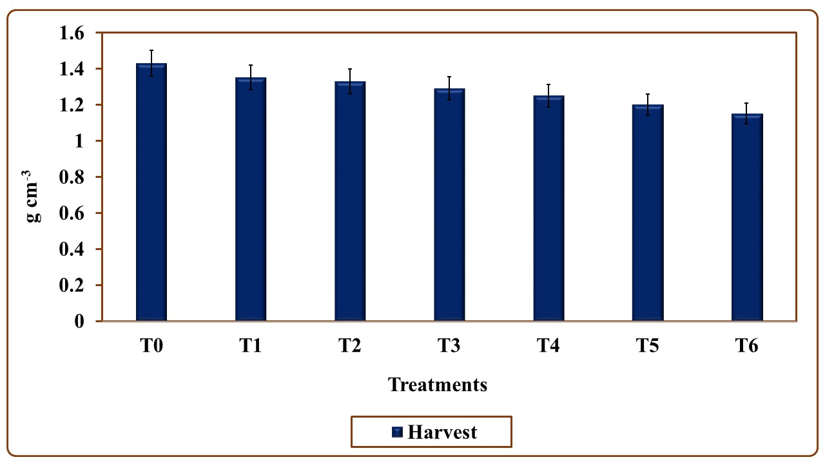

In contrast, soil porosity (Fig. 9) exhibited a substantial enhancement thought the study period. The Suaeda compost enriched with cow dung manure and Azospirillum resulted in 25.92 % increase in porosity when compared to other halophytic compost treatments and the unmanured soil. Soil analysis during the harvest stage revealed that soil organic carbon (Fig. 10) was increased significantly in all halophytic compost treatments, with the maximum enhancement of 72.34 % recorded in the soil amended with Suaeda maritima compost combined with cow dung manure and Azospirillum.
Figure 9. Impact of halophytic compost application on soil porosity. (n=3) p<0.05. Values shown are mean ± S.E.
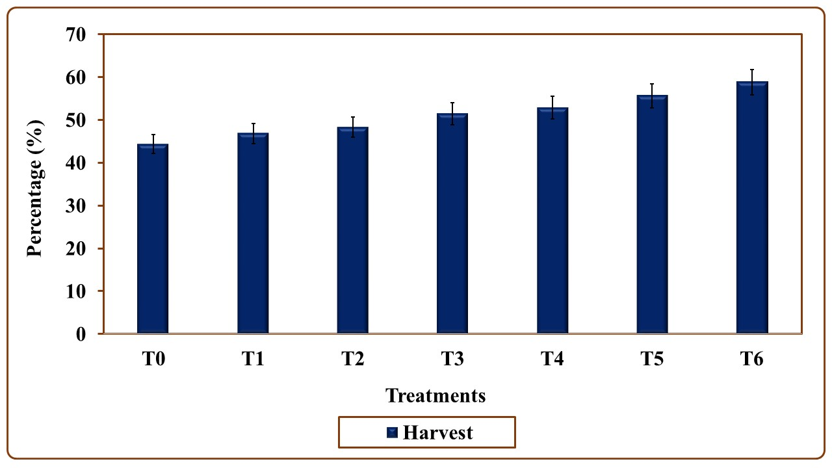

Figure 10. Impact of halophytic compost application on soil organic carbon. (n=3) p<0.05. Values shown are mean ± S.E.
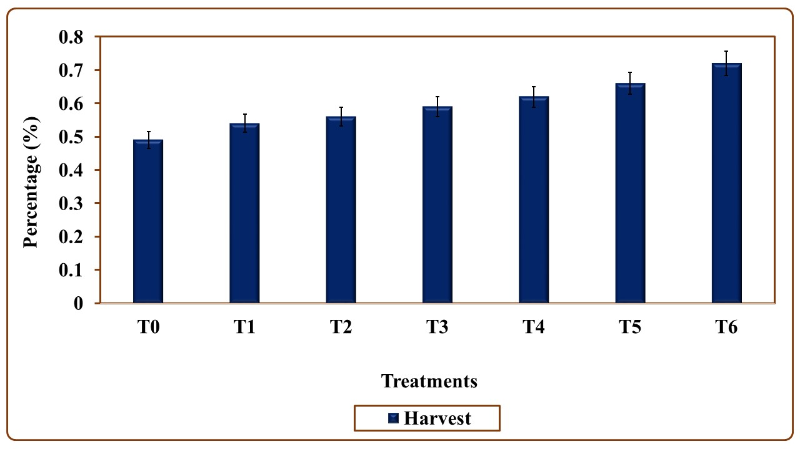

4-DISCUSSION
In the current investigation, the incorporation of halophytic compost notably enhanced the soil microbial count compared to the unmanured control. Among the six halophytic compost treatments, the combination of Suaeda maritima compost with cow dung manure and Azospirillum (T₆) recorded the highest bacterial, fungal, and actinomycetes populations, demonstrating its superior ability to stimulate microbial activity. These findings are in accordance with several reports, particularly Patel et al. (2024) noticed that the combined amendment of farmyard manure, Rhizobium, and PSB significantly increased soil microbial populations, resulting in a 61.50% rise in bacteria, 57.33% in fungi, and 58.52% in actinomycetes. Similarly, Gorski et al. (2024) reported that green manure with biofertilizers increased 76.0 per cent in bacteria, 58.0 per cent in fungi and 39.0 per cent in actinomycetes. Shah et al. (2020) also documented that halophytic compost applications significantly elevated microbial populations in black gram soil, with increases Bacterial (66.67%), fungi (62.5%), and actinomycetes (63.62%) during the first 45 days, followed by a gradual decline toward harvest (23.84%, 28.33%, and 30% reduction, respectively). Collectively, these studies support the present findings, emphasizing the positive influence of halophytic compost on soil microbial dynamics.
Application of halophytic compost led to a notable increase in soil dehydrogenase activity in the present study. Similar trends have been reported by El-Sawah et al. (2021) observed a 48.8% enhancement in dehydrogenase activity in guar-cultivated soils following biofertilizer application compared with the control. Singh et al. (2015) also documented a 43.60 % increase in dehydrogenase activity in rice soils treatment with vermicompost and biofertilizers. Similar results were noted by Balakrishnan et al. (2007), reported nearly a 20% reduction in dehydrogenase activity 60 days after halophytic compost application. Since dehydrogenase activity largely reflects the metabolic status of soil microorganisms, it is strongly associated with soil microbial biomass carbon, particularly in organically treated soils (García-Gil et al., 2000).
In this research, halophytic compost also enhanced soil cellulase activity. Comparable findings were reported by Al-Khalidi and Al-Taweel (2024) demonstrated a 68% increase in cellulase activity in broccoli-cultivated soils treated with biofertilizers and seaweed extract. Lu and Zhow (2023) also noticed that application of organic manures significantly enhanced cellulase activity in soil of maize field in mountain red soil. Although Balakrishnan et al. (2007) noted a 20.6% decline in cellulase activity following halophytic compost application at 60 days. The improvement in cellulase activity is strongly correlated with enhanced soil microbial populations, as documented by (Kshattriya et al., 1992 and Aziz et al., 2018).
From the study, it is also observed that soil microbial and enzyme activities usually increased upto first 45 days due to the availability of easily decomposable organic matter and during the harvest time these organic substances were completely decomposed, resulting in lower microbial activities which resulting in reductions in enzymes activities. (Liu et al., 2017).
The results also indicate a significant reduction in soil pH, EC, Bulk density and increased porosity and organic carbon. Our result accordance with several other findings also reported that application of farmyard manure significantly reduced soil pH (7%) and electrical conductivity (32.14%) of quinoa and Jew’s mallow cultivated soil compared to chemical fertilizers (Youssef and farag, 2021). Shah and Ravindran et al (2020) also reported that application of halophytic compost significantly decreased pH (7.8 %) and electrical conductivity (29 5%) of Black gram cultivated soil. This reduction in soil pH under halophytic compost treatments may be attributed to the release of H⁺ ions and various organic and inorganic acidic compounds generated during the continuous decomposition of the compost. Additionally, the CO₂ released during organic matter mineralization can dissolve in soil water to form carbonic acid, which further contributes to the acidification and subsequent neutralization of soil pH and reduced soil electrical conductivity (Candemir et al., 2011).
From the result observed that halophytic compost application reduced the soil bulk density. Similar findings were made by several workers and 11 % reduction was observed with application of green manure and farmyard manure (Mujdeci et al., 2020), 11.76% with farmyard manure and combination of Biofertilizers (Gopinath et al., 2011) and 16.17 with saw dust compost and farmyard manure (Jain and Kalamdhad, 2020). Additionally, applying organic manures to soils causes the release of polysaccharides and bacterial gums, which improve aggregation of soil and lower bulk density (Rayne and Aula, 2020).
The current study also confirmed that halophytes derived compost application significantly enhanced soil porosity. Similar to our results with 47.94 per cent increase was noticed in soil treated with crop residues + farmyard manure + biofertilizers in soil (Jyoti sharma et al., 2023), 16 per cent with green manure + poultry manure in soil of cassava (Bilong et al., 2022). The improvement in soil total porosity due to halophytic compost application can be associated to the role of organic matter in promoting the formation of stable soil aggregates, which create more pore spaces and enhance soil porosity (Lehmann et al., 2020). Decomposed organic matter increases the proportion of macropores and micropores, facilitating better air circulation and water infiltration. Additionally, earthworm and microbial activity contribute to porosity by burrowing and breaking down organic materials (Bilong et al., 2022).
In this research, it is shown that incorporation of both halophytes derived composts enhanced the organic carbon in Vigna unguiculata cultivated soil when compared to untreated control. Similar reports are available that incorporation of various organic amendments increased the organic carbon to 24.57 per cent with organic compost in soil of Solanum lycopersicum (Piya et al., 2018) and application of farmyard manure enhanced 45% organic carbon in soil (Abdalla et al., 2022). The increase in soil organic carbon in the current study may have been caused by both direct incorporation of organic matter through organic manures, which subsequent decomposed to raise the soil's organic carbon content, and increased root development, which collects organic leftovers (Shah and Ravindran, 2023).
5-CONCLUSION
The current study demonstrated that applying Suaeda maritima compost along with cow dung manure and Azospirillum greatly enhanced the physical, chemical, and biological characteristics of the soil. This integrated nutrient management approach enhanced soil microbial population and enzymatic activities, indicating an improved microbial functioning and nutrient cycling. Although soil pH, electrical conductivity, and bulk density declined, soil porosity and organic carbon content increased concurrently, suggesting an improved soil fertility and structure. Overall, the combined use of halophytic compost along with cow dung manure, and Azospirillum proved to be an effective and sustainable strategy for improving coastal salt affected agricultural soil.
REFERENCES
1.Abdalla, K., Sun, Y., Zarebanadkouki, M., Gaiser, T., Seidel, S., & Pausch, J. (2022). Long-term continuous farmyard manure application increases soil carbon when combined with mineral fertilizers due to lower priming effects. Geoderma, 428, 116216.
2.Al-Khalidi, A. M., & Al-Taweel, L. S. (2024). The Effect of Biofertilizers and Seaweed Extract on the Activity of Cellulase Enzyme and β-Glucosidase in Soil Planted with Broccoli Plants. In IOP Conference Series: Earth and Environmental Science (Vol. 1371, No. 10, p. 102003). IOP Publishing.
3.Antonious, G. F., Turley, E. T., & Dawood, M. H. (2020). Monitoring soil enzymes activity before and after animal manure application. Agriculture, 10(5), 166.
4.Aziz, M. A., Hazra, F., Salma, S., & Nursyamsi, D. (2018). Soil enzyme activities and their relationship to total soil bacteria, soil microbial biomass and soil chemical characteristics of organic and conventional farming. Journal of Tropical Soils, 23(3), 133-141.
5.Balakrishnan V, Venkatesan K, Ravindran KC. The influence of halophytic compost, farmyard manure and phosphobacteria on soil microflora and enzyme activities. Plant Soil and Environment. 2007 Apr 30;53(4):186.
6.Balakrishnan, V., Venkatesan, K., Sanjiviraja, K., Indrajith, A., & Ravindran, KC. (2010). Application of an organic halophytic manure on yield characteristics of Arachis hypogaea Linn. International Journal of Engineering, Science and Technology, 2(1), 134-143.
7.Bilong, E. G., Abossolo-Angue, M., Ajebesone, F. N., Anaba, B. D., Madong, B. À., Nomo, L. B., & Bilong, P. (2022). Improving soil physical properties and cassava productivity through organic manures management in the southern Cameroon. Heliyon, 8(6).
8.Candemir, F., & Gülser, C. (2010). Effects of different agricultural wastes on some soil quality indexes in clay and loamy sand fields. Communications in Soil Science and Plant Analysis, 42(1), 13-28.
9.Cuevas VC. 1997. Rapid composting technology in the Philippines: Its role in producing good-quality organic fertilizers. Food and Fertilizer Technology Center Extension Bulletin, 444: 1–13.
10.Dewis, J., & Freitas, F. (1970). Physical and chemical methods of soil and water analysis.275-pp.
11.Dinesh, R., Srinivasan, V., Hamza, S., & Manjusha, A. (2010). Short-term incorporation of organic manures and biofertilizers influences biochemical and microbial characteristics of soils under an annual crop [Turmeric (Curcuma longa L.)]. Bioresource technology, 101(12), 4697-4702.
12.El-Sawah, A. M., El-Keblawy, A., Ali, D. F. I., Ibrahim, H. M., El-Sheikh, M. A., Sharma, A., ... & Sheteiwy, M. S. (2021). Arbuscular mycorrhizal fungi and plant growth-promoting rhizobacteria enhance soil key enzymes, plant growth, seed yield, and qualitative attributes of guar. Agriculture, 11(3), 194.
13.Galstyan, A. S. (1965). Effect of temperature on activity of soil enzymes.177-181.
14.Garcia-Gill J.C., Plaza C., Soler-Rovira P., Polo A. (2000): Long-term effects of municipal solid waste compost application on soil enzyme activities and microbial biomass. Soil Biol. Biochem., 32: 1907–1913.
15.Górski, R., Niewiadomska, A., Płaza, A., Wolna-Maruwka, A., Swędrzyńska, D., Głuchowska, K., & Rosa, R. (2024). Enhancing soil microbial activity and spelt (Triticum spelta L.) yield in organic farming through biofertilizer and green manure applications. Agronomy, 14(12), 2845.
16.Harshitha, C., & Prema, G. (2024). Incidence, transmission, host range and population dynamics of aphids transmitting bean common mosaic virus of cowpea. Journal of Farm Sciences, 37(01), 12-19.
17.Jackson, R. D. (1973). Diurnal changes in soil water content during drying. Field soil water regime, 5, 37-55.
18.Joshi, D., Gediya, K. M., Patel, J. S., Birari, M. M., & Gupta, S. (2016). Effect of organic manures on growth and yield of summer cowpea [Vigna unguiculata (L.) Walp] under middle Gujarat conditions. Agricultural Science Digest-A Research Journal, 36(2), 134-137.
19.Kashyap, P., & Jain, M. (2025). Organic Farming: Emerging Practices, Effect on Environment and Nutrition. Nature Environment & Pollution Technology, 24.
20.Kirarei, E. K., Kipsumbai, P. K., Jeruto, P., & Kiprop, E. K. (2024). An overview on the Taxonomy, Distribution, Production and Economic Importance of Cowpea (Vigna unguiculata L. Walp). Journal of Crops, Livestock and Pest Management, 2(3), 1-14.
21.Klute, A. (1986). Water retention: laboratory methods. Methods of soil analysis: part 1 physical and mineralogical methods, 5, 635-662.
22.Lehmann, J., Bossio, D. A., Kögel-Knabner, I., & Rillig, M. C. (2020). The concept and future prospects of soil health. Nature Reviews Earth & Environment, 1(10), 544-553.
23.Liu, J., Shu, A., Song, W., Shi, W., Li, M., Zhang, W., ... & Gao, Z. (2021). Long-term organic fertilizer substitution increases rice yield by improving soil properties and regulating soil bacteria. Geoderma, 404, 115287.
24.Liu, S., Razavi, B. S., Su, X., Maharjan, M., Zarebanadkouki, M., Blagodatskaya, E., & Kuzyakov, Y. (2017). Spatio-temporal patterns of enzyme activities after manure application reflect mechanisms of niche differentiation between plants and microorganisms. Soil Biology and Biochemistry, 112, 100-109.
25.Lu, Z., Zhou, Y., Li, Y., Li, C., Lu, M., Sun, X., ... & Fan, M. (2023). Effects of partial substitution of chemical fertilizer with organic manure on the activity of enzyme and soil bacterial communities in the mountain red soil. Frontiers in Microbiology, 14, 1234904.
26.Megali, L., Glauser, G., & Rasmann, S. (2013). Fertilization with beneficial microorganisms decreases tomato defenses against insect pests. Agronomy for sustainable development, 34(3), 649-656.
27.Meng, Q., Yang, J., Yao, R., & Liu, G. (2013). Soil quality in east coastal region of China as related to different land use types. Journal of Soils and Sediments, 13(4), 664-676.
28.Nelson, D. W., & Sommers, L. E. (1982). Total carbon, organic carbon, and organic matter. Methods of soil analysis: Part 2 chemical and microbiological properties, 9, 539-579.
29.Patel, K. K., Pandey, A. K., Baheliya, A. K., Singh, V., Yadav, R., Pandey, S., & Yadav, V. (2024). A comparative study of the effects of biofertilizers and chemical fertilizers on soil physical and biological properties under chickpea crop (Cicer arietinum L.). International Journal of Environment and Climate Change, 14(3), 72-80.
30.Piya, S., Shrestha, I., Gauchan, D. P., & Lamichhane, J. (2018). Vermicomposting in organic Agriculture: Influence on the soil nutrients and plant growth. International Journal of Research, 5(20), 1055-1063.
31.Pramer, D., & Schmidt, E. L. (1965). Decomposition of cellulose. Experimental Soil Microbiology. Exercise, 30, 90-91.
32.Ravindran, K. C., Venkatesan, K., Balasubramanian, T., & Balakrishnan, V. (2007). Effect of halophytic compost along with farmyard manure and phosphobacteria on growth characteristics of Arachis hypogaea Linn. Science of the total environment, 384(1-3), 333-341.
33.Rayne, N., & Aula, L. (2020). Livestock manure and the impacts on soil health: A review. Soil Systems, 4(4), 64.
34.Sanjay Kumar, S. K., Kumar, J., Himanshu Kumar, H. K., Anurag Padhan, A. P., & Sanjeev Kumar, S. K. (2017). Effect of biofertilizer (Rhizobium) and vermi compost on growth and yield of garden pea (Pisum sativum L.) sub sp. hortense Asch. and Grabn. 75-78.
35.Sarwar, G., Schmeisky, H., Hussain, N., Muhammad, S., Ibrahim, M., & Safdar, E. (2008). Improvement of soil physical and chemical properties with compost application in rice-wheat cropping system. Pakistan Journal of Botany, 40(1), 275-282.
36.Shah, M. A., & Ravindran, K. C. (2020). Optimization of halophytic compost along with farmyard manure and Rhizobium on growth of Vigna mungo L. Plant Archives, 20(2), 1398-1405.
37.Shah, M. A., & Ravindran, K. C. (2023). Impact of halophytic compost along with farmyard manure and Rhizobium on biochemical and soil physico-chemical properties of organically cultivated urd bean.
38.Shah, M. A., Ravindran, K. C., & Elango, R. (2020). Synergistic effect of halophytic compost in combination with farmyard manure and Rhizobium on soil microflora and yield parameters of black gram (Vigna Mungo L.). Int. J. Bot. Stud., 5(3), 497-503.
39.Sharma, T., Singh, J., Madaik, S., Kumar, P., Singh, A., Rana, B. B., & Chauhan, G. (2024). Organic input incorporation for enhancing sustainability and economic viability of cowpea in North-Western Himalayan region. Frontiers in Agronomy, 6, 1458603.
40.Shi, W. (2010). Agricultural and ecological significance of soil enzymes: soil carbon sequestration and nutrient cycling. In Soil enzymology (pp. 43-60). Berlin, Heidelberg: Springer Berlin Heidelberg.
41.Singh, G., Kumar, D., & Sharma, P. (2015). Effect of organics, biofertilizers and crop residue application on soil microbial activity in rice–wheat and rice-wheat mungbean cropping systems in the Indo-Gangetic plains. Cogent Geoscience, 1(1), 1085296.
42.Singh, G., Sharma, M., Manan, J., & Singh, G. (2016). Assessment of soil fertility status under different cropping sequences in District Kapurthala. Journal of Krishi Vigyan, 5(1), 1.
43.Tabatabai, M. A. (1982). Soil enzymes. Methods of soil analysis: Part 2 chemical and microbiological properties, 9, 903-947.
44.USDA. (2021). Food Data Central. https://fdc.nal.usda.gov/ (accessed June 11, 2021).
45.Youssef, M. A., & Farag, M. I. H. (2021). Co-application of organic manure and bio-fertilizer to improve soil fertility and production of quinoa and proceeding Jew’s mallow crops. Journal of Soil Science and Plant Nutrition, 21(3), 2472-2488.
Wu, H., Chu, S., Ouyang, X., Zou, Z., Fu, H., Liu, Y., Shi, X., Zhang, Y., Ouyang, K., Zhang, L., & Hu, D. (2024). Effects of Cow-Dung Vermicomposting on Soil Carbon Mineralization and Temperature Sensitivity in Camellia oleifera Forest. Agriculture, 14(11), 1973. https://doi.org/10.3390/agriculture14111973

Kumari P, Sharma B, Kumari R, Murya BR. Soil Microbial Dynamics as Influenced by Organic Amendments in Alluvium Soil of Indo-Gangetic Plains, India. J Pure Appl Microbiol. 2016;10(4):2919-2924. doi: 10.22207/JPAM.10.4.57

Ganesh D. Jadhav, Ritu S. Thakare, and Prasad B. Margal. 2025. “Dynamics of Soil Enzyme Activities and Microbial Populations under Different Temperature Regimes and Organic Residue Amendments”. Journal of Advances in Biology & Biotechnology 28 (10):379–394. https://doi.org/10.9734/jabb/2025/v28i103067.

Deeksha Gupta, R. Bajpai, S. B. Agrawal, B. S. Dwivedi, Komal Bhatt, Poornima Malviya, and Rahul Mandloi. 2024. “Influence of Phosphorus and Phosphate-Solubilizing Bacteria on Soil Microbial Dynamics in Mustard under Gmelina-Based Agroforestry”. Journal of Experimental Agriculture International 46 (12):418–425. https://doi.org/10.9734/jeai/2024/v46i123148.

