Influence of Cultural Media, Temperature, and pH on the Growth Characteristics of Fusarium oxysporum f. sp. dianthi Isolated from Carnation
Anuj Prasad, Vijay Kumar, Kaplna, K.C. Singh, Mamta Bohra
COH, Veer Chandra Singh Garhwali Uttarakhand University of Horticulture and Forestry, Bharsar, Pauri Garhwal, Uttarakhand – 246123

ABSTRACT
Fusarium is a large genus of filamentous, soil-dwelling ascomycetous fungi. While most species are harmless saprobes and commonly found in soil, some cause diseases in a variety of crops, including cereals, pulses, fruits, ornamentals, and vegetables. The fungi block the vascular bundles in plants, hindering water flow, which results in wilting and drying. Specifically, Fusarium oxysporum f. sp. dianthi causes wilting and plant death in carnations. Fusarium wilt symptoms include yellowing and stunted growth in older plants, initially affecting one side, which eventually leads to the wilting of the entire plant. The xylem tissue dries up and turns brown, causing the plant to die. The present investigation was conducted at the Department of Plant Pathology, VCSG UUHF, Bharsar, Pauri Garhwal, Uttarakhand to assess the influence of various culture media, temperature regimes, and pH levels on the growth of Fusarium oxysporum f. sp. dianthi. Maximum mycelial growth of the pathogen (89.59 mm) was observed on Potato Dextrose Agar (PDA) medium after seven days of incubation. Among the temperature treatments, 30 °C supported the highest mycelial growth (79.10 mm), while pH 6.0 favoured optimum growth (69.90 mm) under in-vitro conditions.
Key words: Fusarium wilt, culture media, isolation, pH, temperature, Dianthus caryophyllus
1. INTRODUCTION
Carnation (Dianthus caryophyllus L.), a dicotyledonous plant from the Caryophyllaceae family, is one of the most widely grown commercial flowers in the world. It is still an essential floriculture crop in temperate climates, where it is cultivated, all year given its high adaptability and steady market demand. The crop is especially valued for its long vase life, which increases its aesthetic value and economic significance in both the wholesale and retail flower sectors (Aalifar et al., 2020). With the growing demand for high-quality cut flowers, there is a greater emphasis on creating carnation varieties with superior floral characteristics and increased yield. Meeting this objective requires the systematic collection, conservation and evaluation of available germplasm, which serves as the foundation for breeding efforts and the development of improved cultivars (Tarannum and Naik, 2014). (Ibrahim, 2016) reported that carnation essential oil exhibits a range of therapeutic properties. It has been associated with improved wound healing, relief from asthma and eye-related ailments, reduction of dizziness, enhancement of memory and notable antiseptic effects. Dianthus caryophyllus L. is believed to have originated in the Mediterranean region. It is considered one of the ten most widely cultivated cut flowers worldwide and holds substantial commercial importance in the global ornamental and decorative flower industry (Hashemabadi et al., 2015). The major disease of carnation is powdery mildew, leaf spot, Bacterial leaf spot, root rot and Fusarium wilt, symptoms include yellowing and stunted growth in older plants, initially affecting one side, which eventually leads to the wilting of the entire plant. The xylem tissue dries up and turns brown, causing the plant to die (Sharma and Sharma, 2008).
In India, carnation cultivation faces significant challenges due to the widespread incidence of wilt disease, which can cause severe yield losses ranging from 40% to 79% (Purnachandra, 2017). As per the DAC&FW Second Advance Estimates (2023–24), the country’s floriculture sector spans nearly 0.285 million hectares, producing around 2.284 million tonnes of loose flowers and 0.947 million tonnes of cut flowers. Among these, annual carnation production is approximately 6 MT, with Himachal Pradesh contributing the largest share (2.75 MT, about 45%), followed by Uttarakhand with 1.25 MT (Anon., 2015).
2. MATERIAL AND METHODS
2.1 Isolation and Maintenance of Fusarium oxysporum f. sp. dianthi
An infected carnation leaf showing typical wilt symptoms was collected from the Floriculture and Landscaping Block, College of Horticulture, VCSG UUHF, Bharsar and brought to the laboratory for pathogen isolation. The sample was washed under running tap water, air-dried and small sections (2 cm) taken from the junction of healthy and infected tissues. These pieces were surface sterilized in 0.1% sodium hypochlorite for 30 seconds, rinsed thoroughly with sterile distilled water and aseptically plated on Potato Dextrose Agar (PDA). The plates were incubated at 25 ± 2 °C and monitored daily for fungal growth. After about one week, the emerging fungal colony was purified through repeated subculturing and maintained on PDA slants at 4 °C for further study. Identification was carried out based on microscopic examination of the mycelial characteristics.
2.2 Identification of the pathogen
The morphological features of the fungus were examined to confirm the identity of the isolated pathogen. Slides were prepared using water and cotton blue stain, and the fungal structures were observed under a compound microscope at 40X magnification. Colony appearance, colony color, mycelial growth, and the size and form of conidia were recorded and compared with the known characteristics of Fusarium oxysporum f. sp. dianthi.
2.3 Cultural studies
2.3.1 Growth characters on different solid media
The cultural variation of Fusarium oxysporum f. sp. dianthi was assessed on five solid media viz. Potato Dextrose Agar (PDA), Oat Meal Agar, Czapek-Dox Agar, Corn Meal Agar and Rose Bengal Agar. Each medium was sterilized at 121 °C under 15 psi for 15 minutes and 20 ml of the medium was poured into 90 mm sterile Petri plates. The plates were inoculated with a 5 mm mycelial disc and incubated at 25 °C.
2.4 Physiological studies
2.4.1 Growth characters on different temperature
Potato Dextrose Agar (PDA) medium was used to study the influence of different temperatures on the growth of Fusarium oxysporum f. sp. dianthi. The medium was poured into Petri plates and four replications were maintained for each temperature treatment. The plates were incubated at 15 ℃, 20 ℃, 25 ℃, 30 ℃ and 35 ℃ for 7 days. Radial mycelial growth was recorded after 7th days of incubation.
2.4.2 Growth characters on different pH
Potato Dextrose Agar (PDA) was used as the basal medium for the pH study. About 20 ml of PDA was dispensed into 100 ml conical flasks and the pH was adjusted to 5.0, 5.5, 6.0, 6.5 and 7.0 using appropriate volumes of HCl or NaOH. Each pH level was maintained in four replications. The plates were then incubated at 25 ± 2 °C and the radial growth of the fungus was recorded after 7th days of incubation.
2.5 Statistical analysis
The experimental data collected during the laboratory investigations were statistically analysed following the principles of a Completely Randomized Design (CRD). The mean values were subjected to analysis of variance (ANOVA) as outlined by Gomez and Gomez (1984), employing OPSTAT and MS-Excel software packages. The computed F-statistic was subsequently compared with the corresponding tabulated F-value. In cases where the F-test indicated significance, the critical difference (CD) was determined to ascertain the relative superiority of individual treatments over the others.
3. RESULTS AND DISCUSSION
3.1 Effect of different culture media on mycelial growth (mm) of Fusarium oxysporum f. sp. dianthi
The results clearly showed notable differences in the mycelial growth of the pathogen across the five solid media after seven days of incubation. The maximum radial growth was observed on T1: Potato Dextrose Agar (PDA), with a mean colony diameter of (89.59 mm). This was followed by T2: Oat Meal Agar (64.82 mm), T3: Czapek’s Dextrose Agar (62.81 mm) and T4: Corn Meal Agar (80.75 mm). In contrast, T5: Rose Bengal Agar supported the least fungal growth, with the pathogen recording a mean colony diameter of only 15.61 mm. The present findings align with the research by Hedge et al. (2018) who conducted cultural studies on nine different solid media and found that the radial growth of Fusarium oxysporum f. sp. dianthi was most pronounced on Potato Dextrose Agar, with a growth measurement of (90 mm.) (Munde et al. 2020), reported that the radial growth of Fusarium oxysporum f. sp. gladioli was maximum on Potato Dextrose Agar, measuring (89.66 mm). This growth was significantly greater than on all other media tested. (Kumari et al. 2023) studied the effect of different culture media and temperatures on the mycelial growth and sporulation of Fusarium oxysporum f. sp. ciceri. Among the eight media tested, the pathogen showed maximum growth on Potato Dextrose Agar (PDA) and Czapek’s Dox agar.
Table 1. Effect of Different Culture Media on Mycelial Growth of Fungi
Treatments | Treatments details | Mycelial growth (mm) ± S.E. (m)
T₁ | Potato dextrose agar | 89.59±0.22
T₂ | Oat meal agar | 84.41±0.24
T₃ | Czapek’s dextrose agar media | 83.72±0.28
T₄ | Corn meal agar | 80.75±0.28
T₅ | Rose Bengal agar media | 15.61±0.36
SE_{(d)} |  | 0.40
C.D _{(0.05)} |  | 0.85
Plate no. 3.1 Effect of Different Culture Media on Mycelial Growth of Fungi
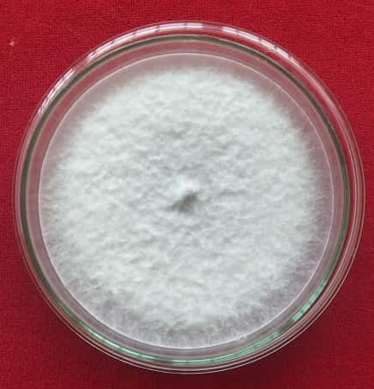 | 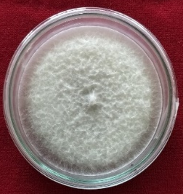 | 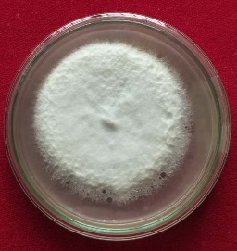 | 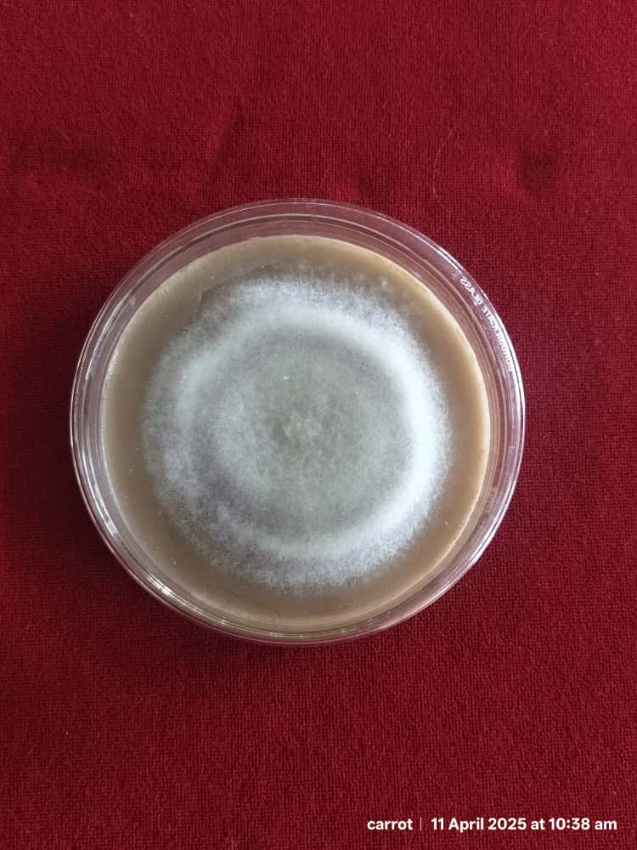 | 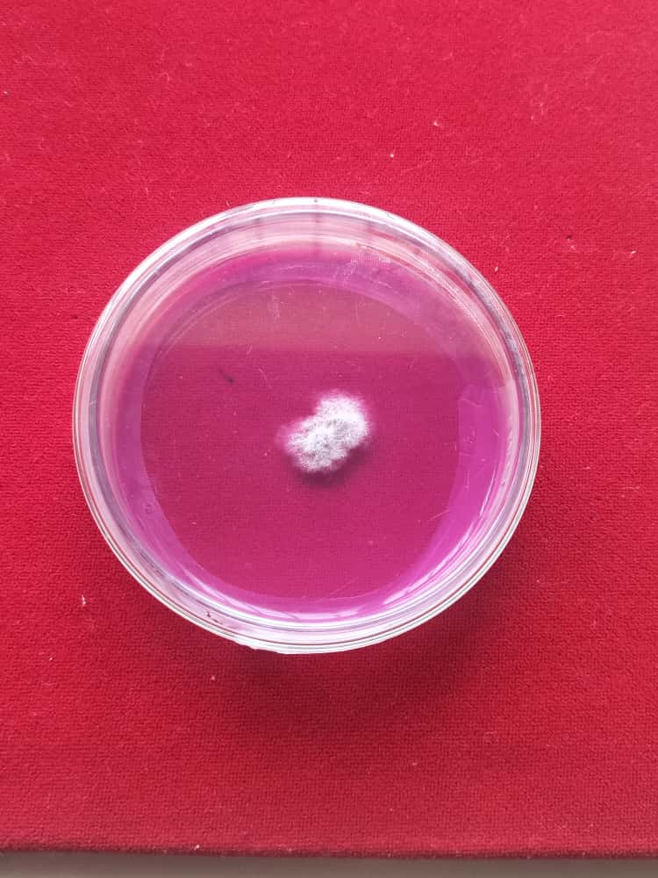
T₁ Potato dextrose agar | T₂ Oat Meal agar | T₃ Czapek’s dextrose agar | T₄ Corn Meal Agar | T₅ Rose Bengal Agar
Figure no. 3.1 Effect of Different Culture Media on Mycelial Growth of Fungi

3.2 Effect of different temperature on mycelial growth (mm) of F. oxysporum f. sp. dianthi
Among the tested temperature conditions, the maximum mycelial growth was recorded at 30 °C (T₄), with the maximum radial expansion reaching an average of (79.10 mm). This suggests that 30 °C provides the most favourable environmental conditions for the pathogen’s metabolic activity and vegetative development. The second maximum growth was observed at 25 °C (T₃), with a mean colony diameter of (61.78) mm, indicating that slightly higher temperatures still support substantial, though slightly reduced growth. These results align with the research conducted by Pempee et al. (2020) found that 30 °C was the most suitable temperature for Fusarium oxysporum f. sp. ciceri. They found maximum radial growth of the pathogen occurred at 30 °C (80.95mm). Correspondingly, Sahu et al. (2024) found Fusarium oxysporum f. sp. glycines on PDA medium at temperatures ranging from 10 °C to 40 °C. They observed that the maximum radial growth of the pathogen occurred at 30°C (85 mm). Likewise, (Munde et al. 2020) reported that Fusarium oxysporum f. sp. gladioli produced the maximum mycelial biomass at 30 °C, followed by 25 °C, while growth was considerably reduced at 35 °C.
Table 2. Effect of Temperature on Mycelial Growth of Fungi
T. No. | Temperature (℃) | Mycelial growth (mm) ± S.E. (m)
T₁ | 15 | 21.90±0.29
T₂ | 20 | 46.90 ±0.44
T₃ | 25 | 61.78±0.33
T₄ | 30 | 79.10±0.23
T₅ | 35 | 35.15±0.14
SE (d.) |  | 0.43
C.D _{(0.05)} |  | 0.92

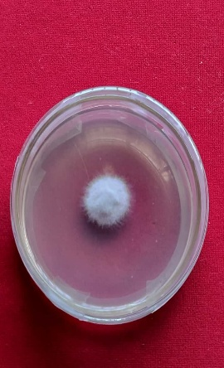 | 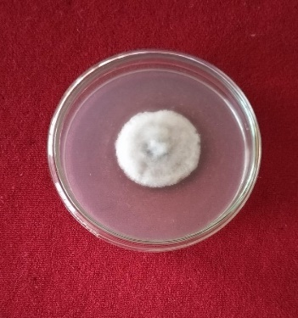 | 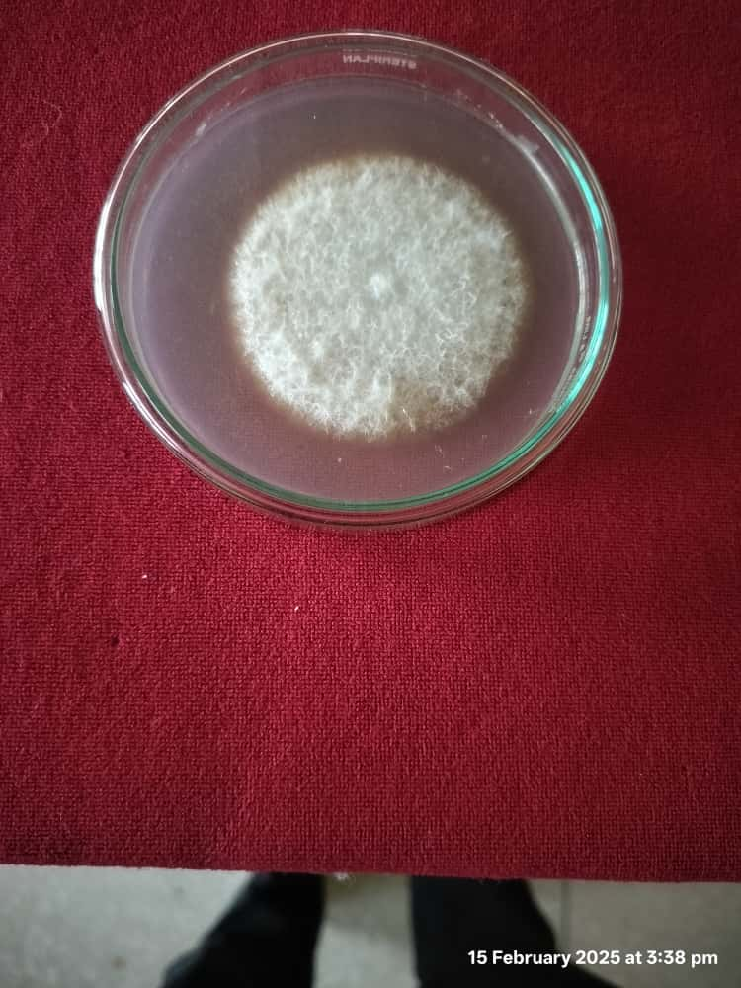 | 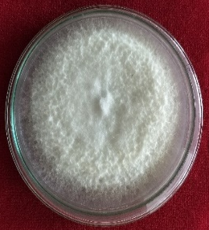 | 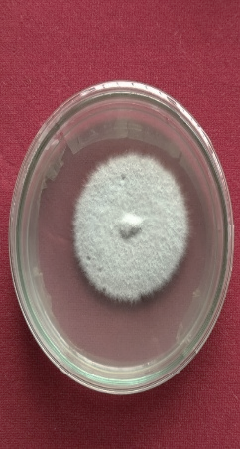
Plate no. 2. Effect of Temperature on Mycelial Growth of Fungi

Figure no. 2. Effect of Temperature on Mycelial Growth of Fungi

3.3 Effect of different pH on mycelial growth (mm) of Fusarium oxysporum f. sp. dianthi
The effect of varying pH levels on the radial mycelial growth of Fusarium oxysporum f. sp. dianthi was systematically evaluated by adjusting the culture medium to pH values of 5.0, 5.5, 6.0, 6.5 and 7.0. The results demonstrated that pH had a significant impact on fungal growth, with distinct variations in colony diameter across treatments. Maximum growth was observed at pH 6.0, where the colony reached a diameter of 65.35 mm, indicating that slightly acidic conditions are most favourable for fungal development. This was closely followed by pH 6.5, which supported substantial growth (64.89 mm). Moderate growth was recorded at pH 5.5 (64.19 mm), while further deviations from the optimal range led to a marked decline in mycelial expansion. Specifically, pH 5.0 and 5.5 exhibited reduced colony diameters of (43.75 mm) and (49.14 mm), respectively, suggesting that near-neutral and strongly acidic conditions are less conducive to the fungus’s growth. Overall, the findings highlight that F. oxysporum f. sp. dianthi exhibits optimal growth under mildly acidic conditions, with pH 6.0 being the most favourable for its radial mycelial development. The findings of the present investigation are in accordant with those of (Rao et al., 2020) and Sahu et al. (2024) reported similar findings in their studies regarding the growth of Fusarium oxysporum. (Rao et al. 2020) observed that the fungus exhibited the maximum mycelial growth at pH 6, with a recorded growth measurement of (90.93 mm) followed pH 7 with the mycelial extension measuring (85.3 mm). (Saho et al. 2025) demonstrated that pH 6.5 (85.00 mm) and pH 7 (82.83 mm) were also found favourable for the growth of test pathogen F. oxysporum f. sp. glycines. (Ram, 2022) reported that Fusarium oxysporum f. sp. lentis exhibited maximum radial growth at pH 6.0, with pH 6.5 were found to be conducive.

Table 3. Effect of pH on Mycelial Growth of Fungi
T. No. | pH | Mycelial growth (mm) ± S.E. (m)
T₁ | 5.0 | 51.02±0.30
T₂ | 5.5 | 55.15±0.19
T₃ | 6.0 | 69.90±0.23
T₄ | 6.5 | 64.89±0.21
T₅ | 7.0 | 62.46±0.32
SE (d) |  | 0.36
C.D _{(0.05)} |  | 0.78

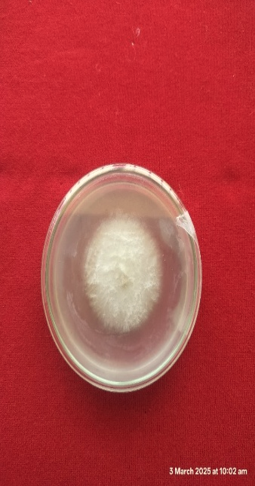 | 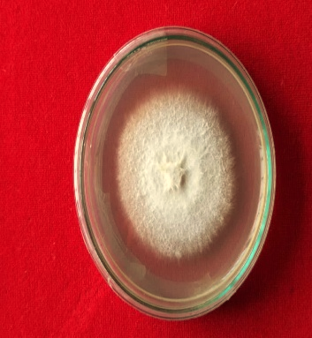 | 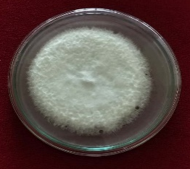 | 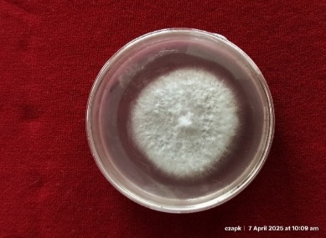 | 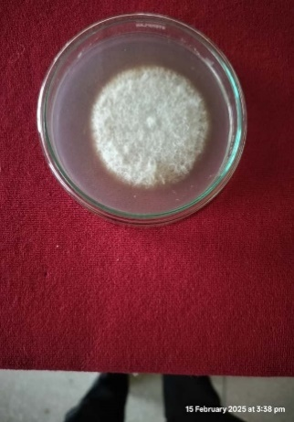
T₁ pH-5.0 | T₂ pH-5.5 | T₃ pH-6.0 | T₄ pH-6.5 | T₅ pH-7.0
Plate no. 3. Effect of pH on Mycelial Growth of Fungi
Figure no. 3. Effect of pH on Mycelial Growth of Fungi

4. CONCLUSION
The findings confirmed that Fusarium oxysporum f. sp. Dianthus is the pathogen that causes wilt in carnation, which causes symptoms such as gradual leaf yellowing, darker vascular tissues, and complete plant death. The fungus developed with a smooth, dense mycelium, producing clearly visible microconidia and macroconidia. Of all the cultural medium tested, PDA supported the fastest growth. The pathogen also grew best at pH 6.0, and at 30 °C, it showed the most mycelial growth among all temperature treatments.
Disclaimer (Artificial intelligence)
Option 1:
Author(s) hereby declare that NO generative AI technologies such as Large Language Models (ChatGPT, COPILOT, etc.) and text-to-image generators have been used during the writing or editing of this manuscript.
Option 2:
Author(s) hereby declare that generative AI technologies such as Large Language Models, etc. have been used during the writing or editing of manuscripts. This explanation will include the name, version, model, and source of the generative AI technology and as well as all input prompts provided to the generative AI technology
Details of the AI usage are given below:
1.
2.
3.

REFERENCES
Aalifar, M., Aliniaeifard, S., Arab, M., Mehrjerdi, M.Z., Serek, M. 2020. Blue light postpones senescence of carnation flowers through regulation of ethylene and abscisic acid pathway- related genes. Plant Physiology and Biochemistry.151:103-112.
Horticulture Statistics Division, Department of Agriculture, Cooperation & Farmers Welfare, Government of India. (2015). Horticultural Statistics at a Glance 2015. Oxford University Press.
Gomez, K. A. and Gomez, A. A. 1984. Statistical Procedure for Agricultural Research. 2nd Edition, Willey, Hoboken. 28-192.
https://www.wiley.com/en-us/Statistical+Procedures+for+Agricultural+Research,+2nd+Edition-p-9780471870920
Hashemabadi, D., Kaviani, B., Shirinpour, A. and Yaghoobi, D. 2015. Response of cut carnation (Dianthus caryophllus L.cv. Tempo) to essential oils and antimicrobial compounds. International Journal of Bioscience. 6:636–644.
Hedge, K. T., Narayanaswamy, H. and Veeraghanti, K. S. 2018. Morphological and cultural characteristics of Fusarium oxysporum f.sp. dianthi under laboratory condition. Journal of Pharmacognosy and Phytochemistry. 7(4):2839-2842.
Ibrahim, M.E. 2016. Agrochemical studies on Dianthus caryophyllus L. grown in Egypt.
International Journal of Pharmtech Research. 9(4):113-117.
Kamlesh Ram 2022. Effect of different pH, temperature and media on growth and sporulation of Fusarium oxysporum f. sp. lentis, causing wilt of lentil. The Pharma Innovation Journal 2022; 11(6): 1043-1047
http://www.sphinxsai.com/pharmtech.php
Munde, S. S., Mukadam, D. S., and Chavan, A. M. 2020. Morphological, Cultural and Physiological Characteristics of Fusarium oxysporum f. sp. gladioli. International Journal of Current Microbiology and Applied Sciences. 11:1-9.

Nitika Kumari1, C.B. Meena, Chirag Gautam, D.L. Yadav, Yamini Tak and R.K.Meena 2023. Effect of Media and Temperature on Growth and Sporulation of Fusarium oxysporumf. sp. ciceriin vitro. Int. J. Microbiol. & Appl. Sciences 2023 1(1): 63 - 67

Pempee, M. S., Satyadev, P., & Poonam, K. 2020. Effects of different temperature, pH and relative humidity on the growth of Fusarium oxysporum f. sp. ciceri causing Chickpea wilt. International Journal of Current Microbiology and Applied Sciences. 9(9):1381-1388.
https://doi.org/10.20546/ijcmas.2020.909.175
Gowda, G. P., Dhananjaya, M. V., & Halesh, G. K. (2017). Screening carnation genotypes for resistance against Fusarium wilt (Fusarium oxysporum f. sp. dianthi) isolates viz. IIHR and Pune. *International Journal of Microbiology Research*, *9*(3), 878-880. https://www.bioinfopublication.org/pages.php?id=BP0000290
Rao, Y. H., Devi, P. S., and Vardhani, V. 2020. Effect of media & Ph on mycelial growth of Fusarium oxysporum f. sp. lycopersici causing fusarium wilt of tomato in Manipur under in-vitro condition and effect of native Trichoderma spp. one chemical fungicide (Mancozeb) on growth. International Journal of Chemical Studies. 8(5):2120-2123.
https://doi.org/10.22271/chemi.2020.v8.i5ac.10615
Sahu. R., Kumar, S., Kumar, R. and Pipalde, Y. 2024. Effect of Different Media, pH and temperature on Growth and Sporulation of Fusarium Wilt of Soybean cause by Fusarium oxysporum f. sp. glycines. Biological Forum – An International Journal. 16(7):183-189.

S. S. Munde1, D. N. Dhutraj1, P. B. Khaire and P. H. Ghante. 2020. Morphological, Cultural and Physiological Characteristics of Pathogen associated with Wilt of Gladiolus. Int.J.Curr.Microbiol.App.Sci (2020) Special Issue-11: 3719-3730.
https://www.researchtrend.net/bfij.php
Tarannum, M. S. and Naik, B. H. 2014. Performance of carnation (Dianthus caryophyllus L.) genotypes for qualitative and quantitative parameters to assess genetic variability among genotypes. American International Journal of Research in Formal, Applied and Natural Sciences. 5:96-01.
Vincent, J. M. (1947). Distortion of fungal hyphae in the presence of certain inhibitors. Nature, 159, 850. https://doi.org/10.1038/159850b0
https://doi.org/10.12692/ijb/6.3.36-44
http://www.phytojournal.com/archives/2018/vol7issue4/PartAR/7-4-100-100.pdf
https://doi.org/10.1016/j.plaphy.2020.03.018
http://www.ijcmas.com/special-issue-11-2020.php

.

