Antidiabetic and Hepatoprotective Activity of Barleria grandiflora Ethanolic Leaf Extract in STZ-induced Diabetic Rats

ABSTRACT
Aim: Diabetes mellitus is one of the most common diseases and a continueing global epidemic, with over 1 to 9 adults living with the diabetes. It exacerbates multiorgan damages including the liver. Our previous study shows potent antioxidant and anti-inflammatory activity in the ethanolic leaf extract of B. grandiflora (BGEE). The present study was designed to evaluate the antidiabetic and hepatoprotective activity of BGEE against diabetic rats.
Study Design: BGEE was subjected to evaluate antidiabetic and hepatoprotective activity against STZ-induced diabetic rats.
Place and Duration of Study: “Shri Shankaracharya College of Pharmaceutical Sciences, Shri Shankaracharya Professional University, Bhilai-490020, Chhattisgarh, India”, over the period of 4 months
Methodology: For the study, Wistar albino rats (150-180 g) were randomly divided into different groups (n = 6 animals per group). Diabetes was induced in animals by administration of a single dose of STZ (50 mg/kg, i.p.). BGEE at two dose levels, 100 and 200 mg/kg/day, p.o., were administered in their respective groups (BGEE-100 and BGEE-200) for consecutive ten weeks and assessed against the STZ control group. The normal group was also included in the study.
Results: BGEE treatments significantly (P < 0.05) reduced blood glucose levels compared to the STZ control group. Moreover, BGEE treatments significantly (P < 0.05) restored the serum hepatic enzymes (SGOT, SGPT, and ALP), hepatic antioxidants (CAT, SOD, and GSH), and lipid peroxidation (MDA) compared to the STZ control group. The beneficial effect of BGEE against diabetic hepatopathy was also reflected in histopathological studies.
Conclusion: According to these findings, B. grandiflora is a very promising natural resource for the creation of potent, multi-target phytotherapeutics that can treat glycemic dysregulation and related diabetic hepatopathy.
Keywords: Barleria grandiflora; Diabetes; Antidiabetic Activity; Hepatoprotective activity; STZ-induced diabetes
- INTRODUCTION
Diabetes Mellitus (DM) is a pervasive, chronic metabolic disorder. It is defined by persistent hyperglycemia resulting from impaired insulin secretion, action, or a combination of both (Damasceno et al., 2014). In addition to upsetting glucose homeostasis, uncontrolled diabetes mellitus can lead to major micro- and macrovascular issues that damage vital organs like the liver, kidneys, and heart (Roy, 2025). Due to its essential functions in detoxification, lipid metabolism, and glucose regulation, the liver is particularly susceptible to damage, a condition known as diabetic hepatopathy (Özkan & Koyutürk, 2025). The continuous clinical challenge necessitates the investigation of new, multi-targeted therapeutic agents. These agents are often found in large quantities in traditional plant-based medicine, which is still the primary source of healthcare worldwide (Yuan et al., 2016; Latif & Nawaz, 2025). Targeting multiple pathways simultaneously is the best way to treat diabetes and its complications. Because they offer multifunctional protective effects with potentially fewer side effects, plant-derived medications have recently attracted interest as viable alternatives to synthetic medications (Nasim et al., 2022).
There are more than 300 species in the genus Barleria, which belongs to the Acanthaceae family. The taxonomy, cytogenetics, and phytochemistry of these species vary greatly. They also have a great deal of pharmacological potential, including strong anti-inflammatory, anti-hyperglycemic, and antioxidant properties (Gangaram et al., 2021; Lekhak et al., 2022). The variety of pharmacological activity is typically attributed to a rich phytochemical profile that includes flavonoids, alkaloids, glycosides, and phenolic compounds (Lekhak et al., 2022).
An important species in the kingdom of plants, Barleria grandiflora Dalzell, is highly esteemed in the history of traditional Indian medicine. Its common names, "Shwet keshariya" and "Dev Koranti," which refer to its traditional use and alleged medicinal value, are widely used to identify it. Recent research on this plant's potential for therapeutic use has produced encouraging findings (Sawarkar et al., 2016). A previous study conducted by our research group assessed different solvent extracts of B. grandiflora leaves. This research demonstrated that the ethanolic leaf extract of B. grandiflora (BGEE) possesses considerable potential antioxidant and anti-inflammatory activity. The BGEE's considerably higher concentrations of important phytochemicals, particularly phenolics and flavonoids, were responsible for its improved therapeutic efficacy when compared to the aqueous and petroleum ether extracts (Sao et al., 2025). These findings are the groundwork for our current research. And it is well known that flavonoids have great potential to exert their positive effect on diabetes and its complications (Yi et al., 2023). Therefore, in continuation of the previous study, we assessed the antidiabetic potential of BGEE concomitant with hepatoprotective activity, which remains unexplored.
Streptozotocin (STZ) is commonly employed in research to induce a model of diabetes. It achieves this by generating Reactive Oxygen Species (ROS), which selectively destroy pancreatic beta-cells (Damasceno et al., 2014). The resulting hyperglycemia causes systemic oxidative stress, leading to damage in other organs, such as the liver. Consequently, rat models of STZ-induced diabetes are a useful system for evaluating potential therapeutic agents that can both manage high blood sugar and provide protection against secondary liver injury (Alanazi et al., 2025).
- MATERIALS AND METHODS
  - Chemicals and reagents
STZ (Himedia Laboratories Pvt. Ltd., India) was purchased from a local vendor. Other chemicals and reagents were obtained from the departmental store.
  - Plant materials
The fresh leaves of Barleria grandiflora Dalzell (Acanthaceae) were collected in December 2024 from the Durg area of Chhattisgarh. Plant authentication was performed by Professor Praveen Joshi of the Ayurvedic College in Raipur, Chhattisgarh, India. A voucher specimen (Ref. No. SSPU/SSCPS/ResCell/2024, dated 20 Feb 2024) is submitted for future reference in the herbarium of the same institution.
2.3. Plant extraction
B. grandiflora leaves were first cleaned with tap water and then allowed to air dry at room temperature for two to three weeks. Once dry, the leaves were ground into a coarse powder. This powdered material underwent defatting with petroleum ether before extraction. Ultrasound-assisted extraction was performed using specific parameters, which were determined based on a previous study. The extraction used a Labman Pro-656 probe sonicator (Labman Scientific Instrument Pvt. Ltd., India) equipped with a 6 mm probe. The conditions were: 30% power, a pulse rate of 2 seconds on and 2 seconds off, 90% v/v ethanol as the solvent, a solid-to-liquid ratio of 1:5, an extraction time of 8 minutes, and a temperature of 50 °C (Choudhary et al., 2025). Extracts were filtered through Whatman filter paper under vacuum, and concentrated under reduced pressure at 50 ⁰C. The extract was lyophilized (Navyug, India), stored in amber bottles, and kept at -20 ⁰C until analysis.
2.4. Experimental animals
Wistar albino rats (150-180 g, 15-18 weeks old, mixed sex, n = 30) were used, with the study approved by the Institutional Animal Ethical Committee of Shri Shankaracharya Professional University, Bhilai (Ref. No. SSPU/KIPS/IAEC/2024/006). Rats were sourced from the university's animal house (Registration No. 2312/PO/ReBi/S/2024/CCSEA) and housed in standard environmental conditions (22 ± 2°C, 50-60% RH, 300-400 lux, 12:12 h light-dark cycle) as per CCSEA guidelines. They received standard diets and water ad libitum and were acclimatized for seven days before experimentation to minimize stress.
  - Drug and solutions
A fresh solution of STZ (50 mg/mL) was made in citrate buffer (0.1 M, pH 4.5), while a stock solution of BGEE (100 mg/mL) was prepared by suspending it in 0.3% carboxymethylcellulose.
  - STZ-induced diabetic rat model
The STZ-induced animal model was used to induce experimental diabetes and complications (Li et al., 2019). Each animal's blood glucose levels were monitored using a digital glucometer (BG-03, Morepen Laboratories Ltd., HP, India) to establish a baseline (90–120 mg/dL) prior to the experimental groups being divided. The normal control (NC) group consisted of six rats that were given a single intraperitoneal (i.p.) dose of citrate buffer (10 mL/kg). To induce diabetes in the remaining animals (n = 24), a single intraperitoneal injection of freshly prepared STZ (50 mg/kg) was administered. To verify the induction of diabetes, blood glucose levels were measured 72 hours following STZ therapy. Rats with >220 mg/dL were classified as having diabetes. Thereafter, diabetic rats were divided into different treatment groups: STZcontrol group and BGEE-treated (BGEE-100 and BGEE-200) groups, with six animals in each group. The detailed experimental protocol for 10 weeks is described as follows:
Group 1—the normal group—received 0.3% carboxymethylcellulose (10 mL/kg/day, p.o.).
Group 2—the STZ control group—received 0.3% carboxymethylcellulose (10 mL/kg/day, p.o.).
Group 4—the BGEE 100 group—received BGEE (100 mg/kg/day, p.o.).
Group 5—the BGEE 200 group—received BGEE (200 mg/kg/day, p.o.).
The blood glucose level and body weight of each animal were examined on the day of diabetic induction, and at the end of the 5th week and 10th week. Upon the successful completion of the experimental protocol, the animals were humanely sacrificed under overdose of anesthesia (ketamine >80 mg/kg, i.p.), and blood was immediately drawn via cardiac puncture. Blood serum was separated using a serum separator tube and stored at 2-4°C until biochemical estimation. For the pathophysiological investigation, the liver was also isolated and kept at -20°C.
  - Estimation of serum hepatic markers
The blood serum was used to estimate the serum hepatic biomarkers such as serum glutamic oxaloacetic transaminase (SGOT), serum glutamic pyruvic transaminase (SGPT), and alkaline phosphatase (ALP) using a clinical bioanalyzer (Erba Chem 5X, Transasia Bio-Medicals Ltd., Mumbai, India) by diagnostic kits (Transasia Bio-Medical Ltd., Solan, H.P., India).
  - Estimation of tissue oxidative stress markers
Isolated liver tissues were homogenized (10% w/v) with 0.1 M potassium phosphate buffer (pH 7.2), and the supernatant was separated by centrifugation (10000 rpm, 30 min, 4 °C). The supernatant of the liver homogenate was utilized to estimate the oxidative stress markers using a UV-visible spectrophotometer (UV-1780, Shimadzu, USA).
    - Superoxide dismutase (SOD)
SOD enzymatic function was estimated using the Kakkar et al. (1984) method, based on inhibiting nitroblue tetrazolium. SOD activity is expressed as U/mg, where one unit (U) reduces the nitro blue tetrazolium photoreduction rate by 50%. The reaction mixture contained 1.0 ml of supernatant of liver homogenate, 1.2 ml of 52 mM sodium pyrophosphate buffer (pH 8.3), 0.1 ml of 186 μM phenazonium methosulphate, 0.3 ml of 300 μM nitro blue tetrazolium, and 0.2 ml of 780 μM NADH. 3.0 ml double distilled water was added, and the mixture was incubated at 30ºC for 60 sec. The reaction was stopped with 1.0 ml of glacial acetic acid. 4.0 ml n-butanol was added, shaken, allowed to stand for 10 min, and centrifuged at 2500 rpm for 5 min. The butanol layer was separated, and absorbance was read at 560 nm against a butanol blank. A system without enzymes served as the control (Kakkar et al., 1984).
    - Catalase (CAT) activity
CAT activity was determined spectrophotometrically using Sinha's (1972) method, which measures hydrogen peroxide (H2O2) decomposition. Activity was expressed as % H2O2 consumed/min. The assay mixture (0.1 ml sample, 1 ml 0.1M phosphate buffer (pH 7.0), 0.4 ml 0.2M H2O2) was reacted for 1 min before being stopped with 2 ml dichromate acetic acid reagent. The resulting color product was measured at 570 nm against a blank (Sinha, 1972).
    - Reduced glutathione (GSH)
GSH was estimated using Ellman's reagent (Ellman, 1959). The yellow product from the reaction of GSH and Ellman’s reagent (5, 5’-dithiobis (2-nitrobenzoic acid)) was read spectrophotometrically at 412 nm (Ellman, 1959). Samples were deproteinized with 10% trichloroacetic acid and centrifuged (5000 rpm, 10 min). The protein-free supernatant (0.2 ml) was treated with 4 ml of 0.3 M Na₂HPO₄ (pH 8.0) and 0.5 ml of 0.04% (w/v) Ellman’s reagent. Absorbance was measured at 412 nm. A standard curve established using pure GSH (1-10 µmol/ml) was used to estimate GSH concentration in µmole/g.
    - Malondialdehyde (MDA)
MDA was estimated using the TBA assay methods. The reaction mixture, containing 0.5 ml test sample and 2.6 ml phosphate buffer (pH 7.0), was incubated at 37 °C for 30 minutes, then centrifuged (3000 rpm, 10 min) to separate the supernatant. A 0.5 ml portion of the supernatant was treated with 2 ml of 1% TBA solution, boiled for 15 min, and then cooled on ice. Following a final 15-minute centrifugation at 3000 rpm, the absorbance of the colored supernatant was read against a blank at 532 nm. The absorbance value was converted to MDA equivalents (nmol/ml) using the molar extinction coefficient of 1.56 x 10⁵ M⁻¹ cm⁻¹ (Stocks & Dormandy, 1971)
  - Histopathological examination
The rats' livers were isolated, rinsed with cold distilled water, and preserved in 10% formalin. Following formalin fixation, the tissue was washed with tap water, then serially dehydrated in ethanol, and cleared using xylene. The xylene-cleared tissue was subsequently embedded in paraffin wax. 5 µm thick sections were cut from the paraffin blocks using a microtome and stained with hematoxylin and eosin (H&E) for histopathological analysis. The prepared microscopic slides were then examined under a microscope.
  - Data analysis
Data were analyzed using GraphPad Prism 8.0. One-way or two-way analysis of variance (ANOVA) parametric test was employed to analyze the significant difference (P < 0.05) between groups mean ± standard error of mean (SEM) of six datasets.
- RESULTS
3.1. Effects on blood glucose level
Table 1 represents the effect of BGEE on blood glucose level. Treatment with STZ significantly (P < 0.05 vs the normal group) elevated the blood glucose levels after 72 hours of STZ administration (Induction Day), as shown in the results. Treatment with the BGEE after induction to 10th weeks significantly (P < 0.05 vs the STZ control group) attenuated the hyperglycemia as indicated by a reduction in blood glucose levels. The results also indicate that BGEE at 200 mg/kg had potent antidiabetic activity than BGEE 100.
Table 1. Effect of Barleria grandiflora Ethanolic Leaf Extract on blood glucose level.
SN | Group | Induction Day | 5th Week | 10th week
 |  | Blood Glucose Level (mg/dL)
1 | Normal | 91.00 ± 0.96 | 93.16 ± 1.10 | 92.66 ± 1.66
2 | STZ Control | 239.16 ± 8.28* | 308.0 ± 5.53* | 378.50 ± 12.42*
3 | BGEE 100 | 235.00 ± 4.96 | 187.33 ± 3.75# | 158.50 ± 5.05#
4 | BGEE 200 | 219.66 ± 7.03 | 177.66 ± 4.67# | 135.83 ± 4.44#
Data (mean ± SEM, n = 6) were analyzed using two-way ANOVA followed by Bonferroni’s post hoc test. *P ˂ 0.05 when compared to the normal group, and #P ˂ 0.05 when compared to the STZ control group. BGEE 100: BGEE (100 mg/kg/day, p.o.) and BGEE 200: BGEE (200 mg/kg/day, p.o.).
3.2. Effects on serum hepatic markers
Figure 1 represents the effect of BGEE on serum hepatotoxicity markers like SGOT, SGPT, and ALP. In the STZ control group, serum levels of liver function enzymes – SGOT, SGPT, and ALT were found to be significantly (P < 0.05) elevated compared to the normal group, indicating the severity of hepatic cellular damage caused by systemic diabetes stress. BGEE treatments resulted in a significant (P < 0.05) restoration of these enzymes compared to the STZ control group, indicating potent hepatoprotective activity of BGEE against diabetic-induced hepatic injury. BGEE at a 200 mg/kg dose level demonstrated prominent hepatoprotective effects.
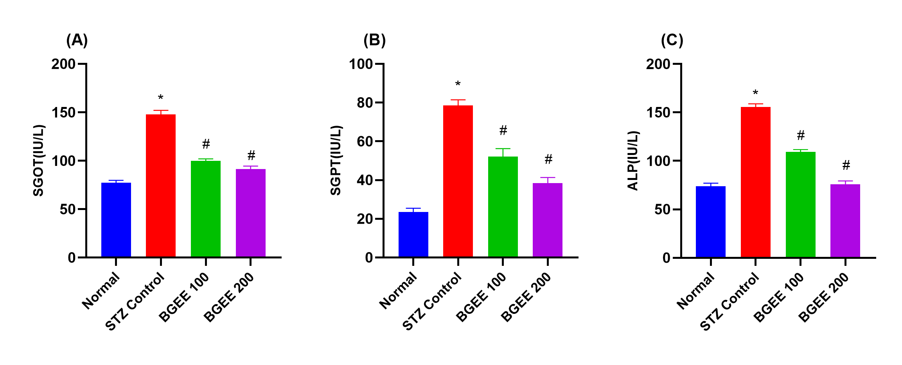
Fig. 1. Effect of Barleria grandiflora Ethanolic Leaf Extract on serum hepatic markers: (A) serum glutamic oxaloacetic transaminase (SGOT), (B) serum glutamic pyruvic transaminase (SGPT), and (C) alkaline phosphatase (ALP).
“Data (mean ± SEM, n = 6) were analyzed using one-way ANOVA followed by Tukey’s post hoc test. *P ˂ 0.05 when compared to the normal group, and #P ˂ 0.05 when compared to the STZ control group”. BGEE 100: BGEE (100 mg/kg/day, p.o.) and BGEE 200: BGEE (200 mg/kg/day, p.o.).
3.3. Effects on liver oxidative stress markers
Figure 2 represents the effect of BGEE on oxidative stress markers in liver tissues. The STZ-control group showed significant (P < 0.05) reduction in antioxidants (CAT, SOD, and GSH) and elevation of MDA level compared to the normal group, indicating the hepatic oxidative stress caused by diabetes stress. While treatments with BGEE at 100 and 200 mg/kg dose levels significantly (P < 0.05) increased antioxidants and reduced MDA levels. These effects showed potent hepatoprotective activity of BGEE against oxidative damage caused by diabetes stress.
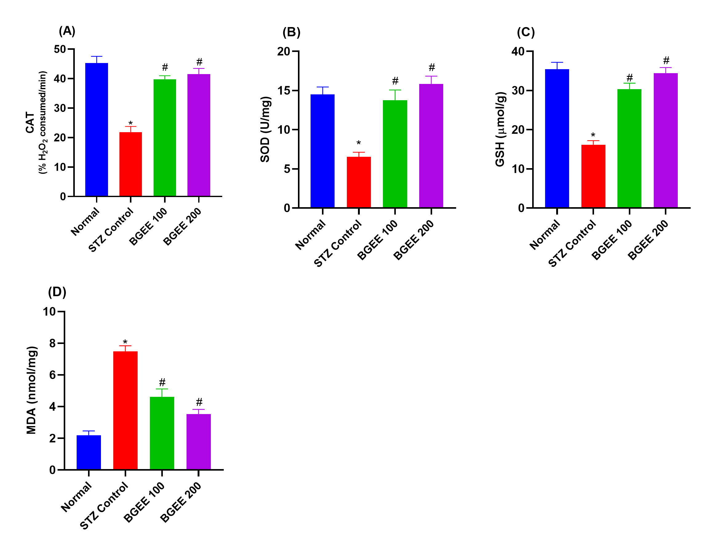
Fig. 2. Effect of Barleria grandiflora Ethanolic Leaf Extract on Liver Oxidative Stress Markers: (A) Catalase (CAT), (B) Superoxide dismutase (SOD), (C) Reduced glutathione (GSH), and (D) Malondialdehyde (MDA)
“Data (mean ± SEM, n = 6) were analyzed using one-way ANOVA followed by Tukey’s post hoc test. *P ˂ 0.05 when compared to the normal group, and #P ˂ 0.05 when compared to the STZ control group”. BGEE 100: BGEE (100 mg/kg/day, p.o.) and BGEE 200: BGEE (200 mg/kg/day, p.o.).
3.4. Histopathology
Histopathological analysis of liver tissues (Figure 3) demonstrated the protective effect of the BGEE against STZ-induced liver injury in diabetic rats. The normal control group exhibited characteristic normal liver architecture, with hepatocytes arranged in well-defined hepatic cords (trabeculae) radiating from a central vein. On the other hand, the STZ control group exhibited severe hepatocyte damage, which was marked by notable vascular/sinusoidal congestion, hepatocellular degeneration/vacuolization (steatosis), and significant disorganization. BGEE treatment produced a protective effect that was dose-dependent. The partial restoration of structural features and a decrease in congestion and degeneration indicated that the BGEE 100 group had moderate protection. The BGEE 200 group showed notable protection, greatly lessening the severity of liver damage caused by STZ. The substantial hepatoprotective activity of BGEE is confirmed by this histopathological evidence. This histopathological evidence confirms the significant hepatoprotective activity of BGEE against STZ exposure. The extract's protective mechanism involves maintaining the normal hepatic architecture, reducing hepatocellular damage (such as steatosis), and decreasing the vascular congestion associated with the diabetic state, with the 200 mg/kg dose proving superior to the 100 mg/kg dose.

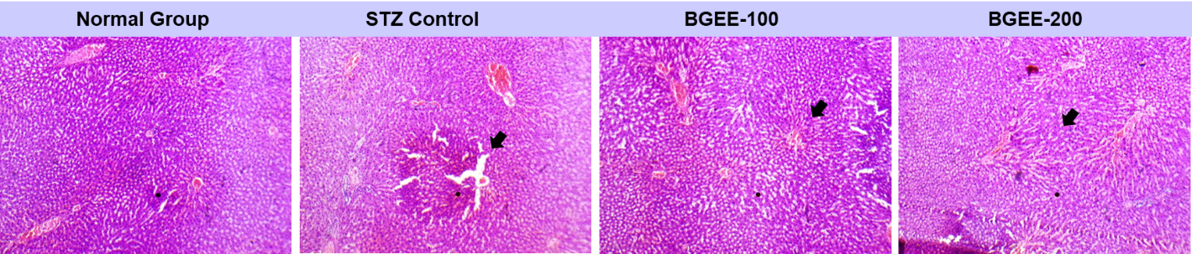
Fig. 3. Histopathology of hematoxylin and eosin (H & E)-stained sections of liver tissues.
BGEE 100: BGEE (100 mg/kg/day, p.o.) and BGEE 200: BGEE (200 mg/kg/day, p.o.).
- DISCUSSION
The present research strongly validates the beneficial use of B. grandiflora on diabetes and associated hepatotoxicity by exhibiting a significant, dose-dependent reduction of blood glucose level and restoration of serum hepatic and hepatic oxidative stress markers in the STZ-induced diabetic model in rats. The STZ model is intrinsically driven by oxidative stress, which initiates β-pancreatic cell destruction (Damasceno et al., 2014). Therefore, the anti-hyperglycemic activity of BGEE is likely correlated with its potent antioxidant activity, which was previously established (Sao et al., 2025). In our previous study, we found that phenolic and flavonoids are the major phytoconstituents, and these compounds in the B. grandiflora leaves provide the molecular basis for this action. These phytochemicals act as highly efficient free radical scavengers, intercepting the reactive oxygen species (ROS) generated by STZ exposure, and protect pancreatic cells and exhibit antidiabetic activity (Yi et al., 2023), which was observed in the research. Chronic administration of BGEE led to a significant reduction in blood sugar level compared to the normal group, which could be due to modulation of glucose homeostasis. The previous research shows that flavonoids can improve insulin sensitivity and glucose tolerance by modulating signaling cascades like AMPK (Zhou et al., 2023). The dual mechanism antioxidant activity and improved peripheral sensitivity allow the BGEE to provide comprehensive glycemic control.
Furthermore, the BGEE treatments effectively protect against hepatic damage, indicated by the restoration of serum hepatic markers, hepatic antioxidants, and lipid peroxidation. In diabetic hepatopathy, chronic hyperglycemia potentiates excessive ROS production and lipid peroxidation, destabilizing hepatocyte membranes and leading to functional enzyme leakage (Satyarengga et al., 2017). Therefore, the STZ control group showed marked elevation of serum hepatic markers (SGOT, SGPT, and ALP), and hepatic oxidative damage as indicated by reduction in antioxidants (CAT, SOD, GSH) and elevation of MDA level compared to the normal group. The protective effects of BGEE are strongly attributed to its high concentration of phytochemical antioxidants. Polyphenolic compounds possess readily available hydroxy groups capable of chelating metal ions and efficiently scavenging free radicals, thereby preventing oxidative damages of hepatocytes that was reflected in our biomarker results. The histopathological data confirm the biochemical findings. The liver section from diabetic rats (STZ control group) exhibited severe patho-histological alterations, characterized by extensive vacuolization and inflammatory cell infiltration. In contrast, the liver section of BGEE treated group showed preventive action on liver histoarchitecture, as shown in Figure 3.
Furthermore, beyond the antioxidant activity, the BGEE showed positive anti-inflammatory activity in our previous study (Sao et al., 2025), which may also correlate with the mechanism behind the hepatoprotection. It is well known that diabetic stress induces inflammation in the liver, often mediated by the nuclear factor kappa-B (NF-κB) pathway (Baker et al., 2011; Mohamed et al., 2016). The flavonoids, which are the major phytoconstituents of BGEE, are known to modulate the NF-κB pathway and suppress the inflammatory response (Li et al., 2023). By inhibiting this inflammatory signaling, BGEE may successfully intercept the inflammatory damage caused by hyperglycemia. Overall, the findings suggest the potential beneficial role of B. grandiflora on diabetes and associated hepatotoxicity.
- CONCLUSION
The current study provides scientific and preclinical validation for the traditional use of B. grandiflora leaves in managing diabetes mellitus and associated diseases. The B. grandiflora leaves ethanolic extract demonstrated significant antidiabetic activity, achieving a substantial reduction in blood glucose level and effectively reducing the diabetic hepatopathy, restoring serum hepatic markers and oxidative stress. These protective effects are strongly correlated with the presence of bioactive phytochemicals, especially flavonoids and polyphenolic compounds, which exert potent antioxidant and anti-inflammatory actions. These results position B. grandiflora as a highly promising natural resource for the development of effective, multi-target phytotherapeutics capable of addressing both glycemic dysregulation and associated diabetic organ complications.
CONFLICT OF INTEREST
Authors have declared that no competing interests exist.
CONSENT AND ETHICAL APPROVAL
The Institutional Animal Ethical Committee of Shri Shankaracharya Professional University, Bhilai, approved the experimental protocols on animals.
COMPETING INTERESTS DISCLAIMER
Authors have declared that they have no known competing financial interests OR non-financial interests OR personal relationships that could have appeared to influence the work reported in this paper.

DISCLAIMER (ARTIFICIAL INTELLIGENCE)

Author(s) hereby declare that NO generative AI technologies such as Large Language Models (ChatGPT, COPILOT, etc.) and text-to-image generators have been used during the writing or editing of this manuscript.

REFERENCES
- Alanazi, A.Z., Algahtani, M.M., Alotaibi, F.A., Al-Rejaie, S.S., Alqinyah, M., Alhamed, A.S., Alhamami, H.N., Nadeem, A., Raish, M., Aljerian, K., Alragas, A.M. & Alhazzani, K. (2025) Investigation of The Hepatoprotective Potential of Liposomal Resveratrol as Polyphenols Against Liver Damage in Streptozotocin Diabetic Rat Model. Int J Med Sci, 22, 3380-3392.
- Baker, R.G., Hayden, M.S. & Ghosh, S. (2011) NF-κB, inflammation, and metabolic disease. Cell Metab, 13, 11-22.
- Choudhary, R., Sahu, H.K., Banchhor, M., Avantika, Kashyap, A. & Sahu, T.K. (2025) Optimization of ultrasound-assisted extraction of apple peel using central composite design for extractive yield, phenolic content, and antioxidant activity. J Pharmacog Phytochem, 14, 209-217.
- Damasceno, D.C., Netto, A.O., Iessi, I.L., Gallego, F.Q., Corvino, S.B., Dallaqua, B., Sinzato, Y.K., Bueno, A., Calderon, I.M. & Rudge, M.V. (2014) Streptozotocin-induced diabetes models: pathophysiological mechanisms and fetal outcomes. Biomed Res Int, 2014, 819065.
- Ellman, G.L. (1959) Tissue sulfhydryl groups. Arch Biochem Biophys., 82, 70-77.
- Gangaram, S., Naidoo, Y., Dewir, Y.H. & El-Hendawy, S. (2021) Phytochemicals and Biological activities of Barleria (Acanthaceae). Plants, 11.
- Kakkar, P., Das, B. & Viswanathan, P.N. (1984) A modified spectrophotometric assay of superoxide dismutase. Indian J Biochem Biophys., 21, 130-132.
- Latif, R. & Nawaz, T. (2025) Medicinal plants and human health: a comprehensive review of bioactive compounds, therapeutic effects, and applications. Phytochem Rev.
- Lekhak, M.M., Patil, S.S., Deshmukh, P.V., Lekhak, U.M., Kumar, V. & Rastogi, A. (2022) Genus Barleria L. (Acanthaceae): a review of its taxonomy, cytogenetics, phytochemistry and pharmacological potential. J Pharm Pharmacol, 74, 812-842.

- Li, L., Qin, Y., Xin, X., Wang, S., Liu, Z. & Feng, X. (2023) The great potential of flavonoids as candidate drugs for NAFLD. Biomed Pharmacother, 164, 114991.
- Mohamed, J., Nazratun Nafizah, A.H., Zariyantey, A.H. & Budin, S.B. (2016) Mechanisms of Diabetes-Induced Liver Damage: The role of oxidative stress and inflammation. Sultan Qaboos Univ Med J, 16, e132-141.
- Nasim, N., Sandeep, I.S. & Mohanty, S. (2022) Plant-derived natural products for drug discovery: current approaches and prospects. Nucleus, 65, 399-411.
- Özkan, S. & Koyutürk, M. (2025) Assessment of Liver Damage in an Experimental Model of Streptozotocin-Induced Diabetes in Sprague Dawley Rats: Focusing on Morphological and Oxidative Stress Status. Bakirkoy Tip Dergisi / Med J of Bakirkoy, 21, 267-273.
- Roy, B. (2025) Pathophysiological Mechanisms of Diabetes-Induced Macrovascular and Microvascular Complications: The Role of Oxidative Stress. Med Sci (Basel), 13.
- Sao, M., Shree, J. & Choudhary, R. (2025) Anti-inflammatory and antioxidant activity of Barleria grandiflora leaf extracts with exploration of pharmacognostic and phytochemical analysis. Int J Pharm Pharm Sci, 17, 63-69.
- Satyarengga, M., Zubatov, Y., Frances, S., Narayanswami, G. & Galindo, R.J. (2017) Glycogenic Hepatopathy: A Complication Of Uncontrolled Diabetes. AACE Clinical Case Reports, 3, e255-e259.
- Sawarkar, H., Kashyap, P., Kaur, C.D., Pandey, A., Biswas, D., Singh, M. & Dhongade, H. (2016) Antimicrobial and TNF-alpha Inhibitory Activity of Barleria prionitis and Barleria grandiflora: A Comparative Study. Indian J Pharm Educ Res, 50, 409-417.
- Sinha, A.K. (1972) Colorimetric assay of catalase. Anal Biochem., 47, 389-394.
- Stocks, J. & Dormandy, T.L. (1971) The autoxidation of human red cell lipids induced by hydrogen peroxide. Br J Haematol, 20, 95-111.
- Yi, X., Dong, M., Guo, N., Tian, J., Lei, P., Wang, S., Yang, Y. & Shi, Y. (2023) Flavonoids improve type 2 diabetes mellitus and its complications: a review. Front Nutr, 10, 1192131.
- Yuan, H., Ma, Q., Ye, L. & Piao, G. (2016) The Traditional Medicine and Modern Medicine from Natural Products. Molecules, 21.
- Zhou, M., Konigsberg, W.H., Hao, C., Pan, Y., Sun, J. & Wang, X. (2023) Bioactivity and mechanisms of flavonoids in decreasing insulin resistance. J Enzyme Inhib Med Chem, 38, 2199168.

