Computational Investigation of Eugenol–Triazole Derivatives Targeting Breast Cancer Proteins

.
ABSTRACT

Aims: The present study aimed to evaluate the binding affinity and interaction profiles of the newly designed eugenol-triazole derivatives against key breast cancer- associated protein targets using molecular docking, to identify promising lead compounds for anti-breast cancer drug development.
Study design: Computational in silico molecular docking study.
Place and Duration of Study: All molecular modeling studies were conducted using the Schrodinger Maestro software.
Methodology: A total of 35 designed eugenol-triazole derivatives were selected as ligands for the structure-based molecular docking (SBDD) studies against key breast cancer targets retrieved from the Protein Data Bank, including (PDB IDs: 2IOG, 1SQN, 1M17, 5DXT, and 4DRH). Molecular docking simulations were performed using Schrodinger Maestro software. Binding affinities were evaluated based on docking scores. The performance of the designed eugenol-triazole derivatives was compared with co-crystallized ligands along with reference standards for each target.
Results: Numerous eugenol-triazole derivatives demonstrated favorable docking scores and stable binding conformations within the active sites of selected breast cancer-related protein targets. The primary interactions involved hydrogen bonding with crucial active-site residues and π–π stacking interactions, attributed mainly to the presence of the triazole moiety. In multiple targets, the binding affinities selected derivatives were comparable to or better than those of standard reference ligands, indicating protein-ligand complementarity.
Conclusion: Among the designed compounds Tria-23 (-8.976 kcal/mol, Erα, PDB ID: 2IOG), Tria-8 (-10.102, PR, PDB ID: 1SQN), Tria-25 (-7.637 and -5.434, EGFR and mTOR, PDB IDs: 1M17, and 4DRH), and Tria-24 (-6.808, PI3Kα, PDB ID: 5DXT) emerged as most potential lead molecules. Incorporation of the triazole ring enhanced molecular interactions and binding stability within the target active sites. These results provide a strong computational rationale for further in vitro and in vivo biological evolution of the designed compounds as potential anti-breast cancer agents.

Keywords: Eugenol, Triazole derivatives, Breast cancer, Molecular docking, In silico studies, Anticancer agents.

1. INTRODUCTION

Breast cancer is the most commonly diagnosed malignancy in women and a major global health problem. Despite substantial advances in early detection and treatment, challenges such as multidrug resistance, systemic toxicity, and the limited selectivity of current chemotherapeutic drugs continue to impede successful disease management. As a result, the discovery and development of novel anticancer medicines with enhanced effectiveness and safety profiles remain a critical unmet need (Siegel et al., 2025; Bray et al., 2024; Vasan et al., 2019; Bukowski et al., 2020).

Natural products play an important role in anticancer drug discovery, serving both as therapeutic agents and as scaffolds for structure modification. Their broad spectrum of biological activities and remarkable structural diversity have significantly contributed to the development of several clinically approved anticancer drugs (Atanasov et al., 2021; Rodrigues et al., 2021). Eugenol, a natural phenylpropanoid derived from clove oil, has a wide range of pharmacological properties including antibacterial, antioxidant, anti-inflammatory, and anti-cancer activities. However, despite its selectivity and inherited property, the modest anticancer activity of the eugenol required structural modification to enhance its anticancer abilities (Fernandes et al., 2024; Nazreen et al., 2023).

Triazoles are five-membered organic compounds having three nitrogen atoms, offering significant chemical stability, promising pharmacokinetic properties, and a strong capability to form hydrogen bonds with biological targets. These behaviors make triazole-containing compounds predominantly valuable in the field of medicinal chemistry, especially for developing anticancer agents (Matin et al., 2022). Recent research studies have established that compounds of 1,2,4-triazole can effectively influence critical cancer-related pathways, such as cell cycle regulation and triggered cell death, by enhancing interactions between ligands and proteins (Naeem et al., 2022).

Molecular docking serves as an important computational tool in the early stages of drug discovery. It allows predictions regarding how small molecules bind to biological targets, and predicts their affinities and interaction patterns, which aids in the rational selection of leads before experimental validation (Agu et al., 2023; Pagadala et al., 2017; Ayub et al., 2024). Recent research studies have employed docking-based approaches to screen and optimize anticancer drugs, including hybridized derivatives obtained from natural molecules and heterocycle compounds, targeting proteins associated with breast cancer (Sowa-Kasprzak et al., 2023; Alam., 2023).

In the present study, in silico molecular docking was conducted on key anti-breast cancer proteins using newly designed eugenol-triazole compounds with the aid of Schrodinger Maestro software to evaluate their anticancer potential. The progression of breast cancer is linked to the dysregulation of multiple signaling pathways, mainly those involving hormone receptors and kinases related to growth factors. Several enzymes and receptors play pivotal roles in the tumor initiation, proliferation, survival, and resistance to therapy, thereby representing attractive targets for the development of novel anticancer candidates (Newman et al., 2020; Naeem et al., 2022).

The key target breast cancer proteins include estrogen receptor alpha (Erα), progesterone receptor (PR), epidermal growth factor (EGFR), phosphotidylinositol-3-kinase alpha (PIK3α), and mammalian target of rapamycin (mTOR). These factors are important in both hormone-dependent and hormone-independent subtypes of breast cancer (Osborne et al., 2011; Costa et al., 2017; Mayer et al., 2016). For instance, ERα (PDB ID 2IOG) is a transcription factor that regulates processes such as proliferation, differentiation, and apoptosis within breast tissue. Elevated estrogen signaling is closely related to an increased risk of breast cancer and tumor progression, especially in ER-positive cases (Yager et al., 2006). Similarly, PR (PDB ID 1SQN) serves as a significant biomarker that modulates hormone-driven tumor growth and endocrine therapy response (Mohammed et al., 2015).

Moreover, EGFR (PDB ID: 1M17) is frequently overexpressed and aggressive in triple-negative breast cancer. The activation of EGFR promotes cell proliferation, invasion, angiogenesis, and resistance to chemotherapy, making it a key therapeutic target. Irregular EGFR signaling also regulates the downstream pathways like PI3K/AKT/mTOR, improving cancer survival rates (Normanno et al., 2006; Hu et al., 2018).

PI3Kα (PDB ID 5DXT), a catalytic subunit p110α significantly altered in breast cancer, regulates cell growth, metabolism, and survivability. Mutations in PI3Kα stimulate the pathway, resulting in poor prognosis and resistance to treatments (Thorpe et al., 2006). The downstream protein mTOR (PDB ID: 4DRH) serves as a master regulator of protein synthesis, cell proliferation, and metabolism, and its dysregulation is frequently seen in metastatic breast cancer (Laplante et al., 2012).
The cytotoxic effects of both eugenol and the 1,2,4-triazole scaffold framework motivated our molecular docking studies to investigate the binding affinities and interaction profiles of newly designed eugenol-triazole derivatives targeting ERα, PR, EGFR, PI3Kα, and mTOR proteins.
2. Materials and Methods

This section is divided into several parts, including drug-likeness, protein preparation, ligand preparation, grid generation, and molecular docking.
Drug likeness
The drug-likeness and oral bioavailability of the designed derivatives were evaluated using Lipinski’s rule of five. Predictions were made with the SwissADME web tool (https://www.swissadme.ch/). The criteria for this rule include a molecular weight ≤ 500 g/mol, a logP value not exceeding 5, not more than 5 hydrogen bond donors (HBD), not more than 10 hydrogen bond acceptors (HBA), a topological polar surface area (TPSA) of 140 Å² or less, and a maximum of 10 rotatable bonds (Lipinski., 2000).
Protein preparation
The 3D crystal structures of target proteins related to breast cancer were obtained from the Protein Data Bank (PDB) (www.rcsb.org). These include ERα (PDB ID: 2IOG, resolution 1.60 Å, deposited on 2007-10-09), PR (PDB ID: 1SQN, resolution 1.45 Å, deposited on 2004-07-09), EGFR (PDB ID: 1M17, resolution 2.60 Å, deposited on 2002-09-04), PI3Kα (PDB ID: 5DXT, resolution 2.25 Å, deposited on 2016-01-27), and mTOR (PDB ID: 4DRH, resolution 2.30 Å, deposited on 2013-02-06). All these selected crystal structures were free of mutations. The protein was prepared using the Schrodinger Maestro protein preparation wizard (Release S. 1: Prime. Schrödinger., 2020). This process involved removing crystallographic water molecules, assigning bond orders and formal charges, filling side chains and loops, assigning hydrogen bonds, converting selenomethionine residues to methionine, and optimizing and energy-minimizing protein structures to create biologically relevant conformations suitable for molecular docking.
Ligand Preparation
All ligand structures were created using ChemDraw Professional. Their two-dimensional structures were imported into the project workspace using SMILES notation. Co-crystallized ligands and reference standards were obtained from the PubChem database in SDF format and imported accordingly. The Schrodinger Maestro LigPrep module (Release S. 2: LigPrep. Schrödinger., 2017), was used for ligand preparation. It applied the OPLS-2005 force field at a pH of 7.0 ± 2.0. Epik generated ionization states, and specific chiralities were preserved while allowing changes at other stereo centers, resulting in a maximum of 32 stereoisomers per ligand.

Receptor Grid Generation
The receptor grid outlines the region of the protein where ligand binding interacts and was generated using the Receptor Grid Generation tool in Maestro, centered on the co-crystallized ligand present in each protein structure. The grid box dimensions described the area around the active site using x, y, and z coordinates to adequately encompass the active-site residues involved in ligand binding.

To validate the docking protocol, the co-crystallized ligand was redocked into the corresponding protein binding site using the same grid parameters. The docked pose was then superimposed with the experimental crystal structure, and the root mean square deviation (RMSD) was calculated. The reproducibility and reliability of the docking procedure were confirmed by an RMSD of ≤ 2.0 Å.

Molecular Docking
The Glide module in Schrodinger Maestro (Glide, Schrödinger Release 2020-1), was used for molecular docking. The prepared ligands were docked into the active sites of the target receptor grids using the standard precision (SP) mode with flexible ligand sampling. The GlideScore evaluates the best ligand binding affinity in the receptor binding pocket, where more negative values indicate stronger predicted binding. The ligand interaction diagram tool illustrated important interactions between ligands and active site residues in the crystal structure. The selected ligand 2D structures for docking are shown in Fig. 1.

Fig.1: Eugenol-triazole derivatives 2D structures
3. results and discussion

This research work began with the evolution of molecular properties and drug-likeness of the designed derivatives by applying Lipinski’s rule of five, a key criterion in rational drug design, as it helps predict oral bioavailability and potential biological activity of drug-like molecules. Compounds showing more than one Lipinski violation were excluded from further analysis. Among the designed series, the calculated molecular properties of the derivatives are summarized in Table 1.

Table 1. Drug-likeness properties of eugenol-triazole derivatives evaluated using Lipinski’s rule of five.

Compound Code | Drug likeness (Lipinski rule)
 | Mol. Wt. (g/mol) | No. Hydrogen bond donor | No. Hydrogen acceptor | TPSA  (Å²) | No of rotatable bonds | Log P value
Eugenol | 164.20 | 1 | 2 | 29.46 | 3 | 2.37
Tria-1 | 368.45 | 0 | 5 | 97.58 | 7 | 3.75
Tria-2 | 402.90 | 0 | 5 | 97.58 | 7 | 3.93
Tria-3 | 437.34 | 0 | 5 | 97.58 | 7 | 4.32
Tria-4 | 402.90 | 0 | 5 | 97.58 | 7 | 3.84
Tria-5 | 437.34 | 0 | 5 | 97.58 | 7 | 4.12
Tria-6 | 447.35 | 0 | 5 | 97.58 | 7 | 4.09
Tria-7 | 447.35 | 0 | 5 | 97.58 | 7 | 3.93
Tria-8 | 447.35 | 0 | 5 | 97.58 | 7 | 3.92
Tria-9 | 526.24 | 0 | 5 | 97.58 | 7 | 4.50
Tria-10 | 526.24 | 0 | 5 | 97.58 | 7 | 4.39
Tria-11 | 386.44 | 0 | 6 | 97.58 | 7 | 3.96
Tria-12 | 386.44 | 0 | 6 | 97.58 | 7 | 3.78
Tria-13 | 386.44 | 0 | 6 | 97.58 | 7 | 3.82
Tria-14 | 404.43 | 0 | 7 | 97.58 | 7 | 4.06
Tria-15 | 494.35 | 0 | 5 | 97.58 | 7 | 4.22
Tria-16 | 494.35 | 0 | 5 | 97.58 | 7 | 3.85
Tria-17 | 413.45 | 0 | 7 | 143.40 | 8 | 3.29
Tria-18 | 413.45 | 0 | 7 | 143.40 | 8 | 3.25
Tria-19 | 413.45 | 0 | 7 | 143.40 | 8 | 3.38
Tria-20 | 458.45 | 0 | 9 | 133.10 | 9 | 2.75
Tria-21 | 458.45 | 0 | 9 | 189.22 | 9 | 2.72
Tria-22 | 384.45 | 1 | 6 | 117.81 | 7 | 3.27
Tria-23 | 384.45 | 1 | 6 | 117.81 | 7 | 3.03
Tria-24 | 384.45 | 1 | 6 | 117.81 | 7 | 3.26
Tria-25 | 400.45 | 2 | 7 | 138.04 | 7 | 3.14
Tria-26 | 400.45 | 2 | 2 | 138.04 | 7 | 3.19
Tria-27 | 383.47 | 1 | 5 | 123.60 | 7 | 352
Tria-28 | 383.47 | 1 | 5 | 123.60 | 7 | 3.53
Tria-29 | 398.48 | 0 | 6 | 106.81 | 8 | 3.51
Tria-30 | 398.48 | 0 | 6 | 106.81 | 8 | 3.98
Tria-31 | 428.50 | 1 | 7 | 116.04 | 9 | 4.13
Tria-32 | 414.48 | 1 | 7 | 127.04 | 8 | 3.42
Tria33 | 358.41 | 0 | 6 | 110.72 | 7 | 3.29
Tria-34 | 382.48 | 0 | 5 | 97.58 | 7 | 4.15
Tria-35 | 382.48 | 0 | 5 | 97.58 | 7 | 3.45

Docking studies
Herein, we used a virtual screening strategy to predict the binding affinities of the designed compounds at some selected breast cancer–related protein targets (Rasul et al., 2022). Estrogen receptor alpha (ERα, PDB: 2IOG), progesterone receptor (PR, PDB: 1SQN), epidermal growth factor receptor (EGFR, PDB: 1M17), phosphatidylinositol 3-kinase alpha (PI3Kα, PDB: 5DXT), and mammalian target of rapamycin (mTOR, PDB ID: 4DRH) were chosen as the five key targets and were downloaded from the Protein Data Bank. All 35 designed eugenol-triazole derivatives were examined for ligand docking studies.

Docking prepared ligands into the active sites of each target protein was performed using Schrodinger Maestro, with grid box size maintained at 10 × 10 × 10 Å in the x, y, and z axes. Standard precision (SP) mode of docking was used, as it offers an optimal compromise between speed and accuracy, well-suited for sifting through a relatively large number of artificially designed molecules and comparing relative binding affinities across multiple targets. The docking results were further analyzed using the Ligand Interaction Diagram tool to identify key hydrogen bonding and hydrophobic interactions with active-site residues.

Although extra precision (XP) docking and molecular dynamics (MD) simulations can provide additional refinement, these approaches were beyond the scope of the present screening-based study. The most promising compounds identified through SP docking are proposed for future XP docking and MD simulations to further validate binding stability and dynamic behavior. For comparison, we used known anticancer drugs, including 4-hydroxytamoxifen, letrozole, fulvestrant, progesterone, tamoxifen, gefitinib, doxorubicin, and neratinib as reference compounds. We calculated binding affinity energies, and summarized the docking results of eugenol-triazole derivatives that showed hydrogen-bond interactions like those of the co-crystallized ligands in the respective protein structures in Table 2.

Table 2. Molecular docking scores and interaction profiles of the ligands with selected breast cancer targets.

PDB ID | S. No | Compound name/code | Binding affinity (kcal/ mol) | H-Bonds
PDB ID:2IOG | 1 | 2-arylindole (co-crystal) | -13.922 | Glu353, Arg394
PDB ID:2IOG | 2 | 4-hydroxytamoxifen | -11.736 | Asp351, Glu353, Arg394
PDB ID:2IOG | 3 | Methylpiperidinopyrazole | -10.895 | Arg394
PDB ID:2IOG | 4 | Letrozole | -9.072 | Arg394, Lys531
PDB ID:2IOG | 5 | Fulvestrant | -10.903 | Leu387, Leu536
PDB ID:2IOG | 6 | Eugenol | -6.116 | Glu353, Arg394
PDB ID:2IOG | 7 | Tria-23 | -10.102 | Glu353, Arg394
PDB ID:2IOG | 8 | Tria-28 | -9.347 | Glu353
PDB ID:2IOG | 9 | Tria-24 | -9.057 | Leu346, Glu353
PDB ID:1SQN | 1 | NDR (co-crystal) | -11.531 | Gln725
PDB ID:1SQN | 2 | Progesterone | -10.893 | Gln725
PDB ID:1SQN | 3 | Eugenol | -5.923 | Met759
PDB ID:1SQN | 4 | Tria-8 | -8.976 | Gln725
PDB ID:1SQN | 5 | Tria-34 | -8.180 | Gln725
PDB ID:1SQN | 6 | Tria-18 | -8.161 | Gln725, Leu718
PDB ID:1SQN | 7 | Tria-14 | -7.778 | Gln725
PDB ID:1M17 | 1 | Erlotinib (co-crystal) | -8.412 | Cys773, Met769
PDB ID:1M17 | 2 | Gefitinib | -7.676 | Lys721, Met769
PDB ID:1M17 | 3 | Eugenol | -4.514 | -
PDB ID:1M17 | 4 | Tria-25 | -7.637 | Met769, Thr766, Asp831, Glu738
PDB ID:1M17 | 5 | Tria-24 | -7.422 | Gln767, Asp831, Glu738
PDB ID:1M17 | 6 | Tria-13 | -6.974 | Met769, Asp831
PDB ID:1M17 | 7 | Tria-11 | -6.809 | Met769, Thr766
PDB ID:1M17 | 8 | Tria-22 | -6.752 | Met769, Asp831
PDB ID:5DXT | 1 | Alpelisib (co-crystal) | -10.264 | Gln859(2), Ser854, Val851(2)
PDB ID:5DXT | 2 | Tamoxifen | -6.396 | Glu798
PDB ID:5DXT | 3 | Eugenol | -5.809 | Glu849, Val851(2)
PDB ID:5DXT | 4 | Tria-24 | -6.808 | Ser774, Val851
PDB ID:5DXT | 5 | Tria-29 | -6.264 | Arg770(2), Val851, Ser854
PDB ID:4DRH | 1 | RAP | -6.457 | Lys 52, Ser 80, Gln 85, Gly84, Ile87, Tyr 113
PDB ID:4DRH | 2 | Doxorubicin | -5.693 | Gly84, Ile87, Ala112
PDB ID:4DRH | 3 | Letrozole | -4.862 | Ile87, Lys121
PDB ID:4DRH | 4 | Neratinib | -5.202 | Ala112, Tyr113, Ser118
PDB ID:4DRH | 5 | Eugenol | -4.315 | Asp68
PDB ID:4DRH | 6 | Tria-25 | -5.434 | Lys121
PDB ID:4DRH | 7 | Tria-14 | -5.405 | Tyr113
PDB ID:4DRH | 8 | Tria-22 | -5.397 | Tyr113
PDB ID:4DRH | 9 | Tria-1 | -5.302 | Lys121
PDB ID:4DRH | 10 | Tria-24 | -4.962 | Lys121
PDB ID:4DRH | 11 | Tria-21 | -4.803 | Tyr113

Eugenol is a natural phenylpropenic bioactive molecule in cloves, it exhibited anticancer properties mainly attributed by cell cycle arrest, induction of apoptosis, inhibition of tumor proliferation, reducing angiogenesis and modulating pathways related to oxidative-inflammatory cascade (Abdullah et al., 2021; Debnath et al., 2025)..The low bioavailability and dose-dependent toxicity of eugenol present significant challenges to its direct clinical applications (Noman et al., 2025; Faruq et al., 2025).Therefore, structural modification strategies are being explored to improve the effectiveness of eugenol-based compounds (Alam., 2024; Pangesti et al., 2024).
In this study, we performed molecular docking to evaluate how eugenol, along with some standard anticancer drugs, co-crystallized ligands, and newly designed eugenol-triazole derivatives, interacts with key targets: ERα (PDB ID: 2IOG), PR (1SQN), EGFR (1M17), PI3Kα (5DXT), and mTOR (4DRH). We analyzed the binding affinity scores (in kcal/mol) and hydrogen-bond interactions with conserved active-site residues to assess binding stability and biological relevance. Among the 35 eugenol-triazole derivatives examined, 20 compounds showed significant hydrogen bonding interactions that were comparable to those of the corresponding co-crystallized ligands at important breast cancer targets.
Our molecular docking study focused on the interaction profiles and binding affinities of various ligands within the estrogen receptor alpha (ERα) active site using the crystal structure (PDB ID: 2IOG). We used binding free energy (ΔG, kcal/mol) as the key measure of the strength of these interactions. The 2-arylindole (co-crystallized ligand), had the highest binding affinity of −13.922, formed strong hydrogen bonds with conserved residues like Glu353 and Arg394, along with significant hydrophobic and π–π stacking interactions (Fig. 1a).
Clinically used ERα inhibitors also demonstrated promising binding profiles. 4-hydroxytamoxifen showed binding affinity of −11.736, interacting with Asp351, Glu353, and Arg394. Meanwhile, fulvestrant (−10.903) and methylpiperidinopyrazole (-10.895) had similar affinities, interacting with Arg394 and other residues such as Leu387 and Leu536.
Among designed derivatives, Tria-23 emerged as the most promising candidate with a binding affinity of −10.102 and formed hydrogen bonds with Glu353 (bond length: 1.8 Å) and Arg394, and was further stabilized by hydrophobic and Van der Waals interactions involving residues like Trp383, Leu384, Leu387, Met388, Leu391, Leu349, Ala350, Asp351, and Phe404, (Fig. 1b). The three-dimensional binding mode of Tria-23 is illustrated in Fig.1c. The superimposed docking poses of the docking compounds (Fig.1d), confirmed that the derivatives adopt a consistent binding orientation within the ERα active site, highlighting Tria-23 as a promising lead compound for further optimization and experimental validation.

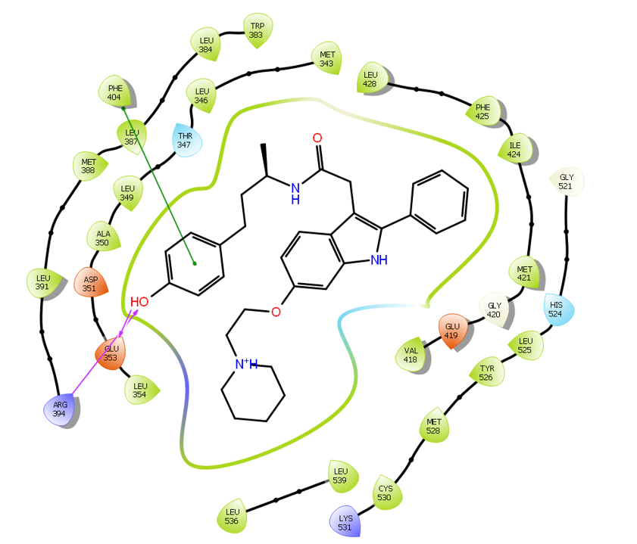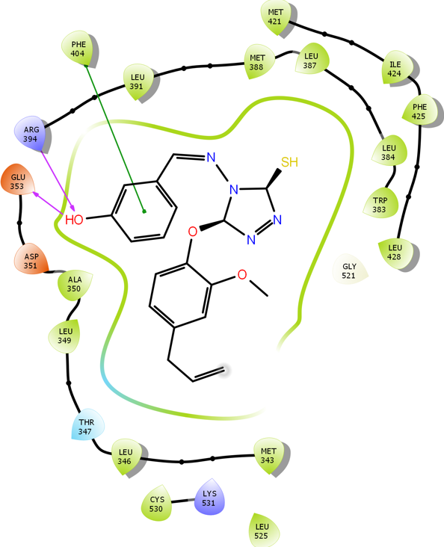
- b)

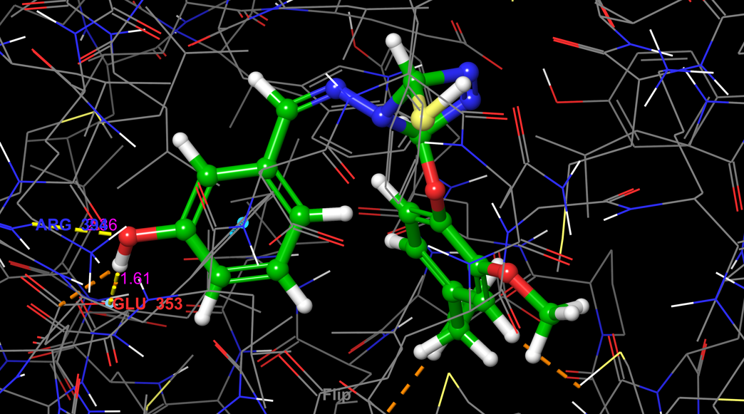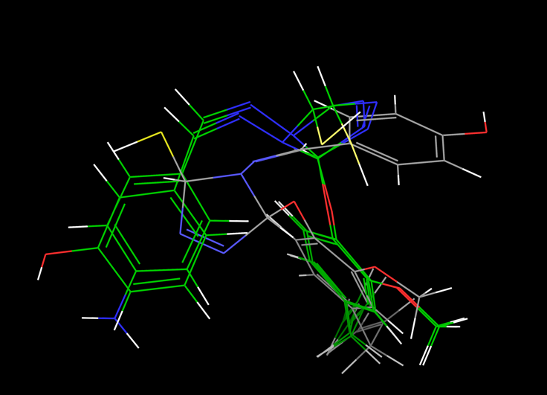

- d)
Fig. 1 a) 2D ligand-protein interaction diagram of the co-crystal ligand (2-arylindole), b) 2D interaction diagram of Tria-23, c) 3D docking pose of Tria-23 within the active site, and d) superimposed docked poses of eugenol-triazole ligands.
To ensure the docking method was effective and to explore other hormone-related targets, we conducted molecular docking on the progesterone receptor (PR) using its crystal structure (PDB ID: 1SQN). The co-crystallized ligand, NDR, had the highest binding affinity, −11.531. Its interaction with the important residue Gln725 emphasizes the residue’s role in ligand stability in the binding pocket. Docking studies disclosed that the progesterone had generated a binding affinity of −10.893 and interacted with Gln725 closely resembling the NDR. Conversely, eugenol has a binding affinity of −5.923 and mainly interacted with Met759, indicating it has limited stabilization in the active site. In contrast, the all designed compounds exhibited better binding affinities compared to parent eugenol, highlighting the beneficial effects of of the incorporation of the triazole motif. Among these, Tria-8 had a binding affinity of −8.976 and forms a hydrogen bond with the Gln725 binding pocket, making it the most potent compound, followed by Tria-28 which demonstrates a bending affinity of −8.161 and uniquely interacts with both Gln725 and Leu718, signifying additional stabilization through hydrogen bonding.
To-dimensional ligand-protein interaction map of the co-crystallized ligand NDR (Fig. 2a), showing a strong hydrogen bond between amide hydrogen of Gln725 and carbonyl oxygen of ligand. This polar interactions is further strengthened by hydrophobic interactions with residues such as Arg766, Leu763, Val760, Met759, Met756, Trp755, Leu715, Leu718, Asn719, Leu721, and Gly722 and these interactions, enhances the binding affinity of NDR ligand. The 3D structure of NDR in Fig. 2b confirms these interactions, highlighting the importance of the hydrogen bond with Gln725 at around 2.31 Å, which falls within the optimum range. Residues Met759, Leu718, and Leu721 make several short-range Van der Waals interactions (usually <4.0 Å) to ensure a close fit within the active site.
The three-dimensional binding interactions of Tria-8 in the target protein active site in Fig. 2c, shows a short hydrogen bond (~1.75 Å) with Gln725, indicating a strong stabilizing interaction that likely serves as the principal anchor point for this sequence of ligands. In addition to this key hydrogen bond, Tria-8 establishes multiple hydrophobic interactions with nearby residues leading to greater binding stability compared to other triazole compounds. Furthermore, the CPK (space-filling) model (Fig. 2d) shows the docked ligands steric compatibility with the protein binding pocket. The absence of steric conflicts and the broad contact surface highlight the relevance of favorable Van der Waals interactions, implying a favorable 'lock-and-key' binding mechanism.

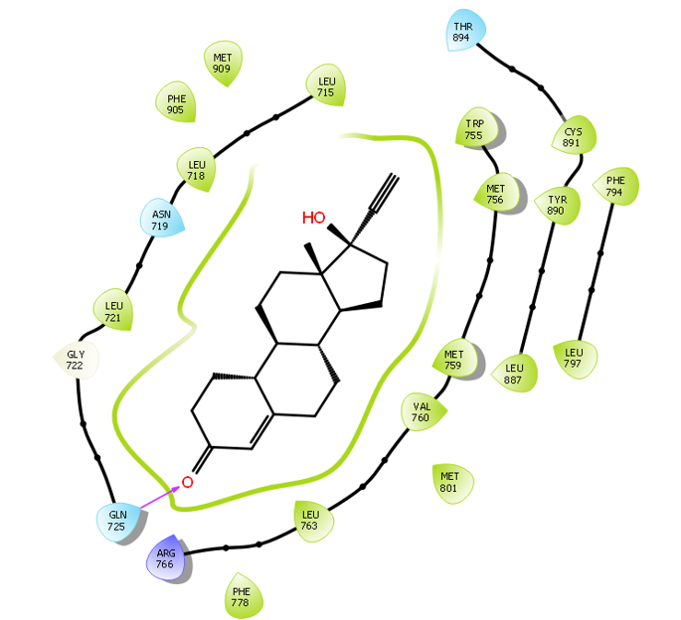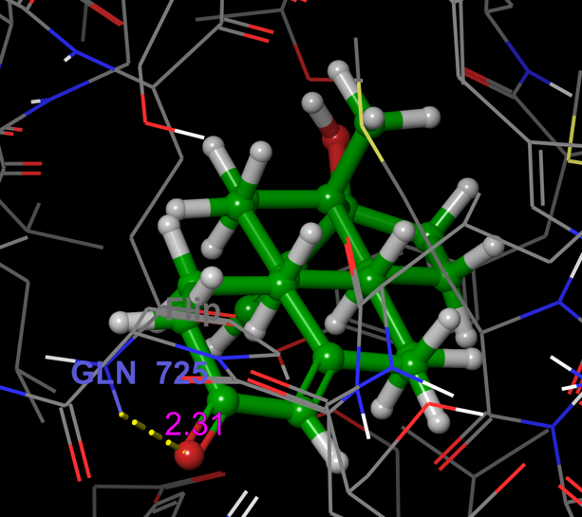
- b)
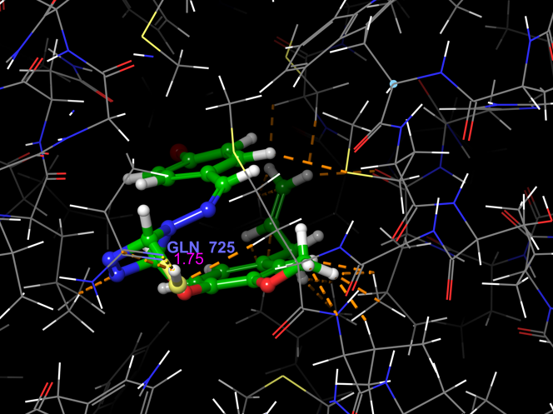
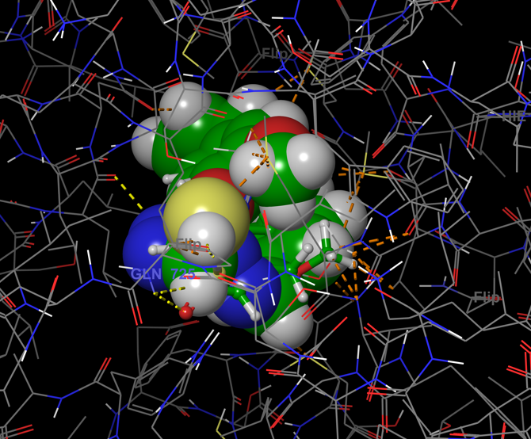
- d)
Fig. 2 a) 2D ligand-protein interaction map of the co-crystallized ligand NDR, b) 3D binding interactions of NDR within the active site, c) 3D binding interactions of Tria-8 in the target protein active site, and d) 3D CPK representation showing interactions of eugenol-triazole ligands within the binding pocket.

In our molecular docking studies, we investigated the interactions of eugenol-based triazole derivatives with the active site of the epidermal growth factor receptor (EGFR; PDB ID: 1M17) by computing binding free energies and determining ligand-protein affinity. Erlotinib, a co-crystallized ligand, has a significant binding free energy of -8.412, proving the docking protocol's validity and reference for predicting the binding behavior of newly designed ligands. The high affinity of erlotinib can be due to critical interactions with Cys773 and Met769, which play an important role in stabilizing inhibitors within the EGFR active site. A reference standard, gefitinib had generated a binding affinity of -7.676 through interactions with Lys721 and Met769, similar to the co-crystal ligand erlotinib. Eugenol exhibited a significantly lower binding affinity of −4.514 and did not establish strong interactions with key active-site residues, reflecting poor compatibility and stabilization. Tria-25 has rendered four hydrogen bonds with key protein residues, Met769, Thr766, Asp831, and Glu738, and a binding affinity of −7.637. it is due to hydrogen bonding interactions, and Thr766, Gln767, and Leu768 hold Tria-25 rigidly at its binding pocket with hydrophobic interactions.
The docking analysis of co-crystal ligand erlotinib (Figs. 3a and 3b) reveals that its high affinity arises from hydrogen bonds formed between the quinazoline core and key active sites such as Met769 and Lys721 with 3.13 and 2.87 Å bond lengths. These interactions, further reinforced by extensive hydrophobic bonds, (Leu768, Gln767, Thr766, Ile765, Leu820, Asp776, Leu694) and π–π stacking interactions, hold the erlotinib ligand rigidly at its defined non-polar binding pocket. In comparison, two-dimensional ligand–protein interaction map of Tria-25 (Fig. 3c) forms numerous hydrogen bonds with residues like Met769, Thr766, Asp831, and Glu738 and is also stabilized by hydrophobic interactions with nearby non-polar amino acids, which collectively explain its high binding score. Moreover, the superimposed 3D structures of designed ligands (Fig. 3d) confirmed that all the ligands docked in the same binding mode across the series. The consistent orientation of the triazole moiety and substituted aromatic rings within the binding pocket identifies these features as essential pharmacophoric elements. Modifying these peripheral substituents offers enormous possibilities for additional optimization to improve binding affinity and selectivity.
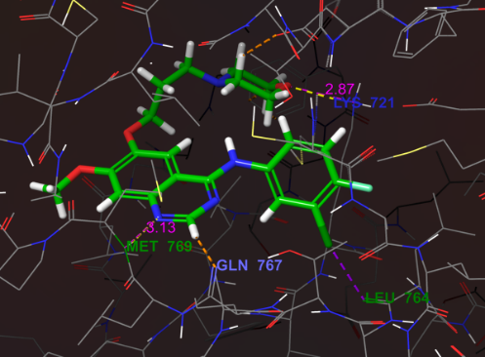
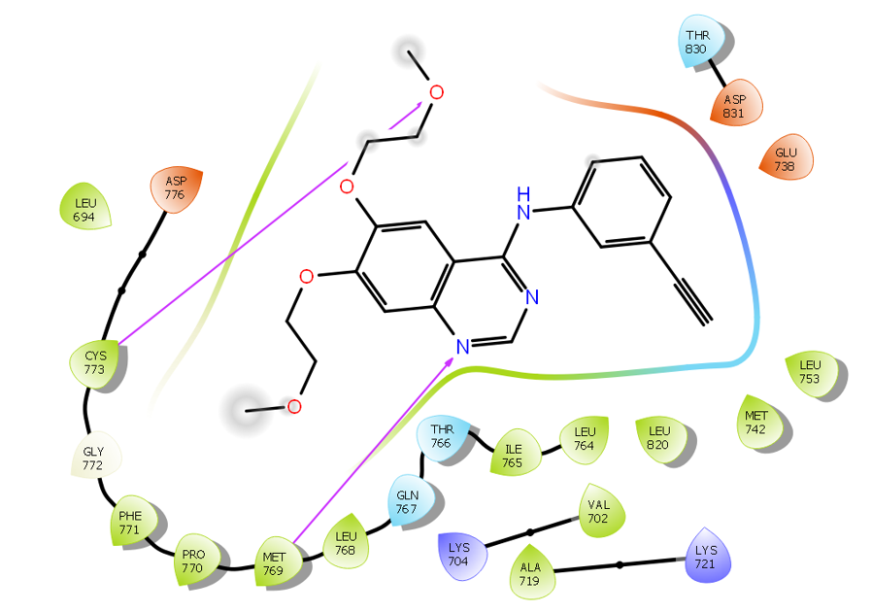
a) b)

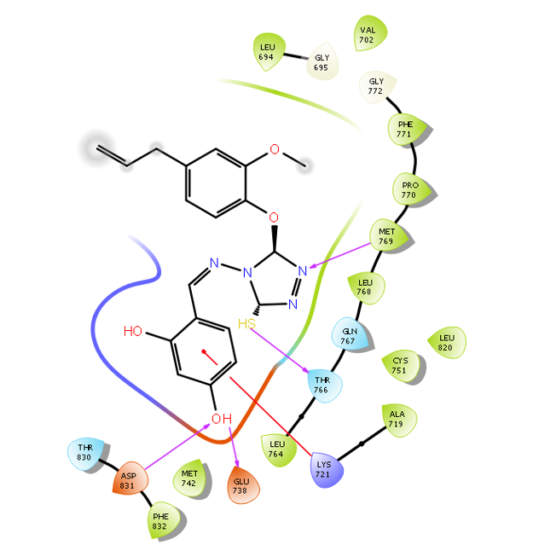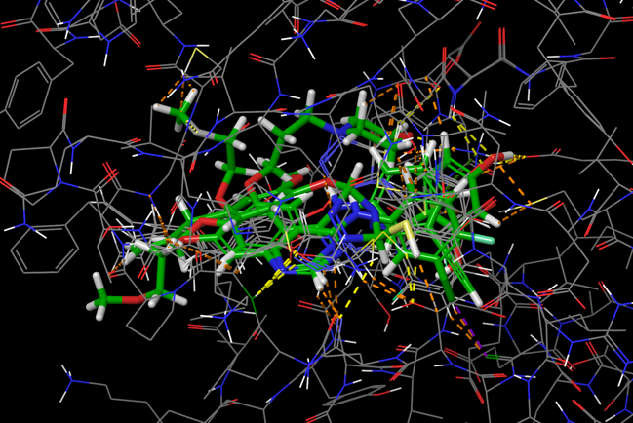

- d)

Fig. 3 a) 2D ligand–protein interaction map of co-crystallized ligand Erlotinib, b) 3D binding interactions of Erlotinib within the active site, c) 2D ligand–protein interaction map of Tria-25, d) 3D ligand interactions of eugenol–triazole ligands within the binding pocket.

The docking analysis of the PI3Kα target (PDB ID: 5DXT) with the chosen designed compounds was performed. According to the docking results, alpelisib showed the highest binding affinity of −10.264 with ~2.4 and 2.6 Å bond lengths. This strong binding affinity is largely attributed to the formation of multiple stabilizing hydrogen bonds with key residues like Gln859, Ser854, and Val851. Additionally, there are important hydrophobic interactions involving Ile932, Phe930, Tyr836, Ile848, Glu849, and Arg770 that contribute to this stability, as detailed in Figs. 4a and 4b. In these evaluations, compound Tria-24 was found to show the best binding affinity of −6.808. It establishes essential hydrogen bonds with Ser774 and Val851, along with hydrophobic interactions and a notable π–π stacking interaction with Trp790, which helps lock the ligand in the active site (see Figs. 4c and 4d). In addition to the reference compounds, tamoxifen has generated a binding affinity of −6.396, mainly interacting with Glu798 but failing to achieve significant stabilization within the binding pocket. The eugenol parent molecule showed the binding affinity −5.8809 with limited interactions with residues Glu849 and Val851, indicating that it is not effectively engaging the PI3Kα active site.
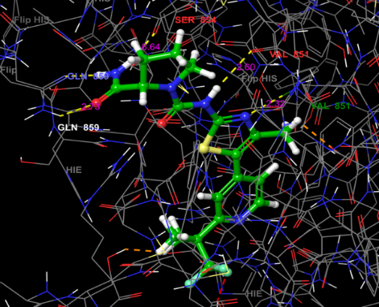
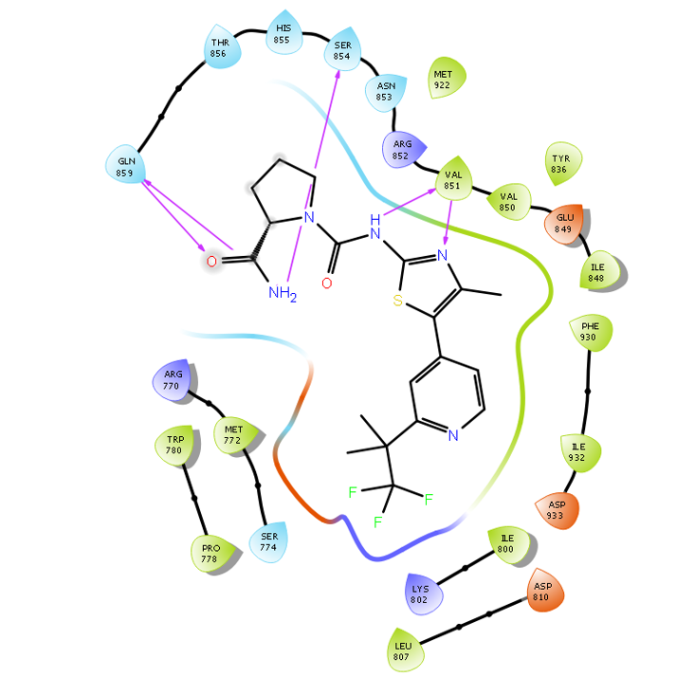
a) b)
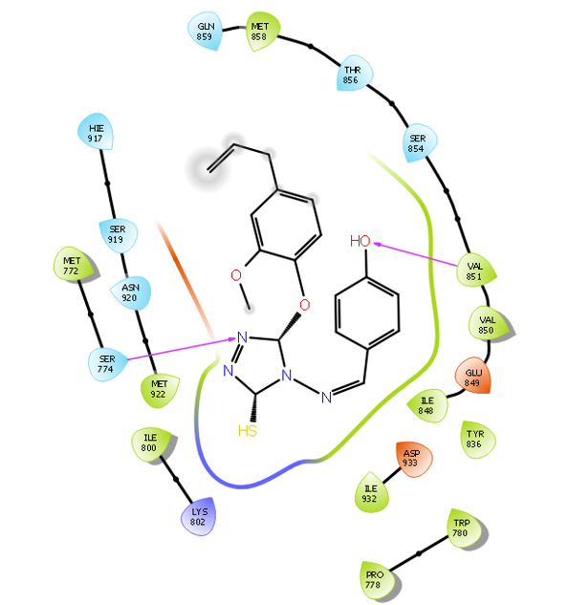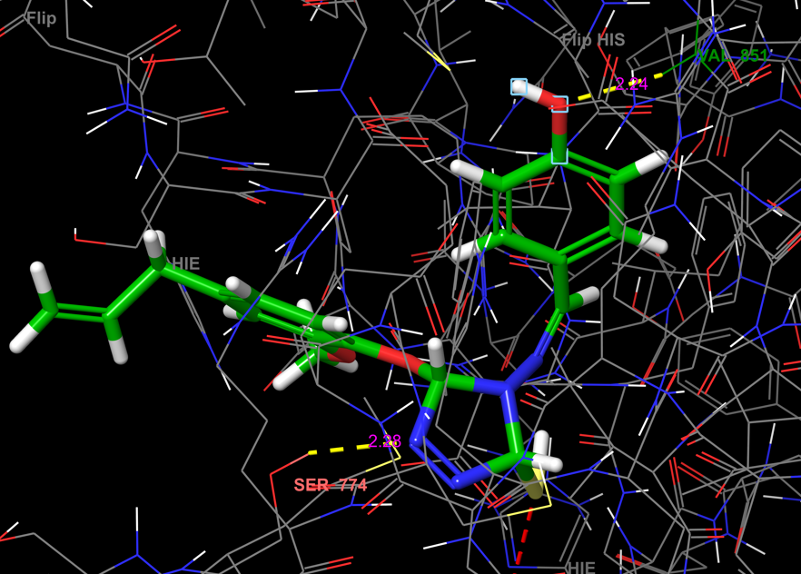
c) d)
Fig. 4 a) 2D interaction map of co-crystallized alpelisib, b) 3D binding mode of alpelisib in the active site, c) 2D interaction map of Tria-24, and d) 3D binding mode of Tria-24 within the binding pocket.
The better docking position has been demonstrated to have the most interacting residues in the mammalian target of rapamycin active site (mTOR). Rapamycin, co-crystallized with the structure of PDB ID: 4DRH, exhibited the highest binding affinity of -6.45. This high binding stability can be attributed to the formation of numerous hydrogen bonds with key residues such as Lys52, Ser80, Gln85, Gly84, Ile87, and Tyr113. These amino acid residues aid in identifying and stabilizing ligands within the active site of proteins. Which is conveyed with a relatively acceptable bond length. The 2D ligand-protein interaction diagram (Fig. 5b) shows Tria-8 forming hydrogen bonds and hydrophobic interactions with key residues such as Ile87, Tyr57, Leu128, Phe130, and Tyr113. The interaction profile resembles that of rapamycin. (Fig. 5c) confirms that the ligand fits optimally within the mTOR binding pocket. This highlights the significance of these conserved residues for effective inhibition.
The reference molecules had binding affinities of −5.693, −5.202, and −4.862 for doxorubicin, neratinib, and letrozole, based on molecular docking analysis. Other docked derivatives exhibit binding affinities ranging from -4.803 to -5.405. Eugenol had the weakest binding affinity (-4.315), generating only one hydrogen bond with Asp68. This shows a lack of stability and weak compatibility within the mTOR binding site, resulting in a comparatively low inhibitory potency when compared to reference inhibitors.
Overall, these findings demonstrate that triazole substitution considerably increases the interaction potential of eugenol derivatives with mTOR, highlighting their potential as multitarget inhibitors of the PI3K/AKT/mTOR signaling pathway.

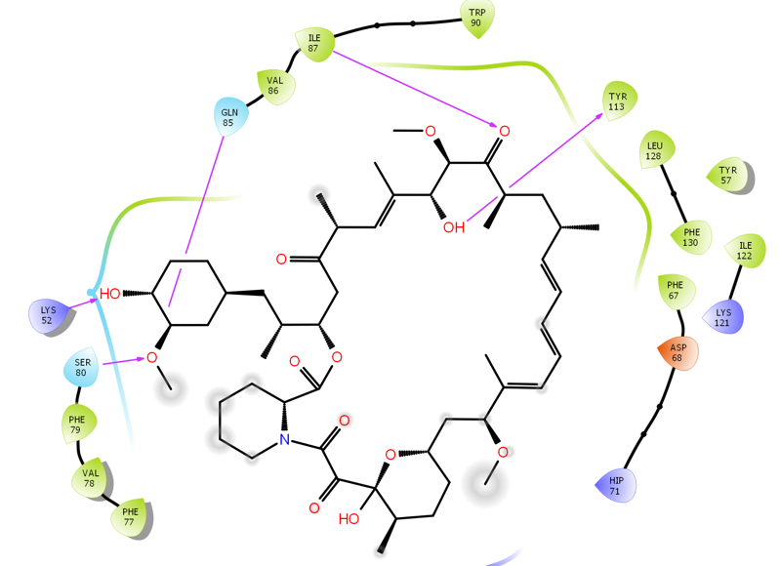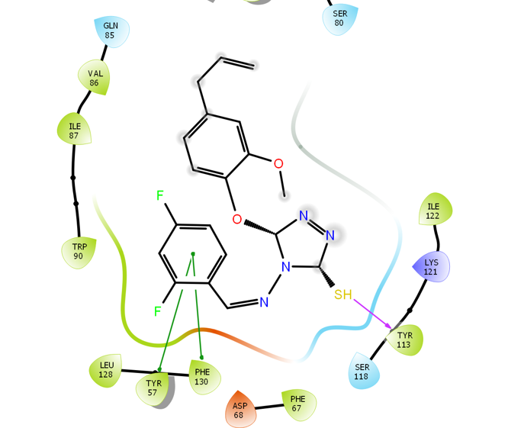
- b)

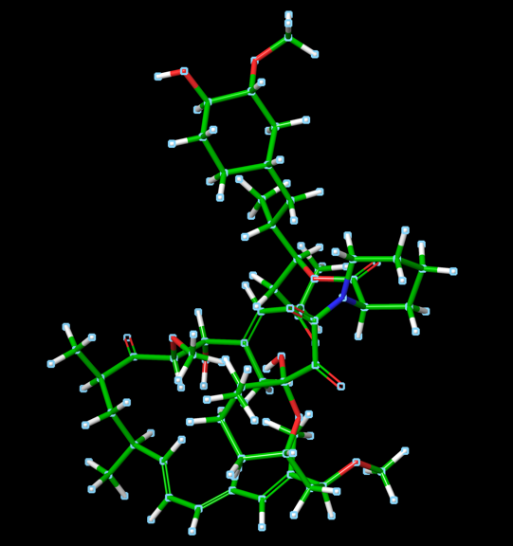
c)
Fig 5. a) Two-dimensional ligand–protein interaction map of co-crystallized ligand rapamycin (RAP) within the mTOR binding site, b) two-dimensional interaction map of Tria-8, c) three-dimensional binding conformation of rapamycin.
4. CONCLUSION

The molecular docking studies have revealed important potential in identifying eugenol- based hybrids as promising lead molecules for anticancer drug discovery. Initially, Lipinski’s Rule of Five was applied to predict the bioavailability and drug-likeness properties of designed eugenol hybrids. Subsequently, molecular docking analyses were carried out to evaluate the binding affinities and interaction profiles of these compounds against breast cancer-associated targets including Erα (PDB ID: 2IOG), PR (PDB ID: 1SQN), EGFR (PDB ID: 1M17), PI3Kα (5DXT), and mTOR (PDB ID: 4DRH). The results of the present study conclude that 20 out of the 35 eugenol-triazole derivatives exhibit promising anti-breast cancer potential.

The compounds Tria-8, Tria-23, Tria-24, and Tria-25 highlight promising interaction with multiple receptors, identifying them as potential lead molecules. Overall the study highlights the potential of eugenol-triazole compounds as multitarget breast cancer drugs and provides a strong benchmark for future studies, including molecular dynamic simulations, ADME evolution, and in vitro and in vivo biological assessments.

COMPETING INTERESTS DISCLAIMER:
Authors have declared that they have no known competing financial interests, non-financial interests OR personal relationships that could have appeared to influence the work reported in this paper.
Disclaimer (Artificial intelligence)
Option 1:
Author(s) hereby declare that NO generative AI technologies such as Large Language Models (ChatGPT, COPILOT, etc.) and text-to-image generators have been used during the writing or editing of this manuscript.

REFERENCES

- Siegel, R. L., Kratzer, T. B., Giaquinto, A. N., Sung, H., & Jemal, A. (2025). Cancer statistics, 2025. CA: a cancer journal for clinicians, 75(1), 10–45.
- Bray, F., Laversanne, M., Sung, H., Ferlay, J., Siegel, R. L., Soerjomataram, I., & Jemal, A. (2024). Global cancer statistics 2022: GLOBOCAN estimates of incidence and mortality worldwide for 36 cancers in 185 countries. CA: A Cancer Journal for Clinicians, 74(3), 229–263.
- Vasan, N., Baselga, J., & Hyman, D. M. (2019). A view on drug resistance in cancer. Nature, 575(7782), 299–309.
- Bukowski, K., Kciuk, M., & Kontek, R. (2020). Mechanisms of Multidrug Resistance in Cancer Chemotherapy. International journal of molecular sciences, 21(9), 3233.
- Atanasov, a. G., Zotchev, S. B., Dirsch, V. M., & Supuran, C. T. (2021). Natural products in drug discovery: advances and opportunities. Nature Reviews Drug Discovery, 20(3), 200–216.
- Rodrigues, T., Reker, D., Schneider, P., & Schneider, G. (2016). Counting on natural products for drug design. Nature Chemistry, 8(6), 531–541.
- Fernandes Melo Reis, R. C., Pontes Silva, A. V., Veiga Torres, A. D., de Cassia Alves Iemini, R., Lapa, I. R., Franco, L. L., Pinto Braga, S. F., Carvalho, D. T., Dias, D. F., & de Souza, T. B. (2024). From clove oil to bioactive agents: synthetic routes, antimicrobial and antiparasitic activities of eugenol derivatives. Future medicinal chemistry, 16(20), 2169–2188.
- Nazreen, S., Elbehairi, S. E. I., Malebari, A. M., Alghamdi, N., Alshehri, R. F., Shati, A. A., Ali, N. M., Alfaifi, M. Y., Elhenawy, A. A., & Alam, M. M. (2023). New Natural Eugenol Derivatives as Antiproliferative Agents: Synthesis, Biological Evaluation, and Computational Studies. ACS omega, 8(21), 18811–18822.
- Matin, M. M., Matin, P., Rahman, M. R., Ben Hadda, T., Almalki, F. A., Mahmud, S., Ghoneim, M. M., Alruwaily, M., & Alshehri, S. (2022). Triazoles and Their Derivatives: Chemistry, Synthesis, and Therapeutic Applications. Frontiers in molecular biosciences, 9, 864286.
- Naeem, N., Mughal, E. U., Sadiq, A., Othman, G. A., & Shakoor, B. (2025). Recent Advances in 1,2,4-Triazole-Based Anticancer Agents: Structural Optimization, Mechanisms, and Therapeutic Potential (2022-2025). Archiv der Pharmazie, 358(7), e70059.
- Agu, P. C., Afiukwa, C. A., Orji, O. U., Ezeh, E. M., Ofoke, I. H., Ogbu, C. O., Ugwuja, E. I., & Aja, P. M. (2023). Molecular docking as a tool for the discovery of molecular targets of nutraceuticals in disease management. Scientific reports, 13(1), 13398.
- Pagadala, N. S., Syed, K., & Tuszynski, J. (2017). Software for molecular docking: a review. Biophysical reviews, 9(2), 91–102.
- Ayub, M. A., Tyagi, A. R., Srivastava, S. K., & Singh, P. (2024). Quantum DFT analysis and molecular docking investigation of various potential breast cancer drugs. Journal of Materials Chemistry. B, 13(1), 218–238.
- Sowa-Kasprzak, K., Totoń, E., Kujawski, J., Olender, D., Lisiak, N., Zaprutko, L., Rubiś, B., Kaczmarek, M., & Pawełczyk, A. (2023). Synthesis, Cytotoxicity, and Molecular Docking of New Hybrid Compounds by the Combination of Curcumin with Oleanolic Acid. Biomedicines, 11(6), 1506.
- Alam M. M. (2023). Synthesis and anticancer activity of novel Eugenol derivatives against breast cancer cells. Natural product research, 37(10), 1632–1640.
- Newman, D. J., & Cragg, G. M. (2020). Natural Products as Sources of New Drugs over the Nearly Four Decades from 01/1981 to 09/2019. Journal of natural products, 83(3), 770–803.
- Naeem, A., Hu, P., Yang, M., Zhang, J., Liu, Y., Zhu, W., & Zheng, Q. (2022). Natural Products as Anticancer Agents: Current Status and Future Perspectives. Molecules (Basel, Switzerland), 27(23), 8367.
- Osborne, C. K., & Schiff, R. (2011). Mechanisms of endocrine resistance in breast cancer. Annual review of medicine, 62, 233–247.
- Costa, R. L. B., & Gradishar, W. J. (2017). Differences Are Important: Breast Cancer Therapy in Different Ethnic Groups. Journal of global oncology, 3(4), 281–284.
- Mayer, I. A., & Arteaga, C. L. (2016). The PI3K/AKT Pathway as a Target for Cancer Treatment. Annual review of medicine, 67, 11–28.
- Yager, J. D., & Davidson, N. E. (2006). Estrogen carcinogenesis in breast cancer. The New England journal of medicine, 354(3), 270–282.
- Mohammed, H., Russell, I. A., Stark, R., Rueda, O. M., Hickey, T. E., Tarulli, G. A., Serandour, A. A., Birrell, S. N., Bruna, A., Saadi, A., Menon, S., Hadfield, J., Pugh, M., Raj, G. V., Brown, G. D., D'Santos, C., Robinson, J. L., Silva, G., Launchbury, R., Perou, C. M.,. Carroll, J. S. (2015). Progesterone receptor modulates ERα action in breast cancer. Nature, 523(7560), 313–317.
- Normanno, N., De Luca, A., Bianco, C., Strizzi, L., Mancino, M., Maiello, M. R., Carotenuto, A., De Feo, G., Caponigro, F., & Salomon, D. S. (2006). Epidermal growth factor receptor (EGFR) signaling in cancer. Gene, 366(1), 2–16.
- Hu, J., Zhang, H., Cao, M., Wang, L., Wu, S., & Fang, B. (2018). Auranofin Enhances Ibrutinib's Anticancer Activity in EGFR-Mutant Lung Adenocarcinoma. Molecular cancer therapeutics, 17(10), 2156–2163.
- Thorpe, L. M., Yuzugullu, H., & Zhao, J. J. (2015). PI3K in cancer: divergent roles of isoforms, modes of activation and therapeutic targeting. Nature Reviews. Cancer, 15(1), 7–24.
- Laplante, M., & Sabatini, D. M. (2012). mTOR signaling in growth control and disease. Cell, 149(2), 274–293. SwissADME https://www.swissadme.ch/
- Lipinski, c. A. (2000). Drug-like properties and causes of poor solubility and permeability. Journal of pharmacological and toxicological methods, 44(1), 235–249.
PDB, www.rcsb.org
- Release S. 1: Prime. Schrödinger, LLC, New York, NY. 2020
- Release S. 2: LigPrep, Schrödinger, LLC, New York, NY, 2017. New York, NY. 2017.
- Schrödinger Release 2020-1: Glide, Schrödinger, LLC, New York, NY, 2020.
- Rasul, H. O., Aziz, B. K., Ghafour, D. D., & Kivrak, A. (2022). In silico molecular docking and dynamic simulation of eugenol compounds against breast cancer. Journal of Molecular Modeling, 28(1), 17.
- Abdullah, M. L., Al-Shabanah, O., Hassan, Z. K., & Hafez, M. M. (2021). Eugenol-Induced Autophagy and Apoptosis in Breast Cancer Cells via PI3K/AKT/FOXO3a Pathway Inhibition. International journal of molecular sciences, 22(17), 9243.
- Debnath, A., Lo, Y.-H., Bhattacharya, M., Wen, Z.-H., Chakraborty, C., & Das, A. (2025). Eugenol’s anti-cancer properties, its modulation of signalling pathways, and cascades across various cancers: A review. Current Research in Biotechnology, 10, 100330.
- Noman, A. M., Sultan, M. T., Mazhar, A., Khan, W. A., Imran, M., Hussain, M., Mostafa, E. M., El-Ghorab, A. H., Ghoneim, M. M., Selim, S., Abdelgawad, M. A., Al Jbawi, E., Alsagaby, S. A., & Al Abdulmonem, W. (2025). Eugenol: An Insight into the Anticancer Perspective and Pharmacological Aspects. Food science & nutrition, 13(8), e70727.
- Faruq, A. U., & Ibrahim, I. M. (2025). Comprehensive overview of eugenol: Sources, structure, pharmacological activities, mechanisms of action, safety profile, and applications. Journal of Drug Design and Medicinal Chemistry, 11(3), 39–47.
- Alam, M. M. (2024). New 1,2,4-triazole-based eugenol derivatives as anti-COX-2 and anticancer agents. Journal of Umm Al-Qura University for Applied Sciences, 10, 555–566.
- Pangesti, D. P., Az-Zahra, N. F., Warsito, W., & Masruri, M. (2024). Synthesis of eugenol ester derivatives as breast cancer drugs. AIP Conference Proceedings, 3055(1), 030001.

