Ethnopharmacological survey of medicinal plants used against sexually transmitted infections in the Korhogo department, northern Côte d’Ivoire

ABSTRACT
Background: Resistance to commonly used antibiotics in the treatment of sexually transmitted infections (STIs), such as Trichomonas vaginalis, Chlamydia trachomatis, and Neisseria gonorrhoeae, constitutes a major public health challenge, particularly in the field of reproductive health.
Objective: The purpose of this study was to document medicinal plants traditionally employed by herbal practitioners against STIs in the Korhogo department.
Methods: An ethnopharmacological survey was conducted using an oral questionnaire administered to 80 traditional medicine practitioners from the city of Korhogo and surrounding villages (Côte d’Ivoire).
Results: Seventeen plant species were identified. The most frequently cited were Adansonia digitata (17.65%), Trichilia emetica (11.76%), Carica papaya (11.76%), and Olax subscorpioidea (9.76%). The plant parts most commonly used in remedy preparation were leaves (58.82%), followed by fruits (23.53%), stem bark (11.79%), and roots (5.88%). The predominant preparation methods included infusion (55%), decoction (16.66%), maceration (16.66%), and hydrodistillation (11.68%). Treatment duration generally ranged from one to three weeks, with oral administration being the preferred route (73.68%).
Conclusion: These findings provide an important contribution to the valorization of natural resources in the fight against STIs in the Korhogo department and establish a solid basis for future research.
Keywords: ethnopharmacology, Korhogo, medicinal plants, Sexually transmitted infections

1. INTRODUCTION
Sexually transmitted infections (STIs) are among the most widespread public health problems worldwide, with more than one million curable cases reported every day. This alarming rise is driven by several factors, including low condom use, insufficient testing, social stigma, and the increased vulnerability of young adults (Stewart et al., 2020). Multiple pathogens are implicated in STIs, notably Trichomonas vaginalis (5.0%), Chlamydia trachomatis (4.2%), Neisseria gonorrhoeae (1.6%), and Treponema pallidum (0.5%) (WHO, 2024). The fight against these pathogens relies primarily on the use of specific or broad-spectrum antibiotics (Julie, 2025). Antibiotic therapy has revolutionized the management of bacterial infections, contributing to a significant reduction in STI-related morbidity and mortality. However, excessive and sometimes inappropriate use of these drugs has fostered the emergence of microbial resistance, turning antibiotic resistance into a major public health concern. This worrying situation increasingly stimulates the search for new antibacterial molecules derived from plant resources, capable of neutralizing multidrug-resistant pathogens (WHO, 2023).
Within this context, the present study aims to catalogue the medicinal plants used in the Korhogo department (northern Côte d’Ivoire) for the treatment of sexually transmitted infections, through an ethnopharmacological survey. Previous studies have highlighted that northern Côte d’Ivoire possesses a rich floral diversity with therapeutic properties, representing both a source of pride and ancestral knowledge for local populations (Konan et al., 2019; Soro et al., 2023).
2. MATERIALS AND METHODS
2.1. Equipment
2.1.1. Study Area
The study was conducted in the Poro region, located in northern Côte d’Ivoire, specifically within the Korhogo department. This area covers approximately 13,400 km² and is characterized by a hot, dry climate typical of Sudanian–Sahelian zones (Fig. 1). The dominant vegetation consists of wooded savanna, mainly composed of trees and shrubs ranging from 8 to 12 meters in height. The local population is predominantly Senufo, an ethnolinguistic group deeply rooted in traditional practices and ancestral knowledge, particularly in the field of traditional medicine (Silué et al., 2019).

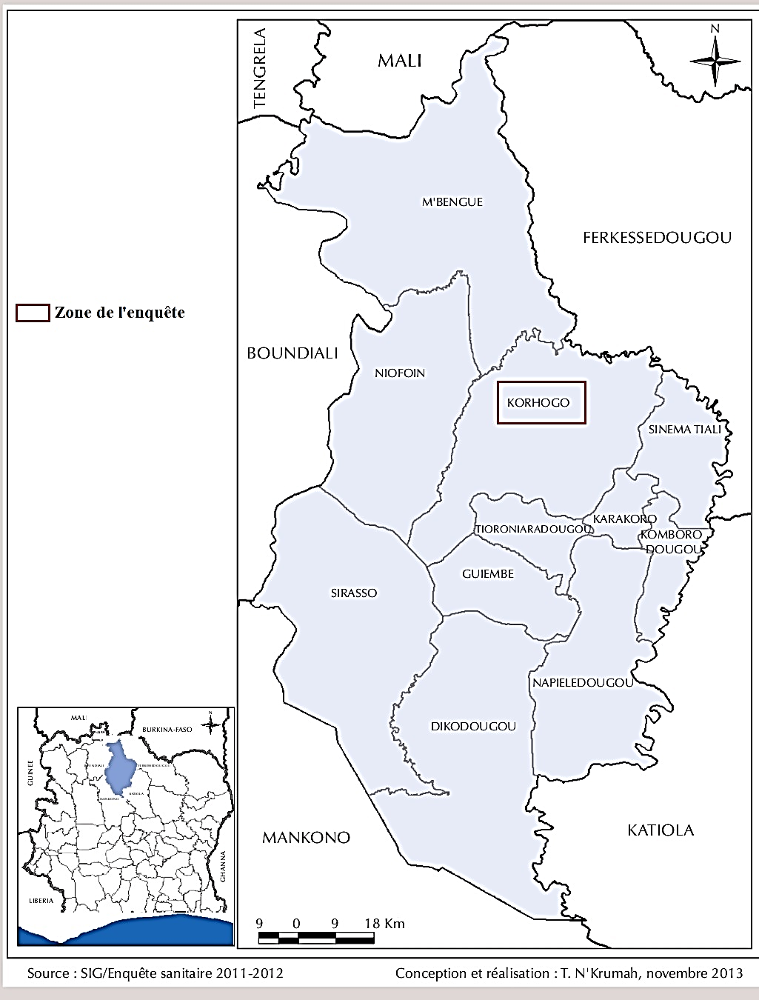

Fig.1 : Map of the Poro region in northern Côte d’Ivoire (Tanoh et al., 2014).
2.1.2. Technical Equipment
The technical equipment used for this ethnopharmacological study included a data collection form with an integrated questionnaire. This form was administered to traditional medicine practitioners, particularly herbalists and traditional healers working in the city of Korhogo and surrounding villages. A digital camera (LCD TFT) was also employed to photograph the plant parts cited, for purposes of botanical identification.
2.2. Methods
The ethnopharmacological survey was conducted from March 6 to May 5, 2024, with the participation of 40 herbalists and 40 traditional healers practicing in the Korhogo department (Côte d’Ivoire). Data were collected through oral interviews, using a standardized form with a structured questionnaire addressing the following elements: plant names, organs or parts used, methods of preparing herbal remedies, routes of administration, and treatment duration.
Subsequently, plant samples were collected and photographed either at markets from herbalists or directly in natural vegetation under the guidance of a local guide. Following sampling, preliminary identification was performed using the PlantNet software. The works of Arbonnier (2002) and Aké-Assi (2011) were consulted to validate the identification. Finally, the nomenclature of the recorded plant species was harmonized according to the Angiosperm Phylogeny Group IV classification (APG IV, 2016).
2.3. Statistical Analysis
Statistical analyses were performed using SPHINX software (Le Sphinx Plus²), and data entry was conducted with Microsoft Word and Excel 2013. The Chi-square test, based on the assumption of distributional equality, was applied to compare the percentages of plants cited, plant organs used, preparation techniques, and routes of administration, with a significance threshold set at 5%.
3. RESULTS AND DISCUSSION
3.1. Results
3.1.1. Botanical classes and plant organs used
The results of the survey on plants used in the treatment of venereal diseases in the Korhogo department are presented in Table 1. Analysis of this table indicates that 17 species of medicinal plants, distributed across 17 genera and 14 botanical families, were identified. The most represented families were Myrtaceae, Fabaceae, and Euphorbiaceae, each accounting for 11.76%. The findings also highlight the predominance of Adansonia digitata (17.65%), followed by Trichilia emetica and Carica papaya (11.76% each), and Olax subscorpioidea (9.76%). Furthermore, the analysis revealed a predominance of leaves (58.82%) and fruits (23.53%) in the preparation of phytomedicines. In contrast, stem bark and roots were cited less frequently, with respective frequencies of 11.79 % and 5.88% (Fig. 2).
3.1.2. Methods of preparing herbal remedies and treatment duration
Regarding the preparation methods of herbal remedies, the survey data indicated that infusion was the most frequently used technique, reported by 55% of respondents, followed by maceration and decoction (16.66% each). In contrast, hydrodistillation was the least employed method, at 11.68% (Fig. 3).
Furthermore, different routes were reported for the administration of phytomedicines. The oral route was the most frequently employed (73.68%), whereas the rectal and cutaneous routes were the least used, with respective frequencies of 15.79% and 10.52 % (Fig. 4).
Finally, regarding treatment duration, the survey revealed that it ranged from one to eight weeks. Plants demonstrating therapeutic efficacy within one week (41.18%), two weeks (23.53%), and three weeks (23.53%) were the most frequently reported, whereas those with efficacy extending to four or eight weeks were the least cited, at 5.88% (Fig. 5).

Table 1 : Directory of medicinal plants used to treat venereal diseases in the Department of Korhogo
Scientific names | Families | Organs used | Preparation methods | Administrative channels | Treatment duration | Frequency of citation (%)
Adansonia digitata | Malvaceae | Stem bark | Decoction | Oral | 1 week | 17.65
Trichilia emetica | Meliaceae | Leaves | Infusion | Oral | 1 week | 11.76
Carica papaya | Caricaceae | Leaves / Roots | Maceration | Oral | 1 week | 11.76
Olax subscorpioidea | Olacaceae | Leaves | Infusion | Oral | 2 weeks | 9.76
Syzygium aromaticum | Myrtaceae | Fruits | Infusion | Oral | 2 weeks | 4.91
Cassytha filiformis | Lauraceae | Leaves | Infusion | Oral | 4 weeks | 4.79
Tetrapleura tetraptera | Fabaceae | Fruits / Leaves | Maceration | Oral | 1 week | 4.64
Heliotropium indicum | Boraginaceae | Leaves | Infusion | Oral | 2 weeks | 4.37
Moringa oleifera | Moringaceae | Fruits | Decoction | Oral | 1 week | 4.07
Vernonia amygdalina | Asteraceae | Leaves | Decoction | Oral | 4 weeks | 3.82
Cocos nucifera | Arecaceae | Fruits | Hydrodistillation | Cutaneous | 4 weeks | 3.82
Aloe vera | Asphodelaceae | Leaves | Hydrodistillation | Cutaneous | 3 weeks | 3.8
Psidium guajava | Myrtaceae | Leaves | Infusion | Rectal | 1 week | 3.45
Alchornea cordifolia | Euphorbiaceae | Leaves | Infusion | Oral / Rectal | 1 week | 3.37
Parkia biglobosa | Fabaceae | Stem bark | Maceration | Oral / Rectal | 4 weeks | 3.28
Annona muricata | Annonaceae | Leaves / Roots | Infusion | Oral | 8 weeks | 2.38
hyllanthus amur | Euphorbiaceae | Leaves | Infusion | Oral | 2 weeks | 2.37

Frequency (%)

c

b
a
a

Parts used

Fig. 2: Parts of plants used in the preparation of the recipes
Bands bearing the same letter do not show a significant difference (P >0.05)

Frequency (%)
b

a
a
a

Preparation method

Fig. 3: Methods of preparing herbal medicines
Bands bearing the same letter do not show a significant difference (P >0.05)

Frequency (%)

b

a
a
Administrative channels

Fig. 4: Routes of administration of drug recipes
Bands bearing the same letter do not show a significant difference (P >0.05)

Frequency (%)

b
c
Treatment duration

b

a
a
Treatment duration

Fig. 5: Duration of treatments with herbal medicines

Bands bearing the same letter do not show a significant difference (P >0.05)

  - Discussion
During the ethnopharmacological study, traditional healers in the Department of Korhogo cited a variety of medicinal plants. Among these, Adansonia digitata was the most frequently mentioned (17.65%), followed by Trichilia emetica and Carica papaya (11.76% each), and then Olax subscorpioidea (9.76%), which are more commonly used in the treatment of sexually transmitted infections (STIs). These findings are consistent with those reported in several surveys conducted in West and sub-Saharan Africa (Kodjo et al., 2022), which confirm the predominance and therapeutic importance of these plants in the traditional management of STIs. The frequent use of these species in traditional medicine can be explained by their richness in bioactive phytochemical compounds and their recognized biological properties. Phytochemical screening of the leaves and fruits of Adansonia digitata and Trichilia emetica revealed the presence of flavonoids, alkaloids, sterols, tannins, terpenoids, and phenolic compounds (Perumal et al., 2020; Ajayi and Ogunjobi, 2024). This significant phytochemical composition confers antioxidant, anti-inflammatory, and antibacterial properties to these plants. With regard to Carica papaya and Olax subscorpioidea, studies have also demonstrated that these plants contain several secondary metabolites capable of inhibiting the growth of bacterial strains involved in STIs (Ahmad et al., 2021; Kumarasinghe et al., 2024).
All parts of the plants are used in the preparation of herbal medicines, with a clear predominance of leaves (58.82%). These findings corroborate those reported by several researchers in Côte d’Ivoire (Konan et al., 2019; Soro et al., 2023) and in Benin (Azonbakin et al., 2021), who observed respective usage frequencies of 35%, 64.40%, and 35.77% in the treatment of various conditions. This predominance may be explained by the central role of leaves in the biosynthesis of pharmacologically active secondary metabolites, as well as by their generally non-destructive harvesting (Manodra and Kele, 2024). Various methods are employed to extract active ingredients or phytochemical compounds from plant organs. Among these, infusion was the most frequently cited, with a frequency of 55%. This observation is consistent with that of Chaachouay et al. (2019) in Moroc, who reported an infusion usage rate of 53.9%. Infusion is a simple and accessible method that enables the efficient extraction of water-soluble secondary metabolites while preserving their thermal stability (Mousa et al., 2025). Furthermore, treatments are predominantly administered orally, with a frequency of 73.68%. These results are similar to those obtained by Soro et al (2023), who reported a frequency of 66.7% in an ethnopharmacological survey on plants used to treat infertility. This convergence may be explained by the fact that many infections are caused by bacteria and parasites located internally. To reach them, treatment must pass through the digestive system, which facilitates absorption and enhances therapeutic efficacy (Kayombo et al., 2013). Regarding treatment duration, the survey revealed that most plants are used over short periods, typically ranging from one to three weeks. This may reflect the traditional healers’ intent to provide rapid relief from acute symptoms commonly associated with infections. Short treatment durations also reduce the constraints linked to prolonged use of herbal remedies. Thus, the duration of medicinal plant use may serve as a relevant indicator of local therapeutic strategies, shaped by empirical knowledge, resource availability, and perceived efficacy (Khan et al., 2021).
- CONCLUSION
The ethnopharmacological survey cataloged medicinal plants used by populations in northern Côte d’Ivoire for the treatment of sexually transmitted infections (STIs). Seventeen medicinal plants were identified based on information provided by herbalists and traditional healers. In this region, Adansonia digitata is most sought-after species, and its leaves are the most commonly used parts for preparing remedies. Infusion is the preferred preparation method, while oral route is the most frequently employed for administering herbal medicines. Majority of the listed plants are reported to be effective against STIs with a short treatment duration. Therefore, phytochemical screening and pharmacological testing of extracts from these plants could provide valuable insights into their effects on the bacterial and fungal strains involved in these infections.
DISCLAIMER (ARTIFICIAL INTELLIGENCE)
Author (s) hereby declared that NO generative AI technologies such as Large Language Models ( ChatGPT , COPILOT, etc.) and text -to-image generators have been used during the writing or editing of this manuscript .
REFERENCES
- Ahmad, M. H., Jatau, A. I., Alshargi, O. Y., Julde, S. A. M., Mohammed, M., Muhammad, S., Mustapha, S., Bala, A. A., Wada, A. S., Aminu, M., & Usman, A. M. (2021). Ethnopharmacological uses, phytochemistry, pharmacology, and toxicology of Olax subscorpioidea Oliv (Olacaceae): a review. Future Journal of Pharmaceutical Sciences, 7(1), 115. https://doi.org/10.1186/s43094-021-00264-w
- Ajayi, B.E., & Ogunjobi, A.A. (2024). Antibacterial activities and antioxidant potential of Adansonia digitata leaves. GSC Biological and Pharmaceutical Sciences, 28(1), 114-131. https://doi.org/10.30574/gscbps.2024.28.1.0260
- Aké-Assi, L. (2011). Abrégé de médecine et de pharmacopée Africaines : quelques plantes employées traditionnellement dans la couverture des soins de santé primaire. NEI-CEDA. https://www.nlm.nih.gov/catalog/bib/101583504
- Angiosperm Phylogeny Group. (2016). An update of the Angiosperm Phylogeny Group classification for the orders and families of flowering plants: APG IV. Botanical Journal of the Linnean Society, 181, 1-20. https://doi.org/10.1111/boj.12385
- Arbonnier, M. (2004). Trees, shrubs and lianas of West African dry zones. Editions Quae, Muséum national d'Histoire naturelle, CIRAD, Margraf Publishers. https://www.librairie-quae.com/produit/100/9782759206742/trees-shrubs-and-lianas-of-west-african-dry-zones
- Azonbakin, S., Dangbemey, P., Osseni, R., Yaude, S. A., Kora, F., Adovoekpe, D., Djego, F., Laleye, A., & Awede, B. (2021). Ethnobotanical survey of plants used in the treatment of male infertility in Benin. *International Journal of Biological and Chemical Sciences*, *15*(4), 1667-1677. https://doi.org/10.4314/ijbcs.v15i4.28
- Chaachouay, N., Benkhnigue, O., Fadli, M., El Ibaoui, H., & Zidane, L. (2019). Ethnobotanical and ethnopharmacological studies of medicinal and aromatic plants used in the treatment of metabolic diseases in the Moroccan Rif. Heliyon, 5(10), e02191. https://doi.org/10.1016/j.heliyon.2019.e02191
- Infections sexuellement transmissibles : de nouvelles recommandations dans la prise en charge. (2025). Santé sur le Net. https://www.sante-sur-le-net.com/infections-sexuellement-transmissibles-de-nouvelles-recommandations-dans-la-prise-en-charge/
- Kayombo, E. J., Mahunnah, R. L. A., & Uiso, F. C. (2013). Prospects and challenges of medicinal plants conservation and traditional medicine in Tanzania. *Anthropology*, *1*(3), 1-8. https://doi.org/10.4172/antp.1000108
- Kayombo, E. J., Mahunnah, R. L. A., & Uiso, F. C. (2013). Prospects and challenges of medicinal plants conservation and traditional medicine in Tanzania. *Anthropology*, *1*(3), 1-8. https://doi.org/10.4172/antp.1000108
- Kodjo, A.M., Tchacondo, T., et Karou, S.D. (2022). Ethnobotanical study of medicinal plants used against sexually transmitted infections in West Africa. African Journal of Traditional Medicine , Complement . Altern . Med., 19(3), 45–56.
- Koman, S. R., Kpan, W. B., Yao, K., & Ouattara, D. (2019). Plants used in the traditional treatment of female infertility in the department of Dabakala (Ivory Coast). *Journal of Animal & Plant Sciences*, *42*(1), 7086-7099. https://doi.org/10.35759/JAnmPlSci.v42-1.1
- Kumarasinghe, H. S., Kim, J. H., Kim, S. L., Kim, K. C., Perera, R. M. T. D., Kim, S. C., & Lee, D. S. (2024). Bioactive constituents from Carica papaya fruit: implications for drug discovery and pharmacological applications. Applied Biological Chemistry, 67(1), 103. https://doi.org/10.1186/s13765-024-00962-y
- Manodra, R.N., et Kele, V.D. (2024). A review of the clinical properties of different leaves . Int. J. Appl . Home Sci., 11(9 and 10), 556–565.
- Mousa, R. B., Elalim, R. M. A., Atala, N. E., Elkayaly, H. A., & Shalaby, E. A. (2024). New methods for extraction of phenolic, flavonoids and catechin compounds from natural sources. Chemical Papers, 79(1), 247-263. https://doi.org/10.1007/s11696-024-03778-8
- WHO. (2024). Implementing global health sector strategies on HIV, viral hepatitis and sexually transmitted infections, 2022–2030, accessed on 10 August 2024 at: https://www.who.int/publications/i/item/9789240094925
- World Health Organization. (2023, April 14). WHO/ECDC report: antimicrobial resistance threatens patient safety in European Region. WHO/Europe. https://www.who.int/europe/fr/news/item/who-ecdc-report--antimicrobial-resistance-threatens-patient-safety-in-european-region
- Perumal, A., Naidu Krishna, S. B., Sershen, Pillay, K., & Govender, P. (2020). Phytochemical composition and biological investigation of Trichilia emetica Vahl. seed extracts. Letters in Applied NanoBioScience, 9(2), 1111–1116. https://doi.org/10.33263/lianbs92.11111116
- Silué, P.D., Koudou, D., Assi-kaudjhis, J.P. (2019). Hydro-agricultural dams in northern Côte d'Ivoire put to the east by the spatial diffusion of innovations. Int. J. humanity . Soc. Sci. Res., 15 (5):63-70.
- Soro, T., Kamagaté, T., Touré, A., Méité, S., Kablan, A. L. C., & Coulibaly, A. (2023). Ethno-pharmacological investigation of medicinal plants used for treatment of human infertility in department of korhogo , north of ivory coast. *European Journal of Biomedical and Pharmaceutical Sciences*, *10*, 15-21. https://www.ejbps.com/abstract/ethno-pharmacological-investigation-of-medicinal-plants-used-for-treatment-of-human-infertility-in-department-of-korhogo-north-of-ivory-coast-10000.html
- Stewart, J., Bukusi, E., Celum, C., Delany-Moretlwe, S., & Baeten, J. M. (2020). Sexually transmitted infections among African women: an opportunity for combination sexually transmitted infection/HIV prevention. AIDS, 34(5), 651-658. https://doi.org/10.1097/QAD.0000000000002472
- N'Krumah, T. A. S. R., Koné, B. A., Tiembré, I., Mbaye, I., Tanner, M., & Cissé, G. (2014). Variabilité climatique et incidence de la méningite cérébro-spinale dans le district sanitaire de Korhogo (Nord de la Côte d'Ivoire). Environnement Risques & Sante, 13(2), 144-152. https://doi.org/10.1684/ERS.2014.0687

