Modelling Early Childbearing as a Bounded Outcome: Adolescent Fertility in Countries and Socioeconomic Strata
Abstract
Childbearing at a young age remains a pressing concern for population health and broader development. Unfortunately, there has been extensive literature based on statistical models that have not properly accounted for the bounded variable and hierarchical structure of the data concerning childbearing at a young age. The purpose of this research is to investigate the trend of childbearing at a young age using harmonised cross-national survey data. The objective of this study is to measure changes in childbearing among young women over time. The data on the percentage distribution of women aged 20-24 years who have given birth to children under age 18 were modelled using a multilevel beta regression model with random effects for countries and regions. The results indicate a significant decrease in early motherhood, with an odds ratio of −1.5 per cent per year (p = 0.000). There are significantly higher prevalence rates of early childbearing in lower-income countries than in the higher-income groups ($β=$0.868, p = 0.006). Compared within countries, the risk of early childbearing increases with residence in rural areas ($β=$ 0.191, p < 0.001) and in the poorest wealth quintile ($β=$0.466, p < 0.001), but the richest fifths have a strong protective effect ($β=$-0.891, p < 0.001). Both region-level and country-level variations are significant. The uniqueness of this study lies in addressing key statistical limitations in existing research by treating early reproduction as a bounded proportional outcome. Some of the take-away recommendations for this study include prioritising equity-oriented policies and using ratio and hierarchical-cognisant models for monitoring teen reproduction.

Keywords: Adolescent fertility, Multilevel beta regression, Socioeconomic inequalities, Wealth quintiles, Rural urban disparities, Cross-national survey data

Introduction
Early childbearing refers to the percentage of women aged 20-24 who give birth before age 18, and is a pressing issue in global public health and development (Morooka et al., 2024; Toss et al., 2024; Araya et al., 2024). Adolescent pregnancy is strongly associated with poor maternal and child health, such as higher risks of obstetric complications, maternal mortality, low birth weight, neonatal mortality and intergenerational poverty and cycles (Rammohan et al., 2025; Brunner et al., 2025; Padhani et al., 2024). Besides health outcomes, early childbearing limits educational attainment among girls, labour markets, and human capital, therefore, reducing the attainment of a number of Sustainable Development Goals, in particular, targets that impact health, education, gender equality, and poverty alleviation (Chandel et al., 2025; Rossouw et al., 2025).
Despite the high tendency towards a decline in fertility among teenagers, and some regions have experienced a decline in the number of teenage births, this has not been evenly spread across the board, with some countries and socioeconomic groups achieving higher gains (Grulich et al., 2025; Amouzou et al., 2025; Maugeri et al.). Large disparities still exist between low- and high-income countries, between regions, and within countries, based on the residence and household wealth.
There are always more instances of early childbearing among rural populations and poorer households since they are the most vulnerable to the structural inequalities of access to education, reproductive health care, and social protection (Tohan et al., 2025; Xie et al., 2025; Vettriselvan et al., 2025; Bari et al., 2024). Such inequalities underscore the need for a strict, comparative, and inequality-sensitive analysis that is not based on national averages but must consider the distribution patterns of early childbearing.
International organisations like UNICEF and the World Bank have put substantial resources into the generation of harmonised cross-national data based on the large-scale surveys like the Demographic and Health Surveys, Multiple Indicator Cluster Surveys, and associated national measures (Li et al., 2025; Hossain et al., 2023; Bornstein et al., 2022; Alkire et al., 2022). These data sets offer an unparalleled opportunity to examine early childbearing at the cross-country, longitudinal, and multidimensional levels of inequality. Nevertheless, the statistical properties of these data, and in particular the proportionality, hierarchical organisation, and the large volume of non-responses across the non-aggregated strata, present methodological challenges that are not adequately addressed in empirical studies. These issues need to be addressed to produce policy-relevant evidence that is representative of both the levels and patterns of early childbearing across varied contexts.
Current empirical research on early childbearing has been primarily descriptive and based on correlational research at the national level (Sun et al., 2024; Phiri et al., 2023; Liang et al., 2025; Huang et al., 2024; Ohuma et al., 2023). A large amount of literature has been recorded on global and regional trends of declining adolescent fertility, with the authors attributing these trends to positive changes in girls' education, age at marriage, increased access to contraceptives, and the development of the socioeconomic environment (Spoorenberg et al., 2024; Garbett et al., 2025; Matovu et al., 2025; Bhushan et al., 2024; Chang et al., 2025). Numerous studies use pooled cross-sectional data or averages across countries, which provide valuable insights into general trends but often conceal the dynamic processes of heterogeneity and inequality within countries (Båge et al., 2024; Endalamew et al., 2025; Karmous et al., 2025).
The other body of literature focuses on socioeconomic and demographic factors that contribute to early childbearing, including household wealth, rural-urban residence, education, cultural expectations, and access to reproductive health services. Most of these studies employ multilevel modelling frameworks, occasionally supplemented by fixed effects to control for country-level unobserved heterogeneity (Ayiah-Mensah et al., 2025; Terefe et al., 2025; Shibeshi et al., 2025; Mataraso et al., 2025; Singh et al., 2024). Although informative, these approaches commonly treat early childbearing as a continuous, unconstrained outcome or a binary-valued outcome, even though the underlying data are proportions bounded between 0 and 1. Such data-model discrepancies and imbalances in the data structure and modelling strategy are a cause for concern, leading to biased estimates, heteroskedasticity, and ineffective inference.
Regarding methodology, the body of research is still dominated by models that disregard the hierarchical, multi-source nature of global survey data (Hu et al., 2024; Wu et al., 2025; Li et al., 2025). The nest of observations spans countries, regions, and survey instruments. However, some analyses use pooled ordinary least squares or simple fixed-effects models that disregard within-country dependence and cross-national heterogeneity. Additionally, missing data at the disaggregated strata are often handled using listwise deletion, which may introduce systematic bias in favour of countries and groups with more comprehensive reporting.
Overall, although earlier studies have produced valuable descriptive and explanatory findings on early childbearing, there remain vital gaps. Statistical models that acknowledge the constrained proportionality of the outcome variable are not widely used; there is inadequate consideration of hierarchical data and data heterogeneity across countries, and no sufficient modelling of inequality within residence and wealth groups within a single framework. Moreover, the variability and instability of early childbearing rates, which are central to measuring the sustainability of progress, are seldom studied directly.
It is against this background that the current research is inspired by the need to enhance the methodological rigour and substantive interpretation of cross-national studies of early childbearing. By harmonising international survey data and modelling strategies that correctly account for proportional results, multilevel data structures, and the dimension of inequality, this study aims to overcome the main drawbacks of the existing literature. The research will offer more plausible estimates of the extent of early childbearing and disparities, better understand heterogeneity across and within nations, and produce evidence more responsive to policy requirements and the monitoring of adolescent health and gender equity.
Materials and Methods
Characteristics and source of data.
The researcher involved the harmonisation of cross-national data on early childbearing collected in large-scale household surveys organised by international agencies. The most important outcome measure is the proportion of women aged 20-24 who delivered before age 18. The estimates are based on national representative surveys, such as Demographic and Health Surveys and Multiple Indicator Cluster Surveys, and on country-specific data. They are presented for various years and disaggregated population strata. The data are multi-decade, multi-national, include both upper- and lower-income countries and geographic areas, and have repeated measurements of the same countries over time.
The data are hierarchical, with observations within countries and countries within greater reporting regions. Moreover, even within the same country, further observations can be provided by the years and sources of the survey. The outcome is a proportion constrained to 0-100 per cent, with high heterogeneity across countries and a strong right skew. Disaggregated strata include national estimates, rural and urban residence, and household wealth quintiles, which introduce systematic patterns of missingness because not all surveys report each stratum in each year. They imply that modelling strategies should take into consideration these features that require respect for the limited nature of the outcome, clustering and repeated measures, and unequal information across strata.
Statistical Modelling Framework
Given the proportional and bounded nature of the outcome variable, a beta regression framework was adopted. Let $y_{ijt}$ denote the proportion of women aged 20–24 who gave birth before age 18 for the stratum $i$ in country $j$ at time $t$, where $0<y_{ijt}<1$. The beta distribution is parameterised by a mean $μ_{ijt}$ and a precision parameter $ϕ$, such that
$y_{ijt}∼\text{Beta}\left(μ_{ijt}ϕ, \left(1-μ_{ijt}\right)ϕ\right).$ ………………………………………….. (1)
The expected value and variance of $y_{ijt}$ are given by
$E\left(y_{ijt}\right)=μ_{ijt}, \text{Var}\left(y_{ijt}\right)=\frac{μ_{ijt}\left(1-μ_{ijt}\right)}{1+ϕ}.$ ………………………………………….. (2)
To relate the mean $μ_{ijt}$ to covariates, a logit link function was used:
$\text{logit}\left(μ_{ijt}\right)=log\left(\frac{μ_{ijt}}{1-μ_{ijt}}\right).$ ………………………………………….. (3)

Multilevel specification
To account for the hierarchical and longitudinal structure of the data, a multilevel model with random intercepts was specified. The linear predictor takes the form
$\text{logit}\left(μ_{ijt}\right)=β_{0}+β_{1}{\text{Year}}_{t}^{c}+β_{2}^{⊤}{Income}_{j}+β_{3}^{⊤}{Stratum}_{i}+u_{r\left(j\right)}+v_{j},$ ………………….. (4)
where $β_{0}$ is the global intercept, ${\text{Year}}_{t}^{c}$ denotes the centred year variable, ${Income}_{j}$ is a vector of income group indicators, and ${Stratum}_{i}$ represents population strata indicators. The term $u_{r\left(j\right)}$ is a random intercept for the reporting region to which country $j$ belongs, and $v_{j}$ is a country-specific random intercept. These random effects are assumed to follow independent normal distributions, $u_{r}∼N\left(0,σ_{r}^{2}\right), and v_{j}∼N\left(0,σ_{c}^{2}\right),$ capturing unobserved regional and country-level heterogeneity, respectively.
This specification allows the model to distinguish between within-country variation over time and between-country and between-region variation, thereby preventing the underestimation of uncertainty in the pooled model. The multilevel beta-regression model also simultaneously accounts for a bounded outcome variable, heteroscedasticity, and clustering. This represents an improvement over the standard linear or logistic model commonly considered in previous studies.

Results and Discussion
Table 1: Fixed effects estimates with p -values and 95% confidence intervals
Predictor | B | SE | z | p | 95% CI LL | 95% CI UL
Intercept | -2.502 | 0.373 | -6.709 | 0.001 | -3.232 | -1.771
Year (centred) | -0.015 | 0.002 | -7.098 | 0.001 | -0.019 | -0.011
wb_income_group_2024Low income | 0.868 | 0.318 | 2.733 | 0.006 | 0.245 | 1.490
wb_income_group_2024Lower middle income | 0.486 | 0.289 | 1.684 | 0.092 | -0.080 | 1.052
wb_income_group_2024Not Classified | 0.767 | 0.622 | 1.233 | 0.218 | -0.452 | 1.987
wb_income_group_2024Upper middle income | 0.249 | 0.278 | 0.896 | 0.370 | -0.295 | 0.793
stratumrural | 0.191 | 0.036 | 5.244 | 0.001 | 0.119 | 0.262
stratumurban | -0.367 | 0.040 | -9.146 | 0.001 | -0.446 | -0.289
stratumpoorest | 0.466 | 0.036 | 12.816 | 0.001 | 0.395 | 0.537
stratumsecond | 0.227 | 0.037 | 6.111 | 0.001 | 0.154 | 0.299
stratummiddle | 0.014 | 0.038 | 0.366 | 0.714 | -0.061 | 0.089
stratumfourth | -0.286 | 0.040 | -7.111 | 0.001 | -0.365 | -0.207
stratumrichest | -0.891 | 0.046 | -19.273 | 0.001 | -0.982 | -0.801

Table 1 presents the fixed effects of the multilevel beta regression model, which provides statistically sound evidence on the temporal dynamics, socioeconomic gradient, and structural disparities in early childbearing, while accounting for the outcome's proportionality. The coefficient for the centred year variable is negative and highly significant, indicating that across income groups, residence, and wealth strata, the trend of decreasing early childbearing has persisted over the years. This result extends previous evidence of declining teenage fertility rates globally, but it contributes to the literature by showing that the decline is statistically significant when analysed in a distributionally appropriate beta framework rather than linear or binary approximations. Their use of a multilevel beta regression is novel in this regard, as the method suppresses bias arising from heteroskedasticity and boundary effects that typify pooled ordinary least squares methods used in prior research.
The inequalities across income groups in Table 1 indicate substantial structural disparities. Low-income countries have a much higher prevalence of early childbearing as compared to high-income reference groups, and this finding supports long-term observations which have shown a relationship between adolescent fertility and macroeconomic deprivation, restricted access to educational opportunities, and restricted access to reproductive health services (Amouzou et al., 2025; Rossouw et al., 2025). The coefficients in the lower-, middle-, and upper-middle-income groups are attenuated. In a few instances, the coefficient is even statistically weak, but the overall gradient indicates a monotonic decreasing relationship between early childbearing and increases in national income. The originality of this is that it quantifies these gradients while accounting for stratification within a country to avoid ecological bias in country-averaged analyses.
The depth of inequality is further emphasised by the stratum-specific effects shown in Table 1. Rural residence and lower wealth quintile are associated with significantly higher early childbearing prevalence than urban residence and higher wealth quintile. The most negative coefficient in the wealthiest quintile indicates the presence of wealth-based inequalities that cut across national income levels. In contrast to other models that considered the effects of wealth or residence separately or used subgroup differences, the current model places these levels within a single hierarchical framework, allowing the direct comparison of inequality dimensions while still providing valid statistical inferences. These results have a clear policy implication for SDG 3 (Good Health and Well-being), SDG 4 (Quality Education), and SDG 5 (Gender Equality), as policies to mitigate rural deprivation and intergenerational poverty need to be tailored rather than universal across countries.
Table 2. Random effects variance components
Random effect group | Term | Variance | SD
unicef_reporting_region | (Intercept) | 0.4614 | 0.6792
iso | (Intercept) | 0.3042 | 0.5515

Table 2 presents the random-intercept variances at the UNICEF reporting region and country levels, which are vital for observing critical heterogeneity in early childbearing. The standard differences at the regional level show that there is a significant difference, influenced by contextual factors that vary across countries within the same region, e.g., cultural norms, legal frameworks governing marriage, and regional policy environments on adolescent fertility, beyond the covariates. In a similar vein, the non-trivial country-level variance indicates the presence of long-term national variations in institutional capacity, health system performance, and social norms.
The fact that the methodological complexity of variance decompositions is a new feature of the literature on early childbearing is a concern, as they have mainly used fixed-effects or pooled methods that neither assess nor eliminate individual and contextual heterogeneity (Hu et al., 2024; Wu et al., 2025). It is clear that, within the area of early childbearing variability, not even observed socioeconomic variables are able to explain it. Such an understanding is of prime relevance to policy formulation because it warns against standardised interventions and emphasises the requirement for regionally and nationally sensitive strategies under SDG 17 (Partnerships for the Goals), especially for intercountry learning and policy transfer.

Table 3: Model fit statistics.
Metric | Value
Akaike Information Criterion (AIC) | -4,618.85
Bayesian Information Criterion (BIC) | -4,535.73
LogLik | 2,325.43
N (rows used) | 1,333.00

Table 3 shows that the multilevel beta regression specification is strongly supported by the model fit statistics. The AIC and BIC values are highly favourable, and the log-likelihood is large, with a large adequate sample size, indicating that the proposed model provides a better balance between explanatory power and parsimony. This structure is more representative of the distributional nature of prevalence at early childbearing than the more traditional linear or logistic models typically used in the literature, and allows for hierarchical data dependencies.
Methodologically, the good model fit justifies the study's primary assumption that accounting for the limited and proportionate nature of early childbearing data is not an elegant this or that, but a substantial enhancement for inference and policy interpretation. This fills one of the significant gaps in the previous literature, where model misspecification has likely led to underestimation of uncertainty and exaggeration of the significance of covariate effects (Båge et al., 2024; Endalamew et al., 2025).
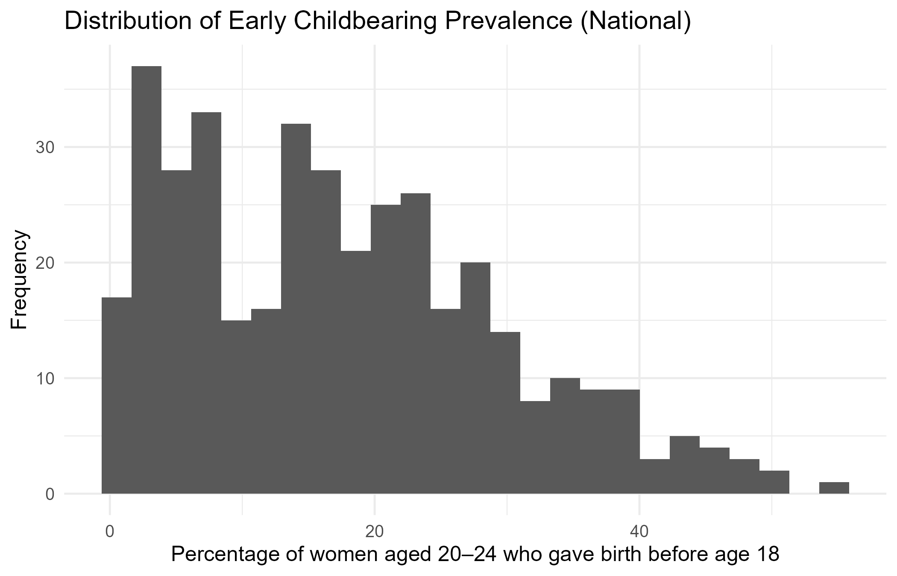Figure 1: Distribution of Early Childbearing Prevalence (National)
Figure 1 shows the distribution of national early childbearing prevalence; it is highly skewed, with most weight at the lower end and a long upper tail. This empirical distribution provides visual justification that early childbearing prevalence is neither normally distributed nor symmetric, thereby supporting the inadequacy of Gaussian assumptions in many previous analyses. The tendency for more observations to be concentrated at lower prevalence levels, together with extremely high-prevalence cases, highlights the coexistence of global development and vulnerable groups.
The originality of the research lies in translating this descriptive observation into a suitable modelling approach, namely beta regression, given the observed data type. Definitely, by making model choice a matter of empirical distributional features, the study enhances the plausibility of the latter conclusion. On the policy front, the distribution in Figure 1 suggests that global averages can still be improved. However, the high-burden countries are at risk of being ignored, which explains the topicality of SDG 10 (Reduced Inequalities).
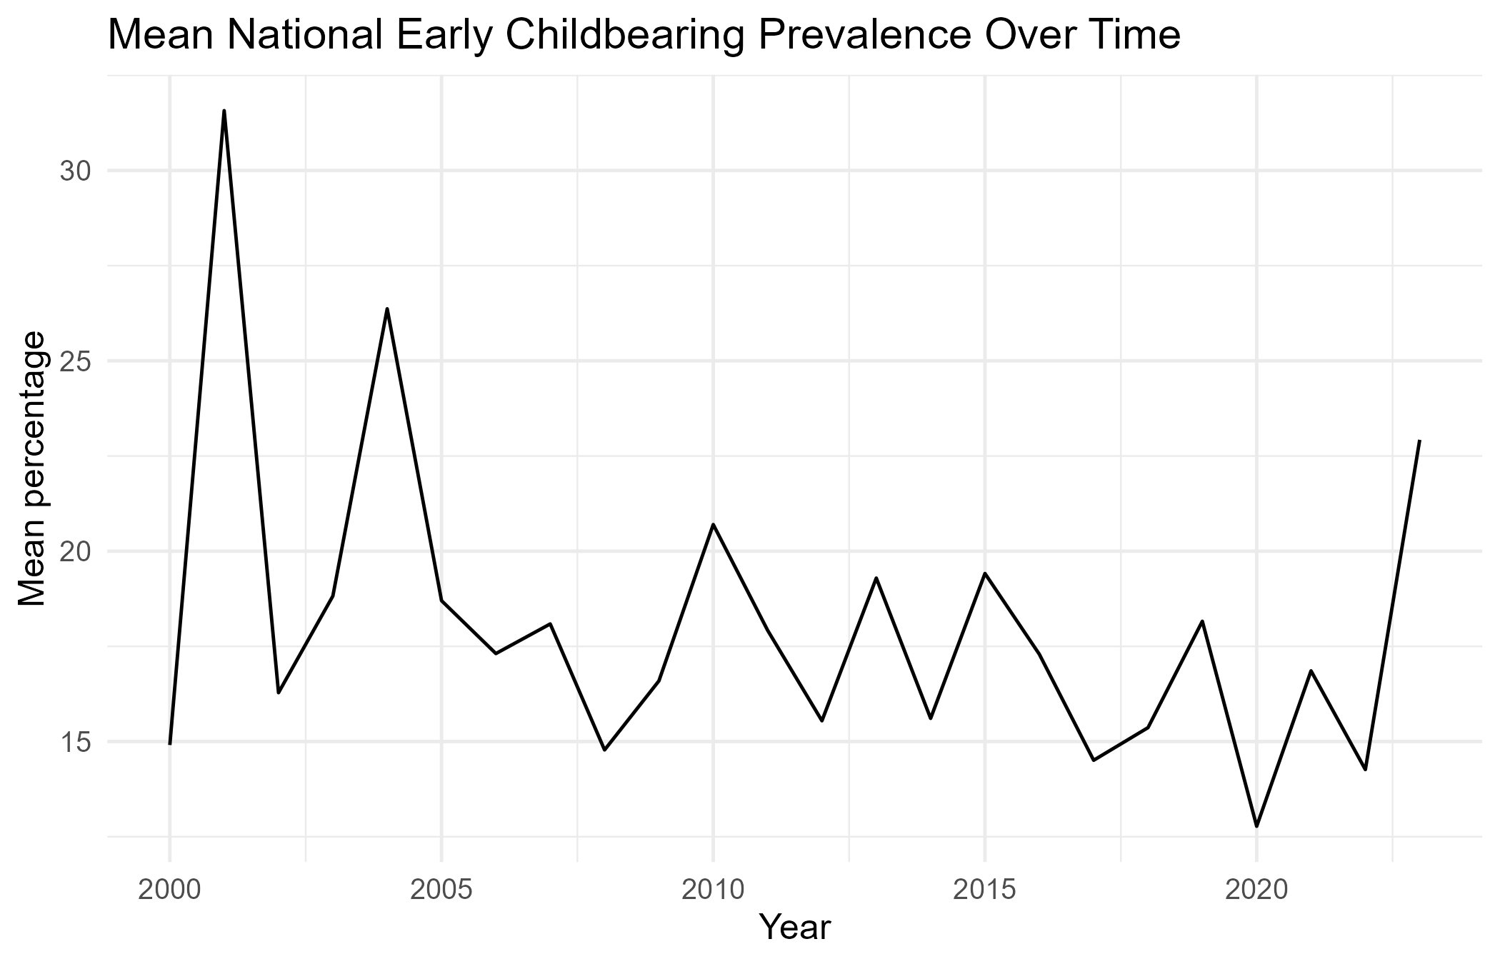Figure 2. Trends in mean national prevalence of early childbearing
The change in early childbearing prevalence in the mean countries over time, depicted in Figure 2, shows an overall decline, punctuated by periods of stagnation. This is in agreement with earlier estimates for the world, characterised by differential rates of decline in teenage fertility (Grulich et al., 2025; Maugeri et al., 2025). The noted variation, however, points to the shortcomings of the linear trend interpretations that propose consistent decreases over time.
The current research contributes to the existing literature by introducing these time patterns into a hierarchical beta regression model that distinguishes actual time change from survey design- and sampling-variability-induced randomness. The figure, therefore, supplements the regression results by providing visual confirmation of the significance of modelling instability rather than smoothing it out. Policy implications are also directly linked to SDG 3 and SDG 5, since periods of stagnation might indicate interruptions in the provision of health services, education systems, or social protection, which should be addressed promptly.
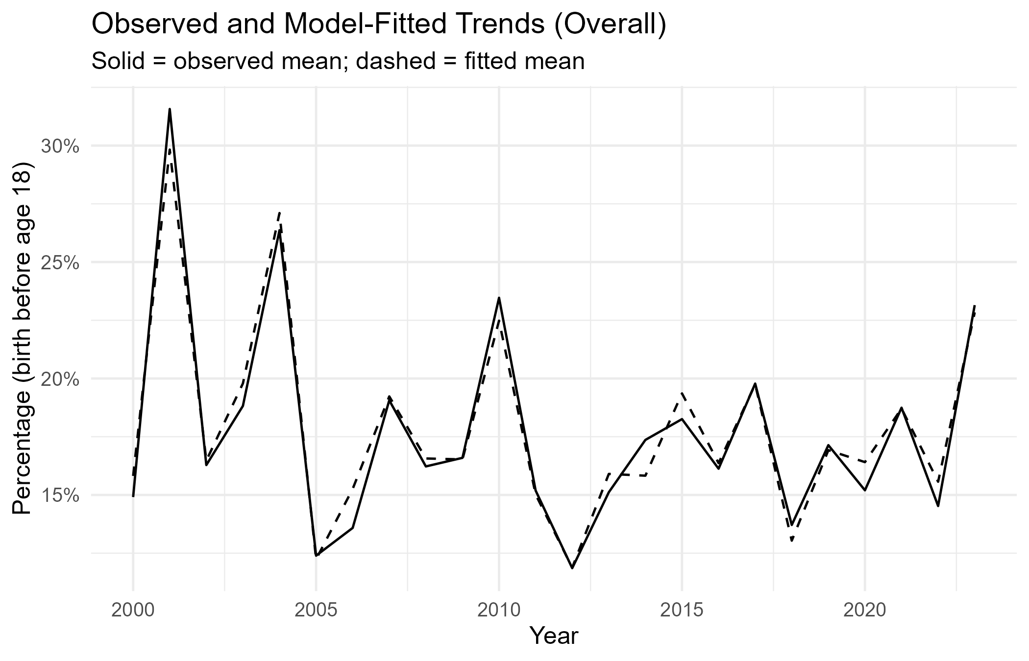Solid= observed mean; dashed=fitted mean
Figure 3: observe and model fitted Trends (overall)
Figure 3 compares observed mean early childbearing prevalence with model-fitted estimates, showing that the empirical trends and fitted values are highly consistent. This concordance provides visual confirmation that the model can extract underlying patterns without overfitting. The very slight discrepancy between the actual and fitted curves for certain periods reflects the ability to remove short-run fluctuations but preserve long-run patterns. The relevance of this number lies in its being another methodological achievement of the article, in that the multilevel design, combined with the respective models for the distribution, enables stable, interpretable trends.
In contrast to descriptive smoothing-only methods, the fitted values presented in Figure 3 are based on a theoretically sound statistical structure. They would be more useful for prognostication and monitoring. This is directly applicable to SDG monitoring systems that need practical trend estimation to be accountable.
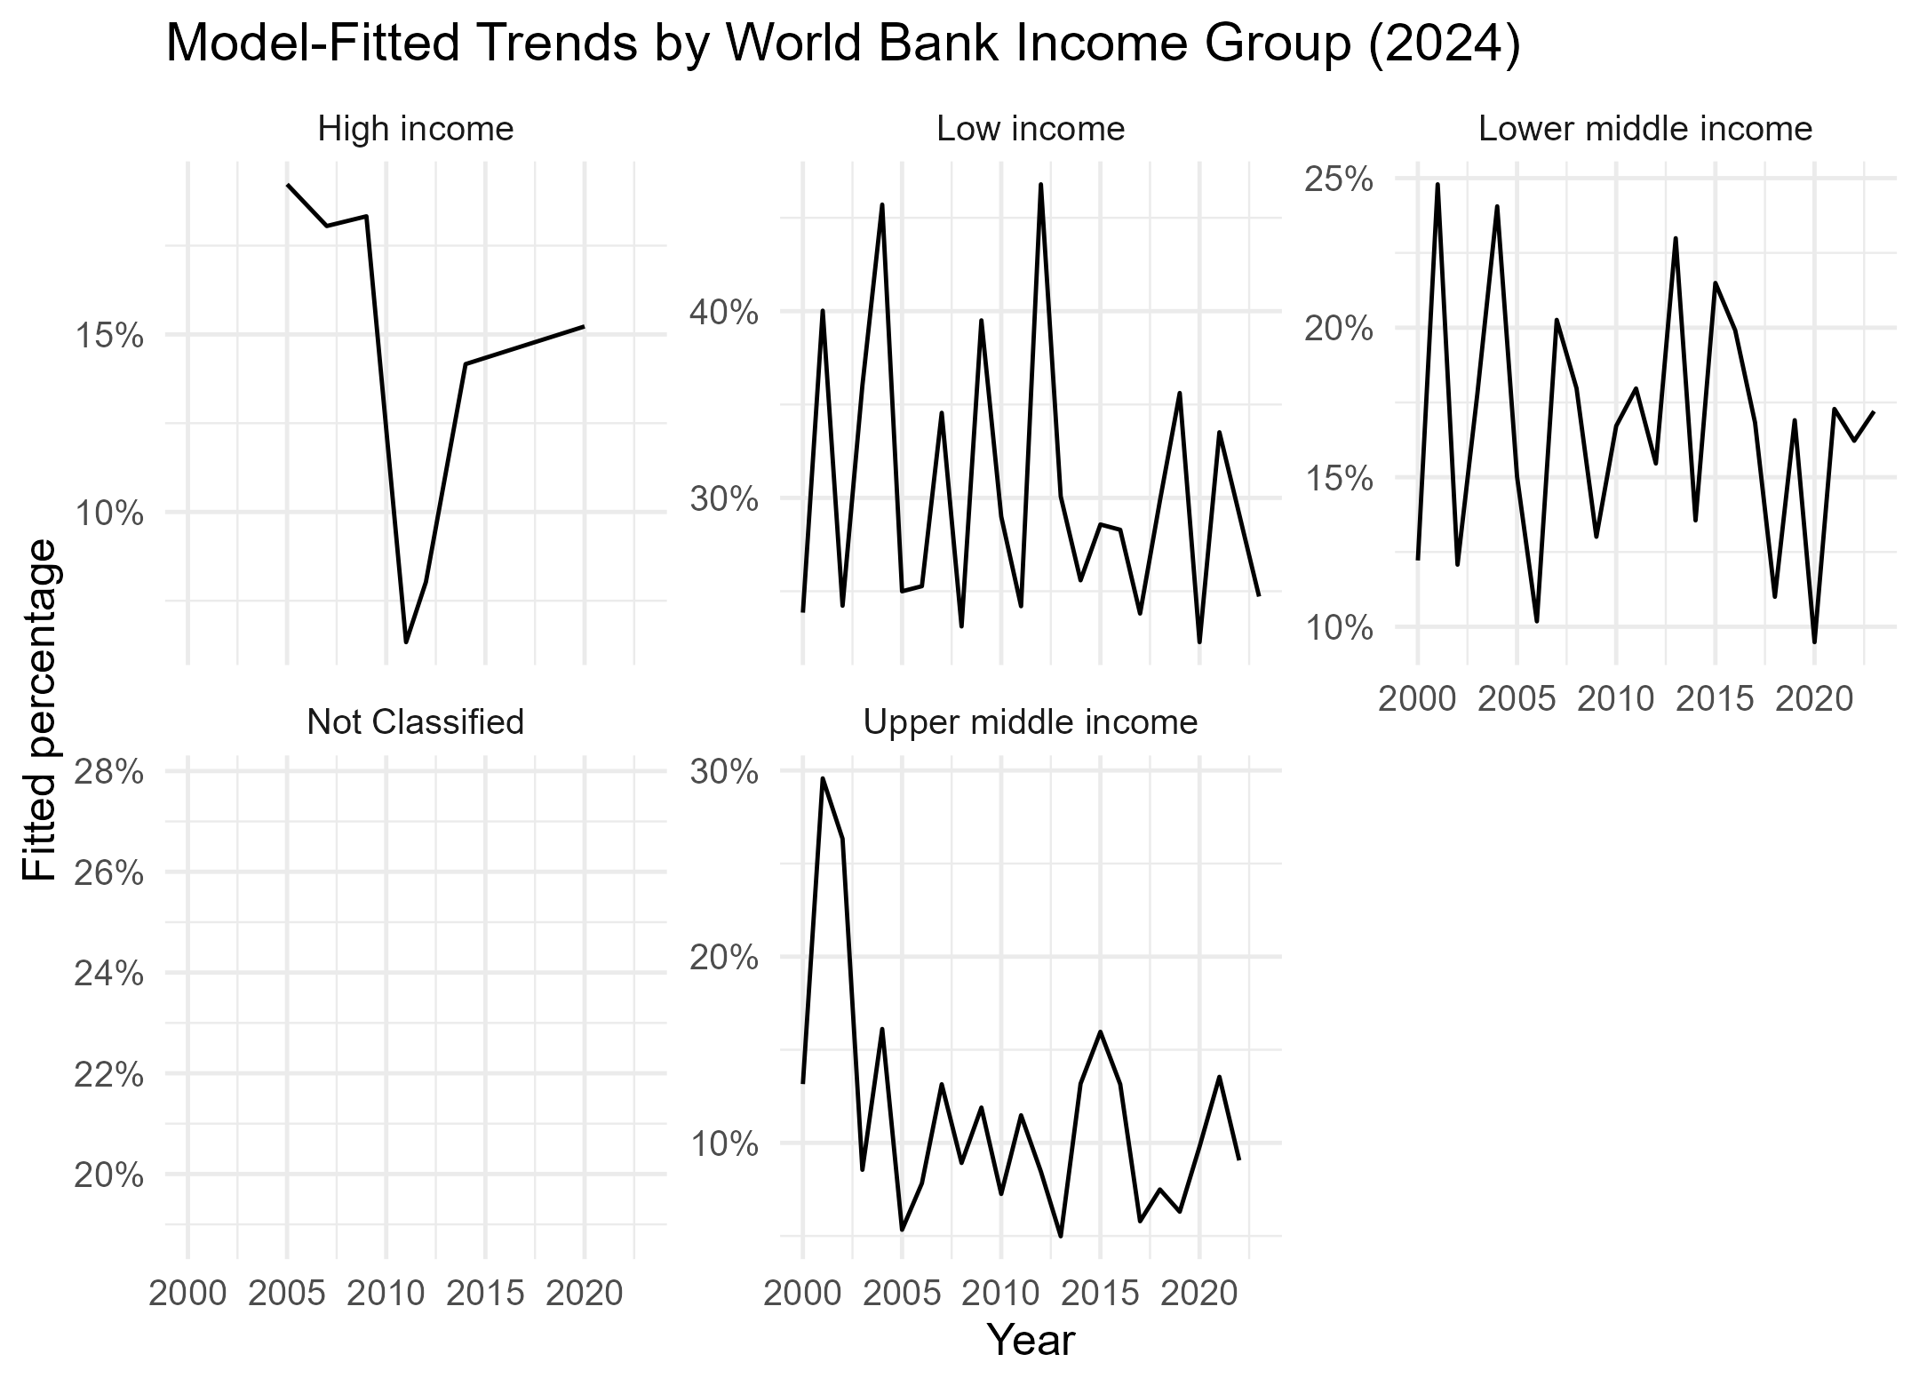
Figure 4: Model-Fitted Trends in the World Bank Income Group (2024)
Figure 4 decomposes trends that have been model-fitted by World Bank income group, showing sharp and enduring differences in early childbearing trajectories. The level of fitted prevalence and prevalence volatility are always higher in low-income countries than in high-income countries, and the prevalence pattern is lower and more consistent. Middle-income populations are in a transitional state, with mixed evidence of convergence and ongoing diversity.
The original aspect of this analysis is highlighted by describing income-specific dynamic pathways calculated using a single multilevel beta model rather than separate subgroup regressions or descriptive plots. This strategy enables one to compare the dynamics of time across income groups directly and to account for common variance and uncertainty. The acute deviation in Figure 4 justifies the call for varying policy actions in line with limited national capacity and resources, in direct tandem with SDG 1 (No Poverty), SDG 3, and SDG 5. It further emphasises the need to make a long-term investment in teenage reproductive health in low-income areas to avoid increasing inequities in the world.
When combined, the tenets of Tables 1-3 and Figures 1-4 show that the research contributes to the literature on early childhood bearers at both the substantive and methodological levels. Through a multilevel beta regression model, the analysis overcomes traditional constraints associated with outcome boundedness, hierarchical data structure and inequality modelling. The results indicate a subtle downward trend, in addition to the stable, structural inequalities presented, which provide a more viable foundation for designing and evaluating policy. This way, the study will provide a new analytical template for future cross-national reproductive health studies based on harmonised survey data.
This study presents a rigorously methodological evaluation of early childbearing using harmonised cross-national survey data and a multilevel beta regression model that explicitly accounts for the limited and hierarchical nature of the outcome. The original and most significant result is a statistically significant, prolonged decline in the prevalence of early childbearing over time. The temporal effect is also harmful and strong, even after controlling for income group, residence, and wealth level, indicating that the global trend toward lower adolescent fertility is not solely due to changes in composition across countries and survey sources. The result supports previous descriptive literature on declining adolescent fertility and extends it by showing that the decline persists under a distributionally suitable, inequality-sensitive modelling approach.
The second important finding is that strong socioeconomic gradients of births persisted. Low-income countries have considerably better-off reference groups with much lower rates of early childbearing, demonstrating the long-lasting influence of structural economic factors on the development of adolescent reproductive outcomes. Even though some middle-income groups show attenuated effects, the overall income gradient remains clear, indicating incomplete convergence in development levels. Importantly, these gaps persist when focusing on within-country inequalities, indicating that emphasising economic development alone is not enough to reduce the risk of early childbearing.
The third significant result concerns within-country inequality patterns. Low wealth and rural residence are consistently associated with high rates of early childbearing, whereas urban residence and high-wealth quintiles exhibit strong protective effects. These effects, and especially their effects on the poorest and the richest groups, demonstrate that household-level socioeconomic position has an effect at least as significant as national income classification. The simultaneous modelling of residence and wealth levels within a multilevel framework provides new evidence that early childbearing is conditioned by the interaction of inequalities at both macro and micro levels.
A fourth significant conclusion is the presence of unobserved heterogeneity across regions and countries. The amount of variance in the random effects at the regional and country levels is a strong indicator that aspects of context, not captured by covariates, influence early childbearing. This study seeks to reveal what is not accounted for in models using both pooled and fixed effects. These models reduce variance by treating unestimated variance rather than accounting for it within their respective contexts. The additional calculation of variance components at the country and regional levels is an improvement in research methodology, as it provides more insight into localisation and irregular trends in early childbearing. Lastly, the model fit and the closeness between the data trends and the model fit indicate that the multilevel beta regression model is far better at describing early child delivery than the traditionally used linear or binary models. In addition, estimates yield ideal results in trend analysis and policy-related inequality analyses due to the bounding nature of dependent variables and the clustering phenomenon.

Conclusion
The empirical investigation is a significant contribution to the empirical research on early childbearing by utilising harmonised international survey data and a multilevel beta regression framework that directly addresses the significant statistical shortcomings of the current body of research. The results affirm that early childbearing has decreased over the years, but it is highly stratified by national income, place of residence, and household wealth. These chronic disparities suggest that development in the world has not been even or that a large group of the population still has a high risk of preterm birth.
From the methodological perspective, this study finds that treating early childbearing as a constrained proportion in a hierarchical model is more likely to produce valid inferences than the conventional method. This is because this method is more extensive in its analysis, focusing on data trends and contextual heterogeneity. Additionally, this method accounts for data gradients. This method provides a template that can be repeated in future cross-national studies of reproductive health and other proportion-based outcome measures, based on complex survey data.
Implications of the policy are evident. Declines in the number of premature births in line with the internationally agreed development agendas will necessitate special, equity-based interventions with emphasis on rural communities and disadvantaged households in terms of socioeconomics, especially those in low-income environments. Investing in the education of girl children, providing reproductive health services, and protecting one’s social life in programs are the areas that need emphasis in implementing sustainable developments. In addition, the high heterogeneity observed across regions and countries in this study further emphasises that each country warrants a custom-made solution.
In conclusion, this study defines the divide between rigour and relevance in methodology and policy, thereby making a practical contribution to the movement towards achieving objectives in health, education, and gender equity. From its findings, it indicates the importance of avoiding country means by using inequality-focused models at the level to guarantee that collective advances in ARH are sustained and overarching.
Declarations
Funding declaration in the manuscript
The authors declare that there is no funding for this research.
Data availability
The data evaluated in this paper were obtained from an online repository at https://github.com/your-repository-link/birth-before-18-analysis
Ethical statement
This study used publicly available, anonymised secondary data and therefore did not require ethical approval
Declaration of competing interest
The authors declare that they have no known competing financial interests or personal relationships that could have influenced the work reported in this paper.
Authors Contributions
F.A-M.: Conceptualisation, Validation, Methodology, Formal Analysis, Writing- Original Draft, Software, Writing - Review & Editing.
F.E.B.: Visualisation, Writing - Review & Editing, Investigation, Methodology. Data Collection, Data Curation,
H.B.: Validation, Writing - Review & Editing, Visualisation, Investigation
E.A.A.: Visualisation, Validation, Writing - Review & Editing, Investigation.
L. A.: Writing - Review & Editing, Investigation.

Disclaimer (Artificial intelligence)
Author(s) hereby declare that NO generative AI technologies such as Large Language Models (ChatGPT, COPILOT, etc.) and text-to-image generators have been used during the writing or editing of this manuscript.
References
- Alkire, S., & Robson, M. (2022). On international household survey data availability for assessing pre-pandemic monetary and multidimensional poverty in developing countries. Development Studies Research, 9(1), 277-295.
- Amouzou, A., Barros, A. J., Requejo, J., Faye, C., Akseer, N., Bendavid, E., ... & Boerma, T. (2025). The 2025 report of the Lancet Countdown to 2030 for women's, children's, and adolescents' health: tracking progress on health and nutrition. The Lancet, 405(10488), 1505-1554.
- Araya, B. M., Aldersey, H. M., Camara, S., Alemu, K., Dyer, S., & Velez, M. P. (2024). The varying estimation of infertility in Ethiopia: the need for a comprehensive definition. BMC Women's Health, 24(1), 280.
- Ayiah-Mensah, Francis, Emmanuel Mensah Baah, Emmanuel Harris, and Samuel Kwame Okai. 2025. “Machine-Learning Implications on Global Antenatal Care Improvement and Equity Disparities: The Wealth Effect, Regional Dynamics and Model-Based”. Asian Journal of Pregnancy and Childbirth 8 (1):527-42. https://doi.org/10.9734/ajpcb/2025/v8i1187.
- Båge, K., Kågesten, A., Uthman, O., Salazar, M., Puranen, B., Svallfors, S., ... & Litorp, H. (2024). Attitudes toward sexual and reproductive health and rights and their associations with reproductive agency: a population-based cross-sectional study in Ethiopia, Kenya, and Zimbabwe. Sexual and Reproductive Health Matters, 32(1), 2444725.
- Bari, K., Sadik, F., & Faraz, N. (2025). Child Marriage and Its Effect on Maternal and Child Health in Pakistan. In Research and Reflections on Child Wellbeing in Pakistan (pp. 93-116). Cham: Springer Nature Switzerland.
- Bhushan, H., Ram, U., Scott, K., Blanchard, A. K., Kumar, P., Agarwal, R., ... & Ramesh, B. M. (2024). Making the health system work for over 25 million births annually: drivers of the notable decline in maternal and newborn mortality in India. BMJ Global Health, 9(Suppl 2), e011411.
- Bornstein, M. H., & Rothenberg, W. A. (2022). The UNICEF Multiple Indicator Cluster Surveys and early childhood development index: Parenting, national development, and early childhood development in 51 low-and middle-income countries. In Parenting and child development in low-and middle-income countries (pp. 240-275). Routledge.
- Brunner, K., Linder, T., Klaritsch, P., Tura, A., Windsperger, K., & Göbl, C. (2025). The Impact of Overweight and Obesity on Pregnancy: A Narrative Review of Physiological Consequences, Risks and Challenges in Prenatal Care, and Early Intervention Strategies. Current Diabetes Reports, 25(1), 30.
- Chandel, A., Yadav, M., & Hung, T. H. (2025). Social and Economic Consequences of Early Marriage on Women's Education and Workforce Participation. In Social, Political, and Health Implications of Early Marriage (pp. 261-290). IGI Global Scientific Publishing.
- Chang, A. Y., Bolongaita, S., Cao, B., Castro, M. C., Karlsson, O., Mao, W., ... & Jamison, D. T. (2025). Epidemiological and demographic trends and projections in global health from 1970 to 2050: a descriptive analysis from the third Lancet Commission on Investing in Health, Global Health 2050. The Lancet, 406(10506), 940-949.
- Endalamew, S. G., Arage, F. G., Taddese, A. A., Asgedom, D. K., Terefe, B., & Assefa, S. K. (2025). Time to first antenatal care contact and pooled prevalence among reproductive-age women in East Africa: Log-logistic shared frailty model. PLoS One, 20(6), e0325002.
- Garbett, A., Neal, S., Luna Hernandez, A., & Tzavidis, N. (2025). Reframing the relationship between fertility and education in adolescence: 60 Years of evidence from Latin America. Population and Development Review.
- Grulich, A. E., Mercer, C. H., Sturrock, B., Baral, S., Turpin, N., Phanuphak, N., ... & Mayer, K. H. (2025). Partial progress in sexual and reproductive health and rights: the influence of sociocultural, behavioural, structural, and technological changes on epidemiological trends. The Lancet, 406(10515), 2100-2118.
- Hossain, M. (2023). Large-scale data gathering: Exploring World Bank’s influence on national learning assessments in LMICs. International Journal of Educational Development, 102, 102877.
- Hu, J., Peng, C., Hu, Y., Wang, Y., Yan, H., Li, J., ... & Yuan, S. (2024). Accessibility evaluation and multi-scenario optimization of medical services in underdeveloped city driven by multi-source data and latest policies for China. Scientific Reports, 14(1), 25707.
- Huang, D., Lai, H., Shi, X., Jiang, J., Zhu, Z., Peng, J., ... & Chen, J. (2024). Global temporal trends and projections of acute hepatitis E incidence among women of childbearing age: age-period-cohort analysis 2021. Journal of Infection, 89(4), 106250.
- Karmous, N., Oualha, O., Drira, A., Masmoudi, A., Bouguerra, B., & Karmous, A. (2025). Factors Associated with Breastfeeding Duration in Tunisia: A Cross-Sectional Analysis Highlighting the Role of Early Initiation. F1000Research, 14, 881. https://doi.org/10.12688/f1000research.169267.2
- Li, L., Wang, J., Wang, X., Peng, P., Shen, J., Zhu, H., & Zhang, Z. (2025). Big data and data science in global governance: anticipating future needs and applications in the UN and beyond. Frontiers in Political Science, 7, 1583772.
- Li, Y., Li, Q., Zhang, L., Li, Y., & Yuan, S. (2025). Development of a Risk Assessment Index System of Non-Specific Neck-Shoulder Pain in Physicians and Nurses: A Delphi and Analytic Hierarchy Process Study in China. Pain Management Nursing.
- Liang, Y., Huang, J., Zhao, Q., Mo, H., Su, Z., Feng, S., ... & Ruan, X. (2025). Global, regional, and national prevalence and trends of infertility among individuals of reproductive age (15–49 years) from 1990 to 2021, with projections to 2040. Human Reproduction, 40(3), 529-544.
- Mataraso, S. J., Espinosa, C. A., Seong, D., Reincke, S. M., Berson, E., Reiss, J. D., ... & Aghaeepour, N. (2025). A machine learning approach to leveraging electronic health records for enhanced omics analysis. Nature Machine Intelligence, 7(2), 293-306.
- Matovu, J. K., Bwanika, J. B., Murungi, I., Kyambadde, J. K., Matsha-Carpentier, N., Zamani, S., & Wanyenze, R. K. (2025). Impact of layered behavioral, socio-economic and school-based interventions on selected behavioral and biomarker indicators among adolescent girls and young women in Uganda. PLOS Global Public Health, 5(6), e0004819.
- Maugeri, A., Barchitta, M., Schillaci, G., & Agodi, A. (2025). Spatial patterns and temporal trends in stillbirth, neonatal, and infant mortality: an exploration of country-level data from 2000 to 2021. Journal of Global Health, 15, 04034.
- Morooka, H., Haug, E. B., Malmo, V., Loennechen, J. P., Mukamal, K. J., Sen, A., ... & Horn, J. (2024). Parity, infertility, age at first birth, and risk of atrial fibrillation: data from the HUNT study. European Journal of Preventive Cardiology, 31(13), 1645-1652.
- Ohuma, E. O., Moller, A. B., Bradley, E., Chakwera, S., Hussain-Alkhateeb, L., Lewin, A., ... & Moran, A. C. (2023). National, regional, and global estimates of preterm birth in 2020, with trends from 2010: a systematic analysis. The Lancet, 402(10409), 1261-1271.
- Padhani, Z. A., Rahim, K. A., Tessema, G. A., Avery, J. C., Damabi, N. M., Castleton, P., ... & Lassi, Z. S. (2024). Exploring preconception health in adolescents and young adults: Identifying risk factors and interventions to prevent adverse maternal, perinatal, and child health outcomes–A scoping review. Plos one, 19(4), e0300177.
- Phiri, M., Kasonde, M. E., Moyo, N., Sikaluzwe, M., & Simona, S. (2023). A multilevel analysis of trends and predictors associated with teenage pregnancy in Zambia (2001–2018). Reproductive Health, 20(1), 16.
- Rammohan, A., Chu, H., Awofeso, N., & Goli, S. (2025). Adolescent pregnancy, maternal and child anaemia: Empirical analysis from India, Bangladesh, and Nigeria. Maternal & Child Nutrition, 21(1), e13723.
- Rossouw, L., Watt, K. G., Timol, F., Davidson, L. L., & Desmond, C. (2025). Early transition markers, opportunities, and limitations that define pathways into the labour market from adolescence to adulthood in South Africa. Development Policy Review, 43(2), e12829.
- Scharlin-Pettee, S., Admasu, Y., & Alkire, S. (2024). Multidimensional poverty, gender, and forced displacement: A multi-country, intrahousehold analysis in Sub-Saharan Africa. The Journal of Development Studies, 60(12), 1852-1878.
- Shibeshi, A. H., Habtie, G. M., Arega, G. G., Hussen, N. M., Hamed, K. E., & Tareke, S. A. (2025). A multilevel analysis of receipt of adequate antenatal care and its determinants among pregnant women in 11 sub-Saharan African countries: insights from recent demographic and health surveys. Clinical Epidemiology and Global Health, 102185.
- Singh, M., Shekhar, C., & Gupta, J. (2024). Distribution and determinants of early marriage and motherhood: a multilevel and geospatial analysis of 707 districts in India. BMC public health, 24(1), 2844.
- Spoorenberg, T., Carlsen, E. Ø., Flatø, M., Stonawski, M., & Skirbekk, V. (2024). The Global Adolescent Fertility Decline is Counteracted by Increasing Teen Births in Sub‐Saharan Africa. Studies in Family Planning, 55(3), 229-245.
- Sun, P., Yu, C., Yin, L., Chen, Y., Sun, Z., Zhang, T., ... & Wan, Z. (2024). Global, regional, and national burden of female cancers in women of child-bearing age, 1990–2021: analysis of data from the global burden of disease study 2021. EClinicalMedicine, 74.
- Terefe, B., Bikale Kebede, F., Nigussie Abrha, N., Fentaw Shiferaw, Y., Kahsay Asgedom, D., Keflie Assefa, S., & Tezera Assimamaw, N. (2025). Multilevel modelling of determinants of perinatal mortality in East Africa: a pooled analysis of National health survey data. BMC Public Health, 25(1), 2003.
- Tohan, M. M., Saha, B. R., Moon, M. I., Howlader, M. H., & Rahman, M. A. (2025). Predictors of anxiety among women of reproductive age in Nepal: a comprehensive nationwide analysis. Social Psychiatry and Psychiatric Epidemiology, 60(2), 475-486.
- Toss, A., Piombino, C., Quarello, P., Trama, A., Mascarin, M., Lambertini, M., ... & Ferrari, A. (2024). Risk factors behind the increase of early-onset cancer in Italian adolescents and young adults: An investigation from the Italian AYA Working group. European Journal of Cancer, 212, 115042.
- Vettriselvan, R., Deepan, A., Jaiswani, G., Balakrishnan, A., & Sakthivel, R. (2025). Health Consequences of Early Marriage: Examining Morbidity and Long-Term Wellbeing. In Social, Political, and Health Implications of Early Marriage (pp. 189-212). IGI Global Scientific Publishing.
- Wu, Q., Song, X., Zhang, J., Ma, Y., Zheng, C., Wang, T., & Yang, G. (2025). Winter Wheat-Yield Estimation in the Huang-Huai-Hai Region Based on KNN-Ward Phenological Zoning and Multi-Source Data. Remote Sensing, 17(22), 3686.
- Xie, Y., Guo, J., & Ma, X. (2025). Digital inclusive financial and household fertility: Discoveries based on dual machine learning algorithm. International Review of Economics & Finance, 97, 103747.

