Effects of Aqueous Leaves Extracts of on Wound Healing for the Demonstration of Epitheliasation and Angiogenesis of Wounded Skin of Wistar Rats

ABSTRACT
The aim of the study was to assess the effects of aqueous leaves extract of individual and polyherbal formulated ointments in wounded skin of wistar rats. Total of 45 healthy wistar rats were divided into 9 groups, with 5 rats in each. Group A negative control, wounded no treatment, group B positive control, wounded and treated with standard drug, group C test wounded treated with aqueous extract of A nilotica only, group D test wounded treated with aqueous leaves extract of A. vera only, group six E test group wounded and treated with aqueous leaves extract of C. procera only, group F test wounded treated with combinations of aqueous leaves extract of A. nilotica and A. vera, group G wounded treated with combinations of aqueous leaf extract of A. nilotica and C. procera, the group H wounded treated with aqueous leaves extract of aloe vera and C. procera and group I test wounded treated with aqueous leaves extract of polyherbal formulation of A. nilotica, A. vera and C. procera. The result of the study showed that extracts of A. nilotica has better physical properties than other extracts with good bioactive compounds, The combination of the three extracts showed better significant histological findings than A. nilotica. There was normal expression of vascular endothelial growth factors gene in group treated with individual A. nilotica extract and in combination of the three extracts. Similar results were also observed in expression of transforming growth factor gene bete-1 and Collagen type 1 alpha 1 gene. The aqueous leaves extract of Acacia nilotica, Aloe vera and Calotropis procera shows very good physical characteristics and presence of secondary metabolites such as Fumaric Acid (FA), Citric Acid (CA), Succinic Acid (SA), and Malic Acid (MA) that possessed wound healing effect. Conclusion the research showed regeneration of epithelia (proliferation of keratinocytes), new blood vessels, collagen fibres and elastic fibres deposition in groups treated with aqueous leaves extract of Acacia nilotica formulated ointments and in combination of the three extracts of the studied sections. The combinations of the three extract ointments possesses potential to cause high expression of the three genes studied.
Keywords: Polyherbal Formulated Ointments, Epitheliasation, Angiogenesis, Wound Healing and Wistar Rats

1.0 Introduction
Wound healing is a complex mechanism that spans over different temporal and spatial scales and aims to restore the architecture, morphology, and functionality of the injured tissue. Starting from the regeneration of residual undamaged cells, the healing cascade will end up in the deposition of new connective tissue that eventually becomes a scar [1]. To accomplish this task, the precise recruitment and coordination of different cell populations are of paramount importance, occurring through mechanical and biochemical regulatory networks during four distinct but overlapping phases [1]. Skin wound healing is a complex and intricate biological process essential for the restoration of tissue integrity and functionality. The ability of the skin to efﬁciently heal wounds is critical for maintaining homeostasis and protecting the body from infections and other external threats. Therefore, understanding the mechanisms underlying this process is of paramount importance, allowing for the development of effective therapeutic strategies to enhance wound healing and the improvement of patient outcomes. [2]. Skin wound healing is an orderly and highly coordinated process aiming to restore skin barrier function [3]. Generally speaking, the healing process consists of four temporally overlapping phases, including hemostasis, inflammation, proliferation, and tissue remodeling [1]. During these stages, a plethora of distinct cell types dynamically interact with each other and function at specific stages, thus mediating the remodeling healing courses. In the hemostasis phase, injured blood vessels constrict, platelets activate to produce fibrin clots, and immune cells are recruited to the wound areas. In the inflammatory phase, neutrophils and macrophages are involved in the inflammatory response to clear bacteria. In the proliferation stage, vascular endothelial cells participate in the formation of new blood vessels, fibroblasts deposit and remodel the extracellular matrix (ECM), and keratinocytes (KCs) proliferate and migrate to close wounds. During the remodeling phase, cells in the granulation tissue undergo apoptosis, and macrophages break down excessive ECM and apoptotic cells [4]. Minor wounds in healthy people generally heal well, however, large areas, age, infection, diabetes, vascular diseases, and many other factors may delay wound healing, resulting in long-term sequelae. Delayed wound healing brings heavy health and economic burden to patients and society [5]. Currently, several treatments, such as wound dressings, tissue engineered substitutes, and skin autografts are available for wound healing [5].
Acacia nilotica (A. nilotica), Del. syn. Acacia arabica (Lam.) Willd. (Mimosaceae) is an imperative multipurpose plant [6]. A. nilotica is a plant 5 to 20 m high with a thick spherical crown, stems and branches usually sinister to black colored, grey-pinkish slash, fissured bark, exuding a reddish low-quality gum. The plant has straight, light, thin, grey spines in axillary pairs, usually in 3 to 12 pairs, 5 to 7.5 cm long in young trees, mature trees commonly without thorns. The leaves are bipinnate, with 3 to 6 pairs of pinnulae and 10 to 30 pairs of leaflets each, rachis with a gland at the bottom of the last pair of pinnulae. Flowers in globulous heads 1.2 to 1.5 cm in diameter of a bright golden-yellow color set up either axillary or whorly on peduncles 2 to 3 cm long located at the end of the branches. Pods are strongly constricted, white-grey, hairy and thick [7]. A. nilotica is a pantropical and subtropical genus with species abundant throughout Asia, Australia, Africa and America. A. nilotica occurs naturally and is imperative in traditional rural and agro-pastoral systems [8]. A. nilotica is recognized by the following names: Acacia, Acacia Arabica, Babhul - Hindi and Napalese, Babla - Bengali, Babool - Unani, Babool Baum - German, Babhoola Sanskrit, Babul, Babul Tree, Huanlong Kyain - Burmese, Kikar, Mughilan - Arabian Indogom Japenese and Ummughiion Persian [9]. A. nilotica is an imperative multipurpose plant that has been used broadly for the treatment of various diseases [10].
Aloe vera (A. vera) is a hardy, perennial, tropical, drought resistant, succulent plant belonging to the Liliaceae family which, historically has been used for a variety of medicinal purposes. Clinical evaluations have revealed that the pharmacological active ingredients are concentrated in both the gel and rind of the A. vera leaves. A. vera is popularly known as Aloe barbadensis by taxonomists. It is being used since 1750 BC by Mesopotamians and Egyptians ([11]. The word “Aloe” derived from the Arabic word “Alloeh” which means shining and bitter substance [11]. The virtues of A. vera have been recorded for thousands of years by many ancient civilizations including Egypt, Persia, Greek, India and Africa. The genus is indigenous to African continent and Mediterranean countries, such as Greece and Southern Italy. It is reported that it grows wild on the islands of Cyprus, Malta, Sicily, Canary Cape, Cape Verde and have spread over arid tracts of India. Out of the 275 species, 42 of them belong to Madagascar region (Africa), 12-15 to Arabian Peninsula and rest are distributed over tropical South Africa. In India, only 4 species (Aloe forbesii, Aloe inermis, Aloe ferox and Aloe barbadensis) are reported to occur and of these Aloe barbadensis is the most widely distributed species. These taxa comprise of several varieties, viz., officinalis, chinensis, litoralis and their cross. The species has a number of synonyms: A. barbadensis Mill., Aloe indica Royle, Aloe perfoliata vera and A. vulgaris Lam., [11]. and common names including Chinese Aloe, Indian Aloe, True Aloe, Barbados Aloe, Burn Aloe, First Aid Plant, Wand of Heaven and Miracle Plant [12]. The species name vera means "true" or "genuine". Some literature identifies the white spotted form of Aloe vera as Aloe vera var. chinensis, [13], however, the species varies widely with regard to leaf spots [14], and it has been suggested that the spotted form of Aloe vera may be similar to A. massawana [14]. The species was introduced to China and various parts of southern Europe in the 17th century [15].
Calotropis procera (C. procera) is a wild-growing plant that belongs to the family Asclepiadaceae, it is a drug of herbal origin, which has been in use for medicinal purpose since time immemorial. Although comparatively toxic, the drug has effectively been employed for the treatment of various ailments commonly found in the tropical regions and is used in the treatment of diseases such as ulcer, inflammation, wound healing, waja-ul-mufasil (arthritis), istisqa (ascites), iltehab (inflammatory conditions), Juzam (leprosy) and zeeq-un-nafs (asthma). This confers to the increased use of medicinal plants as the major source of traditional medicine worldwide [16]. C. procera (Tumfafiya in Hausa) is a plant with a wild-growing ability that has been used for the treatment of a variety of human disease conditions such as wound healing, tumors, inflammation, ulcers and leprosy [17]. The plant is known to release large quantities of milky saps (latex) when its tissues are mechanically damaged. This may be a mechanism of defense of the plant against predators. A number of researches have been conducted on the plant which established it as the major source of drugs used in the modern era [18]. C. procera is among the plants not eaten by grazing animals due to its toxicological characteristic. The latex has been used traditionally in making poisonous arrows. It is toxic to human eyes, producing impaired vision (dimness) as well as photophobia. Plants have been used as characteristic drugs to cure a variety of diseases worldwide. This medicinal action of plants is due to the presence of phytochemicals or bioactive compounds in them [19]. Liver is the major organ that plays an essential role in the metabolism of chemicals through phase one and phase two metabolic reactions. There are four (4) species of this genus, but only C. procera and Calotropis gigantea are well recognized for their medicinal properties [20]. C. procera is drought resistant medicinal perennial shrub mostly found in arid to semi-arid areas. It is a major source of secondary metabolites including phenols, flavonoids, terpenoids, sugars, alkaloids, tannins cardenolides, glycoside, saponins and steroids. It has medicinal properties as hepatoprotective, antioxidant, inflammatory, antimicrobial and antimalarial. It is vigorously used for the ailment of common diseases i.e., fever, leprosy, eczema, diarrhoea, dysentery and jaundice [21].

1.1 MATERIALS AND METHODS

1.2 STUDY LOCATION
The study was carried out in collaboration with Laboratory of Histopathology Department, School of Medical Laboratory Sciences, where tissue processing and staining procedures were carried out, Animal House and Department of Pharmacognosy of Faculty of Pharmaceutical Sciences, Usmanu Danfodiyo University, Sokoto where Animals were procured, surgical wound intervention and phytochemical analysis were carried out.
1.3 ETHICAL APPROVAL
All the procedures of this research were performed according to the Guideline for the Care and Use of Laboratory Animals. Protocols approval of the research was formally obtained from the Ethics and Research Committee on the use of Laboratory Animals for research of the Usmanu Danfodiyo University, Sokoto. The ethical approval registration Number was given as NHREC/UDU-HREC/25/06/2023
1.4 PLANTS COLLECTION AND DRYING OF THE LEAVES
The fresh leaves materials of A. nilotica, A. vera and C. procera were collected at the Herbarium Garden of Botany Department, Faculty of Biological Sciences, Usmanu Danfodiyo University Sokoto. All fresh individual leaves of plants were allowed to dried under the shade in Histopathology Laboratory to avoid destruction of suspected active ingredients by the sunlight.
1.5 PLANTS IDENTIFICATION AND AUTHENTIFICATION
The leaves of each individual plant of A. nilotica, A. vera and C. procera were identified and authenticated by the Department of Pharmacognosy, Faculty of Pharmaceutical Sciences, where specimen voucher number was assigned to each individual plant leaves as follows; A. nilotica: PCG/UDUS/faba/0006 C. procera: PCG/UDUS/apoc/0003 and A. vera: PCG/UDUS/asph/0001 and deposited in the same Department.

1.6 PLANTS PREPARATION AND EXTRACTION PROCEDURES
The fresh leaves of each individual plant of A. nilotica, A. vera and C. procera were washed with clean water and dried under shade. The dried leaf of each individual plant was grinded into fine powder by using a grinder. The crude powdered of each individual leaf was measured about 1000 g and soaked into 3000 mL of distilled water and allowed to stay for 3 days accompanied by continuous shaking of each individual mixture every day. The suspension each individual leaf was extracted by using the cold extraction method according to Rahee & Malik [22]. The suspension each individual leaf was filtered after 3 days by using fine clothes and then filtrates were refiltered using paper through filter funnel, the filtrates of each individual leaf was place on water bath for water to evaporate in order to obtain the pure extract of each individual plants to be use in the treatment of surgically wounded skin of wistar rats as done by Wei et al. [23].
1.7 PREPARATION OF EXTRACTS OINTMENTS AND APPLICATION ON THE WOUNDED SITE
White soft paraffin wax of 95 grams was weighed and melted in a water bath and 5 gram of each individual aqueous leaves extract was weighed and added to the melted white soft paraffin wax to serve as 5 % aqueous extract ointments to be used for the treatment of each individual test groups. Similar measurements were made of 0.25 gram of each 2 individual aqueous extract and combined to make it 5 grams then added to 95 grams of white soft paraffin wax to serve as 5 % aqueous extract ointments. Also 1.7 g of each 3 individual aqueous extract was weighed and combined to make it 5 grams then added to 95 g of white soft paraffin wax to serve as 5 % aqueous extract ointments to be used for treatment of polyherbal formulated ointments group. Each individual aqueous leaves extract ointments and polyherbal formulated ointments of A. nilotica, A. vera and C. procera were applied topically every day on the surgical wounded surface and the wound was covered using sterile gauze. The 5 % Betadine ointment was used for the treatment of the standard group alongside with test groups, to serve as positive control.
1.8 SEMI-QUANTITATIVE OF PHYTOCHEMICAL ANALYSIS OF THE PLANT EXTRACTS
The aqueous extracts powder of each individual leaves was subjected to Gas-Chromatography and Mass-Spectrometric Analysis (GC-MS Analysis) to determine the quantitative of bioactive components analysis was carried out at General Research Chemistry Laboratory of Ahmadu Bello University, Zaria, Nigeria.
1.9 PURCHASE AND CARE OF EXPERIMENTAL ANIMALS
The healthy wistar rats (animals) were purchased from Animal House of Ahmadu Bello University, Zaria. The animals were transported to Sokoto and allowed to acclimatize for the period of 14 days at room conditions and fed with standard pellet diet (sterile food) and water ad libitum. World Health Organisation (WHO), guidelines for animal handling and care were strictly followed in this study. The animals were housed in a cage containing sterile saw dust (procured locally) as bedding throughout the experimental period. The animals were examined and investigated by physical examination and tests backing were done to declare the rat free of any skin parasites or infections before the experiment began. The sterile saw dust in the cages was changed every day to maintain aseptic conditions.

Table 1: Experimental Research Design
Experimental Groups (5 rats) | Treatment Given | Route/Duration /day
A. Negative control | Clean with normal saline | Topically/21
B. Positive control | Betadine ointment (5 %) | Topically/21
C. A. nilotica | Extract of A. nilotica (5 %) | Topically/21
D. A. vera | Extract of A. vera (5 %) | Topically/21
E. C. procera | Extract of C. procera (5 %) | Topically/21
F. A. nilotica and A. vera | Extract of A. nilotica and A. vera (2.5 % each) | Topically/21
G. A. nilotica and C. procera | Extract of A. nilotica and C. procera (2. 5 % each) | Topically/21
H. A. vera and C. procera | Extract of A. vera C. procera and (2.5 % each) | Topically/21
I. A. nilotica, A. vera and C. procera | Extract of A. nilotica, A. vera and C. procera (1.7 % each) | Topically/21

1.11 SHAVING OF FUR AND ACUTE DERMAL TOXICITY STUDY

The fur (hairs) on the dorsal part (back) where the surgical wound was created of each animal was disinfected then shaved using a sterile surgical blade and the surface was decontaminated by wiping with sterile disinfectant spirit. The animals were anaesthetized using chloroform vapour as done by Morton and Malone [24]. The prepared herbal ointments of 5 % formulations of each individual aqueous leaves extract were immediately applied on the shaved skin of wistar rats and left for an hour to be observed for any signs of irritation and abnormal change in colour of the skins, before the application of the extract to the surgically wounded sites. This is to ascertain the safety of the extract on the skin of the experimental animals, as done by Ravishankar and Satya-Sireesh, [25].

1.12 CREATION OF EXCISIONAL SURGICAL WOUNDS ON BACK OF ANIMALS
The Injection ketamine 0.5 ml/kgbwt was administered intra-muscularly to each rat, to calm the animals and the surgical wound was inflicted by excising the skin flap in an aseptic fashion using sterile surgical knife, scissors and forceps where 2 cm x 2 cm diameter in length of full thickness wound was made on the shaved dorsal area of each rat. All the animals’ tail were labeled with different colors using permanent marker according to group and kept in separate groups of five rats per cage. The intervention was commenced with formulated ointments were topically applied daily; the wounded areas were left open. The treatments continued for twenty-one days, then followed by animals sacrificed on the 21 days as done by Ravishankar & Satya-Sireesh [25].
1.12 ANIMAL SACRIFICE AND SAMPLES COLLECTION
At the end of twenty-one (21) days of the treatment period, the animals were sacrificed by intra-muscular injection of ketamine 0.5 ml/kgbwt, the skin at the wounded site was carefully excised with the aid of surgical blade and dissecting forcep. The skin at the surgically wounded site was carefully excised with the aid of surgical blade, scissor and dissecting forcep. It washes with normal saline and fix immediately in 10% formol saline and were subjected to Haematoxylin and Eosin (H&E),
1.13 LABORATORY ANALYSIS
- Histopathological Analysis
Histopathological examination of skin sections of the surgically wounded sites was subjected to H and E staining for demonstration of angiogenesis and epitheliasation by the sue of staining procedure as stated by Avwioro [26].
- Tissue Processing by Automatic Tissue Processor Machine
The skin from margin of surgically wounded rat was brought out of fixative and examine macroscopically on cutting bench representative part of it was cut and place in a pre-labeled cassette. The tissues were dehydrated, cleared and impregnated using automatic tissue processor (Leica TPO1020 model), after which they were embedded using embedding center (Leica EG1160 model). The sections of the skin were embedded in tissue blocks and then cut at 3µm using rotary microtome (Leica RM2125RT), then floated out on labeled glass slides. The cut sections were allowed to dry on hot plate for 15 minutes and stained in Haematoxylin and Eosin stains. Stained sections were examined microscopically using X10 and X40 objectives lenses. Photomicrograph of the skin tissue sections were taken with AmScope Camera and presented alongside with control sections [27].
B. Hematoxylin and Eosin Staining Technique
The Sections were dewaxed in 2 changes for xylene 10 minutes in each change of xylene, the hydrated in descending grades of alcohol (absolute, 90%, 70%) for 2 minutes each. The sections were then washed with water briefly, then followed by staining with Mayer’s Haematoxylin and allowed to stay for 10 minutes. The sections were rinsed in tap water for 1 minute, then differentiated in 1% acid alcohol for 3 seconds, then rinsed in water for 1 minute. The sections were counter stained with 1% eosin stain and allowed to stay for 2 minutes, then rinsed in tap water for 1 minute. The sections were dehydrated in ascending grades of alcohol from 70%, to 90% and then to absolutes for 2 minutes each grade. The sections were then finally cleared in xylene and mounted in DPX Mountant [26].
C. Microscopy and Photomicrograph
All the sections of the skin-stained slide tissue photomicrographs were snapped by using a light Microscope (AmScope, USA) and a Digital Camera was employed for photomicrography (AmScope, USA). Sections assessed and scored as shown in the table below. The results were presented semi-quantitative scores alongside with sections of control.

Table 2: Semi-quantitative scoring pattern of histological stained sections
S/No | Parameters and description | Scores
1 | Total new blood vessel formation
 | a. More than 4 new blood vessels | ++++
 | b. 2-4 new blood vessels | +++
 | c. 1-2 new blood vessels | ++
 | d. There are no new blood vessels | +
2 | The degree of epithelialization
 | a. High epithelialization | ++++
 | b. Normal epithelialization | +++
 | c. Low epithelialization | ++
 | d. There is no epithelialization | +

Ignatius et al., [28]

1.14 RESULTS and DISCUSSION

Table 3: Physical characteristics of aqueous leaves extracts of Acacia nilotica, Aloe vera and Calotropis procera
Plants | Colour | Smell | Texture | Percentage (%) Yield
Acacia nilotica | Dark-brown | Sweet | Gummy | 10
Aloe vera | Brown | Sweet | Powder | 15
Calotropis procera | Brown | Sweet | Powder | 20

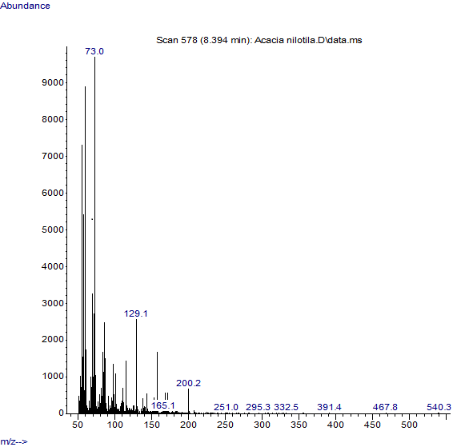
Figure 1a: Gas Chromatography-Mass Spectrometry (GC-MS) analysis of aqueous leaves extract of Acacia nilotica.
A
RT = 8.3948
FG = -COOH

Figure 4.1a: Gas Chromatography-Mass Spectrometry (GC-MS) analysis of aqueous leaves extract of Acacia nilotica
Key: RT = Retention Time. FG = Functional Group, A = Dodecanoic acid, B = 1, 3, 5-Benzeneriol, C = Tetradecanoic acid, D = 1-Octadecanoic acid

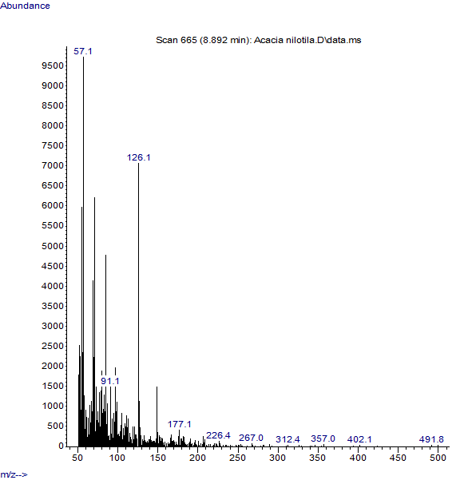
B
RT = 8.8937
FG = -OH

Key: Abbreviation’s description RT = Retention Time, FG = Functional Group. A = Dodecanoic acid and B = 1, 3, 5-Benzeneriol.

Figure 1b: Gas Chromatography-Mass Spectrometry (GC-MS) analysis of aqueous leaves extract of Acacia nilotica.

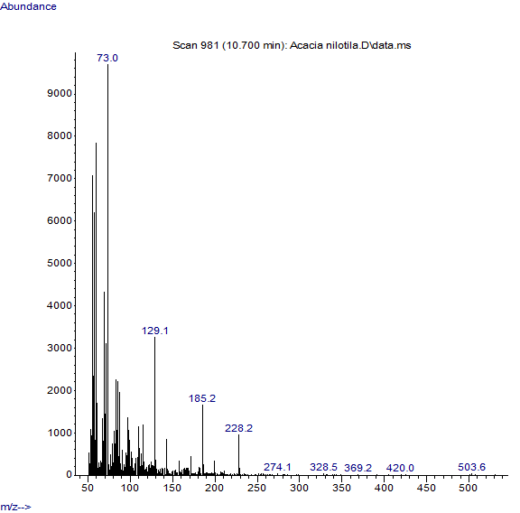
C
RT = 10.6979
FG = -OCOOH

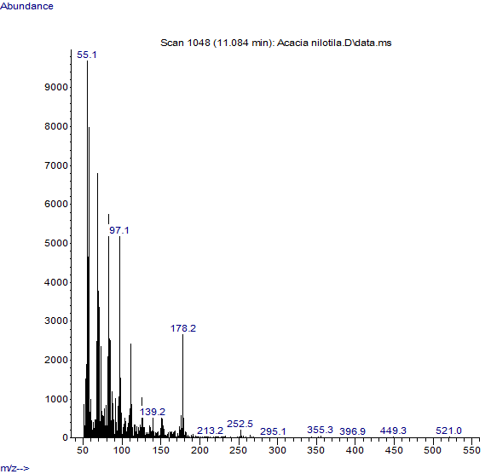
D
RT = 11.0842
FG = R-COOH

Key: Abbreviation’s description RT = Retention Time, FG = Functional Group. C = Tetradecanoic acid, D = 1-Octadecanoic acid
Figure 2a: Gas Chromatography-Mass Spectrometry (GC-MS) analysis of aqueous leaves extract of Aloe vera
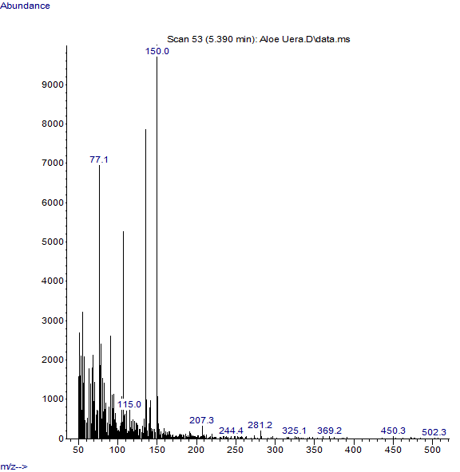
A
RT = 5.3905
FG = -CH3

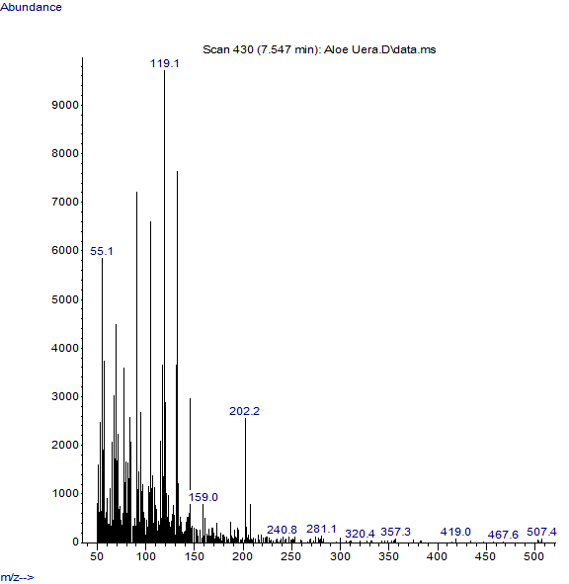
B
RT = 6.411
FG = -OCOOH

Key: Abbreviation’s description RT = Retention Time. FG = Functional Group, A = 2-Methiyl-4-vinylphenol and B = Tetradecanoic acid.
Figure 2b: Gas Chromatography-Mass Spectrometry (GC-MS) analysis of aqueous leaves extract of Aloe vera
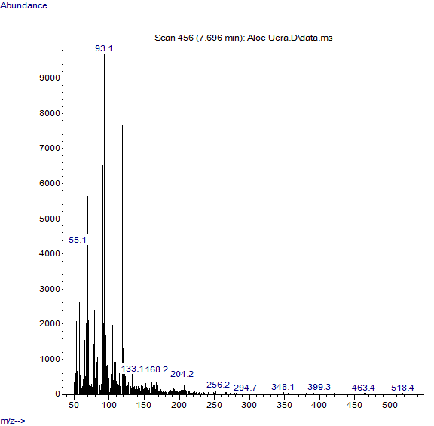
C
RT = 7.5448
FG = -OH

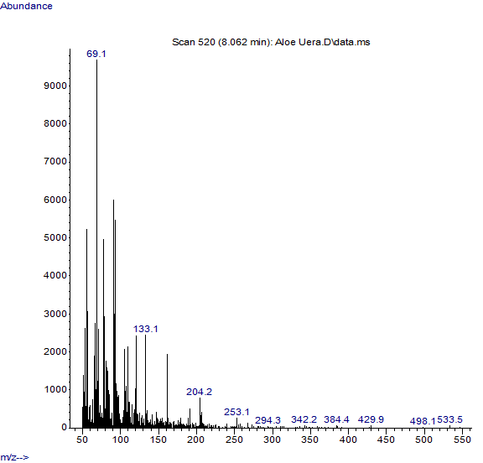
D
RT = 7.6972
FG = -CH3

.
Key: Abbreviation’s description RT = Retention Time. FG = Functional Group, C =Benzane, 1-(1,5-dimethyl-4-hexenyl), 4-methlyl and D = Methyl (1R, 5R)-4-methylene-1-(R)-6methylhept-5-en

Figure 3a: Gas Chromatography-Mass Spectrometry (GC-MS) analysis of aqueous leaves extract of Calotropis procera

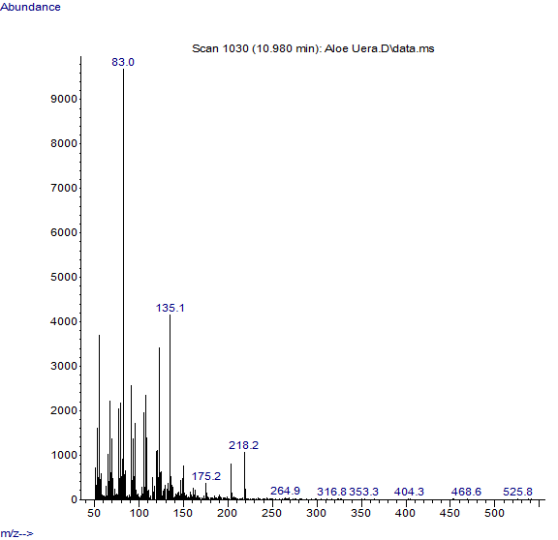
A
RT = 5.1985
FG = CH3

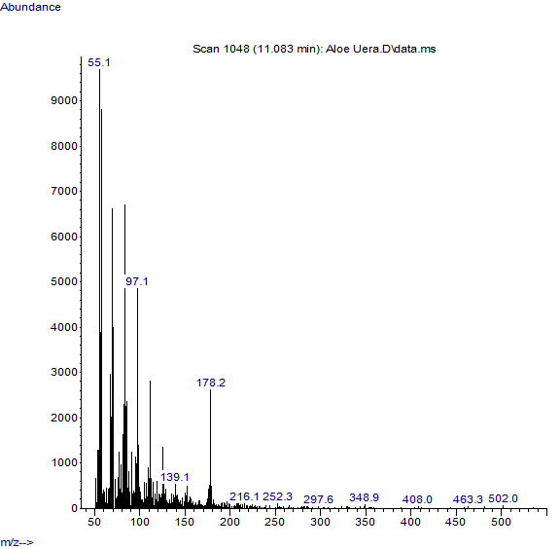
B
RT = 6.3118
FG = C4HC4H3O

Key: Abbreviation’s description RT = Retention Time. FG = Functional Group, A = Naphthalene, and 1-methyl, B = 1-nanodecane.
Figure 3b: Gas Chromatography-Mass Spectrometry (GC-MS) analysis of aqueous leaves extract of Calotropis procera

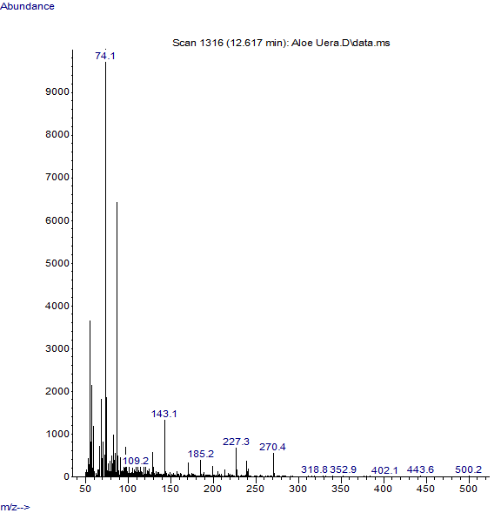
C
RT = 6.4089
FG = -OH

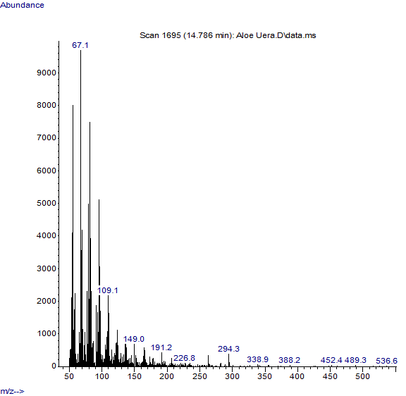
D
RT = 6.5944
FG = -CH3

Key: Abbreviation’s description RT = Retention Time. FG = Functional. Group C = Tetradecane and D = Naphthalene, 1, 6-dimethyl,

Plate 1: Gross appearance of surgical wounds of various groups on day one
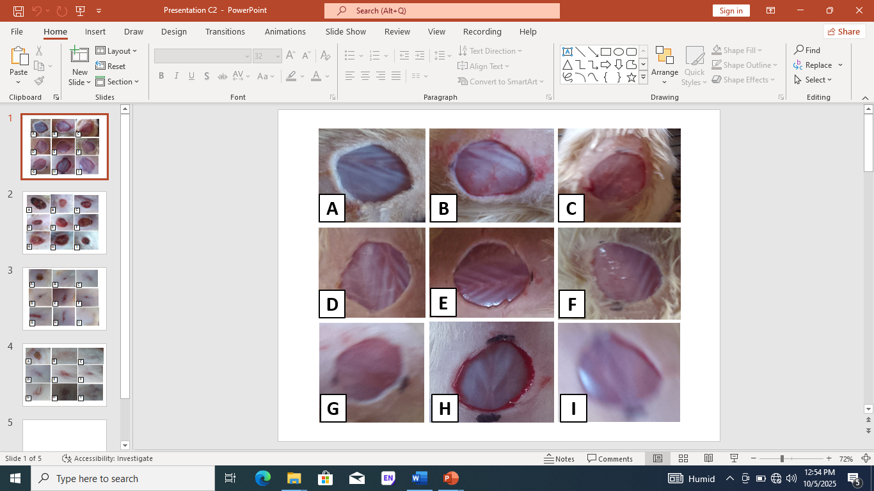
Key: Groups description A = Negative control, B = 5 % Betadine ointment, C = A. nilotica, D = Aloe vera, E = C. procera, F = A. nilotica and Aloe vera, G = A. nilotica and C. procera, H = Aloe vera and C. procera and I = A. nilotica, Aloe vera and C. procera.

Plate 2: Effect of individual and polyherbal formulated aqueous leaves extract ointments on Section of Skin showing newly formed epithelial lining and blood vessels stained with H&E X100
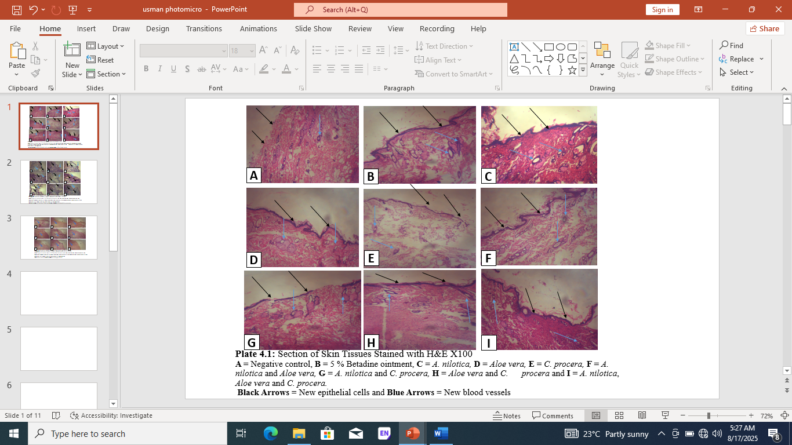
Key: Groups description A = Negative control (loss of epithelia), B = 5 % Betadine ointment (normal formed epithelia), C = A. nilotica ((normal formed epithelia), D = Aloe vera ((normal formed epithelia), E = C. procera ((partial formed epithelia), F = A. nilotica and Aloe vera ((normal formed epithelia), G = A. nilotica and C. procera (normal formed epithelia), H = Aloe vera and C. procera (partial formed epithelia), and I = A. nilotica, Aloe vera and C. procera (normal formed epithelia), Black arrows = Epitheliasation and Blue arrows = Angiogenesis (Blood vessels, collagen and elastic fibres distribution,

Table 4: The effect individual and polyherbal formulated ointments on semi-quantitative scoring of histological skin sections
S/No | Parameter and description | Scores | A | B | C | D | E | F | G | H | I
1 |  | +++  ++  +  - | -  -  -  + | -  ++  -  - | -  ++  -  - | -  ++  -  - | -  -  +  - | -  ++  -  - | -  -  +  - | -  ++  -  - | -  ++  -  -
  Degree of epithelialization
  High epithelialization
  Normal epithelialization
  Low epithelialization
  No epithelialization
2 |  | +++  ++  +  - | -  -  +  - | -  ++  -  - | -  ++  -  - | -  ++  -  - | -  --  +  - | -  ++  -  - | -  ++  -  - | -  ++  -  - | -  ++  -  -
  New blood vessel formation
  Above 4 new blood vessels
  2-4 new blood vessels
  1-2 new blood vessels
  No new blood vessels

Key: Groups description A = Negative control, B = 5 % Betadine ointment, C = A. nilotica, D = Aloe vera, E = C. procera, F = A. nilotica and Aloe vera, G = A. nilotica and C. procera, H = Aloe vera and C. procera and I = A. nilotica, Aloe vera and C. procera

The aqueous extraction leaves procedure of Acacia nilotica, Aloe vera and Calotropis procera were carried out and have very good physical characteristics with significant percentage yield of the extract of 10 %, 15 % and 20 % respectively, the findings of this study were contrary with the findings of the research conducted and reported by Saini [29], and Albert et al. [30], where they reported that, the weight of each pod samples before extraction was 100 g. After extraction, the aqueous extract yielded 14 g while the ethanol extract was 28.6 g, the extracts were dark, the reason could be due to different medium of extraction was used in each research. Similar contrast findings were also reported by the research conducted and reported by Shaﬁul et al. [31], where they reported high percentage yield value above the percentage yield value reported in this study. The reason for this contrary result could be attributed to the fact that, the plant and medium for extraction used in their research was Costus speciosus leaf and 95 % ethanol which were quite different from the one used in this research which was aqueous on Acacia nilotica leaves and distilled water.
The Gas Chromatography-Mass Spectrophotometry (GC-MS) analysis, revealed a number of bioactive components of organic acids, in Acacia nilotica, Aloe vera and Calotropis procera crude aqueous leaves extract that including Fumaric Acid (FA), Citric Acid (CA), Succinic Acid (SA), and Malic Acid (MA). Also, contained esters (fatty acids) and phenolic compounds which are very essential bioactive components responsible for the therapeutic effect in facilitating wound healing process. These findings were in line with the findings of the research conducted and reported by Ammara et al. [32], where they found out that such bioactive components were discovered in their extract used in the research they have carried out. The findings were also in agreement with the research reported by David et al. [33], where they reported that 10 compounds were identified from the extract characterized by the presence of esters and phenolic compounds like 2,4-di-tert-butylphenol, 2-((octyloxy)carbonyl) benzoic acid and sitosterol. The reason for the similar findings could be suspected to be due to the fact that same plant extraction procedure and method of GC-MS analysis procedure The section of skin stained with H & E stain show normal scoring pattern of well-formed epitheliasation and angiogenesis formations which indicate remarkable wound healing progress, in group C treated with 5 % aqueous leaves extract (ALE) of Acacia nilotica formulated ointment, D treated with 5 % ALE of Aloe vera formulated ointment,, F treated with 5 % aqueous leaves extract of Acacia nilotica and Aloe vera formulated ointment, H treated with 5 % ALE of Acacia nilotica and Calotropis procera formulated ointment and I treated with 5 % ALE of Acacia nilotica, Aloe vera and Calotropis procera ointment, while other groups show partial scoring pattern of epitheliasation and angiogenesis formations with minimal granulation tissues around the edge of the wound margin. The findings were in line with the study of Eman et al. [34], who reported that, granulation tissue, at first day there was a scanty amount of granulation tissue in the Acacia nilotica group while in the control group it was absent, after 3 days the granulation tissue still the same for the study group but became scanty in the control group, after 7 days both groups show increased score of granulation tissue formation. were used in both researches.
Th gross appearance of surgical wounds of various groups on day one, the first day of surgical skin wound was inflicted on the dorsal aspect of each rat, there was equal size of wound diameters length of full thickness of surgical skin wound, bleeding was arrested with the aid of small pressure on sterile gauze and after the bleeding has stopped area was washed with normal saline. The surgically wounded skin site appears fresh with approximately equal diameter length and clear margin of the cut in all the groups of this study.
The sections of the skin stained with H & E shows good epithelial regeneration and normal new blood vessels formation (Angiogenesis) in group C treated with 5 % Acacia nilotica aqueous leaves extract of formulated ointment, group D treated with Aloe vera aqueous leaves extract of formulated ointment, group F treated with combination of 5 % Acacia nilotica and Aloe vera aqueous leaves extract of formulated ointment, group H treated with combination of 5 % Aloe vera and Calotropis procera aqueous leaves extract of formulated ointment and group I treated with combination of 5 % Acacia nilotica, Aloe vera and Calotropis procera aqueous leaves extract of formulated ointment. This show that the extract of Acacia nilotica and Aloe vera possesses stimulatory effect in epithelial regeneration and angiogenesis. The group E treated with Calotropis procera aqueous leaves extract of formulated ointment and group G treated with combination of 5 % A. nilotica and C. procera. shows partial epithelial re-generation and few blood vessels formation which indicate less wound healing effect. These findings disagree with the findings of the research conducted and reported by Yung-Ze et al. [35], where they reported that, sections of skin on day 15 show Inflammatory cell infiltration (inflammation), epidermal cell regeneration (re-epithelization), granulomas (granulation), and the number of blood vessels (angiogenesis). The reason could be due to the fact that different extract was used in both researches and also different animal model were used in both researches. However, the findings of this study were in line with the findings of study conducted and reported by Eman et al. (2022), where they reported that granulation tissue formation especially control group in which profound granulation tissue appears while a moderate amount of tissue formed in the study group, on 14 days later the granulations decreased in the control group from the profound amount to moderate while still moderate for the study group, in general, there is an increase in the granulation tissue formation in study groups more than a control group. The reason could be attributed to the same experiment intervention and animal model were used in both researches.
The section of skin stained with H & E stain show normal scoring pattern of well-formed epitheliasation and angiogenesis formations which indicate remarkable wound healing progress, in group C treated with 5 % aqueous leaves extract of Acacia nilotica formulated ointment, D treated with 5 % aqueous leaves extract of Aloe vera formulated ointment,, F treated with 5 % aqueous leaves extract of Acacia nilotica and Aloe vera formulated ointment, H treated with 5 % aqueous leaves extract of Acacia nilotica and Calotropis procera formulated ointment and I treated with 5 % aqueous leaves extract of Acacia nilotica, Aloe vera and Calotropis procera ointment, while other groups show partial scoring pattern of epitheliasation and angiogenesis formations with minimal granulation tissues around the edge of the wound margin. The findings were in line with the study of Eman et al. (2022), who reported that, granulation tissue, at first day there was a scanty amount of granulation tissue in the Acacia nilotica group while in the control group it was absent, after 3 days the granulation tissue still the same for the study group but became scanty in the control group, after 7 days both groups show increased score of granulation tissue formation.

1.16 CONCLUSION
The aqueous leaves extract the Acacia nilotica, Aloe vera and Calotropis procera possess very good physical characteristics and presence of secondary metabolites that possessed wound healing effect.
The aqueous leaves extract the Acacia nilotica, Aloe vera and Calotropis procera possess very good bioactive compound suspected to be responsible wound healing effect.
There was normal regeneration of epithelial lining of epidermal layer (epitheliasation), new blood vessels (angiogenesis), collagen fibres and elastic fibres deposition in groups treated with individual 5 % aqueous leaves extract of Acacia nilotica formulated ointments and in combination of the three extracts of the studied sections.

Disclaimer (Artificial intelligence)
Option 1:
Author(s) hereby declare that NO generative AI technologies such as Large Language Models (ChatGPT, COPILOT, etc.) and text-to-image generators have been used during the writing or editing of this manuscript.
Option 2:
Author(s) hereby declare that generative AI technologies such as Large Language Models, etc. have been used during the writing or editing of manuscripts. This explanation will include the name, version, model, and source of the generative AI technology and as well as all input prompts provided to the generative AI technology
Details of the AI usage are given below:
1.
2.
3.

REFERENCES
- Gurtner G. C., Werner S., Barrandon Y. & Longaker M. T. Wound repair and regeneration. Nature; 2008. 453: 314–321.
- Choudhary V., Choudhary M. & Bollag W.B. Exploring Skin Wound Healing Models and the Impact of Natural Lipids on the Healing Process. International Journal of Molecular Science; 2024. 25: 3790.
- Piperigkou Z., Götte M., Theocharis A. D. & Karamanos N. K. Insights into the key roles of epigenetics in matrix macromolecules-associated wound healing. Advanced Drug Delivery Review; 2018. 129: 16–36.
- Rodrigues M., Kosaric N., Bonham C. A. & Gurtner G. C. Wound healing: A cellular perspective. Physiology Review; 2019. 99(1): 665–706.
- Eming S. A., Martin P. & Tomic-Canic M. Wound repair and regeneration: Mechanisms, signaling, and translation. Science Translational Medicine; 2014. 6(265): 2656.
- Kaur K, Michael H., Arora S., Harkonen P. & Kumar S. In vitro bioactivity-guided fractionation and characterization of polyphenolic inhibitory fractions from Acacia nilotica (L.) Willd. ex Del. Journal of Ethnopharmacology; 2005. 99: 353-630.
- Baravkar A. A., Kale R. N., Patil R. N. & Sawant S. D. Pharmaceutical and biological evaluation of formulated cream of methanolic extract of Acacia nilotica leaves. Research Journal of Pharmaceutical Technology; 2008. 1(4): 481-483.
- Shittu G. A. In vitro antimicrobial and phytochemical activities of Acacia nilotica leaf extract. Journal of Medicinal Plants Research; 2010. 4(12): 1232-1234.
- Steve B. Medicinal Plant Constituents. Available from lifelong pres. www.naturalhealthwizards.com 2004.
- Singh B. N., Singh B. R., Sarma B. K. & Singh H. B. Potential chemoprevention of N-nitrosodiethylamine-induced hepatocarcinogenesis by polyphenolics from Acacia nilotica bark. Chemistry-Biology Interaction; 2009b. 181: 20-28.
- Anonymous D, “Taxon: Aloe vera (L) Burm,” Germplasm Resources Information Network, United States Department of Agriculture; 2008. 4-8
- Liu R. H. Potential synergy of phytochemicals in cancer prevention: Mechanism of action. Journal of Nutrition; 2004. 134:3479S-85.
- Wang P. H., Huang B. S., Horng H. C., Yeh C. C. & Chen Y. J. Wound healing. Journal of Clinical Medical Association; 2018. 81: 94–101.
- Akinyele B. O & Odiyi D. C. Comparative study of the vegetative morphology and existing taxonomic status of Aloe vera L. Journal of plant science; 2007. 2: 558-563.
- Farooqi A. A. & Sreeramu S, Cultivation of Medicinal and Arror crops Revised education; 2001. 27: 355-364.
- Samuel K.1. & Sudi Y. I. Effects Of Calotropis procera Latex on Biochemical and Hematological Parameters in Albino Rats. Nigerian Journal of Biotechnology; 2020. 37(1): 94-100.
- Abidemi E., Abiodun A., Rhaman A. B. & James A. An experimental study of the toxicity effects of Calotropis procera (Aiton) Asclepiadaceae in Sprangue-dawley rats. Western Journal of Pharmaceutical Research; 2017. 6(11): 42-55.
- Ali I. A. Biochemical effects of Calotropis procera on hepatotoxicity. Journal of Biomedical Research Therapy; 2015. 2(12): 446-453.
- Hossain A. H., Hendrikx A. & Punt P. J. Identification of novel citramalate biosynthesis pathways in Aspergillus niger. Fungal Biology and Biotechnology; 2019. 6(19): 84-87.
- Anonymous D. Aloe vera. The ancient plant remedy for today’s stressful life style. http:// wholeleaf.com; 2007. 17: 5-8.
- Hina B., Mumtaz H., Mansoor Hameed & Rashid A. (2024) Photochemistry of Calotropis procera and its Traditional Uses. Natural Products Chemistry and Research; 12(1): 1-2.
- Rahee A. A. & Mallik J. Phytochemical Screenings of the Metholic Extract of Whole Plant Borreria articulari. International Journal of Pharmaceutical & Biological Archieves; 2012. 3(5):1062-1066.
- Wei L. H., Scutellaria barbata D. Don Induces Apoptosis of Human Colon Carcinoma Cell through Activation of the Mitochondrion-dependent Pathway. Journal of Medicinal Plants Research; 2011. 5(10): 1962-1970.
- Morton J. J. and Malone M. H. Evaluation of vulnerary activity by an open wound procedure in rats. Archive International Pharmacodynamics Therapy, 1972. 196:117-126.
- Ravishankar K. & Satya-Sireesha A. Exploration of antimicrobial and wound healing activities using ethanolic leaf extract gel of Nyctanthes arbor-tristis on rabbits. ISSN: 2354-2152. Advancement in Medicinal Plant Research; 2021. 9(4): 68-74.
- Avwioro O. G. Histochemistry and Tissue Pathology. PrinciplesandTechnique3rd Edition. Clavenrianum Press. Ibadan Nigeria, 2014. pp 147-190
- Azem A., Khalaf I., Eman I., Hassanen I., Amr R., Zaki I., Ade F., Tohamy I., Marwa A. & Ibrahim D. Histopathological, immunohistochemical and molecular studies for determination of wound age and vitality in rats. International wound Journal; 2019. 16: 1416=1425
- Ignatius A. K., Rini D. & Sri H. Y. The Effect of Tempeh Extract Gel on Wound Healing in Diabetes Rats: Overview of Tissue Collagen, Wound Closure, Epithelialization and Capillarization. P-ISSN 1693-5683; E-ISSN 2527-7146 Doi: Http://Dx.Doi.Org/10.24071/Jpsc.002357. Jurnal of Farmasi Sains Dan Komunitas; 2020. 17(1): 51-58.
- Saini M. L. Comparative Pharmacognostical and antimicrobial studies of Acacia Species (Mimosaceae). Journal of Medicinal Plants Research; 2008. 2(12): 378–386.
- Albert O. Fasogbon, J. O. Odewade R. T.& Omojoyegbe G. Antibacterial Potential of Pod Extracts of Gum Arabic Tree (Acacia nilotica). Equity Journal of Science and Technology; 2021. 8(1): 100 – 104
- Shaﬁul A., Zishan M., Maien U. M., Mohammad S. M. Asadul K., Azad J., Naima S. Sipar I. and Saiful I. A. Costus speciosus leaf and seed extracts for wound healing: a comparative evaluation using mice excision wound models. Clinical Phytoscience; 2024. 10:5
- Ammara M., Amina S., Muhammad A. A., Ayesha H., Zahra R., Yamna A., Tahreem F., Ayesha G., Syeda K. F. & Muhammad A. (2025). Medical importance of plant (Calotropis procera) in treatment of human diseases. Journal of Medical and Health Science Review; 2(1): 56-59.
- David N. T., Muhammad A. Y., Guy Sedar S. N., Charles F., Jean N. N., Fatima N. & Donatien G. GC/MS analysis, anti-salmonella potential of methanol leaf extracts of tristemma mauritianum and effects on hematological parameters on wistar rats infected with salmonella typhi. International Journal of Pharmacy; 2017. 7(2): 120-131.
- Eman A., Sara T., Noor S. & Muna A. Impact of acacia arabica topical gel on skin wound healing: An experimental study. Pharmacia; 2022. 69(1): 77–83
- Yung-Ze C., Min L., Juei-Tang C., Bor-Shyh L. & Flank L. Wound healing is promoted by Musa paradisiaca (banana) extract in diabetic rats. Archives of Medical Science; 2020. 20(2): 632–640

