Preparation, Property Control, and Microstructural Mechanisms of Red Mud–Metakaolin Composite Cement-Based Foamed Materials

.
ABSTRACT
To promote the efficient utilization of red mud solid waste and the development of low-carbon, energy-efficient building materials, cement-based foamed materials were prepared using red mud, metakaolin, and cement as a composite cementitious system, with solid hydrogen peroxide as the foaming agent. A two-variable experimental design, considering the presence or absence of a superplasticizer, was employed to investigate the effects of foaming agent dosage on mechanical properties, pore structure, and thermal performance through compressive strength testing, scanning electron microscopy (SEM), and thermal conductivity measurements. The results indicate that compressive strength increased significantly with curing age and exhibited an initial increase followed by a decrease with increasing foaming agent dosage, with an optimal dosage of 0.5%, at which the 28-day compressive strength reached 31.6 MPa for specimens containing a superplasticizer. Microstructural analysis revealed that this optimal dosage promoted the formation of a uniform and fine closed-cell pore structure, while secondary hydration reactions involving red mud and metakaolin generated gel phases that effectively filled pores and enhanced matrix compactness. The incorporation of a superplasticizer further improved particle dispersion and hydration efficiency, resulting in increased densification and strength. Overall, this study provides a feasible approach for producing high-performance cement-based foamed materials with high red mud content and offers mechanistic insights into the performance regulation of low-carbon, energy-efficient building materials.
Keywords：red mud; metakaolin; cement-based foamed concrete; solid hydrogen peroxide; compressive strength; microstructure; thermal conductivity
1. INTRODUCTION
1.1 Research Background and Significance
With the global promotion of the “dual-carbon” strategy, the construction industry is undergoing a critical transition toward low-carbon development, energy efficiency, and sustainable resource utilization. Cement-based building materials, although widely used, are associated with high energy consumption and significant carbon emissions during cement production. Therefore, the incorporation of industrial solid wastes into cementitious materials has become an effective approach to reduce environmental burden while maintaining engineering performance. Among various industrial by-products, red mud—a major waste generated during alumina production—has attracted increasing attention due to its large output and potential utilization value.
Red mud is characterized by high alkalinity, fine particle size, and complex chemical composition, with a global annual production exceeding 175 million tons. Long-term stockpiling of red mud not only occupies large areas of land but also poses serious environmental risks, such as soil alkalization and groundwater contamination. According to statistics from the China Nonferrous Metals Industry Association, the comprehensive utilization rate of red mud remains below 10%, indicating significant challenges in its large-scale and high-value reuse. Consequently, the development of effective pathways for red mud recycling is of great environmental and socio-economic importance.
Foamed concrete, as a lightweight cement-based material with adjustable density and excellent thermal insulation properties, has been widely used in building envelopes and energy-saving construction. However, conventional foamed concrete primarily relies on Portland cement, which limits its sustainability and increases its carbon footprint. Incorporating red mud into foamed concrete provides a promising solution by simultaneously addressing solid waste disposal and improving building energy efficiency. Nevertheless, the high alkalinity and relatively low intrinsic reactivity of red mud may negatively affect the stability and performance of cementitious systems when used at high replacement levels.
Metakaolin, a highly reactive aluminosilicate material, has been extensively employed as a supplementary cementitious material due to its strong pozzolanic activity. When combined with cement, metakaolin can participate in secondary hydration reactions, refine pore structure, and enhance mechanical properties. The synergistic use of metakaolin is therefore considered an effective strategy to compensate for the adverse effects associated with high red mud content and to ensure the performance stability of composite cementitious systems.
In addition to binder composition, pore structure regulation plays a decisive role in determining the performance of foamed concrete. Hydrogen peroxide is one of the most commonly used foaming agents owing to its high foaming efficiency and environmentally friendly decomposition products. Compared with liquid hydrogen peroxide, solid hydrogen peroxide (2Na₂CO₃·3H₂O₂) exhibits advantages in terms of storage stability, transportation safety, and controlled gas release, making it particularly suitable for engineering applications. However, the dosage of solid hydrogen peroxide directly influences pore size distribution, pore connectivity, and overall material performance, and thus requires systematic investigation.
1.2 Current Research Status and Research Gaps
In recent years, extensive studies have been conducted on the utilization of red mud in cement-based materials. Previous research has demonstrated that reactive components in red mud can participate in hydration reactions and form cementitious products when incorporated into cement systems, providing a theoretical basis for its application in construction materials. Experimental studies have further shown that red mud can partially replace cement in foamed concrete and lightweight materials, contributing to strength development through hydration product formation.
Several researchers have also explored the influence of hydrogen peroxide dosage on the pore structure and performance of foamed concrete. It has been widely reported that optimized hydrogen peroxide content can lead to a uniform pore structure and achieve a balance between mechanical strength and thermal insulation performance. Meanwhile, the use of superplasticizers has been proven effective in improving workability, particle dispersion, and matrix compactness in cement-based composites, particularly those incorporating solid wastes.
Despite these advances, existing studies still present several limitations. First, in most reported works, the red mud replacement ratio is generally limited to below 30%, as higher contents may adversely affect hydration reactions and material stability due to excessive alkalinity. Studies focusing on composite cementitious systems with red mud contents as high as 50% remain scarce. Second, while the individual effects of hydrogen peroxide dosage or superplasticizer addition have been investigated, systematic studies on their synergistic influence in red mud–metakaolin–cement composite systems are still lacking. In particular, the microstructural evolution mechanisms governing pore structure formation and performance regulation under different foaming and admixture conditions have not been fully clarified.
Therefore, the present study aims to address these research gaps by developing a high-content red mud–metakaolin–cement composite foamed material system. The effects of solid hydrogen peroxide dosage and superplasticizer on mechanical properties, pore structure, thermal performance, and microstructural characteristics are systematically investigated. By elucidating the structure–property relationships and underlying mechanisms, this study seeks to provide scientific guidance for the high-value utilization of red mud and the development of low-carbon, energy-efficient cement-based building materials.

Despite the above studies, several research gaps remain. Most existing research limits the red mud content in cement-based foamed materials to below 30%, and the feasibility of high-content red mud incorporation has not been sufficiently verified. In addition, the synergistic effects of solid hydrogen peroxide dosage and superplasticizer on the mechanical, thermal, and microstructural properties of red mud–metakaolin–cement composite foamed materials have not been systematically investigated.

2 Materials and Methods

2.1 Raw Materials
Table 1. Chemical composition of raw materials determined by X-ray fluorescence (XRF) analysis (wt.%)
Material | SiO₂ | Al₂O₃ | Fe₂O₃ | CaO | MgO | Na₂O | Other
Red mud | 22.5 | 18.3 | 35.7 | 8.2 | 3.1 | 6.8 | Balance
Metakaolin | 52.4 | 42.1 | 1.2 | 0.4 | 0.6 | – | Balance
Cement | 20.3 | 5.1 | 3.4 | 63.5 | 2.2 | – | Balance
Red mud, a by-product generated from alumina production via the Bayer process, was used as a solid waste raw material in this study. Its chemical composition determined by XRF is summarized in Table X. The median particle size (D50) of the red mud is 15.2 μm, and its specific surface area is 2.8 m²/g. Metakaolin with a purity of not less than 95% was employed as a supplementary cementitious material, with a combined active SiO₂ and Al₂O₃ content exceeding 85% and a specific surface area of approximately 20,000 cm²/g. Ordinary Portland cement (P·O 42.5) was used as the primary binder, exhibiting initial and final setting times of 185 min and 240 min, respectively, and compressive strengths of 25.3 MPa at 3 days and 48.6 MPa at 28 days. The chemical compositions of these main cementitious raw materials are presented in Table X. Solid hydrogen peroxide (2Na₂CO₃·3H₂O₂) with a purity of not less than 98% and a particle size of 80 mesh was used as the foaming agent. A polycarboxylate-based high-range water-reducing agent with a solid content of 40% and a water-reduction rate of not less than 25% was adopted as the superplasticizer. Tap water conforming to GB/T 6388-2008 Standard for Water Used in Concrete was used for sample preparation.
2.2 Mix Proportion Design

The mass ratio of red mud, metakaolin, and cement was fixed at 25:25:50, with a total solid mass of 100 g. Two experimental series were designed.
Series A incorporated a superplasticizer, with a water-to-binder ratio of 0.30 (30 g of water) and a superplasticizer dosage of 0.64% by mass of the binder (0.64 g).
Series B contained no superplasticizer and used 40 g of water.

The binder system investigated in this study consisted of a red mud–metakaolin–cement composite, and the water-to-binder ratio was calculated based on the total mass of the composite binder. For both series, solid hydrogen peroxide was added at four levels: 0% (blank control), 0.5%, 1.5%, and 2.5% by mass of total solids. The corresponding specimen codes were A0–A3 and B0–B3, respectively. For each mix proportion, three cubic specimens with dimensions of 40 mm × 40 mm × 40 mm were prepared to ensure the reliability of the test results. The selected admixture dosage range ensures foam stability and pore structure uniformity, while preserving sufficient mechanical properties.The detailed mix proportions are summarized in Table 2.
Table 2- Mix Proportions and Compressive Strength Data
Table2 | Label | RM(g) | MK(g) | cement(g) | 2Na₂CO₃  ·3H₂O₂(g) | water(g) | SP(g)
1 | A0 | 25 | 25 | 50 | 0 | 30 | 0.64
2 | A1 | 25 | 25 | 50 | 0.5 | 30 | 0.64
3 | A2 | 25 | 25 | 50 | 1.5 | 30 | 0.64
4 | A3 | 25 | 25 | 50 | 2.5 | 30 | 0.64
5 | B0 | 25 | 25 | 50 | 0 | 40 | -
6 | B1 | 25 | 25 | 50 | 0.5 | 40 | -
7 | B2 | 25 | 25 | 50 | 1.5 | 40 | -
8 | B3 | 25 | 25 | 50 | 2.5 | 40 | -
Note:RM: Red Mud；MK: Metakaolin；SP: superplasticizer（Water-Reducing Agent）
2.3 Specimen Preparation Procedure

The preparation of specimens involved four main steps: raw material pretreatment, mixing, casting, and curing. Prior to mixing, red mud was dried at 105 °C for 24 h, ground, and sieved through an 80-mesh sieve to remove impurities. Cement and metakaolin were stored in a dry environment before use. According to the designed mix proportions, red mud, metakaolin, cement, and solid hydrogen peroxide were successively added into the mixer and dry-mixed for approximately 2 min to ensure homogeneity. Subsequently, 30 g of water and the superplasticizer were added to Series A, while 40 g of water was added to Series B. The mixtures were then wet-mixed for 3–5 min until a uniform slurry without agglomeration was obtained and adequate workability for casting was achieved. The fresh slurry was slowly poured into cubic molds with dimensions of 40 mm × 40 mm × 40 mm, vibrated for 5–10 s to eliminate entrapped air and improve compaction, and leveled at the surface. The specimens were kept at room temperature (20 ± 2 °C) with a relative humidity of not less than 90% for 24 h before demolding. After demolding, the samples were transferred to a standard curing chamber (20 ± 2 °C, relative humidity ≥ 95%) and cured for 7, 14, and 28 days, respectively.

2.4 Testing Methods
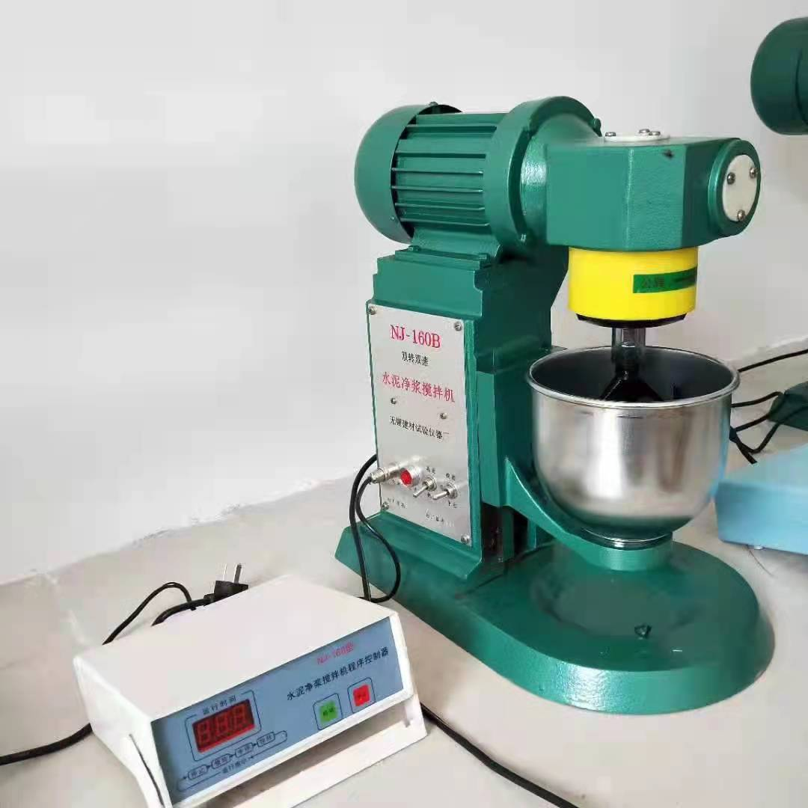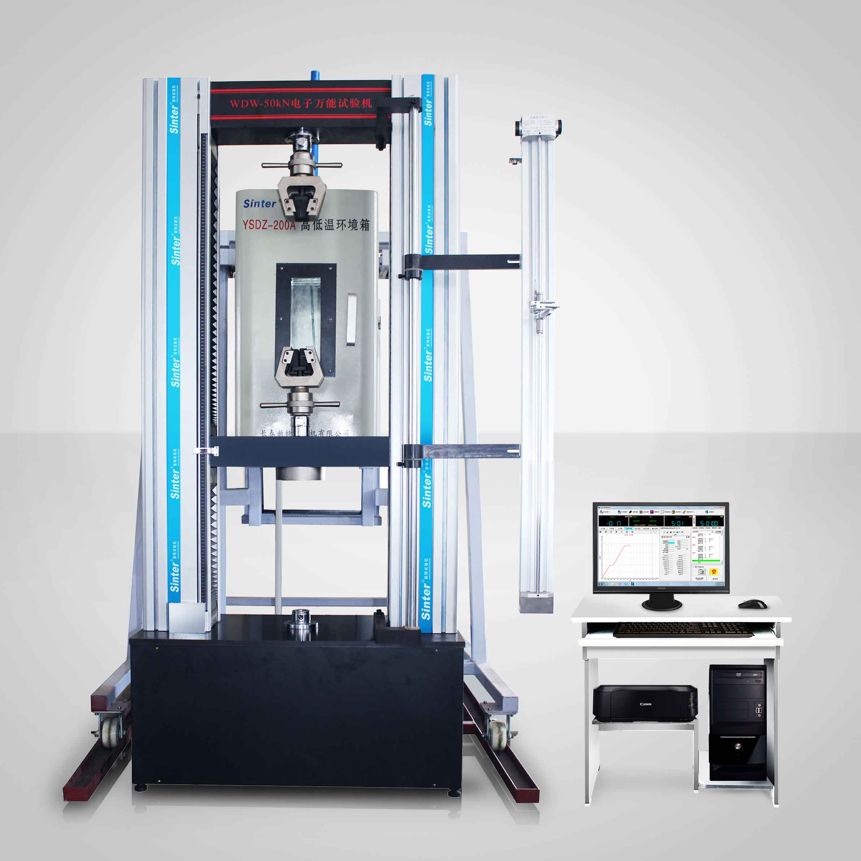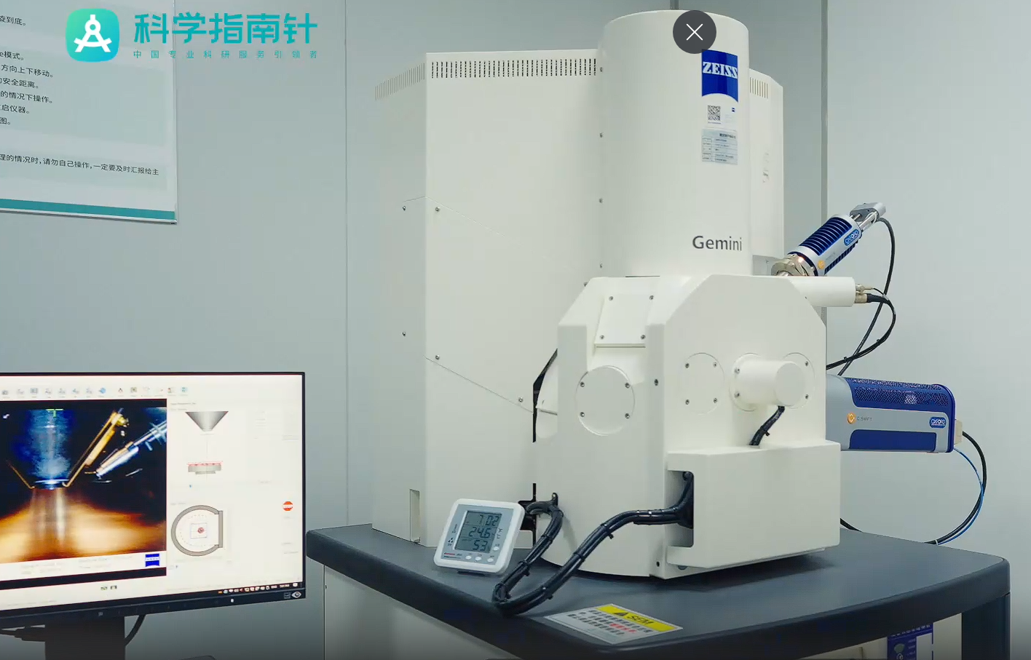
Figure 1. Concrete mixer (left); Compression and flexural testing machine (middle); SEM: Hitachi SU8010 scanning electron microscope (right)

Compressive strength tests were conducted in accordance with GB/T 50081-2019 Standard for Test Methods of Physical and Mechanical Properties of Concrete. Prior to testing, 150×150×150 mm cubic specimens were polished to ensure surface flatness, and their dimensions were measured with a vernier caliper (precision: 0.1 mm) to calculate the bearing area. A computer-controlled electronic universal testing machine (load accuracy: ±1%) was used, with a displacement-controlled loading rate of 0.5 mm/min. For each mix and curing age (7d, 14d, 28d), three parallel specimens were tested; the average value was reported as the compressive strength, with standard deviations ranging from 0.3 to 0.8 MPa. Experimental data were processed and plotted using Origin software.
For microstructural characterization, representative fracture surfaces of 28-day compressive specimens were selected and cut into 10×10×5 mm blocks. The blocks were vacuum-dried at 60℃ for 24h to remove moisture, then gold-coated (film thickness: 5-10 nm) to enhance conductivity. A scanning electron microscope (SU8010, Hitachi, Japan) was employed at an accelerating voltage of 10 kV and a working distance of 8 mm; observations were performed at magnifications of ×500 (for macro-pore distribution) and ×2000 (for micro-morphology of hydration products) to examine pore morphology, pore size distribution, and hydration product characteristics (e.g., C-S-H gel).
Thermal conductivity was measured on 28-day specimens following GB/T 10294-2021 Thermal insulation—Determination of steady-state thermal resistance and related properties—Guarded hot plate and heat flow meter methods. Specimens were pre-treated to a dry state (dried at 105℃ to constant weight), and a guarded hot plate apparatus (precision: ±3%) was used for testing. Three parallel samples were tested for each group, and the results were statistically analyzed to ensure reliability.

3. Results and Discussion

3.1 Results and Analysis of Compressive Strength
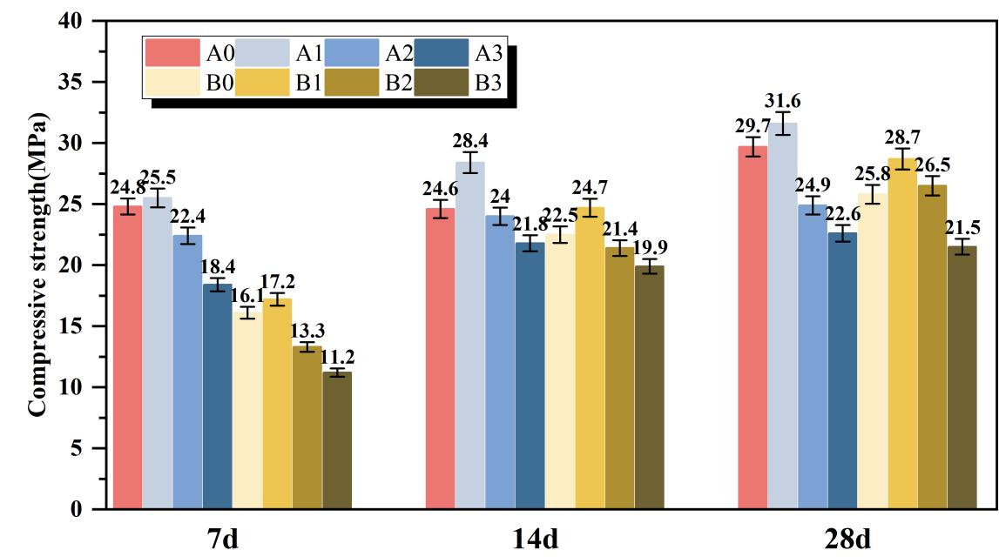
Figure 2 .Compressive strength at different curing ages as a function of solid hydrogen peroxide dosage
As illustrated in Figure 2, the compressive strengths of both Series A and Series B specimens increase markedly with curing age, while exhibiting a typical trend of first increasing and then decreasing with increasing solid hydrogen peroxide dosage. Overall, the compressive strengths of Series A, incorporating a superplasticizer, are consistently higher than those of the corresponding Series B specimens at the same dosage and curing age, indicating the beneficial effect of the superplasticizer on the mechanical performance of the composite system.

From the perspective of curing age, the 28-day compressive strength shows an increase of 33.3% to 93.4% compared with that at 7 days. Notably, the strength growth rate of Series A is generally lower than that of Series B (for example, the strength of A1 increases by 23.9% from 7 to 28 days, whereas B1 shows an increase of 66.9% over the same period). This difference can be attributed to the regulatory effect of the superplasticizer on hydration kinetics. By reducing surface tension and enhancing the dispersion of cementitious particles, the superplasticizer promotes more complete hydration at early ages, causing the strength development to enter a stable stage earlier. This observation is consistent with the findings reported by Ma et al. [7] for red mud–metakaolin cementitious systems.

With respect to the effect of solid hydrogen peroxide content, both series reach their maximum compressive strength at a dosage of 0.5%. At this optimal level, the 28-day compressive strength of A1 reaches 31.6 MPa, representing a 19.7% increase compared with the blank sample A0, while B1 attains 28.7 MPa, corresponding to an improvement of 11.2% relative to B0. When the dosage exceeds 0.5%, the compressive strength decreases continuously. Specifically, the 28-day strength of A3 (2.5% dosage) drops to 22.6 MPa, which is 28.5% lower than that of A1, whereas B3 decreases to 21.5 MPa, showing a reduction of 25.1% compared with B1. The variation trends of compressive strength with respect to solid hydrogen peroxide dosage were plotted using Origin software, as shown in Fig. 1. These results clearly demonstrate the relationship between foaming agent content and compressive strength, providing direct guidance for mix proportion optimization in engineering applications and confirming the general role of foaming agent dosage in regulating the strength of solid-waste-based foamed concrete.

The observed strength evolution can be primarily attributed to the combined effects of pore structure regulation and hydration reaction synergy, with the superplasticizer further enhancing this coupling effect. At the optimal dosage of 0.5%, the decomposition of solid hydrogen peroxide generates an appropriate amount of CO₂ and O₂ bubbles, which are uniformly distributed within the slurry and form fine closed pores with diameters mainly ranging from 50 to 200 μm. Such a pore structure maintains sufficient effective load-bearing area while providing adequate space for the growth of hydration products, in agreement with the conclusions reported by Zhao et al. [8] on pore structure optimization in blast furnace slag foamed concrete. Meanwhile, the reactive SiO₂ and Al₂O₃ components in red mud and metakaolin participate in secondary hydration reactions with Ca(OH)₂ released during cement hydration, leading to the formation of abundant calcium–silicate–hydrate (C–S–H) gel and needle- or rod-like anorthite crystals (CaAl₂Si₂O₈·4H₂O). These hydration products interweave and fill the pore spaces, significantly enhancing the structural compactness of the material [8]. In this process, the pozzolanic activity of metakaolin plays a critical role, as its fine particles not only act as fillers but also provide active sites for the adsorption of hydration products and the promotion of secondary hydration reactions [9]. Consequently, the compressive strength reaches its maximum value, which is consistent with the “secondary hydration–pore filling” strengthening mechanism reported by Liu et al. [10] for red-mud-based foamed concrete.

When the solid hydrogen peroxide dosage exceeds 0.5%, excessive gas generation leads to frequent bubble collision and coalescence, resulting in large pores with diameters greater than 500 μm or even interconnected pore structures. This markedly increases internal defects and reduces the effective load-bearing area. In addition, excessive bubbles hinder the adhesion and growth of hydration products on pore walls, lowering the density of the pore structure and ultimately causing a pronounced deterioration in compressive strength. By contrast, the incorporation of a superplasticizer improves the dispersion of cementitious particles, thereby enhancing both the extent of hydration and the uniformity of the pore structure. On the one hand, the superplasticizer suppresses the agglomeration of red mud and metakaolin particles, allowing their active components to more effectively participate in secondary hydration reactions. On the other hand, the improved workability of the slurry facilitates a more stable and uniform distribution of bubbles during casting, reducing localized bubble accumulation and coalescence. As a result, Series A specimens exhibit a more optimized pore structure and more complete hydration, leading to superior mechanical performance compared with Series B, which is also supported by the findings of Tang et al. [11] regarding the influence of superplasticizers on solid-waste-based cementitious materials.

3.2 Microstructural (SEM) Characterization and Analysis
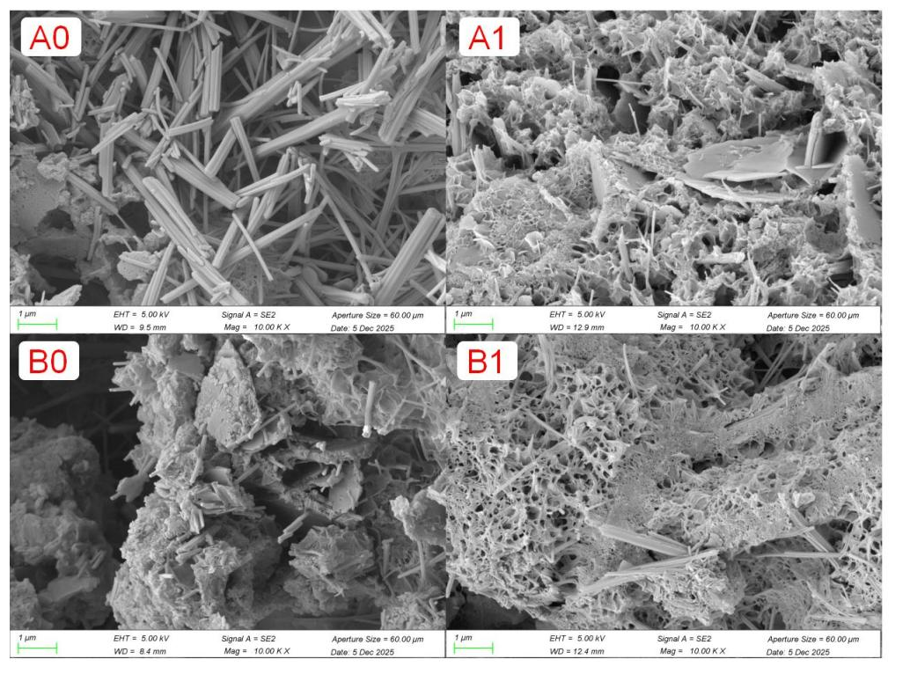
Figure 3.SEM microstructure
The scanning electron microscopy (Figure 3.SEM) observations reveal pronounced differences in the microstructures of the specimens, and the observed microstructural features show a strong correlation with the corresponding macroscopic mechanical properties. The A1 specimen, containing 0.5% solid hydrogen peroxide and a superplasticizer, exhibits a uniformly distributed fine closed-pore structure, with pore diameters predominantly ranging from 50 to 150 μm. The pore walls are dense and continuous, and abundant C–S–H gel interwoven with anorthite crystals can be observed filling the pore spaces. This microstructural configuration is the primary reason for the peak compressive strength of A1: an appropriate amount of gas bubbles provides sufficient space for hydration product development, while the dispersing effect of the superplasticizer promotes more complete secondary hydration of the reactive components, thereby enhancing the compactness of the matrix [10].

In contrast, the B3 specimen (2.5% solid hydrogen peroxide without superplasticizer) is characterized by extensive interconnected macropores, accompanied by severe disruption of matrix continuity and the presence of only limited amounts of loose cementitious material. This behavior can be attributed to excessive gas generation, which compromises the integrity of the slurry, as well as the absence of a superplasticizer, leading to particle agglomeration and inhibited hydration reactions. Although the compressive strength of this specimen is relatively low, its pore structure contributes to superior thermal insulation performance. A similar phenomenon was reported by Li et al. [9] in their study on circulating fluidized bed fly ash–based foamed lightweight soil.

For the remaining specimens, the A0 and B0 groups display comparatively dense microstructures but insufficient hydration, as indicated by the limited formation of hydration products. With increasing foaming agent content, specimens A2, A3, and B1, B2 exhibit progressive pore enlargement and coalescence, resulting in reduced structural integrity and a corresponding decline in compressive strength.

3.3 Results and Analysis of Thermal Conductivity
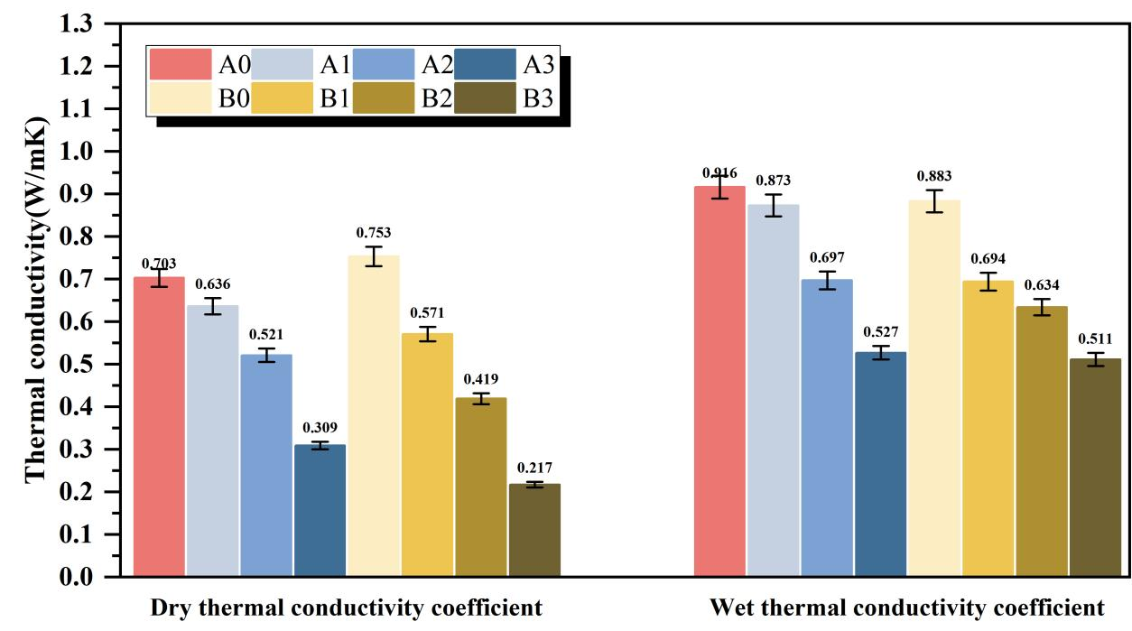
Figure 4. Dry and wet thermal conductivity tests at 28 days

The dry and wet thermal conductivity values of specimens with different solid hydrogen peroxide dosages at 28 days are summarized in Figure 4. As indicated by the results, the thermal conductivity of the specimens decreases markedly with increasing solid hydrogen peroxide content under both dry and saturated conditions. Moreover, for the same foaming agent dosage, the dry and wet thermal conductivity values of Series B (without superplasticizer) are generally lower than those of Series A (with superplasticizer), suggesting that the incorporation of a superplasticizer has a measurable influence on the thermal performance of the material.

In detail, the dry thermal conductivity of Series A decreases from 0.703 W/(m·K) for A0 to 0.309 W/(m·K) for A3, corresponding to an overall reduction of 56.0%. The wet thermal conductivity of Series A shows a similar trend, decreasing from 0.916 W/(m·K) to 0.527 W/(m·K), with a reduction of 42.5%. In comparison, Series B exhibits a more pronounced decrease in thermal conductivity. The dry thermal conductivity drops from 0.753 W/(m·K) for B0 to 0.217 W/(m·K) for B3, representing a reduction of 71.2%, while the wet thermal conductivity decreases from 0.883 W/(m·K) to 0.511 W/(m·K), corresponding to a reduction of 42.1%.

The observed reduction in thermal conductivity can be primarily attributed to the evolution of pore structure induced by increasing solid hydrogen peroxide dosage. Higher foaming agent contents lead to a significant increase in porosity, and since the thermal conductivity of air is much lower than that of the cementitious matrix, the increased presence of air-filled pores effectively disrupts heat transfer pathways, resulting in lower overall thermal conductivity. This finding is consistent with the conclusions reported by Liu et al. [2] regarding the relationship between porosity and thermal conductivity in red-mud-based foamed concrete. In addition, the thermal conductivity measured under wet conditions is consistently higher than that under dry conditions for all specimens. This behavior arises from the fact that water has a higher thermal conductivity than air; upon water absorption, pore water partially replaces entrapped air and becomes the dominant heat transfer medium, thereby increasing the thermal conductivity. This phenomenon is in accordance with the general principles governing the thermal performance of building materials [9].

4 Conclusions
(1) The compressive strength of red mud–metakaolin–cement-based foamed materials increased significantly with curing age and exhibited an initial increase followed by a decrease with increasing solid hydrogen peroxide dosage. At the optimal dosage of 0.5%, the 28-day compressive strength reached 31.6 MPa for specimens containing a water-reducing agent, representing an improvement of approximately 19.7% compared with the corresponding reference sample. For specimens without a water-reducing agent, the strength reached 28.7 MPa, corresponding to an increase of about 11.2%.
(2) At the optimal foaming agent dosage of 0.5%, a fine and uniformly distributed closed-cell pore structure was formed. Hydration products, mainly calcium–silicate–hydrate (C–S–H) gel and anorthite crystals, effectively filled the pores and enhanced matrix compactness. In contrast, excessive foaming agent addition led to pore coalescence and enlarged defects, resulting in a noticeable reduction in mechanical performance.
(3) The incorporation of a water-reducing agent significantly improved particle dispersion and hydration efficiency, leading to consistently higher compressive strength at all curing ages. Compared with specimens without a water-reducing agent, the compressive strength was enhanced by up to 20–30%, depending on curing age and foaming agent dosage.
(4) The thermal conductivity of the foamed materials decreased markedly with increasing solid hydrogen peroxide content. Under optimal conditions, the dry thermal conductivity was reduced to 0.309 W/(m·K), corresponding to a maximum reduction of 56.0%, while the wet thermal conductivity decreased to 0.527 W/(m·K), representing a reduction of approximately 42.5%. This indicates a significant improvement in thermal insulation performance.
(5) The optimal mix proportion identified in this study enables the effective incorporation of high-content red mud into cement-based foamed materials while achieving a balanced improvement in mechanical strength and thermal insulation. Compared with conventional Portland cement concrete, the proposed system can reduce carbon emissions by approximately 86 kg/m³, highlighting its potential for low-carbon and energy-efficient building applications.

Acknowledgements
This research was supported by the Master’s Innovation Enhancement Program at North China University of Water Resources and Electric Power, No. NCWUYC-202416093 (C. Liu). The authors would like to express their gratitude to the laboratory at North China University of Water Resources and Electric Power for providing the facilities and experimental equipment.

Competing interests

The authors declare that there are no conflicts of interest.
Disclaimer (Artificial intelligence)
The author(s) hereby declare that NO generative AI technologies, such as Large Language Models (ChatGPT, Copilot, etc.) and text-to-image generators, have been used during the writing or editing of this manuscript.

References
1. Jiang J, Luo Q, Wang S, Wei D, Huang Y, Ou X: Sustainable utilization of red mud and bauxite tailings: mechanical and environmental perspectives in cemented backfill. Minerals Engineering 2025, 232:109489.
2. Liu S, Huang G, Gupta M, Jiang B, Pan F: Microstructures, mechanical properties and deformation mechanism of heterogeneous metal materials: A review. Journal of Materials Science & Technology 2026, 248:1-46.
3. Luo Q, Zhang X, Yu J, Geng G: Influence of metakaolin content on the microstructure and strength in hardened LC3 paste. CEMENT 2025, 19:100138.
4. Li P, Yan X, Gao S, Cao R: Boosting photocatalytic hydrogen production coupled with benzyl alcohol oxidation over CdS/metal–organic framework composites. Chemical Engineering Journal 2021, 421:129870.
5. Althoey F, Ansari WS, Sufian M, Deifalla AF: Advancements in low-carbon concrete as a construction material for the sustainable built environment. Developments in the Built Environment 2023, 16:100284.
6. He J, Gao Q, Song X, Bu X, He J: Effect of foaming agent on physical and mechanical properties of alkali-activated slag foamed concrete. Construction and Building Materials 2019, 226:280-287.
7. Ma Y, Du H, Zheng S, Zhou Z, Zhang H, Ma Y, Passerini S, Wu Y: High-Entropy Approach vs. Traditional Doping Strategy for Layered Oxide Cathodes in Alkali-Metal-Ion Batteries: A Comparative Study. Energy Storage Materials 2025, 79:104295.
8. Zhao G, Yan D, Ren G, Zhu Z, Wu T, Ding S, Shi M, Fan H: Influence of ground granulated blast furnace slag on the dispersivity and mechanical property of dispersive soil. Construction and Building Materials 2023, 409:134036.
9. Li Y, Cheng D, Tian J, Zhu Y, Xu H, Huang Y, Chi X: Unlocking high lithium-ion transport in solid polymer electrolytes with dynamic hydrogen-bonded zinc-adeninate framework. Cell Reports Physical Science 2025, 6(6):102624.
10. Liu Y-L, Liu C, Qian L-P, Wang A-G, Sun D-S, Guo D: Foaming processes and properties of geopolymer foam concrete: Effect of the activator. Construction and Building Materials 2023, 391:131830.
11. Tang X, Guo R, Pan T, Fu C, Zhu Y, Li Y: The effect of calcium silicate hydrate – polycarboxylate nanocomposites (CPNs) on hydration, microstructure, and mechanical properties of red mud–cement composites. Construction and Building Materials 2026, 506:144885.
12. Sun F, Hu A, Han J, Xin S, Ma Z, Wang Y, Li J, Wan Q, Tang R, Wu S et al: Synergistic pinning and piezoelectric effects in CNT/BaTiO3 network for SiO-based anodes toward ultra-stable lithium batteries. Journal of Energy Chemistry 2026, 115:748-758.
13. Xie W, Chen B, Rong H: Gas production and slurry expansion behavior of hydrogen peroxide foamed cement pastes. Construction and Building Materials 2024, 454:139006.
14. Gu X, Wang H, Liu J, Zhu Z, Wang S, Xu X: Synergistic effects of steel slag and metakaolin in cementitious systems: Packing properties, strength, and microstructure. Construction and Building Materials 2024, 411:134395.
15. Dang J, Jing H, Zhao J, Jin Y, Du H: Thermal and mechanical performance of foamed concrete incorporating artificial ceramsite made from excavation soil. Journal of Building Engineering 2025, 113:114038.
16. Fan D, Zhang C, Lu J-X, Peng L, Yu R, Poon CS: Rheology dependent pore structure optimization of high-performance foam concrete. Cement and Concrete Research 2025, 188:107737.
17. Yu K, Jia M, Tian W, Yang Y, Liu Y: Enhanced thermo-mechanical properties of cementitious composites via red mud-based microencapsulated phase change material: Towards energy conservation in building. Energy 2024, 290:130301.
18. Singh V, Bano S, Chauhan VB, Pal P, Kumar A, Srivastava JB: Red mud as a sustainable road construction material: An experimental investigation. Construction and Building Materials 2024, 411:134549.
19. Das N, Kumar V, Chaure K, Pandey P: Environmental restoration of polyaromatic hydrocarbon-contaminated soil through sustainable rhizoremediation: insights into bioeconomy and high-throughput systematic analysis. Environmental Science Advances 2025, 4(6):842-883.

Abbreviations
RM – Red mud
MK – Metakaolin
SP – Superplasticizer (water-reducing agent)
SEM – Scanning electron microscopy
XRF – X-ray fluorescence
C–S–H – Calcium–silicate–hydrate
D50 – Median particle size

