Spatiotemporal Dynamics of Wetland Ecosystems in The Gambia (1985–2022)

.
ABSTRACT

Wetlands in The Gambia support biodiversity and livelihoods, yet long-term, country-scale evidence of change remains limited. Using the 30 m Global Land Cover with Fine Classification System (GLC_FCS30D) product, this study mapped national wetland extent and classes from 1985 to 2022 and summarised patterns across administrative regions. Total wetland area increased from 1,136.2 km² in 1985 to 1,252.9 km² in 2022 (net +116.7 km²; +10.3%). Floodplain wetlands remained the dominant class, while the largest proportional gains occurred in marsh and tidal-flat units. Trend analysis using ordinary least squares regression indicated a significant positive national trajectory, and Pettitt’s test detected a change point in 2011. K-Means clustering revealed three distinct regional typologies: Cluster 0 (North Bank, Lower River) showed conversion of flooded flats to marsh and mangrove; Cluster 1 (Kanifing, Upper River, West Coast) exhibited mixed trends; Cluster 2 (Central River) displayed mangrove loss (−8.50 km²) alongside major marsh expansion (+51.03 km²). Regionally, wetland expansion was greatest in the West Coast and Lower River regions and was spatially concentrated along the Gambia River corridor and coastal wetland complexes. The resulting time series and spatial products provide a baseline for monitoring, prioritising wetland management, and assessing the sensitivity of Gambian wetlands to climate variability and land-use change.

Keywords: Wetland dynamics, Land cover change, Remote sensing, The Gambia, Ecosystem services, K-Means clustering

1. INTRODUCTION

Wetlands are ecosystems in which water saturation governs soil development and the composition of biological communities, spanning freshwater marshes and floodplains to mangroves and tidal flats (Mitsch & Gosselink, 2015; Prajapati & Patel, 2025). Across Africa, these systems support food production, water regulation, flood buffering, and carbon storage, yet they remain exposed to drainage, conversion, and hydrological alteration (Convention on Wetlands, 2021; Garba et al., 2025). Recent global assessments continue to report long-term losses of natural wetlands alongside degradation of remaining areas, with direct implications for biodiversity and climate adaptation planning (Convention on Wetlands, 2021).

Wetland research and management are increasingly shaped by satellite Earth observation, because field inventories alone rarely provide the temporal cadence or spatial coverage needed to track change in dynamic, seasonally inundated landscapes (Thamaga et al., 2021). Over the last decade, practice has moved from single-date classification toward dense time series, cloud computing, and machine-learning workflows that can characterise seasonality, gradual trends, and abrupt shifts within one analytical framework (Jafarzadeh et al., 2022; Abdelmajeed et al., 2023). Africa-wide mapping illustrates these advances: wetlands have been delineated for 2020 at 30 m using Landsat archives and Google Earth Engine (Li et al., 2022), while 10 m products have begun to resolve fragmentation patterns and their association with population pressure at continental scale (Garba et al., 2025).

In parallel, global land-cover products with higher spatial resolution and faster update cycles provide additional baselines for national monitoring. Dynamic World supplies near–real-time 10 m land-cover probabilities derived from Sentinel‑2 using deep learning, which can be used for rapid screening of change events and for cross-product comparison (Brown et al., 2022). Such developments expand the empirical basis for national wetland assessments, but they also sharpen the need for transparent validation and uncertainty reporting so that mapped change can be interpreted consistently across products and across years (Tyukavina et al., 2025).

The Gambia contains internationally recognised wetland complexes along the River Gambia, its tributary floodplains, and coastal estuaries, supporting rice cultivation, fisheries, grazing, and mangrove-based livelihoods (Harou et al., 2022). These systems are shaped by strong seasonality and interannual rainfall variability, while land-use pressures and settlement expansion can alter connectivity, salinity regimes, and sediment dynamics, especially in the lower estuary (Ceesay & Touray, 2022; Harou et al., 2022). National policy instruments and international reporting obligations recognise these values, yet countrywide evidence on long-term wetland extent dynamics remains limited and often relies on short time windows or site-scale studies (Convention on Wetlands, 2021; Thamaga et al., 2021). Within The Gambia, this gap persists despite a longstanding legal and policy architecture for environmental management and biodiversity conservation (Government of The Gambia, 1994; Government of The Gambia, 2003). Recent conceptual work also emphasises that wetland monitoring is most useful when it is linked to decision pathways and updated iteratively as new imagery and improved classifiers become available (Steinbach et al., 2021).

Recent work has shown that Landsat time series can support spatiotemporal modelling of wetland ecosystems and their dynamics at landscape scales (Mejía-Ávila et al., 2019). In this study the GLC_FCS30D Global 30‑m Land Cover Change Dataset (1985–2022) is used to quantify national wetland dynamics and to characterise transitions among wetland and non-wetland classes (Zhang et al., 2024). The product integrates dense Landsat time series with change-detection methods to deliver annual land-cover labels across 36 categories, including swamp, marsh, flooded flat, mangrove, salt marsh, and tidal flat (Zhang et al., 2024). The study combines trend analysis, breakpoint detection, and post-classification transition matrices to identify (i) whether national wetland area has changed directionally, (ii) when major shifts occurred, and (iii) which conversions dominate gains and losses. The outputs are intended to support evidence-based wetland management and restoration planning, and to inform time-series reporting on water-related ecosystem extent where consistent national baselines are required (Convention on Wetlands, 2021).

This study is guided by three primary objectives: to quantify the temporal trends in wetland extent across The Gambia from 1985 to 2022; to assess spatial patterns of wetland change through clustering and regional comparisons; and to identify major land-cover transitions involving wetland classes, with attention to periods of accelerated change.

2. methodology

This study employed a combination of geospatial data extraction, statistical time-series analysis, and unsupervised machine learning to assess wetland dynamics in The Gambia. The methodological framework was designed to address three research objectives: (1) quantify long-term trends in national wetland extent, (2) detect abrupt shifts in wetland area trajectories, and (3) identify spatially distinct patterns of wetland change across administrative regions.

Description of the study area
The Gambia is defined by the eponymous river that bisects its territory, creating a narrow strip of land extending approximately 480 kilometers inland from the Atlantic coast (Figure 1). The nation's topography is predominantly low-lying and flat, with most elevations not exceeding 50 meters above sea level, rendering it highly susceptible to seasonal inundation and coastal processes (Jaiteh & Sarr, 2011). This unique geography, coupled with a subtropical climate, creates a complex hydrological system that governs the country's ecosystems and supports its population. The climate is characterized by a distinct wet season from June to October, driven by the West African monsoon, and a dry season from November to May, influenced by the arid Harmattan winds from the Sahara. Annual precipitation varies spatially, from approximately 900 mm in the eastern interior to over 1,200 mm along the coast (Ceesay & Touray, 2022).

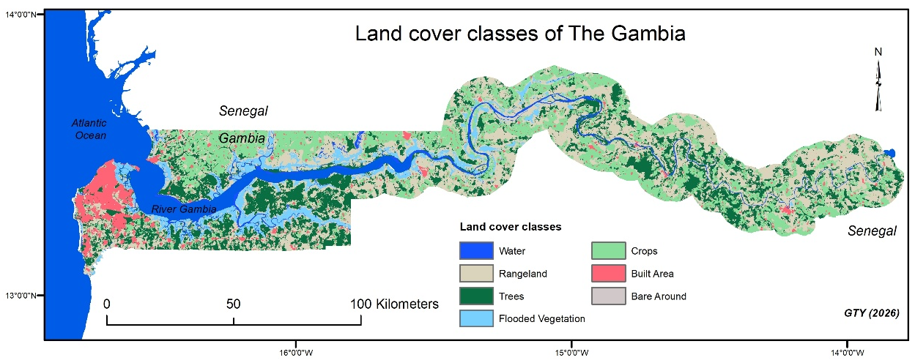
Figure 1. Land cover classes of The Gambia. Based on the Environmental Systems Research Institute (ESRI) global land use land cover (LULC) map, derived from Sentinel-2 at 10-meter resolution. Link: https://livingatlas.arcgis.com/landcover/
The Gambia River is the nation's hydrological backbone, with its lower reaches being tidal for over 200 kilometers, creating a dynamic estuarine environment where freshwater from the upper catchment mixes with saltwater from the Atlantic. This tidal influence shapes water resources through a salinity gradient that shifts seasonally and affects the distribution of aquatic and terrestrial ecosystems. The country’s wetlands arise from this hydro-climatic setting and include habitats such as mangroves, freshwater marshes, salt marshes, and seasonally flooded plains. These ecosystems support biodiversity, including internationally important populations of migratory waterbirds, and they underpin livelihoods through fisheries, agriculture, and forest products (Harou et al., 2022; Convention on Wetlands, 2021). The Tanbi Wetland National Park and the Bao Bolong Wetland Reserve, both designated as Ramsar sites, illustrate national commitments to wetland conservation. Together, geographic setting, climate, and hydrology create a landscape that is resilient in some years and highly exposed in others, which makes national-scale evidence on wetland dynamics important for planning and management.

Data Sources
Land cover information was derived from the GLC_FCS30D Global 30‐meter Land Cover Change Dataset, covering the period from 1985 to 2022. As described by Zhang et al. (2024), this dataset was produced through the integration of dense time‐series Landsat imagery with a continuous change‐detection algorithm. The product delivers high-resolution land cover maps that categorize the Earth’s surface into 36 distinct classes. For the present study, wetlands were specifically identified by focusing on classes with codes 181 through 187, which include Swamp (181), Marsh (182), Flooded Flat (183), Mangrove (185), Salt Marsh (186), and Tidal Flat (187) (Table 1).

Table 1. Wetland classes and their descriptions the GLC_FCS30D dataset (Zhang et al. 2024).
Wetland class | Code | Description
Swamp | 181 | Wetlands dominated by woody vegetation, typically saturated with water.​
Marsh | 182 | Wetlands frequently inundated, characterized by herbaceous plants.​
Flooded Flat | 183 | Flat terrains subject to periodic flooding.​
Mangrove | 185 | Coastal wetlands dominated by mangrove species.​
Salt Marsh | 186 | Coastal grasslands regularly flooded by seawater.
Tidal Flat | 187 | Flat, muddy areas exposed during low tide and submerged during high tide.​

The data are available online, held on the Google Earth Engine Data Catalogue (https://developers.google.com/earth-engine/datasets), and were extracted through the Google Earth Engine Platform (https://code.earthengine.google.com). The data processing workflow entailed several key steps: atmospheric correction, geometric alignment, and temporal mosaicking, followed by a classification process based on continuous change detection. This multi-step procedure yielded both annual and multi-year composites that are robust for long-term change detection, with validation efforts corroborating the dataset’s accuracy against ground-based observations and other established land cover products.

Analysis
To isolate the wetland areas within The Gambia, a country administrative boundary mask was applied during the initial data extraction phase. This mask ensured that only pixels corresponding to the seven designated wetland classes were considered. The resulting spatial outputs were then exported as GeoTIFF files for two time points - 1985 and 2022, to facilitate further spatial analyses in ArcGIS Desktop. Concurrently, two sets of CSV files were generated: one at the level‐1 administrative unit and another at the national level. These tables document the area, expressed in square kilometers, occupied by each wetland class, thereby enabling a detailed temporal comparison of wetland distribution throughout the study period.

A continuous time series of wetland area data for The Gambia was compiled from the land cover datasets to assess temporal trends in areal extent. To robustly identify significant shifts in wetland dynamics, Pettitt’s Test was applied (Pettitt, 1979), a non-parametric method capable of detecting abrupt changes (breakpoints) within the time series. For each potential change point t, a test statistic U(t) was computed using the summation of sign differences between observations before and after t. The maximum absolute value of U(t), designated as the Pettitt statistic K, signalled the most likely change point τ. The statistical significance of the detected change point was assessed using an approximate p-value formulation proposed by Pettitt (1979), expressed as:
p ≈ 2 exp[−6K² / (n³ + n²)]

where K is the maximum absolute value of the Pettitt test statistic U(t), and n denotes the length of the time series. This approximation estimates the probability of observing a change point as extreme as K under the null hypothesis of no change point. Complementing this breakpoint detection, a linear regression-based trend analysis was conducted using ordinary least squares (OLS) regression, wherein the linear model is represented as:

y = β₀ + β₁x + ϵ

Here, y denotes the wetland area for a given year, β₀ is the intercept, β₁ is the slope indicating the rate of change, and ϵ represents the error term. The parameters β₀ and β₁ were estimated by minimizing the sum of squared residuals, thereby quantifying both the direction and magnitude of the overall trend across the study period.

In order to further explore spatial variability in wetland changes among administrative regions, K-Means clustering was employed. Initially, absolute changes in wetland area for each class were calculated as ΔArea = Area(2022) − Area(1985). The data were then organized into a matrix, with administrative regions represented as rows and wetland classes as columns. The K-Means algorithm partitioned the regions into k = 3 clusters by minimizing the within-cluster sum of squares, formally defined by MacQueen (1967) as:

min ∑ᵢ₌₁ᵏ ∑ₓ∈Cᵢ ‖x − μᵢ‖²

where Cᵢ is the set of observations in cluster i and μᵢ is the centroid of cluster i. This clustering analysis was conducted using the scikit-learn library in Python (Pedregosa et al., 2011), which provided an efficient and reproducible implementation of the K-Means algorithm.

Together, these methods offer a dual perspective on the temporal and spatial dynamics of wetland ecosystems in The Gambia. The linear regression analysis elucidates the long-term trajectory of wetland area changes, while Pettitt’s Test identifies episodic shifts that may correspond to external events or management interventions. Furthermore, the application of K-Means clustering reveals regional patterns of change, enabling the identification of administrative areas that have experienced similar trends in wetland dynamics. Following breakpoint identification, a piecewise linear regression was fitted with the breakpoint fixed at the Pettitt estimate to quantify segment-specific trends and any level shift (Muggeo, 2003).

By integrating these quantitative analyses, the methodology supports assessment of both gradual trends and abrupt transitions in wetland cover. The resulting evidence can inform conservation strategies and management actions aimed at maintaining ecological integrity and the benefits that wetlands provide in The Gambia.

3. results

The analysis of the 38-year land cover record yielded three principal sets of findings: national-level trends in total wetland area, changes in the composition of individual wetland classes, and the spatial distribution of these dynamics across The Gambia's administrative regions.
3.1 Increase in the national wetland area
National-level analysis of wetland area indicates an overall increase from 1136.223 km² in 1985 to 1252.231 km² in 2022 (Figure 2). Annual data reveal an upward trend with intermediate values of 1161.894 km² in 1990, 1193.845 km² in 1995, and 1201.063 km² in 2000 (Figure 3). A slight fluctuation was observed in the early 2000s with the area declining to 1179.309 km² in 2003 before stabilizing around 1196 - 1208 km² between 2004 and 2010, followed by a notable increase to 1230.219 km² in 2011. Subsequent years witnessed further consolidation and gradual growth, culminating in values of 1258.999 km² in 2014, 1268.027 km² in 2015, and reaching 1282.896 km² in 2016, before a minor decline and stabilization around 1242–1255 km² in the later years (Figure 3). Collectively, these data demonstrate a consistent, albeit gradual, expansion of wetland area over the study period.
Figure 2. Changes in the area of wetland classes at the national level (1985-2022).

An OLS regression analysis was conducted to evaluate the annual change in wetland area at the national level (Figure 3). The model revealed a statistically significant positive trend, with the Year coefficient estimated at 3.27 km² (SE = 0.401, p < 0.001), indicating that, on average, the wetland area in The Gambia increased by approximately 3.27 km² per year over the study period. The regression model accounted for 73.5% of the variance in wetland extent (R² = 0.735; adjusted R² = 0.724), and an overall F-statistic of 66.64 (p < 0.000001) confirmed the robustness of the relationship. These results provide compelling evidence for a sustained and statistically significant expansion of wetland areas nationally.

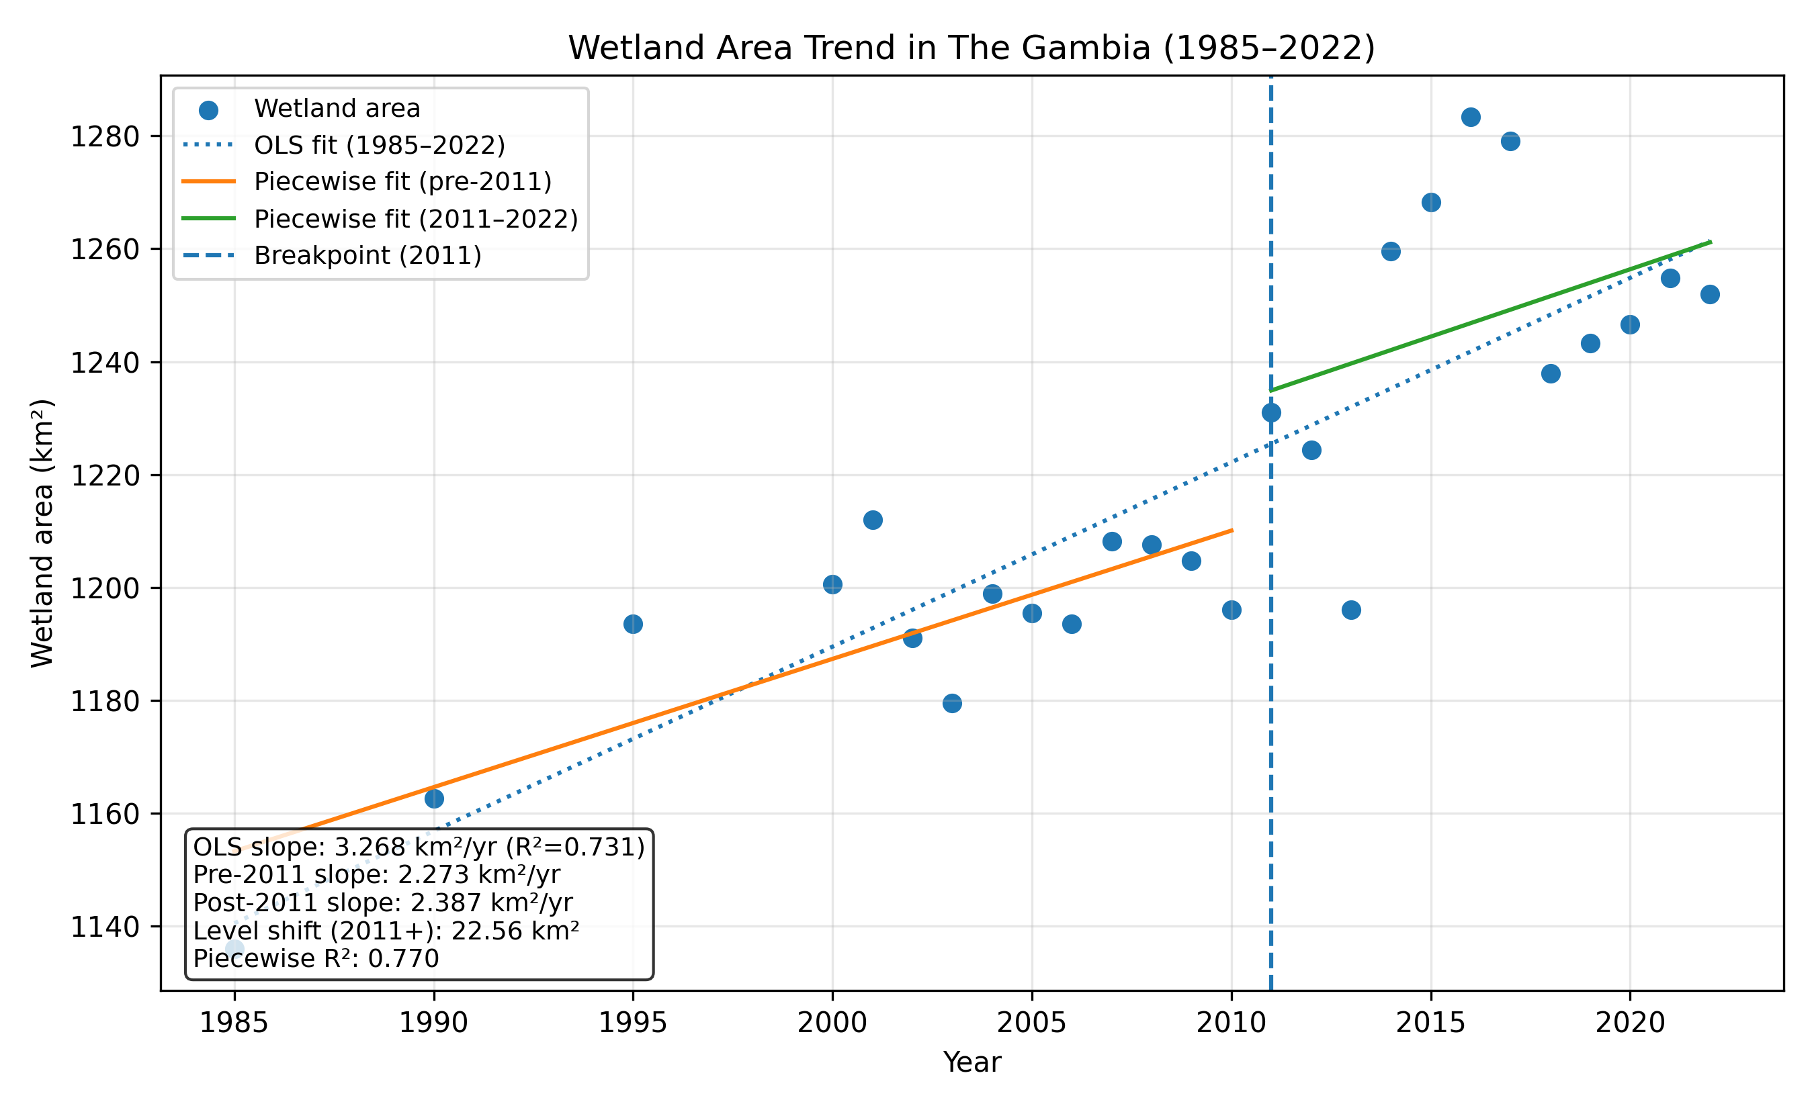
Figure 3. Temporal trend of national wetland area in The Gambia (1985–2022). Points show annual wetland area estimates. The dotted line shows the OLS regression fitted to the full series, while solid lines show the piecewise linear regression fits before and aft er the 2011 breakpoint. The vertical dashed line marks the change point identified by Pettitt’s test.

Pettitt’s Test was applied to the national wetland area time series to detect abrupt changes in its trajectory. The analysis yielded a test statistic (K) of 154.0, with a change point index (τ) of 14, corresponding to the year 2011 (Figure 3). This result was statistically significant (p = 0.00082), indicating that a distinct and abrupt shift in wetland area occurred in 2011. To characterise the regime change indicated by Pettitt’s test, a piecewise linear regression was fitted, with a breakpoint fixed at 2011. The model fitted was:
Area_t = β0 + β1·Year_t + β2·I(Year_t ≥ 2011) + β3·max(0, Year_t − 2011) + ε_t
where β2 represents a level shift at 2011 and β3 represents a change in slope after 2011.

The model suggests an upward level shift of approximately 22.6 km² at 2011 and continued positive trends of 2.27 km² yr⁻¹ before 2011 and 2.39 km² yr⁻¹ during 2011–2022 (model R² = 0.770) (see Figure 3).

3.2 Wetland types and changes
At the national level, wetland class composition and changes were evaluated for 1985 and 2022. The analysis revealed that the area occupied by Swamp wetlands increased from 2.95 km² in 1985 to 3.59 km² in 2022, while Marsh wetlands expanded from 251.49 km² to 354.33 km² over the same period (Figure 4). In contrast, Flooded Flat areas declined from 73.49 km² in 1985 to 53.64 km² in 2022. Mangrove wetlands exhibited a modest increase, growing from 808.73 km² to 834.00 km², and Salt Marsh areas showed a marginal reduction from 0.0129 km² to 0.0078 km². Notably, Tidal Flats, which were absent in 1985, emerged in 2022 with an area of 7.33 km².

Figure 4. Comparing changes in wetland classes at the national level (1985 and 2022).

3.3 Regional difference in wetland coverage
At the regional level, the absolute extent of wetlands varied considerably, with the North Bank region exhibiting the largest wetland area at 442.30 km², followed by the Lower River (269.10 km²) and Central River (260.14 km²) (see Table 2). In contrast, the Upper River had a markedly low wetland area of only 19.84 km². The Kanifing Municipal Council (KMC) region, despite its relatively small total area (116.39 km²), possessed a substantial wetland area of 38.17 km², while the West Coast recorded 217.91 km² of wetlands from a total area of 1949.47 km².

Table 2. Distribution of wetland area by administrative region in 2022.
Administrative  area | Region area  (km sq) | Wetland area  (km sq) | Wetland area  (%)
KMC | 116.4 | 38.2 | 32.8
Central River | 2970.9 | 260.1 | 8.8
Lower River | 1640.4 | 269.1 | 16.4
North Bank | 2609.1 | 442.3 | 17.0
Upper River | 1960.3 | 19.8 | 1.0
West Coast | 1949.5 | 217.9 | 11.2

Expressed as a percentage of the total regional area, the KMC region demonstrated the highest wetland density at 32.79%, a finding that is particularly notable given its limited spatial extent (Table 2). On the other hand, the Upper River’s wetlands accounted for just 1.01% of its total area, underscoring a pronounced regional disparity. The Central River, Lower River, and North Bank regions exhibited moderate wetland coverage percentages of 8.76%, 16.40%, and 16.95%, respectively, whereas the West Coast region displayed a wetland coverage of 11.18%. These results indicate that while some regions boast large absolute areas of wetlands, the proportionate coverage relative to regional size varies markedly, highlighting the need for region-specific conservation and management strategies.

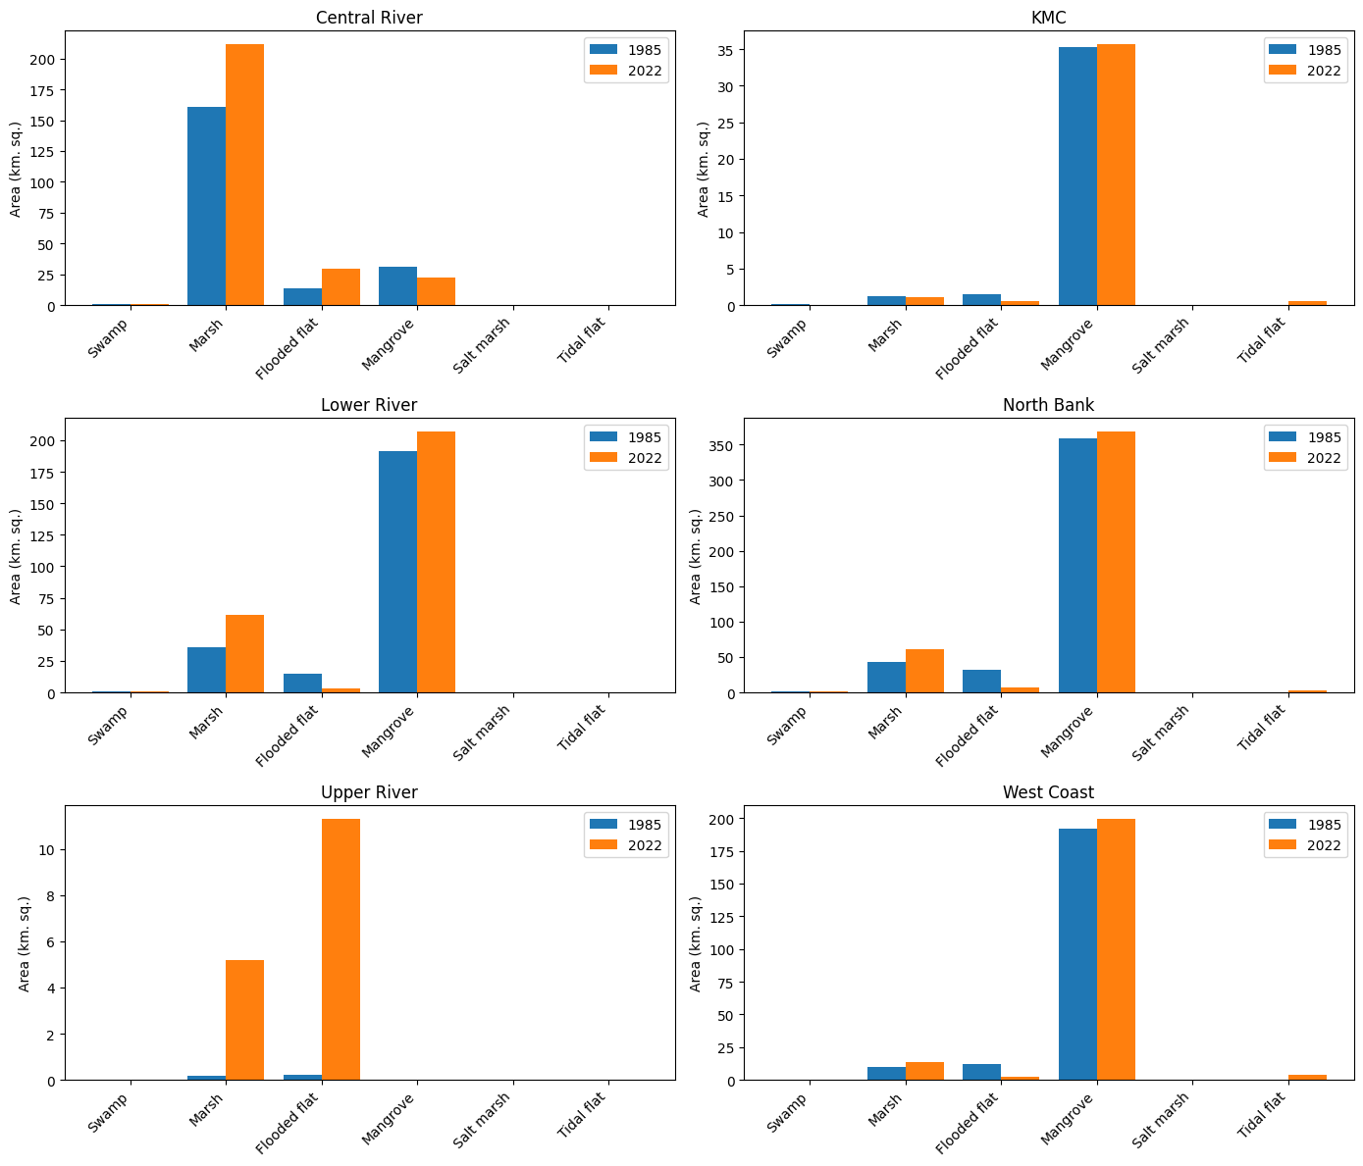
Figure 5. Changes in wetland type by region (1985-2022).

The regional breakdown of wetland class changes between 1985 and 2022 reveals distinct patterns of transformation across The Gambia's six administrative divisions (Figure 5). The Central River region experienced the most pronounced shift, with marsh area expanding from approximately 157 km² to 210 km², while mangrove coverage declined from roughly 30 km² to 20 km². In the Lower River region, mangrove remained the dominant wetland type and increased slightly from 191 km² to 206 km², accompanied by marsh expansion from 37 km² to 68 km² and a reduction in flooded flat area. The North Bank region, which hosts the largest mangrove extent in the country, showed relative stability in mangrove coverage (approximately 350 km² in both periods), though marsh area declined from 50 km² to 35 km² and flooded flat decreased markedly. The Upper River region, dominated by freshwater systems, exhibited substantial marsh expansion from less than 1 km² to over 5 km² and mangrove growth from near zero to approximately 11 km². Kanifing Municipal Council (KMC), the smallest and most urbanized division, maintained limited wetland coverage with mangrove as the predominant class at roughly 35 km². The West Coast region displayed stability in its mangrove-dominated wetland system at approximately 195 km², with minor increases in tidal flat area.

3.4 Regional patterns of changes in wetland area
K-Means clustering of administrative regions revealed three distinct clusters with varying patterns of wetland change between 1985 and 2022. Cluster 0, comprising the North Bank and Lower River regions, exhibited pronounced declines in Flooded flat areas, with reductions of –24.32 km² and –11.78 km², respectively (Table 3). In parallel, these regions experienced moderate to large gains in Marsh (North Bank: +17.32 km²; Lower River: +25.65 km²) and Mangrove areas (North Bank: +9.52 km²; Lower River: +15.97 km²). Both regions showed emergent or expanding Tidal flats (North Bank: +2.60 km²; Lower River: +0.20 km²), while changes in Swamp and Salt marsh classes were minimal. These results suggest a transformation from seasonally flooded areas toward more permanent wetland types, notably Marsh and Mangrove, accompanied by the onset of Tidal flat development (see the change profile and observation in Table 3).

Table 3. Regional absolute change in wetland area by class (2022 - 1985) based on a K-Means clustering algorithm. Three clusters are identified as having similar patterns of change.
Region | Flooded flat | Mangrove | Marsh | Salt marsh | Swamp | Tidal flat | Cluster
North Bank | -24.3152 | 9.5230 | 17.3155 | -0.0082 | 0.7282 | 2.6031 | 0
Lower River | -11.7795 | 15.9678 | 25.6549 | 0.0000 | 0.0019 | 0.1999 | 0
KMC | -0.9988 | 0.4316 | -0.0452 | 0.0043 | -0.0661 | 0.5904 | 1
Upper River | 11.1101 | 0.0000 | 5.0432 | 0.0000 | 0.0000 | 0.0000 | 1
West Coast | -9.7359 | 7.8476 | 3.8478 | -0.0010 | -0.0346 | 3.5279 | 1
Central River | 15.8688 | -8.4990 | 51.0267 | 0.0000 | 0.0134 | 0.4067 | 2

Cluster 1, which includes KMC, Upper River, and West Coast, displayed heterogeneous change patterns. KMC registered moderate losses in Flooded flat (–1.00 km²) and slight declines in both Marsh (–0.05 km²) and Swamp (–0.07 km²) areas, alongside small gains in Mangrove (+0.43 km²) and a notable emergence of Tidal flats (+0.59 km²). In stark contrast, Upper River demonstrated substantial increases from near-zero baselines in Flooded flat (+11.11 km²) and Marsh (+5.04 km²) areas, while other classes remained unchanged. West Coast exhibited significant reductions in Flooded flat (–9.74 km²), coupled with moderate gains in Mangrove (+7.85 km²) and Marsh (+3.85 km²) areas, a small decline in Swamp (–0.03 km²), and an increase in Tidal flats (+3.53 km²). Overall, Cluster 1 is characterized by mixed trends, with some regions showing declines in Flooded flat areas and others, such as Upper River, demonstrating robust increases, alongside variable gains in Marsh, Mangrove, and Tidal flat classes (Table 4).

Table 4. Profiling the three clusters resulting from the k-means analysis.
Cluster | Regions | Change profile | Observation
0 | NBR LRR | Both show large losses in Flooded flat but strong gains in Marsh and Mangroves, alongside smaller positive changes in Tidal flat. Swamp and Salt marsh remain relatively unchanged or show only minor increases/decreases. | A pronounced shift away from Flooded flat toward Marsh and Mangroves, with Tidal flat also appearing but at lower absolute magnitudes.
1 | KMC  URR  WCR | KMC has moderate losses in Flooded flat and Swamp, small declines in Marsh, and modest increases in Mangrove and Tidal flat.  Upper River sees large gains in Flooded flat and Marsh (from near-zero baselines), with minimal or zero change in other classes.  West Coast experiences notable losses in Flooded flat, moderate expansions in Mangrove, Marsh, and Tidal flat, and slight declines in Swamp. | A mixed pattern of gains and losses, where Flooded flat can either increase substantially (Upper River) or decrease (KMC, West Coast), but Marsh tends to rise, and Tidal flat often appears as a new or expanding category.
2 | CRR | A substantial increase in both Flooded flat and Marsh, combined with a noticeable decline in Mangrove. Swamp, Salt marsh, and Tidal flat remain minor or unchanged relative to these shifts. | The region stands out for its very large gains in Marsh (+51) and Flooded flat (+16) while losing Mangroves (-8.5). This unique pattern sets it apart from other regions, leading to its own cluster.

In contrast, Cluster 2, represented solely by the Central River region, is distinguished by a unique pattern of wetland reconfiguration. Here, Flooded flat areas increased substantially by +15.87 km², while Marsh areas experienced a very large gain of +51.03 km². This shift was coupled with a moderate decrease in Mangrove areas (–8.50 km²), whereas changes in Swamp (+0.01 km²) and Tidal flat (+0.41 km²) classes were minimal, and Salt marsh remained unchanged. The pronounced expansion of Marsh areas concurrent with the decline in Mangrove coverage in Central River highlights a strong reallocation of wetland types, setting this region apart from the other clusters and underscoring the spatial variability in wetland dynamics across The Gambia.

4. Discussion

The results indicate a net increase in mapped wetland area from 1985 to 2022, with gains concentrated in flooded flat and marsh-related classes, alongside declines in mangrove- and salt marsh-associated classes in parts of the record (Zhang et al., 2024). Comparable multi-scale studies across Africa emphasise that wetland trajectories are heterogeneous: local gains can co-occur with fragmentation and conversion pressures near population centres (Li et al., 2022; Garba et al., 2025). In The Gambia, the spatial clustering of gains along the lower River Gambia and associated floodplains may reflect a combination of hydroclimatic variability and land management, including the expansion of seasonally inundated agriculture and changes in channel–floodplain connectivity (Ceesay & Touray, 2022; Harou et al., 2022).

The breakpoint analysis identifies 2011 as a change point, with a steeper increase in total mapped wetlands thereafter. Dense time-series approaches have been used in wetland and tidal-wetland applications to isolate periods of rapid conversion or hydrologic reorganisation within long Landsat records (Yang et al., 2022). In The Gambia, a breakpoint around 2011 is consistent with the sensitivity of floodplain and estuarine wetlands to interannual rainfall variability and with potential shifts in land and water management during the early 2010s; attributing the change requires coupling land-cover trajectories with hydrological observations and land-use data (Ceesay & Touray, 2022; Convention on Wetlands, 2021; Thamaga et al., 2021).

The increasing trend in overall wetland area observed at the national scale may therefore reflect both hydroclimatic forcing and human land use. Analyses of Gambian precipitation show interannual variability and periods of intensified rainfall that can expand seasonal inundation across floodplains and low-gradient basins (Ceesay & Touray, 2022). Such flood pulses can expand inundated areas and shift the boundary between flooded flats, marsh, and mangrove units captured in annual Landsat composites (Mejía-Ávila et al., 2019). At the same time, global syntheses emphasise that wetland area and condition are sensitive to drainage, agricultural conversion, and infrastructure development, which can amplify or counteract climate-driven signals depending on location and governance context (Convention on Wetlands, 2021; Thamaga et al., 2021).

Comparative evidence from other regions illustrates that wetland trajectories often combine long-term directional change with episodic shifts. In the northeastern United States, Landsat time series indicate persistent conversion of vegetated tidal wetlands to open water in the context of relative sea-level rise (Yang et al., 2022). Across Africa, continental wetland maps highlight extensive wetland area concentrated near equatorial latitudes and large seasonal dynamics in marsh systems (Li et al., 2022), while high-resolution classification indicates that fragmentation is associated with high population density in several countries (Garba et al., 2025). Global change products for mangroves show that net losses are common in many regions, though rates and uncertainty vary by baseline definition and detection approach (Bunting et al., 2022). Syntheses of wetland remote-sensing research also underline that observed trends depend on sensor choice, temporal density, classifier design, and validation practice (Jafarzadeh et al., 2022; Abdelmajeed et al., 2023). Against this backdrop, the post-2011 increase in mapped wetlands in The Gambia suggests that hydrologic variability and land management may, at least temporarily, offset some conversion pressures, but the concurrent decline in coastal wetland classes points to continued exposure in estuarine zones (Harou et al., 2022; Convention on Wetlands, 2021).

The regional clustering analysis indicates that wetland change is not spatially uniform, with distinct trajectories for floodplain-dominated interior zones and coastal estuarine settings. Such heterogeneity is consistent with continental-scale mapping that shows strong latitudinal controls on wetland distribution, large seasonal dynamics in marsh systems, and high sensitivity to local topography and hydrology (Li et al., 2022). In addition, evidence that wetland fragmentation is associated with large human populations across Africa highlights a plausible mechanism for divergence among Gambian regions as settlement densities and land-use intensity increase (Garba et al., 2025).

The observed shifts in wetland class composition have management implications. Flooded flats and marshes that expand under wetter conditions can support fisheries and grazing, but they may also coincide with agricultural encroachment or sedimentation that alters habitat quality, so area change alone does not capture ecological status (Convention on Wetlands, 2021). For coastal wetlands, the decline in mangrove-associated classes is consistent with Gambian analyses of mangrove land-cover transitions, where erosion, salinity change, and local resource pressures interact (Harou et al., 2022). Broader global products also show that mangrove losses outpace gains in many regions, though rates and uncertainty vary by baseline definition and change-detection approach (Bunting et al., 2022). For salt marsh and tidal-flat classes, apparent declines may also reflect classification ambiguity in narrow estuarine zones where vegetation, turbidity, and tidal state vary within and across years (Yang et al., 2022; Zhang et al., 2024). Seasonal hydrology and spatial heterogeneity shape wetland biogeochemical function; wet-season groundwater heterogeneity has been linked to diverse gene cycling potentials in a paddy wetland ecosystem (Chen et al., 2024).

Several limitations should be considered when interpreting these results. The GLC_FCS30D product provides annual 30 m land-cover labels and has been validated globally, yet wetland boundaries and narrow coastal habitats remain prone to mixed pixels and confusion among spectrally similar classes, particularly where tidal state or seasonal flooding varies within the image archive (Zhang et al., 2024; Yang et al., 2022). A transparent national accuracy and uncertainty assessment would therefore strengthen inference about trend magnitude and class-specific conversions, and recent community guidance provides practical protocols for sampling design, reference data collection, and reporting of uncertainty in area and change estimates (Tyukavina et al., 2025).

A practical use of this work is to provide a national baseline for screening where wetland gains and losses concentrate, supporting the prioritisation of field verification, restoration planning, and environmental impact review. By locating change hotspots, agencies can align monitoring effort with the locations where conversion pressure and ecological risk are likely to be highest, including peri-urban floodplains and sensitive estuarine margins (Convention on Wetlands, 2021; Garba et al., 2025).

Future research can extend this analysis in three directions. First, multi-sensor fusion can reduce misclassification in cloudy seasons and improve discrimination of flooded agriculture, mangrove edges, and narrow riparian wetlands; reviews and meta-analyses indicate that combined optical and Synthetic Aperture Radar (SAR) inputs, implemented through cloud platforms, can improve wetland monitoring performance at scale (Abdelmajeed et al., 2023; Jafarzadeh et al., 2022). Second, operational monitoring could incorporate near–real-time land-cover probabilities to flag potential conversion events for rapid follow-up, drawing on products such as Dynamic World (Brown et al., 2022). Third, a cumulative framework for ongoing investigation should link annual land-cover transitions to hydroclimatic indicators and policy timelines so that attribution can be tested quantitatively, and management actions can be evaluated against measurable wetland outcomes (Steinbach et al., 2021; Convention on Wetlands, 2021; Thamaga et al., 2021).

A cumulative monitoring programme for The Gambia would benefit from shared definitions of wetland classes, version-controlled processing scripts, and periodic independent reference sampling so that successive assessments remain comparable as sensors and classifiers change. Recent guidance on land-cover and change map validation provides a basis for reporting confidence intervals for both wetland area and change, facilitating comparison across products and years (Tyukavina et al., 2025). Building on modular decision-oriented approaches proposed for East African wetland management, national agencies could adopt an iterative cycle of map production, validation, stakeholder review, and targeted field campaigns, thereby turning remote-sensing outputs into a living evidence base for management and research (Steinbach et al., 2021).

Taken together, the results point to a complex national trajectory: mapped wetland area increases over the full record, yet class-specific declines in coastal wetlands suggest persistent vulnerability in estuarine settings. Interpreting these patterns requires attention to both hydroclimatic variability and land-use decisions, and it benefits from situating national trends alongside regional and global evidence on wetland dynamics (Li et al., 2022; Convention on Wetlands, 2021; Garba et al., 2025).

Conclusion

This study provides robust evidence of significant changes in the wetland ecosystems of The Gambia between 1985 and 2022. National-level analyses indicate a statistically significant increase in overall wetland area, with an average annual gain of 3.27 km², alongside notable shifts in wetland class composition. Specifically, the expansion of Marsh and Mangrove areas, the reduction in Flooded flat regions, and the emergence of Tidal Flats collectively signal a transformation in wetland dynamics that may be driven by both climatic variability and anthropogenic influences. The detection of an abrupt change in 2011 via Pettitt’s Test further underscores the dynamic and non-linear nature of changes in these ecosystems.

At the regional level, K-Means clustering indicates that administrative regions follow different wetland-change trajectories, consistent with the influence of local land use and hydrological modification on wetland responses. These spatial differences matter for biodiversity, ecosystem service delivery, and livelihoods that rely on wetland resources. Method limitations 30 m resolution and class confusion in mixed coastal pixels constrain precision, but the combined trend, breakpoint, clustering, and transition analyses provide a reproducible approach for monitoring wetland dynamics.

Future research could incorporate higher-resolution imagery, targeted field validation, and interdisciplinary datasets to test competing explanations for change and to separate hydrological variability from persistent land conversion. Such work would support adaptive management by linking mapped transitions to ecological condition and to the welfare outcomes that depend on wetland functioning. In West African settings where monitoring gaps remain common, sustained national time series paired with transparent validation can also facilitate comparison across countries and across assessment cycles.

ACKNOWLEDGEMENT
This study made use of freely available satellite-derived land-cover data provided through the Google Earth Engine platform. The Global Land-Cover Dynamics Monitoring Product (GLC_FCS30D) was accessed via the Google Earth Engine Data Catalogue, which is maintained by Google LLC in collaboration with international data providers. The GLC_FCS30D dataset was developed and released by the research teams led by Zhang et al. and Liu et al., and is openly distributed for scientific research and environmental monitoring. The author acknowledges the institutions and data infrastructures that support open access to Earth observation data, which enable reproducible, long-term environmental analyses at regional and global scales.

DISCLAIMER (ARTIFICIAL INTELLIGENCE)

Author hereby declare that NO generative AI technologies such as Large Language Models (ChatGPT, COPILOT, etc.) and text-to-image generators have been used during the writing or editing of this manuscript.

References
1. Abdelmajeed, Y., Saleous, N. and Smith, D. (2023) Cloud-Based Remote Sensing for Wetland Monitoring: A Review. Remote Sensing, 15(6), 1660. https://doi.org/10.3390/rs15061660

2. Brown, C.F., Brumby, S.P., Guzder-Williams, B., Birch, T., Hyde, S.B., Mazzariello, J., et al. (2022) Dynamic World, Near real-time global 10 m land use land cover mapping. Scientific Data, 9, 251. https://doi.org/10.1038/s41597-022-01307-4

3. Bunting, P., Rosenqvist, A., Hilarides, L., Lucas, R.M., Thomas, N., Tadono, T., et al. (2022) Global Mangrove Extent Change 1996–2020: Global Mangrove Watch Version 3.0. Remote Sensing, 14(15), 3657. https://doi.org/10.3390/rs14153657

4. Ceesay, A. and Touray, L. (2022) Precipitation patterns in the Gambia from 1981 to 2020. Geographica Pannonica, 26(2),102-111. https://doi.org/10.5937/gp26-36724

5. Convention on Wetlands. (2021) Global Wetland Outlook: Special Edition 2021. Secretariat of the Convention on Wetlands, Gland, Switzerland.

6. Garba, S.I., Ebmeier, S.K., Bastin, J.-F., Mollicone, D. and Holden, J. (2025) Wetland fragmentation associated with large populations across Africa. Nature Communications, 16, 5065. https://doi.org/10.1038/s41467-025-59373-2

7. Government of The Gambia. (1994) National Environment Management Act 1994. Banjul, The Gambia. https://faolex.fao.org/docs/pdf/gam6275A.pdf

8. Government of The Gambia. (2003) Biodiversity and Wildlife Act, 2003. Banjul, The Gambia. https://www.ampeid.org/documents/gambia-(republic-of-the)/biodiversity-and-wildlife-act-2003/

9. Harou, I.L., Inyele, J., Minang, P. and Duguma, L. (2022) Understanding the states and dynamics of mangrove forests in land cover transitions of The Gambia using a Fourier transformation of Landsat and MODIS time series in Google Earth Engine. Frontiers in Forests and Global Change, 5, 934019. https://doi.org/10.3389/ffgc.2022.934019

10. Jafarzadeh, S., Or, D. and Chavoshian, A. (2022) Remote Sensing and Machine Learning Tools to Support Wetland Monitoring: A Meta-Analysis of Three Decades of Research. Remote Sensing, 14(23), 6104. https://doi.org/10.3390/rs14236104

11. Jaiteh, M.S. and Sarr, B. (2011) Climate Change and Development in The Gambia. Ministry of The Environment, Climate Change and Natural Resources (MECCNAR). Banjul, The Gambia. https://doi.org/10.13140/2.1.1731.1040

12. Li, A., Song, K., Chen, S., Mu, Y., Xu, Z. and Zeng, Q. (2022) Mapping African wetlands for 2020 using multiple spectral, geo-ecological features and Google Earth Engine. ISPRS Journal of Photogrammetry and Remote Sensing, 193, 252–268. https://doi.org/10.1016/j.isprsjprs.2022.09.009

13. Mitsch, W.J. and Gosselink, J.G. (2015) Wetlands (5th ed.). Hoboken, NJ: John Wiley & Sons.

14. Muggeo, V.M.R. (2003) Estimating regression models with unknown break-points. Statistics in Medicine, 22(19), 3055–3071. https://doi.org/10.1002/sim.1545

15. Pedregosa, F., Varoquaux, G., Gramfort, A., Michel, V., Thirion, B., Grisel, O., et al. (2011) Scikit-learn: Machine Learning in Python. Journal of Machine Learning Research, 12, 2825–2830. http://jmlr.org/papers/volume12/pedregosa11a/pedregosa11a.pdf

16. Mejía-Ávila, D., Soto, F., Barrera, R., Martínez, D., & Lara, A. (2019). Spatio-temporal modeling of wetland ecosystem using Landsat time-series data. Annals of GIS, 25(3), 231–245. https://doi.org/10.1080/19475683.2019.1617347

17. Pettitt, A.N. (1979) A non-parametric approach to the change-point problem. Applied Statistics, 28(2), 126–135. https://doi.org/10.2307/2346729

18. MacQueen, J. (1967). Some methods for classification and analysis of multivariate observations. Proceedings of the Fifth Berkeley Symposium on Mathematical Statistics and Probability, 1, 281–297. https://projecteuclid.org/euclid.bsmsp/1200512992

19. Steinbach, S., Cornish, N., Franke, J., Hentze, K., Strauch, A., Thonfeld, F., Zwart, S.J. and Nelson, A. (2021) A new conceptual framework for integrating Earth observation in large-scale wetland management in East Africa. Wetlands, 41, 93. https://doi.org/10.1007/s13157-021-01468-9

20. Thamaga, K.H., Dube, T. and Shoko, C. (2021) Advances in satellite remote sensing of the wetland ecosystems in Sub-Saharan Africa. Geocarto International. https://doi.org/10.1080/10106049.2021.1926552

21. Tyukavina, A., Stehman, S.V., Foody, G.M., Bontemps, S., Komarova, A., Tsendbazar, N.-E. and Nickeson, J.E. (Eds.) (2025) Land Cover and Change Map Accuracy Assessment and Area Estimation Good Practices Protocol (Version 1.0). CEOS WGCV/LPV. lpvs.gsfc.nasa.gov/PDF/CEOS_WGCV_LPV_Land_Cover_protocol_Nov2025_V1.1.pdf

22. Yang, X., Zhu, Z., Qiu, S., Kroeger, K.D., Zhu, Z. and Covington, S. (2022) Detection and characterization of coastal tidal wetland change in the northeastern US using Landsat time series. Remote Sensing of Environment, 276, 113047. https://doi.org/10.1016/j.rse.2022.113047

23. Zhang, X., Zhao, T., Xu, H., Liu, W., Wang, J., Chen, X., and Liu, L. (2024) GLC_FCS30D: the first global 30 m land-cover dynamics monitoring product with a fine classification system for the period from 1985 to 2022 generated using dense-time-series Landsat imagery and the continuous change-detection method, Earth Syst. Sci. Data, 16, 1353–1381, https://doi.org/10.5194/essd-16-1353-2024

24. Chen, X., Sheng, Y., Wang, G., Zhou, P., Liao, F., & Mao, H. (2024). Wet season heterogeneity in groundwater reveals diverse gene cycling potentials in a paddy wetland ecosystem. Water Research, 259, 121105. https://doi.org/10.1016/j.watres.2024.121105

25. Prajapati, C., & Patel, P. (2025). Wetland as Ecosystem: A Review with Special Reference to Gujarat, India. Asian Journal of Environment & Ecology, 24(5), 114–127. https://doi.org/10.9734/ajee/2025/v24i5698

