Geoinformatics-Based Assessment of Urban Sprawl in Berhampur, Odisha, India

Abstract
The existing urban infrastructure of Berhampur city has been analysed using geoinformatics, leading to the development of a city planning strategy for a sprawling conglomeration of the coastal city, Berhampur, in South Odisha. This plan aims to assess overall development and promote sustainable urban growth, addressing the lack of literature on the subject. Berhampur, a major urban centre in southern Odisha, has experienced rapid population growth and urban sprawl over the past few decades. This research involved both primary and secondary data collection, field surveys, stakeholder consultations, and the analysis of existing plans and reports. Key components of urban infrastructure, such as transportation, water supply, sanitation, drainage, waste management, housing, and social amenities, were evaluated to identify gaps and constraints in service delivery. Using Geographical Information System (GIS) techniques, spatial mapping of both horizontal and vertical expansions visualises the distribution and adequacy of these necessary urban facilities. The findings indicate an uneven distribution of infrastructure, inadequate waste management systems, and limited open spaces in relation to the city's growing population. The study recommends strategic interventions for urban development in Berhampur, including improved infrastructure, slum redevelopment, enhanced public transport, and sustainable land use management in collaboration with Chhatrapur and Gopalpur. These suggestions aim to create a comprehensive City Development Plan (CDP) for Berhampur, fostering balanced and inclusive growth aligned with Sustainable Development Goal (SDG-11) for sustainable urban settlements.

Key Words: Coastal cities; land surface temperature; land use land cover; NDBI, Urban sprawling

1.0 Introduction
Urban sprawl is posing complex problems and has emerged as an upcoming threat over the last 4 to 5 decades in the Anthropocene epoch, driven by demography (Muchelo et al., 2024^{[1]}), pollution, ecosystem degradation, and socio-economic, political, and environmental factors as players (Mahdabi et al., 2022[02]; Chettri et al., 2023[03]; Soltani et al., 2025[04]). About two million hectares of farmland are lost per year to alleviate the growing need for housing, infrastructure, and leisure in agglomerations in developed countries (Surya et al., 2021[05]; Hassan et al., 2023[06]). Urban growth drives economic and social development, yet its rapid and unplanned growth poses major challenges for sustainable management.

Berhampur, also known as the “Silk City of Odisha,” is a key urban centre in southern Odisha, serving as a commercial, educational, and cultural hub for the Ganjam district. Situated near the Bay of Bengal at an elevation of about 26m, it covers an area of 37.09 sq. km. Named after Lord Brahmeswar, the city has seen rapid population growth and urban expansion, shifting from its traditional core to emerging peripheral areas. Its location along National Highway-16 and proximity to Gopalpur Port further enhance its significance.

As a fast-growing medium-sized city, Berhampur faces challenges such as unplanned development, traffic congestion, waste management issues, and inadequate public services. This study aims to assess the urban infrastructure through GIS-based analysis to support a sustainable City Development Plan (CDP) for balanced growth and improved quality of life in the urban geoinformatics and infrastructure planning in medium-sized cities.

1.2 The study area
Berhampur is a municipal corporation located on the eastern coastline of the Bay of Bengal (BoB) in the southernmost Ganjam district of Odisha. It is approximately 169 km from the state capital, Bhubaneswar. As one of the oldest and largest cities in Odisha, Berhampur is commonly referred to as “The Silk City” due to its silk trade, temples, and unique culture. The city has a population of 355,823 (estimated in 2011); 0.43 m² space is available/person dwelling in 74,720 households (HH). It is the fourth most populous city in Odisha. Berhampur serves as a trading hub for South Odisha and a Class-I Town (SLIP 2015). Presently, the city is agglomerating with a combination of Berhampur, Chhatrapur and Gopalpur Fig. 1(a and b) (AMRUT 2015[7])

a.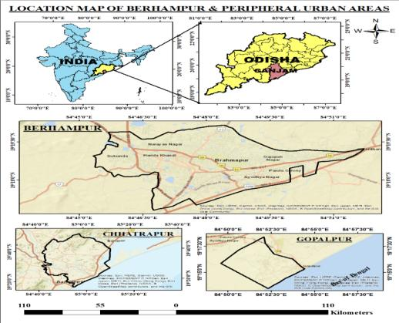
Fig 1 a: The index map of the 3-tier city of Berhampur, Chhatrapur and Gopalpur
Communication:
The city is connected to Kolkata and Madras via National Highway 16 (NH-16), and state highways SH 07, SH 17, and SH 65 also link the area. The nearest airport is in Bhubaneswar, which is approximately 160 km away. Currently, the town hosts several prominent industrial units, including Indian Rare Earths Limited (IREL) and Software Technology Parks of India (STPI). It is also home to the Centre of Entrepreneurship in FinTech, the Titanium Plant, and the proposed TATA SEZ and R.K. Power Plant. The city is notable for its contributions to healthcare, trade, engineering, IT, and tourism. It is evolving into a tier-3 city on the east coast of Odisha, alongside Berhampur, Gopalpur, and Chhatarpur, similar to Jatni in the Khordha-Jatin-Bhubaneswar triad (Mishra et al., 2020[08]) (Fig. 1 a; Fig 1 b: Fig. 1 c).
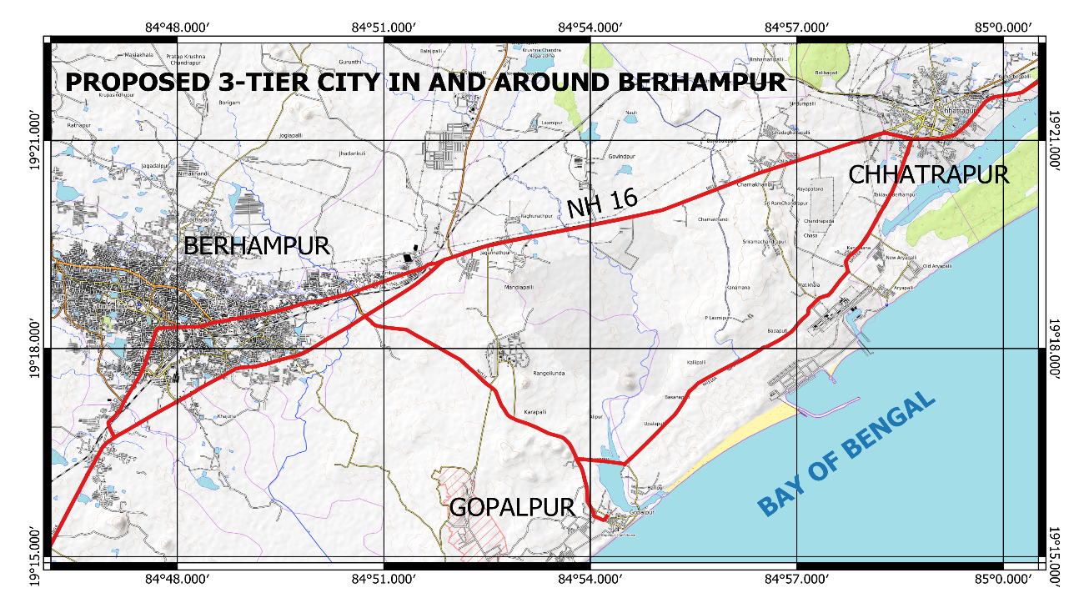

Fig 1 b: The three agglomerating urban areas in the South Odisha Coast (Berhampur, Gopalpur and Chhatrapur (Open Source Map 2000).
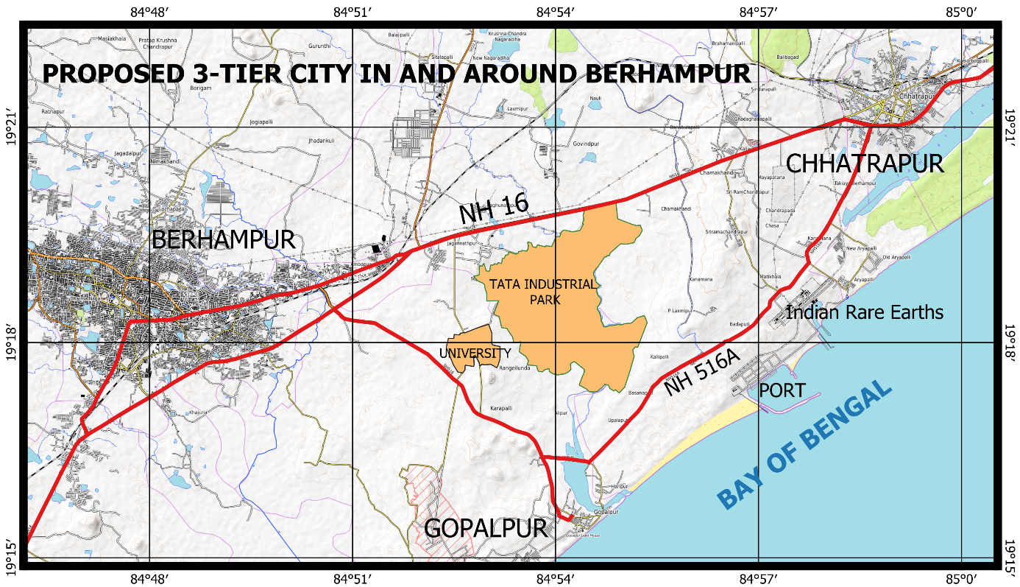

Fig 1 c: The three-tier city has sprawled and become close to each other by extension

Since the three urban towns have agglomerated and extended to touch each other by the construction of high-rise multi-storied buildings, WASH amenities and urban infrastructures. The upcoming Sagar Mala projects, with adequate connectivity and educational hubs, will connect the three townships in future. It is essential to conduct a detailed study and strategic planning to devise a three-tier city connecting Berhampur with Chhatrapur and Gopalpur.

1.3 Demography

As per Wikipedia, in 1867, Berhampur was a municipality under the British Madras Presidency. In 1900, the Brahmapur railway station was in operation. The present population (2024/25) has been projected as 446,000 (rate of growth 2.06%). The highest rate of rise was 5% in 1968, and the lowest was 1.24% during the COVID-19 pandemic, with a 1.45% growth rate from 2021 (Wikipedia). Gopalpur is a Notified Area Committee city in the Ganjam district, Odisha https://www.macrotrends.net/global-metrics/cities/21207/ brahmapur/ population. The Gopalpur township comprises 11 wards with a population of 7,221 (Census India 2011) projected to 10100 by 2025. Chatrapur city is in the outskirts of BeMC and has 14wards with a population of 22,027 (Census India 2011), which shall have a projected population of 32000, and 37900 in the year 2025 and 2031 https://www.census2011.co.in/data/town/801874-chhatrapur-orissa.html.

Berhampur is one of the oldest and fastest-growing cities in southern Odisha, facing major challenges due to rapid and unplanned urban expansion. Increasing population density has created heavy pressure on urban infrastructure and basic services. There is an urgent need to assess facilities like water supply, sanitation, drainage, transportation, housing, and solid waste management to ensure sustainable growth. The city has a considerable number of slum pockets, where poor living conditions, inadequate WASH (Water sanitation and Hygiene) facilities, and a lack of basic amenities are major issues (Mishra S et al., 2020[09]).

Waste Disposal:
Waste disposal and management remain key environmental concerns affecting urban health and cleanliness. A comprehensive study is required to evaluate the existing infrastructure, identify gaps, and guide the preparation of an effective City Development Plan (CDP). The study will help local authorities and planners to promote inclusive development and improve the overall quality of life in Berhampur.

Studies on medium-sized Indian cities, such as Berhampur, reveal several challenges, including unplanned expansion, inadequate public utilities, and limited institutional capacity. Research indicates that the development of Berhampur has mainly occurred in a linear pattern along major transportation corridors, specifically NH-216 (past NH-16) and the Howrah–Chennai railway line. This has resulted in uneven infrastructure distribution across the city. Existing literature also highlights problems related to water scarcity, drainage congestion, solid waste disposal, and traffic management.

Regional Settings of the Study Area
Berhampur, a key city in southern Odisha, is the commercial and educational centre of Ganjam district. It is situated between the Eastern Ghats to the west and the Bay of Bengal’s coastal plains to the east. The open plain slopes toward the sea, while the Mohiri hills, rising to about 800m, lie to the north and west, approximately 14 km from the city. Berhampur is 25 km from the Rushikulya River, which flows into the Bay of Bengal near Gopalpur port, with several small streams, including Ghodahad and the Bahuda River, running through the area.

Berhampur, a statutory town in Odisha, has a population of 355283 according to the 2011 census, making it the fourth most populous urban area in the state. The Berhampur Municipal Corporation (BeMC) is divided into 40 wards, covering an area of 3,709 sq km. It comprises 73,335 households, with approximately 19,134 of these households located in 163 slums that accommodate around 92,000 people (source: OWSSB, Rapid Assessment Report for Berhampur – 2018).

Additionally, the Berhampur Municipal Corporation, along with the notified area councils of Chhatrapur and Gopalpur, has spread over an area of 3,533 hectares, 387.42 hectares, and 190.73 hectares, respectively. Their corresponding populations are 356,598 for Berhampur, 22,027 for Chhatrapur, and 7,221 for Gopalpur.

A perfect amalgamation of Odia and Telugu communities can be seen here due to its being very near to the Odisha–Andhra border, which has turned itself into a major financial hub in Southern Odisha. The rate of urban expansion showed regional differences. Socioeconomic factors, political and institutional factors, natural factors, path effects, and proximity effects were the main driving factors. Urban expansion promoted economic growth, occupied cultivated land, and affected ecological environments.

Scope of The Study

The study encompasses the Berhampur Municipal Corporation (BeMC) area, which serves as the primary urban boundary. It focuses on urban infrastructure components — water supply, sanitation, drainage, transportation, housing, and solid waste management. Special emphasis is given to slum areas, identifying their location, living conditions, and access to basic services. The study intends to (i) evaluate the existing urban infrastructure and living conditions of Berhampur City for effective urban management. (ii) To develop a sustainable and inclusive City Development Plan (CDP) that promotes balanced growth and improves the quality of life.

Objectives:

The objectives of the study are:
- To assess urban sprawl and infrastructure challenges in a rapidly growing Berhampur city.
- The GIS interpretation of the open-source data-based spatial analysis with field observations and recommending the future planning perspectives of the three-tier city.
- To identify set-up gaps and propose strategies for sustainable implementation of SDG-11.

Limitations of the Study

The Neighbouring City Development Plan (CDP) for Berhampur under the JNNURM framework emphasises upgrading services, enhancing connectivity, and promoting sustainable urban management. Assessing current infrastructure and its alignment with the CDP is crucial for identifying gaps and prioritising investments for inclusive urban development.
Similar studies, like the Bhubaneswar CDP under the JNNURM and AMRUT, focus on improving water supply, waste management, stormwater drainage, and public transport through GIS mapping and land-use zoning to manage urban sprawl.
Visakhapatnam’s Smart City Plan also adopts sustainable urban development, concentrating on renewable energy, smart waste collection, coastal protection, and urban mobility. Research on medium-sized cities like Berhampur highlights challenges such as unplanned expansion, inadequate public utilities, and limited institutional capacity, with development mainly along major transport corridors leading to uneven infrastructure distribution. Issues such as water scarcity, drainage congestion, solid waste disposal, and traffic management are also noted.
2.0.0 Methodology:

This study utilises ArcGIS and spatial analysis to map urban growth and infrastructure distribution. By combining primary and secondary data, it aims to identify service gaps and critical areas that require infrastructure upgrades.

The present study emphasises how smart technologies and community involvement can enhance infrastructure maintenance, traffic management, and environmental sustainability. For the analysis of Berhampur city, GIS maps are prepared and simulated based on the Bhubaneswar smart city model. This approach prioritises GIS-based infrastructure assessment, zonal planning, and phased investments to improve service delivery in response to rapid growth. From these studies, it is concluded that successful city development relies on data-driven planning, sector-specific infrastructure analysis, and active community participation.

The software used for the study is ArcMap 10.4, QGIS, Google Earth Pro, Google Earth Engine, Jupyter Notebook, and Google Earth Pro. Recommendations are made for sustainable, inclusive, environmentally, and Eco-friendly urban planning. The findings will support the preparation of a City Development Plan (CDP) for balanced and equitable growth of Berhampur. Adopting them, the planning managers can identify gaps, optimise resources, and prepare an effective and sustainable City Development Plan (CDP).

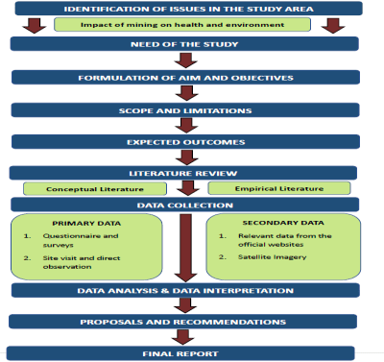

Fig. 2: The methodology adopted for the conceptual 3-tier Berhampur city, Odisha

LULC changes (Land Use/Land Cover) identify various land uses (forests, water bodies, and urban areas) by satellite imagery. The NDBI (Normalised Difference Built-up Index) is a spectral index derived from this imagery by using the Near-Infrared (NIR) and Shortwave Infrared (SWIR) bands. It highlights built-up areas in Cities, and helps in studying trends like urban expansion and its effects on temperature, particularly the Urban Heat Island effect, when compared to LULC data. Essentially, LULC categorises the land broadly, while NDBI quantifies and maps the urban components within those categories, where NIR = near-infrared, Red = Red band. SWIR shortwave infrared. Green: green spectral band:

- The NDVI (Normalised Difference Vegetation Index) = ${(NIR-Red)}/{(NIR+Red)}$ (High: dense, well-vegetated; Low = sparse vegetation).
- The NDBI (Normalised Difference Vegetation Index) =${(SWIR-NIR)}/{ (SWIR+NIR)}$ (High: Urban areas, Low: Fewer settlements)

- The LULC Change detection is calculated as: To quantify the changes between two different time periods (initial, (A_{i}) and final, (A_{f})

Magnitude of Change ($MC$): $MC=A_{f}-A_{i}$
Annual rate of change (ARC) = $\frac{A_{f}-A_{i}}{A_{i}}$
where $n$ is the number of years in the study period.

In the last 2 decades, it has been observed that the Berhampur area, along with the Chhatrapur and Gopalpur areas are sprawling both horizontally and vertically. Using the efficient imagery from GIS tools, it is essential to fill the gap of urban agglomeration, formation of heat Islands, shanty town development and mend the gap in urban lifestyle shortfalls

2.1 Location, Climate and Geology:

The city is centrally located at a distance of 11 km by road from the BoB coast, with high humidity. The maximum summer temperature is 40°C, whereas the minimum winter temperature is 22°C, with an average temperature of 33 °C- 38 °C. The area enjoys both southwest and northeast monsoon temperatures and the average normal rainfall of 1250 mm. The soil condition is clayey except in some places where there is hard soil, latosols, and rocky beds. Towards the west, and NW, the city has hills as per the contour map (Fig 3). (Hohle et al, 2017[11]; Vynikal et al, 2025 [12])

2.2 Shape and contour of Berhampur:

Berhampur city has a linear and irregular urban pattern, unlike the circular layouts of cities like Chandigarh and Jaipur. Its growth is influenced by its history as a British-era market and trade centre, primarily the Howrah–Chennai Railway Line and National Highway-16. Geographical limitations, with the Eastern Ghats to the west and coastal plains to the east, restricted circular development. This led to multiple commercial centres emerging instead of a single nucleus. Planning challenges, such as the absence of a master plan and uneven municipal boundaries, resulted in an irregular layout. Berhampur’s development reflects a transport-driven evolution rather than a planned circular design, resembling a ‘baby kangaroo’ (Fig 3)

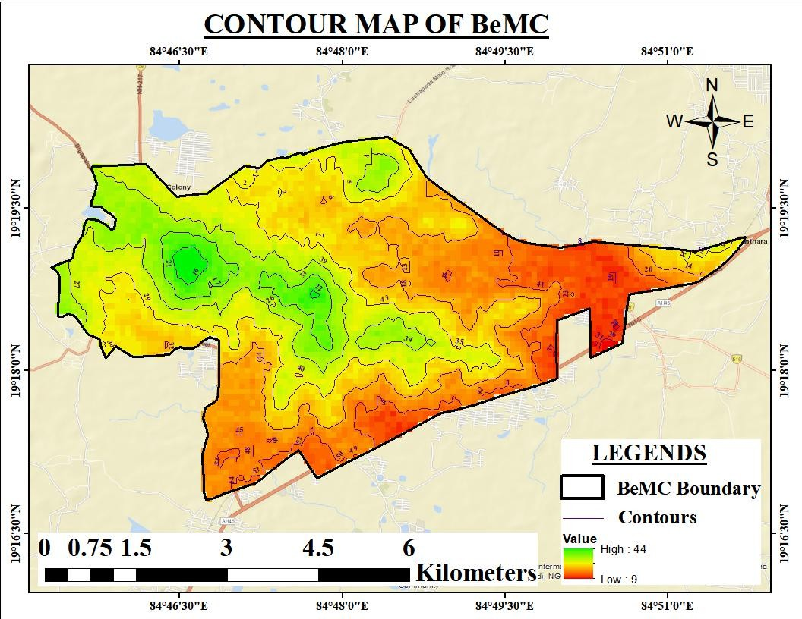

Fig 3: Contour map of Berhampur Municipal Corporation (BeMC)
Culture, Heritage and Tourism of the three-tier city

Berhampur, popularly known as the “Silk City” of Odisha, is renowned for its Berhampuri Patta silk sarees, traditional crafts, and lively cultural festivals like the Thakurani Yatra, which showcase its vibrant heritage and community unity. The city is home to ancient temples such as the Bhimeswar Temple, Budhi Thakurani Temple, and Jagannath Temple, reflecting its deep religious and architectural legacy.

In terms of tourism, Berhampur serves as a gateway to nearby attractions like Gopalpur Beach, Taptapani hot
springs, Tampara Lake, and Tara Tarini Temple, drawing visitors for both spiritual and leisure experiences. Its blend of culture, heritage, and natural beauty makes Berhampur an important destination in southern Odisha’s tourism circuit. Key traditional sectors include Berhampur Patta silk weaving, handloom, brass and metal works, and food processing, which offer employment to local artisans and small traders.

2.3 Area & Population

It has been estimated that during 2011 to 2025, the population increased from 356Th to 468 thousand. Accordingly, the small Gopalpur town and the district headquarters Chhatrapur (from the British period) have also sprawled and agglomerated geo-spatially.
a.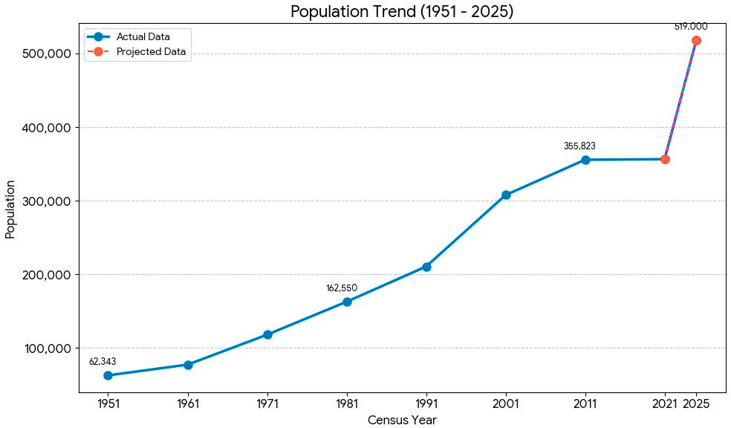 b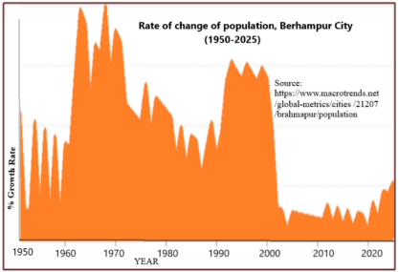

Fig 4 a: Population Trend, b: Rate of rise of Berhampur (1951 to 2025); Source: BeMP PR

The Gopalpur Notified Area Committee in 2025 has an approximate population of 10,100, and the Current estimated population of the Chhatrapur Notified Area Committee, Odisha, in 2025 is approximately 32,000 (Census 2011) [13]. The three-tier Berhampur city must be planned to accommodate about 7 to 8 lakhs people on about 350 km² area, Fig. 4 a and Fig 4 b).

Industrial Activity in Berhampur

Industrial growth around Berhampur is concentrated in areas like Chatrapur, Gopalpur, and the Industrial Growth Centre at Rama Krushnapur. Key industries include Software Technology Parks of India (STPI), promoting IT, Jayshree Chemicals, and software development, Indian Rare Earths Limited (IREL) for mineral extraction, Tata Steel SEZ and Gopalpur Industrial Park focusing on steel and logistics, Asian Paints in Ganjam, Grasim Industries for chemicals, and small-scale fabrication units in Berhampur. Agro-based industries, such as Jeypore Sugar Company and Aska Co-operative Sugar Industry, provide support for rural employment, along with various food processing units in Odisha.

2.4 Land Use and Landcover Analysis

The LULC analysis reveals spatial and temporal changes in urban areas, providing insights into urban growth, resource utilisation, and environmental shifts. A study of the Berhampur Municipal Corporation (BeMC) area, utilising satellite imagery from 2004, 2014, and 2024, assessed urban expansion and land use changes.
I.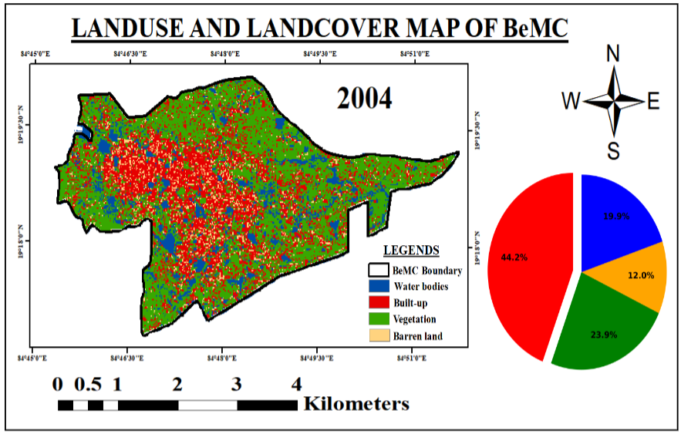

II.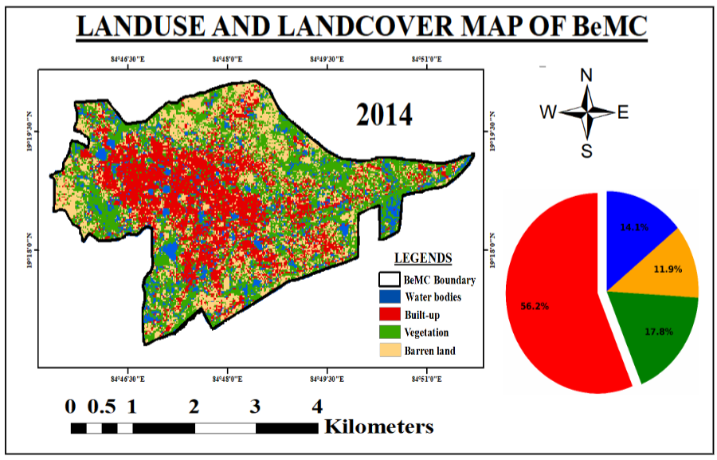
III.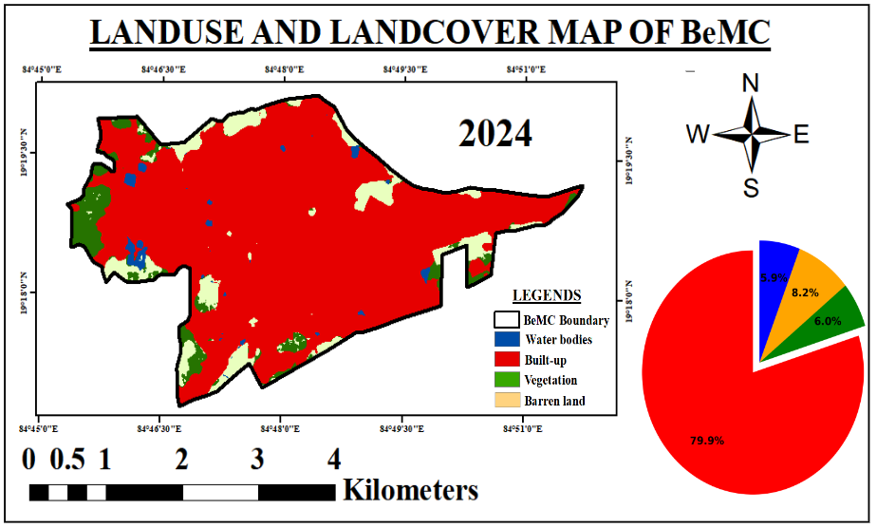

Fig 5 (a): (I-III) LULC Map of Berhampur Municipal Corporation (BeMC) Source – Primary
(Arc GIS), Secondary (Landsat, Sentinel)

Berhampur’s land use change over 20 years clearly demonstrates a shift from a vegetation-dominated landscape to a built-up urban environment, largely driven by population pressure and infrastructural development along major transport corridors. Strategic and sustainable urban planning is essential to manage this growth and maintain ecological balance. The built-up area increased significantly from 44.20% in 2004 to 79.83% in 2024, indicating substantial urban sprawl. Meanwhile, forest/vegetation cover dropped from 23.89% to 6.02%, and water bodies decreased from 19.89% to 5.94%, with barren land remaining stable at around 8.20% in 2024.

Reason for Change: This transformation is primarily due to population growth, housing demand, infrastructure expansion, and commercial development. The establishment of educational institutions, health facilities, and industries around the city accelerated the conversion of open and agricultural lands into urban areas (Fig. 5a and 5b).

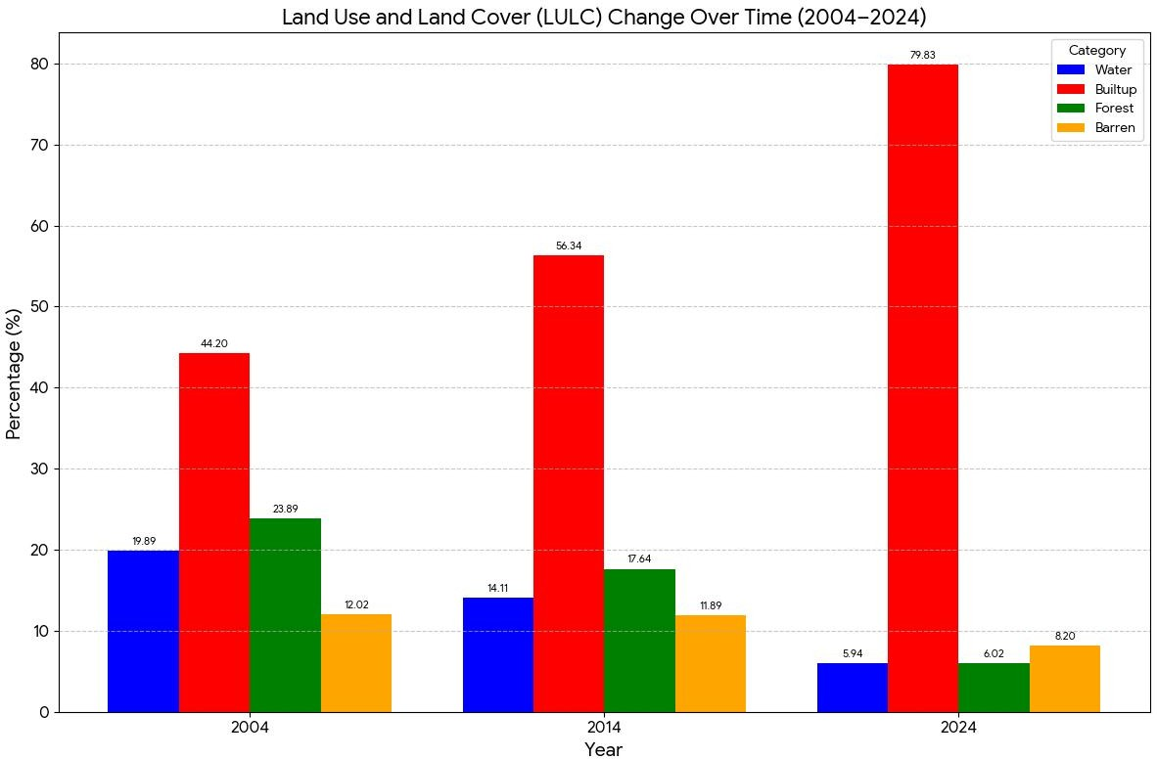

Fig 5 (b): LULC change over time of BeMC (Source - Landsat, Sentinel NDBI (Built-up area change)

Built-up Areas 2004: Built-up development is mainly concentrated in Berhampur city, while Chhatrapur and Gopalpur show limited and isolated built-up patches. Urban areas are spatially disconnected. Overall built-up area: ~5%. Represents an initial stage of urban agglomeration.

Built-up areas 2014: Built-up area increases, especially in Berhampur. Linear expansion observed along the Berhampur–Chhatrapur corridor. Growth begins around Gopalpur, driven by port-based and tourism activities.
Overall built-up area: ~15%. Indicates emerging urban linkage among the three townships.
Built-up areas 2024: Built-up area becomes dense and continuous during 2025. Berhampur acts as the dominant growth pole. Chhatrapur shows strong expansion due to administrative and residential growth. Gopalpur experiences increased built-up development related to port expansion, industries, and coastal infrastructure. Urban areas begin to physically merge, forming a functional urban agglomeration. The Overall built-up area: ~27%

2.5 Direction of Population Growth

The major expansion has taken place toward the north, northeast, and southwest directions, especially around Ankuli, Lanjipalli, Lochapada, and Gate Bazaar areas, following the alignment of NH-16 and the Howrah–Chennai Railway Line.
a.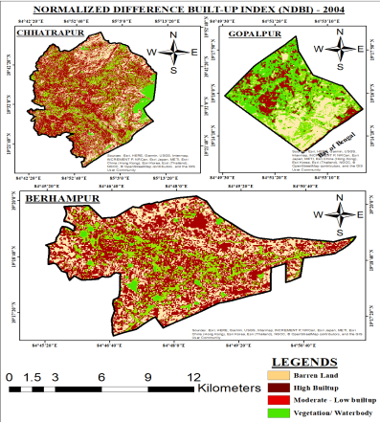b.

C. 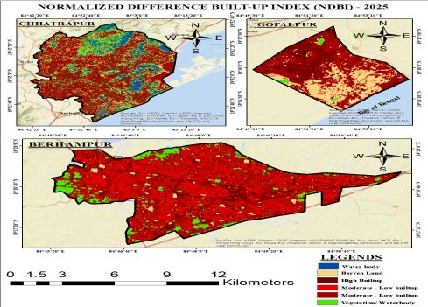
Fig 6 (a -c): The normalised difference built-up area map of Tri-city for 2004, 2014 and 2025
Land Surface Temperature (LST)

These corridors provided better accessibility, attracting residential colonies, commercial complexes, and institutional zones. As a result, the city’s growth has resulted in a reduction of green spaces and pressure on natural resources, particularly the loss of vegetation and the shrinkage of local water bodies. This unbalanced expansion pattern increases the risk of urban flooding, heat island effects, and environmental degradation (Fig. 6 a to Fig. 6c)). The LULC Map (2024) shows that the Built-up area has become the overwhelmingly dominant land cover type, replacing nearly all Vegetation and Barren land, which directly explains the high temperatures across the city (Nayak et al., 2023[14]; Mori et al., 2025 [15]).

Cause of Heat: Urbanisation involves replacing permeable, cooling surfaces (like soil, trees, and grass) with impervious materials like concrete, asphalt, and rooftops. These materials have a low albedo (they absorb more solar radiation) and a high heat capacity (they release heat slowly, often through the night).

Hotspot: Areas of Very High (Dark Red) and High (Red) LST are concentrated exactly where the LULC map shows maximum Built-up density. The entire city boundary appears significantly warmer than the surrounding non-municipal areas (visible as lighter colours outside the boundary). The LST Map show the result as a pervasive and Urban Heat Island (UHI) effects are.

Vulnerability: The central core and the newly developed western and south-western parts—which witnessed the most intense conversion of land—are the hottest areas, confirming that urban sprawl directly correlates with temperature increase Fig 7. The central part may be transformed into an Urban Heat Island (UHI)

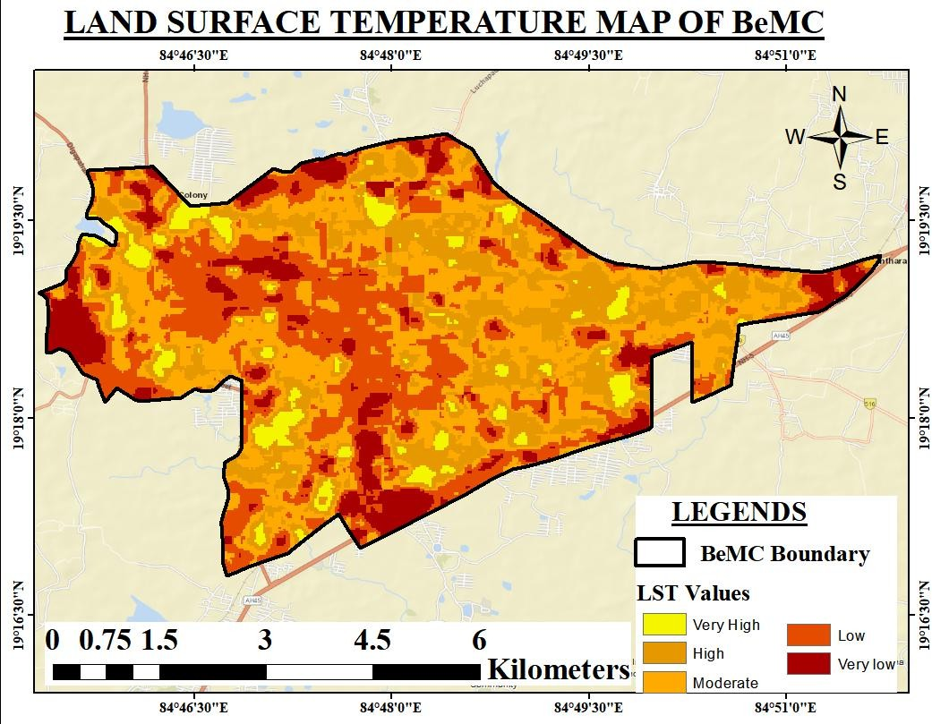
.
Fig 7 - Land Surface Temperature of BeMC; Source - Primary (Arc GIS, Google Earth Pro)

Population Pressure and Environmental Degradation
The population surged from 62,343 in 1951 to a projected 5,19,000 in 2025. This requires massive amounts of space for housing, infrastructure, and commercial activity. This demand has been met by clear-cutting and converting most of the available agricultural and natural land into the Built-up category, as vividly displayed by the LULC maps over the decades. The high population and built-up density in the core area have created the intense heat shown on the LST map, directly linking demographic pressure to environmental degradation and future anticipated heat island (heat stress) (Tal et al, 2025[16] )

2.6 Specific Areas of Berhampur (Based on Maps) -

The most problematic areas based on this correlation are Central and Western Core: This region, where the Built-up area is densest and where commercial activity (traffic junctions) is clustered, shows the largest contiguous patches of Very High (Dark Red) LST. This is the primary UHI hotspot. Fringe/Outskirts (East and South): Even the newly urbanised areas toward the east and south, which were largely green/barren in 2004, are captured by the red Built-up cover in 2024 and correspond to High (Red) or Moderate (Orange) LST. This shows the UHI effect is not just centralised but is spreading with the city's sprawl.

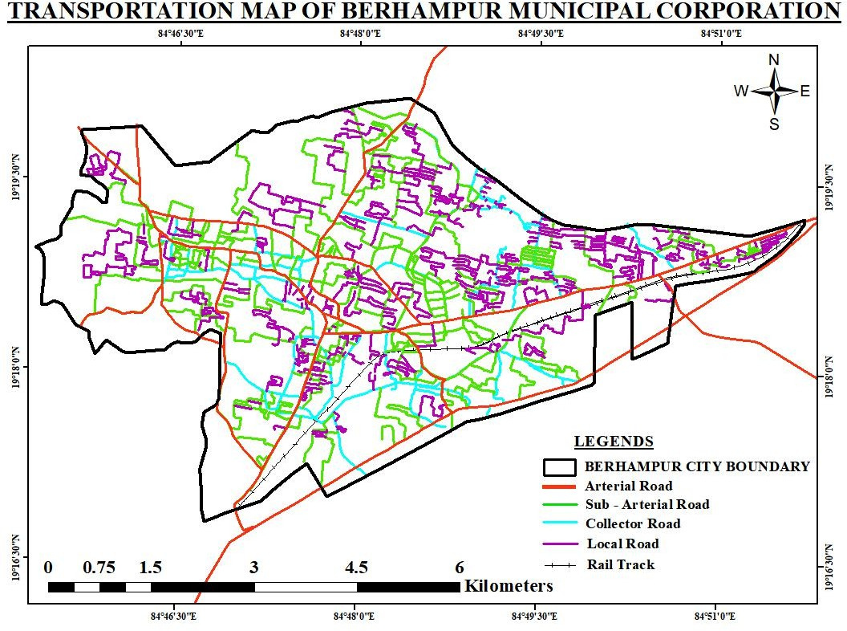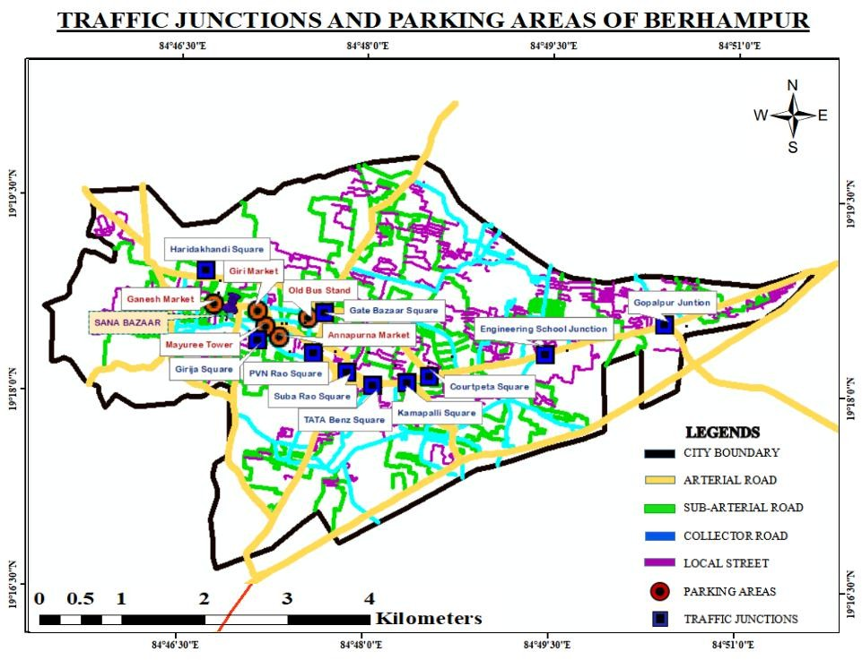
Fig 8 (a-b): Connectivity Map of BeMC and Traffic congestion / Junction Map of BeMC; (b) Traffic
junctions & Parking areas of BeMC; Source - Primary (Arc GIS, Google Earth Pro

2.6 Transportation Network (Traffic Junctions and Parking Areas)
Berhampur’s transport network is highly influenced by a linear transport pattern developed primarily along the NH-16 corridor and the Howrah–Chennai Railway Line. While arterial roads ensure connectivity, the clustering of markets and institutions around main junctions has caused severe congestion. Proper parking management, traffic regulation, and strategic road widening are essential for improving urban mobility and supporting future city development, Fig. 8 (a and b)

Arterial Roads (Yellow lines): The main transport spine of the city, connecting key locations like Gopalpur Junction, Engineering School Junction, Gate Bazaar, Old Bus Stand, and PVN Rao Square.
Sub-Arterial Roads (Green lines): Link residential and market areas with arterial routes, improving accessibility. Collector and Local Streets (Blue & Purple lines): Provide intra-neighbourhood connectivity and access to institutions, markets, and residential colonies. The north–south and east–west connectivity is primarily governed by these major corridors. Arterial Roads (Yellow lines): Form the main transport spine of the city, connecting key locations such as Gopalpur Junction, Engineering School Junction, Gate Bazaar, Old Bus Stand, and PVN Rao Square. Sub-Arterial Roads (Green lines): Link residential and market areas with arterial routes, improving accessibility. Collector and Local Streets (Blue & Purple lines): Provide intra-neighbourhood connectivity and access to institutions, markets, and residential colonies. The north–south and east–these major corridors govern west connectivity (Ranjan et al., 2021[17]; Tripathy et al, 2019 [18}; Bagh et al, 2022 [19]),
Traffic Junctions
High-traffic nodes such as Gate Bazaar Square, PVN Rao Square, Engineering School Junction, Courtpeta Square, and Kamapalli Square experience significant congestion due to commercial and institutional activities. The Old Bus Stand, Annapurna Market, and Giri Market areas are critical intersections where both pedestrian and vehicular movements are dense. Peripheral junctions like Gopalpur Junction and Hardikhandi Square act as gateways linking regional and intra-city routes (Dash et al., 2021[20]).

Parking Areas
The core area of Berhampur has a dense road network but suffers from narrow streets, mixed land use, and encroachments, causing traffic delays. Commercial activities and public transport terminals are major traffic generators. The southern and eastern sides (toward Kamapalli and Gopalpur) show emerging traffic pressure due to new residential and institutional developments. Identified parking zones are mainly concentrated in the central and commercial parts of the city, such as Gate Bazaar, Mayuree Tower, and Old Bus Stand. Lack of organised parking spaces along busy corridors results in on-street parking, contributing to traffic congestion and reduced road efficiency (Gowda et al., 2022[21]).

Result and Discussion:

3.0 Informal Settlements in Berhampur City

The slum dwellers of Berhampur, popularly known as the Silk City, continue to live in poor conditions despite various government housing schemes. Although the Berhampur Municipal Corporation (BeMC) aimed to make the city slum-free, nearly 163 slums still exist, housing around 17,686 households and 1.57 lakh people. Under Central-sponsored schemes like VAMBAY, IHSDP, and RAY, about 5,000 beneficiaries were identified for housing assistance. However, progress has been uneven — only 73 families benefited under VAMBAY (2001), and 1,200 residents were selected under IHSDP (2010–11), out of which 462 units were completed. Later, 1,528 units (2012) and 2,058 units (2013) were constructed under RAY, but many dwellers abandoned them due to the absence of basic infrastructure such as roads, water, and electricity (Tripathy et al, 2017[22]).

Currently, Berhampur has about 117,541 people (29,572 households) living in 254 slums, including 190 authorised and 64 unauthorised settlements. Most slums are irregularly scattered, concentrated in wards 3, 7, 9, 12, and 34, with ward 31 being the only one without a slum population. The highest authorised slum households are in wards 7 (1622 HHs), 8 (1328 HHs), and 9 (1545 HHs), while unauthorised slums are concentrated in wards 3, 33, and 34. Existing Schemes for Slum Development through Swarna Jayanti Sahara Rojgar Yojana, Annapurna Scheme, National slum development program, Balmiki Ambedkar awas Yojana and Antardoya Anna Yojana

3.1 Clustering: Slum pockets are not randomly distributed but are clustered in specific zones, primarily in the Central and Western parts of the city, just outside the most historically dense core. A notable cluster exists in the North-Western corner (including slums 10, 11, 12, 13, 15, 16, 17), and another significant area is located in the central-east (slums 4, 5, 18, 19). Scale: The total Area of Approved Slums is 2.159683 Sq. Km, representing 6.4% of the total Municipal Area of BeMC (Fig 9).

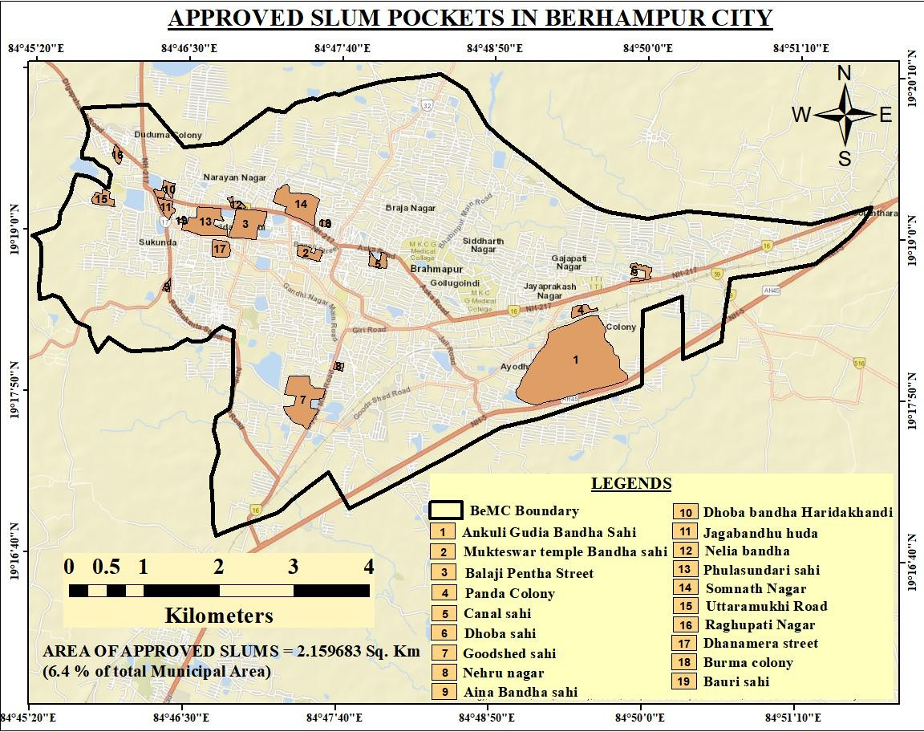

Fig 9: Approved Slum Pockets of BeMC Source - Primary (Arc GIS, Google Earth Pro)

Location Rationale: Slums often form on marginalised land or near employment centres. The location of many slums (e.g., Slum 5 near MKCG Medical College and Hospital) suggests proximity to work opportunities is a key factor.
Insight: Despite the massive increase in the Built-up area shown in the LULC map (indicating general construction), a significant portion of the population is housed in informal settlements. This signifies a mismatch between the speed of growth and the provision of adequate, equitable housing.
Slums Exist in Berhampur City
The slumdwellers are the service Providers to society. They live in shantytowns as they can due to uncontrolled population growth and Migration
3.2 High Demographic Pressure: The city experienced a sharp and continuous increase in population (projected to reach over 600Th by 2025). This growth rate is too fast for the city's resources to handle. Influx of Migrants: As a major commercial and educational hub in Southern Odisha, Berhampur attracts a large volume of rural-to-urban migrants seeking work. These migrants are typically low-income earners who require extremely low-cost housing. Housing Market Failure due to pandemics, industry closures, riots and strikes, so that comfortable livelihoods are under jeopardy. During COVID-19, the people staying in Surat, Ahmedabad and other states migrated to Berhampur town and its suburban villages to get jobs near their dwelling place.
Affordability Gap: The formal housing market, including the massive Built-up area expansion shown in the LULC map, largely consists of housing that is unaffordable for the low-income migrant population. Insufficient Low-Cost Housing: The municipal corporation and planning authorities have been unable to provide adequate subsidised/public low-cost housing to meet the demand created by the growth rate. Slums as a Solution: Slums emerge as the default, cheapest, and most accessible housing solution for the working class, meeting the basic need for shelter where the formal market fails.

3.3 Location and Economic Magnetism
Proximity to Jobs: Slums are strategically situated to minimise commuting costs and travel time for residents. The clusters shown on the map are often located near the Central Business District (CBD), major markets such as Ganesh Market and Gate Bazaar, as well as key employment centres like MKCG Medical College.
Land Marginalisation: Informal settlements often occupy land that is undesirable, vacant, or legally complicated for formal construction, such as: a) Low-lying areas prone to waterlogging or flooding, b) Narrow strips along railway tracks or major drainage channels, c) Government land that is unutilized or disputed. Lack of Comprehensive Urban Planning
Sprawl over Infill: The LULC maps show sprawling (outward) urban growth. This expansion is often poorly regulated, leading to a patchwork of formal and informal developments that strains existing infrastructure. Inadequate Infrastructure: The municipal services (water, sanitation, roads) are overloaded by the sheer volume of new residents, especially in areas of unplanned slum growth, further degrading the quality of life in these settlements.

3.4 Waterbodies
Berhampur city, renowned for its traditional water management system, had approximately 48 ponds in 2019 that served as essential community water sources. These ponds currently fulfil about 25–30% of the city’s water demand, particularly benefiting low-income residents who rely on them for daily needs. Notable ponds include Salia Bandha, Beda Bandha, Khodasing Bandha, and Nilakantheswar Pond. There is an urgent need for revival, desilting, restoration, interconnections, and community-based conservation programs as part of future urban planning initiatives (Fig. 10a and b).

Issues and Observations: The existing water bodies are in deteriorating condition. They have become heavily silted due to insufficient maintenance, and all the tanks are overrun with aquatic plants due to a lack of cleaning. During the rainy season, the city faces flooding issues caused by blocked water bodies.
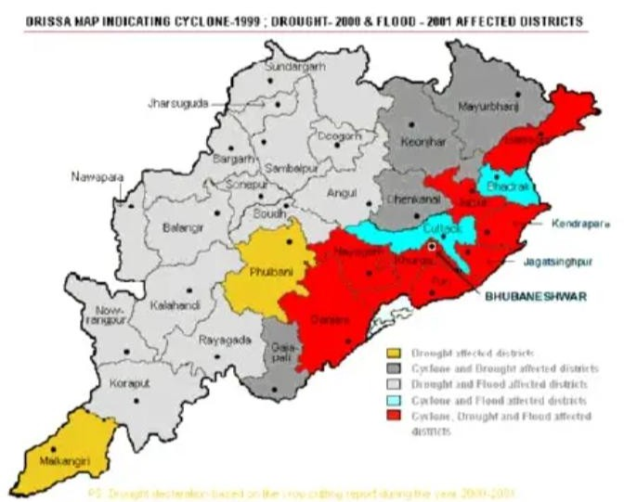
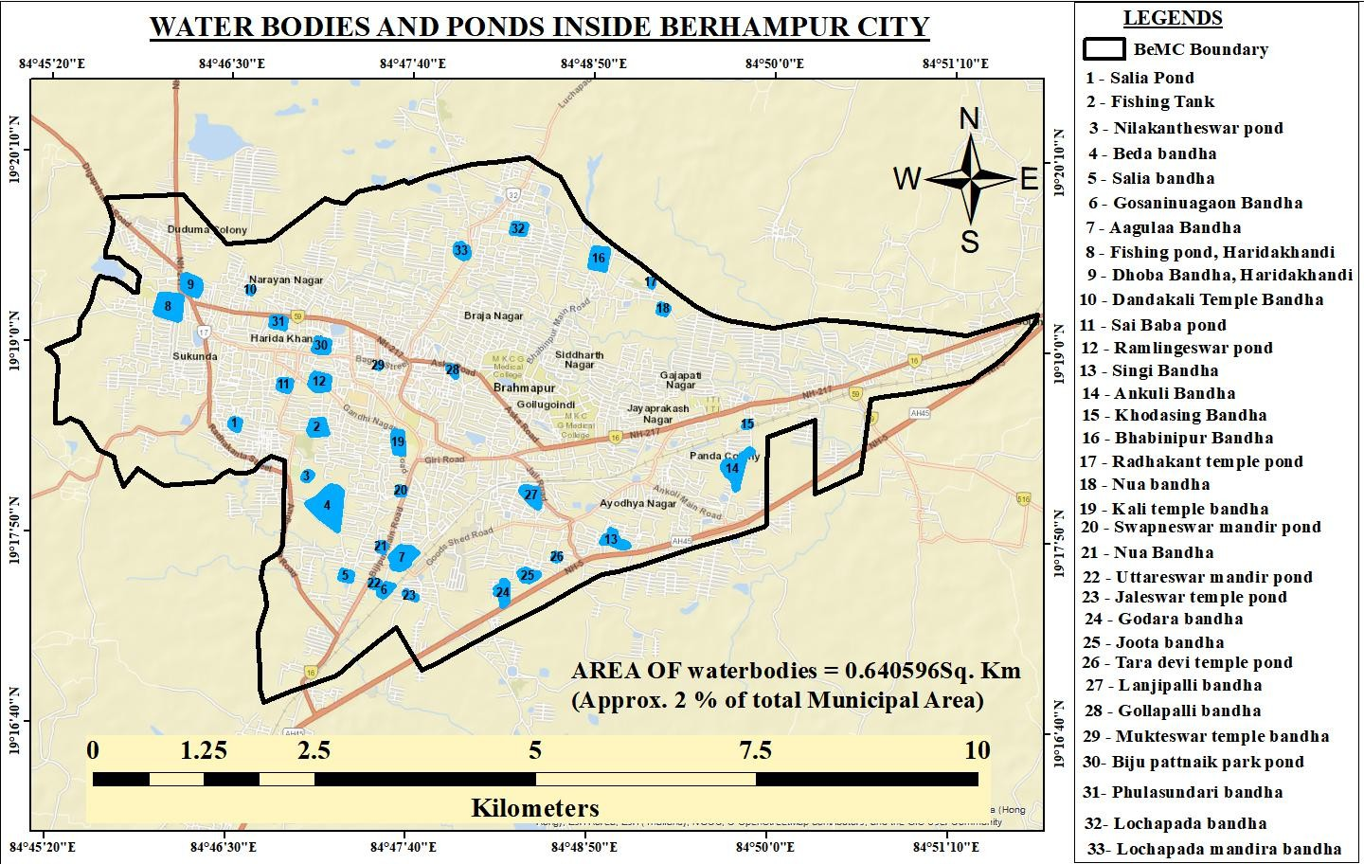
a.

Fig 10 (a and b): (a) Water bodies inside BeMC (b) The vulnerable disaster zone of the sprawl city in coastal Odisha: (Source - Primary (Arc GIS, Google Earth Pro)

Historically, around 34 ponds were interconnected through underground channels that facilitated natural water flow. However, rapid urbanisation has disrupted these connections, reducing their effectiveness. Originally built for irrigation and groundwater recharge, many ponds have now disappeared or changed function due to encroachment, civil disputes, and neglect. Currently, six ponds are under civil dispute, while others have become recreational parks or are filled in for development. Despite these challenges, ponds such as Salia Bandha, Gosaninuagaon Bandha, and Khodasing Bandha continue to play a crucial role in stormwater storage, local groundwater recharge, and maintaining the city’s microclimate. To sustain these traditional water systems, there
Berhampur city had adequate tree plantations and greenery before the 1999 floods, but this was washed away during the floods. Hence, there is an urgent need to develop urban forestry.

3.5 Disaster Management
Bay of Bengal Disturbances: South coastal Odisha is a regular goalpost, and highly vulnerable to cyclonic storms, shattered Berhampur and adjoining areas from the Bay of Bengal, experiencing major hits from cyclones like a VSCS (1999), Philine (2013), Hudhud (2014), Titili (2018), Fani (2019), Gulab (2021),
Jawad (2021) and Asani 2022 during the last 25years.

Coastal Erosion: Indian Ocean Tsunami, 2004, there has been a generation of high waves eroding the coastal stretches between the Bahuda to the Rushikulya River mouth, and the coastal stretches of Berhampur triplet city. Many fisher’s villages are submerged in rising sea during 2013 (Philine and Hoodhood). The World Bank, with Govt. have shifted the villages inland, which has separated the sea from the fishers.

Floods/Waterlogging: During the monsoon, heavy rainfall and overflowing rivers can lead to flooding, especially in low-lying and poorly drained areas of the city.
Heatwaves: Summers sometimes witness extreme temperatures affecting health, particularly for vulnerable populations like the elderly and children.

Man-Made Disasters: The Urban Fire Incidents: Due to narrow lanes, electrical short circuits, and informal settlements, urban fires can occur. Industrial Accidents: The radiation from Indian Rare Earths Limited (IREL) and other Small-scale industries or chemical storage units in the city can pose hazards if safety measures are not followed. Traffic Accidents: High traffic congestion on main roads increases the risk of accidents.
Existing Disaster Management Measures: They include early warning systems for cyclones and issuing flood alerts from the Odisha State Disaster Management Authority (OSDMA), CWC ( the Central Water Commission) and the evacuation of vulnerable residents to shelters. Coastal erosion victims are the most affected, with some fishing communities relocating inland. Emergency services coordinate among fire stations, hospitals, and police, supported by community awareness programs in high-cyclone risk areas.

4.0 Issues and Challenges:
Various threats and issues associated with the people are (a) Inadequate stormwater drainage, causing waterlogging during heavy rains. (b) Limited public awareness about emergency protocols in certain localities. (c) Drinking water problem (d) Inadequate water, sanitation and Hygiene. (e) Unplanned urbanization, obstructing natural drainage and increases urban flood risk. (f) Vulnerable infrastructure in old parts of the city and informal settlements. (g) Slum dwellers and inadequate housing, overcrowding. It is pertinent to analyse the urban city development pattern and structure spatially and temporally. It is essential for the regional development process and the identification of the areas that should be developed further. Additionally, the findings would contribute to planning a sustainable proposed 3-tier Berhampur city, including the developed infrastructure, services, and especially providing sustainable solutions for slum areas.

4.1 Inadequate Water Supply: The basic challenge in the existing situation as Berhampur receives water mainly through a piped water supply from local sources and some groundwater extraction. According to reports, about 25–30% of the population relies on alternative sources like hand pumps or borewells. These issues can be attributed to the uneven distribution of pipes and taps across wards, with some low-income areas facing shortages. Leakage and outdated pipelines lead to water loss and limited treatment, affecting water quality.

4.2 Sewage and Sewerage System: In the existing situation, Berhampur has a partially underground sewer network, those are mostly in banks of main roads, while many residential areas use open drains or septic tanks. Prompt attention is to be given to issues like Open drains cause health hazards and water contamination. Lack of proper sewage treatment plants, mixing of untreated wastewater into local water bodies occurs and Blockages in drains during the monsoon in low-lying areas.

4.3 Drainage System existing: The city has a combination of natural and man-made drains, but many are narrow or encroached, especially in older areas. During heavy rains, flooding occurs in low-lying areas. The issues are blocked drains due to solid waste and debris. Inadequate capacity of drains to handle stormwater during the monsoon. Encroachments are reducing drainage efficiency. Defecation in gulley drains often changes the drain water from green to grey water. A 40 Kiloliters/ day (KLD) SeTP is in operation by BeMc, which uses Decentralised Wastewater Treatment Systems. (DEWATS) technology treating both solid and liquid septage in an integrated, gravity-flow-based system, in the year 2018, and a 75KLD SeTP is under construction at Amba Pua, Berhampur (Fig 11 (a and b) Joshi et al 2017[23]).

a. 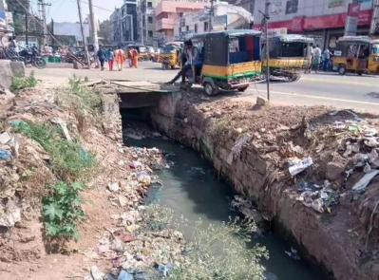b.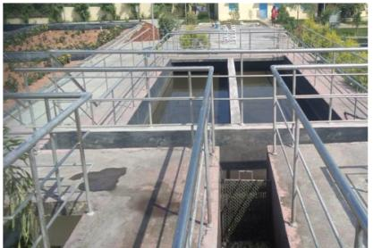
Fig 11 (a-b): (a) Open drains in BeMC (b) The SeTP of 40KLD for Berhampur constructed in 2018

4.4 Sustainable Sanitation
Municipal Solid Waste Generation:
Currently, the Berhampur Municipal Corporation (BeMC) generates an average of 170 to 250 metric tons (MT) of solid waste per day, which is managed through collection, transportation, and disposal at dumping grounds. This amount increases on festive days. Approximately 27% of the waste consists of decomposable household waste, while about 28% is construction debris. Following awareness initiatives, around 60-70% of the city's garbage is now directed to the dumping yards. BeMC plans to manage about 1,500 TPD of waste. As part of Project X, BeMC is implementing an integrated municipal solid waste (MSW) management project at Village Mohuda in Tehsil Kukudakhandi, covering an area of 33.62 acres (Panda et al, 2019[24]).
Storage-
The waste storage practices in the town reflect a significant level of public apathy, largely due to a lack of awareness. Only about 3% of households use closed dustbins for waste, while 10-12% rely on open baskets, which are considered unsafe. The municipality utilises two types of containers: cylindrical concrete bins with a capacity of 0.5 to 0.75 cubic meters and masonry cubicles that hold approximately 4 to 5 cubic meters. Currently, there are about 100 cylindrical bins and cubicle points, which are insufficient for the actual amount of waste generated. In fact, the cubicles can have the capacity $\sim$30% needed for proper waste disposal, and the rest is discarded in open fields cdnbbsr.s3waas.gov.in.
Segregation -
Regarding waste segregation, there is a complete lack of source separation in the town. Mixed waste is commonly discarded in roads, drains, and other public spaces. About 100 rag pickers engage in collecting recyclable materials such as wood, glass, plastics, metals, and other debris, which they then sell to approximately 15 scrap dealers in the city at low prices. These rag pickers earn between Rs. 30 and Rs. 50 daily for their efforts.

Collection, Transportation, Treatment and Disposal
In Berhampur, the municipality is responsible for waste collection, transportation, treatment, and disposal. Residents often discard waste in the streets and drains, creating informal collection points. Municipal sweepers collect this waste using wheelbarrows, but only 60% is collected, and 78% of that is sent to the Chandania Hills dumping yard, which also receives construction debris. Treatment options are limited to this 10-acre site, which may become a landfill in the future. Street cleaning occurs daily from 8 AM to 12 PM, while garbage collection frequency varies based on vehicle and crew availability and the suitability of time and climate. Proposals and Recommendations as per the guidelines for the preparation of detailed project reports and selection of technologies for processing and final disposal of municipal solid waste using 12th Finance Commission grants https://mohua.gov.in/upload/uploadfiles/files/93.pdf.

4.5 Industries -

Large-scale industries like Indian Rare Earth Ltd. in Matikhal are expected to boost ancillary industries in Berhampur. A Rs. 1200 crore Titanium Dioxide project is underway in Chattrapur, while Tata Steel's multi-product SEZ at Gopalpur is set to begin construction in three to four years. The Odisha government's Industrial Policy aims to develop the Rayagada-Gopalpur corridor as an industrial zone, with plans for at least 100 new industries in the Berhampur Municipal area in the next few years. Odisha's government, through IPICOL and IDCO, is enhancing industrial infrastructure to promote economic growth (GOO, 2023. Compendium of Investible Projects [25].

4.5 Land use and land cover: For the smart 3-Tire Berhampur city, it is required to (a) promote compact and planned urban growth instead of uncontrolled sprawl. To ensure sustainable development, future urban planning for Berhampur should focus on: (b) preserving green cover and water bodies through zoning and environmental protection laws. (c) Developing or upgrading satellite townships, urban infrastructure, drainage systems and peripheral growth centres to reduce congestion in the core city. (d) Encouraging mixed land-use planning for balanced residential, commercial, and recreational use.

4.6 Transportation -
The city is expanding northeast along NH217 and NH5, with a new development called New Berhampur. Strong connections to national highways suggest growth potential in both the northeast and southwest. To reduce congestion and enhance regional connectivity, a proposed Ring Road around Berhampur city is essential. This road would start from Ankuli and connect to industrial areas and Tampara Lake, passing near Gopalpur before reconnecting to NH-16 near Ganjam. Improving interconnectivity will require road widening and thorough traffic studies.

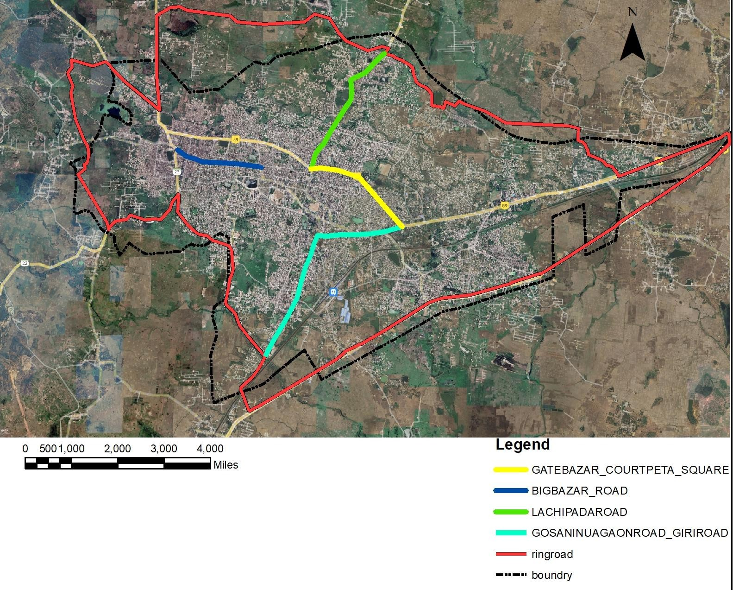

Fig 12: Proposed Ring Road Source - Berhampur Development Authority

The Ring Road diverts traffic away from congested central areas, which enhances connectivity between industrial, residential, and institutional zones. Encourages new commercial and logistic hubs along the peripheral belt. Reduces air and noise pollution in core areas.

Parking Management
The development of multi-level parking structures at Gate Bazaar and Old Bus Stand. Implementation of smart parking systems near institutional and market areas. The Traffic Improvement Measures to be adopted are vertical multilevel parking structures. Signalisation and adequate traffic personnel are to be appointed at major junctions like PVN Rao Square and Engineering School Junction. Road widening and footpath improvement in market areas are warranted. Dedicated lanes for public transport and non-motorised vehicles, and alternate routes are to be fixed to ease the traffic.

Slum Management: For a growing city, the residents of the shantytowns are often the service providers for the people in the city. These slums need in-situ slum redevelopment with affordable housing (PMAY scheme). Relocation of flood-prone slums near Bandha and Canal areas. Integration of slum pockets with water supply, sanitation, road connectivity and sheds for night halt—community development centres near Mukteswar and Hardikhandi areas. Green buffer zones are to be developed along canal embankments to prevent further encroachment (Ali et al, 2021[26], Mishra et al., 2024[27]).

Disaster Management: Since the south Odisha coast is the hotspot for cyclones and coastal erosion, it is necessary to improve stormwater drainage systems to prevent waterlogging. Essential to develop a comprehensive city-wide disaster management plan, including evacuation routes and shelters. Required to promote public awareness campaigns about disaster preparedness and safety measures. To encourage resilient building practices and enforce zoning regulations in hazard-prone areas. Use of GIS-based hazard mapping for better planning and early response, public awareness and mock drills for rescuing the victims by conducting regular disaster drills in schools, offices, and residential areas (Mishra et al, 2014[28], Panda et al, 2020[29]).

Drinking Water Supply: The BeMC’s clean water supply for both drinking and WASH facilities necessitates the upgrade and expansion of the piped water network to ensure it reaches all households. This should be complemented by implementing leakage detection and annual repair and maintenance programs. Additionally, constructing more water treatment plants is essential to guarantee a potable water supply. Promoting rainwater harvesting in public and private buildings is also necessary. (Alice et al, 2023[30]).

Sewage & Sewerage System. To build an efficient sewage and sewerage system in the 3-tier cities to mitigate urban floods, it is required to expand underground sewer networks to cover all neighbourhoods, including building modern sewage treatment plants (STPs). It is essential to introduce regular cleaning and maintenance of drains, encouraging Encourage community awareness on proper sewage disposal.

Solid Waste Management: The BeMC solid waste management serves about 100 thousand people. It is necessary to implement door-to-door waste collection and proper segregation, promote composting of organic waste and recycling of plastics, develop sanitary landfill sites and avoid open dumping. It is required to use GIS and smart bins for efficient waste collection and monitoring.

Liquid Waste Management:
Possible necessities for improving the liquid waste management and the possible activities are: (i) Construction of an RCC drain with cover slabs, (ii) Renovation and repair of the existing drains, (iii) Construction of new SW channels, (iv)Widen and renovate primary and secondary drains. (v) Desilting of existing drains and (Vi) Frequent Cleaning of SWD channel. In addition, ensure regular cleaning and maintenance before the monsoon. Water bodies and ponds can be used for stormwater harvesting and retention basins to reduce pressure on drains. Implement community awareness and government restrictions to prevent dumping in drains or illegal constructions (Biswal et al, 2019 [31]; Barik et al, 2020[31]). The present biomedical wastes generated from the health care establishments are disposed of through common biomedical waste treatment and Disposal (CBWTDF) facilities or by deep-burial practice must be improved (e-mail Paribesh; OSPCB Lr. No. 7312 /VISC(LEM)Proj-304 (Vol-IX) /24-25 Date: 07.04.2025
This manuscript contributes to the scientific community by analyzing the urban city development pattern and structure spatially and temporally. This context is crucial for the regional development process and identification of the areas that should be developed further. Additionally, the findings would contribute to planning a sustainable urban city, including the developed infrastructure, especially by providing sustainable solutions for slum areas

5.0 Conclusion

Berhampur is a growing city facing challenges such as water supply issues, sewage management, drainage problems, and disaster preparedness, exacerbated by rapid urbanisation and inadequate infrastructure. To enhance resilience against floods and health hazards, it is vital to improve pipelines, drainage systems, and waste management, along with fostering community awareness and disaster planning. The Odisha State Government has amalgamated 14 Gram Panchayats since January 4, 2026, to improve urban services. A comprehensive development plan is urgently needed for Berhampur and its surrounding areas, including Chhatrapur and Gopalpur, to ensure sustainable urban development.
To ensure orderly growth in 3-tire Berhampur and its suburbs, designated areas for industrial, residential, commercial, transportation, and recreational purposes must be managed effectively. The agglomeration of the three-tier city should give importance to vertical expansion for residential areas instead of horizontal growth for commercial and residential areas, creating multifunctional hubs. Additionally, implementing effective WASH infrastructure and striving for a zero-slum concept is essential.
This manuscript addresses a significant gap in assessing urban infrastructure in rapidly growing coastal cities in India. By utilising GIS-based spatial analysis alongside field surveys and stakeholder input, the study creates a replicable framework for evaluating infrastructure adequacy and service delivery disparities. The findings reveal spatial inequalities in urban infrastructure and open spaces, providing insights for sustainable urban planning and supporting evidence-based policymaking for SDG 11, benefiting urban planners, geographers, and sustainability researchers.

Disclaimer (Artificial intelligence)
Option 1:
Author(s) hereby declares that NO generative AI technologies such as Large Language Models (ChatGPT, COPILOT, etc.) and text-to-image generators have been used during the writing or editing of this manuscript.

REFERENCES
- Muchelo, R. O., Bishop, T. F. A., Ugbaje, S. U., & Akpa, S. I. C. (2024). Patterns of Urban Sprawl and Agricultural Land Loss in Sub-Saharan Africa: The Cases of the Ugandan Cities of Kampala and Mbarara. Land, 13(7), 1056. https://doi.org/10.3390/land13071056
- Mahdavi, S. (2022). Experience of New Towns in Iran: Planning for the People or with the People? International Journal of Environmental Studies. https://doi.org/10.1080/00207233.2022.2033488
- Chettry, V. (2023). A Critical Review of Urban Sprawl Studies. Journal of Geovisualization and Spatial Analysis, 7, 28. https://doi.org/10.1007/s41651-023-00158-w
- Soltani A, Azizi P, Javadpoor M, Allan A, Bagheri B. Determining and Quantifying Urban Sprawl Drivers: A Delphi-DANP Approach. Land. 2025; 14(2):311. https://doi.org/10.3390/land14020311
- Surya, B., Salim, A., Hernita, H., Suriani, S., Menne, F., & Rasyidi, E. S. (2021). Land Use Change, Urban Agglomeration, and Urban Sprawl: A Sustainable Development Perspective of Makassar City, Indonesia. Land, 10(6), 556. https://doi.org/10.3390/land10060556
- Hassan, M. O., Ling, G. H. T., Rusli, N., Mokhtar, S., Wider, W., & Leng, P. C. (2023). Urban Sprawl Patterns, Drivers, and Impacts: The Case of Mogadishu, Somalia Using Geo-Spatial and SEM Analyses. Land. https://doi.org/10.3390/land12040783
- AMRUT. (2015). Service Level Improvement Plan (SLIP), Atal Mission for Rejuvenation and Urban Transformation, Berhampur. Department of Housing & Urban Development, Government of Odisha. https://urban.odisha.gov.in/
- Mishra, S. P., Kumar, C., Sethi, K. C., & Siddique, M. (2020). Planning Bus Transit Unit in Sprawling Townships; Khurdha Road Junction, Odisha; India. International Journal of Environment and Climate Change, 10(12), 95-109. https://doi.org/10.9734/ijecc/2020/v10i1230288
- Mishra, S., Sahoo, G. C., Mishra, S. P., Sethi, K. C., & Siddique, M. (2020). From Squatter Slums to Modelled Dwellings in Anthropocene: Bhubaneswar, India. International Journal of Engineering and Advanced Technology, 9(3), 2783-2793. https://doi.org/10.35940/ijeat.C5935.029320
- OWSSB; Ernst & Young LLP. (2017). Rapid Assessment Report for Berhampur. Orissa Water Supply & Sewerage Board.
- Höhle, J. (2017). Generating Topographic Map Data from Classification Results. Remote Sensing, 9(3), 224. https://doi.org/10.3390/rs9030224
- Vynikal, J., & Pacina, J. (2025). Automatic Elevation Contour Vectorization: A Case Study in a Deep Learning Approach. ISPRS International Journal of Geo-Information, 14(5), 201. https://doi.org/10.3390/ijgi14050201]
- Govt. of India. (2011). Provisional Population Totals, Rural-Urban Distribution. Paper 2 of 2011. Census of India-2011. http://www.censusindia.gov.in/2011-prov-results/paper2/data_files/india/ paper2_at_a_glance.pdf
- Nayak, SK., Giri JP., Mishra SP., (May, 2023). A Review Study on Decongestion of Hebbal and Devenahalli Road, Bangalore, Karnataka. International Journal of Research Publication and Reviews, 4(5), 2285-2289.
- Mori, E., Di Lorenzo, T., Viviano, A., Jakovljević, T., Marra, E., Moura, B. B., Garosi, C., Manzini, J., Ancillotto, L., Hoshika, Y., et al. (2025). Under Pressure: Environmental Stressors in Urban Ecosystems and Their Ecological and Social Consequences on Biodiversity and Human Well-Being. Stresses https://doi.org/10.3390/stresses5040066
- Tal, A. (2025). The Environmental Impacts of Overpopulation. Encyclopedia, 5(2), 45. https://doi.org/10.3390/encyclopedia5020045
- Ranjan, N., Bhandari, S., Khan, P., Hong, Y.-S., & Kim, H. (2021). Large-Scale Road Network Congestion Pattern Analysis and Prediction Using Deep Convolutional Autoencoder. Sustainability, 13(9), 5108. https://doi.org/10.3390/su13095108
- Tripathy B, Sethi KM. Mishra PK. (2019). Geoinformatics-Based Sprawl Dynamics Analysis of Berhampur Development Authority Area, Odisha, India. Int. Jour. of Recent Tech and Eng. (IJRTE) 8(4):10471-10477, DOI:10.35940/ijrte.D9261.118419
- Bagh, J., & Mishra, S. P. (2022). Road Safety Audit Confirming the Highway Safety Standards; Case Studies, Kalahandi, Odisha. *Indian Journal of Natural Sciences*, *13*(72), 43809-43822. https://www.researchgate.net/publication/362000000_Road_Safety_Audit_Confirming_the_Highway_Safety_Standards_Case_Studies_Kalahandi_Odisha
- Dash, D. K., Mishra, S. P., Siddique, M., & Panda, S. (2021). Congestion and Performance Evaluation of Roundabouts: Case Study at Bhubaneswar City, India. Design Engineering, 4, 181-https://www.researchgate.net/publication/351090000_Congestion_and_Performance_Evaluation_of_ Roundabouts_Case_Study_at_Bhubaneswar_City_India
- Gowd, R., Siba Prasad Msihra, Abhisek Mishra, June , (2022). Road Safety of Agglomerating Cities in India. CJAST,: 2457-1024, 41(19); 1-16, 2, DOI:10.9734/CJAST/2022/v41i1931739
- Tripathy, R. M., Acharya, G. C., Karmee, N. (2017). Assessment of wash practices among women in urban slums of Berhampur, Odisha: a cross-sectional study. International Journal of Research in Medical Sciences, 5(11), 4846–4851. https://doi.org/10.18203/2320-6012.ijrms20174931
- Joshi, A., & Mishra, S. P. (2017). Anthropocene Effects on the River Daya and the Lagoon Chilika by the Effluents of Bhubaneswar city, India: A physicochemical study. International Journal of Advanced Research, 5(10), 2320-5407. https://doi.org/10.21474/IJAR01/5656
- Panda, S. R., Barik, K. K., Mishra, S. P., & Mohanty, S. (2019). Selection of Solid Waste Landfills for Developing Townships in India: A GIS-Based Case Study. *Journal of Emerging Technologies and Innovative Research, 6*(1), 769-783. https://www.jetir.org/view?paper=JETIR1901092
- Govt of Odisha. (2023). Compendium of Investible Projects, Odisha new opportunities. Invest Odisha. https://investodisha.gov.in/MIO/download/Shelf-of-Projects.pdf
- Ali, M. A., Sethy, K. M., Wamo, M., & Kamraju, M. (2021). Urban Environment and Spatial Science (Doctoral dissertation, Doctoral dissertation, Osmania University, Hyderabad, India).
- Mishra SP., Mahato GK., Mishra S., Siddique M. (2024). Innovative Infrastructure and Architecture for Slum Management in Smart City Bhubaneswar. 2024 2nd International Conference on Signal Processing, Communication, Power and Embedded System (SCOPES), DOI: 10.9734/ejnfs/2025/v17i51708
- Mishra, S. P., & Panigrahi, R. K. (2014). Storm impact on south Odisha coast, India. International Journal of Advance Research in Science and Engineering, 3(11), 209-225. https://www.researchgate.net/publication/301690000_STORM_IMPACT_ON_SOUTH_ODISHA_COAST_INDIA
- Panda, S., Mishra, S. P., & Mishra, S. (2020). Disaster Risk Reduction with Resilient Built Environment in Odisha Coast, India. Journal of Xidian University, 14(5). https://doi.org/10.37896/jxu14.5/653
- Alice, A., Behera, D., Behera, M. R., Patra, S. K., & Mishra, J. (2023). Assessment of sanitation and drinking water facilities among slum households in Bhubaneswar, Odisha - A cross-sectional study. J Family Med Prim Care, 12(3), 484-492. https://doi.org/10.4103/jfmpc.jfmpc_1544_22
- Biswal R., Mishra S. P., Pattanayak G. D., (2019), Environmental sensitisation of BMLW of Anthropocene epoch: in developing township: Bhubaneswar, India, Int. Jour. of Chem Tech Research 12(04):127-149, DOI: 10.20902/IJCTR.2019.120417
- Barik, K. K., Panda, S. R., Nanda, S., Tripathy, J. K., Chhotaray, P. K., Annadurai, R., Mishra, S. P., Mitra, D., & Mishra, S. P. (2021). GIS-based saltwater vulnerability mapping of the northern coast of Odisha, East Coast of India. *Arabian Journal of Geosciences*, *14*, 1365. https://doi.org/10.1007/s12517-021-07800-1

