Original Research Article

Platial Information Fusion: Integrating Natural Language Processing and Graph Neural Networks for Context-Aware Geospatial Knowledge Extraction

Abstract
Recent advances in geospatial artificial intelligence (GeoAI) have highlighted the potential of combining natural language processing (NLP) and graph-based learning for extracting semantically enriched spatial knowledge. This study describes the development of a lightweight hybrid framework for context-aware platial information that integrates NLP techniques with Graph Neural Networks (GNNs) to extract and analyze geosemantic knowledge from textual and spatial data. The main purpose is to create a platial knowledge graph that represents cities not simply as locations on maps, but as multidimensional entities with spatial, cultural, historical, and social characteristics. The methodology applied is based on three levels. The first level involves the semantic analysis of descriptive texts about 163 Greek cities which contain historical, cultural and social characteristics. The second level consists in the extraction of geographic data, such as the location of cities and other natural features like mountains, rivers, and seacoast obtained from open sources such as OpenStreetMap. The third level involves the construction of a knowledge graph with multidimensional features and relations. More specifically, we construct a diverse platial knowledge graph where cities are represented as nodes connected to other cities based on semantic features derived from both linguistic content and spatial context. By integrating GNNs, we manage to model and predict latent relationships between urban entities, enabling clustering and comparison of cities with similar geographic and semantic profiles. The preceding methodology is applied to a dataset involving large Greek cities to discover whether geosemantic fusion can reveal patterns of urban identity and regional connectivity.
By adopting this methodology, groups of cities that present similar characteristics are identified, without necessarily being geographically adjacent. Indicative examples show that cities sharing similar semantic and environmental characteristics can be grouped even when they are geographically distant. For example, Ioannina and Tripoli can be grouped due to their mountainous character and historical importance, while cities such as Kalamata, Kavala and Rhodes, although geographically dispersed, are correlated through their coastal tourism profile. The study focuses on Greece but provides a generalizable model for the multidimensional conceptualisation of place, which can be extended to other regions or countries. The resulting embeddings and city groupings are evaluated through clustering analysis, enabling the identification of latent similarities in urban identity and regional characteristics. This research is an attempt to expand the scientific approach of Platial Information Science, proposing a flexible and scalable tool for analyzing cities in a way that goes beyond traditional geographic mapping. The results highlight the potential for applications in spatial humanities, cultural geography, and urban planning.

Keywords: platial, natural language processing, NLP, graph neural networks, GNNs, GeoAI, urban semantics, knowledge graphs.

1. Introduction

Over the past twenty years, the notion of "place" in the context of Geographic Information Science (GIScience) has shifted from a more traditional, coordinate-based spatial rationale to a more human-centric, multidimensional understanding and representation. This change has been referred to as the "platial turn" (Westerholt et al., 2018b), focusing on the fact that places are not simply points in space but also a social and semantic construct (Couclelis, 2010; Goodchild, 2011). Since geographic models usually describe places through external features, there is increasing interest in methods that help us better understand and combine their qualitative, experienced, lived, and, interpreted aspects. Such an understanding of place has been substantiated by both theoretical and technological developments. These efforts contributed to the conceptual scaffolding necessary for synthesizing GIS with Semantic Web frameworks and human-centered interpretations of space. In parallel, these efforts coincided with the emergence of geospatial artificial intelligence (GeoAI) resulting from the intersection of geography, computer, and data science to conceptualize, model, and develop powerful tools for learning about complex spatial systems (Janowicz et al., 2020).

GeoAI capitalizes on machine learning, deep learning, and data mining to discover knowledge from vast amounts of both spatial and non-spatial data (Liu & Biljecki, 2022). One of the biggest drivers of this development has been the integration of natural language processing (NLP) tools that can be implemented using unstructured textual data sources such as Wikipedia articles, travel blogs, and regional and historical archives (Gao et al., 2017). These texts offer geographical descriptions of places as they pertain to local culture, social activities, environmental conditions, and historical processes - dimensions that we routinely do not find in traditional geospatial repositories. Furthermore, natural language processing techniques such as named entity recognition, keyphrase extraction, topic modeling, and text classification have been applied to identify geospatial knowledge found in text corpuses in many recent studies. These developments show that it is now more important than ever to find ways to connect language and geography, especially since it has become easier to represent and share complex knowledge.

Graph-based machine learning is a quickly emerging, parallel approach to GeoAI. Graph Neural Networks (GNNs) are emerging as a powerful way to model non-Euclidean data such as social networks, transportation networks, and urban infrastructures. For example, in geospatial applications, GNNs have been used to analyze mobility flows, predict land use, and discover spatial anomalies (Fan et al., 2025; Gurav et al., 2021; Lee & Lauw, 2024; Zhan & Datta, 2025; Zhu et al., 2022). GNNs process both localized and global patterns of connectivity, which makes them a natural fit for modeling places as nodes in spatial and semantic networks. Based on these use cases, the current study proposes a hybrid framework for platial information fusion that combines NLP with GNNs, to construct a multi-dimensional representation of urban entities. The goal is to create a platial knowledge graph that can encode geographic coordinates and administrative features, but also semantic features based on history, morphology, population, elevation, and urban density. The approach considers the city as a multidimensional node. More specifically, we employ the relations produced from textual semantics and structured attributes (e.g., elevation, population, morphology) to reveal latent patterns of both similarity and connectivity, regardless of physical distance.

This study makes contributions to the literature in a few ways. First, it operationalizes the foundational principles of Platial Information Science through a computational framework that integrates the dimensions of language and space. Second, it applies and assesses state-of-the-art machine learning methodologies from a new context that integrates semantic and spatial reasoning. In advancing a multidimensional understanding of place, the paper also establishes a methodology that is scalable and transferable to address projects that engage aspects of city connectivity not just in Greece but anywhere. The combination of NLP and GNNs provides a novel framework to interpret and analyse places by considering their extensive richness, while enabling the analysis of a custom-made dataset which combines structured and unstructured data sources.

The paper is organized as follows. Section 2 reviews related work on Platial Information Science, Section 3 details the research design, data collection methods, and analysis techniques used, while it presents the findings of the research, Section 4 summarizes the main points of the paper and Section 5 offers recommendations for future research.

2. Literature Review

2.1 Platial Information Science

Platial Information Science (Mocnik, 2022; Mocnik & Westerholt, 2022; Westerholt et al., 2020; Westerholt & Mocnik, 2020) represents a shift in geographic research from focusing solely on spatial data—defined by coordinates and geometry—toward a richer, more nuanced understanding of "place." While traditional GIScience has excelled at handling spatial data, it often treats spatial and thematic information separately, failing to capture the full complexity of places, which include identities, affective states, affordances, and social meanings. Platial Information Science intends to be a more coherent characterization of a theoretical and systematic development potentially able to represent and analyze places formally rather than only the spaces or territory they occupy (Goodchild, 2015; Mocnik, 2022; Westerholt et al., 2018a). These works aim to integrate qualitative and semantic types of space into structured representations. This approach ultimately informs the theoretical framework for accounting for rich and complex elements related to real-world places (and not confined to traditional, strictly geometric approaches). It also, enables the combination of spatial data with semantic data embedded within human experiences and interpretations.

2.1.1 The Platial Turn in GIScience

The “platial turn” has grown as there are increasing amounts of user-generated and urban geographic datasets, such as geosocial media feeds, that indicate how people approach and interpret the world (Westerholt et al., 2018a). Inherently platial in themselves, these geosocial media datasets facilitate and reflect the social, cultural, behavioral, and cognitive aspects of place. Considering this, GIS researchers have built on the notion of platial by indicating the limitations of typical GIS when thinking about spatial objects as if they were points, lines, or polygons (the geometric primitives) (ibid.). The concept of platial suggests that a paradigm shift from spatial GIS to platial analysis would lead and produce inferences that resemble the human-centric dispositions of inhabiting and understanding place (Goodchild, 2015; Westerholt et al., 2018a).

2.1.2 Integrating Platial Perspectives in Geographic Data Analysis

Platial Information Science expands the frontiers of geographic data analysis through the human experience of place. In health geography, for example, only the platial perspective incorporates all the geographic aspects of people's health behaviors because these behaviors are derived from their perceptions about place, not spatial proximity (Goodchild, 2015). Platial analysis also facilitates interdisciplinary perspectives from geography, sociology, psychology, and computer science to develop our understanding of place (Goodchild, 2015; Westerholt et al., 2018a). Importantly, platial information is useful because it attributes meaning to spatial data. Geo-text data connects geographic space with natural language by enabling the integration of spatial context within textual content. In data-driven geospatial semantics, geo-text presents the researcher with opportunities that are difficult or impossible to arrive at through spatial data (Hu, 2018). Automated extraction and modeling of geographic information from scientific articles further demonstrate the potential of platial approaches to enhance spatial analysis and exploration (Acheson & Purves, 2021).

2.1.3 Applications and Opportunities

Platial information science may have a prominent role across many fields. For instance, it introduces frameworks like "platial mobility," which integrate spatial, temporal and sociological data to convey where things are, as well as how the significance and nature of places change over time (Chishtie et al., 2023). This is especially valuable for disaster management, risk reduction and pandemic response cases, whereby understanding and managing the movement and transformations of places (for instance, the displacement of communities from floods or COVID-19 limitations) is critical (ibid.).

Though promising, platial information science has a long way to go before meaningful formal representation and implementation are fully realized. As a new field of study, there is much additional work required technically and theoretically before we can develop platial technology that can operate alongside existing GIS (Goodchild 2015; Mocnik 2022; Westerholt et al. 2018b). Realizing this requires more interdisciplinary collaboration and innovation in processing, modeling, and analytical capacities (Mocnik, 2022; Westerholt et al., 2018a).

As the field develops and evolves, provided that the necessary theoretical frameworks and tools are developed, the platial research has the potential to change how we analyze, interpret and use geographic data in theory and practice (Goodchild, 2015; Mocnik, 2022; Westerholt et al., 2018a).

2.2 NLP for Geospatial Semantics

Natural Language Processing (NLP) techniques have been of immense value when used to extract spatially relevant semantic data from unstructured and semi-structured texts. Texts like encyclopaedias, historical documents, travel stories, and news articles constitute a rich source of geospatial and cultural information that we don't make use of with traditional GIS approaches.

Techniques such as keyphrase extraction, named entity recognition, and topic modeling can be used to extract geospatial semantics (Janowicz et al., 2014; Gao et al., 2017; Kokla & Guilbert, 2020). By using these techniques, researchers can systematically identify geographic entities, characterize relationships between places, and discover thematic dimensions of spatial narratives. Thus, NLP techniques provide a significant addition to spatial data by adding semantic attributes that are necessary for a richer understanding of places. Furthermore, harvesting geospatial data from natural language texts captures both real-time human experiences and historical information, offering a complementary perspective to structured datasets (Hu & Adams, 2021).

Recent frameworks such as ChatGeoAI and GeoNLU (Mansourian & Oucheikh, 2024; Naveen et al., 2024) demonstrate how NLP can bridge the gap between natural language queries and geospatial data infrastructures. ChatGeoAI, built on Llama 2, enables users to perform complex geospatial analyses in PyQGIS using natural language, employing entity recognition and ontology mapping to interpret user intent and generate executable code for GIS operations (Mansourian & Oucheikh, 2024). This approach empowers non-expert users to conduct spatial analyses without deep technical knowledge, supporting tasks from map styling to data manipulation and visualization (ibid.). Similarly, GeoNLU provides a comprehensive architecture for seamless interaction with spatial data infrastructures, enhancing the accessibility and usability of geospatial data exploration and decision-making (Naveen et al., 2024).

Large Language Models (LLMs) are also being used to automate geospatial workflows. They enhance accessibility, automate complex workflows, enable the extraction of valuable spatial insights from unstructured data, and improve geospatial reasoning. These advances are making geospatial analysis more user-friendly, efficient, and capable of supporting a wide range of applications, from research and policy-making to real-time decision support (Bhandari et al., 2023; Fernandez & Dube, 2023; Y. Hu & Adams, 2021; Jiang & Yang, 2024; Mansourian & Oucheikh, 2024; Naveen et al., 2024; Yan & Lee, 2024; Zhang et al., 2024).

GeoGPT integrates semantic understanding with GIS tools, allowing users to input natural language instructions for tasks such as data collection and spatial queries (Zhang et al., 2024). The system autonomously plans and executes the necessary GIS operations, streamlining workflow development and increasing efficiency for GIS professionals. MapGPT further extends these capabilities by combining spatial and textual data representations, enabling contextually aware responses to location-based queries and supporting geospatial computations and visualizations (Fernandez & Dube, 2023).

Advanced models like GeoReasoner address the challenges of generalizing to unseen geospatial scenarios and integrating geospatial context with linguistic information (Yan & Lee, 2024). By encoding direction and distance as spatial embeddings and training on both anchor and neighbor-level inputs, GeoReasoner excels in tasks such as toponym recognition, linking, and geo-entity typing, outperforming previous baselines. However, studies show that while LLMs possess some geospatial knowledge and reasoning abilities, more sophisticated models are required to synthesize and apply this knowledge effectively for informed geospatial decision-making (Bhandari et al., 2023).

Furthermore, NLP techniques enable the translation of natural language questions into structured queries for spatial databases. LLMs can generate accurate SQL code for spatial joins and other operations, allowing users to interact with geospatial datasets through conversational interfaces. This approach improves the efficiency of spatial data analysis and opens the door to automated geospatial analytics (Jiang & Yang, 2024).

2.3 Graph Neural Networks in Geospatial Data Analysis

The latest research trends in the field of GeoAI highlight the importance of combining deep learning architectures with knowledge graph representation that exclusively concern artificial intelligence for geospatial topics. Gao et al., (2023) provide an overview of the methodological foundations of GeoAI, pointing out the integration of various neural models such as convolutional, recurrent, transformer-based, and graph neural networks with geospatial knowledge graphs, in order to incorporate spatial thinking into AI.

Graph Neural Networks (GNNs) have significantly improved geospatial data analysis by enabling more accurate, flexible, and interpretable modeling of complex spatial relationships outperforming many traditional methods, especially when dealing with irregular, non-Euclidean, or multivariate geospatial data.

GNNs have quickly become a popular means to model complex relational structures and perform learning tasks directly on graphs. Their use in geospatial contexts has been particularly encouraging with research studies employing GNNs to model road networks, urban mobility, and citizen interactions with social-environmental situations (Hu et al., 2021; Z. Li et al., 2021; Rahmani et al., 2023).

GNNs have been successfully applied to predict and interpolate spatial phenomena, such as environmental hazards, disease outbreaks, and urban analytics. For example, spatially aware GNNs like GraphSAGE have been used to forecast the presence of West Nile virus, outperforming traditional machine learning methods by effectively capturing spatial dependencies in irregularly sampled data (Tonks et al., 2024). Similar or superior performance to Gaussian processes has been proved using GNNs in the rules of spatial interpolation and regression, through explicit modeling of spatial context and autocorrelation (Klemmer et al., 2021).

GNNs, such as SRGCNNs (spatial regression graph convolutional neural networks), incorporate non-standard data formats and can model multivariate distributions in spatial settings. These models learn from samples and make accurate predictions and inferences about unobserved locations and commonly outperform traditional spatial regression approaches in predicting and inferencing about unobserved spatial variables, especially when faced with spatially sparse, irregularly obtained, or aggregated data (Li et al., 2023; Tonks et al., 2024; Zhu et al., 2022).

Numerous geospatial applications involve spatial units that are irregularly shaped or hierarchically organized. Hierarchical constraint-based GNNs have been implemented to model urban areas (Li et al., 2023) to impute missing values in urban datasets. These GNNs are capable of modeling the spatial relationship for multiple spatial scales and aggregating information about neighboring units. They also showed an improvement on fine-grain urban data imputation and classification tasks that can support traffic management, public safety, and resource allocation strategies.

Conventional GNNs are based on Euclidean distances and may not adequately model some of the underlying complexity of spatial relationships. Klemmer et al., (2021) presented the contextualized PE-GNN framework and introduced concepts in learning context-aware vector encodings of geographic coordinates. Spatial autocorrelation was considered as part of the prediction task along with the main task itself. The PE-GNN exhibited improved performance with spatial interpolation and regression tasks and was shown to match or exceed the conveyance ability of Gaussian processes, which are the standard method for spatial interpolation.

Urban analytics use GNNs to represent urban roads and the connections between them as graphs which can be evaluated and used to generate GNNs predictions in tasks such as traffic volume predictions or estimations of population. Subsequent development of explainable AI methods, including GNNExplainer, increases the interpretability of GNNs, which is useful to address transparency and algorithmic bias in areas of socio economic inquiry (Liu et al., 2024).

This study represents a significant contribution to knowledge by producing a new multidimensional dataset of major Greek cities that merges semantic, geographic, and morphological properties. The dataset is more than a single source of data, as multiple steps of textual data mining, spatial classification, and focusing on semantic topics were undertaken to build and curate the dataset, which is the basis of both the platial knowledge graph and graph-based clustering models. The dataset can be interpreted as a rich representation of urban entities that provide descriptions of cities combining structured elements, (e.g., elevation, population, morphology) with unstructured semantic descriptions based on wikipedia entries. The data integrated into this model was used purposefully with the intentional representation for platial analysis to conceptualize cities as places defined based on meaning, identity, and multidimensional attributes and relationships.

3. Methodology

3.1 Workflow

The workflow of the proposed approach is shown in Figure 1. The case study investigates Greek cities by drawing on multilingual Wikipedia articles and open-source spatial datasets that entail descriptive, demographic, and environmental variables. The extracted data creates a set of descriptive attributes for each city. This set is encompassed in a graph structure with a graph-based embedding method using GraphSAGE, creating embeddings that represent each city. We then employ clustering algorithms, which are rank-ordered to produce Spectral Clustering and GNN clustering to find clusters of cities that are similar along semantic-geographic profiles learned from the embeddings.

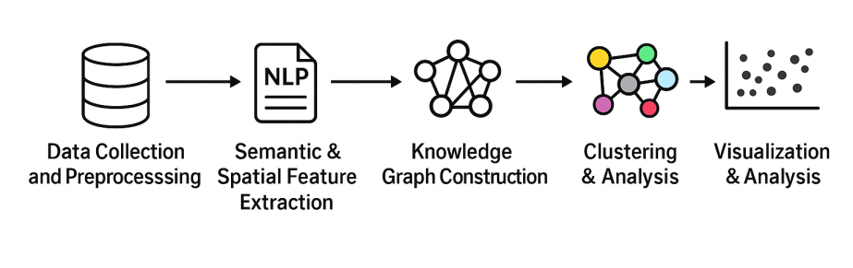
Fig. 1. Platial Information Fusion Workflow

3.2 Data Collection and Preprocessing

3.2.1. City Selection and Dataset Composition

A final set of 163 Greek cities, was created to represent a diversity of urban morphologies, regional contexts, and elevation categories. For the purposes of this research, we selected cities with population over 10k. Each selected city included a series of attributes that allow for both semantic and geographic analysis which included:
- Elevation
- Morphology type
- Building density category
- Green cover
- Population (latest available – 2021 year – cities with population over 10k)
- Semantic summary (Wikipedia)
This descriptive dataset provided the first level of input for the platial knowledge graph and the second level of clustering based on a semantic or graph-based analysis.

3.2.2 Urban Morphological Classification Based on LCZ

Cities were categorized by climate zones classes according to the Local Climate Zone (LCZ) classification scheme designed by Stewart & Oke, (2012), which has been used worldwide and tested in Greece (Agathangelidis et al., 2020; Sarris et al., 2005). Local Climate Zones (LCZs) emerged as a new standard for characterizing urban landscapes, providing a holistic classification approach that takes into account micro-scale land-cover and associated physical properties. Cities were classified into one of the three general morphological types using aggregated Local Climate Zone (LCZ) classifications. LCZ data for each city were collected via the LCZ Generator web application, which generates raster-based maps of the LCZ classes for a city by using satellite(s) and ancillary data (Demuzere et al., 2021).

For each city, we downloaded the corresponding LCZ raster and computed the proportional coverage of each LCZ class. These proportions were then used to infer topographic form and urban density. Elevation data for every city was accessed programmatically using the Vrisko Apostasi online tool (https://vriskoapostasi.gr/en/elevation) by sending HTTP requests based on geographic coordinates, then parsing the returned HTML content to read the reported elevation. All data processing and classification were implemented using custom Python scripts.

Type A – Lowland/Coastal Cities
- Elevation: 0-200m
- Topographic Form: flat, coastal plain
- Urban Form: high density population, strong anthropogenic influence on the environment, high thermal load
- LCZ indicator: LCZ 1-6 (compact high or medium-rise)

Type B – Mid-altitude Transitional Cities
- Elevation: 200-600m
- Topographic Form: undulating terrain with transition zones between lowlands and mountainous areas
- Urban form: mixed land use, moderate sized building footprint, moderate thermal exposure to environment
- LCZ indicator: LCZ C (compact mid-rise or scattered residential, detached homes)

Type C – High altitude (mountain) Cities
- Elevation > 600m
- Topographic Form: steep, mountainous ranges such as valleys or plateaus
- Urban Form: low density population with very limited urban expansion
- LCZ indicator: LCZ F, LCZ G (scarcely built, or vegetated terrain)

3.2.3 Building Density and Green Cover Indicators

Using LCZ criteria (Stewart & Oke, 2012), two additional urban form indicators were calculated for each city:
- Building Density: estimated via the built-up surface fraction and Floor Area Ratio (FAR)
  - High: > 60% built coverage (LCZ 1–2)
  - Medium: 30–60% (LCZ 3–4)
  - Low: < 30% (LCZ 6)
- Green Cover: derived from vegetation fraction as defined in LCZ types
  - High: > 50% (LCZ A–B: forest, dense vegetation)
  - Medium: 20–50% (LCZ D–E: sparse or agricultural vegetation)
  - Low: < 20% (LCZ 1–3: urban built-up)

These classifications were manually curated by taking into account city topography, urban land cover assessments and LCZ theory.

3.2.4 Semantic Summary Extraction via Wikipedia

Descriptive summaries (which provided semantic context to the urban entity) were automatically extracted using the Python wikipedia library (Wikipedia, 2014). The summaries were taken from the English-language and the Greek-language Wikipedia page for each city. In addition, the summaries had also underwent processing to ensure disambiguation (for example pulling out any multilingual content and references of namesake cities). Since full Wikipedia articles can vary in length and structure so radically, we would summarize through the Sumy library, so that each summary would be a brief extractive summary through Latent Semantic Analysis (LSA). This method preserved descriptive data regarding the historical, economic, and cultural facets of each city, respectively. An indicative summary of the city of Piraeus is presented in Figure 2.

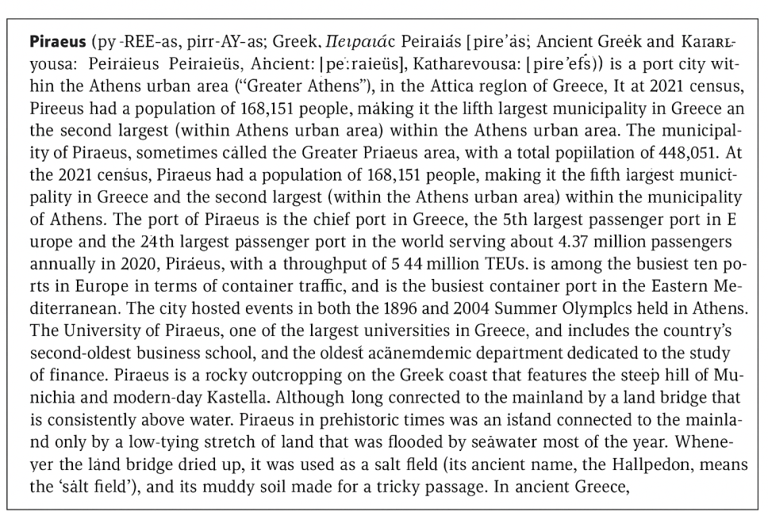
Fig. 2. Indicative example of retrieved summary for the city of Piraeus (Wikipedia, 2014)

3.2.5 Final Dataset Format

The final dataset includes the following fields per city (Table 1):

Table 1. Dataset fields

City
Summary (Wikipedia-based)
Morphology (A, B, or C)
Elevation
Building Density (High, Medium, Low)
Vegetation (High, Medium, Low)
Population (inhabitants)

Combining these attributes formed a multimodal urban profile which enabled clustering based on semantic and morphological similarity.

3.3. Knowledge Graph Construction and GNN Embedding

To provide a way to dive into these multidimensional relations between cities, a knowledge graph was developed where city nodes are created with edges that represent semantic similarities that arise from text descriptions and from the other collected attributes as well. The graph-based representation allows for the modeling of latent geosemantic ties that are not situated solely on geographic proximity or simple congruence of attributes.

3.3.1 Graph Construction Based on Semantic Similarity

The first graph (Figure 3) used a city-to-city semantic similarity matrix which was created by applying sentence embeddings using TextRank method (Li & Zhao, 2016) to the summaries created from Wikipedia. A cosine similarity (Gunawan et al., 2018) score was calculated for each pair of cities, which resulted in a symmetric matrix measuring semantic proximity. In order to maintain graph sparsity, and only keep meaningful relations, a similarity threshold of 0.6 was used, which designated any pair of city-summaries with a semantic similarity level above the threshold to be connected by an undirected edge. The graph was highly sparse, while still respecting thematic relationships such as shared historical context, tourism profiles, or their geographic or environmental similarities. Since the nodes (cities) did not have any predefined input features, random feature vectors (dimensionality 64) were assigned. These would later be updated by the Graph Neural Network during training.
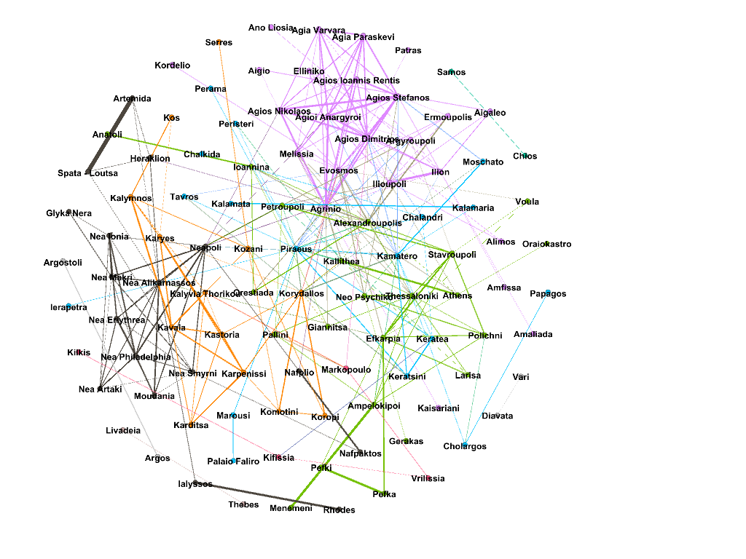
Fig. 3. Gephi - Semantic Clustering (Threshold 0,6) (Fruchterman Reingold layout)

3.3.2 Graph Neural Network (GNN) Embedding

To learn vector representations (embeddings) that embody the structural and semantic context of each city, we employed a GraphSAGE (Graph Sample and Aggregate) neural network (Hamilton et al., 2017) that aggregates information from each node's neighborhood to form low-dimensional embeddings with relational context.

The architecture was comprised of two GraphSAGE convolutional layers with 64 hidden units. The model was trained using a self-supervised reconstruction loss, which forced the neighborhood similarity to persist in the embedding space. Over 150 training epochs, the GNN learned to uncover patterns of connectivity and proximity between nodes (cities) based on the structure of the semantic graph.

The final node embeddings represented a latent semantic-geographic space; cities with similar narrative profiles were positioned closely to one another, yet they may be geographically distant. Lastly, Spectral Clustering was applied on the resulting 105 cities with similarity threshold over 0.6 and 4 clusters were created (Figure 3, Figure 4). The first cluster contains a large number of cities, including Thessaloniki suburbs, regional hubs, and cities with large population or strong economic role. The second cluster represents a wide mix of Athenian suburbs, regional centers, and coastal cities. It shows good cohesion based on population density and semantic context from the city summaries. The third cluster includes Athens and surrounding municipalities, along with prominent touristic or administrative cities like Kalamaria and Heraklion. The fourth cluster includes more peripheral or less densely populated cities, some touristic or administrative centers but with generally lower population density.

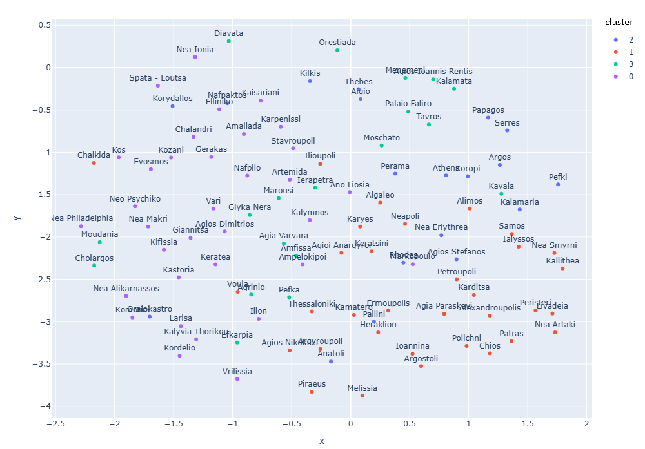

Fig. 4. UMAP - Semantic Clustering (GNN Embeddings – Threshold 0.6)

3.3.3 Spectral and GNN-Based Clustering

To investigate city clusters, cluster algorithms were applied to the GNN embeddings without taking into account the semantic similarity matrix so as to investigate these clustering results, too. Specifically, two (2) methods of clustering were performed:
- Spectral Clustering, based on the k-nearest neighbors graph affinity, and
- GNN-inferred Clustering, based on the learned embedding space directly
The number of clusters was determined by silhouette score, where we found the best separation for spectral clustering was k=5, and the GNN-based embeddings were found to be k=10. Each method displayed different thematic patterns. Spectral clustering grouped cities based on similar macro-level spatial characteristics (e.g., coastal tourism, mountain-based history). GNN-based clustering demonstrated a finer level of granularity amongst patterns in cities, as comparing similarities was subtler (e.g., similar morphology and morphology function types).

Gephi (Bastian et al., 2009) was used to support the visualization and exploration of clusters. Each node was populated with attributes such as elevation, population and morphology type.

3.4 Clustering and Analysis of Results

This section presents the results of the clustering process, comparing the outcomes of both spectral and graph-based methods, and interpreting the urban profiles revealed by the analysis. The goal was to identify semantically coherent groups of cities based on the constructed knowledge graph and learned embeddings as well as clustering without taking into account the similarity matrix.

3.4.1 Clustering Performance and Evaluation

The silhouette analysis revealed that the Spectral Clustering with five broad thematic clusters (k=5), consists of the best fit of the semantic similarity structure of the cities (Figure 5, Figure 6).

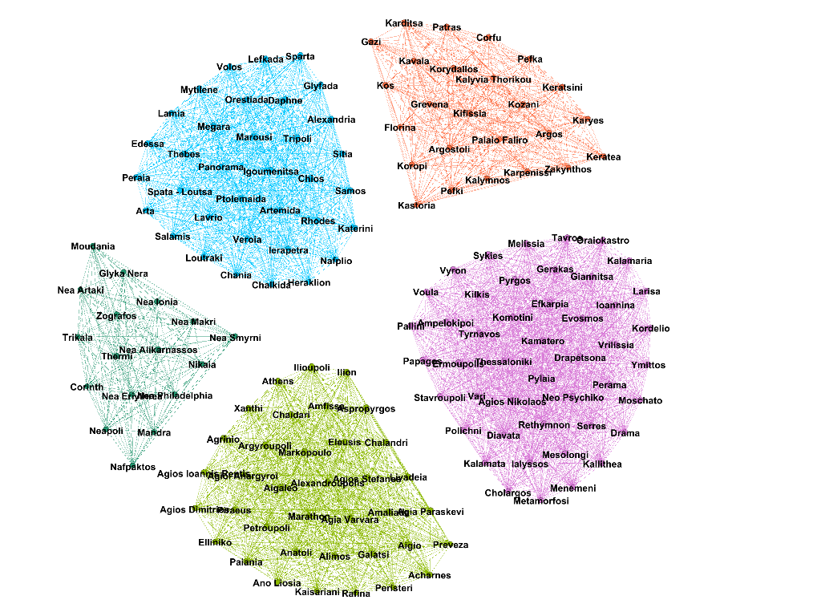

Fig. 5. Gephi - Spectral Clustering (Fruchterman Reingold layout)
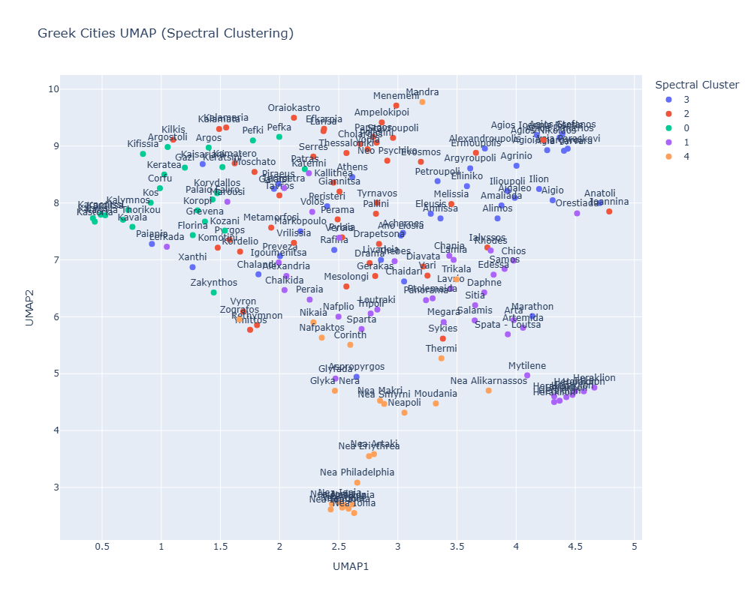
Fig. 6. UMAP - Spectral Clustering

Clustering using GNN embeddings showed that it performed best at k = 10 producing finer granularity in urban profiles (Figure 7, Figure 8).

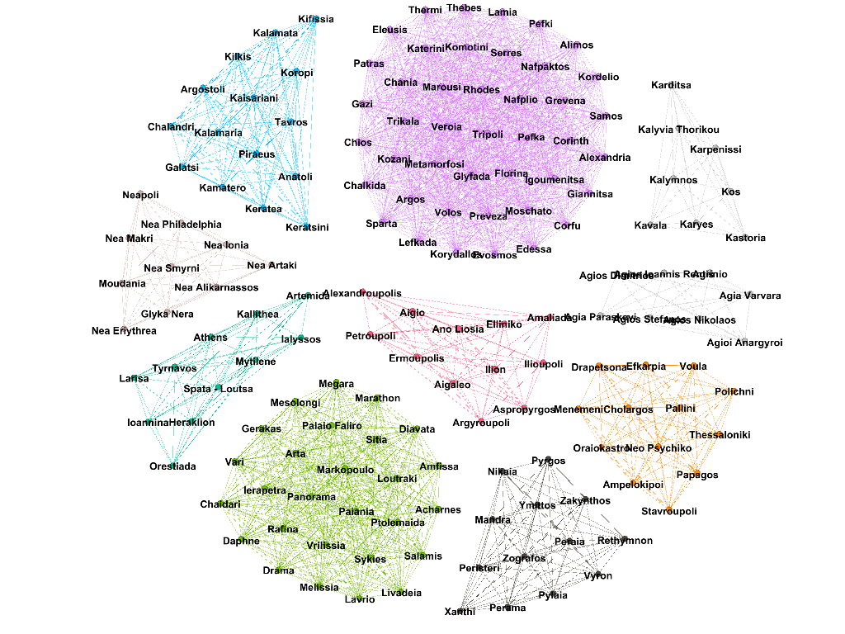
Fig. 7. Gephi - GNN Clustering (Fruchterman Reingold layout)
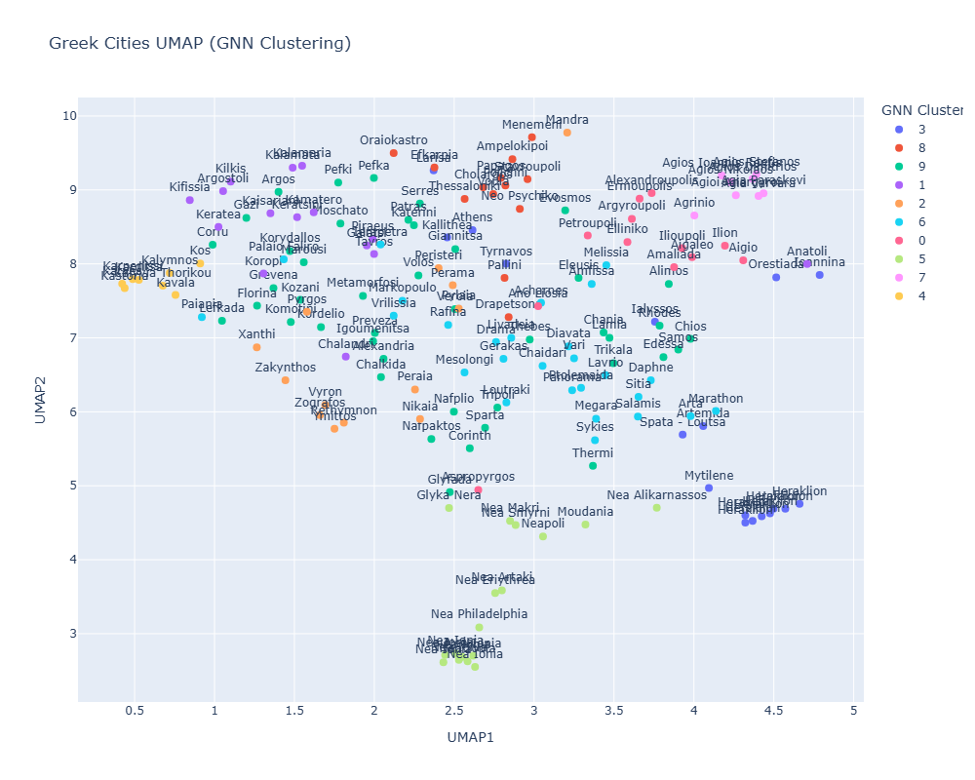
Fig. 8. UMAP - GNN Clustering

Although the best silhouette scores were low due to the intricacies of urban semantics, they did indicate a presence of distinguishable patterns. To visualize and explore the high-dimensional semantic embeddings of cities, UMAP (Uniform Manifold Approximation and Projection) was applied, a dimensionality reduction technique that preserves the global and local structure of data (McInnes et al., 2018). UMAP projects high-dimensional data into two-dimensional space, which helps reveal semantic patterns and clustering tendencies in text representations.

3.5 Interpretation of Spectral and GNN Clusters

The identified clusters were analysed according to morphology, and semantic content using both the structured urban aspects and the summaries from Wikipedia. From each cluster, a representative subset of cities was selected to show examples of the thematic groupings.

Cluster Examples - GNN-based Clustering (k=10)
- Mountainous and historic cities: Ioannina, Tripoli, Kastoria - shared high morphology, cultural history, and lower levels of building density.
- Coastal and touristic cities: Kalamata, Kavala, Rhodes - all near coastlines with references to beaches, tourism, and port activity in tourism.
- Metropolitan centers and mixed cities range: Athens, Heraklion, Larisa - cities with a diversity of functions, high populations and available rich cultural content.

These examples verified that the graph structure identified and provided indices of thematic and morphological proximity including cities that were further apart geographically.

Cluster Examples - Spectral Clustering (k=5)
The spectral cluster analysis model also creates broader, thematic groups that demonstrate high-level urban segmentation.
- Cluster 1: Compact urban centers with dense development.
- Cluster 2: Mid-sized regional hub with transitional morphology.
- Cluster 3: Historic, mountainous cities with cultural landmarks.
- Cluster 4: Coastal cities with emphasis on tourism.
- Cluster 5: Peripheral or less urban areas.

3.6 Export and Visualization

The spatial layouts and connectedness patterns shown through Gephi (Bastian et al., 2009) supported more investigations, and qualitative analysis of the results (Figures 3,5,7). Gephi is a free, open-source software that supports exploration and visualization for all types of graphs and networks. Gephi can visualize complex graphs and networks with many edges and nodes while optimising graph readability and can allow user participation to discover hidden patterns. Depending on the intention of a certain graph or network, different algorithms might be used, which can be represented with different available layouts (Anastopoulou et al., 2021).

Cluster statistics were also exported into structured spread sheets capturing average values and categorical distributions per cluster.

There was also a statistical assessment of mean value and categorical distributions per cluster to support qualitative interpretation. The GNN-based clustering yielded highly compact and distinct clusters, with Cluster 3 having the largest population (105.218 inhabitants), and lowest elevation, nearly matching large urban centers like Athens and Heraklion. With cities like Karpenisi and Kastoria , Cluster 4 had the highest elevation (311m), and was predominantly taken up by mountainous morphology, as well as high green cover.

Spectral Clustering (the embeddings from the GNN) produced looser groupings of clusters. Cluster 3 remained the most urbanized cluster (~61k average population), and Cluster 0 was comprised of mountainous or semi-mountainous cities which had high elevation and more vegetation.

The semantic clustering (at a threshold of 0.6), confirmed that similarities in theme could still align with urban morphology and elevation, where Cluster 2 contained the most populous and dense cities (i.e, Athens) and Cluster 3 included smaller and greener towns.

After performing a comparative analysis to identify difference between GNN-based clustering, spectral clustering and semantic clustering, it can be stated that GNN-based clustering provides greater sensitivity to extreme characteristics of urbanization within the data, whilst spectral clustering and semantic clustering captured more thematic continuity.

4. Conclusion

In this research, a framework was proposed for extracting and analyzing platial knowledge using Natural Language Processing (NLP) techniques alongside Graph Neural Networks (GNNs). By utilizing structured morphological information of a city with semantic information extracted from textual descriptions, we were able to develop a multimodal platial knowledge graph that gives us more than the spatial configuration of each city. This method approaches its narrative, historical, and morphological expressions.

GNN embedding and clustering exposed relation patterns between urban entities beyond distance. Cities, such as Ioannina and Tripoli, were associated because of their mountainous morphology and cultural heritage, while geographically distant coastal cities such as Kalamata, Kavala, and Rhodes were associated because of their maritime, touristic identity; these results indicate the utility of platial modeling in describing non-contiguous urban areas with some common semantic profile.

The contribution of the current research is multidimensional. First, it outlines the development of an urban dataset that aggregates geographic, demographic, morphological, and semantic features for a representative sample of Greek cities. Second, it describes how a semantic similarity graph was formed by drawing on Wikipedia-sourced summaries along with physical qualities, which ultimately produced a hybrid model of place. Third, it illustrates the use of GraphSAGE neural networks to learn embedded representations of cities in a semantic-geographic space. Finally, it assesses the utility of clustering algorithms (Spectral Clustering, graph-based embedding clustering) in identifying useful clusters of cities. Collectively, these parts enable a more profound, contextually sensitive understanding of place, which bridges linguistic understanding and spatial structure.

In conclusion, the resulting graph offers a new variant of an urban semantic network, a graph of cities connected not through roads or distance, but through narrative, thematic and morphological similarity. This platial approach opens up new forms of urban analysis and supports:
- The semantic clustering of cities to support policies and planning,
- The recognition of urban types that, as we have spotted, transcend the restrictive boundaries of traditional zoning or census limits.
This research has combined semantics derived from texts and graph-based machine learning and attempts to move beyond traditional GIS analysis to a richer understanding of place.

There are multiple ways to extend this study. A natural follow-on is to expand the geographical scope of the dataset to accommodate cities from other countries and linguistic backgrounds to enable comparative, cross-cultural platial analysis. Furthermore, there is promise in extending the study area beyond the spatial dimension, incorporating temporal dimensions such as demographic trends, historical events, or environmental change, so that a place could be considered as an evolving, dynamic entity. In terms of methodology, future research may build on the semantic extraction pipeline through the use of ontologies, named entity recognition, and integration of linked open data, leading to more expressive and interoperable knowledge graphs. Finally, the framework can be applied in other domains, including urban policy design, cultural heritage, and regional planning, where semantic clustering of cities may offer valuable insights into identity, connectivity, and resilience.

Data Availability

The data that support the findings of this study was parsed from the web, specifically from Wikipedia.org. The final parsed dataset that was used during the training phase can be found at the following link: https://figshare.com/s/3b738d5e205e5a1d61de ). DOI: 10.6084/m9.figshare.30421906.

Disclaimer (Artificial intelligence)
Author(s) hereby declare that NO generative AI technologies such as Large Language Models (ChatGPT, COPILOT, etc.) and text-to-image generators have been used during the writing or editing of this manuscript.

References

Acheson, E., & Purves, R. S. (2021). Extracting and modeling geographic information from scientific articles. PLOS ONE, 16(1), e0244918 https://doi.org/10.1371/journal.pone.0244918

Agathangelidis, I., Cartalis, C., & Santamouris, M. (2020). Urban Morphological Controls on Surface Thermal Dynamics: A Comparative Assessment of Major European Cities with a Focus on Athens, Greece. Climate, 8(11), 131. https://doi.org/10.3390/cli8110131

Anastopoulou, N., Kavouras, M., Kokla, M., & Tomai, E. (2021). CONCEPTS – LOCATIONS – EMOTIONS: SEMANTIC ANALYSIS AND VISUALIZATION OF CLIMATE CHANGE TEXTS. The International Archives of the Photogrammetry, Remote Sensing and Spatial Information Sciences, XLIII-B4-2021, 31–37. https://doi.org/10.5194/isprs-archives-XLIII-B4-2021-31-2021

Bastian, M., Heymann, S., & Jacomy, M. (2009). Gephi: An Open Source Software for Exploring and Manipulating Networks. Proceedings of the International AAAI Conference on Web and Social Media, 3(1), 361–362. https://doi.org/10.1609/icwsm.v3i1.13937

Bhandari, P., Anastasopoulos, A., & Pfoser, D. (2023). Are Large Language Models Geospatially Knowledgeable? Proceedings of the 31st ACM International Conference on Advances in Geographic Information Systems https://doi.org/10.1145/3589132.3625625

Chishtie, F., Bulbul, R., Babukova, P., & Scholz, J. (2023). Platial mobility: Expanding place and mobility in GIS via platio-temporal representations and the mobilities paradigm. Journal of Geographical Systems, 25(1), 77–101. https://doi.org/10.1007/s10109-022-00389-3

Couclelis, H. (2010). Ontologies of geographic information. International Journal of Geographical Information Science, 24(12), 1785–1809. https://doi.org/10.1080/13658816.2010.484392

Demuzere, M., Kittner, J., & Bechtel, B. (2021). LCZ Generator: A Web Application to Create Local Climate Zone Maps. Frontiers in Environmental Science, 9, 637455. https://doi.org/10.3389/fenvs.2021.637455

Fan, Y., Lu, X., Liu, H., Wang, P., Liu, L., Ma, H., & Zhou, J. (2025). Towards Predicting Urban Land Use Changes: A Dynamic Graph Alignment Perspective. ACM Transactions on Intelligent Systems and Technology, 16(2), 1–24. https://doi.org/10.1145/3712702

Fernandez, A., & Dube, S. (2023). Core Building Blocks: Next Gen Geo Spatial GPT Application. arXiv. https://doi.org/10.48550/arXiv.2310.11029

Gao, S., Janowicz, K., Montello, D. R., Hu, Y., Yang, J.-A., McKenzie, G., Ju, Y., Gong, L., Adams, B., & Yan, B. (2017). A data-synthesis-driven method for detecting and extracting vague cognitive regions. International Journal of Geographical Information Science. https://doi.org/10.1080/13658816.2016.1273357

Gao, S., Rao, J., Liang, Y., Kang, Y., Zhu, J., & Zhu, R. (2023). GeoAI Methodological Foundations: Deep Neural Networks and Knowledge Graphs. In Handbook of Geospatial Artificial Intelligence (pp. 45-74). CRC Press.

Goodchild, M. F. (2011). Formalizing Place in Geographic Information Systems. In L. M. Burton, S. A. Matthews, M. Leung, S. P. Kemp, & D. T. Takeuchi (Eds.), Communities, Neighborhoods, and Health (pp. 21–33). https://doi.org/10.1007/978-1-4419-7482-2_2

Goodchild, M. F. (2015). Space, place and health. Annals of GIS. https://doi.org/10.1080/19475683.2015.1007895

Gunawan, D., Sembiring, C. A., & Budiman, M. A. (2018). The Implementation of Cosine Similarity to Calculate Text Relevance between Two Documents. Journal of Physics: Conference Series. https://doi.org/10.1088/1742-6596/978/1/012120

Gurav, R., De, D., Thakur, G., & Fan, J. (2021). Conflation of Geospatial POI Data and Ground-level Imagery via Link Prediction on Joint Semantic Graph. Proceedings of the 4th ACM SIGSPATIAL International Workshop on AI for Geographic Knowledge Discovery. https://doi.org/10.1145/3486635.3491068

Hamilton, W. L., Ying, Z., & Leskovec, J. (2017). Inductive representation learning on large graphs. Advances in Neural Information Processing Systems, 30. https://doi.org/10.48550/arXiv.1706.02216

Hu, S., Gao, S., Wu, L., Xu, Y., Zhang, Z., Cui, H., & Gong, X. (2021). Urban function classification at road segment level using taxi trajectory data: A graph convolutional neural network approach. Computers, Environment and Urban Systems https://doi.org/10.1016/j.compenvurbsys.2021.101619

Hu, Y. (2018). Geo‐text data and data‐driven geospatial semantics. Geography Compass, 12(11), e12404. https://doi.org/10.1111/gec3.12404

Hu, Y., & Adams, B. (2021). Harvesting Big Geospatial Data from Natural Language Texts. In M. Werner & Y.-Y. Chiang (Eds.), Handbook of Big Geospatial Data (pp. 487–507). Springer International Publishing. https://doi.org/10.1007/978-3-030-55462-0_19

Janowicz, K., Gao, S., McKenzie, G., Hu, Y., & Bhaduri, B. (2020). GeoAI: Spatially explicit artificial intelligence techniques for geographic knowledge discovery and beyond. International Journal of Geographical Information Science, 34(4), 625–636. https://doi.org/10.1080/13658816.2019.1684500

Janowicz, K., Hitzler, P., Adams, B., Kolas, D., & Vardeman, C. (2014). Five Stars of Linked Data Vocabulary Use. Semantic Web -- Interoperability, Usability, Applicability, 5(3), 173-176. https://doi.org/10.3233/SW-140135

Jiang, Y., & Yang, C. (2024). Is ChatGPT a Good Geospatial Data Analyst? Exploring the Integration of Natural Language into Structured Query Language within a Spatial Database. ISPRS International Journal of Geo-Information, 13(1), 26. https://doi.org/10.3390/ijgi13010026

Klemmer, K., Safir, N. S., & Neill, D. B. (2021). Positional Encoder Graph Neural Networks for Geographic Data. https://doi.org/10.48550/arXiv.2111.10144

Kokla, M., & Guilbert, E. (2020). A Review of Geospatial Semantic Information Modeling and Elicitation Approaches. ISPRS International Journal of Geo-Information, 9(3), 146. https://doi.org/10.3390/ijgi9030146

Lee, W. J., & Lauw, H. W. (2024). Latent Representation Learning for Geospatial Entities. ACM Transactions on Spatial Algorithms and Systems, 10(4), 1–31. https://doi.org/10.1145/3663474

Li, S., Yang, W., Huang, S., Chen, R., Cheng, X., Zhou, S., Gong, J., Qian, H., & Fang, F. (2023). A hierarchical constraint-based graph neural network for imputing urban area data. International Journal of Geographical Information Science, 37(9), 1998–2019. https://doi.org/10.1080/13658816.2023.2239307

Li, W., & Zhao, J. (2016). TextRank Algorithm by Exploiting Wikipedia for Short Text Keywords Extraction. 2016 3rd International Conference on Information Science and Control Engineering (ICISCE), 683–686. https://doi.org/10.1109/ICISCE.2016.151

Li, Z., Gong, J., Lu, C., & Yi, Y. (2021). Interactive Behavior Prediction for Heterogeneous Traffic Participants in the Urban Road: A Graph-Neural-Network-Based Multitask Learning Framework. IEEE/ASME Transactions on Mechatronics, 26(3), 1339–1349. https://doi.org/10.1109/TMECH.2021.3073736

Liu, P., & Biljecki, F. (2022). A review of spatially-explicit GeoAI applications in Urban Geography. International Journal of Applied Earth Observation and Geoinformation, 112, 102936. https://doi.org/10.1016/j.jag.2022.102936

Liu, P., Zhang, Y., & Biljecki, F. (2024). Explainable spatially explicit geospatial artificial intelligence in urban analytics. Environment and Planning B: Urban Analytics and City Science, 51(5), 1104–1123. https://doi.org/10.1177/23998083231204689

Mansourian, A., & Oucheikh, R. (2024). ChatGeoAI: Enabling Geospatial Analysis for Public through Natural Language, with Large Language Models. ISPRS International Journal of Geo-Information. https://doi.org/10.3390/ijgi13100348

McInnes, L., Healy, J., Saul, N., & Großberger, L. (2018). UMAP: Uniform Manifold Approximation and Projection. Journal of Open Source Software, 3(29), 861. https://doi.org/10.21105/joss.00861

Mocnik, F.-B. (2022). Putting Geographical Information Science in Place – Towards Theories of Platial Information and Platial Information Systems. Progress in Human Geography, 46(3), 798–828. https://doi.org/10.1177/03091325221074023

Mocnik, F.-B., & Westerholt, R. (2022). Introduction to the Third International Symposium on Platial Information Science. Places Across Cultures: Proceedings of the 3rd International Symposium on Platial Information Science (PLATIAL'21) https://doi.org/10.5281/ZENODO.6413106

Naveen, P., Maheswar, R., & Trojovský, P. (2024). GeoNLU: Bridging the gap between natural language and spatial data infrastructures. Alexandria Engineering Journal, 87, 126–147. https://doi.org/10.1016/j.aej.2023.12.027

Rahmani, S., Baghbani, A., Bouguila, N., & Patterson, Z. (2023). Graph Neural Networks for Intelligent Transportation Systems: A Survey. IEEE Transactions on Intelligent Transportation Systems, 24(8), 8846–8885. https://doi.org/10.1109/TITS.2023.3257759

Sarris, A., KARAKOUDIS, S., VIDAKI, C., & Soupios, P. (2005). Study of the Morphological Attributes of Crete through the Use of Remote Sensing Techniques. IASME Trans, 6.

Stewart, I. D., & Oke, T. R. (2012). Local Climate Zones for Urban Temperature Studies. Bulletin of the American Meteorological Society, 93(12), 1879–1900. https://doi.org/10.1175/BAMS-D-11-00019.1

Tonks, A., Harris, T., Li, B., Brown, W., & Smith, R. (2024). Forecasting West Nile Virus With Graph Neural Networks: Harnessing Spatial Dependence in Irregularly Sampled Geospatial Data. GeoHealth https://doi.org/10.1029/2023GH000784

Westerholt, R., Mocnik, F., & Comber, A. (2020). A place for place: Modelling and analysing platial representations. Transactions in GIS, 24(4), 811–818. https://doi.org/10.1111/tgis.12647

Westerholt, R., & Mocnik, F.-B. (2020). Introduction to the Second International Symposium on Platial Information Science. In F.-B. Mocnik & R. Westerholt (Eds.), Proceedings of the 2nd International Symposium on Platial Information Science (PLATIAL'19) (pp. 1–3). https://doi.org/10.5281/zenodo.3628847

Westerholt, R., Mocnik, F.-B., & Zipf, A. (2018). Introduction to the PLATIAL’18 Workshop on Platial Analysis. Proceedings of the 1st Workshop on Platial Analysis (PLATIAL'18) https://doi.org/10.5281/zenodo.1475267

Westerholt, R., Mocnik, F.-B., & Zipf, A. (2018). On the Way to Platial Analysis: Can Geosocial Media Provide the Necessary Impetus? In Proceedings of the First Workshop on Platial Analysis (PLATIAL’18). Zenodo. https://doi.org/10.5281/ZENODO.1475269

Goldsmith, J. (2014). Wikipedia API for Python (Version 1.4.0). https://github.com/goldsmith/Wikipedia

Yan, Y., & Lee, J. (2024). GeoReasoner: Reasoning On Geospatially Grounded Context For Natural Language Understanding. arXiv. https://doi.org/10.48550/arXiv.2408.11366

Zhan, W., & Datta, A. (2025). Neural Networks for Geospatial Data. Journal of the American Statistical Association, 120(549), 535–547. https://doi.org/10.1080/01621459.2024.2356293

Zhang, Y., Wei, C., He, Z., & Yu, W. (2024). GeoGPT: An assistant for understanding and processing geospatial tasks. International Journal of Applied Earth Observation and Geoinformation. https://doi.org/10.1016/j.jag.2024.103976

Zhu, D., Liu, Y., Yao, X., & Fischer, M. M. (2022). Spatial regression graph convolutional neural networks: A deep learning paradigm for spatial multivariate distributions. GeoInformatica. https://doi.org/10.1007/s10707-021-00454-x

