Spatial Analyses of Traditional Housing and Implication for Security in Abeokuta South and Abeokuta North Local Government Areas in Ogun State

Abstract
The linkage between traditional housing and the security of lives and properties of the people has generated an issue of debate over time. Therefore, criminality, social menace and other vices become frequent in traditional areas, particularly in developing nations. Many studies on security have focused on the planned settlements of the cities, while the traditional areas have gained little attention in the literature. This study, therefore, analyses the spatial pattern of traditional architecture and its implications on the security of lives and properties of the residents of Abeokuta South and Abeokuta North Local Government Areas, Ogun State, Nigeria. A combination of location and allocation model and broken window theories was adopted. A cross-sectional survey research design was used, while both primary and secondary data were sourced. Using the Geographical Information System (GIS) ArcGIS-10, the coordinates of all (449) the houses in the traditional area of Itoko (82), Ijemo (81), Ago-oko (109) in Abeokuta South, and Ajitadidun (43), Mokola (81), Iberekodo (53), in the Abeokuta North were taken and used to generate the locational attributes of the settlements. The quantitative data were analysed using Nearest Neighbours Analysis (NNA). The results revealed that the spatial distribution pattern of all sampled buildings at Itoko, Ijemo, Ago-oko and Ajitadun, Mokola, and Iberekodo were clustered (R_{n}=0.013340 and R_{n} = 0.049828) respectively. The security of the residents in the study area is negatively affected. Therefore, blending modern and traditional concepts to improve security in the study area is recommended.
Keywords: Traditional housing pattern, Spatial analyses, Security architecture, Crime, Abeokuta

1.0 Introduction
The built environment refers to any physical change constructed by humans in the natural environment (Shapiro, 1997). It includes built components such as buildings, monuments, roads, parks and markets (Lawrence & Low, 1990). Housing, as one of the smallest building blocks of the built environment, has evolved in form and material in response to changing social and cultural needs (Rapoport, 1969). Examples of the built environment include cities, characterised by changes in information technology, infrastructure, economic growth and development, and tremendous cultural transformation (Emusa & Idakwoji, 2023). Housing as an infrastructure constitutes a strategic aspect of urban planning. Studies on various aspects of infrastructure have been documented (Jimoh & Abdullahi, 2022; Umar, J., & Oriri, O., 2023). Jimoh, U. U., & Olagunju, D. K. (2022). Jimoh (2022), Jimoh, Jimoh, U., & Falola, O. (2018). Jimoh (2021), Jimoh & Famewo (2022), Jimoh & Famewo (2023), Jimoh & Ayomide (2022), Jimoh & Otokiti (2022).

However, these features precipitate criminality at the global and local level, and as a result, are worrisome in achieving Sustainable Development Goal 11 (Auwalu & Dickson, 2019). The related aspect of the SDG-11 to the subject is Target 11.3, which states that: “enhance inclusive and sustainable urbanisation and capacities for participatory, integrated and sustainable human settlement planning and management in all countries” by 2030.
One major characteristic of human settlements that cannot be taken away is their transformative dimension. On the other hand, the unique transformations are accompanied by attendant problems, such as housing shortages resulting in homelessness, traffic congestion, unemployment, and, of course, a high rate of crime, among others (Adewuyi et al., 2017). Consequently, it has been established that cities and urban centres have higher rates of violence and crime than rural areas. This assertion can be referred to the traditional pattern of development in Third World countries, whose experiences are captured as countries of rural villages changing to countries of towns, cities, and megacities. (Kehinde & Odiaka, 2020). To control this approach, numerous villages have been actively implementing village conservation and reconstruction programs as an effective method of enhancing the ethnic cultural industries (Cillis et al., 2019; Wang et al., 2019; Dasic et al., 2020; Xu et al., 2021; Mayuzumi, 2022; Zhu et al., 2022). This is a pragmatic effort to confront the challenges that might arise from the traditional pattern transformation in China.
However, the traditional settlement patterns in Nigeria and specifically in Yoruba land, which are identified by the nature of their housing: a bungalow, using wood or mud and thatch with large courtyards and courtyards at the center and farmland at the rear, may be seen as being vulnerable due to inappropriate planning and designing of housing (Adeyemi et al, 2021). Rogerson and Armitage (2024) believed that the transformation from traditional housing to modern housing design has influenced the rate of crime and criminality worldwide. Another problem that modernity generates is the loss of homogenisation of architectural styles; the loss of cultural identity, which preaches isolation and loneliness in the same community. Nevertheless, it must be noted that neither of the two categories is immune to crime and criminality. In this context, the study aims to investigate the impact of housing patterns on the security architecture in Abeokuta South and Abeokuta North Local Government Areas (LGA) in Ogun State. The research questions are:
- What are the diverse security architectures and the contemporary measures put in place to address security issues in the study area?
- What are the impacts of housing patterns on the security architecture in the study area?
Spatial pattern analysis is a concept that encompasses procedures for (1) identifying the characteristics of georeferenced data, particularly as they are represented on maps, (2) testing hypotheses, and (3) constructing models that provide meaning to relationships between georeferenced variables (Arthur, 2005). The shapefile can be points, lines, or shapes. The needed data for the concept may include buildings and their arrangement, roads and their length, location of facilities, among others. It can also be used to identify and explain patterns such as crime spot areas, determine trends, measure and use to explain the inter-spatial characteristics of dependent variables. The analyses will assist in making inferences on space allocation and the neighbourhood social life as an important aspect of urban transformation (Kadhim et al, 2024). There have been attempts to establish a connection between the spatial organisation of houses and psychosocial effects, including social isolation, social control and psychological discomfort (Bafna & Chambers 2013). Through its effect on the protection, security and effectiveness of a building’s functions, the spatial layout of a neighbourhood has a clear impact on space performance. In typology, there are five fundamental ways a building’s spaces can relate to one another, as depicted in Figure 1. Examples of types of cities are centralised: Beijing, China; Linear: Bern, Switzerland; Radial: Paris, France; Clustered: Onitsha, Nigeria; and Grid: Ilesa, Nigeria (UN-Habitat, 2014, Emily, 2024, & Wen et al, 2025). The five spatial dynamics of the cities form different social implications.
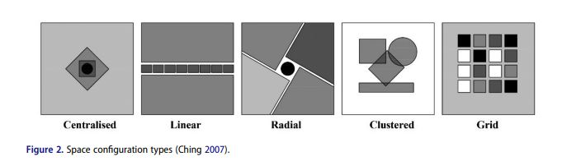
Figure 1: Space Configuration Types
Sources: Ching, 2007 & Kadhim et al, 2024

In a study of North American cities, scholars constructed a system dynamics model to analyze the dynamic relationship between industrial development, transportation infrastructure construction and urban expansion, and found that the large-scale construction of factories and the extension of transportation lines in the process of industrialization attracted a large number of people to migrate, thereby promoting the continuous outward expansion of cities in space (Knaap, & Hopkins,2001). In Europe, another study used system dynamics models to explore how the construction of transportation hubs changes the flow of urban population and the distribution of economic activities, thereby affecting the direction and scale of urban expansion (Hall & Pfeiffer, 2008). The research reveals the close internal connection between spatial urban expansion and the process of industrialisation, transportation infrastructure construction, and population migration.
Adadu (2015) opined that the forms and patterns of traditional housing settings are a complex phenomenon for which there is no single narration or explanation, as people with very different attitudes and ideas respond to varied physical environments. Traditional housing forms vary and change from place to place due to diverse social, cultural, ritual, economic, and physical factors. Adadu believed that the construction or building of a house or houses is a cultural phenomenon; its form and organisation are greatly influenced by the cultural background to which the developer belongs, the area where the development is taking place, or the desire of the producer to develop a dwelling which is best suited to the way of life of a developer or the people. On the other hand, the traditional housing pattern is giving for the modern housing pattern. However, the rapid urbanisation and modernisation processes have led to significant changes in residential patterns and housing structures. The restructuring process of residential units from houses to homes has been influenced by modernity, which has resulted in new housing models that prioritise energy efficiency, comfort, micro-climate, economy, innovation, and location over social, cultural, ethnic, psychological, emotional, and religious aspects (Ronald et al. 2016; Murie 2009; Tong & Hays 1996). Formolly & Saraei (2024) revealed the negative effects of modernisation on residential transformation, particularly in historical areas where rapid construction neglects cultural heritage. The modern housing pattern preaches isolation and loneliness. The majority are now developing housing with security fences and the installation of electric wires to prevent external aggression. However, this failed to deter the criminal elements from perpetuating their evil agenda. Nowadays, kidnapping, armed robbery, and raping, to mention a few, are on the high side (Adedeji Daramola & Olanrewaju, 2022). Adedeji et al. (2022) believed that the modern housing pattern had triggered crimes such as armed robbery and burglary within the neighbourhood. Anifowe and Ilias (2018) and Oguntunde, Ojo, Okagbue, and Oguntunde (2018) opined that burglaries, murder, armed robbery, felonious wounding, manslaughter, bribery, and corruption are the most common crimes in modern housing patterns, which were not too pronounced in traditional housing settings/patterns due to the design and numbers of dwellers within the vicinity. Igwe et al. (2017) observed that the increase in housing burglary is a result of the introduction of innovation in housing development patterns in the urban centre.
MacDonald (2024) opined that crime and criminality are influenced and encouraged by the pattern of the built environment or vicinity. Crime prevention through housing design patterns is a global challenge that is confronting housing developers and security agencies globally. Many valuable lives have been lost due to the inappropriate planning and designing of housing. Criminals hide under this lapse to perpetrate their nefarious activities. Nigeria is undoubtedly one of the nations with a huge housing pattern problem, most especially in terms of conversion from traditional patterns to modern patterns. However, Owamoyo and Tabibi (2023) believe that globalisation has significantly eroded traditional architectural practices, materials, and preferences, displacing traditional patterns of housing development in Nigerian urban areas.
The modernisation of housing patterns, most especially in the urban centre, has tremendously contributed to the rate of crime and criminality in the heart of the city. Environment and housing design patterns are integral parts of the quality of life people live (Ademola, 2019). This globalisation has had great impacts, but the impact did not come without challenges and potential drawbacks. As global influences shape design choices, there is a risk of eroding local architectural traditions and heritage. However, the challenges confronting traditional housing patterns include, but are not limited to, undefined gates and the absence of rules specifically guiding the coming and going of people. The implication of the lack of these facilities and governing rules that regulate the movement of people within the estate has led to the attacks of various forms, such as robbery of various types, rape, and kidnapping, to mention a few. However, the lack of these features is one of the reasons why people demand modern housing patterns.
The in-depth exploration of spatial patterns and security has significant conceptual and theoretical connotations, particularly in the context of achieving Sustainable Development Goals. It is no longer surprising that the gradual transformation from traditional architecture occurs while structures stand with fewer occupants, allowing neighbourhoods to become havens for criminal activity due to a lack of active (young) residents. As a result, the neighbourhoods where these types of structures exist may be susceptible to insecurity.
Some research used multivariate regression analysis methods based on long-term land use data and found that with the rapid development of the economy, urban construction land has continued to expand, the area of cultivated land has gradually decreased, and land use has shown a rapid transformation from agricultural land to construction land (Liu et al, 2020). Similar studies employed space syntax tools and system dynamics analysis. The study concludes that the linear type represents the most private typology, followed by the cluster and then the central type. The centralised typology is the most connected and accessible to different spaces within the residential unit, followed by the cluster type and the linear type, with a significant difference (Dilara & Mehtap, 2024 and Kadhim et al, 2024).
2.0 MATERIALS AND METHODS
Abeokuta is the administrative seat of two local governments: Abeokuta South, with its seat at Ake, and Abeokuta North, based at Akomoje. It is regarded as a major industrial centre in Nigeria. The primary occupations of the people of Abeokuta include tie and dye, weaving, commerce, and farming. Major commercial centres in Abeokuta comprise Kuto, Itoku, Sapon, and Lafenwa.
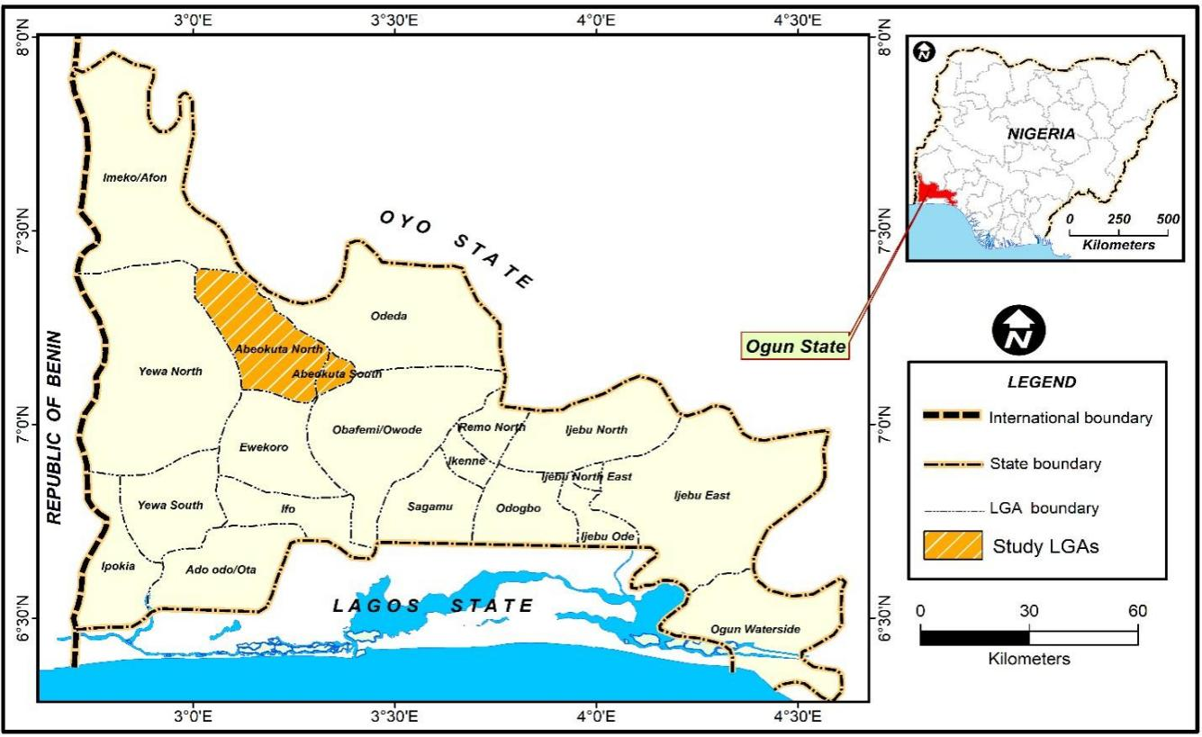
Figure 2: Map of the study area (Abeokuta, Ogun State, Nigeria)

The sampled settlements for the present study are Itoko, Ijemo, and Ago-oko in Abeokuta South, and Ajitadidun, Mokola, and Iberekodo in Abeokuta North. Itoku was founded as a consequence of war and served as a refugee camp for the Egbas fleeing the devastation of their homesteads (Orile) in 1830. Itoko and Ago-oko were known as places of refuge and settlement. The most notable event associated with Ijemo is the Ijemo Massacre of 1914, which led to the abrogation of the Treaty of 1893. This massacre, where unarmed men, women, and children were killed, was widely condemned and discussed in West African and English newspapers. Ijemo also holds significance as a site where the oral traditions and historical accounts of the Egba people have been preserved. Ajitadun's and Mokola's impact on the history of Abeokuta establishment is significant and is intertwined with the city's foundation as a refuge for Egba people fleeing the Oyo Empire, while Iberekodo is a reference to the location where Abeokuta was founded.
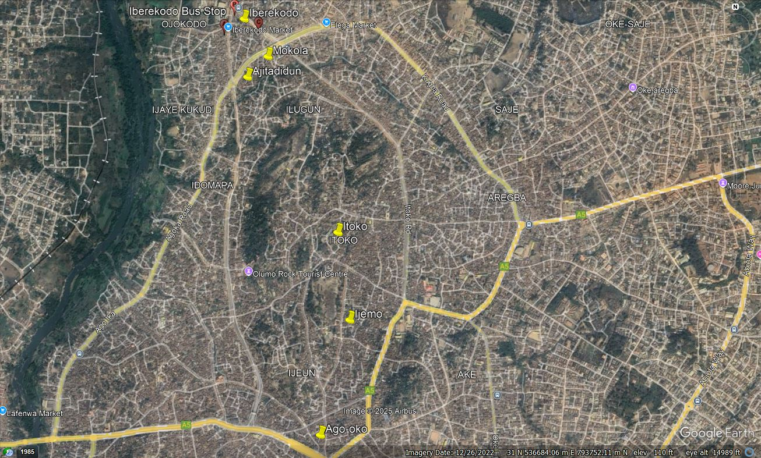
Plate 1: Imagery of important areas around the study area
Source: Google Earth Pro, 2025
2.1 Research Design
This study adopted cross-sectional survey research design methods. The study used both primary and secondary sources of data to gather information. The latitude and longitude GIS coordinates of all the buildings were taken to locate individual buildings and analysed and plotted in Arc-GIS 10 for analysis. The Nearest Neighbours Analysis (NNA) was also done to ascertain or determine the spatial distribution or pattern of the distribution.
Table 1: Projected population of the area selected
LGA | Localities | Area | 2006
Abeokuta South | Ake axis | Itoko | 235
Abeokuta South | Ijemo axis | Ijemo | 231
Abeokuta South | Sapon axis | Ago Oko | 312
Abeokuta North | Ijeun axis | Ajitadidun | 123
Abeokuta North | Adedotun axis | Mokola | 232
Abeokuta North | Elega | Iberekodo | 151
Total |  |  | 1,284
3.0 Results and Discussion
The spatial pattern of traditional housing in the study area.
The Nearest Neighbour Analysis (NNA) technique was used to analyse the spatial pattern of sampled buildings in the study area. The result was interpreted in ArcMap 10.8 software using the ‘Average Nearest Neighbours’ statistics tool extension to determine the spatial pattern. The coordinates in Universal Traverse Mercator (UTM) Zone 31N of the sampled buildings were imported, formatted, and saved in Microsoft Excel as ‘Text Tab Delimited’ format. This result was imported into ArcMap 10.8 to establish their location. Also, the boundaries of the two study LGAs (Abeokuta North and South) were extracted to define the extent of the LGAs on which the analysis was based. The location of the sampled buildings was overlayed on the boundary of the study area to generate the spatial pattern parameters. The results of this operation are shown in Table 1 and 2
N
Nearest Neighbour Statistics formula is given as: R_{n} = 2D A
Where:
Rn = the nearest neighbour value,
d = the mean distance of the nearest neighbour in kilometres
n = the number of features to be studied (sampled buildings)
a = the area of study in meters square.
Rn ranges from 0 to 2.15 at p values of 0, 1, and 2.15, which signifies clustered, random, and uniform distributions.
Table 2: Result of the spatial pattern of sampled building in Abeokuta North
Study Area | Observed Mean  Distance | Expected Mean  Distance | Rn Value | Z  Score | P Value | Area of Study  (m²) | No. of Sample  (n) | Pattern
Abeokuta | 14.5677 | 1092.059 | 0.013340 | - | 0.0 | 8443570
178 | Clustered
North |  |  |  | 25.112224
Source: Field Survey, (2024)

Table 3: Result of the spatial pattern of sampled building in Abeokuta South
Study Area | Observed Mean  Distance | Expected Mean  Distfance | Rn Value | Z  Score | P Value | Area of Study  (m²) | No. of Sample  (n) | Pattern
Abeokuta | 14.7456 | 295.9304 | 0.049828 | - | 0.0 | 9528140 | (n)
272 | Clustered
South |  |  |  | 29.97903
Source: Field Survey (2024)

Tables 1 and .2. show the result of the Nearest Neighbour statistics as a measure of the spatial pattern of sampled buildings (n =178) in the study area. From Table 1, the R_{n} value of 0.01 was obtained. This indicates that the spatial distribution pattern of all sampled buildings in Ajitadidun, Mokola, and Iberekodo in Abeokuta North Local Government is Clustered (R_{n} < 1). Testing the summary of this result, it can be stated that, given the z-score of -25.1122237894, there is less than 1% likelihood that this clustered pattern could be the result of random chance. Further, the degree of clustering was analysed, showing that the spatial pattern exhibits a high degree of clustering. In other words, the R_{n} value tends towards perfect clustering (0). Figure 3 shows a visualisation of the pattern of the sampled buildings in Abeokuta North LGA.
Similarly, the result from Table 2 indicates an Rn value of 0.05 with a total number of buildings (n=272). This also shows that the spatial pattern of sampled buildings in Ago Oko, Ijemo, and Itoko in Abeokuta South Local Government Area (LGA) is clustered (Rn<1). Therefore, the summary of this result means that given the z-score of -29.9790309069 (Table 3), there is less than 1% likelihood that this clustered pattern could result from random chance. In this case, the degree of the clustering pattern is moderate, as the Rn value is halfway between 0 and 1. Figure 3 shows a visualisation of the pattern of the sampled buildings in Abeokuta South LGA. Overall, the spatial pattern of the sampled buildings in the two LGAs is clustered, meaning they are close to each other within the same geographical enclave.
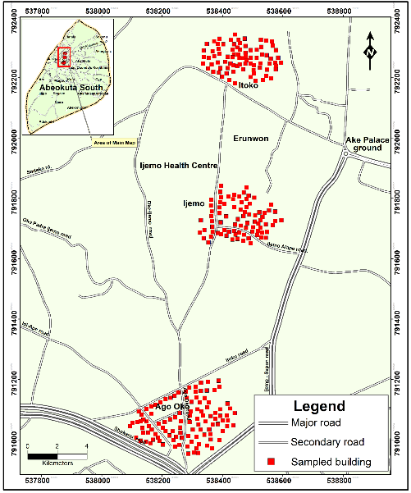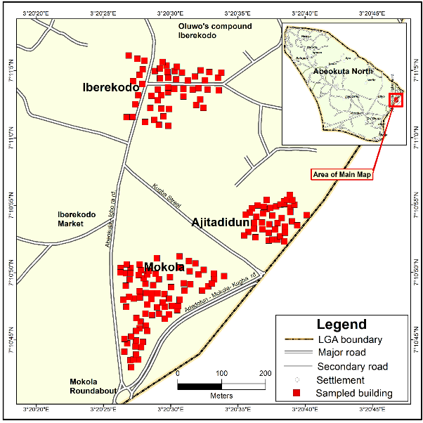
Figure 3: Spatial distribution of sampled buildings in Abeokuta South Local Government Area

By implication, though, clustered housing patterns have several implications, including social interaction and community cohesion, but can also lead to inequalities in which wealthier families may cluster around better resources, leaving poorer families with less desirable access to security. The findings of this study are in line with the opinion of Igbo and Ugwuoke (2019), who say the pattern of housing development helps to aid criminals, invariably leading to loss of lives and properties. Also, Kehinde and Odiaka (2020) concluded that a pattern of housing development tends to lead to more violence and a higher property crime rate.

5.0 Conclusion
The relationship between housing patterns and criminality cannot be underestimated globally. This study has revealed that the pattern of housing design plays a huge role in curbing crime and criminality in our society. Hence, this study affirms the two theories, Pattern Language Theory and neo-Marxist theory, which are primarily concerned with the pattern of housing development and its implications.
Therefore, housing developers should ensure that necessary security equipment is installed in their facilities. This will help reduce the level of crime on their valuable property. To reduce the level of crime and criminality in our various households, this study advocates the importance of cross-blending modern and traditional concepts. In traditional housing patterns, identification of co-neighbours is easier. This will help in fishing out the evildoers in the community. Better security watch: The community must employ competent hands to secure valuables. They should engage vigilantes who will oversee their properties day and night because the pattern of housing design will only reduce, but cannot eradicate crime and criminality in our society. Furthermore, this study also recommends the installation of high-decibel alarms, the detection of glass breaks, population control, house numbering, the allocation of special tags to the area's residents, including cars, and the installation of security cameras to curb crime in various housing communities. Adequate provision of infrastructure facilities. This includes lighting up the surrounding area at night. This will help monitor and discover strange movements within the community.
Disclaimer (Artificial intelligence)
Author(s) hereby declare that NO generative AI technologies such as Large Language Models (ChatGPT, COPILOT, etc.) and text-to-image generators have been used during the writing or editing of this manuscript.

References
- Adewuyi, T. O., Eneji, P. A., Baduku, A. S., & Olofin, E. A. (2017). Spatio-temporal analysis of urban crime pattern and its implication for Abuja Municipal Area Council, Nigeria. Indonesian Journal of Geography, 49(2), 145–154. https://doi.org/10.22146/ijg.15341 .
- Adeyemi, R. A., Mayaki, J., Zewotir, T. T., & Ramroop, S. (2021). Demography and crime: A spatial analysis of geographical patterns and risk factors of crimes in Nigeria. Spatial Statistics. https://doi.org/10.1016/j.spasta.2020.100485 .
- Getis, A. (2005). Spatial Pattern Analysis. In K. Kempf-Leonard (Ed.), Encyclopedia of Social Measurement (pp. 627-632). Elsevier. https://doi.org/10.1016/B0-12-369398-5/00336-4 .
- Auwalu, F. K., & Dickson, P. D. (2019). Bamboo as a sustainable material for building construction in Nigeria. Civil and Environmental Research, 11(8), 30–36. https://doi.org/10.7176/CER.11.8.30-36 .
- Bafna, S., & Chambers, E. C. (2013). The influence of spatial organization of the home on inhabitant activity. In Y. O. Kim, H. T. Park, & K. W. Seo (Eds.), *Proceedings of the Ninth International Space Syntax Symposium*. Sejong University Press. https://www.spacesyntax.net/symposia/sss9/
- Ching, F. D. K. 2007. Architecture Form, Space, and Order. 3rd ed. Hoboken, New Jersey: John Wiley & Sons, Inc.
- Talen, E. (2024). Linear Cities. In What Cities Say: A Social Interpretation of Urban Patterns and Forms. Oxford University Press. https://doi.org/10.1093/oso/9780197647769.003.0006
- Emusa, H., & Idakwoji, W. A. (2023). Sustainability of traditional building practices in Nigeria: The case of Igala traditional architecture. International Journal of Science and Research Archive, 10(02), 041–055. https://doi.org/10.30574/ijsra.2023.10.2.0886 .
- Formolly, A., Saraei, M.H. (2024). Socio-cultural transformations in modernity and the household patterns: a study on local traditions, housing, and the impact and evolution of vernacular architecture in Yazd, Iran. City Territ Archit 11, 15. https://doi.org/10.1186/s40410-024-00236-6.
- Hall, P.; & Pfeiffer, U. (2008). Urbanization in Europe 1950–2000: An overview. GeoJournal 2008, 71, 1–14.
- Jimoh, U. U., & Abdullahi, W. O. (2022). Generation and Composition of Biomedical Waste in Selected Hospitals in Akure South Local Government Area, Nigeria. African Journal of Biomedical Research, 25(1), 73-81. https://ojshostng.com/index.php/ajbr/article/view/2201
- Jimoh, U. U., & Olagunju, D. K. (2022). Resident’s Compliance with Colonial Planning Regulations in Peri-Urban Area of Ibadan, Nigeria. Journal of Inclusive Cities and Built Environment, 2(4), 37-52. https://doi.org/10.54030/2788-564X/2022/sp1v1a4
- Jimoh, U. U. (2022). Spatial and seasonal patterns of flood inundation in Lokoja, Kogi State in Nigeria. Forum Geografi, 36.
- Jimoh, U.U., & Falola, O.J. (2018). Residents' perception of the effect of dump site on residential rental value in Oluyole Local Government, Oyo State, Nigeria. Ethiopian Journal of Environmental Studies & Management, 11(Supplement), 775-788. https://doi.org/https://ejesm.org/doi/v11.1S
- Jimoh, U. U. (2021). Physical planning standard of health care facilities in the rural communities of Ondo State, Nigeria. Development in Practice, 31(6), 717-725. https://doi.org/10.1080/09614524.2020.1860193
- Jimoh, U. U., & Famewo, A. (2022). Occupational health risks of informal e-waste activities on major landfills and e-village in Lagos State, Nigeria. Journal of Public Health Policy, 43(3), 335-346. https://doi.org/10.1057/s41271-022-00360-y
- Jimoh, U. U., & Famewo, A. S. (2023). Involvement of Teenagers in E-Waste Activities on Major Landfills in Lagos, South-Western Nigeria. African Journal of Biomedical Research, 26(2), 173-178. https://doi.org/10.4314/ajbr.v26i2.4
- Jimoh, U. U., & Ayomide, F.(2022). Inequality of Public Health and Effects of Health Care Accessibility on the Patient Referral System in Ondo State. Gelenbevi Scientific Research Journal, 2(1), 16-25.
- Jimoh, U. U., & Otokiti, K. V. (2022). The effect of poorly controlled physical development on urban food production in Ibadan, Nigeria. South African Journal of Geomatics, 11(2), 247-261. https://doi.org/10.4314/sajg.v11i2.6
- Khalil, K. F., Sadiq, C. J., & Farhan, R. F. (2024). Space performance assessment of traditional houses in Akre. Journal of Asian Architecture and Building Engineering. https://doi.org/10.1080/13467581.2024.2358212
- Kehinde, O. J., & Odiaka, N. O. W. (2020). Community policing and environmental design: Panaceas to crime prevention in Ibadan, Nigeria. UNIOSUN Journal of Engineering and Environmental Sciences, 2(2). https://doi.org/10.36108/ujees/0202.20.0230
- Knaap, G. J., & Hopkins, L. D. (2001). The inventory approach to urban growth boundaries. Journal of the American Planning Association, 67(3), 314–326. https://doi.org/10.1080/01944360108976238
- Lawrence, D. L., & Low, S. M. (1990). The Built Environment and Spatial Form. Annual Review of Anthropology, 19, 453–505. https://doi.org/10.1146/annurev.an.19.100190.002321
- Liu, Y.; Liu, X.; Chen, Y.; Long, H. (2020). Land use transitions in China: Insights from the integrated analysis of satellite remote sensing data. J. Clean. Prod. 2020, 262, 121273.

- Rapoport, A. (1969). House form and culture. Prentice Hall.

- Shapiro, J. S. (1997). Fingerprints on the Landscape: Space Syntax Analysis and Cultural Evolution in the Northern Rio Grande. The Pennsylvania State University.
- Wen, N., Yin, H., Ma, Z., Peng, J., Tang, K., Yao, D., Xiang, G., Xu, L., Ye, J., & Yu, H. (2025). Central Place Theory Based on Mobile Signal Data: The Case of Urban Parks in Beijing and Changsha. Land, 14(4), 673. https://doi.org/10.3390/land14040673 .

