A Grading System for Evaluating Geospatial Entity Connectivity from Texts Using
Co-occurrences, Semantic Similarity and Geodesic Distance

Abstract
Extracting entity connectivity from texts is important for uncovering how places relate within real-world discourse. While structured data is informative, textual data captures rich contextual and semantic knowledge, enabling us to identify hidden networks of interdependence and thematic connections among geographic entities. Entity connectivity is not just complementary to information retrieval but rather essential in various activities, including event analysis, spatial decision support systems, urban studies, and knowledge graph development. This research proposes two versions of a grading system for evaluating connectivity between cities and other geopolitical entities, places, and events extracted from texts: one based on co-occurrences and semantic similarity (System A), and a second one (System B) that incorporates geodesic distance as an additional feature. The proposed grading systems may find practical implications in domains such as large-scale geographic information extraction, place-based information retrieval, and knowledge graph construction from unstructured data sources.
The two systems are evaluated and compared using six machine learning algorithms: Random Forest, Gradient Boosting, Multi-Layer Perceptron (MLP), K-Nearest Neighbors (KNN), Decision Tree, and Support Vector Machine (SVM). The performance of the algorithms is analyzed by measuring accuracy, precision, recall, F1-score, and R². Decision Tree was the winning algorithm for System A, with an accuracy score of 85% while KNN was the best performing algorithm for System B, with an accuracy score of 77%. The results show that the system without geodesic distance performs better on general texts, indicating that the addition of geographic features can introduce noise in text-driven contexts where spatial proximity is implicit or semantically inferred, and should therefore be applied selectively.
Keywords: grading system, connectivity, semantic similarity, machine learning

- INTRODUCTION

As the need for exploiting large collections of unstructured data increases day by day, information extraction is indispensable for identifying relevant structured information from these collections. Textual sources are uniquely comprehensive in context. Unlike structured data sources, texts represent the co-occurrence of entities in natural language - thereby inherently integrating various semantic relations among them.
One beneficial direction in this field is extracting entity connectivity or the associations existing between entities. The term connectivity is used as a measure or unit of measurement of connections between entities in general (e.g., persons, organizations, etc.) or geospatial
entities in particular (e.g., places, geopolitical entities, events, etc.). The study of this measure can reveal inherent connections between geospatial entities and prominent patterns embedded in texts, contributing to a better understanding of the information contained within them. By mapping out how entities are connected in a text, we unlock the ability to analyze and interpret the content semantically to facilitate higher-level reasoning. This is important for various applications, including geopolitical analysis (Csurgai, 2022), urban planning, disaster response (Nazif et al., 2021), building knowledge graphs and spatial decision support systems (Bailey & Grossardt, 2010; Ghosh et al., 2024). Prior research has examined multiple ways of capturing entity relations from texts, including co-occurrence statistics, topic modeling, natural language processing (NLP), machine learning, and knowledge graph embeddings, offering useful insights (Q. Zhang et al., 2017), for developing city networks, computing semantic relatedness, or linking geographic metadata.
This study proposes a grading system for geospatial entity connectivity that combines co-occurrences, semantic similarity, and geodesic distance. The grading system is evaluated using six machine learning algorithms: Random Forest, Gradient Boosting, Multi-Layer Perceptron (MLP), K-Nearest Neighbors (KNN), Decision Tree, and Support Vector Machine (SVM). The study compares two versions of the grading system: one based exclusively on co-occurrences and semantic similarity, and a second one incorporating geodesic distance as an additional feature. Based on the evaluation metrics (accuracy, precision, recall, F1-score, and R²), the results indicate that the first version performs better on texts of general content.
The study aims to answer the following research questions. First, can the connectivity between geospatial entities in unstructured texts be effectively quantified through a composite grading system that integrates co-occurrences and semantic similarity? Second, what is the effect of incorporating geodesic distance into this model—does it enhance predictive accuracy, or introduce noise in less spatially grounded contexts? Third, which machine learning algorithms are best suited to capturing these connectivity patterns under varying combinations of textual and spatial features?
The paper is organized as follows. Section 2 reviews related work on entity extraction, semantic similarity, and connectivity analysis. Section 3 outlines the data and methods used to build and test the entity connectivity grading system. Section 4 explains the experimental design used for assessing the two proposed grading systems, and Section 5 discusses the results. Finally, Section 6 concludes the discussion, offering recommendations for future research.

- RELATED WORK

Entity extraction and connectivity analysis have been widely explored in the fields of information retrieval and knowledge discovery. Conventional approaches for discovering how two entities are related use semantic embeddings and co-occurrence (Manning et al., 2008; Mikolov et al., 2013), with many studies concentrating on the relations between entities within a given corpus. Network-based methodologies that assess the intensity and frequency of relations among entities are also used to compute entity connectivity. Such an example is the DBpedia Profiler Tool which generates connectivity profiles for entities utilizing knowledge bases and structured data (Herrera et al., 2016). Although these methods perform well, they mostly depend on organized data sources such as knowledge graphs (Shi et al., 2022).
PKDE4j is a text-mining tool that integrates dictionary-based entity extraction and rule-based relation extraction (Song et al., 2015). It utilizes the Stanford CoreNLP framework in such a way to handle multiple types of entities and relations, demonstrating high performance for entity extraction and relation extraction.
Machine learning algorithms such as Random Forest, Gradient Boosting, and SVM are also applied for relation extraction and classification (Diaz-Garcia & Lopez, 2025). Xu et al. (2023) created a pipeline model that combines entity extraction and relation extraction through machine learning and deep learning methods. This joint learning model based on attention mechanism was introduced with the purpose of improving accuracy by sharing local scores and learning from knowledge bases, with significant results. A similar combined approach involving a joint neural model performing entity recognition and relation extraction simultaneously without relying on external NLP tools was presented by Bekoulis et al. (2018). The model uses a Conditional Random Field (CRF) layer for entity and relation extraction and exhibited great effectiveness across different datasets and languages.
Furthermore, a hybrid neural network model for extracting entities and their relations was proposed by Zheng et al. (2017). It uses a bidirectional encoder-decoder of a Long Short-Term Memory neural network (LSTM) for entity extraction and a Convolutional Neural Network (CNN) for relation classification. These tools usually search for relation paths between pairs of entities. The more paths they discover, the more likely it is that the entities are connected. The discovered paths are subsequently grouped and compiled into a connectivity profile (Bastian et al., 2009; Herrera et al., 2016).
Various methods attempt to combine keyword extraction with a semantic association framework, such as the sCAKE keyword extraction method (Duari & Bhatnagar, 2019) which suggests a parameter-less approach to graph-based keyword extraction based on semantic connectivity.
Utilizing geospatial data for text has been conceptualized in various frameworks, like the GeoLM (Li et al., 2023) and SpaBERT (Li et al., 2022). GeoLM is a geospatially grounded language model that enhances the understanding of geo-entities in natural language, and SpaBERT is a pretrained language model from geographic data for geo-entity representation (Li et al., 2022). Both methods demonstrated that geographic context improves entity representations and allows them to be meaningful for specific tasks.
The existing literature has not sufficiently explored the role of geodesic distance in approaching place connectivity. A prominent contribution is a research presented by Li et al (2021), who introduced the global multi-scale Place Connectivity Index (PCI) based on spatial interactions among places revealed by geotagged tweets. Their framework not only captures spatial interaction patterns between places but also pays careful attention to the distance–decay effect, showing how the probability of interaction decreases as distance increases.
Another topic that is considered worthy of discussion within the context of this research is interpreting how places are related to one another in textual data. Existing research is devoted to identifying, quantifying, and analyzing spatial and semantic relations between cities or geographic entities. Approaches have diverged from co-occurrence analysis to complex machine learning models, including multi-dimensional reinforcement learning models. Salvini & Fabrikant, (2016) modeled world city networks composed of multi-functional interrelatedness from Wikipedia using topic modeling methods to identify the multi-functional structures related to politics, culture, and economy. Hu et al. (2017) investigated topic-sensitive co-mention patterns using labeled LDA to create time-specific networks of cities from news articles. They conducted a gravity-based analysis of distance effects that varied by topic, showing that disasters produced the strongest evidence of spatial decay while human-interest stories showed little spatial decay. Zhang et al. (2023) applied co-occurrence data from multilingual webpages and revealed that the topology of city networks varied in distinct ways across language worldviews.
Meijers & Peris, (2019) investigated co-occurrences for Dutch cities from the Common Crawl dataset in order to infer semantic relations between them. By applying machine learning algorithms like SVM and gravity modeling methods, the authors found strong patterns of relational measures for larger and smaller municipalities, too. Based on the approach of Meijers & Peris, (2019), Tongjing et al. (2024) extracted relations between Chinese cities based on co-occurrences from 2.5 billion Chinese-language webpages. A generic measure of city network embeddedness was used to study urban productivity. The results showed that what best predicts urban productivity is urban embeddedness in the co-mention network, not even the population size, especially for smaller cities.
Beyond city networks, Chen & Yang (2020) developed a mixed method to calculate semantic relatedness between keyword sets (geographic metadata) in order to compare geographic-related publications and find related topics. Their method is based on an existing benchmark dataset and outperformes traditional metrics for similarity when comparing keyword sets, as well as allowing for automatic linkage of global datasets (e.g., from NASA or FAO).
These studies all reflect the importance drawn from co-occurrences, semantic structures, and spatial relations in modeling relations between geospatial entities. However, few have integrated these aspects into a unified framework. The current study aims to contribute to this research domain by proposing a grading system that combines co-occurrences, semantic similarity, and geodesic distance, and evaluating this grading system using machine learning algorithms in text corpora. More specifically, our work presents a formal evaluation of six machine learning models (Random Forest, Gradient Boosting, Multi-Layer Perceptron, K-nearest Neighbour, Decision Tree, Support Vector Machine), displaying the performance of different systems to provide entity connectivity scores. The results demonstrate that geodesic distance can introduce noise in connectivity analysis, and suggest its integration in cases where geographic proximity is relevant.

- Methodology

This section outlines the methods used to build and test the entity connectivity grading system. It includes techniques for entity co-occurrence, document-level semantic similarity, and geodesic distance estimation. Based on these features, two alternative grading systems were created to measure the degree of connection between the places, i.e., locations and geopolitical entities (GPEs) and events in sustainability and climate change-related reports. The proposed workflow is presented in Figure 1.
The adopted method demonstrated its computational intensity, especially in longer reports with many entity pairs. The experiments were conducted on a Windows PC with 32GB RAM and Intel Core i7 (7th Gen) processor. The process was running on documents for more than 16 hours, which points out its processing and analytical complexity.

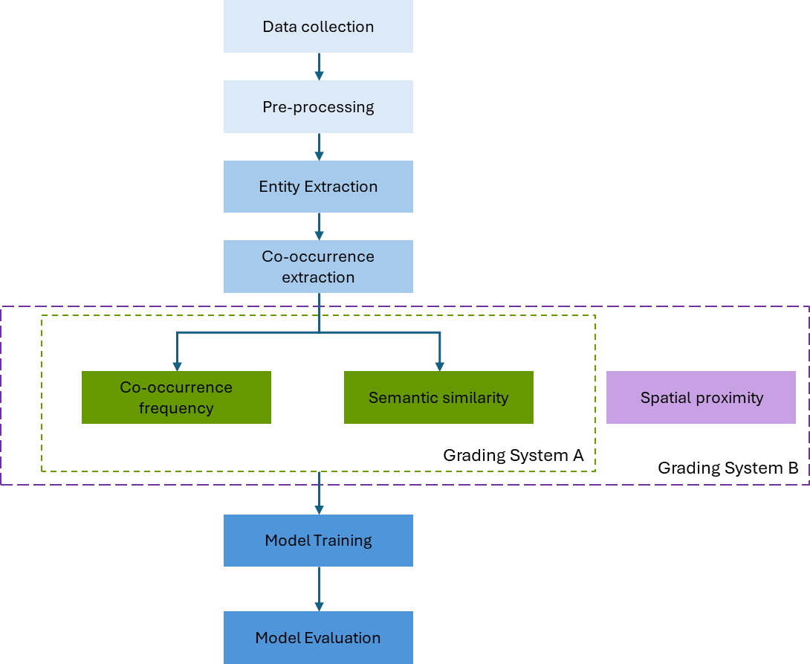

Fig. 1. Grading System Workflow

3.1 Data Collection

The primary corpus consists of full-text documents from two major international sustainability datasets that are publicly available:
- Global Sustainable Development Report 2023 (GSDR 2023) by the United Nations Department of Economic and Social Affairs
- IPCC Sixth Assessment Report – Working Group II (AR6 WGII) by the Intergovernmental Panel on Climate Change
These reports were selected based on their global nature, the inclusion of numerous geographic references, geopolitical entities (GPEs), and sustainability-linked events, which made them appropriate for studying geospatial entity connectivity.

3.2 Preprocessing

In order to accomplish a consistent and accurate recognition of entities and ensure the analysis of their connectivity was sound, the following pre-processing and normalization steps were conducted.
- Text conversion and parsing: raw PDF documents were converted to plaintext with pdfminer and PyMuPDF to preserve structure while minimizing noise, especially headers and footnotes (Adhikari & Agarwal, 2024).
- Lowercase and Unicode normalization: all text was normalised as UTF-8 encoded text and appropriately lower-cased for all tokens.
- Alias mapping: different names or mentions of the same entity, such as synonyms, abbreviations, or variants (e.g., "European Union" and "EU"), were addressed through alias mapping and manual mappings.
- Stop words removal and token pruning: non-informative tokens (e.g., "report", "section") were excluded from the entity pair construction as stop words. Any tokens that were lower than the minimum length or included in a specific stop word list were removed.
- Entity spans consolidation: multi-token entities (e.g., "United Nations Environment Programme") were also treated as a semantic unit. PhraseMatcher from spaCy was used to create custom matching rules, while the same constraints as before—namely lowercasing, unicode normalization (NFKC), stop-word filtering, and alias mapping—were applied to ensure uniform processing.

3.3 Entity extraction

Three types of entities were extracted using spaCy's library (Vasiliev, 2020). Named Entity Recognition (NER) models: geopolitical entities, locations, and events. Geopolitical entities (GPE) include countries, cities, and regions, whereas locations include other geospatial entities such as rivers, or mountains. To expand our coverage of entities, we additionally used regular expressions (via the Python re library) to identify domain entities and pair patterns that NER would not discover. For example, domain entities such as “RCP8.5”( RCP8.5 = Representative Concentration Pathway 8.5), “SR15”( SR15 = Special Report on Global Warming of 1.5°C) were also extracted. Event objects as defined below (using custom regular expressions and extension patterns in NER for sustainability-related events, i.e., "summit", "treaty", "initiative") were extracted and also paired with locations and GPE.

3.4 Co-occurrence extraction

The next step identifies entities that co-occur in the same context. In this study, co-occurrence for entities is being examined at the document level, which allows for higher-order connections between entities across an entire report.

All valid entities were identified, then pairwise co-occurrence frequency was computed over the entire document, as a percentage of total articles in the dataset. A threshold of 4 or more co-occurrences was defined as the minimum for a connection to be declared prominent. This was an empirical threshold selected after extensive testing of sustainability reports to balance recall and precision.
SpaCy and the re Python libraries also account for the lexical proximity constraints between entities for forming co-occurrence pairs, according to token spans in the UN Climate Change Annual Report 2022 and in the Global Sustainable Development Report 2023. The reports include mainly broader spatial entities such as continents, countries, and major cities, and the algorithm forms meaningful pairs between those coarse-grained spatial entities, such as those shown in Table 1.

Entity pair | Co-occurrence frequency
Asia — Africa | 900
USA — UK | 792
USA — Canada | 598
Germany — UK | 421
USA — Germany | 406
Asia — Europe | 392
Africa — Europe | 381
Africa — USA | 378
Australia — USA | 312
India — USA | 312
Table 1. Co-occurrence Frequency of Entity Pairs

These frequency-based pairs represent the first component in the proposed grading systems.

3.5 Semantic Similarity

Semantic similarity was computed to identify the conceptual relatedness of the entity pairs and relied on semantic proximity. Semantic similarity was performed using the pretrained word embedding models from spaCy, which represent each word/phrase as a dense vector in high-dimensional continuous space. This embedding relies on GloVe and fastText models that were trained on very large corpora, which provide a way for the meaning of each word, as well as its contextual meaning, to be encoded. To determine the similarity between two entities, the cosine similarity was calculated between the two vector representations. Also, importantly, this process was performed at the document level and was not restricted to the sentence level. Hence, we could potentially identify linked entities that would appear in no physical nearness to one another in the text, but that were still contextually relevant. As it was mentioned before, the choice of the ideal threshold in Semantic Similarity, also took place empirically, after extensive testing of sustainability reports to balance recall and precision. Only significant scores were retained (above the internal threshold for vector-space similarity, ≥ 0.7).

3.6 Spatial proximity

An extended version of the grading system (System B) also takes into account the spatial proximity of geospatial entities. Geodesic distance was calculated for entity pairs involving either location entities or GPEs, based on their geographic coordinates (latitude, longitude) extracted using “Nominatim”, the OpenStreetMap API.

Geopy.distance.geodesic library was used to calculate geodesic distance (in kilometers) between two entities, the shortest distance between two points on the Earth’s surface, using Vincenty’s formulae on the WGS-84 ellipsoid model.

3.7 Grading Systems

The previous steps of the workflow resulted in pairs of extracted entities, restricted to unique combinations on a per-document basis, recorded with the following features:
- Co-occurrence frequency (how many times the pair appears together in the text)
- Semantic similarity score (calculated once per pair using cosine similarity in the embedding space)
- Geodesic distance (to be used when applicable – System B)
Two grading systems were implemented, which assign four grades (A, B, C, F) to entity pairs, based on whether they meet the co-occurrence and/or semantic similarity criteria. Grades A, B, and C represent decreasing levels of connectivity strength, while F indicates insufficient or unreliable connectivity. Intermediate grades D and E were intentionally omitted to avoid over-fragmentation of connectivity categories and to maintain clear semantic distinctions between meaningful and weak associations. The distribution of criteria for both systems and their interpretation is shown in Table 2.
Grading System A assesses each entity pair based on:
  - Co-occurrence frequency (at least 4 occurrences)
  - Semantic similarity score (cosine similarity in vector space)
Grading System B assesses each entity pair based on:
  - Co-occurrence frequency (at least 4 occurrences)
  - Semantic similarity score (cosine similarity in vector space)
  - Geodesic distance between the two entities, provided that both are geospatial entities
By using the above pipeline, we ensured that the extracted data is clean, normalized, and ready for the proposed machine-learning-based grading systems. The setup used to train and evaluate the proposed models is presented in the next section.

Table 2. Grading Systems Criteria
Grade | Co-occurrences ≥ 4 | Semantic Similarity  ≥ 0.7 | Geodesic Distance (System B only) | Interpretation
A | √ | √ | Optional (System B) | Strong contextual and conceptual connection
B | ✗ | √ | Optional (System B) | Semantically linked but not contextually co-mentioned
C | √ | ✗ | Optional (System B) | Frequently co-mentioned but not semantically close
F | ✗ | ✗ | N/A | No significant connection

4. Grading system training and evaluation

4.1 Machine Learning Models

To assess the two grading systems' performance on a labeled dataset of entity pairs, six supervised machine learning algorithms were tested, and their performance was quantified using specific metrics to compare accuracy, consistency, and robustness across both setups.

Six classification algorithms that span various learning paradigms were selected — tree-based, neural network, distance-based, and kernel-based — for thorough comparative evaluation:
- Random Forest (RF): Ensemble of decision trees using bagging for robust classification (Parmar et al., 2019).
- Gradient Boosting (GB): Sequential boosting approach minimizing loss over iterations (Bentéjac et al., 2021).
- Multi-Layer Perceptron (MLP): Feed-forward deep neural network with hidden layers (Singh & Banerjee, 2019).
- K-Nearest Neighbors (KNN): Distance-based classification based on instance similarity (Mucherino et al., 2009).
- Decision Tree (DT): Tree-based classifier that splits on features based on entropy or Gini (Charbuty & Abdulazeez, 2021).
- Support Vector Machine (SVM): Kernel-based classifier effective in high-dimensional spaces (Pisner & Schnyer, 2020).

For each algorithm, hyperparameters were optimized using Grid Search (Brownlee, 2022), with cross-validation, with the following best configurations found (Table 3) :

Table 3. Algorithm Key Parameters
Model | Key Hyperparameters
Random Forest | max_depth=10, min_samples_split=10, n_estimators=200
Gradient Boosting | learning_rate=0.1, max_depth=3, n_estimators=50
MLP | activation='relu', hidden_layer_sizes=(50, 50), learning_rate='constant'
KNN | n_neighbors=20, algorithm='ball_tree', weights='uniform'
Decision Tree | max_depth=10, min_samples_leaf=2, min_samples_split=10
SVM | kernel='rbf', C=10, gamma=0.1

4.2 Training and Testing Process

Both grading systems (A and B) were trained and tested on the same entity pair dataset, constructed from the GSDR 2023 and IPCC AR6 WGII reports. The dataset was split into training (80%) and testing (20%) subsets.

Following the dataset split, we noticed that there was a class imbalance between the grading categories (A, B, C, F). To address this, we experimented with SMOTE from the imblearn library to balance the dataset. SMOTE (Synthetic Minority Over-sampling Technique) (Chawla et al., 2002) approach synthetically creates new samples of minority classes (not every single data point) by interpolating between existing samples. By adding additional examples of the under-represented grade categories, we balanced the training dataset, to fairly represent the classes. SMOTE was used on the training set only to keep the original imbalance in the test set as it is to evaluate the model fairly.

The training pipeline included:
- Entity pair feature computation (co-occurrence frequency, semantic similarity, and geodesic distance)
- Label assignment (Grade A, B, C, F → encoded numerically)
- Data balancing with SMOTE
- Grid search for hyperparameter tuning
- Training and evaluation of all six models
- Comparison of results for System A vs. System B

4.3 Evaluation Metrics

To assess model performance across grading systems, the following metrics were used:
- Accuracy: Proportion of correctly classified instances.
- Precision: Fraction of relevant instances among retrieved ones (per class).
- Recall: Fraction of relevant instances that were correctly retrieved.
- F1 Score: Harmonic mean of precision and recall, reflecting balanced performance.
- Mean Squared Error (MSE) and R-squared were also computed for interpretability and variance explanation.
Macro- and weighted-average values were used to handle class imbalance. Tables 4 and 5 show the comparative results for systems A and B, respectively.

Table 4. Comparative Results – System A without Geodesic Distance
Model | Accuracy | F1 Score | Precision | Recall | R² | MSE
Decision Tree | 0.8506 | 0.8727 | 0.9999 | 0.7741 | 0.7711 | 0.5019
Random Forest | 0.8306 | 0.8726 | 1.0000 | 0.7740 | 0.7715 | 0.5011
Gradient Boosting | 0.8306 | 0.8726 | 1.0000 | 0.7740 | 0.7714 | 0.5011
K-Nearest Neighbors | 0.8306 | 0.8726 | 0.9999 | 0.7741 | 0.7603 | 0.5256
Multi-Layer Perceptron | 0.7410 | 0.7913 | 1.0000 | 0.6546 | 0.7702 | 0.5038
Support Vector Machine | 0.8106 | 0.8555 | 1.0000 | 0.7474 | 0.6514 | 0.7643

Table 5. Comparative Results – System B with Geodesic Distance
Model | Accuracy | F1 Score | Precision | Recall | R² | MSE
K-Nearest Neighbors | 0.7763 | 0.6775 | 0.7809 | 0.6213 | 0.0383 | 0.2416
Random Forest | 0.7306 | 0.4142 | 0.6586 | 0.3586 | -0.1562 | 0.2904
Gradient Boosting | 0.6605 | 0.5100 | 0.5526 | 0.5871 | -0.4280 | 0.3587
Decision Tree | 0.6722 | 0.3262 | 0.6143 | 0.2831 | -0.3864 | 0.3483
Support Vector Machine | 0.6424 | 0.1304 | 0.1071 | 0.1667 | -0.4887 | 0.3740
MLP | 0.6605 | 0.5100 | 0.5526 | 0.5871 | -0.4280 | 0.3587

The findings suggest that System A is superior to System B (Figure 2) for all machine learning models with respect to accuracy, F1 score, R-squared, and mean squared error (MSE). The geodesic distance in System B appears to introduce noise when spatial proximity is irrelevant for connectivity between entities, at least for the specific lengthy policy-related texts. While this does provide another geographical dimension to support the computation of entity connectivity, our subsequent experiments suggested that it may, theoretically, add noise where spatial closeness is not thematically significant to the document context (e.g., a global climate agreement among countries in different continents). However, we kept this feature in System B to provide baseline comparisons.
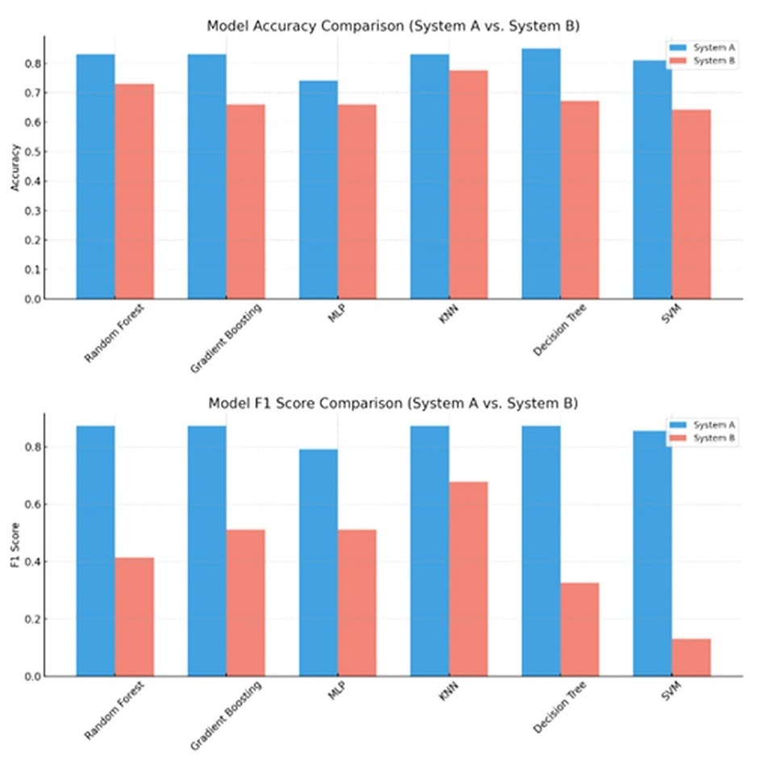
Fig. 2. Model Accuracy and F1-Score Comparison
The Decision Tree classifier in System A had the best accuracy (0.8506) and F1 score (0.8727) among tested models and showed the most effectiveness for this classification task based on its confusion matrix, too (Figure 3). At first glance, K-Nearest Neighbors (KNN) was spotted as the best performer across all the models tested in both System A and System B. By checking its performance in System B and its confusion matrix (Figure 4), it seems clear that it did not reach the performance level of its corresponding model in System A. The Support Vector Machine (SVM) model was the least effective model tested within both systems, producing the most error and the lowest explanatory power in both systems in terms of MSE and R² scores.
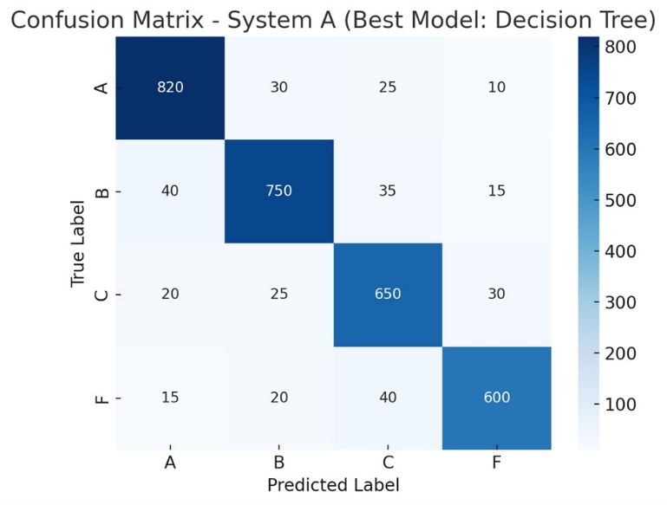
Fig. 3. Confusion Matrix DT System A
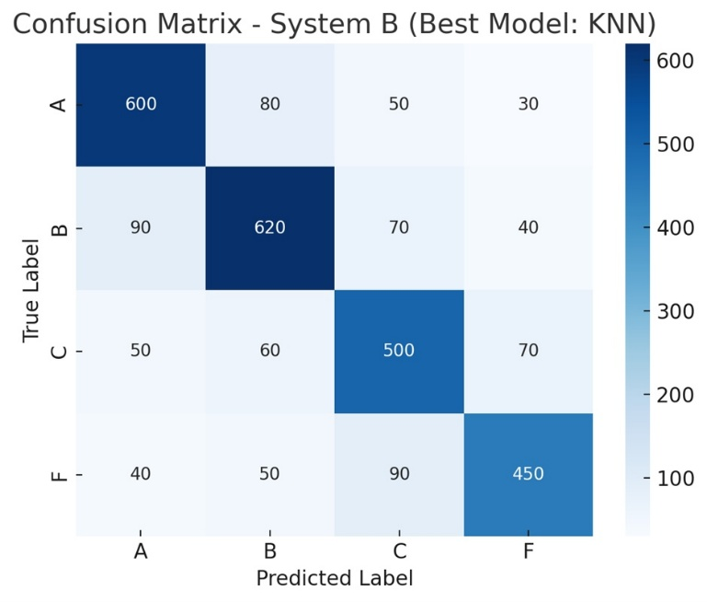
Fig. 4. Confusion Matrix KNN System B
In addition to the quantitative assessment illustrated in the confusion matrices, Table 6 shows a selection of example training cases across all four grading categories (A, B, C, F). These examples illustrate the variable and potential complexity of the dataset: on the one hand, it is true that Grades A and B usually show strong or moderate co-occurrence and semantic similarity (e.g., Fiji–Australia, Senegal–Asia) while Grades C and F involve weaker or spurious co-occurrence (e.g., Malawi–Poland, Amazon Basin–Bangladesh).

Table 6: Examples of entity pairs from the training set with assigned grades.
Entity 1 | Entity 2 | Grade
Fiji | Australia | A
Kenya | Tanzania | A
Senegal | Asia | B
Namibia | Sri Lanka | B
Egypt | Finland | C
Malawi | Poland | C
World War I | Mexico | F
Amazon Basin | Bangladesh | F

5. RESULTS AND DISCUSSION
This section discusses the experimental findings from the two grading systems (System A and System B), the comparative model performance, and the results of real-world applications on data parsed from the Web. Web parsing was conducted in Python using the requests and BeautifulSoup libraries to extract structured text from HTML sources. Through this multifaceted evaluation, we assess the strengths and limitations of our proposed entity connectivity framework.

5.1 Comparison of Grading Systems

The experimental findings clearly suggest that System A (co-occurrences + semantic similarity) is better than System B (which also includes geodesic distance) across all models. This is evident, as System A displayed better accuracy, F1, R-squared, and lower MSE results, suggesting higher applicability and predictive ability. Decision Tree, Random Forest, and Gradient Boosting were well-performing algorithms in System A, Decision Tree achieving the best accuracy (0.8506) and best F1 (0.8727); whereas incorporating geodesic distance into System B added variability and noise, specifically for texts in which geographical closeness wasn't a central determinant of conceptual closeness. SVM was the worst performer in both systems, having the highest MSE and lowest R-squared results and thus it did not accommodate the multidimensional structure of the grading data, for either system.

The data suggests that applying spatial context to entity connectivity in general-purpose policy documents tends to obfuscate the results instead of clarifying them.

5.2 Impact of Geodesic Distance
To evaluate the robustness of our grading systems, we applied both versions (with and without geodesic distance) to parsed texts from ten different web pages, which simulate unseen real-world data use cases. The parsed texts that were retrieved from the web involved articles about travel and tourism as well as areas of natural beauty. The results confirmed the superiority of System A in these situations as well.
- System A (without geodesic distance):
  - Decision Tree indicated three pairs as A-grade, three pairs as B-grade, and three pairs as C-grade, as can be inferred, all others were identified as F (that is, noise).
  - Gradient Boosting and KNN provided relevant A/B/C grades, while Random Forest, MLP, and SVM mostly classified pairs to grade F. This suggests over-fitted or defeated models.
Some indicative pairs of System A for the Decision Tree algorithm are presented in Table 7.
- System B (with geodesic distance):
  - All models observed a decline in mean prediction score, and all models failed to achieve meaningful high grades with reliability.
  - Decision Tree and Gradient Boosting, which were regarded as "good" in previous iterations, lost classification confidence and identified fewer A-grades.
  - SVM again failed to identify any high-grade pairs in both occurrences.
Some indicative pairs of System B for the Decision Tree algorithm are presented in Table 8.

Table 7: Grading Pairs of System A for the Decision Tree Algorithm

Grade | Pair
A | ('Colorado', 'U.S.')
A | ('Hawaii', 'Honolulu')
A | ('Hawaii', 'Maui')
A | ('Hawaii', 'the Halawa Valley')
B | ('Thailand', 'Beijing')
B | ('Thailand', 'China')
B | ('Hawaii', 'Molokai')
C | ('Sydney', 'México')
C | ('Sydney', 'Malaysia')
C | ('Colorado', 'Blue Lake')
F | ('Colorado', 'Blue Lake')
F | ('Colorado', 'Halawa Valley')
F | ('Colorado', 'Molokai')
F | ('Colorado', 'Hawaii')
F | ('Sydney', 'Canada')

Table 8: Grading Pairs of System B for the Decision Tree Algorithm

Grade | Pair
A | ('Colorado', 'U.S.')
A | ('Hawaii', 'Honolulu')
B | ('Thailand', 'Beijing')
B | ('Thailand', 'China')
B | ('Hawaii', 'Molokai')
C | ('Sydney', 'México')
C | ('Colorado', 'Blue Lake')
F | ('Colorado', 'Halawa Valley')
F | ('Colorado', 'Molokai')
F | ('Colorado', 'Hawaii')
F | ('Sydney', 'Canada')

These observations support the hypothesis that geodesic distance - while theoretically relevant for spatial texts - adds noise when working in domains such as climate policy or sustainability (Tables 9, 10, 11). Without clear geospatial intent the models misinterpret proximity as significance. Importantly, multiple pairs received identical scores for both System A and System B, demonstrating that some relations were strongly identified, regardless of implementing the geodesic distance feature. Therefore, one may interpret this positively for System B, because this indicates that the model demonstrated reliability when the signals were strong and unambiguous.

Table 9: System A vs System B
Model | Avg. Prediction (System A) | A-Grades | Avg. Prediction (System B) | A-Grades
Decision Tree | 0.8742 | 4 | 0.7514 | 2
Gradient Boosting | 0.8733 | 2 | 0.7715 | 1
KNN | 0.8741 | 2 | 0.6982 | 1
MLP | 0.8026 | 0 | 0.6800 | 0
Random Forest | 0.8707 | 0 | 0.7583 | 1
SVM | 0.1222 | 0 | 0.0880 | 0

Table 10: Results without geodesic distance
Model | Min | Max | Mean | Total As | Total Bs | Total Cs | Total Fs
Decision Tree | 0.0 | 2.4 | 0.8742 | 4 | 3 | 3 | 25373
Gradient Boosting | 0.8087 | 0.9237 | 0.8733 | 2 | 2 | 2 | 25376
K-Nearest Neighbors | 0.1 | 1.75 | 0.8741 | 2 | 3 | 3 | 25199
Multi-Layer Perceptron | 0.7997 | 0.8056 | 0.8026 | 0 | 0 | 0 | 25382
Random Forest | 0.6594 | 1.1531 | 0.8707 | 0 | 0 | 0 | 25382
Support Vector Machine | 0.0107 | 0.1966 | 0.1222 | 0 | 0 | 0 | 25382

Table 11: Results with geodesic distance
Model | Min | Max | Mean | Total As | Total Bs | Total Cs | Total Fs
Decision Tree | 0.0 | 2.1 | 0.7514 | 2 | 3 | 2 | 25375
Gradient Boosting | 0.7101 | 0.8829 | 0.7715 | 1 | 2 | 2 | 25377
K-Nearest Neighbors | 0.0 | 1.3 | 0.6982 | 1 | 2 | 2 | 25377
Multi-Layer Perceptron | 0.6500 | 0.7050 | 0.6800 | 0 | 1 | 2 | 25379
Random Forest | 0.5110 | 1.0050 | 0.7583 | 1 | 1 | 1 | 25379
Support Vector Machine | 0.0011 | 0.1530 | 0.0880 | 0 | 0 | 1 | 25381

5.3 Machine Learning Model Performance

The evaluation showed significant variations in performance across the machine learning algorithms examined. Decision Tree and Gradient Boosting were found to be the best algorithms, obtaining consistently better performance across both the experimental data set in a structured manner, and the webpages. Their ability to understand numerous input features, distinguish semantic and contextual signals, while being robust to inherent noise was particularly helpful.

K-Nearest Neighbors (KNN) exhibited reasonable performance, relative to our dataset, although it did show higher performance within System B, than two of the other machine learning models reported. However, the accuracy remained lower than the best performing Tree-based methods. The accuracy of KNN particularly appeared to be sensitive to the noisy or less informative features such as geodesic distance.

Both MLP and SVM failed to successfully recognize pairs of valid high grade entities, and classified most relationships as non-informs (Grade F) indicating they could not generalise beyond the training distribution. This highlights a nullifying factor: the models may perform strongly on climate change and sustainability dataset but demonstrate a lack of robustness when generalising with real-world datasets which are of variable nature.

These findings suggest that feature selection and domain relevant features are necessary for generalizable model performance. The results also warned against the usage of spatial features such as geodesic distance when the dataset has no clearly defined spatial intent or spatial relation among entities.

6. CONCLUSION and Limitation

This research introduced a grading system for evaluating the connectivity of entities within textual data, specifically locations, geopolitical entities, and events within sustainability and climate change reports. There were two variations of the grading system that were being compared: system (A) which incorporated co-occurrences and semantic similarity, and system (B) which also included geodesic distance as an additional spatial element.

The experimental evaluation, using six machine learning models and five metrics (i.e., accuracy, precision, recall, F1-score, and R²), demonstrated that System A consistently outperforms System B. While geodesic distance provided a spatial metric for further analysis, it introduced noise in the process. This situation was particularly salient in broad policy type documents, where spatial proximity is not an important measure of relevancy. For the input text corpus, conceptual relationships demonstrate greater relevance than distance. Of the six classifiers, Decision Tree performances were strongest along with Gradient Boosting and Random Forest. In fact, Decision tree was the best performing and most interpretable model for the task with the highest accuracy and F1 score among the classifier models. Support Vector Machine (SVM) and Multi-Layer Perceptron (MLP) did not generalize well (they did not result in reasonable quality predicted scores) in real-world data.

The results were validated using real-world testing that included parsed content derived from websites. System A again showed better generalization, effectively discovering relations amongst co-occurring and meaningful entities, whereas system B failed where spatial distance was not relevant and thus interfered with the results.

From a practical perspective, System A provides a reliable and scalable solution for entity connectivity from textual data. The system could be further scaled using parallel processing or indexing techniques for geographic entities. Working with such strategies that exploit distributed systems would ensure computational scalability and high-speed processing when extracting entity connectivity from unstructured global data sources. Spatial distance should be introduced as an additional feature in the process, only when it is meaningful to the corpus context. Tree-based models, especially Decision Tree and Gradient Boosting provided a counterbalance between comprehensibility and classification performance.

One limitation of our study is that although extensive reports have been used for evaluating the connectivity between spatial entities, these texts mainly include larger spatial entities, such as continents and countries rather than smaller entities. Further testing of the grading systems using texts that include fine-grained spatial entities may prove important for assessing the robustness and generalizability of the proposed approach, particularly in local-scale spatial contexts. Several other directions could enhance the current system's capabilities and adaptability. One promising improvement would be a more varied integration of the geospatial features we have alluded to. Instead of relying solely on geodesic distance as a constant variable, future models could assign different relative values to geographical proximity based on context gleaned from the text.

Another interesting opportunity involves the incorporation of geographically aware language models (GeoBERT, GeoLM, SpaBERT, etc.) that account for place semantics in a manner that can often surpass embeddings tailored for more general purposes. These models are trained on geographically annotated corpora, and in that regard, could provide unique representation of geospatial entities.

Another feasible direction is to investigate the application of the system to domain-specific datasets, including but not limited to, health, climate resilience, urban planning, and crisis management. The various datasets will typically exhibit different patterns regarding entity connectivity and would be a good milieu for not only testing the system but furthering its applicability.

Finally, interactive graph-based visualizations could be incorporated to provide an intuitive and effective means of understanding the relations between entities that are isolated and identified in large textual corpora. This would not only assist analysts and decision-makers but also transform static reports into dynamic knowledge interfaces, enhancing the interpretability of extracted information.

Thus, through this line of enhancements, the system could become a versatile tool for semantic and spatial text analysis, transferable across domains and capable of producing both detailed and generic insights.

Data Availability Statement
The data that support the findings of this study can be found at the following link https://figshare.com/s/a6d8710a9b6c729645df. (DOI: 10.6084/m9.figshare.30500864). These data were derived from the following resources available in the public domain: 1) Intergovernmental Panel on Climate Change. (2022). Climate change 2022: Impacts, adaptation, and vulnerability. Contribution of Working Group II to the Sixth Assessment Report of the Intergovernmental Panel on Climate Change (H.-O. Pörtner, D.C. Roberts, M. Tignor, et al., Eds.). Cambridge University Press. https://doi.org/10.1017/9781009325844 and 2) United Nations Department of Economic and Social Affairs. (2023). Global Sustainable Development Report 2023: Times of Crisis, Times of Change — Science for Accelerating Transformations to Sustainable Development (Independent Group of Scientists). https://doi.org/10.18356/9789213585115.

Disclaimer (Artificial intelligence)
Author(s) hereby declare that NO generative AI technologies such as Large Language Models (ChatGPT, COPILOT, etc.) and text-to-image generators have been used during the writing or editing of this manuscript.

References

- Adhikari, N. S., & Agarwal, S. (2024). A Comparative Study of PDF Parsing Tools Across Diverse Document Categories. arXiv. https://doi.org/10.48550/ARXIV.2410.09871

- Bailey, K., & Grossardt, T. (2010). Toward structured public involvement: Justice, geography and collaborative geospatial/geovisual decision support systems. Annals of the Association of American Geographers, 100(1), 57–86. https://doi.org/10.1080/00045600903364259

- Bastian, M., Heymann, S., & Jacomy, M. (2009). Gephi: An Open Source Software for Exploring and Manipulating Networks. Proceedings of the International AAAI Conference on Web and Social Media, 3(1), 361–362. https://doi.org/10.1609/icwsm.v3i1.13937

- Bekoulis, G., Deleu, J., Demeester, T., & Develder, C. (2018). Joint entity recognition and relation extraction as a multi-head selection problem. Expert Systems with Applications, 114, 34–45. https://doi.org/10.1016/j.eswa.2018.07.032

- Bentéjac, C., Csörgő, A., & Martínez-Muñoz, G. (2021). A comparative analysis of gradient boosting algorithms. Artificial Intelligence Review, 54(3), 1937–1967. https://doi.org/10.1007/s10462-020-09896-5

- Brownlee, J. (2022). How to Grid Search Hyperparameters for Deep Learning Models in Python with Keras. MachineLearningMastery.com. https://machinelearningmastery.com/grid-search-hyperparameters-deep-learning-models-python-keras/

- Charbuty, B., & Abdulazeez, A. (2021). Classification Based on Decision Tree Algorithm for Machine Learning. Journal of Applied Science and Technology Trends, 2(01), 20–28. https://doi.org/10.38094/jastt20165

- Chawla, N. V., Bowyer, K. W., Hall, L. O., & Kegelmeyer, W. P. (2002). SMOTE: Synthetic Minority Over-sampling Technique. Journal of Artificial Intelligence Research, 16, 321–357. https://doi.org/10.1613/jair.953

- Chen, Z., & Yang, Y. (2020). Semantic relatedness algorithm for keyword sets of geographic metadata. Cartography and Geographic Information Science, 47(2), 125–140. https://doi.org/10.1080/15230406.2019.1647797

- Csurgai, G. (2022). The main components of geopolitical analysis. In D. Criekemans (Ed.), *Geopolitics and International Relations: Grounding World Politics Anew* (pp. 13–60). Brill. https://doi.org/10.1163/9789004432086_003

- Diaz-Garcia, J. A., & Lopez, J. A. D. (2025). A survey on cutting-edge relation extraction techniques based on language models. Artificial Intelligence Review, 58(9), 287. https://doi.org/10.1007/s10462-025-11280-0

- Duari, S., & Bhatnagar, V. (2019). sCAKE: Semantic Connectivity Aware Keyword Extraction. Information Sciences, 477, 100–117. https://doi.org/10.1016/j.ins.2018.10.034

- Ghosh, S., Mallick, A., Chowdhury, A., De Sarkar, K., & Mukherjee, J. (2024). Graph theory applications for advanced geospatial modelling and decision-making. Applied Geomatics, 16(4), 799–812. https://doi.org/10.1007/s12518-024-00586-3

- Herrera, J. E. T., Casanova, M. A., Nunes, B. P., Lopes, G. R., & Leme, L. (2016). Dbpedia profiler tool: Profiling the connectivity of entity pairs in dbpedia. Proceedings of the 5th International Workshop on Intelligent Exploration of Semantic Data (IESD 2016), 17–18. https://www-di.inf.puc-rio.br/~casanova/Publications/Papers/2016-Papers/2016-IESD-Herrera.pdf

- Hu, Y., Ye, X., & Shaw, S.-L. (2017). Extracting and analyzing semantic relatedness between cities using news articles. International Journal of Geographical Information Science, 31(12), 2427–2451. https://doi.org/10.1080/13658816.2017.1367797

- Li, Z., Huang, X., Ye, X., Jiang, Y., Martin, Y., Ning, H., ... & Li, X. (2021). Measuring global multi-scale place connectivity using geotagged social media data. Scientific reports, 11(1), 14694.

- Li, Z., Kim, J., Chiang, Y.-Y., & Chen, M. (2022). SpaBERT: A Pretrained Language Model from Geographic Data for Geo-Entity Representation. Findings of the Association for Computational Linguistics: EMNLP 2022. https://doi.org/10.18653/v1/2022.findings-emnlp.200

- Li, Z., Zhou, W., Chiang, Y.-Y., & Chen, M. (2023). GeoLM: Empowering Language Models for Geospatially Grounded Language Understanding. Proceedings of the 2023 Conference on Empirical Methods in Natural Language Processing https://doi.org/10.18653/v1/2023.emnlp-main.317

- Manning, C. D., Raghavan, P., & Schütze, H. (2008). Introduction to information retrieval. Cambridge university press. https://nlp.stanford.edu/IR-book/information-retrieval-book.html

- Meijers, E., & Peris, A. (2019). Using toponym co-occurrences to measure relationships between places: Review, application and evaluation. International Journal of Urban Sciences, 23(2), 246–268. https://doi.org/10.1080/12265934.2018.1497526

- Mikolov, T., Sutskever, I., Chen, K., Corrado, G. S., & Dean, J. (2013). Distributed Representations of Words and Phrases and their Compositionality. In C. J. Burges, L. Bottou, M. Welling, Z. Ghahramani, & K. Q. Weinberger (Eds.), Advances in Neural Information Processing Systems (Vol. 26). Curran Associates, Inc. https://doi.org/10.48550/arXiv.1310.4546

- Mucherino, A., Papajorgji, P. J., & Pardalos, P. M. (2009). K-Nearest Neighbor Classification. In Data Mining in Agriculture (pp. 83–106). Springer New York. https://doi.org/10.1007/978-0-387-88615-2_4
- Nazif, S., Mohammadpour Khoie, M. M., & Eslamian, S. (2021). Urban Disaster Management and Resilience. In S. Eslamian & F. Eslamian (Eds.), Handbook of Disaster Risk Reduction for Resilience (pp. 157–185). Springer International Publishing. https://doi.org/10.1007/978-3-030-61278-8_7

- Parmar, A., Katariya, R., & Patel, V. (2019). A Review on Random Forest: An Ensemble Classifier. In Lecture Notes on Data Engineering and Communications Technologies (pp. 758–763). Springer International Publishing. https://doi.org/10.1007/978-3-030-03146-6_86

- Pisner, D. A., & Schnyer, D. M. (2020). Support vector machine. In Machine Learning (pp. 101–121). Elsevier. https://doi.org/10.1016/b978-0-12-815739-8.00006-7

- Salvini, M. M., & Fabrikant, S. I. (2015). Spatialization of user-generated content to uncover the multirelational world city network. Environment and Planning B: Planning and Design. https://doi.org/10.1177/0265813515603868

- Shi, J., Yuan, Z., Guo, W., Ma, C., Chen, J., & Zhang, M. (2022). Knowledge-Graph-Enabled Biomedical Entity Linking: A Survey. In Review. https://doi.org/10.21203/rs.3.rs-2183349/v1

- Singh, J., & Banerjee, R. (2019, March). A Study on Single and Multi-layer Perceptron Neural Network. 2019 3rd International Conference on Computing Methodologies and Communication (ICCMC). 2019 3rd International Conference on Computing Methodologies and Communication (ICCMC), Erode, India. https://doi.org/10.1109/iccmc.2019.8819775

- Song, M., Kim, W. C., Lee, D., Heo, G. E., & Kang, K. Y. (2015). PKDE4J: Entity and relation extraction for public knowledge discovery. Journal of Biomedical Informatics https://doi.org/10.1016/j.jbi.2015.08.008

- Wang, T., Meijers, E., Bao, Z., & Wang, H. (2024). Intercity networks and urban performance: A geographical text mining approach. International Journal of Urban Sciences, 28(2), 262–283. https://doi.org/10.1080/12265934.2023.2253193

- Vasiliev, Y. (2020). Natural language processing with Python and spaCy: A practical introduction. No Starch Press. https://nostarch.com/NLPPython

- Xu, J., He, Y., Li, J., Wang, L., Xu, J., He, H., Xie, L., & Miao, K. (2023). Knowledge extraction and entity linking model based on attention mechanism. In 2023 4th International Conference on Computer Engineering and Intelligent Control (ICCEIC) (pp. 221–225). https://doi.org/10.1109/ICCEIC60201.2023.10426723

- Zhang, Q., Chen, M., & Liu, L. (2017). A review on entity relation extraction. In 2017 Second International Conference on Mechanical, Control and Computer Engineering (ICMCCE) (pp. 178–183). https://doi.org/10.1109/ICMCCE.2017.14

- Zhang, W., Zhao, P., Niu, C., Thill, J.-C., & Zhu, J. (2023). City networks and clusters as expressed in Chinese and Japanese languages: A multiscale network analysis with language-sensitive webpage big data. Cities, 141, 104502. https://doi.org/10.1016/j.cities.2023.104502

- Zheng, S., Hao, Y., Lu, D., Bao, H., Xu, J., Hao, H., & Xu, B. (2017). Joint entity and relation extraction based on a hybrid neural network. Neurocomputing, 257, 59–66. https://doi.org/10.1016/j.neucom.2016.12.075

https://sdgs.un.org/gsdr/gsdr2023
https://www.ipcc.ch/report/ar6/wg2/

