Analysis of practices and obstacles limiting women's safe access to land in the commune of Kpomassè, Benin

Abstract
The realities of land access and management, and the patriarchal system that dominates social organization in Africa, impact women's access to land.

This study analyzes the practices and obstacles limiting women's secure access to land in the commune of Kpomassè, Benin. The methodology is based on a mixed-methods approach combining documentary research, direct observation, and focus group interviews. The survey was conducted with a sample of 327 people distributed across five districts.

The results reveal that inheritance remains the dominant mode of access (41%), primarily benefiting men (68%) compared to only 12% for women, due to the weight of patriarchal norms. Consequently, women overwhelmingly resort to loans and leases (63%), 92% of which are based on precarious verbal contracts. From an economic standpoint, the cost of purchasing a plot of land can represent up to 666% of the average annual income of a rural woman, making land acquisition virtually impossible without financial support.

This study demonstrates that land reforms remain largely ineffective at the local level due to entrenched customary practices. The findings suggest the urgent need to simplify and reduce the costs of administrative procedures and to implement gender-sensitive local policies to ensure more equitable land governance.
Keywords: Land security, Patriarchal norms, Secure access to land, Kpomasse commune

- Introduction
Land issues have always been a major challenge for economic and social development. As such, they constitute a global concern (Tchaou, 2014, pp. 12-13) ^{¹.} In Africa, the realities of access to and management of land, as well as the patriarchal system that dominates the continent's social organization, have long had a significant impact on the land situation. Women, for social or customary reasons, face difficulties accessing land. Indeed, beyond biological and anatomical sex, there is a social construction of gender, a social and cultural construction of stereotypes and feminine and masculine roles (Y. Nicolas, 2008, p. 27)². Women are disadvantaged in various ways due to the patriarchal and masculine nature of the state and politics³Women have long occupied a position inferior to that of men in Africa, although it should be noted that in matrilineal communities, women were the sole source of inheritance and legitimacy for any leadership (SSM Kanji, 1997, p. 14) ⁴ . According to J. Nyerere (year to be specified), "in Africa, women toil all their lives on land that does not belong to them to produce what they do not control, and if their marriage ends in divorce or the death of their husband, they can be sent away empty-handed" (F. Diop and L. Touré, 2012, p. 345) ^{5.} This quote summarizes the problem of women's access to and control of land, as well as its contribution to development. In Benin, the vast majority of rural women work in the agricultural sector, but they have the most precarious access to land (I. Oumarou, 2008, p. 10) ^{6.} Compared to men, women generally own small farms on which they exercise precarious rights, because they are excluded from land inheritance law and have few financial resources to acquire land where a land market exists (Tchaou, 2014, p. 12-13) ^{1.} In 2013, according to the results of the modular survey on household living conditions, regardless of the method of acquiring plots, women had limited access to land. Indeed, 85% of landowners were men, compared to only 14.9% women (INSAE, 2013, p. 16) ^{7.} Access to land and the securing of land rights, for poor and rural populations in general and for women in particular, are essential for food security. Yet, this role is still insufficiently taken into account, and women have less access to and less control over land, natural resources, means of production, and financial resources (S. Charlier et al., 2016, p. 1) ⁸ .
It is within this general context that the study conducted in the commune of Kpomassasè is situated. This commune, like many localities in Benin, is confronted with the dynamics of land pressures and local practices relating to access to and security of land. It is relevant, in this specific context, to analyze how the mechanisms for securing land rights actually function and, above all, what specific obstacles limit women's access to land, despite legislative developments and the challenges of development .
The overall objective of this research is to’analyser les pratiques et obstacles limitant l’accès sécurisé à la terre des femmes dans la commune de Kpomassè au Bénin
Given the importance of land tenure security for the development and empowerment of women in Benin, this research attempts to answer the following main question:
What are the practices regarding land security and what are the main obstacles that, at the level of the commune of Kpomasse, limit women's secure access to land?
- 1- Study environment
The commune of Kpomassè is located in the southwest of the Atlantique department, between 6°20'20'' and 6°37'59'' north latitude and between 1°56'32'' and 2°5'18'' east longitude. It is one of the five communes in the Intercommunal Ecodevelopment Zone (ZIED). It is bordered to the north by the commune of Allada, to the south by the commune of Ouidah, to the west by the communes of Comè and Bopa (with a natural boundary formed by Lake Ahémé and a tributary of the Couffo River), and to the east by the communes of Tori, Bossito, and Ouidah. The attached figure illustrates the geographical location of the commune of Kpomassè .
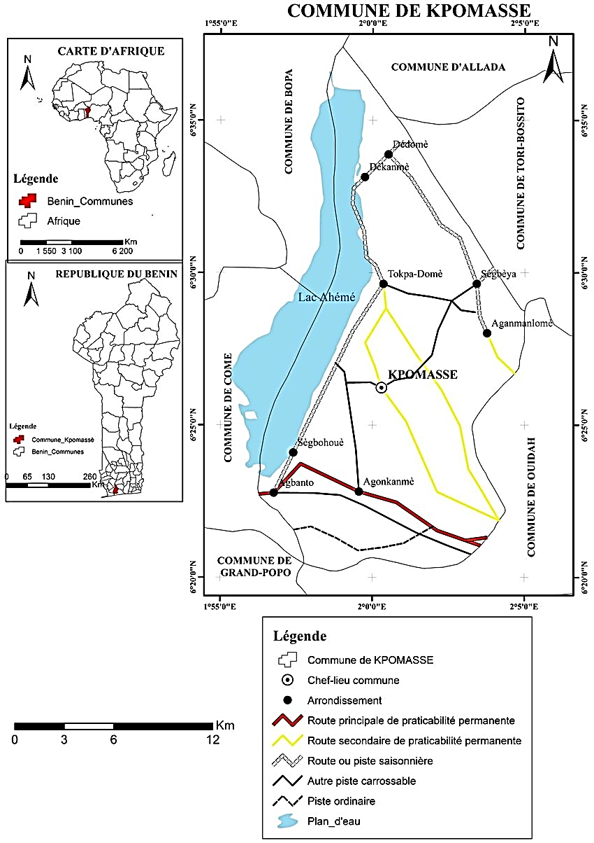
Figure 1: Map of the geographical location of the commune of Kpomasse
Source: IGN topographic map, 1992
- Data and methodology
In this study, the methodological approach adopted relies on both quantitative and qualitative data. More specifically, the data used includes demographic (1990 to 2020), socio-economic, agricultural, and legal/administrative data. To collect as much reliable data and information as possible, several techniques were employed, including direct observation. Focus groups of 6 to 10 people were also organized to compare and supplement the information gathered through questionnaires. The information collected from participants was processed using Word 2016 for text, Excel 2016 for tables and figures, and ArcView 3.2 for maps.
  - Determining the sample size
Participants in the survey were selected using purposive sampling. The target population consisted primarily of farming households, the municipal land registry office, and the Kpomasse SCDA (Agricultural Development and Planning Service). Other participants included agents, women landowners, traditional chiefs, and village chiefs. Three criteria determined the selection of survey participants:
- be a farmer and have at least 5 years of experience;
- to be an actor that deals with land issues;
- to become a regular actor.
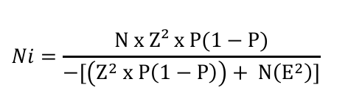
D. Schwartz's formula (1995, p. 13) ⁹ was used to determine the sample size for each site.
- Ni = the sample size
- N = The target population size for the selected sites is 21,094 (sum of population sizes per district)
- Z = confidence level 96, or 1.96
- P = estimated standard proportion 30, or 0.03
- E = maximum error tolerance of 5 or 0.05
Applying this statistical formula allows us to determine the sample size.
Ni = 327.
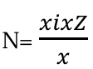
The number of people is chosen in each district according to a quota formula.
Or
N = the number of people interviewed byarrondissement
Xi = the total number of people per arrondissement Z = the total number of people interviewed in the five districts
X = the total number of people in the 5 arrondissement
Table 1: Sample distribution by arrondissement
commune | Boroughs | Population size | Sample size
Kpomasse | Agonkanmè, | 4,422 | 68
Kpomasse | Aganmanlomè, | 3,591 | 56
Kpomasse | Dekanmè | 5,154 | 80
Kpomasse | Sègbea | 3,119 | 48
Kpomasse | Tokpa-domè | 4,808 | 75
TOTAL | 5 | 28,707 | 327
INSAE/INStaD data processing 2013, September 2024
A total of 327 people, spread across five districts, were selected for the survey. In addition, 10 key informants were chosen for this study. These key informants were selected based on their position and role in the development of the Kpomasse commune.

  - Computer science
Les thèmes ont été dégagés par une analyse manuelle des questionnaires et des guides d'entretien administrés sur le terrain. Le processus a suivi une logique de regroupement thématique, où les témoignages et informations recueillis auprès des acteurs (groupes de discussion et informateurs clés) ont été organisés par catégories pour soutenir l'argumentation et les commentaires des résultats.
  - Analyse des variables quantitatives
Les données chiffrées ont fait l'objet d'un traitement informatique rigoureux pour en extraire des tendances statistiques. Le logiciel Microsoft Excel 2016 a été utilisé pour la structuration des tableaux et la création de figures, notamment des histogrammes. Une régression linéaire a été utilisé pour mesurer l'impact du coût d'accès à la terre sur l'exclusion des femmes. Les modèles SWOT (Forces, Faiblesses, Opportunités, Menaces) et MACTOR (Matrice d'Alliances et Conflits entre Tactiques, Objectifs et Recommandations) ont servi de base pour l'interprétation globale des résultats.
- Results and discussion
  - Typology of land access methods and their impact on land tenure security
In the commune of Kpomass è, three main modes of access to land have been identified: inheritance, purchase, and loans or leases. These modes determine not only who has access to land, but also the degree of land tenure security, particularly for women, in a context marked by patriarchal norms and modern agrarian reforms.
  - Gender disparities in land transfer
Inheritance is the most common means of accessing land among the Kpomassesè. The commune, which represents 41% of the land, reflects customary practices deeply rooted in family and patriarchal systems. The dynamics of land transmission through inheritance highlight gender-based disparities in land access between men and women. Figure 2 illustrates this gendered distribution of land access.
Figure 2: Distribution of land inheritances by sex
Source: Results of field surveys, January 2025

Analysis of Figure 2 reveals that 68% of the men surveyed inherited agricultural or residential land directly, compared to only 12% of the women participating in the survey. This figure illustrates a clear gender disparity , with significantly more men inheriting land. When women do inherit, they often receive plots of lesser economic value or with precarious usage rights, which limits their ability to invest in agriculture or secure sustainable access to land.
In Kpomassè, women face numerous obstacles to accessing land through inheritance. Patrilineal systems favor male heirs, considered the guarantors of family continuity. This exclusion is particularly pronounced for married women, who are considered part of their husband's family. Widows are especially vulnerable. Table 2 presents the obstacles to land inheritance for women in the Kpomassè commune.

Table 2: Obstacles to women's land inheritance in the Kpomassesè commune
Obstacle | Percentage of women surveyed (%)
Patriarchal norms | 15
Land acquired by the in-laws | 05
Precarious usage rights without formalization | 38
High administrative costs | 42
Source: Field surveys, January 2025

Reading Table 2, it appears that the main obstacles related to land inheritance encountered by women in the commune of Kpomasse are patriarchal norms, the reclamation of land by in-laws, precarious usage rights without formalization and high administrative costs for registering plots.
  - Access through purchase: financial and administrative barriers to women's access
Access to land through the land market is an increasingly common method of acquisition in the municipality of Kpomassè, particularly in peri-urban areas such as the Kpomassè-Centre district, where land pressure is intensifying due to urbanization and the growing demand for residential and agricultural land. Table 3 presents the distribution of land acquisitions by gender.

Table 3: Distribution of land purchases by sex
Village | Male buyers ( %) | Average area (ha) Men | female shoppers  (%) | Average area (ha) - Women
Agonkanmè | 27 | 20 | 02 | 1
Aganmanlomè | 08 | 6 | 02 | 1
Dekanmè | 11 | 9 | 03 | 2
Sègbea | 17 | 12 | 04 | 3
Tokpa-domè | 20 | 16 | 05 | 4
Total | 84 | 63 | 16 | 11
Source : Field surveys, January 2025
Analysis of Table 3 reveals that women are underrepresented, accounting for only 16% of land transactions and having access to smaller plots totaling 11 hectares, which limits their potential for agricultural investment or real estate development. Conversely , men are better represented, with a participation rate of 84% and a total of 63 hectares acquired.
Financial constraints pose a major obstacle for women seeking to acquire land. Surveys reveal that in Kpomasse-Centre, the average price of a 0.5-hectare residential plot is 4 million FCFA, and that of a 0.5-hectare agricultural plot in a rural area is 2 million FCFA. These amounts are prohibitive for the majority of women, whose average income, according to the data collected, is 50,000 FCFA per month, compared to 100,000 FCFA for men. Figure 3 presents the average cost of 500 m² plots and the monthly income by sex.

Figure 3 : Average cost of plots and monthly income by sex
Source: Field surveys, January 2024
Analysis of Figure 3 reveals significant gender disparities in access to land ownership through purchase among the Kpomassesè people. In the Kpomassasè commune, women face considerably greater financial barriers than men. These constraints limit their ability to secure their land rights. The average cost of a 500 m² plot in an urban area is 1,500,000 FCFA, compared to 800,000 FCFA in a rural area. This represents 30 and 16 times the average monthly income of women, respectively.
The administrative procedures required to formalize land acquisitions constitute another major obstacle for women. Registering the title deed, essential to guarantee the purchase, incurs high administrative fees of 75,000 FCFA, representing 2 to 4% of the land price, and involves complex procedures with the town hall or notaries. Table 4 presents the administrative obstacles related to land registration according to gender.
Table 4: Administrative obstacles related to the registration of parcels by type bysexe
Obstacles | Male buyers (%) | Buyers  (%)
Complexity of procedures | 68 | 79
High costs of formalities | 72 | 82
Lack of information on procedures | 70 | 90
Source: Field surveys, January 2025
Analysis of Table 4 reveals that women et les hommes face more obstacles related to administrative procedures . While land acquisition offers the possibility of securing land ownership through official titles, it remains precarious dans le milieu d’étude for les hommes et surtout pour women.
  - Loans and rentals: the impact of verbal and written contracts on women's land security
Land loans and leases constitute temporary forms of access to land, particularly widespread in the commune of Kpomasse , where agricultural and residential land is often made available through formal or informal agreements (article 363, al.1 du code foncier et domaniale). Les règles qui encadrent la délégation des droits d’usage sur les terres rurales appartenant à une personne privée en République du Bénin sont précisées par les dispositions des articles 354, al. 2, 359, 362, 363 et 364 du code foncier et domanialThese mechanisms allow some households, especially women, to access land without owning it, but their impact on land tenure security varies depending on the nature of the contracts, whether verbal or written.
Table 5 shows… Distribution of loans and rentals by gender.
Table 5 : Distribution of loans and rents by gender
Boroughs | Loans and rentals  (Women) (%) | Loans and rentals  (Men) (%)
Agonkanmè, | 14 | 09
Aganmanlomè | 16 | 09
Dekanmè | 18 | 10
Sègbea | 07 | 04
Tokpa-domè | 8 | 05
Total | 63 | 37
Source: Field surveys, January 2025
Table 5 shows that women (63%) are more dependent on loans and rentals than men (37%).
Most of these arrangements rely on verbal contracts, particularly in rural areas. These verbal contracts predominate in loans and leases, representing 83% of the cases recorded. These agreements, often made with family members, heads of households, or neighbors, are based on trust and social relationships. However, they offer limited land security, especially for women. Surveys reveal that 33% of women benefiting from loans or leases reported feeling insecure, particularly in the face of sudden evictions or disputes with landlords. Verbal contracts are especially precarious for women because they depend on the decisions of landlords, who are often men. The women interviewed indicated that their access to land depended on the goodwill of the lender, without any legal guarantees. This precariousness limits their ability to invest in land, for example, to improve agricultural practices or plan for the long term. Figure 4 shows the distribution of verbal and written contracts by gender.
Figure 4 : Proportion of verbal and written contracts concluded by gender
Source : Field surveys, January 2024
Analysis of Figure 4 shows that women (92%) rely more on verbal contracts than men (73%) and have fewer written contracts (8%) than men (27%), which accentuates their land vulnerability compared to men.
  - Documents presuming ownership
Documents establishing presumed ownership in land law are provisional documents attesting to a person's presumed ownership of a plot of land. These documents are considered tools for securing the land tenure system because they constitute a guarantee before the finalization of administrative procedures leading to the issuance of the definitive title. Table 6 presents the types of presumed ownership documents held by the individuals selected for the survey, categorized by sex, in the municipality of Kpomassasè.
Table 6: Types of presumptive ownership documents by genre
Document types | Women (%) | Men (%)
ADC ( Attestationcustomary detention) | 05 | 28
sales contract | 03 | 22
Dump | 33 | 17
moving certificate | - | 10
tax assessments for the last three years | - | -
registration certificate | - | -
administrative certificate | - | -
rural land certificate | - | -
No document | 59 | 23
*- : Nothing
Source: Results of the field survey, January 2024

Analysis of Table 6 reveals that women only possess land receipts (33%), sales contracts (3%) and property titles (5%) as documents attesting to land ownership, making them more vulnerable in the event of conflict. The official document indicating presumed ownership identified at their level is the ADC (Attestation de Consommation de Commune - Communal Consumption Certificate). In contrast, men hold ADCs (28%) and resettlement certificates (10%) as official documents. They also possess unofficial documents such as receipts (17%) and deeds of sale (22%). It is worth noting that 59% of women possess no documents, compared to 23% of men. Documents indicating presumed ownership, while inferior to property titles in terms of legal value, offer temporary recognition of rights, particularly in a context where few plots of land in the Kpomassasè commune are titled.
  - Sociocultural and economic obstacles to women's access to land
    - Discriminatory social and cultural norms
In the commune of Kpomassè , inheritance practices, based on a patriarchal system, largely exclude women from land inheritance rights, thus marginalizing them in terms of access to land. These norms, rooted in the traditions of the socio-cultural communities in the study area, favor the transmission of land to male heirs, relegating women to dependent roles. Traditional practices predominate: 82% of respondents stated that land is primarily passed down to sons in the lineage. Women, particularly daughters and widows, are often excluded, except when they obtain temporary access through their husbands or fathers. Figure 5 illustrates the consequences of this exclusion from inheritance for women in the commune of Kpomassè.
Figure 5: Impacts of inheritance exclusion on women
Source: Results of field surveys, month of survey to be specified: 2025
Analysis of Figure 5 reveals that the consequences of exclusion from inheritance are primarily land insecurity (68%), followed by economic dependence (63%) and family conflicts (32%). The exclusion of women from land inheritance in the Kpomassae commune reflects deeply entrenched patrilineal norms.
    - economic and institutional barriers
In the commune of Kpomassaè, economic and institutional barriers significantly hinder women's access to land, exacerbating gender inequalities already deeply entrenched in cultural and family norms. Figure 6 presents the costs of accessing land by district included in the survey.
Figure 6: Land access costs by district and impact on gender
Source: Field surveys, February 2025
Analysis of Figure 6 shows that in the districts of In Agonkanmè and Dékanmè, the average price of half a hectare is 4,000,000 and 3,000,000 FCFA, respectively. In the district of Aganmanlomè, the average price of half a hectare is 2,000,000 FCFA, while in the districts of Sègbeya and Tokpa-domè, it is 1,500,000 and 2,500,000 FCFA, respectively. Rent in these districts ranges from 80,000 to 100,000 FCFA. The administrative fees for registering a purchased plot amount to 75,000 FCFA. Figure 7 presents the costs of accessing land according to the average annual income of women.
Figure 7: Land access costs relative to women's average annual income
Source : Field surveys, February 2025
Analysis of Figure 7 highlights an important point: given that the average income of a rural woman in the Kpomassè commune is 600,000 FCFA, acquiring a half-hectare plot in a peri-urban area would cost her 666% of her annual income, compared to only 32% for renting a similar plot. However, for a half-hectare plot in a rural area, this cost would be 333%, compared to only 16% for renting. This situation explains why female farmers most often opt for renting: purchasing is simply too expensive for them, given their low incomes.
A linear regression shows that land access costs explain 62% of the variance in women's exclusion from land ownership (R² = 0.62, p < 0.01), with gender playing a moderating role (β = -0.38, p < 0.05). Among the main gender-related factors is income inequality . Women earn 60% less than men, making land acquisition prohibitively expensive for them. Furthermore, their access to credit is limited because microfinance institutions often require collateral, which women rarely possess.

- Conclusion
This study, using a mixed-methods approach, achieved its objective of analyzing the practices and obstacles limiting women's secure access to land in the Kpomassè commune of Benin. The results demonstrate that, despite legislative reforms, the predominance of patriarchal norms and economic vulnerability leave 59% of women without any property documents.
- To address this structural insecurity, the following proposals are essential:
- - Simplify and reduce the costs of registration formalities to make land tenure security accessible to those with modest incomes.
- - Strengthen the dissemination of the land and property code at the district and village levels so that modern law prevails over discriminatory customs in inheritance matters.
- - Implement gender-sensitive local policies, particularly those facilitating access to credit and the formal recognition of lease agreements.

Consent
As per international standards or university standards, Participants’ written consent has been collected and preserved by the author(s).

Disclaimer (Artificial intelligence)
Option 1:
Author(s) hereby declare that NO generative AI technologies such as Large Language Models (ChatGPT, COPILOT, etc.) and text-to-image generators have been used during the writing or editing of this manuscript.
Option 2:
Author(s) hereby declare that generative AI technologies such as Large Language Models, etc. have been used during the writing or editing of manuscripts. This explanation will include the name, version, model, and source of the generative AI technology and as well as all input prompts provided to the generative AI technology
Details of the AI usage are given below:
1.
2.
3.

References
- Tchaou, S. B. (2014). Land dynamics in urban areas facing the challenges of local development in the municipalities of Ouidah and Allada [Unpublished doctoral dissertation]. University of Abomey-Calavi.involving various actors and institutions, pp. 12-13.
- NICOLAS Y., (2008): Introduction to the concept of gender and international solidarity, where they meet and exchange information on their practices, Harmattan, Paris, pp. 27-35. Gender and development, In "Gender and Development", actors in women's rights and...
- Sow, N. F. (2008). L’accès des femmes à la terre en Afrique de l’Ouest : problématique et pistes de solutions au Sénégal et au Burkina Faso. Projet DIMITRA, FAO. http://www.fao.org/docrep/016/ap532f/ap532f.pdf
- Kanji, S. S. M. (1997). Des droits de la femme africaine d’hier à demain. Xamal. https://africultures.com/php/?nav=fiche_ouvrage&no=1000
- Diop, F., & Touré, L. (2012). Contribution du système d'information géographique (SIG) dans la lecture du problème de l'accès des femmes au foncier rural au Sénégal : Cas des communautés rurales de KeurMomarSarr, Médina Ndiathbé (Vallée et Zone sylvo pastorale), Diender (Niayes), Bandafassi (Sénégal Oriental), Diendé (Casamance). *Revue de Géographie du Laboratoire Leïdi*, (10), 345. https://core.ac.uk/download/pdf/235896000.pdf
- Oumarou, I. (2008). *Women and Local Development: A Socio-Anthropological Analysis of Land Tenure in Niger: The Case of the Tillabéry Region* [Doctoral dissertation, University of Rennes 2]. https://www.theses.fr/2008REN21003
- INSAE, (2013): General Population and Housing Census (RGPH4), Provisional Results; 124 phttps://instad.bj/rgph4-2013/​
- Charlier, S., Diop Sall, F., & Lopez, G. (2014). Land governance through a gender lens: Case studies in Niger, Senegal, and Bolivia. In H. Guétat-Bernard (Ed.), *Feminine-masculine: Gender and family farming* (pp. 39-54). Quae. https://doi.org/10.35690/978-2-7592-2163-9
- Schwartz D., (1995): Statistical Methods for Physicians and Biologists. 4th Edition (Flammarion Medical Edition), Paris, 314 p
- Republic of Benin. Law No. 2013-01 of August 14, 2013, establishing the Land and Real Estate Code of the Republic of Benin. Official Gazette of the Republic of Benin; 2013. https://sgg.gouv.bj/document/loi-n-2013-01-du-14-aout-2013/

