Original Research Article

Cluster-Based Flare-Gas Aggregation in the Niger Delta and Empirical Gas-to-Power Modelling for Enhanced Energy Security in Nigeria
.
ABSTRACT

Aims: This study aims to quantify the power-generation potential of optimally aggregated flare-gas clusters in the Niger Delta. This is achieved by integrating geospatial clustering, gas-conditioning process simulation, and empirical gas-to-power modelling. The objective of the study is to provide a practical basis for translating flare-gas recovery into enhanced energy security in Nigeria.
Study Design: The study adopts a quantitative, model-based analytical design. It builds on an existing geospatial clustering framework and extends it through process simulation and data-driven power-generation modelling.
Place and Duration of Study: The study focuses on twenty-four onshore oil and gas flowstations located in the Niger Delta, Nigeria. Power-plant operational data used for the empirical modelling cover the period from 1 January 2024 to 15 August 2024.
Methodology: Previously optimized flare-gas clusters were adopted as fixed spatial units. Cluster-level gas compositions were determined using volume-weighted aggregation while gas-conditioning simulations, including dehydration and natural gas liquids recovery, were performed in Aspen UniSim Design to produce turbine-suitable lean gas. An empirical gas-to-power regression model was developed using operational data from the Afam VI combined-cycle gas-turbine plant. The regression was applied to deliver the simulated lean-gas outputs to estimate both cluster-level and total power-generation potential.
Results: The conditioned lean-gas streams exhibited stable methane-rich compositions, with lower heating values ranging from 46.29 to 47.92 MJ/kg. Applying the empirical model yielded an estimated total recoverable capacity of approximately 578 MW. This corresponds to 13,872 MWh/day or 5.06 TWh/year. Over 70% of this capacity is concentrated in two clusters, demonstrating the effectiveness of spatial aggregation for prioritizing infrastructure investment.
Conclusion: The results demonstrate that cluster-based flare-gas aggregation, combined with realistic gas conditioning and empirical power modelling, can deliver meaningful and achievable electricity generation. This approach provides a credible pathway for reducing gas flaring while strengthening Nigeria’s energy security.

Keywords: Gas-to-power; Niger Delta; Flare gas; Clustering; Energy security; Lean gas

1. INTRODUCTION

Nigeria holds one of the largest proven natural gas reserves in Africa, yet it continues to experience persistent electricity shortages that undermine national energy security. Despite having approximately 210.54 TCF as of 2025 (THISDAY Live, 2025), a significant proportion of associated gas (AG) continues to be flared due to infrastructural and monetization constraints. Hence, gas wastage and power scarcity occur simultaneously. This remains one of the most critical inefficiencies within Nigeria’s energy system.
Gas flaring results in substantial economic losses, environmental degradation, and missed opportunities for domestic energy supply (Olujobi & Ape, 2025). Recent regulatory reports indicate that Nigeria continues to flare hundreds of millions of standard cubic feet (MMSCF) of gas daily, volumes that are theoretically sufficient to support multiple medium- to large-scale gas-fired power plants. According to Okoro, et al. (2021), there is a need to implement a policy of energy conservation through reduction of associated gas flaring. At the same time, actual electricity delivered to the national grid remains far below installed capacity. This is due to fuel supply constraints, pipeline disruptions, and infrastructure unreliability.
1.1 Gas Flaring and Energy Security in Nigeria
Gas flaring remains a clear inefficiency in Nigeria’s petroleum production system. This results in environmental harm, economic losses, and underutilization of valuable energy resources. Nigeria consistently ranks among the world’s top gas-flaring nations. This is largely due to AG production from oil fields lacking adequate gas processing infrastructure. Numerous studies have documented the environmental and socio-economic impacts of gas flaring in the Niger Delta (Awulu, 2021; Okoro et al., 2021; World Bank, 2024). These effects persist even as Nigeria seeks to reposition gas as a transition fuel for economic growth.
From an energy-security perspective, the persistence of routine flaring is particularly paradoxical. Nigeria’s power sector is dominated by gas-fired thermal plants, yet generation output remains constrained by inadequate fuel supply, pipeline disruptions, and infrastructure failures. Energy security frameworks emphasize availability, reliability, and affordability of energy supply. Flare-gas utilization is a strategic pathway for strengthening Nigeria’s energy security and improving power system resilience (Aigbe et al., 2023). It calls for coordinated planning that accounts for the spatial dispersion of flare sites, infrastructure optimization, and realistic power-plant performance under local operating conditions (Musa & Ibrahim, 2025).
1.2 Flare-Gas Recovery
A range of technologies has been proposed and deployed worldwide for flare-gas recovery. These include gas reinjection, gas-to-liquids (GTL), compressed natural gas (CNG), liquefied natural gas (LNG), and gas-to-power systems. Among these options, gas-to-power can be integrated directly into existing electricity infrastructure (Okoro et al., 2021).
Previous studies on gas-to-power systems have typically focused on techno-economic feasibility, emissions reduction potential, and comparative analysis of conversion technologies. Also, flare-gas sources are frequently treated as single, centralized supply points. This overlooks the spatially dispersed nature of flare-gas production, as well as the infrastructure constraints that strongly influence pipeline routing and overall project viability (Aigbe et al., 2023). Systematic planning should be considered beyond just gas volumes; hence gas and power infrastructure planning should be treated jointly (Wang et. al, 2023). Recent studies have emphasized the importance of multi-scale energy systems engineering frameworks for optimizing natural gas utilization across production, processing, and end-use stages, particularly in areas characterized by resource inefficiencies and energy-access constraints (Tso et al., 2020).
1.3 Geospatial Optimization and Cluster-Based Flare-Gas Aggregation
A key challenge in flare-gas utilization is the fragmented spatial distribution of flare sites, particularly in the Niger Delta. Many flare points are geographically dispersed and individually too small to justify standalone gas recovery projects.
Recent advances in geospatial analysis and optimization techniques have enabled more systematic planning of energy infrastructure. Clustering algorithms, such as K-means, have been used in engineering and environmental studies to group spatially distributed assets in a manner that minimizes distance and cost (Jain, 2010; Ikotun et al., 2023). In gas-gathering systems, clustering offers a practical solution. Aggregating small and dispersed gas sources into centralized hubs improves economies of scale and reduces pipeline length.
Building on this concept, Nwankwo, Omijeh, and Ehikhamenle (2025) applied a cluster-based geospatial optimization framework to twenty-four onshore flare sites in the Niger Delta. The study used K-means clustering supported by the Elbow Method and silhouette validation, thereby identifying four statistically robust clusters. That work established a spatially optimized foundation for centralized gas-gathering infrastructure.
While the study by Nwankwo et al. (2025) advanced the application of clustering theory to flare-gas optimization in Nigeria, it stopped at the level of spatial aggregation and volumetric assessment. Downstream utilization was identified as a necessary next step for translating spatial feasibility into energy-security outcomes.
1.4 Gas Conditioning for Power Generation
Before flare gas can be used for power generation, it must be conditioned to meet gas-turbine fuel specifications (Molière, 2023). Raw flare gas usually contains water vapour and heavier hydrocarbons that can create operational issues. In practice, gas conditioning often includes dehydration—frequently via triethylene glycol (TEG)—to remove moisture (Liu et al., 2022). While NGL recovery manages heavier components, control hydrocarbon dew point, and stabilizes fuel quality (Islam et al., 2024; Kazemi, 2025).
Process-simulation tools such as Aspen HYSYS and UniSim Design are commonly used to model gas-conditioning systems and to estimate lean-gas yield under varying feed compositions and operating conditions. These tools allow engineers to represent real-gas behaviour and phase equilibrium.
Studies have shown that inadequate gas conditioning can lead to turbine fouling and performance degradation in gas turbines. Moisture and heavier hydrocarbons are particularly problematic, as they promote corrosion and liquid dropout, within fuel systems and turbine components (Molière, 2023). As a result, realistic estimation of gas-to-power potential depends not only on the volume of available gas, but also on accurate modelling of gas-processing units. Many gas-to-power assessments omit the conditioning stage. Common practices include applying generic heating values or assuming ideal, pipeline-quality gas without explicitly modelling dehydration and NGL recovery.
1.5 Power-Generation Modelling.
Modelling of power-generation in gas-fired plants is commonly based on heat-rate equations or turbine efficiency curves. While these methods provide useful first-order estimates, they do not capture real-world operational behaviour, particularly in developing-countries. This is because plants operate under variable load, fuel quality fluctuations, and maintenance constraints (Molière, 2023).
Empirical models derived from actual plant data offer a more realistic alternative. Having a correlation between gas input rates and delivered megawatt output; such models implicitly account for operational inefficiencies and site-specific conditions. Leveraging such data enables the development of regression-based power-generation models. In Nigeria, access to high-quality operational data from combined-cycle gas turbine (CCGT) plants such as Afam VI presents a unique opportunity to develop data-driven models that represent real system performance.
This study directly builds on the cluster-based framework established by Nwankwo et al. (2025) by integrating process simulation and empirical power-generation modelling. Lean-gas streams derived from aggregated flare-gas clusters are first simulated through standard gas-conditioning units. This is to ensure fuel suitability for power generation. An empirical power-generation model, developed using operational data from the Afam VI power plant, is then applied to estimate the electricity-generation potential of each flare-gas cluster.
1.6 Purpose and Objectives of the Study
The primary purpose of this study is to quantify the realistic power-generation potential of optimally aggregated flare-gas clusters in the Niger Delta by integrating geospatial clustering, gas-conditioning process simulation, and empirical power-generation modelling. The findings are intended to support policymakers, gas developers, and infrastructure planners involved in flare-reduction initiatives. It will also support domestic gas utilization programmes.
The specific objectives of this study are to:
- adopt previously optimized flare-gas cluster configurations for the Niger Delta;
- determine the cluster-level gas compositions using volume-weighted aggregation;
- simulate gas-conditioning to produce lean gas suitable for gas-turbine operation;
- develop an empirical gas-to-power model using operational data from the Afam VI gas power plant in the Niger Delta;
- estimate the cluster-level and total power-generation potential from aggregated flare gas; and
- evaluate the implications of cluster-based gas-to-power deployment for enhancing Nigeria’s energy security.

2. methodology
2.1 Study Area
The study focuses on selected onshore oil and gas flowstations within the Niger Delta region of Nigeria. This region hosts the majority of Nigeria’s oil and gas production activities. It also accounts for a significant share of routine gas flaring. Offshore facilities were excluded due to differences in seabed topography, and marine logistics, which introduce cost and design dynamics beyond the scope of this onshore-focused analysis.
2.2 Data Sources
Flare-gas composition data were obtained from operational records of the oil fields hosting the twenty-four (24) onshore flowstations considered in this study. The compositional datasets include the major hydrocarbon components and impurities in the gas stream. These composition data were used to develop cluster-level gas streams for process simulation.
In addition, daily operational records of gas consumption and corresponding electrical power output were obtained from a combined-cycle gas turbine (CCGT) power plant. The dataset was over the period 1 January 2024 to 15 August 2024, covering a total of 229 operational days.
Together, the flare-gas composition data and the power-plant operational records form the primary datasets used for downstream gas-conditioning simulation and empirical gas-to-power modelling in this study. This data-driven approach ensures that power-generation estimates are realistic based on actual plant performance rather than assumed theoretical efficiencies.
2.3 Flare-Gas Cluster Framework
The flare-gas clusters adopted in this study were derived from a previously published geospatial optimization analysis by the authors. In that study, twenty-four (24) onshore flare sites were grouped into four statistically robust clusters using K-means clustering. The clustering framework established flare-gas aggregation hubs suitable for shared infrastructure development.
In the present study, the identified clusters are treated as fixed spatial units. No further clustering or re-optimization was performed; rather the cluster outputs serve as inputs for gas-conditioning simulation and power-generation modelling. This ensures continuity while extending the analysis from spatial feasibility to energy-conversion potential.
2.4 Cluster-Level Gas Composition Determination
A weighted compositional aggregation approach was applied to compute gas compositions for each cluster. The mole fraction of a given component was calculated as a flare-rate-weighted average of the compositions of its constituent flowstations. This approach ensures that flowstations contributing larger flare volumes exert proportionally greater influence on the resulting cluster composition.
The cluster-level mole fraction for component i was computed using equation (2.1):
$y_{i,cluster}=\frac{\sum_{j=1}^{n}{\left(y_{i,j} . Q_{j}\right)}}{\sum_{j=1}^{n}{Q_{j}}}$ (2.1)
where:
$y_{i,j}$ is the mole fraction of component i at flowstation j;
$Q_{j}$ is the average flare-gas rate of flowstation j;
$n$is the number of flowstations within the cluster.
All compositional data processing with equation 2.1 were performed using Python (See Figure 1), ensuring numerical consistency and reproducibility.
Python scripts were developed to:
- import flowstation flare volumes and gas compositions;
- normalize component mole fractions;
- apply weighted averaging to compute cluster-specific gas compositions;
- generate final cluster feed specifications compatible with process simulation inputs.
The scripts follow standard mass- and mole-balance logic and are available upon request to support reproducibility.

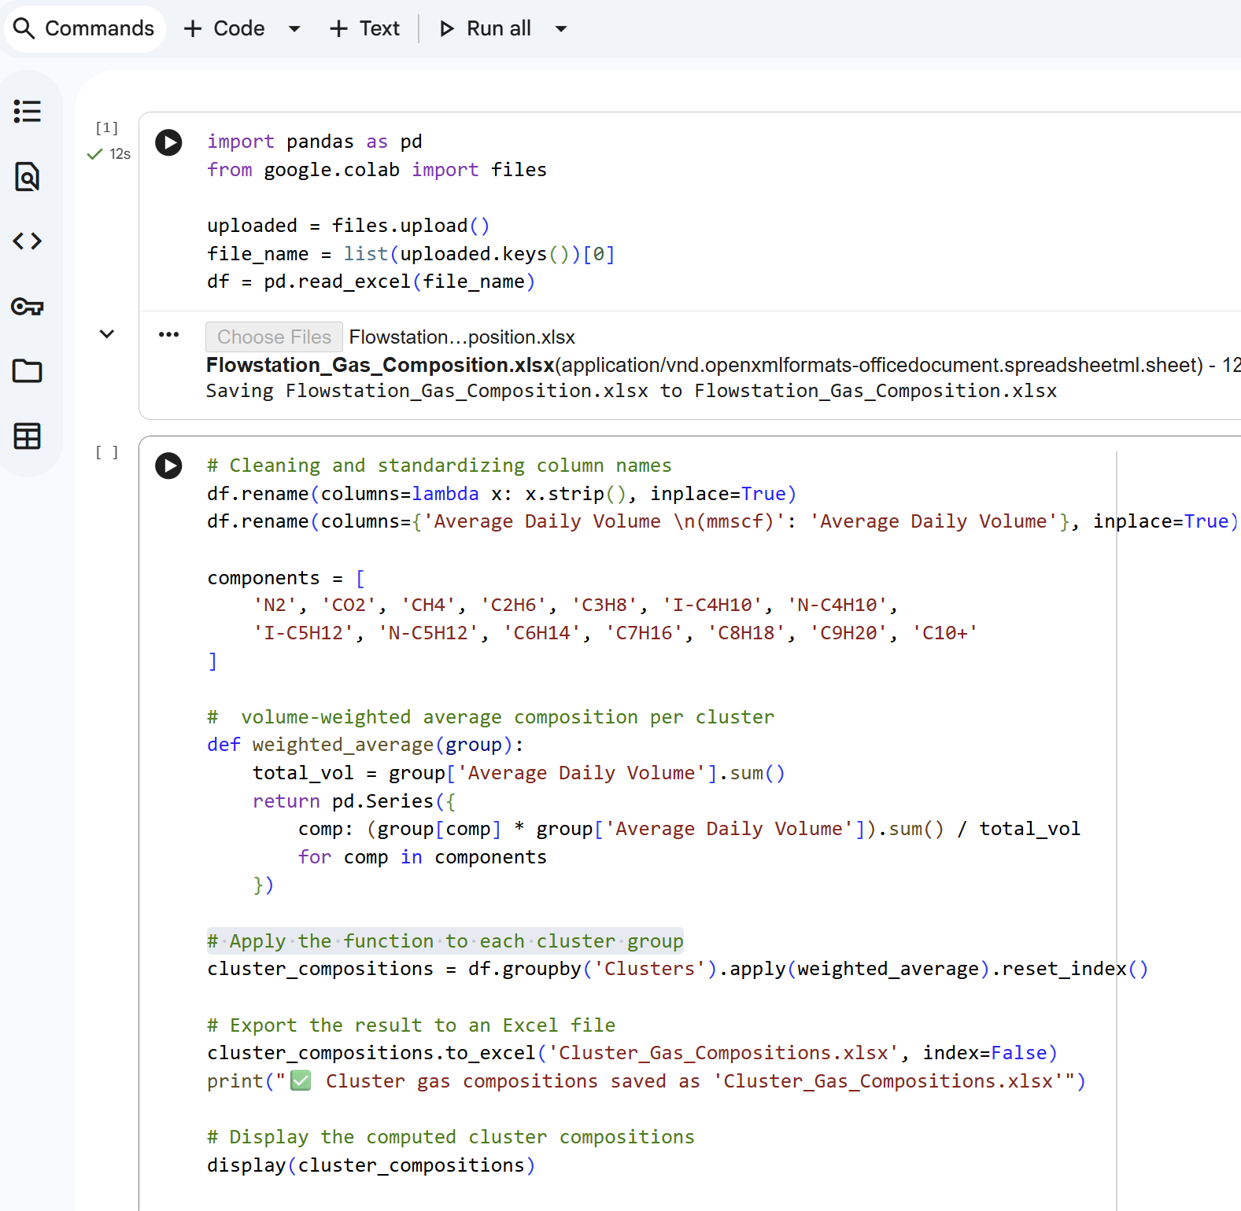
Figure 1 Python Script for Computing Volume-Weighted Cluster Gas Compositions

UniSim Design needs the molecular weight (MW) and flowrate of the feed gas (in kmol/h) as input parameters. The average molecular weight ($MW_{avg}$) of the gas from each cluster was determined by the sum of the products of the mole fraction y_{i} of each component and its corresponding molecular weight as in equation (2.2).
$$MW_{avg}=\sum_{i=1}^{m}{\left(y_{i}×MW_{i}\right) (2.2)}$$where $MW_{j}$is the molecular weight of component i, while $m$is the total number of gas components.
To convert daily flare volumes (in mmscf/day) to molar flowrates (in kmol/h), two conversion steps were applied. Firstly, volumes were converted from mmscf/day to standard cubic meters per day (scm/day) using equation (2.3):
$$\frac{scm}{day}=\left(\frac{mmscf}{day}\right)×28,316.8 (2.3)$$Then, the volumetric flowrate was converted to a molar flowrate (kmol/h) using equation 2.4:
$$\text{Flowrate (}\text{kmol}\text{/h)}=\frac{\text{scm/day}}{24×MW_{avg}} (2.4)$$The above computations were carried out in Python to ensure consistency. The resulting molecular weights and molar flowrates were tabulated in section 3 and was used as feed-gas parameters for UniSim Design modelling.
2.5 Gas Conditioning and Process Simulation
2.5.1 Simulation Environment
In this study, the gas-conditioning simulations were carried out using Aspen UniSim Design, a steady-state process-modelling platform widely applied in natural-gas processing research. Simulators such as UniSim and Aspen HYSYS are routinely used to model dehydration systems, hydrocarbon separation units, and gas-treatment trains. The Peng–Robinson + UNIQUAC thermodynamic property package was utilized to predict vapor–liquid equilibria accurately.
Recent studies have demonstrated the suitability of these simulators for evaluating dehydration and hydrocarbon-recovery systems under steady-state conditions, including triethylene glycol (TEG) dehydration and NGL recovery configurations. Their thermodynamic frameworks enable realistic representation of mass transfer, phase behaviour, and energy balances. This makes them appropriate tools for assessing flare-gas conditioning schemes. (Liu et al., 2022; Islam et al., 2024).
Each flare-gas cluster was represented by a feed stream defined by:
- cluster-specific gas composition (from Section 3.3),
- aggregated flare-gas flow rate,
- representative inlet temperature and pressure.
2.5.2 Conditioning Configuration
The gas processing applied to each cluster (as in Figure 2) comprised of:
- an inlet separator for free-water removal;
- a triethylene glycol (TEG) dehydration unit to reduce water content;
- a natural gas liquids (NGL) recovery section to control hydrocarbon dew point and heating value.
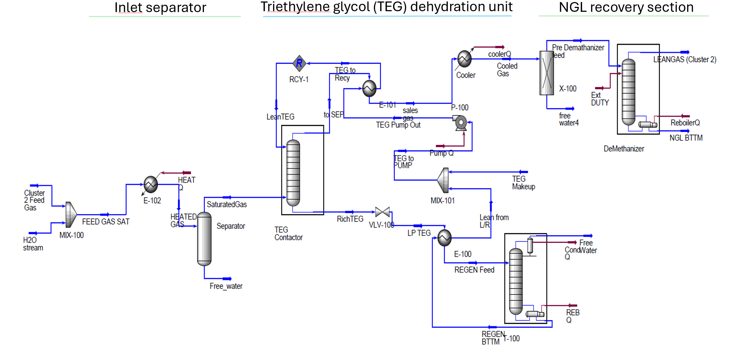
Figure 2 Gas processing Simulation layout (UniSim Software)

2.6 Lean-Gas Output and Heating Value Estimation
The main output of the gas-processing simulation is lean gas; which is conditioned natural gas suitable for gas-turbine combustion. For each cluster, the lean-gas composition and flow rate were extracted from the simulation results.
The energy content of the lean gas streams produced from the process simulations was evaluated using the Lower Heating Value (LHV). The lower heating value (LHV) was adopted because the water formed during combustion remains in the vapor phase and its latent heat is not recovered; hence LHV (net calorific value) is the appropriate basis for performance calculations. This convention is consistent with recent gas-turbine performance studies (Naeim et al., 2022; Kim et al., 2025). Consequently, LHV provides a realistic basis for assessing the usable energy available from the conditioned gas streams (Clarke Energy, n.d.).
2.7 Empirical Power-Generation Model Development
2.7.1 Model Basis
An empirical power-generation model was developed using operational data from the Afam VI combined-cycle gas turbine (CCGT) power plant. Unlike theoretical heat-rate models, empirical approaches capture real operational behaviour, including part-load operation, auxiliary losses, and site-specific efficiencies.
Daily records of gas consumption and corresponding electrical output from 01 January 2024 to 15 August 2024 (totaling 229 days) were analysed to establish a statistical relationship between fuel input and generated power. The daily operational dataset included total gas feed (MMSCF/day) and corresponding electrical output (MW) covering multiple days of operation. The data was from the three Gas turbines in Afam VI.

2.7.2 Model Formulation
A linear regression model was hence fitted between the daily gas feed and the corresponding power output using Python script as shown in Figure (3). The regression equation obtained provided a real-world benchmark for the simulated clusters. Model adequacy was evaluated using the coefficient of determination ($R^{2}$) and residual diagnostics.

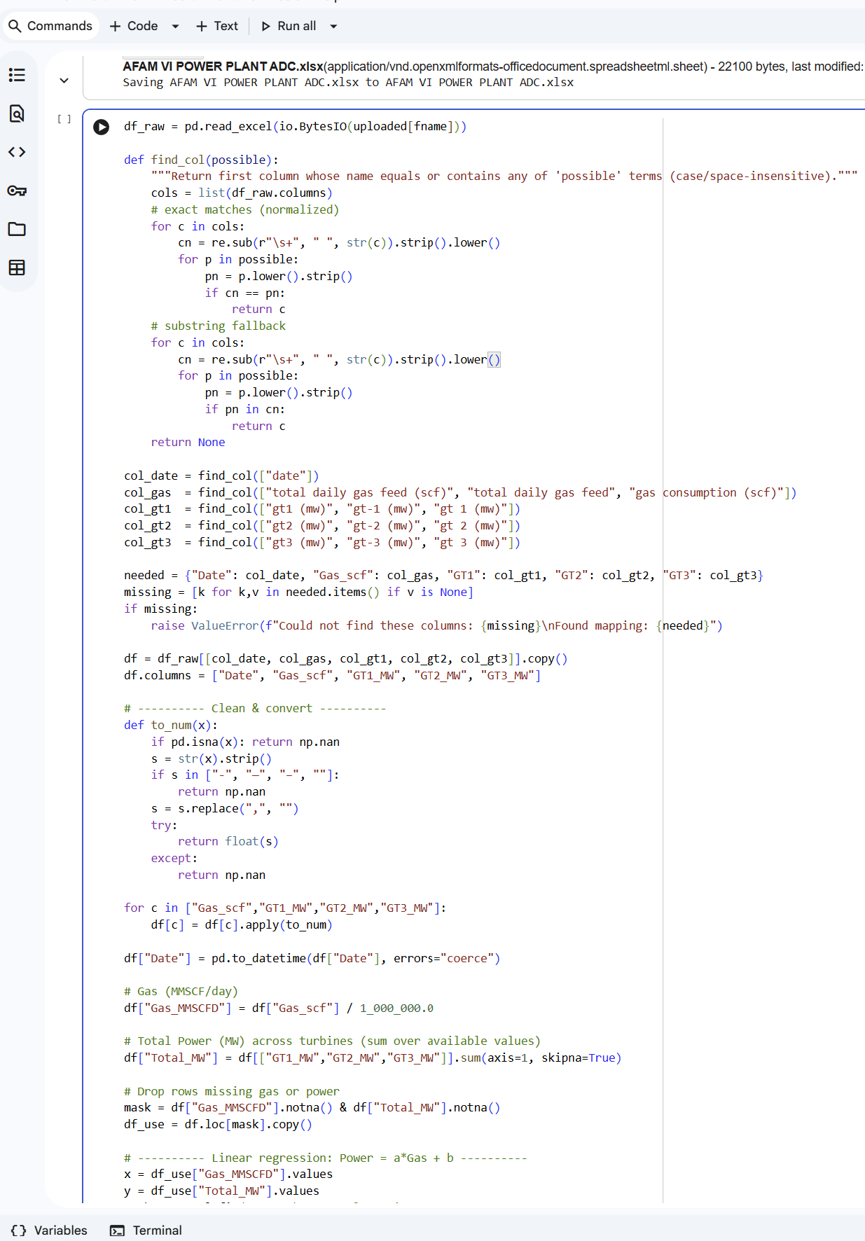
Figure 3: Python script used for Afam VI regression analysis

2.8 Estimation of Cluster-Level Power Generation
Lean-gas flow rates obtained from process simulation were converted to units compatible with the Afam VI empirical model. The regression equation was then applied, thereby estimating the electricity-generation potential of each flare-gas cluster. This approach provides realistic and implementable projections of gas-to-power potential.

3. results

3.1 Cluster-Level Gas Composition and Feed Characteristics
Table (1) summarizes the average molecular weights of the aggregated flare-gas streams for the four clusters. It was derived using Python-based compositional aggregation based on equation (2.2). The molecular weights range from 18.565 g/mol (Cluster 0) to 27.337 g/mol (Cluster 2), reflecting variations in heavier hydrocarbon content across the clusters.
Daily flare-gas volumes adopted from the geospatial optimization study by Nwankwo et al (2025) were converted to molar flowrates for UniSim Design input. As shown in Table (2), Cluster 0 has the largest flare volume (45.99 MMSCF/day), corresponding to a UniSim feed flowrate of 2,922.6 kmol/h. While Cluster 2 has the smallest feed flowrate at 973.4 kmol/h. These feed specifications formed the basis for subsequent gas-conditioning simulations.

Table 1 Cluster’s gas average molecular weight (MW) (derived using Python code)
Clusters | Average MW (g/mol)
0 | 18.565
1 | 22.199
2 | 27.337
3 | 18.623

Table 2 Cluster gas Flowrate in kmol/hr (derived)
Cluster | Daily Flare (mmscf) | Daily Flare (scm) | Average MW | UniSim Input (kmol/hr)
0 | 45.986 | 1302165.944 | 18.565 | 2922.575
1 | 24.557 | 695383.898 | 22.199 | 1305.204
2 | 22.552 | 638613.273 | 27.337 | 973.356
3 | 30.222 | 855803.978 | 18.623 | 1914.714

Based on the Python script executed in Figure (1), it resulted in the cluster-gas compositions captured in Table (3).

Table 3 Clusters’ Gas Composition (derived from Python analysis)
Clusters | N₂ | CO₂ | CH₄ | C₂H₆ | C₃H₈ | I-C₄H₁₀ | N-C₄H₁₀
0 | 0.764 | 2.582 | 88.959 | 5.231 | 1.220 | 0.383 | 0.385
1 | 0.037 | 1.923 | 77.514 | 8.605 | 6.934 | 1.465 | 2.001
2 | 1.932 | 1.354 | 62.276 | 12.679 | 9.212 | 3.616 | 4.260
3 | 0.337 | 1.044 | 88.924 | 5.713 | 2.205 | 0.551 | 0.703
 | I-C₅H₁₂ | N-C₅H₁₂ | C₆H₁₄ | C₇H₁₆ | C₈H₁₈ | C₉H₂₀ | C₁₀+
0 | 0.168 | 0.119 | 0.084 | 0.100 | 0.005 | 0.000 | 0.000
1 | 0.607 | 0.385 | 0.216 | 0.147 | 0.110 | 0.044 | 0.011
2 | 1.710 | 1.146 | 0.935 | 0.837 | 0.024 | 0.012 | 0.006
3 | 0.269 | 0.218 | 0.028 | 0.009 | 0.000 | 0.000 | 0.000

The clustered gas compositions for the four clusters, as presented in Table (3), show that methane (CH₄) is the predominant component across all clusters. This is consistent with the typical composition of associated gas from onshore Niger Delta reservoirs (Awulu, 2021; Emekwuru, 2024). Methane concentrations range from 77.51% in Cluster 1 to 88.96% in Cluster 0, reflecting moderate variability in reservoir characteristics and separation efficiency across the contributing flowstations.
Carbon dioxide (CO₂) occurs only in minor proportions, with concentrations ranging between 1.04% and 2.58%. The values fall within the expected limits for untreated associated gas in Nigerian onshore production systems (Olujobi et al., 2022; Fan et al., 2025). The relatively low CO₂ content suggests favourable conditions for gas-to-power applications; as excessive CO₂ would reduce heating value and adversely affect combustion performance.
Heavier hydrocarbons such as ethane (C₂H₆), propane (C₃H₈), and butanes (C₄)—contribute modest fractions to the overall gas composition. The presence of these components is typical of AG streams and necessitates appropriate gas-conditioning measures to prevent condensation and ensure fuel-gas quality suitable for gas-turbine operation (Wu et al., 2022; Fagbami et al., 2024).
3.2 Lean-Gas Output from Cluster-Level Gas Conditioning
Steady-state gas-conditioning simulations were successfully completed for all four clusters using Aspen UniSim Design. It is an established practice in gas-processing studies in using steady-state simulation to evaluate dehydration/conditioning performance and compliance (Chong et al., 2023). The demethanizer operating conditions and the resulting lean-gas outputs are summarized in Table (4).
Lean-gas flow rates obtained from the simulations range from 637.1 kmol/h (Cluster 2) to 2,707 kmol/h (Cluster 0). Table (5) presents the composition of the lean gas produced after processing. Methane purity of the conditioned gas is consistently high (95.0–96.0 mol %), which supports fuel-gas suitability for gas-turbine when assessed alongside interchangeability parameters such as Wobbe Index / methane number and related fuel-quality constraints (Welch, 2013; Kuczyński et al., 2020). These results indicate that aggregated flare gas from all clusters can be processed into turbine-suitable lean gas, consistent with practical cluster-gathering/processing case evidence (Fagbami et al., 2024).

Table 4 Demethanizer boundary conditions and lean-gas recovery (UniSim results)
Cluster | Pre-demeth. feed P (kPa) | Pre-demeth. feed T (°C) | Bottom (kettle) T (°C) | Lean-gas product P (kPa) | Lean-gas product T (°C) | Lean-gas flow (kmol/h) | CH4 purity (Mol%)
0 | 3,000 | −95 | 10.43 | 2,275 | −95.30 | 2,707 | 95.99%
1 | 3,000 | −95 | 39.85 | 2,275 | −88.54 | 1,053 | 96.00%
2 | 3,000 | −95 | 41.57 | 2,275 | −91.09 | 637.1 | 95.00%
3 | 3,000 | −95 | 33.17 | 2,275 | −89.86 | 1,772 | 96.00%

Table 5 Lean Gas Compositions of the Clusters (Mole Fractions) – from UniSim Design
Cluster | N₂ | CO₂ | CH₄ | C₂H₆ | C₃H₈ | C₄ +
Cluster 0 | 0.008 | 0.022 | 0.96 | 0.01 | 0.000 | 0
Cluster 1 | 0.000 | 0.023 | 0.96 | 0.015 | 0.001 | 0
Cluster 2 | 0.029 | 0.008 | 0.95 | 0.012 | 0.001 | 0
Cluster 3 | 0.004 | 0.011 | 0.96 | 0.025 | 0.000 | 0

3.3 Lean-Gas Properties and Heating Value
The molecular weights of the lean-gas streams obtained from the UniSim simulations (Table 6) fall within a narrow range of 16.76–16.94 g/mol, which indicates convergence toward methane-dominated fuel streams due to NGL recovery. This range is consistent with methane-rich natural gas compositions typically reported for conditioned fuel gas supplied to gas turbines after hydrocarbon dew-point control (Kuczyński et al., 2020).
The corresponding lower heating values (LHVs), presented in the same table, range from 46.29 MJ/kg for Cluster 0 to 47.92 MJ/kg for Cluster 3. These values are in close agreement with reported LHVs for high-methane natural gas. The observed consistency in LHV across the clusters is particularly important for power estimation, as it implies that variations in power-generation potential are driven primarily by available gas flow rate, rather than significant differences in fuel quality. When fuel composition and heating value remain within a narrow band, a single empirical gas-to-power relationship can be reliably applied across multiple operating scenarios (Kuczyński et al., 2020). This supports the adoption of a unified empirical gas-to-power model for subsequent analysis in this study.

Table .6 Calculated Lower Heating Values (LHV) and Molecular Weights of Lean Gas Streams
Cluster | LHV (MJ/kmol) | Molecular Weight (g/mol) | LHV (MJ/kg)
0 | 781.85 | 16.89 | 46.29
1 | 790.98 | 16.94 | 46.69
2 | 778.72 | 16.81 | 46.33
3 | 803.15 | 16.76 | 47.92

3.4 Afam VI Empirical Gas-to-Power Regression
Operational data from the Afam VI combined-cycle gas turbine (CCGT) plant were analysed, which established an empirical relationship between daily gas input and delivered electrical output. Equation (3.1) gives the regression obtained from regression graph (Figure 4) is:
$$P=4.689G+7.2 Equation (3.1)$$
where
$P$= electrical power output (MW)
$G$= gas input (MMSCF/day)
This model exhibits a high coefficient of determination ($R^{2}=0.903$), indicating strong explanatory power. And confirms its suitability for realistic power estimation in Nigeria.
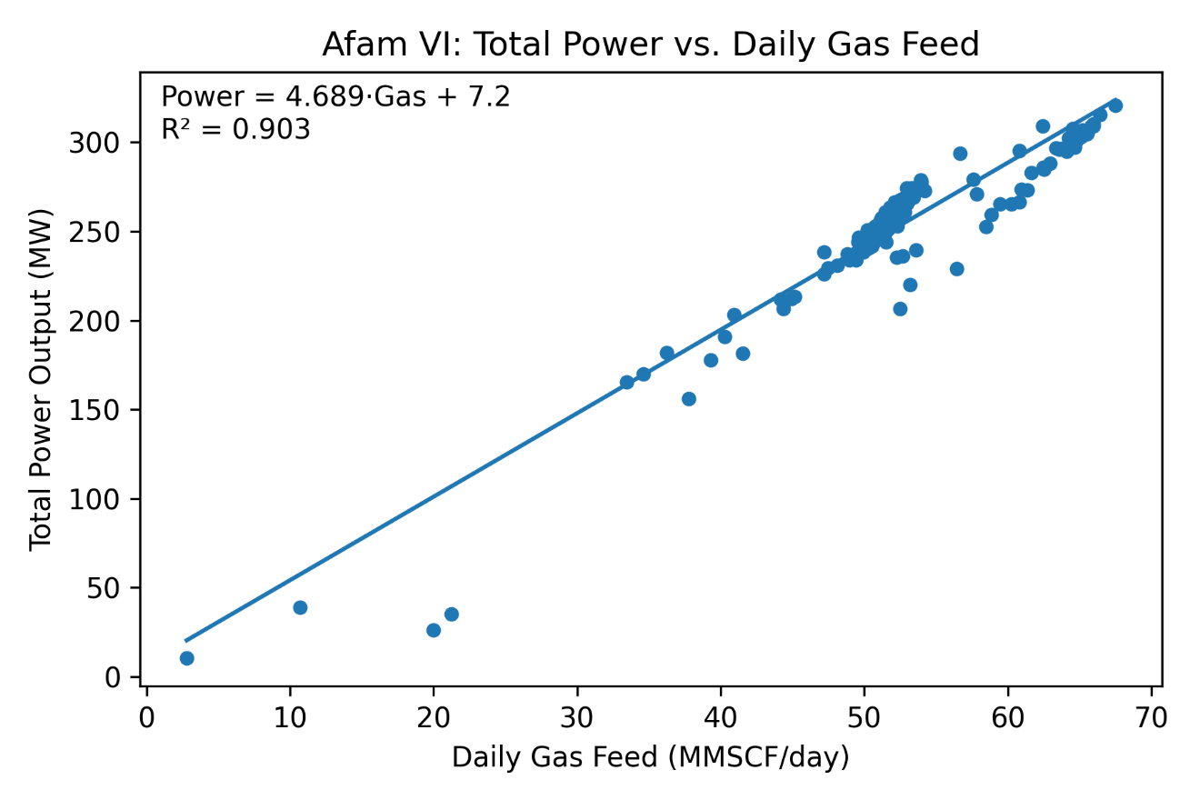
Figure 4 Afam VI: Total Power vs. Daily Gas Feed (derived: Python code script)
3.5 Conversion of Simulated Lean Gas to Regression Input
Lean-gas flowrates from UniSim (kmol/h) were converted to daily volumetric flowrates (MMSCF/day) to match the regression input basis. At standard temperature and pressure (0 °C, 1 atm), the molar volume of an ideal gas is 22.414 m³/kmol, as obtained from the ideal gas law using thermodynamic constants (NIST, 2023). Hence, using standard gas conditions:
- 1 kmol ≈ 22.414 m³
- 1 m³ ≈ 35.3147 scf
- therefore, 1 kmol ≈ 791 scf
Equation 3.2 gives the conversion applied:
$$G=\frac{\left({\dot{n}}_{\text{lean}} × 24 × 791\right)}{{10}^{6}} (3.2)$$Where G = Lean gas flowrates in MMSCF/day
$${\dot{n}}_{\text{lean}}=Lean gas in kmol/h$$
Applying this to the simulation outputs yields Table (7):

Table.7 Clustered lean gas flow rate (mmscfd)
Cluster | Lean gas (kmol/h) | Lean gas (MMSCF/day)
0 | 2,707.00 | 51.38
1 | 1,053.00 | 19.98
2 | 637.1 | 12.11
3 | 1,772.00 | 33.63

3.6 Estimated Power Generation from Flare-Gas Clusters
The converted lean-gas flowrates were substituted directly into the Afam VI regression model. Table (8) gives the resulting cluster-level power estimates. In this study, the reported power values represent average power output (effective capacity) under continuous operation, rather than instantaneous or peak power.

Table 8: Estimated cluster-level gas input, power generation capacity, and daily energy output
Cluster | Gas input (MMSCF/day) | Power (MW) | Energy (MWh/day)
0 | 51.38 | 248.2 | 5,957
1 | 19.98 | 101 | 2,424
2 | 12.11 | 64 | 1,536
3 | 33.63 | 164.8 | 3,955

Total estimated power: ≈ 578 MW
Total daily energy: ≈ 13,872 MWh/day

4. DISCUSSION
4.1 Implications of Cluster-Based Gas-to-Power for Energy Security
The results demonstrate that optimally aggregated flare-gas clusters in the Niger Delta can realistically support approximately 578 MW of power capacity using empirically observed plant performance. This level of generation is considered significant because within the Nigerian power system, incremental additions of 100–200 MW have been shown to improve grid stability, and reserve margin in gas-dominated electricity systems (Aigbe et al., 2023; Wang et al., 2023).
A key insight from the analysis is the uneven contribution of clusters to total power potential. More than 70% of the estimated capacity is supplied by Clusters 0 and 3, reflecting the effectiveness of cluster-based aggregation in concentrating dispersed flare volumes into economically meaningful supply streams. Studies have demonstrated that spatial aggregation and hub-based gas-gathering strategies significantly improve infrastructure utilization and energy recovery from small, distributed gas sources (Ikotun et al., 2023; Fagbami et al., 2024). This confirms that spatial optimization, when combined with realistic gas conditioning and empirical power modelling, provides a credible pathway for translating flare-gas recovery into energy-security outcomes.
Unlike purely theoretical gas-to-power assessments, the present study incorporates real operational behavior through the Afam VI empirical model. Thus, it accounts for part-load effects and site-specific inefficiencies. Therefore, the estimated capacity reflects achievable power output rather than idealized conversion efficiency. Empirical modelling approaches improve the reliability of power-generation projections, particularly in developing-countries characterized by operational constraints (Molière, 2023; Wang et al., 2023). This enhances the usefulness of the results for infrastructure planning and energy-policy evaluation.
4.2 Energy Potential and Equivalent Population Coverage
The combined power-generation potential of the four clusters was evaluated by converting the estimated cluster-level power outputs into annual electrical energy. The total recoverable electrical energy from the clustered flare-gas streams is approximately 13,872 MWh/day. Under continuous operation, the energy will correspond to about 5.06 TWh/year.
The estimated energy output was benchmarked against Nigeria’s average per-capita electricity consumption. As shown in Figure (5), Nigeria’s per-capita electricity consumption has remained below 200 kWh/person/year over the period 2000–2022. The average value being 152.17 kWh/person/year (Statista, 2023). Using this benchmark, the annual recoverable energy (equation 4.1) from the aggregated flare-gas clusters could supply the electricity needs of approximately 33 million people.
$$\frac{5.06×{10}^{9}\text{ kWh/year}}{152.17\text{ kWh/person/year}}≈33.3\text{ million people }\text{ (4.1)}$$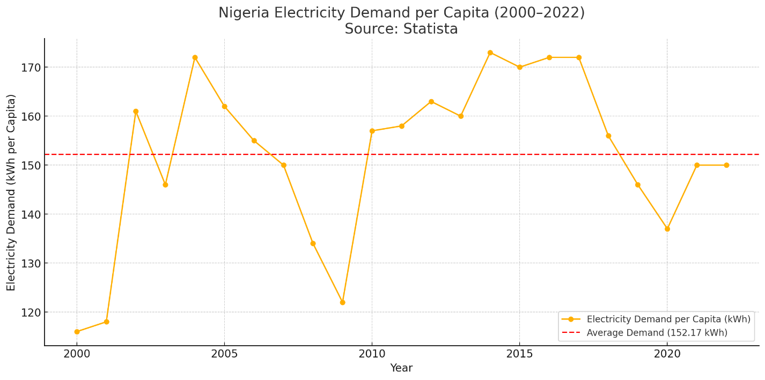
Figure 5: Nigeria’s electricity Demand per capita (2000–2022) (Source: Statista, 2023).

This equivalent population coverage represents approximately 15% of Nigeria’s estimated population, based on current national demographic data. While this energy alone cannot resolve Nigeria’s power deficit, it can meaningfully reduce supply gaps, particularly when deployed as distributed or regionally embedded generation close to flare sites.

5. Conclusion
This study quantified the power-generation potential of aggregated flare gas in the Niger Delta. It combined geospatial clustering, gas-conditioning process simulation, and empirical gas-to-power modelling. The analysis built on a previously optimized clustering framework for twenty-four onshore flare sites and extended it to address gas quality and achievable power output.
The flare gas from all four clusters was simulated into methane-rich lean gas. The narrow range of lean-gas molecular weights and lower heating values across clusters demonstrated that fuel quality variability was minimal after conditioning, thereby justifying the application of a unified empirical gas-to-power relationship.
Using operational data from the Afam VI combined-cycle gas-turbine plant, the empirical model estimated a total recoverable capacity of about 578 MW. This corresponds to approximately 13,872 MWh per day, or 5.06 TWh per year. The majority of the recoverable power potential is concentrated within two clusters, which shows the effectiveness of cluster-based aggregation in converting spatially dispersed flare volumes into economically meaningful power supply.
When benchmarked against Nigeria’s per-capita electricity consumption, the recovered energy could supply electricity to about 33 million people. This represents roughly 15% of the national population. While this contribution alone cannot eliminate Nigeria’s power deficit, it can meaningfully reduce supply gaps.
Overall, the results show that cluster-based flare-gas utilization is technically feasible and policy relevant. The framework therefore provides practical guidance for translating flare-reduction efforts into reliable electricity supply.
Future work can extend this approach by including transmission constraints and economic optimization. These additions would further support investment planning and phased implementation across the Niger Delta.
A key limitation of this study is that it focuses on technical potential rather than economic feasibility. The results demonstrate that clustered flare gas can support significant and realistically achievable power generation. However, the analysis does not evaluate capital costs, operating costs, tariff structures, or project-level financial viability. Consequently, the findings should be interpreted as a technical benchmark and not an investment case.

DATA AVAILABILITY STATEMENT

The data used in this study include flare-gas composition data and power-plant operational records obtained through technical and operational access arrangements. Due to confidentiality and data-use restrictions, these datasets are not publicly available. Aggregated and processed data supporting the findings of this study are included within the article. Additional information may be made available from the corresponding author upon reasonable request.

COMPETING INTERESTS DISCLAIMER:
Authors have declared that they have no known competing financial interests OR non-financial interests OR personal relationships that could have appeared to influence the work reported in this paper.

Disclaimer (Artificial intelligence)
The author(s) declare that generative artificial intelligence tools were used during the revision stage of this manuscript solely for language refinement and sentence restructuring. ChatGPT (OpenAI GPT-5.2) was used to assist with rephrasing reviewer-recommended sections. All ideas, data, analyses, results, interpretations, and conceptual development presented in this manuscript are entirely the original work of the authors.

Details of AI Usage
Rephrasing and clarity improvement in the abstract and introduction.
Language refinement and sentence restructuring following reviewer comments.

References

- THISDAY Live. (2025, April 12). NUPRC: Nigeria’s oil reserves hit 37.28 billion barrels, gas 210.54 TCF in 2025. https://www.thisdaylive.com/2025/04/12/nuprc-nigerias-oil-reserves-hit-37-28-billion-barrels-gas-210-54-tcf-in-2025/
- Olujobi, O. J., & Ape, N. T. (2025). Reforming legal frameworks for combating gas flaring in Nigeria: A comparative legal analysis and sustainable solutions. Resources Policy, 109, 105721. https://doi.org/10.1016/j.resourpol.2025.105721
- Okoro, E. E., Adeleye, B. N., Okoye, L. U., & Maxwell, O. (2021). Gas flaring, ineffective utilization of energy resource and associated economic impact in Nigeria: Evidence from ARDL and Bayer-Hanck cointegration techniques. Energy Policy, 153, 112260. https://doi.org/10.1016/j.enpol.2021.112260
- Awulu, E. (2021). Gas flaring in Nigeria: A crisis for the environment. Academia Letters, Article 3799, 1–6. https://doi.org/10.20935/AL3799
- World Bank. (2024). Global gas flaring tracker report 2024. World Bank Global Gas Flaring Reduction Partnership. https://www.worldbank.org/en/programs/gasflaringreduction
- Aigbe, G. O., Stringer, L. C., & Cotton, M. (2023). Gas flaring in Nigeria: A multi-level governance and policy coherence analysis. Anthropocene Science, 2, 1–14. https://doi.org/10.1007/s44177-023-00045-5
- Musa, I., & Ibrahim, S. (2025). Assessing the effect of gas flaring on economic sustainability in Nigeria’s oil and gas sector. International Journal of Spectrum Research in Social and Management Sciences, 1(4), 123–147. https://doi.org/10.5281/zenodo.17686587
- Wang, Y., Yang, Y., & Xu, Q. (2023). Integrated planning of natural gas and electricity distribution systems for enhancing resilience. International Journal of Electrical Power & Energy Systems, 151, 109103. https://doi.org/10.1016/j.ijepes.2023.109103
- Tso, W. W., Demirhan, C. D., Floudas, C. A., & Pistikopoulos, E. N. (2020). Multi-scale energy systems engineering for optimal natural gas utilization. Catalysis Today, 356, 18–26. https://doi.org/10.1016/j.cattod.2019.09.009
- Jain, A. K. (2010).Data clustering: 50 years beyond K-means. Pattern Recognition Letters, 31(8), 651–666. https://doi.org/10.1016/j.patrec.2009.09.011
- Ikotun, A. M., Ezugwu, A. E., Abualigah, L., Abuhaija, B., & Heming, J. (2023). K-means clustering algorithms: A comprehensive review, variants analysis, and advances in the era of big data. Information Sciences, 622, 178–210. https://doi.org/10.1016/j.ins.2022.11.139
- Nwankwo, A. C., Omijeh, B. O., & Ehikhamenle, M. (2025). Cluster-based geospatial optimization of gas flaring sites in the Niger Delta for enhanced gas recovery. Journal of Engineering Research and Reports, 27(12), 441–454. https://doi.org/10.9734/jerr/2025/v27i121751
- Molière, M. (2023). The fuel flexibility of gas turbines: A review and retrospective outlook. Energies, 16(9), 3962. https://doi.org/10.3390/en16093962
- Liu, G., Zhang, X., Chen, Y., & Li, H. (2022). Technical, Economical, and Environmental Performance Assessment of an Improved Triethylene Glycol Dehydration Process for Shale Gas. ACS Omega, 7(9), 8163–8174. https://doi.org/10.1021/acsomega.1c05236
- Islam, M., Al-Sobhi, S. A., Naquash, A., Qyyum, M. A., & Lee, M. (2024). Optimal process selection for natural gas liquids recovery… Energy, 289, 129757. https://doi.org/10.1016/j.energy.2023.129757
- Kazemi, A. (2025). Natural gas liquids (NGL) recovery: A framework for environmental, technical and economic assessments and optimizations. Chemical Engineering Science, 316, 121928. https://doi.org/10.1016/j.ces.2025.121928
- Naeim, K. A., Hegazi, A. A., Awad, M. M., & El-Emam, S. H. (2022). Thermodynamic analysis of gas turbine performance using the enthalpy–entropy approach. Case Studies in Thermal Engineering, 34, 102036. https://doi.org/10.1016/j.csite.2022.102036
- Kim, S. R., Jeong, J. H., & Kim, T. S. (2025). Investigation of operational strategies of natural gas-hydrogen-ammonia co-fired gas turbine combined cycle in simultaneous consideration of performance and CO₂ emission. Case Studies in Thermal Engineering, 73, 106584. https://doi.org/10.1016/j.csite.2025.106584
- Clarke Energy. (n.d.). Heating value. In Clarke Energy US. Retrieved June 28, 2025, from https://www.clarke-energy.com/us/heating-value/
- Emekwuru, N. (2024). Characterization of the dominant stages at which gas flaring is introduced in the Niger Delta: Impacts and policy options to ameliorate them. Environments, 11(7), 158. https://doi.org/10.3390/environments11070158
- Olujobi, O. J., Yebisi, T. E., Patrick, O. P., & Ariremako, A. I. (2022). The legal framework for combating gas flaring in Nigeria’s oil and gas industry: Can it promote sustainable energy security? Sustainability, 14(13), 7626. https://doi.org/10.3390/su14137626
- Fan, Y., Masnadi, M. S., Jing, L., Ren, B., & Brandt, A. R. (2025). The Pyxis Project: A geospatial data system for emission estimation monitoring in the oil and gas industry. Energy and AI, 22, 100601. https://doi.org/10.1016/j.egyai.2025.100601
- Wu, Y., Cui, Z. Y., Lin, H., Wang, Y. F., & Feng, X. (2022). An optimization method for shale gas gathering system—Consideration of reliability enhancement under earthquake-related uncertainties. Petroleum Science, 19(5), 2431–2447. https://doi.org/10.1016/j.petsci.2021.12.029
- Fagbami, D., Ekpeti, E., Bamidele, A., Odeh, A., Odogbo, A., & Jimmy, D. (2024). Cluster gathering of associated and non-associated natural gas: The KGG case study (Paper No. SPE-221681-MS). https://doi.org/10.2118/221681-MS
- Chong, D. J. S., Foo, D. C. Y., & Putra, Z. A. (2023). A reduced order model for triethylene glycol natural gas dehydration system. South African Journal of Chemical Engineering, 44, 51–67. https://doi.org/10.1016/j.sajce.2023.01.001
- Welch, M. (2013). Gas Turbine Fuel and Fuel Quality Requirements for Use in Industrial Gas Turbines. https://files01.core.ac.uk/download/pdf/186719088.pdf
- Kuczyński, S., Łaciak, M., Szurlej, A., & Włodek, T. (2020). Impact of Liquefied Natural Gas Composition Changes on Methane Number and Wobbe Index. Energies, 13(19), 5060. https://doi.org/10.3390/en13195060
- National Institute of Standards and Technology (NIST). (2023). Fundamental constants and thermodynamic definitions. NIST Chemistry WebBook. https://doi.org/10.18434/T4D303
- Statista. (2023). Per capita electricity consumption in Nigeria from 2000 to 2022. https://www.statista.com/statistics/1306967/per-capita-electricity-demand-in-nigeria/

