Scalable Fraud Detection in High-Volume Financial Data Using Gradient-Boosting Models

Abstract—In the evolving landscape of online transactions, fraudulent actions are becoming more sophisticated, fraud detection is still a significant difficulty. This study investigates the use of machine learning methods to improve online transaction fraud detection. In this research, a comprehensive machine learning-based fraud detection system using the PaySim dataset is presented, which is a simulated dataset replicating real-world mobile money transfer. It is methodologically based on thorough exploratory data analysis, MinMax normalization, and class balancing using SMOTE to deal with severe data imbalance and splitting with training (80%) and testing (20%). XGBoost and LightGBM are two advanced gradient boosting models that are assessed using standard measures such as ROC-AUC, accuracy, precision, recall, F1-score, and confusion matrices. The results of the experiment indicate that XGBoost is better than all the models compared 99.91% and 99.98% accuracy, and LightGBM is 96.72% with good overall performance. The proposed framework is also superior to the existing methods, such as FinSafeNet, Logistic Regression, and GAN-VAE, as it can be further verified through the comparative analysis. The results indicate that gradient-boosting models are suitable for high-volume financial transaction settings and provide a reliable baseline for applied fraud detection research.
Keywords—Security, financial fraud detection systems, transaction analysis, machine learning, PaySim data.

Introduction
The advent of online banking, digital banking, online shopping and mobile payment modes, new avenues for fraud to be committed, resulting in billions of dollars in losses annually. Financial accounting fraud has increased in the current economic climate, investors, academic researchers, the media, the financial community, and regulators have become very interested in financial accounting fraud detection, or FAFD[1]. The need to identify, characterize, and disclose financial accounting fraud has grown as a result of several high-profile financial scams that were found and revealed at major corporations during the past ten years, including Enron, Lucent, WorldCom, and Satyam. Because digitalization makes fraudsters more nimble, criminals are using technology to perpetrate online fraud on a larger scale and breadth than in the past [2][3]. The methods that fraudsters and attackers employ are becoming increasingly complex: Malicious software that have been modified for several banking apps might get past the security safeguards in place [4].
Enhancing the security and dependability of payment transactions for consumers and financial institutions alike requires effective fraud detection systems [5]. ML is one of the most popular approaches used in the numerous research on this subject conducted in the last several years. While machine learning (ML) can be useful for detecting fraud, there are certain obstacles that must be addressed. The main problem is that credit card transaction data is inherently unbalanced; fraudulent transactions make up just a small portion of total transactions [6][7]. Models suffer from this mismatch because it can lead to improper learning and a high false positive rate, which reports legal transactions as fraudulent. For models to be effective, they must be updated often since fraudsters are always changing their strategies [8]. The difficulty is in scaling and applying models in real-time while preserving low latency and high accuracy [9].
Financial accounting fraud detection has been motivated by the need to ensure that digital financial systems are protected and that people have trust in the systems. As online banking, mobile payments, and e-commerce increase in popularity, fraudsters are taking advantage of digitalization to commit more advanced crimes and result in billions of losses every year. Cases such as Enron and Satyam are of high profile and reflect the destructive effects of unnoticed fraud, and thus, an effective system of detecting fraud is important. Machine learning provides effective methods to detect anomalies in large datasets of transactions, yet issues like the imbalance of data, the development of new fraud strategies and future studies and advancements in the field are motivated by the need for precision in real-time. The following crucial elements of this study aid in the development of scalable financial fraud detection:
- Conduct data-pre-processing pipeline, including categorical encoding, and MinMax normalization, ensuring stable feature distributions for gradient-boosting frameworks.
- Development of a unified fraud-detection architecture that integrates EDA, and evaluation specifically optimized for large-scale mobile money transaction data from the PaySim dataset.
- SMOTE applied on the PaySim dataset to effectively balance fraud classes and enhance minority pattern learning.
- Propose and develop LightGBM and XGBoost, demonstrating their computational efficiency, scalability, and suitability for high-volume transactional fraud detection.
The necessity to propose the given framework is explained by the urgency of the need to detect fraud effectively and in a scalable manner, and process large and heavily imbalanced financial data. In contrast to the conventional methods, the piece combines a strict preprocessing pipeline with SMOTE-based balancing and tests two advanced gradient boosting models, including XGBoost and LightGBM, on the PaySim dataset. The difference is in the fact that these techniques are used in combination to detect subtle patterns of fraud with unmatched accuracy, as shown by the near perfection of XGBoost. Also, the paper gives the full comparison with the available models, proving the superiority and practical applicability of the proposed approach to contemporary financial fraud detection.

Structure of the Paper
The study is structured as follows: Section II reviews existing literature, Section III describes the dataset and the proposed framework, Section IV reports the experimental results, and Section V outlines the concluding remarks and future research directions.

Justification and Novelty
The justification demonstrates the value of gradient boosting models to be used in combination with systematic preprocesses and with the use of SMOTE-based class balancing of large-scale, high- imbalanced data on financial transactions. The research in terms of its empirical data of model behavior under circumstances of extreme imbalance of classes will provide practical input into the concept of methodological enhancement in the area of research about fraud detection in the future. The fact that the XGBoost and LightGBM are being compared with the existing methods will assist in enhancing the comparative knowledge and make a reasonable contribution to the selection of the model that will be employed by the researchers and players in the industry interested in the development and design of efficient and effective systems of financial security.

Literature Review
This section discusses some review articles on fraud detection in financial and healthcare domains using ML and DL approaches. Table 1 brings out the paper, methods, data set, major findings, and limitations/research.
Athiththan and Ramanan (2025) on a dataset of 900 credit card transactions (450 of which were real and 450 were fraudulent). The model proposed has got an accuracy of 96%, the precision of legitimate transactions is 75% and the accuracy of fraudulent transactions is 90%. Recall rates were likewise high, accounting for 87% of fraudulent transactions and 86% of valid transactions. The findings suggest that the suggested model may prove to be a useful instrument in the fight against credit card fraud and it provides a high accuracy as well as strong privacy offers [10].
Sun, Qi and Shen, (2025) provides a rigorous comparison of classical machine learning models-Logistic Regression, SVM, Random Forest, and LightGBM-and a Gated Recurrent Unit (GRU) deep learning model on a large-scale, imbalanced bank account fraud dataset. All classical models, including the widely-used tree-based ensembles, proved ineffective at the primary detection task, with fraud recall scores below 7 %. In stark contrast, the GRU network successfully identified the vast majority of fraudulent cases, achieving over 78 % recall on the minority fraud class, albeit at the cost of very low precision[11].
Wang and Meng, (2025) suggested model uses large-scale enterprise financial data to unveil concealed correlations, identify fraudulent transactions, and pinpoint unusual financial behaviors. The system improves financial risk assessment and fraud detection with high precision using advanced data mining methodologies. Experimental findings on actual financial datasets indicate that the suggested approach has a classification accuracy of 96%, surpassing traditional methods in detecting financial anomalies with enhanced precision and recall[12].
Sharma and Gupta, (2024) examined various highly descriptive models with an extensive dataset of financial transactions. Our results demonstrate that the LSTM model achieved the highest performance, with an accuracy of 95.8%, precision of 86.3%, recall of 79.4%, F1-score of 82.7%, and AUC-ROC of 0.936. The CNN model also performed well, attaining an accuracy of 95.2%, precision of 84.1%, recall of 77.8%, F1-score of 80.8%, and AUC-ROC of 0.924. The autoencoder effectively identified anomalies, achieving an accuracy of 94.8%, precision of 83.2%, recall of 76.5%, F1score of 79.7%, and AUC-ROC of 0.918[13].
Sharma and Sharma, (2024) consists of data cleaning using automatic approaches, machine learning algorithms such as CNNs and RNNs for modeling, and key metrics that involve accuracy, sensitivity, specificity, AUC, and ROC curves when evaluating the model. The analysis shows, that the RNN architecture performs even better than the CNN model observing an incredible accuracy of 95.8%, sensitivity of 93.7%, and specificity of 97. 5 % with an AUC of 0. 972[14].
Tang and Liu (2024) experimental testing of two datasets of financial data of varying sizes. Results on Datasets 1 and 2 show that, in terms of AUC-PR (0.882, 0.816) and AUC-ROC (0.982, 0.994), the suggested SDT model outperforms conventional detection techniques. Further improvement of the AUC-PR values (0.884, 0.892) and AUC-ROC values (0.963, 0.998) can be achieved by the implementation and testing of federated learning in a distributed environment [15].
Basani (2024) proposes a real-time, AI-based, XGBoost, and data engineering optimization fraud detection model that can process 10,000 transactions per second with a low latency of 7 ms. With the use of Explainable AI (XAI), the system solves the issue of data imbalance in fraud procedures and adds a transparent aspect. SHAP values allow users to make predictions using the model accessible. According to testing results on real-world financial transaction datasets, the suggested method is correct on 99.2% of the datasets, with accuracy and recall scores above 95% and 93%, respectively [16].
Somkunwar et al. (2023) adds an efficient tool to the financial equipment’s, which boosts security and confidence, as it allows the detection of fake payments at the earliest stage. Through the use of machine learning and Benford's Law, this technology is essential in avoiding financial misconduct. Its 94.83% fraud detection accuracy rate attests to its effectiveness [17].
Al-Momani and Aljawarneh (2022) Therefore, monitoring suspicious transactions need to be a crucial part of any payment system. By analyzing customer behavior from previous transaction data, fraudulent transactions can be identified. In order to address the shortcomings of earlier research, a neural network model is suggested in this study to identify several fraudulent transaction types using a current data set. The suggested model produced an AUC of 99%, as shown by the experimental findings [18].
Bhowmik et al., (2022) suggest an efficient fraud detection methodology. The propose a unique nonlinear embedded clustering to resolve imbalances in the dataset, followed by a Deep Belief Network for detecting fraudulent transactions. The proposed model achieved an accuracy of 94% with a 70:30 ratio of training-validation dataset[19].

TABLE 1: Summary of background study for Fraud Detection using machine learning
Author (Year) | Methods / Models | Dataset | Key Findings | Limitations | Future Work
Athiththan & Ramanan (2025) | Privacy-preserving ML-based fraud detection model | 900 credit card transactions (450 genuine, 450 fraudulent) | Achieved 96% accuracy; fraud detection accuracy of 90%; high recall for both fraud (87%) and legitimate transactions (86%) | Small dataset size; limited real-world scalability | Validation on large-scale, real-time transaction datasets
Sun, Qi & Shen (2025) | Logistic Regression, SVM, Random Forest, LightGBM, GRU | Large-scale imbalanced bank fraud dataset | Classical ML models showed poor fraud recall (<7%); GRU achieved >78% fraud recall | Very low precision for GRU; class imbalance impact | Precision optimization and hybrid deep learning architectures
Wang & Meng (2025) | Advanced data mining and ML-based fraud detection | Large-scale enterprise financial data | Achieved 96% classification accuracy with improved precision and recall over traditional methods | Limited discussion on real-time deployment | Integration with real-time financial monitoring systems
Sharma & Gupta (2024) | LSTM, CNN, Autoencoder | Large financial transaction dataset | LSTM performed best (95.8% accuracy, AUC-ROC 0.936); CNN and autoencoder also effective | High computational complexity | Lightweight deep learning models for faster detection
Sharma & Sharma (2024) | CNN, RNN | Financial transaction dataset | RNN outperformed CNN with 95.8% accuracy and AUC of 0.972 | Model interpretability not addressed | Explainable AI integration
Tang & Liu (2024) | Secure Decision Tree (SDT), Federated Learning | Two financial datasets of different sizes | SDT outperformed traditional methods; federated learning further improved AUC-PR and AUC-ROC | Communication overhead in federated setup | Optimization of federated learning efficiency
Basani (2024) | XGBoost with XAI (SHAP) | Real-world financial transaction datasets | 99.2% accuracy; recall >93%; supports 10,000 TPS with 7 ms latency | High system complexity | Expansion to multi-bank distributed environments
Somkunwar et al. (2023) | Machine Learning + Benford’s Law | Financial payment data | Achieved 94.83% fraud detection accuracy | Limited adaptability to evolving fraud patterns | Adaptive learning-based fraud detection
Al-Momani & Aljawarneh (2022) | Neural Network-based fraud detection | Contemporary transaction dataset | Achieved AUC of 99% with high detection capability | Limited comparison with deep learning models | Hybrid neural architectures for enhanced detection
Bhowmik et al. (2022) | Embedded clustering + Deep Belief Network (DBN) | Financial fraud dataset (70:30 split) | Achieved 94% accuracy; effective imbalance handling | Moderate accuracy compared to newer models | Ensemble deep learning with imbalance-aware training

Methodology
A streamlined methodology for financial transactions starts with collecting the PaySim dataset, that Preprocessing, including handling missing values, one-hot encoding, normalization, and SMOTE is applied to correct class imbalance. Models for fraud detection dubbed XGBoost and LGBM are proposed, and the dataset is separated into training and testing sets. Model performance is assessed using accuracy, precision, recall, and F1-score, which helps in further analysis and progressive improvement, as shown in Fig. 1.

- Flowchart for Fraud Detection in Financial Data.
The other steps of the proposed methodology are discussed briefly as follows:

Data Collection
Synthetic Financial Dataset for Fraud Detection was created by means of the PaySim simulator that recreates the behavior of mobile money transfers and fraud patterns. It includes about 6.3 million transactions, with a minute fraction of them considered to be fraudulent, and this is a reflection of the extreme imbalance of real financial systems. Finding patterns and links in a data collection is made possible through the important process of exploratory data analysis, or EDA. Before creating predictive models, the paysim dataset was analyzed using several exploratory techniques to better understand the data.
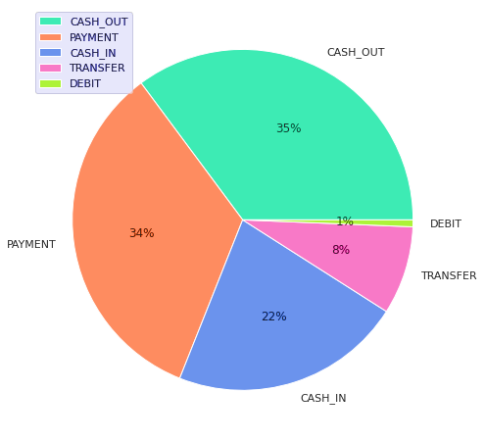
- Pie chart for different categories of Transactions.
In Fig. 2, illustrates the dataset's distribution of transaction kinds. The graphic displays many categories, each of which is denoted by a distinct color section. The majority of the data is concentrated in a few transaction types, while others form only small portions of the chart. This distribution reflects a clear imbalance, with some transaction types being much more prevalent than the rest.
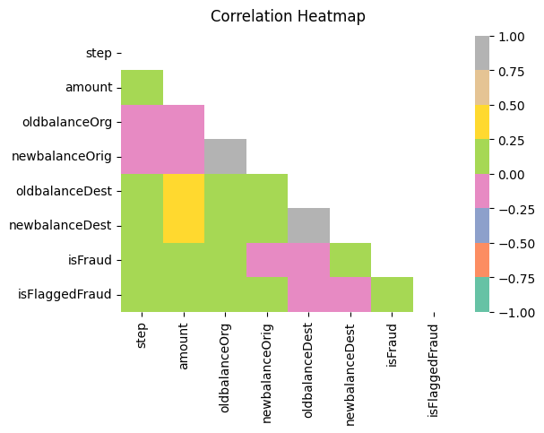
- Correlation Heatmap of dataset features.
Fig. 3 shows correlations between variables of the data set, and the variables of the fraud indicators isFraud and isFlaggedFraud. The heatmap is applied on a color scale of deep blue (strong negative correlation) to yellow-green (strong positive correlation), and the neutral correlations are displayed in gray. The visual representation to understand pattern and dependency between variables, including the negative relationship between oldbalanceOrg and newbalanceOrig or the low correlation between isFraud and most balance-related features, can provide information on possible predictors of a fraudulent activity.
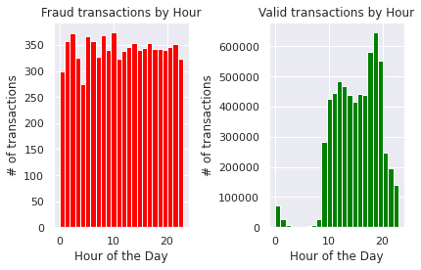
- Distribution of fraudulent and valid transactions.
The distribution of legitimate and fraudulent transactions throughout the day is shown in Fig. 4. The left plot shows that fraudulent activity occurs relatively uniformly throughout the day, with no specific hourly peak. In contrast, the right plot reveals that valid transactions are heavily concentrated during business hours, peaking around the late afternoon and evening. It means that fraudulent transactions are more evenly distributed unlike legitimate transactions which are normally carried out in normal ways of human activity.

Data Preprocessing
Preprocessing is necessary due to noise, inconsistency, and imbalance of classes in real-world data on fraud. It starts with an inspection of data, then elimination of the outliers, irrelevant features, and null entries to ensure integrity. Normalization and transformation gears the dataset towards the model training, which of high quality, scalable, and consistent. All of these measures yield a balanced, cleansed and well-organized data set to test a model reliably.
- Initial Data Inspection: Dataset analyzed with exploratory data analysis to get a feel of the structure and summary statistics, and deleting irrelevant columns (timestamps, identifiers, etc.).
- Handling Missing Values: Data that have a null value was deleted upon verification to ensure the integrity of the records and to eliminate bias.
- Outlier Removal: Eliminating outliers would perhaps remove important signs of fraudulence, and since the model is weak in determining real fraud cases, it would lessen its utility in detecting fraud cases.
- Feature exclude: The feature isFlaggedFraud was excluded from model training due to its strong correlation with the target label and its direct dependence on transaction-level fraud indicators.

Data Encoding
The label encoding used to encode categorical variables into numerical ones to be handled by machine learning models. The type of transaction and customer identifiers (nameOrig, nameDest) are coded in this work with LabelEncoder, but in this case, the categories are assigned a unique integer. This transformation does not modify the categorical information but only makes the data set fit in algorithms with numerical inputs. It also guarantees the uniform representation of the categories, decreases the complexity of models, and enhances the computation efficiency in the course of training.

Data Normalization
This study used MinMax normalizing, sometimes referred to as the MinMax Scaler, as its normalizing method. Equation (1) gives the transformation's mathematical formulation:
$z_{i}=\frac{z_{i}-z_{min}}{z_{min}-z_{max}}$ (1)
In this notation, the normalized value of the ith observation, which is limited to the interval [0, 1], is denoted by $z_{i}$ . The original, unnormalized observation is represented by the symbol $z_{i}$ , and the maximum and minimum values inside the associated feature are represented by the symbols $z_{max}$ and $z_{min}$.

Data Splitting
It partitions the dataset into 80:20 training and test sets. For training and hyperparameter adjustment, the training set was especially used. The test set assesses the generalizability and performance of the model.

SMOTE for Address Class Imblanace
To overcome the class imbalance depicted in Fig. 5, The Synthetic Minority Oversampling Technique (SMOTE) finds the closest neighbors and interpolates between them to create new instances of the minority class. This method not only balances the classes but also enables the model to discover the faintest fraud patterns since the data is not just copied. In this instance, SMOTE converted the initial data where Class 1 constituted only 0.1 of the data into a balanced dataset with 50% of each of the classes, enhancing the model's capacity to discover and recognize patterns of the minority classes.
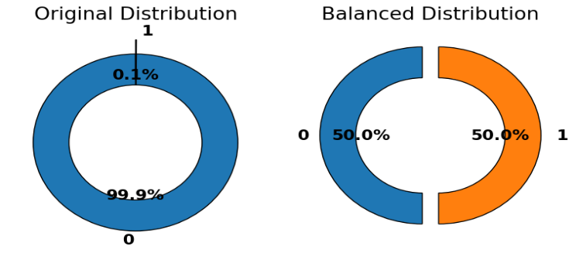
- Donut chart for Class Distribution.

Model Selection
In this exercise, use the Paysim dataset to train several models. Experiments are conducted using the XGBoost and LightGBM models.

XGBoost
A complex gradient tree boosting-based algorithm called XGBoost may be able to effectively tackle complex machine learning issues. A popular algorithm for medical data in a variety of research fields, XGBoost is renowned for its excellent performance and minimal memory and time complexity. But XGBoost is sensitive to this kind of information. Thus, it is quite fascinating to see how well these models perform when such data and balanced generated data are used. The regularized objective function optimized by the XGBoost method is displayed in Equation (2).
Large-scale machine learning issues may be effectively handled by XGBoost, an advanced gradient tree boosting-based approach. The great performance and minimal time and memory complexity of XGBoost have made it popular for usage with medical data in a variety of research fields. XGBoost is susceptible to such information, though. Thus, it is quite intriguing to see how well these models perform when given such data, as well as balanced generated data. Equation (2) displays the regularized objective function that the XGBoost method has optimized:
$L_{XYB}=\sum_{i=1}^{n}{l\left(y_{i},{\hat{y}}_{i}\right)+λ\sum_{k=1}^{T}{Ω(f_{k})}}$ (2)
Where has the logistic loss occurred${\hat{y}}_{i}$ is a regularization term that penalizes model complexity and represents the expected probability$Ω(f_{k})$ . By penalizing complex models, to avoid overfitting, the XGBoost regularized goal function is essential. In order to generalize to the unknown data, the model's accuracy and complexity are scaled using the regularization term $Ω(f_{k})$. This greatly increases the assurance that the forecasts are more accurate, this is necessary for the prediction models to function well in real-world applications. XGBoost has the following hyperparameters that are used to manage model learning and complexity: n estimators (trees), max depth (trees depth) and learning rate. Also, subsample and colsample_bytree enhance the generalization, whereas regularization (λ and α) allow to prevent overfitting and obtain stable results.

LGBM
A LightGBM is a reliable technique for applying gradient boosting in decision trees. LightGBM uses tree-based learning algorithms, making it a strong choice for gradient boosting. Because of its decentralized and efficient architecture, it offers faster training and increased output. Variable bucketing is carried out via a histogram-based technique called LightGBM, which uses less memory while increasing training speed and accuracy. It can handle big and complicated datasets and operates faster when taught. Both GPU-based and parallel learning are supported. In supervised learning contexts, the technique allows one to deduce information about a target Y from only X in Equation (3).
$\hat{f}=\arg{\min_{f}E_{y,X} L(y,f\left(x\right))}$ (3)
A supervised training set (X) and a loss function $L(y,f\left(x\right))$ whose predicted value is to be lowered are used in the LightGBM approach to achieve this$\hat{f}$(x). The main hyperparameters that have been used to configure LightGBM are num of leaves which is used to regulate model complexity and max depth to ensure overfitting. The learning rate indicates the contribution per tree and n estimated specifies the number of boosting cycles. Moreover, feature_fraction and bagging_fraction are applied to enhance generalization, whereas regularization parameters (lambda l 1 and lambda l 2 ) are employed in order to stabilize the model and prevent overfitting.

Evaluation metrics
To evaluate the efficiency of the fraud detection system's categorization models, various performance metrics are employed, including the confusion matrix, which encapsulates the predicted and actual classification outcomes. TP indicates the number of correctly classified positive samples, TN indicates the number of correctly classified negative samples, FP indicates the number of mistakenly classified negative samples as positive, and FN indicates the number of incorrectly classed positive samples as negative. After that, Equations (4) through (7) can be used to define the performance measures:
$Accuracy= \frac{TP+TN}{Total Number of Instances}$ (4)
$Precision =\frac{TP}{TP+FP }$ (5)
$Recall =\frac{TP}{TP+FN }$ (6)
$F=\frac{2\left(Precision×Recall\right)}{Precision+Recall}$ (7)
Accuracy is the total proportion of correctly predicted cases among all instances. Precision is a measure of optimistic projections' accuracy. The percentage of real suspicious fraud that the model properly recognized is known as recall, or sensitivity. The center of precision is thus played by the F1-score equation, which blends recollection and accuracy. A Receiver Operating Characteristics (ROC) curve displays the false positive rate (FPR) on the x-axis and the true positive rate (TPR) on the y-axis.

Result Analysis and Discussion
This section reports the models' performance results for Fraud Detection in High-Volume Financial Data. Every experiment was conducted on a PC running Windows 11 (64-bit) with an Intel Core i9 CPU (3.6 GHz, 12 cores) and 32 GB of RAM. Standard metrics were employed to assess the model, including F1-score, recall, accuracy, and precision, as indicated in Table 2. The LGBM model has an accuracy of 96.72, which is a good overall performance in classification. XGBoost has an accuracy of 99.91, and this means that it is very effective in detecting all of the important measures.
TABLE 2: Performance Evaluation of the propose Models for Fraud Detection
Measures | LGBM | XGB
Accuracy | 96.72 | 99.91
Precision | 98.79 | 99.89
Recall | 98.97 | 99.98
F1-score | 97.23 | 99.23
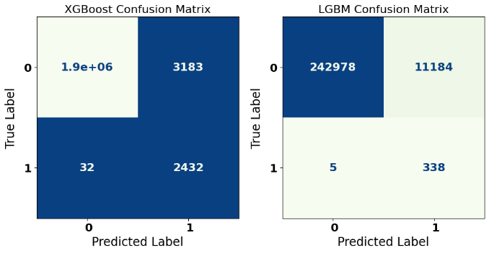
- Confusion Matrix of XGBoost and LGBM Model.
Fig. 6 presents the proposed models' confusion matrix, which shows how well they perform in binary classification. This model has high accuracy, with 1.9 million true negatives, 2,432 true positives which is high predictive ability of the two classes. False identifications are minimal and constitute just 3,183 false positives and 32 false negatives indicating superior recall and precision. This table shows the strength of XGBoost in the classification of the two categories and the error rate is quite low even with a large dataset.
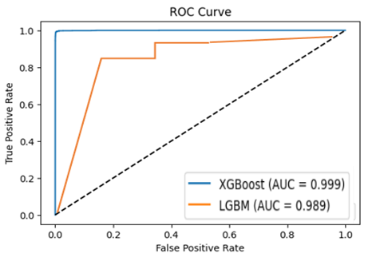
- ROC Curve of both Propose Models
Fig. 7 displays the ROC curves of the proposed XGBoost and LGBM models, which give a comparative view of classification performance. The XGBoost model has a perfect Area Under the Curve (AUC) of 0.99, which means that it has an ideal performance in discriminating between classes at all the thresholds. Conversely, LGBM model is also doing very well with the AUC of 0.98, which is a bit less than XGBoost. It displays low false positive rates and high true positive rates, and XGBoost can provide superior overall accuracy and dependability. The curve is anticipated to rise sharply on the top-left side.

Comparative Analysis and Discussion
Table 3 shows a comparative analysis of different models, as well as methods of detecting fraud, depending on key performance metrics. The results of the FinSafeNet are high with the accuracy 97.88 and F1-score of 95.12 whereas the Logistic Regression (LR) performance is not high according to all measures. The GAN VAE model offers a respectable level of precision but a lower recall and F1-score, making it challenging to identify fraudulent instances. Both XGBoost and LGBM exhibit good accuracy, recall, and F1-scores, demonstrating their power and dependability in identifying fraud in unbalanced datasets.
tABLE 3: Models performance comparison for Fraud Detection
Model / Method | Accuracy | Precision | Recall | F1-score
FinSafeNet [20] | 97.88 | 96.55 | 95.46 | 95.12
LR [21] | 88 | 77 | 88 | 82
GAN VAE [22] | 94.60 | 83.20 | 76.30 | 79.50
LGBM | 96.72 | 98.79 | 98.97 | 97.23
XGB | 99.91 | 99.89 | 99.98 | 99.23
The relative analysis indicates the great performance of gradient-boosting models, specifically XGBoost with the realistic experimental conditions. The updated text enhances the transparency of the methods and the clarity of the scalability statements, thus, the article could be seen as an important source of information in both applied studies and practical fraud detection systems.
The proposed fraud detection framework offers significant advantages, including high accuracy, strong scalability, and the ability to detect rare fraudulent patterns within large transactional datasets by combining effective preprocessing, SMOTE-based balancing, and advanced gradient boosting models. Simultaneously, ethical aspects are crucial to achieving the reasonable, clear, and accountable utilization of financial information. It involves protection of user privacy by ensuring their anonymity, eliminating bias in the algorithms, not labeling legitimate users as fraudulent, and making sure that the models make decisions that can be explained and used with legitimate purposes of financial monitoring.

Conclusion and Future Work
The concern of credit card fraud in the banking industry is on the rise as it is likely to pose risks to consumers and financial institutions. ML methods have been effective in identification of fraudulent transactions in the recent years. The study compares how well two well-known machine learning algorithms—XGBoost and LGBM—perform in detecting credit card fraud.. The study offers a robust fraud detection system that includes the following aspects developed preprocessing, and ML models which are viable in detecting fraud in PaySim dataset. The results indicate that XGBoost can achieve high performance with the accuracy of 99.91, recall and AUC of 0.98 and 0.99 which was better than 96.72 with LightGBM and 94.60 with GAN-VAE which is not available as FinSafeNet (97.88) and GAN-VAE (94.60) model. As much as these good results were obtained, the study has limitations in that it used synthetic data which may not be reflective of fraud complexities and large-scale model training which is very expensive to compute.
The proposed study can be further developed in the future by researchers testing the framework of the proposed study on actual data of financial transactions to capture the practical dynamics of fraud. Anomaly detection methods that involve deep learning techniques and explainable AI approaches can be further enhanced to boost detection abilities, transparency, and trustworthiness to be used in actual banking settings. Also, the next working direction will be to test the framework in real time environments by investigating the performance of the run time, computational efficiency and resource usage to determine its quality regarding processing high volume transactions. Lastly, systematic hyperparameter optimization and explicit analysis of configurations of comparative models, including FinSafeNet, Logistic Regression, and GAN-VAE, will be done to provide equitable benchmarking and a better understanding of how the models work.
Disclaimer (Artificial intelligence)
Author(s) hereby declare that NO generative AI technologies such as Large Language Models (ChatGPT, COPILOT, etc.) and text-to-image generators have been used during the writing or editing of this manuscript.

References
[1] F. Zhang, Y. Ding, and Y. Liao, “Financial Data Collection Based on Big Data Intelligent Processing,” Int. J. Inf. Technol. Syst. Approach, vol. 16, pp. 1–13, 2023, doi: 10.4018/IJITSA.320514.
[2] S. J. Wawge, “A Survey on the Identification of Credit Card Fraud Using Machine Learning with Precision, Performance, and Challenges,” Int. J. Innov. Sci. Res. Technol., vol. 10, no. 4, pp. 3345–3352, May 2025, doi: 10.38124/ijisrt/25apr1813.
[3] V. Verma, “Deep Learning-Based Fraud Detection in Financial Transactions: A Case Study Using Real-Time Data Streams,” ESP J. Eng. Technol. Adv., vol. 3, no. 4, pp. 149–157, 2023, doi: 10.56472/25832646/JETA-V3I8P117.
[4] H. P. Kapadia and K. B. Thakkar, “The Roadmap to Digital Transformation in Banking: Advancing Credit Card Fraud Detection with Hybrid Deep Learning Model,” Int. Conf. "Trends Eng. Syst. Technol., 2025.
[5] Bhasker Reddy Ande, “Federated Learning and Explainable AI for Decentralized Fraud Detection in Financial Systems,” J. Inf. Syst. Eng. Manag., vol. 10, no. 35, pp. 48–56, 2025.
[6] Vibhor Pal and Satyadhar Kumar Chintagunta, “Transformer-Based Graph Neural Networks for RealTime Fraud Detection in Blockchain Networks,” Int. J. Adv. Res. Sci. Commun. Technol., vol. 3, no. 3, pp. 1401–1411, Jul. 2023, doi: 10.48175/IJARSCT-11978Y.
[7] H. Kali, “Optimizing Credit Card Fraud Transactions Identification and Classification In Banking Industry Using Machine Learning Algorithms,” Int. J. Recent Technol. Sci. Manag., vol. 9, no. 11, pp. 85–96, 2024.
[8] Yeshwanth Macha and Sunij Kumar Pulichikkunnu, “An Explainable AI System for Fraud Identification in Insurance Claims via Machine-Learning Methods,” Int. J. Adv. Res. Sci. Commun. Technol., vol. 3, no. 3, pp. 1391–1400, Jul. 2023, doi: 10.48175/IJARSCT-11978X.
[9] S. B. Shah, “Advancing Financial Security with Scalable AI: Explainable Machine Learning Models for Transaction Fraud Detection,” in 2025 4th International Conference on Distributed Computing and Electrical Circuits and Electronics (ICDCECE), 2025, pp. 1–7. doi: 10.1109/ICDCECE65353.2025.11034838.
[10] V. Athiththan and Y. R. Ramanan, “Credit Card Fraud Detection Using Homomorphic Encryption Based On Unsupervised Anomaly Detection Network,” in 2025 International Research Conference on Smart Computing and Systems Engineering (SCSE), 2025, pp. 1–6. doi: 10.1109/SCSE65633.2025.11030995.
[11] W. Sun, Z. Qi, and Q. Shen, “High-Recall Deep Learning: A Gated Recurrent Unit Approach to Bank Account Fraud Detection on Imbalanced Data,” in 2025 5th International Conference on Digital Society and Intelligent Systems (DSInS), IEEE, Nov. 2025, pp. 207–212. doi: 10.1109/DSInS68311.2025.11329905.
[12] S. Wang and Q. Meng, “Intelligent Enterprise Financial Anomaly Detection using Association Rule Mining for Enhanced Risk Assessment,” in 2025 4th International Conference on Distributed Computing and Electrical Circuits and Electronics (ICDCECE), IEEE, Apr. 2025, pp. 1–7. doi: 10.1109/ICDCECE65353.2025.11035797.
[13] R. Sharma and S. Gupta, “Strategic Deployment of Deep Learning Algorithms to Mitigate Fraud in Online Finance,” in Proceedings of International Conference on Circuit Power and Computing Technologies, ICCPCT 2024, 2024. doi: 10.1109/ICCPCT61902.2024.10673115.
[14] R. Sharma and A. Sharma, “Combatting Digital Financial Fraud through Strategic Deep Learning Approaches,” in 2024 2nd International Conference on Sustainable Computing and Smart Systems (ICSCSS), IEEE, Jul. 2024, pp. 824–828. doi: 10.1109/ICSCSS60660.2024.10625249.
[15] Y. Tang and Z. Liu, “A Credit Card Fraud Detection Algorithm Based on SDT and Federated Learning,” IEEE Access, vol. 12, pp. 182547–182560, 2024, doi: 10.1109/ACCESS.2024.3491175.
[16] M. A. Reddy Basani, “Data Engineering and ML for Real-Time Fraud Detection in Financial Transactions,” in 2024 IEEE 8th Conference on Energy Internet and Energy System Integration (EI2), IEEE, Nov. 2024, pp. 91–96. doi: 10.1109/EI264398.2024.10991757.
[17] R. K. Somkunwar, A. Pimpalkar, K. M. Katakdound, A. S. Bhide, S. P. Chinchalkar, and Y. M. Patil, “A Fraud Detection System in Financial Networks Using AntiBenford Subgraphs and Machine Learning Algorithms,” in 2023 International Conference on Ambient Intelligence, Knowledge Informatics and Industrial Electronics (AIKIIE), IEEE, Nov. 2023, pp. 1–6. doi: 10.1109/AIKIIE60097.2023.10390325.
[18] A. Al-Momani and S. A. Aljawarneh, “Fraudulent Transactions Prediction Using Deep Neural Network,” in 2022 International Conference on Engineering & MIS (ICEMIS), IEEE, Jul. 2022, pp. 1–7. doi: 10.1109/ICEMIS56295.2022.9914349.
[19] A. Bhowmik, M. Sannigrahi, D. Chowdhury, A. D. Dwivedi, and R. Rao Mukkamala, “DBNex: Deep Belief Network and Explainable AI based Financial Fraud Detection,” in 2022 IEEE International Conference on Big Data (Big Data), IEEE, Dec. 2022, pp. 3033–3042. doi: 10.1109/BigData55660.2022.10020494.
[20] A. R. Khan et al., “FinSafeNet: securing digital transactions using optimized deep learning and multi-kernel PCA(MKPCA) with Nyström approximation,” Sci. Rep., vol. 14, no. 1, pp. 1–24, 2024, doi: 10.1038/s41598-024-76214-2.
[21] W. T. Loo, K. W. Khaw, X. Y. Chew, A. Alnoor, and S. T. Lim, “Predicting the Loan Default Using Machine Learning Algorithms: A Case Study in India,” J. Eng. Technol., vol. 14, no. 2, pp. 2180–3811, 2023.
[22] T. Tang, J. Yao, Y. Wang, Q. Sha, H. Feng, and Z. Xu, “Application of Deep Generative Models forAnomalyDetection in Complex Financial Transactions,” Int. Conf. Artif. Intell. Internet Digit. Econ., pp. 1–6, 2025, doi: 10.48550/arXiv.2504.15491.

