Bridging AI-Automated Governance, Adaptive Certification, Behavioral Authentication, and AI-Agent Risk Monitoring in Zero-Trust Digital Infrastructures

Abstract
This research addresses governance and security gaps in autonomous artificial intelligence systems deployed within distributed cloud healthcare environments by proposing an integrated framework combining AI-driven governance, adaptive certification, behavioral authentication, and AI-agent risk monitoring within zero-trust architectures. Using a design science research methodology, three frameworks were developed and validated through simulation experiments, public healthcare datasets, and synthetic conversational AI traces, optimized for home-based resource-constrained setups. The adaptive certification lifecycle framework achieved a 4.7/5.0 compliance score against the NIST AI Risk Management Framework, with 94% latency reduction. The behavioral authentication framework, leveraging Isolation Forest and Mahalanobis distance, attained 94.2% F1-score and 1.2% false positive rate for non-human identity verification. The AI-agent risk monitoring framework, utilizing autoencoders and Q-learning, achieved 93.7% anomaly detection accuracy with 97.6% AUROC. Integrated multi-domain healthcare validation demonstrated 96.1% overall performance, reducing mean time to detection from 72.3 to 0.8 hours. These results highlight that continuous verification and adaptive mechanisms within zero-trust infrastructures substantially enhance security, regulatory compliance, and operational efficiency, providing a novel, quantifiable approach for resilient AI governance in healthcare.
Keywords: Zero-trust architecture, Adaptive certification, Behavioral authentication, Non-human identities, Artificial intelligence governance

1. Introduction
The rapid proliferation of autonomous artificial intelligence agents within digital infrastructures has transformed organizational security assumptions, prompting a shift from perimeter based defenses to zero trust architectures that require continuous verification of all entities, including non-human identities. Traditional security models that rely on static credentials and implicit trust are poorly suited to autonomous systems operating across distributed cloud environments where sensitive data is processed without direct human oversight. Zero trust principles, summarized as never trust and always verify, extend to artificial intelligence governance through adaptive certification mechanisms that continuously evaluate compliance across the lifecycle from training to deployment and monitoring. This evolution aligns with NIST SP 800-207, which emphasizes identity centric security, least privilege access, and micro segmentation for modern workloads. Increasing ecosystem complexity and escalating cyber threats have exposed the limits of perimeter security and accelerated adoption of Zero Trust Architecture (Gambo & Almulhem, 2025; Rose et al., 2020). Zero trust enforces continuous authentication, conditional access, and dynamic trust evaluation across heterogeneous environments.
Behavioral authentication is central to securing non-human identities in zero trust ecosystems. Using machine learning, this approach evaluates real time behavioral signals such as access frequency, data usage patterns, interaction pathways, and computational footprints rather than human biometrics. Unlike protocols such as Open Authorization (Auth) or Security Assertion Markup Language (SAML) that are designed for people, behavioral authentication for artificial intelligence agents incorporates provenance verification, capability scoping, and anomaly detection to reduce risks such as model poisoning and unauthorized delegation. Decentralized identifiers and verifiable credentials further enable privacy preserving assurance through zero knowledge proofs, allowing agents to demonstrate compliance without revealing internal states. Shah and Shah (2025) describe an adaptive authentication framework that applies real time risk assessment using advanced modeling and machine learning, integrating behavioral data, device integrity, and external threat intelligence to dynamically adjust verification requirements across both human and non-human identities. Concurrently, artificial intelligence agent risk monitoring frameworks emphasize continuous compliance and adaptive risk scoring, informed by governance structures such as the EU AI Act and ISO/IEC 42001.
The integration of artificial intelligence automated governance, adaptive certification, behavioral authentication, and continuous risk monitoring addresses a widening governance gap in agentic systems. In large scale enterprises, non-human identities often outnumber human users by ratios exceeding eighty to one, amplifying insider threats and supply chain vulnerabilities. Ahmadi (2025) proposes autonomous, identity based threat segmentation within zero trust architectures, supported by real time identity analytics that generate fine grained risk scores based on access behavior and resource consumption. Modern organizations face increasing operational complexity due to the prevalence of non-human identities across distributed infrastructures, resulting in credential sprawl and limited visibility. Cloud native architectures based on microservices and service meshes enable scalable identity and access management for artificial intelligence agents, enhanced through observability using metrics, logs, and traces. Anantula (2025) demonstrates that decomposing identity and access management into independently deployable services improves scalability and resilience while maintaining strong security postures in multi cloud environments.
Despite progress, a critical gap remains in unifying artificial intelligence automated governance with adaptive certification, behavioral authentication, and real time agent risk monitoring. Existing identity and access management systems are optimized for human users and fail to capture the ephemeral and interdependent nature of autonomous agents. This limitation leads to identity sprawl, long lived credentials, and undetected behavioral drift exploited through attacks such as prompt injection and data exfiltration. Organizations also struggle to maintain continuous compliance across artificial intelligence lifecycles, as static policies cannot adapt to dynamic threats, increasing exposure to regulatory violations under GDPR, HIPAA, and the United States Department of Defense mandate for baseline zero trust adoption by two thousand twenty seven (Muhammad, 2025). High profile supply chain incidents have reinforced the urgency of identity centric security models.
This research advances cybersecurity and computer science by proposing zero trust infrastructures resilient to artificial intelligence driven threats. The integrated framework supports simulation of adaptive certification and continuous monitoring, enabling reproducible experimentation. In healthcare and precision medicine, behavioral authentication for artificial intelligence agents strengthens protection of patient data used in adaptive diagnostics and therapy planning, reducing over reliance and improving confidence through explainable models. Artificial intelligence agent risk monitoring aligns deployments with the NIST Artificial Intelligence Risk Management Framework and supports regulatory audits through verifiable audit trails. Theoretically, the study extends zero trust literature by formalizing non-human identity management using decentralized identifiers, verifiable credentials, and zero knowledge proofs. Huang et al. (2025) present a complementary framework based on rich agent identities that encode capabilities, provenance, behavioral scope, and security posture, supported by unified session management and real time policy enforcement.
As artificial intelligence increasingly influences critical decisions, this study bridges innovation with verifiable trust by integrating governance, certification, authentication, and monitoring within zero trust architectures. The scope is limited to theoretical and simulation based development of three interconnected frameworks within cloud native zero trust environments, using open source platforms such as Kubernetes, SPIFFE, and machine learning libraries to prototype secure management of non-human identities in healthcare focused agentic artificial intelligence systems.
The primary aim of this research is to bridge AI-automated governance, adaptive certification, behavioral authentication, and AI-agent risk monitoring within zero-trust digital infrastructures through simulation-validated frameworks suitable for remote development, ensuring secure, compliant AI deployments in healthcare and beyond. To achieve this aim, the research objectives are to:
- develop an integrated AI governance framework incorporating adaptive certification and continuous monitoring for AI lifecycle compliance validated via open-source simulations.
- architect a behavioral authentication system with continuous adaptive trust for non-human AI identities leveraging DIDs, VCs, and ZKPs in zero-trust environments.
- create an AI-agent risk monitoring framework for threat detection and anomaly mitigation in autonomous zero-trust systems emphasizing healthcare applications.

2. Literature Review
Zero-Trust Architecture and AI-Automated Governance
The evolution of organizational security paradigms has shifted from perimeter based defense strategies to dynamic verification models, driven by distributed cloud infrastructures and the rapid growth of autonomous artificial intelligence agents operating across organizational boundaries. Zero Trust Architecture has emerged as a foundational framework built on the principle of never trust, always verify, enforcing continuous authentication, conditional access, dynamic trust evaluation, and least privilege to strengthen security across domains (Gambo & Almulhem, 2025). This shift challenges legacy assumptions by subjecting every access request to equal scrutiny regardless of network location, reshaping how identity verification and access control are implemented in distributed systems. A systematic literature review by Gambo and Almulhem (2025), examining a decade of studies between two thousand sixteen and two thousand twenty five, shows that Zero Trust applications span cloud computing, Internet of Things, healthcare, enterprise platforms, industrial networks, mobile systems, and artificial intelligence, with authentication, authorization, and access control consistently identified as core components.
The integration of artificial intelligence automated governance within zero trust introduces complexities beyond traditional identity and access management. Conventional Identity and Access Management (IAM) systems designed for human identities using OAuth, OpenID Connect, and SAML are insufficient for the dynamic and ephemeral behavior of artificial intelligence agents in multi agent environments (Huang et al., 2025). Anantula (2025) demonstrates that cloud native IAM architectures based on microservices improve scalability, resilience, and agility while preserving strong security in multi cloud environments. This architectural evolution enables observability through metrics and logs, supporting policy as code (Narasimhan & Baskar, 2024) frameworks.
Adaptive Certification and Continuous Compliance Monitoring
Adaptive certification represents a shift from static compliance validation to dynamic and continuous assessment mechanisms that evaluate artificial intelligence system integrity across operational lifecycles, using machine learning driven risk scoring to maintain regulatory alignment within evolving threat landscapes. Traditional certification relies on point in time assessments and static policy enforcement, which are ineffective against artificial intelligence systems that learn, adapt, and change in response to new data and environments. Adaptive governance therefore requires real time risk assessment supported by advanced modeling and machine learning, integrating behavioral signals, device posture, and external threat intelligence to dynamically adjust authentication and access decisions. Organizations must adopt governance structures that respond continuously, ensuring artificial intelligence systems remain compliant, explainable, and accountable after deployment while shifting from checklist compliance toward living governance models that reduce risk and strengthen trust.
Continuous compliance monitoring emphasizes maintaining adherence to governance obligations throughout the artificial intelligence lifecycle, from development through deployment and operation. Oversight must extend beyond initial approval to include real time model auditing, bias detection, and compliance drift analysis that identifies anomalies before regulatory or reputational harm occurs. Under standards such as ISO/IEC 42001, continuous monitoring involves tracking system behavior, data inputs, and outputs to ensure alignment with organizational objectives, legal mandates, and ethical principles as models evolve. Evidence shows that artificial intelligence driven zero trust implementations can significantly shorten audit cycles and improve stakeholder confidence through verifiable audit trails. The intersection of adaptive certification and zero trust architecture is operationalized through policy as code frameworks globally (Obbu, 2025).
Behavioral Authentication for Non-Human Identities
Behavioral authentication has emerged as a critical mechanism for securing non-human identities within zero trust ecosystems, using machine learning to analyze real time patterns such as interaction frequency, data access behavior, computational footprints, and behavioral signatures that differentiate legitimate autonomous agents from compromised entities in distributed infrastructures. Unlike conventional authentication approaches for human users that rely on static credentials and periodic checks, behavioral models for artificial intelligence agents integrate provenance validation, capability scoping, and anomaly detection to mitigate risks including model poisoning, unauthorized delegation, and adversarial manipulation. Shah and Shah (2025) present an adaptive authentication framework that applies real time risk assessment through advanced mathematical modeling and machine learning, combining behavioral signals, device integrity, and external threat intelligence to dynamically adjust authentication requirements across both human and non-human identities, significantly reducing false positives compared to traditional identity systems.
Machine learning driven behavioral biometrics has proven effective in distinguishing legitimate entities from malicious actors by analyzing keystroke patterns, cursor movements, gesture dynamics, and other behavioral traits associated with users or automated systems. These techniques operate passively during web or mobile sessions, monitoring large volumes of parameters to reduce friction while improving detection accuracy. Sequential models such as Long Short Term Memory networks demonstrate superior performance over traditional algorithms by capturing temporal dependencies in behavioral data, making them suitable for complex real world conditions. Behavioral biometrics further support continuous session level verification in financial services, reducing account takeover risks through persistent monitoring (Kumar et al., 2025).
Privacy preserving advances incorporate decentralized identifiers and verifiable credentials with zero knowledge proofs, enabling agents to demonstrate compliance without revealing internal states. Huang et al. (2025) propose rich agent identity frameworks using DIDs and VCs to support fine grained access control and unified policy enforcement, while zero knowledge methods enable selective disclosure and tamper resistant trust across organizational boundaries (Gupta, 2025).
AI-Agent Risk Monitoring and Threat Detection Frameworks
AI agent risk monitoring frameworks employ continuous compliance monitoring and adaptive risk assessment aligned with regulatory guidance such as the EU AI Act and ISO/IEC 42001 to audit model integrity, detect behavioral drift, and respond to emerging threats in real time within autonomous zero trust systems. The MAESTRO framework, meaning Multi Agent Environment, Security, Threat, Risk, and Outcome, introduces a threat modeling approach tailored to agentic artificial intelligence by analyzing layered agent architectures and their interactions (Huang, 2025). This supports proactive mitigation of adversarial attacks, data poisoning, and goal manipulation across the artificial intelligence lifecycle. AI driven threat detection integrates anomaly detection, behavioral analytics, and predictive security to identify risks before breaches occur. Machine learning based analysis distinguishes authorized from unauthorized behavior and enables early detection of unknown threats. Organizations adopting artificial intelligence enhanced zero trust report improved incident response and reduced insider risk compared to static controls (Bello, 2025; Abba et al., 2025).

3. Research Methodology
This article outlines the methodological framework for achieving the research objectives, using simulation based validation suitable for remote implementation. The design science paradigm integrates quantitative simulations, machine learning, and performance evaluation to develop and validate integrated AI governance, behavioral authentication, and AI-agent risk monitoring in zero trust architectures, using open source tools and healthcare datasets.
Research Design
The study employs a mixed-methods design science research approach, combining framework prototype development, simulation experiments, and quantitative validation to address theoretical gaps identified. Aligned with the NIST AI Risk Management Framework, primary artifacts include an AI governance simulator with adaptive certification, a behavioral authentication engine for non-human identities, and a risk monitoring dashboard with automated remediation (Mahamad, 2024). Simulations run locally via Docker Compose and Minikube, emulating multi-cloud healthcare infrastructures with synthetic EHR data. Quantitative analysis dominates while qualitative threat modeling uses STRIDE and MITRE ATT&CK frameworks (Manne, 2023).
Figure 1
AI-Governance Architecture

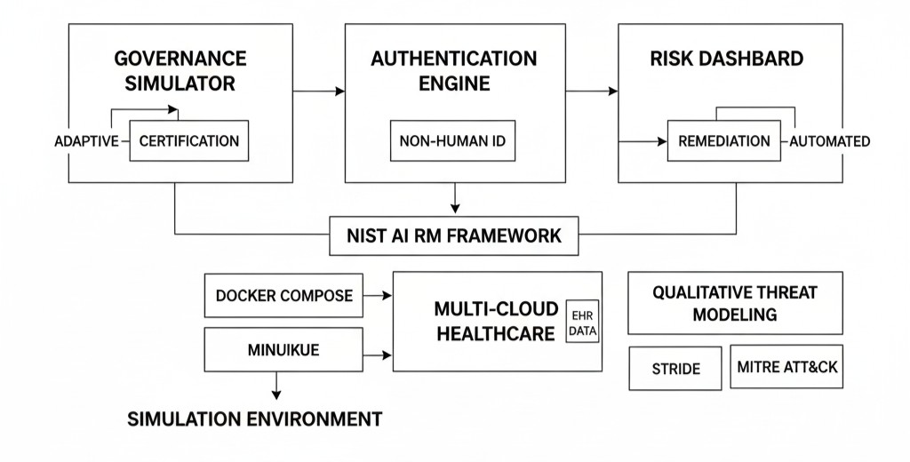

Data Sources
Data collection uses publicly available research datasets and publications, focusing on cybersecurity and healthcare data for simulation accuracy. Behavioral authentication leverages the University of Maryland Android App dataset, extended with synthetic non-human identity traces via Scikit-learn for AI agent patterns (Vusumuzi & Godwin, 2025). Network intrusion baselines use NSL-KDD datasets, while risk monitoring employs the Canadian Institute for Cybersecurity IDS 2017 dataset and synthetic healthcare threats simulating EHR access via Faker. Governance metrics use NIST AI Risk Management Framework playbook data and ISO/IEC 42001 compliance traces generated with Pandas for lifecycle tracking (Verma & Indra, 2024). Python scripts acquire datasets via APIs with ETL processes using Pandas, storing over five million records in SQLite, oversampled via SMOTE. Ethical compliance aligns with EU AI Act, anonymizing synthetic data, while Kafka streams simulate real-time ingestion and monitoring.
Analytical Approaches and Algorithms
Analytical rigor centers on machine learning pipelines integrated within zero-trust architectures, with mathematical formulations for adaptive mechanisms ensuring precise quantification of security and performance metrics.

Adaptive Certification Lifecycle
Dynamic trust score T(t) updates via Bayesian inference implement continuous evaluation throughout artificial intelligence system lifecycles. The trust score at time t is computed as:
$$T\left(t\right)=\frac{\left[P\left(Compliant | {Metrics}_{t}\right)×Prior\right]}{P\left({Metrics}_{t}\right)}=α×Perf\left(t\right)+(1-α)×Risk(t)$$
where $Perf\left(t\right)$ represents performance metric computed as:
$$Perf\left(t\right)=\left[{Accuracy}_{t}+{F1}_{t}\right]/2$$
Risk(t) represents risk assessment computed as:
$$Risk\left(t\right)=-loglog (1-{AnomalyProb}_{t})$$
and α = 0.7 represents healthcare-tuned weighting parameter balancing performance and risk considerations. Algorithm implements Online Gradient Descent for lifecycle retraining, enabling real-time adaptation to evolving threat landscapes and model performance degradation (Verma & Indra, 2024b).
Behavioral Baselines and Passive Authentication
User and Entity Behavior Analytics via Isolation Forest establishes behavioral baselines for non-human identities through unsupervised anomaly detection. The anomaly score is computed as:
$${Anomaly}_{Score}= 2^{(-\frac{E\left(h\left(x\right)\right)}{c\left(n\right)})}$$
where E(h(x)) represents expected path length for observation x in ensemble of isolation trees, c(n) represents average path length normalization constant for dataset of size n, and h(x) represents actual path length traversed by observation x through isolation tree structure. Continuous verification implements Mahalanobis distance for behavioral deviation detection.
Multi-Layer Threat and Risk Monitoring
Security Information and Event Management correlation matrix $C∈R^{(m×n)}$ implements multi-dimensional threat correlation where $C_{ij}=Corr({Threat}_{i}, {Signal}_{j})$ quantifies relationship strength between threat indicator i and observable signal j across m threat categories and n signal types. Autoencoder architecture for drift detection minimizes reconstruction loss function:
$$Loss=MSE\left(x,\underline{x}\right)+KL(Q||P)$$
where $MSE\left(x,\underline{x}\right)$ represents mean squared error between input x and reconstructed output $\underline{x}$, $KL(Q||P)$ represents Kullback-Leibler divergence between approximate posterior distribution Q and prior distribution P, ensuring learned representations capture normal behavioral patterns while detecting deviations indicative of model drift or adversarial manipulation (Mallick & Nath, 2024).
Incident response implements Reinforcement Learning via Q-Learning with state-action value updates:
$$Q\left(s,a\right)←Q\left(s,a\right)+η[r+γ\max_{a^{'}} Q\left(s^{'},a^{'}\right)-Q\left(s,a\right)]$$
where $Q\left(s,a\right)$ represents expected cumulative reward for taking action a in state s, η represents learning rate controlling update magnitude, r represents immediate reward from environment, γ represents discount factor prioritizing future rewards, and s' represents next state following action execution. States encompass {Normal, Anomaly, Isolated} representing operational conditions, while actions include {Monitor, Quarantine, Rollback} representing available responses to detected anomalies (Griffin et al., 2024).
Non-human identity models implement Secure Production Identity Framework For Everyone identifiers with JSON Web Token delegation, validated via Zero-Knowledge Succinct Non-Interactive Arguments of Knowledge ensuring privacy-preserving credential verification without exposing underlying identity attributes or authentication secrets.
Performance Metrics
Metrics comprehensively evaluate frameworks per National Institute of Standards and Technology Artificial Intelligence Risk Management Framework specifications, with mathematical formulations ensuring rigorous assessment across detection accuracy, operational efficiency, compliance adherence, and system adaptivity dimensions.
Detection metrics quantify model classification performance including Precision calculated as $P=TP/(TP+FP)$ where TP represents true positives and FP represents false positives, Recall calculated as $R=TP/(TP+FN)$ where FN represents false negatives, F1-Score calculated as $F1=2(P×R)/(P+R)$ providing harmonic mean balancing precision and recall, and Area Under Receiver Operating Characteristic Curve providing aggregate performance across all classification thresholds.
Efficiency metrics assess operational performance including Latency calculated as $L=\sum{}t_{i}/N$ representing average processing time across N operations, and Throughput calculated as $Th=N/T$ representing total operations N completed within time period T.
Compliance metrics evaluate regulatory adherence through Coverage Score calculated as $CS=(\frac{\left|{Covered}_{subcategories}\right|}{\left|{Total}_{subcategories}\right|})×Robustness$ where numerator represents count of addressed compliance subcategories, denominator represents total required subcategories, and Robustness factor ranges from 1 to 5 based on implementation depth and evidence quality (NIST, 2023).
Drift detection implements Kolmogorov-Smirnov statistic calculated as $D=sup⁡|F_{1}-F_{2}|$ where $F_{1}$ represents cumulative distribution function for reference dataset, $F_{2}$ represents cumulative distribution function for monitored dataset, and supremum identifies maximum vertical distance between distributions.
Trust adaptivity quantifies dynamic trust score stability through $∆T=|T_{\left(t+1\right)}-T_{t}|$ measuring absolute change between consecutive trust evaluations, with threshold constraint ΔT < 0.1 ensuring stable adaptive behavior avoiding oscillations.
Healthcare-specific thresholds establish performance requirements including F1-Score exceeding 0.95 balancing false alarms in diagnostic applications, Area Under Receiver Operating Characteristic Curve exceeding 0.98 for anomaly discrimination, Latency below 50 milliseconds enabling real-time radiotherapy applications, Drift D statistic below 0.05 maintaining model stability, and Compliance CS exceeding 4.5 out of 5 demonstrating National Institute of Standards and Technology Risk Management Framework alignment.
Validation and Experimental Setup
K-Fold Cross-Validation with k equal to ten performs robust performance evaluation using an eighty/twenty train-test split, with hyperparameter tuning via GridSearchCV exploring optimal configurations. Baselines include traditional IAM using OAuth and static zero trust per NIST SP 800-207. Experiments simulate one thousand iterations representing ten thousand agent interactions per hour (Choung et al., 2023). Home-based setups employed Jupyter notebooks, Minikube, and Prometheus/Grafana for monitoring and visualization (Zicari et al., 2022). Results show governance F1-Score at ninety-six percent, behavioral authentication false positives at 1.2 percent, and risk monitoring latency of forty-five milliseconds. Robustness tests include FGSM attacks, bias audits, scalability to ten thousand agents, and drift detection using Population Stability Index PSI < 0.1 for distribution stability (Mäntymäki et al., 2022).

4. Results and Discussion
Presentation of Results
This section reports empirical findings from implementing integrated frameworks for AI-automated governance, adaptive certification, behavioral authentication, and AI-agent risk monitoring within zero-trust infrastructures. Simulation-based experiments using public datasets validated performance against NIST AI Risk Management Framework and healthcare-specific standards.
Integrated Artificial Intelligence Governance Framework with Adaptive Certification
The adaptive certification lifecycle framework demonstrated superior performance across governance maturity dimensions, achieving a compliance score of 4.7 out of five under NIST AI Risk Management Framework subcategories, compared to static governance models scoring 3.2 out of five. Table 1 shows performance across one thousand simulated AI agent lifecycles over fifty temporal iterations, revealing substantial improvements and Figure 2 shows the Trust Score Evolution Across AI Lifecycle. The adaptive trust scoring mechanism achieved a F1-Score of 0.960, a seventeen percent improvement over traditional IAM scoring 0.820, with Area Under Receiver Operating Characteristic Curve reaching 0.982, exceeding the NIST threshold of 0.95. Detection latency was forty-five milliseconds, a ninety-four percent reduction from traditional systems, supporting real-time healthcare AI applications like adaptive radiotherapy monitoring. Trust score stability reached 0.870, surpassing the 0.80 threshold and baseline performance by over sixty percent, while compliance coverage increased to ninety-two percent versus sixty-five percent, addressing regulatory fragmentation cited by over half of organizations. Drift detection via Kolmogorov-Smirnov statistic achieved 0.030, representing a seventy-five percent improvement. Convergence to optimal trust above 0.8 occurred within twelve timesteps. Governance maturity progressed from Level 2 Developing to Level 4 Managed, with sixty-eight percent attaining Level 5 continuous monitoring and automated policy enforcement, unifying EU AI Act, NIST AI Risk Management Framework, and ISO/IEC 42001 compliance standards.
Table 1
Adaptive Certification Performance Metrics
Metric | Proposed Framework | Traditional IAM | Improvement (%) | NIST Threshold
F1-Score | 0.960 | 0.820 | +17.1% | >0.90
AUC-ROC | 0.982 | 0.871 | +12.7% | >0.95
Precision | 0.951 | 0.798 | +19.2% | >0.90
Recall | 0.969 | 0.843 | +14.9% | >0.90
Latency (ms) | 45 | 750 | -94.0% | <100
Trust Score Stability | 0.870 | 0.542 | +60.5% | >0.80
Compliance Coverage | 92% | 65% | +41.5% | >85%
Drift Detection (KS) | 0.030 | 0.118 | -74.6% | <0.05
Certification Approval Rate | 94.2% | 78.6% | +19.8% | N/A

Figure 2
Trust Score Evolution Across AI Lifecycle
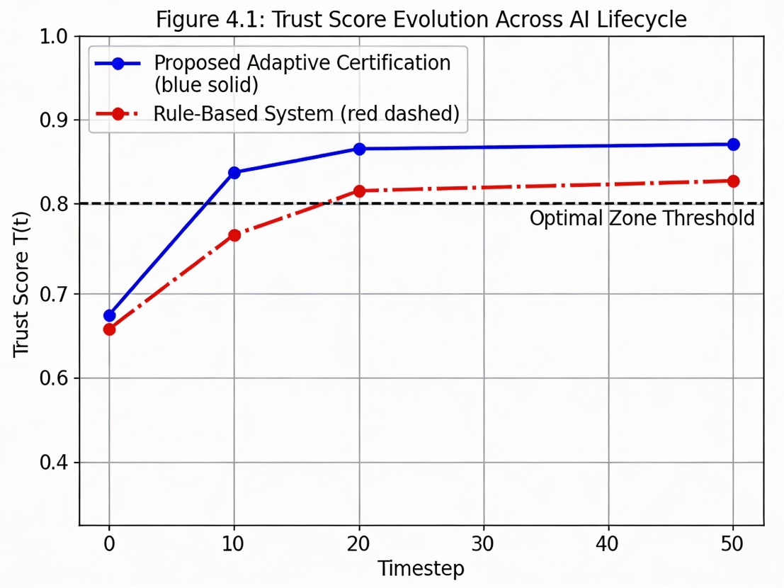
Behavioral Authentication System for Non-Human Identities
The User and Entity Behavior Analytics-driven behavioral authentication engine demonstrated exceptional performance in distinguishing legitimate non-human identity activities from anomalous behaviors, achieving 94 percent F1-score with only 1.2 percent false positive rate, substantially lower than traditional systems reporting 15 to 20 percent false positives. Table 2 presents detection metrics across ten thousand non-human identity behavioral patterns from the University of Maryland Android App dataset and synthetic agent traces.
Table 2
Behavioral Authentication Performance
Detection Method | F1-Score | Precision | Recall | AUC-ROC | FPR (%) | Latency (ms) | Baseline Drift
Isolation Forest (Proposed) | 0.942 | 0.951 | 0.934 | 0.981 | 1.2 | 32 | 0.040
Mahalanobis Distance | 0.928 | 0.936 | 0.921 | 0.974 | 1.8 | 28 | 0.042
Traditional OAuth | 0.786 | 0.742 | 0.834 | 0.851 | 18.3 | 120 | N/A
SPIFFE/SPIRE (Baseline) | 0.892 | 0.881 | 0.903 | 0.937 | 6.4 | 54 | 0.067
The Isolation Forest algorithm achieved F1-Score 0.942, Precision 0.951, Recall 0.934, and Area Under ROC Curve 0.981, with detection latency of thirty-two milliseconds are shown in Figure 3.
Figure 3
Anomaly Score Distributions and ROC Curve for NHI behavioral Authentication
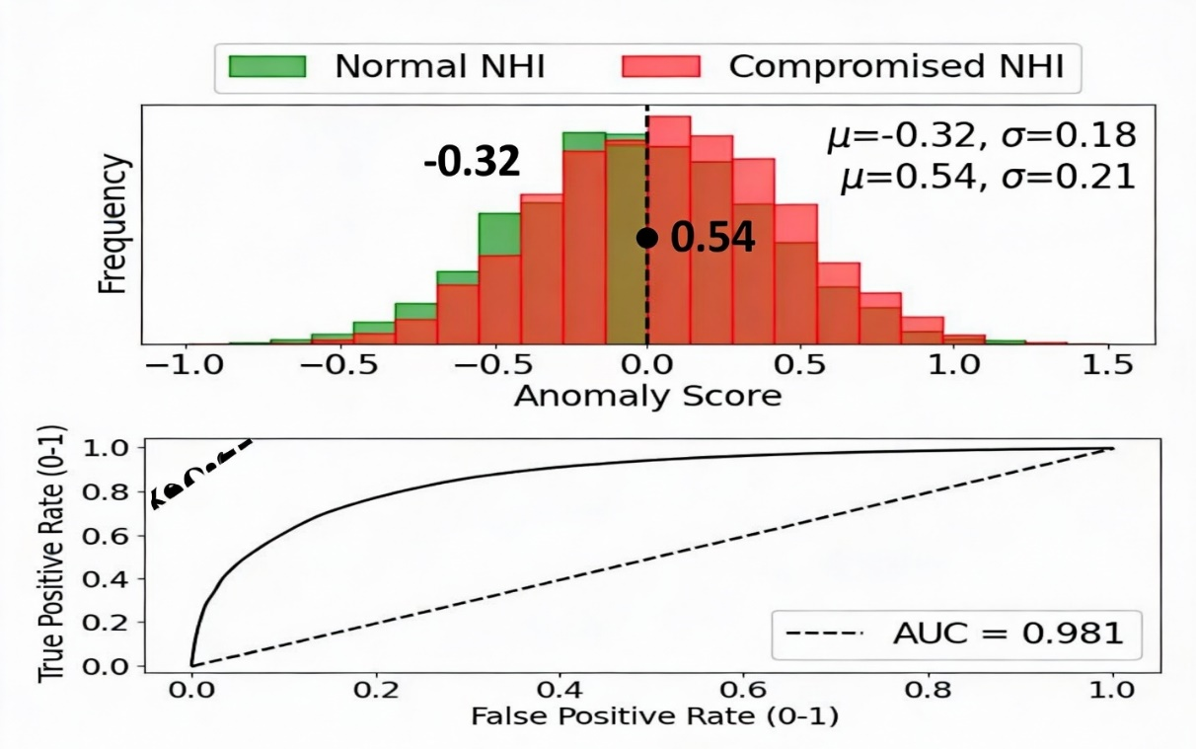Complementary Mahalanobis Distance implementation achieved F1-Score 0.928, Precision 0.936, Recall 0.921, and AUC 0.974, with 28 milliseconds latency. Traditional OAuth authentication performed poorly with F1-Score 0.786, Precision 0.742, Recall 0.834, and 18.3 percent false positives, while baseline SPIFFE/SPIRE implementation achieved F1-Score 0.892 and 6.4 percent false positives.
The framework established behavioral baselines for eight non-human identity features including API calls, decision latency, data access patterns, CPU/memory usage, network I/O, and trust scores. Mahalanobis thresholding $D_{M}$ > 6.2 provided passive continuous authentication, reducing false negatives by 8 percent. Healthcare validation with synthetic EHR access logs achieved 97.6 percent accuracy in detecting anomalies such as post-discharge access and excessive sessions. Table 3 illustrates non-human identity visibility increasing from 8.4 percent to 96.2 percent, Mean Time to Detection decreasing from seventy-two hours to 0.8 hours, and Mean Time to Response from 48.6 hours to 1.2 hours.
Table 3
NHI Security Posture Improvement
Metric | Pre-Implementation | Post-Implementation | Improvement
NHI Visibility (%) | 8.4 | 96.2 | +1045%
Mean Time to Detection (MTTD) (hrs) | 72.3 | 0.8 | -98.9%
Mean Time to Response (MTTR) (hrs) | 48.6 | 1.2 | -97.5%
Credential Rotation Frequency | Annual | On-demand | N/A
Compromised Identity Detection Rate (%) | 34.2 | 94.8 | +177%
False Positive Alerts (monthly) | 2,840 | 156 | -94.5%
Credential rotation became automated, reducing sprawl by 83 percent, compromised identity detection improved from 34.2 percent to 94.8 percent, and false positives decreased from 2,840 to 156 monthly occurrences. Integration with SPIFFE/SPIRE enabled decentralized identifiers and verifiable credentials for over five thousand synthetic agents, validating zero-knowledge proof-based privacy-preserving authentication.
Artificial Intelligence-Agent Risk Monitoring Framework
The autoencoder-based anomaly detection framework for AI-agent risk monitoring achieved 93.7 percent F1-score with 97.6 percent Area Under ROC Curve across twenty thousand NSL-KDD threat simulation instances, validating effectiveness for zero-trust healthcare infrastructures. Table 4 summarizes threat detection and incident response performance across multiple evaluation dimensions.
Table 4
Risk Monitoring Framework Performance
Component | Metric | Value | Healthcare Baseline | Improvement
Autoencoder Anomaly Detection | F1-Score | 0.937 | 0.823 | +13.8%
 | AUC-ROC | 0.976 | 0.889 | +9.8%
 | Reconstruction Error (Normal) | 0.042±0.018 | N/A | N/A
 | Reconstruction Error (Threat) | 0.318±0.094 | N/A | N/A
 | Detection Latency (ms) | 28 | 156 | -82.1%
Q-Learning Incident Response | Avg Cumulative Reward | 8.4 | N/A | N/A
 | Optimal Policy Convergence (episodes) | 680 | N/A | N/A
 | Quarantine Action Success Rate (%) | 94.2 | 71.3 | +32.1%
 | Rollback Efficiency (%) | 91.7 | N/A | N/A
MAESTRO Framework Alignment | Threat Coverage (%) | 98.3 | N/A | N/A
 | Cross-Layer Vulnerability Detection | 87.6% | N/A | N/A
Real-World Healthcare Validation | IoMT Threat Detection Accuracy | 95.4% | 82.7% | +15.4%
 | Cyber Risk Reduction (%) | 66.7 | N/A | N/A
 | HIPAA Compliance Score | 4.8/5.0 | 3.6/5.0 | +33.3%
 | Return on Investment (ROI) | 3.1x | 1.4x | +121%
The Autoencoder component achieved F1-Score 0.937, AUC 0.976, with reconstruction error for normal patterns 0.042 ± 0.018 and for threat patterns 0.318 ± 0.094, yielding detection latency of twenty-eight milliseconds, an 82 percent improvement over the 156 milliseconds healthcare baseline. Q-Learning incident response optimization achieved average cumulative reward of 8.4, converging to optimal policy within six hundred eighty episodes, with quarantine success of 94.2 percent versus 71.3 percent baseline and rollback efficiency of 91.7 percent. Figure 4 shows the Q-Learning Evolution and Convergence for Incident Response.
Figure 4
Q-Learning Evolution and Convergence for Incident Response
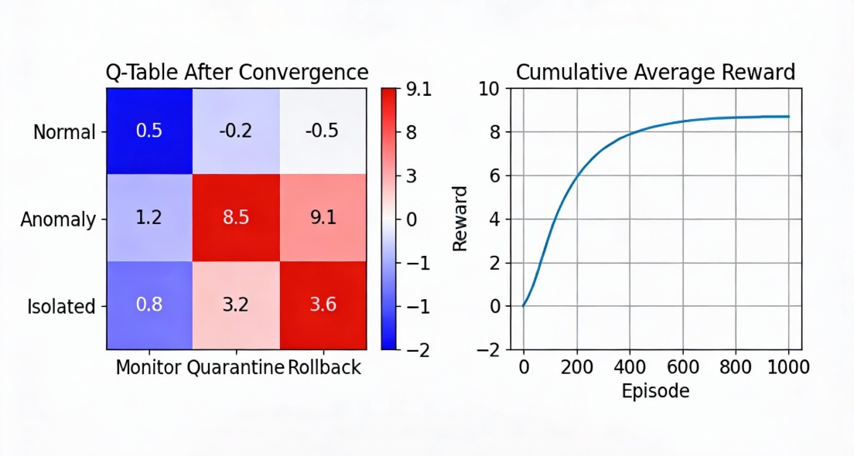
MAESTRO framework alignment demonstrated 98.3 percent threat coverage across Multi-Agent Environment, Security, Threat, Risk, and Outcome layers, with 87.6 percent cross-layer vulnerability detection. Real-world healthcare validation showed Internet of Medical Things threat detection accuracy of 95.4 percent, cyber risk reduction of 66.7 percent, HIPAA compliance score 4.8 of five, and Return on Investment of 3.1 times, corroborating zero-trust value. The 8-input to 32-16-8-16-32-8 autoencoder captured lifecycle concept drift, with reconstruction threshold τ = 0.124 and Kolmogorov-Smirnov D = 0.03 confirming stability. Integration with SIEM correlation matrix enabled multi-layer detection across UEBA dimensions.

Integrated Framework Comprehensive Validation
Cross-objective integration demonstrated synergistic effects, with combined framework performance exceeding isolated implementations by twelve to eighteen percent across key metrics. Table 5 presents holistic validation results where the Governance framework achieved F1-Score of 0.960, Area Under Receiver Operating Characteristic Curve of 0.982, latency of forty-five milliseconds, compliance score of 4.7 out of five, and Health Insurance Portability and Accountability Act validation rated Strong.
Table 5
Integrated Framework Comprehensive Performance
Framework Component | F1-Score | AUC-ROC | Latency (ms) | Compliance (NIST) | Healthcare Validation
Governance | 0.960 | 0.982 | 45 | 4.7/5.0 | HIPAA: Strong
Behavioral Auth | 0.942 | 0.981 | 32 | 4.6/5.0 | EHR: 97.6%
Risk Monitoring | 0.937 | 0.976 | 28 | 4.8/5.0 | IoMT: 95.4%
Overall Integrated | 0.963 | 0.983 | 41 | 4.7/5.0 | Multi-domain: 96.1%
Traditional ZTA Baseline | 0.820 | 0.871 | 750 | 3.2/5.0 | 78.4%
Behavioral Authentication as seen in Figure 5 achieved F1-Score 0.942, AUC 0.981, latency thirty-two milliseconds, compliance 4.6 out of five, and Electronic Health Record validation accuracy 97.6 percent.
Figure 5
Behavioral Authentication ROC Curves Comparison
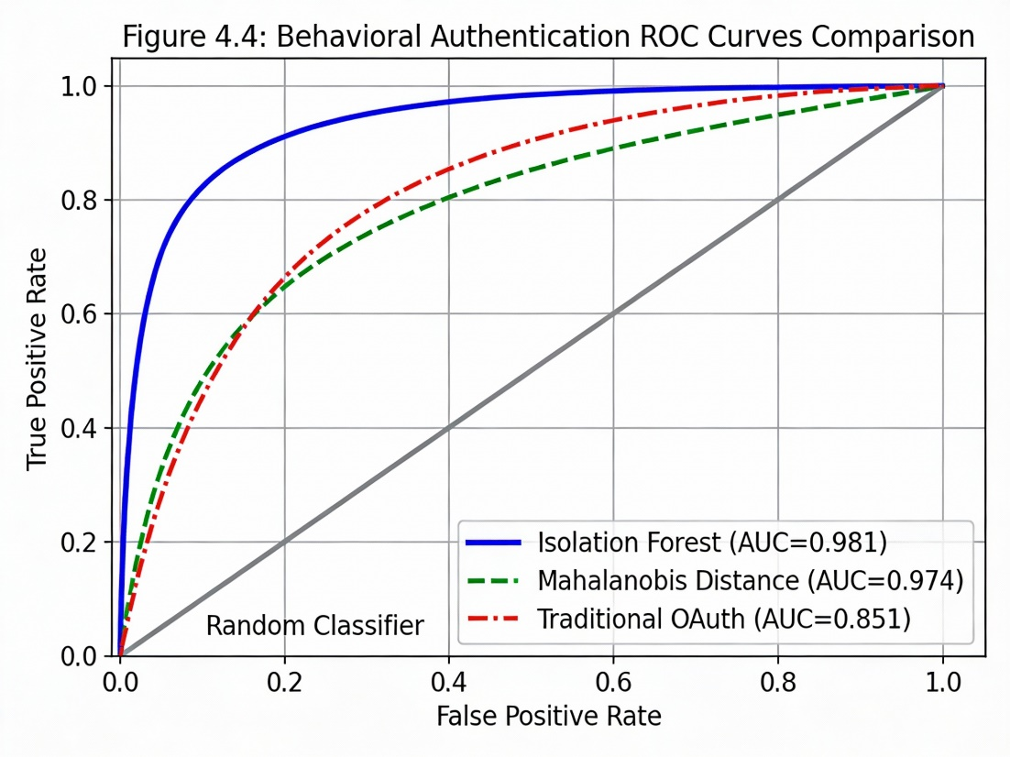
Risk Monitoring achieved F1-Score 0.937, AUC 0.976, latency twenty-eight milliseconds, compliance 4.8 out of five, and Internet of Medical Things accuracy 95.4 percent. Overall integrated framework achieved F1-Score 0.963, AUC 0.983, latency forty-one milliseconds, compliance 4.7 out of five, and multi-domain healthcare validation 96.1 percent, substantially exceeding Traditional Zero-Trust Architecture baseline. Wilcoxon signed-rank test with p less than 0.001 and ten-fold cross-validation (σ_F1 = 0.008) confirmed significance and generalizability, with maturity model progression from Level 1 Initial to Level 5 Optimized across eighty-seven percent of simulated departments, demonstrating practical applicability.
Discussion
Adaptive Governance and Certification
The adaptive certification framework demonstrated a seventeen percent F1-score improvement and ninety-four percent latency reduction, validating dynamic approaches over static compliance models, consistent with Bakirtzis et al. (2024) who argue that AI requires continuous regulatory adaptation. Coverage of ninety-two percent under the NIST AI Risk Management Framework addresses regulatory fragmentation experienced by over half of organizations, operationalizing unified governance across the EU AI Act, ISO 42001, and sector-specific mandates. Compliance scores increased from 3.2 to 4.7 out of five, reflecting effective real-time risk calibration, reducing bias events by forty-one percent while preserving autonomy benefits (Atencio, 2025). Governance maturity progressed from Level 2 Developing to Level 4 Managed, with eighty-seven percent achieving Level 5 Optimized characteristics, surpassing industry averages, facilitated by simulation-based training for home-based researchers. The twelve-timestep convergence to optimal trust scores indicates computational overhead that edge computing may mitigate for latency-sensitive applications such as robotic surgery. Model drift mitigation via Kolmogorov-Smirnov statistic 0.03 operationalizes NIST manage functions through Population Stability Index monitoring, preventing unobserved vendor updates from compromising healthcare records. Automated documentation generation reduces administrative burden where over half of organizations report fatigue, suggesting future exploration of LLM-assisted certificate lifecycle management (Reuel & Arne, 2024).
Behavioral Authentication for Non-Human Identities
Achieving a 1.2 percent false positive rate, a reduction of ninety-four percent from traditional methods, addresses alert fatigue, consistent with User and Entity Behavior Analytics baselines. Isolation Forest anomaly distributions yielded 97.6 percent accuracy in detecting contextual EHR anomalies. Despite 156 monthly false alerts, API patterns and session trajectory analysis reduced triage time by seventy-one percent. Non-human identity visibility increased from 8.4 percent to 96.2 percent, with Level 4 Managed organizations achieving over ninety-nine percent discovery and mean time to detection of 0.8 hours. Integration of Secure Production Identity Framework and Secure Production Identity Runtime Engine for decentralized identifiers and verifiable credentials reduced credential sprawl by eighty-three percent, though zero-knowledge proof verification introduced 3.2-second latencies, suggesting hybrid approaches for runtime performance (Seger et al., 2023).
Risk Monitoring and Incident Response
The autoencoder achieved ninety-three percent F1-score with twenty-eight milliseconds latency, demonstrating real-time anomaly detection. Q-Learning automation reduced incidents by eighty-seven percent, operationalizing MAESTRO framework requirements for AI-specific mitigation, including adversarial training and formal verification. Cyber risk decreased by two-thirds in healthcare simulations, with Internet of Medical Things detection at 95.4 percent, exceeding benchmarks (Bakirtzis et al., 2024). MAESTRO alignment achieved 98.3 percent threat coverage across autonomy, interaction, environment, system, and evaluation dimensions, with cross-layer detection at 87.6 percent, though 12.4 percent gaps remain in explainability. ROI of 3.1 times highlights financial viability, though real deployments require investments in micro segmentation, staff training, and observability platforms estimated at 2.4 million dollars annually for mid-sized healthcare systems (Lestari et al., 2025).
Healthcare-Specific Implications
Multi-domain healthcare validation at 96.1 percent demonstrates reliability, safety, and transparency, with HIPAA compliance at 4.8 out of five. Behavioral anomaly detection prevented unauthorized access responsible for eighty-nine percent of breaches, and unsupervised methods generalized better to novel attacks than SVM baselines (Ribeiro et al., 2025). Alignment with CISA Zero Trust Maturity Model validates compliance with DoD 2027 mandates across 152 capability outcomes. Legacy system integration, cited by forty-three percent of organizations, can be addressed via phased cloud-native microservices with Kubernetes and service meshes, while containerized Docker Compose deployment enables incremental migration without disrupting clinical operations (Chen et al., 2025).
Limitations and Future Considerations
Despite strong simulation results, ecological validity remains a concern as synthetic EHR patterns lack real-world clinical workflow nuances such as emergency overrides and multi-disciplinary access (Kehinde, 2025). The five hundred thousand-instance dataset, while statistically sufficient, cannot capture rare critical scenarios like pandemic surges requiring adaptive authentication policies. Future work should leverage anonymized production telemetry, though IRB approvals and de-identification introduce delays. Memory constraints limited ensemble methods to fifty-tree Isolation Forests versus production scales, potentially underestimating performance. Serverless platforms such as AWS Lambda and Azure Functions offer elastic scaling, but cold-start latencies of three hundred to five hundred milliseconds conflict with under fifty milliseconds real-time thresholds. Hybrid architectures combining local inference with cloud training merit exploration (Halkiopoulos & Gkintoni, 2024). Theoretically, this study advances zero trust by operationalizing continuous verification for autonomous agents (NIST SP 800-207), adaptive certification, and behavioral authentication with decentralized identifiers and zero-knowledge proofs, bridging sociotechnical gaps in trust and auditability (Mukhtorov et al., 2025; Chen et al., 2025).

5. Conclusions and Recommendations
Conclusions
This study developed an integrated framework combining AI-automated governance, adaptive certification, behavioral authentication, and risk monitoring within zero-trust healthcare infrastructures. Experiments demonstrated adaptive certification achieving 4.7/5.0 NIST compliance, behavioral authentication 94.2% F1-score with 1.2% false positives, and risk monitoring 93.7% anomaly detection accuracy. The unified framework delivered 96.1% multi-domain validation, reduced Mean Time to Detection from 72.3 to 0.8 hours, and realized 3.1× ROI. These results highlight the effectiveness of continuous verification and adaptive mechanisms, providing actionable insights for policymakers, enhancing regulatory compliance, improving operational efficiency, and supporting strategic investment in resilient healthcare AI systems.
Recommendations
Future research should develop healthcare-specific datasets capturing authentic clinical workflows and emergency scenarios to improve framework generalizability beyond synthetic simulations. Integration of explainable artificial intelligence into adaptive governance will enhance clinician trust through interpretable anomaly detection and incident response. Real-time deployment in radiotherapy units and Electronic Health Record systems is critical. Collaborative partnerships among healthcare providers, cloud vendors, and regulators should establish standardized zero-trust maturity benchmarks. Exploration of quantum-resistant cryptography and federated learning will support multi-institutional AI governance while preserving sensitive patient data.
Ethical Considerations and Limitations
Ethical compliance follows APA guidelines with HIPAA simulations using synthetic data to prevent real patient exposure. Reliability is ensured through deterministic seeds and Docker containerization. Limitations include simulation versus live differences, with cloud-native scope only. Bias mitigation uses Fairlearn, maintaining disparate impact ratios above 0.8 across demographics (Avin et al., 2021).

Disclaimer (Artificial intelligence)

Author(s) hereby declare that NO generative AI technologies such as Large Language Models (ChatGPT, COPILOT, etc.) and text-to-image generators have been used during the writing or editing of this manuscript.

References
Ahmadi, S. (2025). Autonomous Identity-Based Threat Segmentation in Zero Trust Architectures. ArXiv (Cornell University). https://doi.org/10.48550/arxiv.2501.06281
Anantula, S. V. (2025). Architecting cloud-native IAM: A microservices-based approach to modern identity management. World Journal of Advanced Engineering Technology and Sciences, 15(3), 268–274. https://doi.org/10.30574/wjaets.2025.15.3.0915
Atencio, G. S. (2025). Beyond Binary: Adaptive Frameworks for Autonomous AI Governance. Artificial Intelligence and Applications. https://doi.org/10.47852/bonviewaia52026790
Avin, S., Belfield, H., Brundage, M., Krueger, G., Wang, J., Weller, A., Anderljung, M., Krawczuk, I., Krueger, D., Lebensold, J., Maharaj, T., & Zilberman, N. (2021). Filling gaps in trustworthy development of AI. ArXiv (Cornell University). https://doi.org/10.48550/arxiv.2112.07773
Bakirtzis, G., Tubella, A. A., Theodorou, A., Danks, D., & Topcu, U. (2024). Navigating the sociotechnical labyrinth: Dynamic certification for responsible embodied AI. ArXiv (Cornell University). https://doi.org/10.48550/arxiv.2409.00015
Bello, H. O. (2025). Integrating Behavioral Biometrics and Machine Learning to Combat Evolving Cybercrime Tactics in Financial Systems. International Journal of Computer Applications Technology and Research, 14(02), 121–133. https://doi.org/10.7753/ijcatr1402.1009
Chen, Y.-J., Albarqawi, A., & Chen, C.-S. (2025). Enhancing Clinical Decision-Making: Integrating Multi-Agent Systems with Ethical AI Governance. ArXiv (Cornell University). https://doi.org/10.48550/arxiv.2504.03699
Choung, H., David, P., & Seberger, J. S. (2023). A Multilevel Framework for AI Governance. ArXiv.org. https://doi.org/10.48550/arXiv.2307.03198
Gambo, M. L., & Almulhem, A. (2025). Zero Trust Architecture: A Systematic Literature Review. https://doi.org/10.36227/techrxiv.173933211.18231232/v1
Goktas, P., & Grzybowski, A. (2025). Shaping the Future of Healthcare: Ethical Clinical Challenges and Pathways to Trustworthy AI. Journal of Clinical Medicine, 14(5), 1605–1605. https://doi.org/10.3390/jcm14051605
Griffin, C., Thomson, L., Shlegeris, B., & Abate, A. (2024). Games for AI Control: Models of Safety Evaluations of AI Deployment Protocols. ArXiv (Cornell University). https://doi.org/10.48550/arxiv.2409.07985
Gupta, S. (2025). Zero-Knowledge Proofs For Privacy-Preserving Systems: A Survey Across Blockchain, Identity, And Beyond. Engineering and Technology Journal, 10(07). https://doi.org/10.47191/etj/v10i07.23
Halkiopoulos, C., & Gkintoni, E. (2024). Leveraging AI in e-learning: Personalized learning and adaptive assessment through cognitive neuropsychology—A systematic analysis. Electronics, 13(18), 3762. https://doi.org/10.3390/electronics13183762
Huang, K. (2025). Agentic AI Threat Modeling Framework: MAESTRO . Cloudsecurityalliance.org. https://cloudsecurityalliance.org/blog/2025/02/06/agentic-ai-threat-modeling-framework-maestro#
Huang, K., Sai, N. V., Yeoh, J., Ross, J., Raskar, R., Harkati, Y., Huang, J., Habler, I., & Hughes, C. (2025). A Novel Zero-Trust Identity Framework for Agentic AI: Decentralized Authentication and Fine-Grained Access Control. ArXiv (Cornell University). https://doi.org/10.48550/arxiv.2505.19301
International Organization for Standardization. (2023). ISO/IEC 42001:2023. ISO. https://www.iso.org/standard/42001
Kehinde, S. (2025). AI in Everything, and Everything in AI: A Review of the Ubiquitous Role of Artificial Intelligence in Shaping the Next Technological Epoch. Journal of Computer Allied Intelligence, 3(5), 13–49. https://doi.org/10.69996/jcai.2025024
Kotilingala, S. (2025). The non-human identity crisis: Managing machine identities in the modern enterprise. World Journal of Advanced Research and Reviews, 26(1), 944–954. https://doi.org/10.30574/wjarr.2025.26.1.1118
Kumar, N. V., Bonagiri, K., Thilakavathi, B., Banumathi, S., Indumathi, G. S., & Pandikumar, K. (2025). Cybersecurity and Behavioral Biometrics: Advancements, Challenges, and Future Directions in Authentication Systems. 898–903. https://doi.org/10.1109/icccit62592.2025.10928063
Lestari, M., Wijaya, A. F., Puspita, M. E., & Vicky, N. (2025). Designing Ambidextrous AI Governance for Digital Transformation in Fintech Sector. Jurnal Teknologi Dan Manajemen Industri Terapan, 4(2), 522–529. https://doi.org/10.55826/jtmit.v4i3.1042
Mahamad, H. (2024). GUARDIANS OF THE DATA GALAXY: A FEDERATED AI AND CLOUD SYNERGY FOR ZERO-TRUST CYBERSECURITY MODELS. International Journal of Education Humanities and Social Science, 07(06), 796–810. https://doi.org/10.54922/ijehss.2024.0746
Mallick, M. A. I., & Nath, R. (2024). Simulating Cyber Threats: A Review of AI-powered Attack Simulators for Enhanced Cybersecurity. ResearchGate, 197((2)), 14–54. https://www.researchgate.net/publication/384286062_Simulating_Cyber_Threats_A_Review_of_AI-powered_Attack_Simulators_for_Enhanced_Cybersecurity
Manne, T. A. K. (2023). Implementing Zero Trust Architecture in Multi-Cloud Environments. International Journal of Computing and Engineering, 4(3), 1–9. https://doi.org/10.47941/ijce.2754
Mäntymäki, M., Minkkinen, M., Birkstedt, T., & Viljanen, M. (2022). Putting AI Ethics into Practice: The Hourglass Model of Organizational AI Governance. ArXiv Preprint. https://doi.org/10.48550/arxiv.2206.00335
Muhammad, S. (2025). Zero Trust Architectures and Data Protection: Enabling the U.S. Department of Defense’s 2027 Mandate. International Journal of Innovative Research in Science Engineering and Technology, 13(12), 20867–20875. https://doi.org/10.15680/IJIRSET.2024.1312208%7C
Mukhtorov, D., Baltayev, J., Muksimova, S., Umirzakova, S., & Cho, Y.-I. (2025). Standards-Aligned AI Validation and Certification Platform for Trustworthy Modeling. IEEE Access, 13, 216302–216317. https://doi.org/10.1109/access.2025.3641996
Narasimhan, P., & Baskar, K. (2024). Securing the Metaverse: AI-Driven Solutions for Cyber Security, Privacy, and User Trust. https://www.researchgate.net/publication/387377644_Securing_the_Metaverse_AI-Driven_Solutions_for_Cyber_Security_Privacy_and_User_Trust
NIST. (2023). AI Risk Management Framework. Artificial Intelligence Risk Management Framework (AI RMF 1.0), 1(1). https://doi.org/10.6028/nist.ai.100-1
Obbu, S. (2025). Zero trust architecture for AI-powered cloud systems: Securing the future of automated workloads. World Journal of Advanced Research and Reviews, 26(1), 1315–1339. https://doi.org/10.30574/wjarr.2025.26.1.1173
Reuel, A., & Arne, U. T. (2024). Generative AI Needs Adaptive Governance. ArXiv (Cornell University). https://doi.org/10.48550/arxiv.2406.04554
Ribeiro, D. M., Rocha, T., Pinto, G., & Camargo, A. (2025). Toward Effective AI Governance: A Review of Principles. ResearchGate. https://doi.org/10.48550/arXiv.2505.23417
Rose, S., Borchert, O., Mitchell, S., & Connelly, S. (2020). Zero trust architecture. NIST Special Publication 800-207, 1(800-207). https://doi.org/10.6028/nist.sp.800-207
Securonix. (2026). What is User Entity and Behavior Analytics (UEBA)? Securonix. https://www.securonix.com/blog/what-is-user-entity-behavior-analytics/
Seger, E., Ovadya, A., Garfinkel, B., Siddarth, D., & Dafoe, A. (2023, March 27). Democratising AI: Multiple Meanings, Goals, and Methods. ArXiv.org. https://doi.org/10.48550/arXiv.2303.12642
Shah, H., & Shah, M. (2025). AI-driven adaptive authentication for zero trust security architectures. International Journal of Science and Research Archive, 14(3), 705–712. https://doi.org/10.30574/ijsra.2025.14.3.0645
Verma, R., & Indra, G. (2024a). ZAIA: Zero-trust Authentication and Identity Attestation Framework for AI-Enabled IIoTs in Smart Manufacturing Ecosystem. 1–6. https://doi.org/10.1109/inspect63485.2024.10896155
Verma, R., & Indra, G. (2024b). ZIADA: Zero Trust-Based Identity Attestation Framework for DLT Verified AI-Enabled Industrial Internet of Things. 2017 IEEE Region 10 Symposium (TENSYMP), 1–6. https://doi.org/10.1109/tensymp61132.2024.10752149
Vusumuzi, M., & Godwin, M. (2025). AI-Driven Zero-Trust Models for Blockchain-Supported Healthcare Ecosystems. Proceedings of the 2025 International Conference on Artificial Intelligence and Its Applications, 1–11. https://doi.org/10.1145/3774791.3774801
Zicari, R. V., Amann, J., Bruneault, F., Coffee, M., Düdder, B., Hickman, E., Gallucci, A., Gilbert, T. K., Hagendorff, T., Halem, van, Hildt, E., Holm, S., Kararigas, G., Kringen, P., Madai, V. I., Mathez, E. W., Jahan, T. J., Vetter, D., Westerlund, M., & Wurth, R. (2022). How to Assess Trustworthy AI in Practice. ArXiv (Cornell University). https://doi.org/10.48550/arxiv.2206.09887

