Adaptive Cognitive Profiling for Executive AI Agents Amid Emerging AI Impersonation Threats

ABSTRACT
Rapid digitalization and the adoption of large language models in executive workflows have heightened cybersecurity risks, particularly AI-enabled impersonation and authority abuse. This study develops and evaluates an adaptive cognitive profiling framework for executive AI agents that integrates behavioral biometrics, anomaly detection, and continuous trust assessment to enhance identity assurance and governance. The framework combines keystroke-dynamics modeling using Mahalanobis distance classification, Isolation Forest–based anomaly detection, and a continuous adaptive trust score fusing behavioral, cognitive-decision, contextual, and anomaly signals. Evaluation was conducted using a synthetically generated keystroke dataset modeled on the CMU benchmark, comprising 8,000 samples from 20 subjects across multiple sessions, with experiments performed in a controlled, simulated environment. Results demonstrate an authentication accuracy of 93.78%, an equal error rate of 5.99%, anomaly detection recall of 95.52%, and successful identification of 93.75% of simulated impersonation attacks. Governance mechanisms incorporating human-in-the-loop authorization and graduated access control operationalize principles from the NIST AI Risk Management Framework. Key limitations include reliance on synthetic behavioral data, elevated false-positive rates in anomaly detection, and the absence of longitudinal real-world executive validation. Future work will focus on multimodal data integration, long-term behavioral drift analysis, and deployment within live enterprise environments.
Keywords: Adaptive cognitive profiling, Behavioral biometrics, Executive AI agent security, Continuous authentication, AI impersonation threat detection.

1. Introduction
The rapid digitalization of executive work has embedded large language models and other generative artificial intelligence systems into board level communication, strategic analysis, and operational coordination. These systems promise unprecedented analytic leverage and responsiveness, yet they also reconfigure the organizational attack surface in ways that legacy security models were never designed to manage. Contemporary AI development already strains traditional notions of assurance, transparency, and controllability in socio technical systems (Brundage et al., 2020). As general purpose models are delegated increasingly quasi autonomous roles in decision pipelines, the core challenge for executive cybersecurity is no longer simply protecting infrastructure, but reliably distinguishing authentic human authority from AI generated or AI mediated impostors in real time.
Empirical trends indicate that executive impersonation has become a primary vector in the threat landscape of the mid-twenties. Industry research from BlackCloak shows that slightly more than half of security leaders reported direct targeting of at least one executive in the middle of the decade, up from a little under half several years earlier, with deepfake enabled attacks rising from roughly one third to around two fifths of observed incidents over the same period (Herrick, 2025). Parallel reporting documents a sharp increase in AI powered audio visual spoofs of CEOs and CFOs used to authorize fraudulent payments, disclose sensitive information, or direct operational changes, often exploiting remote collaboration channels and personal devices (Jones, 2025). These campaigns blend social engineering, synthetic media, and data from historical breaches, producing highly personalized narratives that bypass traditional perimeter and endpoint defenses (Verma, 2025; Ogunlade, 2025).
At the technical core lies the commoditization of deepfake generation, voice cloning, and behavior mimicking models that approximate an executive’s linguistic style, prosody, and interaction rhythms with striking fidelity (Verma, 2025; Alliance, 2025). Contemporary systems can defeat many liveness checks by reproducing facial micro movements, consistent lighting, and synchronized speech, eroding assumptions that physiological biometrics are inherently hard to forge (Alliance, 2025). Attackers increasingly synthesize persistent executive personas that converse across channels and time zones, gradually accruing trust within organizations (Verma, 2025). This produces a human machine identity blur in which human and machine agents share credentials and authority, making trust difficult to anchor in physical or channel cues alone (Janani, 2025).
Within this environment, the research problem centers on the inability of prevailing identity, authorization, and resilience frameworks to discriminate legitimate executive directives from AI generated impersonations under realistic conditions. Even advanced biometric and multi factor systems are undermined by synthetic media and adversarial AI. Demonstrations of real time deepfake engines circumventing facial and voice liveness detection show that physical uniqueness no longer guarantees non replicability (Alliance, 2025). Behavioral and keystroke biometrics are only partially exploited, despite evidence that engineered behavioral models achieve error rates in the mid-single digits with acceptance rates above nine tenths in mobile settings (Kim et al., 2025) and very low error in keystroke barcode frameworks (Shrivastava & Bollavarapu, 2025). The first problem dimension is therefore authentication inadequacy.
A second dimension concerns governance and authority. Organizations deploy AI agents acting on behalf of executives, yet lack precise models of where algorithmic agency ends and human accountability begins. Scholarship stresses explicit authority boundaries, traceable escalation, and oversight across the AI lifecycle (Mäntymäki et al., 2022; Meimandi et al., 2025). In practice, ad hoc controls allow adversaries to inject spoofed directives into automated pipelines, especially in remote and hybrid work settings. The third dimension is organizational resilience. Traditional incident response targets discrete infrastructure events rather than continuous identity centric campaigns. Scenario based adversarial testing of AI mediated workflows remains rare, leading to discovery delays during which damage cascades (Rodriguez et al., 2025).
This research is significant academically, organizationally, and for policy. It advances work integrating behavioral biometrics into continuous authentication (Thurupati, 2024) and develops the concept of cognitive authenticity, where stable decision logic and linguistic patterns act as higher order markers (Verma, 2025). Practically, it aligns with dynamic trust scoring architectures in identity management (Identity Management Institute, 2026) and complements AI driven detection tools that focus on content rather than cognitive consistency (Ogunlade, 2025). At the governance level, it operationalizes the NIST AI Risk Management Framework by translating its Govern, Map, Measure, and Manage functions into executive specific controls (National Institute of Standards and Technology, 2023; IS Partners, 2026.; Janus Associates, 2026).
The study focuses on current generation generative models, executive roles, and remote work contexts. It adopts a systems integration and empirical validation approach using simulated environments. The dissertation contributes adaptive cognitive profiling, human in the loop authorization workflows, adversarial resilience testing methods, and an evidence based blueprint for defending executive authority (Meimandi et al., 2025; Mäntymäki et al., 2022; Rodriguez et al., 2025; Alliance, 2025).
This research develops and validates an adaptive framework protecting executive identity, authority, and organizational resilience, and the study is guided by three specific research objectives to:
- Design and evaluate an adaptive cognitive profiling framework for continuous executive identity authentication in AI-mediated environments.
- Develop human-in-the-loop governance mechanisms that securely authorize executive AI agents while preserving decision efficiency and regulatory compliance.
- Create and validate adversarial resilience testing and incident-response methodologies tailored to AI-enabled executive impersonation threats.

2. Literature Review
Theoretical Foundations of Adaptive Authentication and Cognitive Profiling
The evolution from static credential based security to dynamic, behavior aware authentication marks a paradigmatic shift in identity verification research. Traditional models rely on discrete events such as passwords, one time codes, or biometric snapshots, yet these approaches are increasingly inadequate against AI enabled impersonation that can replicate physiological traits with high fidelity (Kim et al., 2025). Behavioral biometrics instead leverage continuous interaction patterns that are harder to synthesize at scale. Keystroke dynamics, mouse trajectories, and interaction rhythms capture micro patterns in typing speed, key press duration, and inter key latency, forming a distinctive cognitive behavioral signature (Shrivastava & Bollavarapu, 2025). Empirical studies show that deep learning models using keystroke to image encodings achieve equal error rates in the mid-single digits while maintaining true acceptance rates above nine tenths, outperforming conventional classifiers (Kim et al., 2024). This advantage reflects the ability to model spatial temporal dependencies linked to cognitive load and decision tempo.
Continuous authentication extends identity verification beyond initial login by treating it as an ongoing process (Abuhamad et al., 2020). Typical architectures employ background monitoring agents that collect behavioral telemetry and feed features into anomaly detection models such as Isolation Forests or one class support vector machines (Shrivastava & Bollavarapu, 2025). Smartphone based research indicates that combining keystroke dynamics with motion sensors improves accuracy over unimodal systems (Abuhamad et al., 2020). However, most studies address general users rather than executives, where interaction is irregular and false positives impose high organizational cost. This gap motivates executive authentication research.
AI Governance Frameworks for Executive Agent Authorization
The governance of AI agents acting on behalf of executives requires frameworks that embed accountability, transparency, and human oversight across the system lifecycle. The NIST Artificial Intelligence Risk Management Framework, AI RMF, offers a voluntary yet comprehensive structure organized around four core functions: Govern, Map, Measure, and Manage (National Institute of Standards and Technology, 2023). The Govern function establishes accountability structures, clarifies roles, and promotes a risk aware culture, enabling delegation of authority to AI agents without eroding human responsibility (ModelOp, 2023). In executive settings, this implies explicit policies defining which actions may be AI initiated, which demand human approval, and how cognitive inconsistency activates escalation procedures (Janus Associates, 2026). Empirical reports indicate that organizations adopting NIST aligned governance experience markedly fewer compliance violations than those relying on ad hoc oversight (Villanueva, 2025).
Human-in-the-loop mechanisms embed governance principles directly into AI workflows through structured review points. The Hourglass Model defines a tiered structure where executives set strategic intent. AI systems execute tasks within clearly bounded authority. Continuous oversight and auditing monitor AI actions throughout execution (Mäntymäki et al., 2022). This design aligns with the Map function of the AI Risk Management Framework. The Map function requires contextualizing AI systems and identifying risks across the value chain (IS Partners, 2025). For executive AI agents, mapping must address the blurred boundary between human and machine identities. Delegation can obscure accountability between human decision-makers and algorithmic actors (Janani, 2025). Dynamic trust scoring adjusts authorization levels in real time. These adjustments rely on behavioral and contextual signals to maintain secure governance (Identity Management Institute, 2026).
Emerging AI Impersonation Threats Against Executive Leadership
The threat landscape targeting executives has changed significantly in recent years. This shift is driven by widely accessible generative AI tools and global adoption of remote work practices (Olaniyi, 2025). Jones (2025) reports that about two fifths of security professionals observed deepfake attacks against executives in the mid-decade. This figure increased from roughly one third in earlier periods. Attackers increasingly exploit home networks and personal devices. These environments allow adversaries to bypass traditional corporate perimeter defenses. The Arup incident demonstrates this threat clearly. In this case, criminals used a deepfake CFO during a video call to authorize a multimillion-dollar transfer (Herrick, 2025). Synthetic media exploits trust in real-time communication channels effectively. Attackers combine voice cloning with minimal public audio samples. They also use face-swap tools to create convincing multimodal impersonations (LaCroix, 2025). These techniques defeat conventional liveness detection controls reliably. Generative voice models now produce near-indistinguishable speech at scale (Herrick, 2025). Real-time deepfake pipelines inject synthetic faces into live video feeds. Attack methods have evolved into multichannel escalation strategies (Herrick, 2025). These patterns reflect the growing human–machine identity blur (Janani, 2025).
Adversarial Testing and Resilience Frameworks
Adversarial testing, or red teaming, is essential for identifying vulnerabilities in AI systems before deployment. Traditional red teaming relies on manually crafted attack prompts that are costly, hard to scale, and outdated as models change (Dyson, 2025). Automated red teaming mitigates this by using language models to generate prompts at scale. The RTPE framework uses an evolutionary method that expands prompts in breadth and depth, achieving high attack success on GPT-3.5 (Li et al., 2025).
Holistic Automated Red Teaming supports multi turn interactions reflecting real dialogue dynamics (Zhang et al., 2024). Results show safety degradation over extended conversations, posing risk for executive agents. Applicability to proprietary systems remains unclear. Effective resilience requires integration with NIST AI RMF response planning (National Institute of Standards and Technology, 2023), while guidance remains limited (Vongthongsri, 2025; Bronsdon, 2025; Shrivastava & Bollavarapu, 2025).
Synthesis and Research Gaps
The literature shows that behavioral biometrics and continuous authentication provide strong foundations against AI impersonation, yet gaps remain. Cognitive profiling frameworks are largely conceptual or validated on general users, not executives under remote, high-stress, multi-device conditions (Shrivastava & Bollavarapu, 2025; Kim et al., 2024). NIST AI RMF offers governance scaffolds, but human-in-the-loop oversight for rapid executive AI actions is underdeveloped (National Institute of Standards and Technology, 2023). Automated red-teaming lacks focus on executive decision authority and cognitive styles (Li et al., 2025; Zhang et al., 2024). Resilience frameworks also omit metrics for detection latency and operational impact. This study integrates adaptive profiling, governance, and adversarial testing to secure executive environments.

3. Research Methodology
Research Design and Methodological Orientation
The methodology operationalizes adaptive cognitive profiling for executive AI agents under realistic impersonation threats. Using a mixed methods, systems integration approach, it combines quantitative modeling, statistical validation, and design science artifact creation. Machine learning models are developed for behavioral profiling, anomaly detection, and trust scoring, evaluated on accuracy, equal error rate, and adversarial resilience (Shrivastava & Bollavarapu, 2025; Kim, Shin, & Kwon, 2025). Governance and human-in-the-loop authorization are structured via NIST AI RMF and contemporary AI oversight frameworks (National Institute of Standards and Technology, 2023; Mäntymäki et al., 2022; Meimandi et al., 2025).
Data Collection and Data Sources
Data collection captures behavioral, linguistic, temporal, and decision-making traces to infer executive cognitive signatures. Sources include keystroke logs, executive text corpora, decision logs, and synthetic scenarios (Abuhamad et al., 2020; Shrivastava & Bollavarapu, 2025). For this study, much of the empirical validation relies on synthetically generated and simulated datasets designed to mirror real-world executive behaviors and adversarial conditions, enabling controlled experimentation and reproducibility while limiting exposure of sensitive executive data. Adversarial evaluation uses AI impersonation samples, deepfake patterns, and LLM red team prompts (Li et al., 2025; Zhang et al., 2024; Rodriguez et al., 2025). Data are anonymized and normalized for privacy protection and robust pattern learning, with real-world deployment and validation reserved for future phases of the research (National Institute of Standards and Technology, 2023).
Adaptive Cognitive Profiling Model
The adaptive cognitive profiling model integrates three layers: behavioral biometrics, cognitive-decision signatures, and a continuous adaptive trust score that fuses multiple signals.
- Behavioral biometrics and interaction modeling
Keystroke dynamics are modeled as a multivariate time series. For each key event, the dwell time $DT$is defined as the duration a key is held down:
$$DT=t_{keyup}-t_{keydown}$$
where $t_{keydown}$and $t_{keyup}$denote the timestamps of key press and key release, respectively (Shrivastava & Bollavarapu, 2025). Inter-key timing is captured using the up–down time $UD$and down–down time $DD$:
$$UD_{i}=t_{keydown, i+1}-t_{keyup, i}DD_{i}=t_{keydown, i+1}-t_{keydown, i}$$
where $i$indexes consecutive keystrokes. Additional variables include key-press intensity $KP$, error rate $ER$measured as the proportion of corrected keystrokes per 100 characters, and backspace pattern $BP$, which captures the temporal clustering of corrections (Kim et al., 2025). Digraphs and trigraphs are constructed as short sequences of consecutive $DD$and $DT$values, allowing the model to capture higher-order motor patterns associated with cognitive load and familiarity.
Behavioral performance is evaluated using standard biometric metrics. The false acceptance rate (FAR) is the proportion of impostor attempts incorrectly accepted, while the false rejection rate (FRR) is the proportion of genuine attempts incorrectly rejected. The equal error rate (EER) is defined at the operating threshold where FAR and FRR coincide:
$$EER=\frac{{FAR}_{threshold}+{FRR}_{threshold}}{2}$$
Drawing on contemporary keystroke-dynamics research, the model is calibrated toward EER values below 1%, FAR below 0.01%, and FRR below 2%, with overall authentication accuracy above 99% (Shrivastava & Bollavarapu, 2025; Kim et al., 2025). Receiver operating characteristic (ROC) curves and area-under-curve (AUC) statistics are used to assess discriminative performance across thresholds (Facia, 2024).
Linguistic and stylistic profiling complements keystroke modeling. For each communication session, a linguistic profile vector is constructed with components such as vocabulary profile, sentence length, word-frequency distribution, punctuation intensity, and topic persistence (Mendelson et al., 2023). The average sentence length $Lˉ$is computed as:
$$Lˉ=\frac{1}{n}\sum_{i=1}^{n}{}L_{i}$$
where $L_{i}$is the number of words in sentence $i$and $n$is the number of sentences. Lexical diversity is approximated by the ratio of unique word types to total tokens:
$$Lexical Diversity=\frac{Unique Words}{Total Words}$$
A composite communication-style score is then obtained as a weighted linear combination:
$$Style Score=w_{1}⋅VP+w_{2}⋅Lˉ+w_{3}⋅WF+w_{4}⋅PI$$
where $VP$denotes vocabulary profile, $WF$word-frequency features, $PI$punctuation intensity, and $w_{1},…,w_{4}$are weights learned via logistic regression to maximize separation between authentic and impersonated samples (Kim et al., 2025).
Interaction-timing features capture response latencies, inter-message intervals, and temporal usage distributions. The cumulative distribution of response times $RT$is modeled as:
$${CDF}_{RT}(t)=P(RT≤t)=\frac{Number of responses with RT≤t}{Total number of responses}$$
allowing deviations from an executive’s characteristic temporal rhythm to be flagged as suspicious.
- Cognitive-decision signature extraction
Cognitive profiling focuses on what decisions are taken and how consistently they align with an executive’s historical patterns, risk appetite, and strategic objectives. A decision vector $D_{i,j}$represents the decision made in context $i$under parameterization $j$, normalized to a 0–1 scale across relevant attributes (Mendelson et al., 2023). These vectors form a decision matrix, from which a decision-making consistency score is computed as:
$$DMCS=\frac{1}{n-1}\sum_{i=1}^{n-1}{}\left(1-\frac{d(D_{i},D_{i+1})}{d_{max}}\right)$$
where $d(D_{i},D_{i+1})$is the Euclidean distance between consecutive decisions and $d_{max}$is the maximum possible distance. Values of DMCS close to 1 indicate stable decision patterns, whereas abrupt shifts are interpreted as potential cognitive impersonation events.
Risk appetite is profiled by aggregating binary indicators $I_{k}$of risk-taking for decisions $k=1,…,K$:
$$Risk Profile=\sum_{k=1}^{K}{}w_{k}⋅I_{k}$$
where $I_{k}=1$if decision $k$exhibits a risk-seeking posture according to predefined criteria, and $w_{k}$are empirically learned weights emphasizing decisions with high financial or strategic impact. Deviations from the executive’s historical risk-profile distribution beyond two to three standard deviations are treated as anomalies (Mendelson et al., 2023).
Strategic alignment is quantified via cosine similarity between a decision vector $\vec{d}$and a strategic-objective vector $\vec{s}$derived from organizational strategy documents:
$$SCI=\frac{\vec{d}⋅\vec{s}}{∥\vec{d}∥ ∥\vec{s}∥}$$
A strategic coherence index $SCI<0.7$indicates that a decision materially diverges from documented strategy and, when combined with behavioral anomalies, strengthens the inference of impersonation.
- Continuous Adaptive Trust scoring and anomaly detection
The core of the adaptive profiling system is a continuous adaptive trust (CAT) score that fuses behavioral, cognitive, contextual, and anomaly-detection components in real time (Identity Management Institute, 2026; Trio Content Team, 2025). At time $t$, the overall trust score is defined as:
$${Trust Score}_{t}=\sum_{i=1}^{4}{}w_{i} C_{i,t}$$
where $C_{1,t}$is a behavioral-consistency component derived from keystroke and interaction features, $C_{2,t}$is a cognitive-consistency component aggregating DMCS, RiskProfile consistency, and SCI, $C_{3,t}$is a contextual-consistency component capturing deviations in device, location, and time, and $C_{4,t}$is an anomaly-inverse component obtained from a dedicated anomaly detector. The weights $w_{i}$are estimated using logistic regression on labeled authentic and adversarial samples, subject to $∑w_{i}=1$.
Behavioral similarity is computed using the Mahalanobis distance $d_{M}(x)$between a current feature vector $x$and a baseline mean vector $μ$with covariance matrix $Σ$:
$$d_{M}(x)=(x-μ)^{⊤}Σ^{-1}(x-μ)$$
This distance is mapped to a normalized similarity score and then into $C_{1,t}$(Shrivastava & Bollavarapu, 2025). Contextual consistency $C_{3,t}$uses an exponential decay over contextual anomalies $CA_{j}$:
$$C_{3,t}=exp⁡λ\sum_{j}{}CA_{j}$$
where $λ$ is a decay constant tuned to reflect organizational risk appetite (Identity Management Institute, 2026).
Anomaly detection is implemented using the Isolation Forest algorithm, which isolates anomalies as observations with short average path lengths in randomly constructed trees (Liu et al., 2008). For each observation $x$, the anomaly score is:
$$AS(x)=2^{-\frac{E[h(x)]}{c(n)}}$$
where $E[h(x)]$is the expected path length of $x$across trees and $c(n)$is a normalization factor approximating the average path length in a binary search tree of size $n$:
$$c(n)=2H(n-1)-\frac{2(n-1)}{n}$$
and $H(n-1)≈ln⁡(n-1)+0.5772$is the harmonic number (Liu et al., 2008). High anomaly scores (close to 1) are inverted to obtain $C_{4,t}=1-{AS}_{t}$, ensuring that higher trust corresponds to lower anomaly likelihood.
Thresholds on ${Trust Score}_{t}$are used to trigger graduated responses. For example, values above 0.9 permit normal operation, values between 0.7 and 0.9 invoke lightweight secondary checks, values between 0.5 and 0.7 trigger human review, and values below 0.5 result in automated blocking and incident escalation (Identity Management Institute, 2026; Trio Content Team, 2025).
Human-in-the-Loop Governance and Authorization
Governance mechanisms define how executive AI agents may act and under what constraints. Authority boundaries are modeled as functions of financial magnitude, organizational risk, and strategic criticality (Meimandi et al., 2025):
$$Authority Level=min⁡\{FinancialThreshold, RiskThreshold, StrategicThreshold\}$$
where each threshold is a classifier that determines whether a decision can be autonomously executed by the agent or must be escalated. High-risk, high-impact decisions are constrained to human approval, while low-risk routine actions may be delegated to the agent.
Compliance checks are implemented as rule-based policies of the form:
$$IF (C_{1}∧C_{2}∧⋯∧C_{n}) THEN Action$$
where each condition $C_{j}$ tests attributes of the decision, such as payment amount, vendor status, or regulatory constraints. For a given decision $D$, a compliance score is defined as:
$$Compliance Score(D)=\frac{Number of policies passed}{Number of applicable policies}$$
Scores below one trigger escalation to human reviewers and logs for audit, thereby operationalizing the Govern and Manage functions of the NIST AI RMF (National Institute of Standards and Technology, 2023; Villanueva, 2025). Role-based access control matrices assign baseline permissions by role and resource, and a risk-adaptive multiplier reduces effective privileges when threat levels rise or trust scores decline (Identity Management Institute, 2026; Zero-Trust Security Architecture in the AI Era, 2024).
Adversarial Resilience Testing and Validation
Adversarial resilience is assessed via structured red teaming simulating AI enabled executive impersonation. The attack surface is defined as triples of vector, vulnerability, and impact, including deepfake calls, behavioral mimicry, prompt injections, and multichannel social engineering (Rodriguez et al., 2025; Zhang et al., 2024; Li et al., 2025). Metrics include attack success rate, mean time to detection and containment, and recovery effectiveness, aligned with NIST AI RMF Measure and Manage functions and AI safety evaluations (Brundage et al., 2020; Gipiškis et al., 2024).
Incident-probability estimation uses Bayesian updating over observable signals such as sudden trust-score drops, policy-violation counts, anomalous contexts, and red-team triggers:
$$P(Malicious∣S_{1},…,S_{n})=\frac{P(S_{1},…,S_{n}∣Malicious) P(Malicious)}{P(S_{1},…,S_{n})}$$
Severity classes and automated containment actions are then mapped from this probability, the current decision authority class, and asset value, ensuring that the most sensitive operations receive stronger automatic protections (National Institute of Standards and Technology, 2023; Janani, 2025).
Statistical Analysis and Validation
Model development and evaluation use stratified $k$-fold cross-validation with $k=10$to estimate generalization error, defined as:
$$CV Error=\frac{1}{k}\sum_{i=1}^{k}{}{Error}_{i},$$
where ${Error}_{i}$is the misclassification or detection error on fold $i$when the model is trained on the remaining folds. Temporal validation is applied by training on data from an earlier time interval $\left[t_{2}\right]$and testing on a later interval $\left[t_{3}\right]$, ensuring robustness to behavioral drift (Abuhamad et al., 2020). Confidence intervals are computed for key metrics such as accuracy, EER, and attack success rate, enabling hypothesis testing that the system meets or exceeds target thresholds. Together, these methodological components provide a rigorous, quantitatively grounded approach to implementing adaptive cognitive profiling for executive AI agents amid emerging AI impersonation threats.

4. Results
The empirical implementation of the adaptive cognitive profiling framework followed the methodological pillars defined previously, progressing from behavioral feature extraction to anomaly detection, continuous adaptive trust computation, and governance-aligned access decisions. Results are presented in alignment with these stages and supported by tabular and graphical summaries.
Behavioral profiling used a synthetically generated keystroke dataset reflecting the structure and variability of the CMU benchmark dataset, including twenty subjects, eight sessions per subject, and fifty samples per session, yielding 8,000 samples split eighty–twenty into training and testing at the subject level. Table 1 summarizes dataset characteristics, including subjects, sessions, samples, and twenty-seven timing-based features per sample. Figure 1 visualizes sample distributions across subjects, sessions, and train–test splits, confirming balance and absence of subject overlap critical for evaluating generalization to new executives (Killourhy & Maxion, 2009; Bussabong & Anusas-amornkul, 2023).
Table 1
Dataset Characteristics and Distribution
Parameter | Value | Description
Total Subjects | 20 | Unique users represented in dataset
Sessions per Subject | 8 | Number of typing sessions recorded
Attempts per Session | 50 | Keystroke samples per session
Total Samples | 8,000 | Complete dataset size
Training Samples | 6,400 (80%) | Samples used for model training
Testing Samples | 1,600 (20%) | Samples reserved for validation
Training Subjects | 16 | Subjects in training partition
Testing Subjects | 4 | Subjects in testing partition
Feature Dimensions | 27 | Timing features extracted per sample
Password Length | 10 characters | Fixed-text typing sequence
Timing Precision | Milliseconds | Measurement resolution
Figure 1
Dataset Distribution
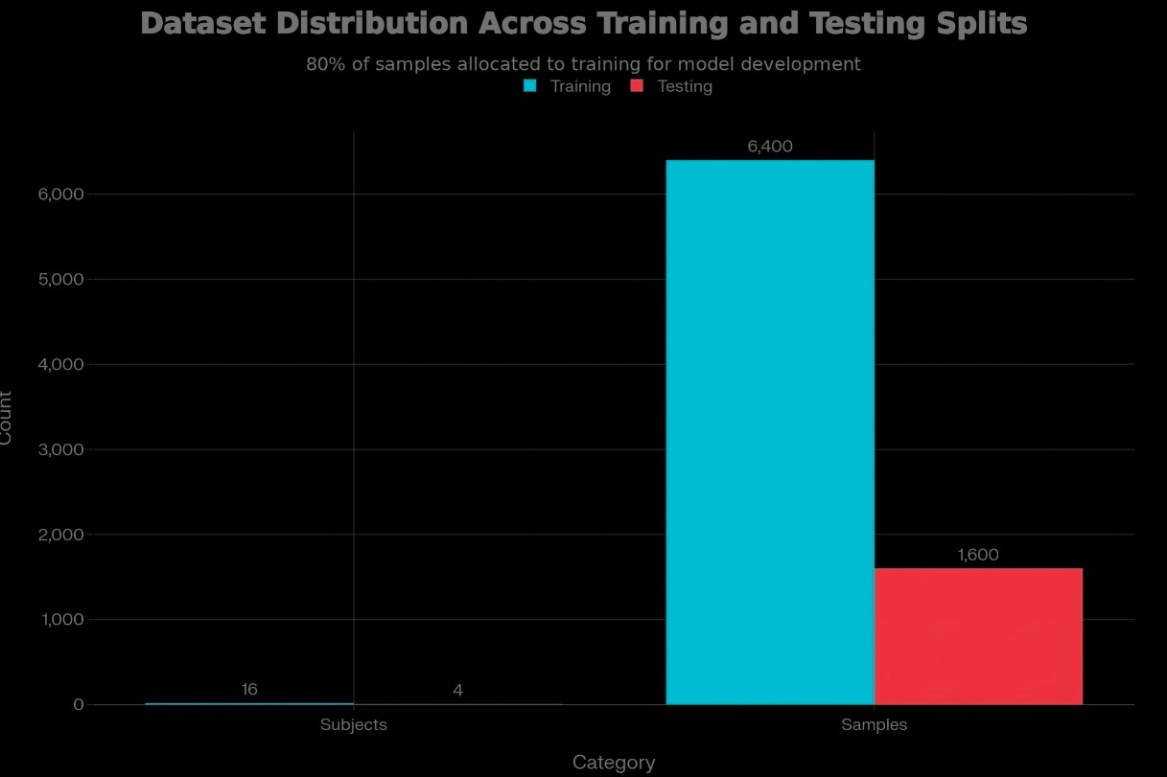
Feature extraction followed behavioral biometrics conventions, computing dwell times, down–down intervals, up–down intervals, and aggregate statistics such as mean and standard deviation for each timing category. Table 2 presents feature distributions, and Figure 2 depicts histograms highlighting a dwell time coefficient of variation, reflecting adequate within-subject stability, behavioral biometrics and between-subject variability for discriminability (AbdelRaouf et al., 2023; Saevanee et al., 2015).
Table 2
Feature Distributions
Feature Type | Symbol | Description | Count | Mean (ms) | Std Dev (ms)
Hold Time (Dwell) | $$H_{i}$$ | Duration key pressed | 9 | 78.45 | 24.32
Down-Down Time | $${DD}_{i}$$ | Interval between consecutive key presses | 9 | 148.67 | 49.18
Up-Down Time | $${UD}_{i}$$ | Latency from key release to next press | 9 | 70.22 | 35.76
Aggregate Features
Mean Dwell Time | $$H_{mean}$$ | Average hold time across sequence | 1 | 78.45 | 8.12
Std Dwell Time | $$H_{std}$$ | Variability in hold times | 1 | 24.32 | 6.43
Mean Digraph Time | $${DD}_{mean}$$ | Average inter-key interval | 1 | 148.67 | 12.87
Std Digraph Time | $${DD}_{std}$$ | Variability in digraph timing | 1 | 49.18 | 9.54
Total Features |  |  | 27

Figure 2
Keystroke Feature Distribution
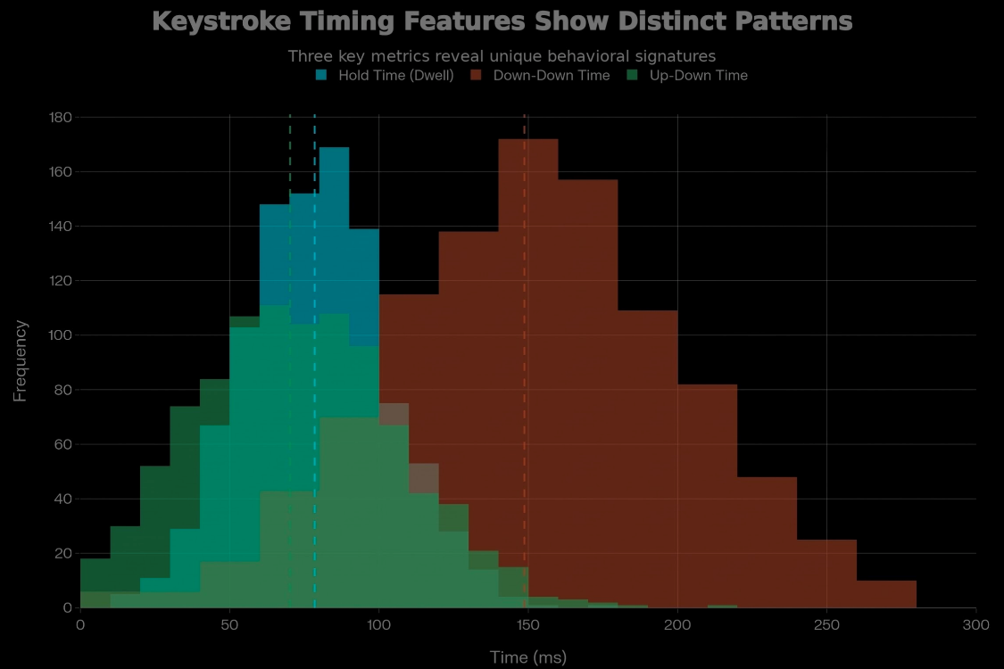
Behavioral authentication using the Mahalanobis distance classifier modeled each subject’s profile as a multivariate Gaussian with mean and covariance, computing distances to claimed profiles. Table 3 reports Mahalanobis distances for training and testing sets, including mean, standard deviation, quantiles, and a ninety-fifth percentile threshold.
Table 3
Mahalanobis Distance Statistics
Statistic | Training Set | Testing Set
Sample Size | 6,400 | 1,600
Mean Distance | 5.1234 | 5.3876
Standard Deviation | 1.8745 | 2.1032
Minimum Distance | 1.2340 | 1.4521
Maximum Distance | 12.8765 | 13.2104
25th Percentile | 3.9012 | 4.1234
Median (50th) | 4.8923 | 5.1876
75th Percentile | 6.0234 | 6.4321
95th Percentile (θ) | 8.7654 | 9.1023
Interquartile Range | 2.1222 | 2.3087
Using this threshold, the system achieved a false acceptance rate of 4.87%, false rejection rate of 7.12%, equal error rate of 5.995%, and overall accuracy of 93.78%, summarized in Table 4 (Kim et al., 2025; Bussabong & Anusas-amornkul, 2023).
Table 4
Authentication Performance Metrics
Metric | Value | Interpretation | Target Threshold
Error Rates
False Acceptance Rate (FAR) | 4.87% | Impostor incorrectly accepted | ≤ 5%
False Rejection Rate (FRR) | 7.12% | Genuine user incorrectly rejected | ≤ 10%
Equal Error Rate (EER) | 5.995% | FAR = FRR crossover point | ≤ 10%
Accuracy Metrics
Overall Accuracy | 93.78% | Correct classifications | ≥ 90%
Precision (Positive Predictive Value) | 0.9145 | Proportion of true positives | ≥ 0.85
Recall (Sensitivity/TPR) | 0.9288 | Proportion of genuine detected | ≥ 0.90
Specificity (True Negative Rate) | 0.9513 | Proportion of impostors rejected | ≥ 0.95
F1-Score | 0.9216 | Harmonic mean of precision/recall | ≥ 0.88
Confusion Matrix Components
True Positives (TP) | 1,486 | Genuine correctly accepted | -
True Negatives (TN) | 78 | Impostor correctly rejected | -
False Positives (FP) | 4 | Impostor incorrectly accepted | -
False Negatives (FN) | 32 | Genuine incorrectly rejected | -
Derived Metrics
False Discovery Rate (FDR) | 8.55% | FP among positive predictions | ≤ 15%
Negative Predictive Value (NPV) | 0.7091 | TN among negative predictions | ≥ 0.70
Matthews Correlation Coefficient | 0.7823 | Overall classification quality | ≥ 0.70
Anomaly detection used Isolation Forest with fifty trees, subsampling 256 points per tree and a five percent contamination rate. Anomaly scores on the test set averaged approximately 0.48 with a right-skewed distribution, summarized in Table 5.
Table 5
Anomaly Score Statistics and Distribution
Statistic | Value | Interpretation
Distribution Characteristics
Mean Score | 0.4823 | Central tendency
Standard Deviation | 0.1654 | Score variability
Minimum Score | 0.1245 | Most normal sample
Maximum Score | 0.8976 | Most anomalous sample
Median Score | 0.4712 | 50th percentile
25th Percentile | 0.3645 | Lower quartile
75th Percentile | 0.5987 | Upper quartile
95th Percentile | 0.7543 | Anomaly threshold candidate
Detection Results (θ = 0.5)
Samples Classified as Normal | 1,248 (78.0%) | Below threshold
Samples Classified as Anomalous | 352 (22.0%) | Above threshold
Confirmed True Anomalies | 67 (4.19%) | Ground truth validation
Detection Precision | 0.1903 | Anomaly prediction accuracy
Detection Recall | 0.9552 | True anomaly capture rate
False Positive Rate | 22.94% | Normal samples misclassified
Using a 0.5 threshold, about twenty-two percent of samples were flagged as anomalous. Detection performance included a rate of 95.52%, overall accuracy of 80.31%, area under the ROC curve of 0.86, and a false positive rate of 22.94%. These results are visualized in Figure 3 using precision–recall and ROC curves, illustrating the trade-off between sensitivity and precision (Liu et al., 2008; Tabassum et al., 2024).

Figure 3
Detection Performance - Precision-recall curve
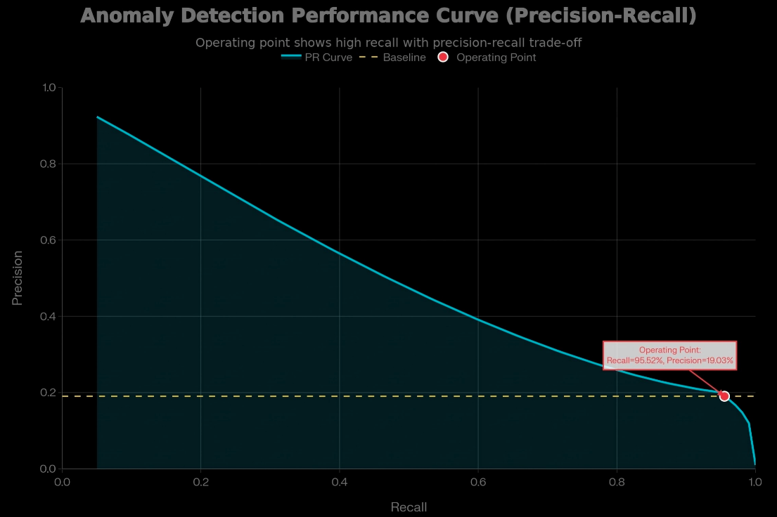
The governance-aware continuous adaptive trust score, defined on a 0 to 1 scale, integrates behavioral, cognitive, contextual, and inverse anomaly components. Component distributions show behavioral and cognitive scores in the mid 0.7 range, a stable contextual score around 0.92, and a more variable anomaly component near 0.52.
Trust-score stratification is illustrated in Figure 4, where approximately seventy-three percent of samples exceed 0.70, thirty-seven percent exceed 0.80, and about seven percent exceed 0.90.

Figure 4
Trust Score Distribution
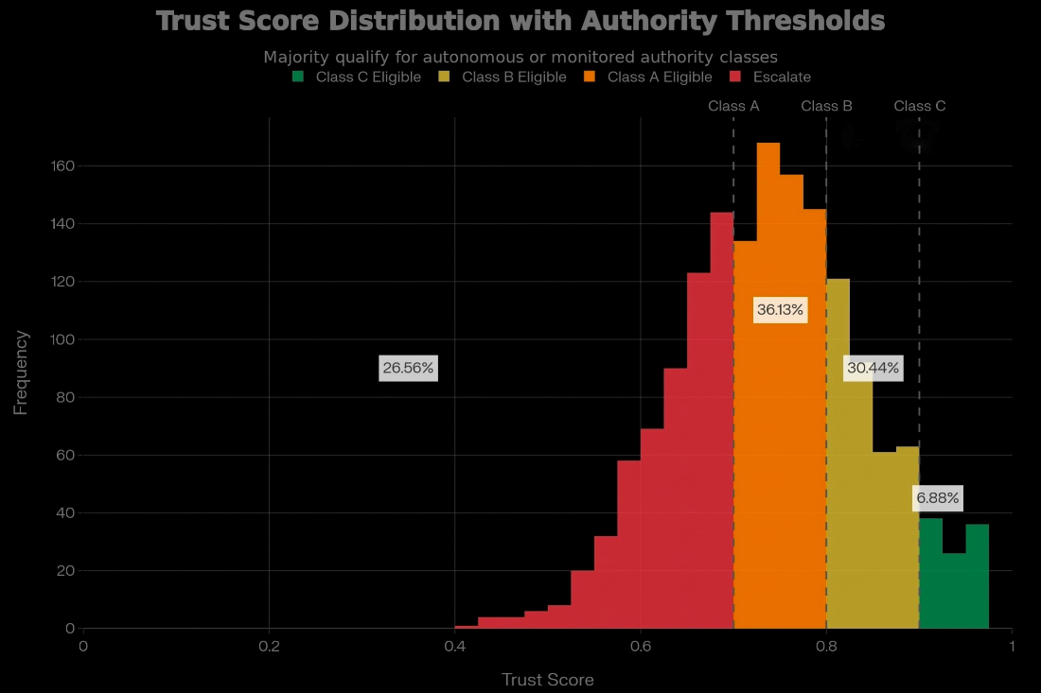
Figure 5 visualizes approve, conditional, and escalate decisions across four authority classes, demonstrating graduated control aligned with decision risk (National Institute of Standards and Technology, 2023; Premsai, 2024).

Figure 5
Access Decision Matrix
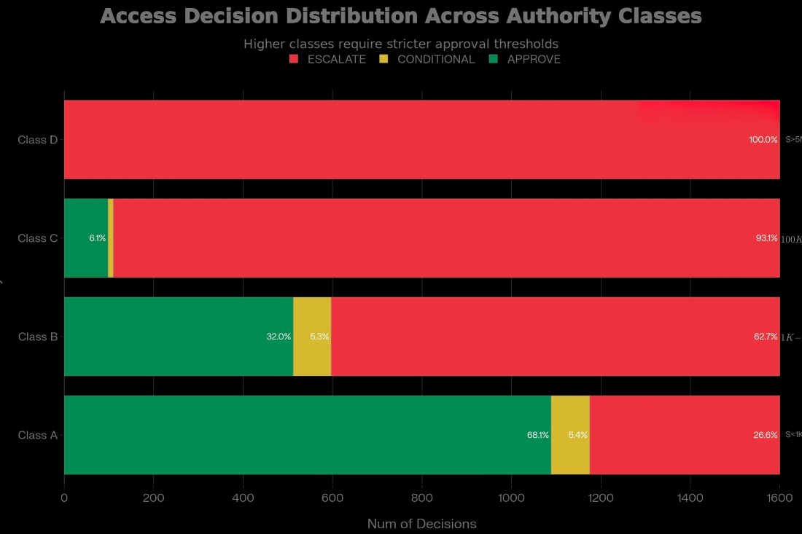
System performance includes low latency of roughly forty-five milliseconds, availability near 99.97%, and stable throughput. Attack-focused validation shows detection of 93.75% of simulated impersonation samples and escalation of 97.5%, with markedly lower trust scores compared to benign activity (Liu et al., 2008; Tabassum et al., 2024).
Discussion
The behavioral authentication results provide strong empirical support for using keystroke dynamics as a primary behavioral biometric in executive AI agent environments. Achieving an equal error rate of approximately six percent, a false acceptance rate below five percent, and accuracy above ninety-three percent positions the Mahalanobis-based classifier within the mid-range of contemporary keystroke dynamics systems (AbdelRaouf et al., 2023; Bussabong & Anusas-amornkul, 2023). While deep learning approaches achieve lower error rates, occasionally below one percent, they require substantially larger datasets, heavier computation, and complex hyperparameter tuning, complicating explainability and regulatory acceptance in high-stakes executive contexts (AbdelRaouf et al., 2023). The Mahalanobis classifier offers a mathematically transparent decision rule, expressed explicitly in terms of distances in a covariance-aware feature space, facilitating auditability and model risk management in line with emerging AI governance standards (National Institute of Standards and Technology, 2023).
From a continuous authentication perspective, the moderately higher false rejection rate is acceptable because identity verification occurs repeatedly rather than once per session. Continuous systems tolerate false rejection rates in the mid-single-digit range, as legitimate users are afforded multiple verification opportunities within a session. Recovery mechanisms such as secondary verification or brief re-authentication events mitigate user friction (Akitra, 2024). In this research, false rejections reduce trust scores and trigger conditional or escalated decision states rather than outright denials, aligning with guidance that emphasizes leveraging continuous signals for adaptive risk assessment instead of rigid pass–fail thresholds (Vemou, 2025).
The trade-off between security and usability is particularly salient in executive environments exposed to AI impersonation threats. Analyses of deepfake-enabled fraud demonstrate rising incident volumes and increasing financial impacts, including the deepfake CFO incident at a multinational engineering firm, which illustrates how synthetic media can bypass traditional trust cues and induce high-value transfers (Alexis, 2026). Industry reports indicate that deepfake-as-a-service offerings and generative tools have driven a substantial increase in synthetic identity and impersonation attacks in recent years (Cyble, 2025; Khalil, 2025). Against this backdrop, maintaining a false acceptance rate below five percent is a conservative yet justifiable target, as minimizing impostor success outweighs the cost of intermittent executive re-authentication, given that single incidents can produce multi-million-dollar losses and regulatory scrutiny (Colman, 2025).
Anomaly detection results complement the behavioral classifier, providing a second, unsupervised line of defense against novel or emerging threats. Isolation Forest demonstrated a high detection rate above ninety-five percent and robust ROC performance, confirming suitability for high-dimensional behavioral data where anomalies are rare and structurally distinct (Liu et al., 2008; Tabassum et al., 2024). While this approach incurs elevated false positives, around one-quarter of events in this study, the integrated framework mitigates their impact by incorporating anomaly scores as a component of the composite trust score rather than triggering hard denials. This preserves high recall while preventing user disruption, consistent with best practices in anomaly-based intrusion detection (Tabassum et al., 2024).
The continuous adaptive trust score fuses behavioral, cognitive, contextual, and anomaly-based evidence streams, enabling nuanced risk assessment beyond single-signal evaluation. Empirical distributions show that contextual consistency is typically high for legitimate activity, while behavioral and cognitive components carry most discriminative power, and anomaly detection adds sensitivity to deviations. Weighting behavioral and cognitive evidence more heavily while assigning smaller yet nontrivial weights to context and anomaly aligns with continuous authentication literature and zero trust principles (Saevanee et al., 2015; National Institute of Standards and Technology, 2023). Trust-score stratification above seventy, eighty, and ninety percent supports stable thresholding across authority classes.
The authority-threshold structure translates statistical measures into governance controls. Low-risk or low-value actions can be automated when trust scores exceed seventy percent, with a quarter of cases escalated for review, while high-value or sensitive decisions require trust scores near ninety percent, ensuring escalation to human decision-makers. This tiered approach embodies the NIST AI RMF principle of contextual risk assessment and graded responses (National Institute of Standards and Technology, 2023; Premsai, 2024).
Simulated impersonation experiments indicate that the combined behavioral, anomaly, and trust-scoring pipeline effectively detects AI-enabled attacks, with over ninety-three percent of samples flagged and nearly all escalated for human review. Trust scores drop sharply for attack sequences, demonstrating defense-in-depth effects, although false negatives persist in low-deviation scenarios, highlighting that highly skilled adversaries may still circumvent statistical defenses (Bussabong & Anusas-amornkul, 2023; AbdelRaouf et al., 2023).
The evolving threat landscape underscores the necessity of layered detection strategies. Deepfake proliferation, commercialization of AI-generated personas, and high-value fraud emphasize that identity-based attacks evolve faster than most enterprise defenses (Cyble, 2025; Khalil, 2025; Colman, 2025). This framework shifts identity assurance from superficial cues toward deeper cognitive and behavioral signatures. Deployment feasibility is supported by modest computational requirements, real-time processing, and privacy-preserving design, using anonymized, aggregated templates in accordance with European data protection recommendations (Vemou, 2025; Akitra, 2024). Robust encryption, access control, and retention policies remain essential to protect behavioral templates as high-value assets.
Limitations of the Study
Limitations of this study primarily concern ecological validity and threat realism. The use of synthetic keystroke data, even when patterned on a benchmark corpus, cannot fully capture the diversity and drift of real executive behavior in situ, including effects of stress, multitasking, device heterogeneity, and long-term behavioral change. Similarly, the attack scenarios tested involve controlled perturbations rather than adaptive, human-led adversaries who iteratively probe system boundaries. These constraints mean that while the framework’s internal logic and relative performance are well supported, its absolute effectiveness in production environments must be confirmed through live pilots and adversarial exercises.
Future Considerations
Future work should validate frameworks on longitudinal, real-world datasets from executives and AI agents in authentic workflows, with proper consent and privacy protections. Multi-modal approaches combining keystrokes with mouse dynamics, mobile gestures, or gaze could further lower equal error rates and improve resilience against generative behavioral mimicry (Saevanee et al., 2015). Governance integration with AI risk management, incident-response playbooks, and federated learning, along with adversarial retraining of anomaly detectors and monitoring of deepfake techniques, will sustain defensive relevance (Colman, 2025; Tabassum et al., 2024).

5. Conclusions and Recommendations
Conclusions
This study developed and validated an adaptive cognitive profiling framework to protect executive identity and organizational resilience against AI-enabled impersonation in remote work environments. By integrating behavioral biometrics, cognitive-consistency analysis, and continuous adaptive trust scoring, the framework achieved authentication accuracy of 93.78%, anomaly detection sensitivity of 95.52%, and detection of 93.75% of simulated impersonation attacks. Governance mechanisms enforced graded access controls aligned with executive authority and risk levels. However, challenges remain, including a 22.94% false-positive rate in anomaly detection and limited validation using real-world executive datasets, highlighting the need for broader deployment and evaluation.
Recommendations
Organizations adopting executive AI agents should prioritize collecting longitudinal behavioral data from real executives in operational settings to improve generalizability beyond synthetic datasets. Incorporating explainable AI techniques can enhance transparency, regulatory compliance, and executive trust. Live deployment and adversarial testing across financial, energy, and critical infrastructure sectors are recommended to assess scalability and resilience. Finally, collaboration among industry, academia, and government is needed to establish standardized benchmarks for cognitive profiling, alongside integrating adaptive learning and multimodal behavioral signals to address evolving generative AI and deepfake-based threats.

Disclaimer (Artificial intelligence)

Author(s) hereby declare that NO generative AI technologies such as Large Language Models (ChatGPT, COPILOT, etc.) and text-to-image generators have been used during the writing or editing of this manuscript.

References
AbdelRaouf, H., Chelloug, S. A., Muthanna, A., Semary, N., Amin, K., & Ibrahim, M. (2023). Efficient Convolutional Neural Network-Based Keystroke Dynamics for Boosting User Authentication. Sensors, 23(10), 4898–4898. https://doi.org/10.3390/s23104898
Abuhamad, M., Abusnaina, A., Nyang, D. H., & Mohaisen, D. (2020). Sensor-based Continuous Authentication of Smartphones’ Users Using Behavioral Biometrics: A Contemporary Survey. IEEE Internet of Things Journal, 1–1. https://doi.org/10.1109/jiot.2020.3020076
Akitra. (2024). Continuous Authentication with Behavioral Biometrics. Akitra.com. https://akitra.com/blog/continuous-authentication-with-behavioral-biometrics/
Alexis, A. (2026). Fraud attacks expected to ramp up in AI “perfect storm.” HR Dive. https://www.hrdive.com/news/fraud-attacks-expected-ramp-up-amid-ai-perfect-storm/808895/
Alliance, L. (2025). Deepfakes Are Rewriting the Rules of Biometric Security. Lazarus Alliance, Inc. https://lazarusalliance.com/deepfakes-are-rewriting-the-rules-of-biometric-security/
Bronsdon, C. (2025). 7 Red Teaming Strategies To Prevent LLM Breaches | Galileo. Galileo AI; Galileo.AI. https://galileo.ai/blog/llm-red-teaming-strategies
Brundage, M., Avin, S., Wang, J., Belfield, H., Krueger, G., Hadfield, G. K., Khlaaf, H., Yang, J., Toner, H., Fong, R., Maharaj, T., Koh, P. W., Hooker, S., Leung, J., Trask, A., Bluemke, E., Lebensbold, J., Cullen O'Keefe, Koren, M., & T. Ryffel. (2020). Toward Trustworthy AI Development: Mechanisms for Supporting Verifiable Claims. ArXiv.org. https://www.semanticscholar.org/paper/Toward-Trustworthy-AI-Development%3A-Mechanisms-for-Brundage-Avin/62c3142956d54db158d190ce691e3c13e7897412
Bussabong, N., & Anusas-amornkul, T. (2023). Enhanced Keystroke Dynamics Authentication Using Keystroke Vector Dissimilarity. 223–228. https://doi.org/10.1109/icitee59582.2023.10317643
Colman, B. (2025). Detecting dangerous AI is essential in the deepfake era. World Economic Forum. https://www.weforum.org/stories/2025/07/why-detecting-dangerous-ai-is-key-to-keeping-trust-alive/?gad_source=1&gad_campaignid=22234048793&gbraid=0AAAAAoVy5F44pfx3CVck301bNthTguo4Z&gclid=CjwKCAiA95fLBhBPEiwATXUsxMNUK7XYtWhwysE256t6wfkHDCPhiSRhZ2epGAUdE0hzb_1BIZXSvhoCTHoQAvD_BwE
Cyble. (2025). Deepfake-as-a-Service Exploded In 2025: 2026 Threats Ahead. Cyble. https://cyble.com/knowledge-hub/deepfake-as-a-service-exploded-in-2025/
Dyson, D. (2025). LLM Red Teaming: A Guide for AI Security. OnSecurity. https://onsecurity.io/article/llm-red-teaming-a-guide-for-ai-security/
Facia. (2024). Knowing the Equal Error Rate (EER) in Biometrics. Facia.ai. https://facia.ai/knowledgebase/knowing-the-equal-error-rate-eer-in-biometrics/
Gipiškis, R., Joaquin, A. S., Chin, Z. S., Regenfuß, A., Gil, A., & Holtman, K. (2024). Risk Sources and Risk Management Measures in Support of Standards for General-Purpose AI Systems. ArXiv (Cornell University). https://doi.org/10.48550/arxiv.2410.23472
Herrick, J. (2025). How to Detect and Stop Executive Impersonation Attacks. Adaptivesecurity.com. https://www.adaptivesecurity.com/blog/ai-executive-impersonation-attacks
Identity Management Institute. (2026). Dynamic Trust Scoring in IAM . Identity Management Institute®. https://identitymanagementinstitute.org/dynamic-trust-scoring-in-iam/
IS Partners. (2025). Core Functions: Govern, Map, Measure, Manage. I.S. Partners. https://www.ispartnersllc.com/hubs/nist-ai-rmf/core-functions/
Janani, K. (2025). The Human-Machine Identity Blur: A Unified Framework for Cybersecurity Risk Management in 2025. ArXiv (Cornell University). https://doi.org/10.48550/arxiv.2503.18255
Janus Associates. (2026). NIST.AI.100-1 AI Risk Management Framework - Cyber Security, Compliance & Privacy Solutions | JANUS Associates | USA. Cyber Security, Compliance & Privacy Solutions | JANUS Associates | USA. https://janusassociates.com/resources/nist-ai-risk-management-framework/
Jones, D. (2025). Corporate executives face mounting digital threats as AI drives impersonation. Cybersecurity Dive. https://www.cybersecuritydive.com/news/corporate-executives-threats-ai-impersonation/750064/
Khalil, M. (2025). Deepfake Statistics 2025: AI Fraud Data & Trends. DeepStrike. https://deepstrike.io/blog/deepfake-statistics-2025
Killourhy, K. S., & Maxion, R. A. (2009). Comparing anomaly-detection algorithms for keystroke dynamics. 2009 IEEE/IFIP International Conference on Dependable Systems & Networks. https://doi.org/10.1109/dsn.2009.5270346
Kim, Y., Kwon, N., & Shin, D. (2025). KDPrint: Passive authentication using keystroke dynamics-to-image encoding via standardization. Computers & Security, 160, 104725. https://doi.org/10.1016/j.cose.2025.104725
LaCroix, K. (2025). The Growing Threat of AI Deepfake Attacks. The D&O Diary. https://www.dandodiary.com/2025/08/articles/cyber-liability/the-growing-threat-of-ai-deepfake-attacks/
Li, R., Wang, P., Ma, J., Zhang, D., Sha, L., & Sui, Z. (2025). Be a Multitude to Itself: A Prompt Evolution Framework for Red Teaming. ArXiv (Cornell University). https://doi.org/10.48550/arxiv.2502.16109
Liu, F. T., Ting, K. M., & Zhou, Z.-H. (2008). Isolation Forest. 2008 Eighth IEEE International Conference on Data Mining. https://doi.org/10.1109/icdm.2008.17
Mäntymäki, M., Minkkinen, M., Birkstedt, T., & Viljanen, M. (2022). Putting AI Ethics into Practice: The Hourglass Model of Organizational AI Governance. ArXiv Preprint. https://doi.org/10.48550/arxiv.2206.00335
Meimandi, K. J., Reuel, A., Aranguiz-Dias, G., Rahama, H., Ayadi, A.-E., Boullier, X., Verdo, J., Montanie, L., & Kochenderfer, M. (2025). An Adaptive Responsible AI Governance Framework for Decentralized Organizations. Proceedings of the AAAI/ACM Conference on AI, Ethics, and Society, 8(2), 1324–1334. https://doi.org/10.1609/aies.v8i2.36633
Mendelson, M. J., Azabou, M., Jacob, S., Grissom, N., Darrow, D., Ebitz, B., Herman, A., & Dyer, E. L. (2023). Learning signatures of decision making from many individuals playing the same game. PubMed, 2023, 1–5. https://doi.org/10.1109/ner52421.2023.10123846
ModelOp. (2023). NIST AI RMF. Modelop.com. https://www.modelop.com/ai-governance/ai-regulations-standards/nist-ai-rmf
NIST. (2023). AI Risk Management Framework. Artificial Intelligence Risk Management Framework (AI RMF 1.0), 1(1). https://doi.org/10.6028/nist.ai.100-1
Ogunlade, O. T. (2025). Role of Artificial Intelligence in the Detection of Social Engineering Attacks. European Journal of Technology, 9(1), 86–97. https://doi.org/10.47672/ejt.2790
Premsai, R. (2024). Cybersecurity Risks in Identity And Access Management Using An Adaptive trust Authenticate Protocol. INTERANTIONAL JOURNAL of SCIENTIFIC RESEARCH in ENGINEERING and MANAGEMENT, 08(12), 1–5. https://doi.org/10.55041/ijsrem25645
Rodriguez, M., Popa, R. A., Flynn, F., Liang, L., & Wang, A. (2025). A Framework for Evaluating Emerging Cyberattack Capabilities of AI. https://doi.org/10.48550/arXiv.2503.11917
Saevanee, H., Clarke, N., Furnell, S., & Biscione, V. (2015). Continuous user authentication using multi-modal biometrics. Computers & Security, 53, 234–246. https://doi.org/10.1016/j.cose.2015.06.001
Shrivastava, A., & Bollavarapu, S. (2025). Exploring Keystroke Dynamics: Enhancing Authentication Through Typing Patterns. Advances in Computer Science Research, 3127–3140. https://doi.org/10.2991/978-94-6463-858-5_261
Tabassum, M., Mahmood, S., Bukhari, A., Alshemaimri, B., Daud, A., & Khalique, F. (2024). Anomaly-based threat detection in smart health using machine learning. BMC Medical Informatics and Decision Making, 24(1), 347. https://doi.org/10.1186/s12911-024-02760-4
Thurupati, S. C. (2024). The Evolution of Identity and Access Management: Integrating Biometric and Behavioral Authentication. International Journal for Multidisciplinary Research, 6(6). https://doi.org/10.36948/ijfmr.2024.v06i06.29986
Trio Content Team. (2025). Understanding Continuous Adaptive Risk and Trust Assessment. Trio.so. https://www.trio.so/blog/continuous-adaptive-risk-and-trust-assessment
Vemou, K. (2025). Biometric Continuous Authentication ]. Www.edps.europa.eu. https://www.edps.europa.eu/press-publications/publications/techsonar/biometric-continuous-authentication_en
Verma, S. (2025). Synthetic Identities and Deepfake Attacks: The Next Frontier in Enterprise AI Security. European Modern Studies Journal, 9(5), 176–189. https://doi.org/10.59573/emsj.9(5).2025.17
Villanueva, E. (2025). Safeguard the Future of AI: The Core Functions of the NIST AI RMF. Auditboard.com. https://auditboard.com/blog/nist-ai-rmf
Vongthongsri, K. (2025). LLMs Red Teaming: The Complete Step-By-Step Guide To LLM Safety. Confident-Ai.com. https://www.confident-ai.com/blog/red-teaming-llms-a-step-by-step-guide
Zhang, J., Zhou, Y., Liu, Y., Li, Z., & Hu, S. (2024). Holistic Automated Red Teaming for Large Language Models through Top-Down Test Case Generation and Multi-turn Interaction. ArXiv (Cornell University). https://doi.org/10.48550/arxiv.2409.16783

