Original Research Article
Improvement And Performance Evaluation Of A Developed Coconut Dehusking Machine

Abstract: Manual coconut dehusking is slow, labor-intensive, and often unsafe, motivating the development of mechanized dehusking machines. However, existing designs often suffer from long processing times and low efficiency. This study presents design improvements and a performance evaluation of a developed coconut dehusking machine. Key modifications included upgrading the drive system to a 3 hp geared motor, optimizing the blade configuration, and refining the frame and roller alignment. The improved machine was experimentally tested on ten coconut samples, and performance was assessed using dehusking time and energy consumption as metrics. Results showed a reduction in dehusking time to 9–13 seconds per coconut, compared to 15–25 seconds for the original machine, and improved energy efficiency due to shorter processing time. These findings demonstrate that the implemented design improvements significantly enhance machine performance, making it more efficient and suitable for small- to medium-scale coconut processing, while acknowledging that further testing with a larger sample is recommended.
Keywords: Coconut dehusking machine; design improvement; performance evaluation; dehusking time; energy consumption
INTRODUCTION
Coconut (Cocos nucifera) is one of the most important crops cultivated in tropical countries worldwide. It plays a major role in supporting rural livelihoods and national economies because almost every part of the coconut can be used. The coconut meat is processed into products such as copra and coconut oil, while the outer husk is used to produce coir fibre for ropes, mats, brushes, and other materials (Adedipe, 2024). Because of this wide range of uses, coconut processing provides income for farmers, processors, and traders in many developing countries. Before any of these useful products can be made, the hard outer husk of the coconut must first be removed. This process is known as dehusking. The coconut husk is very tough and tightly attached to the shell, which makes dehusking a difficult task. Traditionally, coconuts are dehusked manually using simple tools such as machetes, sharp metal spikes, or pointed wooden stakes embedded in the ground, a process that is labour-intensive, time-consuming, and poses significant safety risks to operators (Nampoothiri, 2018; Sarita & Monton, 2025). Recent studies on mechanised dehusking confirm that manual methods limit productivity and expose workers to physical strain, motivating the development of improved mechanised dehusking machines.
Manual dehusking is very slow and requires a lot of physical effort. Removing the husk from a single coconut can take several minutes, especially when the worker becomes tired (Adedipe, 2024). The work is also physically demanding because the husk is hard, fibrous, and heavy, which causes fatigue after long hours of work. In addition, manual dehusking is dangerous. Workers are often exposed to cuts, puncture wounds, and other injuries when the tool slips or when too much force is applied (Baskaran, 2024). Because of these challenges, farmers and small-scale processors are unable to dehusk large quantities of coconuts in a short time, which reduces productivity and increases labour costs. Due to these difficulties, researchers and engineers have long looked for better ways to remove coconut husks. This led to the development of mechanised coconut dehusking machines. These machines are designed to reduce human effort and improve safety by using mechanical power to remove the husk. Most mechanised dehusking machines operate with electric motors or other power sources that drive spiked rollers, blades, or gripping mechanisms that tear the husk away from the shell (Adebimpe, 2024). By using machines, the dehusking process becomes faster, more consistent, and less physically stressful for workers.
Studies have shown that mechanised dehusking machines can significantly improve productivity. Some machines can process dozens or even hundreds of coconuts per hour, which is far more than what can be achieved through manual labour (Baskaran, 2024). In addition, machines reduce the risk of injury because the worker no longer needs to hold the coconut close to sharp tools. Mechanisation also helps reduce labour costs, as fewer workers are required to process the same quantity of coconuts (Adedipe, 2024). However, despite these advantages, many existing coconut dehusking machines still have limitations. Some machines consume too much energy, making them expensive to operate, especially in areas with unstable electricity supply. Others are too large, complex, or costly for small- and medium-scale farmers to afford or maintain (Baskaran, 2024).
Although many studies have reported different designs of coconut dehusking machines, there is still a clear gap in the literature. Most previous studies either focus mainly on describing the design of the machine or on reporting performance results without clearly linking those results to specific design changes. This makes it difficult to understand how particular mechanical improvements, such as changes in blade arrangement, motor power, or transmission systems, directly affect performance indicators like processing time and energy consumption (Baskaran, 2024). To address this gap, the present study combines design improvement with performance evaluation in a single investigation. In this study, key components of an existing coconut dehusking machine were modified to improve efficiency. The improved machine was then tested and compared with the original design to measure differences in dehusking time and energy consumption.
LITERATURE REVIEW
Coconut dehusking has traditionally been performed manually using sharp tools, a method that requires considerable physical effort and exposes operators to injuries and fatigue. As coconut processing volumes increase, these limitations have driven the development of mechanised dehusking technologies aimed at improving safety and productivity (Owuama, 2025). Mechanised coconut dehusking machines reported in the literature employ different operating principles, including spiked rollers, cutting blades, gripping mechanisms, and automated feeding systems. Studies have shown that such machines can significantly reduce dehusking time and labour requirements when compared to manual methods (Pascua, 2018). For instance, Adebimpe (2024) developed an automated coconut dehusking machine that achieved substantial reductions in processing time, while Onyenanu (2025) highlighted the importance of structural integrity in ensuring consistent machine performance.
Several locally developed machines have also been reported, with emphasis on affordability and the use of locally sourced materials. Adedipe (2024) evaluated a cost-effective coconut dehusking machine and reported improved safety and reduced physical stress, although the dehusking time remained relatively high. Other studies have demonstrated that machine performance is strongly influenced by design parameters such as motor power, blade geometry, roller alignment, and transmission efficiency (Rahman, 2020; Bathaei, 2023; Oladimeji, 2021).
Performance evaluation of coconut dehusking machines commonly focuses on indicators such as dehusking time, throughput capacity, efficiency, and energy consumption. Dehusking time is a critical metric because it directly reflects productivity and operational efficiency (Rahman, 2020; Owuama, 2025). Despite the growing body of research, many studies either concentrate on machine development without a detailed performance comparison or present performance results without clearly linking them to specific design modifications.
From the reviewed literature, it is evident that there is limited work that systematically examines how specific design improvements influence the performance of an existing coconut dehusking machine through direct experimental comparison. This gap underscores the need for studies that combine mechanical design optimization with quantitative performance evaluation. The present study addresses this gap by modifying a previously developed coconut dehusking machine (Oluwayanmife, 2026) and experimentally assessing the impact of the improvements on dehusking time and energy consumption.
MATERIALS AND METHODS
Description of the Developed Coconut Dehusking Machine
The coconut dehusking machine used in this study was originally designed, simulated, and fabricated in an earlier work by Oluwayanmife (2026). In that study, the conceptual design, analytical calculations, CAD modelling, simulation, and fabrication of the machine were presented, and its basic operational feasibility was experimentally validated. The machine consists of a steel frame, a geared electric motor, dehusking rollers fitted with blades, a chain and sprocket transmission system, and supporting structural components (Oluwayanmife, 2026). Although the developed machine was functional and suitable for small- and medium-scale coconut processing, operational testing revealed certain performance limitations, including relatively long dehusking time and moderate energy efficiency. These limitations informed the present study, which focuses on improving key components of the original machine and evaluating the resulting performance enhancements. The description provided in this section, therefore, serves as a baseline, while detailed attention is given to the design improvements implemented in this work.
Design Improvements Implemented
Performance evaluation of the initial coconut dehusking machine indicated the need for improvements in processing speed, energy efficiency, and load-handling capability. A detailed inspection identified the electric gear reduction motor as a critical limitation. Coconut dehusking requires high output torque at low rotational speed to overcome the husk–shell bonding force, particularly in mature coconuts. To ensure consistency between motor selection, gearbox design, and roller performance, a simplified torque analysis was conducted based on fundamental force transmission principles (Budynas, 2020; Norton 2019).
The force required for coconut dehusking was estimated at approximately 450 N, accounting for the combined resistance encountered at multiple contact points between the dehusking blades and the coconut husk (Oluwayanmife, 2026). Considering an effective moment arm of 80 mm for the roller–shaft assembly, the minimum torque required at the roller shaft was determined using:
Torque _{required} = F × r
where F is the dehusking force and r is the perpendicular distance from the shaft center (Norton, 2019). This yielded a required torque of approximately 36 Nm. To accommodate variability in coconut size, husk moisture content, and material uncertainties, a factor of safety of 1.25 was applied, resulting in a design torque requirement of 45 Nm (Juvinall, 2017).
The machine is driven by an electric motor coupled to a reduction gearbox to achieve the required torque at low operating speeds. The relationship between motor power, rotational speed, and torque is given by:
$$T= \frac{60P}{2πN}$$
where T is torque (Nm), P is motor power (W), and N is rotational speed (rpm) (Budynas, 2020), (Srivastava, 2019). For the original 2 hp motor (Figure 1) operating at 1500 rpm, the motor shaft torque was calculated as approximately 9.5 Nm. To address the torque limitation, a 3 hp motor (Figure 2) with a higher power rating was installed. The gearbox provides a speed reduction ratio of 1:25, reducing the output speed to approximately 60 rpm. Neglecting minor transmission losses, the output torque after gear reduction is amplified proportionally:
T_{output} = T_{motor} × Gear Reduction
resulting in an estimated gearbox output torque of approximately 350 Nm, significantly exceeding the minimum design requirement.
The gearbox output torque is transmitted to the dehusking rollers through a spur gear system with a velocity ratio of 1:1, preserving both torque and rotational speed. Spur gear parameters, including module, pitch circle diameter, and tooth geometry, were selected to safely transmit the calculated torque based on standard mechanical design guidelines (Khurmi, 2018).
The calculated design torque of 45 Nm represents the minimum torque required at the roller shaft to overcome the coconut husk resistance. The actual output torque provided by the motor–gearbox system (180–355 Nm) significantly exceeds this minimum, ensuring smooth operation and a sufficient torque margin to accommodate larger coconuts, moisture variability, and frictional losses. Experimental observations during testing showed smooth dehusking operation, reduced processing time, and no motor stalling under load. These results confirm that the upgraded motor–gearbox configuration provides a substantial torque margin beyond the minimum design requirement and that the analytical torque estimates are consistent with observed performance.
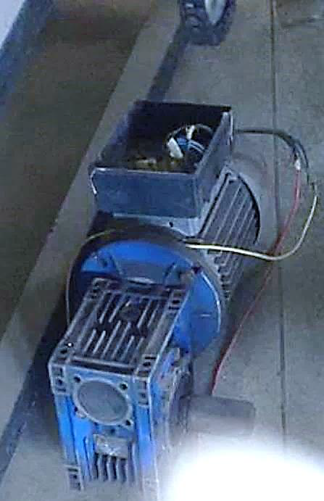
Figure 1 The 2hp Electric Gear Reduction Motor (FUTA Workshop, 2021)
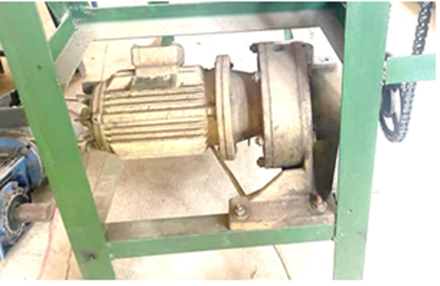maa
Figure 2: The 3hp Electric Gear Reduction Motor (FUTA Workshop, 2023)
Another factor affecting performance was the angle between the rollers and the machine frame, which critically influences the contact between the coconut and the dehusking spikes. In the original configuration, the blades were set at an angle of 30° relative to the frame, as shown in Figure 3. This made the design not steep enough and reduced proper contact between the coconut and the rollers. This poor alignment made the dehusking process slower and less effective. These problems were also observed with the chains and sprockets that transfer power from the motor to the rotating shaft. Many of these parts were slightly misaligned and worn out. These conditions reduced smooth power transmission and increased the risk of machine failure during operation. Similarly, several bolts and nuts holding the machine together were of poor quality. Some had already started to rust, while others had become loose. This weakened the machine structure, affected safety, and reduced the machine’s overall lifespan. To address this limitation, the angle betwenn the dehusking rollers and the machine frame was modified to improve coconut–roller contact. The improved design reduced the blade angle from 30° to 15°, as shown in Figure 4, allowing better contact between the coconut and the rollers and improving the effectiveness of the dehusking process
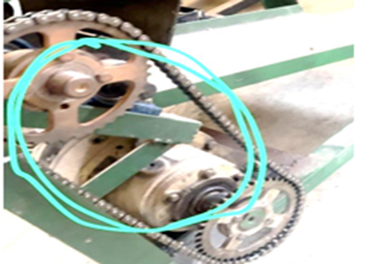
Figure 3: The blades positioned at an angle 30o (FUTA Workshop, 2023)
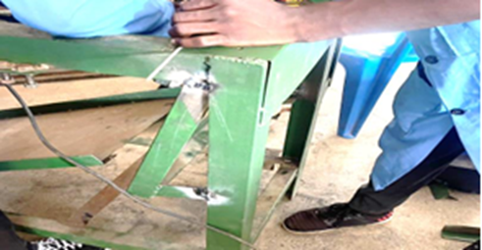
Figure 4: The blades positioned at an angle 15o (FUTA Workshop, 2023)
Another problem was found in the flap that guides the coconuts toward the dehusking rollers. The flaps were too short and could not properly position the coconuts before they reached the spikes as seen in figure 5. As a result, coconuts were sometimes poorly aligned, leading to inefficient dehusking and occasional damage to the coconut shell. Improvements were made to the roller flaps, which helped guide coconuts into the dehusking area. Initially, the flaps were only 160 mm long, which were further extended to 300 mm to provide better support and positioning. In addition, the flaps were moved 100 mm farther away from the blades as seen in figure 6. This reduced friction, prevented interference with the blades, and allowed coconuts to move more smoothly through the machine.
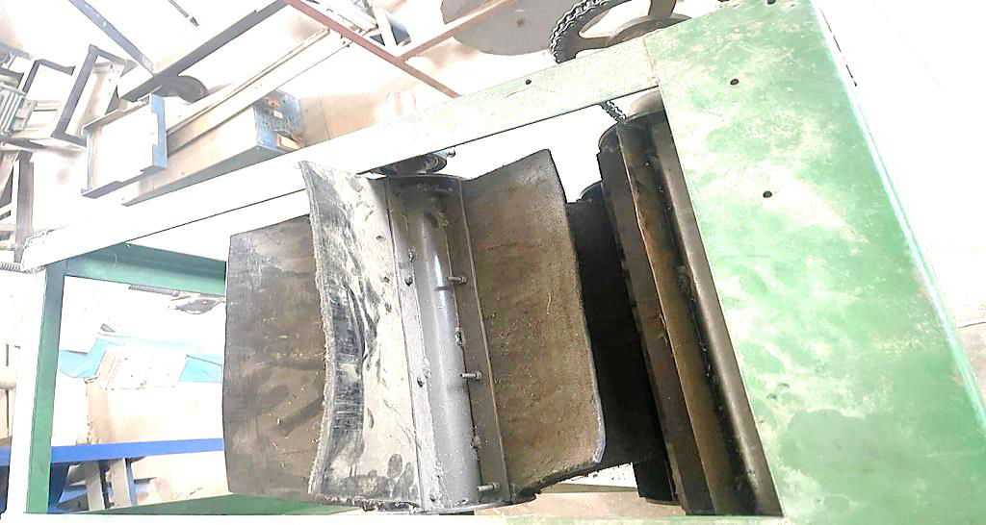
Figure 5 The old short flap (Futa Workshop, 2023)
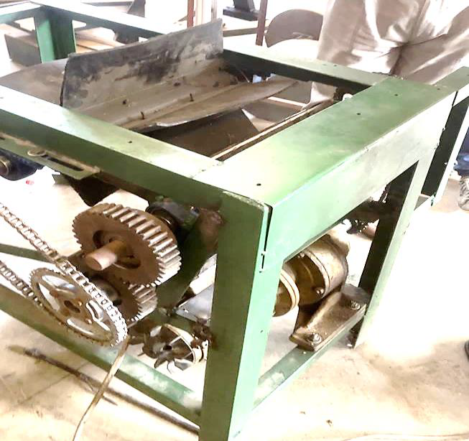
Figure 6: The New and Extended Flap (Futa Workshop)
The cutting blades also presented a design flaw. In the original machine, the blades were sharpened in an incorrect orientation, causing them to press against the coconut rather than cutting smoothly into the husk. This caused unnecessary force on the coconut, reduced cutting efficiency, and sometimes led to cracking or damage. A new design was used; the blade tips were reshaped into a triangular form. This new shape allowed the blade to pierce and slice through the husk more easily, rather than pressing against it. As a result, the dehusking process became faster, cleaner, and less damaging to the coconut.
The worn-out chains and sprockets were completely replaced with new components. Prior to installation, the surrounding areas were thoroughly cleaned to remove rust and debris. During this process, it was observed that altering the angle between the blades and the frame affected the required chain length. Specifically, the existing chain connecting the lower roller and flap became too short, necessitating the installation of a longer chain to ensure smooth motion and proper power transmission.
All rusted or weakened bolts and nuts were also replaced. Old fasteners were carefully removed, and the holes were cleaned to guarantee proper alignment and fit. New, stronger, corrosion-resistant bolts and nuts were installed and correctly tightened. These changes reinforced the machine structure, improved operator safety, and enhanced the overall durability and appearance of the machine.
Collectively, these modifications increased the machine’s power, operational efficiency, and reliability, making it better suited for practical coconut dehusking applications. Table 1 provides a summary of the key design improvements implemented in the coconut dehusking machine, highlighting the modifications made to the motor, blades, frame, and transmission system to enhance operational efficiency and reduce dehusking time.
Table 1: Summary of design improvements
Component | Configuration in Original Machine | Configuration in Improved Machine | Intended Purpose/Effect
Electric Motor | Low-power motor | High-power motor | To provide sufficient torque and reduce dehusking time.
Dehusking spikes/blades | Basic spike geometry | Modified spike geometry with improved penetration | To enhance husk penetration and fast husk separation.
Shaft-frame alignment | Moderate alignment | Improved alignment | To reduce vibration and mechanical losses.
Transmission system | Worn chain and sprocket | Replaced and properly tensioned the chain and sprocket | To improve power transmission efficiency.
Machine frame | Light structural support | Reinforced frame members | To improve stability during operation.
Overall performance | Longer dehusking time | Reduced dehusking time | To enhance operational efficiency.

Experimental Setup and Procedure
Descriptive statistical analysis was adopted in this study due to the experimental nature and limited sample size, with mean, standard deviation, and box-and-whisker plots used to assess central tendency and variability under identical operating conditions. Tests were carried out to evaluate the performance of the improved coconut dehusking machine compared to the old version. Ten coconuts were used for each test, with each coconut fed into the machine individually. A stopwatch was used to measure how long it took for the machine to completely remove the husk from each coconut and was recorded as the dehusking time. To make a fair comparison, the time results from the old machine were taken from previous test records. These results were then compared with the new results from the improved machine, which was tested under the same working conditions. During all the tests, the motor speed was kept the same so that the results would be accurate and consistent.
The machine’s performance was judged mainly by two things: how long it took to remove the husk and how much energy the machine used. The dehusking time simply means the time needed to fully remove the husk from one coconut. This shows how fast and efficient the machine is. The energy used by the machine was estimated using the motor’s power rating and the time taken to dehusk each coconut. These two measurements were chosen because they clearly show whether the changes made to the machine improved its performance. The results from the tests were arranged in tables and shown in graphs, including box-and-whisker plots, to make it easy to see the difference between the old machine and the improved one.

RESULTS AND DISCUSSION
Effect of Design Improvements on Machine Performance
The design improvements implemented on the developed coconut dehusking machine had a noticeable impact on its operational behaviour. The upgraded motor supplied more power and torque, allowing the dehusking shaft to run smoothly even under load. The modified blades penetrated the coconut husk more effectively, which helped reduce the time needed to remove the husk. In addition, improving the shaft alignment and strengthening the frame reduced vibration, making the machine more stable during operation. Table 2 summarizes the key differences between the original and improved machine components, including motor shaft torque, motor power, gear ratio, roller output torque, and output speed. The upgraded 3 hp motor combined with a higher gear reduction increased the output torque at the rollers from 180 Nm to 355 Nm, while reducing roller speed from 79 rpm to 60 rpm. These modifications, along with adjustments to flap length and roller angle, improved coconut gripping and penetration by the dehusking blades, resulting in faster and more consistent dehusking performance.
Table 2: Comparison of Key Components Between Original and Improved Coconut Dehusking Machines
S/N | Components and Specification | Original Configuration | Improved Configuration
1 | Reduction Motor:  - Motor shaft torque  - Motor power  - Gear ratio  - Output torque at rollers  - Output speed | 9.5 Nm  2 hp (1.5 kW)  1:19  180 Nm  79 rpm | 14.2 Nm  3 hp (2.2 kW)  1:25  355 Nm  60 rpm
2 | Flap (Length) | 160mm | 300mm
3 | Angle between roller and frame | 30º | 15º

Dehusking Time Performance of the Original and Improved Machines
Dehusking time was used as the primary indicator of machine performance. Ten coconut samples were used for the evaluation, and the performance of the improved machine was compared directly with that of the original design. For dry coconuts, the original machine recorded dehusking times ranging from 15 to 25 seconds per coconut. In contrast, the improved machine achieved significantly lower dehusking times, operating within a range of 9 to 13 seconds per coconut. This represents a clear reduction in processing time and indicates improved efficiency of the redesigned machine. The comparative dehusking time results obtained from the experimental tests are presented in Table 3. The data show that the improved machine consistently achieved shorter dehusking times across all tested samples when compared with the original design, indicating enhanced operational efficiency. To strengthen the reliability of the performance comparison, basic descriptive statistical analysis was conducted on the dehusking time data obtained from the ten experimental samples. The original machine recorded a mean dehusking time of 20.4 s with a standard deviation of 3.2 s, indicating relatively high variability in performance. In contrast, the improved machine achieved a significantly lower mean dehusking time of 11.0 s with a standard deviation of 1.5 s, reflecting more consistent operation. This corresponds to an average reduction in dehusking time of approximately 46% when compared to the original machine.
Table 3: Dehusking Times for Dry Coconuts Using Original and Improved Machines
Sample Number | Original Machine Dehusking Time (s) | Improved Machine Dehusking Time (s)
1 | 15 | 9
2 | 17 | 10
3 | 18 | 11
4 | 20 | 12
5 | 21 | 13
6 | 22 | 10
7 | 23 | 11
8 | 24 | 12
9 | 25 | 9
10 | 19 | 13
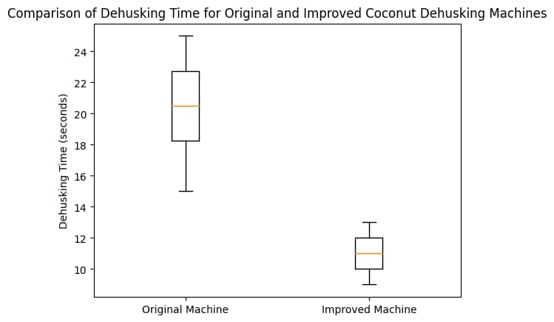
Figure 7: Box-and-whisker plot comparing the dehusking time of the original and improved machines

The box-and-whisker plot presented in Figure 7 further illustrates the distribution and variability of dehusking times for both machines. The improved machine exhibits a lower median value and a narrower interquartile range compared to the original machine, indicating reduced variability and improved consistency in performance. This confirms that the observed reduction in dehusking time is not limited to isolated samples but is consistent across all tested coconuts.
Energy Consumption Performance of the Original and Improved Machines
The energy consumption of the coconut dehusking machine was estimated using the product of the rated motor power and the recorded dehusking time for each trial. This approach is commonly used for preliminary and comparative energy evaluation of agricultural processing machines when direct electrical measurements are not available (Hunt, 2001). The method assumes steady motor operation at rated power and therefore provides an approximation of energy usage per coconut.

The energy consumption (power x time) of the original and improved coconut dehusking machines was evaluated using the product of motor power rating and dehusking time for each experimental trial. Although the improved machine operated at a higher power rating (3 hp) compared to the original machine (2 hp), the results indicate a noticeable reduction in energy consumed per coconut in most trials. This improvement is primarily attributed to the significantly shorter dehusking time achieved by the enhanced roller–blade mechanism. As presented in Table 4, the original machine recorded energy consumption values ranging from approximately 22.38 kJ to 37.30 kJ per coconut, while the improved machine exhibited a narrower range of about 20.14 kJ to 29.09 kJ. The average energy consumption per coconut was 30.0 ± 5.2 kJ for the original machine and 24.6 ± 3.3 kJ for the improved machine, confirming a reduction in both mean energy usage and variability despite the higher motor power rating. The lower average energy consumption and reduced variability observed for the improved machine demonstrate superior energy efficiency and more consistent performance. These results suggest that the improved machine is better suited for continuous operation, particularly in small- and medium-scale coconut processing facilities where minimising energy cost and improving productivity are critical considerations.

Table 4: Energy Consumption per Coconut for the Original and Improved Machines
Sample Number | Original Machine Energy (kJ) | Improved Machine Energy (kJ)
1 | 22.3 | 20.1
2 | 25.4 | 22.3
3 | 26.9 | 24.6
4 | 29..9 | 26.8
5 | 31.3 | 29.0
6 | 32.8 | 22.4
7 | 34.3 | 24.6
8 | 35.8 | 26.8
9 | 37.3 | 20.1
10 | 28.3 | 29.0
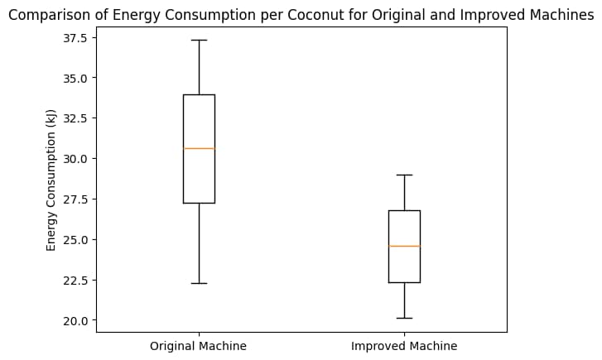
Figure 8: Comparison of energy consumption per coconut for original and improved machines
The box-and-whisker plot in Figure 8 shows that the improved machine has a lower median energy consumption and a smaller interquartile range compared to the original machine, indicating more efficient and consistent energy usage. Despite operating at a higher power rating, the improved 3 hp machine consumes comparable or even lower energy per coconut in several cases due to significantly reduced processing time.
It should be noted that the estimated energy consumption values do not account for transient load variations, motor efficiency, or mechanical losses within the transmission system. More accurate energy evaluation would require direct measurement of electrical parameters such as current and voltage during operation (Chapman, 2012). However, the adopted method remains suitable for relative performance comparison under identical operating conditions (Bathaei, 2023).
Discussion of Performance Improvements
The results obtained from this study clearly show that the improved coconut dehusking machine performed better than the original version in terms of dehusking time and overall efficiency. The improved machine achieved a dehusking time of 9–13 seconds per coconut, compared to 15–25 seconds recorded for the original machine. This reduction in processing time confirms that the design modifications introduced were effective in improving machine performance. Similar improvements have been reported in previous studies on coconut dehusking machines. For instance, Jimoh (2023) reported that a modified motorised coconut dehusking machine achieved an efficiency of about 90% with a processing capacity of approximately 122 coconuts per hour. However, when translated to time per coconut, their system still required a longer processing duration than the improved machine developed in the present study. This suggests that the current design offers faster operation under similar mechanical conditions.
In another related study, Adedipe (2024) developed a cost-effective coconut dehusking machine aimed at reducing manual effort. Although the machine improved safety and reduced physical stress, it recorded an average dehusking time of over 90 seconds per coconut, which is significantly higher than the values obtained in this study. The large difference highlights the advantage of the improved mechanical configuration used in the present work, particularly in terms of spike arrangement and torque transmission. The findings of this study also compare favourably with other locally developed machines reported in the literature. Olorunfemi (2022) recorded a processing capacity of about 80 coconuts per hour with an efficiency of 90.4% using a modified roller-based dehusking mechanism. By contrast, the improved machine in this study, operating at 9–13 seconds per coconut, corresponds to an estimated capacity of approximately 277–400 coconuts per hour under continuous operation. This places the machine among the higher-performing coconut dehusking systems reported in recent studies.
Studies that incorporated advanced design tools such as simulation and improved shaft alignment have also reported notable performance gains. Oluwayanmife (2026) documented a coconut dehusking machine capable of processing between 200 and 250 coconuts per hour. While their design employed more complex fabrication techniques, the improved machine in the present study achieved comparable or higher throughput using relatively simple mechanical improvements, making it more suitable for small- and medium-scale processors. Energy consumption is another important aspect of machine performance, especially for rural and small-scale users. Previous studies have shown that machines with shorter processing times generally consume less energy per unit of output (Owuama, 2025). In this study, the reduction in dehusking time directly translated to lower energy consumption per coconut when compared to the original machine. This improvement enhances the economic viability of the machine and supports its potential adoption in areas where energy cost and availability are critical concerns.
Overall, the results demonstrate that targeted mechanical improvements can significantly enhance the performance of a coconut dehusking machine. Compared with existing designs reported in the literature, the improved machine offers faster dehusking time, higher processing capacity, and better energy efficiency. These findings confirm that locally developed machines, when properly improved and evaluated, can compete favourably with more complex and expensive systems reported by other researchers.
CONCLUSION
This study presented the improvement and performance evaluation of a developed coconut dehusking machine to enhance operational efficiency and reduce processing time. The key design modifications were implemented on the existing machine, including improvements to the drive system, dehusking spike geometry, structural alignment, and overall machine stability. The performance evaluation results showed that the improved machine significantly outperformed the original design. Dehusking time was reduced from a range of 15–25 seconds to 9–13 seconds per coconut, demonstrating a clear improvement in processing efficiency. In addition, the improved machine exhibited lower energy consumption per coconut, which can be attributed to the reduced dehusking time and improved power transmission efficiency. The findings confirm that targeted mechanical improvements can lead to substantial performance gains in coconut dehusking machines. The improved machine offers a more efficient and practical solution for small- and medium-scale coconut processing operations, with the potential to reduce labour effort, processing time, and energy costs. Overall, the study provides useful insight into how design optimisation can enhance the performance of agricultural processing machines.

FUTURE RECOMMENDATION
Based on the findings of this study, further work is recommended to enhance the applicability of the improved coconut dehusking machine. Future studies may consider testing the machine under a wider range of operating conditions, including different coconut sizes and moisture levels. In addition, a detailed economic analysis could be carried out to assess the cost–benefit implications of the design improvements. Incorporating adjustable or automated features may also further improve usability and performance for large-scale processing applications.

COMPETING INTERESTS DISCLAIMER:
Authors have declared that they have no known competing financial interests OR non-financial interests OR personal relationships that could have appeared to influence the work reported in this paper.
Disclaimer (Artificial intelligence)
Author(s) hereby declare that NO generative AI technologies such as Large Language Models (ChatGPT, COPILOT, etc.) and text-to-image generators have been used during the writing or editing of this manuscript.

REFERENCES
- Adebimpe, A. M., Uguru-Okorie, D. C., Aribisala, A. A., & Lateef, A. K. (2024). Design of an automated coconut dehusking machine with radio frequency control and lead screw mechanism. FUDMA Journal of Sciences, 8(5). https://doi.org/10.33003/
- Adedipe, J. O. (2024). Enhancing coconut processing efficiency: Design and evaluation of a cost-effective coconut de-husking machine. Jurnal Riset Perkebunan, 5(2), 94–102. https://doi.org/10.25077/
- Bathaei, A., & Štreimikienė, D. (2023). Renewable Energy and Sustainable Agriculture: Review of Indicators. Sustainability, 15(19), 14307. https://doi.org/10.3390/su151914307
- Baskaran, M., Aruneshwaran, A. C., Shyam, K. S., & Sreeharan, B. N. (2024). Advancements in coconut dehusking technologies and future trends: A review. Journal of Advancement in Machines, 9(2).
- Budynas, R. G., & Nisbett, J. K. (2020). Shigley’s mechanical engineering design (11th ed.). New York, NY: McGraw-Hill Education.
- Chapman, S. J. (2012). Electric machinery fundamentals (5th ed.). New York, NY: McGraw-Hill.
- Hunt, D. (2001). Farm power and machinery management (10th ed.). Ames, IA: Iowa State University Press.
- Jimoh, R. O., Bello, M. K., Abiodun, L. O., Oyedokun, J. A., Oladipo, N. O., & Ogunjirin, O. A. (2023). Modification and performance evaluation of the NCAM motorised coconut dehusking machine. World Journal of Advanced Engineering Technology and Sciences, 09(01), 001–007. https://doi.org/10.30574/wjaets.2023.9.1.0120
- Juvinall, R. C., & Marshek, K. M. (2017). Fundamentals of machine component design (6th ed.). Hoboken, NJ: Wiley.
- Khurmi, R. S., & Gupta, J. K. (2018). Theory of machines. S. Chand Publishing.
- Nampoothiri, K.U.K. & Krishnakumar, V. & Thampan, P. & Nair, Achuthan. (2018). The Coconut Palm (Cocos nucifera L.) - Research and Development Perspectives. 10.1007/978-981-13-2754-4.
- Norton, R. L. (2019). Machine design: An integrated approach (6th ed.). Pearson Education.
- Oladimeji, T. E., Akinola, A. A., & Yusuf, K. O. (2021). Effect of design parameters on the performance of agricultural processing machines. Journal of Engineering and Applied Sciences, 16(3), 85–93.
- Olorunfemi, O. (2022). Development of a modified dehusking machine for local varieties of coconut. Covenant Journal of Engineering Technology.
- Oluwayanmife, J., Arogundade, I., Ayeni, O., & Akinnuli, O. (2026). Design, simulation and fabrication of a coconut dehusking machine. Journal of Engineering Research and Reports, 28(1), 13–24. https://doi.org/10.9734/jerr/2026/v28i11756
- Onyenanu, I., Madu, K., Nzenwa, C., & Madukasi, A. (2025). Appraisal of the structural integrity of a coconut dehusking machine frame using modal analysis. NIPES Journal of Science and Technology Research, 7(3), 365–372. https://doi.org/10.37933/nipes/7.3.2025.1423
- Owuama, K. C., Onyegirim, S. N. K., Nwankwo, E. I., & Onyenanu, I. U. (2025). Advancements in coconut dehusking technologies: A comprehensive review of mechanisation trends, performance metrics, and sustainability. IPS Journal of Engineering and Technology, 1(2), 101–110. https://doi.org/10.54117/ijet.v1i2.17
- Pascua, A. M., Pascua, M. L. L., & Peralta, E. K. (2018). Performance characteristics of a coconut dehusking machine. International Journal of Advances in Agricultural Science and Technology, 5(2).
- Rahman, M. M., Islam, M. S., & Hossain, M. A. (2020). Performance evaluation of a mechanical coconut dehusker. International Journal of Agricultural Engineering, 13(1), 45–52.
- Sarita, V. B., & Monton, K. R. (2025). Functionality, usability, and acceptability assessment of dual blade coconut dehusker. International Journal of Research in Innovation and Applied Science, 10–15. https://doi.org/10.51584/IJRIAS.2025.1002002
- Srivastava, A. K., Goering, C. E., Rohrbach, R. P., & Buckmaster, D. R. (2019). Engineering principles of agricultural machines (3rd ed.). ASABE.

