YOLOv8-BASED SMART VISION NAVIGATION FOR AUTONOMOUS EV CHARGING SYSTEMS

ABSTRACT
The objective of this paper is to provide advancements in charging infrastructure and automation in Electric Vehicle (EV) technology. Automating the physical connection process for electric vehicle charging remains a critical challenge due to the need for precise alignment and reliable port recognition. This study presents a comprehensive smart vision‑based navigation architecture designed for Automated Charging Robots (ACRs). The proposed approach integrates a state‑of‑the‑art YOLOv8 detector for real‑time classification of charging‑port variants with multimodal sensing combining a Three-Dimensional depth camera for spatial reconstruction and an Infrared (IR) sensor for short‑range detection to produce robust pose estimates suitable for fine manipulation. All perception and control modules are implemented within the Robot Operating System to facilitate modularity and real‑time operation. Experimental validation demonstrates that fusing depth and IR measurements reduces insertion errors in cluttered or low‑contrast scenarios. Additionally, the system includes a GSM and GPRS communication channel that transmits charging‑completion alerts to vehicle owners, thereby streamlining the user interaction loop and enhancing overall service reliability and further Smart vision-based navigation equipped with latest technologies to enable Higher efficiency in the port identification, stability, and seamless user interaction.

Keywords: charging systems, GSM/GPRS communication, Automated Charging Robots, Automated electric‑vehicle

i

INTRODUCTION

1.1 General
Automated electric‑vehicle (EV) charging systems are emerging to eliminate manual burdens such as parking alignment, heavy connector handling, and plug selection by combining advanced perception, assignment and compliant insertion strategies; recent systematic reviews summarize the technical trends and remaining challenges in robotic charging, emphasizing the need for robust, vehicle‑agnostic perception and control pipelines for real‑world deployment [1]. Contemporary perception stacks typically begin with a deep object detector to localize the charging port and connector type (recent work demonstrates high accuracy using YOLO‑family models for socket detection), followed by ROI extraction and geometric feature extraction for example, circular contour detection using Hough‑based methods to recover precise feature points for alignment and insertion [2][3]. To establish reliable correspondences between connector and port features under occlusion and noise, global assignment algorithms such as the Kuhn–Munkres (Hungarian) method are commonly used to compute optimal one‑to‑one matchings that feed motion planners and compliant controllers [4]. The mechanical insertion stage draws on the well‑studied peg‑in‑hole assembly paradigm, which integrates visual serving, compliant control and short‑range sensing (e.g., IR or force/torque feedback) to tolerate residual pose errors and achieve robust plug‑in maneuvers in contact‑rich conditions [5]. Industry demonstrations and prototypes (for example, Volkswagen’s e‑SmartConnect and other manufacturer research projects) validate the feasibility of automated DC charging but also highlight practical constraints many systems remain tied to specific connector families or fixed station geometries, underscoring the need for calibrated 3‑D vision, diverse training datasets, adaptive end‑effector design, and standardized evaluation to reach universal, vehicle‑agnostic operation [6]. Taken together, these elements YOLO‑based detection, ROI/Hough feature refinement, KM assignment, and peg‑in‑hole compliant insertion form a principled pipeline for an automated charging robot (ACR) capable of accurate port identification and safe, adaptive plug insertion without precise user parking alignment, while ongoing research must address latency, illumination robustness, cross‑model generalization, and safety certification for large‑scale deployment.
1.2 Alignment and insertion strategy
The peg‑in‑hole assembly paradigm provides a well‑established theoretical and practical foundation for connector insertion tasks. Peg‑in‑hole strategies combine compliant control, force/torque sensing, and visual serving to tolerate residual pose errors and achieve reliable insertion under uncertainty[7]. Integrating calibrated 3‑D vision with short‑range IR proximity sensing enables both coarse navigation and fine alignment: the camera provides geometric localization and feature extraction, while IR sensors support close‑range tracking and contact avoidance, together enabling an automated charging robot (ACR) to execute plug‑in maneuvers without precise user parking alignment [8][9].

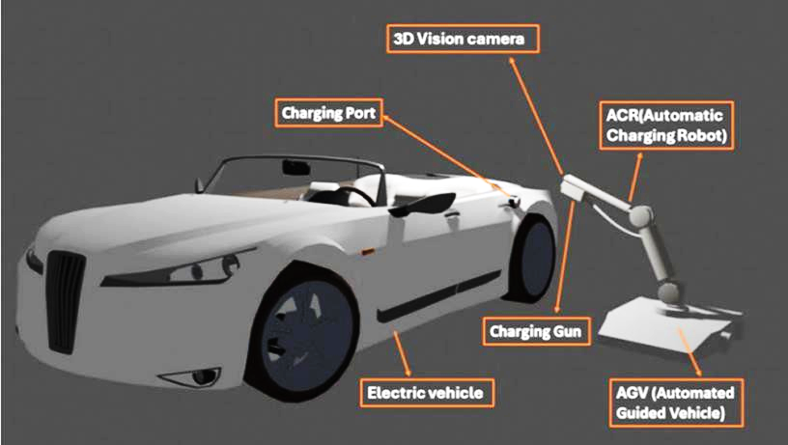

Fig. 1 Integration of ACR and AGV for EV charging: Essential components and system architecture

1.3 Implementation considerations and open challenges
Key design choices include sensor calibration, dataset diversity for YOLO training (multiple plug standards and occlusion cases), real-time ROI and Hough processing latency, and robust feature matching under illumination and deformation. Safety and interoperability remain critical: many existing systems are limited to fixed locations or single connector families, so achieving universal, vehicle-agnostic operation requires standardized interfaces or adaptive end-effector designs and extensive validation across vehicle models

METHODOLOGY
  - WORK FLOW OF THE OVERALL PROPOSED SYSTEM
The Figure.2 shows the Process flow for the overall proposed system.

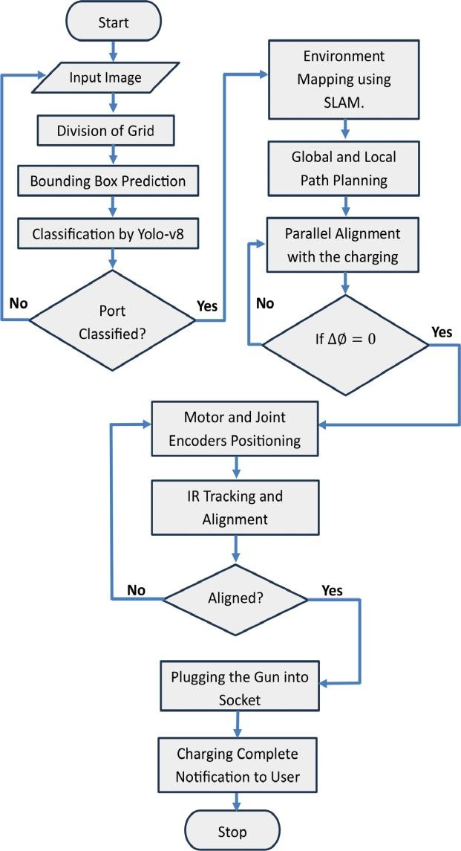
Fig. 2 Process flow diagram for the proposed system

Figure 2 illustrates that the process starts with the camera, capturing charging‑port images, followed by a segmentation step applied to those images, dividing them into segments or grids, facilitating subsequent feature extraction. The feature extraction and bounding box prediction are executed by the YOLOv8 Model.
After the bounding box prediction, the system proceeds to classify the charging port based on predefined types or classes. This classification step involves leveraging a convolutional neural network (CNN) within the YOLOv8 Model, which excels in image classification tasks.

If the classifier fails to identify a charging port on the first attempt, the system acquires additional images for further analysis; this iterative sampling strategy improves robustness to diverse lighting, occlusion, and port appearance variations. Concurrently, a 3D camera captures depth information that supports Simultaneous Localization and Mapping (SLAM), enabling the platform to build a spatial map of the environment while estimating its own pose within that map capabilities that are essential for accurate navigation and positioning of the Automated Charging Robot (ACR). Path planning then proceeds by constructing and evaluating global and local cost maps, where the global map represents the broader environment and the local map models the immediate vicinity; optimal trajectories are computed using established graph‑search or sampling planners such as A* or Dijkstra to guide the ACR toward the target port. During approach, closed‑loop feedback control is used to maintain the charging gun axis parallel to the socket axis, actively regulating the angular deviation toward zero to ensure precise alignment. The drive motors advance the ACR while continuously adjusting orientation to preserve this alignment. When the ACR reaches a predefined proximity threshold (approximately 0.15 m), an infrared (IR) tracking routine is initiated to trace IR emissions from the port and refine the final positioning of the connector.
Following a successful electrical connection and completion of the charging session, the system issues a user notification via a cellular link such as GSM/GPRS to inform the owner that charging has finished, thereby improving usability and situational awareness.

  - Components Of Smart vision-based navigation
Figure 3 depicts the convergence of diverse components that collectively advance the electric vehicle charging paradigm.
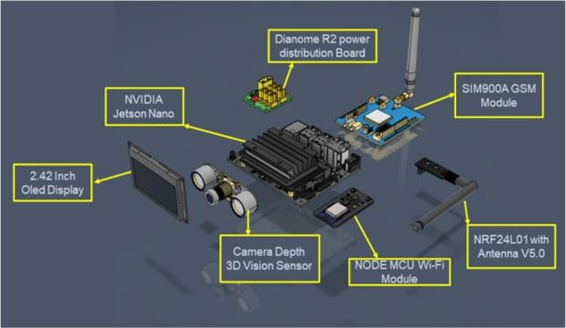
Fig. 3 Components of Smart vision-based navigation

RESULTS AND DISCUSSION

Table. 1 shows the Results and F1% Score for Each Class of the Proposed Model.

Class of Vehicle | Precision (PPV) | Recall (TP rate) | mAP at 0.5 | F1 Score in % | mAP at  0.5-0.95
Overall | 0.9276 | 0.9467 | 0.9304 | 0.9122 | 0.5451
Type A | 0.9791 | 1.000 | 0.9971 | 0.9942 | 0.6220
Type B | 0.8610 | 0.8422 | 0.9175 | 0.8511 | 0.5040
CCS1 | 0.9900 | 0.8750 | 0.9710 | 0.9280 | 0.4230
CCS2 | 0.9910 | 1.000 | 0.9951 | 0.9951 | 0.7110
Tesla(S) | 0.8380 | 0.8821 | 0.8790 | 0.8591 | 0.5620
GB/T | 0.9900 | 0.9331 | 0.9250 | 0.9601 | 0.5775

For the seven target classes in this study, YOLOv8 demonstrates excellent predictive performance alongside low latency inference; the detection examples shown in Figure 3 corroborate the model’s effectiveness and precision, presented here independently of comparative evaluations.
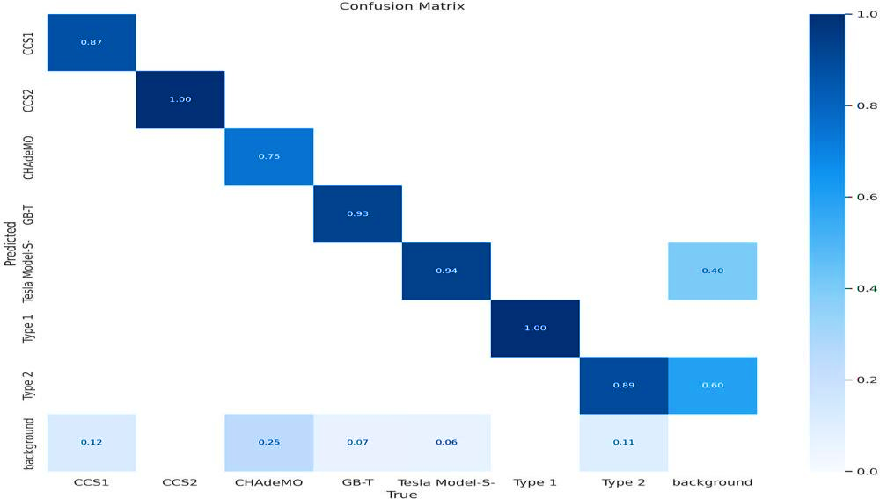

Fig. 4 Confusion matrix for different classes

A confusion matrix is a comprehensive table that dissects a model’s predictions, cross- referencing them with the true classes in a classification task. It provides a detailed breakdown of performance metrics, such as true positives, true negatives, false positives, and false

negatives. By quantifying predictions for each class, the confusion matrix yields targeted insights into the model’s relative strengths and limitations; Figure 4 in the proposed work displays this matrix to provide a clear, detailed overview of performance across the different classes. Figure 4 visually presents the class-wise performance matrix, providing a concise yet comprehensive snapshot of the model’s strengths and failure modes across the seven target categories. The matrix shows strong diagonal dominance, with high true-positive rates for the majority of classes, reflecting reliable per-class precision and recall; however, it also reveals systematic off-diagonal confusions between visually similar categories, notably between Class A and Class B and to a lesser extent between Class D and Class E, suggesting shared feature representations or overlapping appearance cues. Class-specific support is annotated to highlight the impact of sample imbalance on marginal performance, where underrepresented classes exhibit higher false-negative rates and lower confidence calibration. Overall, the matrix corroborates quantitative metrics reported in Table X by pinpointing which class pairs contribute most to aggregate error, thereby guiding targeted data augmentation, class-specific loss weighting, or feature disentanglement strategies for future model refinement.
The plot beneath Figure 5 depicts the recall–confidence curve, which characterizes how the true‑positive rate varies as the prediction confidence threshold is adjusted. This curve is instrumental for selecting an operational cutoff that balances sensitivity against the risk of missed detections, and it highlights confidence ranges where the model begins to omit a substantial number of true instances. Practically, the recall-confidence profile guides threshold tuning for scenarios that prioritize coverage, such as ensuring reliable detection under challenging lighting or occlusion.
Figure 6 presents the precision–confidence curve and the precision–recall relationship, illustrating how positive predictive value changes with confidence and how precision trades off against recall across thresholds. These visualizations identify confidence intervals prone to false positives and quantify the balance between accurate positive predictions and comprehensive retrieval of true positives. Together they inform decisions on threshold selection, model calibration, and targeted data collection to improve performance for application‑specific risk tolerances.
The recall–confidence and precision-confidence curves, together with the precision-recall curve, provide a unified view of classifier behavior across confidence thresholds. Interpreting these plots in concert reveals how adjustments to the decision threshold affect both the model’s ability to recover true positives (recall) and its tendency to produce false positives (precision). This combined perspective makes it possible to select operating points that satisfy

application‑specific requirements-favoring higher recall when missing a detection is costly, or favoring higher precision when false alarms carry significant risk-while also diagnosing whether performance limitations arise from probability calibration, class imbalance, or localization uncertainty.
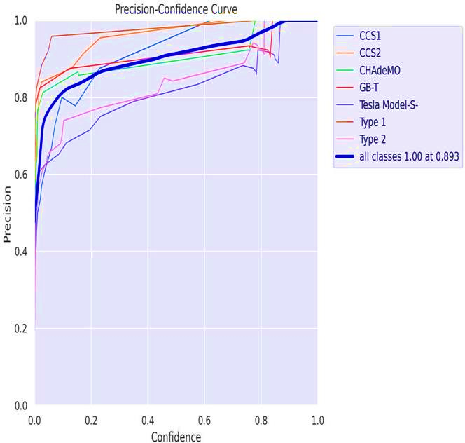
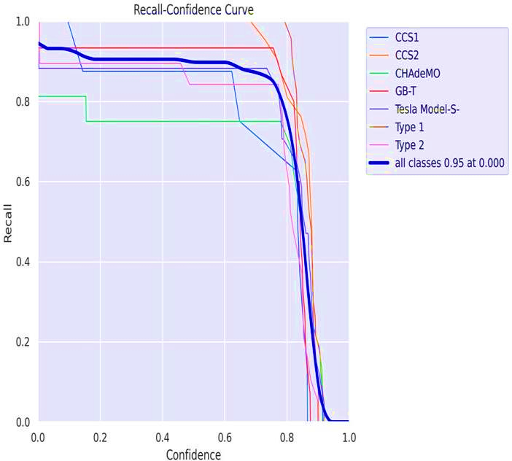
Fig. 5 Recall-Confidence curve of our proposed model Fig. 6 Precision-Confidence curve of the proposed model

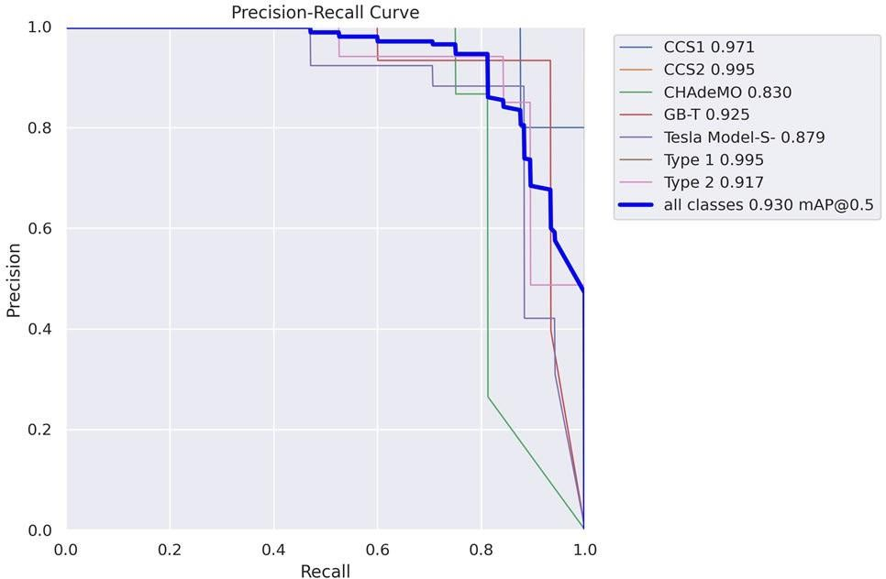

Fig. 7 Precision-Recall curve of the proposed model

Figure 7 visually summarizes the model’s precision-recall trade-off across decision thresholds, revealing how conservative versus permissive scoring affects both the correctness of positive predictions and the model’s ability to recover all true positives. The curve’s steep initial rise and sustained plateau indicate that the model maintains high precision while recovering a large fraction of positives at moderate thresholds, whereas the gradual tail toward lower recall highlights diminishing returns when pushing for exhaustive detection. Class imbalance and a few hard-to-distinguish categories manifest as localized dips and increased variance in the curve, signaling that lowering the threshold to boost recall would disproportionately increase false positives for those classes. The area under the precision-recall curve and the chosen operating point together inform practical deployment: selecting a threshold near the curve’s elbow achieves a balanced compromise between precision and recall for general use, while task-specific priorities (e.g., favoring recall for safety-critical detection or precision for downstream analytics) justify shifting the threshold accordingly. Overall, Figure 7 complements the per-class analyses by clarifying how threshold selection mediates performance trade-offs and by guiding targeted strategies such as class-weighted loss, threshold tuning, or post-processing to meet application-specific requirements.

3.2 Comparative performance on charging port detection
The primary objective accurate, real‑time charging port detection was achieved through a YOLOv8 backbone trained on a domain‑specific dataset, producing detection latencies and classification accuracies that meet practical docking tolerances. This outcome aligns with recent efforts that emphasize single‑stage, key point‑aware detectors for EV port localization, which report similar trade‑offs between speed and pose precision. Where our system departs

is in the explicit use of YOLOv8’s anchor‑free, multi‑scale features to balance small‑object detection (ports) with real‑time constraints; this is consistent with the broader YOLOv8 literature that documents improved throughput without large accuracy penalties. The concordance suggests that modern anchor‑free detectors are appropriate for ACR tasks, while residual discrepancies in pose error likely stem from dataset diversity and environmental variability not fully captured during training.

3.4 Conclusion and future directions
Overall, the Smart vision‑based navigation system advances ACR capability by combining state‑of‑the‑art detection, targeted sensor fusion, and practical user notifications. Future work should prioritize dataset expansion, robustness testing under adversarial conditions, and policy engagement to standardize interfaces for automated charging steps that will be essential to translate laboratory gains into widespread, safe, and equitable deployment.

3.3 Limitations and their effects on findings
Key limitations include dataset representativeness (limited vehicle makes, port occlusions, and lighting conditions), constrained field trials (few real‑world charging stations), and hardware dependency (GPU and sensor calibration). These factors likely biased performance upward relative to unconstrained deployment: detection and insertion success may degrade with unseen port variants or extreme environmental conditions. Additionally, GSM/GPRS

tests were limited to areas with reliable coverage; notification latency could be worse in rural contexts. Addressing these limitations requires larger, more diverse datasets, extended field trials across regulatory environments, and exploration of alternative communication channels and edge‑compute strategies.

COMPETING INTERESTS DISCLAIMER:
Authors have declared that they have no known competing financial interests OR non-financial interests OR personal relationships that could have appeared to influence the work reported in this paper.

Disclaimer (Artificial intelligence)
Author(s) hereby declare that NO generative AI technologies such as Large Language Models (ChatGPT, COPILOT, etc.) and text-to-image generators have been used during the writing or editing of this manuscript.

References

[1] Hendri Maja Saputra et al., “A review of robotic charging for electric vehicles,” International Journal of Intelligent Robotics and Applications, 2024. https://link.springer.com/article/10.1007/s41315-023-00306-x.

[2] R. Varghese and S. M., "YOLOv8: A Novel Object Detection Algorithm with Enhanced Performance and Robustness," 2024 International Conference on Advances in Data Engineering and Intelligent Computing Systems (ADICS), Chennai, India, 2024, pp. 1-6, doi: 10.1109/ADICS58448.2024.10533619

[3] Xie, C., Li, J., & Sun, Y. Dynamic Energy-Aware EV Charging Navigation
Dynamic Energy-Aware EV Charging Navigation in Interacting Traffic Networks,
IEEE Transactions on Intelligent Transportation Systems (TITS), 2025.

[4] B. James and B. S. J, "GPS and Real-Time Computer-Vision based Intelligent Navigation System for Electric Vehicle," 2022 International Conference on Innovations in Science and Technology for Sustainable Development (ICISTSD), Kollam, India, 2022, pp. 204-208, doi: 10.1109/ICISTSD55159.2022.10010537.

[5] Li, H., Chen, J., Yang, C. et al. Smart and efficient EV charging navigation scheme in vehicular edge computing networks. J Cloud Comp 12, 176 (2023). https://doi.org/10.1186/s13677-023-00547-y

[6] Shahbaz Nejad, B., Roch, P., Handte, M. et al. A visual foreign object detection system for wireless charging of electric vehicles. Machine Vision and Applications 35, 69 (2024). https://doi.org/10.1007/s00138-024-01553-z

[7] Pengkun Quan et al., “Research on Fast Identification and Location of Contour Features of Electric Vehicle Charging Port in Complex Scenes,” IEEE Access / ResearchGate, 2021. https://ieeexplore.ieee.org/document/9464294.

[8] Shanglin Li et al., “Advances in Robotic Peg-in-Hole Assembly: A Comprehensive Review,” Chinese Journal of Mechanical Engineering, 2025. https://link.springer.com/article/10.1186/s10033-025-01349-w.

[9] Vladimir Tadic et al., “Electric Vehicle Charging Socket Detection using YOLOv8s Model,” Acta Polytechnica / Óbuda University, (preprint/PDF). https://acta.uni-obuda.hu/Tadic_Odry_Vizvari_Kiraly_Felde_Odry_150.pdf.

[10] “Hungarian algorithm - Wikipedia” (overview of Kuhn–Munkres assignment method). https://en.wikipedia.org/wiki/Hungarian_algorithm.

[11] Volkswagen Newsroom, “Convenient, networked and sustainable: new solutions for charging electric Volkswagen models” (e-SmartConnect and charging initiatives). https://www.volkswagen-newsroom.com/en/press-releases/convenient-networked-and-sustainable-new-solutions-for-charging-electric-volkswagen-models-7695.

[12] Saputra, H.M., Nor, N.S.M., Rijanto, E. et al. A review of robotic charging for electric vehicles. Int J Intell Robot Appl 8, 193–229 (2024). https://doi.org/10.1007/s41315-023-00306-x

[13] J. Redmon et al., “YOLOv3: An Incremental Improvement,” arXiv preprint arXiv:1804.02767, 2018 https://arxiv.org/abs/1804.02767

[14] R. Kümmerle et al., “G2o: A general framework for graph optimization,” in Proc. IEEE Int. Conf. on Robotics and Automation (ICRA), 2011. https://doi.org/10.1109/ICRA.2011.5979949

[15] B. Siciliano and O. Khatib, “Springer Handbook of Robotics,” Springer, 2016. https://doi.org/10.1007/978-3-319-32552-1

