Original Research Article

Gain Enhancement in 2.4 GHz Rectangular Microstrip Antenna Arrays Using Hybrid Corporate–Series Feeding

ABSTRACT:
A robust antenna design that addresses the growing demand for compact, high-performance wireless devices remains a major challenge, particularly in achieving high antenna gain while maintaining compact size and acceptable bandwidth in microstrip antenna arrays. This paper presents the design, simulation, and performance analysis of rectangular microstrip antennas fed using different techniques at 2.4 GHz. Four antenna configurations were investigated: an inset-fed single-band rectangular microstrip antenna (RMSA), two corporate-fed RMSA arrays (1 × 2 and 1 × 4), and a 2 × 2 corporate–series-fed (hybrid-fed) RMSA array. All antenna dimensions and feed network parameters were optimized through parametric tuning using CST Studio Suite, guided by transmission-line model equations to achieve impedance matching, gain enhancement, and acceptable bandwidth performance. Simulation results show that show that the single-band antenna achieved an impedance bandwidth of 68.3 MHz (2.85% fractional bandwidth). The corporate-fed 1 × 4 array exhibited a bandwidth of 44.33 MHz (1.85%), while the 1 × 2 corporate-fed and 2 × 2 hybrid-fed arrays achieved bandwidths of 33.06 MHz (1.38%) and 50.41 MHz (2.26%), respectively. A comparative evaluation of antenna gains reveals that the hybrid-fed 2 × 2 RMSA array provides superior gain performance compared to the other configurations, demonstrating its effectiveness in overcoming the gain–bandwidth–size trade-off inherent in microstrip antenna arrays. The achieved bandwidth and gain characteristics make the proposed antenna suitable for compact ISM-band WLAN devices, while the array configurations are recommended for less size-constrained wireless applications.

Keywords: [Microstrip, array antenna, cooperative-fed, series-fed, bandwidth, inset-fed].

1.0 INTRODUCTION

Wireless systems cannot function without antennas. The bulk of antenna applications are in telecommunications, which is where they are most frequently encountered [1] [2]. According to [3], whereas a transmission line requires a guiding structure (typically one conductor), antennas require no guiding structure. As defined by [4], an antenna is an electrical device that transmits electromagnetic waves into space by converting electric power given at the input into radio waves and at the receiver side, which intercepts these radio waves and converts them back into electrical energy.

In the field of telecommunication, antennas fabricated with the aid of a photolithographic process on a printed circuit board (PCB) are known as microstrip antennas or printed antennas [5]. According to [6] and [7], microstrip antenna offers desirable flexibility and versatility in terms of fields of application. This is mainly due to their inherent characteristics such as lightweight, low-profile structure, low cost of production, and robust nature. Despite the versatility of microstrip antennas (MSAs), they are limited in gain and bandwidth performance.

Different authors have proposed several methods to improve the performance of MSAs. As stated by [8], array configuration is usually adopted to enhance the gain of MSAs. However, [9] in his work reported that the array feed, to a large extent, determines the gain improvement achieved.
In this paper, MSA arrays with diverse feeding techniques are presented to understand the effect of the feeding scheme on the realized antenna gain. This report is arranged in sections: section 1 looks at the introduction to the study, some related articles are reviewed in Section 2 and the design methodology is presented in Section 3. Results achieved are summarized in section 4 which is briefly followed by a conclusion with reference appended thereafter.
2.0 Review of related literature

A number of rectangular microstrip antenna arrays have been the subject of numerous research publications. These researchers used a variety of design strategies, setups, and electromagnetic simulators to determine the performance parameters of their antenna.

Ali and Khawaja [10] designed, optimised, and simulated a $2×2$ rectangular U-slot microstrip patch antenna array for wireless sensor networks at 2.1 GHz and 3.5 GHz frequencies. Multiple-Input Multiple-Output (MIMO) applications for high-speed wireless sensor networks (WSNs) based communication standards in the 1-5 GHz frequency range were the focus of their antenna design. The antenna simulation was done in Agilent ADS Momentum utilising Rogers TMM3 substrate ($ε_{r}=3.27$ and $h=6.35 mm$). Minimum return losses were -19 and -17 dB at 2.1 and 3.5 GHz. At 2.1 GHz, the $2×2$ U-slot rectangular patch antenna array attained the greatest gain of 11 dBi. The antenna met its design objectives, although no specific design equation was presented for the patch, U-slot on the patch, and patch feed, and as stated by the authors, all antenna optimization was done on the software platform, negating the standard for antenna design equations.

A $4×4$ microstrip patch antenna array for near-field focused operation at 2.4 GHz at 800 mm from the reference origin was presented by [11]. The $36 mm × 28 mm$ rectangular patch antenna used an inset-fed method on a 1.6 mm thick FR-4 dielectric substrate. The antenna array resonated at 2.39 GHz with -56 dB return loss. At 2.4 GHz, return loss was -17 dB, below the threshold of -10 dB. The report stated that the antenna had a 50 MHz -10 dB bandwidth.

Akaninyene et al. [12] presented $1×2$ and $1×4$ symmetrical one-dimensional antenna arrays. Using transmission line model equations and an inset feed approach at 2.4 GHz, the scientists used rectangular geometry on a Roger/RT Duroid substrate with a dielectric constant of 2.2 Compared to the 1x2 and 1x4 antenna arrays, the single patch (5.26 dB) has a notable antenna gain enhancement (10.29 dB). However, the minimal return loss showed that the 1x2 and 1x4 antenna arrays' VSWR was above 2, indicating impedance mismatch at the specified frequency.

Sivia et al. [13] proposed a 1x4 triple band rectangular microstrip patch antenna array with operating frequencies between 8 – 12 GHz using Roger/RT Duroid substrate material with a dielectric constant of 2.2 and a thickness of 1.6 mm. The authors adopted transmission line model equations with a stripline feeding method of design. This was used to compute the dimensions of the patch and the corresponding feed lines. The results obtained showed that the antenna achieved minimum return losses of -11.8 dB, -12.9 dB, and -9.4 dB at 8.86 GHz, 9.16 GHz, and 11.01 GHz frequencies, respectively. In terms of gain and directivity, the authors reported gains of 9.95 dB, 10.76 dB, and 7.97 dB with directivities of 13.11 dB, 12.65 dB, and 11.25 dB at corresponding frequencies of 8.86 GHz, 9.16 GHz, and 11.01 GHz frequencies. A rule of thumb in microstrip antenna design is to achieve a VSWR below 2 and a minimum return loss that is below the -10 dB mark as proof of effective impedance match at exact or approximately the designed frequency. From observation, the proposed antenna fell short of meeting the desired triple band as outlined in their objective.

Recent studies have explored various feeding techniques and optimization methods to enhance the performance of microstrip antennas and arrays. For example, Obiadi et al. [14] conducted a comparative analysis of corporate, series, and hybrid-fed arrays at 2.4 GHz, demonstrating the impact of feed networks on gain and bandwidth.
Additionally, Saeed and Nwajana [15] reported optimized rectangular microstrip array designs for contemporary wireless applications, highlighting trends in compact array performance at higher frequencies.
A recent survey by Ahmed et al. [16] also reviews strategies for bandwidth and gain enhancement in microstrip antennas, offering a broader context for optimization challenges addressed in this work.
3.0 methodology
This section presents the design steps for single band RMSA at 2.4 GHz followed by the considerations for the design of multi-element antenna arrays proposed.
3.1 Single Band Patch Antenna Design
The proposed antennas have basic rectangular patch shapes, FR-4 substrate with a dielectric constant ($ε_{r}$) = 4.2, loss tangent (tanδ) = 0.019 and resonant frequency ($f_{r}$) = 2.4 GHz, respectively. The height (h) of the substrate is determined from Equations (1) and (2) [6]:
h $≤$ 0.3 x $\frac{λ_{0}}{2π\sqrt{ε_{r}}}$ (1)
$λ_{0}$ = $\frac{c}{f_{r}}$ (2)
A single-band microstrip antenna with a centre frequency of 2.4 GHz is first designed using transmission line model equations obtained from [6], [17], [18]. The rectangular patch structure acts as a resonator; thus, the length and width of the patch are typically selected in such a way that $L_{P}$ $<$ ${ W}_{P}$ $<$ 2$L_{P}$ for efficient and enhanced radiation. The design equations used for the rectangular microstrip patch are itemized as follows:
- The width $\left(W_{P}\right)$ of the microstrip patch is computed from Equation 3.
$W_{P}$ = $\frac{C}{2f_{r}\sqrt{\frac{(ε_{r}+1)}{2}}}$ (3)
- The effective dielectric constant ($Ԑ_{reff}$) is obtained from Equation 4.
$Ԑ_{reff}=\frac{Ԑ_{r}+1}{2}+\frac{Ԑ_{r}-1}{2}\left.{\left[1+12\left(\frac{h}{{ W}_{P}}\right)\right]}^{-1/2}\right.$ (4)
- The effective length $L_{eff}$ of the patch is calculated from Equation 5.
$L_{eff}= \frac{c}{2f_{r}\sqrt{Ԑ_{reff}}}$ (5)
- The length extension $\left(∆L\right)$ is deducted from the length of the patch$\left(L_{P}\right)$ with the actual length of the patch unchanged (in most cases). The length extension is considered due to the fringing field as seen in Equation 6.
ΔL = 0.412h $\frac{\left[Ԑ_{reff}+0.3\right]\left[\frac{W}{h}+0.264\right]}{\left[Ԑ_{reff}-0.258\right]\left[\frac{W}{h}+0.813\right]}$ (6)
- Calculation of the actual length of the patch (${ L}_{P}$) is done using Equation 7.
$L_{eff}$ = $L_{P}$ +2Δ (7)
$L_{P}$ = $L_{eff}$ - 2ΔL (8)
- Calculation of the ground plane dimensions (Lg and Wg): For both finite and infinite ground planes, the size of the ground plane must be greater than the patch dimensions by approximately six times the substrate thickness (h) all around the patch periphery [6]. Hence, for this design, the ground plane dimensions are calculated thus:
Lg = $L_{P}$ + 6h (9)
Wg =${ W}_{P}$ + 6h (10)
vii) Determination of the patch thickness (t): The metallic patch is selected to be very thin such that t << ${ λ}_{0}$.

3.2 Cooperate-fed MSA Array Design
The cooperate-series-fed 2 x 2 MSA antenna array proposed in this study comprises two primary patches and two secondary patches. The primary patches are patches that are directly linked to the feed network, while the secondary patches are those that are fed directly from the primary patches. To reduce the complexity of the feeding network of the proposed cooperate-series-fed 2 x 2 MSA array, inset-fed technique is adopted for the primary patches using available computational formulas to determine the dimensions of the feed network as itemized in the following steps:
Step 1: Calculate the notch width, g using the equation from [19] as given in Equation 11.
g = $\frac{c f_{r} × {10}^{-9} ×4.65 × {10}^{-9} }{\sqrt{{2ε}_{reff}}}$ (11)
Step 2: Calculate the resonant input resistance R_{in} thus;
$R_{in}(y=y_{o})=\frac{1}{2\left(G_{1}+ G_{12}\right)}\cos^{2}\left(\frac{πy_{o}}{L_{p}}\right)$ (12)
The equation for the characteristic impedance Z_{o} is given as;
$Z_{0}=\left\{\begin{aligned}\frac{60}{\sqrt{ε_{reff}}} \ln\left[\frac{8h}{W_{f}}+ \frac{W_{f}}{4h}\right] for \frac{W_{f} }{h} ≤1 \\ \frac{120π}{\sqrt{ε_{reff}}}\left[\frac{W_{f}}{h}+1.393+ 0.667\ln\left(\frac{W_{f}}{h}+1.444\right)\right] for \frac{W_{f} }{h} ≥1\end{aligned}\right.$ (13)
$I_{1}=-2+\cos\left(X\right)+XS_{i}\left(X\right)+\frac{\sin\left(X\right)}{X}$ (14)
$X=kW_{p}$ (15)
G₁ = $\frac{I_{1}}{120π^{2}}$ (16)
G₁₂ = $\frac{1}{120π^{2}} \int_{0}^{π}{{\left[\frac{sin⁡(\frac{kW_{p}}{2}cosθ)}{cosθ}\right]}^{2}J_{o}(kL_{p}sinθ)\sin^{3}θdθ}$ (17)
where J_{o} is the Bessel function of the first kind of order zero. G₁₂ is resolved using a MATLAB-based program developed for the calculation of rectangular microstrip antenna parameters.
Step 3: Calculate the inset feed recessed distance $y_{0}$ and the width of the transmission line $W_{f}$ thus;
Z₀ = R_{in(edge)} $\cos^{2}(\frac{π}{L_{p}}y_{0})$ (18)
$y_{0}= \frac{L_{p}}{π} \cos^{-1}\left[\sqrt{\frac{Z_{0}}{R_{in(edge)}}} \right]$ (19)
According to [20], the width of the transmission line is calculated thus, for $\frac{W_{f}}{h} >2$, Equation 20 was used.
$\frac{W_{f}}{h}=\frac{2}{π}\left[B-1-\ln\left(2B-1\right)+\frac{ε_{r}-1}{{2ε}_{r}}\left\{\ln\left(B-1\right)+0.39-\frac{0.61}{ε_{r}}\right\}\right]$ (20)
where, $B=\frac{377π}{2Z_{0}\sqrt{ε_{r}}}$
The summary of the inset feed dimensions computed is presented in Table 1.

Table 1: Design dimensions of 2.4 GHz single band inset-fed RMSA

Design Parameter | Values
Patch dimensions:
Length ($L_{p}$)  Width ($W_{p}$)  Dielectric constant ($ε_{r}$)  Substrate height (h)  Patch thickness (t) | 29.52 mm  37.97 mm  4.2  1.60 mm  0.035 mm
Ground plane dimensions:
Length of ground plane ($L_{g})$  Width of ground plane ($W_{g}$) | 39.12 mm  47.57 mm
Feed line dimensions:
Width of transmission line ($W_{f}$)  Inset fed gap (g$)$  Inset fed distance (${ y}_{0})$  Length of 50 Ω line $\left(L_{f}\right)$  Characteristic impedance of the feed line ($Z_{0}$) | 3.30 mm  1.20 mm  11.12 mm  4.80  50 Ω

The schematic diagram of the designed 2.4 GHz inset-fed antenna is depicted in Figure 1 while the designed antenna in CST studio is given in Figure 2.
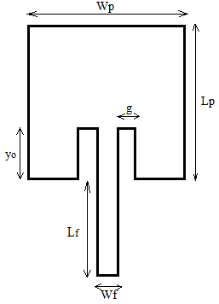
Figure 1: Schematic diagram of inset-fed MSA at 2.4 GHz

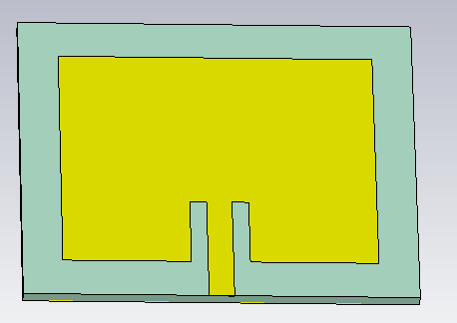
Figure 2: Model of 2.4 GHz inset-feed Single Band MSA in CST studio
The proposed array configuration is principally comprised of four rectangular microstrip patch antennas with two feeding methods for the primary and secondary patches. The corporate feed network was used for transmission and collection of power for the primary patches while series feed was employed for the secondary patches. A typical cooperate feed network is subdivided into three parts:
- Microstrip Lines
- Microstrip T-Junctions power divider
- Mitred Bends

i. Microstrip Lines: A microstrip line feed of $Z_{0}=$50 Ω ramose off into two feed lines of $2Z_{0}$ ($Z_{1}=2×50=100 Ω$) capacity which further branches into a $Z_{2}=70.7 Ω$ feed line as expressed in Equation 21 is used in a parallel array feed network for the proposed antenna.
$Z_{1}=$ $\sqrt{Z_{0} Z_{1} }$ (21)
ii. Microstrip T- T-junction power divider: The T-Junction power divider/splitter is a three-port network similar to the Wilkinson 3 port power divider but it does not have any isolation between the output ports as illustrated in Figure 3 [21].
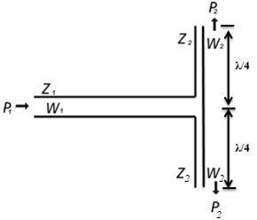
Figure 3: Microstrip T-junction

$P_{1}$ is the input port with an impedance of $Z_{1}=Z_{0}$ and a width of $W_{1}=W_{f}$ . The power at $P_{1}$ is split into two outputs, ${2P}_{2}$.
iii. Mitred Bend: A mitred bend is illustrated in Figure 4.
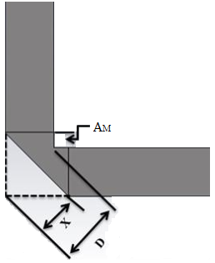
Figure 4: Microstrip mitred bend

Expressions for $A_{M}$, X and D are given by Equations 22 to 24 as:
$D=W×\sqrt{2}$ (22)
where W is the width of the transmission line and h is the height of the substrate.
$X=D×\left[0.52+0.65e^{\left(-1.35\frac{W}{h}\right)}\right]$ (23)
$A_{m}=\left(X-\frac{D}{2}\right)×\sqrt{2}$ (24)
Table 2 gives a summary of the computed dimensions of the patch and feed network of the proposed array antennas.

For simplicity, it was necessary to start by first designing a 1 x 2 MSA array at 2.4 GHz which served as a template for both the 1 x 4 cooperate-fed antenna array and the 2 x 2 cooperate-series-fed antenna array. The feed network design for the 1 x 2 array antenna starts with a 50 Ω line branching off to a 100 Ω feed that is further transformed to a 70.71 Ω before the final branch that feeds the patch with a suitable impedance match as illustrated in the sketch showing the width corresponding to each impedance in Figure 5. The only difference between the 1 x 2 feed network and that of the 1 x 4 cooperate feed is that in the cooperate-fed 1 x 2, the final feed stage of the cooperate feed (50 Ω) is repeated to achieve a 4-element configuration as given in the schematic diagram of Figure 6.

Table 2: Proposed 2 x 2 cooperate-series-fed MSA array dimensions

Parameter | Value (mm)
Patch dimensions:  Length of patch, $L_{p}$ | 27.52
Width of patch, $W_{p}$ | $$39.97$$
Dielectric constant, $ε_{r}$  Height of substrate, h  Feed dimensions: | 4.2  1.60
Width of 50 Ω transmission line, $W_{f}$ | 3.30
Width of 70.7 Ω transmission line, $W_{3}$ | 1.05
Width of 100 Ω transmission line, $W_{2}$ | 0.50
Inset distance, $y_{o}$ | 11.12
Inset gap, g | 1.20
Length of transmission line, $L_{f}$ | 4.80
Length of quarter wave, $L_{q}$  Resonance Frequency, $f_{r}$ | 14.90  2.4 GHz
Ground plain dimensions:  Length of ground plain, $L_{g}$  Width of ground plan, $W_{g}$  Mitred bend dimensions: | 70  160
$$A_{m}$$ | 0.40
X | 2.62
D  Distance between Patches, d | 4.67  61.00

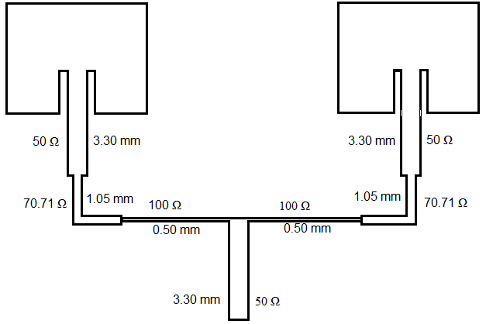
Figure 5: Schematic Diagram of Cooperate-fed 1 x 2 Antenna Array
Figures 7 to 9 give the model of the 1 x 2 and 1 x 4 MSA antenna array designed in CST Studio.
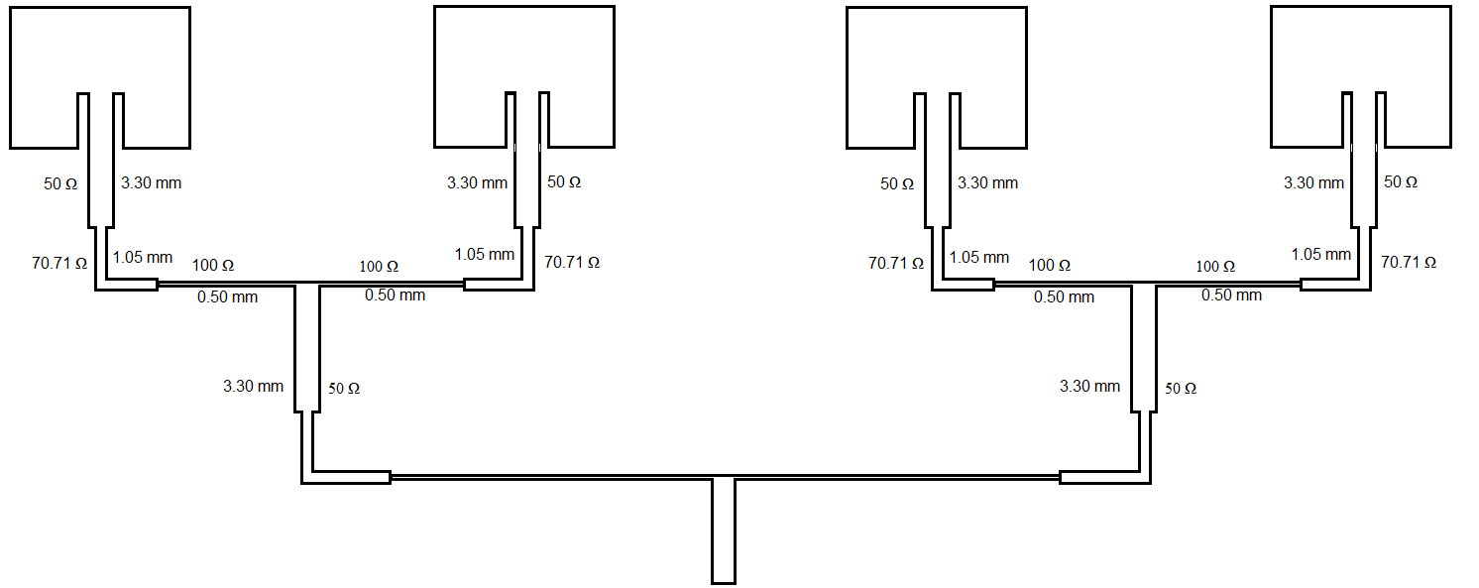
Figure 6: Schematic Diagram of Cooperate-fed 1 x 4 Antenna Array
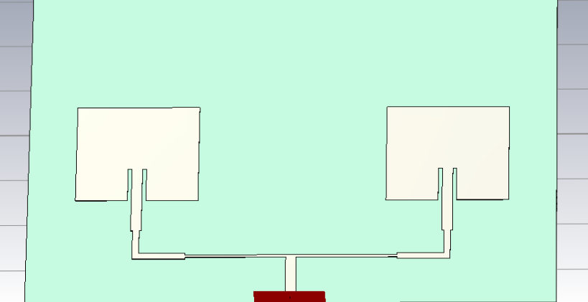
Figure 7: Model of 1 x 2 Cooperate-fed MSA Array
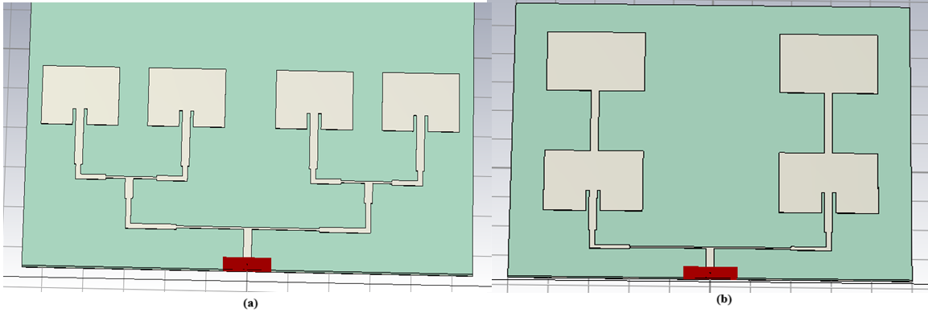
Figure 8: Model array antennas (a) 1 x 4 Cooperate-fed MSA (b) 2 x 2 Cooperate-series-fed 2 x 2 MSA Array
4.0 RESULTS AND DISCUSSION
The results and performance analysis of all antennas designed in section 3 are presented in this section. Results are presented in polar, two-dimensional (2-D), and three-dimensional (3-D) plots. Antenna parameters such as return loss, bandwidth, and gain were used to assess the proposed antennas’ performance.

4.1 Return loss
A minimum return loss of -26.394 dB at a resonance frequency of 2.416 GHz and an impedance bandwidth of 68.3 MHz was achieved by the inset-fed single-band antenna as given in Figure 9. The return loss plots of the $1×2$ and $1×4$ cooperate-fed antenna array are presented in Figures 10 and 11 from which minimum return loss of -22.901 dB and -31.898 dB at 2.368 GHz and 2.395 GHz resonance frequencies were achieved. Also, impedance bandwidths of 33.06 MHz and 44.33 MHz, respectively were achieved. Furthermore, a minimum return loss of -34.62 dB at 2.437 GHz was achieved by the proposed $2×2$ cooperate-series-fed array antenna along with an impedance bandwidth of 50.41 MHz as illustrated in Figure 12.
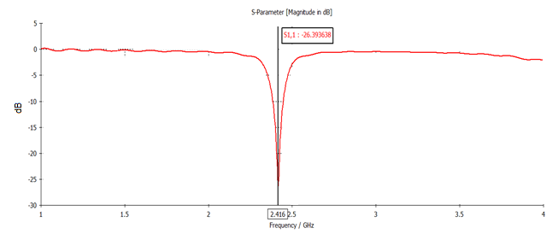
Figure 9: Return Loss plot of inset-fed single-band antenna
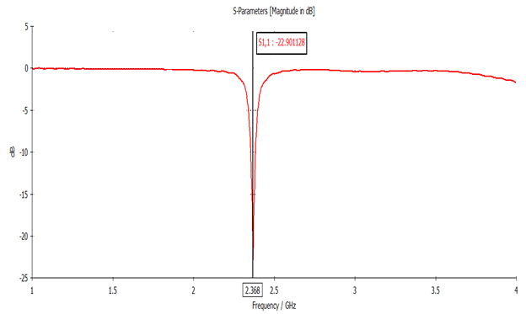
Figure 10: Return loss plot of the proposed $1×2$ cooperate-fed antenna array

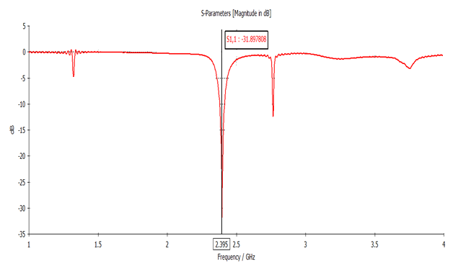
Figure 11: Return loss plot of the proposed 1 x 4 cooperate-fed antenna array
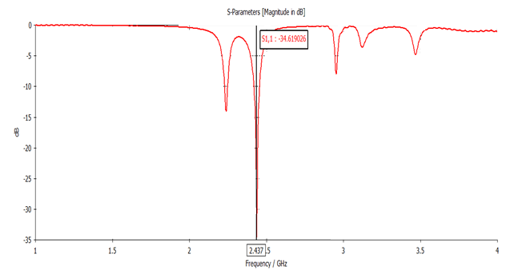
Figure 12: Return loss plot of the proposed $2×2$ cooperate-series-fed antenna array
Thus, the percentage impedance bandwidth of the antennas considered is presented as follows:
Using the mathematical expression given in Equation 25 from [22], the percentage bandwidth at 2.4 GHz of the antennas designed was calculated thus;
$\% bandwidth= \frac{f_{H} - f_{L}}{f_{C}}×100$ (25)
Inset-fed single-band Bandwidth = $\frac{2.4512-2.3829}{2.4} ×100\%$ = $2.85$
1 x 2 cooperate-fed array antenna - Bandwidth = $\frac{2.3876-2.3545}{2.4} ×100$ = $1.38 \%$
1 x 4 cooperate-fed array antenna - Bandwidth = $\frac{2.4187-2.3744}{2.4} ×100$ = $1.85 \%$
2 x 2 cooperate-series-fed array antenna - Bandwidth = $\frac{2.4322-2.3818}{2.4} ×100$ = $2.26 \%$
The percentage bandwidths obtained from the return loss plots give an interesting trend observed from the calculated values in that, a noticeable drop in bandwidth was noticeable in the arrays using a cooperate-feed network compared to the series-feed except for the combined-feed (hybrid-feed) that showed an improvement in bandwidth. However, in all the designs, the percentage bandwidth of the series-fed $1×4$ array antenna was higher than that of the counterpart arrays and the single-band antennas.
4.2 Gain of the Proposed Antenna
The IEEE 3-D gain of the inset-fed single-band antennas designed in section 3 is shown in Figure 13 from where it is seen that the antenna achieved a gain of 4.85 dB at 2.4 GHz.

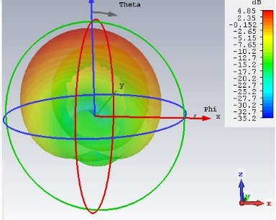
Figure 13: 3-D gain of inset-fed single band antenna at 2.4 GHz
The standard IEEE gain of 11.50 dB was achieved at 2.4 GHz by the $1×4$ cooperate-fed RMSA arrays as shown in Figure 14.

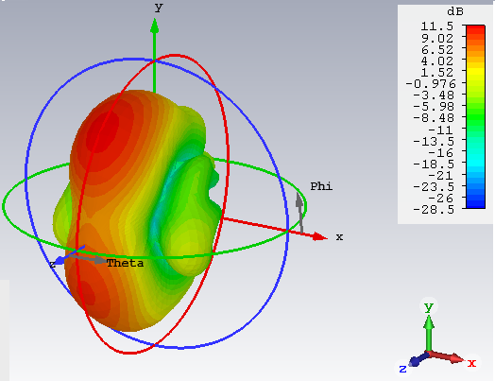
Figure 14: 3-D gain of proposed 1 x 4 cooperate-fed RMSA array at 2.4 GHz

The antenna gain of the $1×2$ cooperate-fed and $2×2$ cooperate-series-fed (hybrid) RMSA arrays are presented in Figure 15. While the $1×2$ cooperate-fed array achieved a gain of 10.1 dB is a significant improvement from the single band patch earlier designed, the $2×2$ hybrid-fed array showed a superior gain performance of 14 dB which is notably higher than that achieved by the $1×4$ cooperate-fed antenna array.

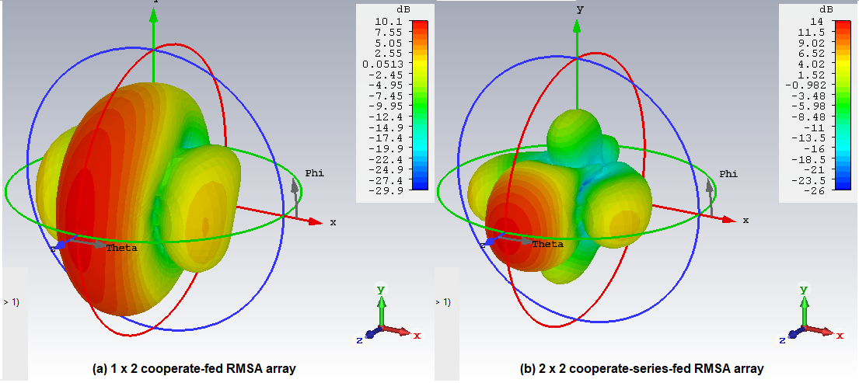
Figure 15: 3-D gain of 1 x 2 cooperate-fed and 2 x 2 hybrid-fed RMSA array at 2.4 GHz
From Table 3, it is evident that the reviewed works performed well, but none matched the performance of the proposed 2 x 2 RMSA array in terms of gain. Sizes of the different antennas would have been used as a yardstick for comparison only if they were all operating at the same frequency. Also, unlike bandwidth, combined gain performance is not an important measure used for antenna parametric comparison, hence the exclusion of dual-band antenna arrays in the comparison.

Table 3: Comparison of proposed 2 x 2 antenna array with some selected published works
Antenna | Gain (dBi) | $f_{r}$ (GHz) | Bandwidth (MHz)
[11] | 13.3 | 2.4 | 50
[12] | 10.29 | 2.4 | -
[8] | 13.2 | 2.4 | 30
Huquel et al. (2011) [23] |  | 10 | -
Kumar and Gupta (2013) [24] | 7.09 | 2.4 | 112
designed 1 x 4 series-fed | 5.08 | 2.4 | 152.07
designed 1 x 4 cooperate-fed | 11.5 | 2.4 | 44.33
Proposed 2x2 RMSA | 14 | 2.4 | 50.41

Table 4 presents a concise comparison of the electrical performance of the single patch antenna and the proposed array configurations, highlighting the gain enhancement achieved through array implementation.

Table 4: Comparative Performance of Single Patch and Array Antenna Configurations at 2.4 GHz

Antenna Configuration | Feeding Technique | Resonant Frequency (GHz) | Impedance Bandwidth (MHz) | Fractional Bandwidth (%) | Gain (dB)
Single Patch RMSA | Inset-fed | 2.416 | 68.30 | 2.85 | 4.85
1 × 2 RMSA Array | Corporate-fed | 2.368 | 33.06 | 1.38 | 10.10
1 × 4 RMSA Array | Corporate-fed | 2.395 | 44.33 | 1.85 | 11.50
2 × 2 RMSA Array | Hybrid-fed | 2.437 | 50.41 | 2.26 | 14.00

5. Conclusion
In this paper, four antennas - single band RMSAs (inset-fed), two cooperate-fed RMSA arrays (1 x 2 and 1 x 4), and a 2 x 2 cooperate-series-fed RMSA array at 2.4 GHz – have been designed, simulated, and analyzed. Results obtained show that bandwidths of 68.3 MHz which represent 2.85 % at 2.4 GHz, were achieved by the single-band antennas. The 1 x 4 arrays (cooperate-fed) achieved bandwidths of 4.33 MHz representing 1.85 %; while bandwidths of 33.06 MHz and 50.41 MHz which represent 1.38 % and 2.26% were achieved by 1 x 2 cooperate-fed and 2 x 2 hybrid-fed RMSA array. In terms of antenna gain the 2 x 2 hybrid-fed array antenna showed more superior gain than every other antenna studied.

Disclaimer (Artificial intelligence)
Option 1:
Author(s) hereby declare that NO generative AI technologies such as Large Language Models (ChatGPT, COPILOT, etc.) and text-to-image generators have been used during the writing or editing of this manuscript.
References
[1] Stutzman, W. L., & Thiele, G. A. (2013). *Antenna theory and design* (3rd ed.). John Wiley & Sons. https://www.wiley.com/en-us/Antenna+Theory+and+Design,+3rd+Edition-p-9780470576649
[2] U. M. Lambert, U. K. Michael, and O. A. Bernard, “Ultra-wideband Metamaterial-based Rectangular Microstrip Antenna for Sub-6 GHz 5G and other Microwave Applications,” J. Eng. Res. Reports, vol. 25, no. 7, pp. 1–10, 2023, DOI:10.9734/JERR/2023/v25i7932
[3] Razzaqi, A. A., Khawaja, B. A., Ramzan, M., Zafar, M. J., Nasir, S. A., Mustaqim, M., Tarar, M. A., & Tauqeer, T. (2014). A triple-band antenna array for next-generation wireless and satellite-based applications. International Journal of Microwave and Wireless Technologies, 8(1), 1-10. https://doi.org/10.1017/S1759078714001275
[4] Singh, I., & Tripathi, V. S. (2011). Micro strip Patch Antenna and its Applications: a Survey. *International Journal of Computer Applications in Technology, 2(5), 1595–1599. http://www.inderscienceonline.com/loi/ijcat
[5] E. Md.Mosharraf, A. Shabnam, “Design of microstrip patch antenna for 2.4 GHz application,” Int. J. Res. Trends Innov., vol. 7, no. 7, pp. 1–5, 2022. https://www.ijrti.org/papers/IJRTI2207019.pdf
[6] Balanis, C. A. (2005). Antenna theory: Analysis and design (3rd ed.). John Wiley & Sons. https://www.wiley.com/en-us/Antenna+Theory%3A+Analysis+and+Design%2C+3rd+Edition-p-9780471667827
[7] Utahile, A. D., Michael, U. K., & Bernard, O. A. (2023). Multiband Band and Dual Diversity Eight-Element MIMO Microstrip Antenna for Wireless Applications. Journal of Engineering Research and Reports, 25(7), 32–42. https://doi.org/10.9734/jerr/2023/v25i7935
[8] Khraisat, Y. S. H. (2011). Design of 4 Elements Rectangular Microstrip Patch Antenna with High Gain for 2.4 GHz applications. Mod. Appl. Sci., 6(1), 68–74. https://doi.org/10.5539/mas.v6n1p68
[9] Alsager, A. F. (2011). Design and Analysis of Microstrip Patch Antenna Arrays. (Master's thesis). University of Borås, School of Engineering. https://www.diva-portal.org/smash/record.jsf?pid=diva2%3A1312395
[10] M. Ali and B. A. Khawaja, “Dual BandMicrostrip patch antenna array for next generation wireless sensor network applications,” in PROCEEDINGS OF 2013 International Conference on Sensor Network Security Technology and Privacy Communication System, 2013, no. November 2016, pp. 39–43. https://doi.org/10.1109/SNS-PCS.2013.6553831
[11] Sohail, M. (2016). *Near Field Focusing of Rectangular Microstrip Patch Antenna Array* [Master's thesis, Eastern Mediterranean University]. http://hdl.handle.net/11129/2929
[12] Obot, A. B., Igwue, G. A., & Udofia, K. M. (2019). Design and Simulation of Rectangular Microstrip Antenna Arrays for Improved Gain Performance. International Journal of Networks and Communications. https://doi.org/10.5923/j.ijnc.20190902.02
[13] S. K. Sidhu and J. S. Sivia, “Analysis and Design Rectangular Patch with Half Rectangular Fractal Techniques,” Procedia Comput. Sci., vol. 85, no. Cms, pp. 386–392, 2016, https://doi.org/10.1016/j.procs.2016.05.247
[14] F., Obiadi & K., Udofia, & M., Udofia. (2024). Comparative Analysis of Microstrip Antenna Arrays with Diverse Feeding Techniques. Journal of Engineering Research and Reports. 26. 18-38. 10.9734/jerr/2024/v26i11060.
[15] M. Saeed and A. Nwajana, “Design of a rectangular linear microstrip patch antenna array for 5G communication,” in Proc. IEEE Array, 2024, pp. 1–4, doi: 10.1109/ARRAY58370.2024.10880409.
[16] M. Ahmed and M. H. Kabir, “An analysis of methods for enhancing gain and bandwidth in ultra-wideband microstrip patch antennas,” Cureus J. Eng., 2025, doi: 10.7759/s44388-025-03326-4.
[17] Kumar, G., & Ray, K. P. (2003). Broadband microstrip antennas. Artech House. https://us.artechhouse.com/Broadband-Microstrip-Antennas-P1390.aspx
[18] Huang, Y., & Boyle, K. (2008). Antennas: From theory to practice. John Wiley & Sons. https://www.wiley.com/en-us/Antennas%3A+From+Theory+to+Practice-p-9780470772928
[19] N. Ramli, M. T. Ali, A. L. Yusof, S. M. Kayat, H. Alias, and M. A. Sulaiman, “A frequency reconfigurable stacked patch microstrip antenna (FRSPMA) using C-Foam in stacked substrate,” in 2012 IEEE Asia-Pacific Conference on Applied Electromagnetics, APACE 2012 - Proceedings, 2012, pp. 322–326. https://doi.org/10.1109/APACE.2012.6457685
[20] Pozar, D. M. (2012). *Microwave Engineering* (4th ed.). John Wiley & Sons, Inc. https://www.wiley.com/en-us/Microwave+Engineering,+4th+Edition-p-9780470631553
[21] James, J. R., & Hall, P. S. (1989). Handbook of Microstrip Antennas. Peter Peregrinus, Ltd. https://digital-library.theiet.org/content/books/9780863417597
[22] Siakavara, K. (2011). Methods to Design Microstrip Antennas for Modern Applications. In N. Nasimuddin (Ed.), Microstrip Antennas. IntechOpen. https://doi.org/10.5772/609
[23] T. Huque1, K. Hosain, S. Islam, and A. Chowdhury, “Design and performance analysis of microstrip array antennas with optimum parameters for X-band applications,” Int. J. Adv. Comput. Sci. Appl., vol. 2, no. 4, pp. 81–87, 2011.
[24] A. Kumar and R. Gupta, “Series microstrip patch antenna array for wireless communication,” Int. J. Eng. Res. Technol., vol. 2, no. 3, pp. 1–5, Mar. 2013.

