Original Research Article

Dynamic response of a QLY tower crane under pulsating wind loads in the wind direction

.
ABSTRACT

This study investigates the dynamic response of the QLY tower crane under pulsating wind loads. An autoregressive model was employed to simulate pulsating wind speeds. A finite element model of the entire crane was established and subjected to modal analysis, determining its fundamental structural period to be 2.77 seconds. Transient dynamic analysis at four working radii revealed: - The middle boom section exhibited the most sensitive response. - Pulsating wind loads significantly amplified dynamic responses compared to static wind loads, with displacement errors exceeding 178% at specific nodes. - Stress fluctuations were severe during short-radius operations, while long-radius operations primarily exhibited low-frequency vibrations. Results indicate static analysis severely underestimates actual wind-induced vibrations. It is recommended to implement vibration reduction measures in flexible regions of the boom and tower to enhance safety.

Keywords: Tower crane; Downwind pulsating wind; Transient dynamics; Wind vibration control.

1. INTRODUCTION

To fully harness wind resources, China's wind power development has exhibited two distinct trends: decentralized wind farms and larger turbines. With the rapid growth of the wind power industry, wind turbine installation demands increasingly higher standards for construction efficiency and safety^{[1]}. Given the complex road conditions across different wind farms, the cost of relocating between sites significantly impacts profitability^{[2]}. The difficulty and expense of constructing access roads continue to rise. Tower cranes, with their inherent advantages of mobility, operational efficiency, and strong road adaptability, have become the primary equipment for wind turbine installation^{[3]}. Due to the highly flexible structural characteristics of this equipment type, wind loads represent one of the primary controlling loads affecting its safety^{[4]}. In recent years, wind-induced damage incidents involving wind turbine tower cranes have become frequent^{[5]}. Therefore, in-depth research into their wind-induced dynamic response characteristics and structural wind vibration control is crucial for enhancing equipment operational safety, holding significant research significance and practical engineering value in related fields^{[6]}. This paper takes a QLY-type tower crane as an example to investigate the impact of pulsating wind loads on tower cranes^{[7]}.

2. Establishment of the Tower Crane Finite Element Model

2.1 Main Technical Parameters of Tower Cranes

Table.1 Main Technical Parameters of a QLY Tower Crane
Parameter Name | value
Rated Lifting Moment | 1760（t·m）
Lifting Capacity | Maximum Lifting Capacity (t) | 125
Lifting Capacity | Maximum Lifting Capacity at Working Radius (t) | 15
Working Radius | Maximum Working Radius (m) | 45
Working Radius | Minimum Working Radius (m) | 12.5
Working Radius | Maximum Lifting Capacity at Working Radius (m) | 12.5~16.5
Maximum Lifting Height | 132m
Maximum Permissible Wind Speed During Operation | 15.5（m/s）
Maximum Permissible Wind Speed When Not in Operation | 31（m/s）

2.2 Finite Element Modeling and Contact Configuration for the Entire Machine

The tower crane comprises the tower body, horizontal jib, slewing jib, luffing jib, tie rods, wire ropes, and other components. The tower structure employs a four-section telescoping truss configuration, with each telescoping section connected via two pins at the web members^{[8]}. Lateral pre-tensioning devices are added to the vertical tower body to enhance structural rigidity and improve load-bearing capacity. The jib comprises a root section, intermediate sections, and a jib tip. When fully extended after standard section assembly, the total height reaches 92.974m, with a jib length of 79m^{[9]}.
The truss structure is modeled using beam188 elements. Jib stiffeners are simulated with shell181 elements, where welded connections between shell and beam elements are simulated via bound contact. Wire ropes and tie rods are modeled using link10 elements^{[10]}.
The tower body's four standard sections, horizontal stabilizer, slewing stabilizer, and tower arm were each created as new parts. Multiple individual components were merged into a single topologically continuous part, with nodes automatically shared, eliminating the need for additional contact settings. Fixed contacts were set between tower body standard sections to simulate bolted connections. Full constraints were applied to the four nodes at the base of the tower body foundation section, the six nodes where tie rods and wire ropes contact the base. Hinge connections are established between the tower arm and horizontal arm, and between the horizontal arm and swing brace arm. Hinge connections are also set between tie rods and the boom, tie rods and horizontal arm, wire ropes and tie rods, and wire ropes and both horizontal arm and swing brace arm, releasing only rotational freedom about the X-axis. The main chords of the swing brace arm and horizontal brace arm are fabricated from Q345C and Q460D steel, respectively. The tower body and boom utilize Q690D steel, while the main line circular tubes of the truss employ HSM770 steel. The steel has an elastic modulus E = 210 GPa, Poisson's ratio μ = 0.3, and material density ρ = 7.85 g/cm². The finite element model of the entire machine is established as shown in Figure 2-1 below. Establishment of the Finite Element Model for the Entire Machine and Contact Settings^{[11]}.
The tower crane comprises the tower body, horizontal jib, slewing jib, hoisting jib, tie rods, wire ropes, and other components. The tower structure employs a four-section telescoping truss configuration, with each telescoping section connected via two pins at the web members^{[12]}. Lateral pre-tensioning devices are added to the vertical tower body to enhance structural rigidity and load-bearing capacity. The hoisting jib consists of the root section, intermediate section, and jib tip. Upon full extension after standard section assembly, the total height reaches 92.974m with a total jib length of 79m .
The truss structure is simulated using beam188 elements. Jib stiffeners are modeled with shell181 elements, where welded connections between shell and beam elements are simulated via bound contact. Wire ropes and tie rods are simulated using link10 elements.
The four standard sections of the tower body, horizontal stabilizer, slewing stabilizer, and tower arm were each created as a new part. Multiple individual components were merged into a single topologically continuous part, with nodes automatically shared, eliminating the need for additional contact settings. Fixed contacts were set between the standard sections of the tower body to simulate bolted connections. Full constraints were applied to the four nodes at the bottom of the tower body's foundation section, the six nodes where tie rods and wire ropes contact the bottom, and the corresponding nodes on the tower body. Hinge connections are established between the tower arm and horizontal arm, and between the horizontal arm and swing brace arm. Hinge connections are also set between tie rods and the boom, tie rods and horizontal arm, wire ropes and tie rods, and wire ropes and both horizontal arm and swing brace arm, releasing only rotational freedom about the X-axis. The main chords of the swing brace arm and horizontal brace arm are fabricated from Q345C and Q460D steel, respectively. The tower body and boom utilize Q690D steel, while the main line circular tubes of the truss employ HSM770 steel. The steel has an elastic modulus E = 210 GPa, Poisson's ratio μ = 0.3, and material density ρ = 7.85 g/cm² . The finite element model of the entire machine is established as shown in Figure 1 below.
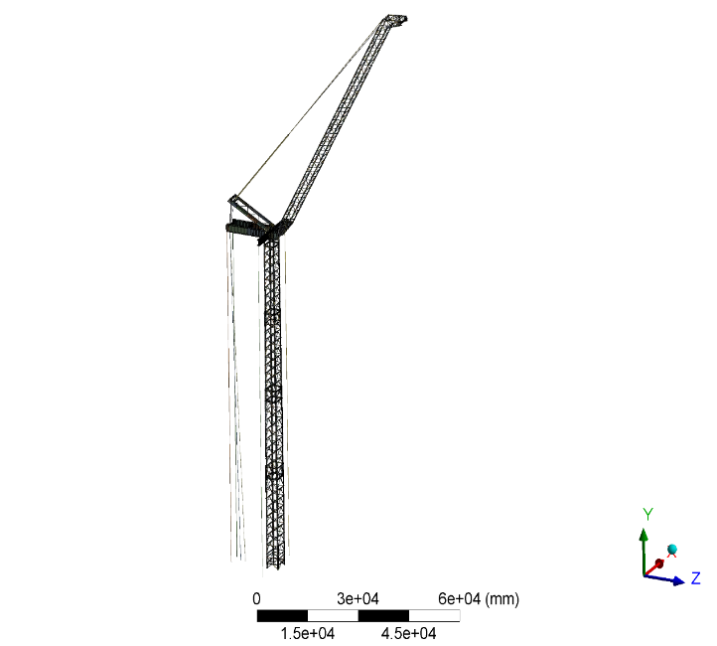
Fig. 1 Finite Element Model of the Complete Machine

3. Downwind Pulsating Wind Simulation

The air motion within the atmospheric boundary layer exhibits random turbulent behavior. Typically, the air motion at a given point is considered to consist of two components: a mean wind with constant magnitude and direction, and a pulsating wind with randomly varying magnitude and direction. The mean wind represents the average wind speed over a specific observation period, with a period generally exceeding 10 minutes. During this interval, the wind's magnitude and direction remain largely unchanged over time. When acting upon mechanical structures, it can be treated as a static load. The pulsating wind reflects the turbulent nature of near-surface winds, exhibiting very short periods of several seconds to tens of seconds. These periods often align closely with the natural vibration periods of structures, leading to its treatment as a dynamic load in analyses. Consequently, in engineering structural analysis, wind loads affecting structures at different heights must account for both the mean wind and the pulsating wind. In practical engineering applications, instantaneous wind speed can be regarded as the superposition of average wind speed and pulsating wind speed acting on the structure.

3.1 Pulsating Wind Speed Time History Curve

To analyze the transient dynamic response of tower crane structures under pulsating winds, this study employs an AR model from linear filtering techniques for pulsating wind speed time history simulation. Based on terrain characteristics, Class B terrain (fields, villages, and suburbs) is selected as the operating environment for the tower crane. Its main parameters are shown in Table2 below. The simulation time step is set to 0.1 s, with 1000 sample points and a total duration of 100 s.
Table.2 Key parameters for simulating pulsating wind speed time series using linear filtering method
Aerodynamic roughness length $z_{0}$（m） | 0.1$m$
Ground roughness coefficient | K=0.00215
Wind profile power exponent α value | 0.15
Wind speed time series time step (s) | 0.1s
Total duration of wind speed time series T (s) | 100s
AR model order | $$p=5$$
Target power spectrum | Davenport
Start frequency/Hz | 0.01
End frequency/Hz | 20
Frequency increment/Hz | 0.01
Reference height $z_{b}$ | 10m
Reference height wind speed | 31m/s

Based on the aforementioned pulsating wind simulation parameters, a corresponding program was developed using MATLAB software. The resulting time-history curves for pulsating wind speeds at 100m and 180m locations, corresponding to a reference wind speed of 31m/s, are shown in Figures 2 and 3 below.
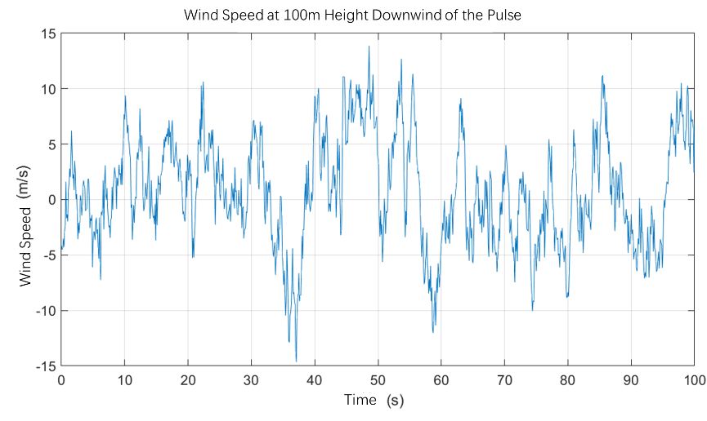

Fig.2 Time-series curve of downwind pulsating wind speed at 100m height
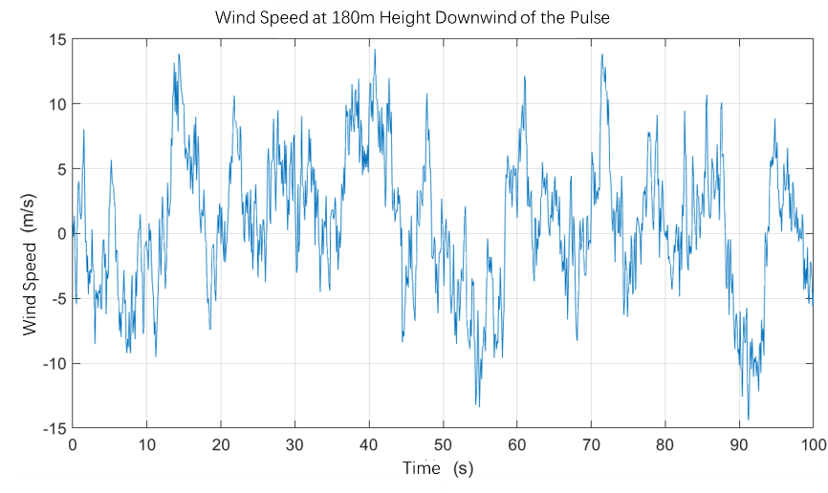
Fig.3 Downwind pulsating wind speed at 180m height
By superimposing the average wind speed at corresponding heights—determined using an exponential average wind profile model—onto the downwind pulsating wind speed time series, the total wind speed time series at that height can be synthesized. The resulting total wind speed time series curves at 100m and 180m heights are shown in Figures 4 and 5 below.
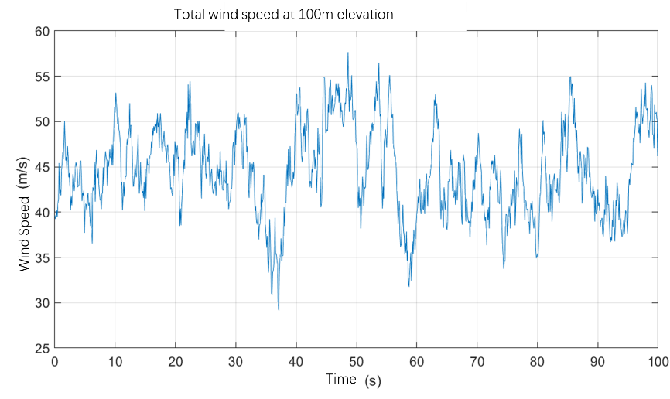
Fig.4 Total wind speed time series curve at 100m elevation
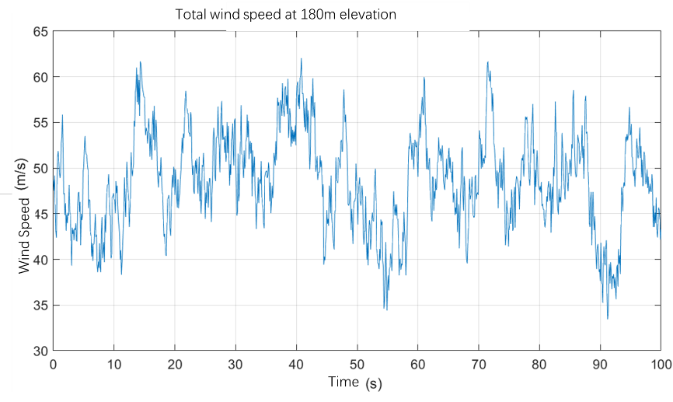
Fig.5 Total wind speed time series curve at 180m elevationt
To validate the simulation's effectiveness, the generated time history underwent a Fast Fourier Transform to obtain the simulated power spectrum, which was then compared against the target Davenport spectrum. The comparison results indicate that the simulated spectrum aligns closely with the target spectrum in both overall trend and amplitude. This demonstrates that the simulated spectrum accurately reproduces the target spectrum, meeting engineering analysis requirements. It provides reliable pulsating wind input for subsequent transient dynamics analysis of the tower crane.

3.2 Total Wind Load Time History Curve

The tower crane structure is divided into equal height segments at 10-meter intervals. The windward projection area of the crane structure is calculated for each height segment. Multiplying this area by the total wind speed time history curve obtained at the corresponding height yields the wind load time history acting on the crane structure at that height segment. For the rear panel structure of the tower crane, the corresponding wind reduction factor must be applied. Finally, the wind load is distributed to the corresponding nodes in the finite element model according to node distribution, forming the wind load input for transient dynamic analysis. Figure 6 below shows the total wind load time history curves calculated at three characteristic heights: 40m, 90m, and 180m.
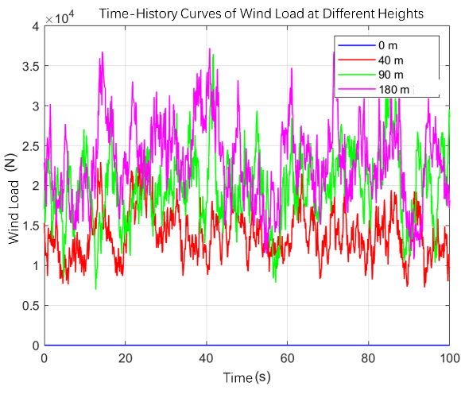
Fig.6 Time-History Curve of Total Wind Load at Three Characteristic Heights

4. Modal Analysis

Prior to conducting transient dynamic analysis, a modal analysis was first performed on the tower crane to provide a basis for determining the integration time step and setting damping parameters . The calculation yielded the first twenty natural frequencies of the structure under four working radii. Since the values of the natural frequencies for each mode across the four operating conditions are highly similar, with the exception of modes 1, 11, and 18, the frequency differences for the vast majority of modes are less than 3%. This indicates that the overall vibration mode shapes of the structure do not vary significantly under different working radii. Therefore, using the maximum working radius of 45m as an example, the first twenty natural frequencies of the tower crane under the 45m operating condition are presented in Table 3.
Table.3 Tower Crane 45m Working Condition: First Twenty Natural Frequencies
Order | 1 | 2 | 3 | 4 | 5 | 6 | 7
frequency/Hz | 0.3606 | 0.46777 | 0.9401 | 1.0115 | 1.2684 | 1.4198 | 1.4635
Order | 8 | 9 | 10 | 11 | 12 | 13 | 14
frequency/Hz | 1.9367 | 2.3862 | 2.3939 | 2.4392 | 2.7726 | 3.1349 | 3.2532
Order | 15 | 16 | 17 | 18 | 19 | 20
frequency/Hz | 3.3918 | 3.5117 | 4.0581 | 4.8355 | 4.919 | 5.0716

Based on the first natural frequency (0.3606 Hz), the fundamental period of the tower crane is calculated to be approximately 2.77 seconds.

5. Analysis of Downwind Pulsating Wind Load Response

To evaluate the dynamic response characteristics of a certain tower crane under extreme wind loads, this study conducted transient dynamic analysis of pulsating wind loads at four different working radii. The analysis was based on a load model combining downwind pulsating wind and mean wind effects.
The pulsating wind speed time history generated by MATLAB was converted into a wind load time history through a series of formula calculations. The data was saved as a .txt file and applied to the corresponding height segment nodes of the tower crane via an array table. Downwind pulsating wind was applied at a 0° wind direction angle, aligned with the average wind direction. Through parameterized operations including solution and post-processing, the transient dynamic analysis results of the tower crane under downwind pulsating wind were obtained.

5.1 Displacement-Time Curve

The total displacement-time curves for the tower crane under four operating conditions are shown in Figure 7-10 below. A comparative analysis of the four sets of displacement-time data is conducted.

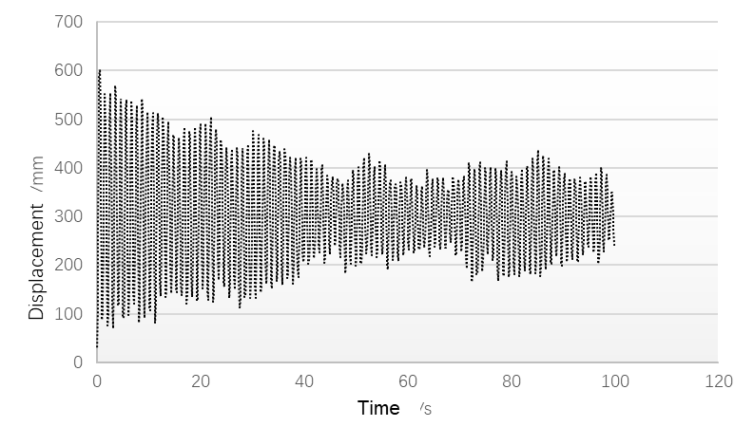
Fig.7 Total displacement-time curve for 45m operating condition
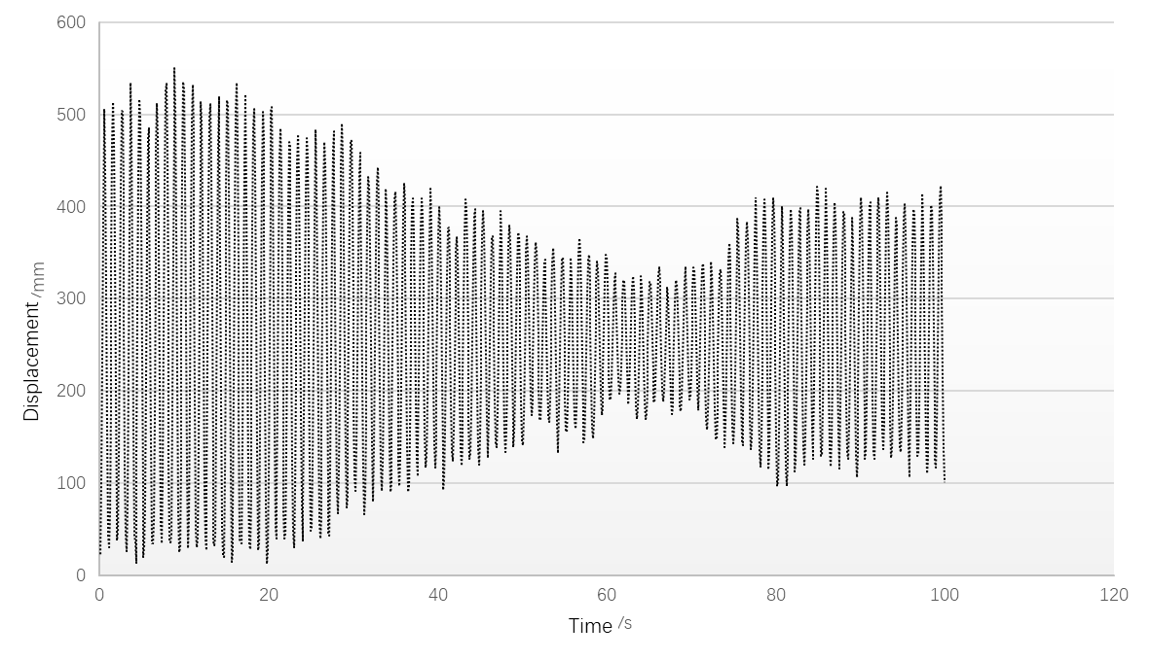
Fig.8 Total displacement-time curve for 30m operating condition
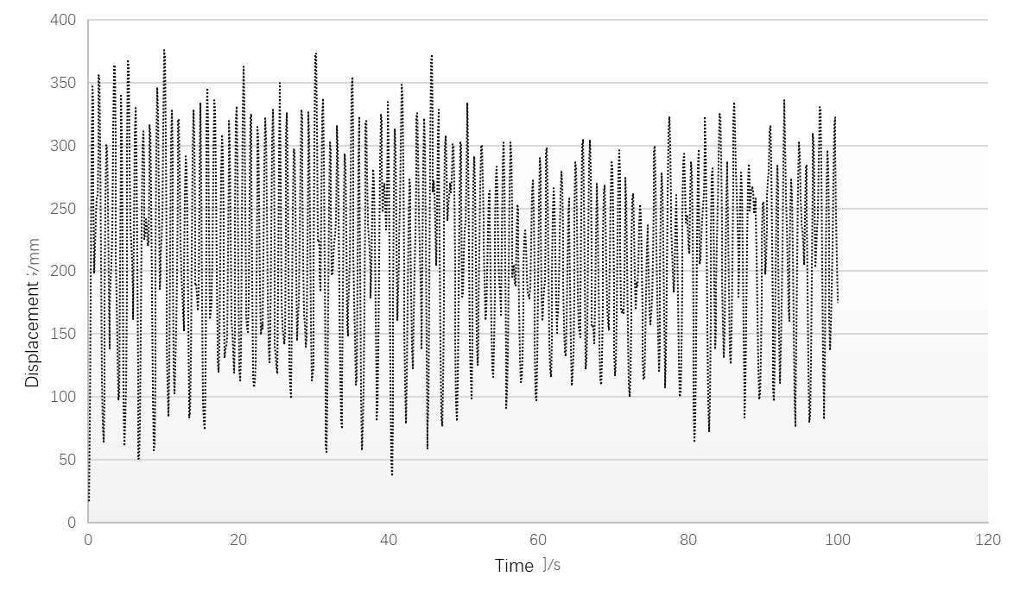
Fig.9 Total displacement-time curve for 16.5m operating condition
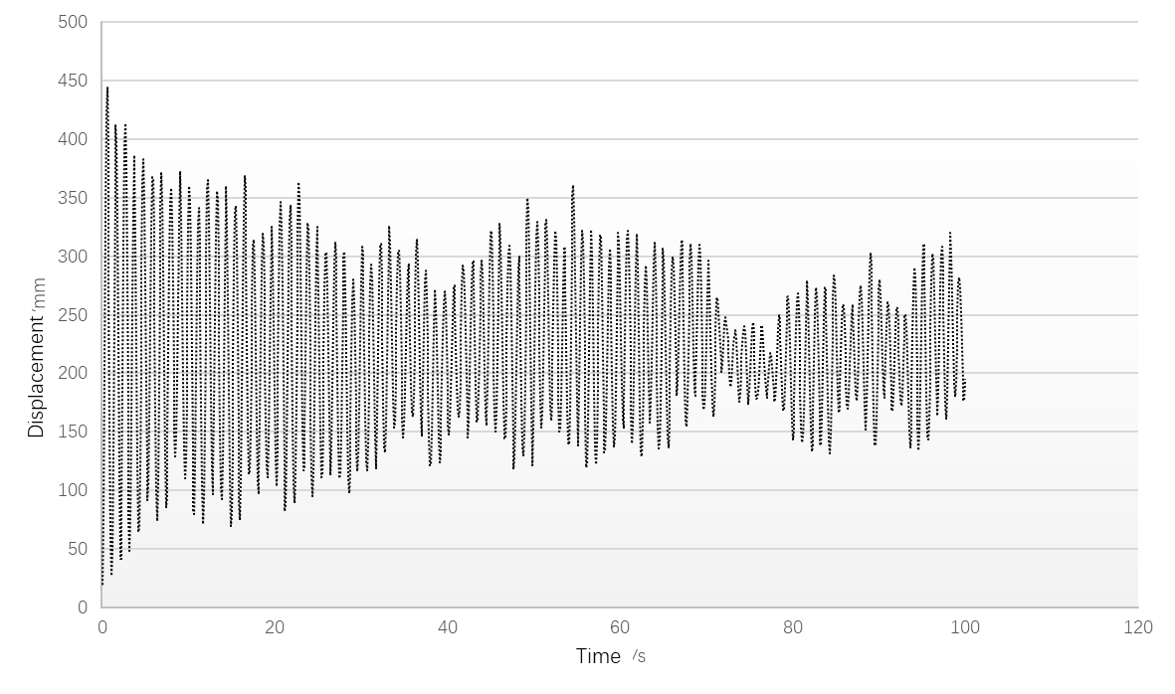
Fig.10 Total displacement-time curve for 12.5m operating condition

Under operating condition 1, the structural risk point for maximum displacement has shifted from the tower base to the mid-section of the boom. This occurs because high-turbulence winds excite higher-order modes of the boom, causing coupled vibrations with the tower body and generating severe dynamic amplification within the wake disturbance zone. The response pattern under Operating Condition 2 resembles that of Condition 1 but exhibits reduced intensity, with a peak displacement of approximately 550 mm and a more regular vibration decay trend. The displacement time history under Condition 3 shows no distinct initial impact, instead rising rapidly after about 1.1 seconds to form a sustained high-level plateau lasting several seconds, peaking at around 370 mm. The entire time history displays smooth, periodically stable large-amplitude pulsations. Unlike turbulence-induced random vibrations, this pattern indicates potential aeroelastic instability at critical wind speeds for the tower crane under this condition. Although its displacement peak is not the highest, such long-period, constant-amplitude vibrations would drastically accelerate structural fatigue damage accumulation, posing a severe threat to the crane's operational integrity and safety. Condition 4 exhibited the smoothest response, with a peak displacement of approximately 440 mm. Its vibration decayed rapidly and exhibited a regular pattern, closely resembling single-degree-of-freedom damped vibration. This indicates that this condition corresponds to lower average wind speeds and turbulence intensity, where the structural response is dominated by quasi-static components induced by the mean wind, with minimal resonance response.

5.2 Stress-Time Curve

The time-history diagrams of maximum equivalent stress for the tower crane under two working radii reveal that the average stress at 16.5m is 181.6 MPa, approximately 37% higher than the 132.2 MPa at 45m. The peak stress reaches 317.4 MPa, exceeding the 257.6 MPa at 45m by 23%. Simultaneously, stress fluctuations are more pronounced at the 16.5m radius, with high-frequency peaks occurring relatively more frequently. From a dynamic response mechanism analysis, the 45m radius exhibits greater structural flexibility, manifesting as low-frequency vibration characteristics. In contrast, the 16.5m radius demonstrates increased structural stiffness, allowing wind loads to be transmitted more directly and resulting in a pronounced high-frequency impact response.
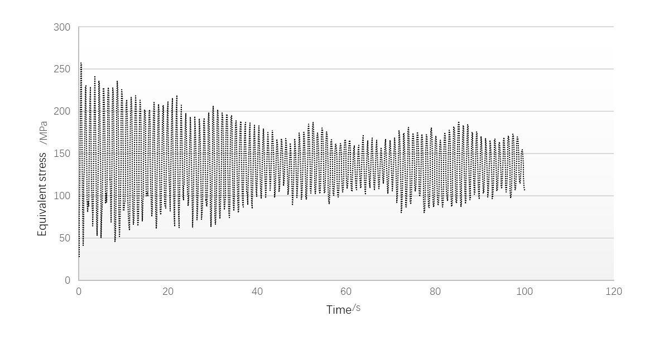
Fig.11 Maximum equivalent stress time history curve at 45m operating conditions
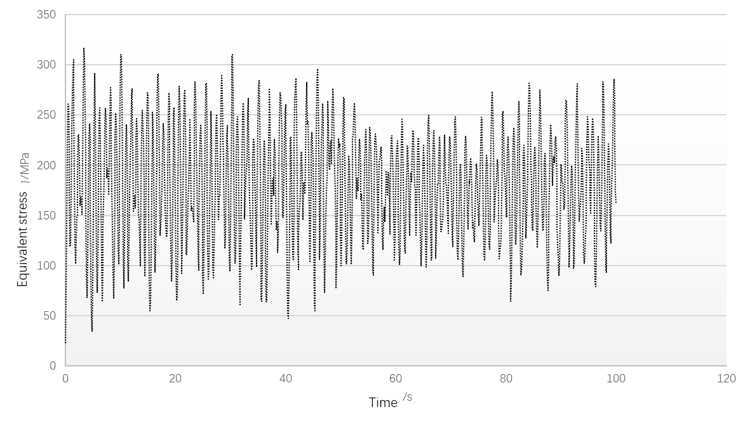
Fig.12 Maximum equivalent stress time history curve at 16.5m operating conditions

5.3 Comparison of Static Wind Load and Pulsating Wind Load Calculation Results

A comparative analysis was conducted between the transient dynamic analysis results considering the combined response of average wind and pulsating wind under non-operational conditions during storm events, and the static wind load results considering only average wind . The comparison nodes are as follows:
- Boom tip connection node 12258 with the tie rod, boom-to-horizontal-arm hinge point 127, tower top node 24629, swing-arm-to-horizontal-arm hinge point 5700, mid-boom node 10799, and mid-tower node 7533. Displacement results extracted from these six observation points in different directions are compared in Table4 below.
Table4 Comparison of Static Wind Load and Pulsating Wind Load Calculation Results
Node Number | Direction | Maximum Displacement (Absolute Value)/mm |  | Relative Error/%
Node Number | Direction | Static Analysis | Dynamic Analysis | Relative Error/%
12258 | X | 0.50 | 38.7 | 7640.00
12258 | Y | 87.8 | 114.0 | 29.84
12258 | Z | 112.9 | 150.0 | 32.86
127 | X | 2.21 | 4.34 | 96.38
127 | Y | 10.71 | 15.86 | 48.09
127 | Z | 0.7 | 1.21 | 72.86
24629 | X | 1.82 | 2.75 | 51.10
24629 | Y | 9.72 | 13.86 | 42.59
24629 | Z | 1.42 | 3.06 | 115.49
7533 | X | 2.62 | 13.71 | 423.28
7533 | Y | 6.24 | 5.11 | -18.11
7533 | Z | 1.88 | 46.49 | 2373.94
5700 | X | 3.16 | 5.22 | 65.19
5700 | Y | 7.46 | 9.43 | 26.41
5700 | Z | 0.9 | 1.41 | 56.67
10799 | X | 3.86 | 56.2 | 1355.96
10799 | Y | 110.77 | 308.96 | 178.94
10799 | Z | 165.21 | 512.26 | 210.07

The data in the table above indicates that the transient dynamic response considering pulsating wind is significantly higher than the static response considering only average wind. Except for a slight decrease in the Y-direction displacement at node 7533, the dynamic displacements in all other directions have increased markedly. This confirms that pulsating wind significantly amplifies structural response, and the amplification effect exhibits distinct local and directional variations. Node 10799 at the mid-boom section exhibits the highest sensitivity, with all directional errors exceeding 178%, indicating the mid-boom as the primary amplification zone for wind-induced vibration. Node 7533 on the tower body shows substantial Z-direction error, suggesting potential significant lateral vibration in the tower structure. Node 12258 at the boom tip exhibits an abnormally large X-direction error due to an extremely small static displacement baseline, though the actual displacement remains within permissible limits. Joint nodes exhibited relatively smaller errors (26%-96%) due to stronger constraints at connection points, which suppressed dynamic amplification.
Analysis of response directionality revealed that the boom's primary load directions (Y and Z axes) amplified by approximately 30%-210%. Average wind remained dominant, though pulsating wind contributed significantly. In minor directions with smaller static displacements, such as node 12258 in the X-direction, the dynamic amplification factor is substantial. This likely reflects the excitation of certain higher-order modes under dynamic loading, generating pronounced responses in specific directions. Node 7533 exhibits smaller dynamic response than static displacement in the Y-direction, possibly due to phase inversion between the average dynamic response and static displacement components in the Y-direction, leading to mutual cancellation.

6. CONCLUSION

In engineering practice, relying solely on static analysis can significantly underestimate actual responses, particularly in the mid-section of the boom and the tower body, where underestimation can range from several to dozens of times. Therefore, it is essential to focus on the stresses and deformations in the mid-boom under dynamic loads to prevent buckling or cumulative fatigue damage. For mid-tower joints, local strength and overall stability must be verified to withstand substantial lateral vibration responses. Additionally, it is recommended to consider installing damping devices or implementing aerodynamic measures in more flexible areas such as the boom and upper tower sections to reduce wind-induced vibration responses.
Competing interests

Authors have declared that no competing interests exist.

DISCLAIMER (ARTIFICIAL INTELLIGENCE)
Author(s) hereby declare that NO generative AI technologies such as Large Language Models (ChatGPT, COPILOT, etc.) and text-to-image generators have been used during the writing or editing of this manuscript.

References

[1]Cungen L ,Shuo M ,Xiaoping L , et al.A tracking control method with the fast finite-time command filter for four degrees of freedom tower cranes[J].Transactions of the Institute of Measurement and Control,2025,47(4):688-699. https://doi.org/10.1177/01423312241259066
[2]Chuanjing H ,Can L ,Zhi L , et al.Tower crane systems modeling and adaptive robust sliding mode control design under unknown frictions and wind disturbances[J].Transactions of the Institute of Measurement and Control,2025,47(4):795-809. https://doi.org/10.1177/01423312241266090
[3]Ding D ,Deng Z ,Yang R .YOLO-TC: An Optimized Detection Model for Monitoring Safety-Critical Small Objects in Tower Crane Operations[J].Algorithms,2025,18(1):27-27. https://doi.org/10.3390/a18010027
[4]Loveikin S V ,Romasevych O Y ,Loveikin V A , et al.Power Criterion Optimization of Concurrent Start of Trolleying and Slewing Mechanisms in Tower Crane[J].International Applied Mechanics,2024,60(4):1-15. http://jnas.nbuv.gov.ua/article/UJRN-0001505487
[5]Zamfirache A I ,Precup E R ,Petriu M E .Safe reinforcement learning-based control using deep deterministic policy gradient algorithm and slime mould algorithm with experimental tower crane system validation[J].Information Sciences,2025,692121640-121640. https://doi.org/10.1016/j.ins.2024.121640
[6]Zamfirache A I ,Precup E R ,Petriu M E .Safe reinforcement learning-based control using deep deterministic policy gradient algorithm and slime mould algorithm with experimental tower crane system validation[J].Information Sciences,2025,692121640-121640. https://doi.org/10.1016/j.ins.2024.121640
[7]Loveikin S V ,Romasevych O Y ,Loveikin V A , et al.Power Criterion Optimization of Concurrent Start of Trolleying and Slewing Mechanisms in Tower Crane[J].International Applied Mechanics,2024,60(4):1-15. https://doi.org/10.1007/s10778-024-01295-5
[8]Solazzi L ,Rustighi E .Passive earthquake vibration mitigation of a steel tower crane by joint dampers[J].Journal of Physics: Conference Series,2024,2909(1):012028-012028. https://doi.org/10.1088/1742-6596/2909/1/012028
[9]Zamfirache A I ,Precup E R ,Petriu M E .Safe reinforcement learning-based control using deep deterministic policy gradient algorithm and slime mould algorithm with experimental tower crane system validation[J].Information Sciences,2025,692121640-121640. https://doi.org/10.1016/j.ins.2024.121640
[10]Thi L H ,Nguyen C V ,Nguyen L T .Adaptive finite-time extended state observer-based model predictive control with Flatness motivated trajectory planning for 5-DOF tower cranes[J].European Journal of Control,2025,81101149-101149. https://doi.org/10.1016/j.ejcon.2024.101149
[11]Xu M ,Zhou H .Quantitative Assessment and Prediction for Tower Crane Construction Safety Resilience Based on Historical Database[J].Buildings,2025,15(23):4280-4280.DOI:10.3390/BUILDINGS15234280 https://doi.org/10.3390/buildings15234280 .
[12]Wang X ,Wang H ,Wang S , et al.Digital twin-driven structure safety monitoring method for revolving floating cranes based on multi-fidelity surrogate models[J].Marine Structures,2026,105103925-103925.DOI:10.1016/J.MARSTRUC.2025.103925.

