Original Research Article

YOLOv11-GA: Global Attention and Adaptive Loss for Sonar Target Detection

.
ABSTRACT

Sonar image target detection holds significant application value in critical fields such as marine resource exploration, underwater object search, and rescue operations. However, sonar images suffer from inherent complex background noise interference. Coupled with the widespread class imbalance issue in existing datasets, the detection models suffer from poor adaptability and suboptimal performance in sonar scenarios. To address the aforementioned issues, this paper proposes an improved sonar target detection method based on YOLOv11, named YOLOv11-GA. The specific improvements are as follows: A Global Attention Mechanism (GAM) is introduced before the SPPF layer in the YOLOv11 backbone network to enhance the model's ability to focus on key features while suppressing non-key features. An Adaptive Threshold Focal Loss (ATFL) function is incorporated to dynamically adjust loss weights, thereby reducing interference from easily classified samples and strengthening learning attention toward difficult-to-classify samples. To validate the effectiveness of the method, comparative experiments were conducted on two publicly available datasets: the Sonar Common Target Detection Dataset (SCTD) and the Forward-Looking Sonar Marine Debris Dataset (FLSMDD). The proposed model was evaluated through ablation studies and comparative experiments against multiple baseline and mainstream detectors. Experimental results show that YOLOv11-GA outperforms the baseline YOLOv11 by 2.4% in mAP@0.50 on SCTD and by 1.6% on FLSMDD, confirming its enhanced adaptability and detection capability in complex underwater environments. Furthermore, the model maintains a high inference speed of 68.84 FPS, which satisfies the real-time requirements in practical sonar applications such as underwater navigation and monitoring systems.

Keywords: Sonar Image Target Detection; Class Imbalance; Global Attention Mechanism (GAM); Adaptive Threshold Focal Loss (ATFL)

1. INTRODUCTION

With the intensification of marine development and the growing demand for underwater operations, the precision requirements for underwater environmental perception and target detection have significantly increased. Sonar imaging systems have become a core detection technology in key fields such as marine resource exploration and seabed structure identification due to their advantages of being unaffected by water optical limitations and having long detection ranges (Zhu et al., 2024). Sonar target detection, as a core component, directly determines the efficiency and safety of underwater operations. However, sonar images are susceptible to background noise generated by underwater environmental interference, leading to blurred target features (He et al., 2023). Furthermore, existing sonar datasets commonly suffer from class imbalance, causing models to favor majority class samples while exhibiting low detection accuracy for minority classes (Sun et al., 2022).

Target detection in sonar imaging has undergone a transition from traditional machine learning to deep learning. Early research primarily relied on edge detection and threshold segmentation techniques. Reed et al. (2003) employed unsupervised Markov Random Fields (MRF) for shadow extraction and target segmentation, representing a seminal work in early side-scan sonar target detection. Wang X. et al. (2019) employed adaptive threshold estimation for noise reduction and segmentation of sonar images. However, such traditional methods typically rely on manually designed features and exhibit limited sensitivity to interference factors such as underwater noise and shadows, making them ineffective in addressing complex and variable underwater acoustic environments. In recent years, breakthroughs in deep learning technology for optical image detection have rapidly driven the adaptation of related algorithms to sonar target detection. With its robust automatic feature extraction capabilities and excellent generalization performance, deep learning-based sonar target detection has become a research hotspot in this field. Tang et al. (2020) employed the Faster R-CNN network architecture to develop an automated detection system for shipwreck targets using side-scan sonar in seabed environments, enabling the identification and localization of submerged shipwreck remains. Kong et al. (2019) improved the feature extraction network based on YOLOv3, proposing the dual-path feature fusion YOLOv3-DPPFIN network. By employing a dense connection method for multi-scale prediction, its sonar image detection performance comprehensively outperformed YOLOv3. Ma et al. (2024) improved the YOLOv8 model by combining an efficient multi-scale attention mechanism with a bidirectional feature pyramid network, addressing the challenge of detecting objects with large scale variations in sonar images. Li et al. (2025) proposed the SMC-YOLO network, which effectively addresses the challenges of low resolution, high noise, and multi-scale target detection in underwater sonar images by incorporating Space-to-Depth Convolution, Content-Guided Feature Pyramid Network, and a Mixed Local Channel Attention. This approach achieves a favorable balance between detection accuracy and inference efficiency on public datasets. Although these improvements have yielded significant results in sonar image target detection, existing methods still face numerous challenges: inadequate suppression of background noise interference and limited effectiveness in addressing class imbalance issues. These bottlenecks pose substantial difficulties for target detection technology in practical sonar image applications.

Therefore, addressing the limitations of existing sonar image target detection methods, this paper proposes an improved sonar target detection approach, YOLOv11-GA, using YOLOv11 as the baseline network. The main contributions of this work are as follows:

(1) A Global Attention Mechanism (GAM) is introduced before the SPPF layer in the YOLOv11 backbone network. By enabling global interactions and enhancing feature maps, this mechanism increases the model's sensitivity to target features while reducing interference from non-critical information. This approach enhances the model's adaptability and detection performance in complex sonar environments.

(2) To address the class imbalance issue in sonar datasets, we incorporate the fully adaptive threshold focal loss (ATFL) function into the classification loss calculation of YOLOv11. This loss function dynamically adjusts weights based on sample classification difficulty, suppressing the loss contribution from easily classified samples while enhancing learning for difficult-to-classify and minority samples. This approach effectively improves the model's detection performance in class-imbalanced scenarios.

(3) Experimental validation on the SCTD and FLSMDD public sonar datasets demonstrated that the improved YOLOv11-GA model achieved performance improvements of 2.4% and 1.6% in the mAP@0.50 metric, respectively, compared to the baseline model.

The remainder of this paper is structured as follows: Section 2 describes the architecture of the proposed network; Section 3 presents experimental results and analysis; Section 4 concludes the paper.

2. METHODLOGY

2.1 The Proposed YOLOv11-GA Framework

To address core challenges in existing sonar image target detection methods, such as insufficient background noise suppression and category imbalance, this paper proposes YOLOv11-GA, an improved target detection method tailored for sonar scenarios based on the YOLOv11 model. As shown in Fig. 1, this method builds upon the classic Backbone-Neck-Head architecture of YOLOv11 while introducing two key improvements tailored to sonar image characteristics: First, we embed the GAM layer before the SPPF layer at the backbone network's base level. This enhances the model's ability to focus on key target features by strengthening global feature interactions, thereby suppressing background noise interference. Second, we introduce the ATFL function during loss calculation in the detection head. This dynamically adjusts loss weights to mitigate class imbalance issues, improving recognition performance for minority class targets.

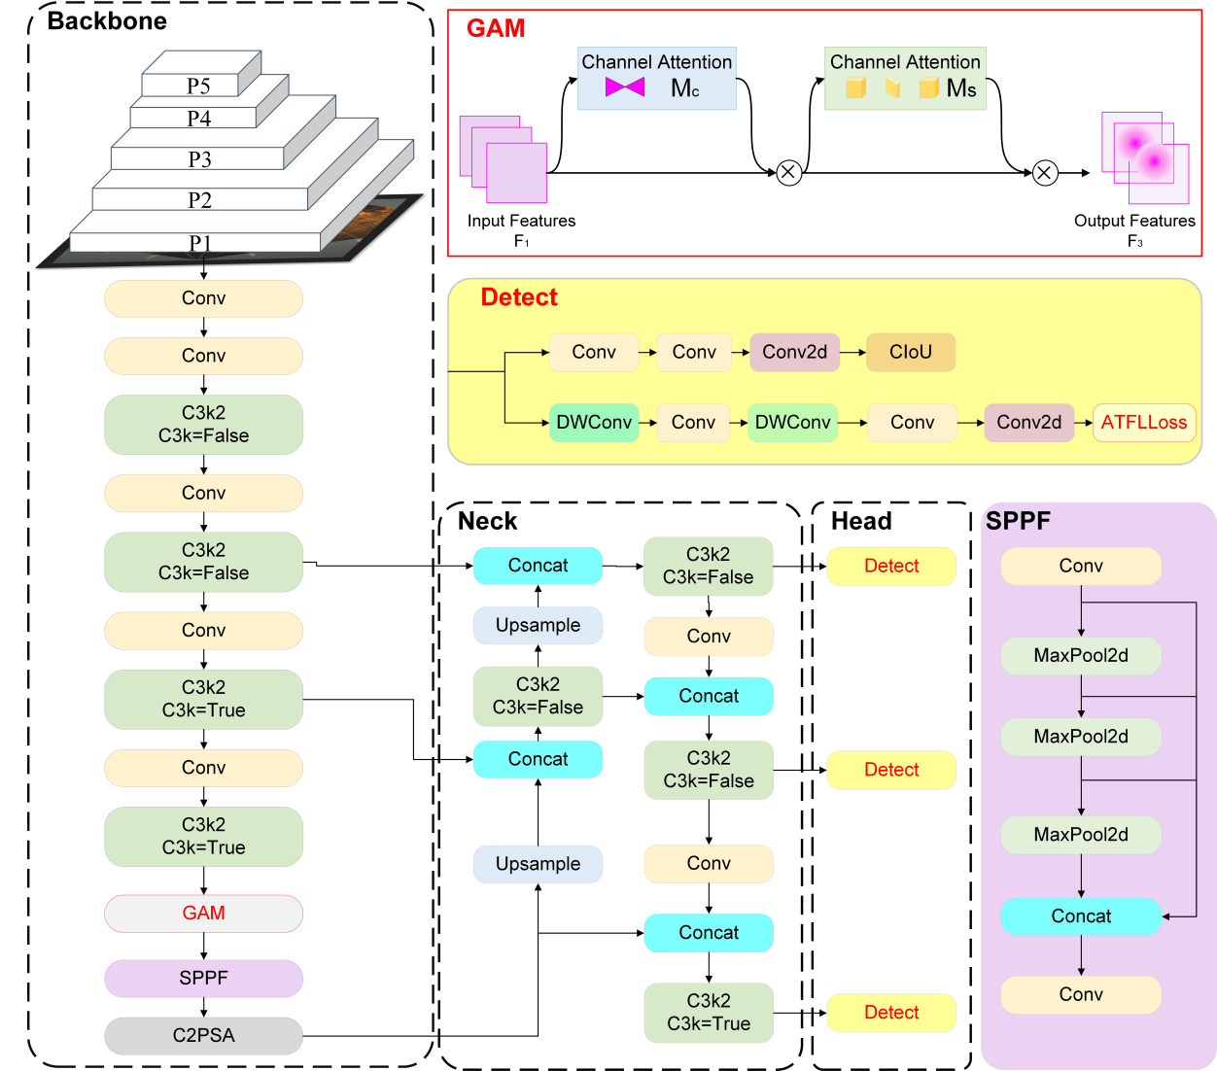

Fig.1 The architecture of the proposed YOLOv11-GA framework.

YOLOv11-GA employs multi-layer convolutions and residual connections in its backbone network to extract features from sonar images across multiple levels, generating multi-scale feature maps. Before entering the SPPF layer for feature pooling and aggregation, the GAM attention module is introduced to enhance the feature maps output by the backbone network. Through the synergistic effects of channel attention and spatial attention, it filters and amplifies target-related features while suppressing redundant information such as noise. The enhanced feature map is fed into the neck network, where cross-scale feature fusion is achieved through the Feature Pyramid Network (FPN) and Path Aggregation Network (PAN) structures, enhancing the model's adaptability to sonar targets of varying sizes. Ultimately, the fused multi-scale feature maps are fed into the detection head. The classification branch calculates loss using the ATFL loss function, while the regression branch retains the CIoU loss function from YOLOv11. Through multi-task joint optimization, they collectively achieve precise classification and localization of targets within sonar images.

2.2 YOLOv11 Framework

YOLOv11 is a one-stage object detection model proposed by the Ultralytics team, consisting of three components: the Backbone, Neck, and Head. Its architecture is illustrated in Fig. 2.

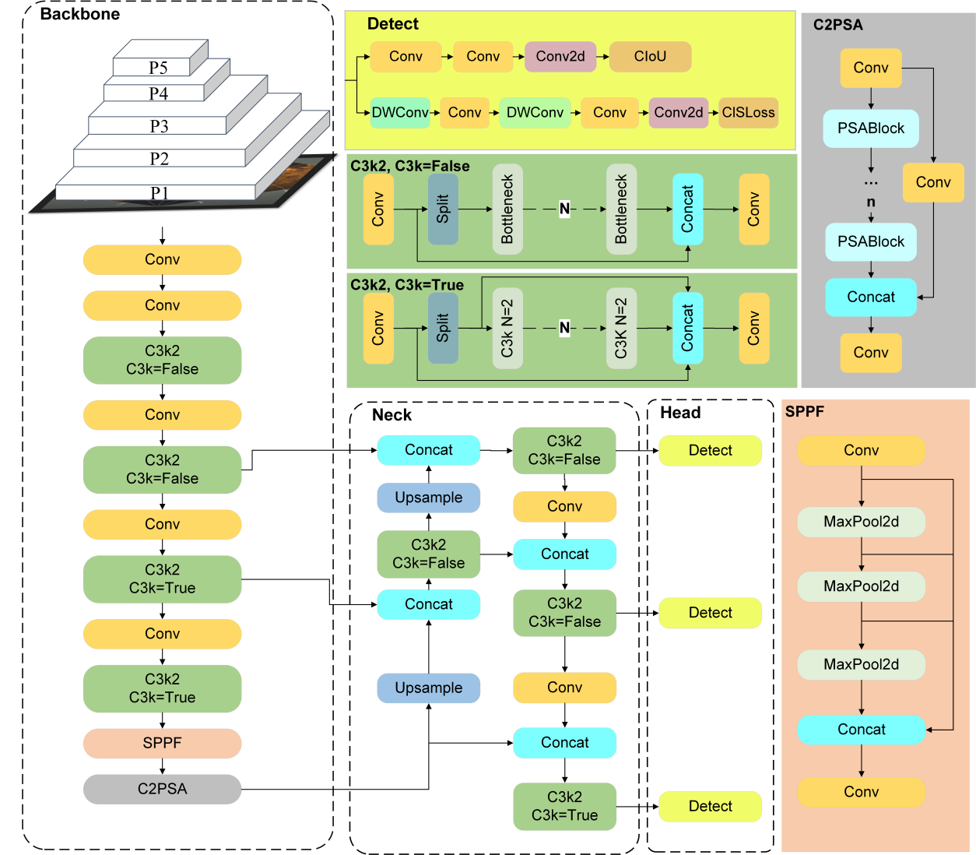

Fig.2 The architecture of the YOLOv11 framework

As the core feature extraction unit of the model, the Backbone focuses on hierarchically mining multi-scale and highly discriminative feature information from input images. While ensuring strong feature representation capability, it achieves a balance between performance and computational efficiency through a lightweight design philosophy, laying a solid foundation for subsequent detection and segmentation tasks.

The Neck network serves as a bridging component connecting the Backbone and the Head. Its core function is to perform cross-scale fusion of the deep semantic features and shallow detail features output by the Backbone through multiple Upsample and Concat operations. This effectively compensates for the information gaps between features of different levels, further enhances the comprehensive representation capability of features, and strengthens the model's adaptability to multi-scale targets.

The Head network is responsible for generating the final detection results. It achieves accurate coverage of targets with different sizes by relying on multi-scale feature maps; meanwhile, it incorporates Depthwise Convolution (DWConv) to optimize computational efficiency. On the premise of reducing the model's parameter count and computational load, it efficiently outputs the target's bounding box coordinates, class probabilities, and segmentation masks, ultimately realizing integrated and precise object detection and instance segmentation.

2.3 GAM module

GAM is a feature enhancement module based on the convolutional block attention module (CBAM) architecture (Liu et al., 2021). To enhance model detection efficiency and strengthen cross-dimensional feature interaction capabilities, a feature interaction mechanism integrating channel, width, and height dimensions is introduced. Compared to traditional attention mechanisms, GAM achieves more effective global information fusion across multiple dimensions, thereby more precisely focusing on key target features while effectively suppressing redundant background noise. It addresses the shortcomings of traditional attention modules, such as inadequate capture of cross-dimensional features and susceptibility to critical information loss, making it particularly suitable for extracting target features from sonar images with complex background noise.

GAM employs a structure where the channel attention submodule and spatial attention submodule are connected in series. These two submodules are calibrated collaboratively to achieve refined enhancement of the input feature map. The GAM network architecture is illustrated in Fig. 3.

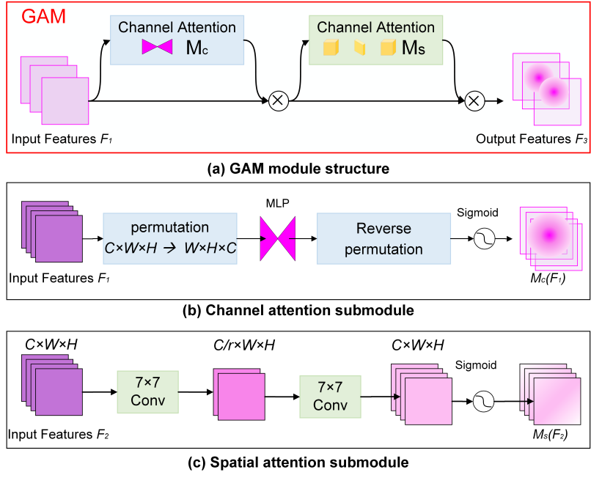

Fig.3 GAM channel-spatial structure

The GAM first performs dimensionality reduction on the input feature map F₁ via its channel attention submodule, reshaping it from C×H×W to W×H×C to preserve cross-dimensional correlation information. Subsequently, a two-layer bottleneck structure MLP processes the data: first compressing the channel dimension to 1/16 of the original size, then restoring it to the original channel count. This ultimately generates channel attention weights, which are element-wise multiplied with the original features to produce the intermediate feature map F₂. This achieves key information enhancement and noise suppression at the channel level. Subsequently, the spatial attention submodule further processes F₂. This module employs two cascaded 7×7 convolutions to construct spatial attention paths, progressively extracting and enhancing the spatial features of the target while avoiding information loss caused by pooling operations. The first convolutional layer halves the number of channels. After batch normalization and GELU activation, the second convolutional layer restores the channel count. This ultimately generates spatial attention weights, which are then multiplied element-wise with F₂ to produce the enhanced output feature map F₃. Ultimately, achieving systematic feature enhancement from channel to spatial dimensions significantly improves the quality and discriminative power of feature maps. The computational processes for F₂ and F₃ are shown in Eq. (1) (Woo et al., 2018).

Here, denotes the channel attention map, and denotes the spatial attention map. The symbol represents element-wise multiplication.

2.4 ATFL loss

For imbalanced sonar datasets, traditional cross-entropy loss assigns equal weights to all samples. In imbalanced scenarios, models tend to be dominated by majority class samples, resulting in low detection accuracy for minority class sonar targets (Mao et al., 2023). Furthermore, the CIoU loss commonly used in YOLO series models lacks specialized mechanisms to address category imbalance. In scenarios where background samples far outnumber target samples, model performance degrades significantly (Li et al., 2025). This issue is particularly pronounced in sonar image detection, as the complex background noise in sonar images can easily be misclassified by models as negative samples, further exacerbating the negative effects of class imbalance.

ATFL is an adaptive loss function designed to enhance model performance in class-imbalanced scenarios (Yang et al., 2024). Its core mechanism lies in the adaptive adjustment of loss weights and the design of dynamic thresholds. The ATFL function calculates two key parameters and , based on the current sample's prediction confidence level and its historical prediction trends. This ensures reflects the model's overall classification stability is reflected during training, preventing weight allocation instability caused by single-prediction fluctuations. The formulas for and are as follows:

Here, represents the smoothed confidence level, obtained by combining the historical forecast mean with the current forecast value:

Here, denotes the number of iterations during training, representing the average predicted probability value for each training cycle. ATFL employs a piecewise function to apply differential weighting to the loss:

When ≤0.5, the sample is considered a hard-to-classify sample, and the loss function increases its weight through the exponential term . When >0.5, the sample is classified as an easy-to-classify sample, and its loss contribution is dynamically suppressed based on the smooth confidence calculation, preventing the model from overemphasizing high-confidence samples.

3. EXPERIMENTAL RESULTS AND ANALYSIS

3.1 Datasets and Experimental Setup

3.1.1 Datasets

This study employs two publicly available sonar target detection datasets: the Sonar Common Target Detection Dataset (SCTD) (Zhou et al., 2021) and the Forward-Looking Sonar Marine Debris Dataset (FLSMDD) (Xie et al., 2022). Both datasets encompass complex underwater environments, effectively validating the adaptability and generalization capabilities of the proposed YOLOv11-GA model across diverse sonar target detection tasks.

The SCTD dataset integrates sonar images from three modalities: side-scan sonar, forward-looking sonar, and synthetic aperture sonar. It comprises 357 samples covering three target categories: aircraft, human, and shipwreck. The FLSMDD dataset is constructed using the ARIS Explorer 3000 forward-looking sonar sensor. This dataset presents more challenging noise interference and lower image contrast. The dataset contains 1,868 images covering 10 categories of typical marine debris and contaminants: bottle, can, drink carton, tire, chain, valve, propeller, hook, shampoo bottle, and standing bottle. Fig. 4 presents the statistical distribution of instances across categories in the SCTD and FLSMDD datasets, revealing significant class imbalance in the data.

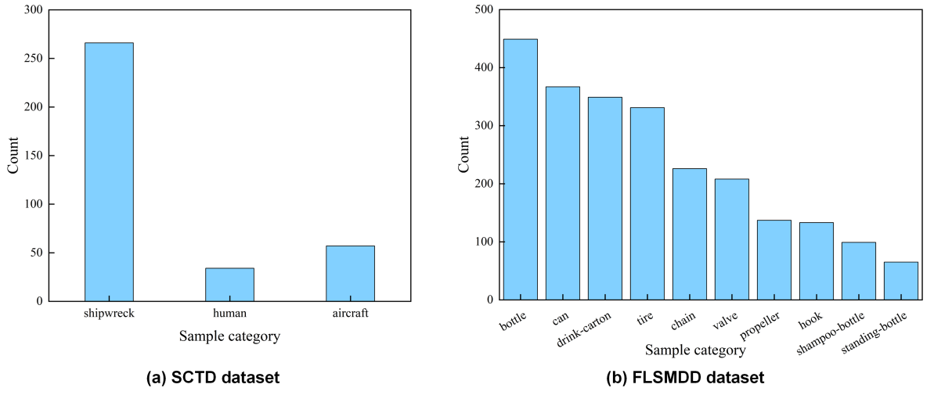

Fig.4 Statistical distribution of class instances in the datasets

3.1.2 Experimental setup

The hardware configuration for this experiment is as follows: Windows 10 64-bit operating system, Intel Core i7-8700 processor, NVIDIA RTX 4060 GPU (24GB VRAM), and 16GB of RAM. The software environment is based on Python and PyCharm, utilizing the PyTorch 2.6.0 framework and accelerated by CUDA 12.6. During training, the dataset is split into training, validation, and test sets at a ratio of 7:2:1. Input image dimensions are uniformly resized to 640×640, with a batch size set to 4 to accommodate GPU memory constraints. Using the stochastic gradient descent (SGD) optimizer with momentum set to 0.9, weight decay set to 5e-4, and training set to 300 epochs.

To validate the effectiveness of the proposed model, F1 Score, mAP@0.50, and Frames Per Second (FPS) were adopted as the primary evaluation metrics (Zhang, 2025), providing a comprehensive assessment of the model's performance in underwater sonar target detection. F1 Score is the harmonic mean of precision and recall (Hossain, 2024a), capable of comprehensively reflecting the model's classification ability under balanced positive and negative samples. Meanwhile, mAP@0.50, calculated as the weighted average of the average precision across all categories at an IoU threshold of 0.5, holistically measures the detection model's localization and recognition performance in multi-class tasks. FPS directly reflects the model's inference speed, which is crucial for practical deployment scenarios such as real-time underwater monitoring. The calculation formula is as follows:

Here, TP denotes the number of positive samples correctly classified as positive by the model; FP denotes the number of negative samples incorrectly classified as positive; FN denotes the number of positive samples incorrectly classified as negative; N represents the total number of target class instances; t represents the time required to infer a single image.

3.2 Ablation Experiments

To validate the effectiveness and reliability of the proposed method, we conducted ablation experiments on two distinct sonar datasets, SCTD and FLSMDD, which differ in size and type and exhibit class imbalance. The final results are shown in Tab. 1. We found that compared to the baseline model, the network models improved using GAM and ATFL both achieved a certain increase in accuracy, with the latter showing a greater improvement. This demonstrates that the ATFL loss function is more targeted at mitigating the class imbalance issue in sonar datasets. By dynamically adjusting loss weights, it effectively enhances the model's focus on learning minority class targets, significantly reducing the under-detection of minority classes caused by majority class samples dominating training. Meanwhile, the GAM attention mechanism precisely suppresses background noise interference in sonar images by enhancing cross-dimensional feature interactions, thereby improving target feature recognition and laying the foundation for enhanced detection accuracy. The sonar detection method proposed in this paper, YOLOv11-GA, achieved the best results on both sonar datasets. Specifically, on the SCTD dataset, our method achieved an F1 score of 93.8% and a precision of 93.8%, representing improvements of 5.4% and 2.4%, respectively, over the baseline model. On the FLSMDD dataset, which features more complex noise and more pronounced class imbalance, YOLOv11-GA achieved an F1 Score of 95.7% and an mAP@0.50, representing improvements of 3.1% and 1.6%, respectively, over the baseline model. Although the FPS of YOLOv11-GA decreased slightly from 79.26 frames per second in YOLOv11 to 68.84 frames per second, it remains well above the conventional 30 frames per second real-time standard for underwater object detection, fully meeting practical application requirements. Therefore, the method proposed in this paper not only accurately identifies the types of sonar images but also effectively addresses issues of severe noise interference and data imbalance, thereby enhancing the performance of sonar target detection.

Regarding generalization capability, SCTD and FLSMDD differ significantly in dataset scale, target categories, and noise characteristics, with SCTD covering diverse underwater targets in complex, multi-noise marine environments and FLSMDD focusing on underwater debris detection. The model demonstrates stable detection performance on both datasets, effectively validating its strong adaptability and generalization across different sonar scenarios.

Table 1. Detection performance of the ablation experiment on the SCTD and FLSMDD datasets

Dataset |  | Performance index | YOLOv11  (baseline) | YOLOv11  +GAM | YOLOv11  +ATFL | YOLOv11+GAM+ATFL  (YOLOv11-GA)
SCTD | F1 Score |  | 0.884 | 0.925 | 0.931 | 0.938
SCTD | mAP@0.50 |  | 0.901 | 0.917 | 0.919 | 0.925
SCTD | FPS |  | 79.26 | 69.11 | 78.37 | 68.84
FLSMDD | F1 Score |  | 0.916 | 0.932 | 0.942 | 0.947
FLSMDD | mAP@0.50 |  | 0.937 | 0.954 | 0.956 | 0.953
FLSMDD | FPS |  | 79.26 | 69.11 | 78.37 | 68.84

On the SCTD and FLSMDD datasets, the detection results of the YOLOv11-GA model are shown in Fig. 5, demonstrating excellent detection performance across all object categories.

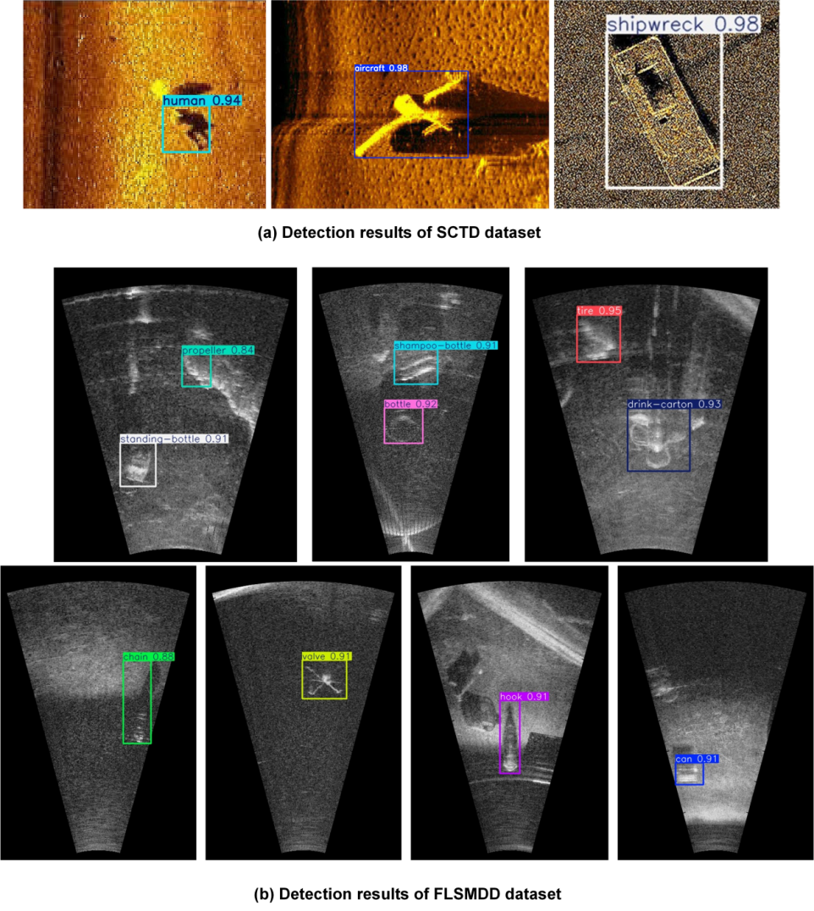

Fig. 5 Detection results of YOLOv11-GA on SCTD and FLSMDD datasets

3.3 Comparison Experiments

To further validate the advantages of the proposed method, we compared YOLOv11-GA with existing object detection methods: Faster RCNN (Ren et al., 2016), SSD (Liu et al., 2016), YOLOv8 (Swathi and Challa, 2024), and DETR (Carion et al., 2020). The results are shown in Tab. 2. The results demonstrate that the proposed method achieves superior performance on both the SCTD and FLSMDD datasets.

Table 2: Comparison of results with existing object detection methods on the SCTD and FLSMDD datasets

Dataset |  | Performance index | Faster RCNN | SSD | YOLOv8 | DETR | YOLOv11-GA
SCTD | F1 Score |  | 0.895 | 0.886 | 0.903 | 0.905 | 0.938
SCTD | mAP@0.50 |  | 0.886 | 0.869 | 0.912 | 0.903 | 0.925
SCTD | FPS |  | 13.89 | 38.65 | 89.29 | 41.28 | 68.84
FLSMDD | F1 Score |  | 0.893 | 0.888 | 0.918 | 0.910 | 0.947
FLSMDD | mAP@0.50 |  | 0.897 | 0.891 | 0.935 | 0.924 | 0.953
FLSMDD | FPS |  | 13.89 | 38.65 | 89.29 | 41.28 | 68.84

Specifically, classical object detection methods exhibit certain limitations when addressing severe noise interference and imbalanced datasets. As shown in Tab. 2, the traditional two-stage method Faster-RCNN achieves mAP@0.50 scores of only 0.886 and 0.897 on the SCTD and FLSMDD datasets, respectively. This model primarily relies on a pre-trained Region Proposal Network (RPN) and manually designed network architecture for feature extraction, making it difficult to effectively adapt to the complex noise distribution and weak texture features in sonar images. The single-stage SSD model recorded an mAP@0.50 below 0.90, indicating a lack of robustness in the class-imbalanced sonar environment. Although the mainstream YOLOv8 model improved performance to 0.912 and 0.935 on the respective datasets, its detection efficacy for minority-class objects remained constrained due to the absence of sonar-specific optimizations. Meanwhile, DETR, which leverages a Transformer architecture to enhance feature interaction, achieved an mAP@0.50 of 0.924 on FLSMDD, suggesting that this approach also falls short of fully addressing the inherent challenge of class imbalance. YOLOv11-GA significantly outperforms traditional detection models such as Faster RCNN, SSD, and DETR in terms of frame rate. Although it is slightly slower than YOLOv8, this minor decrease in speed is offset by a noticeable improvement in accuracy. This model offers a balanced performance advantage while still fully meeting the requirements for real-time detection applications.

The proposed YOLOv11-GA model comprehensively outperformed all the aforementioned counterparts, attaining optimal results on both datasets across both the F1-Score and mAP@0.50 metrics. This result fully demonstrates that YOLOv11-GA, through the synergistic improvement of the GAM attention mechanism and the ATFL loss function, not only addresses the insufficient suppression of sonar noise in traditional methods but also mitigates the low detection accuracy of minority classes caused by class imbalance. It is thus better suited to the practical application requirements of sonar target detection.

4. Conclusion

This paper addresses the challenges of severe background noise interference and imbalanced category distribution in sonar image target detection by proposing an improved algorithm based on YOLOv11, termed YOLOv11-GA. By introducing the GAM attention mechanism before the SPPF layer in the YOLOv11 backbone network, target feature focusing and noise suppression are enhanced. The introduction of the ATFL loss function dynamically adjusts classification loss weights to mitigate the impact of class imbalance on detection performance. Experiments on the FLSMDD and SCTD datasets demonstrate that YOLOv11-GA outperforms the baseline model and current mainstream comparative methods across key metrics, including mAP@0.50. The research findings validate the effectiveness of the proposed improvement strategy, providing a viable solution for sonar target detection in complex underwater environments.

Disclaimer (Artificial intelligence)

Authors hereby declare that NO generative AI technologies such as Large Language Models (ChatGPT, COPILOT, etc.) and text-to-image generators have been used during the writing or editing of this manuscript.

References

- Carion, N., Massa, F., Synnaeve, G., Usunier, N., Kirillov, A., & Zagoruyko, S. (2020, August). End-to-end object detection with transformers. In European conference on computer vision (pp. 213-229). Cham: Springer International Publishing. https://doi.org/10.1007/978-3-030-58452-8_13

- He, J., Chen, J., Xu, H., & Ayub, M. S. (2023). Small target detection method based on low-rank sparse matrix factorization for side-scan sonar images. Remote Sensing, 15(8), 2054. https://doi.org/10.3390/rs15082054

- Hossain, E. (2024a). Evaluation Criteria and Model Selection. In E. Hossain (Ed.), Machine Learning Crash Course for Engineers (pp. 69–116). Springer International Publishing. https://doi.org/10.1007/978-3-031-46990-9_2

- Kong, W., Hong, J., Jia, M., Yao, J., Cong, W., Hu, H., & Zhang, H. (2019). YOLOv3-DPFIN: A dual-path feature fusion neural network for robust real-time sonar target detection. IEEE Sensors Journal, 20(7), 3745-3756. https://doi.org/10.1109/JSEN.2019.2960796

- Li, B., Zhang, R., & Xu, X. (2025). SMC-YOLO: efficient object detector for underwater small sonar target. Journal of Real-Time Image Processing, 22(145), 1-14. https://doi.org/10.1007/s11554-025-01724-9

- Li, J., Wang, L., Hua, L., Kong, Y., Yang, Y., Dong, R., ... & Zhang, Z. (2025). GS-YOLO: An improved plateau pika’s hole and bare patch detection algorithm based on YOLOv5s for UAV images. Smart Agricultural Technology, 101149. https://doi.org/10.1016/j.atech.2025.101149

- Liu, W., Anguelov, D., Erhan, D., Szegedy, C., Reed, S., Fu, C. Y., & Berg, A. C. (2016, September). Ssd: Single shot multibox detector. In European conference on computer vision (pp. 21-37). Cham: Springer International Publishing. https://doi.org/10.1007/978-3-319-46448-0_2

- Liu, Y., Shao, Z., & Hoffmann, N. (2021). Global attention mechanism: Retain information to enhance channel-spatial interactions. arXiv preprint arXiv: 2112.05561. https://doi.org/10.48550/arXiv.2112.05561

- Ma, Q., Jin, S., Bian, G., & Cui, Y. (2024). Multi-scale marine object detection in side-scan sonar images based on BES-YOLO. Sensors, 24(14), 4428. https://doi.org/10.3390/s24144428

- Mao, A., Mohri, M., & Zhong, Y. (2023, July). Cross-entropy loss functions: Theoretical analysis and applications. In International conference on Machine learning (pp. 23803-23828). pmlr. https://proceedings.mlr.press/v202/mao23b.html

- Ren, S., He, K., Girshick, R., & Sun, J. (2016). Faster R-CNN: Towards real-time object detection with region proposal networks. IEEE transactions on pattern analysis and machine intelligence, 39(6), 1137-1149. https://doi.org/10.1109/TPAMI.2016.2577031

- Reed, S., Petillot, Y., & Bell, J. (2003). An automatic approach to the detection and extraction of mine features in sidescan sonar. IEEE journal of oceanic engineering, 28(1), 90-105. https://doi.org/10.1109/JOE.2002.808199

- Sun, Y., Zheng, H., Zhang, G., Ren, J., Xu, H., & Xu, C. (2022). DP-ViT: A dual-path vision transformer for real-time sonar target detection. Remote Sensing, 14(22), 5807. https://doi.org/10.3390/rs14225807

- Swathi, Y., & Challa, M. (2024, January). YOLOv8: Advancements and innovations in object detection. In International Conference on Smart Computing and Communication (pp. 1-13). Singapore: Springer Nature Singapore. https://doi.org/10.1007/978-981-97-1322-6V

- Tang, Y. L., Jin, S. H., Bian, G., Zhang, Y. Z., & Li, F. (2020, October). Wreckage target recognition in side-scan sonar images based on an improved faster r-cnn model. In 2020 International Conference on Big Data & Artificial Intelligence & Software Engineering (ICBASE) (pp. 348-354). IEEE. https://doi.org/10.1109/ICBASE51484.2020.00077

- Wang, X., Li, Q., Yin, J., Han, X., & Hao, W. (2019). An adaptive denoising and detection approach for underwater sonar image. Remote Sensing, 11(4), 396. https://doi.org/10.3390/rs11040396

- Wang, Z., Zhang, S., Huang, W., Guo, J., & Zeng, L. (2021). Sonar image target detection based on adaptive global feature enhancement network. IEEE Sensors Journal, 22(2), 1509-1530. https://doi.org/10.1109/JSEN.2021.3131645

- Woo, S., Park, J., Lee, J. Y., & Kweon, I. S. (2018). CBAM: Convolutional block attention module. In Proceedings of the European conference on computer vision (ECCV) (pp. 3-19). https://doi.org/10.1007/978-3-030-01234-2_1

- Xie, K., Yang, J., & Qiu, K. (2022). A dataset with multibeam forward-looking sonar for underwater object detection. Scientific Data, 9(1), 739. https://doi.org/10.1038/s41597-022-01854-w

- Yang, B., Zhang, X., Zhang, J., Luo, J., Zhou, M., & Pi, Y. (2024). EFLNet: Enhancing Feature Learning for Infrared Small Target Detection. https://doi.org/10.1109/TGRS.2024.3367900

- Zhou, Y., Chen, S. C., Wu, K., Ning M. G., Chen H. K., & Zhang P. SCTD 1.0:Sonar Common Target Detection Dataset[J].Computer Science, 2021, 48(11A): 334-339. https://doi.org/10.11896/jsjkx.210100138

- Zhu, J., Li, H., Qing, P., Hou, J., & Peng, Y. (2024). Side-scan sonar image augmentation method based on cc-wgan. Applied Sciences, 14(17), 8031. https://doi.org/10.3390/app14178031

- Zhang, J. (2025). Evolution of YOLO: A Comparative Analysis of YOLOv5, YOLOv8, and YOLOv10. Applied and Computational Engineering, 119, 173-181. https://doi.org/10.54254/27552721/2025.21591

