Original Research Article

Study on the Influence of Drawbead Parameters on the Formability of Fuel Cell Bipolar Plates

ABSTRACT
As a crucial component of new energy vehicles, fuel cells rely heavily on the performance of their bipolar plates, which are among the core parts determining their overall efficiency. The flow field design of metallic bipolar plates plays a significant role in optimizing gas distribution, improving fuel utilization, and enhancing battery performance. Stamping is a key technology that determines the forming quality, cost-effectiveness, and industrial production of metallic bipolar plates. Drawbeads are widely used in the stamping industry, yet research on how drawbead parameters affect the forming quality of bipolar plates remains limited. Therefore, this study conducts an in-depth investigation into the stamping formability of metallic bipolar plates in Proton Exchange Membrane Fuel Cells (PEMFC). The most common parallel flow field is selected for stamping simulation, and the forming quality of metallic bipolar plates is analyzed based on parameters such as the distance between the drawbead and the flow channel area, drawbead depth, blank holder force, and friction coefficient. The results indicate that as the distance between the drawbead and the flow channel increases, the wrinkling area expands, but the occurrence of fracture is alleviated. Increasing the drawbead depth and blank holder force can reduce the incidence of wrinkling, while the friction coefficient has a relatively minor effect on wrinkling. However, reducing the friction coefficient can significantly mitigate the occurrence of fracture.
Keywords: Proton Exchange Membrane Fuel Cell; Metallic Bipolar Plates; Stamping Forming; Drawbead

1 INTRODUCTION
The rapid development of the modern world, while bringing convenience to people, has also caused significant damage to nature. People have gradually come to recognize the importance of protecting the environment, leading to the emergence of various low-carbon and eco-friendly products. New energy vehicles are one such representative, and among them, fuel cell vehicles stand out due to their zero-emission characteristics.
The core of a fuel cell vehicle is undoubtedly the fuel cell itself, which consists of numerous components such as the electrolyte membrane, bipolar plates, and catalysts. As one of the core components within the fuel cell stack, the bipolar plate performs critical functions including mechanical support, current conduction, gas distribution, and heat dissipation. These functions directly impact the battery's performance and stability [1]. Its cost constitutes 20%-30% of the stack cost, and its weight makes up 60%-80% of the stack weight [2].
As a key component in fuel cells, the manufacturing quality of bipolar plates directly affects the performance and lifespan of the fuel cell. The stamping process holds significant importance in bipolar plate manufacturing. Consequently, many researchers have focused on optimizing existing processes and developing new ones. Bong et al. developed a multi-stage micro-channel stamping forming process and validated its effectiveness in improving formability through simulation and experiments [3]. Xu et al. studied a multi-pass forming process which enhanced the ultimate forming depth and accuracy while reducing contact resistance by minimizing localized deformation tendencies [4]. Mohammadtabar N et al. proposed a two-step hydroforming process that reduced material overstretching and thickness non-uniformity, thereby decreasing defects in the formed parts [5]. Abeyrathna B et al. prepared bipolar plates using a roll forming process and verified its feasibility [6]. Hossein Talebi-Ghadikolaee et al. investigated an improved stamping process that effectively prevented excessively high maximum thinning rates [7]. Qi Z et al. addressing the bottleneck in manufacturing micro-channels with high aspect ratios, studied a three-stage stamping process. They analyzed the influence of various factors on thickness thinning through finite element (FE) simulation and optimization of the three-stage stamping, subsequently designed the mold, conducted experiments, and ultimately developed a process highly suitable for the mass production of bipolar plates from ultra-thin titanium sheets [8]. This demonstrates that multi-step stamping is a commonly used process for producing bipolar plates.
Drawbeads can effectively reduce wrinkling during sheet metal stamping, making them a key research focus in the sheet metal forming industry. Alex Raimundo de Oliveira et al. developed the Concentric Circles Method (CCM), focusing on improving the stamping process. By precisely interpreting the influence mechanism of blank holder pressure and drawbead geometry used in experiments, they explained the performance results obtained from Forming Limit Curves (FLCs). They found that circular drawbeads provided better formability for DP600 steel. They also modified the Nakazima test, combining nano-indentation testing and Electron Backscatter Diffraction (EBSD) material characterization techniques to investigate the formability of cold-formed DP600 steel sheets in the die radius area, with a focus on analyzing the influence of different drawbead geometries [9]. Rafael Guetter Bohatch et al. found that circular drawbeads produced the most uniform hardness variation along the stamped sheet profile, with relatively lower hardness values compared to other geometries. This indicates that drawbeads can effectively mitigate hardness fluctuations, contributing to improved sheet formability [10]. Jidapa Leelaseat et al. discovered that increasing the height of the male drawbead effectively reduced wrinkling but led to increased thinning, while increasing the female groove radius produced the opposite effect [11]. Sarang Yi et al. proposed a real-time formability prediction method based on a digital twin framework that considers both drawbead position and blank holder force parameters. By constructing a digital twin system and employing machine learning models such as Artificial Neural Networks (ANNs) to predict sheet metal forming processes, they trained machine learning models using data on drawbead positions and blank holder forces generated from finite element analysis, achieving real-time prediction and verification of wrinkling and cracking defects [12].
As can be seen, both multi-step stamping and drawbeads can effectively enhance stamping formability. Therefore, this study will be based on two-step stamping. It will conduct simulation-based research and analysis on the influence of the distance between the drawbead and the flow channel, as well as the depth of the drawbead, on forming quality. Through iterative adjustment of various parameters based on feedback from simulation results, the optimal forming quality will be pursued.

Methodology

2 Model Establishment and Material Selection
This study is based on UG modeling and Dynaform simulation, both of which are professional-grade software tools widely used in the field of industrial design and manufacturing. UG is a comprehensive Product Lifecycle Management (PLM) software that integrates multiple functions such as design, engineering, and manufacturing. It offers significant advantages in areas such as 3D modeling, assembly design, engineering analysis (e.g., Finite Element Analysis and Computational Fluid Dynamics), and CAM (Computer-Aided Manufacturing). It supports the entire development process of complex products, from conceptual design to final production, providing users with a seamless working environment that greatly enhances efficiency from design to manufacturing.
Dynaform, on the other hand, is a software specifically designed for stamping forming analysis, serving as a powerful tool for simulating and optimizing sheet metal forming processes. Dynaform can provide highly accurate forming simulations, helping engineers anticipate potential issues during the forming process—such as cracking, wrinkling, and others—at the design stage. This enables optimization of mold design and process parameters, reducing trial-and-error costs. Its strengths lie in its extensive material library and advanced plastic deformation algorithms, making Dynaform particularly effective in addressing complex sheet metal forming challenges.

2.1 Model Establishment
The metallic bipolar plate forming part and stamping die were created using UG 3D design software. The punch and blank holder used in the simulation are shown in Figure 1, with the flow channel being an area 19 mm long and 18 mm wide. The simplified punch for the bipolar plate is shown in Figure 2, and a schematic diagram of the flow channel cross-section is shown in Figure 3. The overall dimensions of the sheet are 40 mm×40 mm, with a thickness of 0.1 mm. Here, S represents the flow channel width, W the rib width, H the flow channel depth, R the inner fillet radius, r the outer fillet radius, and α the draft angle. This section will focus on the side boss count/height, stamping speed, friction coefficient, and blank holder force as the primary research parameters to analyze their impact on stamping forming quality. The model selected for this study is only a small-scale sample used for research purposes, and future work will involve expanding the model selection and dimensions.

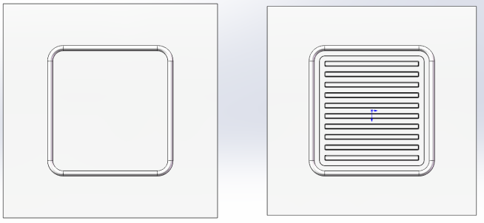
(a). Two-step stamping punch (left: Station ①, right: Station ②)
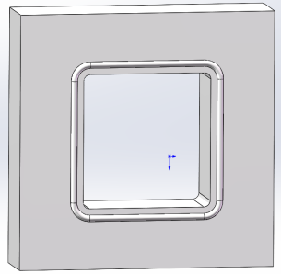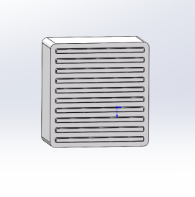
(b). Station ② - Blank holder only (c). Station ② - Punch only
Figure1 Simplified models of metal bipolar plates and stamping

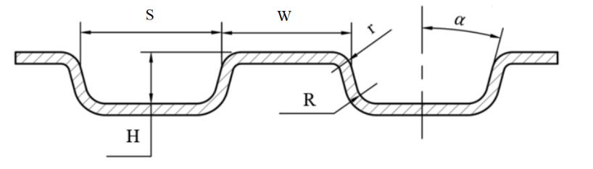
Figure2 Metal bipolar plate flow channel section diagram

The IGS file of the three-dimensional model was imported into the Dynaform simulation software. First, the part layers were divided to facilitate subsequent operations. The 3D analysis type was selected, with the sheet thickness set to 0.1 mm. The process type was configured as double-action forming, using the upper die/lower die as the tool reference surfaces, and set to double-action mode. The movement speeds of both the blank holder and the punch were set to 500 mm/s. Station ① is used to form the drawbead, while Station ② employs a blank holder with a drawbead to clamp the sheet edge, followed by forming the parallel grooves. The principle is illustrated in Figure 3.
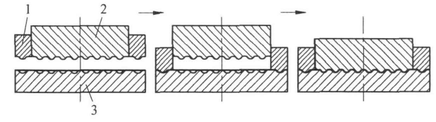
1. Blank holder (with drawbead), 2. Forming punch, 3. Forming die
Figure3 Double-action Schematic Diagram

2.2 Material Selection and Parameter Setting
The planar sheet material is modeled as shell elements with an element size set to 0.4 mm and a tool radius of 0.08 mm. The element formulation is defined as Belytschko-Tsay, employing Gaussian integration with five integration points.
Currently, there are various material options for bipolar plates, among which titanium has sparked considerable controversy. Modanloo V et al. studied titanium plates, but titanium is more expensive compared to stainless steel [13]. Moreover, research by Vahid Modanloo et al. indicates that titanium has low formability and is prone to fracture [14]. S. Baskar et al. investigated cathode components and their materials, including the most well-known and widely discussed stainless steel and graphite/carbon as cathode materials [15]. Mohamed Barakat et al. emphasized the critical role of carbon-based supports in enhancing the performance of Fe–N–C catalysts across various fuel cell technologies. They examined the structure-property-performance relationships governing the dispersion, stability, and electronic environment of Fe–Nₓ active sites, highlighting how porosity, conductivity, and surface chemistry influence catalytic activity and durability. This study focuses on 304 stainless steel, which offers better formability, lower cost, broader applicability, and higher benefits from research outcomes [16]. Considering factors such as cost, weight, and processing difficulty of current bipolar plate materials, SS304 stainless steel has become a commonly used material due to its low cost and excellent physical properties [17-20]. Its core advantages in industrial production lie in its exceptional cost-effectiveness and comprehensive performance: with an alloy composition of 18% chromium and 8-10% nickel, it exhibits excellent corrosion resistance (against atmospheric conditions, freshwater, and weak acidic media) and mechanical strength from room temperature up to 500°C. Its high ductility (elongation ≥40%) supports complex forming processes such as deep drawing and spinning, while its low carbon content (≤0.08%) ensures weldability without the need for heat treatment. The surface can be polished to Ra ≤0.4 μm to meet sanitary requirements for food and medical applications, and it is 100% recyclable. Compared to molybdenum-containing 316L stainless steel, SS304 reduces costs by 30%, and its global large-scale supply ensures cost-effectiveness. These excellent properties make it the material of choice for foundational industrial sectors such as chemical equipment, food machinery, architectural structures, and transportation vehicles. The material properties are shown in Table 1.

Table 1 SS304 stainless steel material performance parameters

Density(g/cm3) | Elastic Modulus  (/MPa) | Poisson's Ratio | Yield Strength  (MPa) | Hardening Exponent
7.85 | 207000 | 0.28 | 248 | 0.502

The Tool Mesh meshing method is employed, primarily utilizing quadrilateral elements with a maximum size of 0.4 mm and a minimum size of 0.04 mm. The gap tolerance is set to 0.01 mm, and the default contact friction coefficient between the die and the sheet is 0.125. Taking a metallic bipolar plate with a flow channel width S of 1 mm, rib width W of 1 mm, flow channel depth H of 0.5 mm, both inner fillet radius R and outer fillet radius r set to 0.1 mm, and a draft angle α of 5° as an example, a simulation model is established.
The process is divided into two stages: Closing and Drawing. The Closing stage refers to the movement of the blank holder until it contacts the die, utilizing penalty function contact with a penalty factor set to 0.15. To reduce the impact of initial penetration, the contact gap is set to 0.11 mm. The Drawing stage involves the movement of the punch until it mates with the die, with the contact gap also set to 0.11 mm. The closing speed for both stages is 500 mm/s, using the default velocity curve. The blank holder force is determined by the formula:
 | $F_{q}=q$A | （1）
Where A represents the projection area of the blank sheet on the blank holder, and q denotes the unit blank holder pressure, which is set to 3 MPa.

Results & Discussion

3 Drawbead Parameter Settings and Simulation

3.1 Effect of the Distance Between the Drawbead and the Flow Channel on Forming Quality
Based on the designed flow channel size and overall sheet dimensions, the variation range for the distance between the drawbead and the flow channel was set from 2 mm to 8 mm, with intervals of 2 mm, resulting in 4 groups. The blank holder force gradually decreased as the spacing increased, calculated using Formula (1). Corresponding blank holder forces of 3540 N, 3000 N, 2364 N, and 1632 N were selected for simulation in Work Step 2 for the increasing distances, respectively. Figure 4 shows the forming limit diagrams for the sheet under different distances. From the figure, it can be observed that when the distance is small, no wrinkling occurs at the four corners of the flow channel area. However, as the distance gradually increases, the wrinkling area expands, but only slight wrinkling occurs, and fracture phenomena significantly decrease.
This is because increasing the distance between the drawbead and the forming area is equivalent to adding a "buffer zone" between the constraint point (the bead) and the critical point (the die radius). A larger distance exacerbates wrinkling, primarily because the material inside the bead forms a larger "unsupported zone." This part of the material, when flowing toward the die cavity, lacks rigid blank holder constraint and is highly prone to instability and wrinkling under tangential compressive stress. Conversely, a larger distance can reduce fracture for two reasons: first, the material in the "buffer zone" inside the bead acts as a "material reservoir," providing supplemental material when the critical area thins, thereby mitigating localized over-stretching; second, the significant flow resistance generated by the drawbead can relax and homogenize over this distance before reaching the die radius, avoiding the direct superposition of high stress and forming tension, which could otherwise lead to cracking.
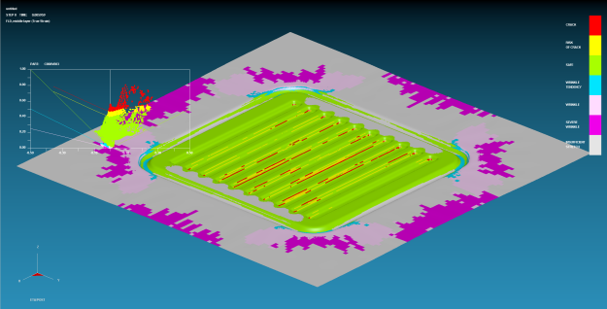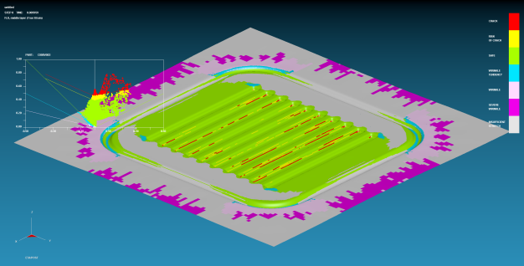
(a)2mm (b) 4mm
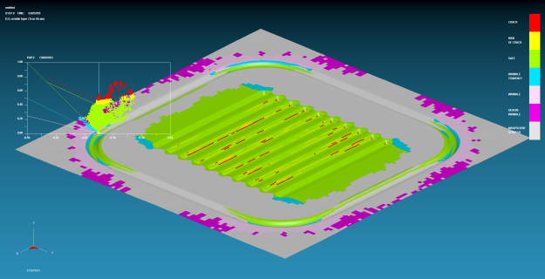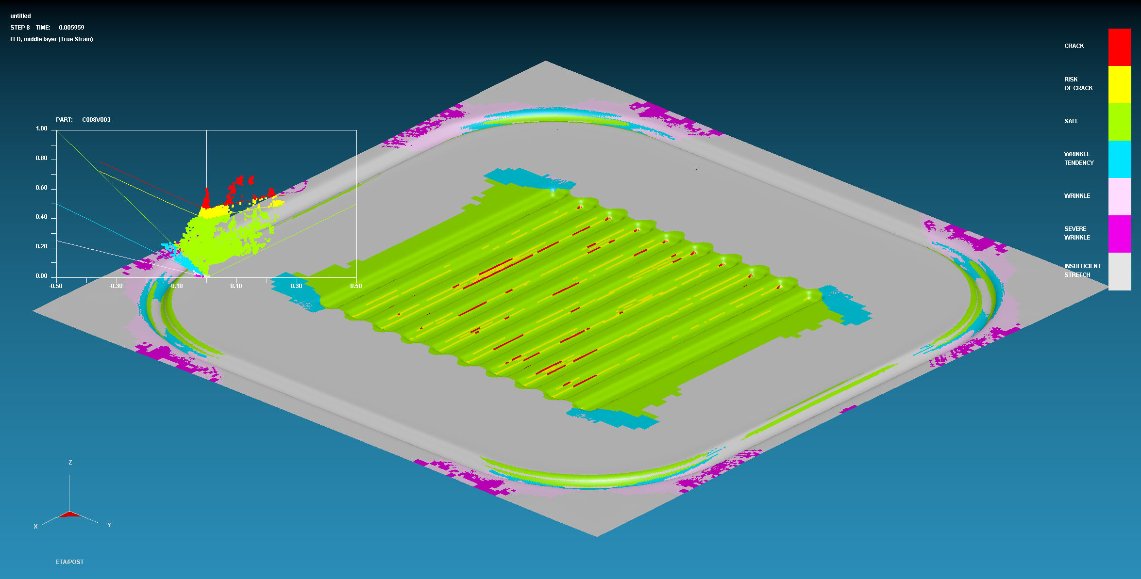
(6)mm (d) 8mm
Figure4 Forming Limit Diagrams of the Sheet under Different Spacings

Therefore, when selecting the distance between the drawbead and the flow channel, a larger spacing should be chosen as much as possible to reduce the occurrence of fracture, provided that severe wrinkling does not occur.

3.2 The Influence of Drawbead Depth on Forming Quality
Based on the condition of an 8 mm spacing and according to the sheet thickness, the variation range of the drawbead depth was set from 0.1 mm to 0.5 mm, with intervals of 0.1 mm, resulting in 5 groups. Figure 5 shows the forming limit diagrams of the sheet under different drawbead depths. From the figure, it can be observed that when the depth is small, obvious wrinkling occurs at the four corners of the flow channel area. As the depth increases, the wrinkling phenomenon gradually decreases, and when the depth reaches 0.2 mm, no significant wrinkling is observed.
This is because the depth of the drawbead is critical in controlling the resistance to material flow. When the depth is shallow, the bending deformation required for the material to cross the bead and the friction experienced are relatively small, resulting in insufficient flow resistance. This allows excessive and rapid inflow of material from the flange area into the die cavity, causing compressive instability in the circumferential direction due to material accumulation and leading to wrinkling. As the depth increases, the material must undergo more severe bending-unbending deformation, and the contact pressure and friction with the die increase significantly. This substantially enhances the flow resistance, effectively constraining and slowing down the material inflow. As a result, the material in the flange area maintains controlled and uniform flow, suppressing compressive instability and reducing the wrinkling phenomenon.
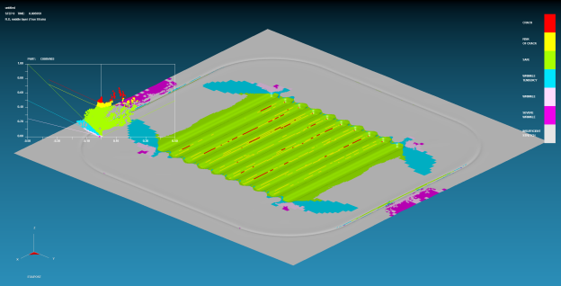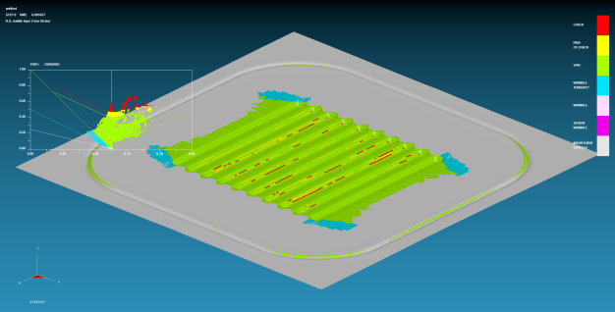
(a)0.1mm (b) 0.2mm
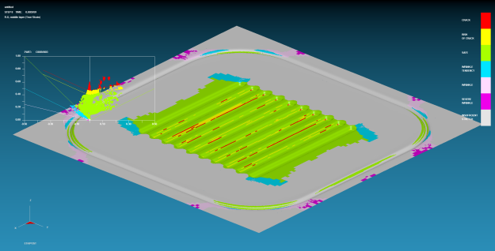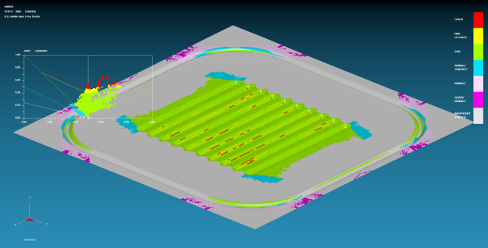(c) 0.3mm (d) 0.4mm
(e) 0.5mm
Figure 5 Forming Limit Diagrams of the Sheet under Different Drawbead Depths

Therefore, it is advisable to select a greater drawbead depth to avoid wrinkling in the flow channel area. Additionally, material flow can be restricted by adjusting the blank holder force in coordination with the drawbead.

4 Impact of Blank Holder Force and Friction Coefficient

4.1 The Influence of Blank Holder Force
Based on a drawbead with an 8 mm spacing and 0.2 mm depth, the variation range of the blank holder force was set from 630 N to 2630 N, with intervals of 500 N, resulting in 5 groups. Figure 6 shows the forming limit diagrams of the sheet under different blank holder forces. From the figure, it can be observed that as the blank holder force increases, the wrinkling range at the corners of the flow channel gradually decreases, while the fracture range in the central part of the flow channel gradually expands. Severe wrinkling occurs when the blank holder force is 630 N, but it disappears when the force increases to 1130 N.
The blank holder force is a key factor in controlling material flow during stamping. Increasing the blank holder force enhances the frictional resistance between the material and the die, effectively restricting excessive and disordered inflow of material from the flange area into the cavity, thereby suppressing material accumulation and wrinkling at the corners of the flow channel. However, when the blank holder force is too high, the material inflow is severely impeded. This prevents timely supplementation of external material to the most deformation-prone areas, such as the ribs and fillets of the flow channel, forcing local material to undergo excessive stretching and thinning. Consequently, the risk and extent of fracture significantly increase.

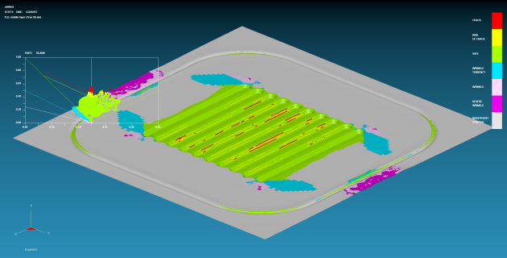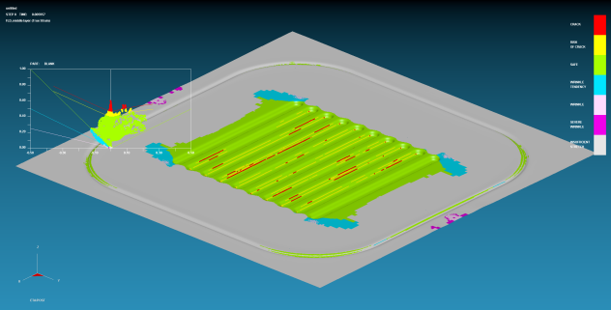
(a)630N (b) 1130N
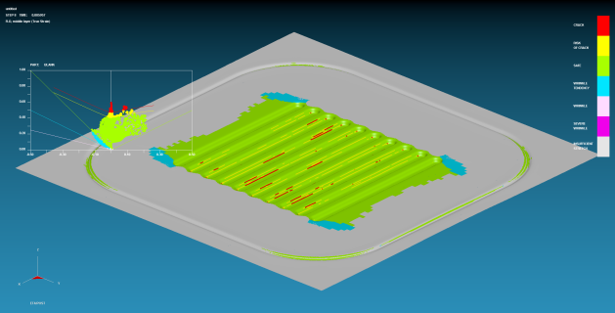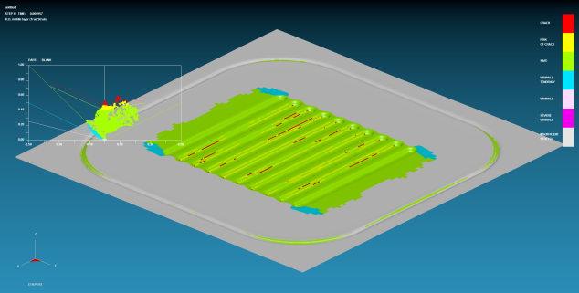
(c)1630N (d)2130N
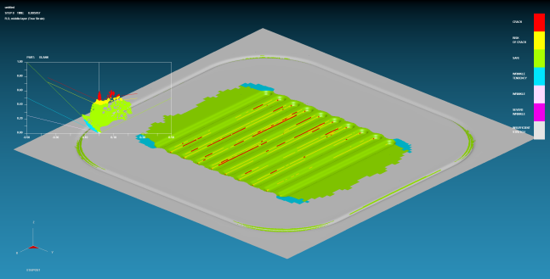
(e)2630N
Figure 6 Forming Limit Diagrams of the Sheet under Different Blank Holder Forces

Therefore, when adjusting the blank holder force, it should be kept as low as possible while ensuring that severe wrinkling does not occur, in order to reduce the risk of fracture.

4.2 The Influence of Friction Coefficient
Based on the condition of a 1130 N blank holder force, the friction coefficient was varied within a range of 0.075 to 0.175, with intervals of 0.025, resulting in 5 groups for simulation analysis. Figure 7 shows the forming limit diagrams under different friction coefficients. The results indicate that as the friction coefficient increases, wrinkling at the corners of the flow channel slightly decreases. Even when the friction coefficient is as low as 0.075, no severe wrinkling occurs. However, the incidence of fracture in the flow channel region significantly increases, demonstrating that the friction coefficient has a minimal effect on wrinkling but a substantial impact on fracture.
This phenomenon arises from the differential influence of friction on material flow paths. Increasing the friction coefficient globally enhances the resistance to material flow. For areas such as the corners of the flow channel, which are in a state of compressive instability, friction can only slightly restrict the influx of excess material, resulting in limited mitigation of wrinkling. However, for regions of the flow channel that require material supplementation (particularly the ribs), increased friction severely impedes the inflow of material from the flange area. This prevents these regions from receiving external material supply during stretching, leading to localized excessive thinning and a sharp rise in the risk of fracture. Therefore, the friction coefficient is a sensitive factor that exacerbates fracture rather than an effective means of suppressing wrinkling.

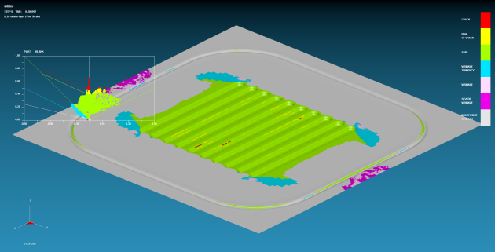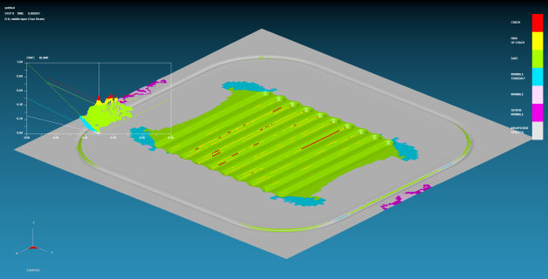
(a)0.075 (b)0.1
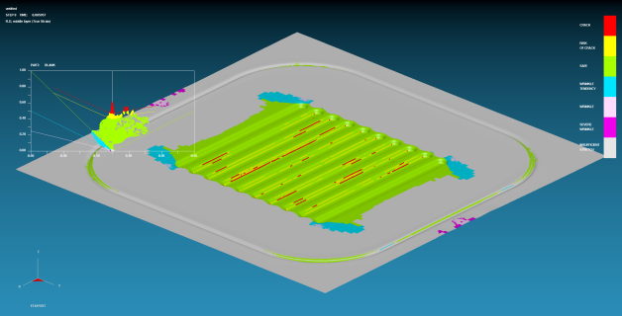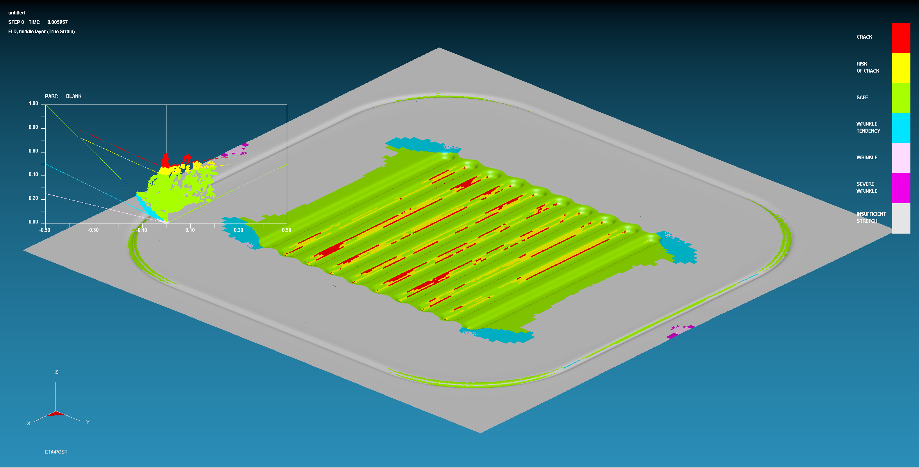
(c)0.125 (d)0.15
(e)0.175
Figure 7 Forming Limit Diagram of the Sheet Under Different Friction Coefficients

Therefore, when selecting lubricants, those with a lower friction coefficient should be prioritized whenever possible. A better lubrication effect helps mitigate the occurrence of fracture.

CONCLUSION
This study determines optimal stamping parameters for bipolar plates by adjusting the distance between the drawbead and the flow channel, the depth of the drawbead, the blank holder force, and the friction coefficient. The results demonstrate that:
- As the distance between the drawbead and the flow channel increases, wrinkling at the corners of the flow channel gradually becomes more pronounced, but fracture is alleviated. This is because the increased distance provides a larger buffer zone for the forming of the flow channel area. Even when the distance is increased to 8 mm, no severe wrinkling occurs. Therefore, appropriately increasing the distance during parameter adjustment can help reduce the occurrence of fracture.
- When the depth of the drawbead is gradually increased, wrinkling is significantly mitigated. This is because a deeper drawbead more effectively restricts material flow, although it may exacerbate the occurrence of fracture. When the depth reaches 0.2 mm, no severe wrinkling is observed. Thus, a depth of 0.2 mm can be used as a reference value.
- Increasing the blank holder force can alleviate wrinkling but may slightly intensify fracture. This is because a higher blank holder force better restricts material flow, and when combined with the drawbead, it effectively mitigates wrinkling. When the blank holder force is increased to 1130 N, no severe wrinkling occurs. Therefore, during parameter adjustment, a higher blank holder force can be selected as long as fracture does not occur.
- As the friction coefficient increases, fracture in the flow channel area becomes more severe, while wrinkling only slightly decreases. This indicates that the friction coefficient is not an effective means of suppressing wrinkling. To reduce fracture, lubricants with lower friction coefficients should be prioritized.

DISCLAIMER (ARTIFICIAL INTELLIGENCE)
Author(s) hereby declare that NO generative AI technologies such as Large Language Models (ChatGPT, COPILOT, etc) and text-to-image generators have been used during writing or editing of manuscripts.

REFERENCES
- Xin Gao, Jiayi Chen, Runjing Xu, Zheng Zhen, Xiantai Zeng, Xiaodong Chen, Lifeng Cui,Research progress and prospect of the materials of bipolar plates for proton exchange membrane fuel cells (PEMFCs),International Journal of Hydrogen Energy,Volume 50, Part C,2024,Pages 711-743,ISSN 0360-3199,https://doi.org/10.1016/j.ijhydene.2023.09.005.
- Yu Leng, Pingwen Ming, Daijun Yang, Cunman Zhang,Stainless steel bipolar plates for proton exchange membrane fuel cells: Materials, flow channel design and forming processes,Journal of Power Sources,Volume 451,2020,227783,ISSN 0378-7753,https://doi.org/10.1016/j.jpowsour.2020.227783.
- Hyuk Jong Bong, Jinwoo Lee, Jong-Hee Kim, Frédéric Barlat, Myoung-Gyu Lee,Two-stage forming approach for manufacturing ferritic stainless steel bipolar plates in PEM fuel cell: Experiments and numerical simulations,International Journal of Hydrogen Energy,Volume 42, Issue 10,2017,Pages 6965-6977,ISSN 0360-3199,https://doi.org/10.1016/j.ijhydene.2016.12.094.
- Zhutian Xu, Zhipeng Li, Rui Zhang, Tianhao Jiang, Linfa Peng,Fabrication of micro channels for titanium PEMFC bipolar plates by multistage forming process,International Journal of Hydrogen Energy,Volume 46, Issue 19,2021,Pages 11092-11103,ISSN 0360-3199,https://doi.org/10.1016/j.ijhydene.2020.07.230.
- Mohammadtabar, N., Bakhshi-Jooybari, M., Hosseinipour, S.J. et al. Feasibility study of a double-step hydroforming process for fabrication of fuel cell bipolar plates with slotted interdigitated serpentine flow field. Int J Adv Manuf Technol 85, 765–777 (2016). https://doi.org/10.1007/s00170-015-7960-y.
- Buddhika Abeyrathna, Peng Zhang, Michael P. Pereira, Daniel Wilkosz, Matthias Weiss,Micro-roll forming of stainless steel bipolar plates for fuel cells,International Journal of Hydrogen Energy,Volume 44, Issue 7,2019,Pages 3861-3875,ISSN 0360-3199,https://doi.org/10.1016/j.ijhydene.2018.12.013.
- Hossein Talebi-Ghadikolaee, Mohammad Mahdi Barzegari, Shahaboddin Seddighi,Investigation of deformation mechanics and forming limit of thin-walled metallic bipolar plates,International Journal of Hydrogen Energy,Volume 48, Issue 11,2023,Pages 4469-4491,ISSN 0360-3199,https://doi.org/10.1016/j.ijhydene.2022.10.270.
- Zhong, Q., Hua, R., Wang, C. et al. Investigation on three-stage stamping of micro-channels with titanium ultra-thin sheet used for PEM fuel cell bipolar plates. Int J Adv Manuf Technol 127, 1377–1389 (2023). https://doi.org/10.1007/s00170-023-11618-4.
- Oliveira D R A ,Bohatch G R ,Nikhare C , et al.A new grid method to analyze the formability of sheet metals by concentric circles printed on surface of the material[J].The International Journal of Advanced Manufacturing Technology,2025,139(5-6):1-22. https://doi.org/10.1007/S00170-025-16093-7
- Bohatch G R ,Oliveira D R A ,Nikhare P C , et al.DP600 Steel Stampability Analysis Through Microstructural Characterization by Electron Backscatter Diffraction and Nanoindentation[J].Journal of Manufacturing and Materials Processing,2025,9(7):234-234. https://doi.org/10.3390/jmmp9070234
- Leelaseat J ,Sunanta A ,Suranuntchai S .Formability Assessment Based on Q-Value for Optimizing the Deep Drawing Process of Automotive Parts Made from Aluminum Alloys Sheet[J].Metals,2025,15(1):68-68. https://doi.org/10.3390/met15010068
- Yi S ,Hyun D ,Hong S .The Real-Time Prediction of Cracks and Wrinkles in Sheet Metal Forming According to Changes in Shape and Position of Drawbeads Based on a Digital Twin[J].Applied Sciences,2025,15(2):700-700. https://doi.org/10.3390/app15020700
- Modanloo, V., Alimirzaloo, V. & Elyasi, M. Optimal Design of Stamping Process for Fabrication of Titanium Bipolar Plates Using the Integration of Finite Element and Response Surface Methods. Arab J Sci Eng 45, 1097–1107 (2020). https://doi.org/10.1007/s13369-019-04232-8.
- Vahid Modanloo, Hossein Talebi-Ghadikolaee, Vali Alimirzaloo, Majid Elyasi,Fracture prediction in the stamping of titanium bipolar plate for PEM fuel cells,International Journal of Hydrogen Energy,Volume 46, Issue 7,2021,Pages 5729-5739,ISSN 0360-3199,https://doi.org/10.1016/j.ijhydene.2020.11.088.
- Baskar S ,Jayaprabakar J ,A R , et al.Possible bio cathode materials for usage in microbial fuel cells towards energy generation and wastewater treatment to sustain environment: A review[J].Results in Engineering,2025,25104161-104161.DOI:10.1016/J.RINENG.2025.104161.
- Barakat M ,Ramzy K ,Mansour M T , et al.Recent Developments in Carbon-supported Fe–N–C Catalysts for ORR in Fuel Cells: A Review[J].Journal of Engineering Research and Reports,2025,27(8):1-13.DOI:10.9734/JERR/2025/V27I81591.
- Kivanc Karacan, Selahattin Celik, Serkan Toros, Mahmut Alkan, Ugur Aydin,Investigation of formability of metallic bipolar plates via stamping for light-weight PEM fuel cells,International Journal of Hydrogen Energy,Volume 45, Issue 60,2020,Pages 35149-35161,ISSN 0360-3199,https://doi.org/10.1016/j.ijhydene.2020.01.251.
- Hossein Talebi-Ghadikolaee, Mohammad Mahdi Barzegari, Shahaboddin Seddighi,Investigation of deformation mechanics and forming limit of thin-walled metallic bipolar plates,International Journal of Hydrogen Energy,Volume 48, Issue 11,2023,Pages 4469-4491,ISSN 0360-3199,https://doi.org/10.1016/j.ijhydene.2022.10.270.
- Pengyan, G., Cunwu, H., Jiahao, F., & Chengwei, L. (2022). A Study on the Current status of Metal Bipolar Plate Materials and Stamping and Forming for Fuel Cells. Journal of Engineering Research and Reports, 23(9), 29-40. https://doi.org/10.9734/jerr/2022/v23i9746
- Tatsuhiko Aizawa, Eiji Iwamura, Kuniyoshi Itoh,Nano-lamination in amorphous carbon for tailored coating in micro-dry stamping of AISI-304 stainless steel sheets,Surface and Coatings Technology,Volume 203, Issues 5–7,2008,Pages 794-798,ISSN 0257-8972,https://doi.org/10.1016/j.surfcoat.2008.08.059.

