Original Research Article

Stabilization of Expansive Soil Using Gum Arabic and Quarry Dust for Sustainable Highway Subgrade Application

.
ABSTRACT
Aim: Expansive soils, characterized by their significant volume changes with moisture fluctuations, pose substantial challenges in highway construction due to their tendency to cause pavement distress and structural instability. This study investigates the potential of using a combination of Gum Arabic, a natural and biodegradable resin, and quarry dust, an industrial by-product, as sustainable alternatives for stabilizing expansive soils in highway subgrade applications.
Methodology: Laboratory experiments were conducted on expansive soil samples treated with varying proportions of Gum Arabic and quarry dust. The geotechnical properties assessed included Atterberg limits, compaction characteristics, California Bearing Ratio (CBR), and Shear strength.
Results: The soil was initially characterized as an inorganic clay of medium plasticity (CL) with a plasticity index of 29.46%, linear shrinkage of 10.71%, and specific gravity of 2.01, indicating high swell potential and poor suitability for engineering applications in its natural state. Stabilization was carried out using varying proportions of gum arabic (2%–8%) and stone dust (5%–20%) all expressed as percentages by dry weight of soil. CBR results showed that the optimum improvement occurred at 4% gum arabic and 10% stone dust, achieving a 14-day CBR of 9%, compared to 4.15% in the untreated compacted soil. Shear strength was also enhanced, with the maximum shear strength of 33.12 kN/m² recorded at 2% gum arabic and 5% stone dust, driven by increased apparent cohesion.
Conclusion: The study concludes that moderate dosages of gum arabic and stone dust can significantly improve the strength characteristics of expansive soils, making them more suitable for subgrade applications. However, performance depends on proper dosage selection and adequate curing

Keywords: Soil stabilization, Gum Arabic, Quarry dust, Expansive soil.

1. INTRODUCTION

The performance and longevity of civil engineering infrastructure, especially highway pavements and subgrades, are seriously threatened by expansive soils' substantial volume fluctuations in response to variations in moisture content (Almuaythir et al., 2024). Pavement heaving, cracking, differential settlement, and ultimately structural failure result from these soils, which are usually rich in active clay minerals like montmorillonite, swelling during wet conditions and shrinking during dry ones (Awang et al., 2021; Ishak et al., 2021; Wahab et al., 2022; Zaini & Hassan, 2023a, 2023b). These detrimental impacts are made worse in areas that experience cyclical wetting and drying, such as tropical and semi-arid conditions. This leads to higher maintenance costs and worse road safety (Venkateshwara & Satyanarayana, 2024; Zhen et al., 2022). Because of their high compressibility, limited bearing capacity, and loss of shear strength under moisture changes, expansive soils are typically not appropriate for direct engineering applications in their natural form (Ikeagwuani & Nwonu, 2019; Puppala, 2021). Slope instability and subgrade deterioration are accelerated by repeated wetting-drying cycles that increase erosion and crack propagation (Zhen et al., 2022).
Therefore, in order to improve the load-bearing capacity, volumetric stability, and long-term performance of expansive soils in highway construction, effective stabilizing measures are crucial. Through cation exchange and pozzolanic reactions, which decrease flexibility and enhance strength properties, conventional stabilizing techniques—most notably lime and cement treatment—have been extensively used to lessen the unfavorable behavior of expansive soils (Venkateshwara & Satyanarayana, 2024). These stabilizers are being questioned more and more for their high carbon footprint, energy-intensive production methods, and growing material costs despite their technical efficacy (Bian et al., 2024; Zhao et al., 2021; Zaini & Hassan, 2023c; Zolkepli et al., 2019).
Additionally, long-term field studies have shown that, especially under repeated environmental loads, lime-stabilized sections may not be as resistant to cracking as other reinforcement techniques as geosynthetics (Roodi & Zornberg, 2020). Recent research has moved toward environmentally benign and sustainable soil stabilizing options in response to these constraints. When added to expansive soils, quarry dust—a waste byproduct of stone crushing operations—has drawn interest due to its potential to increase soil gradation, decrease plasticity, and improve strength metrics (Zada et al., 2023). In addition to enhancing geotechnical performance, its application promotes environmental sustainability and waste management. The binding and cementitious qualities of Gum Arabic, a naturally occurring biodegradable polymer generated from Acacia trees, have also been studied for use in soil stabilization applications (Prasad et al., 2022; Mudgil & Mudgil, 2024).Even at comparatively modest dosages, studies have shown that Gum Arabic can improve strength behavior, decrease permeability, and increase soil cohesiveness in both drenched and unsoaked circumstances (Ajagbe et al., 2024).Gum Arabic offers a viable sustainable alternative to traditional chemical stabilizers because it is non-toxic and renewable, especially in areas with a high concentration of Acacia species (Aloqbi, 2020). Despite these developments, research to date has mostly concentrated on the specific application of biopolymers like Gum Arabic or quarry dust.
The combined or synergistic effects of quarry dust and gum Arabic on the geotechnical behavior of expansive soils, particularly for highway subgrade applications, are yet largely unexplored. Furthermore, assessing their effectiveness in the context of sustainable pavement construction—taking into account both environmental impact and engineering efficiency—has received little attention.
This study examines the stabilization of expansive soil utilizing quarry dust and gum Arabic as sustainable additives for highway subgrade improvement in light of these gaps. In order to support the creation of economical and ecologically sound soil stabilization techniques for sustainable highway infrastructure, the study attempts to assess their combined effects on important geotechnical characteristics, such as plasticity, strength, and moisture sensitivity.

2. material and methods
2.1 Material Selection
i. Soil Sample: The soil sample was collected in a site situated at 7°45′33″ N, 5°23′36″ E, which corresponds to a location within Ire-Ekiti in Ikole Local Government Area, Ekiti State, Nigeria, in the southwest region of Nigeria. The top soils were removed to a depth of 0.5 m before the soil samples were taken, sealed in plastic bags and put in sack to avoid loss of moisture during transportation. The soil samples were allowed to dry before pulverizing to obtain particles passing sieve BS No. 4.75 mm.
ii. Quarry Dust: Quarry dust, which was sourced locally, was used as one of the stabilizing agents. The dust was finely ground to pass through a 2mm sieve.
iii. Gum Arabic: The Gum Arabic used in this study was sourced from the Acacia Senegal tree. It was purchased in a powdered form, which was dissolved in water to prepare the required concentrations for soil treatment.
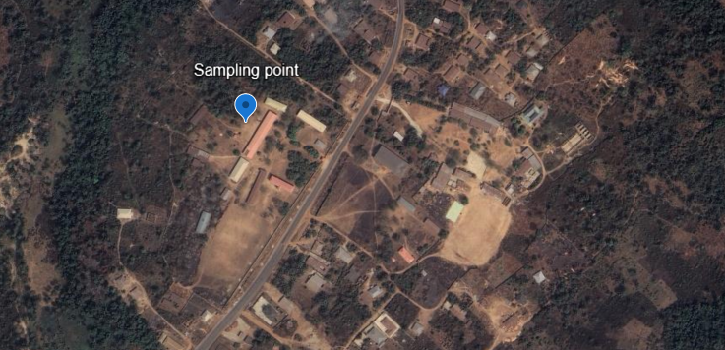
2.2 Mix Proportions and Sample Preparation
Soil samples were stabilized using different ratios of Gum Arabic and Quarry Dust in order to assess the impact of these additives on the geotechnical characteristics of the expansive soil. Gum Arabic was applied to the soil at doses of 2%, 4%, 6% and 8% by dry weight, and quarry dust was added at replacement levels of 5%, 10%, 15% and 20% by dry weight of soil. Previous research on biopolymer and quarry dust stabilization guided the dosage selection process, which also extended into untested combinations to evaluate possible synergistic effects.

To guarantee a consistent particle size distribution, the soil samples were air-dried, ground, and put through the proper filter before being mixed. Using a computerized balance, the necessary amounts of dirt, quarry dust and gum Arabic were precisely weighed. Before adding Gum Arabic, a homogenous mixture of soil and quarry dust was first achieved by dry mixing. To improve its dispersion within the soil matrix, gum Arabic was applied in a regulated manner in solution form. Distilled water was gradually added to reach the required moisture content, guaranteeing compliance with the specifications of the corresponding geotechnical tests. The cohesive nature of Gum Arabic and the fine texture of Quarry Dust presented significant obstacles during sample preparation, especially in ensuring uniform mixing. Furthermore, it was challenging to maintain a constant moisture content since Gum Arabic had a propensity to absorb water quickly, which resulted in localized agglomeration. Long-term mixing, gradual water addition, and frequent turning of the soil mixture were used to overcome these difficulties until workable consistency and visual uniformity were attained. To evaluate the short-term effects of stabilization, the produced specimens were cured for 7 and 14 days after being compacted in compliance with pertinent standard protocols. Specimens were sealed to avoid evaporation and guarantee consistent hydration, and curing was carried out under carefully monitored laboratory settings to reduce moisture loss. These curing times were chosen in order to assess how strength and stabilizing effects changed over time.
2.3 Laboratory Testing Program
In compliance with pertinent standards, laboratory tests for natural moisture content, specific gravity, particle size distribution, Atterberg limits, compaction, CBR, and direct shear were carried out.
- BS 1377 (1990) – Soil testing methods
- BS 1924 (1990) – Stabilized soils and Test1 (A) BS 1377 (1990) – Natural soil Atterberg limits (Tanyıldızı et al., 2023).)
- BS1377 (1990) – CBR test (Irokwe et al., 2022).
- ASTM D3080 – Direct shear test
Since all tests adhered precisely to conventional codal provisions, detailed procedural details are removed for the sake of conciseness.

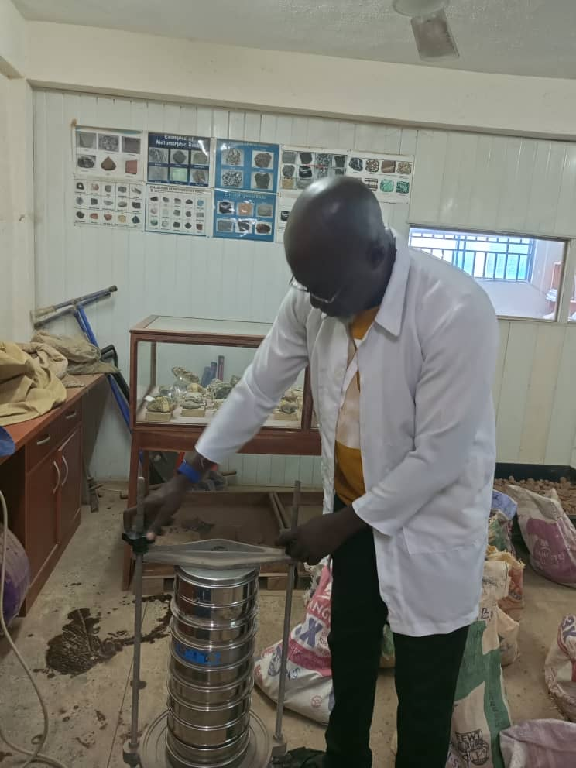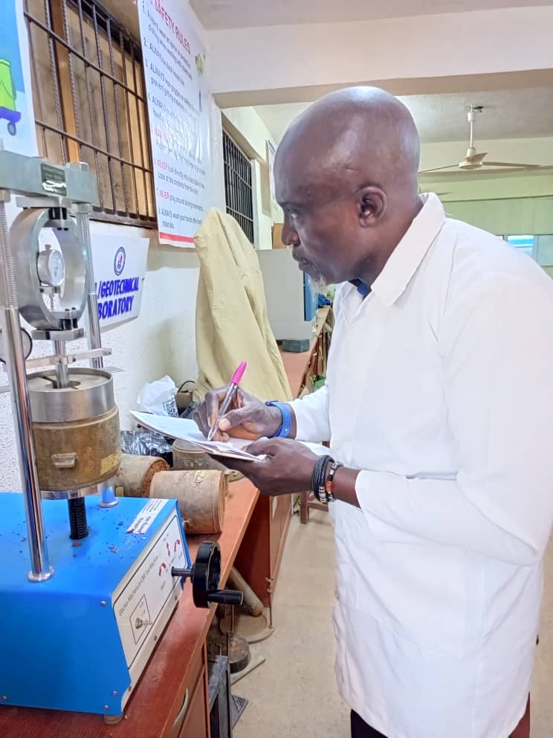
Fig. 1. Sieve Analysis of Soil Sample Fig. 2. California Bearing Ratio apparatus

2.4 X-Ray Diffraction Test
The X-Ray Diffraction (XRD) test was conducted to determine the mineralogical composition of the soil samples (Hamed et al., 2021). Prior to testing, the soil samples were air-dried thoroughly to eliminate moisture that could interfere with the results. The dried samples were then ground to a fine powder using a mortar and pestle to ensure uniform particle size, which is critical for accurate diffraction patterns.
After grinding, the powdered samples were mounted on sample holders using a standard back-loading technique to reduce preferred orientation of the particles. The samples were then placed in the XRD machine, and the test was carried out using Cu-Kα radiation as the X-ray source, operated at 40 kV and 30 mA. The scanning range was typically set between 5° and 70° 2θ at a scanning rate of 2° per minute.
As the X-rays interacted with the crystalline structure of the soil minerals, diffraction patterns were generated and recorded. The resulting diffractograms were analyzed using specialized software that compared the peak positions and intensities with reference patterns in a mineral database. This allowed for the identification of the various mineral phases present in the soil sample, such as quartz, kaolinite, illite, or montmorillonite

3. results and discussion
3.1 Characterization of Soil Sample
Table 1 shows the engineering characteristics of the soil sample before stabilization (Zhu, et al., 2025). In comparison to the usual range of 2.60 to 2.75 for natural soils, the specific gravity of the soil was found to be 2.10. This may indicate the presence of organic debris or a high clay concentration. The plasticity, consistency and shrink-swell behavior of fine-grained soils were evaluated using the Atterberg limits. Although it was lower than the liquid limit, the plastic limit of the soil (18.34%) is typical of active clay soils. The liquid limit of the soil was found to be 47.8%, showing a modest ability to retain water.
The high degree of plasticity of the soil was confirmed by the Plasticity Index (29.46%), and its classification as an expansive clay which presents serious problems for pavement stability was further supported by the Linear Shrinkage (10.71%). Poor bearing ability was indicated by the Liquidity Index (1.47), which indicates that the soil is in a soft to plastic state in the field. The soil is categorized as CL (In organic clay of medium plasticity) by the Unified Soil Classification System (USCS) based on the Atterberg limit data. These features demonstrate that the soil must first go through chemical stabilization or heat activation in order to be effectively used in roadway applications (Zhu et al., 2025).

Table 1. Initial Characterization Test (Before Stabilization)
S/N | Parameters | Values
1. | Average Moisture Content (%) | 4.1%
2. | Average Specific gravity of Soil Sample | 2.01
3. | Plastic Limit (%) | 18.34 %
5. | Liquid limit (%) | 47.8 %
6. | Plastic Index | 29.46 %
7. | Liquidity index (%) | 1.47
8. | Consistency Index | 2.67
9. | Linear Shrinkage (%) | 10.71
10. | Classification | Inorganic clay of medium plasticity
11. | CBR | 41.5 %
12. | Direct Shear Strength | 24.93994 kN/m²

The Plasticity Index of the soil shows expansive, active clay, which is particularly troublesome in pavement subgrades. The XRD data' mineralogical identification of montmorillonite (33%) is consistent with the high PI. Additionally, because the soil's liquidity index (LI) is greater than 1, it is naturally above the plastic limit, indicating that it is in a soft to very soft state in-situ and if left untreated, it could become unstable under loading. According to the consistency index, earth behaves like an extremely hard or stiff substance when it is drier than the plastic limit. Because of its extreme flexibility and shrinkage, vulnerability to volume changes and poor workability and stability in wet conditions, the soil in its natural state is not appropriate for use as a subgrade or untreated base material in pavement construction for highway applications.

3.2 Sieve Analysis of Soil Sample
To ascertain the particle size distribution of the soil sample and categorize it using the Unified Soil Classification System (USCS), sieve analysis and hydrometer analysis (Table 2) were carried out (Seděčkováet al., 2024). According to the USCS classification, the soil was categorized as having a moderate sand content, falling into the clayey or silty soil categories. This data aided in assessing the engineering characteristics of the soil, including its possible expansiveness, permeability and flexibility. The fines (< 0.075 mm) portion was separated into silt and clay by the hydrometer test. Because the soil included more than 50% particles, the USCS classed it as fine-grained soil.

Table 2. Hydrometer analysis of soil sample
Hydrometer Analysis |  |  |  | Temp ºC = 26 |  |  | Temp. Corr. Fact (C_{T}) = 1.65
2 | 5 | 6 | 7 | 8 | 9 | 10 | 11 | 12 | 13
Time of Reading (min) | L | K | Actual Hydro. Reading R_{a} | Corr. Hydro. Reading R_{c} | % Finer | Hydro. Corr. Only for Meniscus R | L/t | D (mm) | % Finer P_{A}
0.5 | 7.4 | 0.0127 | 53 | 49 | 98 | 54.0 | 14.8 | 0.048858 | 53.312
1 | 7.8 | 0.0127 | 51 | 47 | 94 | 52.0 | 7.8 | 0.035469 | 51.136
2 | 8.1 | 0.0127 | 49 | 45 | 90 | 50.0 | 4.05 | 0.025558 | 48.96
4 | 8.8 | 0.0127 | 45 | 41 | 82 | 46.0 | 2.2 | 0.018837 | 44.608
8 | 9.4 | 0.0127 | 41 | 37 | 74 | 42.0 | 1.175 | 0.013766 | 40.256
15 | 9.9 | 0.0127 | 38 | 34 | 68 | 39.0 | 0.66 | 0.010318 | 36.992
30 | 10.5 | 0.0127 | 34 | 30 | 60 | 35.0 | 0.35 | 0.007513 | 32.64
60 | 10.7 | 0.0127 | 33 | 29 | 58 | 34.0 | 0.178333 | 0.005363 | 31.552
120 | 11.1 | 0.0127 | 31 | 27 | 54 | 32.0 | 0.0925 | 0.003863 | 29.376
240 | 11.4 | 0.0127 | 29 | 25 | 40 | 30.0 | 0.0475 | 0.002768 | 27.2
360 | 11.7 | 0.0127 | 27 | 23 | 46 | 28.0 | 0.0325 | 0.002290 | 25.024
480 | 11.9 | 0.0127 | 26 | 22 | 44 | 27.0 | 0.024792 | 0.002 | 23.936
1440 | 12.5 | 0.0127 | 22 | 18 | 36 | 23.0 | 0.008681 | 0.001183 | 19.584

The grain size analysis showed the soil was dominated by fines, particularly silt, with a notable clay fraction. With >35% silt and moderate clay, the soil is classified as either ML (Silt of low plasticity) or CL-ML (silty clay of low plasticity).
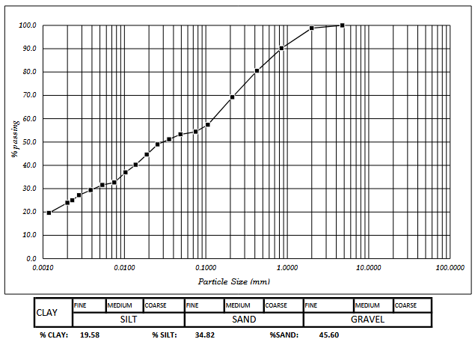
Fig. 3. Particle size distribution curve
3.3 Compaction Test
The compaction characteristics (In Figure 4) revealed that the soil has a high Optimum Moisture Content (26%) and a relatively low Maximum Dry Density (1.57 kg/m³). This behavior is typical of fine-grained, clay-rich soils with high plasticity (Ajagbe et al., 2024). The low dry density is consistent with the soil's high void ratio and low specific gravity, while the high OMC reflects its significant water absorption capacity and expansive nature. These characteristics support the previous classification and validate that stabilization or modification is required prior to use in construction applications, particularly in pavement subgrades or as a raw material for geopolymer binders.

Maximum Dry Density | 1.57kg/m³
Optimum Moisture Content | 26%
Fig. 4. A graph of dry density against moisture content
3.3 Mineral Composition of the Expansive Soil Sample
To understand the mineralogical behavior of the expansive soil and its impact on the performance of soil, X-ray diffraction (XRD) and quantitative analysis were conducted (Hamed et al., 2021). The XRD data revealed that the soil sample contained major crystalline phases whice includes Montmorillonite (33%), Muscovite (18%), Clinochlore (44%) and Quartz (5.1%), Table 3 shows the crystalline mineral phases and their relevance in the soil sample.
Montmorillonite (33%) is a high-swelling smectite clay. Its presence indicates high plasticity and water sensitivity, which negatively affect dimensional stability in pavements (Utkarsh and Jain, 2024). However, under alkaline conditions in geopolymer systems, some montmorillonite structures may disintegrate or be immobilized within the aluminosilicate network. Still, pre-treatment or replacement is recommended for reliable concrete performance. Muscovite (18%), although less reactive, can act as a non-plastic filler and may slightly reduce the reactivity of the binder system. Its platy morphology can influence the flow properties of fresh mixes. Clinochlore (44%) is generally inert and contributes to the overall mineral matrix but plays a minor role in the geopolymerization process. Little Quartz suggests the soil is relatively fine-grained and reactive, but it also means it lacks stable, non-reactive aggregates, which might otherwise help in long-term dimensional stability.

Table 3. Identified Phases in the Soil Sample and their Relevance
Mineral | Chemical Formula | Weight % | Relevance
Montmorillonite | Al₂Si₄O₁₀(OH)₂·nH₂O | 33% | Expansive smectite clay, reactive and thermally activatable; important for geopolymer potential.
Muscovite | KAl₂(AlSi₃O₁₀)(OH)₂ | 18% | Mica-type mineral with moderate swelling potential, Mica group mineral, non-plastic filler, limited pozzolanic activity
Clinochlore | (Mg,Fe)₅Al(Si₃Al)O₁₀(OH)₈ | 44% | Primary phase; chlorite mineral, relatively inert in cement chemistry, but affects plasticity and particle shape.
Quartz | SiO₂ | 5.1 | Inert crystalline filler; contributes stability and mechanical packing.
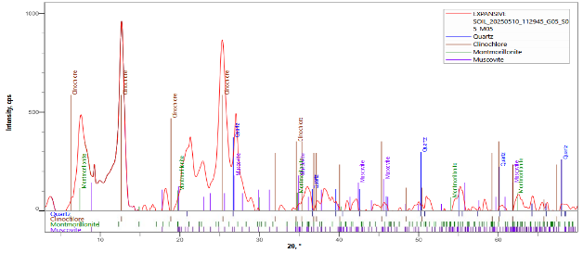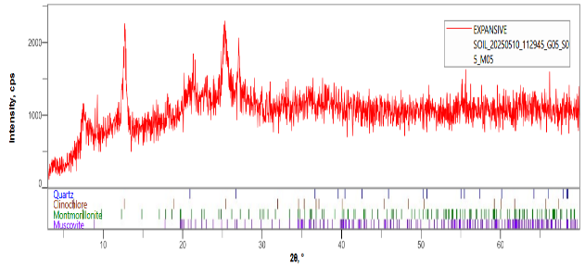
Fig. 5. Phase data view of soil sample Fig. 6. Multiply profile of soil sample
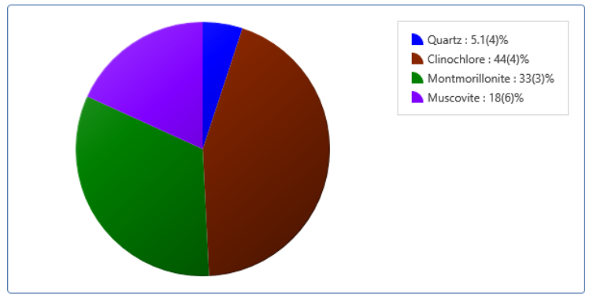
Fig. 7. Plot of results of soil sample
3.3 California Bearing Ratio
The California Bearing Ratio (CBR) test was used to evaluate the load-bearing capacity of expansive soil treated with varying dosages of gum Arabic and stone dust. The CBR values of soil stabilized with gum Arabic and stone dust in varying dosages is shown on Table 4 and Figure 8. The results show how stabilization using gum Arabic and stone dust affects the California Bearing Ratio (CBR) of expansive clay soil.
The control sample (untreated soil) had the highest 7-day CBR of 4.15%, which likely reflects a temporary increase in strength due to compaction rather than genuine long-term stability. Given the high plasticity and shrinkage of the soil, such a high value is not expected to sustain over time or moisture fluctuations. At 2% gum Arabic and 5% stone dust, the 7-day CBR significantly decreased to 3.25%, but improved to 5% after 14 days. This indicates delayed strength gain as the binding effect of gum Arabic and mechanical interlocking from stone dust begins to take effect. The 4% gum Arabic and 10% stone dust mix achieved the highest 14-day CBR of 9%, suggesting this dosage provides the most effective balance between organic binder content and mechanical reinforcement. Gum Arabic likely aids in bonding soil particles, while stone dust fills void and improves density. Increasing the dosage further (6–8% gum Arabic and 15–20% stone dust) did not lead to further improvement in CBR values. In fact, the 14-day CBR dropped slightly to 4.75%, likely due to, overuse of gum Arabic, which may begin to introduce too much organic content or reduce compatibility as well as excessive stone dust, which could disturb the optimal grading or bonding ratio.
The results shows that moderate doses of gum Arabic and stone dust (4%: 10%) offer the best improvement in bearing capacity over time. Excess dosages can lead to diminishing returns due to poor particle bonding or excess fines (Sugumaran and Neme, 2024).
Table 4: CBR values of soil samples at different dosage treatment
S/N | Treatment Dosage | CBR (%)
 |  | 7 days | 14 days
1. | Control (Untreated) | 4.15
2. | 2% Gum Arabic : 5% Stone Dust | 3.25 | 5
3. | 4% Gum Arabic : 10% Stone Dust | 2.25 | 9
4. | 6% Gum Arabic : 15% Stone Dust | 5 | 4.75
5. | 8% Gum Arabic : 20% Stone Dust | 5 | 4.75

Fig. 8: California Bearing Ratio of Soil Samples
3.3 Direct Shear Strength Test
The shear strength behavior of the soil samples treated with varying combinations of gum Arabic and stone dust was evaluated at 7 and 14 days to assess their stability under shear loading and the result is presented on Table 5 and Figure 9. The control sample consistently had the lowest shear strength (24.94 kN/m²) and cohesion (7.4 kN/m²), confirming its weaker natural structure, which is probably caused by poor inter-particle bonding and high plasticity.
The highest shear strength values were obtained at 7 days (31.72 kN/m²) and 14 days (33.12 kN/m²) with the treatment combination of 2% gum Arabic and 5% stone dust. This was mainly due to a significant increase in cohesion rather than friction angle. Interestingly, this 2%:5% treatment showed very low angles of shearing resistance (1.41° and 1.70°), suggesting that gum Arabic cohesive binding was very effective in increasing shear strength even though inter-particle friction was low. For higher dosages (4%:10%, 6%:15%, 8%:20%), cohesion moderately improved, and the angle of internal friction stabilized around 3.2° to 4.6°, resulting in steady shear strength values in the 24–28 kN/m² range
Gum Arabic functions as a binding agent, enhancing interparticle adhesion and boosting shear resistance, as evidenced by the increase in cohesiveness observed in all treated samples (Rimbarngaye et al., 2022). Stone dust likely contributed to matrix densification and reduction of voids, improving the mechanical interlocking to some extent—though less dominant than the cohesive contribution. The relatively low and fluctuating friction angles across treatments suggest that cohesion dominates shear behavior in treated expansive clay, typical of clay-rich soils.
The optimal treatment for shear strength enhancement appears to be 2% gum Arabic and 5% stone dust, offering a significant increase in cohesion and overall shear capacity. Increasing the dosage beyond this point does not produce proportional strength gains, and in some cases, may lower friction angles due to excess fines or binder saturation. These findings reinforce the importance of dosage optimization when using organic and mineral stabilizers for improving the strength behavior of expansive soils.
Table 5: Shear Strength Values of Soil Sample
Parameters | Shear Strength of Soil Samples
 | 7 days
 | Control | 2% 5% | 4% 10% | 6% 15% | 8% 20%
Apparent Cohesion C’ (kN/m²) | 7.4 | 26.8 | 11.62 | 11.62 | 13.01
Angle of shearing resistance | 5.012 | 1.41 | 4.61 | 3.57 | 3.25
Shear Strength (kN/m²) | 24.93994 | 31.72282 | 27.74675 | 24.0978 | 24.36682
 | 14days
 | Control | 2% 5% | 4% 10% | 6% 15% | 8% 20%
Apparent Cohesion C’ (kN/m²) | 7.4 | 27.18 | 12.39 | 11.94 | 12.83
Angle of shearing resistance | 5.012 | 1.7 | 4.59 | 3.54 | 4.46
Shear Strength | 24.93994 | 33.11586 | 28.44649 | 24.31268 | 28.42986

Fig. 9: Shear Strength of Soil Samples

4. Conclusion

This study investigated the effectiveness of using gum Arabic and stone dust as stabilizing agents to improve the geotechnical properties of expansive soil. The untreated soil was characterized by high plasticity, low specific gravity, high linear shrinkage, and poor shear strength, making it unsuitable for pavement subgrades without modification.
Based on the findings from this study, the following conclusions are given
i. The soil was classified as inorganic clay of medium plasticity (CL) with a plasticity index of 29.46% and a linear shrinkage of 10.71%, confirming its expansive nature.
ii. The soil had a low specific gravity of 2.01 and a maximum dry density of 1.57 kg/m³, with an optimum moisture content of 26%.
iii. XRD analysis revealed high proportions of clinochlore (44%), montmorillonite (33%), and muscovite (18%), minerals known to influence swelling behavior.
iv. The best improvement in unsoaked CBR at 14 days was observed at 4% gum Arabic and 10% stone dust, achieving 9%, indicating improved bearing capacity with curing.
v. The maximum shear strength (33.12 kN/m²) was obtained with 2% gum Arabic and 5% stone dust after 14 days, attributed to a major increase in apparent cohesion
4.1 Recommendations
Based on the findings on this study, the following recommendations are given
i. Since strength gains increased between 7 and 14 days, longer curing durations (e.g., 28 days) may yield further improvements and should be considered in future studies.
ii. The clay content and mineralogy suggest that the soil may serve as a potential geopolymer precursor if thermally activated. Further study is recommended to assess this potential.
iii. Investigate the long-term durability and environmental performance of gum Arabic-stabilized soils.

COMPETING INTERESTS DISCLAIMER:
Authors have declared that they have no known competing financial interests OR non-financial interests OR personal relationships that could have appeared to influence the work reported in this paper.
Disclaimer (Artificial intelligence)
Option 1:
Author(s) hereby declare that NO generative AI technologies such as Large Language Models (ChatGPT, COPILOT, etc.) and text-to-image generators have been used during the writing or editing of this manuscript.
Option 2:
Author(s) hereby declare that generative AI technologies such as Large Language Models, etc. have been used during the writing or editing of manuscripts. This explanation will include the name, version, model, and source of the generative AI technology and as well as all input prompts provided to the generative AI technology
Details of the AI usage are given below:
1.
2.
3.

References

- Ajagbe, W. O., Akolade, A. S., Ogunlade, O. D., Olaomotito, P. A., Odunewu, I. D., & Alabi, O. O. (2024). Application of gum Arabic on the geotechnical properties of subgrade materials. Acta Technica Jaurinensis. https://doi.org/10.14513/actatechjaur.00748
- Almuaythir, S., & Abbas, M. F. (2023). Expansive soil remediation using cement kiln dust as stabilizer. Case Studies in Construction Materials, 18, e01983. https://doi.org/10.1016/j.cscm.2023.e01983
- Almuaythir, S., Zaini, M. S. I., Hasan, M., & Hoque, M. I. (2024). Sustainable soil stabilization using industrial waste ash: Enhancing expansive clay properties. Heliyon, 10(20), e39124. https://doi.org/10.1016/j.heliyon.2024.e39124
- Aloqbi, A. A. (2020). Gum Arabic as a natural product with antimicrobial and anticancer activities. Archives of Pharmacy Practice, 11(2), 107-112. https://archivepp.com/archive/volume.11/issue.2/
- Awang, H., Salmanfarsi, A. F., Zaini, M. S. I., Mohamad Yazid, M. A. F., & Ali, M. I. (2021). Investigation of groundwater table under rock slope by using electrical resistivity imaging at Sri Jaya, Pahang, Malaysia. IOP Conference Series: Earth and Environmental Science, 682(1), 012017. https://doi.org/10.1088/1755-1315/682/1/012017
- Bian, X., Ren, Z., Zeng, L., Zhao, F., Yao, Y., & Li, X. (2024). Effects of biochar on the compressibility of soil with high water content. Journal of Cleaner Production, 434, 140032. https://doi.org/10.1016/j.jclepro.2023.140032
- Bishnoi, D. K. M. (2019). A result paper on experimental study on stabilization of soil subgrade by adding stone dust.
- EL Afandi, M., Yehia, S., Landolsi, T., Qaddoumi, N., & Elchalakani, M. (2023). Concrete-to-concrete bond Strength: A review. Construction and Building Materials, 363, 129820. https://doi.org/10.1016/j.conbuildmat.2022.129820
- Hamed, Heiam & Hale, William & Stern, Ben. (2021). X-RAY DIFFRACTION TO DETERMINE THE MINERALOGY IN SOIL SAMPLES IN THE UK. International Journal of Engineering Applied Sciences and Technology. 5. 10.33564/IJEAST.2021.v05i10.014.
- Hasan, M., Zaini, M. S. I., Yie, L. S., Masri, K. A., Jaya, R. P., Hyodo, M., & Winter, M. J. (2021). Effect of optimum utilization of silica fume and eggshell ash to the engineering properties of expansive soil. Journal of Materials Research and Technology. https://doi.org/10.1016/j.jmrt.2021.07.023
- Hasyimi, T., & Syahril, S. (2021). Improvement of Soft Soil for Subgrade Stabilized with Emulsified Asphalt and Tailing. In Advances in Engineering Research: Proceedings of the 2nd International Seminar of Science and Applied Technology (ISSAT 2021). Atlantis Press. https://doi.org/10.2991/aer.k.211106.074
- Ikeagwuani, C. C., & Nwonu, D. C. (2019). Emerging trends in expansive soil stabilisation: A review. Journal of Rock Mechanics and Geotechnical Engineering, 11(2), 423–440. https://doi.org/10.1016/j.jrmge.2018.08.013
- Irokwe, J. O., Nwaogazie, I. L., & Sule, S. (2022). Development of Empirical Models for the Estimation of CBR Value of Soil from Their Index Properties: A Case Study of the Ogbia-Nembe Road in Niger Delta Region of Nigeria. Open Journal of Civil Engineering, 12(4), 648–664. https://doi.org/10.4236/ojce.2022.124036
- Karami, H., Pooni, J., Robert, D., Costa, S., Li, J., & Setunge, S. (2021). Use of secondary additives in fly ash based soil stabilization for soft subgrades. Transportation Geotechnics, 29, 100585. https://doi.org/10.1016/j.trgeo.2021.100585
- Khudhair, A. A., Shaia, H., & Aodah, H. H. (2023). Improving of the subgrade soil using chemical additives. Maǧallaẗ Al Baṣraẗ Li l ʻulūm al Handasiyyaẗ, 23(1), 7–13. https://doi.org/10.33971/bjes.23.1.2
- Marx Ferdinand Ahlinhan, Orphée Joel Dansou, Bidossessi Dorothée Djenou, Léonard Sounouvou, and Edmond Codjo Adjovi. 2025. “Swelling and Shrinkage Performance of Expansive Soils under Repeated Moisture Variations”. Current Journal of Applied Science and Technology 44 (4):91–110. https://doi.org/10.9734/cjast/2025/v44i44517.

- Mudgil, D., & Mudgil, S. (2024). Acacia gum: Chemistry, properties & food applications. Food and Humanity, 2, 100264. https://doi.org/10.1016/j.foohum.2024.100264
- Prasad, N., Thombare, N., Sharma, S.C., & Kumar, S. (2022). Gum Arabic – A versatile natural gum: A review on production, processing, properties and applications. Industrial Crops and Products https://doi.org/10.1016/j.indcrop.2022.115304
- Puppala, A. J. (2021). Performance evaluation of infrastructure on problematic expansive soils: Characterization challenges, innovative stabilization designs, and monitoring methods. Journal of Geotechnical and Geoenvironmental Engineering https://doi.org/10.1061/(ASCE)GT.1943-5606.0002518
- Rimbarngaye, A., Mwero, J. N., & Ronoh, E. K. (2022). Effect of gum Arabic content on maximum dry density and optimum moisture content of laterite soil. Heliyon, 8(11). https://doi.org/10.1016/j.heliyon.2022.e11553
- Roodi, G. H., & Zornberg, J. G. (2020). Long-term field evaluation of a geosynthetic-stabilized roadway founded on expansive clays. Journal of Geotechnical and Geoenvironmental Engineering, 146(4), 05020001. https://doi.org/10.1061/(ASCE)GT.1943-5606.0002206
- Sedláčková, K., Ševelová, L., Igaz, D., & Aydın, E. (2024). Determination of Particle Size Distribution: Comparison of Standard Hydrometer Method and Laser Diffraction Analysis for Use in Forestry. Forests, 15(2), 327. https://doi.org/10.3390/f15020327
- Sugumaran, B., & Neme, I. (2024). Effect of adsorption interactions of Arabic gum with cement. Materials Research Express, 11(6), 065503. https://doi.org/10.1088/2053-1591/ad51d8
- Tanyıldızı, M., Uz, V. E., & Gökalp, İ. (2023). Utilization of waste materials in the stabilization of expansive pavement subgrade: An extensive review. Construction and Building Materials https://doi.org/10.1016/j.conbuildmat.2023.132435
- Utkarsh, & Jain, P. K. (2024). Enhancing the properties of swelling soils with lime, fly ash, and expanded polystyrene -A review. Heliyon, 10(12), e32908. https://doi.org/10.1016/j.heliyon.2024.e32908
- Reddy, K. L. V., & Murty Dasaka, S. (2024). Stabilization of expansive soil for highway embankment: A critical review. Japanese Geotechnical Society Special Publication, 10, 1554–1559. https://doi.org/10.3208/jgssp.v10.OS-30-06
- Waheed, M., & Asmael, N. (2018). Improvement of engineering soil properties using non-traditional additives. MATEC Web of Conferences, 162, 01027 https://doi.org/10.1051/matecconf/201816201027
- Wahab, A., Hasan, M., Mohd Kusin, F., Embong, Z., Zaman, Q. U., Babar, Z. U., & Imran, M. S. (2022). Physical Properties of Undisturbed Tropical Peat Soil at Pekan District, Pahang, West Malaysia. International Journal of Integrated Engineering, 14(4), 403–414. https://publisher.uthm.edu.my/ojs/index.php/ijie/article/view/8667
- Zada, U., Jamal, A., Iqbal, M., Eldin, S. M., Almoshaogeh, M., Bekkouche, S. R., & Almuaythir, S. (2023). Recent advances in expansive soil stabilization using admixtures: Current challenges and opportunities. Case Studies in Construction Materials https://doi.org/10.1016/j.cscm.2023.e01985
- Zaini, M. S. I., & Hasan, M. (2023). Effects of industrial and agricultural recycled waste enhanced with lime utilisation in stabilising kaolinitic soil. International Journal of Sustainable Construction Engineering and Technology, 14(4), 332–353. https://doi.org/10.30880/ijscet.2023.14.04.025
- Zaini, M. S. I., & Hasan, M. (2023). Effectiveness of silica fume eggshell ash and lime use on the properties of kaolinitic clay. International Journal of Engineering and Technology Innovation, 13(4). https://doi.org/10.46604/ijeti.2023.11936
- Zaini, M. S. I., Hasan, M., & Jusoh, W. N. B. W. (2025). Utilization of bottom ash waste as a granular column to enhance the lateral load capacity of soft kaolin clay soil. Environmental Science and Pollution Research, 32(22), 12951–12977. https://doi.org/10.1007/s11356-023-25966-x
- Zhao, D., Zhang, B., Shen, W., Wu, M., Guan, Y., Wu, J., Zhang, Z., & Zhu, J. (2021). High industrial solid waste road base course binder: Performance regulation, hydration characteristics and practical application. Journal of Cleaner Production, 313, 127879. https://doi.org/10.1016/j.jclepro.2021.127879
- Zhen, H., Shi, H., Zhang, W., Ma, S., Gao, F., & Ma, M. (2022). Expansive soil embankment filling and cutting treatment technology: A systematic review. Advances in Materials Science and Engineering https://doi.org/10.1155/2022/4045620
- Zhu, M., Leo, C., Zeng, Q., Fanna, D. J., Hsi, J., Karimi, R., Fabbri, A., Liyanapathirana, S., Hu, P., & Alzghool, H. (2025). Efficacy of expansive soil stabilisation using un-calcinated Kaolinite-Based Alkali-Activated binders. Cleaner Materials, 16, 100315. https://doi.org/10.1016/j.clema.2025.100315
- Zolkepli, M. F., Ishak, M. F., & Zaini, M. S. I. (2019). Slope stability analysis using modified Fellenius's and Bishop's method. IOP Conference Series: Materials Science and Engineering, 527(1), 012004. https://doi.org/10.1088/1757-899X/527/1/012004

