Original Research Article
Design and Implementation of an Automated Weather-Controlled Retractable Canopy System
for Nursery Beds

.
ABSTRACT

The automated nursery bed canopy system represents a significant advancement in smart farming. This project addressed the need for precision and automation in nursery bed environments. Traditional nursery bed management faces challenges in providing protection for seedlings. This project seeks to revolutionise nursery bed cultivation by creating an automated canopy system capable of responding to environmental conditions intelligently. This study designed and implemented a hardware prototype of an automated weather-controlled retractable canopy system for nursery beds by integrating an ESP32 microcontroller, resistive soil moisture and rain sensors, a DHT22 humidity and temperature sensor, relay high-torque DC motor, solar panels, and the Blynk platform. A robust frame structure for retraction was constructed, using sensors including resistive soil moisture and rain sensors, a DHT22 humidity and temperature sensor, and motorized mechanisms including relays and high-torque DC motors for canopy movement. IoT was also integrated to ensure real-time feedback and data collection. The system met the coverage angle of 180° and was stable under different wind conditions. The time to open and cover the nursery bed under rainfall was 3 seconds, with a canopy position adjustment of ± 5°. The automated canopy systems gave a 50% higher growth rate (1.8 cm/day vs. 1.2 cm/day) compared to the manually controlled environment. The survival rate increased to 96% under the automated system, 8% better than traditional nurseries. Meanwhile, water use efficiency improved as the automated system achieved 11 kg of tomatoes per cubic meter of water compared to 6 kg/m³ under regular methods. The automated system was able to achieve better precision, reduce manual intervention, and offer potential applications in smart agriculture.

Keywords: automated canopy system, nursery bed protection, weather monitoring, embedded systems, smart farming technology, traditional nursery, mechatronics engineering

1. INTRODUCTION
Nursery beds are important in horticulture and commercial agriculture as they provide a means to control the environment for fragile young plants as they germinate before they are transplanted. These nurseries determine the quality and quantity of planting materials for various crops (Fifer and Motis, 2021). According to Fifer and Motis (2021), the nursery site should be well-drained, fertile, accessible, have an adequate water supply, sunlight, and wind protection, as well as be free from pests and diseases. The nursery should also provide optimal temperature, humidity, light, and ventilation. Based on the size and type of the nursery, different covering structures can be employed, including polyhouses, shade nets, mist chambers, or open beds (Singh et al., 2017). Traditional nursery operations heavily rely on manual labor for tasks such as shading, irrigation, and environmental control, which are often inefficient, inconsistent, and unable to quickly adapt to dynamic environmental conditions, thereby compromising seedling quality and increasing production costs. (Mahmud, M. S. et al., 2023). Also, existing canopy systems for nursery beds have received limited attention in recent research.

There are several studies on canopy systems for different applications, including outdoor shading for residential spaces, agricultural greenhouses, and garden pavilions. Gudela et al. (2020) designed and implemented an automatic umbrella actuated through water and temperature sensors. Their study highlighted how sensor-based control mechanisms can be used in mechanical systems and how feasible it is to integrate IoT technologies into everyday life. The insight from this study can be utilized in the design of an automated nursery bed canopy system, as the prototype is actuated based on readings from water and temperature sensors, addressing the need for adaptable and responsive systems that can protect users from rain and excessive heat. Similarly, Jason (2015) designed and implemented an automated retractable awning system with a rain sensor, aiming to provide an efficient solution to manage a canopy under different weather conditions. The study noted how traditional awning systems require manual operation and can be cumbersome and time-consuming, necessitating the implementation of rain sensors to accurately and responsively detect rainfall. Furthermore, Azhar et al. (2020) designed and developed the Sumato awning system, offering a foundation for understanding automated awning technologies and serving as a reference to adding advanced sensing technologies and actuation mechanisms into shading solutions. In the project, advanced light sensors and weather sensors were employed to effect automatic adjustment of the awning based on ambient lighting conditions and weather parameters. The system also had an actuation mechanism that used electric motors and intelligent control algorithms for the smooth and precise movement of the awning. These studies confirm the use of advanced technology for canopy systems, albeit in a different context other than nursery bed protection.

These mechanisms have not been effectively implemented for nursery beds in the specific context of weather protection. The limitation of manual approaches to nursery bed protection includes the need for constant monitoring and intervention, sparking a need for automated solutions in the context of nursery beds. While there is a plethora of studies on manual methods of covering and uncovering nursery beds to shield plants from precipitation and extreme temperature, there is limited research that focuses specifically on automated systems. In some regions, including Nigeria, conventional methods of managing nurseries depend on manual methods to protect seeds from adverse weather conditions like excessive sunlight, heavy rainfall, or wind. Usually, these methods are inconsistent and demand intensive human assistance, which can reduce the growth rate and survival rate of the seedling. Automation and sensor technologies have advanced and helped in the development of systems that can respond to the weather through monitoring environmental parameters in real-time and actuating mechanical components accordingly. The use of real-time sensors, such as raindrop sensors and temperature sensors, combined with intelligent control algorithms, presents an opportunity to automate canopy movements based on environmental conditions (Gudela et al., 2020; Jason, 2015).

Nursery cultivation is a term that covers several crops in agriculture. However, tomato will be focused on in this study. Tomato (Solanum lycopersicum) is a popular vegetable that can be grown in several climates and soils (Mohammed Ali et al., 2025). However, it is prone to pests and diseases, especially when it is still a seedling (Mohammed Ali et al., 2025). Therefore, tomato requires stringent nursery cultivation for proper growth and survival, involving the use of growing medium, sowing seed trays, adequate water and fertilizer, and protection from pests and diseases to improve germination rate, uniform growth, and increased yield (Lin et al., 2018). Singh et al. (2017) noted the benefits of using high-tech nursery techniques for horticultural crops such as tomatoes, including modern nursery structure, mother stocks and rootstocks selection, media preparation, and sterilization, pest and disease management, etc. Automating the process of shielding nurseries from adverse weather conditions offers a transformative solution in agriculture that optimizes the growth and yield of various plants. Integrating this technology into agriculture reduces costs for farmers, dependence on human efforts, and potential for human error (Duckette et al., 2018). They streamline farming processes and improve agricultural efficiency, contributing to the well-being of the nursery (Duckette et al., 2018).

The field of mechatronics offers several technological advancements in the areas of IoT, automation, and sensing. Mat et al. (2016) explored the use of IoT technologies and wireless sensor networks (WSN) for monitoring soil moisture in precision agriculture, focusing on achieving proper irrigation using WSN technology. They noted that WSN has significantly improved monitoring and control applications, enabling efficient communication with many sensors. The study proved that using a wireless moisture sensor network (WMSN) to build a feedback irrigation system where irrigation is done when soil moisture reaches a predefined threshold saved 1500 ml of water per day per tree, illustrating the usefulness of advanced technology in agriculture. Similarly, Prathibha et al. (2017) looked into an IoT-based monitoring system in smart agriculture, aiming to leverage IoT and automation for smart agriculture. The study focused on monitoring environmental factors, including humidity and temperature, through sensors, to improve the yield of crops. A CC3200 single chip and a camera interface for image feedback through MMS to farmers were integrated, further showing the streamlined processes that automation brings to agriculture. However, these studies do not focus on the uniqueness of the nursery in agriculture and the integration of IoT and automation technologies in that context.

Furthermore, Kareem et al. (2021) explored the working principles of the ESP32 microcontroller module and its analytical comparison in embedded systems design, providing insights into how capable and functional these low-cost microcontroller modules are in automation and control aspects in the context of a canopy system. The comparison was based on hardware specifications and programming tools, and a Wi-Fi analyzer system was designed and implemented as an example of using the ESP32 module in a low-cost, low-energy embedded system. The findings showed that this low-cost module can be used for prototyping and low-budget embedded systems, which can be scaled over time. Similarly, Carducci et al. (2019) explored the enabling of ESP32-based IoT applications in building automation systems, focusing on how the module can be used for data acquisition, communication, and control, which can be extended to the context of automating the nursery bed canopy mechanism.

The project covers the design, fabrication, and testing of a retractable canopy system specifically tailored for nursery bed applications. The prototype was designed to cover a nursery bed area of 80 by 50 cm, a size chosen to ensure compatibility with standard nursery bed dimensions while providing sufficient coverage for plants inside. The canopy protects plants from adverse weather conditions, including intense rainfall and solar radiation, by retracting 180 ° for maximum coverage of the nursery bed when closed. By employing sensors to detect rain and monitor temperature levels, the system autonomously retracts the canopy mechanism to shield plants during rainfall and high temperatures. The project contributes to the advancement of automated canopy systems by combining mechanical design principles, sensor technologies, and automation algorithms, creating a robust and reliable solution that addresses the challenges faced in nursery bed cultivation and promotes the sustainable growth of plants in adverse weather conditions.

2. methodology
2.1 Project Approach and Methodology
2.1.1 Project Planning
The project planning phase involved defining the project objectives, scope, and deliverables. The objectives of the project were to design a system that monitors the weather of a plant nursery, implement a hardware prototype of the proposed design, and evaluate the performance of the system. An extensive literature review was conducted to understand existing canopy systems, automation technologies that had been implemented with them, and sensing methods.

2.1.2 System Design
In this phase, a conceptual design was developed, highlighting all phases, components, and technologies that were required following the objectives of the project. Factors such as canopy dimension, range of motion, materials selection, stability, and ease of operation were taken into consideration, and detailed engineering drawings, schematics, and system specifications were developed. The system block diagram is presented in Fig. 1, showing how the system communicates, as well as providing an overview of all the required components of the system and how they are connected.

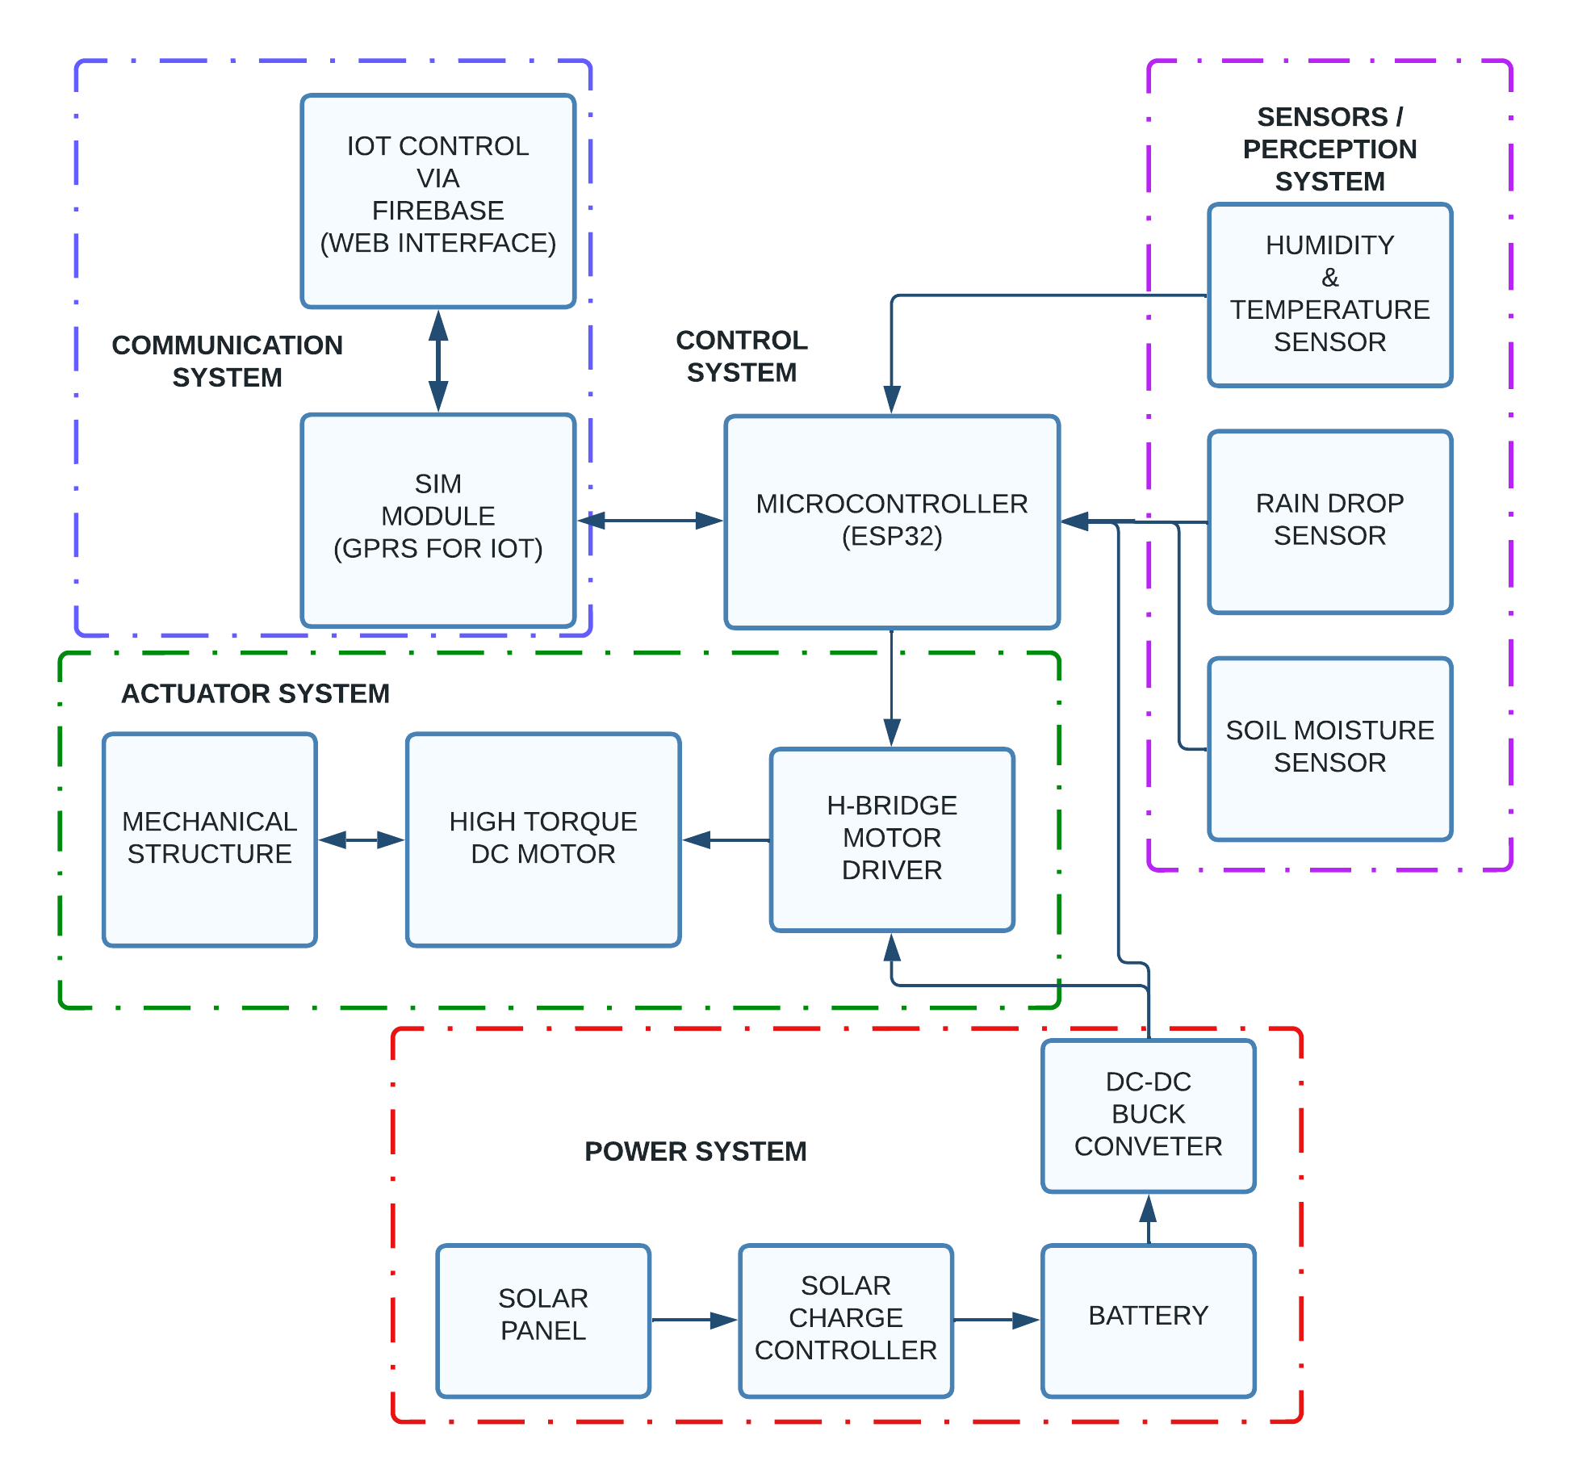
Fig. 1. System Block Diagram of the retractable canopy system

2.1.2.1 Mechanical Design
This aspect of the system design covers all mechanical aspects of the canopy mechanism, including the frame structure, hinges, and pivot points, all of which are important elements in achieving the desired range of motion, stability, and function of the mechanism.

The frame structure formed the main support for the canopy mechanism, providing stability and rigidity to make sure the system operates properly. It was constructed with steel rods. The steel material was selected because of its strength, weight, and ability to withstand environmental conditions in line with other similar canopy systems (Gudela et al., 2020; Azhar et al., 2020; Jason, 2015). The frame was designed to accommodate the dimensions of the nursery bed, providing a suitable platform for the installation of other mechanical components, and consisted of horizontal and vertical ribs that were securely connected using appropriate fasteners and welding techniques as seen in Fig. 2. The frame was engineered to withstand the force exerted during extension and retraction of the canopy and external environmental conditions.

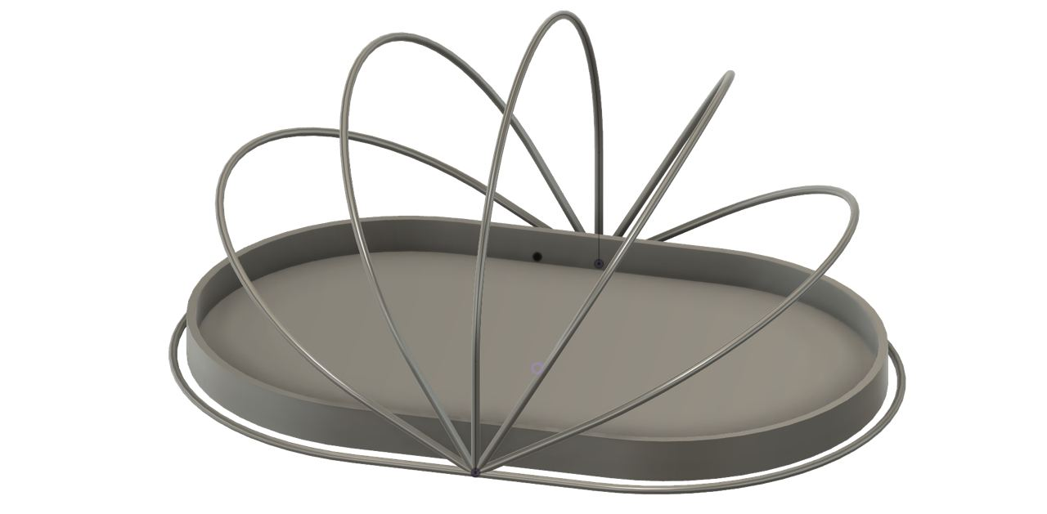
Fig. 2. Frame Structure of the Nursery Bed

The hinges are another essential component in the mechanical design of the system, enabling the rotational movement of the canopy system. They provided a flexible connection between the different mechanical parts of the system, allowing for smooth, controlled motion. They were strategically positioned along the frame structure to ensure proper folding and unfolding of the canopy. The hinges used for the project were also made of steel to withstand repetitive motion, external stresses, and a harsh environment. The pivot points also played an important role in allowing the canopy mechanism to rotate around a specific axis, facilitating the desired range by being placed at key locations. A steel shaft mechanism was also used to provide the rotational axis for the canopy (Kim et al., 2020; Li et al., 2023), and proper alignment and secure fastening were ensured to enable a stable and smooth movement of the canopy.

2.1.2.2 Electric Motor and H-Bridge Driver
The electric motor is the driving force for the canopy extension, retraction, and adjustment, while the driver is used to ensure the desired torque and speed for smooth and controlled motion. When selecting the motor, power, size, and efficiency were considered. Based on these considerations, Brush DC motors were used for the project because they are simple to use, easy to control, and offer reliable torque output (Xie et al., 2022). Not to mention that they are often used in several projects that require a retractable canopy system (Gudela et al., 2020; Jason, 2015). The brush DC motor selected for the project was a 12-volt high-torque DC motor (H-Bridge driver), which had sufficient power to drive the canopy mechanism while still being compact enough to fit the system design. The motor power rating was determined based on the load requirements and the desired speed of the canopy movement.

2.1.2.3 Sensing Component
The sensing component for the project included raindrops, humidity, soil moisture, and temperature sensors, all of which are important for detecting environmental conditions and triggering the appropriate action for the canopy extension and retraction. Raindrop sensors play an important role in detecting rain and initiating the canopy retraction process as they detect water droplets and signal the onset of rainfall. For the project, resistive raindrop sensors were used, which operate based on a change in resistance when they are exposed to water (Joshi et al., 2018). DHT22 temperature and humidity sensor was also implemented in the project to monitor the ambient temperature of the surrounding environment and the relative humidity in the air. When specific temperature thresholds are exceeded, the temperature sensor sends signals to control the system. The humidity sensor converts moisture content in the atmosphere into an electrical signal that corresponds to the humidity level, sending signals when specific humidity levels are exceeded, which turns off the humidifier devices embedded in the system. The humidity sensor is integrated into the IoT system through a microcontroller. The data from these sensors is displayed on a user interface and used for automated control and decision making. Resistive soil moisture sensors were also implemented to measure the moisture content of the soil by measuring the electrical conductivity of the soil, which is correlated with moisture levels (Saleh et al., 2016; Santos et al., 2022). This sensor is embedded in the soil at a suitable depth and connected to the IoT system, measuring moisture content and sending data to the microcontroller, which transmits this data to a central hub to determine irrigation schedules (Millán et al., 2019).

2.1.2.3 IoT Infrastructure and Connectivity Options
The IoT infrastructure allows the different components to communicate seamlessly and integrate, allowing for remote monitoring, control, and data analysis. It consists of interconnected devices, sensors, communication networks, and cloud-based platforms for data exchange and intelligent decision-making (Alam, 2021). In this project, this infrastructure allowed real-time monitoring of environmental conditions, controlled the canopy mechanism remotely, and analysed data to evaluate the performance of the system. The IoT infrastructure has a control unit that is equipped with microcontrollers and processes sensor data, while sending a signal to the motor. Cloud storage was important to store and analyse the data that was collected (Hashem et al., 2014). There were several connectivity options for IoT systems, and all of them have their own features and suitability. For the project, the choice of connectivity depended on range, data rate, power consumption, and network infrastructure. In the context of the project, remote farm locations, access to Wi-Fi, and Bluetooth connectivity may be limited, hence, cellular connectivity became the favourable option. This option covers a wider area and allows for connectivity in remote locations where there are poor network connections (Bhuiyan, 2020).

2.1.3 Control System
2.1.3.1 Control Algorithms and Automation Logic
The control algorithms and automation logic enabled intelligent decision-making and automated operation of the canopy mechanism based on sensor inputs and predefined rules. The control algorithms started by processing the data received from the sensors, and analyzing it to determine the current environmental conditions, such as the presence of rainfall, soil moisture content, humidity, or exceeding temperature thresholds. The automation logic consists of predefined rules and decision-making processes that dictate the behaviour of the canopy system. Based on the sensor data and predefined thresholds, the automation logic determines whether the canopy should retract or remain open to protect the plants. For instance, when raindrop sensors detect the presence of rainfall, the automation logic triggers the canopy retraction mechanism to provide immediate protection for the plants. Meanwhile, when temperature sensors detect that the ambient temperature has exceeded a predefined threshold, the automation logic triggers canopy closure to shield the plants from extreme heat. Likewise, when the soil moisture sensor detects a reduction in soil moisture content, the automation logic triggers the embedded irrigation system to wet the soil. And finally, when the humidity sensor detects a humidity level lag or an attainment, the automation logic triggers humidifier actions accordingly. This proactive approach ensures the plants' well-being and reduces the risk of damage due to high temperatures. The control algorithm encompasses the decision-making processes and control signals that drive the electric motor and gearing mechanism of the canopy system. It translates the outputs of the automation logic into precise motor control commands to achieve the desired canopy movement. The control algorithm determined the speed, direction, and duration of motor operation to retract or extend the canopy. To ensure smooth and precise canopy movement, the control algorithm incorporated proportional-integral-derivative (PID) control as its feedback control technique. Feedback from position sensors or limit switches can be used to provide accurate position feedback and adjust the motor control signals accordingly. Fig. 3 uses a flow diagram to illustrate the control algorithm of the system. Furthermore, the project also implemented a user interface in the form of a mobile application that let users monitor the system status, set their preferences, and override the automated operation if needed, allowing the user to manually control the system. This is especially useful when the user wants to manually open or close the canopy mechanism for maintenance purposes.

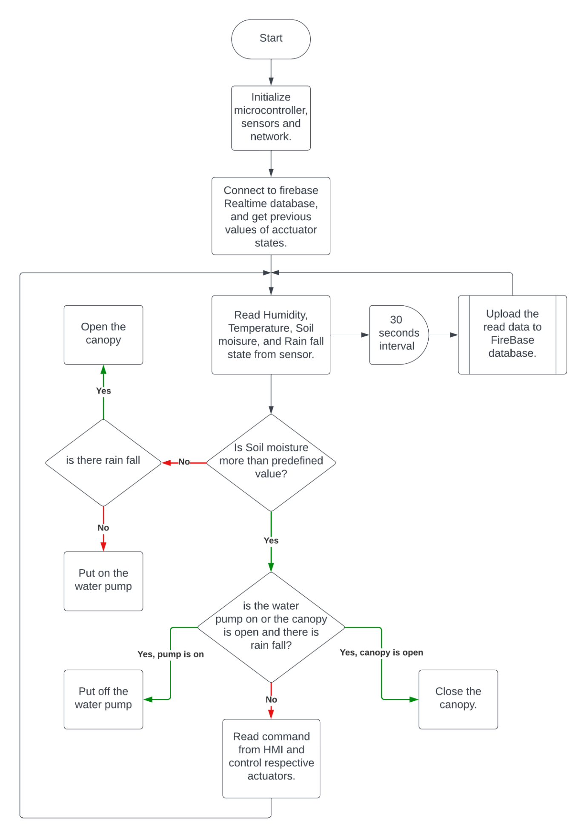
Fig. 3. Flowchart Diagram of System Operation and Automation

2.1.3.2 Software Development
The software development was an important aspect of the project, especially as it was a requirement in implementing the control algorithm, user interface, and communication protocols that guide system operation. The programming languages employed in this aspect include C and C++, which are usually used for low-level system development, including programming the microcontroller and motor control, offering direct hardware access, and efficient code execution. JavaScript, a scripting language that is mostly used for web-based user interfaces, was used to create an interactive and dynamic user interface that was accessible through a mobile application. Also, HTML and CSS were implemented to define the structure of the web page and style its appearance. Several frameworks and libraries were employed in the project, including Arduino, ESP-IDF (Espressif IoT Development Framework), SIM800/SIM900 module library, and Blynk SDK. Arduino is a platform that makes it easy to program microcontrollers, offering a rich ecosystem of libraries and examples for rapid prototyping (Zlatanov, 2016). ESP-IDF was also used to program the ESP32 microcontroller, with a comprehensive library and tools to develop the automation and control functions of the system, while offering GPIO control, network connectivity, and communication protocol (Babiuch and Postulka, 2021). The SIM800/SIM900 module library aided in allowing the system to connect to the SIM module for cellular connectivity. It gives the command to establish communication with the cellular network, while also managing the SIM module features such as voice calls, SMS, and GPRS. The Blynk SDK served as the backend for the IoT functionalities and communication. It provides an SDK for creating interactive and connected IoT applications, helping to efficiently manage real-time data, user authentication, and device communication (Singh and Kapoor, 2017). The software development codes for this system is presented in Appendix 1.

2.1.3.3 User Interface Design and Functionality
The user interface implemented in the study was the primary means for users or farmers to interact with the system, monitor its status, and control how it operates, playing an important role in making sure that the canopy system is managed effectively. The interface was designed in a way that ensured it was usable, intuitive, and efficient. Fig. 4 shows the homepage of the user interface.

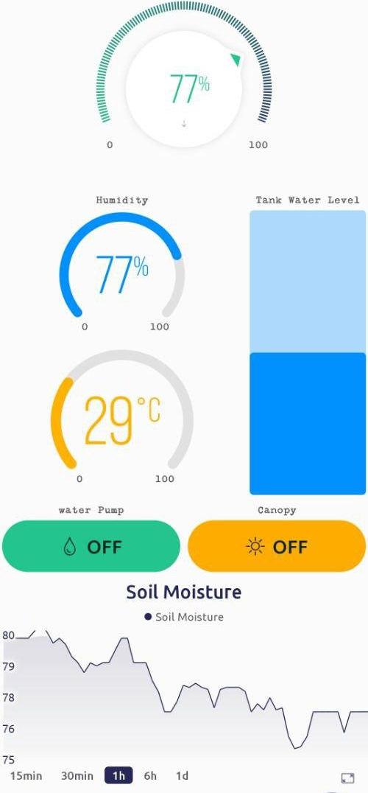
Fig. 4. User Interface Design

2.2 Hardware and Software Components
Tables 1 and 2 outline the details of the key hardware and software components used in the project. Meanwhile, Fig. 5, 6 and 7 shows the motor and mechanical system of the canopy, the electronic components on a Veroboard and the prototype build respectively.

Table 1. Comprehensive List of Hardware Materials and Components
S/N | Hardware Materials | Model | Purpose/Function
1 | ESP32 Microcontroller | LILYGO ESP32 | Control Purpose
2 | Resistive Soil Moisture Sensor |  | Measure Soil Moisture
3 | Humidity and Temperature sensor | DHT22 | Measures temperature and humidity
4 | Relay | 5V Relay Module | Works with Motor Pump
5 | 12 Volts Surface Pump | 12V Pump | Water supply to hose
6 | OLED Display | SSD1306 0.9' | Display of System Status
7 | Ultrasonic Sensor | HC-SR04 | Detect tank water level
8 | 12 volts Lead-acid battery | 12v battery | Power supply
9 | 12 volts high torque DC motor (H-Bridge Driver) | 16 RPM 12v DC motor | Retract the canopy mechanism
10 | 12 volts Solar Panel | 30W solar panel | Autonomous energy source
11 | Hose Sprinkler |  | Water Supply to plant
12 | Resistive Rain Sensor | Analog Rainfall Sensor | Senses Rainfall
13 | Charge Controller | 12v Solar Charge Controller | Charges Batteries
14 | Buck Converter | LM2596 | Converts AC to DC
15 | Aluminium | N/A | Hinges
16 | Steel | N/A | Metal frame
17 | Wood | N/A | Nursery Bed
18 | Fasteners | N/A | Holds the component together
19 | Linear Low-Density Polyethylene  (LLDPE). | N/A | Canopy Material

Table 2. List of Software Components
S/N | Software Component | Purpose/Function
1 | ESP32 Integration | Control purpose
2 | Arduino SDK | Programming ESP32
3 | Blynk Platform | IoT connection
4 | TinyGSM | SIM and Internet communication.
5 | Solidworks Application | System Design

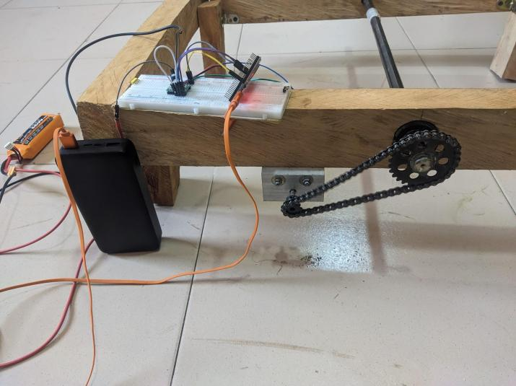
Fig. 5. Motor and Mechanical System of the Canopy

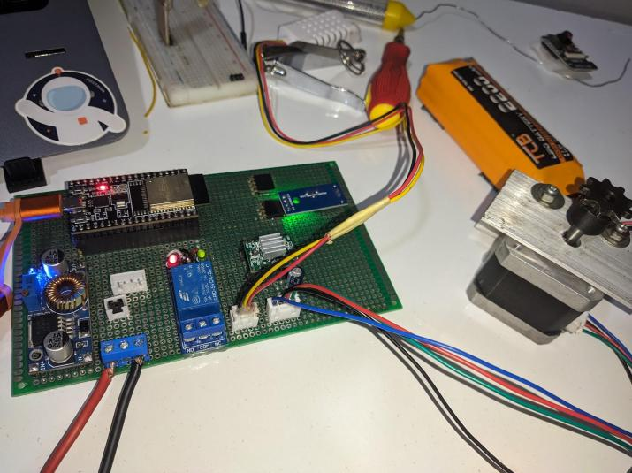
Fig. 6. Electronic Component on Veroboard

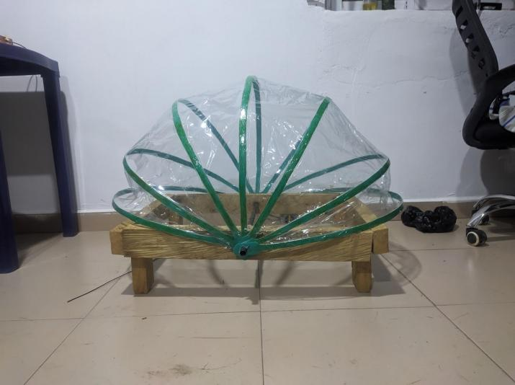
Fig. 7. Constructed Prototype

2.3 Design Calculations
Motor Selection
Torque (T) required to extend and retract the canopy
T = (Canopy Weight) x (Radius of Motor Pulley)
T = 3kg × 0.275m
T = 0.85Nm

Speed (N) required for the desired movement:
N = (Canopy Travel Distance) / (Time to Extend or Retract)
N = 0.8m / 30 secs
N = 0.026m/s

Power Requirements
Total power (P) required for the system:
P = (Motor and Pump Power) + (Esp32 and Sensor Power)
P = 7.2W + 5WP = 12.2W

Irrigation Volume (for tomato)
Water requirements (W) based on plant density and desired moisture level:
W = (Plant Density) x (Water Requirement per Plant)
W = 15 plants × 0.2 litres/day
W = 3 litres per day

Energy Efficiency
Daily energy consumption (E_consumed) of the system:
E_consumed = (Motor and Pump Power) x (Motor and Pump Operating Hours) + (Esp 32 and Sensor Power) x (Esp32 and Sensor Operating Hours)
E_consumed = (7.2W × 2 hours) + (5W × 24 hours)
E_consumed = 134.4Wh per day

E_generated (by solar panel) = 30W × 5 hours
E_generated = 150Wh per day

Energy efficiency = 134.4 / 150 × 100
Energy efficiency = 86.9%

2.3 Testing and Evaluation
After the prototype had been developed, the next phase was testing and evaluation to check if the canopy system functions and performs as expected. Different aspects of the system were evaluated, including canopy coverage, stability under different wind conditions, response time to environmental stimuli, and accuracy of the canopy position adjustment, following the work of Shafik et al. (2020). The system was also evaluated on its efficiency in nurturing the test seedlings, tomatoes. Parameters that were checked include growth rate, survival rate, water use efficiency, protection against adverse conditions, and labour efficiency.

3. results and discussion
The results of the implemented canopy system are provided in terms of the evaluation metrics, including overall performance and effectiveness in nurturing the test seedlings, which were observed for 6 weeks. Table 3 highlights the evaluation results of the system performance, while Table 4 highlights the evaluation results for test crop protection. The test crop used was Tomato (Solanum lycopersicum).

The project successfully achieved all predefined performance metrics, aligning with previous research (Ajao et al., 2017; Gudela et al., 2020). It provided complete canopy coverage, ensuring comprehensive protection for all plants in the nursery bed. The system demonstrated remarkable stability under varying wind conditions, emphasising the importance of stability for reliable plant protection. Furthermore, the project exhibited rapid response times to environmental changes, effectively preventing potential plant damage due to rainfall or extreme temperatures. This swift responsiveness, as emphasised in previous research (Gudela et al., 2020; Jason, 2015), was facilitated through sensor integration and automation logic. The system consistently achieved precise canopy position adjustments based on sensor inputs, ensuring optimal shielding without compromising plant health.

These findings align with existing research in the field, corroborating the system's effectiveness. The automated nursery bed demonstrated a remarkable capacity to accelerate tomato seedling growth. By providing a controlled environment and swift, automated adjustments, it outperformed traditional beds, as supported by studies by Li et al. (2019) and Gudela et al. (2020).

Table 3. Evaluation Results for System Performance
Performance Metric | Measured Metrics | Evaluation Result | Results
Canopy Coverage | Coverage angle:  180 ° | Met | The canopy system achieved complete coverage of the nursery bed area, effectively shielding all plants. This success aligns with findings from similar studies (Ajao et al., 2017; Gudela et al., 2020) where automated canopy systems effectively protected the entire designated area.
Stability Under Different Wind Conditions | nil | Met | The system exhibited robust stability even under high wind conditions. Its sturdy frame, securely anchored design, and sensor-triggered canopy retraction ensured the system's resilience in adverse weather. Studies on similar systems (Azhar et al., 2020; Cai et al., 2019) have reported similar stability under varying wind conditions.
Response Time to Environmental Stimuli | Time to open/ cover under rainfall:  3 seconds | Met | The system demonstrated rapid response times to changes in environmental conditions, such as rainfall and temperature fluctuations. The integration of real-time sensors and automation logic facilitated swift adjustments in canopy position, ensuring timely protection. This aligns with findings from related research (Gudela et al., 2020; Jason, 2015), highlighting the importance of quick response times in automated canopy systems.
Accuracy of Canopy Position Adjustment | ± 5 degrees | Met | Precise adjustment of the canopy's position was consistently achieved based on sensor inputs. The system's high accuracy in canopy positioning prevented overexposure or excessive shielding of plants. This precision aligns with findings in automation studies (Azhar et al., 2020; Cai et al., 2019), emphasising the importance of canopy accurate adjustments.

Table 4. Evaluation Results for Tomato Seedlings Protection
Performance Metric | Automated Nursery Bed | Traditional Nursery Bed | Results
Growth Rate | Exceeded - 1.8 cm/day | Met - 1.2 cm/day | The growth rate of tomato seedlings in the automated nursery bed exceeded that in traditional nursery beds.
Survival Rate | Exceeded - 96% | Met - 88% | The survival rate of tomato seedlings in the automated nursery bed surpassed that in traditional beds. Continuous monitoring and prompt protection against adverse conditions contributed to this result (Tajudeen et al., 2022; Dron et al., 2022).
Plant Health Monitoring | Exceeded | Partially Met | The automated system excelled in plant health monitoring, maintaining optimal environmental conditions. Traditional beds lacked this level of precision in monitoring, potentially leading to suboptimal growth (Hasanuzzaman et al., 2016).
Water Efficiency | Exceeded - 11 kg/m³ (drip-assisted) | Exceeded - 6 kg/m³ (furrow method) | The automated system demonstrated superior water efficiency, utilising water more effectively than traditional methods. Automated irrigation and soil moisture control contributed to this advantage.
Resource Utilisation | Exceeded | Exceeded | Resource utilisation was more efficient in the automated system. It consumed less power and water per unit of growth compared to traditional practices, contributing to reduced operational costs.
Protection Against Adverse Conditions | Exceeded | Partially Met | The automated system excelled in protecting seedlings from adverse conditions. It rapidly responded to weather changes, whereas traditional beds relied on manual intervention (Gudela et al., 2020; Jason, 2015).
Labour Efficiency | Exceeded | Exceeded | Labour efficiency was significantly higher in the automated system, requiring minimal human intervention. Traditional beds necessitated regular manual oversight and adjustment (Fifer and Motis, 2021).
Disease Prevention | Exceeded | Met | The automated system effectively prevented diseases, notably root rot, due to waterlogging. Disease incidence was lower compared to traditional methods (Tajudeen et al., 2022; Dron et al., 2022).

4. Conclusion

In summary, the design and implementation of an automated nursery bed canopy system combines elements of automation, IoT, and innovative design. The successful integration of all the required components resulted in a functional system that maintains optimal growth conditions for tomato seedlings. Evaluation results have shown that the system improves survival rates and water use efficiency and promotes faster and healthier growth, validating the potential of smart farming technologies to improve agriculture. The successful deployment of this system shows the importance of adopting automated solutions to address climate variability, especially where resources are limited.

Disclaimer (Artificial intelligence)
The authors hereby declare that NO generative AI technologies such as Large Language Models and text-to-image generators have been used during the writing or editing of this manuscript.

References
Ahmadnejad K., M., and Asefi, M. (2016). Propose of movement pattern for curved retractable roofs with using of movable bars. Naqshejahan-Basic studies and New Technologies of Architecture and Planning, 6(3), 27-37.
Ajao, K. R., Yahaya, T., Kolawole, M. Y., and Aweda, J. O. (2017). Design, Fabrication and Performance Evaluation of Awning/Canopy for Thermal Comfortability.
Alam, T. (2021). Cloud-based IoT applications and their roles in smart cities. Smart Cities, 4(3), 1196-1219.
Arul Prince, A. J., Reddy, A. S., Nagateja, K., Chowdary, N. N. (2021). Design and Analysis of A Spur Gear with Composite Material. International Journal of Engineering Research and Technology (IJERT), 10(04), 123-132.
Asefi, M., Valadi, S., and EbrahimiSalari, E. (2013). New proposal for a retractable roof over a courtyard in Tabriz Islamic Art University. International Journal of Architectural Engineering and Urban Planning, Tehran, 23(2), 113-120.
Azam, G., and Islam, M. T. (2015, August). Design and fabrication of a voice controlled wheelchair for physically disabled people. In International Conference on Physics Sustainable Development and Technology (ICPSDT-2015) (Vol. 1, pp. 81-90).
Azhar, Izzatul, N., Mohamad, N., Fatin N., Omar, M., (2020). Sumato Awning.
Babiuch, M., and Postulka, J. (2021). Smart Home Monitoring System Using ESP32 Microcontrollers. IntechOpen.
Bhuiyan, M. (2020). Solutions for wireless internet connectivity in remote and rural areas (Master's thesis, M. Bhuiyan).
Blesslin Sheeba, T., Anand, L. D., Manohar, G., Selvan, S., Wilfred, C. B., Muthukumar, K., ... and Asfaw, B. T. (2022). Machine Learning Algorithm for Soil Analysis and Classification of Micronutrients in IoT-Enabled Automated Farms. Journal of Nanomaterials, 2022.
Budijono, S. (2021, July). Smart Warning System Using SIM800L and ESP32. In IOP Conference Series: Earth and Environmental Science (Vol. 794, No. 1, p. 012132). IOP Publishing.
Cai, J., Zhang, Q., Feng, J., and Xu, Y. (2019). Modeling and kinematic path selection of retractable kirigami roof structures. Computer‐Aided Civil and Infrastructure Engineering, 34(4), 352-363.
Carducci, C. G. C., Monti, A., Schraven, M. H., Schumacher, M., and Mueller, D. (2019, June). Enabling ESP32-based IoT applications in building automation systems. In 2019 II Workshop on Metrology for Industry 4.0 and IoT (MetroInd4. 0andIoT) (pp. 306-311). IEEE.
Dron, N., Simpfendorfer, S., Sutton, T., Pengilley, G., and Hobson, K. (2022). Cause of death: Phytophthora or flood? Effects of waterlogging on Phytophthora medicaginis and resistance of chickpea (Cicer arietinum). Agronomy, 12(1), 89.
Duckett, T., Pearson, S., Blackmore, S., Grieve, B., Chen, W. H., Cielniak, G., ... and Yang, G. Z. (2018). Agricultural robotics: the future of robotic agriculture. arXiv preprint arXiv:1806.06762.
FAO. (2010). Modern oil palm cultivation [Online]. Retrieved from: the oil palm (fao.org). [Accessed: 3 September 2023]
Fifer, G. and Motis, T. (2021). Small-Scale Nursery Management. ECHO Publication Issue. Retrieved from: https://assets.echocommunity.org/publication_issue/f18a5550-662c-4838-86b4-a1b8a2b2347f/en/tn-97-small-scale-nursery-management.pdf. [Accessed: 4 September 2023]
Gudela, M. D., Kulkarni, A., Dhotre, A., and Shrimali, K. (2020). Design of an Automatic Umbrella Actuated through Water and Temperature Sensors. Journal of Mechatronics and Robotics. 4. 191-210. 10.3844/jmrsp.2020.191.210.
Guba, S., Horváth, B., and Szalai, I. (2022). Application and comparison of thermistors and fiber optic temperature sensor reference for ILP measurement of magnetic fluids in double cell magnetic hyperthermia. Heliyon, 8(6), e09606.
Haase, D. L., Bouzza, K., Emerton, L., Friday, J. B., Lieberg, B., Aldrete, A., and Davis, A. S. (2021). The High Cost of the Low-Cost Polybag System: A Review of Nursery Seedling Production Systems. Land, 10(8), 826. MDPI AG. Retrieved from: http://dx.doi.org/10.3390/land10080826
Haase, D. L., Landis, T. D., and Dumroese, R. K. (2014). Outplanting [Chapter 17]. In: Wilkinson, Kim M.; Landis, Thomas D.; Haase, Diane L.; Daley, Brian F.; Dumroese, R. Kasten, eds. Tropical Nursery Manual: A guide to starting and operating a nursery for native and traditional plants. Agriculture Handbook 732. Washington, DC: US Department of Agriculture, Forest Service. p. 313-337., 732, 313-337.
Hamsini, U., Prasad, H., Bhatta, K., and Bhaskar, L. (2023, January). Automated Awning System. In 2023 International Conference on Intelligent and Innovative Technologies in Computing, Electrical and Electronics (IITCEE) (pp. 912-915). IEEE.
Hasanuzzaman, M., Nahar, K., Rahman, A., Mahmud, J. A., Hossain, M. S., and Fujita, M. (2016). Soybean production and environmental stresses. In Environmental stresses in soybean production (pp. 61-102). Academic Press.
Hashem, I., Ibrahim, Y., Yaqoob, I., Anuar, N., Mokhtar, S., Gani, A., and Khan, S. (2014). The rise of "Big Data" on cloud computing: Review and open research issues. Information Systems, 47, 98-115. doi:10.1016/j.is.2014.07.006.
Husain, M. D., Kennon, R., and Dias, T. (2014). Design and fabrication of temperature sensing fabric. Journal of Industrial Textiles, 44(3), 398-417.
Jabar, M. (2021). System Design and Implementation for Locating and Controlling Objects using (GSM/GPS).
Jason, J. (2015). An Automated Retractable Awning With Raining Sensor. Universiti Malaysia Sarawak (UNIMAS).
Joshi, M., Jogalekar, K., Sonawane, D. N., Sagare, V., and Joshi, M. A. (2013, December). A novel and cost effective resistive rain sensor for automatic wiper control: Circuit modelling and implementation. In 2013 Seventh International Conference on Sensing Technology (ICST) (pp. 40-45). IEEE.
Kareem, Husam, and Dmitriy Dunaev. "The Working Principles of ESP32 and Analytical Comparison of using Low-Cost Microcontroller Modules in Embedded Systems Design." In 2021 4th International Conference on Circuits, Systems and Simulation (ICCSS), pp. 130-135. IEEE, 2021.
Karmakar, G., Roy, S., Chattopadhyay, G., and Xiao, Z. (2017, February). Dynamically controlling exterior and interior window coverings through IoT for environmentally friendly smart homes. In 2017 IEEE International Conference on Mechatronics (ICM) (pp. 487-491). IEEE.
Kim, J., Moon, J., Kim, J., and Lee, G. (2020). Compact variable gravity compensation mechanism with a geometrically optimised lever for maximizing the variable ratio of torque generation. IEEE/ASME Transactions on Mechatronics, 25(4), 2019-2026.
Korotcenkov, G., Simonenko, N. P., Simonenko, E. P., Sysoev, V. V., and Brinzari, V. (2023). Based Humidity Sensors as Promising Flexible Devices, State of the Art, Part 2: Humidity-Sensor Performances. Nanomaterials, 13(8), 1381.
Leakey, R. R. B. (2014). Agroforestry: participatory domestication of trees.
Leonidas, E., Ayvar-Soberanis, S., Laalej, H., Fitzpatrick, S., and Willmott, J. R. (2022). A comparative review of thermocouple and infrared radiation temperature measurement methods during the machining of metals. Sensors, 22(13), 4693.
Li, J., Zhan, D., Jiang, Z., Zhang, H., Yang, Y., and Zhang, Y. (2023). Progress on improving strength-toughness of ultra-high strength martensitic steels for aerospace applications: A review. Journal of Materials Research and Technology.
Lin, L. J., Luther, G. C., and Hanson, P. (2015). Raising healthy tomato seedlings. AVRDC–The World Vegetable Center publication, 15-795.Herdiansyah, H., Negoro, H., Rusdayanti, N. and Shara, S. (2020). Palm oil plantation and cultivation: Prosperity and productivity of smallholders. Open Agriculture, 5(1), 617-630. https://doi.org/10.1515/opag-2020-0063
Li, Wu-Jeng and Yen, Chiaming and Lin, You-Sheng and Tung, Shu-Chu and Huang, Shih-Miao. (2018). JustIoT Internet of Things based on the Firebase Real-time Database. 10.1109/SMILE.2018.8353979.
Mahmud, M. S., Zahid, A., & Das, A. K. (2023). Sensing and Automation Technologies for Ornamental Nursery Crop Production: Current Status and Future Prospects. Sensors, 23(4), 1818. https://doi.org/10.3390/s23041818.
Mat, I., Kassim, M. R. M., Harun, A. N., and Yusoff, I. M. (2016, October). IoT in precision agriculture applications using wireless moisture sensor network. In 2016 IEEE Conference on Open Systems (ICOS) (pp. 24-29). IEEE.
Millán, S., Casadesús, J., Campillo, C., Moñino, M. J., and Prieto, M. H. (2019). Using soil moisture sensors for automated irrigation scheduling in a plum crop. Water, 11(10), 2061.
Mohammed Ali, U., Soresa, D. N., & Fufa, T. W. (2025). Tailoring Tomato (Solanum lycopersicum L.) Traits to Microclimates: A Multilocation Evaluation of Yield and Quality Responses in Western Ethiopia. Scientifica, 2025(1), 6345142.
Nur'Atikah , A. R. (2013). Analysis of the wind effect on the patio cover (awning) structure in Malaysia.
Nutakor, C., Montonen, J., Nerg, J., Heikkinen, J., Sopanen, J., and Pyrhönen, J. (2018). Development and validation of an integrated planetary gear set permanent magnet electric motor power loss model. Tribology International, 124, 34-45.
Prathibha, S. R., Hongal, A., and Jyothi, M. P. (2017, March). IoT-based monitoring system in smart agriculture. In 2017 international conference on recent advances in electronics and communication technology (ICRAECT) (pp. 81-84). IEEE.
Ravindhar, N. V., and Sasikumar, S. (2022). An effective monitoring, storage and analyze on industrial process on cloud big data by data publishing in industrial wireless sensor network. Measurement: Sensors, 100525.
Shafik, W., Matinkhah, M., Asadi, M., Ahmadi, Z., and Hadiyan, Z. (2020). A study on internet of things performance evaluation. Journal of Communications Technology, Electronics and Computer Science, 2020, 1-19.
Saleh, M., Elhajj, I. H., Asmar, D., Bashour, I., and Kidess, S. (2016, November). Experimental evaluation of low-cost resistive soil moisture sensors. In 2016 IEEE International Multidisciplinary Conference on Engineering Technology (IMCET) (pp. 179-184). IEEE.
Santos, C. P. D., Rodrigues, A. A., Canafístula, F. J. F., Rocha Neto, O. C. D., Daher, S., and Teixeira, A. D. S. (2022). Performance of the capacitive moisture sensor under different saline conditions. Revista Ciência Agronômica, 53.
Sarangi, S. K., Maji, B., Singh, S., Burman, D., Mandal, S., Sharma, D. K., ... and Haefele, S. M. (2015). Improved nursery management further enhances the productivity of stress-tolerant rice varieties in coastal rainfed lowlands. Field Crops Research, 174, 61-70.
Shenoy, V., Tripathi, P., Mahadik, A., Nalawade, P., and Mahajan, A. (2018). Devices Used for Measuring Solar Radiation–A Review. In International Conference on Innovative and Advanced Technologies in Engineering. IOSR Journal of Engineering (IOSRJEN) www. iosrjen. org ISSN (e) (pp. 2250-3021).
Singh, R. R., Meena, L. K., and Singh, P. (2017). High Tech Nursery Management in Horticultural Crops: A Way for Enhancing Income. International Journal of Current Microbiology and Applied Sciences, 6(6), 3162–3172. https://doi.org/10.20546/IJCMAS.2017.606.372
Sosa, M. (2017). Running-in of gears-surface and efficiency transformation (Doctoral dissertation, KTH Royal Institute of Technology).
Sun, Y., Zhang, J., Li, C., Yang, J., Li, H., Jiang, T., and Chen, B. (2022). Double-Network Hydrogel for Stretchable Triboelectric Nanogenerator and Integrated Electroluminescent Skin with Self-Powered Rapid Visual Sensing. Electronics, 11(13), 1928.
Tajudeen, T. T., Omotayo, A., Ogundele, F. O., and Rathbun, L. C. (2022). The Effect of Climate Change on Food Crop Production in Lagos State. Foods, 11(24), 3987.
Talaviya, T., Shah, D., Patel, N., Yagnik, H., and Shah, M. (2020). Implementation of artificial intelligence in agriculture for optimisation of irrigation and application of pesticides and herbicides. Artificial Intelligence in Agriculture, 4, 58-73.
Trubachev, E., Savelyeva, T., and Pushkareva, T. (2018). Practice of design and productionn of worm gears with localized contact. Advanced gear engineering, 327-343.
Walter, J., and Kromdijk, J. (2022). Here comes the sun: How optimization of photosynthetic light reactions can boost crop yields. Journal of Integrative Plant Biology, 64(2), 564-591.
Wara, S. T., Awelewa, A. A., Hope, O., Felix, A. A., and Tobiloba, O. (2016). Design and Implementation of an Automatic Irrigation System Based on Monitoring Soil Moisture. Journal of Electrical Engineering, 16(2), 10-10.
Wei, T., Xia, H., Yue, B., Wu, Y., and Liu, Q. (2021). Remote sensing of raindrop size distribution using the coherent Doppler lidar. Optics Express, 29(11), 17246-17257.
Wu, L., Sheng, Y., Xu, X., Chen, Z., Wang, Q., Wang, Z., and Yin, Y. (2019). Quality Chinese Shade Retractable Awning Pergola Roof for Garden. Case Reports in Medicine, 2019.
Xie, D., Chen, L., Liu, L., Chen, L., and Wang, H. (2022). Actuators and sensors for application in agricultural robots: A review. Machines, 10(10), 913.
Zhang, Q., Pan, N., Meloni, M., Lu, D., Cai, J., and Feng, J. (2021). Reliability analysis of radially retractable roofs with revolute joint clearances. Reliability Engineering and System Safety, 208, 107401.
Zhou, X., and Fang, J. (2013). Precise braking torque control for attitude control flywheel with small inductance brushless DC motor. IEEE Transactions on Power Electronics, 28(11), 5380-5390.
Zlatanov, N. (2016). Arduino and open-source computer hardware and software. J. Water, Sanit. Hyg. Dev, 10(11), 1-8..

APPENDIX

Code snipet

System setup:
void setup(){
Serial.begin(115200);

initWiFi();
configTime(0, 0, ntpServer);

config.api_key = API_KEY;
auth.user.email = USER_EMAIL;
auth.user.password = USER_PASSWORD;
config.database_url = DATABASE_URL;

Firebase.reconnectWiFi(true);
fbdo.setResponseSize(4096);

/* Assign the callback function for the long running token generation task */
config.token_status_callback = tokenStatusCallback; //see addons/TokenHelper.h

// Assign the maximum retry of token generation
config.max_token_generation_retry = 5;

// Initialize the library with the Firebase authen and config
Firebase.begin(andconfig, andauth);

// Getting the user UID might take a few seconds
Serial.println("Getting User UID");
while ((auth.token.uid) == "") {
Serial.print('.');
delay(1000);
}
// Print user UID
uid = auth.token.uid.c_str();
Serial.print("User UID: ");
Serial.println(uid);
signupOK = true;

// Update database path
databasePath = "/BoardData/";
databasePath += uid;
databasePath += "/readings";

listenerPath = "/BoardControl/";
listenerPath += uid;

// Streaming (whenever data changes on a path)
// Begin stream on a database path --> board1/outputs/digital
if (!Firebase.RTDB.beginStream(andstream, listenerPath.c_str()))
Serial.printf("stream begin error, %s\n\n", stream.errorReason().c_str());

// Assign a calback function to run when it detects changes on the database
Firebase.RTDB.setStreamCallback(andstream, streamCallback, streamTimeoutCallback);

pinMode(trigPin, OUTPUT);
pinMode(echoPin, INPUT);

pinMode(PUMP_RELAY, OUTPUT);
pinMode(RAIN_PIN, INPUT);

dht.begin();
digitalWrite(PUMP_RELAY, HIGH);
delay(150);
digitalWrite(PUMP_RELAY, LOW);
pumpRelayFlag = false;

stepperSetup();

Serial.println("done with setup");
}

Automation control logic:
if ( (millis() - readSensorPrevMillis > 10000) || readSensorPrevMillis == 0)
{
dht_reading = dht_readings();
water_level = readWaterLevel();
soilMoisture = moisture();
Serial.printf("Soil moisture: %d\n", soilMoisture);
batteryVoltage = battery_voltage_readings();
rainState = digitalRead(RAIN_PIN);
Serial.printf("Rain state: %d\n", rainState);
Serial.println(batteryVoltage);
readSensorPrevMillis = millis();

if( rainState == 0 andand soilMoisture < 50 andand canopyState == 1) {
Serial.println("state 1");
canopyCommand = 0;
runStepperCommand = true;
} else if ( rainState == 1 andand soilMoisture < 50 ) {
Serial.println("state 2");
pumpRelayFlag = true;
digitalWrite(PUMP_RELAY, HIGH);
} else if ( rainState = 1 andand soilMoisture > 60 andand canopyState == 0 ) {
Serial.println("state 3");
canopyCommand = 1;
runStepperCommand = true;
if ( pumpRelayFlag == true ) {
pumpRelayFlag = false;
digitalWrite(PUMP_RELAY, LOW);
}
} else if ( rainState == 0 andand soilMoisture > 60 andand canopyState == 0 ) {
Serial.println("state 4");
canopyCommand = 1;
runStepperCommand = true;
} else if ( rainState == 1 andand soilMoisture > 60 andand canopyState == 1) {
Serial.println("state 5");
pumpRelayFlag = true;
digitalWrite(PUMP_RELAY, LOW);
} else if ( rainState == 1 andand soilMoisture < 50 andand canopyState == 0 ) {
Serial.println("state 6");
canopyCommand = 1;
runStepperCommand = true;
pumpRelayFlag = true;
digitalWrite(PUMP_RELAY, HIGH);
}
}

Motor control:
#include <Arduino.h>
#include <AccelStepper.h>
#include "stepper_control.h"

// Creates an instance
AccelStepper myStepper(motorInterfaceType, STEP_PIN, DIR_PIN);

void stepperSetup() {
myStepper.setPinsInverted(false, false, true);
myStepper.setEnablePin(ENABLE_PIN);
myStepper.setMaxSpeed(200);
myStepper.setAcceleration(50);
myStepper.disableOutputs();
}
void openCanopy() {
myStepper.enableOutputs();
myStepper.moveTo(-170);
}
void closeCanopy() {
myStepper.enableOutputs();
myStepper.moveTo(180);
}
bool runStepper() {
return myStepper.run();
}
void disableStepper() {
myStepper.disableOutputs();

