Lead-Free Inverted Perovskite Solar Cells Using Cu₂O/ZnO Inorganic Transport Layers: Synthesis, Characterization and Device Performance.
Original Research Article

ABSTRACT
Perovskite solar cells (PSCs), often referred to as fourth-generation solar cells, have attracted significant research interest in recent years due to their high-power conversion efficiency, simple fabrication processes, low processing temperatures, mechanical flexibility, lightweight nature, and the low cost of constituent materials compared with conventional silicon-based solar cells. However, the long-term instability and environmental concerns associated with PSCs remain major obstacles to their commercialization. The aim of this study focuses on the synthesis and characterization of solar cell materials, as well as the fabrication of an inverted perovskite solar cell device. In this work, lead-free perovskite solar cells employing inorganic charge transport materials were carefully designed and systematically investigated. This paper addresses an important and timely research challenge in the field of photovoltaic materials, particularly the development of environmentally benign, lead-free perovskite solar cells. The incorporation of inorganic transport layers (Cu₂O and ZnO) in combination with a tin-based perovskite absorber within an inverted planar device architecture contributes to enhanced device stability and reduced material toxicity. This work is highly relevant to researchers focused on sustainable energy materials and low-cost solar cell fabrication. Furthermore, the achieved power conversion efficiency of 7.44% and the retention of approximately 95% of the initial device performance after 1000 hours of continuous operation under standard solar illumination (1000 W m⁻²) in ambient conditions highlight the practical significance of this study.
- INTRODUCTION
The increasing global energy demand driven by population growth has led to a corresponding rise in daily energy consumption (Nyiekaa et al., 2024a). The expansion of renewable energy utilization is essential, as reliance on non-renewable energy sources such as fossil fuels contributes significantly to environmental problems (Saha, Singh, & Bhattacharya, 2023). Among renewable sources, solar energy is the most notable and promising due to its clean, abundant, and virtually limitless nature. It is also cost-effective and environmentally friendly (Noman, Khan, & Jan, 2024). Various strategies have been developed to harness solar energy, including solar architecture (Ionescu, 2015), solar heating (Nanda, Pambudi, & Aziz, 2023), artificial photosynthesis (Tian, 2021), photovoltaics, and photocatalytic water splitting (Li, 2023).
Solar cells are broadly categorized into four generations. The first generation comprises crystalline silicon (c-Si) and gallium arsenide (GaAs) cells, while the second generation includes thin films such as cadmium telluride (CdTe), amorphous silicon (a-Si), and copper indium gallium selenide (CIGS). Third-generation solar cells consist of emerging technologies, including dye-sensitized solar cells (DSSCs), copper zinc tin sulfide (CZTS), and quantum dots (QDs). Fourth-generation solar cells encompass novel “inorganics-in-organics” devices, such as hybrid perovskites (Jonathan, 2022; Et-taya, Ouslimane, & Benami, 2020). Research has also focused on CdTe-based (Major, 2016; Arce-Plaza, 2018), quantum-dot-sensitized (Pan et al., 2018; Carey et al., 2015), CIGS (Zhu et al., 2017; Feurer et al., 2017), organic (Solak & Irmak, 2023), and perovskite-based solar cells (Afre & Pugliese, 2024; Nur-E-Alam et al., 2025).
The commercialization of solar cells depends on several factors, including power conversion efficiency (PCE), material costs, and fabrication techniques. Silicon-based solar cells can achieve efficiencies exceeding 26%, approaching their theoretical limit (Hsieh et al., 2020; Kim et al., 2021). Perovskite solar cells (PSCs), a class of fourth-generation solar cells, offer a promising alternative to silicon-based devices. PSCs have recently attracted considerable attention due to their high PCE, low processing temperatures, and low fabrication costs. Key properties of perovskite materials include high absorption coefficients, good charge-carrier mobility, low exciton binding energy, and long charge-carrier diffusion lengths (Afre & Pugliese, 2024; Lyu et al., 2017). Both pure and modified methylammonium lead halides have been extensively studied as perovskite materials due to their high photovoltaic performance (Mangrulkar & Stevenson, 2021; Parashar & Kaul, 2021).
Despite their high efficiencies, lead-based perovskites face regulatory restrictions in several regions, notably the European Union, due to their toxicity to humans and the environment (Li et al., 2020; De Los Santos et al., 2020). Methylammonium tin halide (CH₃NH₃SnX₃) perovskites have been proposed as promising alternatives because of their favorable optoelectronic properties and direct bandgap of approximately 1.3 eV, which is ideal for absorber layers (Shukla et al., 2020; Byranvand et al., 2022). In this study, methylammonium tin iodide (CH₃NH₃SnI₃) is specifically considered.
Several challenges hinder the large-scale commercialization of PSCs, including the high cost of transport materials, the toxicity of certain perovskites, and device degradation. For instance, Spiro-OMeTAD (2,2’,7,7’-tetrakis[N,N-di(4-methoxyphenyl)amino]-9,9’-spirobifluorene), a commonly used hole transport material (HTM), has a relatively short lifespan despite recent advancements. Its high cost and complex synthesis can limit PSC commercialization (Wang et al., 2019; Zhao et al., 2019). Moreover, Spiro-OMeTAD contributes to electrode polarization, which is responsible for current density–voltage (J–V) hysteresis and adversely affects device stability (Gonzales, Guerrero, & Bisquert, 2021; Chen et al., 2016). Conventional PSC architectures, which employ inorganic electrodes and organic transport materials, are a primary cause of reduced device longevity (Wang et al., 2019; Zhao et al., 2019). Pinholes in the HTL further compromise stability by allowing oxygen and ambient moisture to degrade the perovskite absorber (Wan et al., 2022; Asad et al., 2019).
To overcome these limitations, recent studies have focused on developing efficient PSCs using novel HTMs to replace Spiro-OMeTAD (Nyiekaa et al., 2024b; Rahman et al., 2019) or employing HTL-free architectures to simplify device structure, reduce fabrication costs, and prevent perovskite degradation (Wang et al., 2016; Raminafshar et al., 2019)
Recent reviews indicate that tin-based perovskites offer competitive efficiencies and environmentally friendly alternatives to lead-based perovskites; however, a fundamental challenge remains their intrinsic material instability, primarily due to Sn²⁺ oxidation and ion migration. Strategies such as defect engineering, interface optimization, additive chemistry, and encapsulation are driving rapid advancements in this field. Nevertheless, extensive research is still required to achieve commercial-grade stability (Zhang et al., 2025; Hardy, Fiedler and Kennedy, 2025). The majority of high-efficiency tin-based perovskite devices are fabricated via spin-coating, which limits uniformity and reproducibility over large areas. While promising, scalable deposition methods such as blade coating and slot-die coating require precise control of interface quality and crystallization kinetics. Therefore, bridging the gap between laboratory-scale demonstrations and commercially viable tin-based perovskite solar cells will require advancements in oxidation suppression, defect passivation, scalable processing, and effective encapsulation techniques (Agresti et al., 2024).
The objectives of this study are to simplify perovskite solar cell (PSC) fabrication, reduce production costs, and enhance device performance. The use of appropriate back-contact electrodes and inorganic charge transport materials in solar cell construction can improve both stability and efficiency while significantly lowering production costs. Moreover, the inverted planar architecture enables high-efficiency devices without the need for silicon components or organic hole transport materials (HTMs), potentially expanding their industrial applicability.
Despite significant advancements in PSC research, few studies have focused on inverted planar PSCs, which have received less attention compared to conventional PSCs. Rigorous investigation is therefore required to optimize the performance of these devices relative to their traditional counterparts. Most previous studies on inverted planar PSCs have focused on the use of spiro-OMeTAD as the HTM and gold as the back-contact electrode.
In this study, an inverted device architecture (ITO/Cu₂O/CH₃NH₃SnI₃/ZnO/Al) was employed, in which indium tin oxide (ITO) serves as the transparent conducting electrode, Cu₂O as the hole transport layer, CH₃NH₃SnI₃ as the perovskite absorber, ZnO as the electron transport layer, and aluminum (Al) as the back-contact metal electrode.
- METHODOLOGY
  - Material synthesis
    - Synthesis of Cu₂O nanoparticles by wet chemical reduction method
For the synthesis of cuprous oxide (Cu₂O) nanoparticles, a blue precursor solution was first prepared by dissolving 0.799 g of copper (II) sulphate (CuSO₄, 99%, BDH) in 50 mL of deionized water under vigorous stirring. Separately, 6 g of polyethylene glycol (PEG 6000, Sigma-Aldrich) was dissolved in 50 mL of deionized water, and this solution was added to the copper sulphate solution, resulting in a light-blue-coloured mixture. Subsequently, 0.9 g of ascorbic acid (C₆H₈O₆, ≥99.5%, Chemiz) and 0.4 g of sodium hydroxide (NaOH, 98%, Chemiz) were dissolved in 100 mL of deionized water, and the resulting solution was added to the reaction mixture, which changed to an orange colour.
Finally, an aqueous solution of sodium borohydride (NaBH₄, ≥98%, ACROS) was prepared by dissolving 0.4 g in 50 mL of deionized water under constant stirring and then added to the reaction mixture, yielding a dark red suspension. The reaction mixture was allowed to cool and stand at room temperature for 24 h. The resulting precipitate was collected by centrifugation at 3,000 rpm for 15 min, washed three times with methanol, decanted, and dried in an oven (Memmert) at 60 °C for 24 h.
    - Synthesis of CH₃NH₃SnI₃ crystals using the cooling crystallization method
First, methylammonium iodide (MAI) was synthesized by dropwise addition of 10.0 mL of hydroiodic acid (HI, 57% in water, Merck) to a mixture of 9.3 mL of methylamine (CH₃NH₂, 40% in water, Merck) and 25 mL of absolute ethanol (C₂H₅OH, 99.9%, Chemiz) at 0 °C in an ice bath under continuous stirring for 120 min. The reaction was conducted in a 100 mL beaker and sealed with parafilm to minimize the influence of environmental exposure. Due to the exothermic nature of the reaction, the resulting precipitate was recovered by solvent evaporation using a hot plate (PMC 730 Series) set at 50 °C for 30 min inside a fume cupboard. The crude product was subsequently dissolved in absolute ethanol (C₂H₅OH, 99.7%, Chemiz), recrystallized, and washed three times with diethyl ether (C₄H₁₀O, QReC). After decantation, the material was transferred to a Petri dish and dried in a drying oven (Memmert) at 60 °C for 24 h, yielding white crystalline methylammonium iodide.
Subsequently, CH₃NH₃SnI₃ crystals were synthesized under ambient conditions by dissolving 1.144 g of freshly prepared MAI and 0.969 g of tin (II) oxide (SnO, 99%, Alfa Aesar) in a mixed aqueous solution of hydroiodic acid (7.2 mL, 57% in water, Merck) and hypo phosphorous acid (7.2 mL, 50 wt% in water, Chemiz). The reaction mixture was maintained at 60 °C for 2 h under continuous stirring. Crystallization of CH₃NH₃SnI₃ occurred upon cooling the solution to room temperature. The resulting precipitate was washed with diethyl ether and dried under air vacuum at 60 °C for 2 h, producing dark green, shiny CH₃NH₃SnI₃ crystals
    - Synthesis of ZnO nanoparticles by sol-gel method
Zinc acetate dihydrate, Zn(C₂H₃O₂) ₂·2H₂O (2.95 g), was dissolved in 125 mL of methanol under continuous stirring at 65 °C to initiate the synthesis of ZnO nanoparticles. Subsequently, a solution of potassium hydroxide (KOH, 1.48 g) in methanol (65 mL) was added dropwise to the reaction mixture over a period of 15 min while maintaining the temperature at 60 °C. The reaction mixture was then stirred magnetically at 65 °C for 2.5 h. After cooling to room temperature, the resulting precipitate was washed three times with methanol, the supernatant was decanted, and the precipitate was dried in an oven (Memmert) at 60 °C for 24 h.
  - Device Fabrication
An Indium tin oxide (ITO) glass substrates with dimensions of 1.5 cm × 1.5 cm and a sheet resistance of approximately 10 Ω sq⁻¹ (Zhuhai Kaivo) were sequentially cleaned for 5 min each in an ultrasonic bath using a commercial detergent, acetone, and isopropanol. First, a 6 mg mL⁻¹ dispersion of Cu₂O nanoparticles in a mixed solvent of 1-butanol, methanol, and chloroform (2:1:1) was spin-coated onto the substrate at 3,000 rpm for 30 s, forming a uniform thin film.
Subsequently, freshly prepared CH₃NH₃SnI₃ crystals were dissolved at a concentration of 460 mg L⁻¹ in a mixed solvent of N,N-dimethylformamide (DMF, 99.8%, QReC) and dimethyl sulfoxide (DMSO, 99.9%, Chemiz), and the resulting solution was spin-coated onto the Cu₂O layer at 3,000 rpm for 15 s. A 6 mg mL⁻¹ dispersion of ZnO nanoparticles in the same mixed solvent system (1-butanol/methanol/chloroform, 2:1:1) was then deposited by spin coating at 3,000 rpm for 20 s to form a thin electron-transport layer. All solution-processed layers were deposited using an acceleration rate of 1,000 rpm s⁻¹.
Finally, an aluminium electrode was deposited by thermal evaporation at a base pressure of 1 × 10⁻⁷ mbar with a deposition rate of 2 Å s⁻¹ for 8 min, resulting in a smooth aluminium nanolayer. All device layers were fabricated under ambient conditions and dried in air at a relative humidity of approximately 50%.
- RESULTS AND DISCUSSION
  - Discussions on the material synthesis
    - Analysis of Cu₂O nanoparticles by wet chemical reduction method
After Cu₂O nanoparticles were synthesized following the procedure described in the Materials Synthesis section, the reaction mixture was centrifuged to collect and stabilize the precipitates. The supernatant was decanted, and the precipitate was repeatedly washed with deionized water to remove unreacted species and byproducts. The obtained product was then dried in a hot-air oven to eliminate residual moisture. Polyethylene glycol (PEG) acted as a capping and stabilizing agent, effectively controlling particle growth and preventing agglomeration. Sodium borohydride (NaBH₄) served as the primary reducing agent, facilitating the reduction of Cu²⁺ ions to Cu⁺, thereby promoting the formation of Cu₂O nanoparticles. Ascorbic acid functioned as an antioxidant, inhibiting the oxidation of Cu₂O to CuO during and after synthesis, while sodium hydroxide (NaOH) regulated the solution alkalinity, maintaining the pH in the range of 10–12, which is favorable for Cu₂O nanoparticles formation.
    - Analysis of CH₃NH₃SnI₃ crystals using cooling crystallization method
Methylammonium iodide (MAI), a key precursor for methylammonium tin iodide (CH₃NH₃SnI₃), was freshly synthesized in the laboratory rather than commercially procured. Following synthesis, the MAI precipitate was recovered by solvent evaporation carried out inside a fume cupboard due to the exothermic nature of the reaction. The dried MAI was carefully collected from the Petri dish and stored in a clean, airtight container, with the lid sealed using parafilm. As the synthesis was performed outside a nitrogen-filled glove box, this precaution was taken to minimize degradation of MAI arising from exposure to oxygen and moisture.
For the synthesis of CH₃NH₃SnI₃, stoichiometric amounts of MAI and SnO powders were dissolved in an aqueous mixture of hydroiodic acid (HI) and hypo phosphorous acid (H₃PO₂) at 60 °C. Hypo phosphorous acid was employed as a reducing agent to stabilize Sn²⁺ and I⁻ species and to suppress oxidation during precursor dissolution and crystal growth, in agreement with previous reports (Dang et al., 2016; Stoumpos, Malliakas, & Kanatzidis, 2013). Upon rapid cooling of the precursor solution from 60 °C to room temperature, crystallization was initiated, leading to the formation of CH₃NH₃SnI₃ crystals, which initially nucleated at the surface of the solution.
    - Analysis of ZnO nanoparticles by sol-gel method
Zinc acetate, a widely used precursor for the synthesis of ZnO nanoparticles, was hydrolysed in methanol to produce ZnO nanoparticles employed as electron-selective contacts (Kim, Kim, & Oh, 2015; Beek et al., 2005). Compared with water, methanol influences the hydrolysis process differently due to its lower dielectric constant, reduced polarity, and distinct solvation behavior, which collectively affect precursor reactivity and nucleation kinetics. Although zinc acetate undergoes hydrolysis in methanol through mechanisms analogous to aqueous systems, notable differences arise in solubility and reaction dynamics.
In methanolic media, zinc acetate initially reacts with methanol to form zinc methoxide and acetic acid. The resulting zinc methoxide subsequently undergoes hydrolysis, yielding zinc hydroxide, either through reaction with trace water present in the solvent or moisture from the environment. The zinc hydroxide intermediate then undergoes thermal decomposition upon heating, leading to the formation of ZnO nanoparticles. Following synthesis, the ZnO nanoparticles were thoroughly washed with methanol to remove residual organic species and byproducts and subsequently dried under vacuum.
A relatively low precursor concentration was employed to promote controlled nucleation, resulting in smaller and more uniform nanoparticle sizes. In addition, a short aging time and a maximum synthesis temperature of 65 °C were maintained throughout the process to suppress excessive particle growth and aggregation, thereby ensuring the formation of well-defined and homogeneous ZnO nanoparticles.
  - Sample Characterization Analysis
    - X-ray diffraction (XRD) analysis
The X-axis (2θ, degrees) represents the diffraction angle, while the Y-axis (intensity, a.u.) denotes the relative diffraction intensity. X-ray diffraction (XRD) measurements were performed over 2θ ranges of 20–80° for Cu₂O and ZnO, 8–60° for CH₃NH₃I (MAI), and 8–45° for CH₃NH₃SnI₃. The diffraction peaks were indexed using Miller indices (hkl), corresponding to specific crystallographic planes.
The sharp and well-defined diffraction peaks indicate that the Cu₂O sample is highly crystalline and phase-pure. In particular, the strong (111) reflection observed at 36.5° suggests a preferred orientation along this plane, as shown in Fig. 1(a). The observed diffraction peaks are consistent with the cubic crystal structure of Cu₂O. The XRD pattern of CH₃NH₃I (MAI) confirm its high crystallinity, with a dominant (101) reflection at 18.6°, as illustrated in Fig. 1(b). The presence of multiple sharp reflections verifies the tetragonal/orthorhombic crystalline phase of MAI, while the absence of unidentified peaks indicates high phase purity.
Similarly, the XRD pattern of the synthesized CH₃NH₃SnI₃ confirms the formation of a highly crystalline tetragonal perovskite structure. Prominent reflections corresponding to the (200) and (202) planes are observed at 28.5° and 39.5°, respectively, as shown in Fig. 1(c). The lack of secondary peaks associated with SnI₂, SnI₄, or other impurity phases further confirms the good phase purity of the CH₃NH₃SnI₃ nanoparticles.
For ZnO, the dominant diffraction peaks indexed to the (100), (002), and (101) planes indicate a hexagonal wurtzite crystal structure. The most intense peak at 36.2°, corresponding to the (101) plane, suggests preferential growth along this direction, as depicted in Fig. 1(d). The sharpness and high intensity of the diffraction peaks demonstrate excellent crystallinity, while the absence of additional peaks confirms the formation of single-phase ZnO without impurities such as Zn(OH)₂ or metallic Zn.
The obtained XRD patterns are in good agreement with previously reported literature for Cu₂O (Aseena et al., 2022; Mallik et al., 2020; Tahir & Tougaard, 2012), CH₃NH₃I (Wu et al., 2021), CH₃NH₃SnI₃ (Choi Won-Gyu et al., 2022), and ZnO (Aseena et al., 2022; Abraham et al., 2018).

.
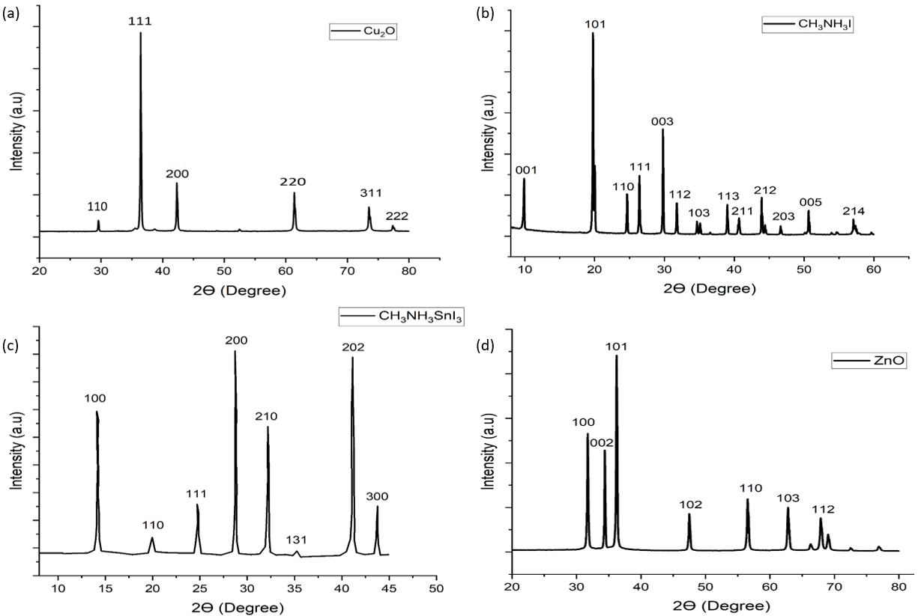
Fig. 1. X-ray diffraction (XRD) patterns of the synthesized nanomaterials used in this study, confirming their crystalline phases and structural purity. The diffraction peaks correspond to (a) Cu₂O nanoparticles, (b) CH₃NH₃I precursor, (c) CH₃NH₃SnI₃ perovskite, and (d) ZnO nanoparticles. The observed peak positions and intensities are consistent with their respective standard crystallographic data, indicating successful material synthesis.
    - Field emission scanning electron microscopy (FESEM) analysis
The powder samples of the synthesized Cu₂O, CH₃NH₃SnI₃, and ZnO were characterized using field-emission scanning electron microscopy (FESEM) to examine their surface morphology and particle size distribution. The FESEM image and corresponding particle size distribution of Cu₂O are shown in Figs. 2(a) and 2(b), respectively. Likewise, the FESEM image and particle size distribution of CH₃NH₃SnI₃ are presented in Figs. 2(c) and 2(d), while those of ZnO are depicted in Figs. 2(e) and 2(f), respectively.
The FESEM analysis revealed that the Cu₂O and ZnO samples consist of relatively smooth particles with cubic and spherical morphologies, respectively, whereas the CH₃NH₃SnI₃ sample exhibits particles with a predominantly tetragonal morphology. The observed particle sizes show a moderate degree of variation, indicating non-uniform growth during synthesis. Quantitative analysis using ImageJ software yielded average particle sizes of 207.91 nm for Cu₂O, 370.51 nm for CH₃NH₃SnI₃, and 188.22 nm for ZnO, as illustrated in Figs. 2(b), 2(d), and 2(f), respectively.
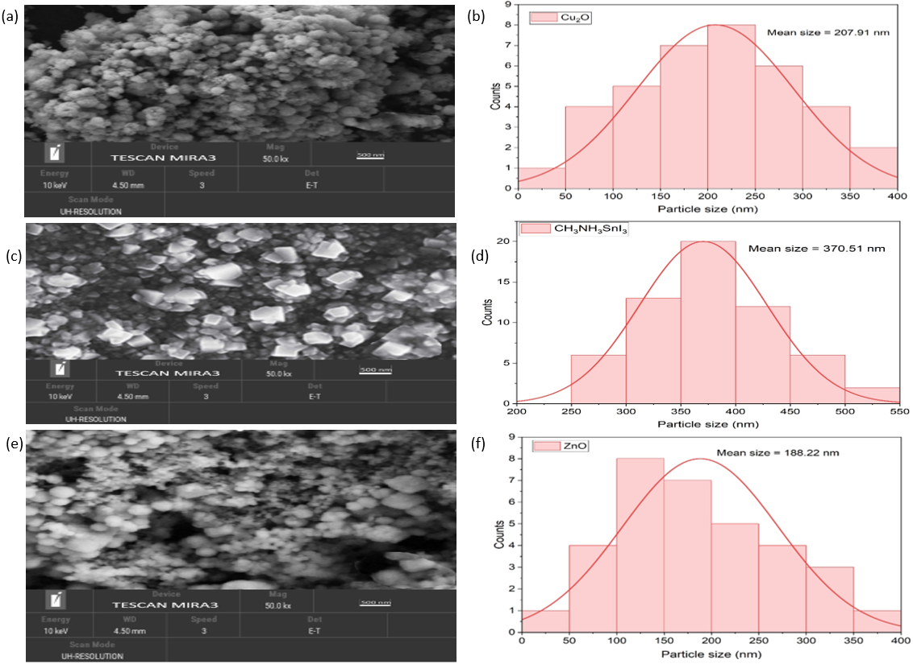
Fig. 2. Field-emission scanning electron microscopy (FESEM) images and corresponding particle size distributions of the synthesized nanomaterials used in the device fabrication. (a) FESEM image of Cu₂O nanoparticles showing their surface morphology; (b) particle size distribution histogram of Cu₂O nanoparticles obtained from FESEM analysis. (c) FESEM image of CH₃NH₃SnI₃ perovskite nanoparticles illustrating grain morphology; (d) corresponding particle size distribution. (e) FESEM image of ZnO nanoparticles highlighting particle uniformity; (f) particle size distribution histogram of ZnO nanoparticles.
    - UV-visible spectroscopy analysis
UV–visible spectroscopy was performed to investigate the optical properties of the materials. The absorbance spectra of Cu₂O nanoparticles dispersed in 1-butanol were recorded over a wavelength range of 400–800 nm. For CH₃NH₃SnI₃ dispersed in N,N-dimethylformamide (DMF), the UV–visible absorbance spectra were obtained in the range of 500–900 nm. Similarly, the absorbance spectra of ZnO nanoparticles dispersed in methanol were measured over a wavelength range of 300–800 nm. The UV–visible absorbance spectra, along with the corresponding Tauc plots for Cu₂O, CH₃NH₃SnI₃, and ZnO, are presented in Figs. 3(a), 3(b), and 3(c), respectively. The optical band gaps of Cu₂O, CH₃NH₃SnI₃, and ZnO nanoparticles were determined from the Tauc plots using the relationships given in Equations (1) and (2).
$$α= \frac{2.303 x A}{T} (1)$$
$(αhʋ)={A\left(hv-E_{g}\right)}^{n} (2$)
where $α$ is the absorption coefficient, $A$ is the absorbance, T is the thickness (diameter of the cuvette), $h$ is the Plank’s constant, $ʋ$ is the frequency of the photon, $hʋ$ is the energy of a photon, and $n$ is the exponential coefficient having values of 0.5 and 2 for direct and indirect electronic transitions, respectively. Equation (2) represents the Tauc’s relation equation. An intercept at $hʋ$ axis in ${(αhʋ)}^{2}$ plot against $hʋ$ represents the band gap energy (Viezbicke et al., 2015). The calculated band gaps $E_{g}$ for Cu₂O, CH₃NH₃SnI_{3,} and ZnO are 2.17 eV, 1.32 eV, and 3.20 eV, as shown in Figs. 3(a), 3(b) and 3(c), respectively. It is important to add that for most metal-based nanostructures such as Cu₂O and ZnO, the band gap value increases as crystallite size decreases.
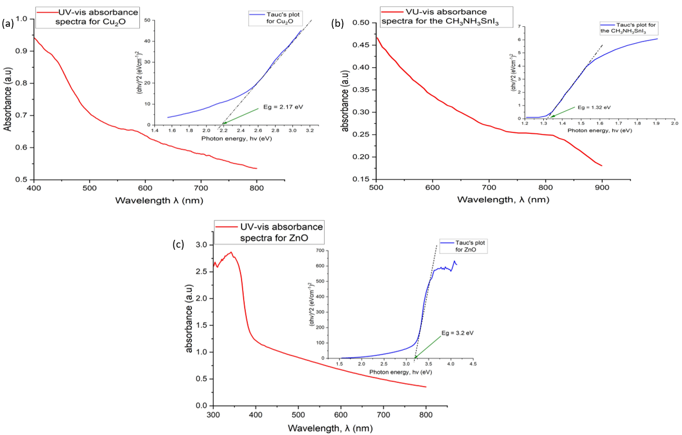
Fig. 3. UV–visible absorbance spectra and corresponding Tauc plots used to estimate the optical band gaps of the synthesized nanomaterials. (a) Cu₂O nanoparticles, (b) CH₃NH₃SnI₃ perovskite nanoparticles, and (c) ZnO nanoparticles. The absorbance spectra illustrate the optical absorption behavior of each material, while the Tauc plots $\left(αhν)^{n}\right.$ versus photon energy $\left(hν\right)$were employed to determine the optical band gap energies by extrapolating the linear region to the energy axis.
  - Device Fabrication Analysis
An indium tin oxide (ITO)-coated glass substrate, used as the top conducting interface, was cleaned in an ultrasonic bath sequentially with commercial detergent, acetone, and isopropanol to remove surface impurities. Cu₂O nanoparticles, employed as the hole transport material (HTM), were dispersed in a mixture of 1-butanol, methanol, and chloroform (2:1:1) without additional binders and spin-coated onto the ITO substrate at 3,000 rpm for 60 s, without the need for calcination or sintering.
CH₃NH₃SnI₃ was selected as the perovskite absorber due to its environmentally friendly nature. Freshly prepared CH₃NH₃SnI₃ crystals were dissolved in a mixture of N,N-dimethylformamide (DMF) and dimethyl sulfoxide (DMSO) to improve film morphology and reduce crystal defects, thereby enhancing charge-transfer efficiency. The CH₃NH₃SnI₃ layer was spin-coated onto the Cu₂O-coated substrate at 3,000 rpm for 20 s.
ZnO nanoparticles, used as the electron transport material (ETM), were dispersed in a mixture of 1-butanol, methanol, and chloroform (2:1:1) without additional binders and spin-coated onto the perovskite layer at 3,000 rpm for 30 s, also without calcination or sintering. All spin-coated layers were deposited at an acceleration of 1,000 rpm s⁻¹.
Finally, an aluminium electrode was deposited via thermal evaporation under a base pressure of 1 × 10⁻⁷ mbar at a deposition rate of 2 Å s⁻¹, forming a smooth aluminium nanolayer. All device layers were fabricated under ambient conditions and dried in air at a relative humidity of approximately 50%. The step-by-step schematic of the fabrication process and the energy-level diagram of the fabricated inverted device structure are presented in Figs. 4(a) and 4(b), respectively.
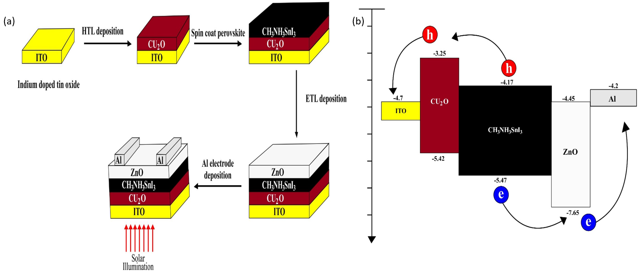
Fig. 4. Schematic illustrations of the inverted perovskite solar cell fabrication process and device energetics. (a) Three-dimensional schematic showing the step-by-step fabrication sequence of the inverted device, including layer deposition order and interface formation. (b) Energy-level diagram of the fabricated inverted device structure, illustrating the relative positions of the conduction band minimum (CBM), valence band maximum (VBM), and Fermi levels of each functional layer, as well as charge-carrier transport pathways and selective electron and hole extraction across the device architecture.

  - Device Testing and Analysis
The current–voltage (J–V) curves of the fabricated solar cells were measured using a digital source-measurement unit. The J–V characteristics, including forward and reverse scans, are presented in this paper and are comparable to those reported by Aseena et al. (2022) in terms of material components. However, our device features an inverted architecture composed of lead-free perovskite (CH₃NH₃SnI₃) and a cost-effective aluminium back-contact electrode. The inverted device achieved a power conversion efficiency (PCE) of 7.44%, exceeding the 6.02% reported by Aseena et al. (2022).
The high performance of this device can be attributed to both the choice of materials and its structural configuration. The top-view photograph of the fabricated inverted device and the experimental setup used for testing under illumination are shown in Figs. 5(a) and 5(b), respectively. The device exhibited negligible hysteresis between forward and reverse scans (Fig. 5(c)), consistent with previous reports (Wang et al., 2021; Yu et al., 2018).
Notably, the fabricated device demonstrated superior stability compared to the work of Seo et al. (2018), retaining 95% of its initial PCE (from 7.44% to 6.98%) after 1,000 hours of exposure to 1,000 W/m² solar illumination under 50% relative humidity, as shown in Fig. 5(d). These results are in agreement with findings reported by Hao et al. (2021).
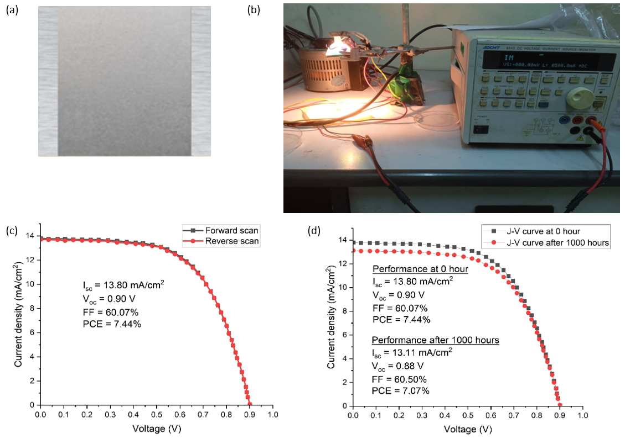
Fig. 5. Photographic, measurement, and performance characterization of the fabricated inverted device: (a) top-view image of the device layout and electrodes; (b) schematic of the J–V measurement setup under illumination; (c) forward and reverse J–V curves showing hysteresis behavior; and (d) J–V characteristics at 0 h and after 1000 h, demonstrating device stability over time.
- CONCLUSION
The XRD analysis produced well-defined diffraction patterns for Cu₂O, CH₃NH₃SnI₃, and ZnO. EDX results confirmed the correct elemental composition and stoichiometric proportions. FESEM images revealed smooth nanoparticle morphologies, with average particle sizes of 207.91 nm, 370.51 nm, and 188.22 nm for Cu₂O, CH₃NH₃SnI₃, and ZnO, respectively. Tauc plots derived from UV–Vis spectroscopy data indicated direct band gaps of 2.17 eV, 1.32 eV, and 3.20 eV for Cu₂O, CH₃NH₃SnI₃, and ZnO, respectively.
The fabricated solar cell demonstrated outstanding performance, achieving a power conversion efficiency (PCE) of 7.44%, the highest reported for devices employing inorganic transport layers (Cu₂O and ZnO) fabricated at room temperature under 50% relative humidity. The device retained 95% of its initial performance after 1,000 hours of exposure to standard solar illumination, highlighting exceptional stability for methylammonium tin-based perovskite devices.
The inverted device architecture (ITO/Cu₂O/CH₃NH₃SnI₃/ZnO/Al) is highly promising, providing a pathway toward eco-friendly, cost-effective, and stable perovskite solar cells with negligible hysteresis using inorganic transport materials.
DISCLAIMER (ARTIFICIAL INTELLIGENCE)
The author (s) hereby declare that generative AI technologies such as Large Language Models, etc have been used during writing or editing of this manuscript. This explanation will include the name, version, model, and source of the generative AI technology and as well as all input prompts provided to the generative AI technology.
Details of the AI usage are given below:
- ChatGPT based on the GPT-5 mini model for polishing the English language for better readability.
Competing interests
The authors declared no competing interest that could affect the work reported in the paper.

REFERENCES
Abraham, N., Rufus, A., Unni, C., Philip, D. (2018). Dye sensitized solar cells using catalytically active CuO-ZnO nanocomposite synthesized by single step method, Spectrochimica Acta Part A: Molecular and Biomolecular Spectroscopy. 200: 116-126. https://doi.org/10.1016/j.saa.2018.04.015
Afre, R.A. and Pugliese, D. (2024). Perovskite solar cells: a review of the latest advances in materials, fabrication techniques, and stability enhancement strategies. Micromachines, 15(2), 192. https://doi.org/10.3390/mi15020192
Agresti, A., Di Giacomo, F., Pescetelli, S. and Di Carlo, A. (2024). Scalable deposition techniques for large-area perovskite photovoltaic technology: A multi-perspective review. Nano Energy, 122, 109317. https://doi.org/10.1016/j.nanoen.2024.109317
Arce-Plaza, A., Sánchez-Rodriguez, F., Courel-Piedrahita, M., Galán, O.V., Hernandez-Calderon, V., Ramirez-Velasco, S. and López, M.O. (2018). CdTe thin films: deposition techniques and applications. Coatings and Thin-Film Technologies, 131-148. https://doi.org/10.5772/intechopen.82070
Asad, J., Shaat, S.K., Musleh, H., Shurrab, N., Issa, A., Lahmar, A., Al Kahlout, A. and Al Dahoudi, N. (2019). Perovskite solar cells free of hole transport layer. Journal of Sol-Gel Science and Technology, 90(3), 443-449. https://doi.org/10.1007/s10971-019-04957-w
Aseena, S., Abraham, N., Dennis Babu, G. S., Kathiresan, S., Suresh Babu, V. (2022). Solution-Synthesized Cu₂O as a Hole Transport Layer for a ZnO-Based Planar Heterojunction Perovskite Solar Cells Fabricated at room temperature. Journal of electronic Material. 51: 1692-1699. https://doi.org/10.1007/s11664-022-09442-9
Beek, W.J., Wienk, M.M., Kemerink, M., Yang, X. and Janssen, R.A. (2005). Hybrid zinc oxide conjugated polymer bulk heterojunction solar cells. The Journal of Physical Chemistry B, 109(19), 9505-9516. https://doi.org/10.1021/jp050745x
Byranvand, M.M., Zuo, W., Imani, R., Pazoki, M. and Saliba, M. (2022). Tin-based halide perovskite materials: properties and applications. Chemical Science, 13(23), 6766-6781. https://doi.org/10.1039/D2SC01914K
Carey, G.H., Abdelhady, A.L., Ning, Z., Thon, S.M., Bakr, O.M. and Sargent, E.H. (2015). Colloidal quantum dot solar cells. Chemical reviews, 115(23), 12732-12763. https://doi.org/10.1021/acs.chemrev.5b00063
Chen, B., Yang, M., Priya, S. and Zhu, K. (2016). Origin of J–V hysteresis in perovskite solar cells. The journal of physical chemistry letters, 7(5), 905-917. https://doi.org/10.1021/acs.jpclett.6b00215
Choi Won-Gyu, Lee S, Jeon B-C, Moon T (2022). Single-source evaporation of CH₃NH₃SnI₃ for Pb-free perovskite solar cells. Int J Energy Res. 9875 – 9881 https://doi.org/10.1002/er.7761
Dang, Y., Zhou, Y., Liu, X., Ju, D., Xia, S., Xia, H. and Tao, X. (2016). Formation of hybrid perovskite tin iodide single crystals by top‐seeded solution growth. Angewandte Chemie International Edition, 55(10), 3447-3450. https://doi.org/10.1002/anie.201511792
De Los Santos, I.M., Cortina-Marrero, H.J., Ruíz-Sánchez, M.A., Hechavarría-Difur, L., Sánchez-Rodríguez, F.J., Courel, M. and Hu, H. (2020). Optimization of CH3NH3PbI3 perovskite solar cells: A theoretical and experimental study. Solar Energy, 199, 198-205. https://doi.org/10.1016/j.solener.2020.02.026
Et-taya, L., Ouslimane, T. and Benami, A. (2020). Numerical analysis of earth-abundant Cu2ZnSn (SxSe1-x) 4 solar cells based on Spectroscopic Ellipsometry results by using SCAPS-1D. Solar Energy, 201, 827-835. https://doi.org/10.1016/j.solener.2020.03.070
Feurer, T., Reinhard, P., Avancini, E., Bissig, B., Löckinger, J., Fuchs, P., Carron, R., Weiss, T.P., Perrenoud, J., Stutterheim, S. and Buecheler, S. (2017). Progress in thin film CIGS photovoltaics–Research and development, manufacturing, and applications. Progress in Photovoltaics: Research and Applications, 25(7), 645-667. https://doi.org/10.1002/pip.2811
Gonzales, C., Guerrero, A. and Bisquert, J. (2021). Spectral properties of the dynamic state transition in metal halide perovskite-based memristor exhibiting negative capacitance. Applied Physics Letters, 118(7). https://doi.org/10.1063/5.0037916
Hardy, J., Fiedler, H. and Kennedy, J. (2025). A review on the current status and chemistry of tin halide perovskite films for photovoltaics. Progress in Materials Science, 101446. https://doi.org/10.1016/j.pmatsci.2025.101446
Hao, L., Li, T., Ma, X., Wu, J., Qiao, L., Wu, X., Hou, G., Pei, H., Wang, X., and Zhang, X. (2021). A tin‑based perovskite solar cell with an inverted hole‑free transport layer to achieve high energy conversion efficiency by SCAPS device simulation. Optical and Quantum Electronics. 53:524. https://doi.org/10.1007/s11082-021-03175-5
Hsieh, M.L., Kaiser, A., Bhattacharya, S., John, S. and Lin, S.Y. (2020). Experimental demonstration of broadband solar absorption beyond the Lambertian limit in certain thin silicon photonic crystals. Scientific Reports, 10(1), 11857. https://doi.org/10.1038/s41598-020-68704-w
Ionescu, C., Baracu, T., Vlad, G.E., Necula, H. and Badea, A. (2015). The historical evolution of the energy efficient buildings. Renewable and Sustainable Energy Reviews, 49, 243-253. https://doi.org/10.1016/j.rser.2015.04.062
Jonathan, L., Diguna, L.J., Samy, O., Muqoyyanah, M., Abu Bakar, S., Birowosuto, M.D. and El Moutaouakil, A. (2022). Hybrid organic–inorganic perovskite halide materials for photovoltaics towards their commercialization. Polymers, 14(5), 1059. https://doi.org/10.3390/polym14051059
Kim, S., Kim, Y.C. and Oh, S.G. (2015). Synthesis of highly concentrated ZnO nanorod sol by sol-gel method and their applications for inverted organic solar cells. Korean Chemical Engineering Research, 53(3). http://dx.doi.org/10.9713/kcer.2015.53.3.350
Kim, S., Trinh, T.T., Park, J., Pham, D.P., Lee, S., Do, H.B., Dang, N.N., Dao, V.A., Kim, J. and Yi, J. (2021). Over 30% efficiency bifacial 4-terminal perovskite-heterojunction silicon tandem solar cells with spectral albedo. Scientific Reports, 11(1), 15524. https://doi.org/10.1038/s41598-021-94848-4
Li, J., Cao, H.L., Jiao, W.B., Wang, Q., Wei, M., Cantone, I., Lü, J. and Abate, A. (2020). Biological impact of lead from halide perovskites reveals the risk of introducing a safe threshold. Nature communications, 11(1), 310. https://doi.org/10.1038/s41467-019-13910-y
Li, X., Zheng, X., Zhen, Y. and Liang, Y. (2023). Photogenerated carrier-assisted electrocatalysts for efficient water splitting. Catalysts, 13(4), 712. https://doi.org/10.3390/catal13040712
Lyu, M., Yun, J.H., Chen, P., Hao, M. and Wang, L., 2017. Addressing toxicity of lead: progress and applications of low‐toxic metal halide perovskites and their derivatives. Advanced Energy Materials, 7(15), p.1602512. https://doi.org/10.1002/aenm.201602512
Major, J.D. (2016). Grain boundaries in CdTe thin film solar cells: a review. Semiconductor Science and Technology, 31(9), 093001. https://doi.org/10.1088/0268-1242/31/9/093001
Mallik, M., Monia, S., Gupta, M., Ghosh, A., Toppo, M.P. and Roy, H. (2020). Synthesis and characterization of Cu₂O nanoparticles. Journal of Alloys and Compounds, 829:154623. https://doi.org/10.1016/j.jallcom.2020.154623
Mangrulkar, M. and Stevenson, K.J. (2021). The progress of additive engineering for CH3NH3PbI3 photo-active layer in the context of perovskite solar cells. Crystals, 11(7), 814. https://doi.org/10.3390/cryst11070814
Nanda, I.R., Pambudi, N.A. and Aziz, M., (2023). Review on the progress of solar water heaters and their future perspectives. Energy Technology, 11(10), 2300191. https://doi.org/10.1002/ente.202300191
Noman, M., Khan, Z. and Jan, S.T. (2024). A comprehensive review on the advancements and challenges in perovskite solar cell technology. RSC advances, 14(8), 5085-5131. https://doi.org/10.1039/D3RA07518D
Nur-E-Alam, M., Islam, M.S., Abedin, T., Islam, M.A., Yap, B.K., Kiong, T.S., Das, N., Rahman, M.R. and Khandaker, M.U. (2025). Current scenario and future trends on stability issues of perovskite solar cells: a mini review. Current Opinion in Colloid & Interface Science, 101895. https://doi.org/10.1016/j.cocis.2025.101895
Nyiekaa, E.A., Aika, T, A., Danladi, E., Akhabue, C.E. and Orukpe, P.E. (2024a). Simulation and optimization of 30.17% high performance N-type TCO-free inverted perovskite solar cell using inorganic transport materials. Scientific Reports 1412024 https://doi.org/10.1038/s41598-024-62882-7
Nyiekaa, E.A., Aika, T.A., Orukpe, P.E., Akhabue, C.E. and Danladi, E. (2024b). Development on inverted perovskite solar cells: A review. Heliyon, 10(2). https://doi.org/10.1016/j.heliyon.2024.e24689
Pan, Z., Rao, H., Mora-Seró, I., Bisquert, J. and Zhong, X. (2018). Quantum dot-sensitized solar cells. Chemical Society Reviews, 47(20), 7659-7702. https://doi.org/10.1039/C8CS00431E
Parashar, M. and Kaul, A.B. (2021). Methylammonium lead tri-iodide perovskite solar cells with varying equimolar concentrations of perovskite precursors. Applied Sciences, 11(24), 11689. https://doi.org/10.3390/app112411689
Rahman, M.S., Miah, S., Marma, M.S.W. and Sabrina, T. (2019), February. Simulation based investigation of inverted planar perovskite solar cell with all metal oxide inorganic transport layers. In 2019 International Conference on Electrical, Computer and Communication Engineering (ECCE) (pp. 1-6). IEEE. https://doi.org/10.1109/ECACE.2019.8679283
Raminafshar, C., Raptis, D., Mohammadi, M.R. and Lianos, P. (2019). Study of hole-transporter-free perovskite solar cells based on fully printable components. Micromachines, 10(4), 266. https://doi.org/10.3390/mi10040266
Saha, P., Singh, S. and Bhattacharya, S., (2023). Efficient and lead-free perovskite solar cells based on defect-ordered methyl ammonium antimony iodide. IEEE Transactions on Electron Devices, 70(3), 1095-1101. https://doi.org/10.1109/TED.2023.3235870
Seo, S., Jeong, S., Bae, C., Park, N.G. and Shin, H. (2018). Perovskite solar cells with inorganic electron‐and hole‐transport layers exhibiting long‐term (≈ 500 h) stability at 85° C under continuous 1 sun illumination in ambient air. Advanced Materials, 30(29), 1801010. https://doi.org/10.1002/adma.201801010
Shukla, A., Sharma, V.K., Gupta, S.K. and Verma, A.S. (2020). Computational determination of the physical-thermoelectric parameters of tin-based organomatallic halide perovskites (CH3NH3SnX3, X= Br and I): Emerging materials for optoelectronic devices. Materials Chemistry and Physics, 253, 123389. https://doi.org/10.1016/j.matchemphys.2020.123389
Solak, E.K. and Irmak, E., 2023. Advances in organic photovoltaic cells: a comprehensive review of materials, technologies, and performance. RSC advances, 13(18), pp.12244-12269. https://doi.org/10.1039/D3RA01454A
Stoumpos, C.C., Malliakas, C.D. and Kanatzidis, M.G. (2013). Semiconducting tin and lead iodide perovskites with organic cations: phase transitions, high mobilities, and near-infrared photoluminescent properties. Inorganic chemistry, 52(15), 9019-9038. https://doi.org/10.1021/ic401215x
Tahir, D. and Tougaard, S. (2012). Electroic and optical properties of Cu, CuO and Cu₂O studied by electronic spectroscopy. J. Phys.: Condens. Matter 24 175002. https://doi.org/10.1088/0953-8984/24/17/175002
Tian, L., Xin, Q., Zhao, C., Xie, G., Akram, M.Z., Wang, W., Ma, R., Jia, X., Guo, B. and Gong, J.R. (2021). Nanoarray structures for artificial photosynthesis. Small, 17(38), 2006530. https://doi.org/10.1002/smll.202006530
Viezbicke, B.D., Patel, S., Davis, B.E. and Birnie III, D.P. (2015). Evaluation of the Tauc method for optical absorption edge determination: ZnO thin films as a model system. physica status solidi (b), 252(8), 1700-1710. https://doi.org/10.1002/pssb.201552007
Wan, S., Zhu, Y., Hong, D. and Tian, Y. (2022). Controllable introduction of surface defects on CH₃NH₃PbI₃ perovskite. Nanomaterials, 12(6), 1002. https://doi.org/10.3390/nano12061002
Wang, Q., Phung, N., Di Girolamo, D., Vivo, P. and Abate, A. (2019). Enhancement in lifespan of halide perovskite solar cells. Energy & Environmental Science, 12(3), 865-886. https://doi.org/10.1039/C8EE02852D
Wang, T., Chen, J., Wu, G. and Li, M. (2016). Optimal design of efficient hole transporting layer free planar perovskite solar cell. Science china materials, 59(9), 703-709. https://doi.org/10.1007/s40843-016-5108-4
Wang, Z., Zhang, D., Yang, G. and Yu, J. (2021). Exceeding 19% efficiency for inverted perovskite solar cells used conventional organic small molecule TPD as hole transport layer. Applied Physics Letters, 118(18). https://doi.org/10.1063/5.0050512
Wu, J., Wang, Y., Su, C. et al. (2021). Preparation and characterization of planar heterojunction perovskite solar cells based on c-TiO₂/CH₃NH₃PbI₃/HTM/Ag structure. J Sol-Gel Sci Technol. 100, 440–450. https://doi.org/10.1007/s10971-021-05682-z
Yu, J.C., Hong, J.A., Jung, E.D., Kim, D.B., Baek, S.M., Lee, S., Cho, S., Park, S.S., Choi, K.J. and Song, M.H., (2018). Highly efficient and stable inverted perovskite solar cell employing PEDOT: GO composite layer as a hole transport layer. Scientific reports, 8(1), 1070. https://doi.org/10.1038/s41598-018-19612-7
Zhang, B., Zeng, Z., Dong, H., Gao, W. and Ran, C. (2025). Recent advances in tin halide perovskite solar cells: a critical review. Journal of Materials Chemistry A, 13(37), 30708-30754. https://doi.org/10.1039/D5TA04568A
Zhao, Z., Gu, F., Rao, H., Ye, S., Liu, Z., Bian, Z. and Huang, C. (2019). Metal halide perovskite materials for solar cells with long‐term stability. Advanced Energy Materials, 9(3), 1802671. https://doi.org/10.1002/aenm.201802671
Zhu, M., Park, S.Y., Kang, T., Han, H.G., Jun, H.Y. and Ryu, S.O. (2017). Investigation of CuIn1− xGaxSe2 thin films prepared by chemical solution-based processes for CIGS solar cells. Molecular Crystals and Liquid Crystals, 645(1), 175-184. https://doi.org/10.1080/15421406.2016.1277641

