Enhancing Dynamic Stability of Solar PV Micro Grid Clusters via Genetic Algorithm Optimized Adaptive Droop Control and Tie-line Stabilization

ABSTRACt
Micro grid networks are increasingly adopting solar photovoltaic (PV) systems due to their sustainability and distributed generation advantages. However, the intermittent nature of solar energy caused by varying irradiance and temperature increases significant challenges in maintaining power balance, voltage stability, and frequency control, especially in interconnected micro-grid clusters. Traditional droop control methods, though commonly used for decentralized load sharing, suffer from fixed parameters that do not adapt well to changing conditions. This often leads to power-sharing errors, voltage instability, and degraded overall performance. Additionally, uncoordinated tie-line power exchanges between micro grids can introduce oscillations and stoppage, further affecting system reliability. Addressing these issues, this article introduces an advanced control strategy that combines Adaptive Droop Control (ADC), Genetic Algorithm (GA) optimization, and tie-line stabilization. The GA component ensures optimal real-time tuning of droop parameters based on prevailing system conditions, while ADC dynamically adjusts those parameters to enhance responsiveness to fluctuations. Through GA the power sharing between interconnected micro-grids has been solved by adjusting voltage and frequency to operate in real time adoption regardless of any changes occur.

Keywords: [Micro grid Clusters
Solar Photovoltaic (PV) Systems
Renewable Energy Integration
Adaptive Droop Control (ADC)
Genetic Algorithm (GA) Optimization
Power Sharing
Voltage Stability]
1. INTRODUCTION
As power systems become more energetic, micro-grid networks are gaining popularity, often incorporating renewable sources like solar PV panels. While solar power is a great clean and renewable option that's easy to access, it’s not always available on demand. Its output heavily depends on weather conditions such as sunlight and temperature. When multiple PV systems are connected in a micro-grid but still isolated from each other, these differences in output become more noticeable. It’s also tougher to keep everything balanced like matching generation with consumption and maintain stable voltage and frequency as more micro-grids are linked together in parallel. In the past, micro grids used a pretty straightforward way to share loads called droop control. It didn't need fancy, quick communication links to work. But, the usual droop methods often struggle when things get a bit hectic or change quickly. They can cause frequency swings, voltage problems, and messy power sharing because they don’t handle asynchronous conditions well when the load or power sources change. Plus, when you have a bunch of micro grids linked together, managing the connections across them can lead to oscillations, uneven power flows, and other issues, System wide instability. These issues necessitate a more responsive and intelligent control approach that can adapt to real-time system dynamics .So, this proposal is all about combining a tie-line restoration technique with a GA-based Adaptive Droop Control (ADC) to tackle some of those ongoing issues. Basically, the ADC tweaks its settings on the fly to keep up with changing system conditions, while the GA helps find the best parameters to make everything work more smoothly. On top of that, to keep the system stable and coordinated especially when it comes to oscillations we manage the power flows between micro-grids using tie-line stabilization methods. All these tricks together aim to make interconnected solar PV micro-grid clusters more stable, improve power quality, and boost resilience, really helping to bring more renewable energy into both city and rural power networks ([1] K. Hasan, feb,2022).
2. LITERATURE SURVEY
A micro grid is basically a small power system that can run on its own or connect to the bigger grid. It supports various types of energy sources, but solar panels are the most popular. Solar power is pretty awesome because it lasts a long time, doesn’t need much maintenance, and is getting cheaper all the time. This makes it a perfect fit for micro-grids that often rely on solar energy systems be intermittent in nature. Solar power generation is changing almost continuously due to time dependent and unpredictable energy production characteristics, i.e. the weather. Even though solar panels have a lot of benefits, adding them to micro grids can be tricky, especially when it comes to keeping things stable. The challenge comes from trying to meet the unpredictable nature of solar power, all while ensuring the micro grid delivers a steady voltage and frequency. When power is needed, everything has to be perfectly synchronized and balanced across the system so that users even in remote or off-grid spots always have reliable power.

Dynamic Stability Challenges in Solar PV Micro grids
According to Lasseter, Micro grids and Distributed Energy Resources, 2011, micro grid dynamic stability is about the system's ability to manage either an immediate disturbance or ongoing variations in power generation and load density. This is of great importance within micro grids that include solar photovoltaic (PV) systems as the single most dominant energy source. Solar PV certainly provides clean, renewable energy, but it is quite dependent on conditions including cloud drifts, temperature changes, and solar irradiance. Such events lead to large and highly variable energy supply, which presents a difficult task for the voltage control and droop-oriented micro grid. If these fluctuations are not properly managed, they can undermine the fundamental reliability and health of the entire system ([10] S. Mehta and P. Basak, April 2021).
According to Akhil et al., DOE Micro Grid Research, Development, and Demonstration, 2014, frequency instability is a major challenge to dynamic stability in micro grids, especially due to the rapid fluctuations in solar power generation. Solar PV inverters lack inherent rotational inertia, unlike traditional synchronous generators, making frequency much more sensitive to sudden changes. A rapid drop in generation can cause the system frequency to fall sharply, potentially activating protection relays or leading to disconnection from the main grid. Voltage instability also becomes a concern when reactive power supply or demand shifts suddenly. Micro grids must provide rapid and reliable voltage support, particularly during cloud cover or peak solar output. If this support is insufficient, equipment can exceed its operational voltage range, and sensitive loads may suffer disruptions due to voltage sags ([13] A. A. Akhil et al., 2013).
According to Guerrero et al., Advanced Control Architectures for Intelligent Micro grids, 2012, another major contributor to dynamic instability is load imbalance, which results from the non-synchronous variation in energy supply and demand. When solar generation unexpectedly drops and the load remains high, the grid may face overloads or be forced to shed loads to prevent system collapse. Conversely, excess generation in the absence of sufficient demand or energy storage can result in over-voltage conditions. This imbalance not only degrades system performance but can also lead to inefficient energy use and premature aging of equipment. To address these challenges, dynamic stability solutions often incorporate real-time monitoring, intelligent load forecasting, adaptive control strategies, and the integration of energy storage systems. These tools work together to absorb power fluctuations, maintain system balance, and ensure consistent power delivery in the face of variable solar generation ([16] N. Salehi, 2022).

Genetic Algorithm Optimization for Micro Grid Control
According to Moradi and Abedini, Application of Genetic Algorithms in Smart Grid Optimization, 2020, Genetic Algorithms (GAs) are powerful optimization techniques inspired by the principles of natural evolution and selection. They operate by generating a population of potential solutions and iteratively refining them through selection, crossover, and mutation to arrive at an optimal or near-optimal solution. In the context of micro-grid management, GAs are particularly valuable because they can simultaneously optimize multiple interdependent variables such as load distribution, inverter control settings, and energy storage allocation. This capability makes GAs especially effective for improving the dynamic stability of micro grids, where adaptability and real-time decision-making are essential.As highlighted by Abido in Intelligent Optimization Techniques in Power Systems, 2020, one of the major advantages of Genetic Algorithms (GAs) is their ability to handle the nonlinear, large-scale, and dynamic conditions typical of micro-grids, where traditional optimization methods often struggle or become inefficient. GAs do not require gradient information or assume linearity, which is particularly important in solar PV micro grids where variables like irradiance, temperature, and load demand can change unpredictably. The global search capability of GAs helps to avoid local optima, making them well-suited for exploring the entire solution space and identifying robust control strategies that improve system performance across a wide range of operating conditions. In solar PV micro grids, GAs play a crucial role in optimizing the interaction between various components under fluctuating conditions. As noted by Abido in Intelligent Optimization Techniques in Power Systems, 2020, GAs can fine-tune the charge and discharge cycles of battery storage systems in coordination with solar generation, ensuring that excess solar power is stored when available and dispatched efficiently during low-generation periods. GAs can also determine the optimal balance between renewable energy and backup power sources, minimizing reliance on fossil fuels while ensuring grid reliability. Furthermore, GAs support demand-side management by optimizing which loads should be prioritized or curtailed based on system constraints and user preferences, contributing to the overall efficiency and stability of the micro-grid. Moreover, GAs can significantly improve the load shedding process by selecting which non-critical loads to disconnect during periods of supply shortfall in a way that minimizes disruption and maintains stability. Instead of using static thresholds or fixed load-shedding hierarchies, GA-based approaches adapt to the real-time conditions of the micro-grid, offering smarter, context-aware decisions. By continuously evolving control parameters, GAs ensure that the system remains responsive and balanced, even in the face of rapid solar power variability. Ultimately, this contributes to a more resilient and efficient micro grid that can harness solar energy effectively while ensuring uninterrupted service to critical loads (Abido, 2002).

Adaptive Droop Control Strategies
Adaptive droop control introduces a more responsive and intelligent approach to load shedding in micro grids by continuously monitoring and reacting to dynamic conditions in real time. As highlighted by Guerrero et al. in Advanced Control and Optimization Strategies for Micro-grid Stability and Resilience, 2022, unlike fixed or pre-programmed load shedding strategies, adaptive systems evaluate both short-term and long-term variations in generation and demand to determine how much load to shed at any given moment. This flexibility is especially valuable in solar PV micro-grids, where rapid fluctuations in solar irradiance can cause power variations in seconds, while load profiles may change gradually throughout the day. By adapting to real-time data, these systems help maintain balance, reduce unnecessary load shedding, and improve overall micro-grid stability. Several advanced control techniques support the implementation of adaptive droop control. As discussed by Guerrero et al. in Advanced Control and Optimization Strategies for Micro-grid Stability and Resilience, 2018, one such method is Model Predictive Control (MPC), which uses mathematical models of the micro-grid to predict future system behavior and optimize control actions in advance. MPC takes into account constraints and expected disturbances to make proactive adjustments, ensuring that the grid is prepared for fluctuations before they arise. This makes MPC highly effective in preventing voltage and frequency instability caused by sudden changes in solar power. Fuzzy Logic Control (FLC), on the other hand, manages system uncertainty by interpreting vague or imprecise inputs, such as partially known load behavior or uncertain solar output. FLC converts these inputs into flexible control actions based on human-like reasoning, making it especially well-suited for managing the inherent variability of renewable energy sources. In more complex or nonlinear systems, neural network-based control has proven to be highly effective. As observed by Kumar et al. in Smart Grid Systems and Renewable Energy Technologies, 2022, these systems utilize artificial neural networks trained on historical data to learn and predict system behavior patterns. Once trained, neural networks can adapt to real-time inputs, making decisions based on learned responses to similar past conditions. This makes them especially suited for managing scenarios where solar generation patterns and load responses are too complex for traditional control models. Together, these adaptive control methods form a powerful framework for maintaining dynamic stability in solar PV micro-grids, particularly in environments characterized by high variability and unpredictable operating conditions ([16] N. Salehi, 2022).

Tie Line Stabilization in Micro grids
Tie lines are really important when it comes to keeping the power flowing smoothly across different micro grids or between a micro grid and the main utility grid. Basically, they let excess electricity from one grid be shared with another that might need a little boost. This helps keep everything balanced, making sure power generation and demand stay in sync, as discussed by Liu and others in their 2020 book, 'Micro-grid and Multi-micro-grid Operation and Control.' Especially with solar PV micro grids, tie lines are a lifesaver because they provide a backup way to support loads when sunlight fluctuations cause solar generation to dip or spike unexpectedly However, these interconnections can also become points of vulnerability. Fluctuations in sunlight or passing clouds can cause the amount of solar power generated to vary a lot. These changes can upset the balance across the power lines, which might cause instability not just in the main grid but also in the micro-grid that's feeding it. To handle this, folks use tie line stabilization techniques to keep everything in sync and make sure power flows smoothly. One of the most common methods is frequency-based control. Basically, the system keeps an eye on the system's frequency and makes quick adjustments by tweaking the output from nearby generators or energy storage units. Like Xu and colleagues explained in their 2020 paper, this process helps counteract sudden drops or jumps in solar power by either soaking up excess energy or releasing it to bring the frequency back to normal. within its safe operating range. Similarly, voltage-based control addresses fluctuations in voltage that can arise when active and reactive power flows are not properly balanced. This method modulates reactive power, often using inverters or capacitor banks, to maintain voltage levels and prevent over-voltage or under voltage conditions at the tie line interface
For more resilient performance, especially in systems facing both frequency and voltage instabilities, hybrid control strategies are implemented. As discussed by Zhao et al. in Hybrid Control Strategies for Renewable Energy Systems, 2020, these strategies combine the capabilities of frequency and voltage control, providing a coordinated response to complex and variable conditions. By adjusting both active and reactive power flows in real time, hybrid approaches ensure that tie lines remain stable and interconnected grids stay synchronized. Such strategies are essential in high-penetration solar PV micro grids, where variability is frequent and potentially severe. Effective tie line stabilization not only prevents cascading failures but also enhances the overall reliability and efficiency of micro grid clusters ([21] Z. Liu, 2020).

Genetic Algorithm Optimized Adaptive Drop Control and Tie Line Stabilization
Hybrid control methods are really useful for keeping things steady, especially in systems that have to deal with both voltage and frequency ups and downs. These approaches mix voltage and frequency management skills, giving a smart, coordinated way to handle tricky and unpredictable situations (Sharma et al., management solutions for Hybrid Power Systems, 2021. By making quick tweaks to active and reactive power flows in real-time, hybrid techniques help ensure everything runs smoothly and reliably. That tie lines remain stable and interconnected Micro-grids keep in sync, which is really important, especially in setups where a lot of solar panels are feeding power in that's called high-penetration solar PV micro-grids. Since the power can fluctuate a lot and sometimes pretty wildly, having solid tactics to keep everything stable is a must. Not only does this help stop big failures from spreading, but making sure the tie lines stay steady actually makes the whole micro-grid system more reliable and efficient. To help the system handle changes in power output smoothly, people use genetic algorithms (GAs) to fine-tune things like when and how much load to shed. In the study "Application of Genetic Algorithms in Power System Optimization" from 2020, Kumar and his team mention how GAs can also be used to set the right parameters for tie line stabilization. This way, power can transfer smoothly between connected micro-grids or between a micro-grid and the main grid, making everything work more smoothly. By optimizing these control strategies, it is possible to minimize energy losses, reduce operational costs, and enhance the overall stability and performance of solar PV micro grids.

Recent Advances and Applications
Lately, there's been a lot of talk about using genetic algorithms to improve how stable photovoltaic micro-grids are. Researchers have been trying out GA-based methods to manage load shedding in micro-grids that use a mix of renewable energy sources like solar panels and batteries. This approach really helps when the sun’s intensity is fluctuating a lot, making the whole system much more stable. They’re also using GA optimization to keep the power flow between connected micro-grids in check and prevent instability. Overall, these evolutionary algorithms are proving to be pretty effective at tackling issues like controlling how power drops happen and stabilizing tie lines, which in turn helps keep these solar PV micro-grid running smoothly and efficiently. Making sure that solar PV micro-grid clusters stay stable and respond well is really important for keeping things running smoothly and reliably. One way to fix some of the issues caused by the unpredictable nature of solar energy is to combine genetic algorithms with adaptive droop control and tie line stability ([24] M. Sharma, Nov 2020). These strategies can help keep the micro-grid steady and make it more flexible when loads or power sources change, by fine-tuning control methods. Moving forward, how well we develop and refine these techniques will really influence whether solar PV micro-grids become a solid part of our energy future, especially as we incorporate more renewable sources. This review emphasizes how mixing advanced optimization methods with adaptive control systems can help achieve the best possible stability in these kinds of micro-grids.
3. methodology
Inspired by the idea of natural evolution, the Genetic Algorithm (GA) is a pretty handy and adaptable way to optimize solutions. It works by improving options step-by-step over time using processes like crossover, mutation, and selection. This makes GA especially great for fine-tuning control settings that are key to keeping a solar PV micro-grid system running smoothly. For example, tie-line stabilization helps ensure that power flow between connected micro-grids stays balanced and coordinated. Meanwhile, droop control adjusts how resources like solar panels respond when there are shifts in frequency or load. GA is used to tune parameters within the adaptive droop control strategy such as the active and reactive power droop coefficients, and potentially parameters of the tie line stabilizers that governs power exchange between micro grids .Each solution candidate represents a unique set of controller parameters including proportional integral(PI) gains, droop coefficients, and tie line control gains. The system can adapt to changes in the environment, load shifts, and fluctuations in power generation. It does this through GA's iterative improvements, which fine-tune solutions across generations to find the best or nearly best parameters. Because of this smart, data-driven tweaking ability, GA is a great choice for keeping solar-powered micro-grids running smoothly, even when conditions are complicated or unpredictable. At the start of the Genetic Algorithm (GA) process, we create an initial population where each individual stands for a possible set of control parameters to keep the tie-line stable and manage droop response. We then evaluate these candidates using a carefully designed fitness function that takes into account key factors like frequency deviations, voltage stability, and how well power sharing is handled across interconnected grids. This fitness score helps us gauge how well each candidate performs overall within the micro grid system. The top performers those with the highest scores are selected to kick off the next generation. Inspired by natural evolution, we use techniques like crossover, which mixes parts of parameter sets from two parent candidates, and mutation, which makes small random tweaks to introduce diversity, keeping the process moving forward towards better solutions ([20] N. G. Bhavani et al., 2022). The algorithm generates new candidate solutions that potentially improve upon the previous generation. This iterative process continues over multiple generations, gradually refining the control parameters to optimize system behavior. As a result, GA dynamically converges on parameter configurations that enhance the stability, coordination, and efficiency of the solar PV micro grid cluster under varying operational conditions.
Genetic Algorithm (GA) provides a significant advantage in its ability to adapt to dynamic and unpredictable operating conditions, which is essential for solar PV systems where energy output can vary drastically due to changing weather patterns and solar irradiance. Unlike traditional static control strategies that rely on fixed parameter settings and often fail to cope with sudden fluctuations, GA continuously refines its control parameters in real time by evaluating current system performance. This allows the system to dynamically respond to variations in load demand, voltage levels, and power generation, maintaining optimal performance even under erratic conditions. By constantly evolving its control strategy based on real-time feedback, GA ensures that the micro grid remains stable, synchronized, and efficient despite external disturbances, making it particularly effective in maintaining the resilience of solar PV micro grid clusters throughout the day and across different seasons.
By using genetic algorithms (GA) to automatically find the best settings for tie-line stability and droop control, we can really boost how well interconnected micro-grids stay in sync and work together. It eliminates the hassle of manual tuning, which can often be tricky and not super accurate especially in big systems with lots of dispersed energy sources and complex connections. Since GAs can adjust themselves based on changing load demands and how much energy is coming in, the whole system stays balanced. This helps prevent issues like instability or poor power quality, ensuring everything runs smoothly. Overall, this leads to more reliable energy supply and makes better use of all those dispersed resources, creating a stronger, better-managed micro-grid setup. The integration of Genetic Algorithm (GA) into solar PV micro grids fosters the development of a smarter and more autonomous energy infrastructure. By leveraging principles inspired by natural evolution, GA continuously evolves control strategies to identify and apply improvements in system performance, stability, and efficiency. This ongoing adaptation allows the micro grid to self-optimize in response to fluctuating environmental conditions and varying load demands, reducing the need for human intervention. As renewable energy systems become increasingly complex and dynamic, GA’s intelligent and flexible control capabilities make it an ideal solution for managing these challenges, ultimately supporting more resilient, efficient, and sustainable energy networks ([5] M. N. H. Shazon and A. Jawad, 2022).

3.1 Data Collection
Table 1. Data collected at chunya feeder

Month | Voltage (kV) | Power (MW) | Power factor
JANUARY | 33.4 | 7.5 | 0.81
FEBRUARY | 32.5 | 8.0 | 0.88
MARCH | 35.0 | 8.2 | 0.84
APRIL | 33.5 | 8.5 | 0.83
MAY | 33.8 | 8.8 | 0.92
JUNE | 34.0 | 9.0 | 0.94
JULY | 33.6 | 8.7 | 0.86
AUGUST | 34.5 | 8.3 | 0.85
SEPTEMBER | 34.9 | 8.5 | 0.87
OCTOBER | 34.6 | 8.0 | 0.90
NOVEMBER | 34.0 | 7.8 | 0.89
DECEMBER | 33.2 | 7.6 | 0.88

Fig 1. Shows a graph of data collected at Chunya TANESCO feeder in Mbeya region, Tanzania

Fig 1. Graph of data collected at Chunya TANESCO feeder in Mbeya region, Tanzania

3.2 Data Analysis
In addition to providing important information about the operating dynamics of the solar PV micro grid clusters according to fig 1, the year-round monthly voltage, power, and power factor data supports the necessity of adaptive optimization using Genetic Algorithms (GA). A closer look at the data shows voltage swings that could affect load-sharing and frequency stability in micro grid systems, ranging from a low of 32.5 kV in February to a high of 35.0 kV in March. In a similar vein, seasonal variations in electricity output, which range from 7.5 MW in January to 9.0 MW in June, are likely brought on by changes in solar radiation and energy demand. These variations demonstrate the need for a control system that can adjust in real time in order to maintain system stability and efficient power distribution. Monthly variations also occur in the power factor, which ranges from 0.81 in January to 0.94 in June and gauges how effectively electrical power is converted into productive activity. A low power factor typically denotes inadequate voltage regulation and increased losses, which can be particularly troublesome in decentralized systems, as was shown in January. Conversely, a higher power factor, like in June, indicates better grid performance and energy efficiency. These differences further support the need for a GA-based control strategy that can dynamically modify tie-line and droop characteristics to improve power factor constancy year-round. In May, June, and October, when the power factor is relatively high (0.92, 0.94, and 0.90, respectively), the voltage and power outputs are also more consistent, suggesting generally favorable operating conditions. However, January and February show lower performance metrics, demonstrating how environmental factors affect PV production and grid behavior. By optimizing control parameters to adaptively manage power-sharing and maintain system reliability, the GA can reduce the disruptions caused by these variations. The overall trend of power output and voltage illustrates the importance of seasonal adaptation in micro grid control systems. For example, voltage levels normally range from 32.5 to 35.0 kV, but even small variations can lead to imbalances in multi-grid settings if they are not properly managed. By enabling the control strategy to respond to these minor yet important changes, GA enhances grid synchronization and load dispatch accuracy. This leads to reduced energy losses and improved power quality throughout the year. By incorporating this real-world data into the optimization framework, the necessity and applicability of the GA-based methodology are confirmed. It demonstrates how challenging it would be for a fixed-parameter control strategy to maintain consistent and efficient operation across such a broad range of operating conditions. However, GA's real-time evolution and adaptation ensure robust and robust control that supports the financial and technical goals of a renewable energy-powered micro grid system.
3.3 Block diagram
Figure 2 presents a block diagram of hybrid solar power system that uses both DC and AC buses to manage and share energy. A charge controller keeps an eye on the battery, which stores energy, and manages the DC power generated by the solar panels. This DC power from the solar panels and the battery is fed into a common DC bus, providing a stable source. To ensure the energy from renewable sources is reliable, this DC power is then converted into AC by an inverter. The AC is sent to the AC bus, which distributes electricity to whatever needs it, whether it's the connected load or the main utility grid if needed.

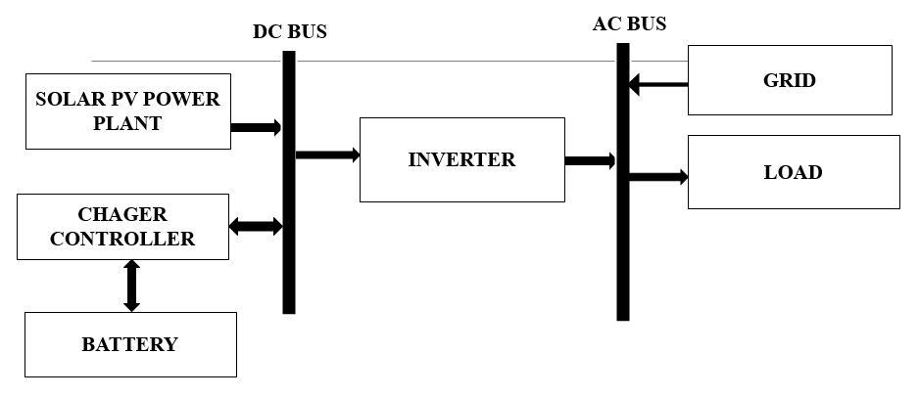
Fig 2. Block diagram of hybrid solar power system that uses both DC and AC buses to manage and share energy.

Droop control equation
Droop control adjusts frequency and voltage in response to active and reactive power changes, respectively;
$f_{i}$=$f^{*}$-$k_{p, i}\left(P_{i}-{P_{i}}^{*}\right)$
$V_{i}$=$V^{*}$-$k_{q, i}\left(Q_{i}-{Q_{i}}^{*}\right)$
where:
$f^{*}$,$V^{*}$ Nominal frequency and voltage set points
${P_{i}}^{*}$,${Q_{i}}^{*}$ Reference active and reactive power
$k_{p, i}$, -$k_{q, i}$: Active and reactive power droop coefficients for micro-grid ii, adaptively optimized adaptive droop control with integral action
Genetic algorithm optimization
The parameters $k_{p, i}$,$k_{q, i}$,$k_{i, i}$,$k_{j, i}$ for each micro grid are optimized via a Genetic Algorithm to minimize a performance index JJ;
J=$\int_{0}^{T}{\left[w_{f}\sum_{i}{{\left(f_{i}-f^{*}\right)}^{2}}+w_{v}\sum_{i}{{\left(V_{i}-V^{*}\right)}^{2}}\right]}$dt
where:
$w_{f}$,$w_{v}$ Weighting factors for frequency and voltage deviations
T: Time horizon for dynamic response evaluation
The GA iteratively searches for droop coefficients that minimize JJ, thereby enhancing dynamic stability and reducing oscillations caused by load/generation variations and tie line interactions.
Tie line power flow model
Power flow through the tie line connecting micro grid i and j is:
$P_{tie, ij}$=$\frac{V_{i}V_{j}}{X_{ij}}\sin\left(δ_{i}-δ_{j}\right)$
$Q_{tie, ij}$=$\frac{{V_{i}}^{2}}{X_{ij}}-\frac{V_{i}V_{j}}{X_{ij}}\cos\left(δ_{i}-δ_{j}\right)$
where:
$X_{ij}$: Reactance of the tie line between clusters ii and j
$δ_{i}$,$δ_{j}$ Voltage phase angles at micro grids ii and j
4. simulated results
4.1. Solar PV Integration
The solar PV array serves as the main renewable energy source integrated into multiple interconnected micro grids. The waveform of Fig. 3 demonstrates a graph of balanced and stable voltage outputs throughout the micro grid system, reflecting effective power-sharing and synchronization. Adaptive droop control, optimized through a genetic algorithm, dynamically modulates power output to respond to load changes, while tie-line stabilization minimizes power oscillations between the micro grids. These combined strategies significantly improve the dynamic stability and operational resilience of the solar PV-based distributed energy system.
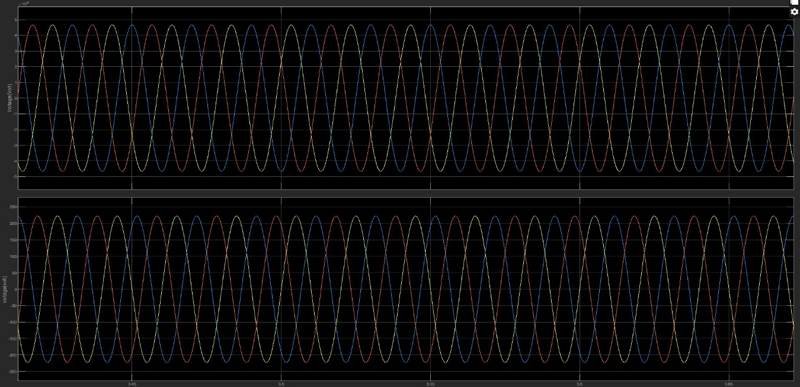
Fig 3. Graph of balanced and stable voltage outputs throughout the micro grid system, reflecting effective power-sharing and synchronization.
4.2. Grid Connected Operation
The waveform of fig 4 represents a graph of the voltage profile of the grid-connected section of the system. Clear, stable sinusoidal waveforms across all phases indicate effective synchronization between the micro grids and the main grid. Genetic algorithm-tuned droop control ensures precise power flow management, while tie-line stabilization prevents oscillatory interactions among interconnected micro grids. These features contribute to enhanced dynamic stability, minimized voltage distortion, and reliable energy exchange, even under varying load or generation conditions.
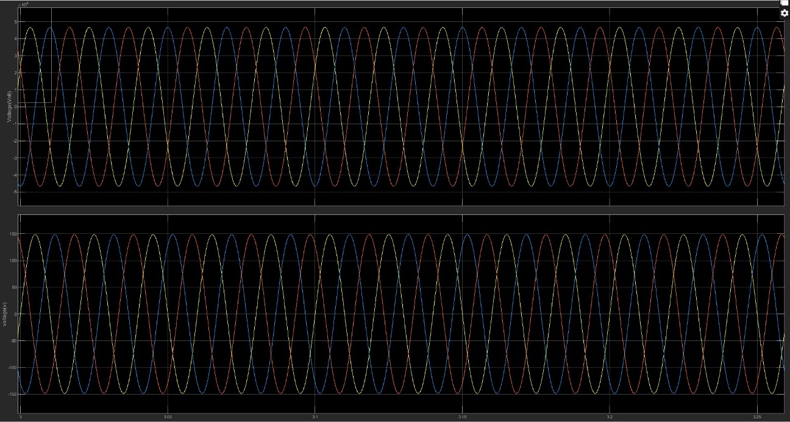

Fig 4. Graph of voltage profile of the grid-connected section of the system.
4.3. Frequency Stability
Frequency in this project refers to the steady and stable oscillation rate of the alternating current within the interconnected solar PV micro grid clusters. Maintaining a consistent frequency is crucial for ensuring synchronous operation between multiple micro grids and the main grid. Fig. 5 shows frequency stability through adaptive droop control, optimized by the genetic algorithm, helps regulate the frequency by adjusting power output in response to load changes, thereby preventing frequency deviations. Tie-line stabilization further supports frequency stability by minimizing power oscillations and disturbances exchanged between the micro grids. Together, these controls maintain a reliable and consistent frequency, which is essential for the dynamic stability and seamless integration of the distributed solar PV energy system.
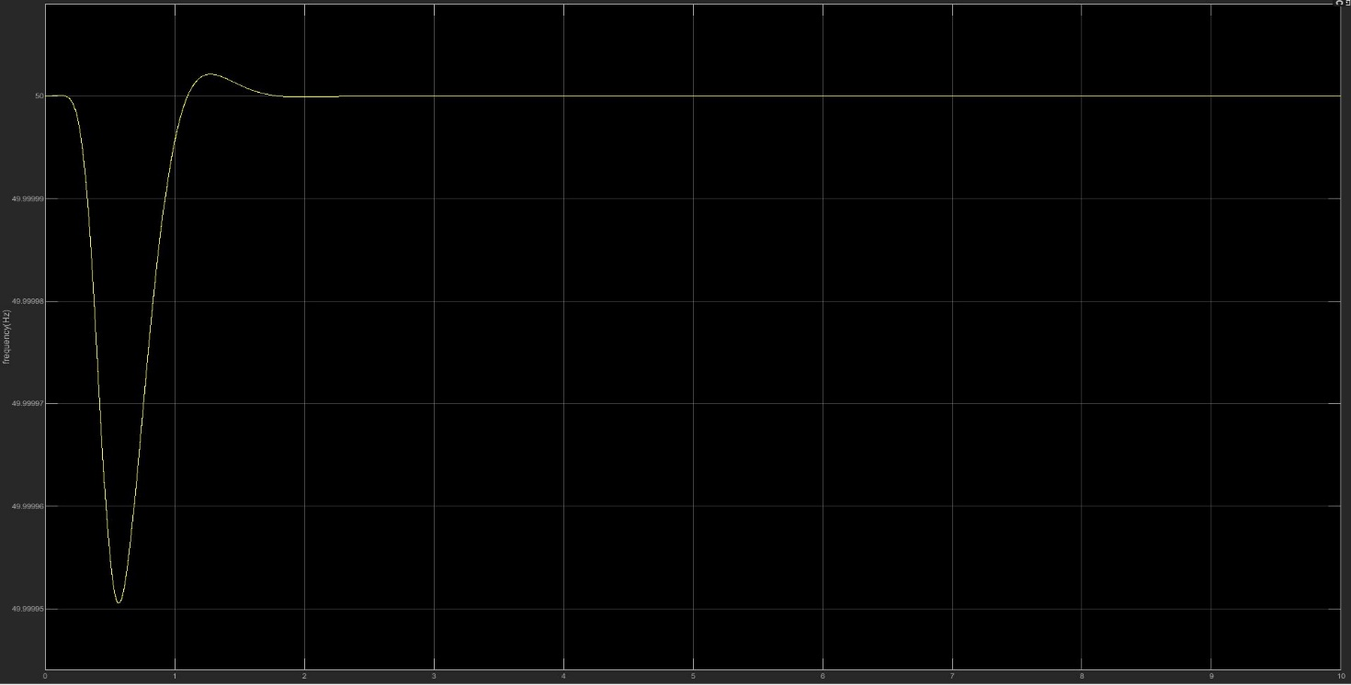
Fig 5. Frequency stability
5. Conclusion
The main concentration of this research paper has been to precisely improve the control and dynamic stability at micro PV grid interconnections clusters with intelligent/ adaptive strategies. It entails constructing and validating 2–3 solar PV micro grids backboned to integrate to model a realistic cluster of large scale distributed energy network. The micro grids are tested over a spectrum of environmental and load conditions to ensure that the proposed control strategies are robust. One of the main part is using droop control in an adaptive manner, which means this type of power control will modulate its response according to the live conditions of the system[9]. In order to improve the performance, Genetic Algorithms (GAs) are used in order refine droop control parameters to enable more dynamic behavior of the system under change and also converge on voltage/frequency stability than conventional methods. The article focuses solely on the use of solar PV systems without tapping in other potential of energy sources such as wind, biomass, or hydro for improvement of system reliability. Future works should prioritize deploying this adaptive control system using embedded controllers or field programmable gate arrays because they are faster and well deterministic in control task in a power system. In addition, more studies may be, in future, performed using hybrid micro grid systems and other artificial intelligent algorithms.
Disclaimer (Artificial intelligence)
Option 1:
Author(s) hereby declare that NO generative AI technologies such as Large Language Models (ChatGPT, COPILOT, etc.) and text-to-image generators have been used during the writing or editing of this manuscript.
Option 2:
Author(s) hereby declare that generative AI technologies such as Large Language Models, etc. have been used during the writing or editing of manuscripts. This explanation will include the name, version, model, and source of the generative AI technology and as well as all input prompts provided to the generative AI technology
Details of the AI usage are given below:
1.
2.
3.

References
([1] K. Hasan, feb,2022)[2] V. H. U. Eze, K. Richard, K. J. Ukagwu, and W. Okafor, “Factors Influencing the Efficiency of Solar Energy Systems,” J. Eng. Technol. Appl. Sci. JETAS, vol. 6, no. 3, pp. 119–131, 2024.
([3] M. M. Hasan et al., 2023)[4] Y. A.-R. I. Mohamed and E. F. El-Saadany, “A control scheme for PWM voltage-source distributed-generation inverters for fast load-voltage regulation and effective mitigation of unbalanced voltage disturbances,” IEEE Trans. Ind. Electron., vol. 55, no. 5, pp. 2072–2084, 2008.
([5] M. N. H. Shazon and A. Jawad, 2022)[6] K. Yu, Q. Ai, S. Wang, J. Ni, and T. Lv, “Analysis and optimization of droop controller for microgrid system based on small-signal dynamic model,” IEEE Trans. Smart Grid, vol. 7, no. 2, pp. 695–705, 2015.
[7] S. Shivashankar, S. Mekhilef, H. Mokhlis, and M. Karimi, “Mitigating methods of power fluctuation of photovoltaic (PV) sources–A review,” Renew. Sustain. Energy Rev., vol. 59, pp. 1170–1184, 2016.
[8] M. M. R. Ahmed et al., “Mitigating uncertainty problems of renewable energy resources through efficient integration of hybrid solar PV/wind systems into power networks,” IEEe Access, vol. 12, pp. 30311–30328, 2024.
[9] T. A. Jumani, M. W. Mustafa, A. S. Alghamdi, M. M. Rasid, A. Alamgir, and ([8] M. M. R. Ahmed et al., 2024)A. B. Awan, “Swarm intelligence-based optimization techniques for dynamic response and power quality enhancement of AC microgrids: A comprehensive review,” IEEE Access, vol. 8, pp. 75986–76001, 2020.
([10] S. Mehta and P. Basak, April 2021)[11] F. Chen, R. Burgos, D. Boroyevich, J. C. Vasquez, and J. M. Guerrero, “Investigation of nonlinear droop control in DC power distribution systems: Load sharing, voltage regulation, efficiency, and stability,” IEEE Trans. Power Electron., vol. 34, no. 10, pp. 9404–9421, 2019.
[12] P. Basak, S. Chowdhury, S. H. nee Dey, and S. P. Chowdhury, “A literature review on integration of distributed energy resources in the perspective of control, protection and stability of microgrid,” Renew. Sustain. Energy Rev., vol. 16, no. 8, pp. 5545–5556, 2012.
([13] A. A. Akhil et al., 2013)[14] J. M. Guerrero, M. Chandorkar, T.-L. Lee, and P. C. Loh, “Advanced control architectures for intelligent microgrids—Part I: Decentralized and hierarchical control,” IEEE Trans. Ind. Electron., vol. 60, no. 4, pp. 1254–1262, 2012.
[15] J. P. Lopes, N. Hatziargyriou, J. Mutale, P. Djapic, and N. Jenkins, “Integrating distributed generation into electric power systems: A review of drivers, challenges and opportunities,” Electr. Power Syst. Res., vol. 77, no. 9, pp. 1189–1203 (Abido, 2002), 2007.
([16] N. Salehi, 2022)[17] E. A. Mahdiraji and N. Ramezani, “Optimal in smart grids considering interruptible loads and photo-voltaic sources using genetic optimization,” Signal Process. Renew. Energy, vol. 4, no. 1, pp. 37–50, 2020.
[18] M. A. Abido, “Optimal design of power-system stabilizers using particle swarm optimization,” IEEE Trans. Energy Convers., vol. 17, no. 3, pp. 406–413, 2002.
[19] N. Salehi, H. Martínez-García, G. Velasco-Quesada, and J. M. Guerrero, “A comprehensive review of control strategies and optimization methods for individual and community microgrids,” IEEE Access, vol. 10, pp. 15935–15955, 2022.
([20] N. G. Bhavani et al., 2022)([21] Z. Liu, 2020)[22] Q. Xu, N. Vafamand, L. Chen, T. Dragičević, L. Xie, and F. Blaabjerg, “Review on advanced control technologies for bidirectional DC/DC converters in DC microgrids,” IEEE J. Emerg. Sel. Top. Power Electron., vol. 9, no. 2, pp. 1205–1221, 2020.
([24] M. Sharma, Nov 2020)[25] L. Kumar, M. K. Kar, and S. Kumar, “Statistical analysis based reactive power optimization using improved differential evolutionary algorithm,” Expert Syst., vol. 40, no. 1, p. e13091, Jan. 2023, doi: 10.1111/exsy.13091.

