Global Talent Mobility Barriers: The Plight of Indian Professionals in International Markets

Abstract:
This study examines at the way increasing international talent mobility regulations affect Indian professionals' career paths and the strategic reactions of multinational corporations. Using a mixed-methods research design, the study evaluates trends in employability, mobility preferences, and retention by combining quantitative analysis of secondary data from government publications, industry reports, and workforce surveys with qualitative insights from scholarly literature. The results show that tighter immigration laws and increased geopolitical protectionism have damaged traditional foreign assignment channels for Indian professionals, decreased international mobility, and increased career insecurity. At the organizational level, these limitations have accelerated a strategic move toward offshore operations, increased reliance on remote and hybrid work models, expansion of Global Capability Centers in India, and increased funding for local recruiting and reskilling programs in host nations. The study emphasizes the need for adaptive mobility frameworks that strike a balance between organizational competitiveness, employee career development, and regulatory compliance, with significant implications for global human resource management. In order to investigate the long-term impacts of virtual mobility, hybrid work arrangements, and changing immigration laws on workforce engagement, retention, and global talent strategies, future research is advised to use longitudinal and primary data methodologies.
Keywords: Talent Mobility, Visa Restrictions, Indian Professionals, Global Employment, Workforce Retention

1. Introduction:
The migration of qualified professionals across borders has long affected the global economy, with Indian expertise making up a significant percentage of the international workforce in a number of industries. India's participation in international labor markets has always been fueled by a paradigm that makes it possible for skilled and reasonably priced professionals to accept overseas assignments in places like North America, Europe, and other developed nations. Temporary migration regimes, such as work visa programs like the H-1B and L-1, which have fostered organizational growth in host countries and helped solve ongoing skill shortages, have played a major role in facilitating this mobility. However, the rising presence of institutional and legal hurdles has limited global mobility, creating significant psychological, economic, and professional obstacles for Indian professionals looking to pursue long-term overseas careers.
This mutually advantageous arrangement has been under increasing pressure in recent years due to the escalation of nationalistic labor regulations and geopolitical protectionism in major host nations. Higher application fees, more stringent eligibility requirements, heightened regulatory scrutiny, and longer processing times are characteristics of revised migration and work visa regimes that are increasingly designed to support domestic worker goals. These developments interrupt long-term career advancement, severely limit Indian professionals' access to abroad assignments, and increase labor and compliance costs for multinational corporations. As a result, talent mobility has changed from being an administrative issue to a strategic challenge that is changing international employment patterns and global workforce planning.
Increasing mobility limits have far-reaching effects that go well beyond short-term organizational or financial concerns. At the individual level, Indian professionals are more likely to face psychological stress from long-term family separation and visa dependency, limited international advancement, and job instability. These limitations are causing a strategic realignment at the organizational and industry level, leading companies to increase offshore operations, fortify Global Capability Centers in India, and make larger investments in local employment and talent development within host nations. Therefore, this study aims to investigate the direct and indirect consequences of tightening global talent mobility regimes on Indian professionals' career paths and the changing competitive strategies of companies that operate in an increasingly regulated global labor market.
1.1 Talent Mobility
Talent mobility refers to the ease with which skilled employees can move across roles, organizations, or international borders to pursue professional growth and contribute to global business operations. The movement of individuals across nations or regions serves as a key channel for the global exchange of knowledge, skills, and technological innovation (Bao, Zhao, Li, & Li, 2023). According to the OECD (2023), around 5.1 million highly skilled professionals relocate each year to work in different countries, with Indian IT specialists forming a significant part of this mobile workforce. Global mobility is growing, in part because a globally mobile talent pool offers more functional flexibility, the chance to train employees, and the ability to share best practices across international business units (Tansley & Kirk, 2017). However, evolving immigration rules, geopolitical tensions, and economic uncertainties have started to restrict such movement, particularly in technology-driven industries. Despite these challenges, the rise of remote work and digital platforms has given new meaning to mobility, allowing professionals to collaborate globally without relocation. This shift highlights a transformation from traditional physical mobility to virtual talent mobility, which is reshaping how organizations access and manage talent across borders.
1.2 Global Employment
Global employment is increasingly influenced by economic integration, technological advancement, and cross-border labor mobility. International commerce has greatly contributed to employment stability, which is essential for maintaining social and economic stability. It is well known that traditional "cross border" trading has become increasingly difficult in recent years due to the slowdown in hyper globalization, which has created an increasingly complex environment (Yue, Hou, Zhang, & Ye, 2024). Global employment strategies contribute to knowledge transfer, leadership development, and the creation of a more adaptable workforce capable of responding to dynamic economic conditions. As a result, countries and companies that invest in developing talent mobility frameworks are better positioned to leverage the benefits of a globally connected labor market. The world has been more globalized over the past 20 years due to the removal of trade barriers, the quick advancement of technology, the decline in the cost of communication and transportation, and the rise in worldwide migration (Mushtaq, Ahmed, Fahlevi, Aljuaid, & Saniuk, 2022). Simultaneously, globalization introduces challenges such as skill mismatches, regulatory complexities, and cultural adaptation issues for both employers and employees. Despite these challenges, global employment strategies contribute to knowledge transfer, leadership development, and the creation of a more adaptable workforce capable of responding to dynamic economic conditions. As a result, countries and companies that invest in developing talent mobility frameworks are better positioned to leverage the benefits of a globally connected labor market.
1.3 Workforce Retention
Employee retention remains a vital priority for organizations aiming to sustain high productivity levels and minimize the expenses associated with staff turnover. Retaining skilled employees not only ensures operational continuity but also fosters organizational knowledge and expertise. Successful employee retention approaches typically involve offering attractive pay packages, providing avenues for career advancement, fostering employee involvement, and promoting a supportive organizational culture. In addition, open communication, acknowledgment of employee achievements, and adaptable work policies have been found to improve job satisfaction and strengthen organizational commitment. Employers must concentrate on talent management techniques in order to keep their best workers. Retaining personnel allows a firm to save money on hiring, as well as time and energy that may be utilized for other critical tasks (Kumar, 2021). Leadership support and mentoring programs also play a key role in retaining talent by providing guidance, growth opportunities, and a sense of belonging. Additionally, organizations that invest in employee well-being, mental health support, and a fair performance management system tend to see higher retention rates. By focusing on these aspects, companies can build a loyal workforce, reduce recruitment costs, and achieve long-term strategic objectives. Retaining employees is crucial for organizational success, along with reducing costs and improving motivation and capabilities. Employee retention has emerged as a significant challenge for the hospitality sector in the 21st century. Retaining talented employees in the hospitality business is a constant challenge due to workforce shifts (Ghani et al., 2022). Employees may exit an organization for multiple reasons, such as seeking higher-paying opportunities elsewhere, experiencing poor relationships with supervisors, pursuing further education or vocational training, relocating due to family circumstances, or facing termination from their current role (Singh, 2019).
Barriers to Sustaining a Committed Workforce:
- Work-life balance has gained growing significance among employees and often impacts their decision to remain with an organization. In the modern workplace, individuals increasingly seek flexible work options that enable them to effectively manage both personal and professional responsibilities (Kossivi, Xu, & Kalgora, 2016).
- Career growth encompasses the progression of an employee’s professional journey, involving their roles, responsibilities, and learning experiences gained through formal and informal means. It includes elements such as professional development, promotions, career aspirations, and remuneration. Implementing a well-defined career development plan serves as an effective strategy for retaining skilled employees and sustaining their motivation (Mazlan & Jambulingam, 2023).
- Compensation is important for employee retention because it motivates and encourages employees to perform well within the organization. Organizations should offer monetary incentives, such as raises and bonuses, for employees who leave for financial reasons, and non-monetary incentives, such as awards and benefits (Mahadi, Woo, Baskaran, & Yaakop, 2020).
- Organization should work to enhance their strategies, such as eliminating favoritism and nepotism and appreciating employees as valuable assets of the business. Their dedication and loyalty to the company improve with the amount of recognition they receive (Ramachandran & Prasad, 2022).
- Employees may look for job security elsewhere if they are afraid that automation will replace their current position. In light of automation, businesses must offer training and stress the importance of human abilities (CultureMonkey, 2024).
- An unpleasant workplace culture can seriously impair employee retention because it frequently fosters an atmosphere in which rivalry becomes unhealthy, communication is poor, and appreciation is limited. Assess the culture of your company on a regular basis to find areas for improvement and misalignments (SmallBizTrends, 2024).

1.4 Visa Restrictions and Their Impact on Talent Mobility
Visa restrictions have emerged as a significant barrier to global talent mobility, particularly affecting multinational organizations that rely on cross-border workforce movement. Tightened immigration policies, increased visa fees, and complex regulatory procedures often limit the ability of companies to transfer skilled employees across international locations. However, there is a misperception that professionals and skilled workers find it simpler to obtain positions abroad and have their visas processed than other groups. Notwithstanding valid reasons, incumbents from the Global South encounter disproportionate obstacles while trying to secure visa permits, irrespective of their skill level and in spite of widespread dissent (Ullah, Chattoraj, & Kathy, 2024). Visa policies primarily restrict and govern cross-border mobility. Nevertheless, visa limitations impose significant costs owing to administrative procedures and staffing requirements. Furthermore, they may impede and dissuade the type of mobility that governments need for economic purposes (Mau, Gülzau, Laube, & Zaun, 2015). Strict quotas, long processing times, and difficult application procedures might discourage skilled individuals from seeking jobs abroad, leaving firms unable to locate the talent they require (Star Mountain Resources, n.d.). Immigration is more than just movement; it is also about money. Global talent mobility boosts economies, drives innovation, and closes gaps in critical industries. Restrictive rules can stifle growth, whereas flexible systems unleash potential (Jade Times, 2023).
2. Literature Review
- S. Mau, F. Gülzau, L. Laube, and N. Zaun (2015): This study analyzes the evolution of visa policies to reveal a persistent global mobility divide shaped by political and economic inequalities. Their study demonstrates that visa regulations increasingly favor citizens of wealthier nations, granting them broader travel freedom, while individuals from developing countries face growing restrictions. This imbalance highlights how state policies institutionalize inequality in cross-border mobility, reinforcing existing global hierarchies, and limiting equitable access to international opportunities.
- B. Kossivi, M. Xu, and B. Kalgora (2016): This study examines the primary determinants of employee retention, with a particular focus on the roles of job satisfaction, workplace conditions, and organizational culture. The study finds that supportive management, competitive compensation, and career development opportunities are critical in retaining employees. Additionally, the research highlights that understanding employee needs and aligning them with organizational goals significantly reduces turnover and strengthens workforce stability.
- Tansley, C., & Kirk, S. (2017): This study explored how talent mobility is conceptualized and managed within emerging markets. Their study revealed that framing mobility as both a strategic and developmental tool enables organizations to better utilize global talent pools. The authors emphasized that effective mobility programs foster leadership growth, cross-cultural learning, and organizational adaptability in competitive international environments.
- Singh, D. (2019): This study reviews recent trends in employee retention, emphasizing the growing importance of organizational culture, career development, and recognition programs. The study highlights that companies adopting proactive retention strategies experience higher employee satisfaction and lower turnover rates. Furthermore, Singh notes that understanding employee needs and aligning them with organizational goals is critical for sustaining a committed and productive workforce.
- N. Mahadi, N. Woo, S. Baskaran, and A. Yaakop (2020): This study identifies the main factors affecting employee retention, emphasizing the significance of job satisfaction, organizational loyalty, and a supportive workplace atmosphere. Their study finds that competitive compensation, career development opportunities, and positive management-employee relationships significantly affect employees’ decisions to stay. The study emphasizes that recognizing these elements enables organizations to design effective retention initiatives, minimize employee turnover, and sustain a consistent and efficient workforce.
- Kumar, S. (2021): This research analyzes the impact of talent management initiatives on employee retention and turnover intentions. The findings suggest that companies adopt well-organized talent management frameworks—encompassing career advancement opportunities, performance evaluations, and training initiatives—tend to experience reduced employee turnover. Effective talent management not only enhances employee commitment but also strengthens organizational stability and performance. The research highlights that proactive investment in human capital is key to retaining skilled employees in competitive business environments.
- M. Mushtaq, S. Ahmed, M. Fahlevi, M. Aljuaid, and S. Saniuk (2022): This research explores how globalization influences employment, emphasizing the essential contribution of human capital in this relationship. Their study indicates that countries with higher levels of skilled labor experience stronger positive effects of globalization on job creation. The findings suggest that investment in human capital can enhance the benefits of global economic integration while mitigating potential employment vulnerabilities.
- B. Ghani, M. Zada, K. Memon, R. Ullah, A. Khattak, H. Han, A. Ariza-Montes, and L. Araya-Castillo (2022): This study conducted research examining the key difficulties and effective approaches related to employee retention within the hospitality sector. Their review identifies high turnover rates, job stress, and limited career growth as major retention challenges. The research emphasizes that offering attractive pay structures, opportunities for career growth, and a positive organizational climate can greatly enhance employee commitment and retention. These strategies are essential for enhancing workforce stability and sustaining organizational performance in a highly competitive sector.
- Ramachandran, A., & Prasad, C. (2022): This research investigates the determinants of employee retention, stressing the crucial roles of job satisfaction, organizational culture, and supportive leadership. The findings indicate that employees tend to stay longer with organizations that offer career advancement prospects, acknowledge their contributions, and foster a constructive workplace atmosphere. The authors conclude that a strategic focus on employee engagement and well-being is essential for reducing turnover and enhancing organizational performance.
- C. Bao, X. Zhao, Y. Li, and Z. Li (2023): This study highlighted that talent mobility significantly enhances sustainable research productivity by promoting knowledge exchange and innovation. The study found that institutions encouraging cross-border collaboration and flexible work environments achieve higher research performance. Conversely, restrictive mobility policies hinder creativity and long-term competitiveness, emphasizing the need for sustainable HR frameworks that support global talent flow.
- Mazlan, M., & Jambulingam, M. (2023): This research analyzes the major obstacles to retaining talent, emphasizing issues like elevated turnover levels, limited skill availability, and evolving employee expectations. The study emphasizes that inadequate career growth, lack of recognition, and uncompetitive compensation are major contributors to workforce attrition. Furthermore, the authors note that organizations must adopt strategic retention initiatives, including employee engagement programs, professional development, and supportive leadership, to sustain a committed and productive workforce.
- Y. Yue, J. Hou, M. Zhang, and J. Ye (2024): This study examines how stable relationships within global value chains influence employment in China. Their study finds that firms embedded in long-term supply chain networks are better able to maintain workforce stability, even during economic fluctuations. This research highlights the role of interconnected global production networks in mitigating job volatility and supporting labor market resilience.
- Ullah, A., Chattoraj, D., & Kathy, A. (2024): This study explores how global mobility is shaped by the regulatory frameworks surrounding passports and visas. Their study emphasizes that visa policies act as instruments of control, influencing who can move, where, and under what conditions. The authors argue that restrictive visa regimes often create inequalities in mobility, favoring individuals from economically stronger nations while limiting opportunities for those from developing countries. This perspective highlights the complex relationship between state sovereignty, globalization, and the free movement of skilled labor, offering valuable insights for understanding barriers to international talent mobility.
2.1 Research Gap
This research employs a mixed-methods design, integrating both quantitative and qualitative techniques to achieve a comprehensive understanding of talent mobility. While data confirms a significant upskilling of Indian graduates, particularly in B.E/B.Tech and MBA domains, the current literature fails to explore if this enhanced local talent pool effectively mitigates the disruption to the on-site service delivery model caused by stricter work visa policies in host countries like the United States. Furthermore, as the overall willingness for international relocation declines and visa uncertainty increases for Indian IT professionals, there is a distinct need for research into the effectiveness of retention strategies. Current studies only offer general retention advice, missing an analysis of how multinational firms can successfully integrate new virtual collaboration and hybrid work models into their HR frameworks to foster career growth and engagement for skilled workers who are now restricted from traditional global assignment pathways.
2.2 Research Objective
- To evaluate the direct financial and operational impact of new visa restrictions.
- To determine how the strategic adoption of hybrid and virtual work models influences career satisfaction and retention.
3. Research Methodology
This study adopts a mixed-methods approach, combining quantitative and qualitative research to gain a thorough understanding of talent mobility. The quantitative analysis examines factors such as employee turnover rates, internal transfers, and workforce demographics, using secondary data from organizational reports, government publications, and industry surveys. Qualitative insights were drawn from academic journals, books, and periodicals to explore practices, challenges, and strategies related to talent mobility, including financial impacts on IT companies due to higher visa fees and the relationship between employee satisfaction and emerging remote work models. Purposive sampling was employed to select relevant sources, ensuring that only credible and pertinent data were included for analysis. This approach allowed the researcher to concentrate on sources most relevant for generating valuable insights related to the study’s research questions. Integrating both data types allows for a comprehensive assessment of patterns, trends, and underlying factors influencing employee movement. All data sources were carefully selected for credibility, relevance, and validity to ensure robust and reliable analysis.
3.1 Data Analysis and result
Table 1: Employability Rate (2019–2025)
Year | Employability (%)
2019 | 47.28
2020 | 46.21
2021 | 45.9
2022 | 46.2
2023 | 50.3
2024 | 51.25
2025 | 54.81

Source:https://wheebox.com/blog/India-Skills-Report-2025-Enabling-Global-Talent-Mobility.htm
Fig 1: Graph of Employability Rate (2019–2025)
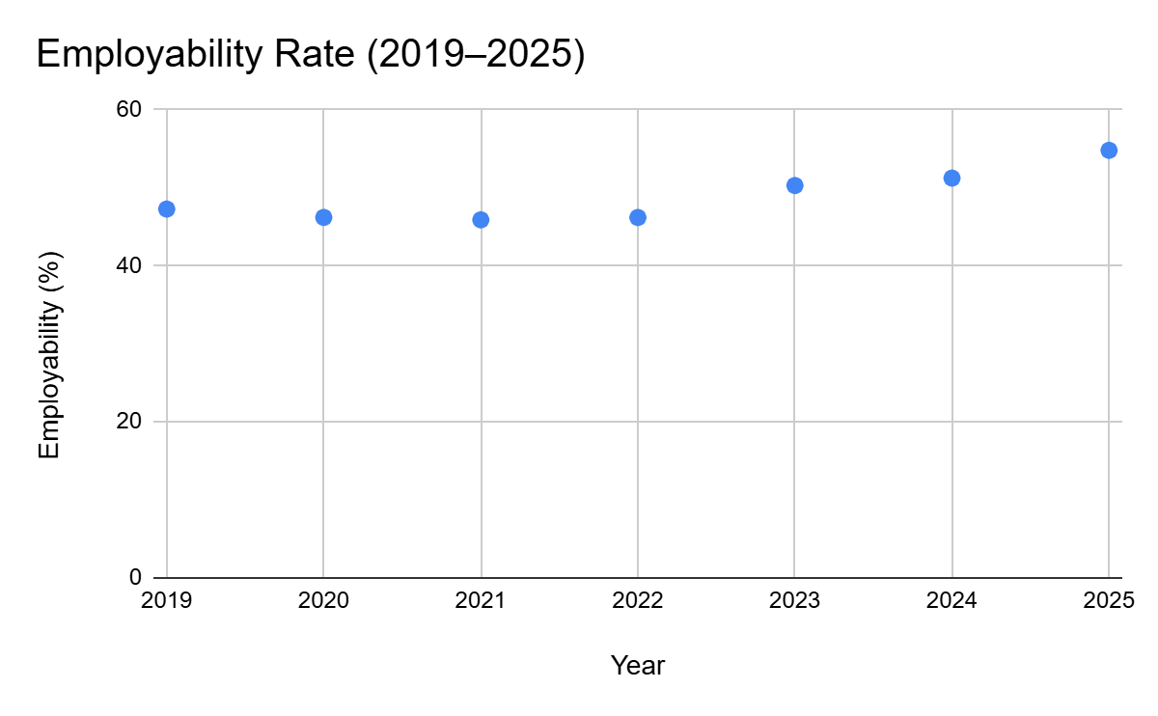
Source: Compiled by the researcher

Table 2: Employability by Domain (2019–2025)
Domain | 2019 | 2020 | 2021 | 2022 | 2023 | 2024 | 2025
B.E/B.Tech | 57.09 | 49 | 46.82 | 55.15 | 57.44 | 64.67 | 71.5
MBA | 36.44 | 54 | 46.59 | 55.09 | 60.1 | 71.16 | 78
B.Arts | 29.3 | 48 | 42.72 | 44.2 | 49.2 | 47.11 | 54
B.Com | 30.06 | 47 | 40.3 | 42.62 | 60.62 | 48.12 | 55
B.Sc | 47.37 | 34 | 30.34 | 38.06 | 37.69 | 51.27 | 58
MCA | 43.1 | 25 | 22.42 | 29.3 | 30.64 | 64.63 | 71
ITI | NA | NA | NA | 31.3 | 34.2 | 40 | 41
Polytechnic | 18.05 | 32 | 25 | 21.42 | 27.61 | 22.37 | 29
B.Pharma | 36.29 | 45 | 37.24 | 44.63 | 57.51 | 54 | 56

Source:https://wheebox.com/blog/India-Skills-Report-2025-Enabling-Global-Talent-Mobility.htm

Fig 2: Graph of Employability by Domain (2019–2025)

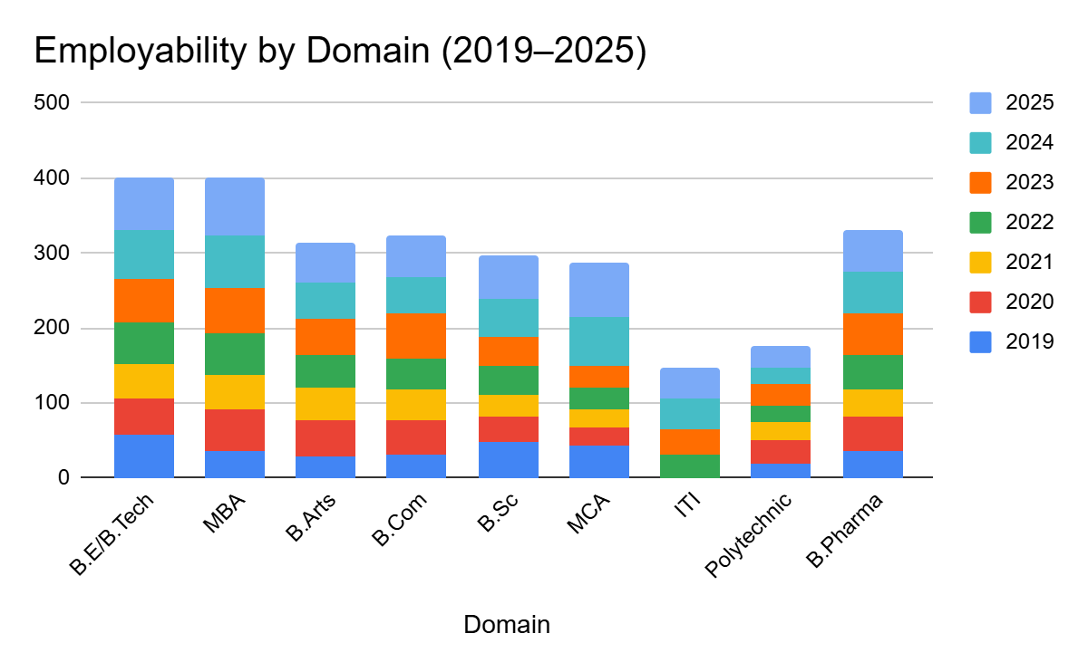
Source: Compiled by the researcher
The employability trend from 2019 to 2025 shows a steady upward movement, indicating consistent improvement in workforce readiness. Employability increased from 47.28% in 2019 to 54.81% in 2025, suggesting that educational institutions and industries have been aligning better with job market requirements.
Across different domains, employability levels vary significantly. MBA and B.E/B.Tech graduates show the highest employability growth, reaching 78% and 71.5% respectively in 2025, reflecting stronger industry integration and skill-based learning. In contrast, Polytechnic and ITI graduates display lower employability rates, highlighting the need for enhanced vocational training and updated curricula. Overall, the data signifies a positive trend toward skill development, though disparities between academic streams persist.
Table 3: Global Workforce Mobility Trends (2018–2023)
Year | Actively Mobile (%) | Passively Mobile (%) | Mobile as a Last Resort (%) | Overall Willingness to Move  Abroad (%)
2018 | 21 | 33 | 25 | 78
2020 | 21 | 24 | 21 | 66
2023 | 23 | 21 | 19 | 63
Source:https://people-mobility.org/global-talent-mobility-trends-key-insights-from-the-decoding-global-talent-2024-report/
Fig 3: Global Workforce Mobility Trends (2018–2023)
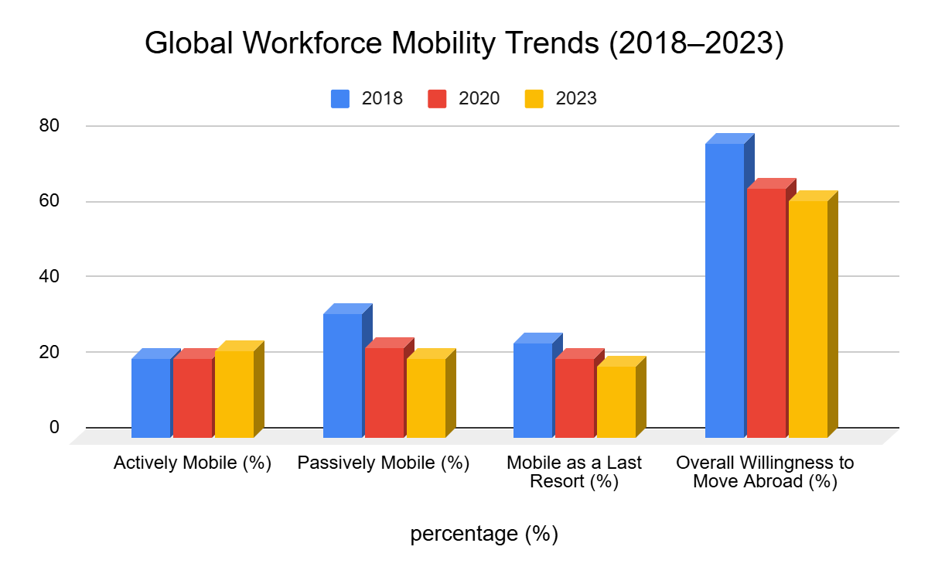
Source: Compiled by the researcher
The data shows a steady decline in the overall willingness of respondents to move abroad for work, dropping from 78% in 2018 to 63% in 2023. While the share of actively mobile workers remained relatively stable, the proportion of those willing to relocate only as a last resort decreased over the years. This suggests that fewer employees are now motivated to seek international opportunities, possibly due to improved local employment options or post-pandemic shifts in work preferences. The findings indicate a growing inclination toward stability and remote work rather than global mobility.
4. Discussion of Findings
The results of this research highlight the essential influence of talent mobility on employee experiences as well as overall organizational performance. Quantitative data indicate that companies with limited internal mobility and unclear career progression pathways experience higher employee turnover and reduced workforce stability. In contrast, organizations implementing structured mobility programs—such as internal transfers, cross-functional rotations, and international assignments—demonstrate improved retention, greater employee satisfaction, and enhanced talent utilization. Qualitative insights reveal that external factors, including increased visa fees for international mobility, the rise of remote work models, and evolving employee expectations, significantly influence mobility decisions and workforce engagement. Additionally, employees perceive organizations that invest in skill development, mentoring, and career planning as more supportive, which strengthens loyalty and organizational commitment. The analysis also suggests that talent mobility facilitates knowledge sharing across departments and geographies, fostering innovation and organizational agility. Overall, these findings indicate that strategically managed talent mobility is not only a tool for operational efficiency but also a key driver of employee engagement, organizational performance, and sustainable competitive advantage.
5. Conclusion
This research emphasizes the strategic significance of talent mobility within contemporary organizations, especially amid increasing globalization and shifting employee expectations. The findings suggest that structured mobility programs—including internal transfers, cross-functional rotations, and international assignments—play a crucial role in enhancing employee satisfaction, reducing attrition, and optimizing workforce productivity. Quantitative data indicate that organizations with well-defined mobility strategies experience lower turnover rates and improved retention of high-performing employees. Qualitative insights further reveal that factors such as remote work models, rising visa costs, and career development opportunities significantly influence employee decisions to remain with or leave an organization. Moreover, talent mobility fosters knowledge sharing, skill development, and organizational agility, enabling companies to respond effectively to changing business environments. Overall, the study concludes that strategically managed talent mobility is not merely a human resource tool but a vital driver of organizational growth, innovation, and long-term competitiveness. Organizations that prioritize mobility, align it with employee aspirations, and address external constraints are better positioned to sustain a motivated, skilled, and resilient workforce.
6. Suggestions
Building on the outcomes of this research, several directions for future investigation can be identified. To begin with, longitudinal research could be undertaken to assess the long-term impact of talent mobility initiatives on employee retention, career development, and organizational effectiveness. Additionally, future studies may examine how emerging technologies—such as artificial intelligence and HR analytics—can strengthen talent mobility practices and forecast patterns of employee movement. Furthermore, comparative research across various sectors or geographical regions could offer a deeper understanding of how cultural, economic, and regulatory dynamics shape talent mobility trends. Fourth, primary data collection through employee surveys and interviews could complement secondary analyses, offering more nuanced perspectives on motivations, challenges, and experiences related to mobility. Lastly, future research could explore how hybrid and remote work arrangements affect both internal and global talent mobility, especially in the post-pandemic era, to better understand changing employee expectations and organizational approaches.
Disclaimer (Artificial intelligence)
Option 1:
Author(s) hereby declare that NO generative AI technologies such as Large Language Models (ChatGPT, COPILOT, etc.) and text-to-image generators have been used during the writing or editing of this manuscript.
Option 2:
Author(s) hereby declare that generative AI technologies such as Large Language Models, etc. have been used during the writing or editing of manuscripts. This explanation will include the name, version, model, and source of the generative AI technology and as well as all input prompts provided to the generative AI technology
Details of the AI usage are given below:
1.
2.
3.

7. References
- Bao, C., Zhao, X., Li, Y., & Li, Z. (2023). How to Maintain Sustainable Research Productivity: From Talents Mobility Perspective. Sustainability. https://doi.org/10.3390/su151511506.
- Tansley, C., & Kirk, S. (2017). You've Been Framed—Framing Talent Mobility in Emerging Markets. Thunderbird International Business Review, 60, 39-51. https://doi.org/10.1002/TIE.21887.
- Yue, Y., Hou, J., Zhang, M., & Ye, J. (2024). Does the sticky relationships of global value chains help stabilize employment? Evidence from China. Structural Change and Economic Dynamics. https://doi.org/10.1016/j.strueco.2024.04.006.
- Mushtaq, M., Ahmed, S., Fahlevi, M., Aljuaid, M., & Saniuk, S. (2022). Globalization and employment nexus: Moderating role of human capital. PLoS ONE, 17. https://doi.org/10.1371/journal.pone.0276431.
- Kumar, S. (2021). The impact of talent management practices on employee turnover and retention intentions. Global Business and Organizational Excellence. https://doi.org/10.1002/JOE.22130.
- Ghani, B., Zada, M., Memon, K., Ullah, R., Khattak, A., Han, H., Ariza-Montes, A., & Araya-Castillo, L. (2022). Challenges and Strategies for Employee Retention in the Hospitality Industry: A Review. Sustainability. https://doi.org/10.3390/su14052885.
- Singh, D. (2019). A Literature Review on Employee Retention with Focus on Recent Trends. International Journal of Scientific Research in Science, Engineering and Technology 6(1). https://doi.org/10.32628/IJSRST195463.
- Kossivi, B., Xu, M., & Kalgora, B. (2016). A STUDY ON DETERMINING FACTORS EMPLOYEE RETENTION. International Research Journal of Modernization in Engineering Technology and Science. https://doi.org/10.4236/JSS.2016.45029.
- Mazlan, M., & Jambulingam, M. (2023). Challenges of Talent Retention: A Review of Literature. Journal of Business and Management Review. https://doi.org/10.47153/jbmr42.6302023.
- Mahadi, N., Woo, N., Baskaran, S., & Yaakop, A. (2020). Determinant Factors for Employee Retention: Should I Stay?. International Journal of Academic Research in Business and Social Sciences. https://doi.org/10.6007/ijarbss/v10-i4/7120.
- Ramachandran, A., & Prasad, C. (2022). Factors associated with employee retention. International Journal of Research in Human Resource Management. https://doi.org/10.33545/26633213.2022.v4.i2a.109.
- Ullah, A., Chattoraj, D., & Kathy, A. (2024). Mobility in a globalised world: How countries regulate mobility with passports and visas. Journal of Public Affairs. https://doi.org/10.1002/pa.2932.
- Mau, S., Gülzau, F., Laube, L., & Zaun, N. (2015). The Global Mobility Divide: How Visa Policies Have Evolved over Time. Journal of Ethnic and Migration Studies, 41, 1192 - 1213. https://doi.org/10.1080/1369183X.2015.1005007.
- https://www.culturemonkey.io/employee-engagement/employee-retention challenges/#15-employee-turnover-challenges-examples
- https://smallbiztrends.com/employee-retention-challenges/
- https://starmountainresources.com/work-visa-limits-a-global-talent-squeeze/
- https://www.jadetimes.com/post/the-impact-of-immigration-policies-on-global-talent-mobility
- https://wheebox.com/blog/India-Skills-Report-2025-Enabling-Global-Talent-Mobility.htm
- https://people-mobility.org/global-talent-mobility-trends-key-insights-from-the-decoding-global-talent-2024-report/

