Long-Term Rainfall Variability and Seasonal Distribution at AMFU, Naganahalli, Mysuru, India: Evidence from 58 Years of Observational Data (1968–2025)

Abstract
Aims:
The present study aimed to analyze long-term rainfall variability and seasonal distribution in the semi-arid region of southern Karnataka, with a focus on understanding its implications for agricultural planning and climate-resilient farming strategies in the Mysuru region.
Study Design:
A retrospective time-series analytical study based on long-term observed rainfall data.
Place and Duration of Study:
The study was conducted using rainfall data recorded at the Weather Observatory of the Agro-Meteorological Field Unit (AMFU), Organic Farming Research Station (OFRS), Naganahalli, Mysuru, under the Gramin Krishi Mausam Sewa programme, covering a period of 58 years from 1968 to 2025.
Methodology:
Monthly and annual rainfall data were subjected to descriptive statistical analysis to evaluate temporal variability, inter-annual fluctuations, seasonal contributions, and extreme rainfall years. Seasonal rainfall distribution was assessed for southwest monsoon, northeast monsoon, summer, and winter periods. Long-term rainfall trends were analyzed using the non-parametric Mann–Kendall test and Sen’s slope estimator.
Results:
The mean annual rainfall of the study area was 693.2 mm, with a high coefficient of variation (>30%), indicating substantial inter-annual variability. Annual rainfall ranged from severe deficit years (<300 mm) to extreme excess years (>1300 mm). The southwest monsoon season (June–September) contributed the largest share of annual rainfall, followed by the northeast monsoon season (October–November), confirming a bimodal rainfall pattern. October recorded the highest mean monthly rainfall, underscoring its importance for kharif crop maturity and rabi crop sowing. Trend analysis revealed a weak, non-significant increasing tendency in annual rainfall, suggesting that variability rather than long-term change dominates rainfall behavior in the region.
Conclusion:
The pronounced rainfall variability and frequent extremes pose significant challenges to rainfed agriculture in the Mysuru region. The long-term rainfall characterization provides a robust baseline for climate-resilient agricultural planning, water resource management, and future agro-climatic research.

Keywords: Long-term rainfall analysis; Rainfall variability; Seasonal rainfall distribution; AMFU Naganahalli; Mysuru climate; Agro-meteorology; Rainfed agriculture; Climate variability

1. Introduction
Rainfall is one of the most important climatic elements influencing agricultural production, water resources, and socio-economic stability, particularly in rain-fed regions of India. Nearly 60 per cent of India’s net sown area depends directly on rainfall, making the assessment of rainfall variability essential for sustainable agricultural planning (Gadgil and Gadgil, 2006). Variations in rainfall amount, distribution, and intensity significantly affect crop growth, soil moisture availability, groundwater recharge, and the occurrence of droughts and floods (Parthasarathy et al., 1994).The Indian climate is predominantly governed by the southwest monsoon, which contributes about 70–80 per cent of the annual rainfall during the period from June to September (Rao et al., 2011). However, studies have shown that monsoon rainfall exhibits high inter-annual and inter-decadal variability, resulting in frequent agricultural uncertainties (Kothawale and Rupa Kumar, 2005). Long-term analysis of rainfall records is therefore critical to understanding climatic fluctuations and developing location-specific adaptation strategies (Guhathakurta et al., 2011).
Several researchers have documented spatial and temporal variations in rainfall across India using long-term datasets. Parthasarathy et al. (1987) reported significant regional differences in rainfall trends across India, emphasizing the need for station-level analysis. Similarly, Krishnakumar et al. (2009) observed changes in monsoon rainfall patterns over southern India, with increased variability affecting agricultural productivity. Such regional-scale assessments often mask micro-level variations, which are crucial for farm-level decision-making.
Karnataka, located in the southern peninsular region of India, experiences a semi-arid to sub-humid climate with considerable rainfall variability. The state receives rainfall from both southwest and northeast monsoons, with spatially uneven distribution (Rajeevan et al., 2012). Studies conducted in different parts of Karnataka have revealed high temporal variability in rainfall and frequent departures from normal rainfall, leading to droughts or excess rainfall events (Nanjundiah et al., 2017).District-level studies in southern Karnataka have highlighted that rainfall variability significantly influences crop planning, sowing windows, and irrigation scheduling (Sikka and Gadgil, 1980). Research by Patil et al. (2014) showed that Mysuru district exhibits pronounced inter-annual rainfall variability, particularly during the monsoon season, affecting rain-fed crops such as finger millet, maize, and pulses. Such variability necessitates the development of localized agrometeorological advisories.Agro-meteorological observatories play a crucial role in generating long-term climatic datasets required for assessing climate variability and supporting agricultural decision-making (Dash et al., 2013). The Agro-Meteorological Field Unit (AMFU) at the Organic Farming Research Station (OFRS), Naganahalli, Mysuru, has been recording rainfall data for several decades, providing a valuable source of continuous and reliable climatic information. Long-term station-based datasets are particularly useful for identifying rainfall trends, seasonal shifts, and extreme events at the local scale (Mishra et al., 2014).
Despite the availability of national and regional rainfall analyses, comprehensive long-term studies focusing on specific agro-ecological locations like Naganahalli, Mysuru, using more than five decades of observed data remain limited. Therefore, the present study aims to analyze 58 years (1968–2025) of rainfall data recorded at AMFU, OFRS, Naganahalli, Mysuru, to assess rainfall variability, seasonal distribution, and long-term characteristics. The findings of this study are expected to support climate-resilient agricultural planning, rainwater management, and the formulation of effective agrometeorological advisories for farmers in the region.
The objectives of the present investigation are:
- To analyze the long-term annual and monthly rainfall variability at AMFU, OFRS, Naganahalli, Mysuru, using 58 years of observed data (1968–2025).
- To assess the seasonal contribution of rainfall during southwest and northeast monsoon periods to the total annual rainfall.
- To examine inter-annual fluctuations and deviations from long-term mean rainfall.
- To generate location-specific rainfall information useful for agricultural planning, rainwater harvesting, and agrometeorological advisory services.

2. Materials and Methods

2.1 Study Area
The present study was conducted using rainfall data recorded at the Agro-Meteorological Field Unit (AMFU) located at the Organic Farming Research Station (OFRS), Naganahalli, Mysuru district, Karnataka, India (12° 22′ N latitude and 76° 42′ E longitude). The station lies in the Southern Dry Zone of Karnataka and represents a semi-arid to sub-humid agro-climatic region. Agriculture in this region is predominantly rain-fed, with major crops including finger millet, maize, pulses, oilseeds, and horticultural crops, making rainfall a critical determinant of crop productivity and sustainability.
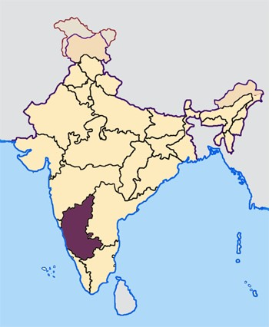
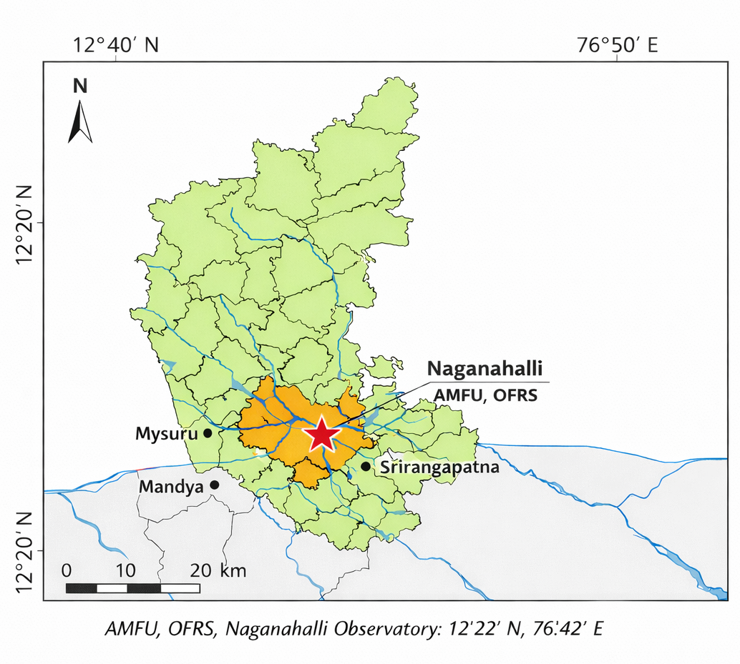
The region experiences a distinctly bimodal rainfall pattern, receiving precipitation mainly from the southwest monsoon (June–September) and the northeast monsoon (October–November), with occasional pre-monsoon showers during April and May. Such climatic characteristics, combined with high rainfall variability, necessitate long-term rainfall assessment to understand temporal variability, seasonal distribution, and their implications for agricultural planning and climate resilience (Sikka & Gadgil, 1980; Rajeevan et al., 2012).
Map 1. The study area of Agro-Meteorological Field Unit (AMFU) located at the Organic Farming Research Station (OFRS), Naganahalli

2.2 Data Source and Description
The rainfall data used in this study consist of 58 years of monthly rainfall records (1968–2025) obtained from the Agro-Meteorological Field Unit (AMFU), OFRS, Naganahalli, Mysuru, operating under the Gramin Krishi Mausam Sewa (GKMS) programme of the India Meteorological Department (IMD). The dataset represents continuous observational records maintained following standard meteorological procedures and quality control protocols recommended by IMD (Rao et al., 2011).Monthly rainfall values were aggregated to compute annual rainfall totals and seasonal rainfall for different monsoon periods. Long-term mean rainfall was calculated using the entire study period to serve as a baseline for variability assessment (Parthasarathy et al., 1987).

2.3 Seasonal Classification of Rainfall
For the purpose of seasonal analysis, the annual rainfall was classified into four distinct seasons, following standard IMD classification (IMD, 2010):
- Winter season: January–February
- Pre-monsoon season: March–May
- Southwest monsoon season: June–September
- Northeast monsoon season: October–December
Seasonal rainfall totals were computed by summing monthly rainfall values corresponding to each season. The percentage contribution of each season to total annual rainfall was also calculated to understand seasonal dominance and agricultural relevance (Parthasarathy et al., 1994).

2.4 Statistical Analysis
Descriptive statistical methods were employed to analyze rainfall characteristics at monthly, seasonal, and annual scales. The following statistical parameters were computed:
- Mean rainfall (mm)
- Standard deviation (SD)
- Coefficient of variation (CV, %)
The coefficient of variation was used as an indicator of rainfall variability, with higher CV values indicating greater rainfall uncertainty and risk for rain-fed agriculture (Kothawale and Rupa Kumar, 2005).Inter-annual rainfall variability was assessed by comparing annual rainfall values against the long-term mean. Years were categorized as deficit, normal, or excess rainfall years based on percentage deviation from the mean, following commonly adopted climatological classification methods (Guhathakurta et al., 2011).

2.5 Trend Analysis
To examine long-term trends in annual and seasonal rainfall, non-parametric trend detection techniques were considered appropriate due to their robustness against non-normal data distribution and outliers. The Mann–Kendall (MK) test was used to detect the presence of monotonic trends in rainfall time series (Mann, 1945; Kendall, 1975). The magnitude of trend was estimated using Sen’s slope estimator, which provides a reliable estimate of trend magnitude in hydro-meteorological time series (Sen, 1968).These methods have been widely applied in rainfall trend studies across India and are recommended for long-term climatic data analysis (Krishnakumar et al., 2009; Mishra et al., 2014).

2.6 Data Analysis and Presentation
All computations were performed using standard spreadsheet tools and statistical software. Results were presented in the form of tables, line graphs, bar charts, and seasonal contribution diagrams to clearly illustrate rainfall variability, trends, and seasonal distribution. Graphical representation was used to enhance interpretation and facilitate comparison across years and seasons (Dash et al., 2013).

3. Results and Discussion

3.1 Long-Term Annual Rainfall Characteristics
Long-term analysis of annual rainfall at AMFU, OFRS, Naganahalli, Mysuru over 58 years (1968–2025) revealed marked inter-annual variability (Table 1). The mean annual rainfall was 693 mm, confirming the semi-arid climatic nature of the region, while the wide range of values indicates an unstable rainfall regime influencing agricultural activities.
Annual rainfall ranged from a minimum of 244 mm in 2016, representing a severe drought year, to a maximum of 1381 mm in 2022, indicating an extreme excess rainfall year. Such large fluctuations reflect dominant climatic variability rather than stability, consistent with earlier studies across southern India (Parthasarathy et al., 1987; Krishnakumar et al., 2009).
The coefficient of variation exceeded 30 per cent (Table 1), signifying high rainfall variability and unreliable conditions for stable crop production (Kothawale & Rupa Kumar, 2005). High variability increases uncertainty in sowing, crop failures during deficit years, and risks of waterlogging and nutrient losses during excess rainfall years (Gadgil & Gadgil, 2006).
Table 1. Descriptive statistics of annual rainfall at AMFU, OFRS, Naganahalli, Mysuru (1968–2025)
Particular | Annual rainfall (mm)
Number of years | 58
Mean | 693.16
Standard deviation | 203.89
Minimum | 244.30
Maximum | 1381.00
25th percentile | 570.28
Median | 666.25
75th percentile | 795.10
Figure 1 illustrates the temporal variation in annual rainfall, showing frequent oscillations between deficit and excess years with no sustained long-term trend. The lack of a consistent increasing or decreasing pattern aligns with findings from other studies in southern India (Krishnakumar et al., 2009; Rajeevan et al., 2012). However, the increased occurrence of extreme rainfall years in recent decades may indicate enhanced variability linked to climate change (Guhathakurta et al., 2011; Jamshadali et al., 2021).
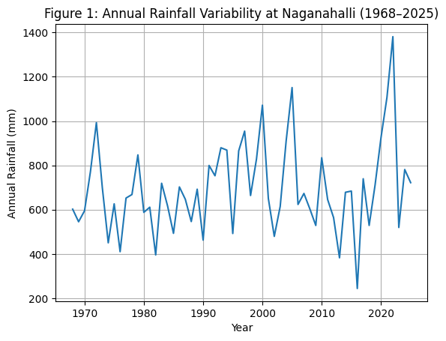
Such pronounced variability has significant implications for rain-fed crops like finger millet, maize, and pulses, which are sensitive to rainfall anomalies during critical growth stages. These findings highlight the need for location-specific rainfall characterization to support agrometeorological advisories, crop planning, and water resource management (Patil et al., 2014; Nanjundiah et al., 2017).
Figure 1: Annual Rainfall Variability at Naganahalli, Mysuru (1968–2025)

3.2 Seasonal Rainfall Distribution and Contribution
Seasonal analysis of rainfall at Naganahalli revealed a distinctly bimodal distribution (Table 2), governed by the southwest and northeast monsoon systems. The southwest monsoon season (June–September) contributed the largest share of annual rainfall (286.9 mm), accounting for nearly 48 per cent of the total. This confirms that kharif agriculture in the region is primarily dependent on southwest monsoon rainfall.
Table 2. Mean seasonal rainfall at AMFU, OFRS, Naganahalli, Mysuru (1968–2025)
Season | Months | Mean rainfall (mm)
Winter | January–February | 11.4
Pre-monsoon | March–May | 182.8
Southwest monsoon | June–September | 286.9
Northeast monsoon | October–December | 212.1
The southwest monsoon emerged as the primary determinant of annual rainfall and kharif crop performance, influencing key agricultural operations such as land preparation, sowing, and early crop establishment. Delays in monsoon onset or prolonged dry spells during this season can adversely affect crop stand and yield potential.
The northeast monsoon season (October–December) was the second major contributor, with a mean rainfall of 212.1 mm (about 32 per cent of annual rainfall). This substantial contribution highlights its importance in supporting crops during reproductive and maturity stages and enabling rabi crop sowing. Variability during this season can therefore influence grain filling, harvest quality, and cropping intensity in the region.
Pre-monsoon rainfall (March–May) contributed about 183 mm (≈15 per cent of annual rainfall) and plays a transitional role by facilitating land preparation, improving soil moisture, and supporting early sowing of short-duration crops. Deficient pre-monsoon rainfall can increase dependence on timely southwest monsoon onset and elevate production risk (Gebregiorgis et al., 2016).
Winter rainfall (January–February) was negligible (11.4 mm), indicating a prolonged dry period with limited natural soil moisture replenishment and groundwater recharge. This enhances reliance on residual moisture, stored water, and irrigation sources.
Overall, nearly 80 per cent of annual rainfall was received during the southwest and northeast monsoon seasons (Figure 2), underscoring the strong dependence of agriculture on monsoon performance. Such pronounced seasonality increases vulnerability of rain-fed farming systems to rainfall anomalies, including delayed onset, early withdrawal, and intra-seasonal dry spells (Kothawale & Rupa Kumar, 2005). Similar seasonal rainfall patterns have been reported across southern peninsular India (Sikka & Gadgil, 1980; Parthasarathy et al., 1994; Rajeevan et al., 2012).
The findings highlight the need for timely sowing, efficient moisture conservation practices, and strengthened rainwater harvesting and groundwater recharge interventions to buffer dry-season water scarcity (Dash et al., 2013). Season-specific agrometeorological advisories tailored to local rainfall patterns are essential for reducing production risks and improving agricultural resilience in the Mysuru region.
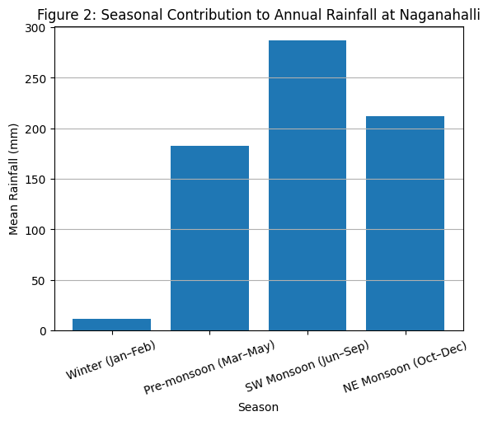

Figure 2: Seasonal Contribution to Annual Rainfall at Naganahalli, Mysuru (1968–2025)

3.3 Monthly Rainfall Distribution Pattern
Monthly rainfall analysis revealed substantial variation across months at Naganahalli (Table 3). October recorded the highest mean monthly rainfall (143.8 mm), followed by May (118.5 mm) and September (108.5 mm), indicating the combined influence of pre-monsoon convection and northeast monsoon rainfall on the annual rainfall regime.
Table 3. Mean monthly rainfall at AMFU, OFRS, Naganahalli, Mysuru (1968–2025)
Month | Mean rainfall (mm)
January | 4.3
February | 7.1
March | 13.9
April | 50.4
May | 118.5
June | 58.3
July | 53.0
August | 67.2
September | 108.5
October | 143.8
November | 54.4
December | 13.7
Rainfall during the southwest monsoon months (June–September) was moderate and relatively consistent, providing essential moisture for kharif crop growth. However, the dominance of October rainfall highlights the critical role of post-monsoon precipitation in sustaining crops during reproductive and maturity stages, particularly for rain-fed crops such as finger millet and maize (Parthasarathy et al., 1994).
In contrast, January to March received negligible rainfall, indicating an extended dry period that contributes to soil moisture depletion and increased dependence on irrigation or residual soil moisture (Sikka & Gadgil, 1980). Such prolonged dryness constrains agricultural activities during winter months.
Figure 3 illustrates a distinct bimodal rainfall pattern, with peaks during May (pre-monsoon) and September–October (monsoon and post-monsoon), a characteristic feature of southern peninsular India (Rajeevan et al., 2012; Krishnakumar et al., 2009). While rainfall in May facilitates land preparation and early sowing, precipitation during September and October is crucial for flowering and grain filling. Excess rainfall during these months, however, can increase the risk of lodging, disease incidence, and harvest losses (Guhathakurta et al., 2011).
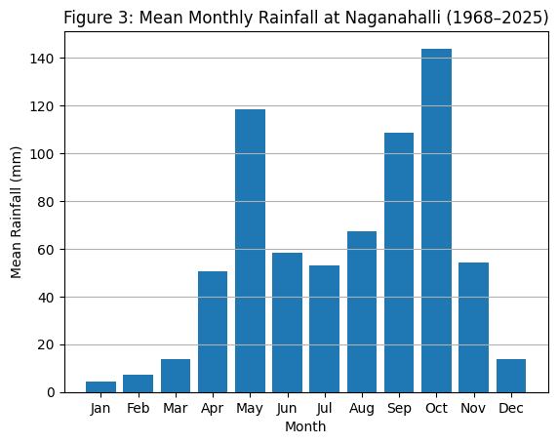
The pronounced concentration and variability of rainfall within a few months heighten the vulnerability of rain-fed farming systems. Delayed or deficient rainfall in May can postpone sowing, whereas excess rainfall in October may adversely affect harvesting and post-harvest operations (Patil et al., 2014). These findings emphasize the importance of real-time agrometeorological advisories and adaptive crop management strategies, including adjustment of sowing dates, use of short-duration or drought-tolerant varieties, and improved soil moisture conservation practices (Gadgil & Gadgil, 2006).
Figure 3: Mean Monthly Rainfall at AMFU, OFRS, Naganahalli, Mysuru (1968–2025)

3.4 Classification of Rainfall Years
Rainfall years at Naganahalli were classified into deficit, normal, and excess categories based on deviations from the long-term mean annual rainfall of 693.16 mm. Years receiving less than 75% of the mean rainfall were categorized as deficit, those receiving 75–125% as normal, and those exceeding 125% as excess rainfall years. This classification approach is widely adopted in rainfall variability and drought assessment studies in India (Parthasarathy et al., 1987; Guhathakurta et al., 2011).
Table 4. Frequency distribution of rainfall years at Naganahalli, Mysuru (1968–2025)
Rainfall category | Criteria | Number of years
Deficit years | < 75% of mean rainfall | 10
Normal years | 75–125% of mean rainfall | 38
Excess years | > 125% of mean rainfall | 10
Total |  | 58
Normal rainfall years dominated the study period, accounting for 38 out of 58 years (≈66%). However, deficit and excess rainfall years each occurred in 10 years, together representing nearly one-third of the total period. The equal frequency of deficit and excess years reflects pronounced rainfall instability in the region.
Deficit rainfall years indicate recurring drought-like conditions, which adversely affect crop establishment, soil moisture availability, and groundwater recharge, thereby increasing dependence on supplemental irrigation. Similar frequencies of deficit years have been reported across peninsular India, highlighting widespread drought vulnerability (Mishra et al., 2014; Patil et al., 2014).
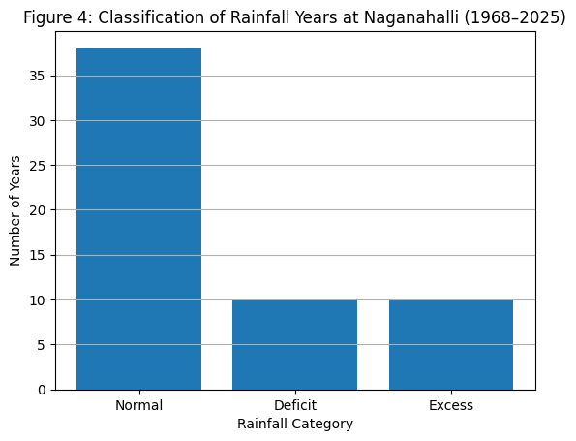
Figure 4 illustrates the distribution of rainfall categories and highlights that, despite the dominance of normal rainfall years, a substantial proportion of years experienced abnormal rainfall conditions. Such extremes pose serious challenges to agricultural sustainability. While deficit years lead to drought stress, crop failure, and groundwater depletion, excess rainfall years can result in runoff losses, soil erosion, nutrient leaching, and increased pest and disease incidence (Dash et al., 2013).
Figure 4: Classification of Rainfall Years at Naganahalli (1968–2025)
Overall, the classification reveals that agriculture in the Naganahalli region is exposed more to climatic extremes than to stable rainfall conditions. Consistent with earlier studies, rainfall variability—rather than changes in mean rainfall—emerges as a key driver of agricultural vulnerability in southern India (Kothawale & Rupa Kumar, 2005; Krishnakumar et al., 2009). These findings underscore the need for adaptive strategies such as crop diversification, contingency crop planning, and strengthened rainwater harvesting practices.

3.5 Long-Term Rainfall Trend Analysis
Long-term trends in annual rainfall at AMFU, OFRS, Naganahalli, Mysuru for the period 1968–2025 were assessed using the Mann–Kendall test and Sen’s slope estimator. Prior to analysis, the rainfall dataset was examined for continuity and consistency, and no missing values or inhomogeneities were detected during the study period.
The Mann–Kendall test yielded a positive Z value (Z = 1.46), indicating a weak increasing tendency; however, the trend was not statistically significant at the 5 per cent level (p > 0.05; |Z| < 1.96), suggesting the absence of a consistent monotonic trend during the study period (Table 5). Sen’s slope estimator indicated a marginal increase of 2.03 mm year⁻¹, reflecting a very slow rate of change in annual rainfall. This gradual increase is negligible when compared with the large inter-annual variability observed in the rainfall series, indicating that variability dominates over long-term change (Ambreen et al., 2023; Venkateswarlu & Singh, 2015).
Table 5. Results of Mann–Kendall trend test and Sen’s slope estimator for annual rainfall at AMFU, OFRS, Naganahalli, Mysuru (1968–2025)
Parameter | Result
Period of analysis | 1968–2025 (58 years)
Mean annual rainfall | 693.16 mm
Mann–Kendall S statistic | +219
Mann–Kendall Z statistic | +1.46
p-value | > 0.05
Significance level | 5% (critical Z = ±1.96)
Trend significance | Not significant
Direction of trend | Slightly increasing
Sen’s slope estimator | +2.03 mm year⁻¹
Overall inference | Rainfall variability dominates over long-term trend
The results indicate that annual rainfall at Naganahalli has not experienced a statistically significant directional change over the past five decades. Although a weak positive trend is evident, its magnitude is small and statistically insignificant. Similar dominance of rainfall variability over long-term trends has been reported across southern and peninsular India (Kothawale & Rupa Kumar, 2005; Rajeevan et al., 2012; Ambreen et al., 2023).
Figure 5 illustrates pronounced year-to-year fluctuations in annual rainfall, with sharp peaks corresponding to excess rainfall years and deep troughs representing drought years. While the fitted trend line shows a gentle upward slope, the wide dispersion of rainfall values around the trend line underscores the dominance of variability and extremes over gradual change.
The absence of a significant long-term trend does not imply climatic stability; rather, it reflects increasing rainfall uncertainty and extreme events, which are widely recognized as key manifestations of climate change in India (Guhathakurta et al., 2011; Krishnakumar et al., 2009). Frequent alternation between deficit and excess rainfall years increases agricultural risk, complicates water resource planning, and challenges rain-fed farming systems (Mishra et al., 2014).
These findings highlight the need for climate-resilient agricultural strategies, including improved rainwater harvesting, soil moisture conservation, and dynamic, location-specific agrometeorological advisories to cope with increasing rainfall variability (Dash et al., 2013).
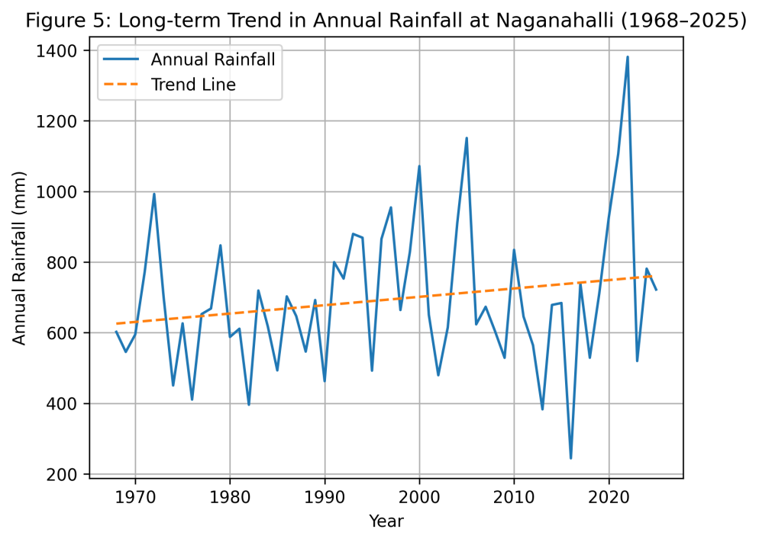
Fig. 5 Long term trend in annual rainfall of AMFU, Naganahalli (1968–2025)

3.6 Implications of Rainfall Variability for Agriculture and Water Management
The long-term rainfall analysis at AMFU, OFRS, Naganahalli, Mysuru demonstrates that rainfall variability, rather than a persistent long-term directional change, is the dominant climatic feature of the region. High inter-annual variability, frequent occurrence of deficit and excess rainfall years, and pronounced seasonality collectively govern agricultural and hydrological conditions, with direct implications for crop productivity, water resource management, and climate resilience.
Rain-fed agriculture in the Mysuru region is highly sensitive to rainfall anomalies, particularly during critical crop growth stages. Deficit rainfall years frequently result in delayed sowing, poor crop establishment, reduced nutrient uptake, and yield instability in major crops such as finger millet, maize, pulses, and oilseeds (Gadgil & Gadgil, 2006; Patil et al., 2014). Prolonged dry spells during the southwest monsoon further intensify moisture stress and increase the risk of crop failure.
Excess rainfall years, although increasing total water availability, pose equally serious challenges. High-intensity rainfall events often lead to runoff losses, soil erosion, nutrient leaching, and waterlogging, particularly in low-lying fields (Dash et al., 2013). Excess rainfall during the northeast monsoon, especially in October, can adversely affect crops at maturity and harvest stages, causing lodging, disease incidence, and post-harvest losses (Parthasarathy et al., 1994).
The strong dependence of the region on both southwest and northeast monsoons necessitates flexible and adaptive crop planning strategies. Adjustments in sowing windows, adoption of short-duration and drought-tolerant varieties, and diversification of cropping systems can help mitigate risks associated with rainfall uncertainty (Krishnakumar et al., 2009). Synchronizing fertilizer application and intercultural operations with rainfall events is also essential to minimize nutrient losses during heavy rainfall periods.
Rainfall variability has significant implications for water resource management. Negligible winter rainfall and high rainfall concentration during a few months highlight the need for effective rainwater harvesting and groundwater recharge measures. Farm ponds, percolation tanks, contour bunds, and soil moisture conservation practices can capture excess monsoon rainfall and provide supplemental irrigation during dry spells (Mishra et al., 2014).
This study, based on 58 years (1968–2025) of rainfall data, confirms the semi-arid nature of the region with a mean annual rainfall of about 693 mm. Rainfall exhibits a bimodal and highly seasonal distribution, with the southwest monsoon contributing the largest share, followed by the northeast monsoon. Monthly analysis identified October as the wettest month, underscoring the importance of post-monsoon rainfall for crop maturity and rabi sowing, while also highlighting increased vulnerability due to rainfall concentration within a limited period.
Although normal rainfall years were dominant, the frequent occurrence of deficit and excess rainfall years indicates persistent climatic instability. Trend analysis revealed no statistically significant long-term trend in annual rainfall, reinforcing that variability and extremes—rather than changes in mean rainfall—govern rainfall behavior in the region.
Overall, rainfall variability remains the key climatic constraint affecting agriculture and water management in Mysuru. The findings provide a strong scientific basis for climate-resilient agricultural planning, improved rainwater harvesting, and efficient water use strategies. Integrating long-term rainfall analysis with real-time, location-specific agrometeorological advisory services will be critical for enhancing farmer resilience and sustainable agricultural development under increasing climate variability.

4. Conclusion
This study analyzed 58 years (1968–2025) of rainfall data recorded at AMFU, OFRS, Naganahalli, Mysuru, to characterize long-term rainfall behavior. The results showed that the region experiences high inter-annual rainfall variability with a mean annual rainfall of about 693 mm, confirming its semi-arid climatic nature.
Rainfall is strongly seasonal and bimodal, with the southwest monsoon contributing the largest share of annual rainfall, followed by the northeast monsoon. Monthly analysis identified October as the wettest month, highlighting the importance of post-monsoon rainfall for crop maturity and rabi sowing. However, rainfall concentration within a few months increases agricultural vulnerability.
Although normal rainfall years were dominant, the frequent occurrence of deficit and excess rainfall years indicates persistent climatic instability. Trend analysis revealed no significant long-term trend in annual rainfall, suggesting that variability and extremes, rather than changes in mean rainfall, govern rainfall behavior in the region.
Overall, rainfall variability remains the key climatic constraint affecting agriculture and water management in Mysuru. The findings provide a scientific basis for improved crop planning, rainwater harvesting, and climate-resilient agricultural strategies, and support the need for integrating long-term rainfall analysis with agrometeorological advisory services.

5. Policy Implications and Recommendations
- Strengthening Rainfed Agriculture
The high inter-annual rainfall variability observed in the region highlights the need to prioritize rainfed agriculture in policy planning. Promotion of drought-tolerant and short-duration crop varieties, along with diversified cropping systems, can reduce production risks during deficit rainfall years.
- Monsoon-based Crop planning
Given the dominance of southwest and northeast monsoon rainfall, crop calendars should be aligned with monsoon onset and withdrawal patterns. Flexible sowing windows and contingency crop plans should be institutionalized at the district and taluk levels to address rainfall uncertainty.
- Rainwater Harvesting and Groundwater Recharge
The concentration of rainfall within a few months necessitates large-scale investment in rainwater harvesting structures such as farm ponds, percolation tanks, contour bunds, and check dams. Policies should encourage on-farm water storage to provide supplemental irrigation during dry spells.
- Soil and Water Conservation Measures
High rainfall variability and occasional excess rainfall events call for strengthening soil conservation practices. Adoption of mulching, conservation tillage, graded bunds, and vegetative barriers should be promoted to reduce runoff, soil erosion, and nutrient losses.
- Location-Specific Agrometeorological Advisories
Long-term rainfall behavior should be integrated with real-time weather forecasts to improve agrometeorological advisory services. Customized advisories at the village or micro-watershed level can help farmers make timely decisions on sowing, irrigation, nutrient management, and harvesting.
- Climate-Resilient Infrastructure and Extension Support
Investment in climate-resilient agricultural infrastructure, combined with capacity building of farmers through extension services, is essential. Training programs focusing on climate risk management, water use efficiency, and adaptive farming practices should be strengthened.
- Data-Driven Planning and Decision Making
Long-term agro-meteorological datasets, such as those used in this study, should be systematically utilized in agricultural planning, insurance design, and disaster preparedness programs. Strengthening weather observatories and data dissemination mechanisms will support evidence-based policy formulation.

Disclaimer (Artificial intelligence)

Author(s) hereby declare that NO generative AI technologies such as Large Language Models (ChatGPT, COPILOT, etc.) and text-to-image generators have been used during the writing or editing of this manuscript.

References
- Ambreen, R., Mengal, S., Rehman, T., Ahmed, S., & Manan, A. (2023). Trend analysis of meteorological variables using Mann–Kendall and Sen’s slope estimator: A case study of Lasbela (Balochistan). Tianjin Daxue Xuebao (Ziran Kexue yu Gongcheng Jishu Ban) / Journal of Tianjin University Science and Technology, 56(7), 49.
- Dash, S. K., Panda, P. C., & Mohanty, U. C. (2013). Climate change and variability over India. Theoretical and Applied Climatology, 116, 97–109.
- FAO. (2017). Climate-Smart Agriculture Sourcebook. Food and Agriculture Organization, Rome.
- Gadgil, S., &Gadgil, S. (2006). The Indian monsoon, GDP and agriculture. Economic and Political Weekly, 41(47), 4887–4895.
- Gebregiorgis, D., Hathorne, E. C., Sijinkumar, A. V., Nagender Nath, B., Nürnberg, D., & Frank, M. (2016). South Asian summer monsoon variability during the last ~54 kyrs inferred from surface water salinity and river runoff proxies. Quaternary Science Reviews, 138, 6–15.
- Goswami, B. N., Venugopal, V., Sengupta, D., Madhusoodanan, M. S., & Xavier, P. K. (2006). Increasing trend of extreme rain events over India in a warming environment. Science, 314, 1442–1445.
- Guhathakurta, P., Rajeevan, M., & Thapliyal, S. (2011). Observed changes in extreme rainfall events over India using 104 years of gridded daily rainfall data. International Journal of Climatology, 31(9), 1156–1164.
- India Meteorological Department (IMD). (2010). Climate of Karnataka. IMD, Pune, India.
- IPCC. (2014). Climate Change 2014: Impacts, Adaptation and Vulnerability. Cambridge University Press.
- Jagannathan, P., & Parthasarathy, B. (1973). Trends and periodicities of rainfall over India. Monthly Weather Review, 101, 371–375.
- Jamshadali, V. H., Reji, M. J. K., Varikoden, H., & Vishnu, R. (2021). Spatial variability of South Asian summer monsoon extreme rainfall events and their association with global climate indices. Journal of Atmospheric and Solar-Terrestrial Physics, 221, 105708.
- Kendall, M. G. (1975). Rank Correlation Methods (4th ed.). Griffin, London.
- Kothawale, D. R., & Rupa Kumar, K. (2005). On the recent changes in surface temperature trends over India. Geophysical Research Letters, 32, L18714.
- Krishnakumar, K. N., Prasada Rao, G. S. L. H. V., &Gopakumar, C. S. (2009). Rainfall trends in twentieth century over Kerala, India. Atmospheric Environment, 43, 1940–1944.
- Mann, H. B. (1945). Non-parametric tests against trend. Econometrica, 13, 245–259.
- Mishra, A. K., Singh, V. P., & Desai, V. R. (2014). Drought characterization: A probabilistic approach. Journal of Geophysical Research: Atmospheres, 119, 1–16.
- Nanjundiah, R. S., Francis, P. A., Ved, M., Gadgil, S., & Srinivasan, J. (2017). Impact of climate change on Indian monsoon. Current Science, 112(2), 348–357.
- Parthasarathy, B., Kumar, K. R., &Kothawale, D. R. (1994). Indian summer monsoon rainfall indices, 1871–1990. Meteorological Magazine, 123, 174–186.
- Parthasarathy, B., Munot, A. A., &Kothawale, D. R. (1987). All-India monthly and seasonal rainfall series: 1871–1985. Theoretical and Applied Climatology, 38, 39–49.
- Patil, R. H., Sidramappa, & Manjunath, K. R. (2014). Rainfall variability and crop planning in southern Karnataka. Journal of Agrometeorology, 16(1), 45–53.
- Rajeevan, M., Bhate, J., &Jaswal, A. K. (2012). Analysis of variability and trends of extreme rainfall events over India using 104 years of gridded daily rainfall data. Mausam, 63(1), 49–56.
- Rao, Y. P. (2011). Southwest Monsoon. India Meteorological Department, New Delhi.
- Rockstrom, J., et al. (2010). Managing water in rainfed agriculture. Philosophical Transactions of the Royal Society B, 363, 1637–1646.
- Rupa Kumar, K., Sahai, A. K., Kumar, K. K., et al. (2006). High-resolution climate change scenarios for India. Current Science, 90(3), 334–345.
- Samra, J. S. (2004). Review and analysis of drought monitoring, declaration and management in India. IWMI Working Paper 84.
- Sen, P. K. (1968). Estimates of the regression coefficient based on Kendall’s tau. Journal of the American Statistical Association, 63, 1379–1389.
- Sharma, K. D., & Tyagi, N. K. (2013). On-farm water management in India. Indian Journal of Agricultural Sciences, 83(7), 705–714.
- Sikka, D. R., &Gadgil, S. (1980). On the maximum cloud zone and the ITCZ over Indian longitudes during the southwest monsoon. Monthly Weather Review, 108, 1840–1853.
- Singh, D., Jain, S. K., & Gupta, R. D. (2005). Trend detection in rainfall series of India. Hydrological Sciences Journal, 50(6), 871–887.
- Subash, N., & Sikka, A. K. (2014). Trend analysis of rainfall and temperature and their implications for agriculture. Journal of Agrometeorology, 16(2), 168–173.
- Venkateswarlu, B., & Singh, A. K. (2015). Climate change adaptation and mitigation strategies in rainfed agriculture. In Climate change modelling, planning and policy for agriculture (pp. 1–11). Springer India.
- Wilks, D. S. (2011). Statistical Methods in the Atmospheric Sciences (3rd ed.). Academic Press, New York.
- WMO. (2012). Standardized Precipitation Index User Guide. World Meteorological Organization, Geneva.
- Yadav, R. K., & Raghavendra, A. (2015). Climate variability and its impact on agriculture in Karnataka. Indian Journal of Dryland Agricultural Research, 30(2), 1–8.

