Effect of pot size and number of plants per pot on growth and flowering of French Marigold (tagetes patula l.) Cv. Arka pari
ABSTRACT
The present investigation was carried out at College of Horticulture, Sri Konda Laxman Telangana Horticultural University, Rajendranagar, Hyderabad during Rabi 2021-2022 and 2022-2023. The experiment was laid in factorial completely randomized design with two factors, twelve treatments and 3 replications to study the effect of pot size and number of plants per pot on growth and flowering of French marigold (Tagetes patula L.) cv. Arka Pari. Interaction of P₃ x N₁: 8 inch pot with single plant showed maximum plant height (20.72, 28.27 and 33.94 cm), plant spread (E-W) (15.95, 23.30 and 31.96 cm), plant spread (N-S) (15.22, 22.65 and 31.87 cm), number of branches (8.53, 14.63 and 20.24), number of leaves (28.90, 55.37 and 83.03), stem diameter (7.45, 8.64 and 9.56 mm) and chlorophyll (SPAD) (70.11, 57.76 and 51.95) at 30, 60 and 90 DAT, respectively. Among three different pot sizes, minimum number of days taken for first flower bud initiation (28.45 days), number of days taken for first flower bud opening (34.73days), 50 percent flowering (47.79 days) and number of days taken for full bloom (56.89 days) were recorded in P₁: 4-inch pot. Among different plant density per pot, N₄: four plants per pot recorded minimum number of days taken for first flower bud initiation (27.22 days), first flower bud opening (33.58 days), 50 percent flowering (47.68 days), number of days taken for full bloom (56.07days). Pooled number of flowers per plant was observed maximum in P₃ x N₁:8 inch pot with single plant (63.13). Pooled number of flowers per pot were found maximum in P₃ x N₄:8 inch pot with four plants (135.93). The interaction effect of different pot size and number of plants per pot was found to be non-significant for number of days taken for flower bud initiation, number of days taken for flower bud opening, 50 percent flowering and number of days taken for full bloom.
Keywords: Tagetes patula L., Pot size, Number of plants per plant, Growth and flowering.
Introduction:
Marigold (Tagetes spp.) is one of the most important loose flower crop, belongs to the family Asteraceae and is native to the Mexico. The genus Tagetes consist of more than 50 species, out of these, Tagetes erecta (African marigold), Tagetes patula (French marigold) are very common and popular for commercial cultivation. French marigold (Tagetes patula L.) is a popular ornamental plant widely cultivated for its vibrant flowers, compact growth, and adaptability to various growing conditions. In container gardening and nursery production, environmental factors such as pot size and plant density significantly influence plant growth, development, and overall ornamental quality. Pot size determines the available root volume, which affects nutrient uptake, water retention, and aeration ultimately impacting plant height, biomass production, flowering, and root expansion. Different physiological and morphological features in plants can be controlled by the container sizes, (Taherpazir and Hashemabadi, 2016). Similarly, the number of plants per pot can create competition for essential resources like light, water, and nutrients, potentially limiting individual plant growth and reducing flower yield due to overcrowding. Understanding how pot size and plant density interact is vital for optimizing plant health and maximizing resource efficiency, especially in space-constrained environments such as urban gardens and commercial production systems. This study was aimed to find appropriate pot size in relation to the ideal plant population for French marigold.
Materials and Methods:
The present investigation was carried out at College of Horticulture, Sri Konda Laxman Telangana Horticultural University, Rajendranagar, Hyderabad during Rabi 2021-2022 and 2022-2023. The experiment was laid out in factorial completely randomized design (FCRD) with two factors, twelve treatments and three replications to study the effect of pot size and number of plants per pot on growth and flowering of French marigold (Tagetes patula L.) cv. Arka Pari. Factor 1 comprised pot size with 4, 6 and 8 inch pots, factor 2 included number of plants per pot with one, two, three and four plants per pot. The protrays were treated with copper oxy chloride 3g L⁻¹, later trays were dried for one day. After drying, the portrays were filled with a media containing cocopeat and vermicompost in 1:1 ratio. Seeds were sown in portrays and watering was done with rose can. First three days, the portrays were covered with polythene sheet to enhance germination. Sowing was done during first fortnight of October and second fortnight of September in first and second seasons respectively. Black PVC pots were used, and the potting media was prepared in the ratio soil: cocopeat: FYM (1:1:1), after which the pots were filled with this mixture. For one plant, a hole was drilled at the centre. For two plants, holes were drilled diametrically opposite each other. For three plants, holes were drilled in an equilateral triangle. For four plants, holes were drilled in a square pattern. Thirty-day-old healthy seedlings were selected and carefully transplanted into the pots. In each replication 5 plants were selected and data was drawn. Data on growth and flowering were recorded and statistically analyzed using two-way ANOVA for Factorial CRD.
Results and discussion
I) Growth parameters
a) Plant height (cm):
The interaction between pot size and number of plants per pot had a significant effect on plant height. From the tables. 1, 2. and 3. it was found that the pooled plant height was maximum in P₃ x N₁:8 inch pot with single plant (20.72, 28.27 and 33.94 cm), which was followed by P₃ x N₂: 8 inch with two plants (18.39 and 26.92 cm) (30 and 60 DAT), P₂ x N₁: 6 inch with single plant (32.60 cm) (90 DAT), and minimum plant height was recorded in P₁ x N₄: 4 inch pot with four plants (11.51, 20.06 and 22.70 cm) at 30, 60 and 90 DAT respectively. The superior plant height observed in larger pots with a single plant may be attributed to the availability of a greater volume of growing medium, which facilitates improved root development and enhanced uptake of water and nutrients. Conversely, smaller pots with a higher number of plants impose greater root restriction, leading to reduced vegetative growth. Reduced container size is also associated with decreased pore space in the growing medium, resulting in lower water-holding capacity and poor aeration, thereby adversely affecting plant growth and ultimately reducing plant height. Hence reduces plant growth, resulting in a reduction in plant height. The results are in conformity with Vernieri et al. (2003) in Sunflower, Carvalho et al. (2008) in Kalanchoe, Suman (2014), Alhajhoj, (2017) in galdiolus, Sanjay (2021) in costus and Tomasi et al. (2024) in cut sunflower.

b) Plant spread (E-W) (cm)
A statistically significant interaction of pot size and plant number per pot was observed for plant spread (E–W). From the tables 4, 5 and 6. it was found that the pooled plant spread (E-W) was maximum in P₃ x N₁:8 inch pot with single plant (15.95, 23.30 and 31.96 cm), which was followed by P₃ x N₂: 8 inch with two plants (14.50, 21.62 and 30.37 cm) and minimum plant spread (E-W) was recorded in P₁ x N₄: 4 inch pot with four plants (8.59, 13.18 and 18.24 cm) at 30, 60 and 90 DAT respectively.
c) Plant spread (N-S) (cm)
Plant spread (N–S) was significantly influenced by the interaction of pot size and number of plants per pot. From the tables 7, 8. and 9. it was found that the pooled plant spread (N-S) was maximum in P₃ x N₁:8 inch pot with single plant (15.22, 22.65 and 31.87 cm), which was followed by P₃ x N₂: 8 inch with two plants (13.35, 21.09 and 30.64 cm), P2 x N1: 6 inch with single plant (12.76, 17.92 and 26.44 cm) and minimum plant spread (N-S) was recorded in P₁ x N₄: 4 inch pot with four plants (8.10, 12.70 and 18.25 cm) at 30, 60 and 90 DAT respectively. Larger pots facilitate greater plant spread due to the increased volume of growing substrate, which not only provides sufficient space for enhanced root development but also ensures favorable physico-chemical properties of the growing medium (Deogade et al., 2020). In the present study, the cultivar Arka Pari, particularly when grown in larger containers, exhibited increased lateral branching, with maximum lateral production observed in 8-inch pots. These findings are in agreement with earlier studies by Biermann (1982) in cyclamen, Al-Meanie et al. (2012), Gupta (2013) in Primula, and Dilta et al. (2019) in azalea. Plant spread per individual plant decreased with an increase in the number of plants per pot, indicating the effect of inter-plant competition. In 4- and 6-inch pots, optimum plant spread was observed up to a density of three plants per pot, whereas a further increase to four plants per pot resulted in a marked reduction in plant spread, possibly due to limited root space and increased competition for nutrients and water. However, in 8-inch pots, adequate plant spread was maintained even at a density of four plants per pot, which may be attributed to the greater availability of growing medium and improved root growth conditions.

Table 1. Effect of pot size and number of plants per pot on plant height (cm) at 30 DAT of French marigold (Tagetes patula L.) cv. Arka Pari during Rabi 2021-22 and 2022-23.
 | Plant height (cm) at 30 DAT
 | 2021-22 |  |  |  |  |  | 2022-23 |  |  |  |  |  |  | Pooled
 | N₁ | N₂ | N₃ |  | N₄ | Mean | N₁ | N₂ | N₃ |  | N₄ | Mean | N₁ |  | N₂ | N₃ |  | N₄ | Mean
P₁ | 15.03 | 13.71 | 12.50 |  | 11.11 | 13.09 | 15.06 | 14.10 | 12.75 |  | 11.91 | 13.45 | 15.04 |  | 13.91 | 12.63 |  | 11.51 | 13.27
P₂ | 18.27 | 17.32 | 16.58 |  | 13.56 | 16.43 | 18.45 | 17.59 | 16.93 |  | 13.97 | 16.74 | 18.36 |  | 17.46 | 16.75 |  | 13.77 | 16.59
P₃ | 20.53 | 18.31 | 17.03 |  | 14.87 | 17.69 | 20.91 | 18.47 | 17.32 |  | 14.60 | 17.83 | 20.72 |  | 18.39 | 17.18 |  | 14.74 | 17.76
Mean | 17.94 | 16.45 | 15.37 |  | 13.18 |  | 18.14 | 16.72 | 15.67 |  | 13.49 |  | 18.04 |  | 16.59 | 15.52 |  | 13.34
 | SEm± |  |  | CD (P=0.05) |  |  | SEm± |  |  | CD (P=0.05) |  |  |  | SEm± |  |  | CD (P=0.05)
P | 0.15 |  |  | 0.42 |  |  | 0.19 |  |  | 0.56 |  |  |  | 0.12 |  |  | 0.36
N | 0.17 |  |  | 0.49 |  |  | 0.22 |  |  | 0.65 |  |  |  | 0.14 |  |  | 0.41
P X N | 0.29 |  |  | 0.85 |  |  | 0.39 |  |  | 1.13 |  |  |  | 0.24 |  |  | 0.71
Table 2. Effect of pot size and number of plants per pot on plant height (cm) at 60 DAT of French marigold (Tagetes patula L.) cv. Arka Pari during Rabi 2021-22 and 2022-23.
 | Plant height (cm) at 60 DAT
 | 2021-22 |  |  |  |  |  | 2022-23 |  |  |  |  |  | Pooled
 | N₁ | N₂ | N₃ |  | N₄ | Mean | N₁ | N₂ | N₃ |  | N₄ | Mean | N₁ | N₂ | N₃ |  | N₄ | Mean
P₁ | 23.96 | 22.46 | 21.71 |  | 19.57 | 21.92 | 24.38 | 23.01 | 22.28 |  | 20.55 | 22.56 | 24.17 | 22.74 | 22.00 |  | 20.06 | 22.24
P₂ | 25.73 | 25.12 | 23.02 |  | 20.39 | 23.56 | 26.28 | 25.65 | 23.97 |  | 21.25 | 24.29 | 26.01 | 25.39 | 23.50 |  | 20.82 | 23.93
P₃ | 27.89 | 26.70 | 25.08 |  | 23.57 | 25.81 | 28.66 | 27.13 | 25.89 |  | 22.51 | 26.05 | 28.27 | 26.92 | 25.48 |  | 23.04 | 25.93
Mean | 25.86 | 24.76 | 23.27 |  | 21.17 |  | 26.44 | 25.27 | 24.05 |  | 21.44 |  | 26.15 | 25.01 | 23.66 |  | 21.31
 | SEm± |  |  | CD (P=0.05) |  |  | SEm± |  |  | CD (P=0.05) |  |  | SEm± |  |  | CD (P=0.05)
P | 0.14 |  |  | 0.41 |  |  | 0.17 |  |  | 0.51 |  |  | 0.12 |  |  | 0.36
N | 0.16 |  |  | 0.47 |  |  | 0.20 |  |  | 0.59 |  |  | 0.14 |  |  | 0.42
P X N | 0.28 |  |  | 0.82 |  |  | 0.35 |  |  | 1.01 |  |  | 0.25 |  |  | 0.72
Factor 1: Pot size (P) Factor 2: Number of plants per pot (N) DAT: Days after transplanting
P₁: 4 inch P₂: 6 inch P₃: 8 inch N₁: One plant per pot N₂: Two plants per pot N₃: Three plants per pot N₄: Four plants per pot
Table 3. Effect of pot size and number of plants per pot on plant height (cm) at 90 DAT of French marigold (Tagetes patula L.) cv. Arka Pari during Rabi 2021-22 and 2022-23.
 | Plant height (cm) at 90 DAT
 | 2021-22 |  |  |  |  |  | 2022-23 |  |  |  |  |  | Pooled
 | N₁ | N₂ | N₃ |  | N₄ | Mean | N₁ | N₂ | N₃ |  | N₄ | Mean | N₁ | N₂ | N₃ |  | N₄ | Mean
P₁ | 29.01 | 26.41 | 24.15 |  | 22.46 | 25.51 | 30.51 | 27.02 | 25.23 |  | 22.94 | 26.42 | 29.76 | 26.72 | 24.69 |  | 22.70 | 25.97
P₂ | 32.76 | 31.31 | 30.66 |  | 26.83 | 30.39 | 32.01 | 31.33 | 30.89 |  | 26.77 | 30.25 | 32.60 | 31.32 | 30.78 |  | 26.80 | 30.37
P₃ | 33.86 | 32.52 | 31.80 |  | 27.17 | 31.34 | 34.03 | 32.06 | 31.73 |  | 28.38 | 31.55 | 33.94 | 32.29 | 31.76 |  | 27.77 | 31.44
Mean | 31.88 | 30.08 | 28.87 |  | 25.48 |  | 32.18 | 30.14 | 29.28 |  | 26.03 |  | 32.10 | 30.11 | 29.08 |  | 25.76
 | SEm± |  |  | CD (P=0.05) |  |  | SEm± |  |  | CD (P=0.05) |  |  | SEm± |  |  | CD (P=0.05)
P | 0.16 |  |  | 0.45 |  |  | 0.19 |  |  | 0.55 |  |  | 0.12 |  |  | 0.34
N | 0.18 |  |  | 0.52 |  |  | 0.22 |  |  | 0.63 |  |  | 0.13 |  |  | 0.39
P X N | 0.31 |  |  | 0.91 |  |  | 0.38 |  |  | 1.10 |  |  | 0.23 |  |  | 0.68

Table 4. Effect of pot size and number of plants per pot on plant spread (E-W) (cm) at 30 DAT of French marigold (Tagetes patula L.) cv. Arka Pari during Rabi 2021-22 and 2022-23.
 | Plant spread (E-W) (cm) at 30 DAT
 | 2021-22 |  |  |  |  | 2022-23 |  |  |  |  | Pooled
 | N₁ | N₂ | N₃ | N₄ | Mean | N₁ | N₂ | N₃ | N₄ | Mean | N₁ | N₂ | N₃ |  | N₄ | Mean
P₁ | 11.36 | 10.70 | 9.80 | 8.53 | 10.10 | 12.74 | 11.17 | 10.11 | 8.65 | 10.67 | 12.05 | 10.93 | 9.95 |  | 8.59 | 10.38
P₂ | 12.82 | 11.84 | 11.47 | 9.25 | 11.35 | 14.00 | 13.02 | 12.63 | 9.62 | 12.32 | 13.41 | 12.43 | 12.05 |  | 9.44 | 11.83
P₃ | 15.61 | 14.04 | 13.24 | 10.94 | 13.46 | 16.30 | 14.97 | 13.99 | 12.14 | 14.35 | 15.95 | 14.50 | 13.62 |  | 11.54 | 13.90
Mean | 13.26 | 12.19 | 11.50 | 9.57 |  | 14.35 | 13.05 | 12.24 | 10.14 |  | 13.81 | 12.62 | 11.87 |  | 9.86
 | SEm± |  | CD (P=0.05) |  |  | SEm± |  | CD (P=0.05) |  |  | SEm± |  |  | CD (P=0.05)
P | 0.10 |  | 0.30 |  |  | 0.11 |  | 0.32 |  |  | 0.08 |  |  | 0.25
N | 0.12 |  | 0.34 |  |  | 0.13 |  | 0.37 |  |  | 0.10 |  |  | 0.28
P X N | 0.20 |  | 0.60 |  |  | 0.22 |  | 0.65 |  |  | 0.17 |  |  | 0.49
Factor 1: Pot size (P) Factor 2: Number of plants per pot (N) DAT: Days after transplanting
P₁: 4 inch P₂: 6 inch P₃: 8 inch N₁: One plant per pot N₂: Two plants per pot N₃: Three plants per pot N₄: Four plants per pot
Table 5. Effect of pot size and number of plants per pot on plant spread (E-W) (cm) at 60 DAT of French marigold (Tagetes patula L.) cv. Arka Pari during Rabi 2021-22 and 2022-23.
 | Plant spread (E-W) (cm) at 60 DAT
 | 2021-22 |  |  |  |  |  | 2022-23 |  |  |  |  |  | Pooled
 | N₁ | N₂ | N₃ |  | N₄ | Mean | N₁ | N₂ | N₃ |  | N₄ | Mean | N₁ | N₂ | N₃ |  | N₄ | Mean
P₁ | 18.25 | 17.21 | 15.51 |  | 13.03 | 16.00 | 18.79 | 17.75 | 15.95 |  | 13.32 | 16.45 | 18.52 | 17.48 | 15.73 |  | 13.18 | 16.22
P₂ | 20.76 | 19.16 | 18.19 |  | 15.69 | 18.45 | 20.36 | 19.33 | 18.03 |  | 15.70 | 18.36 | 20.56 | 19.25 | 18.11 |  | 15.69 | 18.40
P₃ | 23.42 | 21.45 | 18.82 |  | 16.91 | 20.15 | 23.18 | 21.79 | 19.74 |  | 16.80 | 20.38 | 23.30 | 21.62 | 19.28 |  | 16.86 | 20.27
Mean | 20.81 | 19.27 | 17.51 |  | 15.21 |  | 20.78 | 19.62 | 17.91 |  | 15.27 |  | 20.79 | 19.45 | 17.71 |  | 15.24
 | SEm± |  |  | CD (P=0.05) |  |  | SEm± |  |  | CD (P=0.05) |  |  | SEm± |  |  | CD (P=0.05)
P | 0.16 |  |  | 0.47 |  |  | 0.11 |  |  | 0.32 |  |  | 0.10 |  |  | 0.30
N | 0.18 |  |  | 0.54 |  |  | 0.13 |  |  | 0.37 |  |  | 0.12 |  |  | 0.35
P X N | 0.32 |  |  | 0.93 |  |  | 0.22 |  |  | 0.65 |  |  | 0.21 |  |  | 0.61

Table 6. Effect of pot size and number of plants per pot on plant spread (E-W) (cm) at 90 DAT of French marigold (Tagetes patula L.) cv. Arka Pari during Rabi 2021-22 and 2022-23.
 | Plant spread (E-W) (cm) at 90 DAT
 | 2021-22 |  |  |  |  |  | 2022-23 |  |  |  |  |  | Pooled
 | N₁ | N₂ | N₃ |  | N₁ | N₂ | N₃ | N₁ | N₂ |  | N₃ | N₁ | N₂ | N₃ | N₁ |  | N₂ | N₃
P₁ | 24.05 | 23.10 | 20.41 |  | 18.03 | 21.40 | 25.13 | 23.98 | 20.95 |  | 18.45 | 22.13 | 24.59 | 23.54 | 20.68 |  | 18.24 | 21.76
P₂ | 26.98 | 24.92 | 23.63 |  | 20.26 | 23.95 | 27.21 | 25.27 | 23.96 |  | 20.91 | 24.34 | 27.09 | 25.09 | 23.80 |  | 20.59 | 24.14
P₃ | 31.31 | 30.23 | 26.69 |  | 23.11 | 27.84 | 32.60 | 30.51 | 28.04 |  | 22.82 | 28.49 | 31.96 | 30.37 | 26.54 |  | 22.65 | 27.88
Mean | 27.45 | 26.08 | 23.58 |  | 20.47 |  | 28.31 | 26.59 | 24.32 |  | 20.73 |  | 27.88 | 26.33 | 23.67 |  | 20.49
 | SEm± |  |  | CD (P=0.05) |  |  | SEm± |  |  | CD (P=0.05) |  |  | SEm± |  |  | CD (P=0.05)
P | 0.21 |  |  | 0.62 |  |  | 0.19 |  |  | 0.57 |  |  | 0.12 |  |  | 0.35
N | 0.24 |  |  | 0.71 |  |  | 0.22 |  |  | 0.65 |  |  | 0.14 |  |  | 0.41
P X N | 0.42 |  |  | 1.23 |  |  | 0.39 |  |  | 1.13 |  |  | 0.24 |  |  | 0.70
Factor 1: Pot size (P) Factor 2: Number of plants per pot (N) DAT: Days after transplanting
P₁: 4 inch P₂: 6 inch P₃: 8 inch N₁: One plant per pot N₂: Two plants per pot N₃: Three plants per pot N₄: Four plants per pot
Table 7. Effect of pot size and number of plants per pot on plant spread (N-S) (cm) at 30 DAT of French marigold (Tagetes patula L.) cv. Arka Pari during Rabi 2021-22 and 2022-23.
 | Plant spread (N-S) (cm) at 30 DAT
 | 2021-22 |  |  |  |  |  | 2022-23 |  |  |  |  |  | Pooled
 | N₁ | N₂ | N₃ |  | N₄ | Mean | N₁ | N₂ | N₃ |  | N₄ | Mean | N₁ | N₂ | N₃ |  | N₄ | Mean
P₁ | 10.95 | 10.47 | 9.71 |  | 8.07 | 9.80 | 11.35 | 10.66 | 9.83 |  | 8.12 | 9.99 | 11.15 | 10.57 | 9.77 |  | 8.10 | 9.90
P₂ | 12.47 | 11.36 | 10.49 |  | 9.00 | 10.83 | 13.05 | 12.35 | 11.99 |  | 10.16 | 11.89 | 12.76 | 11.86 | 11.24 |  | 9.58 | 11.36
P₃ | 14.52 | 12.94 | 10.84 |  | 9.78 | 12.02 | 15.91 | 13.76 | 12.15 |  | 11.08 | 13.22 | 15.22 | 13.35 | 11.49 |  | 10.43 | 12.62
Mean | 12.65 | 11.59 | 10.35 |  | 8.95 |  | 13.44 | 12.26 | 11.32 |  | 9.79 |  | 13.04 | 11.92 | 10.83 |  | 9.37
 | SEm± |  |  | CD (P=0.05) |  |  | SEm± |  |  | CD (P=0.05) |  |  | SEm± |  |  | CD (P=0.05)
P | 0.10 |  |  | 0.30 |  |  | 0.13 |  |  | 0.37 |  |  | 0.09 |  |  | 0.25
N | 0.12 |  |  | 0.35 |  |  | 0.15 |  |  | 0.42 |  |  | 0.10 |  |  | 0.29
P X N | 0.21 |  |  | 0.60 |  |  | 0.25 |  |  | 0.74 |  |  | 0.17 |  |  | 0.51
Table 8. Effect of pot size and number of plants per pot on plant spread (N-S) (cm) at 60 DAT French marigold (Tagetes patula L.) cv. Arka Pari during Rabi 2021-22 and 2022-23.
 | Plant spread (N-S) (cm) at 60 DAT
 | 2021-22 |  |  |  |  |  | 2022-23 |  |  |  |  |  | Pooled
 | N₁ | N₂ | N₃ |  | N₄ | Mean | N₁ | N₂ | N₃ |  | N₄ | Mean | N₁ | N₂ | N₃ |  | N₄ | Mean
P₁ | 15.94 | 14.83 | 13.46 |  | 12.52 | 14.19 | 16.72 | 15.44 | 14.06 |  | 12.89 | 14.78 | 16.33 | 15.14 | 13.76 |  | 12.70 | 14.48
P₂ | 17.04 | 16.02 | 15.80 |  | 14.55 | 15.86 | 18.80 | 17.45 | 16.77 |  | 14.93 | 16.99 | 17.92 | 16.74 | 16.29 |  | 14.74 | 16.42
P₃ | 22.04 | 20.78 | 18.75 |  | 15.68 | 19.31 | 23.25 | 21.41 | 19.96 |  | 16.76 | 20.35 | 22.65 | 21.09 | 19.35 |  | 16.22 | 19.83
Mean | 18.34 | 17.21 | 16.00 |  | 14.25 |  | 19.59 | 18.10 | 16.93 |  | 14.86 |  | 18.97 | 17.66 | 16.47 |  | 14.55
 | SEm± |  |  | CD (P=0.05) |  |  | SEm± |  |  | CD (P=0.05) |  |  | SEm± |  |  | CD (P=0.05)
P | 0.14 |  |  | 0.25 |  |  | 0.18 |  |  | 0.52 |  |  | 0.11 |  |  | 0.33
N | 0.16 |  |  | 0.29 |  |  | 0.20 |  |  | 0.60 |  |  | 0.13 |  |  | 0.38
P X N | 0.29 |  |  | 0.51 |  |  | 0.35 |  |  | 1.03 |  |  | 0.23 |  |  | 0.67
Factor 1: Pot size (P) Factor 2: Number of plants per pot (N) DAT: Days after transplanting
P₁: 4 inch P₂: 6 inch P₃: 8 inch N₁: One plant per pot N₂: Two plants per pot N₃: Three plants per pot N₄: Four plants per pot
Table 9. Effect of pot size and number of plants per pot on plant spread (N-S) (cm) at 90 French marigold (Tagetes patula L.) cv. Arka Pari during Rabi 2021-22 and 2022-23.
 | Plant spread (N-S) (cm) at 90 DAT
 | 2021-22 |  |  |  |  |  | 2022-23 |  |  |  |  |  | Pooled
 | N₁ | N₂ | N₃ |  | N₄ | Mean | N₁ | N₂ | N₃ |  | N₄ | Mean | N₁ | N₂ | N₃ |  | N₄ | Mean
P₁ | 22.94 | 20.67 | 19.83 |  | 17.78 | 20.31 | 24.38 | 21.77 | 20.89 |  | 18.71 | 21.44 | 23.66 | 21.22 | 20.36 |  | 18.25 | 20.87
P₂ | 25.89 | 24.49 | 22.40 |  | 19.14 | 22.98 | 26.98 | 25.79 | 23.60 |  | 19.12 | 23.87 | 26.44 | 25.14 | 23.00 |  | 19.13 | 23.43
P₃ | 31.62 | 30.35 | 24.78 |  | 21.21 | 26.99 | 32.12 | 30.93 | 26.51 |  | 22.85 | 28.10 | 31.87 | 30.64 | 25.65 |  | 22.03 | 27.55
Mean | 26.82 | 25.17 | 22.33 |  | 19.38 |  | 27.83 | 26.16 | 23.67 |  | 20.23 |  | 27.32 | 25.67 | 23.00 |  | 19.80
 | SEm± |  |  | CD (P=0.05) |  |  | SEm± |  |  | CD (P=0.05) |  |  | SEm± |  |  | CD (P=0.05)
P | 0.18 |  |  | 0.51 |  |  | 0.18 |  |  | 0.52 |  |  | 0.12 |  |  | 0.35
N | 0.20 |  |  | 0.59 |  |  | 0.21 |  |  | 0.60 |  |  | 0.14 |  |  | 0.41
P X N | 0.35 |  |  | 1.03 |  |  | 0.36 |  |  | 1.05 |  |  | 0.24 |  |  | 0.70

Factor 1: Pot size (P) Factor 2: Number of plants per pot (N) DAT: Days after transplanting
P₁: 4 inch P₂: 6 inch P₃: 8 inch N₁: One plant per pot N₂: Two plants per pot N₃: Three plants per pot N₄: Four plants per pot

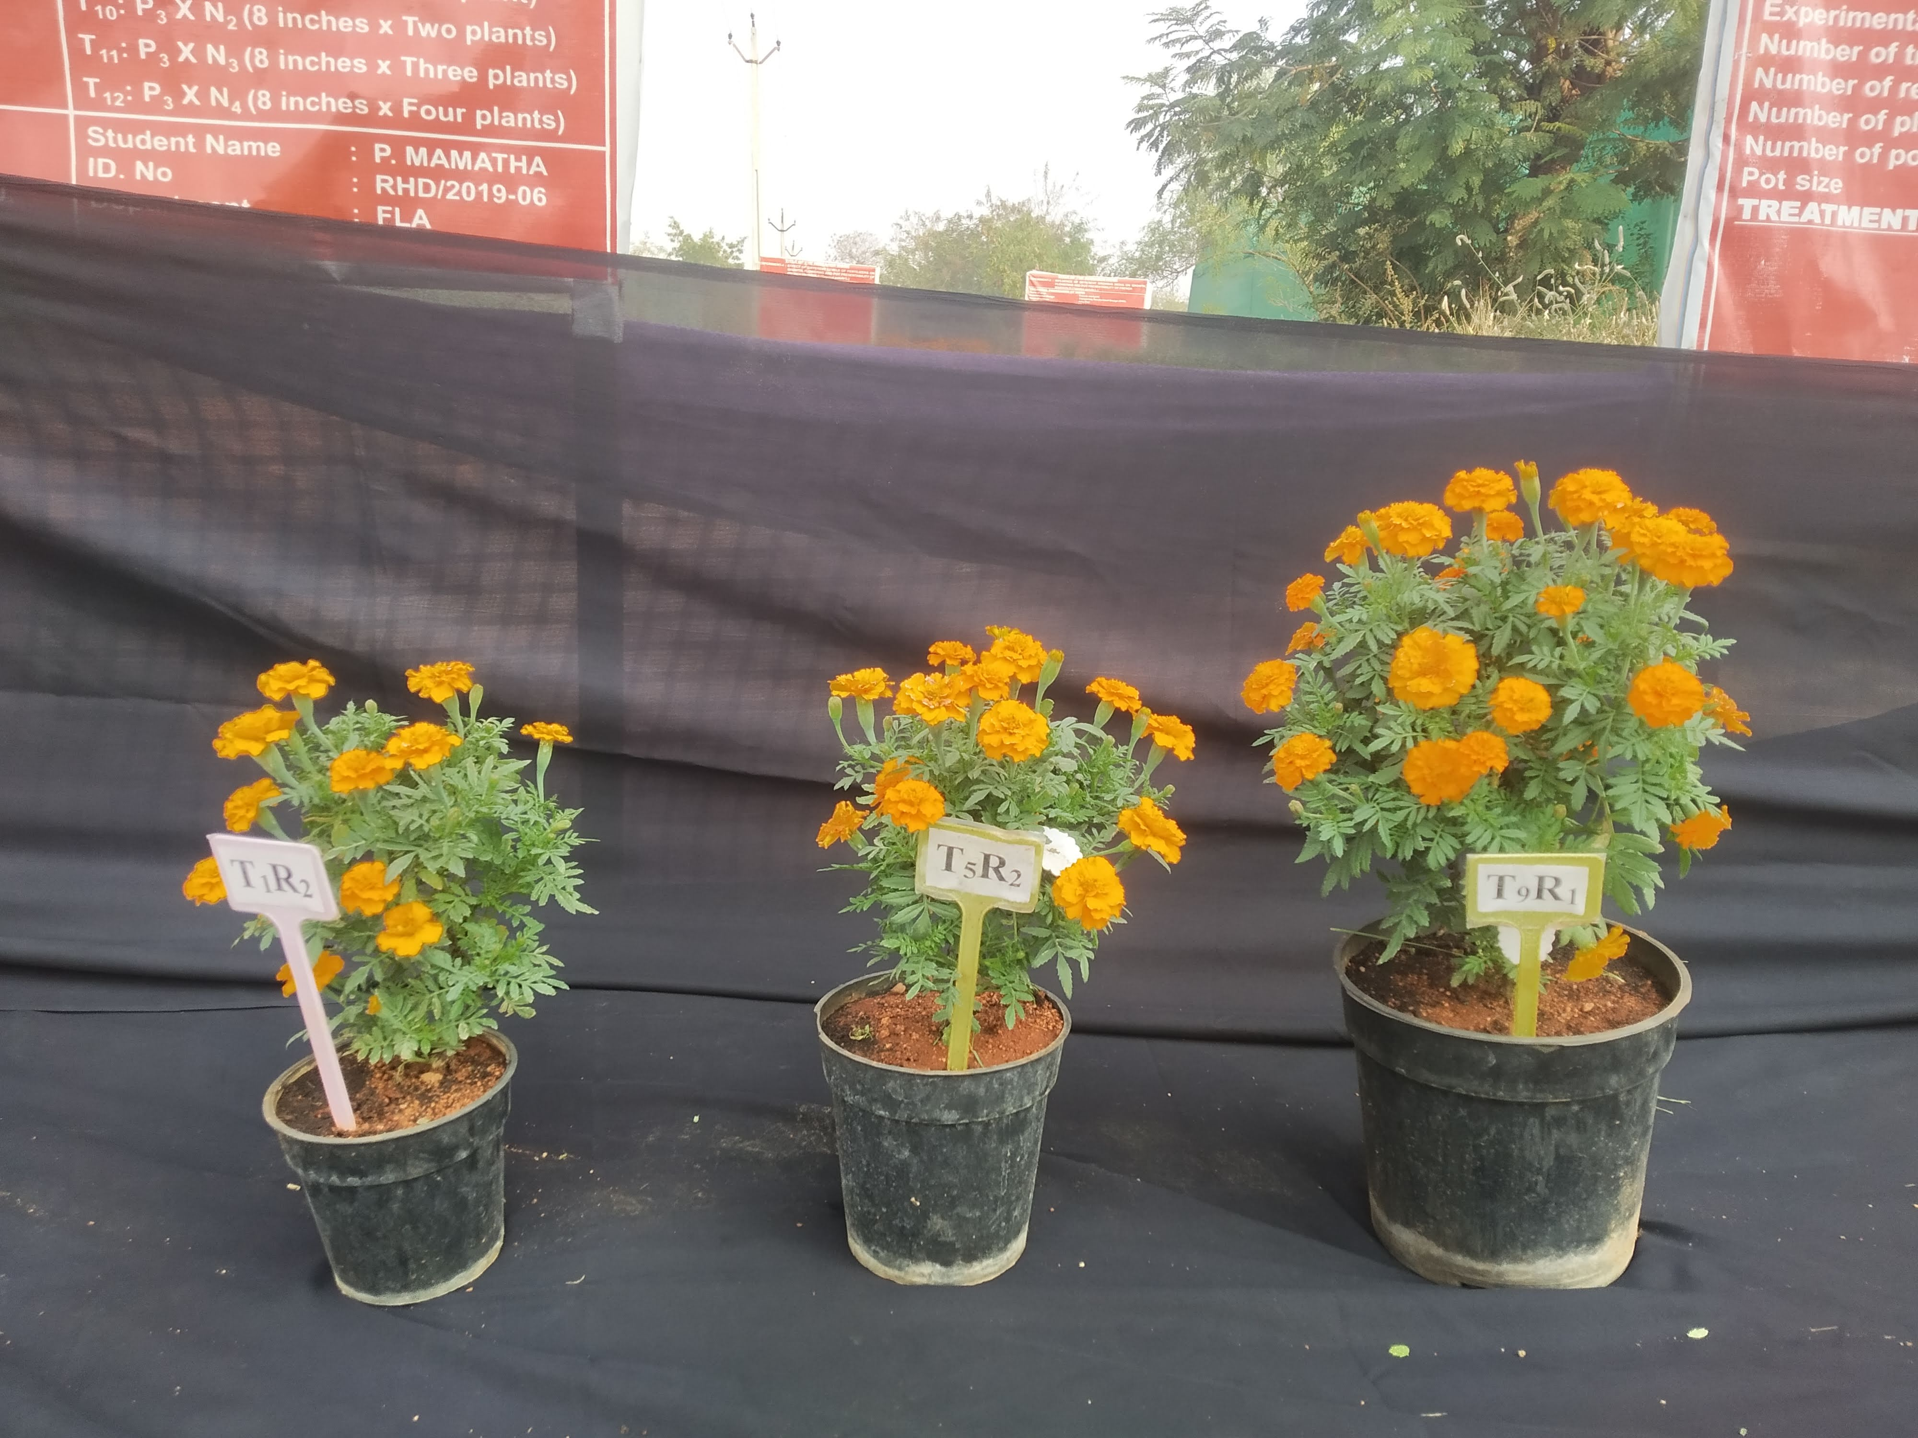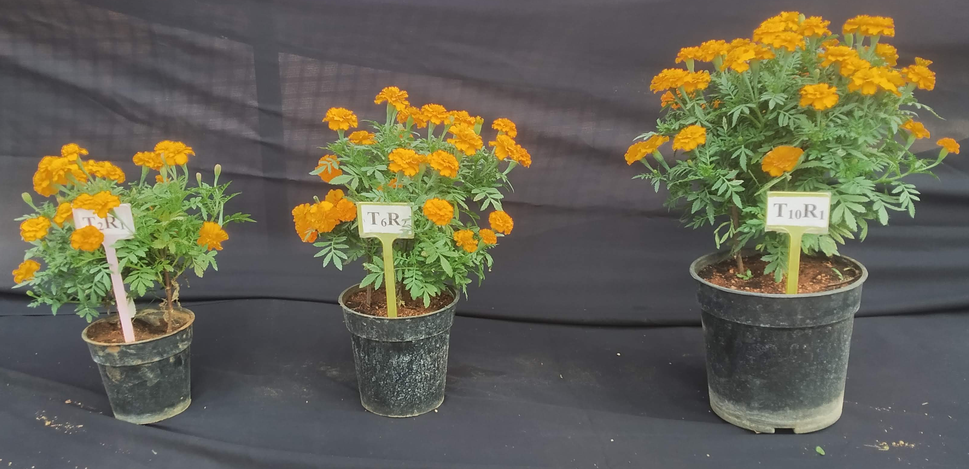
- One plant in 4 inch (T₁), 6 inch (T₅) and 8 inch (T₉) pots B. Two plants in 4 inch (T₂), 6 inch (T₆) and 8 inch (T₁₀) pots

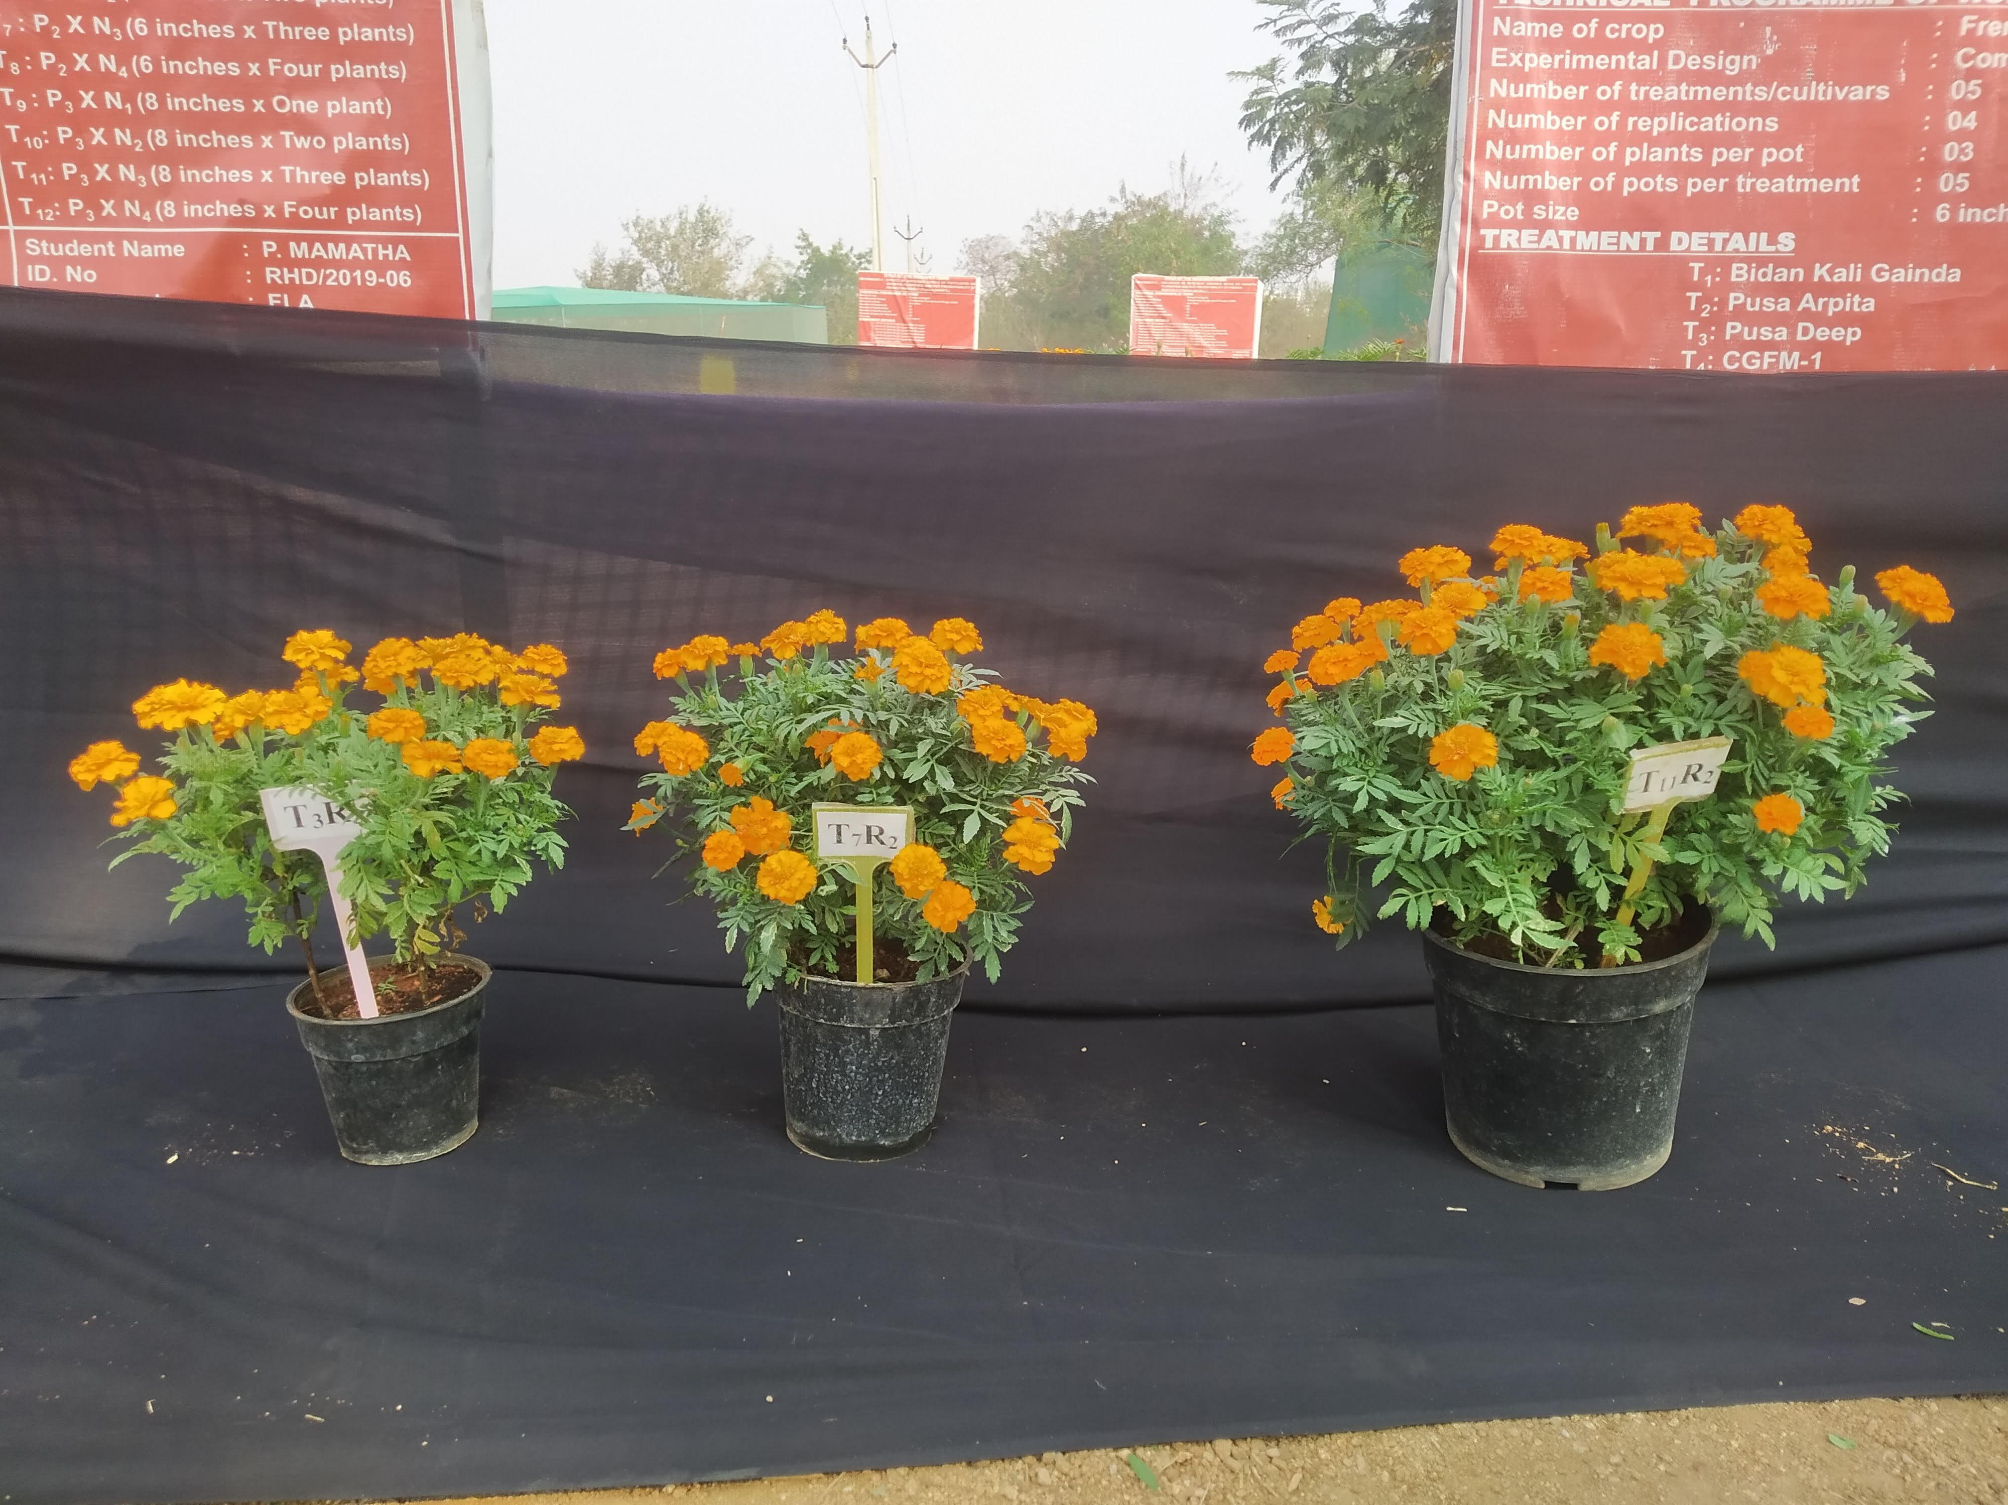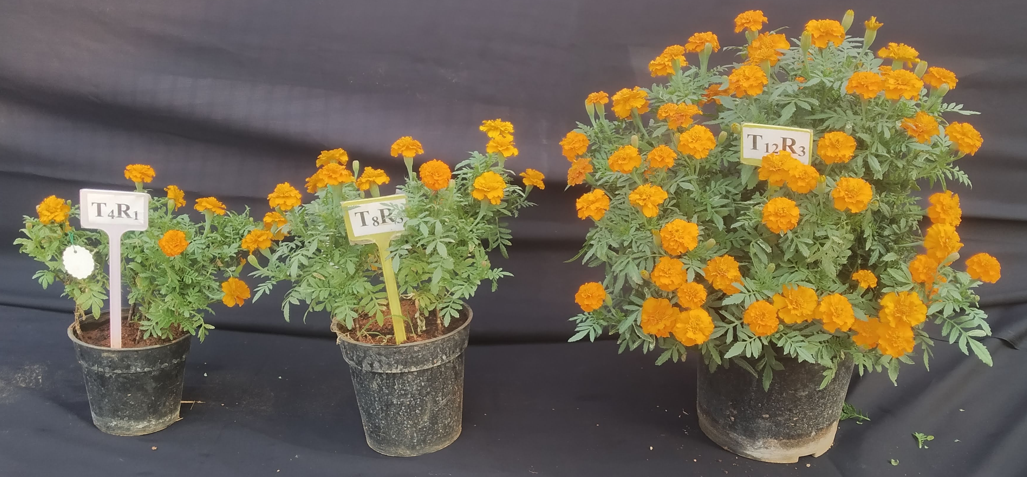
- Three plants in 4 inch (T₃), 6 inch (T₇) and 8 inch (T₁₁) pots D. Four plants in 4 inch (T₄), 6 inch (T₈) and 8 inch (T₁₂) pots
Plate 1. Effect of pot size and number of plants per pot on plant height (cm) of French marigold (Tagetes patula L.) cv. Arka Pari.

T₁ : P₁ x N₁ T₅: P₂ x N₁ T₉: P₃ x N₁
T₂: P₁ x N₂ T₆: P₂ x N₂ T₁₀: P₃ x N₂
T₃: P₁ x N₃ T₇: P₂ x N₃ T₁₁: P₃ x N₃
T₄: P₁ x N₄ T₈: P₂ x N₄ T₁₂: P₃ x N₄

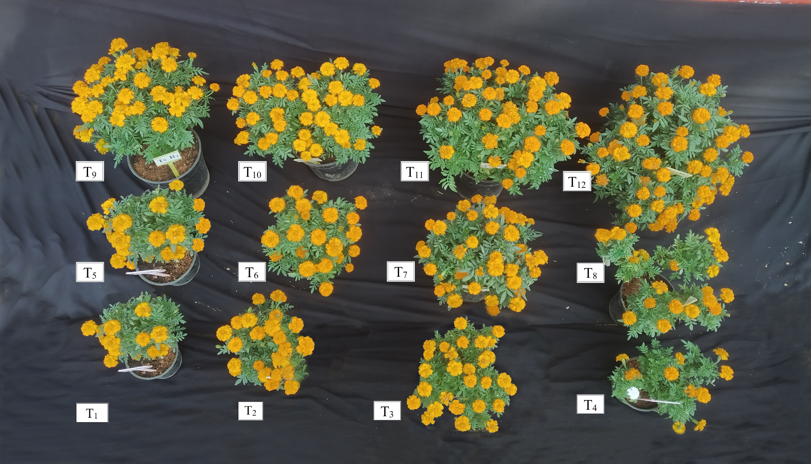
Plate 2. Effect of pot size and number of plants per pot on plant spread (cm²) of French marigold (Tagetes patula L.) cv. Arka Pari
T₁ : P₁ x N₁ T₅: P₂ x N₁ T₉: P₃ x N₁
T₂: P₁ x N₂ T₆: P₂ x N₂ T₁₀: P₃ x N₂
T₃: P₁ x N₃ T₇: P₂ x N₃ T₁₁: P₃ x N₃
T₄: P₁ x N₄ T₈: P₂ x N₄ T₁₂: P₃ x N₄

d) Number of branches
The interaction between pot size and plant density per pot exerted a significant effect on branches production. From the Tables 10, 11. and 12. it was found that the pooled number of branches were maximum in P₃ x N₁:8 inch pot with single plant (8.53, 14.63 and 20.24), which was followed by P₂ x N₁: 6 inch with single plant (7.87) (30 DAT), P₃ x N₂: 8 inch with two plants (13.40 and 18.73) (60 and 90 DAT), and minimum number of branches were recorded in P₁ x N₄: 4 inch pot with four plants (3.87, 5.30 and 9.27) at 30, 60 and 90 DAT. Plants grown at lower densities exhibited a wider root distribution, which provided greater space for vegetative growth and promoted the development of lateral branches compared to plants cultivated at higher densities. As the number of plants per pot increased, the number of branches per plant showed a corresponding decline. The superior performance of plants grown at lower densities may be attributed to reduced inter-plant competition for essential resources such as nutrients, water, and light, which possibly enhanced auxin oxidation in the terminal buds, thereby encouraging lateral branching (Shwetha et al., 2021). Similar findings were reported by Abdulrahman (2011) in stock plants. Furthermore, root restriction imposed by smaller pot sizes adversely affected shoot branching, as limited root space and reduced substrate volume failed to provide optimal growing conditions. Consequently, plants grown in smaller pots produced fewer branches due to constrained root development (Deogade et al., 2020). Results are in conformity with Gupta (2013) in Primula and Dilta et al. (2019) in azaleas.
e) Number of leaves
The interaction effect of different pot sizes and number of plants per pot on number of leaves was found to be significant. From the tables 13, 14. and 15. it was found that the pooled number of leaves were maximum in P₃ x N₁:8 inch pot with single plant (28.90, 55.37 and 83.03) at 30, 60 and 90 DAT which was followed by P₃ x N₂: 8 inch with two plants (26.70 and 51.20) (30 and 60 DAT), P₂ x N₁: 6 inch with single plant (79.13) (90 DAT) and minimum number of leaves were recorded in P₁ x N₄: 4 inch pot with four plants (15.27, 28.10 and 41.23) at 30, 60 and 90 DAT. The maximum number of leaves was observed in plants grown in larger pot sizes at lower planting densities, which may be attributed to enhanced plant height and greater plant spread. The larger pots might completely provide all essential nutrients along with oxygen. The photosynthetic efficacy of plant may be increased due to ample availability of all resources and developed very effectual root system hence produced taller plants with maximum number of leaves. Parallel out comes were noted in Geply et al. (2011) in Jatropa, Al-Meanie et al. (2012) in Nymphea, Alhajhoj (2017) in gladiolus and Tomasi et al. (2024) in cut sunflower.

Table 10. Effect of pot size and number of plants per pot on number of branches at 30 DAT French marigold (Tagetes patula L.) cv. Arka Pari during Rabi 2021-22 and 2022-23.
 | Number of branches at 30 DAT
 | 2021-22 |  |  |  |  |  | 2022-23 |  |  |  |  |  | Pooled
 | N₁ | N₂ | N₃ |  | N₄ | Mean | N₁ | N₂ | N₃ |  | N₄ | Mean | N₁ | N₂ | N₃ |  | N₄ | Mean
P₁ | 5.00 | 4.53 | 4.00 |  | 3.60 | 4.28 | 6.20 | 5.40 | 4.87 |  | 4.13 | 5.15 | 5.60 | 4.97 | 4.43 |  | 3.87 | 4.72
P₂ | 7.73 | 7.00 | 5.80 |  | 4.47 | 6.25 | 8.00 | 7.33 | 6.33 |  | 4.53 | 6.55 | 7.87 | 7.17 | 6.07 |  | 4.50 | 6.40
P₃ | 8.20 | 7.47 | 6.53 |  | 4.87 | 6.77 | 8.87 | 7.73 | 6.60 |  | 5.53 | 7.18 | 8.53 | 7.60 | 6.57 |  | 5.20 | 6.98
Mean | 6.98 | 6.33 | 5.44 |  | 4.31 |  | 7.69 | 6.82 | 5.93 |  | 4.73 |  | 7.33 | 6.58 | 5.69 |  | 4.52
 | SEm± |  |  | CD (P=0.05) |  |  | SEm± |  |  | CD (P=0.05) |  |  | SEm± |  |  | CD (P=0.05)
P | 0.12 |  |  | 0.36 |  |  | 0.12 |  |  | 0.35 |  |  | 0.10 |  |  | 0.29
N | 0.14 |  |  | 0.41 |  |  | 0.14 |  |  | 0.40 |  |  | 0.11 |  |  | 0.33
P X N | 0.24 |  |  | 0.71 |  |  | 0.24 |  |  | 0.70 |  |  | 0.20 |  |  | 0.57
Table 11. Effect of pot size and number of plants per pot on number of branches at 60 DAT of French marigold (Tagetes patula L.) cv. Arka Pari during Rabi 2021-22 and 2022-23.
 | Number of branches at 60 DAT
 | 2021-22 |  |  |  |  |  | 2022-23 |  |  |  |  |  | Pooled
 | N₁ | N₂ | N₃ |  | N₄ | Mean | N₁ | N₂ | N₃ |  | N₄ | Mean | N₁ | N₂ | N₃ |  | N₄ | Mean
P₁ | 10.67 | 9.27 | 7.40 |  | 5.60 | 8.23 | 11.87 | 9.67 | 6.93 |  | 5.00 | 8.37 | 11.27 | 9.47 | 7.17 |  | 5.30 | 8.30
P₂ | 12.40 | 11.60 | 10.60 |  | 9.07 | 10.92 | 12.80 | 11.93 | 11.00 |  | 10.13 | 11.47 | 12.60 | 11.77 | 10.80 |  | 9.60 | 11.19
P₃ | 14.20 | 13.07 | 11.40 |  | 9.53 | 12.05 | 15.07 | 13.73 | 12.67 |  | 10.40 | 12.97 | 14.63 | 13.40 | 12.03 |  | 9.97 | 12.51
Mean | 12.42 | 11.31 | 9.80 |  | 8.07 |  | 13.24 | 11.78 | 10.20 |  | 8.51 |  | 12.83 | 11.54 | 10.00 |  | 8.29
 | SEm± |  |  | CD (P=0.05) |  |  | SEm± |  |  | CD (P=0.05) |  |  | SEm± |  |  | CD (P=0.05)
P | 0.11 |  |  | 0.31 |  |  | 0.14 |  |  | 0.42 |  |  | 0.08 |  |  | 0.24
N | 0.12 |  |  | 0.36 |  |  | 0.17 |  |  | 0.49 |  |  | 0.09 |  |  | 0.28
P X N | 0.22 |  |  | 0.63 |  |  | 0.29 |  |  | 0.85 |  |  | 0.16 |  |  | 0.48
Factor 1: Pot size (P) Factor 2: Number of plants per pot (N) DAT: Days after transplanting
P₁: 4 inch P₂: 6 inch P₃: 8 inch N₁: One plant per pot N₂: Two plants per pot N₃: Three plants per pot N₄: Four plants per pot
Table 12. Effect of pot size and number of plants per pot on number of branches at 90 DAT of French marigold (Tagetes patula L.) cv. Arka Pari during Rabi 2021-22 and 2022-23.
 | Number of branches at 90 DAT
 | 2021-22 |  |  |  |  |  | 2022-23 |  |  |  |  |  | Pooled
 | N₁ | N₂ | N₃ |  | N₄ | Mean | N₁ | N₂ | N₃ |  | N₄ | Mean | N₁ | N₂ | N₃ |  | N₄ | Mean
P₁ | 15.13 | 13.73 | 11.93 |  | 8.93 | 12.43 | 16.67 | 14.53 | 12.93 |  | 9.60 | 13.43 | 15.90 | 14.13 | 12.43 |  | 9.27 | 12.93
P₂ | 18.07 | 17.33 | 15.40 |  | 14.13 | 16.23 | 19.07 | 17.67 | 15.73 |  | 14.80 | 16.82 | 18.57 | 17.50 | 15.57 |  | 14.47 | 16.53
P₃ | 19.00 | 17.53 | 16.47 |  | 13.93 | 16.73 | 21.48 | 19.93 | 17.73 |  | 14.40 | 18.39 | 20.24 | 18.73 | 17.10 |  | 14.17 | 17.56
Mean | 17.40 | 16.20 | 14.60 |  | 12.33 |  | 19.07 | 17.38 | 15.47 |  | 12.93 |  | 18.24 | 16.79 | 15.03 |  | 12.63
 | SEm± |  |  | CD (P=0.05) |  |  | SEm± |  |  | CD (P=0.05) |  |  | SEm± |  |  | CD (P=0.05)
P | 0.15 |  |  | 0.44 |  |  | 0.17 |  |  | 0.49 |  |  | 0.12 |  |  | 0.36
N | 0.18 |  |  | 0.51 |  |  | 0.20 |  |  | 0.57 |  |  | 0.14 |  |  | 0.42
P X N | 0.30 |  |  | 0.89 |  |  | 0.34 |  |  | 0.99 |  |  | 0.25 |  |  | 0.73
Table 13. Effect of pot size and number of plants per pot on number of leaves at 30 DAT of French marigold (Tagetes patula L.) cv. Arka Pari during Rabi 2021-22 and 2022-23.
 | Number of leaves at 30 DAT
 | 2021-22 |  |  |  |  |  | 2022-23 |  |  |  |  |  | Pooled
 | N₁ | N₂ | N₃ |  | N₄ | Mean | N₁ | N₂ | N₃ |  | N₄ | Mean | N₁ | N₂ | N₃ |  | N₄ | Mean
P₁ | 20.53 | 18.07 | 16.80 |  | 14.93 | 17.58 | 21.33 | 18.47 | 17.80 |  | 15.60 | 18.30 | 20.93 | 18.27 | 17.30 |  | 15.27 | 17.94
P₂ | 24.67 | 23.40 | 19.87 |  | 17.33 | 21.32 | 24.93 | 23.73 | 20.53 |  | 18.33 | 21.88 | 24.80 | 23.57 | 20.20 |  | 17.83 | 21.60
P₃ | 28.60 | 26.27 | 23.73 |  | 19.47 | 24.52 | 29.20 | 27.13 | 24.33 |  | 20.80 | 25.37 | 28.90 | 26.70 | 24.03 |  | 20.13 | 24.94
Mean | 24.60 | 22.58 | 20.13 |  | 17.24 |  | 25.16 | 23.11 | 20.89 |  | 18.24 |  | 24.88 | 22.84 | 20.51 |  | 17.74
 | SEm± |  |  | CD (P=0.05) |  |  | SEm± |  |  | CD (P=0.05) |  |  | SEm± |  |  | CD (P=0.05)
P | 0.12 |  |  | 0.35 |  |  | 0.23 |  |  | 0.67 |  |  | 0.15 |  |  | 0.67
N | 0.14 |  |  | 0.41 |  |  | 0.26 |  |  | 0.77 |  |  | 0.17 |  |  | 0.77
P X N | 0.24 |  |  | 0.71 |  |  | 0.46 |  |  | 1.34 |  |  | 0.30 |  |  | 1.34
Factor 1: Pot size (P) Factor 2: Number of plants per pot (N) DAT: Days after transplanting
P₁: 4 inch P₂: 6 inch P₃: 8 inch N₁: One plant per pot N₂: Two plants per pot N₃: Three plants per pot N₄: Four plants per pot
Table 14. Effect of pot size and number of plants per pot on number of leaves at 60 DAT of French marigold (Tagetes patula L.) cv. Arka Pari during Rabi 2021-22 and 2022-23.
 | Number of leaves at 60 DAT
 | 2021-22 |  |  |  |  |  | 2022-23 |  |  |  |  |  | Pooled
 | N₁ | N₂ | N₃ |  | N₄ | Mean | N₁ | N₂ | N₃ |  | N₄ | Mean | N₁ | N₂ | N₃ |  | N₄ | Mean
P₁ | 40.00 | 36.47 | 30.80 |  | 28.80 | 34.02 | 41.27 | 37.93 | 30.93 |  | 27.40 | 34.38 | 40.63 | 37.20 | 30.87 |  | 28.10 | 34.20
P₂ | 49.60 | 46.07 | 41.10 |  | 34.47 | 42.81 | 49.47 | 46.87 | 42.33 |  | 33.33 | 43.00 | 49.53 | 46.47 | 41.72 |  | 33.90 | 42.90
P₃ | 54.60 | 50.47 | 45.20 |  | 38.13 | 47.10 | 56.13 | 51.93 | 46.75 |  | 39.00 | 48.45 | 55.37 | 51.20 | 45.97 |  | 38.57 | 47.78
Mean | 48.07 | 44.33 | 39.03 |  | 33.80 |  | 48.96 | 45.58 | 40.00 |  | 33.24 |  | 48.51 | 44.96 | 39.52 |  | 33.52
 | SEm± |  |  | CD (P=0.05) |  |  | SEm± |  |  | CD (P=0.05) |  |  | SEm± |  |  | CD (P=0.05)
P | 0.24 |  |  | 0.70 |  |  | 0.19 |  |  | 0.56 |  |  | 0.13 |  |  | 0.39
N | 0.28 |  |  | 0.81 |  |  | 0.22 |  |  | 0.64 |  |  | 0.16 |  |  | 0.45
P X N | 0.48 |  |  | 1.40 |  |  | 0.38 |  |  | 1.11 |  |  | 0.27 |  |  | 0.79
Table 15. Effect of pot size and number of plants per pot on number of leaves at 90 DAT of French marigold (Tagetes patula L.) cv. Arka Pari during Rabi 2021-22 and 2022-23.
 | Number of leaves at 90 DAT
 | 2021-22 |  |  |  |  |  | 2022-23 |  |  |  |  |  | Pooled
 | N₁ | N₂ | N₃ |  | N₄ | Mean | N₁ | N₂ | N₃ |  | N₄ | Mean | N₁ | N₂ | N₃ |  | N₄ | Mean
P₁ | 62.80 | 56.20 | 48.93 |  | 41.33 | 52.32 | 63.27 | 57.53 | 50.47 |  | 41.13 | 53.10 | 63.03 | 56.87 | 49.70 |  | 41.23 | 52.71
P₂ | 78.80 | 70.73 | 64.80 |  | 47.13 | 65.37 | 79.47 | 70.75 | 65.73 |  | 49.27 | 66.30 | 79.13 | 70.74 | 65.27 |  | 48.20 | 65.84
P₃ | 82.33 | 76.13 | 69.47 |  | 62.00 | 72.48 | 83.73 | 77.40 | 70.80 |  | 62.87 | 73.70 | 83.03 | 76.77 | 70.13 |  | 62.43 | 73.09
Mean | 74.64 | 67.69 | 61.07 |  | 50.16 |  | 75.49 | 68.56 | 62.33 |  | 51.09 |  | 75.07 | 68.12 | 61.70 |  | 50.62
 | SEm± |  |  | CD (P=0.05) |  |  | SEm± |  |  | CD (P=0.05) |  |  | SEm± |  |  | CD (P=0.05)
P | 0.31 |  |  | 0.90 |  |  | 0.30 |  |  | 0.86 |  |  | 0.22 |  |  | 0.65
N | 0.36 |  |  | 1.04 |  |  | 0.34 |  |  | 1.00 |  |  | 0.26 |  |  | 0.75
P X N | 0.62 |  |  | 1.81 |  |  | 0.59 |  |  | 1.72 |  |  | 0.44 |  |  | 1.29

Factor 1: Pot size (P) Factor 2: Number of plants per pot (N) DAT: Days after transplanting
P₁: 4 inch P₂: 6 inch P₃: 8 inch N₁: One plant per pot N₂: Two plants per pot N₃: Three plants per pot N₄: Four plants per pot

f) Stem diameter (mm)
The interaction between pot size and number of plants per pot significantly influenced stem diameter. From the Tables 16, 17 and 18. it was found that the pooled stem diameter was maximum in P₃ x N₁:8 inch pot with single plant (7.45, 8.64 and 9.56 mm) which was followed P₂ x N₁: 6 inch with single plant (6.82, 7.89 and 8.66 cm) and minimum stem diameter was recorded in P₁ x N₄: 4 inch pot with four plants (2.32, 3.07 and 4.51 cm) at 30, 60 and 90 DAT respectively. The lowest plant density (one plant per pot) produced the maximum stem thickness, which may be associated to more robust and healthy plant growth because of the increased space and resource availability that produced thicker stems. Similar trend was observed by Khalaj et al. (2012) in tuberose and Shwetha et al. (2021) in zinnia. Stem diameter in 8-inch pots was maximum, this might be due to rapid multiplication in vascular bundles due to higher absorption of nutrients and rapid cell division in xylem and phloem. Similar results are observed in Sanjay (2021) in costus and Tomasi et al. (2024) in cut sunflower.
g) Chlorophyll (SPAD)
The interaction effect of different pot size and number of plants per pot on chlorophyll was found to be significant. From the tables 19, 20 and 21. it was found that the pooled chlorophyll (SPAD) meter values were maximum in P₃ x N₁:8 inch pot with single plant (70.11, 57.76 and 51.95) at 30, 60 and 90 DAT, which was followed P₂ x N₁: 6 inch with single plant (67.44 and 47.80) at 30 and 90 DAT, P₃ x N₂: 8 inch with two plants (55.00) at 60 DAT and minimum SPAD values were recorded in P₁ x N₄: 4 inch pot with four plants (48.26, 32.62 and 21.19) at 30, 60 and 90 DAT respectively. Plants grown in larger container sizes maintained significantly higher chlorophyll content compared to those cultivated in smaller containers. Restricted root growth in smaller pots can lead to physiological imbalances, including disruptions in transpiration, stomatal function, and chlorophyll synthesis. These effects may be associated with internal water stress resulting from limited water availability and poor water release from the growing medium. An increase in pot size was consistently associated with higher chlorophyll content. The highest chlorophyll levels were observed in plants grown in large pots with a single plant, which can be attributed to greater availability of nutrients and moisture, as well as sufficient space for root and shoot development. Similar findings were reported by NeSmith et al. (1992), who observed that reduced rooting volume led to a decline in leaf photosynthetic rate accompanied by decreased chlorophyll content.

Table 16. Effect of pot size and number of plants per pot on stem diameter (mm) at 30 DAT of French marigold (Tagetes patula L.) cv. Arka Pari during Rabi 2021-22 and 2022-23.
 | Stem diameter (mm) at 30 DAT
 | 2021-22 |  |  |  |  |  | 2022-23 |  |  |  |  |  | Pooled
 | N₁ | N₂ | N₃ |  | N₄ | Mean | N₁ | N₂ | N₃ |  | N₄ | Mean | N₁ | N₂ | N₃ |  | N₄ | Mean
P₁ | 4.11 | 3.65 | 3.04 |  | 2.21 | 3.25 | 4.97 | 3.95 | 3.35 |  | 2.42 | 3.68 | 4.54 | 3.80 | 3.20 |  | 2.32 | 3.46
P₂ | 6.79 | 5.67 | 4.91 |  | 3.34 | 5.18 | 6.85 | 5.85 | 5.17 |  | 3.75 | 5.40 | 6.82 | 5.76 | 5.04 |  | 3.54 | 5.29
P₃ | 7.11 | 6.23 | 5.74 |  | 4.09 | 5.79 | 7.78 | 6.73 | 5.75 |  | 4.02 | 6.07 | 7.45 | 6.48 | 5.75 |  | 4.06 | 5.93
Mean | 6.01 | 5.18 | 4.56 |  | 3.21 |  | 6.53 | 5.51 | 4.76 |  | 3.40 |  | 6.27 | 5.35 | 4.66 |  | 3.31
 | SEm± |  |  | CD (P=0.05) |  |  | SEm± |  |  | CD (P=0.05) |  |  | SEm± |  |  | CD (P=0.05)
P | 0.06 |  |  | 0.18 |  |  | 0.07 |  |  | 0.20 |  |  | 0.05 |  |  | 0.14
N | 0.07 |  |  | 0.21 |  |  | 0.08 |  |  | 0.23 |  |  | 0.06 |  |  | 0.17
P X N | 0.12 |  |  | 0.36 |  |  | 0.14 |  |  | 0.40 |  |  | 0.10 |  |  | 0.29
Table 17. Effect of pot size and number of plants per pot on stem diameter (mm) at 60 DAT of French marigold (Tagetes patula L.) cv. Arka Pari during Rabi 2021-22 and 2022-23.
 | Stem diameter (mm) at 60 DAT
 | 2021-22 |  |  |  |  |  | 2022-23 |  |  |  |  |  | Pooled
 | N₁ | N₂ | N₃ |  | N₄ | Mean | N₁ | N₂ | N₃ |  | N₄ | Mean | N₁ | N₂ | N₃ |  | N₄ | Mean
P₁ | 5.70 | 4.93 | 4.17 |  | 3.18 | 4.50 | 5.99 | 5.04 | 5.33 |  | 2.97 | 4.83 | 5.84 | 4.99 | 4.75 |  | 3.07 | 4.66
P₂ | 7.83 | 6.93 | 6.24 |  | 4.01 | 6.25 | 7.96 | 7.05 | 6.31 |  | 4.14 | 6.37 | 7.89 | 6.99 | 6.28 |  | 4.08 | 6.31
P₃ | 8.45 | 7.50 | 6.25 |  | 5.03 | 6.81 | 8.83 | 7.51 | 6.70 |  | 5.43 | 7.12 | 8.64 | 7.51 | 6.48 |  | 5.23 | 6.96
Mean | 7.33 | 6.45 | 5.55 |  | 4.08 |  | 7.59 | 6.53 | 6.11 |  | 4.18 |  | 7.46 | 6.49 | 5.83 |  | 4.13
 | SEm± |  |  | CD (P=0.05) |  |  | SEm± |  |  | CD (P=0.05) |  |  | SEm± |  |  | CD (P=0.05)
P | 0.06 |  |  | 0.19 |  |  | 0.07 |  |  | 0.21 |  |  | 0.05 |  |  | 0.16
N | 0.07 |  |  | 0.22 |  |  | 0.08 |  |  | 0.24 |  |  | 0.06 |  |  | 0.18
P X N | 0.13 |  |  | 0.38 |  |  | 0.14 |  |  | 0.42 |  |  | 0.11 |  |  | 0.31
Factor 1: Pot size (P) Factor 2: Number of plants per pot (N) DAT: Days after transplanting
P₁: 4 inch P₂: 6 inch P₃: 8 inch N₁: One plant per pot N₂: Two plants per pot N₃: Three plants per pot N₄: Four plants per pot
Table 18. Effect of pot size and number of plants per pot on stem diameter (mm) at 90 DAT of French marigold (Tagetes patula L.) cv. Arka Pari during Rabi 2021-22 and 2022-23.
 | Stem diameter(mm) at 90 DAT
 | 2021-22 |  |  |  |  |  | 2022-23 |  |  |  |  |  | Pooled
 | N₁ | N₂ | N₃ |  | N₄ | Mean | N₁ | N₂ | N₃ |  | N₄ | Mean | N₁ | N₂ | N₃ |  | N₄ | Mean
P₁ | 6.99 | 6.27 | 5.47 |  | 4.35 | 5.77 | 7.03 | 6.39 | 5.62 |  | 4.66 | 5.93 | 7.01 | 6.33 | 5.55 |  | 4.51 | 5.85
P₂ | 8.53 | 7.85 | 7.10 |  | 5.34 | 7.21 | 8.80 | 7.86 | 7.36 |  | 5.85 | 7.47 | 8.66 | 7.86 | 7.23 |  | 5.60 | 7.34
P₃ | 9.25 | 8.52 | 7.22 |  | 6.22 | 7.80 | 9.87 | 8.46 | 7.59 |  | 6.79 | 8.18 | 9.56 | 8.49 | 7.40 |  | 6.51 | 7.99
Mean | 8.26 | 7.55 | 6.60 |  | 5.31 |  | 8.57 | 7.57 | 6.86 |  | 5.76 |  | 8.41 | 7.56 | 6.73 |  | 5.54
 | SEm± |  |  | CD (P=0.05) |  |  | SEm± |  |  | CD (P=0.05) |  |  | SEm± |  |  | CD (P=0.05)
P | 0.06 |  |  | 0.18 |  |  | 0.08 |  |  | 0.23 |  |  | 0.05 |  |  | 0.14
N | 0.07 |  |  | 0.21 |  |  | 0.09 |  |  | 0.26 |  |  | 0.05 |  |  | 0.16
P X N | 0.13 |  |  | 0.37 |  |  | 0.16 |  |  | 0.46 |  |  | 0.09 |  |  | 0.27
Table 19. Effect of pot size and number of plants per pot on chlorophyll (SPAD) at 30 DAT of French marigold (Tagetes patula L.) cv. Arka Pari during Rabi 2021-22 and 2022-23.
 | Chlorophyll (SPAD) at 30 DAT
 | 2021-22 |  |  |  |  |  | 2022-23 |  |  |  |  |  |  | Pooled
 | N₁ | N₂ | N₃ |  | N₄ | Mean | N₁ | N₂ | N₃ |  | N₄ | Mean | N₁ |  | N₂ | N₃ |  | N₄ | Mean
P₁ | 58.06 | 55.54 | 51.51 |  | 48.36 | 53.37 | 60.95 | 56.79 | 50.86 |  | 48.17 | 54.19 | 59.50 |  | 56.17 | 51.18 |  | 48.26 | 53.78
P₂ | 66.91 | 64.91 | 60.54 |  | 55.47 | 61.96 | 67.97 | 65.42 | 61.26 |  | 55.25 | 62.47 | 67.44 |  | 65.17 | 60.90 |  | 55.36 | 62.22
P₃ | 69.63 | 65.77 | 63.90 |  | 61.10 | 65.10 | 70.58 | 66.15 | 62.89 |  | 60.28 | 64.98 | 70.11 |  | 65.96 | 63.40 |  | 60.69 | 65.04
Mean | 64.87 | 62.07 | 58.65 |  | 54.98 |  | 66.50 | 62.79 | 58.34 |  | 54.56 |  | 65.68 |  | 62.43 | 58.49 |  | 54.77
 | SEm± |  |  | CD (P=0.05) |  |  | SEm± |  |  | CD (P=0.05) |  |  |  | SEm± |  |  | CD (P=0.05)
P | 0.26 |  |  | 0.76 |  |  | 0.21 |  |  | 0.60 |  |  |  | 0.16 |  |  | 0.46
N | 0.30 |  |  | 0.87 |  |  | 0.24 |  |  | 0.70 |  |  |  | 0.18 |  |  | 0.53
P X N | 0.52 |  |  | 1.51 |  |  | 0.41 |  |  | 1.21 |  |  |  | 0.31 |  |  | 0.92
Factor 1: Pot size (P) Factor 2: Number of plants per pot (N) DAT: Days after transplanting
P₁: 4 inch P₂: 6 inch P₃: 8 inch N₁: One plant per pot N₂: Two plants per pot N₃: Three plants per pot N₄: Four plants per pot
Table 20. Effect of pot size and number of plants per pot on chlorophyll (SPAD) at 60 DAT of French marigold (Tagetes patula L.) cv. Arka Pari during Rabi 2021-22 and 2022-23.
 | Chlorophyll (SPAD) at 60 DAT
 | 2021-22 |  |  |  |  | 2022-23 |  |  |  |  | Pooled
 | N₁ | N₂ | N₃ | N₄ | Mean | N₁ | N₂ | N₃ | N₄ | Mean | N₁ | N₂ | N₃ |  | N₄ | Mean
P₁ | 42.02 | 39.13 | 37.55 | 32.91 | 37.90 | 43.01 | 38.27 | 37.58 | 32.33 | 37.80 | 42.51 | 38.70 | 37.57 |  | 32.62 | 37.85
P₂ | 54.39 | 50.87 | 48.27 | 43.31 | 49.21 | 55.13 | 51.89 | 49.15 | 43.37 | 49.89 | 54.76 | 51.38 | 48.71 |  | 43.34 | 49.55
P₃ | 57.35 | 54.77 | 51.03 | 47.82 | 52.74 | 58.17 | 55.23 | 50.96 | 45.41 | 52.44 | 57.76 | 55.00 | 51.00 |  | 47.17 | 52.73
Mean | 51.25 | 48.26 | 45.62 | 41.34 |  | 52.10 | 48.46 | 45.90 | 40.37 |  | 51.68 | 48.36 | 45.76 |  | 41.04
 | SEm± |  | CD (P=0.05) |  |  | SEm± |  | CD (P=0.05) |  |  | SEm± |  |  | CD (P=0.05)
P | 0.19 |  | 0.54 |  |  | 0.25 |  | 0.74 |  |  | 0.18 |  |  | 0.51
N | 0.21 |  | 0.62 |  |  | 0.29 |  | 0.85 |  |  | 0.20 |  |  | 0.59
P X N | 0.37 |  | 1.08 |  |  | 0.50 |  | 1.47 |  |  | 0.35 |  |  | 1.03
Table 21. Effect of pot size and number of plants per pot on chlorophyll (SPAD) at 90 DAT French marigold (Tagetes patula L.) cv. Arka Pari during Rabi 2021-22 and 2022-23.
 | Chlorophyll (SPAD) at 90 DAT
 | 2021-22 |  |  |  |  |  | 2022-23 |  |  |  |  |  | Pooled
 | N₁ | N₂ | N₃ |  | N₄ | Mean | N₁ | N₂ | N₃ |  | N₄ | Mean | N₁ | N₂ | N₃ |  | N₄ | Mean
P₁ | 36.73 | 32.10 | 26.63 |  | 21.09 | 29.14 | 35.98 | 32.94 | 25.78 |  | 21.28 | 29.00 | 36.36 | 32.52 | 26.21 |  | 21.19 | 29.07
P₂ | 47.68 | 42.78 | 39.70 |  | 32.07 | 40.56 | 47.93 | 41.16 | 39.61 |  | 31.09 | 39.95 | 47.80 | 41.97 | 39.66 |  | 31.58 | 40.25
P₃ | 51.05 | 45.89 | 40.48 |  | 36.83 | 43.56 | 52.84 | 45.02 | 41.89 |  | 37.03 | 44.20 | 51.95 | 45.45 | 41.18 |  | 36.93 | 43.88
Mean | 45.15 | 40.26 | 35.60 |  | 30.00 |  | 45.58 | 39.71 | 35.76 |  | 29.80 |  | 45.37 | 39.98 | 35.68 |  | 29.90
 | SEm± |  |  | CD (P=0.05) |  |  | SEm± |  |  | CD (P=0.05) |  |  | SEm± |  |  | CD (P=0.05)
P | 0.26 |  |  | 0.75 |  |  | 0.24 |  |  | 0.69 |  |  | 0.18 |  |  | 0.53
N | 0.30 |  |  | 0.87 |  |  | 0.27 |  |  | 0.80 |  |  | 0.21 |  |  | 0.61
P X N | 0.51 |  |  | 1.50 |  |  | 0.48 |  |  | 1.39 |  |  | 0.36 |  |  | 1.06
Factor 1: Pot size (P) Factor 2: Number of plants per pot (N) DAT: Days after transplanting
P₁: 4 inch P₂: 6 inch P₃: 8 inch N₁: One plant per pot N₂: Two plants per pot N₃: Three plants per pot N₄: Four plants per pot

II) Flowering parameters
- Number of days taken for first flower bud initiation
Pooled data of two seasons, indicated that P₁ (4-inch pot) required the least time for flower bud initiation, (28.45 days), followed by P₂: 6-inch pot (30.46 days) and maximum with pot size P₃: 8-inch (32.53 days). With respect to plant density per pot, pooled number of days taken for flower bud initiation were recorded minimum with N₄: four plants (27.22 days), followed by N₃: three plants (30.37 days), N₂: two plants (31.80 days) maximum with N₁: one plant (32.53 days). The interaction effect of different pot size and number of plants per pot on number of days taken for flower bud initiation was found to be non-significant. There were notable differences between various pot sizes for this parameter. Days to flower bud formation increases linearly with pot size. This was primarily because plants grown in large containers exhibited more vegetative growth, which took longer time to develop into reproductive buds. Consequently, flower bud production was delayed. Findings are in line with Carvalho et al. (2008) in Kalanchoe, Suman (2014) in azaleas, Deogade et al. (2020) in calendula. There were prominent differences between various plant density on number of days taken for flower bud formation. Higher planting densities caused plants to become less vigorous and attempted to reach their reproductive stage earlier because there was more competition among the plants for nutrients, moisture in the soil, and sunlight etc. The results are parallel to the findings of Bhargav et al. (2016) in China aster.
- Number of days taken for flower bud opening
Pooled number of days taken for flower bud opening were recorded minimum in P₁: 4-inch pot (34.73 days), followed by P₂: 6-inch pot (37.26 days) and maximum with pot size P₃: 8-inch (40.45 days). With respect to plant density per pot, pooled number of days taken for flower bud initiation were recorded minimum with N₄: four plants (33.58 days), followed by N₃: three plants (37.82 days), N₂: two plants (38.73 days) maximum with N1: one plant (39.78 days). The interaction effect of different pot size and number of plants per pot on number of days taken for flower bud opening was found to be non-significant. Significant difference was noticed among different pot size and also among different plant densities on number of days taken for flower bud opening. Days for flower bud formation to flower bud opening depends on so many factors like light, temperature, nutrients etc., Time required for flower bud opening also depends on flower diameter, larger flowers may take greater time when compared to smaller flowers. Minimum days taken for flower bud opening in small pots might be due to the reason that the plants grown in smaller pots failed to put up vigorous vegetative growth and as a result there was early induction and also early opening of flower bud (Deogade et al. 2020 in calendula). Similar results were reported by Gupta (2013) in primula and Suman (2014) in azaleas.

Table 22. Effect of pot size and number of plants per pot on the number of days taken for flower bud initiation (days) in French marigold (Tagetes patula L.) cv. Arka Pari during Rabi 2021-22 and 2022-23.
 | Number of days taken for flower bud initiation (days)
 | 2021-22 |  |  |  |  | 2022-23 |  |  |  |  | Pooled
 | N₁ | N₂ | N₃ | N₄ | Mean | N₁ | N₂ | N₃ | N₄ | Mean | N₁ | N₂ | N₃ |  | N₄ | Mean
P₁ | 30.00 | 29.60 | 28.33 | 25.00 | 28.23 | 30.40 | 29.73 | 28.40 | 26.13 | 28.67 | 30.20 | 29.67 | 28.37 |  | 25.57 | 28.45
P₂ | 32.33 | 31.60 | 30.13 | 26.93 | 30.25 | 32.67 | 31.93 | 30.80 | 27.27 | 30.67 | 32.50 | 31.77 | 30.47 |  | 27.10 | 30.46
P₃ | 34.87 | 33.87 | 31.93 | 28.93 | 32.40 | 34.93 | 34.07 | 32.60 | 29.07 | 32.67 | 34.90 | 33.97 | 32.27 |  | 29.00 | 32.53
Mean | 32.40 | 31.69 | 30.13 | 26.96 |  | 32.67 | 31.91 | 30.60 | 27.49 |  | 32.53 | 31.80 | 30.37 |  | 27.22
 | SEm± |  | CD (P=0.05) |  | SIG | SEm± |  | CD (P=0.05) |  | SIG | SEm± |  |  | CD (P=0.05) |  | SIG
P | 0.22 |  | 0.65 |  | S | 0.27 |  | 0.78 |  | S | 0.23 |  |  | 0.67 |  | S
N | 0.26 |  | 0.76 |  | S | 0.31 |  | 0.90 |  | S | 0.27 |  |  | 0.78 |  | S
P X N | 0.45 |  | 1.31 |  | NS | 0.53 |  | 1.56 |  | NS | 0.46 |  |  | 1.34 |  | NS
Table 23. Effect of pot size and number of plants per pot on the number of days taken for flower bud opening (days) in French marigold (Tagetes patula L.) cv. Arka Pari during Rabi 2021-22 and 2022-23.
 | Number of days taken for flower bud opening (days)
 | 2021-22 |  |  |  |  | 2022-23 |  |  |  |  | Pooled
 | N₁ | N₂ | N₃ | N₄ | Mean | N₁ | N₂ | N₃ | N₄ | Mean | N₁ | N₂ | N₃ |  | N₄ | Mean
P₁ | 36.73 | 35.53 | 34.80 | 31.00 | 34.52 | 37.00 | 36.00 | 35.00 | 31.73 | 34.93 | 36.87 | 35.77 | 34.90 |  | 31.37 | 34.73
P₂ | 39.13 | 38.20 | 37.33 | 33.00 | 36.92 | 39.60 | 38.87 | 37.87 | 34.07 | 37.60 | 39.37 | 38.53 | 37.60 |  | 33.53 | 37.26
P₃ | 42.93 | 41.60 | 40.93 | 35.27 | 40.18 | 43.27 | 42.20 | 41.00 | 36.40 | 40.72 | 43.10 | 41.90 | 40.97 |  | 35.83 | 40.45
Mean | 39.60 | 38.44 | 37.69 | 33.09 |  | 39.96 | 39.02 | 37.96 | 34.07 |  | 39.78 | 38.73 | 37.82 |  | 33.58
 | SEm± |  | CD (P=0.05) |  | SIG | SEm± |  | CD (P=0.05) |  | SIG | SEm± |  |  | CD (P=0.05) |  | SIG
P | 0.20 |  | 0.57 |  | S | 0.25 |  | 0.73 |  | S | 0.22 |  |  | 0.63 |  | S
N | 0.23 |  | 0.66 |  | S | 0.29 |  | 0.84 |  | S | 0.25 |  |  | 0.73 |  | S
P X N | 0.39 |  | 1.15 |  | NS | 0.50 |  | 1.46 |  | NS | 0.43 |  |  | 1.27 |  | NS
Factor 1: Pot size (P) Factor 2: Number of plants per pot (N) DAT: Days after transplanting
P₁: 4 inch P₂: 6 inch P₃: 8 inch N₁: One plant per pot N₂: Two plants per pot N₃: Three plants per pot N₄: Four plants per pot

- Number of days taken for 50 percent flowering
Pooled number of days taken for 50 percent flowering were registered minimum in P₁: 4-inch pot (47.79 days), followed by P₂: 6-inch pot (51.08 days) and maximum with pot size P₃: 8-inch (54.21 days). With respect to plant density per pot, pooled number of days taken for flower bud initiation were recorded minimum with N₄: four plants (47.68 days), followed by N₃: three plants (50.70 days), N₂: two plants (52.01 days) maximum with N₁: one plant (53.71 days). The interaction effect of different pot size and number of plants per pot on number of days taken for 50 percent flowering was found to be non-significant. Larger pots with a single plant required the maximum number of days to reach 50 percent flowering. This may be attributed to enhanced vegetative growth, which supported the production of a greater number of flowers and consequently prolonged the period required to attain 50 per cent flowering. Accordingly, a significant difference was observed among pot sizes with respect to the number of days taken for 50 percent flowering. Similar observations were reported by Deogade et al. (2020) in calendula, wherein larger pots resulted in delayed attainment of 50 percent flowering. An increase in plant density resulted in a reduction in the number of days required to reach 50 per cent flowering. This could be due to reduced flower production per plant under higher densities. Increased competition for nutrients, light, oxygen, and other growth resources under higher plant densities adversely affected vegetative growth, leading to earlier attainment of 50 per cent flowering. The present findings are in conformity with the reports of Patel (2005) in tuberose, Bhargav et al. (2016) in China aster, and Shwetha et al. (2021) in zinnia.
D) Number of days taken for full boom
Pooled number of days taken for full bloom were noted minimum in P₁: 4-inch pot (56.89 days), followed by P₂: 6-inch pot (61.18 days) and maximum with pot size P₃: 8-inch (63.80 days). With respect to plant density per pot, pooled number of days taken for flower bud initiation were recorded minimum with N₄: four plants (56.07 days), followed by N₃: three plants (60.14 days), N₂: two plants (62.10 days) maximum with N₁: one plant (64.19 days). The interaction effect of different pot size and number of plants per pot on number of days taken for full loom was found to be non-significant. Significant difference was noticed among different pot size on number of days taken for full bloom. Single plant grown in large pots had good space for root growth, water and nutrients absorption might be increased, so plants had shown abundant vegetative growth, which increased number of flower production ultimately increasing the number of days taken for full bloom. Significant difference was noticed among various plant densities on number of days taken for full bloom might be due to higher plant density, decreased the individual plant growth producing lower number of flowers, finally a smaller number of days taken for full bloom. Similar result was recorded by Bhargav et al. (2016) in China aster and Shwetha et al. (2021) in Zinnia.

Table 24. Effect of pot size and number of plants per pot on the number of days taken for 50 percent flowering (days) in French marigold (Tagetes patula L.) cv. Arka Pari during Rabi 2021-22 and 2022-23.
 | Number of days taken for 50 percent flowering (days)
 | 2021-22 |  |  |  |  | 2022-23 |  |  |  |  | Pooled
 | N₁ | N₂ | N₃ | N₄ | Mean | N₁ | N₂ | N₃ | N₄ | Mean | N₁ | N₂ | N₃ |  | N₄ | Mean
P₁ | 50.27 | 48.07 | 47.13 | 45.20 | 47.67 | 50.67 | 48.20 | 47.47 | 45.33 | 47.92 | 50.47 | 48.13 | 47.30 |  | 45.27 | 47.79
P₂ | 53.73 | 51.93 | 50.20 | 47.00 | 50.72 | 53.93 | 52.93 | 51.07 | 47.80 | 51.43 | 53.83 | 52.43 | 50.63 |  | 47.40 | 51.08
P₃ | 56.00 | 54.27 | 53.73 | 50.13 | 53.53 | 57.67 | 56.67 | 54.60 | 50.60 | 54.88 | 56.83 | 55.47 | 54.17 |  | 50.37 | 54.21
Mean | 53.33 | 51.42 | 50.36 | 47.44 |  | 54.09 | 52.60 | 51.04 | 47.91 |  | 53.71 | 52.01 | 50.70 |  | 47.68
 | SEm± |  | CD (P=0.05) |  | SIG | SEm± |  | CD (P=0.05) |  | SIG | SEm± |  |  | CD (P=0.05) |  | SIG
P | 0.25 |  | 0.74 |  | S | 0.27 |  | 0.79 |  | S | 0.23 |  |  | 0.67 |  | S
N | 0.29 |  | 0.85 |  | S | 0.31 |  | 0.92 |  | S | 0.26 |  |  | 0.77 |  | S
P X N | 0.51 |  | 1.47 |  | NS | 0.54 |  | 1.59 |  | NS | 0.46 |  |  | 1.33 |  | NS
Table 25. Effect of pot size and number of plants per pot on the number of days taken for full bloom (days) in French marigold (Tagetes patula L.) cv. Arka Pari during Rabi 2021-22 and 2022-23.
 | Number of days taken for full bloom (days)
 | 2021-22 |  |  |  |  | 2022-23 |  |  |  |  | Pooled
 | N₁ | N₂ | N₃ | N₄ | Mean | N₁ | N₂ | N₃ | N₄ | Mean | N₁ | N₂ | N₃ |  | N₄ | Mean
P₁ | 60.80 | 57.53 | 55.27 | 52.53 | 56.53 | 61.20 | 58.13 | 56.07 | 53.60 | 57.25 | 61.00 | 57.83 | 55.67 |  | 53.07 | 56.89
P₂ | 64.80 | 62.93 | 60.87 | 55.07 | 60.92 | 65.07 | 63.67 | 61.40 | 55.67 | 61.45 | 64.93 | 63.30 | 61.13 |  | 55.37 | 61.18
P₃ | 66.53 | 65.20 | 63.33 | 59.60 | 63.67 | 66.73 | 65.13 | 63.93 | 59.93 | 63.93 | 66.63 | 65.17 | 63.63 |  | 59.77 | 63.80
Mean | 64.04 | 61.89 | 59.82 | 55.73 |  | 64.33 | 62.31 | 60.47 | 56.40 |  | 64.19 | 62.10 | 60.14 |  | 56.07
 | SEm± |  | CD (P=0.05) |  | SIG | SEm± |  | CD (P=0.05) |  | SIG | SEm± |  |  | CD (P=0.05) |  | SIG
P | 0.30 |  | 0.88 |  | S | 0.30 |  | 0.89 |  | S | 0.29 |  |  | 0.86 |  | S
N | 0.35 |  | 1.02 |  | S | 0.35 |  | 1.03 |  | S | 0.34 |  |  | 0.99 |  | S
P X N | 0.61 |  | 1.77 |  | NS | 0.61 |  | 1.78 |  | NS | 0.59 |  |  | 1.72 |  | NS
Factor 1: Pot size (P) Factor 2: Number of plants per pot (N)
P₁: 4 inch P₂: 6 inch P₃: 8 inch N₁: One plant per pot N₂: Two plants per pot N₃: Three plants per pot N₄: Four plants per pot

- Number of flowers per plant
A statistically significant interaction of pot size and number of plants per pot was found for number of flowers per plant. From the table 26. it was found that the pooled number of flowers per plant were maximum in P₃ x N₁:8 inch pot with single plant (63.13) which was followed by P₃ x N₂: 8 inch with two plants (51.90), P₂ x N₁: 6 inch with single plant (48.50) and minimum number of flowers per plant were recorded in P₁ x N₄: 4 inch pot with four plants (16.13). Large pots showed remarkable difference in production for number of flowers per plant this might be due to more rooting volume, maximum vegetative growth. Alike annotations were recorded in Carvalho et al. (2008) in kalanchoe, Al-Meanie et al. (2012) in Nymphea, Gupta (2013) in primula, Suman (2014) in azaleas, Dilta et al. (2019) in azaleas, Sanjay, (2021) in Costus. When there is less competition among plants, there is more availability of light, nutrients, moisture for each plant to absorb, which in turn encourages the production of more flowers per plant. So single plant with large pots might had shown maximum number of flowers. Comparable outcomes obtained by Abdulrahman (2011) in stock and Shwetha et al. (2021) in Zinnia.
- Number of flowers per pot
The number of flowers per pot was significantly influenced by the interaction of pot size and plant number. There was a significant difference for interaction between pot size and number of plants on number of flowers per pot. From the table 27. it was found that the pooled number of flowers per pot were maximum in P3 x N4:8 inch pot with four plants (135.93) which was followed by P₃ x N₃: 8 inch with three plants (126.00), P₃ x N₂: 6 inch with two plants (102.13) and minimum number of flowers per pot were recorded in P₁ x N₁: 4 inch pot with single plant (35.90). Large pots showed remarkable difference in production for number of flowers this might be due to more rooting volume, maximum vegetative growth. Alike annotations were recorded by Al-Meanie et al. (2012) in Nymphea, Dilta et al. (2019) in azaleas, Sanjay, (2021) in Costus. With an increase in plant density, the number of flowers per pot increased up to a density of three plants in small and medium-sized pots. This response may be due to the ability of small and medium pots to support plant growth effectively up to three plants by providing adequate nutrients, water, and space. However, at a density of four plants per pot, small and medium pots failed to supply sufficient resources, resulting in reduced flower production. In contrast, large pots were capable of supporting even four plants per pot due to the availability of greater substrate volume and resources, thereby recording the maximum number of flowers per pot.

Table 26. Effect of pot size and number of plants per pot on the number of flowers per plant of French marigold (Tagetes patula L.) cv. Arka Pari during Rabi 2021-22 and 2022-23.
 | Number of flowers per plant
 | 2021-22 |  |  |  |  |  | 2022-23 |  |  |  |  |  | Pooled
 | N₁ | N₂ | N₃ |  | N₄ | Mean | N₁ | N₂ | N₃ |  | N₄ | Mean | N₁ | N₂ | N₃ |  | N₄ | Mean
P₁ | 35.73 | 27.73 | 22.33 |  | 15.40 | 25.30 | 36.07 | 28.00 | 23.13 |  | 16.87 | 26.02 | 35.90 | 27.87 | 22.73 |  | 16.13 | 25.66
P₂ | 48.27 | 39.53 | 35.93 |  | 25.60 | 37.33 | 48.73 | 39.80 | 36.07 |  | 26.00 | 37.65 | 48.50 | 39.67 | 36.00 |  | 25.80 | 37.49
P₃ | 62.87 | 51.07 | 42.60 |  | 34.07 | 47.65 | 63.40 | 52.73 | 43.13 |  | 34.67 | 48.48 | 63.13 | 51.90 | 42.87 |  | 34.37 | 48.07
Mean | 48.96 | 39.44 | 33.62 |  | 25.02 |  | 49.40 | 40.18 | 34.11 |  | 25.84 |  | 49.18 | 39.81 | 33.87 |  | 25.43
 | SEm± |  |  | CD (P=0.05) |  |  | SEm± |  |  | CD (P=0.05) |  |  | SEm± |  |  | CD (P=0.05)
P | 0.25 |  |  | 0.72 |  |  | 0.22 |  |  | 0.63 |  |  | 0.16 |  |  | 0.47
N | 0.28 |  |  | 0.83 |  |  | 0.25 |  |  | 0.73 |  |  | 0.18 |  |  | 0.54
P X N | 0.49 |  |  | 1.43 |  |  | 0.43 |  |  | 1.26 |  |  | 0.32 |  |  | 0.93

Table 27. Effect of pot size and number of plants per pot on the number of flowers per pot of French marigold (Tagetes patula L.) cv. Arka Pari during Rabi 2021-22 and 2022-23.
 | Number of flowers per pot
 | 2021-22 |  |  |  |  |  | 2022-23 |  |  |  |  |  | Pooled
 | N₁ | N₂ | N₃ |  | N₄ | Mean | N₁ | N₂ | N₃ |  | N₄ | Mean | N₁ | N₂ | N₃ |  | N₄ | Mean
P₁ | 35.73 | 53.80 | 65.67 |  | 63.53 | 54.68 | 36.07 | 55.07 | 66.40 |  | 64.73 | 55.57 | 35.90 | 54.43 | 66.03 |  | 64.13 | 55.13
P₂ | 48.27 | 79.47 | 104.13 |  | 99.60 | 82.87 | 48.73 | 80.33 | 105.27 |  | 100.13 | 83.62 | 48.50 | 79.90 | 104.70 |  | 99.87 | 83.24
P₃ | 62.87 | 100.67 | 124.40 |  | 135.07 | 105.75 | 63.40 | 103.60 | 127.60 |  | 136.80 | 107.85 | 63.13 | 102.13 | 126.00 |  | 135.93 | 106.80
Mean | 48.96 | 77.98 | 98.07 |  | 99.40 |  | 49.40 | 79.67 | 99.76 |  | 100.56 |  | 49.18 | 78.82 | 98.91 |  | 99.98
 | SEm± |  |  | CD (P=0.05) |  |  | SEm± |  |  | CD (P=0.05) |  |  | SEm± |  |  | CD (P=0.05)
P | 0.45 |  |  | 1.30 |  |  | 0.27 |  |  | 0.78 |  |  | 0.28 |  |  | 0.82
N | 0.51 |  |  | 1.50 |  |  | 0.31 |  |  | 0.90 |  |  | 0.33 |  |  | 0.95
P X N | 0.89 |  |  | 2.60 |  |  | 0.54 |  |  | 1.56 |  |  | 0.56 |  |  | 1.65
Factor 1: Pot size (P) Factor 2: Number of plants per pot (N)
P₁: 4 inch P₂: 6 inch P₃: 8 inch N₁: One plant per pot N₂: Two plants per pot N₃: Three plants per pot N₄: Four plants per pot

Conclusion:
This study revealed that pot size and plant density significantly influenced the growth and flowering performance of French marigold (Tagetes patula L.) cv. Arka Pari. Plants grown in 8-inch pots with a single plant exhibited superior vegetative growth in terms of plant height, spread, number of branches, number of leaves, stem diameter, and chlorophyll content. Among different plant density per pot, N₄: four plants per pot recorded minimum number of days taken for first flower bud initiation, first flower bud opening, 50 percent flowering, number of days taken for full bloom. Based on the overall performance, three plants per pot were found suitable for 4 and 6-inch pots, while four plants per pot in 8-inch pots proved optimal for achieving balanced vegetative growth, compact plant architecture, and maximum flower production.
Disclaimer (Artificial intelligence)

I, hereby declare that NO generative AI technologies such as Large Language Models (ChatGPT, COPILOT, etc.) and text-to-image generators have been used during the writing or editing of this manuscript.

References
- Abdulrahman, Y. 2011. Effect of plant density and culture media on some growth characteristics of stock plant (Matthiola incana). Journal Paper Instructions to Authors General, 94
- Alhajhoj, M. R. 2017. Effects of corm size, planting time and pot size on plant development and flowering of Gladiolus × hybrida. International Journal of Agriculture Innovations and Research. 5(5): 2319-1473.
- Al-Meanie, H. S, Al-Ragam, O, Al-Dosery, N, Zalzaleh, M, Mathew, M. and Suresh. N. 2012. Effect of pot size on plant growth and multiplication of water lilies (Nymphaea sp). American-Eurasian J. Agric. & Environ. Sci. 12 (2): 148-153.
- Bhargav, V, Sharma, B. P, Dilta, B. S, Gupta, Y. C. and Negi, N. 2016. Effect of different plant spacings and cultivars on growth, flowering and seed production of China aster [Callistephus chinensis (L.) Nees]. Research in Environment and Life Science. 9(8): 970-972.
- Carvalho, S. M. P, Almeida, J, Eveleens-Clark, B, Bakker, M. J. and Heuvelink, E. 2008. Modelling visual quality of Kalanchoe blossfeldiana. Influence of cultivar and pot size. Acta Horticulture. 801:1069-1076.
- Deogade, A. S, Ningot, E. P, Thakare, A. A, Ingole A. R. and Dahale, M. H. 2020. Effect of potting mixture and pot size on growth and flowering of calendula. Journal of Pharmacognosy and Phytochemistry. 9 (6): 1147-1151
- Dilta, B. S. Suman, T, Gupta, Y, C, Sharma, B, P, Narender. N. And Sapna. K. 2019. Growth, flowering and presentability of potted azaleas as influenced by pot size and cultivars. Indian Journal of Agricultural Sciences. 89 (2): 199–205
- Geply, O. A, Baiyewu, R. A, Adegoke, I. A, Ayodele, O. O. and Ademola, I. T. 2011. Effect of different pot sizes and growth media on the agronomic performance of Jatropha curcas. Pakistan Journal of Nutrition. 10 (10): 952-954
- Gupta J. 2013. Effect of growing substrates and pot size on growth and flowering of Primula malacoides Franch. M.Sc. Thesis, Submitted to U.H.F. Nauni, Solan.
- Khalaj, M. A, Edrisi, B. and Amiri, M. 2012. Effect of nitrogen and plant spacing on nutrients uptake, yield and growth of tuberose (Polianthes tuberosa L.). Journal of Ornamental and Horticultural Plants. 2(1): 45-54.
- Patel T, Bhatt D. S, Patel J, Tandel, B. M, Singh A, Patil S. 2005. Influence of Growth Retardants on Dwarfism in Bougainvillea (Bougainvillea spectabilis). Biological Forum.14(4a):211-215.
- Sanjay, K. 2021. Effect of different size of pots on growth flowering and rhizome yield of Costus Speciosus (Koenig) Sm. M.Sc. Thesis. Indira Gandhi Vishwavidhyalay, Raipur.
- Shwetha, Seenivasan, N, Lakshminarayana, D. and Praneethkumar, S. 2022. Optimising pinching levels and plant density on flower yield and pot present ability of potted annual: Zinnia elegans. The Pharma Innovation Journal. 11(12): 5498-5503.
- Taherpazir, S. and Hashemabadi, D. 2016. Effect of Cycocel and Pot Size on Vegetative Growth and Flowering of Zinnia (Zinnia elegans). Journal of ornamental plants. 6 (2) :107-114.
- Tomasi, C. T, Lucas, C. R, Tiago, L. T, Jackeline, S. S, Regina, T, Lilian, O. U, Nereu, A. S, Jose, A. S. 2024. Plant density and location: optimization of growth and quality of cut sunflower in tropical and subtropical environments. Plants. 13 (19): 2810. DOI: 10.3390/plants13192810
- Vernieri, P, Incrocci, G, Tognoni, F. and Serra G. 2003. Effect of cultivar, timing, growth retardants, potting type on potted sunflowers production. Acta Horticulturae, 614 (1): 313-318.

