Trial of domestication by vegetative propagation of Lippia multiflora Moldenke (Verbenaceae) in the city of Daloa, Côte d’Ivoire

.
ABSTRACT

Lippia multiflora (Verbenaceae), known as "savannah tea" or "Gambia tea," is a plant that grows wild in sub-Saharan Africa's savannah regions. This plant has a variety of uses, particularly in pharmacopoeia and medicine. However, despite its growing interest, Lippia multiflora remains a wild-harvested product; therefore, its domestication has become a priority. This study aims to contribute to the domestication of Lippia multiflora, with a view to diversifying crops and, above all, ensuring its preservation. Establishing Lippia multiflora plantations requires, first and foremost, a better understanding of the plant's propagation, especially its vegetative growth. The results obtained show that Lippia multiflora reproduces vegetatively by both cuttings and layering. The best results were obtained by air layering. After six weeks of data collection, this treatment yielded satisfactory results in terms of survival rate (81.2% for layers versus 37.4% for cuttings), average number of offshoots (12.68 with layers versus 5.68 for cuttings), average height of offshoots (13.55 cm for layers versus 8.38 cm for cuttings), and number of leaves (13.55 for layers versus 8.38 for cuttings). Thus, air layering could be the best method for the vegetative propagation of Lippia multiflora with a view to its domestication.

Keywords: Floral diversity, Spontaneous plant, Regeneration, Layering, Lippia multiflora, Côte d’Ivoire

1. INTRODUCTION
In Africa, rural populations continue to derive a significant portion of their income from the exploitation of forest products, both timber (wood, fodder) and non-timber (fruits, sap, gum, honey, etc.). However, some species highly beneficial to the community are experiencing increasing difficulties in regeneration due to environmental and human-induced constraints (Ouédraogo et al., 2007; Akpavi et al., 2012), leading to their rapid decline and even extinction. This is the case for Lippia multiflora. Lippia multiflora (Verbenaceae), also known as Gambian tea or savannah tea, is an aromatic plant that grows spontaneously and preferentially in the savannah zones of subtropical Africa (N’Guessan and Yao-Kouamé, 2010; N’Guessan et al., 2015). This plant regenerates naturally through seed dispersal. However, for research and for the rapid improvement of non-domesticated species, vegetative propagation offers multiple advantages.
In Côte d'Ivoire, Lippia multiflora is commercially traded and is now an export crop (Yao-Kouamé et al., 2009; N’Guessan and Yao-Kouamé, 2010). It is cultivated for its leaves, which have significant economic potential due to their diverse uses in food (Terblanche & Kornelius, 1996), medicine (Benoit et al., 1996), pesticides (Porspi, 1992), pharmaceuticals (Noamesi et al., 1985; Mwangui et al., 1991), and cosmetics (Oladimeji et al., 2000). However, like the diverse range of plant species sold on the market, Lippia multiflora is not yet cultivated in Côte d'Ivoire, and the supply of leaves comes solely from natural stands. Consequently, serious problems arise. The first problem relates to the impoverishment and reduction in stand size, which could lead to eventual extinction in the long term. The second problem lies in the fact that harvesting practices are highly destructive, as the stems are broken during collection (Alui et al., 2011). Furthermore, the agroecological zones where most Lippia multiflora stands are found belong to ecosystems based on the coexistence of a herbaceous layer and a woody layer, the existence of which depends on the intensity of environmental factors (drought, fires, livestock grazing, agriculture, etc.). Like other savanna plant species, Lippia multiflora is frequently destroyed by bushfires and deforestation for crops (Yao-Kouamé et al., 2009). Due to its growing economic importance, the overexploitation of Lippia multiflora threatens this species with extinction. Its preservation through domestication has now become an urgent necessity.
It is therefore necessary to investigate artificial regeneration techniques, particularly low-cost vegetative propagation (Bellefontaine et al., 2005; Bellefontaine et al., 2015; Bellefontaine et al., 2016), to contribute to the maintenance and pre-domestication of this species of interest to rural populations. Thus, the objective of this study is to test different vegetative propagation techniques for Lippia multiflora to facilitate its low-cost domestication by rural communities.

2. Methodology

2.1. Geographical Location of the Study Area
The study was conducted in the city of Daloa, at the Jean Lorougnon Guédé University. Daloa is located in the Haut-Sassandra region. The city is situated at 6°53' north latitude and 6°27' west longitude. Daloa is the capital of the Haut-Sassandra region and is located approximately 141 km from Yamoussoukro, the political capital, and approximately 400 km from Abidjan, the economic capital (Diomandé et al., 2017). This region has an area of ​​15,200 km² and an estimated population of 1,430,960 inhabitants. The department of Daloa is bordered to the north by the departments of Vavoua and Zuénoula, to the south by those of Issia and Sinfra, to the west by the departmental districts of Duékoué and Bangolo, and to the east by that of Bouaflé. It covers an area of ​​5,423 km², with an estimated population of 1,430,960 inhabitants (INS/RGPH, 2014).
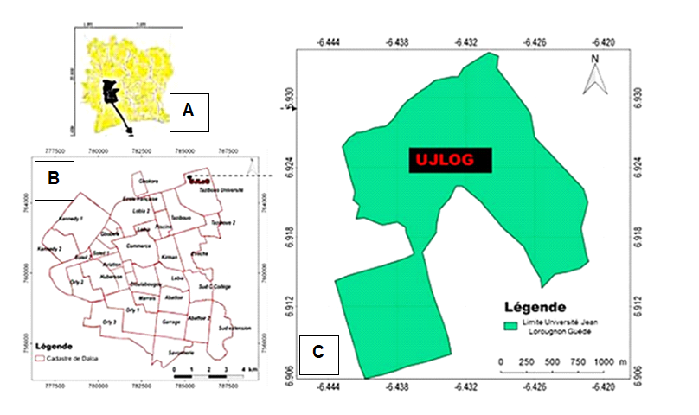

Fig. 1. Location of the study area ; A: Map of Côte d'Ivoire ; B: Map of the city of Daloa ; C: Map of Jean LOROUGNON GUEDE University

2.2. Methods
2.2.1. Plot Preparation
The experimental plot is located within the Jean Lorougnon Guédé University. Cuttings and layerings were taken from Lippia multiflora mother plants located on the study site. They were then transplanted into planting holes distributed across three different sub-blocks. The transplanting of the seedlings was carried out according to the experimental design.

2.2.2. Experimental setup for the tests
The cutting and layering trials were conducted using a completely randomized block design with three replicates. This design consisted of subblocks, each containing 80 plants. The subblocks were separated by 1 m from each other. Each elementary trial block comprised five rows of plants, including two layering rows and three cutting rows. Each row consisted of 16 plants, for a total of 80 plants per subblock. Within each row, the plants were separated by one meter, and the plants at the ends of the blocks were separated by 0.5 m from the block boundary (Fig. 2). In each subblock, the two layering rows consisted of one underground layering row (MS) and one aerial layering row (MA). As for the three (3) cutting lines, they consist of basal cutting (BB), intermediate cutting (BI) and apical cutting (BA), constituting respectively the basal, intermediate and apical parts of the stem.
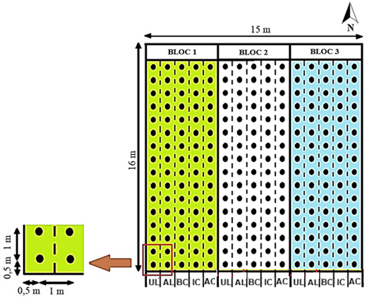
Fig. 2. Diagram of the experimental setup

2.2.3. Taking and planting cuttings and layering
The propagation was carried out on a stand of Lippia multiflora located within the University. The selection of cuttings (Fig. 3A, B, and C) for this propagation method was based on trials involving plants aged 6 and 12 months. These plant ages were chosen according to the number of nodes on the shoots within each age group. The cuttings were taken in the evening to minimize transpiration and therefore, drying. The leaves were trimmed to reduce the surface area exposed to evaporation. The shoots were not transported over long distances, thus eliminating the need for a cooler. Three classes of cuttings were thus established:
- la classe de boutures comportant les nœuds apicaux (partie apicale flexible) ;
- the class of cuttings with intermediate nodes (hard and soft parts of the offshoot);
- the class of cuttings with nodes in a basal position (hard and woody part of the offshoot).
The cuttings obtained measured between 25 and 35 cm and had, on average, 5 to 7 nodes. For layering (Fig. 3D and E), young, lignified orthotropic stems or easily accessible low branches were used. Two treatments were carried out: underground layering and aerial layering at mid-height of the plant's base to determine the most suitable stem section for layering. Following Tchoundjeu & Jaenicke (2002), the selected stem section was covered with dark plastic containing moist potting soil collected from under the parent plant. The entire assembly was secured around the stem, at the nodes, with string to ensure the plastic was wrapped as tightly as possible around the stem and prevent the substrate from drying out. This sleeve was left in place for 1 to 2 months, the period required, depending on the species, for the formation of new adventitious roots. A total of 60 air layers (AMs) were applied, with 4 to 6 layers placed on each of the 12 to 15 Lippia multiflora plants studied. Each individual layer was labeled with the date of layering and the experimental unit number.

Fig. 3. Cuttings and layerings used; A: Cutting from the basal part; B: Cutting from the intermediate part; C: Cutting from the apical part; D: Layering from the underground part; E: Layering from the aerial part

2.2.4. Monitoring and maintenance of cuttings and layering
After setting up the trials, various maintenance operations were carried out: watering and weeding. The plants were watered regularly during their growth with 0.5 liters of water per plant per day. Weeding consisted of removing unwanted plants that compete with the cultivated plants for water and minerals. Weeding was done regularly to increase the plants' chances of survival.
2.2.5. Data Collection on Cuttings and Layers
2.2.5.1. Survival Rates
The survival rate of the suckers was evaluated over a 60-day period after planting. In this experiment, the survival rate is considered equivalent to the budding rate and the differentiation of these buds into seedlings. This rate was recorded every 7 days until the end of the trial. It was calculated by dividing the number of live suckers (Nrv) at a given time after planting by the number of suckers initially planted (Nir), and then multiplying the result by 100. According to Alui (2009), the calculation method used is as follows:

𝑇𝑠 = Nrv ×100 / Ni (1)

where: Nrv: number of living shoots; Nir: number of shoots initially planted

2.2.5.2. Average number of leaves
The number of leaves per plant was determined, as well as the average number of leaves per plant. The number of leaves was counted on each plant. The average number of leaves per plant (Nmf) was determined using the following formula:

𝑁𝑚𝑓 = ΣNf / Np (2)

with: Nf: Number of leaves observed; Np: Number of plants selected for observation

2.2.5.3. Average number of rejections (Nmr)
The formation of suckers begins with the appearance of buds on viable plants. The time of bud appearance and the number of suckers that developed from these buds were recorded every 7 days until the end of the experiment (60 days of culture). The sucker count was performed on all plants to avoid any ambiguity. Then, an average of the counts was calculated to obtain the average number of suckers per plant. According to Koné et al. (2010), the calculation method is expressed as follows:

𝑁𝑚𝑟 = Ntr / Nrv (3)

with: Ntr: Total number of discards; Nrv: Number of live discards

2.2.5.4. Average height of discharges (Hmr)
The height growth of the suckers is determined by measuring their size every 7 days. The height is measured using a measuring tape. The measured portion is from the root collar to the apex. The largest sucker per root division is selected and measured. Thus, the average height of the suckers is determined by the following formula:

𝐻𝑚𝑟= ∑𝑛𝑘=1𝐻𝑚𝑟𝑝 / N (4)
with: Hmrp: Average height of shoots per plant per treatment on an elementary plot; N: Number of shoots counted per treatment.

2.2.6. Statistical analysis of data
The collected data were entered using Excel 2013, which allowed for the creation of pivot tables to summarize the data according to the treatments. These graphs enabled us to compare the different treatments over time. To statistically compare the means of the different treatments, Statistica version 7.1 was used for analysis of variance (ANOVA). The Student-Newman-Keuls (S-N-K) multiple comparison test was also used to classify the different treatments into homogeneous groups when the ANOVA revealed a significant difference between them. This difference is considered significant when the probability is less than 5% (the adopted significance threshold). Thus, when the probability is less than 0.05, the difference is considered significant. If the probability is less than 0.01, it is considered highly significant, and when the probability is less than 0.001, it is considered very highly significant. significant and when the probability is less than 0.001, it is said to be very highly significant.

3. results and discussion
3.1. Results
3.1.1. Dynamics of treatment survival rates over time
Figure 4 shows the survival rate (SR) curves for the different treatments of Lippia multiflora plants over time. The evolution of the curves reveals that plants propagated by layering have a higher survival rate than those propagated by cuttings. Two phases of development can be identified. The first phase, from week 1 to week 3, is characterized by a progressive increase in plant survival rate, reaching its maximum around week 3. The second phase begins after week 3. This phase is characterized by a decrease in plant survival rate, reflected in the downward slope of the curve until week 6. More than 81.2% of the layers survived, compared to 37.4% for the cuttings. However, air layers and basal cuttings exhibited longer survival rates over time. A significant difference in survival was observed six weeks after planting (p > 0.05).
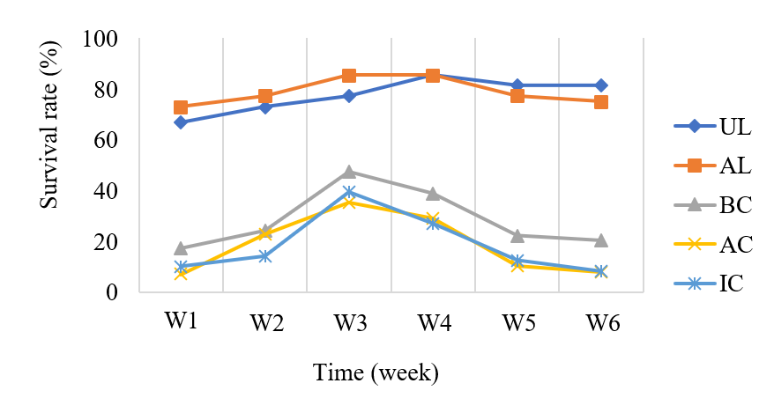
Fig. 4. Evolution of the survival rate of cuttings and layering
UL: Underground Layering, AL: Aerial Layering, BC: Basal cutting, IC: Intermediate cutting, AC: Apical cutting, S: Week

3.1.2. Relationship between survival and planting diameter classes
Figure 5 shows that stem thickness growth correlates with seedling survival as a function of treatment, six weeks after planting. The analysis indicates that all treatments respond positively in the diameter class [0.5–1 cm]. Furthermore, survival rates are highest (100%) with the diameter classes [0.5–1 cm] and [1.5–2 cm], as well as 100% survival with the diameter classes [0.5–1 cm] and [2–2.5 cm], respectively, for subterranean and aerial layering. Apical cuttings result in the lowest survival rates in the number of diameter classes [0–0.5 cm] and [0.5–1 cm].

Fig. 5. Planting survival rate according to diameter classes
UL = underground layering; AL = aerial layering; BC = basal cutting; IC = intermediate cutting; AC = apical cutting

3.1.3. Average number of rejections
Table 1 presents the average number of rejections produced by multiplication type over time. Statistical analyses reveal a significant difference for all treatments (p < 0.05), except for measurement times T2 and T5. Across all measurement times, the highest values ​​(13.76 ± 4.30) were obtained with treatment MA, while treatment AC yielded the lowest values ​​(4.83 ± 3.68).

Table 1. Effect of treatment type on the number of rejections
Measuring time | Type of treatment |  |  |  |  | P
Measuring time | UL | AL | BC | IC | AC | P
T1 | 6,36±2,64 | 8,91±5,46 | 4,61±0,94 | 2,50±0,50 | 1,78±0,95 | 0,03661
T2 | 7,08±3,16 | 6,79±2,94 | 5,25±1,17 | 4,20±2,94 | 2,16±0,76 | 0,07928
T3 | 7,95±3,08 | 10,07±3,57 | 5,33±1,15 | 4,73±2,05 | 2,33±0,57 | 0,01466
T4 | 7,66±2,51 | 10,25±3,13 | 5,50±2,50 | 5±3,00 | 3±1,50 | 0,04303
T5 | 11,08±2,79 | 11,95±8,44 | 5,50±2,50 | 5,33±3,05 | 3,66±3,78 | 0,05175
T6 | 11,61±6,67 | 13,76±4,30 | 6,42±2,28 | 5,81±2,86 | 4,83±3,68 | 0,03527
UL: Underground layering, AL: Aerial layering, BC: Basal cutting, IC: Intermediate cutting, AC: Apical cutting, T: Measurement time, with P < 0.05.

3.1.2.2. Average height of discharges
The average height of the shoots recorded in Table 2 depends on the treatment type and measurement time. The results show a significant difference between treatments (p < 0.05) starting from the second week of measurement. Across all six measurement times, the maximum heights were obtained with plants grown from layering, while plants grown from cuttings produced the lowest heights. Six weeks after planting, the optimal height was reached with the AL treatment (15.36 ± 7.49 cm). This was followed by MS (11.74 ± 1.55 cm), BC (10 ± 2 cm), IC (8.66 ± 4.66 cm), and finally AC (6.50 ± 0.50 cm).

Table 2. Effect of treatment type on discharge height
Measuring time | Type of treatment |  |  |  |  | P
Measuring time | UL | AL | BC | IC | AC | P
T1 | 2,96±3,62 | 3,31±0,68 | 3,16±0,57 | 1,50±0,5 | 1±0,25 | 0,29423
T2 | 4,80±1,87 | 6,00±2,61 | 3,28±2,13 | 2,90±0,74 | 2,00±0,15 | 0,01808
T3 | 6,19±3,63 | 6,33±1,52 | 5,00±±0,10 | 3,33±0,57 | 2,58±0,62 | 0,01971
T4 | 8,81±3,16 | 11,5±3,50 | 7,26±3,74 | 3,66±2,02 | 3,50±0,50 | 0,01223
T5 | 10±2 | 13,47±4,49 | 8,66±8,08 | 6,41±1,23 | 5,12±0,21 | 0,06367
T6 | 11,74±1,55 | 15,36±7,49 | 10±2,00 | 8,66±4,66 | 6,50±0,50 | 0,02808
UL: Underground layering, AL: Aerial layering, BC: Basal cutting, IC: Intermediate cutting, AC: Apical cutting, T: Measurement time, with P < 0.05.

3.1.2.3. Average number of leaves
The average number of leaves produced by treatment type over time is shown in Table 3. Analysis revealed a significant difference between treatments at each measurement period (p < 0.05). After 6 weeks, plants grown by layering had the highest average numbers, with 33.45 ± 5.29 for air layering and 28.40 ± 1.48 for underground layering. Plants grown from cuttings had the lowest average numbers, with 24.50 ± 0.50 for air layering, 15.50 ± 1.50 for apical cuttings, and 20.66 ± 2.08 for intermediate cuttings.

Table 3. Effect of treatment type on the number of leaves
Measuring time | Type of treatment |  |  |  |  | P
Measuring time | UL | AL | BC | IC | AC | P
T1 | 8,30±1,97 | 7,85±3,91 | 5,00±2,51 | 3,50±0,5 | 2±0,12 | 0,0866
T2 | 9,82±2,82 | 12±0,25 | 7,41±1,04 | 5±1,58 | 4,50±1,32 | 0,0001
T3 | 13,15±1,79 | 15,62±1,50 | 10,33±4,04 | 10±2,00 | 7,50±0,86 | 0,0682
T4 | 16,50±0,50 | 20,83±3,75 | 13,34±2,08 | 11,99±,25 | 9,58±4,06 | 0,0133
T5 | 20,50±0,50 | 25,57±2,06 | 17,70±2,13 | 14,50±1,5 | 10,33±5,03 | 0,0091
T6 | 28,40±1,48 | 33,45±5,29 | 24,50±0,50 | 20,66±2,08 | 15,50±1,50 | 0,0513
UL: Underground layering, AL: Aerial layering, BC: Basal cutting, IC: Intermediate cutting, AC: Apical cutting, T: Measurement time, with P < 0.05.

3.2. Discussion
The study aimed to evaluate different types of vegetative propagation of Lippia multiflora. The results show that the survival rate, a crucial parameter in plant domestication programs, remains high for plants propagated by layering. Indeed, upon planting, these plants benefit from roots acquired during layering, which rapidly increases the efficiency of the hydro-mineral nutrition of these young plants (Mguis et al., 2005). This survival rate remains low for cuttings. According to Diatta et al. (2007), the absence of roots is the cause, as it reduces water absorption capacity, leading to a disruption of the water balance and the drying out of cuttings planted directly in soil.
However, at the cutting level, a higher survival rate is observed for cuttings taken from the basal part than for those taken from the middle and apical parts. This is thought to be due to a greater accumulation of biochemical and carbonaceous substances, stimulating root growth in this part of the plant (Sanogo et al., 2009; Bécel, 2010). Besides the origin of the cutting, survival success also depends on the age of the plant material, the planting season, and the characteristics of the trial site (Meunier et al., 2008). Studies conducted by Belem et al. (2008) in Burkina Faso and Niger on *Guiera senegalensis* J.F. Gmel. and *Combretum micranthum* G. Don perfectly illustrate this point. Indeed, cuttings taken from the offshoots of young plants, in continuous contact with the soil, root less, and therefore have a lower survival rate than those taken from older plants.
Regarding growth, the results obtained during the trial show a significant increase in all the parameters studied as a function of time and propagation method. Indeed, plants propagated by layering performed better than those propagated by cuttings. The presence of roots in the layered plants appears to be the reason for this dominance. In fact, the high production of auxins by the roots induces rapid plant development. Thus, according to Bellefontaine et al. (2005), the production of offshoots in certain plants is primarily controlled by regulatory substances produced by the plant's own metabolism.

4. Conclusion
This study concludes that plants propagated from cuttings and layers can be used to establish Lippia multiflora cultivation. The study demonstrated that Lippia multiflora can be cultivated in various areas outside its natural ecological range (savanna). To this end, plant material (stem cuttings and layers) was collected at the Jean LOROUGNON GUÉDÉ University in Daloa (pre-forest zone). The results indicate that the survival rate, average number of suckers, sucker height, and average number of leaves significantly affect growth parameters and leaf yield. Indeed, in both types of vegetative propagation, the agronomic characteristics of the plants vary significantly. Plants propagated from layers yield better results than those propagated from cuttings.

Disclaimer (Artificial intelligence):

Author(s) hereby declare that NO generative AI technologies such as Large Language Models (ChatGPT, COPILOT, etc.) and text-to-image generators have been used during the writing or editing of this manuscript.

References

- Akpavi S., Wala K., Gbogbo K. A., Odah K., Woegan Y. A, Batawila K., Dourma M., Pereki H., Butare I., De-Foucault B. & Akpagana K. (2012). Distribution spatiale des plantes alimentaires mineures ou menacées de disparition au Togo : un indicateur de l’ampleur de leur menace. Acta Botanica Gallica, 159 (4): 411-432.
https://doi.org/10.1080/12538078.2012.737145
- Alui K. A., Yao-Kouamé A., Ballo K. C., Kouadio K. P., N’guessan K. A & Nangah K. Y. (2011). Comportement de deux morphotypes de Lippia multiflora (Verbcnaceae) sur Ferralsols de la région de Yamoussoukro, Côte d'Ivoire. Journal of Applied Biosciences, 38: 2592-2601.
https://www.researchgate.net/publication/216305498_Comportement_de_deux_morphotypes_de_Lippia_multiflora_Verbenaceae_sur_ferralsols_de_la_region_de_Yamoussoukro_Cote_d'Ivoire
- Bécel C. (2010). Croissance racinaire en verger de pêchers - Influence de la disponibilité en assimilats carbonés et des contraintes du sol. Thèse présentée pour obtenir le grade de Docteur en Sciences Agronomiques de l’Université d’Avignon et des Pays de Vaucluse, France, 139 p. https://theses.hal.science/tel-00518376/file/2010AVIG0627_0_0.pdf
- Belem B., Olsen C.S., Theilade I., Bellefontaine R., Guinko S., Lykke A.M., Diallo A. & Boussim J.I. (2008). Identification des arbres hors forêt préférés des populations du Sanmatenga (Burkina Faso). Bois et Forêts des Tropiques, 298 (4): 53-64. https://agritrop.cirad.fr/547088/1/BFT_298_53-60.pdf
- Bellefontaine R., Kechebar M.S.A. & Rahmoune C. (2015). Démarche à adopter pour sauvegarder le patrimoine génétique de l’arganeraie de Tindouf. Revue d’AgroEcologie, 3: 5-21. https://agritrop.cirad.fr/579171/
- Bellefontaine R., Meunier Q., Mapongmetsem P.M., Morin A., Karim S & Houngnon A. (2016). Plaidoyer en faveur du marcottage pour domestiquer les principales espèces ligneuses africaines. Cirad, Montpellier (France), 204 p. https://agritrop.cirad.fr/580936/
- Bellefontaine R., Sabir M., Kokou K., Guinko S., Saadou M., Ichaou A., Hatem C., Bationo B.A., Karim S & Dourma M. (2005). Argumentaire pour l'étude et l'utilisation des marcottes et drageons dans les pays à faible couvert ligneux. Sécheresse, 16 (4): 312-314. https://agritrop.cirad.fr/531006/
- Benoit F., Valentin A., Pelissier Y., Diafouka F., Marion C., Koné-Bamba D., Koné M., Mallie M., Yapo A. and J. M. Bastide. 1996. In vitro antimalarial activity of vegetal extracts used in West African traditional medicine. American Journal of Tropical Medicine and Hygiene, 54 (1): 67-71. https://scispace.com/papers/in-vitro-antimalarial-activity-of-vegetal-extracts-used-in-50kzp82yly
- Diatta S., Kaboré-Zoungrana C. X. & Banoin M. (2007). Possibilités de bouturage Chez Maerua crassifolia Forssk., Capparaceae, un ligneux fourrager sahélien, Afrique Science, 03 (2): 271-288. DOI: 10.4314/afsci.v3i2.61272
- Diomandé M., Kouamé K. B. & Koko A. C. (2017). Comparaison des propriétés chimiques de l’huile et tourteau d’arachide et de noix de cajou sur le marché de Daloa, Côte d’Ivoire. Engineering and Applied Sciences, 4 (11): 28-32. https://www.ijeas.org/download_data/IJEAS0411012.pdf
- INS (2014). Recensement Général de la Population et de l’Habitat. Rapport d’exécution et présentation des principaux résultats. 49 p.
- Meunier Q. M. Arbonnier & Morin A. (2008). Trees, shrubs and climbers valued by rural communities in Western Uganda. Utilization and propagation potential. French Embassy in Uganda and Cirad, Montpellier, France (Ed.), 106 p.https://agritrop.cirad.fr/547871/
- Mguis K., Ksontini M. & Rejeb M. N. (2005). Etude du système racinaire de jeunes plants de Quercus suber L. (Chène liège) dans des conditions semi-contrôlées. Les Annales de l'INRGREF, numéro spécial, 7: 139-152.
- Mwangui J. M., Addae Mensah I., Muriuki G., Munav R. & Lwande W. (1993). The potential for commercialization of threc African Lippia species as sources of essential oils for perfumery and medicinal purposes. Proceedings of the Chicoutimi Symposium, 22 to 25 August 1993, Quebec, Canada, pp. 205-216.
- Mwangui J. W., Addae-Mensah I., Miriuk R., Lwande W. & Hassanili A. (1991). Essential oils of Lippia multiflora species in Kenya IV, Maize weevil (Sitophilus zeamaize) repellancy and larvicidal activity, International Journal of Crude Drug Research: 221-224. https://erepository.uonbi.ac.ke/handle/11295/11112
- N’guessan K. A., Diarrassouba N., Kone B., Alui K. A. & Yao-Kouamé A. (2015). Caractérisation morpho-pédologique et contraintes au développement de Lippia multiflora sur deux sols tropicaux de Côte d’Ivoire. Journal of Animal &Plant Sciences, 24 (3): 3814-3828. https://fr.scribd.com/document/465812451/3
- N’guessan K. A. & Yao-Kouamé A. (2010). Marketing and uses of Lippia multiflora (Verbenaceae) leaves in Côte d'Ivoire. Journal of Applied Biosciences. 29 : 1743-1752. https://www.semanticscholar.org/paper/Marketing-and-utilisation-channels-of-Lippia-leaves-N'guessan-Yao-Kouam%C3%A9/473fd0292b068fa4533d72cc105e9b787a119452
- Noamesi B. K., Adebayo G. L. & Bamgbose S. O. (1985). The vascular actions of aqueous extract of Lippia multiflora, Planta Medica. 3 : 256-258.DOI: 10.1055/s-2007-969472
- Oladimeji, F. A., Orafidiya, O. O., Ogunniyi, T. A. & Adewunmi, T. A. (2000). Pediculocidal and scabicidal properties of Lippia multiflora essential oil. Journal Ethnopharmacol, 72 (1-2) : 305-311.
https://doi.org/10.1016/S0378-8741(00)00229-4
- Ouédraogo H. (2007). Structure démographique et modes de régénération de Pterocarpus erinaceus Poir.et autres espèces prioritaires utilisées dans l’artisanat à l’ouest du Burkina Faso. Mémoire d’Ingénieur, Université Polytechnique de Bobo-Dioulasso (IDR), Burkina Faso, 77 p.
https://www.beep.ird.fr/greenstone/collect/upb/index/assoc/IDR-2007-OUE-STR/IDR-2007-OUE-STR.pdf
- Sangaré A., Koffi E., Akamou F. & Fall C. (2009). État des ressources phytogénétiques pour l’alimentation et l’agriculture: second rapport national, Ministère de l’agriculture, République de Côte d’Ivoire, 63 p.
https://www.fao.org/4/i1500e/cote%20ivoire.pdf
- Tchoundjeu Z. & Jaenicke H. (2002). Layering principles and techniques. In: Vegetative tree propagation in agroforestry. ICRAF, Nairobi (Kenya), 132 p.
- Terblanche F. J. & Cornelius G. (1996). Essential oil constituents Of the genus Lippia (Verbenaceae): a literature review. Journal of Essential Oil Research, (8): 471-485.https://doi.org/10.1080/10412905.1996.9700673
- Yao-Kouamé A., Nangah K Y, K. A. N’guessan K. A., Yao G. F. & Assa A. (2009). Pedolandscape and development Of Lippia multiflora in Southern Côte d'Ivoire. Journal of Envlronjnental Sc:ience and Technology, 2 (1): 56-62. https://doi.org/10.3923/jest.2009.56.62

