Development of an Eco-Friendly Bullock Yoke from Agricultural Waste Using Composite Material Technique for Sustainable Rural Application
Abstract
The transformation of agricultural waste into eco-friendly manner and reduces the effect of green house gases emission due to burning of crop residues. The organic biomass was converted and utilized it in another form with the concept of developing agro waste composite material. Hence, the primary objective of this study was developed a lightweighted, durable and biodegradable composite materials supports sustainable production and attempt a new opportunities as alternatives method over traditional materials. These composites offer significant advantages, particularly in terms of energy savings, low cost, and minimizing environmental impact. The objective of study was developed a yoke that is lightweight, ergonomic comfort to neck, durable, and sustainable by valorising abundant agricultural residue. Wheat straw was grinded in hammer mills and used as reinforcement agent with an unsaturated epoxy resin matrix material. Different combinations of samples were prepared in the laboratory. The composite yoke was fabricated using a compression moulding technique. The samples were tested for mechanical and physical properties. The optimization was done by analysis the strength of different samples and which combination was best for superior toughness and improved stress materials was developed due to the combined effect of silica and agriculture biomass. The results demonstrated that filler type and loading significantly influence the mechanical behaviour of the composites. Among all formulations, the hybrid composite containing 10 wt% silica and 10 wt% biomass (T9) exhibited the most balanced and superior overall performance. This composition showed maximum tensile strength (24.20 N/mm²), compressive strength (78.00 N/mm²), and impact strength (7.2 N/mm²), representing improvements of approximately 54%, 44%, and 58%, respectively, compared to the unfilled control. This study successfully demonstrates the potential of wheat straw-based composites as a viable alternative to wood for manufacturing ergonomic and sustainable harnessing technology (animal yoke), directly contributing to manage crop residue and prevent it from burning and generate income for farmers.
Key words: Animal yoke, Draught Animal, Power, Wheat straw, Natural fibre, composite material
- Introduction
Draught animals are the major source of farm power for the small and marginal farmers of the country. About 85 % of the operational holdings are small and marginal which constitute 25 % of total cultivated area. Animal power has been the main sources of farm power, used extensively for irrigation, threshing and transport besides tillage, sowing and intercultural operation. About 50 % of the net sown area still cultivated by draught animals and are major means for transport in rural areas even there is an increase in the mechanical power sources. Farmers use site specific animal drawn implements and machinery for conducting agricultural unit operation. The implements are designed mainly for draught animals are made of wooden material and heavy in weight. Based on data from Global Forest Watch and the FAO (Food and Agriculture Organization), India has experienced significant, though sometimes conflicted, rates of forest cover loss in recent years. In 2020, India had 44 Mha of natural forest, extending over 15% of its land area. In 2024, it lost 150 kha of natural forest, equivalent to 67 Mt of CO₂ emissions (GFW,2024). Hence today a demand to replace the wood material with composite material Thus the new concept of developed a material using the based on composite material. Other side straw management today is a big problem and mostly farmers are burnt it into the field due to that environment pollution are increased day by day. “With a long history of agriculture, India, the second most populous country in the world, produces huge amounts of food grains, including wheat and rice, for both domestic consumption and export. Among the various crops cultivated, the main contributors of crop residual are rice (43%), wheat (21%), sugarcane (19%), and oil seed crops (5%) and the majority crop residues are burnt” (Jain et al.,2014 & Bhuvaneshwari, S., et al., 2019). Despite its resource potential, post-harvest crop residue is frequently burned or abandoned, particularly in developing regions, exacerbates air pollution, wildfire risks, and correlates with 1.71-1.91% mortality rate increases per 10% burning increment. Open-field burning affects 42.5% of residues in Karnataka, India ,13, 95% in the Philippines, and 20% (140 Mt) of Chinese wheat straw, releasing 3.4 Mt CO, 91 Mt CO₂, and 1.2 Mt PM per 63 Mt combusted (Guan et al., 2017; Gadde et al., 2009; Chendrashekhara et al., 2018; Liu et al., 2021; Abdurrahman et al., 2020; Chanana et al., 2023). Promoting the resourceful utilization of crop residue is therefore imperative. Adopting eco-friendly practices can reduce the global warming potential by 30%–57% ( Guo et al., 2022) and concurrently improve agricultural productivity and soil carbon storage (Bolcu et al ., 2022) . (Ge, Y., & Fan, Li. 2026) studied on the main ways for crop residue recycling utilization of crop residue worldwide include crop residue fertilizer (crop residue return), livestock feed, fuel (commercial and household energy), raw materials (for industrial and handmade products), and base materials (for bio-based materials). The disposal of crop residue is requirement today to protect the environment from green house gas emission. The organic residue is used for income generation for small and marginal farmers. “In India, straw-based industries create 5-10 jobs per unit and protects the forest for making wood based small implements. The mechanization increases fossil fuel consumption which affects environ-ment adversely and increases the import burden. With the growing environmental concern globally, it has become imperative that farmers are encouraged to switch to draught animal power. However, the reversal of mechanization is not possible without the support of technology” (Singh, G, 2021). (Houssou et al .,2013) studied “the draught animal power usage in farming in Ghana. According to his study, some of the factors, that limit the use of draught animals are due to labor force, lack of skill in ploughing, poor design of harnesses, yokes and implement beams, unavailability of metal for fabrication of implements, lack of feed and water. He suggested the use of technology for improvements of agricultural implements and carts. He recommended that mechanization should be allowed to co-exist with the draught animal power”. (Umogbai, 2011) redesigned “an existing heavyweight yoke to improve the work-ing of draught animals. The disadvantages of heavy yoke, which reduce the performance of draught animals, are bending of neck due to heavy weight, wounds inflicted on the animal’s neck because of the persistent rubbing of the yoke on the neck and difficulty to fit and to remove the yoke on the animal body. Many researchers investigated the yokes used in India”. Kumar (Uttam, 2017) developed “two variants of yokes of length of 190 cm and weight of 7 kg. He considered the size and shape of the bullock’s neck. He conducted a field test and found the new design reducing the fatigue of the animals by 25%”. The purpose of present study is attempted to develop a yoke made of agro waste composite materials. The production of composite materials from the agricultural waste has significant interest in recent years due to benefit of waste valorization and the development of sustainable materials. Abundant and often underutilized agricultural residues can be employed as effective reinforcing agents in composite formulations, thereby enhancing the mechanical, thermal and acoustic properties of the composites. Agricultural by products such as wheat straw is rich in lignocelluloses’ fibres. Utilizing these materials enables the creation of composites that exhibit improved mechanical properties, thermal insulation, and biodegradability (Venkataravanappa et al., 2023). The utilization of agriculture waste-based composite in the yoke design is attracting increasing attention due to their potential to create sustainable, eco friendly product while addressing waste management challenges. Research indicates that composite reinforced with plastics, such as polyethylene and polypropylene, to produce materials with enhanced mechanical properties.

- Materials And Methods
2.1 Materials Selection
Two types of materials were selected for construction of animal yoke one was matrix material and another was biodegradable reinforcing materials. The matrix materials were epoxy resins, hardeners, and silica material. The biodegradable materials were jute net, paddy and wheat straw, bagasse and saw dust were used in construction of animal yoke. Wheat straw was collected from the field after that it was grinded in hammer mill so that it was converted into a fine particle size as shown in figure 1.

2.2 Reinforcement
Wheat straw was collected from local farms at the Crop Research Centre Pantanagr Uttarakhand region. It was washed to remove dirt, sun-dried for 72 hours, and mechanically chopped into lengths of 20-30 mm size. The chopped straw was subjected to a 5% NaOH (sodium hydroxide) alkali treatment for 4 hours to improve surface properties, followed by thorough washing and oven-drying at 80°C for 24 hours.

2.3 Matrix Materials
A general-purpose epoxy resin was used as the matrix material in present study.
2.4 Epoxy Resin (CY-230)
Epoxy resin is widely used in industrial application because of their high strength and mechanical adhesiveness characteristic. It is odorless, tasteless and completely non-toxic. It has versatile applications in technical and industrial applications. The physical & chemical properties of CY-230 are given in Table 1. It can be stored for at least a year if they are stored under cool, dry conditions in the original containers. It is also a good solvent and has good chemical resistance over a wide range of temperature.
Table 1. Physical and chemical properties of CY-230
S.N | Resin (Epoxy resin CY-230)
1. | Physical Properties | Yellow-brown, odorless, tasteless and completely nontoxic
2. | Chemical Properties | Plasticized condensation product of bisphenol-A and epichlorohydrin.

2.5 Hardener HY-951
Hardener (HY951), aliphatic primary amines which has enough viscosity at 25º C is used along with matrix material.
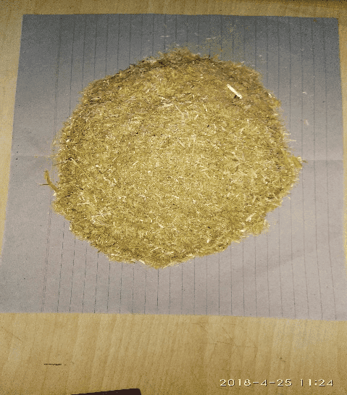 | 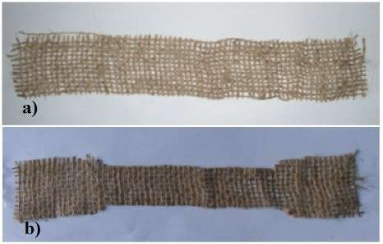
(a) Chopped Straw in hammer mills | (b) biodegradable jute material
Fig.1. Sample preparation by using reinforcing materials

2.6 Yoke Design
An ergonomic yoke was developed in laboratory. The design featured a double-curved contour to match the dorsal profile of a bullock's neck. The contact surfaces were broadened and smoothed to maximize the contact area and minimize pressure points. The final design dimensions were 120 cm x 15 cm x 10 cm respectively.
2.7 Reinforcing Materials
Reinforcing agents are added to the resin to improve the mechanical strength and wear properties. Some of the reinforcing agents such as silica, fly ash, bagasse and paddy straw etc. are used as reinforcing agents to improve the different properties of the composites material.
Silica: Introduce of silica in the matrix material has been taken into consideration. Silica particles improve the physical and the mechanical properties significantly. Silica flour is directly mixed in to the resin and stirred mechanically.
Glass wool: Glass wool is produced in rolls or in slabs, with different thermal and mechanical properties. These are taken as a binding material for enhancing the adhesive property of the models. The glass wool purchased from M/s Fine Finish organics Pvt. Ltd. Mumbai, used as in sand-witched form, between every other two sets of jute net layers.
Jute net: Jute net is biodegradable matting manufactured from jute fiber. It is light in weight and widely used for housing and commercial purposes.
Bagasse and paddy straw: Bagasse is a fibrous residue of cane stalks left over after the crushing and extraction of juice from the sugar cane. Wheat straw was collected after the harvesting. Bagasse and wheat straw can be considered as waste biodegradable material. These are light in weight and don't add much to the density of the samples. The main chemical constituents are lignocelluloses; Hemicelluloses and cellulose are present in the form of hollow cellulose, which contributes about 70 % of the total chemical constituents present in bagasse and wheat straw. Lignin acts as a binder for the cellulose fibers and also behaves as an energy storage system.
2.8 Mold Fabrication
A two-part closed mould was fabricated from mild steel. The inner surfaces were polished and coated with grease as release agent to facilitate easy removal of the final product as shown in Figure 2.

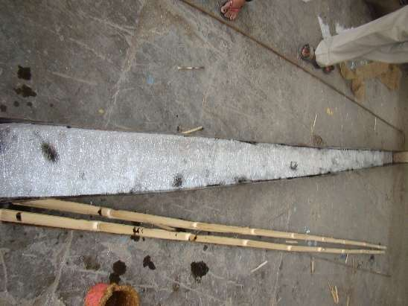 | 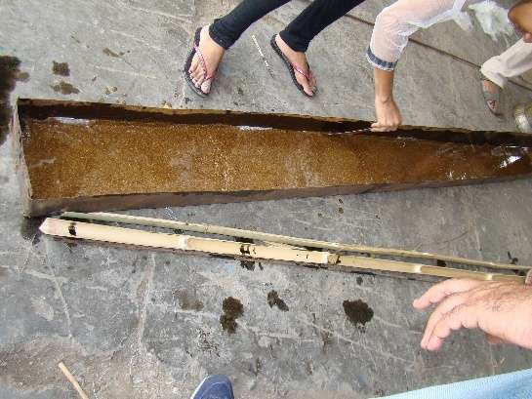 | 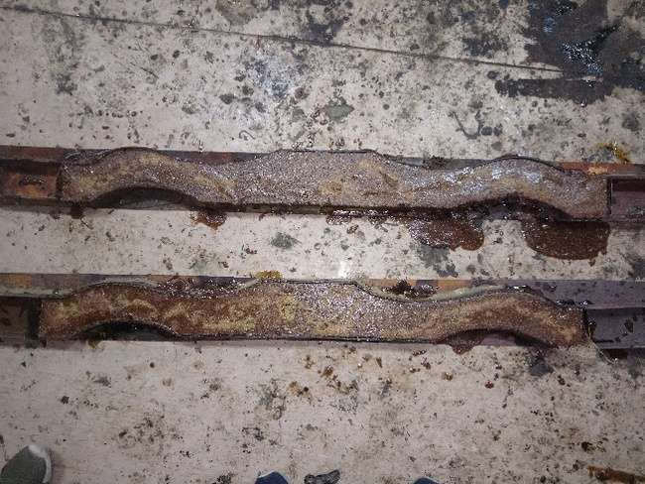

Fig. 2. Pouring of composite material into the mould frame

2.9 Composite Fabrication
The yoke was fabricated using a compression moulding technique. The polyester resin, catalyst (1% by wt.), and accelerator (1% by wt.) were thoroughly mixed. The treated wheat straw fibers were gradually added to the resin mixture and stirred until a uniform; dough-like consistency was achieved. A fibre loading of 40% by weight was maintained. The mixture was carefully placed into the lower half of the heated mould. The mould was closed, and a pressure of 12 MPa was applied using a hydraulic press. The temperature was maintained at 110°C for a curing time of 30 minutes. After curing, the mold was cooled, and the composite yoke was demoulded. Post-processing involved trimming excess flash and sanding the surfaces for a smooth finish.
2.10 Tests Procedure
Though there are number of mechanical tests, which are necessary to determine the suitability of a metal, the following important tests have been performed in the present study.
- Tensile test with the strain rate of 1.00 mm/sec.
- Compression test with the strain rate of 1.00 mm/sec.
- Flexural test
- Hardness test
- Wear test at 0.15 N/mm² pressure and 1500 rpm speed.
- Impact Test
2.11 Mechanical Properties measurement
2.11.1 Tensile strength Measurement
Tensile strength, yield point, yield strength and other tensile properties were determined by prepared a sample of different combinations viz T1,T2,T3,T4,T5,T6,T7,T8 and T9 of reinforcing as well as matrix materials. Details of the treatments were given in Table 2. Tensile testing specimen were prepared per ASTM D 638 standard for tensile strength measurement as shown in Figure 3 respectively. The l₀ gauge length were taken as 5.65$\sqrt{A_{0}}$ . Test were conducted using 200 kN capacity servo hydraulic UTM machine (Model 2012, ANEKY make.)

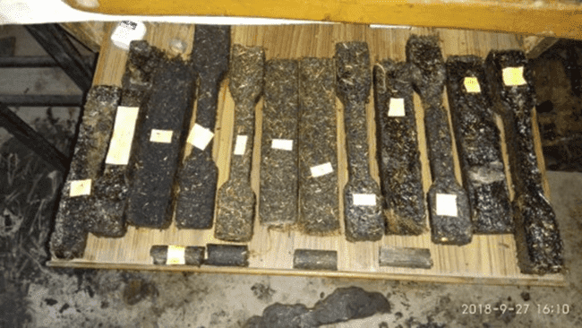 | 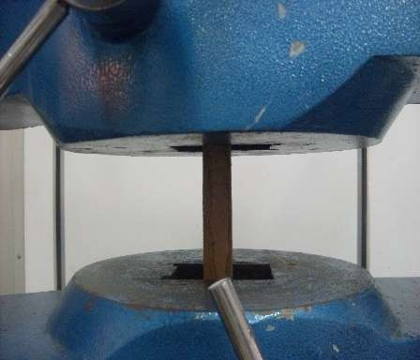
Fig 3: a. Specimen prepared for tensile, compression and bending test according to ISO-1708, 1960. b.Tensile strength measurement
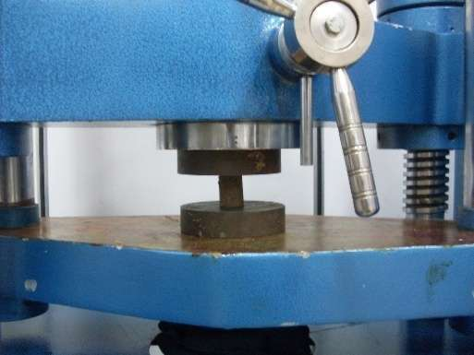 | 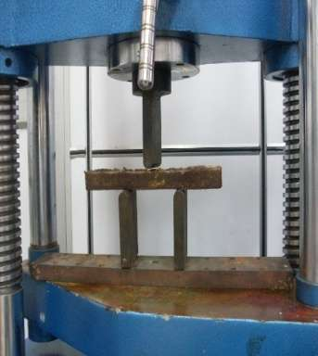
Fig. 4. Compressive strength measurement | Fig.5. Flexural strength measurement

2.11.2 Compression Test
The compression test is simply the opposite of the tension test with respect to the direction of loading. “Compression tests results in mechanical properties that include the compressive yield strength, compressive ultimate strength, and compressive modulus of elasticity in compression, % reduction in length etc. All the compression tests of casted hybrid composites are conducted on 200 kN servo hydraulic UTM machine” (Model 2012, ANEKY make) as shown in Figure 4. All tests are conducted in aspect ratio of 2.0. Circular specimen used for wear and compression test, were prepared using lathe machine as per the requirement of the UTM.

2.11.3 Bending strength
The 3-point bending strength test provides the values for flexural stress-strain response and flexural modulus of the material. The main advantage of a 3-point bending test is the ease of preparing specimen and testing. The test set up and specimen geometry is shown in the figure 5. The results of this test are sensitive to the specimen properties, loading and strain rate. The temperature at the time of test was 24.5°C and relative humidity (RH) was 47%.
2.10.4 Wear Testing Sample pins for wear testing were prepared on lathe machine as per the requirement of the plint wear testing machine.
2.10.5 Impact Testing: The impact strength of a material is determined with a Charpy or Izod impact test as shown in Figure 6. Impact properties are not directly used in fracture mechanics calculations, but the economic impact tests continue to be used as a quality control method to assess notch sensitivity. Notch toughness is the ability that a material possesses to absorb energy in the presence of a flaw.
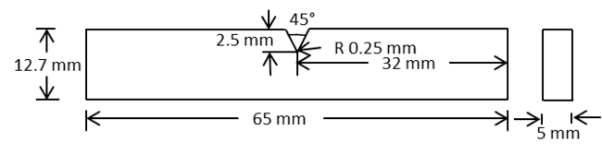 | 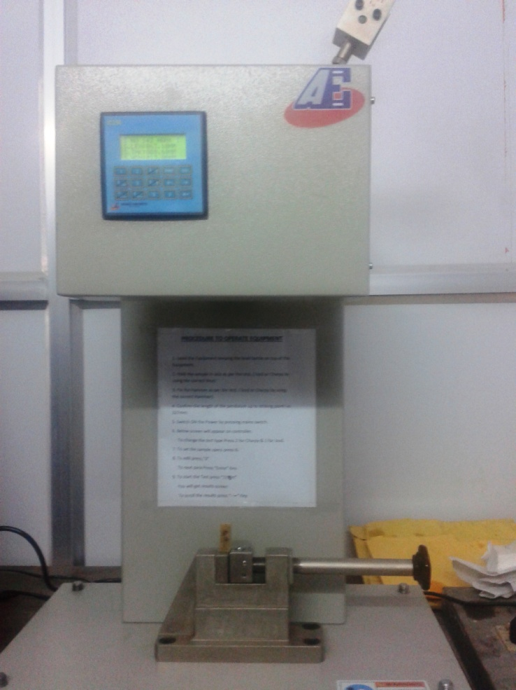  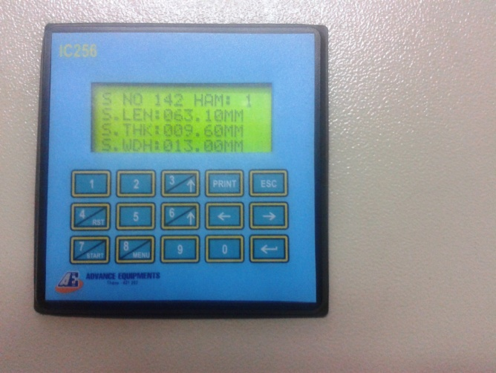
Fig.6. Specimen geometry for impact strength
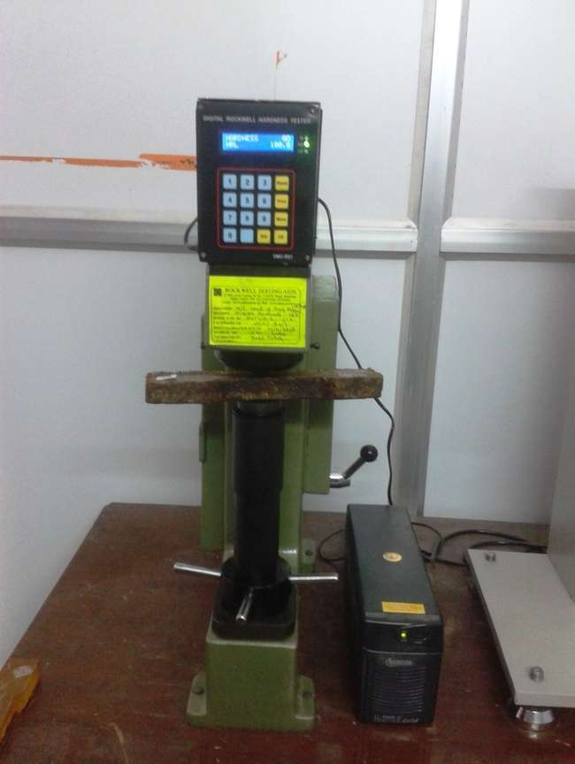 | 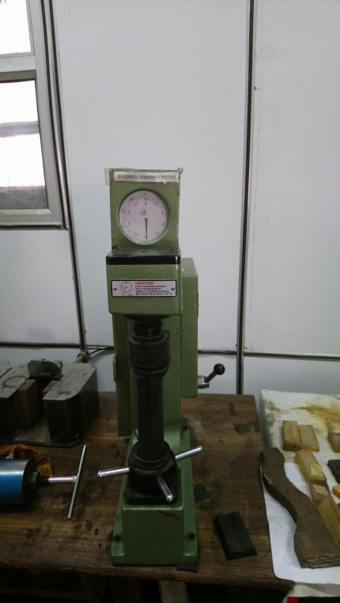
Fig.7. Hardness measurement by RH Machine

.
2.10.6 Hardness test
The Rockwell hardness test is generally performed when quick and direct reading is desirable. The Rockwell hardness test was carried on the Digital Hardness testing machine on L scale.
2.11 Physical properties
The density of the composite yoke and a traditional wooden (Sheesham wood) yoke was determined using the water displacement method (ASTM D792).

2.11.1 Water absorption and thickness swelling test
Water absorption and thickness swelling test were evaluated in laboratory. The samples were made and dissolved in water for 24 hours.
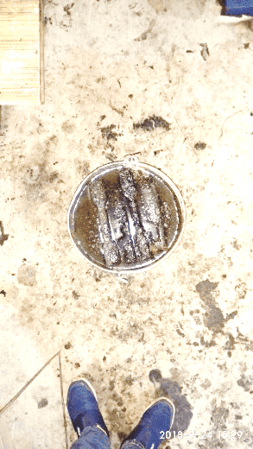
Fig.8. Water Absorption testing of samples
Density
For determination of density of samples of different models were first weighed on electronic weighing machine individually, and then were dipped individually into 50 ml of water kept into a cylindrical beaker of volume 100 ml. Thus,
The mass of the sample = m, gm
Volume of water taken = 50, ml
Volume of the sample and water = (v + 50), ml
Volume of sample = {(v + 50) – 50}
= v, ml
Hence,
Density of the sample/model = Mass of sample / Volume of sample …… (1)

Experimental Analysis
In the present study we were compared the effect of filler composite (silica wt % and biomass wt %) on mechanical properties. Here we were taken two independent variables were silica has four levels ( 0,5,10, and 15%) and biomass levels of ( 0,5,10, and 15%). The data was analysed by using two way ANOVA techniques. The data was present in Table 4.

- RESULTS AND DISCUSSION
3.1 Physical and Mechanical Properties
The mechanical performance of the composites was strongly influenced by the type and proportion of silica and biomass fillers. Statistical interpretation based on relative percentage variation among treatments revealed clear optimum filler combinations and performance thresholds.

Fig. 9. Comparison of strength of various treatment composition
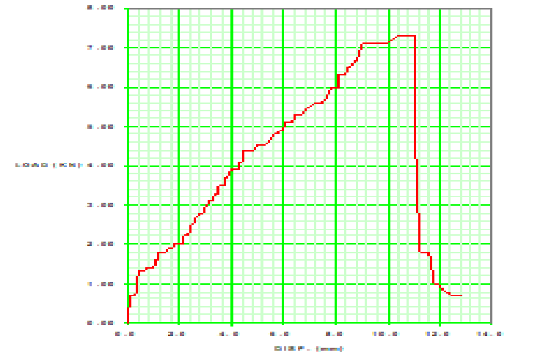
Fig.10. Load versus displacement curve for tensile strength by UTM machine
3.2 Tensile Properties
The ultimate tensile strength (UTS) showed considerable variation across treatments, varying from from 8.98 to 24.20 N/mm². Compared to the control sample T1 (0 wt% silica, 0 wt% biomass), the UTS increased by approximately 54% in T3 (10 wt% silica) and by 54.4% in T9 (10 wt% silica + 10 wt% biomass), indicating statistically significant improvement due to filler reinforcement. The yield strength followed a similar trend, with T9 exhibiting an 85% increase over the control. However, further increase in filler content beyond this level (e.g., T7 and T10) resulted in a reduction of tensile strength by nearly 40–45%, suggesting a statistically meaningful decline due to filler agglomeration and weak interfacial bonding.
The modulus of elasticity increased by approximately 25% with silica addition up to 10 wt% (T2 and T3), demonstrating enhanced stiffness. However, a reduction of more than 45% was observed at higher biomass levels (T7 and T8), indicating loss of structural continuity. Percentage elongation showed an inverse relationship with stiffness, where T3 and T5 exhibited nearly 30–40% higher elongation than the control, implying improved ductility at moderate filler loading.
3.3 Compressive Properties
Compressive ultimate strength exhibited a consistent and statistically significant increase with combined filler addition. The maximum value was observed in T9 (78.00 N/mm²), representing an improvement of approximately 44% over the control sample. Treatments T7 and T8 also showed compressive strength improvements of more than 35%, confirming the effectiveness of hybrid reinforcement under compressive loading.
The compressive modulus of elasticity increased from 303.23 N/mm² (T1) to 372.84 N/mm² (T7), reflecting an enhancement of nearly 23%, which indicates improved resistance to deformation. Percentage reduction in length increased progressively with biomass content, with T9 showing a 33% higher deformation capacity than T1, suggesting improved energy absorption and failure resistance.
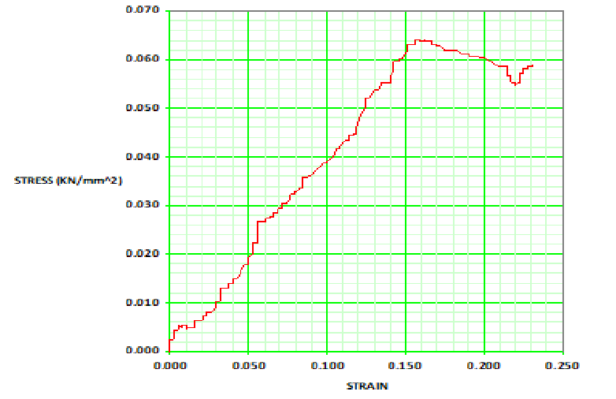
Fig.11. Stress versus strain curve for compressive strength t by UTM machine

3.4 Impact Strength and Hardness
Impact strength demonstrated a statistically meaningful enhancement with filler addition. Compared to the control (4.55 N,mm²), T9 exhibited an impact strength of 7.2 N/mm², corresponding to an increase of approximately 58%. This indicates superior toughness and improved stress dissipation due to the combined effect of silica rigidity and biomass fiber pull-out mechanisms.
Hardness values increased steadily with filler loading, reaching a maximum of 23.6 HRR in T10, which is nearly 105% higher than the control sample. This statistically significant increase confirms improved surface resistance and wear performance of the composites.

Fig.12. Comparison of imapct strength of various treatment composition
3.5 Flexural Properties
Flexural strength analysis showed that T9 achieved an ultimate flexural strength of 41.47 N/mm², which is approximately 11% lower than T1 but 73% higher than T2, indicating that hybrid filler addition enhances bending performance compared to single-filler systems. The flexural modulus increased significantly for T1 and T9, while excessive filler content caused a reduction of up to 70% in flexural stiffness (T4 and T6), indicating premature crack initiation.
Peak displacement values decreased by nearly 35–50% with higher filler content, signifying increased stiffness but reduced flexibility. Peak time reduction in high-filler composites indicates brittle fracture behavior, whereas moderate filler levels exhibited delayed failure.
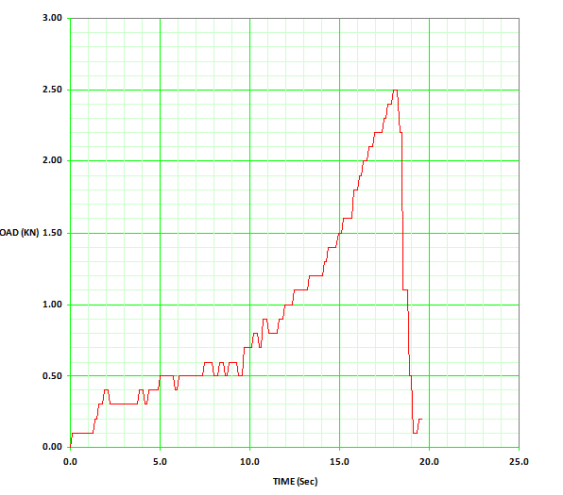
Fig.13. Load versus time curve for flexural strength t by UTM machine

3.6 Density and Physical Properties
The density of the composites ranged from 1.13 to 1.30 g/cc. Compared to natural wood samples (0.72–0.86 g/cc ), the developed composites exhibited 35–80% higher density, indicating better compaction and reduced void content. However, variations among composite treatments remained within ±7%, suggesting good processing consistency.

Fig. 14. Comparison of density of various treatment composition

- Conclusion
The present study evaluated the mechanical performance of silica–biomass–reinforced composites through tensile, compressive, impact, hardness, and flexural tests. The results demonstrated that filler type and loading significantly influence the mechanical behaviour of the composites. Among all formulations, the hybrid composite containing 10 wt% silica and 10 wt% biomass (T9) exhibited the most balanced and superior overall performance. This composition showed maximum tensile strength (24.20 N/mm²), compressive strength (78.00 N/mm²), and impact strength (7.2 N/mm²), representing improvements of approximately 54%, 44%, and 58%, respectively, compared to the unfilled control.
The incorporation of silica enhanced stiffness and load-bearing capacity, while biomass filler contributed to improved toughness and energy absorption. However, excessive filler addition beyond the optimum level resulted in a noticeable reduction in tensile and flexural properties due to filler agglomeration and weakened interfacial bonding. Hardness and density increased consistently with filler content, indicating improved surface resistance and material compactness. Flexural performance was maximized at moderate filler loadings, whereas higher filler percentages led to brittle failure behaviour.
When compared with natural wood materials (Haldu and Seesam), the optimized composite exhibited comparable or superior mechanical properties, particularly in compression, impact resistance, and hardness. These findings confirm that hybrid silica–biomass composites, especially at optimized filler proportions, have strong potential as sustainable alternatives to conventional wood-based and synthetic materials for structural and semi-structural engineering applications.

Disclaimer (Artificial intelligence)

Author(s) hereby declare that NO generative AI technologies such as Large Language Models (ChatGPT, COPILOT, etc.) and text-to-image generators have been used during the writing or editing of this manuscript.

5. References
- Abdurrahman, M. I., Chaki, S., & Saini, G. (2020). Stubble burning: Effects on health & environment, regulations and management practices. Environmental Advances, 2, 100011. https://doi.org/10.1016/j.envadv.2020.100011.
- Bhuvaneshwari, S., Hettiarachchi, H., & Meegoda, J. N. (2019). Crop residue burning in India: policy challenges and potential solutions. International Journal of Environmental Research and Public Health, 16(5), 832. https://doi.org/10.3390/ijerph16050832.
- Bolcu, D., Stănescu, M. M., & Miriţoiu, C. M. (2022). Some Mechanical Properties of Composite Materials with Chopped Wheat Straw Reinforcer and Hybrid Matrix. Polymers, 14(15), 3175. https://doi.org/10.3390/polym14153175.
- Chanana, I., Sharma, A., Kumar, P., Kumar, L., Kulshreshtha, S., Kumar, S., & Patel, S. K. S. (2023). Combustion and stubble burning: a major concern for the environment and human health. Fire, 6(2), 79. https://doi.org/10.3390/fire6020079.
- Chendrashekhara, S., B, L. G., Patila, S. S., & Lokeshaa, H. (2018). Factors influencing the adoption of paddy straw management practices by farmers of Karnataka (India). Current Agriculture Research Journal, 6(2), 225–232. https://doi.org/10.12944/carj.6.2.13.
- Gadde, B., Bonnet, S., Menke, C., & Garivait, S. (2009). Air pollutant emissions from rice straw open field burning in India, Thailand and the Philippines. Environmental Pollution, 157(5), 1554–1558. https://doi.org/10.1016/j.envpol.2009.01.004.
- Ge, Y., & Fan, Li. (2026). Resourceful utilization of crop residue by smallholder farmers in major grain-producing areas: pathways and countermeasures. Scientific Reports. https://doi.org/10.1038/s41598-026-35164-7.
- GFW. (2025). India Deforestation Rates & Statistics. Global Forest Watch Retrieved from https://www.globalforestwatch.org/dashboards/country/IND.
- Guan, Y., Chen, G., Cheng, Z., Yan, B., & Hou, L. (2017). Air pollutant emissions from straw open burning: A case study in Tianjin. Atmospheric Environment, 171, 155–164. https://doi.org/10.1016/j.atmosenv.2017.10.020.
- Guo, X., Li, K., Liu, Y., Zhuang, M., & Wang, C. (2022). Toward the economic-environmental sustainability of smallholder farming systems through judicious management strategies and optimized planting structures. Renewable and Sustainable Energy Reviews, 165, 112619. https://doi.org/10.1016/j.rser.2022.112619.
- Houssou, N., Kolavalli, S., Bobobee,E. & Owusu,V., (2013). Animal traction in Ghana. ideas.repec.org. Retrieved from https://ideas.repec.org/p/fpr/gsspwp/34.html.
- Jain, N., Bhatia, A., & Pathak, H. (2014). Emission of Air Pollutants from Crop Residue Burning in India. Aerosol and Air Quality Research, 14(1), 422–430. https://doi.org/10.4209/aaqr.2013.01.0031.
- Kumar, U. (2017). Development and evaluation of improved double neck yoke for draft animals of Jharkhand State. Retrieved from https://agris.fao.org/search/en/providers/122535/records/65dfa8234c5aef494fe40b9b.
- Li, J., Li, Y., Lin, N., Fang, Y., Dong, Q., Zhang, T.Feng, H. (2024). Ammoniated straw returning: A win-win strategy for increasing crop production and soil carbon sequestration. Agriculture Ecosystems & Environment, 363, 108879. https://doi.org/10.1016/j.agee.2023.108879.
- Liu, Z., Sun, J., Zhu, W., & Qu, Y. (2021). Exploring impacts of perceived value and government regulation on farmers’ willingness to adopt wheat straw incorporation in China. Land, 10(10), 1051. https://doi.org/10.3390/land10101051.
- Singh, G., & Arya, S. K. (2020). A review on management of rice straw by use of cleaner technologies: Abundant opportunities and expectations for Indian farming. Journal of Cleaner Production, 291, 125278. https://doi.org/10.1016/j.jclepro.2020.125278.

- Venkataravanappa, R. Y., Lakshmikanthan, A., Kapilan, N., Chandrashekarappa, M. P. G., Der, O., & Ercetin, A. (2023). Physico-Mechanical property evaluation and morphology study of Moisture-Treated Hemp–Banana Natural-Fiber-Reinforced green composites. Journal of Composites Science, 7(7), 266. https://doi.org/10.3390/jcs7070266.

- Umogbai, V.I. (2011). (n.d.). Development of Double-Neck yoke and harness for animal traction. Journal of Emerging Trends in Engineering and Applied Sciences, 2(1), pp. 87-95.

Type of treatment | Constituent
Type of treatment | Volume and weight of the Specimen | Resin |  | Jute net | Glass wool | Silica (%) | Rice-wheat straw, bagasse, saw dust  Ratio (1:1:1) | Hardner (9 % of the resin vol)
 | Volume (ml) / wt (g) | % of Total Volume | Volume (ml) | Wt % of Resin | Wt % of Resin | Wt % of Resin | Wt % of Resin | Volume (ml)
T₁ | 200 (206.19) | 100% | 200 | - | - | 0 | 0 | 18
T₂ | 200 (206.19) | 95 % | 190 | - | - | 5 | 0 | 17.1
T₃ | 200 (206.19) | 90 % | 180 | - | - | 10 | 0 | 16.2
T₄ | 200 (206.19) | 85 % | 170 | - | - | 15 | 0 | 15.3
T₅ | 200 (206.19) | 85 % | 170 | 5 % (10.00) g | - | 5 | 5 | 15.3
T₆ | 200 (206.19) | 80 % | 160 | 5 % (10.00) g | - | 5 | 10 | 14.4
T₇ | 200 (206.19) | 75 % | 150 | 5 % (10.00) g | - | 5 | 15 | 13.5
T₈ | 200 (206.19) | 80 % | 160 | 5 % (10.00) g | - | 10 | 5 | 14.4
T₉ | 200 (206.19) | 75 % | 150 | 5 % (10.00) g | - | 10 | 10 | 13.5
T₁₀ | 200 (206.19) | 70 % | 0 | 5 % (10.00) g | - | 10 | 15 | 0
Table 2. Preparation of different samples using different quantities of filler and matrix materials

Table 3. Determination of mechanical properties of composite material at different rate of filler material

 |  |  |  | TENSILE STRENGTH |  |  | COMPRESSION STRENGTH |  |  |  |  |  |  |  |  |  | FLEXURAL TEST
S.N | Type of treatment | Filler material |  | Ultimate Strength | Yield Strength | Modulus of Elasticity | % Elongation | Compressive ultimate strength | Compressive yield strength | Modulus of Elasticity | % reduction in length | Impact Strength | Hardness | Mass | Volume | Density | Ultimate Strength | Ultimate Load | Modulus of Elasticity
 |  | Silica  (wt %) | Bio-mass (wt %) | (N/mm²) | (N/mm²) | (N/mm²) | ( %) | (N/mm²) | (N/mm²) | (N/mm²) | % | N/mm² | HRR | (g) | (cc) | (g/cc) | (N/mm²) | kN | (N/mm²)
1. | T₁ | 0 | 0 | 15.68 | 10.56 | 195.37 | 5.45 | 54.04 | 20.8 | 303.2 | 10.82 | 4.55 | 115.43 | 11.3 | 9.8 | 1.15 | 46.74 | 4.50 | 1193.76
2. | T2 | 5 | 0 | 13.83 | 11.78 | 245.45 | 2.64 | 50.92 | 11.2 | 332.2 | 11.34 | 5.26 | 102.86 | 11.7 | 9.9 | 1.16 | 23.94 | 1.66 | 552.37
3. | T3 | 10 | 0 | 20.67 | 13.19 | 239.79 | 7.00 | 65.68 | 47.3 | 297.6 | 11.35 | 5.4 | 100.51 | 11.5 | 9.8 | 1.18 | 32.26 | 1.90 | 911.62
4 | T4 | 15 | 0 | 08.98 | 08.98 | 155.75 | 4.95 | 40.32 | 9.09 | 331.8 | 10.92 | 4.78 | 98.33 | 11.7 | 10.0 | 1.17 | 15.48 | 1.96 | 140.57
5. | T5 | 5 | 5 | 17.35 | 10.91 | 180.17 | 7.59 | 69.94 | 18.92 | 244.61 | 12.45 | 6.00 | 98.16 | 14.8 | 12.1 | 1.22 | 26.25 | 2.80 | 531.48
6 | T6 | 5 | 10 | 15.24 | 11.83 | 143.74 | 5.36 | 65.85 | 37.99 | 269.22 | 13.52 | 6.05 | 92.80 | 13.3 | 10.2 | 1.3 | 21.56 | 2.30 | 134.0
7 | T7 | 5 | 15 | 09.16 | 07.83 | 104.79 | 7.13 | 75.60 | 49.9 | 372.84 | 13.64 | 6.80 | 98.36 | 18.7 | 15.0 | 1.24 | 23.44 | 2.50 | 374.10
8 | T8 | 10 | 5 | 12.14 | 08.09 | 75.39 | 6.70 | 72.30 | 36.14 | 340.94 | 12.13 | 6.85 | 90.83 | 21.8 | 19.0 | 1.14 | 24.68 | 2.63 | 402.84
9 | T9 | 10 | 10 | 24.20 | 19.55 | 229.51 | 5.39 | 78.00 | 51.18 | 337.74 | 14.42 | 7.20 | 86.13 | 22.6 | 20.0 | 1.13 | 41.47 | 42.0 | 886.99
10 | T10 | 10 | 15 | 15.10 | 09.74 | 175.41 | 6.84 | 64.46 | 37.46 | 270.6 | 10.25 | 5.56 | 94.76 | 23.6 | 20.0 | 1.18 | 23.75 | 2.30 | 346.27
11. | Wood1(Haldu) | - | - | 23.82 | 16.35 | 317.77 | 1.15 | 25.68 | 15.09 | 265.89 | 12.25 | - | 22.03 | 18.1 | 21.0 | 0.86 | - | - | -
12 | Wood2(Seesam) | - | - | 22.74 | 11.73 | 358.56 | 2.32 | 32.23 | 26.09 | 263.83 | 14.72 |  | -- | 8.8 | 12.2 | 0.72 | - | - | -

Table 4a. Statistical analysis of effect of filler materials on tensile strength
Source of Variation | SS | df | MS | F | P-value | F crit | Remark
Treatment | 239.22 | 9 | 26.58 | 3.94 | 0.139747 | 2.456281 | Significant
Silica | 54.25 | 2 | 10820.81 | 208.1636 | 3.61E-13 | 3.554557
Error |  | 18 | 51.98223
Total | 293.47 | 29

Table 4b: Statistical analysis of effect of filler materials on compressive strength
Source of Variation | SS | df | MS | F | P-value | F crit | Remark
Treatment | 838.2051 | 9 | 93.1339 | 4.21 | 0.139747 | 2.456281 | Significant
Silica | 21641.62 | 2 | 10820.81 | 208.1636 | 3.61E-13 | 3.554557
Error | 935.6802 | 18 | 51.98223
Total | 23415.51 | 29

Table 4c : Statistical analysis of effect of filler materials on flexural strength

Source of Variation | SS | df | MS | F | P-value | F crit | Remark
Treatment | 272.5387 | 9 | 30.28208 | 3.47 | 0.8414 | 2.456281 | Significant
Silica | 3009.496 | 2 | 1504.748 | 25.83585 | 5.13E-06 | 3.554557
Error | 1048.367 | 18 | 58.24264
Total | 4330.402 | 29

