Impact of Shade on Cocoa Swollen Shoot Virus Disease Hotspots in the Fresco Department, Southern Côte d’Ivoire

ABSTRACT
Cocoa Swollen Shoot Virus (CSSV) represents a major threat to the principal cocoa-producing regions of Côte d’Ivoire, such that effective management of this disease has become a priority for all stakeholders in the cocoa value chain. In this context, the present study was undertaken to contribute to CSSV management by improving understanding of the role of associated trees in cocoa-based agroecosystems. The main objective of this study was to evaluate the effect of trees associated with cocoa plants on the prevalence and spatial configuration of CSSV disease foci in cocoa plantations located in the Fresco Department. To achieve this objective, the infection status of cocoa plantations affected by swollen shoot disease was characterized, and comprehensive botanical inventories of shade trees were conducted both within and around CSSV disease foci. The results revealed a higher density of shade trees in the surrounding areas compared to the interior of disease foci. Overall, these findings suggest that cocoa agroforestry systems incorporating appropriate shade tree species may contribute to limiting the spread of CSSV symptoms and could therefore represent a promising adaptation strategy to mitigate disease severity in cocoa plantations.
Keywords: cocoa plantation, Cocoa Swollen Shoot Virus, Fresco area, landscape configuration, shading

Introduction
Côte d’Ivoire supplies approximately 43% of the global cocoa bean market (ICCO, 2021) and has ranked first among nearly fifty cocoa-producing countries for more than three decades. This major production contributes over 15% to the national Gross Domestic Product and constitutes the primary source of income for thousands of smallholder farmers. Cocoa alone accounts for nearly 50% of Ivorian export products, thereby providing essential economic support to the State.
However, these socio-economic achievements should not obscure the numerous constraints that may lead to a substantial decline in production and exacerbate rural poverty. In general, the constraints affecting cocoa farming in Côte d’Ivoire can be grouped into two main categories. Abiotic constraints include, in particular, fluctuations in market prices and the progressive depletion of forest resources (Freud et al., 2000). Biotic constraints are predominantly driven by diseases and insect pests. Among these bioagressors, black pod disease caused by Phytophthora spp. and mirid bugs (Sahlbergella singularis and Distantiella theobroma) are the most destructive (Coulibaly et al., 2013). In addition, Cocoa Swollen Shoot Virus (CSSV), the causal agent of swollen shoot disease, represents a particularly damaging threat. Notably, Coulibaly et al. (2013) reported that more than 30% of cocoa plantations in the Fresco Department were affected.
In response to this threat, agroforestry has emerged as a promising approach to limit the spread of CSSV. As an agricultural system that integrates trees with crops (and sometimes livestock), agroforestry is widely recognized as both environmentally sustainable and economically viable (Nair, 2007; Valentini, 2007).
Accordingly, the overall objective of this study is to evaluate the effect of trees associated with cocoa plants on the prevalence and spatial configuration of CSSV disease foci in cocoa plantations located in the Fresco Department.

Study area
The Fresco Department, located in southern Côte d’Ivoire, covers an area of 325.5 km² and belongs to the Gbôklè Region (Figure 1). The climate is of the subequatorial type (Avenard, 1971), with mean monthly temperatures ranging from 24 °C to 28 °C. Annual rainfall varies between 15 and 247 mm, with June being the wettest month, recording an average rainfall of 247 mm.
The local economy is primarily based on agricultural activities. The coffee–cocoa system remains dominant, alongside food crops such as rice, plantain banana, maize, and yam. More recently, cashew (Anacardium occidentale) cultivation has been introduced in the area (N’Drin et al., 2019), providing a valuable economic complement to traditional agricultural productions (Coulibaly et al., 2019).
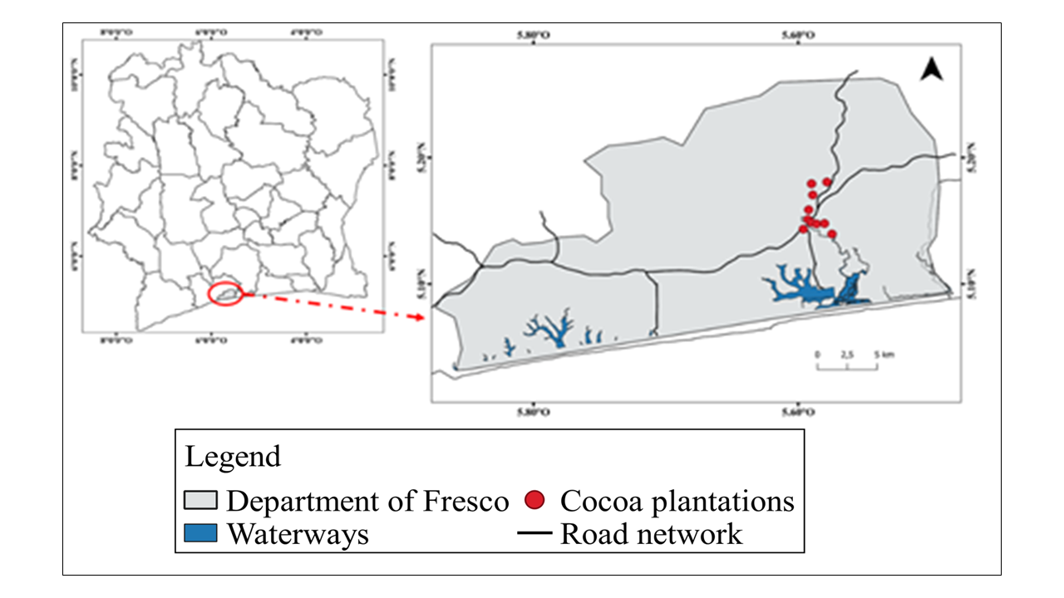
Figure 1. Location of the department of Fresco and the cocoa plantations in the study

- Methodology
  - Sampling design
The present study was conducted across a network of ten (10) cocoa plantations. Observations focused on both cocoa trees and associated shade trees within each plantation. The selection of plantations was based on a typology defined using three main criteria: plantation age, yield level, and the density of associated trees per hectare. All studied sites exhibited a high incidence of cocoa swollen shoot disease. The detailed characteristics of these plantations are presented in Table 1.
Table 1. Characterization of selected cocoa farms
N° | Planting code | Age (years) | Productivity (kg) / ha | Tree density (threshold 20 / ha)
1 | Fresco_1 | 16 | 700 | < 20 trees/ha
2 | Fresco_2 | 20 | 250 | > 20 trees/ha
3 | Fresco_3 | 13 | 500 | > 20 trees/ha
4 | Fresco_4 | 7 | 900 | < 20 trees/ha
5 | Fresco_5 | 20 | 1000 | < 20 trees/ha
6 | Fresco_6 | 17 | 1500 | > 20 trees/ha
7 | Fresco_7 | 20 | 250 | < 20 trees/ha
8 | Fresco_8 | 70 | 2000 | > 20 trees/ha
9 | Fresco_9 | 16 | 1500 | < 20 trees/ha
10 | Fresco_10 | 10 | 600 | > 20 trees/ha

  - Inventory of trees associated with cocoa
The inventory involved the identification, measurement of circumference, and geolocation of trees located within disease hotspots and in the surrounding areas within a 20 m radius of cocoa swollen shoot disease foci. Only trees with a diameter at breast height (dbh) greater than 10 cm were included in the study (Vroh et al., 2010). For buttressed species, circumference measurements were taken 30 cm above the buttress zone.
For each tree meeting the dimensional criteria, GPS coordinates were recorded, and the tree was marked using biodegradable paint to facilitate identification during subsequent verification.

  - Estimation of shade
Shade within CSSV disease hotspots was estimated based on the ground projection of the area covered by the crowns of shade trees. To this end, each crown was approximated as a circular shape, for which two perpendicular diameters (D1 and D2) were measured on the ground using a measuring tape (Figure 2). The mean of these two diameters was then squared and multiplied by π (3.14) to obtain the projected crown area.
These measurements made it possible to quantify shade by calculating the proportion of shaded area within each hotspot, defined as the ratio between the total area occupied by crown projections and the total area of the CSSV hotspot. This proportion theoretically ranges from 0% (absence of shade) to 100% (complete shade).
Shade estimation was conducted in six plantations selected according to their agroecological characteristics. Selection was based on two criteria: plantation age (< 20 years and > 20 years) and the intensity of swollen shoot infection (low, moderate, high), with two plantations selected per infection level. The resulting values were subsequently grouped into three shade classes: 0–30% (low), 30–60% (moderate), and 60–100% (high).

Figure 2. Measuring the ground projection of the crown of shade trees across two diameters

  - Data analysis
Mean comparison tests were used to compare selected calculated parameters, with the objective of determining whether the means of different treatments differed significantly. The significance level was set at 5% (p = 0.05). When significant differences were detected, Tukey’s post hoc test was performed to identify which groups differed from each other.

Results
  - Tree species richness in infection hotspots
A total of 50 tree species were recorded within and around the CSSV infection hotspots, belonging to 36 genera and 23 families. The most represented families were Moraceae (12%), Sterculiaceae (11%), Rutaceae (11%), Apocynaceae (8%), and Anacardiaceae (6%). (Figure 3). Tree density within and around CSSV hotspots ranged from 0 to 56 trees per hectare, with a mean of 17 trees per hectare. Around the hotspots, the average density was 22 trees per hectare, while the mean density within the hotspots was 13 trees per hectare.

Figure 3. Tree species families

  - Spatial distribution of shade trees
Figure 4 illustrates the distribution of shade trees within and around the different CSSV hotspots, as well as the ground projection of their crowns. Overall, the results reveal substantial variability between plantations.
The hotspots in the Fresco 10 plot were the most shaded, featuring a mix of forest and fruit trees. The density of associated trees was relatively low, with 20 trees per hectare in the surveyed area. The total crown cover amounted to approximately 925 m². A large proportion of the associated trees belonged to the families Moraceae (Ficus exasperata, Antiaris toxicaria, and Milicia excelsa) and Sterculiaceae (Sterculia tragacantha). Fruit trees were mainly represented by Persea americana (Lauraceae) and Mangifera indica (Anacardiaceae), whose crown areas were generally small (Table 2). Shade tree distribution within the hotspots was highly heterogeneous.
In contrast, the hotspots of the Fresco 1 plot were the least shaded. These contained only forest trees, namely Antiaris toxicaria (Moraceae), Acacia mangium, Albizia adianthifolia (Mimosaceae), and Afzelia africana (Caesalpiniaceae), planted at an average density of approximately 12 trees per hectare. The crown area in this plot was relatively low, about 216 m² within the surveyed area.

Table 2. List of species in the plantations
N° | Specices | Families | Biological types | Within hotspots | Proximity to hotspotss
01 | Afzelia africana Smith ex Pers. | Caesalpiniaceae | mP | 5 | 2
02 | Albizia adianthifolia (Schumach.) W.F. | Mimosaceae | mP | 10 | 0
03 | Albizia ferruginea (Guill. & Perr.) Benth. | Mimosaceae | mP | 0 | 0
04 | Alstonia boonei De Wild. LC. | Apocynaceae | MP | 3 | 4
05 | Anacardium occidentalis L. | Anacardiaceae | mp | 2 | 6
06 | Anthonotha crassifolia (Baill.) J.Léonard | Caesalpiniaceae | mp | 1 | 0
07 | Antiaris toxicaria Lesch. | Moraceae | mP | 4 | 3
08 | Artocarpus altilis (Parkinson) Fosberg | Mimosaceae | mP | 2 | 2
09 | Baphia nitida Lodd. | Fabaceae | mp | 2 | 0
10 | Blighia sapida K. D. Koenig | Sapindaceae | mP | 2 | 1
11 | Blighia welwitschii (Hiern) Radlk. | Sapindaceae | mP | 0 | 0
12 | Bridelia ferruginea Benth. | Euphorbiaceae | mp | 2 | 1
13 | Carica papaya L. | Caricaceae | mp | 1 | 1
14 | Ceiba pentandra (Linn.) Gaerth. | Bombacaceae | MP | 1 | 2
15 | Celtis zenkeri EngI. | Ulmaceae | mP | 1 | 1
16 | Citrus latipes (Swingle) Tanaka | Rutaceae | mp | 1 | 0
17 | Citrus reticulata Blanco | Rutaceae | mp | 2 | 1
18 | Citrus sinensis (L.) Osbeck | Rutaceae | mp | 2 | 1
19 | Cola nitida (Vent.) Schott & Endl. | Sterculiaceae | mP | 4 | 2
20 | Diospyros mespiIiformis Hochst. | Ebenaceae | mp | 1 | 0
21 | Entandrophragma angolense (Welw.) C. DC. | Meliaceae | MP | 0 | 1
22 | Ficus exasperata Vahl | Moraceae | mp | 1 | 1
23 | Ficus recurvata De Wild. | Moraceae | mp (Ep) | 1 | 0
24 | Ficus sur Forsk. | Moraceae | mp | 4 | 1
25 | Funtumia africana (Benth.) Stapf | Apocynaceae | mP | 2 | 1
26 | Harungana madagascariensis Lam. | Hypericaceae | mp | 2 | 3
27 | Holarrhena floribunda (G. Don) Dur. & Schinz | Apocynaceae | mP | 1 | 0
28 | Kigelia africana (Lam.) Benth. | Bignoniaceae | mp | 0 | 0
29 | Lophira alata Banks ex Gaertn.f. | Ochnaceae | MP | 1 | 1
30 | Mangifera indica Linn. | Anacardiaceae | mP | 4 | 3
31 | Milicia excelsa (Welw.) Benth. | Moraceae | MP | 4 | 4
32 | Millettia zechiana Harms | Fabaceae | mp | 10 | 0
33 | Morinda lucida Benth. | Rubiaceae | mp | 9 | 8
34 | Morus mesozygia Stapf ex A. Chev. | Moraceae | mp | 0 | 0
35 | Musanga cecropioides R. Br. | Musaceae | G | 2 | 0
36 | Myrianthus arboreus P. Beauv. | Cecropiaceae | mP | 3 | 5
37 | Nesogordonia papaverifera (A. Chev.) R. Capuron | Cecropiaceae | mp | 3 | 1
38 | Newbouldia laevis (P. Beauv.) Seemann | Sterculiaceae | MP | 6 | 0
39 | Parkia biglobosa (Jacq.) Benth. | Bignoniaceae | mp | 0 | 0
40 | Persea americana Mill. | Mimosaceae | mi | 7 | 3
41 | Piptadeniastrum africanum (Hook.f.) | Mimosaceae | MP | 0 | 0
42 | Pycnanthus angolensis (Welw.) Warb | Myristicaceae | mP | 3 | 3
43 | Rauvolfia vomitoria Afzel. | Apocynaceae | mp | 10 | 7
44 | Ricinodendron heudelotii (Baill.) Pierre | Euphorbiaceae | mP | 0 | 0
45 | Spondias mombin Linn. | Anacardiaceae | mp | 7 | 9
46 | Sterculia tragacantha Lindl. | Sterculiaceae | mP | 3 | 2
47 | Terminalia ivorensis A. Chev. | Combretaceae | MP | 2 | 0
48 | Terminalia superba EngI. & Diels | Combretaceae | MP | 0 | 0
49 | Triplochiton scleroxylon K. Schum. | Sterculiaceae | MP | 1 | 0
50 | Zanthoxylum Zanthoxyloides (Lam.) | Rutaceae | mp | 1 | 0
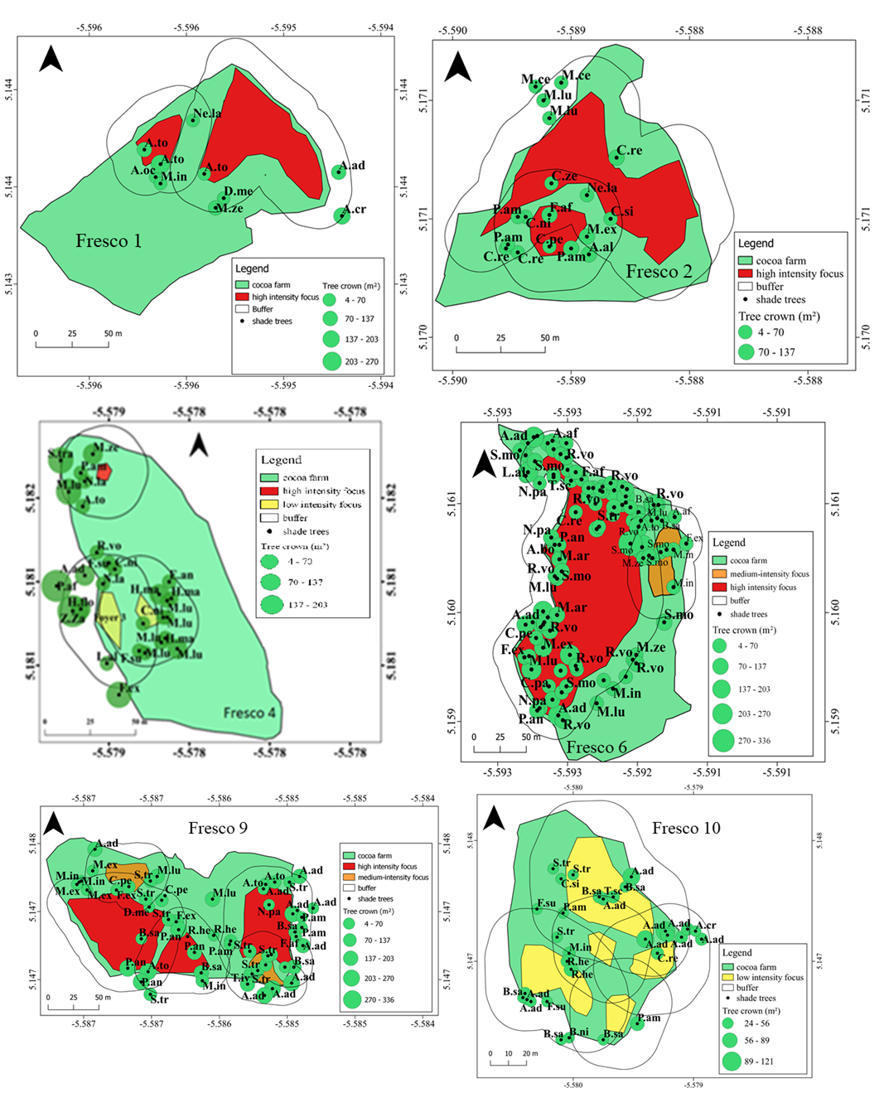
Figure 4. Spatial distribution of shade trees and tree crown area in and around swollen shoot foci (the areas around the foci)
a
b

5.3 Effect of shading on swollen shoot symptom intensity
The proportion of shaded area within and around swollen shoot disease foci ranged from 0 to 69%, with a mean value of 16% (Figure 5). Around the disease foci, the proportion of shaded area was 17%, whereas within the foci it was 15%. The mean comparison test revealed a significant difference between the proportions of shaded areas in the two environments. This finding suggests that the proportion of shaded area may influence the occurrence of CSSV infection foci.

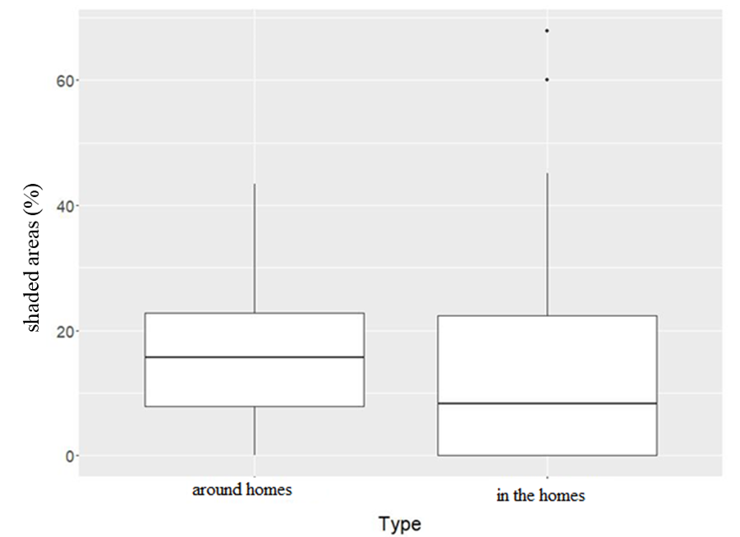
b
a
Figure 5. Comparative boxplots of the proportion of shaded area in and around swollen shoot foci

Discussion
The present study highlights three main findings that clarify the role of associated vegetation and shading in the epidemiology of Cocoa Swollen Shoot Virus (CSSV) in cocoa agroecosystems. First, the floristic composition within and around CSSV disease foci is characterized by a high diversity of woody species, including several families known to contain alternative host plants for the virus. Second, while shading does not appear to influence the prevalence or spatial occurrence of CSSV foci, it is associated with a reduction in symptom expression. Third, these results emphasize the need for selective shade management rather than the complete elimination or uncontrolled increase of shade trees in cocoa plantations.
The floristic richness recorded in and around CSSV outbreaks, comprising 41 species distributed among 36 genera and 23 families, reflects the structural complexity of cocoa agroforestry systems in the study area. The dominance of families such as Moraceae, Sterculiaceae, and Rutaceae is consistent with previous studies conducted in similar agroecosystems (Boko et al., 2020). Importantly, several species within these families (Ficus exasperata, Citrus sinensis, Cola nitida) have been identified as alternative hosts of CSSV (CNRA, 2011). Their presence may contribute to maintaining viral reservoirs and supporting populations of mealybug vectors, thereby increasing the risk of disease persistence at the landscape scale. The high number of intense swollen shoot outbreaks observed in several cocoa plots may thus be partly explained by the abundance of such host species in their immediate environment.
However, our results indicate that overall woody species richness, considered independently of species identity and density, does not significantly influence CSSV prevalence. This suggests that disease dynamics are more strongly driven by the presence and local abundance of specific alternative host species rather than by total tree diversity. Indeed, a cocoa plot may be dominated by a single shade species that is not a known CSSV host, thereby exerting little influence on disease prevalence despite high tree density. This distinction underscores the importance of considering species composition and functional roles rather than aggregate diversity metrics when assessing disease risk in agroforestry systems.
Regarding shading, the test revealed significant relationship between the proportion of shaded area and the prevalence of CSSV foci, indicating that shading alone does not prevent virus spread. Nevertheless, the higher density of shade trees observed around disease foci compared to their interior suggests that shading may influence symptom expression rather than viral transmission. Dense canopy cover may reduce plant stress by moderating microclimatic conditions such as temperature and evapotranspiration, potentially limiting symptom severity without interrupting infection processes. This interpretation is consistent with earlier findings by Jeger and Thresh (1993), who demonstrated that agroforestry systems can reduce the severity of CSSV symptoms while remaining insufficient to halt disease spread.
The role of shading in cocoa production and plant health must therefore be interpreted in a broader ecological context. Excessive or unmanaged shading has been shown to exacerbate certain diseases and pest pressures, as reported for black pod rot caused by Phytophthora megakarya (Nyassé et al., 1999; Ndoumbe-Nkeng & Sache, 2003). Conversely, appropriate shade management can reduce mirid attacks (Sahlbergella singularis) and improve system resilience (Babin et al., 2009). As emphasized by Braudeau (1969) and later by Boffa (2000), shading is not inherently detrimental to cocoa productivity but becomes limiting only when other growth factors are non-limiting. Shade therefore represents a key management lever through which farmers can regulate environmental conditions within cocoa plantations.
Although the present study does not allow for definitive conclusions regarding the control of CSSV spread, it helps to clarify the nuanced role of shade in disease expression under field conditions. These findings provide practical insights for the design of cocoa agroforestry systems, particularly in newly established plantations, where decisions regarding shade intensity and species selection can be optimized to balance disease mitigation, productivity, and ecosystem services.

Conclusion
The results of this study are particularly relevant to cocoa farmers, extension services, agroforestry practitioners, and policymakers involved in cocoa disease management and sustainable production systems. For farmers and extension agents, the findings highlight the potential role of associated trees and shading in reducing the intensity of CSSV symptoms, thereby offering practical guidance for shade management at the farm level. For researchers and plant pathologists, the study underscores the need to distinguish between symptom expression and virus spread, and points to the importance of integrating molecular diagnostics to better understand CSSV epidemiology under shaded conditions. Finally, for policymakers and development programs, the results support the promotion of well-designed cocoa agroforestry systems, emphasizing selective tree species choice to minimize phytosanitary risks while enhancing system resilience and sustainability.

Disclaimer (Artificial intelligence)

Author(s) hereby declare that NO generative AI technologies such as Large Language Models (ChatGPT, COPILOT, etc.) and text-to-image generators have been used during the writing or editing of this manuscript.

References
- Avenard J. M. (1971). Aspects of geomorphology. In: The natural environment of Côte d'Ivoire. ORSTOM Memoir, 50, Paris (France): 9-72.
- Babin R., Gerben M., Hoopen T., Cilas C., Enjalric F., Yede G.P. & Lumare J.P. (2009). Impact of shade on the spatial distribution of Sahlbergella singularis in traditional cocoa agroforests. Agricultural and Forest Entomology, 12(1): 69-79.
- Boffa J.M. (2000). Agroforestry parks in West Africa: keys to conservation and sustainable management. Unasylva, 51: 11-17.
- Boko B.B., Koulibaly A., Amon A.D.E., Dramane K.B., M'Bo K.A.A. & Porembski S. (2020). Farmers' Influence on Plant Diversity Conservation in Traditional Cocoa Agroforestry Systems of Côte d'Ivoire. International Journal of Research Studies in Agricultural Sciences, 6(12): 1-11
- Braudeau J. (1969). The cocoa tree. Techniques Agricoles et Productions Tropicales. Maisonneuve et Larose, Paris (France), 304 p.
- CNRA. (2011). Effectively combating cocoa swollen shoot disease in Côte d'Ivoire, Cocoa technical sheet No. 6 cocoa (Theobroma cacao L.): a review. Expert Agriculture. 47, 653-676.
- Coulibaly B., Krouba D.I., Kouakou A.A.C., Ouattara A.A., Berté D., Ta Bi T.D., Rayaisse J-P., Jamonneau V., Solano Ph., Koffi Y.J.J., Kaba D., Courtin F., Assi Kaudjhis J-P. & Anoh K.P. (2019). Health consequences of rural landscape dynamics in the human African trypanosomiasis (HAT) outbreak of Fresco (Côte d'Ivoire) between 2002 and 2015. Revue Espace, Territoires, Sociétés et Santé, 1(2): 19-36.
- Coulibaly K., Kébé I.B., Koffi N.K., Mpika J. & Koné D. (2013). Characterisation of Phytophthora sp isolates from the cocoa orchard of Côte d'Ivoire. Journal of Applied Biosciences, 70: 5567-5579.
- Freud E.H., Petithuguenin P. & Richard J. (2000). Cocoa fields: a challenge of competitiveness between Africa and Asia. Editions Karthala and CIRAD, Paris (France), 207 p.
- ICCO. (2021). Annual report 2019/2020. International Cocoa Organization, 76 p.
- Jeger M.J. & Thresh J.M. (1993). Modelling reinfection of replanted cocoa by swollen shoot virus in pandemically diseased areas. Journal of Applied Ecology, 30: 187-196.

- Nair P.K.R. (2007). The Coming of Age of Agroforestry. Journal of Science of Food & Agriculture, 87: 1613-1619.
- Ndoumbe-Nkeng M. & Sache I. (2003) Fight against brown rot of cocoa pods in Cameroon. Phytoma-La Défense des Végétaux, (562): 10-12.
- N'drin O.J.A., Konan-Waidhet A.B. & Kienon-Kaboré T.H. (2019). Analysis of the Determinants of Climate Change Resilience of Farmers in the Department of Fresco, Côte d’Ivoire. European Scientific Journal, 15(18): 288-314.
- Nyasse S., Grivet L., Risterucci A.M., Blaha G., Berry D., Lanaud C. & Despreaux D. (1999). Diversity of' Phytophthora megakarya in Central and west Africa revealed by isozyme and RAPD markers. Mycological Research, 103: 1225-1234.
- Valentini G.S. (2007). Evaluation of carbon sequestration in agroforestry plantations and fallow lands resulting from migratory agriculture in the indigenous territories of Talamanca, Costa Rica. Master's thesis, Faculty of Agricultural and Food Sciences, University of Laval, Quebec (Canada), 88 p.
- Vroh B. T. A., Adou Yao C. Y., Kouamé D., N'Da D. H. & N'Guessan K. E., 2010. Floristic and structural diversity on the site of a voluntary nature reserve in Azaguié, south-east Côte d'Ivoire. European Journal of Scientific Research, 45 (3): 411 - 421.

