Governance of insecticidal effect by attapulgite clay in the Callosobruchus chinensis, pulse beetle

ABSTRACT
In recent decades, agricultural pests have caused 30-60% losses by Bruchids, which are the most primary, destructive, cosmopolitan, and polyphagous pests of post-harvest legume commodities in godowns, warehouses, farmers’ traditional bulk seeds storage units and also in the field. It is multiplying very rapidly and causes tremendous quality deterioration and deterioration of pulses stored in the semi-arid areas. The current study aimed to replace synthetic insecticides with acetone botanical powder extracts and attapulgite clay dust against Callosobruchus chinensis (L.) on stored pigeon peas. The powders were extracted with solvent acetone and concentrated to two percent, and used for insect bioassays in the Entomology, ICRISAT. The data was assessed at 24 hours with 48 and 72 hours after treatment application. The results revealed that attapulgite clay dust significantly increased adult mortality (86.67 %), followed by sweet flag (76.67 %), zero mortality in the control. The lowest adult emergence was recorded on attapulgite clay (17.32 %), followed by sweet flag (22.57 %), as compared to the controls (33.14 %). This study demonstrated that the plant powders and attapulgite clay dust are safe, eco-friendly, and effective alternatives to the hazardous chemical insecticides.
Keywords: Adult emergence, Attapulgite clay dust, Botanicals, Bruchids, and Mortality.

INTRODUCTION
The Bruchids cause huge economic losses to post-harvest legume commodities in godowns, warehouses and farmers' traditional bulk seeds storage units. Apart from bruchids, the other insects like Tribolium castaneum, Sitophilus oryzae, Sitophilus zeamais, Sitotroga cerealella also damage the stored grains. There was an enormous drop in the range of between 20 to 50 % have been revealed in grains that are stored in storage units, due to vigorous attack of cowpea beetle, Callosobruchus maculatus, and once in a while the losses may be charged up to 100 percent (Harry, G.I. and Udo I.O. (2013). Azuki bean beetle, C. chinensis, seed damage percentage in chickpea ranged from 8.33-77.40 and 19.15-85.56 under multi-choice and no-choice conditions, respectively (Sathish et al., 2020; Sathish et al., 2020). Tuda et al. (2005 reported that the prominent genus of Callosobruchus represents at least 20 species as these are present mostly all over the region in the world, like tropical and subtropical areas, but most of them originate from the African and Asian continents. Bruchids are one of the prominent, primarily destructive, cosmopolitan, and polyphagous pests of stored pulses. The primary source of infestation starts from field-to-store, which leads to the reduction of both seed germination and commercial value. Prior to that the human consumption of grains is becomes vulnerable. Even though chemical insecticides at the present days like fumigants along with the dusts are showing effectiveness in controlling Bruchids, but to certain point the application at the farm level usage is decreased as one of the main reason is the storage structures at the farmer’s site was not an air tight conditions and mixing of the food grains with the insecticides to protect or get rid of them against insects is also a not safe procedure(Bekele et al., 1995). The indiscriminate use of broad-spectrum bug-spray and various insecticides has build the new problems than resolving them at that point in time. Even though the harmful usage of insecticides are well aware by the farmers during the post-harvest storage times, some of the reasons are leading them to go along with the insecticides like vast increase in resistance of pests from the pesticides, ruination of the advantageous organisms, toxic residual matter from the pesticides in the food consequential health hazards, pollution in the environment which is undesirable and rapid rejuvenation of the target pest population etc., are critical drawbacks that have jump into the undiscriminating usage of insecticides every time at the storage units. So, the research is going on to overcome those problems with the ongoing use of substituent methods by edible oil spraying, inert dust, and plant products as extracts, as these products can be easily affordable and used by the farmers without a second thought process (Isman, 2008). Therefore, the present investigation was conducted to assess the selected botanicals' efficacy by acetone extraction under ambient conditions against Callosobruchus chinensis. It has been concluded with the reports that the pesticides which are derived from the plant as plant-based material are always shows the renewable nature, eco-friendly, cheaper and development of resistance by the insect pests in their generations is also liked to be less.
MATERIALS AND METHODS
Collection and preparation of samples: Seven botanical leaf powders viz., Datura (Datura stramonium L.), Eucalyptus (Eucalyptus globules Labill.), Hyptis (Hyptis suaveolens Jacq.), Lantana (Lantana camara L.), Sweet flag (Acorus calamus L.), Nishinda (Vitex negundo L.) and Neem seeds (Azadirachta indica L.) were collected from the ICRISAT campus. These botanicals were washed and allowed to dry in the shade. In the further step by using an electric grinder, these dried leaves and seeds were ground into fine mix of powder. The powdered compounds were passed through 20 mesh size sieves and stored at 2-8 °C until use. Other chemicals like attapulgite (ABC) clay (Naturally mined clay composed of magnesium–aluminum silicate), and acetone were procured locally for bioassay studies.
Solvent extraction of test powders: By using 250 mL of acetone as a constituent solvent, the 100 grams of each test powder were mixed separately on a stirrer for a total of 30 minutes continuously, and next 24 hours the mixture was allowed to stand without any disturbance. To extract a suitable sample, the mixture is allowed to filter through the Whatman No.1 paper. The filtrates were pooled, and by using 30mL of acetone, the residual matter was extracted again to get more extraction from the extracts. By using the water bath with the required temperature of 65°C, the solvent extraction from the pooled solution after filtration was evaporated. The crude final extracts were weighed, after the complete solvent evaporation and a 2 % per cent (w/v) extract was prepared. The preservation can be done at 5°C in a refrigerator by using sealed bottles for insect bioassays. A concentration of plant and attapulgite dust extracts at 2 mL/kg of grains was used for the experiments. The solvents were evaporated, and the extracts were mixed with the grains thoroughly and placed in petri plates. Water-sprayed grains (without extract) served as the control.
Insect culture: Pure cultures of test insects used in the present studies were obtained from the Entomology laboratory, International Crops Research Institute for the Semi-Arid Tropics (ICRISAT), India. Callosobruchus chinensis were reared on seeds of chickpea during the overall study course period. In general practice, the determination of sex among females and males was done by using standard characters (Arora, 1977). As a root in the study, the base of the experiment can be done by allowing the adults that are emerged freshly of ten pairs to oviposit for a whole one day on the healthy grains which are healthy to gain adults of age, which shows uniformity and this is helpful for future ongoing studies. These cultures are maintained in the specifically designed Bio-Oxygen Demand (BOD) incubator with a temperature of 28 ± 2 °C and relative humidity of 70 ± 5 % in the Entomology Department located in ICRISAT. Adult C. chinensis can be sub-cultured by using chickpea seeds of one kg as a diet in a plastic jar of containing capacity of five liters, and before starting any experiment, a minimum of about 4-5 generations of bruchids were reared every time.
Acetone extracts containing test powders as grain protectant against bruchids: Five pairs of (Male and Female) adults, which are newly emerged, were released through treated grains in each petri dish, and these were covered with a lid. The number of F₁ adults emerged, egg laying, percentage of weight loss, percentage of adult inhibition, number of holes, and mortality percent were recorded at 12, 24, and 72 hours after treatment using the formulae:
1. Percentage of weight loss = × 100
Where, OW = Original weight of grains on dry weight basis
FW = Final weight of grains on dry weight basis
2. Mortality percent= × 100
3. Adult inhibition percent × 100
Where, C = Number of adults emerged from control
T = Number of adults emerged from treatment
Statistical analysis:
By using a standard method like the Completely Randomized Design (CRD), considering five replicates in each treatment is considered. The testing of significant differences of test genotypes can be done by the F-test, and further data by using the GenStat 14th edition is subjected to the analysis of variance (ANOVA). Most observational records say that the comparison of the genotypic studies means at P ≤ 0.05 by using the least significant differences (LSD).

RESULTS AND DISCUSSION
Attapulgite clay dust and leaf powders as grain protectant against C. chinensis: In the present in vitro studies figure 1 reveals that attapulgite clay dust, sweet flag and neem powdered extracts were found to be unalterable having unbelievable nature of insecticidal activity within the short span of duration as compared with the untreated controls and gives a transparent picture of the effectiveness of a product to be used as grain protectant. Significantly high mortality was recorded in C. chinensis adults exposed to attapulgite and botanical extracts for three days. The mortality ranged from 6.67 to 86.67 % across treatments. Highest mortality was recorded in attapulgite clay dust (80.03 %), followed by sweet flag (76.67 %), neem seed kernel extract (73.33 %). While the lowest was recorded on Datura acetone extract (6.67 %) followed by Eucalyptus (16.67 %), Hyptis (20.00 %), Vitex nugundo (23.33 %), and Lantana (36.67%) compared to 0.0 % in the control. The results of the present study on the toxicity effects of plant extracts directly on pests causing effects on the stored grains are in corroboration with many of the per cent previous reports. Saxena et al., (1992a) reported that extracts of methanol and petroleum ether (1.5 % concentration) from the aerial parts of Lantana camara induced 10-43 % mortality in C. chinensis. Lawati et al., (2002) reported a mortality rate of 100% in beetles after exposure to extracts of methanol for 24hours by local plants of Oman in eight extracts and the squamosal seeds. Kim et al., (2003) demonstrated dominant activity, such as after treatment by insecticides, within one day against C. chinensis is shown from the extracts such as oils and bark of Cinnamomum cassia (cinnamon), oil from Cocholeria aroracia (horseradish) and oil from Brassica juncea (mustard). Okoye and Okonkwo in 1996 announced that within 24hours, the adults of C. maculatus show 100% mortality by using the essential oils of Piper guineense (brown pepper) and Dennettia tripetela. Gebremedhin and Mulatu (2000) gave an outline that the C. chinensis adults that are newly emerged have fatal effects by the seed powder of Eucalyptus.
Effect of attapulgite clay dust and botanicals on adult emergence and inhibition: The percentage of figure 2 exhibits that emergence of adults in C. chinensis from the grains, which are admixed with the different plant powder residues, that are varies significantly across treatments as compared to the control. The emergence of adults with the highest percentage was observed on the untreated seeds (33.14 %). Attapulgite clay and botanicals like sweet flag and NSKE powders exhibited statistically significant differences among the treatments. Attapulgite clay with 17.32 % shows the most effectiveness in controlling the emergence of adults and protecting the seeds from bruchid infestation. The sweet flag extract exhibited minimum adult emergence per cent age (22.57) followed by neem seed kernel extract, per cent Lantana, Vitex nugundo, Hyptis, Eucalyptus and Datura (26.30, 28.05, 28.72, 29.00, 29.57 and 30.25, respectively). The highest rate of C. chinensis inhibition was observed in ABC clay dust (92.40 %) and datura treated seeds recorded the lowest inhibition (40.35 %), followed by sweet flag (74.26 %), NSKE (67.25 %), Lantana (59.65 %), Vitex nugundo (52.63 %), Hyptis (49.12 %) and Eucalyptus (40.35 %) as compared 0.0 % in the untreated control. The preceeding results were in consensus with the uncovering of Kumari and Dwivedi (2000) and Venugopalan and Dwivedi (2001) who gave the conclusion that botanical extract with acetone as a solvent during the extraction shows a remarkable reduction in the C. chinensis adult population. From the reports of Sathyaseelan et al., (2008) significant that extracts of botanicals with the usage of ethanol shows the higher reduction in the emergence of C. chinensis adults in green gram seeds. Tapondjou et al., (2000) gave a base with the findings such that Chenopodium ambrosioides can inhibit both progeny of F_{1 and the} emergence of adults like C. maculatus and C. chinensis by using the extracts as in dry leaf powdered forms. Kestenholzetal et al., (2007) distinguished that effectiveness of C. maculatus in adult emergence and infestation can be reduced with the Cassia sophera as extracts in 1 % and 5 % w/w proportions. The further proceedings state that either reduced egg hatching or larval mortality can lead to inhibition in adult emergence.
Oviposition inhibition: The egg laying was significantly reduced on grains treated with different powders as compared to the untreated checks (Figure 3). Lowest egg laying (25.00 eggs) was distinguished in the grains with the treatment of attapulgite clay, followed by sweet flag, NSKE, Lantana, and Vitex nugundo (65.00, 71.00, 82.00, and 94.00 eggs respectively). The mean fecundity recorded on the grains treated with Hyptis was 100.00 eggs, followed by Eucalyptus (115.00 eggs), Datura (119.00 eggs). All the treatments differed statistically from the control (172.00 eggs). Several researcher gave a report that sweet flag extracts with all levels of dosage as 0.5, 1.5, 2.5 g/50 g of seed, reduced the egg laying considerably, where these findings gave massive support to the present study. Gebremedhin and Mulatu (2000) reported that the oils from Chrysanthemum cineraraefolium, Azadirachta indica, Milletiaie ferruginea and were most effectively productive in partial or complete inhibition of egg laying, and emergence of adults from the eggs. The outcome of the present studies shows that the effect of botanicals on oviposition of the pulse beetle is in agreement with the literature cited above.
Weight loss per cent and adult exit holes: The statistical data discloses that effectiveness is shown with all treatments in controlling C. chinensis in terms of per cent weight loss. Figure 4 shows that the mean percentage of weight loss of C. chinensis with different treatments ranged from 2.10 to 13.37 as compared to 19.83 in the control. The minimum per cent weight loss (2.10) was recorded in attapulgite clay powder, followed by sweet flag (3.67) and NSKE (5.40). Wight loss on Lantana powder was on par with NSKE (5.70) followed by Vitex nugundo, Hyptis, Eucalyptus, and Datura (8.38, 9.65, 9.98, and 13.37 per cent, respectively). These outcomes are in corroboration with the findings of Saxena et al. (1992), who disclose with his reports that various plant products (powders, oils and extracts) were efficacious in terms of weight loss against pulse beetle.
The number of Maximum and minimum holes was observed in the seed, which were served with Datura powder (7.33) and attapulgite clay (1.33), respectively. The number of exit holes in other treatments was 3.33 in sweet flag followed by NSKE (3.67), Lantana (4.33), Vitex nugundo (5.00), Hyptis (6.00) and Eucalyptus (6.00). All the treatments were statistically significant compared to the control (9.00). The figures 5a and 5b principal component analysis clearly indicate that the grains of pigeon pea could be preserved from C. chinensis by treating the grains with attapulgite clay and botanicals.
CONCLUSION
In the present study, the overall consequences have proved that both plant powder and attapulgite clay dust extracts were effective in controlling the damage caused by bruchids under storage conditions. Therefore, they may be recommended for storage pest management as these are eco-friendly and can also be included in the food security programs, non-phytotoxic and safe substitutes to synthetical produced pesticides in the market. The plant products will help the farmers to reduce the losses caused by the bruchids under storage conditions without resorting to harmful and non-affordable chemicals.

Disclaimer (Artificial intelligence)
The author (s) hereby declare that no generative AI technologies such as Large Language Models (ChatGPT, COPILOT, etc.) and text-to-image generators have been used during the writing or editing of this manuscript.

REFERENCES
- Arora, G. L. (1977). Taxonomy of the Bruchidae (Coleoptera) of Northwest India. Part I. Adults. Oriental Insects, 11, 1–132. https://doi.org/10.1080/00305316.1977.11745229
- Bekele, A. J., Obeng-Ofori, D., & Hassanali, A. (1995). Products derived from the leaves of Ocimum kilimandscharicum (Labiatae) as post-harvest grain protectants against the infestation of three major stored product insect pests. Bulletin of Entomological Research, 85(3), 361–367. https://doi.org/10.1017/S0007485300036099
- Esen, A., Sari, H., Erler, F., Adak, A., Sari, D., Eker, T., ... & Toker, C. (2019). Screening and selection of accessions in the genus Pisum L. for resistance to pulse beetle (Callosobruchus chinensis L.). Euphytica, 215(4), 82.
- Isman, M. B. (2008). Botanical insecticides: for richer, and for poorer. Pest Management Science, 64, 8-11. https://doi.org/10.1002/ps.1470
- Kestenholz, C., Stevenson, P. C., & Belmain, S. R. (2007). Comparative study of field and laboratory evaluations of the ethnobotanical Cassia sophera L. (Leguminosae) for bioactivity against the storage pests Callosobruchus maculatus (F.) (Coleoptera: Bruchidae) and Sitophilus oryzae (L.) (Coleoptera: Curculionidae). Journal of Stored Products Research, 43(1), 79-86. https://doi.org/10.1016/j.jspr.2006.11.001
- Kim, S. I., Roh, J. Y., Kim, D. H., Lee, H. S., & Ahn, Y. J. (2003). Insecticidal activities of aromatic plant extracts and essential oils against Sitophilus oryzae and Callosobruchus chinensis. Journal of Stored Products Research, 39(3), 293-303. https://doi.org/10.1016/S0022-474X(02)00017-6
- Al-Lawati, H. T., Azam, K. M., & Deadman, M. L. (2002). Insecticidal and repellent properties of subtropical plant extracts against pulse beetle, Callosobruchus chinensis. Journal of Agricultural and Marine Sciences, 7(1), 37-45. https://doi.org/10.24200/jams.vol7iss1pp37-45
- Gebremedhin, & Mulatu (2000). Oviposition-deterrent and toxic effects of various botanicals on the Adzuki bean beetle, Callosobruchus chinensis L. Insect Science and its Application, 20(1), 33-38. https://doi.org/10.1017/S174275840001780X
- Okonkwo, E. U., & Okoye, W. I. (1996). The efficacy of four seed powders and the essential oils as protectants of cowpea and maize grains against infestation by Callosobruchus maculatus (Fabricius) (Coleoptera: Bruchidae) and Sitophilus zeamais (Motschulsky) (Coleoptera: Curculionidae) in Nigeria. International Journal of Pest Management, 42(3), 143–146. https://doi.org/10.1080/09670879609371985
- Sathish, K., Jaba, J., Katlam, B. P., Mishra, S. P., & Rana, D. K. (2020). Evaluation of chickpea, Cicer arietinum, genotypes for resistance to the pulse beetle, Callosobruchus chinensis (L.). Journal of Entomology and Zoology Studies, 8(3), 1002-1006. http://www.entomoljournal.com/archives/2020/vol8issue3/PartB/8-3-10-706.pdf
- Sathyaseelan, V., Baskaran, V., & Mohan, S. (2008). Efficacy of some indigenous pesticidal plants against pulse beetle, Callosobruchus chinensis (L.) on green gram. Journal of Entomology, 5(2), 128-132. https://doi.org/10.3923/je.2008.128.132
- Saxena, R. C., Dixit, O. P., & Harshan, V. (1992). Insecticidal action of Lantana camara against Callosobruchus chinensis (Coleoptera: Bruchidae). *Journal of Stored Products Research*, *28*(4), 279-281. https://doi.org/10.1016/0022-474X(92)90009-F
- Saxena, R. C., Dixit, O. P., & Harshan, V. (1992). Insecticidal action of Lantana camara against Callosobruchus chinensis (Coleoptera: Bruchidae). Journal of Stored Product Research, 28, 279-281. https://doi.org/10.1016/0022-474X(92)90009-F
- Tapondjou, L. A., Adler, C., Bouda, H., & Fontem, D. A. (2002). Efficacy of powder and essential oil from Chenopodium ambrosioides leaves as post-harvest grain protectants against six-stored product beetles. Journal of Stored Products Research, 38(4), 395–402. https://doi.org/10.1016/S0022-474X(01)00044-3
- Tuda, M., Chou, L. Y., Niyomdham, C., Buranapanichpan, S., & Tateishi, Y. (2005). Ecological factors associated with pest status in Callosobruchus (Coleoptera: Bruchidae): High host specificity of non-pests to Cajaninae (Fabaceae). Journal of Stored Products Research, 41(1), 31–45. https://doi.org/10.1016/j.jspr.2003.09.003
- Udo, I. O., & Harry, G. I. (2013). Effect of groundnut oil in protecting stored cowpea (Vigna unguiculata) from attack by cowpea weevil (Callosobruchus maculatus). Journal of Biology, Agriculture and Healthcare, 3(1), 89-92. http://www.iiste.org/Journals/index.php/JBAH/article/view/3989/4046
- Sathish, K., Jaba, J., Katlam, B. P., Vishal, A., Mishra, S. P., & Rana, D. K. (2020). Biology and Morphometrics of Pulse Beetle, Callosobruchus chinensis (L.) on Chickpea. International Research Journal of Pure and Applied Chemistry, 21(23), 161–165. https://doi.org/10.9734/irjpac/2020/v21i2330314.

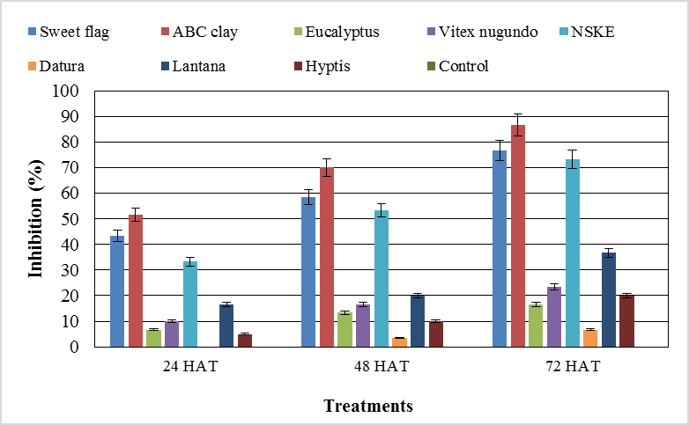
Figure 1 Direct toxicity effect (by dipping method) of attapulgite clay and different plant powders acetone extracts on pulse beetle, C. chinensis after 24, 48 and 72 hours of treatment. (HAT - Hours after treatment).

Figure 2 Surface protectant effect of attapulgite clay different plant powders acetone extracts on adult inhibition and adult emergence percentages of pulse beetle

Figure 3. Surface protectant effect of attapulgite clay and different plant powders acetone extracts on pulse beetle, Callosobruchus chinensis

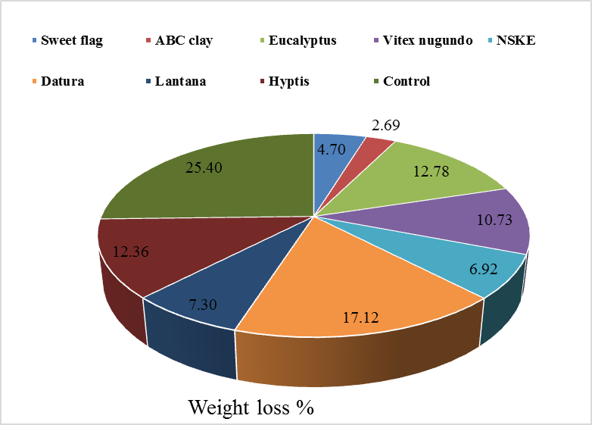
Figure 4 Effect of different extracts on per cent weight loss caused by pulse beetle

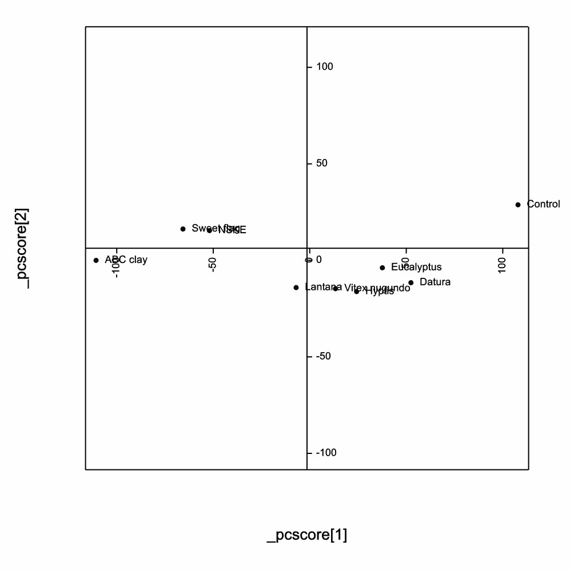

Fig.5a Principal Component Analysis (PCA) based on efficacy of attapulgite clay and different plant extracts against C. chinensis
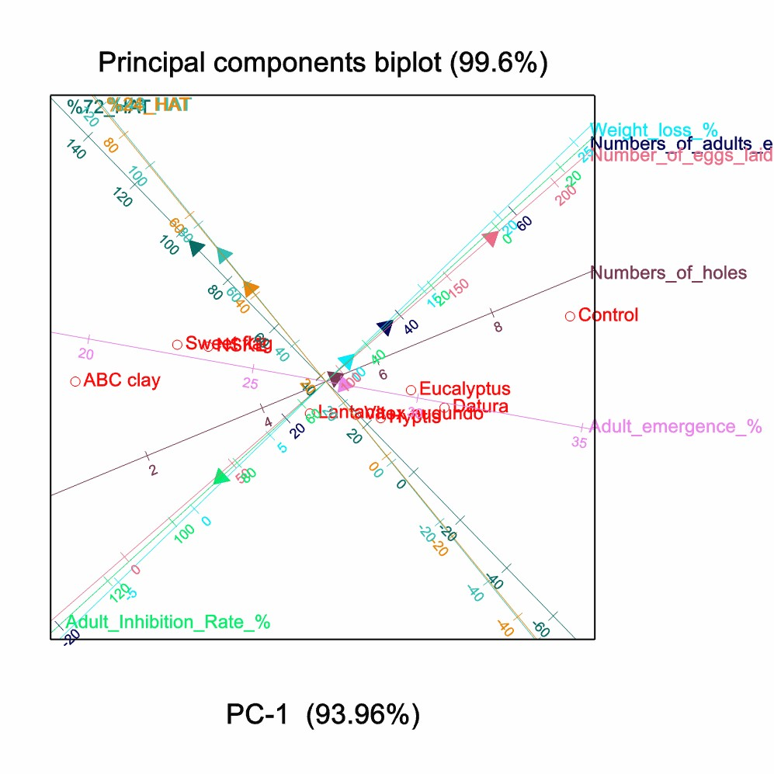
Fig.5b Principal Component Analysis (PCA) biplot based on efficacy of attapulgite clay and different plant extracts against C. chinensis

